UNIT NAME: athletics review contact: dr. Albert tezeno

phone: 972.599.3150 Email: atezeno@collin.edu
GUIDELINES
Time Frames:
- Scope:
The time frame of Program Review is five years, including the year of the review.
Data being reviewed for any item should go back the previous four years, unless not available.
- Deadline Dates:
January 19th, 2021– Program Review Document due to Department Supervisor for review (VP’s may require submissions at their own, earlier due date)
February 1st – Program Review Document due to Program Review Steering Committee
- Years:
Years 1 & 3 – Implement Action Plan of (CIP) and collect data
Years 2 & 4 – Analyze data and findings, Update Action Plan
Year 5 – Write Program Review of past 4 years; Write Continuous Improvement Plan (CIP) and create new Action Plan
LENGTH OF RESPONSES: Information provided to each question may vary but should be generally kept in the range of 1-2 pages.
EVIDENCE GUIDELINES: In the following sections, you will be asked to provide evidence for assertions made.
- Sources: This evidence may come from various sources including Collin College faculty and staff, Service Unit Student Satisfaction Surveys, Service Unit Faculty/Staff Surveys, Ruffalo Noel-Levitz Student Satisfaction Surveys, IPEDS Data (for student enrollment data), National Community College Benchmarking Project data, peer surveys, or unit-level data and surveys. This evidence may be quantitative and/or qualitative. If you are unfamiliar with any of these information sources, contact the Institutional Research Office (IRO) at: effectiveness@collin.edu. Use of additional reliable and valid data sources of which you are aware is encouraged.
- Examples of Evidence Statements:
- Poor example: Employees are encouraged to embrace the College’s core values. (Not verifiable)
- Good example: Core values are discussed with each employee in annual performance evaluations. (Verifiable, but general)
- Better example: Core values are discussed in annual performance evaluations and employees are expected to include one goal that will demonstrate personal improvement related to a core value and document, in the next annual performance evaluation, their accomplishment of that goal. (Replicable, Verifiable)

FOR MORE INFORMATION: Documentation can be found at http://inside.collin.edu/institutionaleffect/Program_Review_Process.html. Any further questions regarding Program Review should be addressed to the Institutional Research Office (effectiveness@collin.edu, 972-985-3714).

Executive Summary:
Briefly summarize the topics that are addressed in this self-study, including areas of strengths and areas of concern. (Information to address this Executive Summary may come from later sections of this document; therefore, this summary may be written after these sections have been completed.) Using the questions in the template as headings in the Executive Summary can provide structure to the overview document.
Executive Summary.
The Collin College Athletic Department provides opportunities for student athletes to fully develop their academic and athletic potential. Through practice, training and competition, the department strives to instill in each student athlete: good sportsmanship and personal integrity along with emphasizing the importance of self-discipline, sacrifice, and dedication to achieving goals.
Through this program assessment tool, we will provide information and observations regarding the Collin College Athletic department in the following areas: program description and services; description of the program’s support for the 2020 Vision and Core Values; data showing program participation; data for student and faculty surveys regarding the department; descriptions and links of all marketing and outreach tools; and a review of the 2015 CIP objectives.
This program review will focus solely on the Athletics program. The previous program review combined Athletics and Wellness. The Wellness program was separated from Athletics in 2016. As part of the restructure, the Athletic director duties were added to the Vice-President of Student and Enrollment Services.
Areas of Strength - During the review process, the Athletics program is shown to excel in support of student athletes and their transfer rate compared to the general student population. Strict GPA requirements from the National Junior College Athletic Association (NJCAA) aid in academic success of the student athletes. The program has also made enhancements to the marketing and promotion of the athletic events, as a response to a weakness identified in the previous program review.
Areas of Concern - Not surprisingly an area of needed improvement discovered in this review is assessment of the program. The limited amount of data for this program provides an opportunity to develop unit specific surveys for the athletes. This provides clear action items for the upcoming Continuous Improvement Plan.

Section I. Are We Doing the Right Things?
- WHAT DOES YOUR SERVICE UNIT DO?
What is the service unit and its context?
This section is used to provide an overview description of the service unit, its relationship to the college and the community it serves. Keep in mind the reviewer may not be familiar with your area. Therefore, provide adequate explanation as needed to ensure understanding.
Suggested/possible points to consider:
- Unit’s purpose (Include the unit’s purpose/mission statement if one exists.)
- Services and products (i.e. event coordination, reports, promotional materials, handouts, etc.)
- Service across campus/departments/district/community
- Regulatory standards the unit must meet

Unit Purpose
The purpose of the Athletic Department is to provide an opportunity for student athletes to fully develop their academic and athletic potential. Through practice, training and competition, the department strives to instill in each student athlete: good sportsmanship and personal integrity along with emphasizing the importance of self-discipline, sacrifice, and dedication to achieving goals.

Overview of the Athletics Program
Website: http://athletics.collin.edu/landing/index

COLLIN COLLEGE ATHLETICS
2800 E. Spring Creek Parkway Suite D-128 Plano, TX 75074

Collin College is a member of the National Junior College Athletic Association (NJCAA) and participates as a Division I school. Colleges of the NJCAA are permitted to participate in any division of a sponsored sport of the association. Every two years member colleges are required to declare the sports it will sponsor and what division they wish to participate. During the past five years, the Athletics program has served student athletes in Men’s Basketball, Women’s Basketball, Men’s Tennis, and Women’s Tennis.

Commitment to Academic Excellence. Academic excellence is a requirement to participate on an athletic team. Athletics teaches integrity through the pursuit of excellence through competitive and academic opportunities. The Athletic department currently has academic support services in place for the student athletes such as the writing and math labs, tutoring, and provides academic advising. Collin College student athletes demonstrate a high success rate in the transition to four-year institutions. This is reflected in the almost $300,000 in Athletic scholarships that have been awarded to Collin College student athletes by colleges and universities over the past 5 years.

Reporting Structure. The program is under the District President, with the Athletic Director directly reporting to the District President. The program currently employs 1 Athletic Director, who also serves as the district Vice-President of Student and Enrollment Services, 2 full-time staff, 3 full-time faculty with athletic/coaching duties, 1 full-time staff with athletic/coaching duties, and 3 part-time coaches. Additionally, the Associate Dean of Student and Enrollment Services oversees compliance for the program.

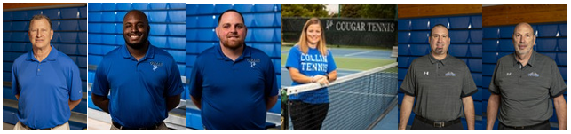

Student Requirements and Eligibility for Participation. Students wishing to participate in the Athletic program must meet requirements for eligibility. The compliance responsibilities of the program include monitoring all requirements and eligibility certification of the student athletes including the following:

- Verifies each student athlete is currently enrolled in at least 12 credit hours
- Verifies each student athlete’s GPA is at least 2.0
- Collects documentation for eligibility file to include:
- Letter of Intent
- High school transcript
- Liability paperwork
- Any college transcript external to Collin College
- Physicals and proof of insurance

The Associate Dean of Student and Enrollment Services collects and reviews all documentation and confirms institutional requirements are met through verification from the Registrar’s office. Certification of eligibility must be completed each semester before the first official contest per sport. All documentation must be collected before certifying sport eligibility and is subject to review from the NJCAA anytime from submission through 3 calendar years after submission. State travel guidelines are followed for athletic travel.

Student participation. During the past five years, the Athletics program has served student athletes in Men’s Basketball, Women’s Basketball, Men’s Tennis, and Women’s Tennis. For the 2019-2020 season, 47 student athletes participated in the program (26 males and 21 females).

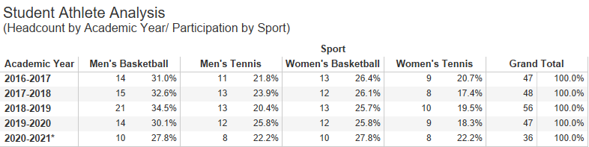
Student Athlete Headcount (Headcount by Academic Year/Participation by Sport) (Percentages represent the number of student athletes in the identified sport as compared to the total number of student athletes for the identified academic year.) Collin IRO; dsm

Scholarships - Under the NJCAA regulations, colleges may grant full athletic scholarships (tuition, books, fees, room & board), up to $250 in course required supplies and transportation costs one time per academic year to and from the college by direct route. Each sport has limits on the number of full scholarships that can be granted. (https://www.njcaa.org/member_colleges/Divisional_Structure )
For basketball, the limit is 15 per team totaling 30 full basketball scholarships for Collin College. For tennis, the limit is 3 full scholarships totaling 6 for Collin College (https://d2o2figo6ddd0g.cloudfront.net/t/5/h92b4tcfcdqbe1/NJCAA_Sports_Procedures_01-04-2020.pdf). Based on the total scholarship amount per team, coaches have the discretion to divide the full scholarship into partial awards in order to support more student athletes.
Scholarship Awards
 | Men’s Team | Women’s Team
2016-2017 | $104,495 | $111,565
2017-2018 | $116,219 | $117,486
2018-2019 | $124,058 | $132,497
2019-2020 | $116,058 | $118,589
Source: EADA reports

Services and Products - Events
Athletics provides student athletes with competitive sport opportunities

Basketball - The Men’s and Women’s basketball programs compete as members of the National Junior College Athletic Association-NJCAA (https://www.njcaa.org/landing/index), NJCAA Region V (traditionally one of the top three regions in the country- based on the number of National Champions in all sports) (https://www.njcaa.org/landing/index), and the Northern Texas Junior College Athletic Conference. Both teams traditionally compete for conference and regional championships. Women’s basketball has been successive Conference Champions for the past five years (2016, 2017, 2018, 2019, 2020). They have also placed 2nd in Region V in 2018, 2019, 2020. Men’s basketball has qualified to play in the Regional Tournament in 2016, 2017, 2018, 2019, 2020

Tennis - The Men’s and Women’s tennis programs also compete across the region. Men and Women’s Tennis has qualified to play in the NJCAA Tournament for the past five years (2016, 2017, 2018, 2019, 2020)

The Collin College Athletics program also serves as a host for local sports camps as well as National tournaments including the upcoming Men’s Tennis Nationals in 2021 and 2023.
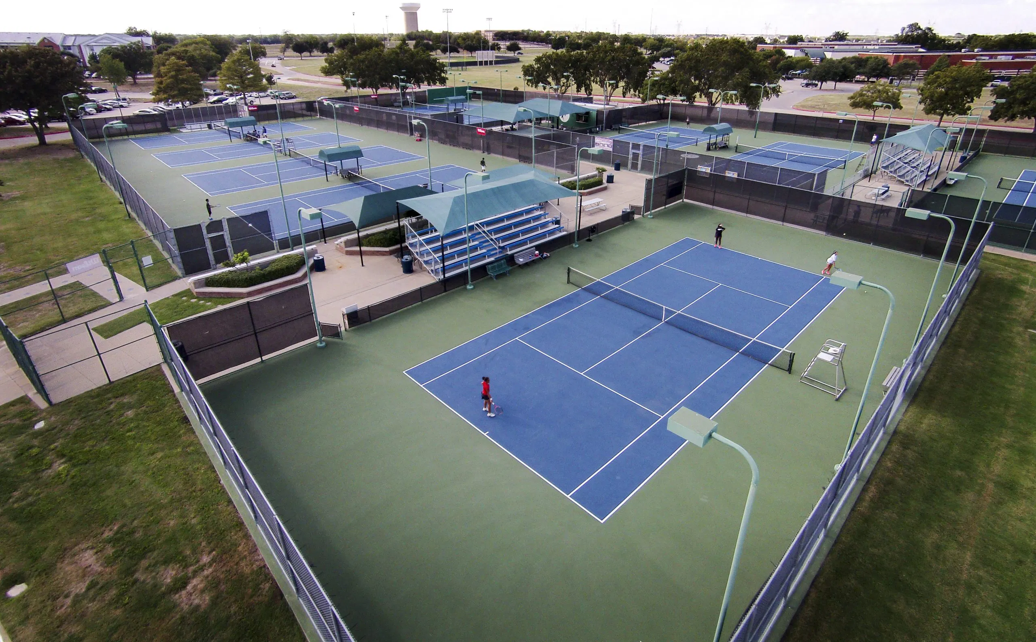
May 1, 2020 – The National Junior College Athletics Association (NJCAA) has selected Collin College to host its Division I Men’s Tennis Championships in 2021 and 2023. The national championship tournament will be held at Collin College’s Plano Campus.
https://www.collincollegenews.com/2020/05/01/collin-college-selected-to-host-mens-tennis-national-championships/
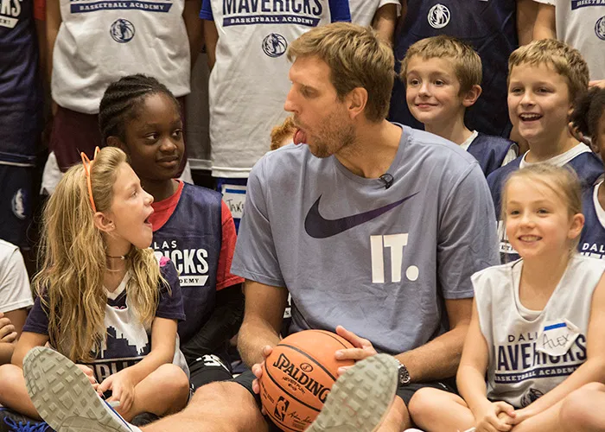

MAVS HOOP CAMP with Dirk Nowitzki in August 2018. https://www.collincollegenews.com/2018/08/31/dirk-nowitzki-kids-around-at-mavs-hoop-camp-in-plano/

Services and Products – Promotional Materials

As identified in the previous program review, a website overhaul was needed and promotional materials should be developed. In partnership with PrestoSports (https://www.prestosports.com/landing/index), the Collin College Athletic program collaborated to offer live streaming and outcomes of the games on the athletics website (http://athletics.collin.edu/landing/index). The site also hosts articles about student transfers to four-year universities, student athlete’s volunteerism, new coaches to Collin College, upcoming tournaments hosted by Collin College, information regarding student athletes named to the Conference All-Academic Team, and news about playoffs and championships.
Promotional materials for Men’s and Women’s basketball were also created. Due to the dynamic schedule of the tennis teams, printed material is a challenge so that information is posted digitally on the website and through social media.

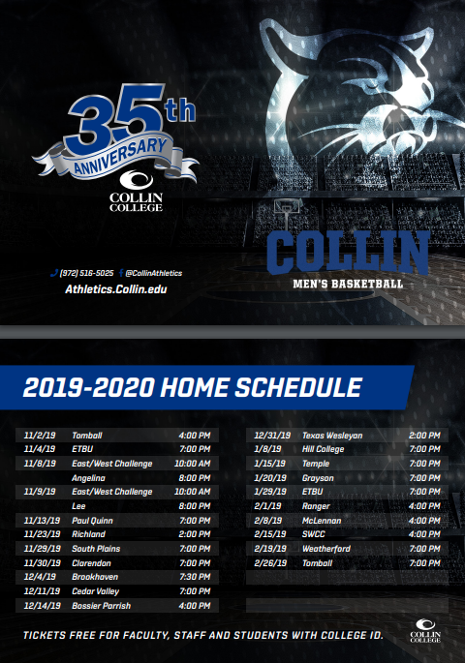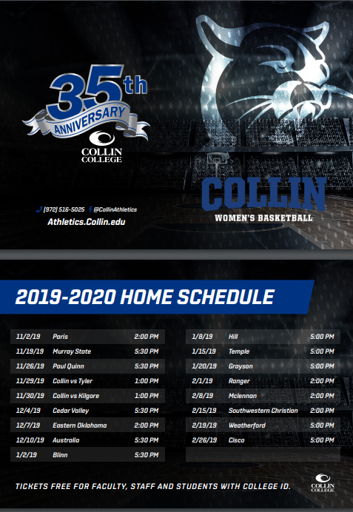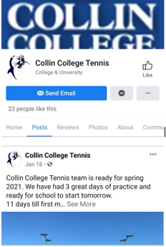
Sample: Basketball schedule cards Sample: Facebook page

Service across campus/departments/district/community
The Athletics program is positioned to partner with diverse organizations and agencies. Student athletes promote service and involvement through their participation in community outreach. This will be expounded upon in the next section addressing the Core Value of Service and Involvement.

Collin College Partnerships
The student athletes interact with campus Housing, CougarCafe, Bursar’s office, and the Student and Enrollment Services division. During the athletic orientation, students meet with the Dean of Students office and are advised of athletic eligibility as well as transfer requirements. The athletic program collaborates with Public Relations for photos, press releases, and social media promotion. Additionally, the athletes will use academic support services such as the writing center and math lab.

Community Partnerships
The Dallas Mavericks have hosted summer basketball camps on the Plano Campus. The City of Plano Visitor’s Bureau partners when Collin College hosts the annual NJCAA Men’s National Tennis tournament. Baylor Scott & White is available to provide back-up onsite certified trainers during games and matches when a Collin College trainer is not available.

Community partnerships also include community agencies and other educational institutions.

- Special Olympics, October 2016. The college’s varsity tennis teams joined with the Collin Lions Club, John Paul II High School and students from Coach Marty Berryman’s physical education classes for an eight-week series of Special Olympic tennis nights on Tuesdays in September and October. The tennis nights host about 30 players, aged 18-40, for fun evenings on the Collin courts. https://www.collincollegenews.com/2016/10/26/collin-students-faculty-work-with-special-olympics-athletes/

Regulatory Standards
The Collin College Athletic program complies with the following regulations:
- Title IX - https://www.ncaa.org/about/resources/inclusion/title-ix-frequently-asked-questions#title
Athletics programs are considered educational programs and activities. There are three basic parts of Title IX as it applies to athletics:
1. Participation: Title IX requires that women and men be provided equitable opportunities to participate in sports. Title IX does not require institutions to offer identical sports but an equal opportunity to play;
2. Scholarships: Title IX requires that female and male student-athletes receive athletics scholarship dollars proportional to their participation; and
3. Other benefits: Title IX requires the equal treatment of female and male student-athletes in the provisions of: (a) equipment and supplies; (b) scheduling of games and practice times; (c) travel and daily allowance/per diem; (d) access to tutoring; (e) coaching, (f) locker rooms, practice and competitive facilities; (g) medical and training facilities and services; (h) housing and dining facilities and services; (i) publicity and promotions; (j) support services and (k) recruitment of student-athletes.

- National Junior College Athletic Association (NJCAA) - https://www.njcaa.org/landing/index
In order to participate in an NJCAA sanctioned sport, a student-athlete must be in good academic standing; in accordance with the rules and bylaws of the NJCAA, the member region and the individual institution. He/she must be an amateur; who has not exhausted his/her eligibility; and who is in good health.

- Federal Educational Rights to Privacy Act (FERPA) - https://www2.ed.gov/policy/gen/guid/fpco/ferpa/index.html
The Family Educational Rights and Privacy Act (FERPA) (20 U.S.C. § 1232g; 34 CFR Part 99) is a Federal law that protects the privacy of student education records. The law applies to all schools that receive funds under an applicable program of the U.S. Department of Education. FERPA also identifies directory information that can be released about a student. Directory information applicable to student athletes includes: weight and height of athletic team members as well as photo/visual likeness

- U.S. Department of Education Equity in Athletics Data Analysis (EADA) - https://ope.ed.gov/athletics/#/
The Equity in Athletics Disclosure Act requires co-educational institutions of postsecondary education that participate in a Title IV, federal student financial assistance program, and have an intercollegiate athletic program, to prepare an annual report to the Department of Education on athletic participation, staffing, and revenues and expenses, by men's and women's teams. Current copies of the EADA report are found on each campus in the Student and Enrollment Service areas, the coaches suite, the athletic compliance office, and online http://athletics.collin.edu/navbar-policies

- Collin College Guide to Re-Entry to Athletics Activities
Regarding COVID considerations and regulations from the Centers for Disease Control and Prevention, the Texas Department of State Health Services, the Texas Education Agency, the National Collegiate Athletic Association, the National Junior College Athletic Association, the National Athletic Trainers' Association, the National Strength & Conditioning Association, and the National Basketball Association. (See manual in Appendix.)

2. Why do we do the things we do? Unit relationship to the College Mission & Strategic plan.
- Provide unit-specific evidence of actions that the unit supports the mission statement: “Collin County Community College District is a student and community-centered institution committed to developing skills, strengthening character, and challenging the intellect.”
Suggested/possible points to consider:
- What evidence is there to support assertions made regarding how the unit relates to the Mission and Strategic Plan?

Support of Mission Statement
The Athletic Department strives to mentor student athletes in developing skills, strengthening character, and challenging the intellect.

Developing Skills. Team practice and games support the growth of physical skills, knowledge of the game and rules, adaptability and team building skills, and compliance rules and regulations.

Strengthening Character. The Athletics department strives to strengthen character with the promotion of teamwork and sportsmanship through athletic competition. Athletes live and work together, which promotes cooperation, compassion and empathy. Student athletes learn the importance of honesty and accountability through fair athletic competition. The team members also serve the community together on multiple volunteer projects. An example of leadership through service is shared in the following section below.

Challenging the Intellect. Academic excellence is a requirement to participate on an athletic team. Athletics challenges the intellect through the support and pursuit of excellence through competitive and academic opportunities. The Athletic department currently has academic support services in place for the student athletes such as the writing and math labs, tutoring, and provides academic advising.

The program also strives to challenge the intellect by offering opportunities (in class, on the courts, and through team interaction) for students to share their varied opinions, perspectives based on their experiences, nationality, culture and background. The presence of international diversity in the program supports a richer learning environment for all students.

NOTE: The department does not currently utilize a measurement tool (i.e. survey, focus groups) to capture its impact on these areas. However, this measurement and assessment need has been identified for the 2021 CIP.

Support of Collin College Core Values
Service and Involvement - Student athletes promote service and involvement through their participation in service to the community. The Men’s and Women’s tennis team have volunteered with Special Olympics every fall for the past five years (12 hours every fall). The Men’s and Women’s basketball team volunteered with Plano Independent School district (PISD) for speaking engagements and mentoring. The basketball teams also volunteered with Big Brothers Big Sisters offering free basketball clinics. The Athletics department has represented Collin College in the community as volunteers donating total of 350 hours in the community each year from 2017-2020.

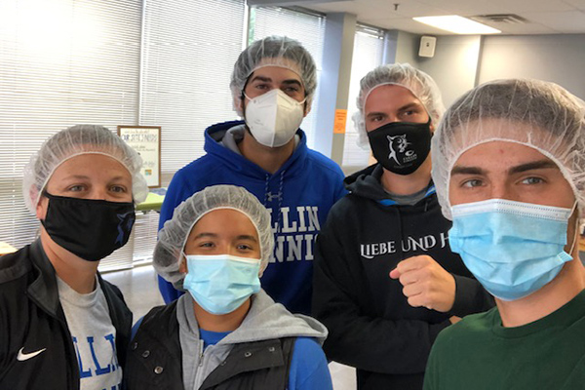
The following is an example of service in the community by Collin College athletes:
Tennis Coach Charity Andrews and a group of players recently volunteered at Feed my Starving Children in Richardson.

Over a two-hour shift, the group along with other volunteers filled 41 boxes which provided 8,856 meals. Those are enough meals for 24 children for one year. FMSC provides these meals to over 70 countries.

"It was a great experience we had, and we felt safe with COVID guidelines giving back," Andrews said. http://athletics.collin.edu/general/2020-21/releases/20201110ii9mcz

Academic Excellence - Academic excellence is a requirement to be part of the athletic team. While each student athlete must be currently enrolled in at least 12 credit hours and maintain a GPA is at least 2.0, many students achieve a level of academic excellence that is recognized and honored with scholarships to four-year universities. Many athletics are recognized for their academic achievement through their selection to the Northern Texas Junior College Athletic Conference Academic All-Conference Team. Each honoree has completed at least three semesters of college work with a minimum of 36 hours of courses that lead to a degree while maintaining a cumulative grade point average of 3.25 or greater. The student athletes participated in a least one season on the varsity level and lettered in their sports.

While some student athletes attend our institution to complete a degree or certificate, most attend Collin College in preparation to transition to four-year institutions. The following is a comparison chart of the transfer rate of Collin College student athletes versus the transfer rate of the general population of Collin College students. The four-year average shows that student athletes transfer to four-year universities at a rate of 30% more than the general population of students.

Transfer Rate Comparison | Athlete transfer rate | General population transfer rate | % Difference of Achievement
2015-2016 | Not available | Not available | Not available
2016-2017 | 82.60% | 66% | 25%
2017-2018 | 86% | 63% | 37%
2018-2019 | 67.30% | 58% | 16%
2019-2020 | 71% | 49% | 45%
Average | 76.73% | 59% | 30%
Data source: Zogotech

Dignity and Respect - Through the dynamics of TEAM, student athletes learn dignity and respect for others, for the game, for the rules, and for personal and team achievements. Student live together, travel together, and compete together and that dynamic creates teachable moments and the skill of conflict management with the outcome of enhanced respect.

- Provide unit-specific evidence that supports how the unit supports the college strategic plan (either 2020 Vision or the 2020-2025 Strategic Plan): http://www.collin.edu/aboutus/strategic_goals.html

Support of Vision 2020
The Athletics program was able to support the following strategic priorities in Vision 2020:

2. Increase outreach and create streamlined pathways from high school.
Athletic coaches are not limited to recruiting in Collin College’s designated service area of Collin and Rockwall county. Therefore, they are able to provide brand recognition of our institution on a national platform. Due to the historical success of the athletes at Collin College, the coaches regularly receive game videos or matches from high schools throughout the country. Given the longevity of the program and coaching staff, many of the local high school coaches communicate directly with Collin College coaches reinforcing partnerships to help transition student from high school to college.

The 2020-21 Men’s and Women’s Basketball rosters contain examples of students coming to Collin College from across the region, state, country, and the world. The following are the hometowns and high schools of the Basketball team:

Women’s Basketball | Men’s Basketball
- The Woodlands, Texas / College Park High School  - Cleburne, Texas / J.R. Arnold High School  - Wylie, Texas / Wylie  - McKinney / Heritage HS  - Richardson, Texas / Richardson  - Copenhagen, Denmark / -  - Albuquerque, New Mexico / Cibola  - Cleburne, Texas / Cleburne  - Arlington, Texas / Arlington Bowie  - Arlington, Texas / Arlington Martin  - Plano, Texas / Lynnwood High School  - Tyler, Texas / Tyler | - Westerville, Ohio / Westerville  - Beirut, Lebanon / International college  - Dearborn Heights, Michigan / Annapolis  - Fort Worth, Texas / Euless Trinity  - Carrolton, TX / Hebron  - Bulgaria / Lee Academy  - Crown Point, Indiana / Don Bosco Prep  - Bakersfield, California / Mt. Zion Prep  - Pine Bluff, Arkansas / Mills  - Richardson, Texas / JJ Pearce  - Plano, Texas / Plano West  - Wylie, Texas / Wylie  - Mansfield, Texas / Timberview
Source: http://athletics.collin.edu/sports/wbkb/2020-21/roster

3. Emphasize student achievement and streamline pathways to four-year colleges and universities.
Through the academic preparation and potential for financial support from scholarships, the student athletes demonstrate higher levels of transfer rates to four-year institutions than the general population. As demonstrated in the previous chart, over 76% of athletes transfer to four-year colleges and universities. Institutions where some students have transferred to include: The University of Texas at Arlington, Abilene Christian University, Angelo State, Oklahoma Baptist, Wayland Baptist, Wesleyan, West Virginia, and Texas State. http://athletics.collin.edu/landing/headlines-featured

Examples of Transfer

Jackson, Marshall, Stallworth Sign Full Scholarships
http://athletics.collin.edu/general/2018-19/releases/20190508q02us3

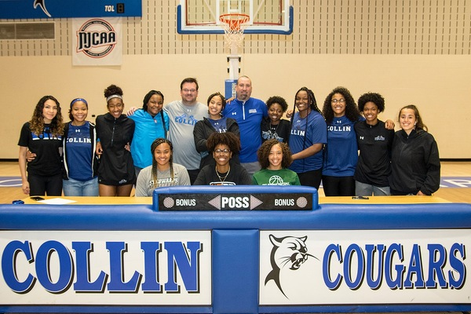
Lady Cougar basketball players Jasmine Jackson, Lauren Stallworth and Briana Marshall celebrated full scholarships with signing ceremonies May 9. Jackson, a sophomore forward/center, will attend St. Edward's University in Austin. Marshall, a sophomore guard from Plano, will attend Oklahoma Baptist University in Shawnee, Oklahoma. Stallworth, a freshman forward originally from Wylie, will attend The University of Texas of the Permian Basin.

White Signs with UNCW
http://athletics.collin.edu/general/2020-21/releases/20201113iojztv

Trazarien White signs with the University of North Carolina Wilmington.
Posted: Nov 13, 2020
Collin College freshman guard Trazarien White has signed a letter of intent to play for the University of North Carolina Wilmington. UNCW is Division I college in the Colonial Athletic Conference. White signed during the NCAA early signing period. He will play for Collin College this spring. White played for Mansfield Timberview during his high school career.

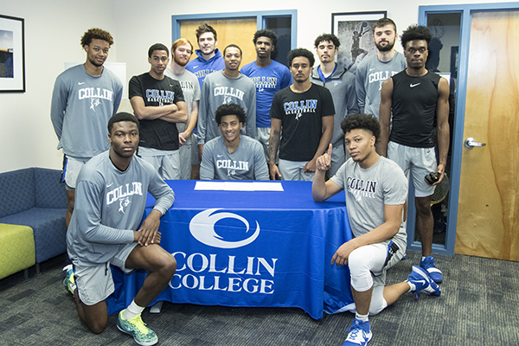
Ceaser signs with Texas State
http://athletics.collin.edu/general/2019-20/releases/20191113twc9go

Nighael Ceaser is surrounded by teammates on signing day. Photo by KIRK DICKEY

Nighael Ceaser, 6-7 forward for Collin College, signed a letter of intent on Nov. 13 to play for Texas State University in San Marcos starting in 2020-21.

6. Create an increasingly welcoming environment for students, community members, faculty and staff.
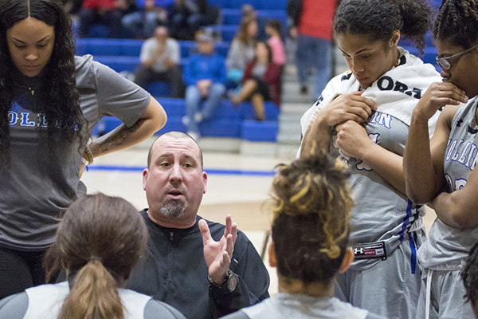
The program creates a mentoring relationship between the coaches and the athletes, encouraging students to share achievements and challenges.

In addition, the college welcomes the community to the camps, games, and special tournaments. During the basketball games, select community groups have the opportunity to showcase their talents. Collin College basketball games are host to half-time performances of local youth cheer groups. The youth basketball program “Little Dribblers” had exposition games as well. Over the past 5 years approximately 40 separate performances were held.

3. WHY DO WE DO THE THINGS WE DO?

A. Make a case with evidence to show that the primary functions/services of the unit are necessary as they are, or they should be modified, or eliminated.

Suggested/possible points to consider:
- What is the purpose and reason for the service?
- How has the function evolved during the 5-year cycle? How have the reasons for the service changed over time?
- What would happen if the unit no longer provided these services and/or the services were outsourced?
- What unit services require the most resources including staff time? Which services add the biggest value to the college? Discuss any discrepancies between the services named in these two questions.
- Is there a clear line of communication with other units involved in or supporting each of these services?
- Does the unit or the college have alternate ways of providing any of these services?
- Are the services offered/conducted as efficiently as possible?

Purpose and Reason
The purpose of the Athletic Department is to promote academic achievement and pursuit of excellence through competitive opportunities at the intercollegiate level for athletes as students and to market the institution to the community. This involves several supporting factors: developing opportunity for students; supporting and promoting academic achievement; providing opportunities for achievement in competitive sports, and giving back to our community through developing youth and serving community.

Primary Functions – Evaluation
Area | Primary Function | Necessary | Modification | Elimination
Sports – Men’s Basketball | Promote academic achievement and pursuit of excellence through competitive sports | Yes | None unless there are changes to regulations (current example includes COVID guidelines) | No
Sports – Women’s Basketball |  | Yes |  | No
Sports – Men’s Tennis |  | Yes |  | No
Sports – Women’s Tennis |  | Yes |  | No
Host - Tournaments | Community Collaboration | Yes | Adhere to COVID guidelines | No
Host – Camps | Giving Back, Developing Young Leaders | Yes |  | No
Recruiting | Selection of athletes for the teams | Yes |  | No

Evolution During the 5-year Cycle
During the past 5 years, Athletics separated from Wellness and moved under the Student and Enrollment Services division. This separation enabled the Wellness program to focus on health and wellness for faculty and staff in the district. The Athletics program was able to highlight program achievements, increasing visibility of the teams while serving as a great recruitment tool within the county, North Texas region, State of Texas, and nationally.
One of the recommendations from the previous program review was to enhance the Athletics website. PrestoSports is the current vendor supporting the athletics website (http://athletics.collin.edu/landing/index ). In addition to live streaming of games, the site also updates outcomes of the games and matches. Using this service has helped increase the efficiency in how scores are reported and viewed by those in the region.
The type and number of sports has not changed in the past 5 years. Since Collin College offers both indoor and outdoor events, the sports do not compete for the same physical space and facilities are able to be maximized during team use. The basketball games and tennis matches are held predominately in the spring but the coaches work with the athletes year-round, enabling facilities and personnel to be utilized efficiently.
Adaption for COVID19 - When COVID19 hit in early Spring 2020, college and universities were brought to a standstill.

As the COVID-19 pandemic advanced, more communities and organizations began making decisions to slow the spread of COVID-19. To this end, the National Collegiate Athletic Association (NCAA) chose to cancel all remaining spring and winter championships. After this decision was made, most institutions and conferences decided to cancel the remainder of their seasons (19-20). Given that student-athletes competing in spring sports had most of their seasons ended prematurely due to these cancellations, the NCAA and NJCAA voted to provide student-athletes meeting explicit criteria to extend their eligibility. In addition to the cancellations made at higher education institutions, secondary schools also canceled or suspended athletic activities for the remainder of the 2020 spring semester. Not only were athletic activities canceled, but most higher education institutions and secondary schools in the United States canceled face-to-face instruction as well.

Per the Considerations and regulations from the Centers for Disease Control and Prevention, the Texas Department of State Health Services, the Texas Education Agency, the National Collegiate Athletic Association, the National Junior College Athletic Association, the National Athletic Trainers' Association, the National Strength & Conditioning Association, the National Football League, Major League Baseball, and the National Basketball Association… Collin College adapted the Guide to Re-Entry to Athletics Activities, which includes the following:

Table of Contents (sample)
Prior to Arriving
Pre-Screening
Structure & Procedures for all Workouts Games/Matches & Scrimmages
Travel Procedures
Post Workout Procedures
Positive Cases, Presumed Positive Cases, and Exposures for Coaches, Staff, & Student-Athletes Contests
(Full document found in the Appendix)
What would happen if the unit no longer provided these services and/or the services were outsourced?
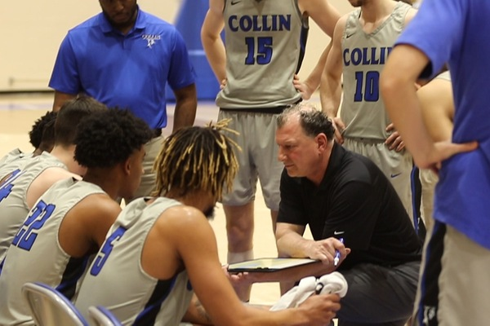
If the program was no longer available, several areas would be majorly affected. First, students would lose the opportunity to come to Collin College (on a sports scholarship), and perhaps not have the opportunity elsewhere. Second, students would not be given an opportunity to excel academically and in sports at Collin College that would get them recognized and that could earn them a scholarship to a four-year university. Thirdly, students would not have the opportunity to be mentored by professionals beyond the classroom. This coach/mentoring relationship is strategic and vital in the development of character and goals. Fourth, the community would not have access to youth sports camps, or the relationships with businesses and corporations that sponsor them. This loss to the community most effects developing youth. Finally, Collin College is a leader in our community for opportunity. The Athletic program, including access to games, tournaments, camps, etc. may be the one only exposure to college and the opportunities offered here for some of our local youth. Finally, Collin College would lose the recognition across the nation for academic and competitive sports achievement.
What unit services require the most resources including staff time? Which services add the biggest value to the college?
The training and conditioning of the student athletes requires the greatest amount of time of the coaching staff. Outside of the preparation for athletic competition, the coaches also evaluate prospective athlete videos (an aspect of recruiting) and facilitation of scholarships (including verification of academic eligibility).
The coaching component adds the biggest value to the college. In addition to the physical strengthening and conditioning of the student athletes, the coaches serve as mentors and educators. This opportunity for the students can help create change for their future. Beyond the impact on the individual students, the Athletic program as a whole elevates the notoriety of the institution to a national level.
Evidence of Unit Success
Collin College Student Athletes Named to Conference All-Academic Team
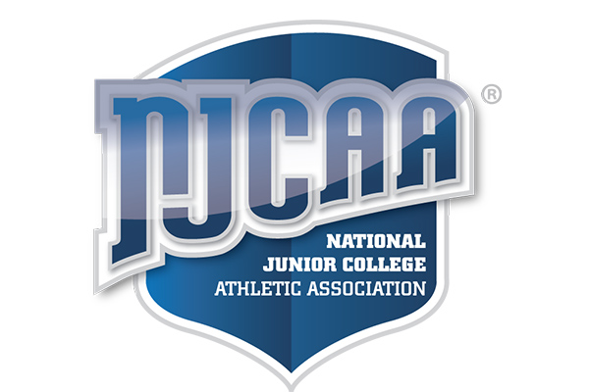
http://athletics.collin.edu/general/2019-20/releases/20200323ptxikw

Posted: Mar 23, 2020
Seven Collin College student athletes have been named to the 2019-20 North Texas Junior College Athletic Conference (NTJCAC) All-Academic Team.
Collin College's selections to the team were:
Women's Basketball – Lucy Ibeh of Lagos, Nigeria, and Anyssia Gibbs of Apple Valley, California
Women's Tennis – Rebekah Clark of Frisco, Andrea Farris of Lucas, and Lea Mjertan of Osijek, Croatia
Men's Tennis – Hector Flores of Caracas, Venezuela, and Tom Golden of Perth, Australia.
Each honoree has completed at least three semesters of college work with a minimum of 36 hours of courses that lead to a degree while maintaining a cumulative grade point average of 3.25 or greater. The student athletes participated in a least one season on the varsity level and lettered in their sports.

Chapman, Edwards, Marshall Named to Academic All-Conference Team
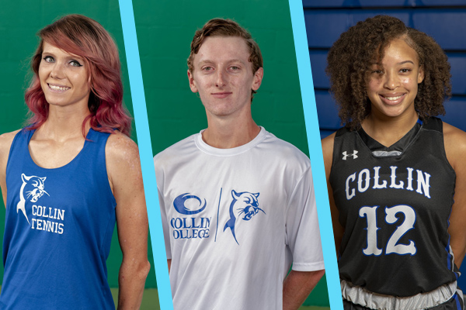
http://athletics.collin.edu/general/2018-19/releases/20190322pl2gwl

Posted: Mar 22, 2019
Three Collin College student athletes have been named to the 2018-19 North Texas Junior College Athletic Conference Academic All-Conference Team. Collin College's selections were: Taylor Chapman of Frisco (tennis), John Edwards of McKinney (tennis) and Briana Marshall of Plano (basketball). Each honoree has completed at least three semesters of college work with a minimum of 36 hours of courses that lead to a degree while maintaining a cumulative grade point average of 3.25 or greater. The student-athletes participated in a least one season on the varsity level and lettered in their sports.

Additional Accolades:
- Basketball All Region/All Conference individual honors: https://www.collincollegenews.com/2020/03/12/collin-college-basketball-players-named-all-region-all-conference/
- Coach Jeff Allen named NTJCAC Women’s Basketball Coach of the Year – 2020
- Basketball Regional Tournament Qualifiers: https://www.collincollegenews.com/2018/03/02/collin-basketball-headed-to-njcaa-regional-tournament/
- Tennis National Qualifiers: https://www.collincollegenews.com/2017/06/01/tennis-teams-perform-at-nationals/
- Tennis Regional Winners: https://www.collincollegenews.com/2017/04/28/tennis-teams-claim-regional-titles/
Evidence of Unit Efficiency
As previously mentioned, the utilization of physical facilities is conducted as efficiently as possible given that basketball and tennis require separate venues. By scheduling home and away games opposite for the Men’s and Women’s basketball teams, the use of the gymnasium is maximized.
The following chart outlines the annual total budget for the department.
Fiscal Year | Total Budget | Areas of Allocation
2016 | $589,533 | Operational and administrative expenses including but not limited to: staffing, travel, uniforms, memberships (NJCAA), and insurance
2017 | $657,093 | Operational and administrative expenses including but not limited to: staffing, travel, uniforms, memberships (NJCAA), and insurance
2018 | $583,397 | Operational and administrative expenses including but not limited to: staffing, travel, uniforms, memberships (NJCAA), and insurance
2019 | $697,199 | Operational and administrative expenses including but not limited to: staffing, travel, uniforms, memberships (NJCAA), and insurance
2020 | $687,238 | Operational and administrative expenses including but not limited to: staffing, travel, uniforms, memberships (NJCAA), and insurance

When the annual budget is divided by the number of student athletes, the average for Collin College is $14,025 per athlete. This is consistent with peer institutions in the Northern Texas Junior College Athletic Conference in which the conference average is $13,858.

NTJCAC Sport | Collin College | Grayson College | Hill College | McLennan College | Ranger College | Southwestern Christian | Temple College | Weatherford College
Athletics Expenses 2019-2020 | $687,238 | $1,194,276 | $1,375,506 | $1,518,540 | $2,684,722 | $266,128 | $1,293,771 | $1,981,927
Total Number Male Athletes | 26 | 45 | 103 | 61 | 160 | 14 | 42 | 78
Total Number Women Athletes | 23 | 35 | 86 | 46 | 114 | 12 | 47 | 54
Total Athletes | 49 | 80 | 189 | 107 | 130 | 26 | 89 | 132
Expenses per Athlete | $14,025 | $14,928 | $7,278 | $14,192 | $20,652 | $10,236 | $14,537 | $15,015

Given the unique requirements of the Athletics program, there is not an alternate way of providing this service.

- Benchmarking: Review two or three comparable, colleges for the way they accomplish these services. Discuss what was learned and what new ideas for service improvement were gained.

Collin College participates in the Northern Texas Junior College Athletic Conference – Region V. The following chart compares Collin College to regional competitors.

College Comparison Observations.
- The average number of individual sports offered is 6.625, with 4 (Collin College) being the lowest and 10 (Weatherford) being the highest.
- Collin College is on target for the average expenditures per student athlete.
- Collin College has the lowest percentage of students participating in competitive sports, with .47% as compared to the average of 11.5%.
- Supporting new athletic programs could require additional facilities or competing with existing sports and venues.

Given Collin College’s strong representation at a national level in both academic and athletic competition, the greatest enhancements need to be within the department in the areas of assessment and leadership development.

Athletics Program Institution Comparison Review
NTJCAC Sport | Collin College | Grayson College | Hill College | McLennan College | Ranger College | Southwestern Christian | Temple College | Weatherford College
Men's Basketball | x | x | x | x | x | x | x | x
Women Basketball | x | x | x | x | x | x | x | x
Men's Tennis | x |  |  |  |  |  |  | x
Women Tennis | x |  |  |  |  |  |  | x
Men's Baseball |  | x | x | x |  |  | x | x
Women Softball |  | x | x | x | x |  | x | x
Men's Golf |  |  |  | x | x |  |  | x
Women’s Golf |  |  |  | x | x |  |  | x
Rodeo |  |  | x |  | x |  |  | x
Volleyball |  |  | x |  |  | x | x | x
Dance |  |  |  | x
Men's Soccer |  |  | x |  | x
Women Soccer |  |  | x |  | x
Men's Track & Field |  |  |  |  |  | x
Women Track & Field |  |  |  |  |  | x
Athletics Expenses 2019-2020 | $687,238 | $1,194,276 | $1,375,506 | $1,518,540 | $2,684,722 | $266,128 | $1,293,771 | $1,981,927
Total Number Male Athletes | 26 | 45 | 103 | 61 | 160 | 14 | 42 | 78
Total Number Women Athletes | 23 | 35 | 86 | 46 | 114 | 12 | 47 | 54
Total Athletes | 49 | 80 | 189 | 107 | 130 | 26 | 89 | 132
Number of Full-time (FT) Undergraduates | 10,341 | 1,426 | 1,433 | 3,300 | 915 | 80 | 1,532 | 2,051
Expenses per Athlete | $14,025 | $14,928 | $7,278 | $14,192 | $20,652 | $10,236 | $14,537 | $15,015
% of Total FT Participating in program | .47% | 5.61% | 13.1% | 3.2% | 14.2% | 32.5% | 5.8% | 6.4%
Total Number of County Residents | 1,035,000 | 136,212 | 36,649 | 256,623 | 18,630 | 8,531 | 362,924 | 142,878
Data Source: EADA report https://ope.ed.gov/athletics/#/

4. HOW DO WE IMPACT STUDENT OUTCOMES?
Make a case with evidence to show effects of the unit on student outcomes.

Suggested/possible points to consider:

How does the unit influence the student experience?

How does the unit influence the student environment and/or safety?

In what way does the unit influence student enrollment, retention, persistence, and/or completion?
- Analyze the evidence you provide. What does it show about the unit?

Student Experience - The Athletics programs positively impacts the student athletes in the areas of leadership development, physical fitness and team dynamics. When conducting the youth outreach programs (such as volunteering with Plano ISD), student athletes have the opportunity to demonstrate their leadership abilities. While there is no formalized leadership training for our athletes, this is an area that has been identified where enhancements can be made to better support the student athletes. Student athletes also demonstrate leadership through community service. The Men’s and Women’s tennis team have volunteered with Special Olympics every fall for the past five years (12 hours every fall). The Men’s and Women’s basketball team volunteered with Plano Independent School district (PISD) for speaking engagements and mentoring. The basketball teams also volunteered with Big Brothers Big Sisters offering free basketball clinics. The Athletics department has represented Collin College in the community as volunteers donating total of 350 hours in the community each year from 2017-2020.

Leadership development has been, typically, an organic process through the mentoring and challenges of the Collin College coaching team. The department will explore a more defined curriculum that focuses on more tangible components of leadership development, as well as developing a tool to measure the learning outcomes.

Student Environment and/or Safety - All athletes are required to participate in an athletic orientation. Topics include: good sportsmanship, drug/drug testing, NJCAA eligibility requirements, and more (Agenda in Appendix). In addition to receiving academic advising for course selection, student athletes will also hear from the Dean of Students office to review the student handbook and code of conduct. https://www.collin.edu/studentresources/personal/studenthandbook.html

A medical doctor is onsite and conducts a physical fitness exam on every athlete. Their physical health and safety are a top priority for the program.

COVID19. Due to COVID NJCAA and the regional athletic directors met to discuss how to safely reinstate athletic programs. During these meetings it was discussed about positive test results, when a team cancel/postpone a game or match, and which states guidelines are in place related to CDC requirements. Example: The coaches started the practice period with teaming up players in sets of 2 or 4. Those players continued to practice with caution following CDC guidelines so that only the same students were exposed to each other during that time. Developing the COVID procedures was a collaborative effort by the athletic trainers in the region. Collin College adapted the Guide to Re-Entry to Athletics Activities (Guide in Appendix)

Student retention, persistence and/or completion - As mentioned previously, the students in the Athletics program are academically successful as shown in the transfer rates of athletes to four-year institutions compared to the general population. With the previous four-year average of athletes being 76.725% and the general student population with a 59% transfer rate (Source: Zogotech). In addition, students are regularly recognized on the Northern Texas Junior College Athletic Conference (NTJCAC) All-Academic Team. Each honoree must complete at least three semesters of college work with a minimum of 36 hours of courses that lead to a degree while maintaining a cumulative grade point average of 3.25 or greater. The student athletes participate in a least one season on the varsity level and have lettered in their sport (http://athletics.collin.edu/general/2019-20/releases/20200323ptxikw).
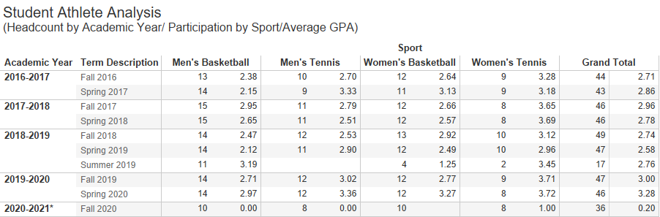

Source: Student Athlete Headcount (Headcount by Academic Year/Participation by Sport/Average GPA) Collin IRO; dsm

Analyzation of Evidence – Throughout this assessment, observations for possible growth have been identified. In addition, awareness (across the district) of this service unit is an area for continued improvement. The updated website and promotion through social media are being used to increase awareness of athletics. Based on feedback from the service unit surveys, there are some opportunities for growth. Student awareness decreased from 2017 to 2019 by 1.4%. The results from the faculty and staff survey are similar in that there was a decrease of 8.1%. However, the Spring 2020 survey term occurred during the COVID closure so that could account for part of the reduction.

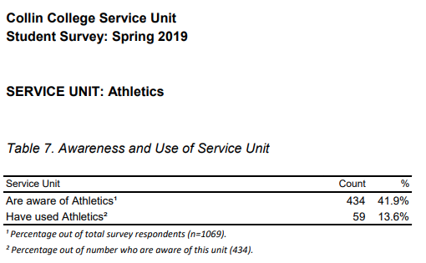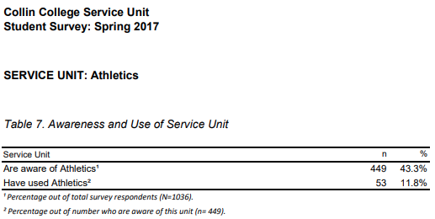
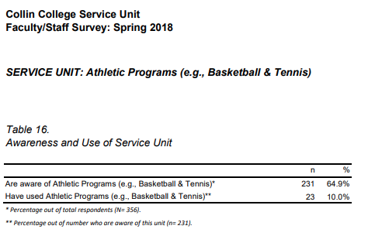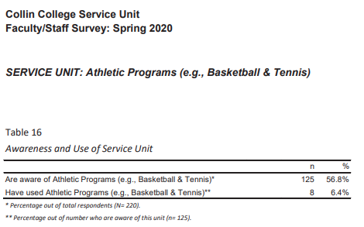

Section II. Are We Doing Things Right?

5. How effectively do we communicate, and how do we know?

A. Make a case that the printed literature and electronic communication are current, provide an accurate representation, and support the college’s recruitment, retention and completion plans.
Suggested/possible points to consider:
- Demonstrate how the unit solicits student feedback regarding its website and literature and how it incorporates that feedback to make improvements.
- Designate who is responsible for monitoring and maintaining the unit’s website, and describe processes in place to ensure that information is current, accurate, relevant, and available.

The Athletics department is responsible for three primary communication pieces: website, basketball schedules, and basketball programs. The tennis teams schedules are dynamic so that information is updated on the website and through social media. Within 24 hours of a game or match, the coaches upload the scores to the Athletics website. Other updates such as team photos and schedules are completed as needed. Since the website is designed by an outside agency, there are limited areas for customization. The printed basketball schedule card was last produced as a separate piece for the 2019-2020 season. Programs for the basketball games are updated and printed for each game to include the opposing team name and roster. The basketball schedule is also listed on the back of the program. The Athletic Director (Vice-President for Student and Enrollment Services) has ultimate approval on all printed materials. Under the current design, there is no student feedback on an ongoing basis.

B. Provide unit website URLs. If no website is available, describe plans for creation of website or explain the absence.

Athletics Website: http://athletics.collin.edu/landing/index

C. In the Unit Literature Review Table, below, document that the elements of information listed on the website or other formats (services available, points of contact, current calendars, handouts, costs and additional fees, hours of availability) were verified for currency, accuracy, relevance, and are readily available to target audiences.

Unit Literature Review Table
Title | Type (i.e. URL, brochure, handout, etc.) | Date of Last Review/Update |  | Responsible Party
Athletics Website | http://athletics.collin.edu/landing/index | 1/21/2021 | Current  Accurate  Relevant  Available | All Assistant Coaches and the Athletic Director
Men’s Basketball schedule | Schedule card | 1/01/2020 | Current  Accurate  Relevant  Available | Athletic Director (currently not in production)
Women’s Basketball schedule | Schedule card | 1/01/2020 | Current  Accurate  Relevant  Available | Athletic Director (currently not in production)
Tennis 2018 Division I Championship Poster (Copy in Appendix) | Poster | 2018 | Current  Accurate  Relevant  Available | Public Relations and Athletic Director
Men’s Basketball program | Handout | Updated every game | Current  Accurate  Relevant  Available | Administrative assistant for the Athletic Director
Women’s Basketball program | Handout | Updated every game | Current  Accurate  Relevant  Available | Administrative assistant for the Athletic Director

6. What partnerships and partner resources are established by the unit, and how are they valuable?
Partnership Resources: List any business, industry, government, college, university, community, and/or consultant partnerships, including internal Collin departments, to advance the service unit outcomes. If a formal agreement is involved, indicate its duration.

Partnership Resources Table
Partner/Organization | Description | Formal Agreement Duration,  if any | Briefly explain the Partnership’s Value to Service Unit
Dallas Mavericks | Youth basketball programs | Per event, approved through Campus Provost | Provides community service for student athletes and promotional opportunities for the institution
The City of Plano Visitor’s Bureau | Tennis tournament | MOU | Collaborative effort to support tennis teams from throughout the country to participate in the national tournament
Texas Health Sports Medicine Specialists | Athlete Physicals | n/a | Aids in the physical safety of the student athletes
SurScan | Drug Testing | District contract, not limited to athletics | Maintain compliance

7. What professional development opportunities add value to your service unit? List please examples.
Make a case with evidence that staff keep current, and fulfill roles that advance the unit and the College. List unit employees, their roles, and known professional development activity in the last four years.

Employee Resources
Employee Name | Role in Unit | Professional Development since Last Program Review**
Jim Sigona | Men’s Basketball Coach | See Appendix
Jeff Allen | Women’s Basketball Coach | See Appendix
Charity Andrews | Men’s & Women’s Tennis | See Appendix
Jeff Barr | Men’s Assistant Basketball Coach | See Appendix
Ray Scott | Women’s Assistant Basketball Coach | See Appendix
Julianne Goza | Athletic Trainer | See Appendix

8. Are facilities, equipment, and funding sufficient to support your service unit? If not, please explain.
[Only respond to this prompt if you are requesting additional resources, otherwise proceed to prompt 9.]
Make a case with evidence that current deficiencies or potential deficiencies related to unit facilities, equipment, maintenance, replacement, plans, or budgets pose important barriers to the unit or student success. As part of your response, complete the resource tables, below, to support your narrative.

Suggested/possible points to consider:
- The useful life of structures and equipment,
- Special structural requirements, and
- Anticipated technology changes impacting equipment sooner than usual.
- If you plan to include new or renovated facilities or replacement of equipment in your unit improvement plan, be sure to justify the need in this section with qualitative and/or quantitative data evidence of the need.

The budget provided is sufficient to support the Athletics program and no additional funds nor facilities are requested.

Section III. Continuous Improvement Plan (CIP)
9. How have past Continuous Improvement Plans contributed to success?
Program Review at Collin College takes place for each unit or program every five years. During the last (fifth) year, the unit evaluates the data collected during the CIP process.
Please describe how you have used your Continuous Improvement Plan (CIP) to make the following improvements to your unit over the past 4 years (your last review can be found on the Program Review Portal):
- Student Outcomes
- Overall improvements to your unit
The previous program review identified two areas to increase support for the Athletics program 1) website and promotional enhancement 2) creation of a Learning Resource Center for student athletes. While the following Continuous Improvement Plans focused on the wellness program (Athletics and Wellness were previously combined), enhancements were made to benefit the Athletics program.
The Athletics website was enhanced significantly and promotional materials were created for distribution. Providing dedicated space for a Learning Resource Center just for athletes was not feasible given the growth of the student population. Student athletes are provided with direct academic support services and meet regularly with advising to review their degree plan.

*Please attach previous CIP Tables in the appendix

10. How will we evaluate our success?
NOTE: Please contact the institutional effectiveness office if you need assistance filling out the CIP tables.
As part of the fifth year of Program Review, the unit should use the observations and data generated by this process along with data from other relevant assessment activities to develop the unit’s CIP and an action plan for the next two years. At the conclusion of the first two years, data collected from the first year, plus any other relevant data that was collected in the interim, should be used to build on the accomplishments of those first two years by developing another two-year action plan for the CIP to help the unit accomplish the expected outcomes established in its CIP or by implementing one of your other plans.

Based on the information, analysis, and discussion that have been presented in your Program Review submission to this point, please summarize the strengths and weaknesses of this unit. This response should be based on information from prior sections of this document. Please describe how the continuous improvement plans you propose below will capitalize on the strengths, mitigate the weaknesses, and improve student success.

Strengths

Over the past five years, the high transfer rate to universities and number of championships demonstrate that the Athletic program is successfully meeting its purpose of academic achievement. With these successes, the Athletics program elevates the notoriety of the institutional to a national level. Strict GPA requirements from the National Junior College Athletic Association aid in academic success of the student athletes. The program has also made enhancements to the marketing and promotion of the athletic events, as a response to a weakness identified in the previous program review. The website is evidence of the improvements. (http://athletics.collin.edu/landing/index)

Opportunities for Growth

Not surprisingly, an area of needed improvement discovered in this review is assessment and evaluation of the program as related to the areas of: learning outcomes, impact on experience, transfer information, and overall impact. The limited amount of data for this program provides an opportunity to develop unit specific surveys for the athletes. This provides clear action items for the upcoming Continuous Improvement Plan.

11. Complete the Continuous Improvement Plan (CIP) tables that follow.
Within the context of the information gleaned in this review process and any other relevant data, identify unit priorities for the next two years, and focus on these priorities to formulate your CIP. This may include short-term administrative, technological, assessment, resource or professional development outcomes as needed.

 | Table 1. CIP Outcomes, Measures & Targets Table
 | Problem | Desired Outcome | Action Needed | Instrument(s)/process(es) used to measure results  (e.g. sign-in sheets, surveys, focus groups, etc.) | What is the Success Mark?
1 | Lack of Qualitative and Quantitative Data regarding learning outcomes, and program impact. | Credible data regarding student learning outcomes, and program impact. | Create an assessment tool that captures student learning outcomes, program participation and program impact. | Student survey, sign in sheets, and focus groups | Data base of student survey responses.
2 | Absence of coordinated leadership training in Athletics | Student athletes will be empowered to enhance leadership skills | Create a leadership development program in Athletics as part of the training and conditioning. | Sign in sheets, and student survey specific to the leadership training and conditioning. | Curriculum of mini leadership sessions, including objectives, content, and experiential application of knowledge by Fall 2021
3 | Incomplete Student Athlete Manual that includes all policies, procedures, protocols, and processes of the Athletic Program. | Students will have information regarding the policies, procedures, protocols and processes of the Athletic Program. | Create a Student Athlete Handbook and/or Manual of Operations | List of Manual Chapters and curriculum | An approved and published Student Athlete Handbook and/or Manual of Operations by Fall 2021.

Continuous Improvement Plan

Outcomes might not change from year to year. For example, if you have not met previous targets, you may wish to retain the same outcomes. If this is an academic, workforce, or continuing education program, you must have at least one student learning outcome. You may also add short-term administrative, technological, assessment, resource or professional development goals, as needed. Choose up to 2 outcomes from Table 1 above to focus on over the next two years.

A. Outcome - Result expected in this unit (from column A on Table 1 above--e.g. Authorization requests will be completed more quickly; Increase client satisfaction with our services).
B. Measure - Instrument(s)/process(es) used to measure results (e.g. surveys, test results, focus groups, etc.).
C. Target - Degree of success expected (e.g. 80% approval rating, 10-day faster request turn-around time, etc.).
D. Action Plan - Implementation of the action plan will begin during the next academic year. Based on analysis, identify actions to be taken to accomplish outcome. What will you do?
E. Results Summary - Summarize the information and data collected in year 1.
F. Findings - Explain how the information and data has impacted the expected outcome and unit success.
G. Implementation of Findings – Describe how you have used or will use your findings and analysis of the data to make unit improvements.

Table 2. CIP Outcomes 1 & 2

- Outcome #1
Leadership training developed for student athletes
- Measure (Outcome #1)  Student survey and sign-in sheets | - Target (Outcome #1)  Student athletes will be empowered to enhance leadership skills
- Action Plan (Outcome #1)
Curriculum will be developed as well as student survey for learning modules for a Fall 2021 implementation
- Results Summary (Outcome #1) TO BE FILLED OUT IN YEAR 2

- Findings (Outcome #1) TO BE FILLED OUT IN YEAR 2

- Implementation of Findings (Outcome #1) TO BE FILLED OUT IN YEAR 2

Table 2. CIP Outcomes 1 & 2 (continued)

- Outcome #2
Student athlete evaluation of Athletic program
- Measure (Outcome #2)  Student survey | - Target (Outcome #2)  Create database of student athlete responses related to program operations
- Action Plan (Outcome #2)
Develop a survey specifically for student athletes to provide program feedback. Year 1 will set baseline data with the following years addressing areas for enhancement.
- Results Summary (Outcome #2) TO BE FILLED OUT IN YEAR 2

- Findings (Outcome #2) TO BE FILLED OUT IN YEAR 2

- Implementation of Findings (Outcome #2) TO BE FILLED OUT IN YEAR 2

Appendix

- Athletic Orientation Agenda
- Tennis Championship Poster
- Employee Credentials
- Previous Continuous Improvement Plan
- Collin College Guide to Re-Entry to Athletics Activities (COVID-19 response)

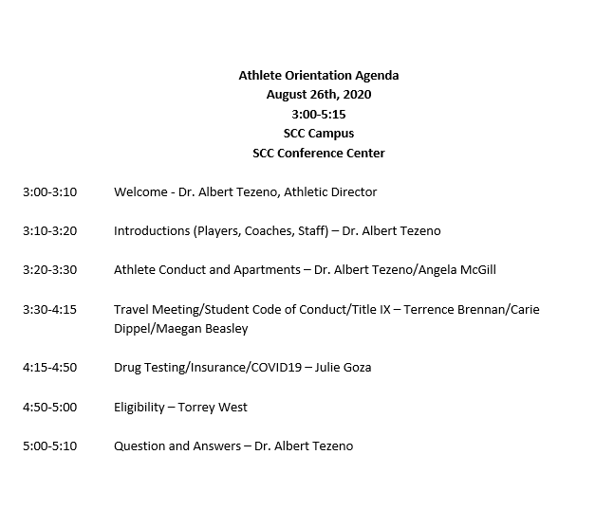
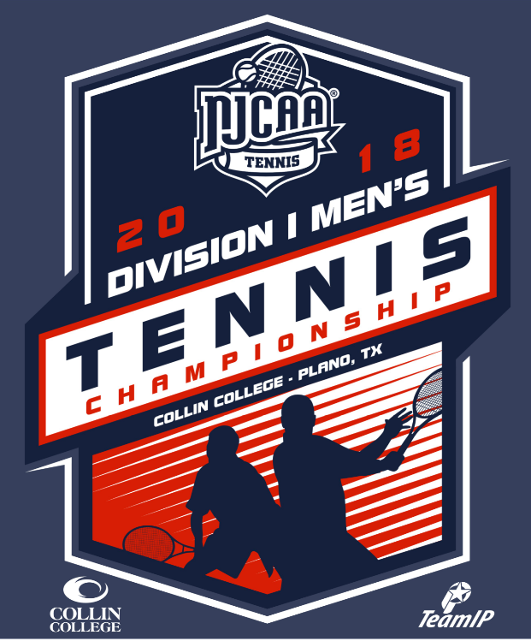

Employee Name | Role in Unit | Credentials | Professional Development since Last Program Review**
Jim Sigona | Men’s Basketball Coach | MS, BA | Attended, National Association of Basketball Coaches Convention, Minneapolis, Minnesota, Spring 2019  Attended, Texas Association of Basketball Coaches Convention, San Antonio, Texas, Spring 2019  Collaborated, Texas A&M University Strength and Conditioning Coach, College Station, Texas, Fall 2018  Participated, National Association of Basketball Coaches Webinars, Fall 2017-Spring 2019  Attended, National Association of Basketball Coaches Convention, San Antonio, Texas, Spring 2018  Participated, National Association of Basketball Coaches Webinars, Fall 2017-Spring 2019  Attended, National Association of Basketball Coaches Convention, San Antonio, Texas, Spring 2018  Attended, Texas Association of Basketball Coaches Convention, San Antonio, Texas, Spring 2018  Advise, Student Athletes, Transfer and Eligibility Requirements, Fall 2017-present  Volunteer, Plano Independent School District, Fall 2017-present
Jeff Allen | Women’s Basketball Coach | AA. BA, MA | Member of TABC, NABC, WBCA organizations. Attend Clinics from these organizations each year. This past year they were done virtually due to Covid. Attended practices and clinics from university programs such as TCU, LSU, Texas Tech and LSU.  Named TABC Coach of the year 2015.  Named United States Marine Corps/WBCA Regional Coach of the Year 2015.  Named United States Marine Corps/WBCA National Coach of the Year Finalist 2018.  Named NTJCAC Conference Coach of the Year 2016,2017,2018 and 2020.
Charity Andrews | Men’s & Women’s Tennis | MS, BSc, AA | All College Day, Spring 2021  Canvas Training 2020  Ad Astra Training 2020  Budget Training 2020  Concur Travel Training 2020-2021  NJCAA Tennis Coach Board Member 2015-2019  ITA Tennis Coach member  UTR Tennis Coach member  CPR/First Aid Certified till Dec 2022
Jeff Barr | Men’s Assistant Basketball Coach | BS, MA | NABC Convention 2019. 2018  TABC Convention 2019
Ray Scott | Women’s Assistant Basketball Coach | BA | Member of TABC.  Recruiting Coordinator  Attends TABC clinics  Attends practices and clinics from universities such as TCU, UTA and Texas Tech.
Julianne Goza | Athletic Trainer | MS, ATC, LAT, CES | - Academic Advising volunteer‐ Jul 2019  - Student Welcome Week‐ August 2019, January 2020, August 2020  - CPR certification with fitness workers‐ January 2019, September 2019  Health and Safety Fair volunteer‐ Apr 2019  Financial Aid Appeal Committee‐ Fall 2019 to present  Adjunct Professor Evaluation‐ October 2019  Health and Safety Kinesiology table organizer ﴾although canceled﴿‐ Spring 2020  Biology hiring committee‐ Spring 2020  Wellness Committee‐ Spring 2020  Summer Camp Volunteer Committee for Kinesiology ﴾SHAPE﴿‐ Spring 2020  Independent Applying the QM Rubric (Virtual) (APPQMR)- December 2020  Development of athletic Covid-19 procedures- June 2020  Professional Development:  1. South Padre Athletic Training Symposium‐ June 2019, South Padre, TX  2. Southwest Athletic Trainers’ Association Symposium‐ July 2019, Arlington, TX.  3. 2020 January Faculty Development Conference‐ January 9, 2020, CHEC  4 Teacher Professor Conference‐ May 27th, 2020, Virtual  5. National Athletic Trainers Association Annual Symposium- June 2020 (Virtual)  6. 2021 Faculty Development Conference- January 7-9, 2021 (Virtual)  Educational:  1. Started Ph.D. in Performance Psychology at Grand Canyon University‐ November 2019  Presentations:  1. SA Cage, BJ Warner, JP Goza. Evidence‐Based Approach to the Use of Tissue Flossing Bands to Improve Perceived and  Actual Joint Range of Motion. Southwest Athletic Trainers’ Association Symposium. July 27, 2019, Arlington, TX.  2. SA Cage, JP Goza, BJ Warner. Evidence Based Approach to Therapeutic Cupping for Chronic Neck and Back Pain. Southwest Texas Athletic Trainers' Association. July 19, 2018, Arlington, TX.  Publications:  1. Cage SA, Warner BJ, Gallegos DM, Warner L, Trail LE, Goza JP, Porche B. Attitudes and Motivations Following Shortened  2020 Season Among NCAA Division II and Division III Baseball Players: A Pilot Study. Research & Investigations in Sports  Medicine. ﴾in press﴿  2. Cage SA, Warner BJ, Gallegos DM, Goza JP, Winkelmann ZK. Perceived and Actual Knowledge of Cupping Therapy Concepts Among Athletic Trainers in the State of Texas. Research & Investigations in Sports Medicine. 2020;6(4):538-542.  Certifications:  1. BOC National Athletic Trainer Certification  2. Texas Athletic Training License  3. Red Cross Instructor Certification  4. Red Cross Professional Rescuer Certification  - 5. Corrective Exercise Specialist Certification

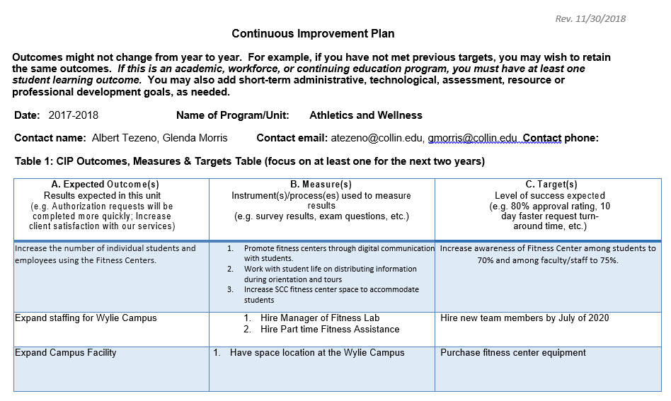

Appendix: COVID-19 response

Collin College Guide to Re-Entry to Athletics Activities
Considerations and regulations from the Centers for Disease Control and Prevention, the Texas Department of State Health Services, the Texas Education Agency, the National Collegiate Athletic Association, the National Junior College Athletic Association, the National Athletic Trainers' Association, the National Strength & Conditioning Association, the National Football League, Major League Baseball, and the National Basketball Association.

Table of Contents

Introduction 3

Prior to Arriving 3-6

Pre-Screening 6

Structure & Procedures for all Workouts 6-9

Games/Matches & Scrimmages 9

Travel Procedures 9-10

Post Workout Procedures 10

Positive Cases, Presumed Positive Cases, and Exposures 11-12
for Coaches, Staff, & Student-Athletes

Contests 12

Appendix I – Return to Campus for Summer Policy and Procedures 13

Appendix II – Action Plan for Positive and Presumed Positive Cases 14-15

Appendix III – COVID-19 Student-Athlete Pre-Screen 16

Appendix V – Pertinent Contact Information 17

Appendix VI – References & Resources 18

Introduction

Coronavirus disease 19 (COVID-19) is an increasingly severe respiratory disease caused by severe acute respiratory syndrome coronavirus 2 (SARS-CoV-2).¹ The disease is highly infectious and features symptoms including fever, dry cough, fatigue, loss of smell, loss of taste, muscle and joint pain, and shortness of breath.¹ In advanced cases, patients have been reported as developing potentially fatal pneumonia, septic shock, metabolic acidosis, and coagulation dysfunction.² In the absence of a proven treatment or vaccine, the primary recommendations to mitigate the spread of COVID-19 has been social distancing, recognition through testing, contact tracing, and enhanced hygiene precautions.^{3,4}
As the COVID-19 pandemic advanced, more communities and organizations began making decisions to slow the spread of COVID-19. To this end, the National Collegiate Athletic Association (NCAA) chose to cancel all remaining spring and winter championships. After this decision was made, most institutions and conferences decided to cancel the remainder of their seasons (19-20). Given that student-athletes competing in spring sports had most of their seasons ended prematurely due to these cancellations, the NCAA and NJCAA voted to provide student-athletes meeting explicit criteria to extend their eligibility. In addition to the cancellations made at higher education institutions, secondary schools also canceled or suspended athletic activities for the remainder of the 2020 spring semester. Not only were athletic activities canceled, but most higher education institutions and secondary schools in the United States canceled face-to-face instruction as well.
Recently, further concerns have arisen regarding the effects COVID-19 has on symptomatic patients' cardiac function .⁵⁻⁹ Approximately 22-28% of individuals suffering from symptomatic COVID-19 have reported such findings.^{5,9} This is concerning because only around 1% non-COVID-19 acute viral infected patients suffer from cardiac complications.⁵ As such, student-athletes will not be allowed to participate in physical activity before being cleared by a cardiologist should they develop COVID-19.
Prior to Arriving

Building Preparations
- Suppose a building has remained dormant for an extended period. In that case, it is recommended that the Institution reviews the CDC's guidance on maintaining water system safety when buildings are dormant and not in use (https://www.cdc.gov/coronavirus/2019-ncov/php/building-water-system.html​) and apply this guidance as appropriate.
- Prior to student-athletes being allowed into buildings for intercollegiate athletics activities, protocols and equipment must be in place to allow for:
  - Adequate and appropriate screening of student-athletes before they participate in activities.
  - Sanitation between all equipment uses, including Tables, benches, chairs, weight-lifting equipment, treatment devices, and therapeutic exercise equipment.
  - Adequate social distancing
    - During treatments, evaluations, therapeutic exercises, and coaching instruction = Minimum 6 feet
    - During moderate to vigorous physical activity, and sport-specific activity = Minimum 12 feet
  - Signage encouraging good hygiene, social distancing, and reporting signs and symptoms of illness

Staff Training
- Coaches and staff will be trained specifically on the protocols outlined in this document and the practices adopted by Collin College Athletics. Individual training will occur during the summer as necessary, with staff training taking place during normal in-service. See Appendix I

Student Training
- All student-athletes, athletic training students, and student coaches/managers will be required to be trained on the general protocols in this document and the available information regarding COVID-19. The majority of this training will be similar to the information received by coaching staff but will be more specific to the individuals' sport.

Establish procedures for student-athletes and staff who are sick on campus.

- Establish procedures to ensure students and staff who become develop symptoms or are exposed to COVID-19 patients are self-isolated and referred to medical evaluation as quickly as possible. See Appendix II.
- The Institution is not responsible for the costs associated with testing for COVID-19 but will provide appropriate referral for further evaluation and decisions regarding testing. CVS is currently our preferred testing site.
- Vulnerable individuals must be warned of the inherent risk of their participation in activities.
- Should a positive or presumed positive COVID-19 case occur, the athletic training staff will work in conjunction with the Dean of Students Office, Emergency Management, and physicians to contact the Texas State Health Department for further instructions.
- Should three positive COVID-19 cases occur within the department (students or staff), all in-person team activities will be suspended until the athletic trainer determines it is safe to return to participation.
- All student-athletes and staff are required to stay home if they are symptomatic of the illness.

Coach and Staff Self-Screening

- Coaches and staff members should self-screen for COVID-19 symptoms prior to any trips to campus.
- Self-screening includes checking oneself for:
  - Cough
  - Shortness of breath/difficulty breathing
  - Chills
  - Muscle pain
  - Headache
  - Sore throat
  - Loss of taste
  - Loss of smell
  - Diarrhea
  - Feeling feverish
  - Measured temperature greater than or equal to 100.0 degrees Fahrenheit
  - Known close contact with a person who is positive or presumed to be positive for COVID-19
- Coaches and staff members should understand the risk of severe illness from COVID-19 for individuals of any age. However, the following conditions may increase this risk:
  - People 65 years and older
  - People who live in a nursing home or long-term care facility
  - People of all ages with underlying medical conditions, particularly if not well controlled, including:
    - Asthma
    - Other chronic lung diseases (e.g., COPD, moderate to severe asthma, etc.)
    - Heart conditions
    - People who are immunocompromised
    - Severe obesity
    - Diabetes
    - Chronic kidney disease
    - Liver disease
    - High blood pressure
    - High cholesterol

Student-Athlete Screening

- Prior to each arrival to campus, student-athletes must fill out a screening form. An athletic training staff member will review these forms prior to the individual being permitted to be on campus. See Appendix III.
- Upon each arrival to campus, student-athletes must undergo a non-contact temperature check from an athletic trainer or coach.
- Any potential signs/symptoms of COVID-19 will result in the student-athlete being sent home to immediately self-isolate along with any members of their household or teammates and coaches who have been in close contact with the individual in the past 48 hours. After sending the student-athlete away, the staff member's responsibility is to inform the Head Athletic Trainer to initiate the action plan.
  - Contact tracing will be implemented in cooperation with the Collin College Dean of Students office.

Facility Cleaning
- Adequate cleaning schedules should be created and implemented for all athletic facilities to mitigate any communicable diseases
- Prior to an individual or groups entering a facility, hard surfaces within that facility should be wiped down and sanitized (chairs, furniture, weight room equipment, athletic training room tables, etc.)

Pre-Screening

As previously mentioned, all coaches and staff members should complete a self-screen at home prior to any trip to campus. Coaches must report to the Head Athletic Trainer if they experience:
  - Cough
  - Shortness of breath/difficulty breathing
  - Chills
  - Muscle pain
  - Headache
  - Sore throat
  - Loss of taste
  - Loss of smell
  - Diarrhea
  - Feeling feverish
  - Measured temperature greater than or equal to 100.0-degrees Fahrenheit
  - Known close contact with a person who is positive or presumed to be positive for COVID-19

All student-athletes must adhere to the procedures set forth regarding screening before arriving at campus and temperature checks upon arrival to campus. Any student-athlete who has not to complete the screening questionnaire will be told to leave until they can complete the questionnaire and then return to campus if given permission.

Structure & Procedures for All Workouts

All attendance must comply with NJCAA and Institutional regulations as outlined by the Athletics Compliance Coordinator.

Group Sizes
- During workouts, coaches are responsible for ensuring appropriate social distancing, hygiene, and safety measures are implemented.
- Group sizes will be determined on a phase by phase basis. See Appendix I.
- Athletic trainers monitoring workouts for safety or tending to an injured student-athlete do not count toward totals unless they remain on the premises throughout the activity.

Location
- Outdoor playing surfaces that are available for workouts include:
  - Intramural Field
    - Pending approval from Recreational Sports
    - Can be divided into two halves
  - Tennis Courts
    - Pending approval from Tennis Coaches
- Indoor playing surfaces that are available for workouts include:
  - Basketball Gym
    - Pending approval from Basketball Coaches
    - Can be divided into six stations with basketball goals (Self-Isolation Period)
    - Doors to the outside can be opened for better airflow
  - Weight room
    - To be determined when phases allow for return

- Locations and protocols will be amended as the progression between each phase occurs. Progressions between phases will be done at the approval of the Head Athletic Trainer

Grouping & Movement
- Workouts must be conducted with the same student-athletes always working out together. This ensures limited exposure if someone develops an illness.
- During the first phase, student-athletes should be within 6-feet of one another during pre-workout instruction or movement into their physical activity area.
- Student-athletes must not be brought together for gatherings after physical activity without at least 6-8 feet of distance between one another.
- Staff will move around to groups as opposed to student-athletes moving from station to station.
- Distancing and facemask requirements will be amended on a phase by phase basis only at the Head Athletic Trainer's approval in accordance with state and federal regulations and mandates.

Weeks 1-2 (Self-Isolation Period)

- Intramural Fields
  - Surfaces can be divided into halves (making two surfaces)
  - Student-athletes must maintain a grid of 12-feet around them during all physical activity.
  - Any training implement given to an individual needs to remain in contact with only that individual.
  - Between sessions, all training implements must be thoroughly disinfected by coaching staff.
  - Do not touch your face while working out. If you do, sanitize your hands before continuing.
- Tennis Courts
  - Each court counts as one surface
  - No more than two student-athletes per playing surface
  - Each student-athlete must have their own set of tennis balls for rallies. Each student-athlete is responsible for retrieving their balls with no assistance from coaching staff or other players.
  - Do not touch your face while working out. If you do, sanitize your hands before continuing.
- Basketball courts
  - No more than two student-athletes per basketball goal
  - Shared equipment should be sanitized with a disinfectant before and after use.
  - Group games with probable contact and a shared ball should be avoided. It is difficult to avoid contact, but there is also uncertainty about shared balls and virus transmission.
  - Do not touch your face while working out. If you do, sanitize your hands before continuing.
  - Consider having workouts outside to avoid too many student-athletes and/or staff in the gym
- Weight Room
  - To be determined when phases allow for return
- Athletes may be allowed to resume all normal practice activities after this 2-week period unless otherwise instructed.

Hygiene & Cleaning

- The Institution must have hand sanitizer or hand-washing stations readily available in the workout area. Student-athletes and staff must use it frequently.
- Student-athletes must arrive wearing workout clothing at the time of their training session.
- Student-athletes are responsible for bringing their water and sports drinks OR bringing their assigned bottle at least through Phase 1. There will be no sharing of bottles or cups.
- Student-athletes must not share towels before, during, or after workout sessions.
- If a student-athlete or staff member touches a surface or object another person has touched, they must immediately wash their hands or use hand sanitizer.
- Consistent with the actions taken by many organizations across the state, all employees should be strongly encouraged to wear cloth face coverings over the nose and mouth.
- All student-athletes must wear cloth face coverings, except while doing an activity where the mask cannot be worn (ex. Moderate to vigorous physical activity, drinking water).
- There can be no shared drinks or food.

Games/Matches & Scrimmages:

- Participants and athletic staff from both the home and away team will be subject to temperature screenings upon arrival to Collin College.
  - If anyone does not pass the screening or have a temperature of 100 degrees or higher, they will not be allowed inside the facilities.
  - Screening rechecks will be permitted.
- During game/match play, coaches, athletic staff, and spectators are required to wear a face mask when inside the facility.
  - Basketball:
    - Student-athletes participating in the game or scrimmage are not required to wear face masks until the game's conclusion or scrimmage.
  - Tennis:
    - Student-athletes who are warming up or participating in a match are not required to wear face masks until their conclusion.
    - Student-athletes who are NOT warming up or participating in a match must wear a face mask when inside the tennis facility
- Fans and spectators from both the home and away team(s) will be permitted to attend home games/matches with the following specifics:
  - Basketball:
    - 75% attendance allowed, which is in line with the state’s capacity based on Covid-19
    - Fans and spectators are required to wear a face mask while inside the gym. If there is no mask, they will be asked to leave the gym.
  - Tennis:
    - 75% attendance allowed, which is in line with the state’s capacity based on Covid-19
    - Fans and spectators are required to wear a face mask while inside the courts. If there is no mask, they will be asked to leave the courts.

Travel Procedures:
- Travel Roster:
  - Coaches will determine a travel roster that meet COVID-19 travel requirements.
  - Travel is limited to only eligible players who are competing in addition to coaches and a manager.
  - Everyone traveling will submit their standard screening protocol in the Sway Medical app before departure.
- Vans/Charter Bus:
  - Teams must wear facemasks while on the van/bus, in the team hotel, and any other time in a group setting but not on the playing court/field or eating.
  - Everyone in the travel party must occupy the same seats on the van/bus throughout the entire trip. Van/bus seating should be arranged with consideration given to the hotel rooming list and on-campus housing (i.e. roommates and suitemates seated nearer).
  - Two people per row
  - For any road trip over 45 minutes a charter bus will be required for adequate spacing.
- Hotel:
  - Student-athletes can only share a room with other student-athletes that they live with either on or off campus.
  - There should be a maximum of one person per bed in each hotel room.
    - If there is an additional sleeper sofa or cot, that would count as an additional bed.
- Positive screening on the road:
  - If a student-athlete receives a positive screening on the road, the following options are:
    - On road trips of less than three hours, an on-call staff driver or family member may drive to the location to pick up the student-athlete and bring them back to campus.
    - Whenever available a 2nd vehicle will go with the team in order to provide transportation in case of need to transport a member or the staff or team back to campus.
    - Student-athlete must stay in their hotel room and any roommates will move into a different room.
- Food:
  - All teams will be required to do take out or delivery.

Post Workout Procedures

- Student-athletes must shower and wash their workout clothing immediately upon returning home.
- Should coaching staff require student-athletes to leave uniforms for team cleaning, one of the two options must be used:
  - Student-athletes must bring a change of clothing and immediately change in a private, socially distanced area to leave uniforms.
    - Consider using a staggered schedule to use the locker room that allows for individuals to maintain at least 6-feet of distance from others.
  - Student-athletes must shower and change clothing at home, and then bring uniforms back to coaching staff during a scheduled window.
- All surfaces in workout areas must be thoroughly disinfected at the end of each day.
- Campuses should institute more frequent cleaning practices, including additional cleaning by custodial staff and additional cleaning by coaching staff. While surface to skin contact is not the primary mode of infection for COVID-19, it is still considered. As such, objects such as door handles, desks, tables, laptops, tablets, keyboards, etc. should be disinfected each day.
Positive Cases, Presumed Positive Cases, and Exposures for Coaches, Staff, and Student-Athletes

- Suppose a positive or presumed positive case of COVID-19 is observed in a student-athlete or staff member. In that case, the group to which that individual was assigned or in contact must be removed immediately from sessions, and all members of the group must self-isolate.
- All individuals participating in activities must receive written notification if a positive COVID-19 case is identified among student-athletes or staff.
- The head athletic trainer will work with the Collin College Dean of Students Office, the Collin College Emergency Management personnel to notify the Collin County and Texas State Health Departments.
- Any student-athlete who tests positive or is presumed positive for COVID-19 must self-isolate and remain out of activities until ALL of the following conditions have been met.
  - At least 72-hours have passed since recovery (resolution of fever without fever-reducing medications.
  - The individual has a significant improvement in respiratory symptoms
  - At least ten days have passed since symptoms first appeared.
  - At least one COVID-19 test (preferably PCR Viral test) is administered and is found to be negative.
  - Completion of return to play protocol after the isolation has ended (minimum of five days)
- Any staff member who tests positive or is presumed positive for COVID-19 must self-isolate and remain out of activities until ALL of the following conditions have been met.
  - At least 72-hours have passed since recovery (resolution of fever without fever-reducing medications.
  - The individual has a significant improvement in respiratory symptoms
  - At least ten days have passed since symptoms first appeared.
  - At least one COVID-19 test (preferably PCR Viral test) is administered and is found to be negative.
  - Completion of return to play protocol after the isolation has ended (minimum of five days)
- Any student-athlete and staff member who lives with or has come in close contact in the past 48 hours with someone who tests positive or is presumed positive for COVID-19 must self-isolate for 14 days. If they do not experience any COVID-19 symptoms during that period, they may return to workouts following completion of a return to play protocol after the isolation has ended. If they experience symptoms, they must self-isolate until the conditions outlined above have been met.
- Positive cases during conference/season:
  - Games/matches and practices will be suspended if there are at least 3 active positive Covid-19 cases on a sports team at one time.

Contests

NJCAA MEN'S & WOMEN'S BASKETBALL
Fall Practice Season
• Permitted 60 consecutive calendar days for practice and scrimmages within September 15, 2020 -December 15, 2020.
• Allowed five (5) scrimmage dates for the year, with a maximum of two (2) scrimmage dates allowed in the spring. Each scrimmage is limited to no more than two outside opponents.

Spring Championship Season
• Practice will be permitted to start on January 11, 2021.
• Competition will be allowed to begin on January 22, 2021.
• Maximum of 22 games.
• All regular season, region, and district championship competition completed by April 10, 2021.
• NJCAA Men's & Women's Basketball Championships are beginning April 19, 2021.

NJCAA DIVISION I WOMEN'S, DIVISION I MEN'S TENNIS

Fall Practice Season
• Permitted 60 consecutive calendar days for practice and scrimmages within September 5, 2020 -November 15, 2020.
• Maximum of 35 dates against outside competition combined between fall and spring.

Spring Championship Season
• Practice will be permitted to begin starting on January 10, 2021.
• Competition will be allowed to start starting on January 22, 2021.
• NJCAA Division I Women's Tennis Championship held May 1-5, 2021.
• NJCAA Division I Men's Tennis Championship had May 17-21, 2021.
Appendix I-Return to Campus Athletics Procedures

Collin College Athletics Department
Return to Campus Plan

- Progression from each phase will be pending approval by athletic administration and athletic training staff
- Through all phases
  - Student-athletes must wear cloth facemasks when not in training sessions
  - Student-athletes must transport themselves to and from training sessions (no carpooling outside of household)
  - The Training group remains the same
  - Sufficient time must be given between sessions to allow for sanitation of equipment and surfaces
  - Student-athletes should be encouraged to avoid non-essential socialization outside of sport-specific activities.
  - Individuals who are considered high risk should be informed that they are not at an increased risk for infection but are at an increased risk for severe symptoms and reactions.
  - Virtual meetings will be used whenever possible or feasible.
  - Should three positive COVID-19 cases occur within the department (students or staff), all in-person team activities will be suspended until the athletic trainer determines it is safe to return to participation.

- This plan will be evaluated and re-evaluated with the athletic director and head athletic trainer, making decisions on changes once we begin to move through this process.

Appendix II-Action Plan for Positive and Presumed Positive Cases
Collin College Athletics
COVID-19 Action Plan
Prior to participation in any strength & conditioning or team activities, student-athletes will complete a questionnaire screening remotely with a staff athletic trainer. Provided they are allowed to do so, student-athletes will come to campus and have their temperature tested.
If the screening reveals any of the following:
- Fever of 100º F or higher
- Chills
- Sweats
- Dry cough
- Sore throat
- Body aches
- Loss of smell
- Loss of taste
- Shortness of breath
- Wheezing
- Nausea
- Diarrhea
- Vomiting
- Headache
- Contact with a known COVID-19 case within the past 14 days
Student-athlete will be removed from that session, and any individuals they have encountered in the past 48 hours. At this time, the student-athlete's primary athletic trainer will be contacted to initiate the following process:
- Inform coaching staff and head athletic trainer via telephone of the physician's decision
  - At this time, the Head Athletic Trainer will inform the Athletic Director, Compliance Coordinator, Dean of Students Office, and Emergency Management
- Follow up on telephone communications via email
If the student-athlete does have a positive COVID-19 test or is presumed positive, the following individuals will also enter a 14-day self-isolation period:
- All coaching staff that have come in direct contact with the individual.
- Any other student-athletes living with that individual.
- Any other student-athletes who have come in direct contact with the individual (ex. Members of their skills/workout session group).
- Athletic trainers who have had direct contact and exhibit one or more symptoms of COVID-19.
- Any other individuals that the student-athlete reports coming into close contact with.
  - Any individuals who have come within 6 feet of the student-athlete
  - Any individuals exposed to respiratory droplets or bodily secretions from the student-athlete
Should the student-athlete live off-campus, they will self-isolate in their off-campus housing.
Should the student-athlete live on campus (we are currently contacting housing to see if they have any provisions in place).
Any individual entering self-isolation will only be allowed to return to contact with other individuals at the Head Athletic Trainer’s approval. Individuals will then have to complete a gradual return to activity protocol to last no less than five days.
To be cleared to return to contact with other individuals, student-athletes who have tested positive for COVID-19 must:
- Have tested negative for COVID-19 (preferably PCR Viral test)
- Remained free of fever for 72 hours without the aid of fever reducing medications
- Be a minimum of 10 days out from the onset of symptoms
- Received clearance from the Head Athletic Trainer

Appendix III-Student-Athlete COVID-19 Pre-screen

Student-Athlete Welfare is a core value of this Athletics Department, and the safety of our student-athletes a top priority. Due to the 2020 COVID-19 pandemic, all student-athletes will be required to pass a screening test before coming to each visit to campus for the 2020-21 school year. We currently track that thru the Sway Medical cell phone app.

Have you been diagnosed with COVID-19? Y N

If yes, do you have documentation to support that you have completed your treatment? Y N

Have you come in contact with anyone diagnosed with COVID-19 in the past 14 days? Y N

Have you had any of the following symptoms in the last 14 days:

Y N Dry Cough
Y N Fever
Y N Shortness of Breath
Y N Body Aches

Y N Nausea

Y N Vomiting

Y N Diarrhea

Y N Loss of Taste or Smell

Y N Chills

I certify that I have provided true and accurate information to the best of my knowledge and understand the importance of answering questions truthfully due to the potential risks of providing inaccurate information.

Student-Athlete Signature Date

______
Student-Athlete Name (Printed) ID Number
Appendix V-Pertinent Contact Information

Julie Goza
- Title: Head Athletic Trainer
- Office Number: (972) 881-5630
- Email: jgoza@collin.edu

Albert Tezeno
- Title: Director of Athletics
- Office Number: (972) 599-3151
- Email: atezeno@collin.edu

Torrey West
- Title: Associate Dean SES, Compliance
- Office Number: (972) 377-1618
- Email: twest@collin.edu
Charity Andrews
- Title: Head Tennis Coach,
- Office Number: (972) 377-1755
- Email: charityandrews@collin.edu

Jim Sigona
- Title: Head Men's Basketball Coach
- Office Number: (972) 881-5845
- Email: jsigona@collin.edu

Jeff Allen
- Title: Head Women's Basketball Coach
- Office Number: (972) 881-5925
- Email: jallen@collin.edu

Terrence Brennan
- Title: District Dean of Students
- Office Number: (972) 881-5604
- Email: dos@collin.edu

Collin County Health Care Services
- Phone Number: (972) 548-5500

Texas Department of State Health Services
- Phone Number: (512) 776-7111
Appendix VI-References & Resources

- Zhong BL, Luo W, Mei LH, Zhang QQ, Liu XG, Li WT, Li Y. Knowledge, attitudes, and practices toward COVID-19 among Chinese residents during the rapid rise period of the COVID-19 outbreak: a quick online cross-sectional Survey. International Journal of Biological Sciences. 2020;16(10):1745-1752.
- Chen N, Zhou M, Dong X, Qu J, Gong F, Han Y, et al. Epidemiological and clinical characteristics of 99 cases of the 2010 novel coronavirus pneumonia in Wuhan, China: A descriptive study. Lancet. 2020;395:507-513.
- Patel R, Babady E, Theel ES, Stroch GA, Pinsky BA, George KS, Smith TC, Bertuzzi S. Report from the American Society of Microbiology COVID-19 International Summit, March 23, 2020: Value of diagnostic testing for SARS-CoV-2/COVID-19. American Society for Microbiology. 2020;11(2).
- Ebrahim SH, Memish ZA. COVID-19 – The role of mass gatherings. Travel Medicine and Infectious Disease. 2020.
- Phelan D, Kim JH, Chung EH. A Game Plan for the Resumption of Sport and Exercise After Coronavirus Disease 2019 (COVID)-19 Infection. JAMA Cardiology. 2020.
- Clerkin KJ, Fried JA, Raiklhelkar J. Coronavirus disease 2019 (COVID-19), and cardiovascular disease. Circulation. 2020.
- Driggin E, Madhavan MV, Bikdeli B, et al. Cardiovascular considerations for patients, healthcare workers, and health systems during the coronavirus disease 2019 (COVID-19) pandemic. Journal of the American College of Cardiology. 2020.
- Maron BJ, Udelson JE, Bonow RO, et al. American Heart Association Electrocardiography and Arrhythmias Committee of Council on Clinical Cardiology, Council on Cardiovascular Disease in Young, Council on Cardiovascular and Stroke Nursing, Council on Functional Genomics and Translational Biology, and American College of Cardiology. Eligibility and disqualification recommendations for competitive athletes with cardiovascular abnormalities. Circulation. 2015;132(22):273-280.
- Shi S, Qin M, Shen B, et al. Association of Cardiac Injury with Mortality in Hospitalized Patients with COVID-19 in Wuhan, China. JAMA Cardiology. 2020.
- Texas Education Agency Guidance
- Centers for Disease Control and Prevention Guidance for Community Mitigation
- Centers for Disease Control Considerations for Institutes of Higher Education
- Current NFL Guidance
- Current MLB Proposal
- Current NBA Guidance
- Current NATA Guidance
- Current NSCA Guidance
- Current NCAA Guidance

