PROGRAM NAME: Computer Systems Authoring Team contact: Ann CERVANTEZ

phone: ___________x1659_________________________________________ Email: acervantez@collin.edu

GUIDELINES
Time Frames:
- Scope:
The time frame of program review is five years, including the year of the review.
Data being reviewed for any item should go back the previous five years, unless not available.
- Deadline Dates:
January 15th – Program Review Document due to Department Dean for review
January 31st – Program Review Document
due to Program Review Steering Committee
- Years:
Years 1 & 3 – Implement Action Plan of (CIP) and collect data
Years 2 & 4 – Analyze data and findings from previous year, Update Action Plan
Year 5 – Write Program Review of past 5 years; Write Continuous Improvement Plan (CIP) and create new Action Plan

LENGTH OF RESPONSES: Information provided to each question may vary but should be generally kept in the range of 1-2 pages.

EVIDENCE GUIDELINES: In the following sections, you will be asked to provide evidence for assertions made.
- Sources: This evidence may come from various sources including professional accreditation reviews, THECB, Texas Workforce Commission’s CREWS, Collin’s Institutional Research Office (IRO), National Student Clearinghouse, IPEDS, JobsEQ, and may be quantitative and/or qualitative. If you are unfamiliar with any of these information sources, contact the Institutional Research Office at: effectiveness@collin.edu. Use of additional reliable and valid data sources of which you are aware is encouraged.
- Examples of Evidence Statements:
- Poor example: Core values are integrated into coursework. (Not verifiable)
- Good example: Core values are integrated into coursework through written reflections. (Verifiable, but general)
- Better example: Core values are integrating into coursework through written reflections asking the student to describe how s/he will demonstrate each of the core values in his or her professional life and demonstrated through service learning opportunities. (Replicable, Verifiable)

THE PROGRAM REVIEW PORTAL can be found at http://inside.collin.edu/institutionaleffect/Program_Review_Process.html. Any further questions regarding Program Review should be addressed to the Institutional Research Office (effectiveness@collin.edu, 972.599.3102).

Executive Summary:
Briefly summarize the topics that are addressed in this self-study, including areas of strengths and areas of concern. (Information to address this Executive Summary may come from later sections of this document; therefore, this summary may be written after these sections have been completed.) Using the questions in the template as headings in the Executive Summary can provide structure to the overview document.
The purpose of this self-study was to evaluate the Computer Systems program in order to assess whether the program is meeting the goals for which it was established. For this purpose the evaluators used program data that is available. The accomplishment of goals will be measured through various means including student data such as enrollment and completion trends. This study revealed several positives for the program and some areas needing improvement. They are broadly classified into the following sections as strengths and weaknesses:
Strengths:
- Faculty stay current in their discipline (see Section 8)
- There is a steady overall enrollment growth in the program (see Section 3)
Weaknesses:
- The average success rate in eight of our courses is 65%
- Lack of a well-designed and comprehensive program description in our web site that includes Web and Mobile Development, Computer Systems and Engineering to provide accurate information to prospective and current students (see Section 6A)
- Lack of a sustained method and/or practice to track student progress through the program for timely completion (see Section 3, p. 8)

As a result of the findings, the following steps are developed to address the weaknesses:
Step #1-Improve academic success rates in the Computer Systems courses that have low rates
The following are being considered:
- Faculty working together to see what, if any, intervention is necessary pedagogically or otherwise.
- Examine course prerequisites to make sure they are needed and, if so, that they are being met.
- Examine learning objectives and ensure assignments and assessments are tied to them.
- Ensure each online course is equivalent to its face-to-face counterpart as much as possible (see Section 5A, p. 13)
- Provide tutoring at all campuses at times needed by students
Step #2-Create a departmental website.
The following are being considered:
- Create a departmental website for Computer Systems (which includes Information Systems, Computer Support, and Database Development) and partner with Web and Mobile Development, Engineering, and Computer Science.
- Model the departmental website off of surrounding area schools’ website.
- Complete a comprehensive survey to get feedback on what information to include on the website
Step #3-Increase successful completion rates in Computer Systems program.
The following are being considered:
- Implement a sustained method and/or practice to track student progress through the program for timely completion (see Section 3, p. 8)
- Schedule classes at additional campuses and at additional times in order to work with students’ schedules

Section I. Are We Doing the Right Things?
1. What does your workforce program do?
What is the program and its context?
This section is used to provide an overview description of the program, its relationship to the college and the community it serves. Keep in mind the reviewer may not be familiar with your area. Therefore, provide adequate explanation as needed to ensure understanding.
Suggested/possible points to consider:
- Program’s purpose (Include the program’s purpose/mission statement if one exists.)
- Brief explanation of the industry(s) the program serves
- Career paths and/or degree paths it prepares graduates to enter
- What regulatory standards must the program meet (THECB, Workforce, external accreditation)
- Program outcomes or marketable skills
- Analyze the evidence provided. What does this show about the program?
The purpose of the Computer Systems program is to teach students how to design and develop information systems, provide computer support, and/or develop databases. The rapid spread of computers and information technology has created a need for highly trained workers in these fields. The degree program offers an AAS (Associate of Applied Science) in information systems, an AAS in computer support, and an AAS in database development. It also offers a certificate in each of these fields. Areas of study include business applications, business programming, management skills, database programming, computer applications and technical skills.
The AAS degree in Information Systems can provide a broad business background and professional skills needed to succeed in a career in computer information systems. The degree in Computer Support can provide the knowledge for specialists to troubleshoot and resolve various computer and software issues. They may work in a help-desk environment or provide technical support in an organization's IT department. Professionals might work in a variety of fields, including computer systems, telecommunications, finance, and educational services. Some professionals may be able to work from home, while others travel to clients' homes to provide computer support. The degree in Database Development can provide careers in database administration technology which prepares graduates to plan, design and run computer database systems for a variety of organizations. This degree includes courses in database fundamentals, SQL programming and database management software.
The program relevancy and currency is supported through our partnership with local industry advisors. Our local Advisory Committee meets twice a year to review what we are doing, suggest improvements and offer insights into both technical skills and soft skills that employers are seeking from our students.
The marketable skills for the program are as follows:
Technical Skills
- Determine how a system should work and how changes in conditions, operations, and the environment will affect outcomes.
- Identify measures or indicators of system performance and the actions needed to improve or correct performance, relative to the goals of the system.
- Investigate system component suitability for specified purposes and make recommendations regarding component use.
- Modify existing databases and database management systems or direct programmers and analysts to make changes.
- Identify the underlying principles, reasons, or facts of information by breaking down information or data into separate parts.
- Write and code logical and physical database descriptions and specify identifiers of database to management system or direct others in coding descriptions.
- Plan, coordinate, and implement security measures to safeguard information in computer files against accidental or unauthorized damage, modification, or disclosure.
- Set up equipment for employee use, performing or ensuring proper installation of cables, operating systems, or appropriate software.
- Read technical manuals, confer with users, or conduct computer diagnostics to investigate and resolve problems or to provide technical assistance and support.
- Refer major hardware or software problems or defective products to vendors or technicians for service.
- Maintain records of daily data communication transactions, problems and remedial action taken, or installation activities.
Soft Skills
- Communicate effectively with peers, managers, end-users, and other stakeholders.
- Work productively with other personnel, managers, end-users, and other stakeholders to achieve optimal solutions to technology problems.
- Work ethically, responsibly, and conscientiously.

2. Why do we do the things we do: Program relationship to the College Mission & Strategic Plan
- Provide program-specific evidence of actions that document how the program supports the College’s mission statement: “Collin County Community College District is a student and community-centered institution committed to developing skills, strengthening character, and challenging the intellect.”
The faculty strive to support the college mission by providing an environment which supports and guides students in gaining fundamental knowledge, concepts, and skills in Computer Systems. Our faculty are involved in service to our college and the community (see Section 8). College service ranges from serving on college-wide committees including the Online Advisory Committee (OAB), and Program Review Steering Committee, and the Curriculum Advisory Committee (CAB) to leadership in the Faculty Council by chairing the Technology Committee. With regards to “strengthening character”, the Computer Systems department is dedicated to developing responsible citizens with personal integrity who have respect for those who come from different backgrounds and who have different perspectives. In our program we model professional behavior, fairness, and respect for our colleagues and our students. The rigor of the program and expectation of high-quality work from students challenges the intellect of our students. Addition of project-based assignments built around real world situations is aimed at not only stimulating the intellect but to challenge as well.
- Provide program-specific evidence that documents how the program supports the College’s strategic plan: https://www.collin.edu/aboutus/strategic_goals.html.
Suggested/possible points to consider:
- What evidence is there to support assertions made regarding how the program relates to the mission, and strategic plan?
- Think broadly-increasing completion, articulation agreements, pathways from high schools, etc.
- Analyze the evidence you provide. What does it show about the program?

The content in Computer Systems is always changing and we must stay abreast of the changing technology/industry. This constant and dynamic nature of our field fuels our preparation in teaching our students to be adept in continual learning and applying what they have learned into the newer opportunities they face. This also calls for constant learning and re-learning new technologies and applications. Students are challenged to think logically and apply the skills that they learn in class to solve various complex problems. They may learn one application, but they might be hired to use another application. They will be hired for their ability to take what they learned in our courses and transfer it to a new environment. Our students must be prepared to continue learning and problem solving after they leave our program. Our commitment is to provide them with the ability to solve complex problems and the knowledge of how to learn new skills. Students are given a variety of opportunities to be creative and innovative in the Computer Systems courses, for example: we have a Projects course where students must plan, design, and implement a technical solution to solve a problem.

The faculty in our area stay up to date with rapidly changing technology by attending conferences, seminars, workshops, reading and taking online courses (see Section 8). The computer systems program works in conjunction with our Web & Mobile and Computer Science disciplines to bring students the knowledge that they need to be successful in the workplace. All three disciplines collaborate with one another to ensure Academic Excellence that will benefit the students with whatever path they choose to take. Our Web & Mobile program demonstrates innovation by being one of the first programs in Texas to provide mobile programming tracks for Apple and Android mobile devices.

Our program also seeks to develop our students’ professionalism which includes dignity, integrity, responsibility and professional ethics. Students are expected to respect each other both in the classroom and online, be responsible by meeting deadlines, and to complete their own work. They are also expected to respect others’ work, copyrights, licenses, and to properly give credit to their sources.

The full-time faculty members that teach these courses are engaged in professional development and college service. The faculty have attended and presented at various technical conferences and workshops/seminars (i.e. Working Connections), taken online courses, obtained higher level degrees, are involved in various technical committees/communities, have volunteered to mentor and advise students, have been involved in various grants, have worked with students to give their real-world experience through internships and collaborative software projects. Our program faculty is involved in service across the campuses. We have faculty members who have served on the Online Advisory Committee (OAB) and the Curriculum Advisory Committee (CAB). We had one faculty member involved in a grant to work on restructuring coursework for our Web Development certificate in into a Competency-Based Education (CBE) format. Our faculty members teach classes in the Computer Systems degrees, but most of them also cross over to teach courses in the Web Development and Computer Science disciplines. Most faculty will read various textbooks and online tutorials to keep abreast of technology. Some others are participating in other committees (such as Technology Committee), working with student orientation events, and participating in campus-based events.

3. Why we do the things we do: Program relationship to student demand

Make a case with evidence to show that students want the Degree or Certificate, and are able to complete the program.

Suggested/possible points to consider:
- The number of students who completed the award in each of the last 5 years. What is the enrollment pattern? Declining, flat, growing, not exhibiting a stable pattern, please explain.
- What are the implications for the next 5 years if the enrollment pattern for the past 5 years continues?
- Describe any actions taken to identify and support students enrolled in program-required courses early in the degree plan. If no actions are taken at the present, please develop and describe a plan to do so.
The following chart shows the enrollment of the fall/spring semesters from 2014-2019. The overall trend shows an overall steady growth in enrollment during this period. However, there was a major update to our program in Fall 2018 which caused a drop in enrollment but is now on the upswing again. This update was brought about by a change in the industry during this time.
Note: Students counted for this measure were enrolled at Collin during the specified term and are identified based on their declared major in Banner.
Term Count of Enrolled Students
FY 2015
Fall 2014 311
Spring 2015 306
Summer 2015 249
FY 2016
Fall 2015 442
Winter 2015 8
Spring 2016 454
Summer 2016 290
FY 2017
Fall 2016 526
Winter 2016 15
Spring 2017 501
Summer 2017 261
FY 2018
Fall 2017 517
Winter 2017 24
Spring 2018 466
Summer 2018 261
FY 2019
Fall 2018 549
Winter 2018 29
Spring 2019 481
Summer 2019 245

The following table (next page) shows the enrollment of the fall/spring semesters from 2014-2019 by term. It includes all courses (excluding core courses) in our programs. The overall trend shows an overall steady growth in enrollment during this period with a few exceptions on certain courses due to two curriculum updates.
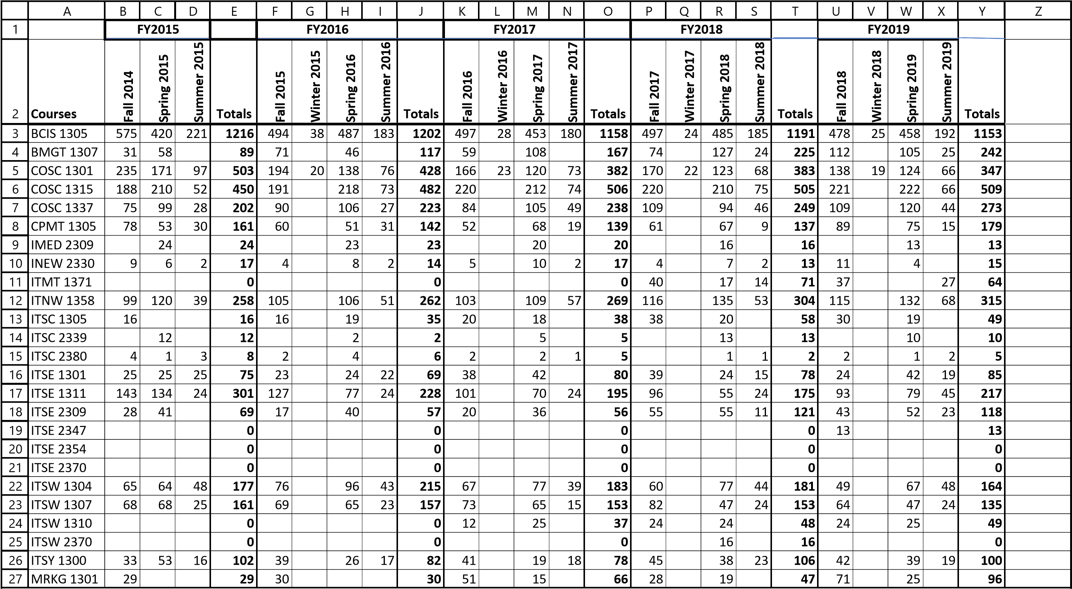
Note: This program course list above is based on the 2018-2019 catalog.

The first curriculum update came in FY 2017 based on our Advisory Committee recommendations to improve soft skills. We implemented a course ITSW 1310 Introduction to Presentation Graphics Software and ran it in Fall 2016. It has had a steady growth in enrollment since then.
Due to a change in industry we had another major update in Fall 2018 and this led to a second curriculum update. This update did however result in a major drop in enrollment in IMED 2309 Internet Commerce and ITSE 1311 Beginning Web Programming in FY2018. They are now back on the upswing but are not yet back to 2015 levels.
During this same period courses in our Database Development degree would not make or had very low enrollment. Based on our Advisory Committee recommendations we implemented ITSW 2370 SAS Programming in Spring 2018 and ITSE 2347 Advanced Database Programming in Fall 2018. These courses have had a steady growth since their implementation. Two other courses in this degree ITSE 2370 Descriptive Analytics and ITSE 2354 Advanced Oracle PL/SQL were implemented but were not making. We started teaching them as independent study classes in FY 2019 for students getting ready to graduate and needing the courses.
Other changes came about in Fall 2017 when the course ITMT 1371 Configuring and Supporting Microsoft Windows 10 replaced the course COSC 1315 Introduction to Programming at the request of our Advisory Committee. The request was for a deeper knowledge of Windows instead of a programming course for entry level Help Desk.
The courses ITSC 2339 Personal Computer Help Desk Support and ITSC 2380 Cooperative Education-Computer and Information Sciences, General are both capstone courses and have enrollment limitations because they can’t be taken until the student is within 2 or 3 courses of graduation. The ITSC 2339 has a low enrollment also because it is a very specialized course with two prerequisites. It. It is taught as an independent study most semesters since there is usually not enough students to make the class. The ITSC 2380 is a Coop class which means it is an internship with a participating partner in industry. If an industry partner can’t be found the student has to substitute another capstone course for it.

Identifying our students early in their academic path is an issue we have needed to address. Having the data available early in the program through a generated report from the college-wide system already in use would allow us to target and support our students in completing the program. This would help our enrollment and help us to track our students as they go through the program. The Career Coaches that have been hired during this program review time frame have helped this a great deal. Another item that would help our students progress through the program would be tutors. We have a few at the Plano Campus but we need tutors at all campuses.
An effective orientation program might help retain students in the program as they learn how to complete it and why they should do so. Most students take BCIS 1305 (Business and Computer Applications) during their first semester in the program. For this reason, the instructor could provide an orientation to the program during this course. The orientation could explain the required and elective courses, their recommended order, and other important topics about the program. The orientation could do more than just provide facts; it could help to create a sense of purpose amongst the students and faculty. Students would not just be taking a class but would be part of a vibrant program. This sense of belonging could help motivate students to be completers.
4. Why we do the things we do: Program relationship to market demand
Make a case with evidence to show that employers need and hire the program’s graduates.
Some resources to utilize for information could be: Texas Workforce Commission, JobsEQ, O-Net, TexasLMI
Suggested/possible points to consider:
  - How many program-related, entry-level jobs are available in the DFW Metroplex for people with an associate’s degree or certificate? If the majority of related jobs in the DFW Metroplex require a baccalaureate degree, provide evidence that you have a current signed articulation agreement with one or more transfer institutions or that you plan to develop one.
  - What proportion of the program’s graduates found related employment within six months of graduation?
  - How do salaries of program completers compare to those for high school graduates and baccalaureate holders?
- What changes are anticipated in market demand in the next 5 years? Do program completers meet, exceed, or fall short of local employment demand? How will the program address under- or over-supply?
- Identify and discuss the program’s strengths and weaknesses related to market demand.

The Computer Systems program has three AAS degrees and three certificates. The AAS degrees are in the fields Computer Support, Information Systems, and Database Development. The certificates are in the same areas.

Local job demand in the Information Technology Careers (encompassing areas in Computer Systems) is stated in a 2017-2022 Interlink High Skill/High Demand Occupations report identified by North Central Texas Regional Employers. http://www.interlink-ntx.org/pdfs/targetedlist.pdf Sources of this document are: Occupation Information: BLS/TWC/ERIS~Education:*NET~Wage Information: 2016 LMCI Texas Wages. Some of the occupations listed are Computer Systems Analysts, Computer User Support Specialists, and Network and Computer Systems Admin. Interlink identifies these occupations as requiring 4 years of education for entry level as well as licenses or certifications. Wages range from $30.00 - $50.00 per hour.

See Occupation Reports for jobs in each area in the Computer Systems program (i.e. Information Systems Managers, User Support Specialists, and Database Administrators) in Appendix 1.
Demand for those seeking employment in Information Technology is growing due to emerging and evolving careers projected to offer future employment opportunities such as those in Business Intelligence Analysts/ Operations Research Analyst, Cloud Computing technology, Convergence technology, and Forensic Science. The management of Information is projected to grow 13% from now until 2024.

Employment of database administrators is projected to grow 9 percent from 2018 to 2028, faster than the average for all occupations. Growth in this occupation will be driven by the increased data needs of companies across the economy. This occupation is identified as requiring 4 years of education for entry level. Wages start at approximately $50.00 per hour.
https://www.bls.gov/ooh/computer-and-information-technology/database-administrators.htm
Database administrators will be needed to organize and present data in a way that makes it easy for analysts and other stakeholders to understand. The employment of database administrators using cloud computing in data processing, hosting, and related services industry is projected to grow 21% from 2018 to 2028. For some of the same reasons employment of DBAs in the computer systems design and related services industry is projected to grow 24 percent from 2018 to 2028.
https://www.bls.gov/ooh/computer-and-information-technology/database-administrators.htm#tab-6
Since most of the programs in Computer Systems require 4 years of education a majority of students must transfer to other institutions of higher learning. Collin College has accommodated these students with transfer agreements to other colleges/universities. They are Austin College, Baylor University, Dallas Baptist University, Southern Methodist University, Texas A&M-Commerce, Texas Tech University, Texas Women’s University, Texas Wesleyan University, University of Texas at Dallas, and University of North Texas.
https://www.collin.edu/transferu/Pre-admnProg.html
In the Dallas/Fort Worth Metroplex there are two other schools that offer programs similar to those offered at Collin College. Tarrant County College offers programs in Information Technology that include Computer Support Specialists and Database Administrators.
https://www.tccd.edu/academics/courses-and-programs/programs-a-z/credit/information-technology/
https://www.tccd.edu/academics/courses-and-programs/programs-a-z/credit/computer-support-specialist/
Also, El Centro, a part of Dallas County Community College, offers programs in Computer Support and Database Administrators.
https://www.elcentrocollege.edu/test/pop/cit/pages/degrees.aspx
Certain aspects of the Computer Systems program make it hard to evaluate the career success of its students. First, many Computer Systems students continue their education at four-year schools and thus elect not to work until they graduate. Second, many students already possess a four-year degree and have been in the workforce before attending Collin. Third, many students elect not to earn a Collin credential but only take courses to attain other career goals. Fourth, many students take courses in the Computer Systems program but are attaining a Collin credential in another program. For these reasons, the number of recent graduates who are employed shortly after their completion at Collin does not present a full picture of the success of Collin’s Computer Systems students. It also makes it very hard to track students’ employment after they graduate.
We are planning to create a LinkedIn.com group which will help us keep track of students after they graduate as well as their employers. This is discussed more in question #7 of this review.
The following chart shows the number of students completing a degree/certification in Computer Systems from 2015-2019. The numbers have been gradually increasing but the numbers are low for the number of students enrolled in the Computer Systems program. As stated above, not all students that start the Computer Systems program at Collin will finish a degree at Collin. Nevertheless, the data does have some utility.

Counts of Awards by Academic Year
Award Type | Major Code | 2015 | 2016 | 2017 | 2018 | 2019 | Total
Computer Systems
Degree | CCSD | 3 |  | 2 |  |  | 5
 | CDBA | 1 | 1 | 1 | 1 | 3 | 7
 | CINF | 2 |  | 2 |  |  | 4
 | CJAV |  | 1 | 2 | 1 |  | 4
 | CJVA | 2 |  |  | 1 |  | 3
 | CPSY | 4 | 3 | 2 | 1 | 2 | 12
 | CSYS | 8 | 4 | 2 |  | 1 | 15
 | ITSC | 1 |  |  |  |  | 1
 | CISY |  |  |  | 3 | 7 | 10
 | CSCS |  |  |  | 1 | 1 | 2
Degree Total |  | 21 | 9 | 11 | 8 | 14 | 63
Certificate | CDBA | 2 | 1 | 1 | 1 |  | 5
 | CINF | 3 | 2 | 1 | 2 | 2 | 10
 | CPSY | 3 | 1 | 4 |  |  | 8
 | CSMA | 1 |  |  |  |  | 1
 | CSYS | 1 | 1 |  |  |  | 2
 | SFDS | 1 |  |  | 1 |  | 2
 | SFJV | 3 | 3 | 1 | 2 | 1 | 10
 | SFWD | 4 |  | 2 | 1 | 2 | 9
 | CMSU |  |  |  | 1 | 3 | 4
 | DATA |  |  |  | 1 | 4 | 5
 | ISYS |  |  |  | 2 | 7 | 9
Certificate Total |  | 18 | 8 | 9 | 11 | 19 | 65
OSA | COAA | 15 | 12 | 3 | 10 | 35 | 75
 | DBAA | 12 | 7 | 1 |  |  | 20
 | HDSK |  |  | 1 | 8 | 3 | 12
OSA Total |  | 27 | 19 | 5 | 18 | 38 | 107
Computer Systems Total |  | 66 | 36 | 25 | 37 | 71 | 214
http://inside.collin.edu/iro/program_review_data/FY2020/Files_to_Post/Measure2a_AwardsByProgram_2015-2019.pdf
The program’s strengths and weaknesses both lie in the fact that we must be able to better track our students as they move through the program. We have Career Coaches now as well as Academic Coaching to better help our students through the program. We also need tutors to help our students be successful both in the classroom and online. As our college expands to additional campuses we must be able to offer our classes on multiple campuses and to provide tutors at multiple campuses to better fit into our students’ schedules.

Section II. Are We Doing Things Right?

5. How effective is our curriculum, and how do we know?

A. Make a case with evidence that there are no curricular barriers to completion. Review data related to course enrollments, course retention rates, course success rates, and the frequency with which courses are scheduled to identify barriers to program completion.
Suggested/possible points to consider:
- Number of students who completed the program awards in each of the last 4 years? If the number of graduates does not average 5 or more per year, describe your plan to increase completions and address this issue in the Continuous Improvement Plan (CIP).
- At what point(s) are substantive percentages of students dropping out of the program? Use data in the “Program-Based Course Performance” tool to examine enrollment flow through the program curriculum. Does the data suggest any curricular barriers to completion? Address problems in the CIP.
- Review course enrollment patterns, course retention rates, course success rates, and the frequency with which courses are scheduled to identify barriers to program completion. Address problems in the CIP.

Since the Academic Year 2014-2015, the Computer Systems program has offered 25 courses (excluding core courses). Out of these courses eight (32%) of them have a low success rate average (less than 60% over the period from FY 2015 – FY 2019). The table below lists these courses.

Course Rubric | Course Name | Success Rate Average  FY 2015-FY 2019
COSC 1315 | Fundamentals of Programming | 69%
*COSC 1337 | Programming Fundamentals II (Java) | 62%
ITSE 1301 | Web Design Tools - Graphics | 66%
ITSE 1311 | Beginning Web Programming | 60%
ITSE 2309 | Database Progrmming - SQL | 65%
ITSW 1304 | Introduction to Spreadsheets (Excel) | 68%
ITSW 1307 | Introduction to Databases (Access) | 62%
MRKG 1301 | Customer Relationship Management | 68%
*This course is now COSC 1437 (a 4-hour course)

See Course Completion and Success Rates by Term charts for each course in the Computer Systems program that has low rates in Appendix 2.

In looking at the above courses’ success rates by term the data reflects the ‘low success’ rates to be in line with various events that happened throughout the years. In Fall 2015 there was a major reorganization at the school eliminating Department Chairs and establishing Discipline Leads. We also lost our Dean due to retirement and it took an amount of time to replace him. There were also major changes in the curriculum established in Fall 2018 due to Advisory Committee recommendations because of changes in industry. At that time our Database Development degree was mostly revamped to reflect the analytical and business intelligence requirements brought up by the board. At this time we added four new courses and hired an associate faculty to help teach them.

Most of the ‘low success rate’ courses are introductory courses. Students tend to enroll in these courses without knowing if they want to pursue the Computer Systems program These students take one or two courses and then drop out of the program or change their major. When this happens the students’ motivation to successfully complete the course declines. Although the success rates went down they have all started to come back up in FY 2019.

Traditionally, many of the COSC programming courses have been taught in a lecture classroom due to not enough lab space. The instructor would need to schedule time in an open computer lab or a lab classroom to take students during class time to work on hands-on activities, projects, etc. This caused a problem because there have not been enough labs for all instructors to do so. To remedy this issue, as many classes as possible are being scheduled and taught in a computer lab. With insufficient lab space we are trying to schedule classes at different times and different campuses to make better use of available computer labs.

Most of our students work and go to school part time. Therefore, we have many nontraditional students with nontraditional schedules. This requires classes to be scheduled at various times as well as online. There are, however, additional challenges for students in online courses especially courses that require hands-on activities and projects with real-world scenarios, as ours do. All courses identified above have online sections. We can’t do away with these online sections, but we can continue to use the technology we have available to make the virtual section of each course as close to its face-to-face equivalent course as possible.
This requires videos, interactive activities among students and between student and instructor, discussion groups available to all, and providing a sense of community to all students in the course. We are upgrading our online courses with regards to online initiatives at Collin such as OAB requirements and the Virtual College.

Many of the technical skills identified by industry are taught at community colleges but are only offered at the junior and senior level at four-year institutions. Also, skills taught at the community college level tend to be more hands-on. Identifying these courses as listed above and intervening with at risk students in these courses may alleviate their low success rates. One way to do this would be for faculty to develop an intervention strategy which would look at learning objectives instead of just courses. We also need to examine the prerequisites for these courses to help ensure student success. We also need to provide more tutoring attention both on campus and online.

B. Show evidence that the institutional standards listed below have been met. For any standard not met, describe the plan for bringing the program into compliance.

- Completers Standard: Average 25 completers over the last five years or an average of at least five completers per year.
Number of completers: ____235____ in last five years.
If below the state standard, attach a plan for raising the number of completers by addressing barriers to completion and/or by increasing the number of students enrolled in the program. Definition of completer—Student has met the requirements for a degree or certificate (Level I or II)
- Licensure Standard: 90% of test takers pass licensure exams.
If applicable, include the licensure pass rate: _Not applicable________
For any pass rate below 90%, describe a plan for raising the pass rate.

- Retention Standard: 78% of students enrolled in program courses on the census date should still be enrolled on the last class day (grades of A through F).
Include the retention rate: ______92%__________
If the retention rate is below 78%, describe a plan for raising the course completion rate.
Took average of retention rate of each course in Computer Systems from FY 2015 – FY 2019 to get overall retention rate.
C. Make a case with evidence that the program curriculum is current.
Suggested/possible points to consider:
- How does the program curriculum compare to curricula at other schools? Review programs at two or more comparable colleges. Discuss what was learned and what new ideas for improvement were gained.
- How does the program curriculum align with any professional association standards or guidelines that may exist?
- Is the curriculum subject to external accreditation? If so, list the accrediting body and the most recent accreditation for your program.
- If the program curriculum differs significantly from these benchmarks, explain how the Collin College curriculum benefits students and other college constituents.

This program review will now compare Collin’s Computer Systems Program to similar programs at El Centro (part of Dallas County Community College District) and Tarrant County College. The Computer Support AAS program in Collin and El Centro is very similar. Tarrant County College also has a Level 1 Certificate in Computer Support as compared to a Level 2 Certificate in Computer Support at Collin. See tables below.

Collin College-AAS Computer Systems in Computer Support (60 hours) | El Centro College-Personal Computer Support AAS (60 hours)
First Year First Semester
BCIS 1305 Business Computer Applications (3) | BCIS 1405 Business Computer Applications (4)
ECON 1301 Introduction to Economics (3)
ENGL 1301 Composition I (3) | ENGL 1301 Composition I (3)
ITSC 1305 Introduction to PC Operating Systems (3) | (First Year Second Semester)
GEN ED Mathematics course (3) | GEN ED Mathematics course (3)
First Year Second Semester
CPMT 1305 IT Essentials I: PC Hardware and Software (3) | ITSC 1405 Introduction to PC Operating Systems (4)
ITSE 1311 Beginning Web Programming (3)
ITSW 1304 Introduction to Spreadsheets – Excel (3) | ITSW 1404 Introduction to Spreadsheets (4)
GEN ED Humanities/Fine Arts course (3) | GEN ED Humanities/Fine Arts (3)
GEN ED Speech course (3) | ELECTIVE Speech (3)
Second Year First Semester
ENGL 2311 Technical and Business Writing (3)
ITNW 1358 Network + (3) | ITNW 1458 Network + (4)
ITSW 1307 Introduction to Database – Access (3) | ITSW 1407 Introduction to Databases (4)
ITSW 1310 Introduction to Presentation Graphics (3) | *ITSW 1401 Introduction to Word Processing (4)
MRKG 1301 Customer Relationship Management (3)
Second Year Second Semester
ITMT 1371 Configuring and Supporting Microsoft Windows 10 (3)
ITSC 2339 Personal Computer Help Desk Support (3) | ITSC 2439 Personal Computer Help Desk Support (4)
ITSC 2380 Cooperative Education – Computer & Info Systems (3) | *ELECTIVE Any Technical Course (4)
ITSE 1301 Web Design Tools – Graphics (3) | IMED 1416 Web Design I (4)
ITST 1300 Fundamentals of Information Security (3) | ITSY 1400 Fundamentals of Information Security (4)
BUSINESS ELECTIVE (3) | ELECTIVE *SOCIAL/BEHAVIORAL SCIENCE (3)
TECHNICAL ELECTIVE (3) | TECHNICAL ELECTIVE (4)
 | TECHNICAL ELECTIVE (1)
NOTE: Courses for El Centro with an * are different from the course required at Collin College

The main differences in Collin’s AAS Computer Support Program and El Centro’s AAS Computer Support Program are the following:
- El Centro’s courses are mostly all 4-hour courses
- Most electives are different
- Collin has more technical courses required
- El Centro does not have a Cooperative Education (internship) course option

Collin College-Certificate Level 1 in Computer Support (30 hours) | Tarrant College-Certificate Level 2 in Computer Support (18 hours)
Summer Semester
ITSE 1311 Beginning Web Programming (3)
ITSW 1304 Introduction to Spreadsheets - Excel (3)
First Semester
CPMT 1305 IT Essentials I: PC Hardware and Software (3)
ITNW 1358 Network + (3) | ITNW 1408 Implementing/Supporting Client Operating Systems (4)
ITSC 1305 Introduction to PC Operating Systems (3) | ITSC 1305 Introduction to PC Operating Systems (3)
ITSW 1310 Introduction to Presentation Graphics Software (3)
Second Semester
ITSC 2339 Personal Computer Help Desk Support (3) | ITSC 2439 Personal Computer Help Desk Support (4)
ITSC 2380 Cooperative Educ – Computer and Info Systems (3)
ITSY 1300 Fundamentals of Information Security (3)
MRKG 1301 Customer Relationship Management (3)
 | ITSC 1425 Personal Computer Hardware (4)
 | ITSC 2346 Computer Center Management (3)

The main differences in Collin College’s Computer Support Level 1 Certificate and Tarrant College’s Level 2 Certificate are the following:
- Tarrant College’s courses are more than 50% 4-hour courses
- Tarrant College does not have a Cooperative Education (internship) course option

There are many Information System programs at four-year institutions in the DFW/Fort Worth area, however, I did not find any comparable to Collin College at a community college. Also, I did not find a program in Database Development in any other community colleges in the area. There were programs in Information Technology and Data Science but they were not comparable to our programs.

D. Present evidence from advisory committee minutes, attendance, and composition that the advisory committee includes employers who are actively engaged on the committee and who are representative of area employers.
1. How many employers does your advisory committee have? _________14__________
2. How many employers attended the last two meetings? ____7 in the Spring 2019; 5 in the Fall 2019___
3. How has the advisory committee impacted the program over the last five years (including latest trends, and insights into latest technologies)?
4. Briefly summarize the curriculum recommendations made by the advisory committee over the last five years.

In Fall 2014 and Spring 2015 discussions for Business Analytics started due to the rising demand to manage semi-structured data in nonrelational databases. A short fix for this was to develop a Special Topics class at the time which would address Business Intelligence/Business Analytics. The programming language of choice for Computer Systems majors in database development was SQL. Discussions on Cybersecurity and Cloud Computing concepts were also being held. Actions recommended by the Advisory Committee and taken in order to revamp the Computer Systems curriculum included the following: dropping the Java and C++ tracks to make the tracks more focused and get more students graduating; also, adding a Descriptive Analytics course and an Advanced Database Programming course to the Database track in Fall 2017.

In Spring 2016 discussions on the database track continued with a recommendation for an SAS Programming course. This course as well as a course in Advanced Oracle was added to the database track in Spring 2017. During this time frame recommendations by the Advisory Committee also included adding a Customer Relationship Management course and a Personal Computer Help Desk Support course to the Computer Support track which was done.

In Spring 2018 discussions on eliminating the Information Systems track started because of its broad nature and lack of specific focus and depth. Recommendations were also made to strengthen the Computer Support track by adding a Windows Operating Systems course. Discussions and recommendations were made to separate the Database Development track from the Computer Systems degree and have it as a degree on its own. These discussions are ongoing.

E. For any required program courses where there is a pattern of low enrollment (fewer than 15 students), explain your plan to grow enrollment and/or revise the curriculum.

The following table identifies the courses that have had low enrollment (fewer than 15 students) from Fall 2014 – Summer 2019 and lists the reasons or plan to raise it.

Term | Enrollment | Reason for Low Enrollment
IMED 2309 Internet Commerce
Spring 2019 | 13 | Due to a major update in Fall 2018 because of a big change in industry. Only offered in the Spring each year. Expected to come back up.
INEW 2330 Comprehensive Software Project Planning & Design
Fall 2014 – Summer 2019 | < 12 each semester | Capstone course for Information Systems. Course is taught as independent study on a per head basis.
ITSC 2339 Personal Computer Help Desk Support
Fall 2014 – Summer 2019 | <14 each semester | Capstone course for Computer Support. Course is taught as independent study on a per head basis.
ITSC 2380 Cooperative Education, Computer & Information Systems, Gen
Fall 2014 – Summer 2019 | <5 each semester | Capstone course with an internship for Computer Systems. Course is taught as independent study on a per head basis.
ITSE 2309 Database Programming - SQL
Summer 2018 | 11 | Due to a major update in Fall 2018 because of a big change in industry. Enrollment came back up in FY 2019.
ITSE 2347 Advanced Database Programming
Fall 2018 | 13 | Due to a major update in Fall 2018 because of a big change in industry we made extensive changes to Database program. This course was added but did not make at first. It finally ran with 13. Expected to come back up in next few semesters.
ITSE 2354 Advanced Oracle PL/SQL
 |  | Due to a major update in Fall 2018 because of a big change in industry we made extensive changes to Database program. This course was added but has not made. It is currently being taught as an independent study on a per head basis to meet the needs of students who need it to graduate. We will keep trying to run it as a class in alternate semesters.
ITSE 2370 Data Analytics
 |  | Due to a major update in Fall 2018 because of a big change in industry we made extensive changes to Database program. This course was added but has not made. It is currently being taught as an independent study on a per head basis to meet the needs of students who need it to graduate. We will keep trying to run it as a class in alternate semesters.
ITSW 1310 Introduction to Presentation Graphics Software
Fall 2016 | 12 | Due to updates in the curriculum in FY 2016 this course was added to the curriculum. This was the first semester it was run. The enrollment has since increased.
ITMT 1371 Configuration & Support MS Windows 10
Summer 2018 | 14 | Due to a major update in Fall 2018 because of a big change in industry. Enrollment came back up in Fall 2018.

F. Make a case with evidence that the program is well-managed.

Suggested/possible points to consider: (Data elements can be found on CougarWeb under Workplace>Institutional Effectiveness>Program Review>Institutional Research Files for Program Review [in the right-hand column].)
- Average class size
- Unduplicated, actual, annual enrollment data
- Grade distributions
- Contact hours taught by full-time and part-time faculty
- Identify all courses that have a success rate below 75%. If any of these are core courses, visit with the discipline lead for the course(s) in question to determine whether or not the content of the course(s) is appropriate to the workforce program outcomes. Using assessment evidence and instructor observations, identify the student learning outcomes that are the greatest challenges for students in courses with low success rates. Explain what instructional and other intervention(s) might improve success rates for each identified course.
- How well are general education requirements integrated with the technical coursework?
- Student satisfaction: What evidence do you have that students are satisfied with the program? What kinds of complaints are made to the associate dean/director by program students?

The Computer Systems program is well managed. Evidence for this includes average class size data and highly qualified professionals to teach the curriculum. Though much of this data already appears in other parts of this Review, below is some of the more important evidence.

The following chart displays average class size.

The courses that have a lower than 15 average class size in FY 2018 and FY 2019 are explained as the following:
BCIS 1305 Business Computer Applications This course had a low enrollment in Winter 2016 but came back up the next semester and stayed up. Sometimes the enrollment in our courses run low in the Wintermester due to students not wanting to take courses in a shorter term.
CPMT 1305 IT Essentials I: PC Hardware Software This course’s class average has grown steadily from FY2015 – FY2019. This course is part of the Computer Systems program in the Computer Support track. There were recommended changes to the curriculum made by the Advisory Committee due to a change in industry during FY2018 which could have affected the enrollment and as a result the class average size at this time. However. it steadily increased in FY2019.
IMED 2309 Internet Commerce This course was at 16 in Spring 2018 and then went down to 13 in Spring 2019. This course is only offered online and therefore many students who take it are already working. The enrollment for this course could have been affected due to a big change in industry in Fall 2018.
INEW 2330 Comprehensive Software Project: Planning and Design This course is a capstone course only available to students within 2-3 courses away from graduation. This course is taught on a per head basis as an independent study class since there are usually only a few students each semester that need the class to graduate.
ITMT 1371 Configuration and Support MS Windows 10 This course’s enrollment went down in Summer 2018 but came back up and stayed up in the remaining semesters in this Review. Our technical courses sometimes run low in the Summer due to students not wanting to take technical courses in a shorter term.
ITSC 2339 Personal Computer Help Desk Support This course is a capstone for the Computer Support track in Computer Systems. Students must be within a few courses of being eligible to graduate. Also, it is a very specialized course with 2 prerequisites that must be met before getting into the course. All these things put limitations on its enrollment.
ITSE 2309 Database Programming - SQL This course’s enrollment went down in Summer 2018 but came back up and stayed up in the remaining semesters in this Review. Our technical courses sometimes run low in the Summer due to students not wanting to take technical courses in a shorter term.
ITSE 2347 Advanced Database Programming This course was added to the Database Development track in Fall 2017; however, it did not make until Fall 2018. Its enrollment is expected to grow as it is offered more.
ITSY 1300 Fundamentals of Information Security This course’s enrollment went down in Spring 2016 but came back up and stayed up in the remaining semesters in this Review. It did have a low enrollment in Summer 2018 but our technical courses sometimes run low in the Summer due to students not wanting to take technical courses in a shorter term.
ITSE 2354 Advanced Oracle PL/SQL This course was added to the Database Development track in Spring 2017; however, it did not make in Spring 2018. The plan is to offer it as an independent study in Spring 2020 for students needing the course to graduate.
ITSE 2370 Descriptive Analytics This course was added to the Database Development track in Fall 2017; however, it did not make in Fall 2018. It was taught as an independent study in Fall 2019 for students needing the course to graduate. The plan is to offer it again in Fall 2020.
ITSW 2370 SAS Programming This course was added to the Database Development track in Spring 2017; it did not make until Spring 2018.

Enrollment, success rates, and completion rates are also appropriate for a rigorous workforce program. The eight courses that have had lower success rates have made improvements in more recent semesters or had an acceptable reason for the lower rates (see explanations on p. 13). See data in table below.

Course Rubric | Course Name | Enrollment  FY 2015-FY 2019 | Completion Rate Average  FY 2015-FY 2019 | Success Rate Average  FY 2015-FY 2019
COSC 1315 | Fundamentals of Programming | 2452 | 91% | 69%
*COSC 1337 | Programming Fundamentals II (Java) | 1185 | 86% | 62%
ITSE 1301 | Web Design Tools - Graphics | 397 | 89% | 66%
ITSE 1311 | Beginning Web Programming | 1116 | 87% | 60%
ITSE 2309 | Database Progrmming - SQL | 420 | 85% | 65%
ITSW 1304 | Introduction to Spreadsheets (Excel) | 920 | 91% | 68%
ITSW 1307 | Introduction to Databases (Access) | 758 | 92% | 62%
MRKG 1301 | Customer Relationship Management | 268 | 94% | 68%
*This course is now COSC 1437 (a 4-hour course)

Collin has an appropriate number of highly skilled and knowledgeable full-time and part-time faculty members who remain current in their specific disciplines. The contact hours for the Computer Systems program taught by these faculty members are in the table below.

Semester | Full Time Faculty Number of Contact Hours | Full Time Faculty Percentage of Contact Hours | Part Time Faculty Number of Contact Hours | Part Time Faculty Percentage of Contact Hours | Total Number of All Faculty Contact Hours
Fall 2015 | 79,584 | 71% | 32,304 | 29% | 111,888
Fall 2016 | 80,640 | 71% | 32,944 | 29% | 113,584
Fall 2017 | 76,592 | 65% | 41,920 | 35% | 118,512
Fall 2018 | 73,968 | 67% | 36,592 | 33% | 110,560
Fall 2019 | 79,760 | 66% | 41,504 | 34% | 121,264

6. How effectively do we communicate, and how do we know?

A. Make a case with evidence that the program literature and electronic sites are current, provide an accurate representation of the program, and support the program’s recruitment plan, retention plan and completion plan.
Suggested/possible points to consider:
- Demonstrate how the unit solicits student feedback regarding its website and literature and how it incorporates that feedback to make improvements.
- Designate who is responsible for monitoring and maintaining the unit’s website, and describe processes in place to ensure that information is current, accurate, relevant, and available.

The Computer Systems program has a communications strategy for prospective students, current students, and former students. The program has a website oriented to prospective students as well as a catalog page hosted on Collin’s website. The website is still under construction but is up and running. The program is also planning an e-Portfolio site for current students, and a LinkedIn.com group for current and former students.

The program’s full-time instructors all contribute to the program’s website. The proposed e-portfolio site will be a Canvas-based website for current students. It will be open to all instructors and their students. The proposed LinkedIn.com group will be for current and former students, Advisory Committee members, faculty, and potential employers. It will be a way to try to follow students and their place of employment after they graduate. The Discipline Lead will develop and maintain content for the e-portfolio site and the LinkedIn.com group.

Here is a link to the program’s catalog information:
http://www.collin.edu/academics/programs/CSYS_1Overview.html

Currently the link only has the program degree courses listed as a pdf on the website.

The program’s Discipline Lead and full-time faculty are developing a program flyer
to be completed in the Academic Year 2020-2021. The Associate Dean, the Coordinator of Marketing and Communication, and the Production Coordinator will be participating in its creation and formatting.

The program’s Discipline Lead (with the help of full-time faculty) will maintain the website, the LinkedIn.com group and the e-portfolio sites. The Discipline Lead and full-time faculty members will have access to the website’s content and can make changes and additions whenever appropriate. The plan is for the website to have relatively stable content, as it will be focused for prospective students. The LinkedIn.com group and the e-portfolio sites will have constantly evolving content for current and former students.

There have been discussions for Computer Systems to join forces with Computer Science, Web and Mobile Development, and Engineering and develop a departmental website. A comparison with Dallas County Community College and with UTD shows that they list contact information, internship possibilities, job outlooks, helpful resources, course descriptions, and degree listings which are interactive with the current schedule, the bookstore, and registration.

The Discipline Lead and full-time faculty members will review all literature and electronic sites at least once each semester. They will work together to make sure all information is current, accurate, relevant, and available.

B. In the following Program Literature Review Table, document that the elements of information listed on the website and in brochures (current academic calendars, grading policies, course syllabi, program handouts, program tuition costs and additional fees, description of articulation agreements, availability of courses and awards, and local job demand in related fields) were verified for currency, accuracy, relevance, and are readily available to students and the public.

The website is the only electronic site for Computer Systems that is active (see table below). The other electronic sites (i.e. the LinkedIn.com and the e-portfolio site will be available in the 2020-2021 Academic Year. Also, a program brochure will be produced in the 2020-2021 Academic Year.

Program Literature Review Table
Title | Type (i.e. URLs, brochures, handouts, etc.) | Date of Last Review/Update |  | Responsible Party
Program website | http://www.collin.edu/academics/programs/CSYS_1Overview.html | 1/11/2020 | x Current  x Accurate  x Relevant  x Available | Discipline Lead
Catalog verification | Occurs after any curriculum update for next catalog | Fall 2018 | x Current  x Accurate  x Relevant  x Available | Discipline Lead

7. How well are we leveraging partnership resources and building relationships, and how do we know?

Partnership Resources: On the table below, list any business, industry, government, college, university, community, and/or consultant partnerships, including internal Collin departments, to advance the service unit outcomes.

Partnership Resources Table
Partner | Description (See Points to Consider) | How is it Valuable to the Program
We have transfer agreements with the following colleges/universities:  - Austin College  - Baylor University  - Dallas Baptist University  - Southern Methodist University  - Texas A & M – Commerce  - Texas Tech University  - Texas Women’s University  - Texas Wesleyan University  - University of Texas at Dallas  - University of North Texas | Colleges/Universities | Having transfer agreements with nearby colleges and universities provides a clear path for students and makes their chances of obtaining a bachelor’s degree in Computer Systems much more obtainable.
We have/had agreements with the following local businesses to provide internships to our students in the COOP courses:  - Diversant, LLC  - Osky Blue  - Rejoice The Lord Church  - Tech Leap Systems  - Price Trace, LLC  - Heritage Eye Center  - ZTE USA  - GM Financial  - Allen ISD  - Walmart  - Encore Wire  - Calibur Home Loans  - Raising Canes  - Green Brick Partners | COOP Course Partners | Having agreements with local businesses provides real time, hands-on jobs for students giving them experience in their major area. This makes their chances of getting a job much more obtainable.
We have enlisted businesses and industry partnerships by having them represented on our Advisory Committee. They are the following:  - Sai Bezawada, Client Executive, IBM  - Paul Chouffet, VP of Client Services, Vazata  - Dr. Brent Dingle, Sr Operations Engineer II, Raytheon  - Jason Dziuk, Technical Project Manager, Code Authority, Inc  - Nathan Fish, System Engineer/Data Scientist, DXC Technology  - Thomas Goodwin, Senior Manager, Sogeti USA  - Norris Lauer, Test Engineer, LL Labs  - Robert Manning, Application Developer, GCSC Financial and GR Systems  - Russ McClelland, Architect, Smart Objx  - Andrew McKnight, Founder & President, Pivocity  - Sergio Prieto, CTO, Sr Partner, Mayan Technologies  - Vidya Shankaran, Dir of Business Operations-Digital Engineering, Cognizant  - Aaron Thibault, VP of Strategic Operations, Gear Box Software  - Michael White, Dir of Technology Operations, Allen ISD | Advisory Committee Members | Having this committee helps us to advance our program outcomes and to ensure we are teaching courses that will keep our students employable.

8. What professional developmental opportunities add value to your program? Provide a List of professional development activities employees have participated in since your last program review.

Employee Name | Role in Program | Professional Development Summary | How is it Valuable to Program
Charles Braun | Teaches COSC 1337, COSC 1437, ITSE 2370, COSC 1436, COSC 2436, INEW 2330 | Taking short (4-6 wks) online courses to update and extend knowledge and skills in the areas of Data Science and Business Analytics. Recently completed a 6-wk course on "Time Series Forecasting for Business Analytics".  Participate in the Teradata University Network of educators and practitioners of Data Analytics for sharing and collaborating information  Member Association for Computing Machinery(ACM), and frequently use their Computer Science Education resources for programming classes  Implemented a Lecture-Lab approach for my face-to-face Programming Fundamentals I - C++ (COSC 1436) classes.  Completed development of the subject matter material(Reading assignments, Lecture notes, Exercises, quizzes, & Programming assignments) for the Programming Fundamentals II - C++ (COSC 1437) Online class.  Completed development of the AAS for CIS Database Development.  Completed development of a 30-hr Certificate for Database Development.  Prepared a preliminary proposal for a Course of Studies for a Data Analytics Advanced Technical Certificate Program(45-hrs)  Identified the audience (market) for Analytics programs as currently practicing Data Analysts, Business Analysts, Computer Systems Analysts, Report Developers, IT and Accounting/Financial Professionals as well as career changers who desire to enhance their skills in Data Analytics.  Explored the feasibility of implementing a 4-yr BS degree program in Data Analytics or a 75-hrs(5-semester) AAS degree program, (similar to the Texas State Technical College programs).  Currently developing ITSE 2370, a Descriptive Analytics course.  Currently developing a COSC 2336 Programming Fundamentals III C++ (Data Structures) online course.  Currently exploring the viability of the various degree options for a Data Analytics course of studies. (e.g., 4-yr vs 2-yr,2-yr vs 45hr Advanced Technical Certificate).  Currently researching/investigating use of Graph Databases to organize and process high volume, unstructured, streaming data; with complex and dynamic relationships in highly connected data for analysis. | Has greatly contributed to the implementation of the Database Development track
Robert Benavides | Teaches COSC 1301, COSC 1315, ITSE 1311, ITSC 1305, ITSC 2339, INEW 2330, ITSC 2380 | Winter Working Connections 2019 – The Beauty and Joy of Computing. Express Online course on Snap programming language, Dec 16 – 18, 2019.  ForwaDFW. A day of learning about AI, machine learning, and data transformations. CapitalOne, Plano, Texas. Keynote speaker Dr. Michio Kaku. July 16, 2018.  Winter Working Connections 2017 – Intro to Python Programming. Express Online course on the Python programming language, Dec 11 – 13, 2017.  Professional Development Workshops – Academic Planning Coach sessions on: Connecting for Success, Advising and Coaching, Zoom and Jabber, Feb 10, 15, and 24, 2017.  Canvas: Faculty Transition Workshops. Building, Quizzes, Assignments, Grading, eLC faculty workshops. Collin College. May 15 – June 18, 2016.  The Changing Face of Engagement – Cengage Learning. Strategies for engaging students in computing classes. Presented by Corinne Hoisington. Arlington, Texas. Nov 6, 2015.  Summer Institute for Collin Faculty – Integrating YouTube into your Course. Facilitator Mark Garcia. Collin College CHEC, Jun 19, 2015.  Summer Working Connections 2014 – Linux Essentials. One full week hands-on course on the Linux Operating System, Collin College Frisco Campus, Jul 7 – 11, 2014. | Highly involved in implementing, modifying and teaching the Computer Support track
Ann Cervantez | Teaches BCIS 1305, ITSW 1307, IMED 2309, ITSE 1311, INEW 2330, ITSC 2380 | Attended Texas Community College Technology Forum, Fall 2014  Attended eLC training session “So You Want To Work on Your Faculty Website”, Summer 2014  Attended Kaltura Webinar “Live Streaming for Everyone-Easily Launch Live Broadcasts”, Summer 2014  Attended Faculty Development Conference “Speaker and Workshop: Dr. Scott Barry Kaufman”, Fall 2014  Attended eLC training session “Using the Blackboard Grade Center Correctly”, Fall 2014  Attended 9th Annual Outcomes and Assessment Conference Core Assessment: First Year Out of the Gate, “The State of the State: Assessing the Core Curriculum”, “Competency-Based Programs: Nuts and Bolts of Implementation and Assessment”, “CBEs Are Coming! Are You Ready?”, Alignment and Online Curriculum: Opportunities, Challenges and Front Line Experience”, Fall 2014  Attended Cengage Webinar “Windows 10”, “Invigorate PowerPoint with Office Mix”, “Flipping College Classroom”, Fall 2014  Presented at Faculty Development Conference, “Google Tools for Education”, Spring 2015  Attended 2 In-Service Sessions on Computer Based Education (CBE) initiative, “Fast Track to Level 1 Certificate in Web Development”, Spring 2016  Attended Faculty Development Conference “Team Based Learning: Using Teams to Engage Students in Learning”, Spring 2016  Attended Office of Institutional Effectiveness seminar “Teaching, Learning, and Curriculum Building”, Summer 2015  Completed Massive Open Online Course (MOOC) “Data Lakes for Big Data”, Summer 2015  Attended Faculty Development Conference, “3 Best Practices in Online Education: Google Docs, Group Work, and Deaf Education,” “From Mess to Success: A Case Study for Creating Video Content for Online Classes,” & “Online Synchronous Communication”  Attended Working Connections, “Designing and Teaching a Computer Systems Principles Course at Your School,” Summer 2017  Attended Working Connections, “Preparing to Teach the Internet of Things,” Summer 2018  Attended QEP Professional Development, “From Zero to Hero-How to Support the Failing Student”, Incorporating Transfer Curriculum in the Classroom,” & “Appreciative Advising-Dreaming and Designing Phases,” Summer 2018  Attended Service Learning Camp, Summer 2018 | Discipline Lead. Also teaches computer applications as well as databases and web design
Sue Furnas | Teaches BCIS 1305, ITSW 1304, ITSW 1310, ITSE 1301, INEW 2330, ITSC 2380 | Attended, Collin Faculty Development Conference, Fall 2014, Fall 2015, Spring 2018  Attended, 10th Annual Texas Community College Technology Forum, Fall 2014  Attended, Webinar – Why your Program is Losing Students and How to Fix It  Attended, 20th Annual Cengage Computing Conference – Phoenix Az  Attended, Webinar – “Hybrid Teaching Techniques” and “The Importance of Defining Learning Objectives”  Attended, Zoom workshop, Fall 2015 – Collin College  Attended, What’s New w/Microsoft Office 2016, Fall 2015 – Cengage Webinar  Attended, The Journey to Digital, Fall 2015 – Collin College  Completed – 2/10/16 eLCs MOOC Series – Beyond the Basics Certification  Attended, Distance Learning Association Conference, Spring  Participated, Faculty Council Summer Institute 2017  Participated, Smart Bar at the Faculty Development Conference 2018  Attended, TCCTA Convention 2018  Reviewed, “Social Presence”, “Teaching Online: The Basics”, and “Evaluating Technology Resources” – Starlink 2018  Attended, From Zero to Hero: How to Support the Failing Student, QEP  Attended, The Connection Practice, QEP  Attended, Faculty Council Summer Institute, Faculty Council Prof Dev | Teaches business applications and spreadsheets.
Scott Johnson | Teaches BCIS 1305 | CCC Collin College – Policies and Acceptance 2016SP  CCCC EEO Laws and Discrimination Prevention for Higher Education 2016SP  CCCC FERPA for Higher Education 2016SP  CCCC Unlawful Harassment Prevention for Higher Education Faculty 2016SP  CCCC Preventing Discrimination and Sexual Violence: title IX, VAWA and Clery Act for Non-Residential Faculty and Staff 2016SP  DCCD XPDL-1000 91054 Mitnick Security Awareness 2019SP  DCCD Hazardous Material Computer Training 2018SP  TCCD Security Awareness Training 2020SP  TCCD Safe Web Browsing 2020SP  TCCD Mobile Device Security 2020SP  TCCD Using the Phish Alert Button – Basic Use 2020SP  TCCD KnowBe4 Security Awareness Training 2020SP  TCCD Not Anymore For Employees 2018SP  TCCD Workplace Answers 2017SP  TCCD Preventing Discrimination and Sexual Violence: title IX, VAWA and Clery Act for Non-Residential Faculty and Staff 2017SP  TCCD Unlawful Harassment Prevention for Higher Education Employees 2017SP  TCCD Preventing Discrimination and Sexual Violence: title IX, VAWA and Clery Act for Non-Residential Faculty and Staff 2016SP  TCCD Unlawful Harassment Prevention for Higher Education Employees 2016SP  UTA GCTA-1920-100 Annual Compliance Training 2020SP [10 parts]  Udemy Complete Python Bootcamp: Go from zero to hero in Python 3 2019SU  UTA GCTA-1920-100 Annual Compliance Training 2019SP [10 parts]
Susan Mahon | Teaches BCIS 1305, COSC 1301, INEW 2330, ITSC 2380 | “What the Best Teachers Do in Class and Online” – STARLINK Training (8/30/14)  “Moving Students from Good to Great – E-Learning Strategies – STARLINK Training (8/31/14)  “Strategies for Teaching to Different Learning Preferences – STARLINK Training (1/21/15)  “Beyond the Basic” MOOC - eCollin Learning Center (1/24/15)  “Course Technology’s The Conference 2015” – Phoenix, AZ (3/18/15 – 3/20/15)  “Course Technology’s The Conference 2016” – Orlando, FL (4/4/16 – 4/6/16)  “Innovation in Teaching Webinar” – Inside Higher Ed Training (5/24/16)  “Canvas Assignments” – eCollin Learning Center (6/1/16)  “Canvas Grading” – eCollin Learning Center (6/1/16)  “Effective Communication for Today’s Learner” – STARLINK Training (Summer 2016)  “Tech Integration Tips and Tricks” – STARLINK Training (Summer 2016)  “The Complete Web Developer Course 2.0 – Udemy (Summer 2016)  Participated in “The Complete Web Developer Course 2.0” offered online by Udemy.  Updated my skills on all application software used in my discipline as it is released every two years.  Researched computer and technology Web sites to share with my students in order to keep them up-to-date regarding trends in computer ethics and using computers in the workplace.  “Communication Strategies: Collaborating, Not Colliding with the Four Generations” – STARLINK Training (6/2/18)  “What the Best College Teachers Do” – STARLINK Training (6/2/18)  “The Engaged Classroom and Creating Its Story” – STARLINK Training (8/2/18)  “Lecture Light Shine: High-Wattage (and Low-Stress) Ideas to Engage Any Student” Webinar – NISOD (7/10/18)  “Teaching Techniques: Beyond Lectures” Webinar – NISOD (6/8/18)
Helen Rhine | Teaches COSC 1301 | Served as a Teaching Fellow on a grant from the National Science Foundation on teaching cybersecurity in community colleges.
Employee Resources Table
**For convenience, if providing a listing of professional development activities, this list may be included in this document as an appendix.

9. Are facilities, equipment, and funding sufficient to support the program? If not, please explain.
[OPTIONAL—Only respond to prompt 9 if you are requesting improved resources for your program. If current facilities and budget are adequate, please proceed to prompt 10.]

Make a case with evidence that current deficiencies or potential deficiencies related to facilities, equipment, maintenance, replacement, plans, or budgets pose important barriers to the service unit or student success. As part of your response, complete the resource tables, below, to support your narrative.
Possible points to consider:
- The useful life of structure, technologies and equipment
- Special structural requirements
- Anticipated technology changes impacting equipment sooner than usual

Equipment/Technology Table
Significant Pieces of Equipment | Description  (i.e. Special Characteristics) | Meets Needs (Y or N):  Current For Next 5 Years |  | Analysis of Equipment Utilization

Financial Resources Table
Source of Funds  (i.e. college budget, grant, etc.) | Meets Needs (Y or N):  Current For Next 5 Years |  | For any no in columns 2 or 3, explain why | For any no in columns 2 or 3, identify expected source of additional funds
Section III. Continuous Improvement Plan (CIP)
10. How have past Continuous improvement plans contributed to success?
Program Review at Collin College takes place for each unit or program every five years. During the last (fifth) year, the program evaluates the data collected during the CIP process.
Please describe how you have used your continuous improvement plan (CIP) to make the following improvements to your program over the past 4 years (your last program review can be found on the Program Review Portal):
  - Student Learning Outcomes
  - Overall improvements to your program
Program full-time faculty members have used the CIP to apply information technology concepts to a variety of business environments through assessing ITSC 2380 (COOP) capstone course as faculty coordinators and through assigned projects in the INEW 2330 capstone course.
Program full-time faculty members have used the CIP to demonstrate professional and effective documentation and communication skills through assessing ITSC 2380 (COOP) capstone course as faculty coordinators and through assigned projects in the INEW 2330 capstone course.

See previous CIP Tables in Appendix 3.
11. How Will we evaluate our success?
NOTE: Please contact the institutional effectiveness office if you need assistance filling out the CIP tables.
As part of the fifth year Program Review, the program should use the observations and data generated by this process along with data from other relevant assessment activities to develop the program’s CIP and an action plan for the next two years. At the conclusion of the first two years, data collected from the first year, plus any other relevant data that was collected in the interim, should be used to build on the accomplishments of those first two years by developing another two-year action plan for the CIP to help the program accomplish the expected outcomes established in its CIP or by implementing one of your other plans.

Based on the information, analysis, and discussion that have been presented up to this point, summarize the strengths and weaknesses of this program. There should be no surprise issues here! This response should be based on information from prior sections of this document. Describe specific actions the faculty intends to take to capitalize on the strengths, mitigate the weaknesses, and improve student success. Provide the rationale for the expected outcomes chosen for the CIP.

Strengths:
- Faculty stay current in their discipline (see Section 8).
- There is a steady overall enrollment growth in the program (see Section 3)
Weaknesses:
- The average success rate in eight of our courses is 65%
- Lack of a well-designed and comprehensive program description in our web site that includes Web and Mobile Development, Computer Systems and Engineering to provide accurate information to prospective and current students (see Section 6A)
- Lack of a sustained method and/or practice to track student progress through the program for timely completion (see Section 3, p. 8)

As a result of the findings, the following steps are developed to address the weaknesses:
Step #1-Improve academic success rates in the Computer Systems courses that have low rates
The following are being considered:
- Faculty working together to see what, if any, intervention is necessary pedagogically or otherwise.
- Examine course prerequisites to make sure they are needed and, if so, that they are being met.
- Examine learning objectives and ensure assignments and assessments are tied to them.
- Ensure each online course is equivalent to its face-to-face counterpart as much as possible (see Section 5A, p. 13)
- Provide tutoring at all campuses at times needed by students
Step #2-Create a departmental website.
The following are being considered:
- Create a departmental website for Computer Systems (which includes Information Systems, Computer Support, and Database Development) and partner with Web and Mobile Development, Engineering, and Computer Science.
- Model the departmental website off of surrounding area schools’ website.
- Complete a comprehensive survey to get feedback on what information to include on the website
Step #3-Increase successful completion rates in Computer Systems program.
The following are being considered:
- Implement a sustained method and/or practice to track student progress through the program for timely completion (see Section 3, p. 8)
- Schedule classes at additional campuses and at additional times in order to work with students’ schedules

12. Complete the Continuous Improvement Plan (CIP) tables that follow.
Within the context of the information gleaned in this review process and any other relevant data, identify program priorities for the next two years, including at least one student learning outcome (or program competency), and focus on these priorities to formulate your CIP. You may also add short-term administrative, technological, assessment, resource or professional development outcomes as needed.

Table 1. CIP Outcomes, Measures & Targets Table (focus on at least one for the next two years)
A. Expected Outcome(s)  Results expected in this program  (e.g. Students will learn how to compare/contrast theories; Increase student retention in PSYC 2301) | B. Measure(s)  Instrument(s)/process(es) used to measure results  (e.g. surveys, end of term class results, test results, etc.) | C. Target(s)  Level of success expected  (e.g. 80% success rate, 25 graduates, etc.)
Improve academic success rates in COSC 1315, COSC 1337, ITSE 1301, ITSE 1311, ITSE 2309, ITSW 1304, ITSW 1307, MRKG 1301. | Semester success rates for COSC 1315, COSC 1337, ITSE 1301, ITSE 1311, ITSE 2309, ITSW 1304, ITSW 1307, MRKG 1301 according to the Institutional Research’s annually provided Program Review data. | Increase success rates to average at least 70%
Create a departmental website to include Computer Systems (which includes Information Systems, Computer Support, and Database Development), Web and Mobile Development, Engineering, and Computer Science. | Student survey feedback | Have a departmental website with information designated by the student survey
Increase the number of students completing the Computer Systems program by Implement a sustained method and/or practice to track student progress through the program for timely completion | Semester completion rates for Computer Systems program according to the Institutional Research’s annually provided Program Review data. | Higher number of students completing the Computer Systems program

Continuous Improvement Plan
Outcomes might not change from year to year. For example, if you have not met previous targets, you may wish to retain the same outcomes. You must have at least one student learning outcome. You may also add short-term administrative, technological, assessment, resource or professional development goals, as needed. Choose 1 to 2 outcomes from Table 1 above to focus on over the next two years.

A. Outcome(s) - Results expected in this program (from column A on Table 1 above--e.g. Students will learn how to compare/contrast Conflict and Structural Functional theories; increase student retention in Nursing Program).
B. Measure(s) - Instrument(s)/process(es) used to measure results (e.g. results of essay assignment, test item questions 6 & 7 from final exam, end of term retention rates, etc.).
C. Target(s) - Degree of success expected (e.g. 80% success rate, 25 graduates per year, increase retention by 2% etc.).
D. Action Plan - Implementation of the action plan will begin during the next academic year. Based on analysis, identify actions to be taken to accomplish outcome. What will you do?
E. Results Summary - Summarize the information and data collected in year 1.
F. Findings - Explain how the information and data has impacted the expected outcome and program success.
G. Implementation of Findings – Describe how you have used or will use your findings and analysis of the data to make program improvements.
Table 2. CIP Outcomes 1, 2, & 3
- Expected Outcome #1
Improve academic success rates in COSC 1315, COSC 1337, ITSE 1301, ITSE 1311, ITSE 2309, ITSW 1304, ITSW 1307, MRKG 1301.
- Measure (Outcome #1)  Semester success rates for COSC 1315, COSC 1337, ITSE 1301, ITSE 1311, ITSE 2309, ITSW 1304, ITSW 1307, MRKG 1301 according to the Institutional Research’s annually provided Program Review data. | - Target (Outcome #1)  Increase success rates to average at least 70%
- Action Plan (Outcome #1)
- Faculty working together to see what, if any, intervention is necessary pedagogically or otherwise.
- Examine course prerequisites to make sure they are needed and, if so, that they are being met.
- Examine learning objectives and ensure assignments and assessments are tied to them.
- Ensure each online course is equivalent to its face-to-face counterpart as much as possible (see Section 5A, p. 13)
- Provide tutoring at all campuses at times needed by students

- Results Summary (Outcome #1) TO BE FILLED OUT IN YEAR 2

- Findings (Outcome #1) TO BE FILLED OUT IN YEAR 2

- Implementation of Findings (Outcome #1) TO BE FILLED OUT IN YEAR 2

Table 2. CIP Outcomes 1, 2, & 3 (continued)
- Expected Outcome #2
Create a departmental website to include Computer Systems (which includes Information Systems, Computer Support, and Database Development), Web and Mobile Development, Engineering, and Computer Science.

- Measure (Outcome #2)  Student survey feedback | - Target (Outcome #2)  Have a departmental website with information designated by the student survey
- Action Plan (Outcome #2)
- Create a departmental website for Computer Systems (which includes Information Systems, Computer Support, and Database Development) and partner with Web and Mobile Development, Engineering, and Computer Science.
- Model the departmental website off of surrounding area schools’ website.
- Complete a comprehensive survey to get feedback on what information to include on the website

- Results Summary (Outcome #2) TO BE FILLED OUT IN YEAR 2

- Findings (Outcome #2) TO BE FILLED OUT IN YEAR 2

- Implementation of Findings (Outcome #2) TO BE FILLED OUT IN YEAR 2

Table 2. CIP Outcomes 1, 2, & 3 (continued)
- Expected Outcome #2
Increase the number of students completing the Computer Systems program by Implement a sustained method and/or practice to track student progress through the program for timely completion
- Measure (Outcome #2)  Semester completion rates for Computer Systems program according to the Institutional Research’s annually provided Program Review data. | - Target (Outcome #2)  Higher number of students completing the Computer Systems program
- Action Plan (Outcome #2)
- Implement a sustained method and/or practice to track student progress through the program for timely completion (see Section 3, p. 8)
- Schedule classes at additional campuses and at additional times in order to work with students’ schedules

- Results Summary (Outcome #2) TO BE FILLED OUT IN YEAR 2

- Findings (Outcome #2) TO BE FILLED OUT IN YEAR 2

- Implementation of Findings (Outcome #2) TO BE FILLED OUT IN YEAR 2

What happens next? The Program Review Report Pathway

- Following approval by the Steering Committee,
- Program Review Reports will be evaluated by the Leadership Team;
- Reports will be posted on the intranet prior to fall semester;
- At any point prior to Intranet posting, reports may be sent back for additional development by the department.

- Program responses to the Program Review Steering Committee recommendations received by August 1st will be posted with the Program Review Report.
- Leadership Team members will work with program supervisors to incorporate Program Review findings into planning and activity changes during the next five years.

Appendix 1 - Occupation Reports for Computer Systems

Source: JobsEQ®, http://www.chmuraecon.com/jobseq
Copyright © 2020 Chmura Economics & Analytics, All Rights Reserved

Occupation Report for
Computer and Information Systems Managers
Dallas-Plano-Irving, TX Metro Division
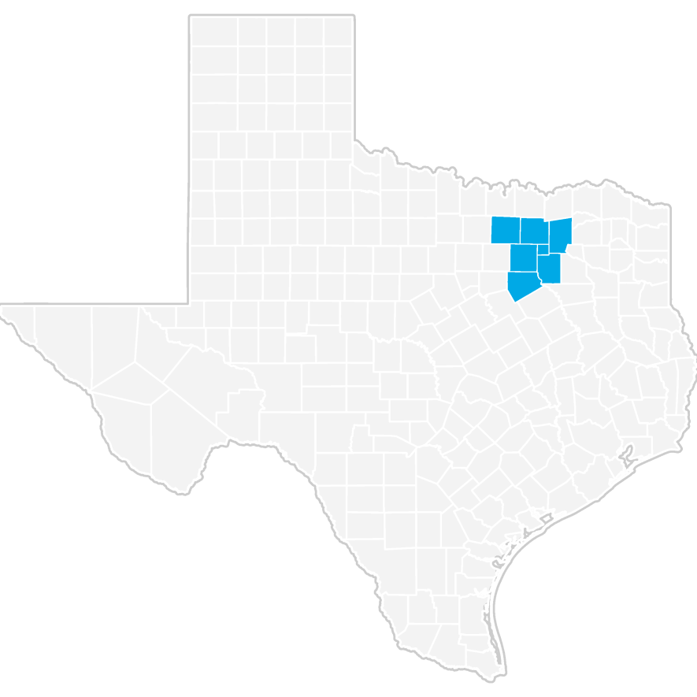

Definition of Computer and Information Systems Managers, SOC 11-3021
Plan, direct, or coordinate activities in such fields as electronic data processing, information systems, systems analysis, and computer programming. Excludes “Computer Occupations" (15-1111 through 15-1199).

Occupation Snapshot
As of 2019Q3, total employment for Computer and Information Systems Managers in the Dallas-Plano-Irving, TX Metro Div was 7,660. Over the past three years, this occupation added 1,041 jobs in the region and is expected to increase by 1,347 jobs over the next seven years, or at an annual average rate of 2.3%.

Computer and Information Systems Managers in Dallas-Plano-Irving, TX Metro Div, 2019q3¹
 |  | Current |  |  | 3-Year History |  |  |  | 7-Year Forecast
Empl | Avg Ann  Wages² | LQ Unempl | Unempl Rate | Online Job  Ads³ | Empl Change | Ann % | Total Demand | Exits | Transfers |  | Empl Growth | Ann % Growth
7,660 | $161,500 | 1.08 142 | 1.8% | 668 | 1,041 5.0% |  | 5,712 | 1,076 | 3,289 |  | 1,347 | 2.3%
Source: JobsEQ®
Data as of 2019Q3 unless noted otherwise
Note: Figures may not sum due to rounding.
- Data based on a four-quarter moving average unless noted otherwise.
- Wage data are as of 2018 and represent the average for all Covered Employment
- Data represent found online ads active within the last thirty days in the selected region; data represents a sampling rather than the complete universe of postings. Ads lacking zip code information but designating a place (city, town, etc.) may be assigned to the zip code with greatest employment in that place for queries in this analytic. Due to alternative county-assignment algorithms, ad counts in this analytic may not match that shown in RTI (nor in the popup window ad list).

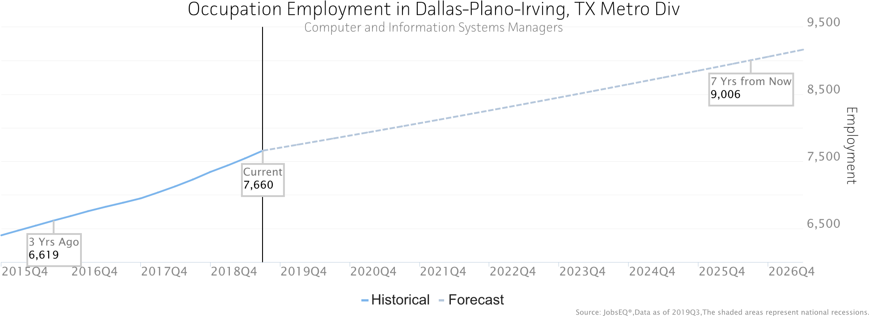
Occupation employment data are estimated via industry employment data and the industry/occupation mix. Industry employment data are derived from the Quarterly Census of Employment and Wages, provided by the Bureau of Labor Statistics and currently updated through 2019Q1, imputed where necessary with preliminary estimates updated to 2019Q3. Wages by occupation are as of 2018 provided by the BLS and imputed where necessary. Forecast employment growth uses national projections from the Bureau of Labor Statistics adapted for regional growth patterns. Occupation unemployment figures are imputed by Chmura.

Geographic Distribution
The below maps illustrate the ZCTA-level distribution of employed Computer and Information Systems Managers in the Dallas-Plano-Irving, TX Metro Div. Employment is shown by place of work and by residence.
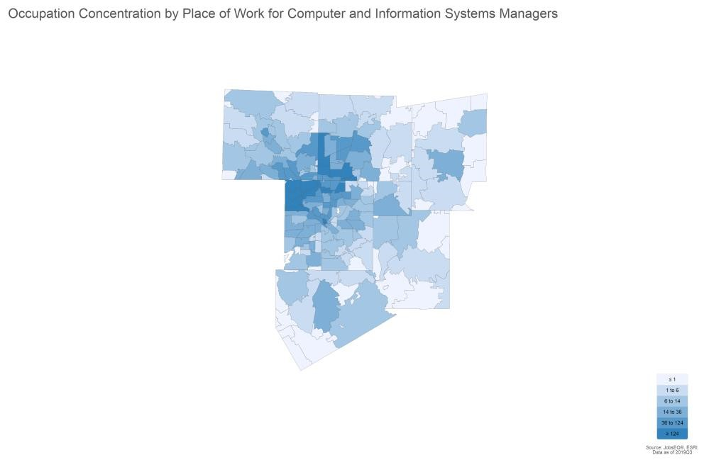

Top ZCTAs by Place of Work for Computer and Information Systems Managers, 2019Q3
Region Employment
ZCTA 75024 (Collin County, TX portion) | 577
ZCTA 75063 | 426
ZCTA 75039 | 335
ZCTA 75038 | 304
ZCTA 75201 | 300
ZCTA 75001 | 270
ZCTA 75240 | 229
ZCTA 75202 | 219
ZCTA 75081 | 213
ZCTA 75093 (Collin County, TX portion) | 204
Source: JobsEQ®
Occupation employment data are estimated via industry employment data and the industry/occupation mix. Industry employment data are derived from the Quarterly Census of Employment and Wages, provided by the Bureau of Labor Statistics and currently updated through 2019Q1, imputed where necessary with preliminary estimates updated to 2019Q3. Occupation by residence data are derived from the same in addition to commuting pattern data.

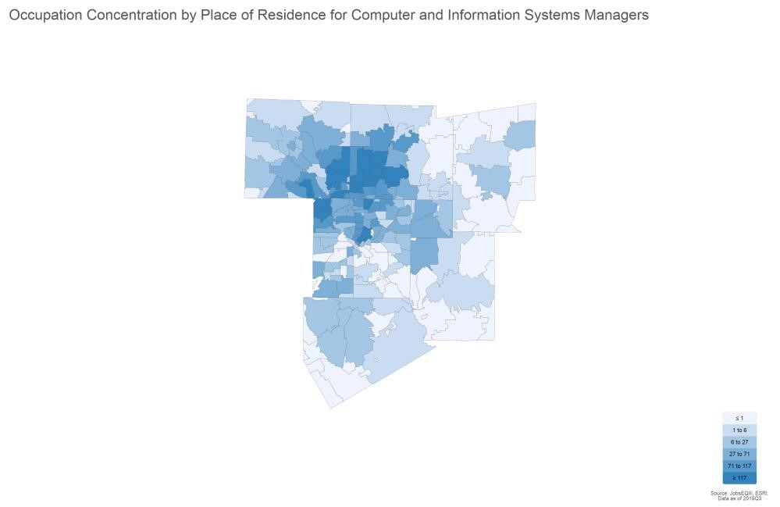

Top ZCTAs by Place of Residence for Computer and Information Systems Managers, 2019Q3
Region Employment
ZCTA 75025 | 228
ZCTA 75070 | 225
ZCTA 75035 | 220
ZCTA 75024 (Collin County, TX portion) | 211
ZCTA 75206 | 198
ZCTA 75093 (Collin County, TX portion) | 191
ZCTA 75034 (Denton County, TX portion) | 188
ZCTA 75002 | 179
ZCTA 75063 | 177
ZCTA 75019 (Dallas County, TX portion) | 164
Source: JobsEQ®
Occupation employment data are estimated via industry employment data and the industry/occupation mix. Industry employment data are derived from the Quarterly Census of Employment and Wages, provided by the Bureau of Labor Statistics and currently updated through 2019Q1, imputed where necessary with preliminary estimates updated to 2019Q3. Occupation by residence data are derived from the same in addition to commuting pattern data.

Employment by Industry
The following table illustrates the industries in the Dallas-Plano-Irving, TX Metro Div which most employ Computer and Information Systems Managers. The single industry most employing this occupation in the region is Computer Systems Design and Related Services, NAICS 5415. This industry employs 2,612 Computer and Information
Systems Managers—employment which is expected to increase by 988 jobs over the next ten years; furthermore, 2,230 additional new workers in this occupation will be needed for this industry due to separation demand, that is, to replace workers in this occupation and industry that retire or move into a different occupation.

Top Industry Distribution for Computer and Information Systems Managers (11-3021) in Dallas-Plano-Irving, TX Metro Div
Current 10-Year Demand
NAICS Code | Industry Title | % of Occ Empl | Empl | Exits | Transfers | Empl Growth | Total  Demand
5415 | Computer Systems Design and Related Services | 34.1% | 2,612 | 550 | 1,680 | 988 | 3,218
5511 | Management of Companies and Enterprises | 8.9% | 678 | 132 | 404 | 127 | 663
5416 | Management, Scientific, and Technical Consulting Services | 4.7% | 363 | 75 | 230 | 122 | 427
5182 | Data Processing, Hosting, and Related Services | 4.3% | 329 | 69 | 211 | 124 | 405
5112 | Software Publishers | 3.3% | 253 | 52 | 159 | 81 | 292
5241 | Insurance Carriers | 3.0% | 228 | 45 | 136 | 44 | 225
5222 | Nondepository Credit Intermediation | 2.2% | 167 | 36 | 111 | 77 | 223
4234 | Professional and Commercial Equipment and Supplies Merchant Wholesalers | 2.2% | 166 | 31 | 94 | 12 | 137
5221 | Depository Credit Intermediation | 2.2% | 166 | 32 | 98 | 27 | 157
5173 | Wired and Wireless Telecommunications Carriers | 2.0% | 156 | 26 | 81 | -18 | 89
5611 | Office Administrative Services | 1.7% | 128 | 27 | 82 | 47 | 155
6113 | Colleges, Universities, and Professional Schools | 1.6% | 119 | 23 | 71 | 23 | 117
3344 | Semiconductor and Other Electronic Component Manufacturing | 1.5% | 116 | 21 | 65 | 3 | 89
5191 | Other Information Services | 1.5% | 111 | 24 | 72 | 45 | 142
3342 | Communications Equipment Manufacturing | 1.3% | 103 | 18 | 54 | -10 | 61
5242 | Agencies, Brokerages, and Other Insurance Related Activities | 1.2% | 90 | 18 | 55 | 22 | 95
5412 | Accounting, Tax Preparation, Bookkeeping, and Payroll Services | 1.1% | 86 | 17 | 51 | 14 | 81
6111 | Elementary and Secondary Schools | 1.0% | 79 | 15 | 46 | 11 | 72
6221 | General Medical and Surgical Hospitals | 1.0% | 75 | 14 | 43 | 10 | 67
5613 | Employment Services | 0.9% | 73 | 14 | 42 | 9 | 65
 | All Others | 20.4% | 1,562 | 300 | 916 | 237 | 1,454
Source: JobsEQ®
Data as of 2019Q3 except wages which are as of 2018. Note that occupation-by-industry wages represent adjusted national data and may not be consistent with regional, all-industry occupation wages shown elsewhere in JobsEQ. Note: Figures may not sum due to rounding.
Occupation employment data are estimated via industry employment data and the industry/occupation mix. Industry employment data are derived from the Quarterly Census of Employment and Wages, provided by the Bureau of Labor Statistics and currently updated through 2019Q1, imputed where necessary with preliminary estimates updated to 2019Q3. Forecast employment growth uses national projections from the Bureau of Labor Statistics adapted for regional growth patterns.

Wages
The average (mean) annual wage for Computer and Information Systems Managers was $161,500 in the DallasPlano-Irving, TX Metro Div as of 2018. For the same year, average entry level wages were approximately $106,900 compared to an average of $188,800 for experienced workers.

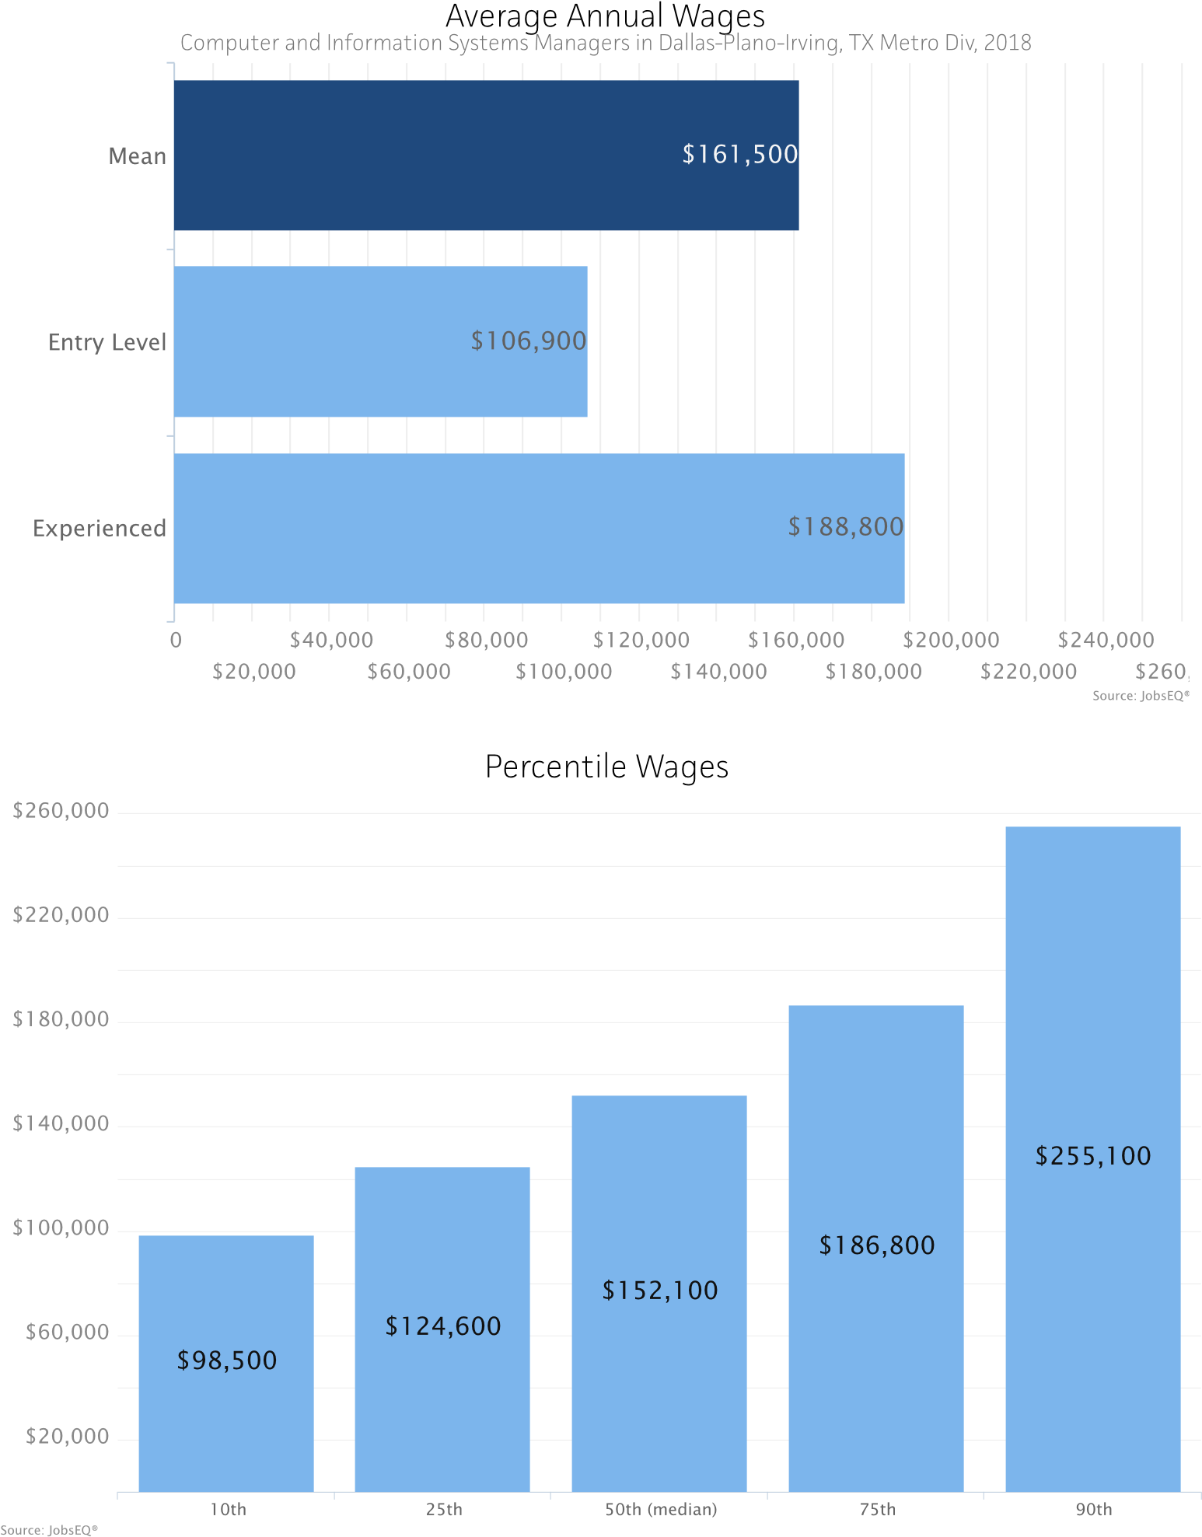
Occupation wages (mean, median, and percentiles) are as of 2018 provided by the BLS, modified and imputed by Chmura where necessary. Entry-level and experienced wages are derived from these source data, computed by Chmura.

Education Profile
Typical education and training requirements for Computer and Information Systems Managers are described below.

Education and Training Requirements
Typical Entry-Level Education: Bachelor's degree
Previous Work Experience: | 5 years or more
Typical On-the-Job Training: | None
Source: JobsEQ®

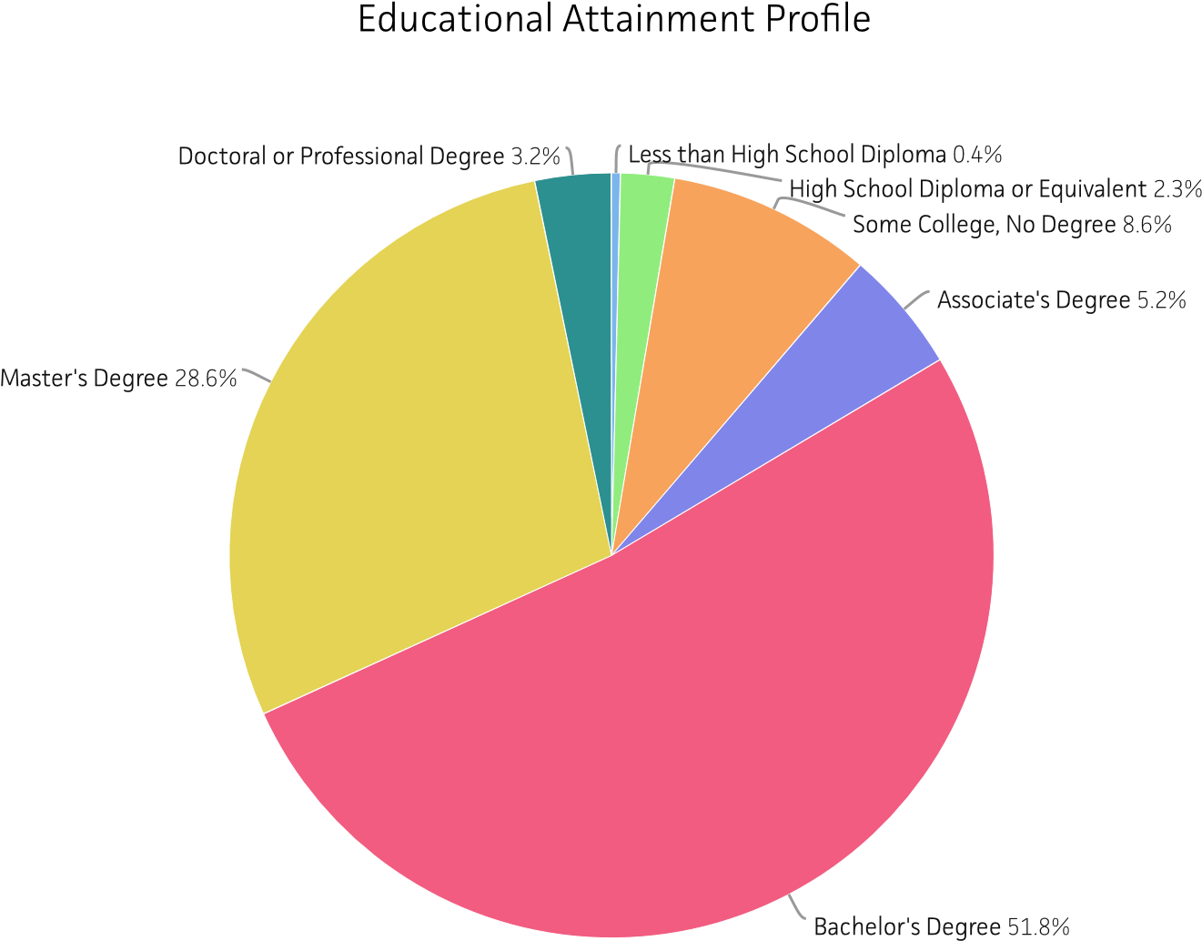

Education and training requirements are from the Bureau of Labor Statistics (BLS); educational attainment mix are regional data modeled by Chmura using Census educational attainment data projected to 2019Q3 along with source data from the BLS.

RTI (Job Postings)

Occupations
Total
SOC Occupation Ads
11-3021.00 2,131
Computer and Information Systems Managers

Source: JobsEQ®
Data reflect online job postings for the 180 day period ending 1/8/2020
Note: Data are subject to revision. Please do not use the volume of data for historical comparisons until such time that an adjusted historical series of these data are provided.

Employers
Employer Name

Total
Ads

JP Morgan Chase

72

KPMG

71

Bank of America

46

Ivy Exec

43

Citi

36

Verizon

35

Pyramid Consulting, Inc

32

Citigroup Inc

28

USAA

28

Goldman Sachs

25

Source: JobsEQ®
Data reflect online job postings for the 180 day period ending 1/8/2020
Note: Data are subject to revision. Please do not use the volume of data for historical comparisons until such time that an adjusted historical series of these data are provided.

Certifications
Certificate Name
Certified Information Systems Security Professional (CISSP)

106
Certified Information Systems Auditor (CISA)

105
Project Management
Professional (PMP)

61

Certified Information Security Manager (CISM)

55

Certified Internal Auditor (CIA)

55

Certified Public Accountant (CPA)

38

Certification in Risk and Information Systems Control (CRISC)

34

Cisco Certified Network
Associate (CCNA)

17

Certified ScrumMaster (CSM)

16

Certified in the Governance of Enterprise IT (CGEIT)

16

Source: JobsEQ®
Data reflect online job postings for the 180 day period ending 1/8/2020
Note: Data are subject to revision. Please do not use the volume of data for historical comparisons until such time that an adjusted historical series of these data are provided.

Hard Skills
Total
Skill Name Ads
Agile

479

Change Management

290

Information Security

266

Information Technology Infrastructure Library (ITIL)

262

Microsoft Excel

241

Scrum

227

Presentation

225

Microsoft Office

216

Oracle

182

Structured Query Language (SQL)

174

Source: JobsEQ®
Data reflect online job postings for the 180 day period ending 1/8/2020
Note: Data are subject to revision. Please do not use the volume of data for historical comparisons until such time that an adjusted historical series of these data are provided.

Soft Skills
Skill Name
Communication (Verbal and written skills) 1,470
Cooperative/Team Player
1,076
Supervision/Management

978

Project Management

791

Analytical

585

Leadership

501

Problem Solving

456

Self
-
Motivated/Ability to Work Independently/Self Leadership

448

Interpersonal Relationships/Maintain Relationships

404

Prioritize

404

Source: JobsEQ®
Data reflect online job postings for the 180 day period ending 1/8/2020
Note: Data are subject to revision. Please do not use the volume of data for historical comparisons until such time that an adjusted historical series of these data are provided.

Job Titles
Total
Job Title Ads
IT Manager

29

Product Manager

24

Incident Manager

12

Manager Senior , Information Technology

11

Technical Delivery Manager

10

Release
Manager

8

Service Delivery Manager

8

Director of Information Technology

7

IT Asset Manager

7

IT Cloud Governance Analyst Lead

7

Source: JobsEQ®
Data reflect online job postings for the 180 day period ending 1/8/2020
Note: Data are subject to revision. Please do not use the volume of data for historical comparisons until such time that an adjusted historical series of these data are provided.

Education Levels
Minimum Education Level
Bachelor's degree 1,316
High school diploma or equivalent
65
Master's degree

51

Associate's degree

20

Doctoral or
professional degree

1

Unspecified/other

678

Source: JobsEQ®
Data reflect online job postings for the 180 day period ending 1/8/2020
Note: Data are subject to revision. Please do not use the volume of data for historical comparisons until such time that an adjusted historical series of these data are provided.

Programs
504
Program Name

Total
Ads

Computer Science

Engineering

174

Business Administration

166

Business

158

Information Technology

144

Information Systems

107

Management Information Systems

105

Finance

65

Accounting

53

Computer Engineering

48

Source
:

®
JobsEQ

Data reflect online job postings for the 180 day period ending 1/8/2020
Note: Data are subject to revision. Please do not use the volume of data for historical comparisons until such time that an adjusted historical series of these data are provided.

Locations
431
Location

Dallas, Texas

Plano, Texas

205
Irving, Texas

196

Dallas, TX 75201

102

Richardson, Texas

82

Dallas, TX 75219

56

Addison, Texas

44

Frisco, Texas

43

Plano, TX 75023

43

Lewisville, Texas

38

Source
:

JobsEQ
®

Data reflect online job postings for the 180 day period ending 1/8/2020
Note: Data are subject to revision. Please do not use the volume of data for historical comparisons until such time that an adjusted historical series of these data are provided.

Region Definition
Dallas-Plano-Irving, TX Metro Div is defined as the following counties:
Collin County, Texas

Hunt County, Texas

Dallas County, Texas

Kaufman County, Texas

Denton County, Texas

Rockwall County, Texas

Ellis County, Texas

Occupation Report for
Computer User Support Specialists
Dallas-Plano-Irving, TX Metro Div

Definition of Computer User Support Specialists, SOC 151151
Provide technical assistance to computer users. Answer questions or resolve computer problems for clients in person, or via telephone or electronically. May provide assistance concerning the use of computer hardware and software, including printing, installation, word processing, electronic mail, and operating systems. Excludes “Network and Computer Systems Administrators” (15-1142).

Occupation Snapshot
As of 2019Q3, total employment for Computer User Support Specialists in the Dallas-Plano-Irving, TX Metro Div was 17,049. Over the past three years, this occupation added 2,446 jobs in the region and is expected to increase by 2,822 jobs over the next seven years, or at an annual average rate of 2.2%.

Computer User Support Specialists in Dallas-Plano-Irving, TX Metro Div, 2019q3¹
 |  | Current |  |  | 3-Year History |  |  |  | 7-Year Forecast
Empl | Avg Ann  Wages² | LQ Unempl | Unempl Rate | Online Job  Ads³ | Empl Change | Ann % | Total Demand | Exits | Transfers |  | Empl Growth | Ann % Growth
17,049 | $52,300 | 1.49 464 | 2.8% | 3,201 | 2,446 5.3% |  | 12,216 | 2,646 | 6,748 |  | 2,822 | 2.2%
Source: JobsEQ®
Data as of 2019Q3 unless noted otherwise
Note: Figures may not sum due to rounding.
- Data based on a four-quarter moving average unless noted otherwise.
- Wage data are as of 2018 and represent the average for all Covered Employment
- Data represent found online ads active within the last thirty days in the selected region; data represents a sampling rather than the complete universe of postings. Ads lacking zip code information but designating a place (city, town, etc.) may be assigned to the zip code with greatest employment in that place for queries in this analytic. Due to alternative county-assignment algorithms, ad counts in this analytic may not match that shown in RTI (nor in the popup window ad list).

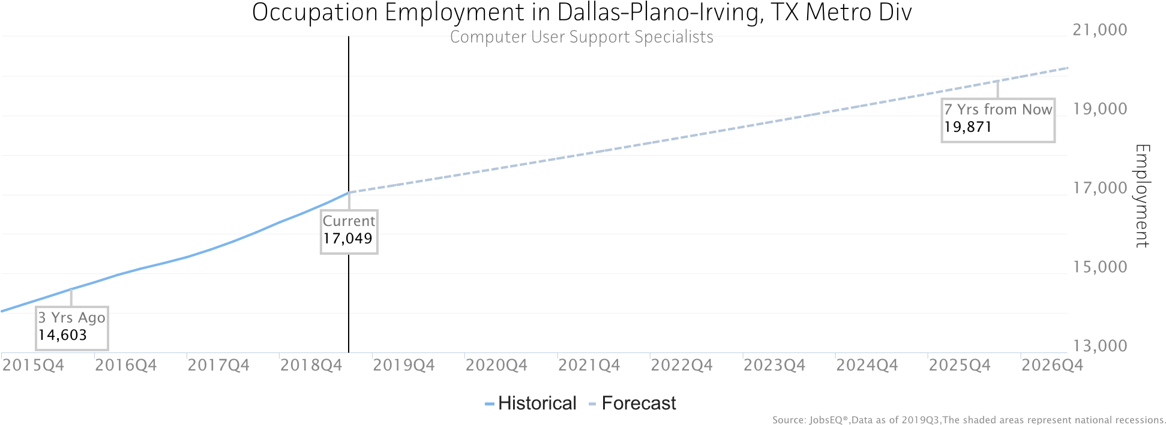
Occupation employment data are estimated via industry employment data and the industry/occupation mix. Industry employment data are derived from the Quarterly Census of Employment and Wages, provided by the Bureau of Labor Statistics and currently updated through 2019Q1, imputed where necessary with preliminary estimates updated to 2019Q3. Wages by occupation are as of 2018 provided by the BLS and imputed where necessary. Forecast employment growth uses national projections from the Bureau of Labor Statistics adapted for regional growth patterns. Occupation unemployment figures are imputed by Chmura.

Geographic Distribution
The below maps illustrate the ZCTA-level distribution of employed Computer User Support Specialists in the DallasPlano-Irving, TX Metro Div. Employment is shown by place of work and by residence.
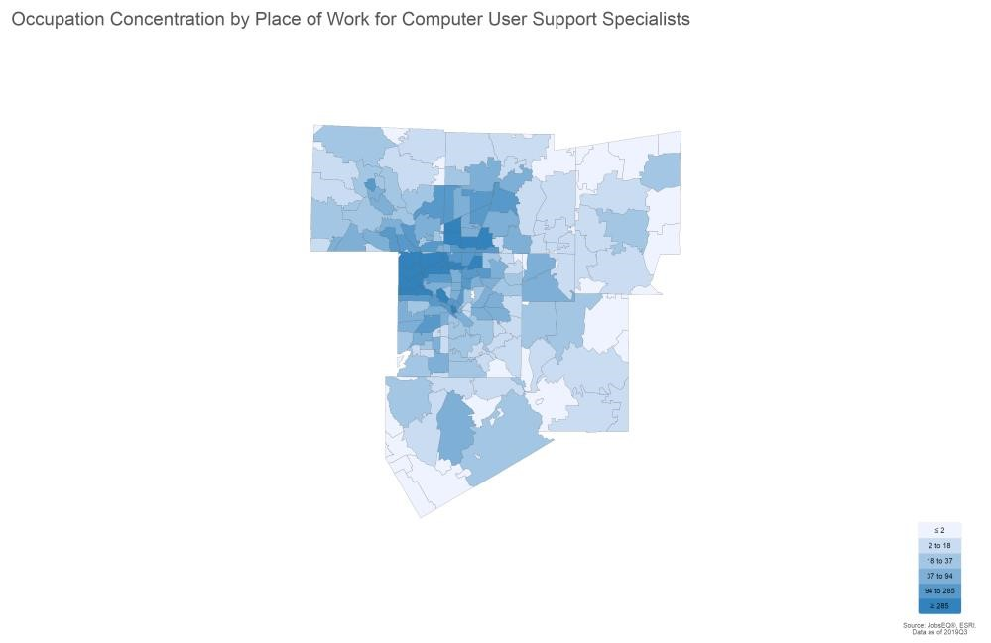

Top ZCTAs by Place of Work for Computer User Support Specialists, 2019Q3
Region Employment
ZCTA 75024 (Collin County, TX portion) | 1,090
ZCTA 75063 | 851
ZCTA 75039 | 654
ZCTA 75038 | 633
ZCTA 75001 | 547
ZCTA 75201 | 543
ZCTA 75202 | 483
ZCTA 75081 | 480
ZCTA 75234 | 477
ZCTA 75240 | 461
Source: JobsEQ®
Occupation employment data are estimated via industry employment data and the industry/occupation mix. Industry employment data are derived from the Quarterly Census of Employment and Wages, provided by the Bureau of Labor Statistics and currently updated through 2019Q1, imputed where necessary with preliminary estimates updated to 2019Q3. Occupation by residence data are derived from the same in addition to commuting pattern data.

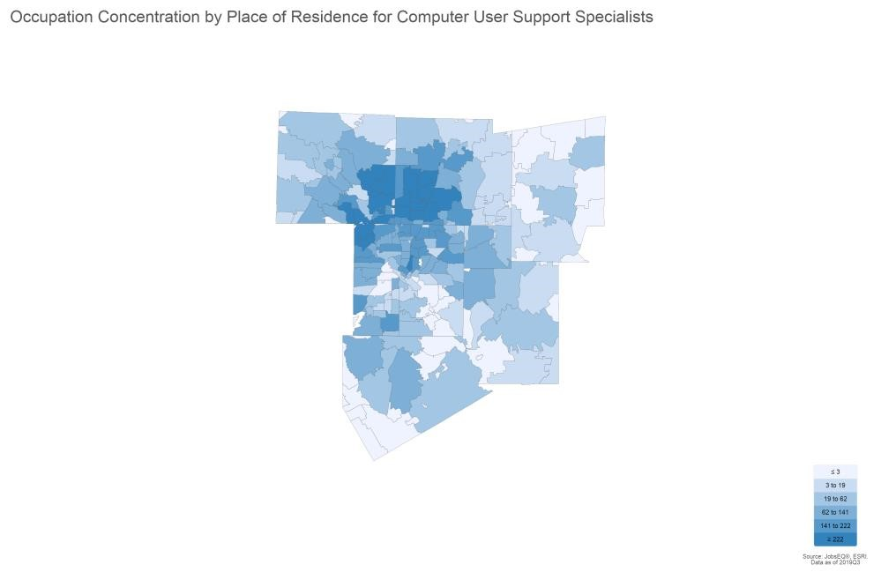

Top ZCTAs by Place of Residence for Computer User Support Specialists, 2019Q3
Region Employment
ZCTA 75070 | 495
ZCTA 75035 | 437
ZCTA 75002 | 398
ZCTA 75034 (Denton County, TX portion) | 374
ZCTA 75025 | 349
ZCTA 75056 | 313
ZCTA 75024 (Collin County, TX portion) | 310
ZCTA 75023 | 299
ZCTA 75093 (Collin County, TX portion) | 294
ZCTA 75007 (Denton County, TX portion) | 274
Source: JobsEQ®
Occupation employment data are estimated via industry employment data and the industry/occupation mix. Industry employment data are derived from the Quarterly Census of Employment and Wages, provided by the Bureau of Labor Statistics and currently updated through 2019Q1, imputed where necessary with preliminary estimates updated to 2019Q3. Occupation by residence data are derived from the same in addition to commuting pattern data.

Employment by Industry
The following table illustrates the industries in the Dallas-Plano-Irving, TX Metro Div which most employ Computer
User Support Specialists. The single industry most employing this occupation in the region is Computer Systems Design and Related Services, NAICS 5415. This industry employs 5,599 Computer User Support Specialists— employment which is expected to increase by 2,115 jobs over the next ten years; furthermore, 4,649 additional new workers in this occupation will be needed for this industry due to separation demand, that is, to replace workers in this occupation and industry that retire or move into a different occupation.

Top Industry Distribution for Computer User Support Specialists (15-1151) in Dallas-Plano-Irving, TX Metro Div
Current 10-Year Demand
NAICS Code | Industry Title | % of Occ Empl | Empl | Exits | Transfers | Empl Growth | Total  Demand
5415 | Computer Systems Design and Related Services | 32.8% | 5,599 | 1,310 | 3,340 | 2,115 | 6,764
4234 | Professional and Commercial Equipment and Supplies Merchant Wholesalers | 5.1% | 872 | 180 | 459 | 66 | 705
5182 | Data Processing, Hosting, and Related Services | 4.7% | 797 | 186 | 475 | 300 | 962
5613 | Employment Services | 4.5% | 767 | 163 | 414 | 101 | 678
5511 | Management of Companies and Enterprises | 4.3% | 740 | 160 | 409 | 138 | 708
6111 | Elementary and Secondary Schools | 4.0% | 689 | 146 | 371 | 88 | 605
5112 | Software Publishers | 3.4% | 582 | 133 | 339 | 186 | 658
5416 | Management, Scientific, and Technical Consulting Services | 3.4% | 573 | 132 | 336 | 192 | 660
5173 | Wired and Wireless Telecommunications Carriers | 2.8% | 483 | 91 | 231 | -56 | 266
6113 | Colleges, Universities, and Professional Schools | 2.3% | 394 | 86 | 218 | 74 | 378
5611 | Office Administrative Services | 1.7% | 290 | 68 | 172 | 106 | 345
5241 | Insurance Carriers | 1.6% | 279 | 60 | 153 | 48 | 261
5221 | Depository Credit Intermediation | 1.4% | 246 | 53 | 135 | 40 | 228
5614 | Business Support Services | 1.3% | 230 | 52 | 132 | 65 | 249
5242 | Agencies, Brokerages, and Other Insurance Related Activities | 1.2% | 204 | 45 | 116 | 51 | 212
3341 | Computer and Peripheral Equipment Manufacturing | 1.2% | 197 | 39 | 99 | -5 | 133
5412 | Accounting, Tax Preparation, Bookkeeping, and Payroll Services | 1.1% | 187 | 40 | 102 | 31 | 173
6221 | General Medical and Surgical Hospitals | 1.0% | 171 | 36 | 92 | 22 | 150
5222 | Nondepository Credit Intermediation | 0.9% | 157 | 36 | 92 | 51 | 178
6112 | Junior Colleges | 0.9% | 150 | 30 | 75 | -3 | 102
 | All Others | 20.2% | 3,442 | 738 | 1,881 | 560 | 3,178
Source: JobsEQ®
Data as of 2019Q3 except wages which are as of 2018. Note that occupation-by-industry wages represent adjusted national data and may not be consistent with regional, all-industry occupation wages shown elsewhere in JobsEQ. Note: Figures may not sum due to rounding.
Occupation employment data are estimated via industry employment data and the industry/occupation mix. Industry employment data are derived from the Quarterly Census of Employment and Wages, provided by the Bureau of Labor Statistics and currently updated through 2019Q1, imputed where necessary with preliminary estimates updated to 2019Q3. Forecast employment growth uses national projections from the Bureau of Labor Statistics adapted for regional growth patterns.

Wages
The average (mean) annual wage for Computer User Support Specialists was $52,300 in the Dallas-Plano-Irving, TX Metro Div as of 2018. For the same year, average entry level wages were approximately $33,600 compared to an average of $61,700 for experienced workers.

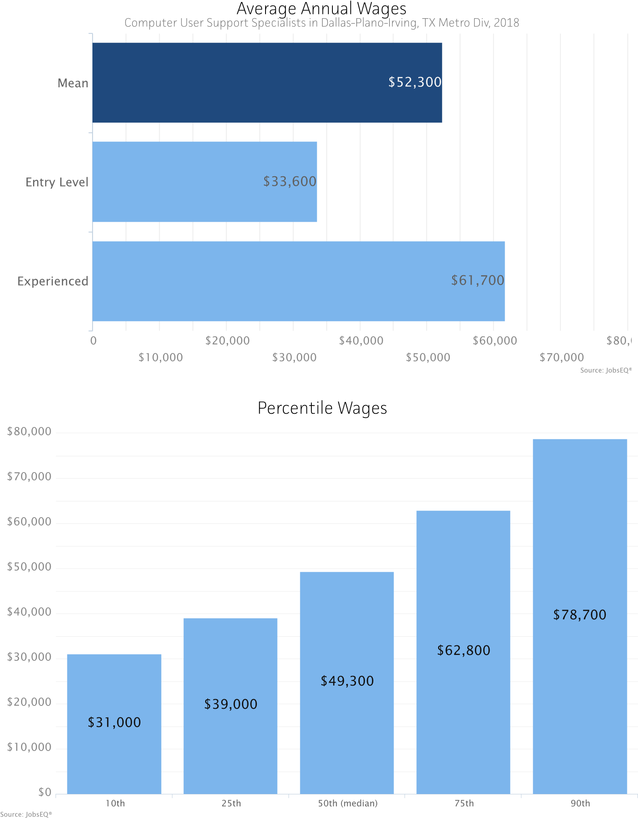
Occupation wages (mean, median, and percentiles) are as of 2018 provided by the BLS, modified and imputed by Chmura where necessary. Entry-level and experienced wages are derived from these source data, computed by Chmura.

Education Profile
Typical education and training requirements for Computer User Support Specialists are described below.

Education and Training Requirements
Typical Entry-Level Education: Some college, no degree
Previous Work Experience: | None
Typical On-the-Job Training: | None
Source: JobsEQ®

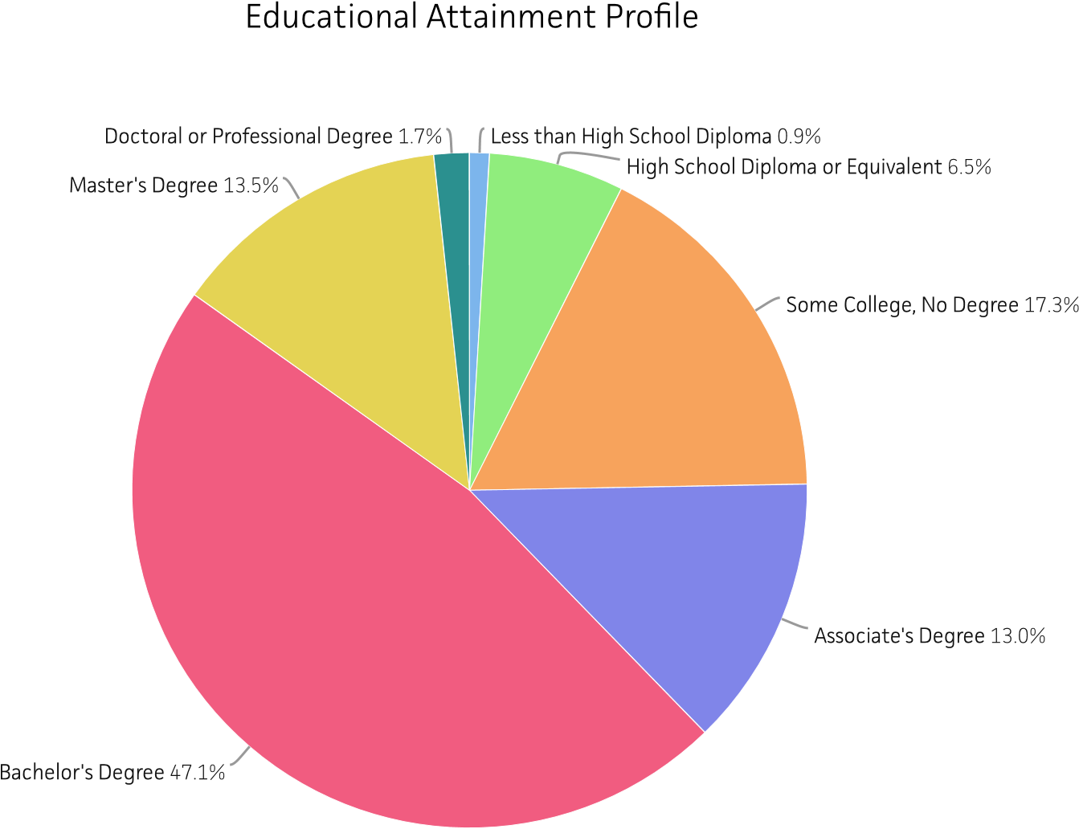

Education and training requirements are from the Bureau of Labor Statistics (BLS); educational attainment mix are regional data modeled by Chmura using Census educational attainment data projected to 2019Q3 along with source data from the BLS.

RTI (Job Postings)

Occupations
Total
SOC Occupation Ads
15-1151.00 9,126
Computer User Support Specialists

Source: JobsEQ®
Data reflect online job postings for the 180 day period ending 1/8/2020
Note: Data are subject to revision. Please do not use the volume of data for historical comparisons until such time that an adjusted historical series of these data are provided.

Employers
Total
Employer Name Ads
Best Buy

157

Bank of America

115

TEKsystems, Inc

111

Raytheon

102

Robert Half Technology

91

Pyramid Consulting, Inc

78

Robert
Half

71

Amazon Web Services, Inc.

65

APEX Systems

64

Baylor Scott & White Health

63

Source: JobsEQ®
Data reflect online job postings for the 180 day period ending 1/8/2020
Note: Data are subject to revision. Please do not use the volume of data for historical comparisons until such time that an adjusted historical series of these data are provided.

Certifications
Certificate Name
Microsoft Certified Solutions Expert (MCSE)

168
Driver's License

140

CompTIA A+ Certification (A+ Certification)

137

Cisco
Certified Network Associate (CCNA)

113

Microsoft Certified Professional (MCP)

99

Microsoft Certified Solutions Associate (MCSA)

84

Secret Clearance

80

Network+ Certification

69

Microsoft Certified IT Professional (MCITP)

42

Cisco
Certified Network Professional (CCNP)

34

Source: JobsEQ®
Data reflect online job postings for the 180 day period ending 1/8/2020
Note: Data are subject to revision. Please do not use the volume of data for historical comparisons until such time that an adjusted historical series of these data are provided.

Hard Skills
1,657
Skill Name

Total
Ads

Microsoft Office

Microsoft Excel

1,384

Microsoft Active Directory

960

Personal Computers (PC)

947

IT Support

875

Structured
Query Language (SQL)

835

Computer Programming/Coding

791

Computer Networking

762

Microsoft Outlook

742

Linux

722

Source: JobsEQ®
Data reflect online job postings for the 180 day period ending 1/8/2020
Note: Data are subject to revision. Please do not use the volume of data for historical comparisons until such time that an adjusted historical series of these data are provided.

Soft Skills
Skill Name
Communication (Verbal and written skills)

5,780
Cooperative/Team Player

2,827

Customer Service

2,697

Self
-
Motivated/Ability to Work
Independently/Self Leadership

2,129

Problem Solving

2,065

Troubleshooting

1,554

Detail Oriented/Meticulous

1,510

Analytical

1,477

Organization

1,465

Adaptability/Flexibility/Tolerance of Change and Uncertainty

1,320

Source: JobsEQ®
Data reflect online job postings for the 180 day period ending 1/8/2020
Note: Data are subject to revision. Please do not use the volume of data for historical comparisons until such time that an adjusted historical series of these data are provided.

Job Titles
Total
Job Title Ads
Desktop Support Technician

71

Desktop Support

65

Geek Squad Consultation Agent

63

Field Service Technician

43

Desktop Support Analyst

40

Customer Support Specialist

30

Service Desk Analyst

29

Technical Support Specialist

29

Application Support Analyst

26

Help Desk Technician

26

Source
:

JobsEQ
®

Data reflect online job postings for the 180 day period ending 1/8/2020
Note: Data are subject to revision. Please do not use the volume of data for historical comparisons until such time that an adjusted historical series of these data are provided.

Education Levels
Minimum Education Level
High school diploma or equivalent
Bachelor's degree

2,313
1,792

902

51

Unspecified/other

4,068

Associate's degree
Master's degree
Source: JobsEQ®
Data reflect online job postings for the 180 day period ending 1/8/2020
Note: Data are subject to revision. Please do not use the volume of data for historical comparisons until such time that an adjusted historical series of these data are provided.

Programs
1,037
Program Name

Total
Ads

Computer Science

Engineering

398

Information Technology

295

Information Systems

235

Business

233

Technical

164

Mathematics

146

Management Information Systems

112

Electrical Engineering

104

Business Administration

85

Source: JobsEQ®
Data reflect online job postings for the 180 day period ending 1/8/2020
Note: Data are subject to revision. Please do not use the volume of data for historical comparisons until such time that an adjusted historical series of these data are provided.

Locations
Location

Dallas, Texas

1,708
Plano, Texas

773

Irving, Texas

645

Dallas, TX 75201

327

Richardson, Texas

300

Frisco, Texas

147

Plano, TX 75023

130

Plano, TX 75024

112

Coppell, Texas

106

Carrollton, Texas

101

Source
:

JobsEQ
®

Data reflect online job postings for the 180 day period ending 1/8/2020
Note: Data are subject to revision. Please do not use the volume of data for historical comparisons until such time that an adjusted historical series of these data are provided.

Region Definition
Dallas-Plano-Irving, TX Metro Div is defined as the following counties:
Collin County, Texas

Hunt County, Texas

Dallas County, Texas

Kaufman County, Texas

Denton County, Texas

Rockwall County, Texas

Ellis County, Texas

Occupation Report for
Database Administrators
Dallas-Plano-Irving, TX Metro Div

Definition of Database Administrators, SOC 15-1141
Administer, test, and implement computer databases, applying knowledge of database management systems. Coordinate changes to computer databases. May plan, coordinate, and implement security measures to safeguard computer databases. Excludes “Information Security Analysts” (15-1122).

Occupation Snapshot
As of 2019Q3, total employment for Database Administrators in the Dallas-Plano-Irving, TX Metro Div was 3,035. Over the past three years, this occupation added 71 jobs in the region and is expected to increase by 462 jobs over the next seven years, or at an annual average rate of 2.0%.

Database Administrators in Dallas-Plano-Irving, TX Metro Div, 2019q3¹
 |  | Current |  |  | 3-Year History |  |  |  | 7-Year Forecast
Empl | Avg Ann  Wages² | LQ Unempl | Unempl Rate | Online Job  Ads³ | Empl Change | Ann % | Total Demand | Exits | Transfers |  | Empl Growth | Ann % Growth
3,035 | $97,600 | 1.55 30 | 1.0% | 615 | 71 0.8% |  | 1,934 | 491 | 981 |  | 462 | 2.0%
Source: JobsEQ®
Data as of 2019Q3 unless noted otherwise
Note: Figures may not sum due to rounding.
- Data based on a four-quarter moving average unless noted otherwise.
- Wage data are as of 2018 and represent the average for all Covered Employment
- Data represent found online ads active within the last thirty days in the selected region; data represents a sampling rather than the complete universe of postings. Ads lacking zip code information but designating a place (city, town, etc.) may be assigned to the zip code with greatest employment in that place for queries in this analytic. Due to alternative county-assignment algorithms, ad counts in this analytic may not match that shown in RTI (nor in the popup window ad list).

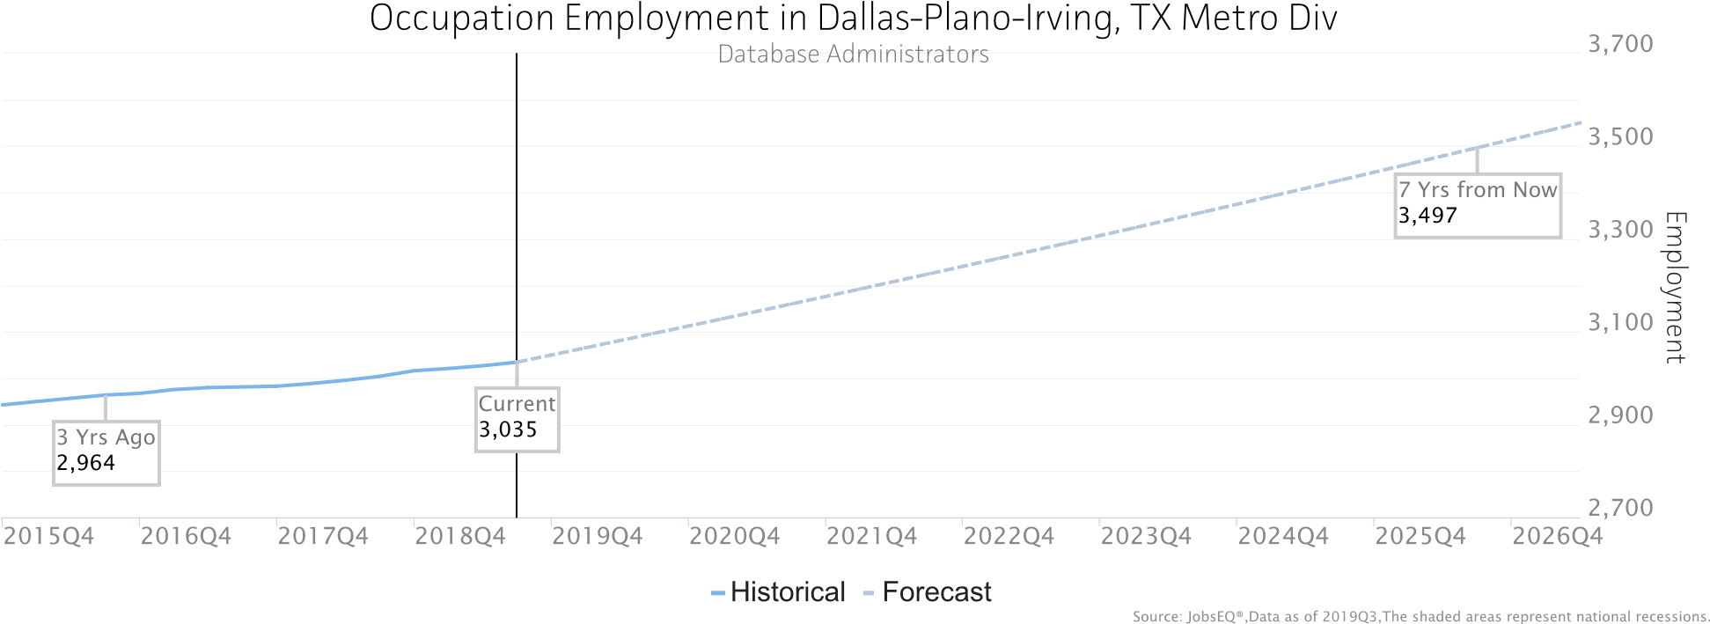
Occupation employment data are estimated via industry employment data and the industry/occupation mix. Industry employment data are derived from the Quarterly Census of Employment and Wages, provided by the Bureau of Labor Statistics and currently updated through 2019Q1, imputed where necessary with preliminary estimates updated to 2019Q3. Wages by occupation are as of 2018 provided by the BLS and imputed where necessary. Forecast employment growth uses national projections from the Bureau of Labor Statistics adapted for regional growth patterns. Occupation unemployment figures are imputed by Chmura.

Geographic Distribution
The below maps illustrate the ZCTA-level distribution of employed Database Administrators in the Dallas-PlanoIrving, TX Metro Div. Employment is shown by place of work and by residence.
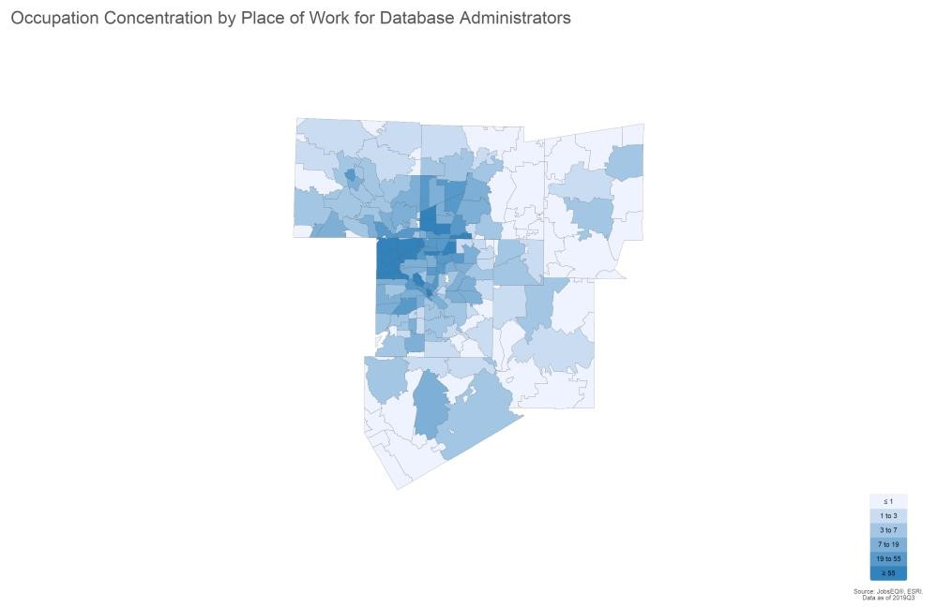

Top ZCTAs by Place of Work for Database Administrators, 2019Q3
Region Employment
ZCTA 75024 (Collin County, TX portion) | 201
ZCTA 75063 | 168
ZCTA 75039 | 126
ZCTA 75201 | 125
ZCTA 75038 | 120
ZCTA 75202 | 97
ZCTA 75001 | 94
ZCTA 75240 | 85
ZCTA 75081 | 79
ZCTA 75093 (Collin County, TX portion) | 74
Source: JobsEQ®
Occupation employment data are estimated via industry employment data and the industry/occupation mix. Industry employment data are derived from the Quarterly Census of Employment and Wages, provided by the Bureau of Labor Statistics and currently updated through 2019Q1, imputed where necessary with preliminary estimates updated to 2019Q3. Occupation by residence data are derived from the same in addition to commuting pattern data.

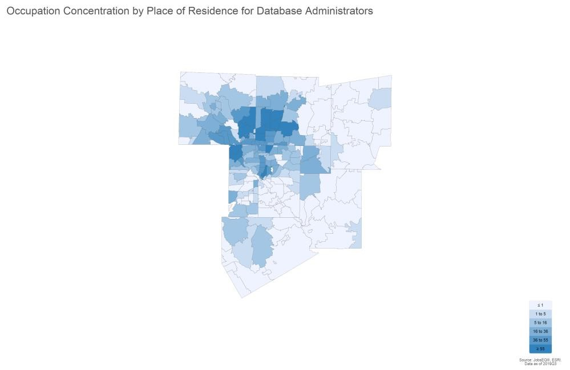

Top ZCTAs by Place of Residence for Database Administrators, 2019Q3
Region Employment
ZCTA 75206 | 98
ZCTA 75070 | 92
ZCTA 75025 | 89
ZCTA 75035 | 89
ZCTA 75024 (Collin County, TX portion) | 83
ZCTA 75002 | 79
ZCTA 75093 (Collin County, TX portion) | 75
ZCTA 75034 (Denton County, TX portion) | 74
ZCTA 75063 | 74
ZCTA 75204 | 71
Source: JobsEQ®
Occupation employment data are estimated via industry employment data and the industry/occupation mix. Industry employment data are derived from the Quarterly Census of Employment and Wages, provided by the Bureau of Labor Statistics and currently updated through 2019Q1, imputed where necessary with preliminary estimates updated to 2019Q3. Occupation by residence data are derived from the same in addition to commuting pattern data.

Employment by Industry
The following table illustrates the industries in the Dallas-Plano-Irving, TX Metro Div which most employ Database
Administrators. The single industry most employing this occupation in the region is Computer Systems Design and Related Services, NAICS 5415. This industry employs 675 Database Administrators—employment which is expected to increase by 255 jobs over the next ten years; furthermore, 497 additional new workers in this occupation will be needed for this industry due to separation demand, that is, to replace workers in this occupation and industry that retire or move into a different occupation.

Top Industry Distribution for Database Administrators (15-1141) in Dallas-Plano-Irving, TX Metro Div
Current 10-Year Demand
NAICS Code | Industry Title | % of Occ Empl | Empl | Exits | Transfers | Empl Growth | Total  Demand
5415 | Computer Systems Design and Related Services | 22.2% | 675 | 166 | 332 | 255 | 752
5511 | Management of Companies and Enterprises | 7.9% | 241 | 55 | 110 | 45 | 210
5173 | Wired and Wireless Telecommunications Carriers | 6.3% | 192 | 38 | 76 | -22 | 91
5182 | Data Processing, Hosting, and Related Services | 5.6% | 169 | 41 | 83 | 64 | 188
5416 | Management, Scientific, and Technical Consulting Services | 4.8% | 145 | 35 | 70 | 49 | 154
5241 | Insurance Carriers | 3.7% | 112 | 25 | 51 | 21 | 97
5222 | Nondepository Credit Intermediation | 3.6% | 109 | 26 | 53 | 36 | 115
5221 | Depository Credit Intermediation | 3.1% | 95 | 22 | 43 | 16 | 80
6113 | Colleges, Universities, and Professional Schools | 2.9% | 87 | 20 | 40 | 16 | 76
5613 | Employment Services | 2.7% | 82 | 18 | 36 | 11 | 65
5112 | Software Publishers | 2.1% | 64 | 15 | 31 | 20 | 66
5611 | Office Administrative Services | 2.0% | 60 | 15 | 29 | 22 | 65
6111 | Elementary and Secondary Schools | 1.9% | 59 | 13 | 26 | 8 | 47
5242 | Agencies, Brokerages, and Other Insurance Related Activities | 1.9% | 58 | 14 | 27 | 14 | 55
3344 | Semiconductor and Other Electronic Component Manufacturing | 1.7% | 51 | 11 | 21 | -1 | 31
6221 | General Medical and Surgical Hospitals | 1.5% | 45 | 10 | 20 | 6 | 36
5179 | Other Telecommunications | 1.4% | 42 | 8 | 17 | -5 | 20
5223 | Activities Related to Credit Intermediation | 1.3% | 39 | 9 | 18 | 7 | 34
8131 | Religious Organizations | 1.1% | 33 | 7 | 15 | 6 | 29
4234 | Professional and Commercial Equipment and Supplies Merchant Wholesalers | 1.1% | 32 | 7 | 14 | 2 | 23
 | All Others | 21.3% | 646 | 146 | 292 | 110 | 548
Source: JobsEQ®
Data as of 2019Q3 except wages which are as of 2018. Note that occupation-by-industry wages represent adjusted national data and may not be consistent with regional, all-industry occupation wages shown elsewhere in JobsEQ. Note: Figures may not sum due to rounding.
Occupation employment data are estimated via industry employment data and the industry/occupation mix. Industry employment data are derived from the Quarterly Census of Employment and Wages, provided by the Bureau of Labor Statistics and currently updated through 2019Q1, imputed where necessary with preliminary estimates updated to 2019Q3. Forecast employment growth uses national projections from the Bureau of Labor Statistics adapted for regional growth patterns.

Wages
The average (mean) annual wage for Database Administrators was $97,600 in the Dallas-Plano-Irving, TX Metro Div as of 2018. For the same year, average entry level wages were approximately $63,400 compared to an average of $114,700 for experienced workers.

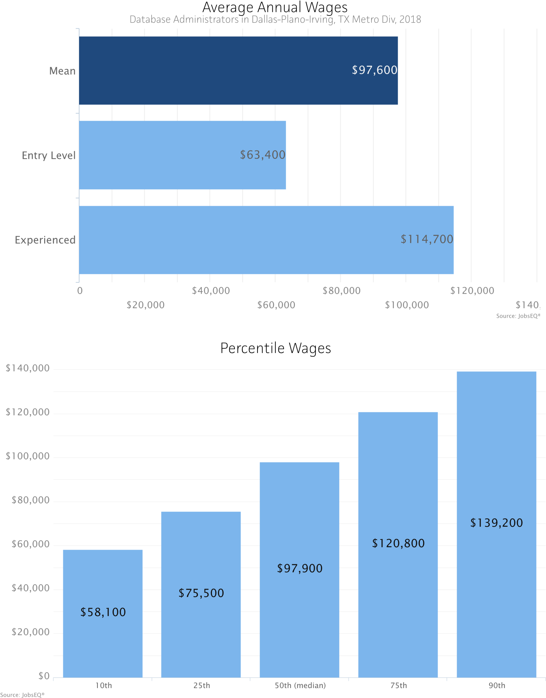
Occupation wages (mean, median, and percentiles) are as of 2018 provided by the BLS, modified and imputed by Chmura where necessary. Entry-level and experienced wages are derived from these source data, computed by Chmura.

Education Profile
Typical education and training requirements for Database Administrators are described below.

Education and Training Requirements
Typical Entry-Level Education: Bachelor's degree
Previous Work Experience: | None
Typical On-the-Job Training: | None
Source: JobsEQ®

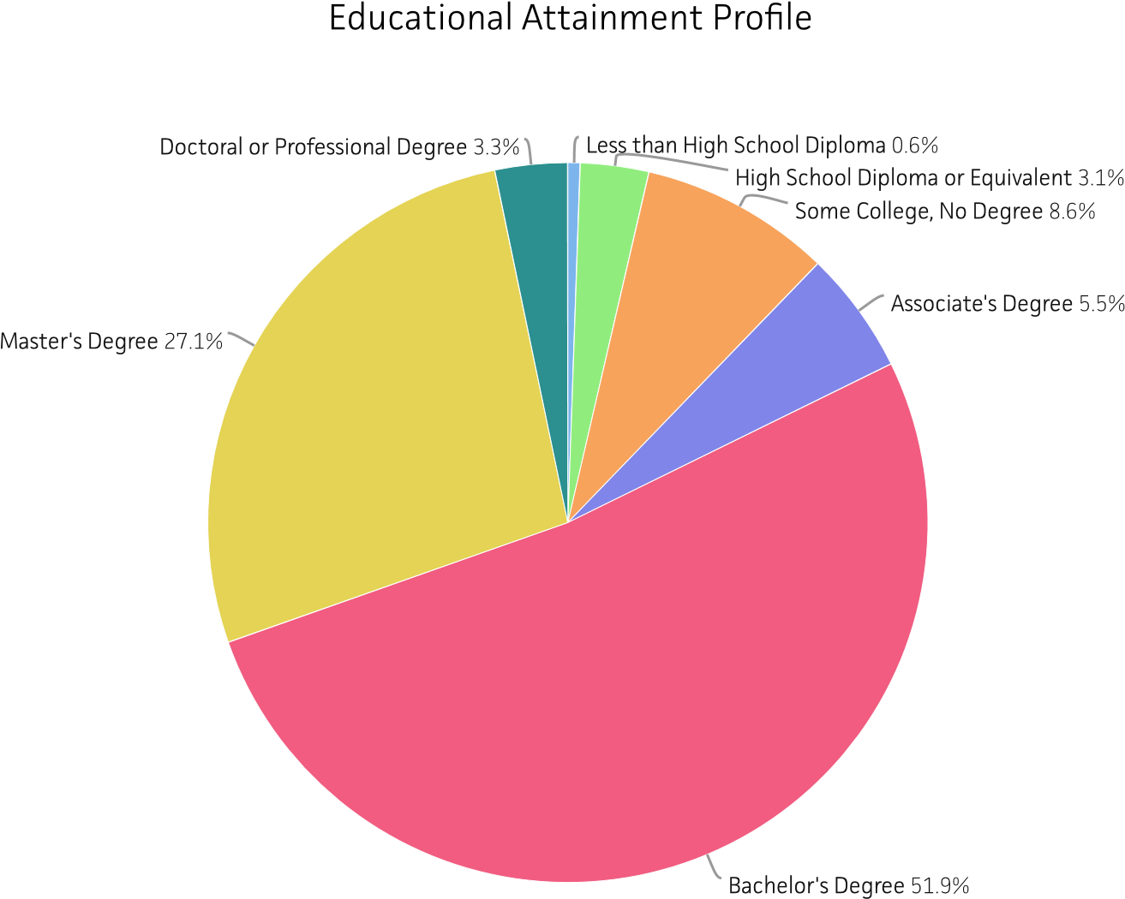

Education and training requirements are from the Bureau of Labor Statistics (BLS); educational attainment mix are regional data modeled by Chmura using Census educational attainment data projected to 2019Q3 along with source data from the BLS.

RTI (Job Postings)

Occupations
Total
SOC Occupation Ads
15-1141.00 Database Administrators 2,257

Source: JobsEQ®
Data reflect online job postings for the 180 day period ending 1/8/2020
Note: Data are subject to revision. Please do not use the volume of data for historical comparisons until such time that an adjusted historical series of these data are provided.

Employers
Employer Name

Total
Ads

Net2Source

50

Robert Half Technology

47

Diverse Lynx

27

Q1 Tech Inc

27

Bank of America

25

ASCII Group LLC

23

Pyramid Consulting,
Inc

22

American Cybersystems, Inc.

20

KPMG

19

Wells Fargo

18

Source: JobsEQ®
Data reflect online job postings for the 180 day period ending 1/8/2020
Note: Data are subject to revision. Please do not use the volume of data for historical comparisons until such time that an adjusted historical series of these data are provided.

Certifications
Certificate Name
Secret Clearance

7
Microsoft Certified IT Professional (MCITP)

5

Amazon Web Services Certification (AWS Certification)

4

Master
ACE (Advanced Certified Engineer) (Master ACE)

4

Microsoft Certified Technology Specialist (MCTS)

4

Oracle Certified

4

Red Hat Certified Engineer (RHCE)

4

Certified Information Security Manager (CISM)

3

Certified Information Systems Security

Professional (CISSP)

3

AWS Certified Solutions Architect

2

Source: JobsEQ®
Data reflect online job postings for the 180 day period ending 1/8/2020
Note: Data are subject to revision. Please do not use the volume of data for historical comparisons until such time that an adjusted historical series of these data are provided.

Hard Skills
Total
Skill Name Ads
Oracle

972

Structured Query Language (SQL)

924

Extract, Transform, Load (ETL)

416

Computer Programming/Coding

415

Linux

376

UNIX

362

Oracle PL/SQL

333

SQL Server Integration Services (SSIS)

289

Shell Script

270

Microsoft SQL Server

257

Source
:

JobsEQ
®

Data reflect online job postings for the 180 day period ending 1/8/2020
Note: Data are subject to revision. Please do not use the volume of data for historical comparisons until such time that an adjusted historical series of these data are provided

.

Soft Skills
Skill Name
Communication (Verbal and written skills)

895
Cooperative/Team Player

420

Analytical

335

Problem Solving

292

Self
-
Motivated/Ability to
Work Independently/Self Leadership

281

Troubleshooting

206

Project Management

145

Detail Oriented/Meticulous

136

Prioritize

121

Dispute Resolution/Conflict Resolution/Diplomacy/Problem Resolution

111

Source: JobsEQ®
Data reflect online job postings for the 180 day period ending 1/8/2020
Note: Data are subject to revision. Please do not use the volume of data for historical comparisons until such time that an adjusted historical series of these data are provided.

Job Titles
Total
Job Title Ads
SQL Developer

64

Database Administrator

55

Oracle DBA

39

SQL DBA

31

Database Developer

26

Oracle PL/SQL Developer

18

SQL Server DBA

18

Oracle Apps DBA

15

Oracle Database Administrator

15

SQL Server Developer

14

Source: JobsEQ®
Data reflect online job postings for the 180 day period ending 1/8/2020
Note: Data are subject to revision. Please do not use the volume of data for historical comparisons until such time that an adjusted historical series of these data are provided.

Education Levels
Minimum Education Level
High school diploma or equivalent
Bachelor's degree

682
25

24

16

Unspecified/other

1,510

Associate's degree
Master's degree
Source: JobsEQ®
Data reflect online job postings for the 180 day period ending 1/8/2020
Note: Data are subject to revision. Please do not use the volume of data for historical comparisons until such time that an adjusted historical series of these data are provided.

Programs
372
Program Name

Total
Ads

Computer Science

Engineering

107

Information Technology

68

Information Systems

67

Management Information Systems

37

Technical

36

Mathematics

35

Business

26

Business Administration

26

Computer Engineering

23

:
Source
JobsEQ
®

Data reflect online job postings for the 180 day period ending 1/8/2020
Note: Data are subject to revision. Please do not use the volume of data for historical comparisons until such time that an adjusted historical series of these data are provided.

Locations
Location

Dallas, TX 75201

380
Dallas, Texas

319

Irving, Texas

198

Plano, Texas

159

Irving, TX 75014

151

Plano, TX 75023

133

Richardson, Texas

79

Richardson, TX 75080

50

Dallas, TX 75203

29

Addison, Texas

27

:
Source
®
JobsEQ

Data reflect online job postings for the 180 day period ending 1/8/2020
Note: Data are subject to revision. Please do not use the volume of data for historical comparisons until such time that an adjusted historical series of these data are provided.

Region Definition
Dallas-Plano-Irving, TX Metro Div is defined as the following counties:
Collin County, Texas

Hunt County, Texas

Dallas County, Texas

Kaufman County, Texas

Denton County, Texas

Rockwall County, Texas

Ellis County, Texas

Appendix 2 – Course Completion and Success Rates by Term
Note: The program’s course list is based on the 2018-2019 academic catalog. The data source is Collin College’s Banner Student Data System 10/02/2019.

COSC 1315 Fundamentals of Programming
Term | Enrollment | Completion Rate | Success Rate
Fall 2014 | 188 | 90% | 64%
Spring 2015 | 210 | 89% | 64%
Summer 2015 | 52 | 90% | 77%
Fall 2015 | 191 | 90% | 69%
Winter 2015
Spring 2016 | 218 | 91% | 70%
Summer 2016 | 73 | 96% | 74%
Fall 2016 | 220 | 92% | 67%
Winter 2016
Spring 2017 | 212 | 93% | 75%
Summer 2017 | 74 | 92% | 73%
Fall 2017 | 220 | 90% | 73%
Winter 2017
Spring 2018 | 210 | 91% | 67%
Summer 2018 | 75 | 97% | 81%
Fall 2018 | 221 | 90% | 71%
Winter 2018
Spring 2019 | 222 | 86% | 64%
Summer 2019 | 66 | 91% | 77%
 |  | 91% | 69%

COSC 1337 Programming Fundamentals II (Java)
Term | Enrollment | Completion Rate | Success Rate
Fall 2014 | 75 | 88% | 53%
Spring 2015 | 99 | 90% | 61%
Summer 2015 | 28 | 86% | 82%
Fall 2015 | 90 | 81% | 59%
Winter 2015
Spring 2016 | 106 | 88% | 58%
Summer 2016 | 27 | 89% | 89%
Fall 2016 | 84 | 82% | 61%
Winter 2016
Spring 2017 | 105 | 91% | 73%
Summer 2017 | 49 | 88% | 82%
Fall 2017 | 109 | 90% | 62%
Winter 2017
Spring 2018 | 94 | 93% | 65%
Summer 2018 | 46 | 74% | 59%
Fall 2018 | 109 | 85% | 52%
Winter 2018
Spring 2019 | 120 | 79% | 53%
Summer 2019 | 44 | 75% | 64%
Averages |  | 86% | 62%

ITSE 1301 Web Design Tools - Graphics
Term | Enrollment | Completion Rate | Success Rate
Fall 2014 | 25 | 97% | 68%
Spring 2015 | 25 | 88% | 56%
Summer 2015 | 25 | 100% | 84%
Fall 2015 | 23 | 83% | 43%
Winter 2015
Spring 2016 | 24 | 88% | 75%
Summer 2016 | 22 | 100% | 77%
Fall 2016 | 38 | 92% | 68%
Winter 2016
Spring 2017 | 42 | 86% | 64%
Summer 2017
Fall 2017 | 39 | 87% | 49%
Winter 2017
Spring 2018 | 24 | 83% | 63%
Summer 2018 | 15 | 73% | 60%
Fall 2018 | 34 | 88% | 67%
Winter 2018
Spring 2019 | 42 | 93% | 74%
Summer 2019 | 19 | 89% | 74%
Averages |  | 89% | 66%

ITSE 1311 Beginning Web Programming
Term | Enrollment | Completion Rate | Success Rate
Fall 2014 | 143 | 85% | 63%
Spring 2015 | 134 | 87% | 60%
Summer 2015 | 24 | 96% | 63%
Fall 2015 | 127 | 89% | 55%
Winter 2015
Spring 2016 | 77 | 91% | 62%
Summer 2016 | 24 | 83% | 42%
Fall 2016 | 101 | 92% | 72%
Winter 2016
Spring 2017 | 70 | 89% | 56%
Summer 2017 | 24 | 75% | 54%
Fall 2017 | 96 | 86% | 56%
Winter 2017
Spring 2018 | 55 | 84% | 56%
Summer 2018 | 24 | 79% | 63%
Fall 2018 | 93 | 86% | 56%
Winter 2018
Spring 2019 | 79 | 86% | 63%
Summer 2019 | 45 | 87% | 67%
Averages |  | 87% | 60%

ITSE 2309 Database Programming - SQL
Term | Enrollment | Completion Rate | Success Rate
Fall 2014 | 28 | 89% | 68%
Spring 2015 | 40 | 80% | 53%
Summer 2015
Fall 2015 | 17 | 82% | 65%
Winter 2015
Spring 2016 | 40 | 90% | 63%
Summer 2016
Fall 2016 | 20 | 95% | 85%
Winter 2016
Spring 2017 | 36 | 94% | 81%
Summer 2017
Fall 2017 | 55 | 91% | 75%
Winter 2017
Spring 2018 | 55 | 80% | 47%
Summer 2018 | 11 | 91% | 82%
Fall 2018 | 43 | 72% | 60%
Winter 2018
Spring 2019 | 52 | 87% | 63%
Summer 2019 | 23 | 74% | 65%
Averages |  | 85% | 65%

ITSW 1304 Introduction to Spreadsheets (Excel)
Term | Enrollment | Completion Rate | Success Rate
Fall 2014 | 65 | 89% | 68%
Spring 2015 | 64 | 92% | 69%
Summer 2015 | 48 | 100% | 58%
Fall 2015 | 76 | 86% | 70%
Winter 2015
Spring 2016 | 96 | 89% | 65%
Summer 2016 | 43 | 91% | 60%
Fall 2016 | 67 | 93% | 61%
Winter 2016
Spring 2017 | 77 | 96% | 73%
Summer 2017 | 39 | 79% | 54%
Fall 2017 | 60 | 93% | 67%
Winter 2017
Spring 2018 | 77 | 87% | 66%
Summer 2018 | 44 | 95% | 82%
Fall 2018 | 49 | 84% | 67%
Winter 2018
Spring 2019 | 67 | 91% | 82%
Summer 2019 | 48 | 96% | 81%
Averages |  | 91% | 68%

ITSW 1307 Introduction to Databases (Access)
Term | Enrollment | Completion Rate | Success Rate
Fall 2014 | 68 | 90% | 66%
Spring 2015 | 68 | 96% | 60%
Summer 2015 | 25 | 100% | 68%
Fall 2015 | 68 | 94% | 52%
Winter 2015
Spring 2016 | 65 | 86% | 51&
Summer 2016 | 23 | 100% | 74%
Fall 2016 | 73 | 96% | 66%
Winter 2016
Spring 2017 | 65 | 92% | 58%
Summer 2017 | 15 | 93% | 73%
Fall 2017 | 82 | 85% | 51%
Winter 2017
Spring 2018 | 47 | 91% | 70%
Summer 2018 | 24 | 100% | 92%
Fall 2018 | 64 | 98% | 63%
Winter 2018
Spring 2019 | 47 | 83% | 55%
Summer 2019 | 24 | 92% | 75%
Averages |  | 92% | 62%

MRKG 1301 Customer Relationship Management
Term | Enrollment | Completion Rate | Success Rate
Fall 2014 | 29 | 97% | 72%
Spring 2015
Summer 2015
Fall 2015 | 30 | 97% | 67%
Winter 2015
Spring 2016
Summer 2016
Fall 2016 | 51 | 98% | 67%
Winter 2016
Spring 2017 | 15 | 87% | 40%
Summer 2017
Fall 2017 | 28 | 100% | 93%
Winter 2017
Spring 2018 | 19 | 95% | 74%
Summer 2018
Fall 2018 | 71 | 93% | 73%
Winter 2018
Spring 2019 | 25 | 76% | 36%
Summer 2019
Averages |  | 94% | 68%

Appendix 3 – Previous CIP tables

12. HOW WILL WE EVALUATE OUR SUCCESS?
This section of the Program Review Report should provide the framework for the action plan the program intends to use to measure progress with particular focus on the changes discussed in the preceding section. It should set measurable priorities which clearly align with college metrics, particularly student learning outcomes. This discussion links back to intended change strategies and what those strategies are meant to accomplish and moves forward into the metrics and measurements which will be used to determine the extent to which the change was successful. Inclusion of incremental steps and a timeline over the next four years will help to shape realistic goals. Complete the attached Continuous Improvement Plan (CIP) form that follows. This CIP will be implemented next academic year. Include the data summary and findings on which the improvement action is based.
Date: 9/10/14 Name of Administrative or Educational Unit: Computer Systems_AAS_& Cert___________________________
Contact Name: Glen Grimes ____ Contact email: GGrimes@collin.edu Contact phone: Office Location ______________

Mission:
 | Computer Systems is an exciting field that presents many opportunities for a student who is proficient in both applications and software development. The rapid spread of computers and information technology has generated a need for highly trained workers to design and develop new information systems that use these technologies to meet the needs of the business organization. The skills acquired in this program will enable the student to solve problems that are encountered when working in this ever-changing and growing field. These skills include planning and developing new computer systems while applying the resources of existing systems to additional operations.
 | PART I: Might not change from year to year
 | A. Outcomes(s)  Results expected in this department/program | B. Measure(s)  The instrument or process used to measure results | C. Target(s)  The level of success expected
 | 1. Apply information technology concepts to a variety of business environments. | Coop—Employer feedback survey re: INEW 2330--Project | Above Average rating  Average of 4 rating on a 4 point scale
 | 2. Demonstrate the ability to work in a team environment. | INEW 2330--Project Teamwork Rubric | Average of 3 rating on a 4 point scale
 | 3. Demonstrate professional and effective documentation and communication skills. | Coop—Employer feedback survey re:  INEW 2330—Project  Instructor rubric rating for INEW 2330--Project | Above Average rating  Average of 4 rating on a 4 point scale

 | A. Outcomes(s)  Results expected in this department/program | B. Measure(s)  The instrument or process used to measure results | C. Target(s)  The level of success expected
 | 4. Computer Support Track: Apply common business productivity software to business functions. | Coop-Employer feedback survey re:  INEW 2330-Project  Instructor rubric rating for INEW 2330-Project ITSC 2339-Project | Above Average rating  Average of 3 rating on a 4 point scale
 | 4. Information Systems Track: Apply common business productivity software to business functions. | Coop—Employer feedback survey re:  INEW 2330—Project & BCIS 2390—Project  Instructor rubric rating for INEW 2330—Project & BCIS 2390-Project | Satisfactory rating  Average of 3 rating on a 4 point scale  For both projects
 | 4. Database Development Track: Design, implement and use relational databases. | Coop—Employer feedback survey re:  INEW 2330—Project  Instructor rubric rating for INEW 2330--Project | Satisfactory rating  Average of 3 rating on a 4 point scale
 | 4. Software Development Track: Apply industry accepted coding practice and standards using an Object-oriented programming language. | Coop—Employer feedback survey re: INEW 2330-Project  Instructor rubric rating for INEW 2330--Project | Above Average rating  Average of 4 rating on a 4 point scale
 | 5. Software Development Track: Demonstrate the ability to read Uniform Modeling Language (UMLat industry standards | Coop—Employer feedback  INEW 2330—Project  Instructor rubric rating for INEW 2330--Project | Satisfactory rating  Average of 4 rating on a 4 point scale
PART II  A. Outcomes  Results expected in this department/program | D. Action Plan  Years 5 & 2  Based on analysis of previous assessment, create an action plan and include it here in the row of the outcomes(s) it addresses. | E. Implement Action Plan  Years 1 & 3  Implement the action plan and collect data | F. Data Results Summary  Years 2 & 4  Summarize the data collected | G. Findings  Years 2 & 4  What does data say about outcome?
Apply information technology concepts to a variety of business environments. | Review goals for integration of technology concepts into the specific objectives.  Include a research section in initial planning of project | Have students add a goal in their learning objective contract that pertains to the technology used in their internship.  Gave students research technology concepts that could pertain to their business project. | COOP: Satisfactory  INEW 2330: 3 out of 4 | COOP: Partially Met  Students did not make own judgements/decisions on what is needed in a business environment.  INEW 2330: Partially Met  Students tried to apply technology concepts that they knew without researching other options for various business environments.
Demonstrate the ability to work in a team environment. | Include project requirement for groupwork and overall class presentation. | Students worked together as a group and presented project to class. | INEW 2330: 3 out of 4 | INEW 2330: Met
Demonstrate professional and effective documentation and communication skills. | Discuss with supervisor opportunities for possible leadership, management, and initial decision making in COOP learning experience. Review goals for | Students included goal(s) pertaining to leadership, management, and/or initial decision making as much as possible in the internship. | COOP: Satisfactory | COOP: Partially Met  Students completed tasks that were given; however, could have shown more leadership, better management, and initiative

 | A. Outcomes(s)  Results expected in this department/program | D. Action Plan  Years 5 & 2  Based on analysis of previous assessment,  create an action plan and include it here in the row of the outcomes(s) it addresses. | E. Implement Action  Plan  Years 1 & 3  Implement the action plan and collect data | F. Data Results  Summary  Years 2 & 4  Summarize the data collected | G. Findings  Years 2 & 4  What does data say about outcome?
 |  | opportunities to display communication skills, decision making, and assumption of more responsibility.  Increase opportunities for leadership, management,  and initial decision making in INEW 2330 class by providing a team environment when  possible with leadership and management  positions where initial decision making is required. | Students were given a scenario which included leadership, management, and/or initial decision making and had to display appropriate documentation and communication skills. | INEW 2330: 4 out of 4 | in task completion.  INEW 2330: Exceeds  expectations  Students submitted user documentation to client.
 | Computer Support Track: Install, configure and troubleshoot basic networks and personal computer hardware and software. | Increase opportunities to Install, configure and troubleshoot basic networks and personal computer hardware and software as much as possible in capstone courses. | Students included a goal(s) in learning contract to provide basic network and/or personal computer hardware and/or software support.  Students completed a goal(s) in class project requirements to provide basic network and/or personal computer hardware and/or software support.  Students included a goal(s) in learning contract to provide basic network and/or personal computer hardware and/or software support. | COOP: Satisfactory  INEW 2330: 3 out of 4  ITSC 2339: 3 out of 4 | COOP: Met  INEW 2330: Met  ITSC 2339: Met
 | Information Systems Track: Apply common business productivity software to business functions. | Review goals for applying common business productivity software concepts into the specific objectives.  Include a common business productivity software section in initial planning of project. | Have students add a goal in their learning objective contract that pertains to applying common business productivity software in their internship.  Gave students requirement(s) for using common business productivity software in their business project. | COOP: Satisfactory  INEW 2330: 3 out of 4 | COOP: Met  INEW 2330: Partially Met  Students tried to apply

 | A. Outcomes(s)  Results expected in this department/program | D. Action Plan  Years 5 & 2  Based on analysis of previous assessment,  create an action plan and include it here in the row of the outcomes(s) it addresses. | E. Implement Action  Plan  Years 1 & 3  Implement the action plan and collect data | F. Data Results  Summary  Years 2 & 4  Summarize the data collected | G. Findings  Years 2 & 4  What does data say about outcome?
 |  | Review goals for analyzing needs for common business productivity software concepts into the specific objectives. | Have students complete a learning objective that pertains to analyzing needs for common business productivity software. | BCIS 2390: 3 out of 4 | software applications that they knew without researching other options for various software requirements.  BCIS 2390: Met
 | Database Development Track: Design, implement and use relational databases. | Review goals for opportunities to analyze business objectives and match them with database requirements. | Have students complete a learning objective in their learning contract (COOP) or in their project (INEW 2330) that pertains to analyzing needs for database requirements and matching them with solutions. | COOP: Satisfactory  INEW 2330: 3 out of 4 | COOP: Partially Met  Students could improve on analytical skills.  INEW 2330: Met
 | Software Development Track: Apply industry accepted coding practice and standards using an object-oriented programming language. | Discuss with supervisor including goals for applying industry accepted coding practice and standards using an object-oriented programming language into the specific objectives.  Include a requirement for industry accepted coding practice and standards using an object-oriented programming language in project. | Students added a goal in their learning objective contract that pertained to applying industry accepted coding practice and standards using an object-oriented programming language.  Students completed requirement by applying industry accepted coding practice and standards using an object-oriented programming language to project. | COOP: Satisfactory  INEW 2330: 3 out of 4 | COOP: Met  INEW 2330: Partially Met  Students tried to apply object-oriented programming that they knew instead of following requirement.

 | A. Outcomes(s)  Results expected in this department/program | D. Action Plan  Years 5 & 2  Based on analysis of previous assessment,  create an action plan and include it here in the row of the outcomes(s) it addresses. | E. Implement Action  Plan  Years 1 & 3  Implement the action plan and collect data | F. Data Results  Summary  Years 2 & 4  Summarize the data collected | G. Findings  Years 2 & 4  What does data say about outcome?
 | Software Development Track: Demonstrate the ability to lead Uniform Modeling Language (UML) at industry standards. | Discuss with supervisor the possibility of including goals for demonstrating the ability to lead UML at industry standards into the specific objectives.  Include a requirement for demonstrating the ability to lead UML at industry standards into the project requirements. | Students worked with supervisor to add and complete a goal in their learning objective contract that pertained to leading UML at industry standards.  Students completed requirement by demonstrating the ability to lead UML at industry standards in a business-client scenario. | COOP: Satisfactory  INEW 2330: 4 out of 4 | COOP: Met  INEW 2330: Exceeds requirements  Students submitted user documents to client.

Continuous Improvement Plan

Outcomes might not change from year to year. For example, if you have not met previous targets, you may wish to retain the same outcomes. If this is an academic, workforce, or continuing education program, you must have at least one student learning outcome. You may also add short-term administrative, technological, assessment, resource or professional development goals, as needed.

Date: 2016 Name of Program/Unit:
Contact name: Cervantez Contact email: acervantez@collin.edu Contact phone: 1659
Table 1: CIP Outcomes, Measures & Targets Table (focus on at least one for the next two years)
A. Expected Outcome(s)  Results expected in this unit  (e.g. Authorization requests will be completed more quickly; Increase client satisfaction with our services) | B. Measure(s)  Instrument(s)/process(es) used to measure results  (e.g. survey results, exam questions, etc.) | C. Target(s)  Level of success expected  (e.g. 80% approval rating, 10 day faster request turn-around time, etc.)
Apply information technology concepts to a variety of business environments. | COOP-Employer feedback survey results  INEW 2330 - Project | Above average rating  Average of 4 rating on a 4 point scale
Demonstrate professional and effective documentation and communication skills. | COOP-Employer feedback survey results  INEW 2330 - Project | Above average rating  Average of 4 rating on a 4 point scale

Description of Fields in the Following CIP Tables:
A. Outcome(s) - Results expected in this program (e.g. Students will learn how to compare/contrast conflict and structural functional theories; increase student retention in Nursing Program).
B. Measure(s) - Instrument(s)/process(es) used to measure results
(e.g. results of surveys, test item questions 6 & 7 from final exam, end of term retention rates, etc.)
C. Target(s) - Degree of success expected (e.g. 80% approval rating, 25 graduates per year, increase retention by 2% etc.).
D. Action Plan - Based on analysis, identify actions to be taken to accomplish outcome. What will you do?
E. Results Summary - Summarize the information and data collected in year 1.
F. Findings - Explain how the information and data has impacted the expected outcome and program success.
G. Implementation of Findings – Describe how you have used or will use your findings and analysis of the data to make improvements.

