PROGRAM NAME: Business support office systems (BOSS) Authoring Team contact: Angela Payne

phone: 972-881-5170 Email: apayne@collin.edu

GUIDELINES
Time Frames:
- Scope:
The time frame of program review is five years, including the year of the review.
Data being reviewed for any item should go back the previous five years, unless not available.
- Deadline Dates:
January 15th – Program Review Document due to Department Dean for review
January 31st – Program Review Document due to Program Review Steering Committee
- Years:
Years 1 & 3 – Implement Action Plan of (CIP) and collect data
Years 2 & 4 – Analyze data and findings from previous year, Update Action Plan
Year 5 – Write Program Review of past 5 years; Write Continuous Improvement Plan (CIP) and create new Action Plan

LENGTH OF RESPONSES: Information provided to each question may vary but should be generally kept in the range of 1-2 pages.

EVIDENCE GUIDELINES: In the following sections, you will be asked to provide evidence for assertions made.
- Sources: This evidence may come from various sources including professional accreditation reviews, THECB, Texas Workforce Commission’s CREWS, Collin’s Institutional Research Office (IRO), National Student Clearinghouse, IPEDS, JobsEQ, and may be quantitative and/or qualitative. If you are unfamiliar with any of these information sources, contact the Institutional Research Office at: effectiveness@collin.edu. Use of additional reliable and valid data sources of which you are aware is encouraged.
- Examples of Evidence Statements:
- Poor example: Core values are integrated into coursework. (Not verifiable)
- Good example: Core values are integrated into coursework through written reflections. (Verifiable, but general)
- Better example: Core values are integrating into coursework through written reflections asking the student to describe how s/he will demonstrate each of the core values in his or her professional life and demonstrated through service learning opportunities. (Replicable, Verifiable)

THE PROGRAM REVIEW PORTAL can be found at http://inside.collin.edu/institutionaleffect/Program_Review_Process.html. Any further questions regarding Program Review should be addressed to the Institutional Research Office (effectiveness@collin.edu, 972.599.3102).
Executive Summary:
Briefly summarize the topics that are addressed in this self-study, including areas of strengths and areas of concern.
Purpose of the Program
This report discusses the Business Office Support Systems (BOSS) program. This program prepares students to become administrative office professionals who are an integral part of almost any industry to manage offices and workplace settings. The program offers several certificates and degrees including office administration, medical office administration, and accounting office support. In addition, it offers certificates and occupational skills awards (OSA).
Faculty in the Program
For at least the past 4 ½ years, the BOSS program had two full time professors: Linda Thompson and Angela Payne. Linda was the discipline lead, but retired recently. I, Angela Payne, have been the discipline lead for the past few months and full-time professor during the past four years. However, our department is currently contracting with several adjuncts/associate professors to help with the teaching load.
Enrollment and Salary
A total of 111 students completed the BOSS program in the last five years. Enrollment is steady and the job market for our students is good due to the economic growth in Collin County and the DFW area. The salary ranges in the Collin County and DFW area range from $40,000+ to $70,000+ depending on the employer and the employee’s experience and education. (source: salaries - JobsEQ and O*Net)
Course Offerings and Student Satisfaction
Many of our students work and attend college so the program’s decision to offer all courses online has allowed our working, adult students to have access to higher education. However, we do offer an accounting I course face-to-face each semester for students who need a more traditional learning environment. Our students and community are pleased with our BOSS program based on student evaluations and the fact that Collin College has hired some of our BOSS graduates. In addition, our graduates work at local employers such as Plano Medical, Hope Center, Hunters Glen Baptist Church, Denton County, 1st in Smiles, JCPenney, and more businesses. (source: collected student data sheet in our learning management system Canvas)

Plans to Grow and Improve the Program
Plans to grow and improve the program is to continue attending student recruitment events, International Association of Administrative Professionals (IAAP) recruitment events, make students aware of the marketable skills desired by employers, use team work projects and networking opportunities in the BOSS industry. In addition, our program will research the feasibility to offer another certificate similar to one of our comparable community colleges Dallas County Community College.

Strengths of the Program
- BOSS faculty are continuously keeping up with the latest technology and implementing online learning smart books and other course materials by researching and implementing materials that contain more engaging learning tools such as videos, step-by-step tutorials, and some even provide immediate feedback for student assignments and exams.
- Offering all online courses (except a few), allows our working, adult students to be able to work and go to college.
- Our professional relationship with the nationally recognized IAA (International Association of Administrative Professionals) helps to keep us abreast of the workplace trends. The local Director of IAAP TX/LA region, has been serving on our advisory committee for at least the last five years, provides valuable insight into the workplace trends, and networking opportunities for faculty and students. In addition, we have several administrative professionals on our advisory committee including local office managers of temporary agencies.

Areas of Concern of the Program
- The technology changes so rapidly, that it is a challenge to use the latest software. Each semester, a few students have older computers. However, the program informs all students on the syllabus of the open computer labs that are available Monday through Sundays on multiple campuses.
- Locating a tutor for QuickBooks has been a challenge. However, I have been available beyond office hours to assist students with getting started with QuickBooks in our Computerized Accounting course that includes QuickBooks program.

Section I. Are We Doing the Right Things?
1. What does your workforce program do?
What is the program and its context?
This section is used to provide an overview description of the program, its relationship to the college and the community it serves. Keep in mind the reviewer may not be familiar with your area. Therefore, provide adequate explanation as needed to ensure understanding.

Suggested/possible points to consider:
- Program’s purpose (Include the program’s purpose/mission statement if one exists.)
- Brief explanation of the industry(s) the program serves
- Career paths and/or degree paths it prepares graduates to enter
- What regulatory standards must the program meet (THECB, Workforce, external accreditation)
- Program outcomes or marketable skills

Program purpose and summary – Business Office Support Systems (BOSS)

Special Note: the program’s names was changed (with the approval of the advisory committee) from Office Systems Technology (OST) to the current name Business Office Support Systems (BOSS)

- Business Office Support Systems (BOSS’s) mission is to prepare students for performing professionally in the ever-changing local area workplace through step-by-step, simple-to-complex hands-on technology training and critical thinking, problem-solving communications. The program is designed to incorporate both the technical and behavioral aspects of careers in the general or medical office fields. Areas of study include: keyboarding; word processing; desktop publishing; proofreading and editing; records and information management; business correspondence and communications; database, presentation, and spreadsheet software; office management; and basic manual and computerized accounting.

• The Business Office Support Systems program has been an important workforce component of the College since the inception of Collin College, then called Collin County Community College District. The original BOSS department was named Office Administration (OFAD). Classes were all face-to-face on site and offered 9 to 3 Monday through Thursday when stay-at-home parents could come learn while their children were in school and offered 5 to 9 evenings to accommodate career adults. From then to now, BOSS graduates proved valuable to the community, including the College, as many BOSS graduates are employed by Collin College. Skills taught by BOSS are integral to all businesses and organizations, validating BOSS’s continued importance to the College and community.

• Business Office Support Systems (hereafter referred to as BOSS) program faculty deliver instruction in 13 credit courses. Prior to 2015, faculty would individually tutor students for more than 2 thousand required assignments on an impromptu basis in an open classroom/laboratory or online, and oversee 2 cooperative work experience courses, requiring faculty to be well-prepared in advance in many areas related to the department’s delivery of consistent, quality instruction to students. BOSS was one of the first departments to standardize course content. BOSS courses therefore provided equitable learning experiences for all students (day/night, online/face-to-face).

All BOSS course are now offered online to allow students to take courses while working and taking care of their family. BOSS faculty revamped the course materials by researching and implementing online learning materials that contain more engaging learning tools such as videos, step-by-step tutorials, some even provide immediate feedback for student assignments and exams. However, the ACNT 1303 – Introduction to Accounting I course is offered face-to-face one or two classes per semester depending on enrollment. Offering the accounting course face-to-face allows an option for students who need a traditional course setting.

• Because technology changes often, faculty are always learning new software programs, operating systems, and technologies and then routinely updating course components to match current instructional objectives based on advisory committee guidance and community needs. Faculty attend seminars, workshops, and webinars in addition to investing significant time in personal study of the ever-changing details involved in keeping courses current and relevant.

• As mentioned above, BOSS Advisory Committee input drives BOSS curriculum and engagement decisions. Committee members share local area workforce needs and make suggestions for preparing students for employment in the field. Students are encouraged through the BOSS Cooperative Work Experience capstone courses to participate in area internships. Faculty, supervisor, and student work together as a team to make the work experience meaningful for the student and productive for the supervisor.

• Faculty are actively involved in college service. Examples include participation in various college committees – Collin Serves, Faculty Council Technology Committee, Council on Excellence, All College Council, and Scholarship Committee. In addition, faculty chair employment search committees, program improvement plans, and program review reports. BOSS also offers online advising for BOSS students as an extra college service; this advising continues through breaks between terms, which are often the busiest times for advising. BOSS specific advising is especially helpful to students concerning recommended course sequencing and course combinations

Marketable skills
1. Create professional documents using appropriate software. Apply the features available in Microsoft Office, Google apps, and other software to finish tasks assigned.
2. Prepare travel arrangements. Provide the appropriate paperwork, time schedules, and reminders.
3. Plan and implement workshops, conferences, podcasts, and webinars. Train others on best practices in these events.
4. Setup and coordinate meetings. Implement meetings using best practices used in the workplace.
5. Type professional documents. Type fast and accurately.
6. Solve problems. Implement solutions in an appropriate and timely manner.
7. Organize people, places, and events. Implement organization skills throughout the workplace.
8. Research files for reports, events, and other tasks. Research all forms of media (online and physical).
9. Learn technology or skills quickly. Apply the appropriate technology or other skills to solve a workplace task.
10. Manage records (clients, financial, etc.). Keep accurate and timely information.

"Soft Skills" – Marketable Skills
1. Communicating effectively and professionally with peers, managers, customers, etc.
2. Analyze data critically to reach sound conclusions
3. Work productively with others to achieve group goals
4. Engage effectively and respectfully with people from many communities and with many perspectives
5. Work ethically, responsibly, and conscientiously
(source: www.indeed.com)

- Brief explanation of the industry(s) the program serves
- Career paths and/or degree paths it prepares graduates to enter

  - Business Office Support System’s mission is to prepare students for performing professionally in the ever-changing local area workplace through step-by-step, simple-to-complex hands-on technology training and critical thinking, problem-solving communications. The program is designed to incorporate both the technical and behavioral aspects of careers in the general or medical office fields. Areas of study include: keyboarding; word processing; desktop publishing; proofreading and editing; records and information management; business correspondence and communications; database, presentation, and spreadsheet software; office management; and basic manual and computerized accounting

  - Administrative professionals serve numerous industries because administrative duties are needed in BOSS companies

  - Career paths include (but are not limited to)
  - Executive Secretaries
  - Executive Administrative Assistants
  - Office Manager
  - Medical Receptionist
  - Accounting Assistant
  - Marketing Assistant

The average salary is $63,200

Source: data for Collin County obtained from JobsEQ and O*Net
Note: Average salary for occupation as of 2018 and job growth projected from 2019 – 2026

2. Why do we do the things we do: Program relationship to the College Mission & Strategic Plan
- Provide program-specific evidence of actions that document how the program supports the College’s mission statement: “Collin County Community College District is a student and community-centered institution committed to developing skills, strengthening character, and challenging the intellect.”
- Provide program-specific evidence that documents how the program supports the College’s strategic plan: https://www.collin.edu/aboutus/strategic_goals.html.
Suggested/possible points to consider:
- What evidence is there to support assertions made regarding how the program relates to the mission, and strategic plan?
- Think broadly-increasing completion, articulation agreements, pathways from high schools, etc.
- Analyze the evidence you provide. What does it show about the program?

A few of the strategic goals that we support through our program includes:
- “Increase Outreach and Create Streamlined Pathways from High School” (Our program has participated in the Super Saturday events for the past 4 years at various campuses to reach out to high schools students regarding our program degrees and certificates.) Also, we have agreements with local high schools that students can take dual credit courses while in high school.
- “Create an Increasingly Welcoming Environment for Students, Community Members, Faculty, and Staff” Instructors send out Welcome letters to students before the course starts. Throughout the semester, instructors send a friendly, weekly announcement to all my students to keep them on track with their assignments.

The program and its faculty contribute to fulfillment of the college mission of Collin County Community College District. It is a student and community-centered institution committed to developing skills, strengthening character, and challenging the intellect. Technical programs, leading to associate degrees or certificates, designed to develop marketable skills and promote economic development. Workforce, economic, and community development initiatives designed to meet local and statewide needs.
• BOSS curriculum is designed to guide students step-by-step through simple-to-complex hands-on assignments for individual development of workplace skills that provide a competitive employment advantage in the current local area workplace. Students complete assignments requiring them to communicate effectively, think critically and accurately, and function productively in teams. Advisory Committee members continue to verify that BOSS graduates are expected to integrate into existing employment departments. Team projects are an especially effective way to prepare students for this expectation.

WORKFORCE PROGRAM REVIEW
• To accomplish program goals of preparing students well for their chosen focus in the BOSS field, BOSS offers the following career preparation options. In addition, BOSS is receptive to updating delivery methods, as beneficial for student success. As mentioned earlier, courses were originally all offered in traditional, face-to-face time windows. Then, BOSS trended to offering courses fully online to meet the needs of working adults with families. Obviously, BOSS is responsive to ever-changing needs and creative in finding ways to meet current needs.
• BOSS course requirements address both learning and academic excellence. For example, course requirements measure learning through specific, required assignments, with highest grades awarded for academic excellence.
• Unexpected technology issues always drive creativity and innovation for the savvy student who creates options for working around issues. Extra credit is granted in many classes for students assisting classmates with solving problems. Many courses include a Discussion forum for classmates’ helpful interactions, encouraging meaningful online discussions.
• Dignity, respect, and integrity are expected of all faculty and students in all aspects of communication and instruction. Syllabi address penalties for infractions and address specifics in the included Netiquette policy. Professors monitor and guide students’ interactions, as advisable, whether online or in class. BOSS faculty and staff demonstrate dignity, respect, and integrity in performing their duties, serving as mentors to students
• Service and involvement are addressed through BOSS’s cooperative work experience options; however, students also demonstrate service and involvement when assisting other students and/or working in teams. Students are so helpful concerning classmates that faculty can learn from the students’ discussions.
Improve academic success by implementing strategies for completion.
• BOSS created an online delivery option for all courses to better allow the BOSS unique population of BOSS returning adults to complete their college credentials along with their other commitments. Online learning permits career adults to study around their employment requirements, including travel. Faculty know from online advising that this has been helpful in BOSS completion. Students have voluntarily thanked online faculty for creating a way for them to study late evenings and weekends, after fulfilling weekday career and parenting commitments.
• Faculty assist Institutional Research in locating graduates and defining their employment by maintaining professional relationships with students after graduation, when possible, and by maintaining digital student advising files for researching student information helpful in contacting and tracking graduates.

Provide access to innovative higher education programs that prepare students for constantly changing academic, societal and career/workplace opportunities.
• BOSS created the Accounting Support – Marketable Skills Achievement Award (MSAA) to meet current workplace needs, resulting in increased accounting enrollment. This was in response to accounting being part of InterLink’s target occupations for the North Central Texas area. It was also in response to Advisory Committee input that included mention of QuickBooks Pro as a valued skill for small businesses.
• BOSS participates in agreements with area high schools and universities for high school to college and college to university pathways. History includes faculty participation in tech prep programs with area high schools. For example, BOSS has long had an agreement in place with The University of North Texas (UNT) for BOSS associate degree graduates to continue their bachelor’s degree course work at UNT.
• Expectations are addressed up front in faculty syllabi. Faculty and staff model workplace professionalism through their own appearance, performance of duties, and interactions with students.
• Faculty and staff adhere to the recommended policy of communicating with students through Cougarmail, CougarWeb, and/or Canvas Mail, protecting the privacy of students and their information.
• Students are encouraged to complete evaluations of instruction which include suggestions for improvements and are helpful to faculty and staff in making improvements, where possible.

Enhance the College’s presence in the community by increasing awareness, cultivating relationships, building partnerships and developing resources to respond to current and future needs.
• Advisory Committee input is key to BOSS awareness to current and future community needs. Fortunately, the Committee includes two temporary employment executives who provide a wide view of community employment trends.
• Advisory Committee guidance is helpful in BOSS building relationships with related community organizations, such as the area organization International Association for Administrative Professionals (IAAP), all working in the BOSS field.
• BOSS has changed its Advisory Committee meeting format from faculty reporting to committee led discussions for agenda items. An ending agenda item includes opening discussion to anything not already covered through the agenda. This has verified that QuickBooks is a desired skill for area small company employers and revealed how important MS Word and Excel skills are for BOSS graduates. Consequently, BOSS faculty are advising students of the importance of these skills and considering any course component or curriculum requirement changes that might better prepare graduates in these areas.

3. Why we do the things we do: Program relationship to student demand

Make a case with evidence to show that students want the Degree or Certificate, and are able to complete the program.

Suggested/possible points to consider:
- The number of students who completed the award in each of the last 5 years. What is the enrollment pattern? Declining, flat, growing, not exhibiting a stable pattern, please explain.
- What are the implications for the next 5 years if the enrollment pattern for the past 5 years continues?
- Describe any actions taken to identify and support students enrolled in program-required courses early in the degree plan. If no actions are taken at the present, please develop and describe a plan to do so.

Over the past five years, there was a total of 111 completers or graduates. There were 25 completers in (2014), 17 completers in (2015-16), 28 completers in (2016-17), 22 completers in (2017-18), and 19 completers in (2018-19).
Students who completed the award in the last 5 years is summarized in the table:
Year 2014 | 2015 – 16 | 2016 – 17 | 2017 – 18 | 2018 – 19
25 | 17 | 28 | 22 | 19

The enrollment pattern is stable, with larger numbers in times of unemployment and resulting retraining and lower numbers when employment is readily available and the economy is better. If enrollment patterns continue, the program should remain stable and very beneficial to the college. Our programs recruitment efforts with high schools, local employers, and persons being retrained for the workforce should allow us to have a stable enrollment.

The plan we use to identify and support students enrolled in the program is to inform students via the syllabus about 1) tutoring offered by the college, 2) accessibility services, 3) college counseling services, 4) faculty office hours, and 5) computer labs open Mon. – Sun. for flexibility. Enrollment does allow required courses to be offered within a 2-year cycle and usually more often. The department goal is for a student to be able to complete a certificate in one academic year. BOSS online advising is available to guide students concerning course sequence and combinations for completion and success.

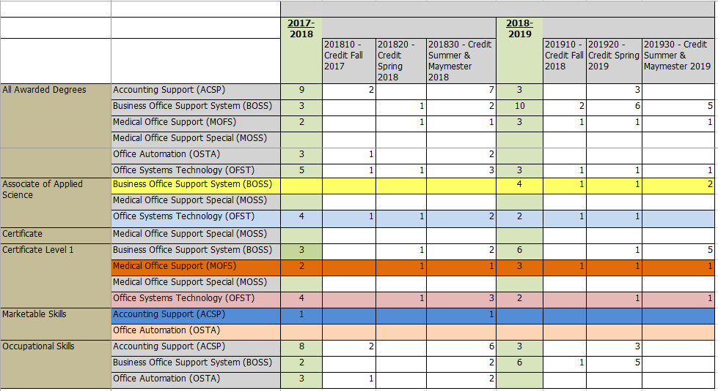
Over the past five years, the BOSS program has offered an AAS degrees and certificates. These are mostly comparable to some of our competitors. Some of the data is showed in the table above.
The AAS degree is called the Business Office Support System (BOSS) and consists of 60 credit hours. The certificates are listed below:
* Business Office Support System and Medical Office Support Specialist (note: Office Systems Technology is the old name)
* Accounting Support is the Marketable Skills Award
The certificates allow a student to start with one or more classes to get started in the program even while a student works because all of our courses are offered online. (and we have a face-to-face Introduction to Accounting course – ACNT 1303) In addition, a student can use the certificate hours to count toward an associate’s degree if the student decides to take more classes toward our program.
Over the past five years, there was a total of 111 completers or graduates. There were 25 completers in (2016), 17 completers in (2015-16), 28 completers in (2016-17), 22 completers in (2017-18), and 19 completers in (2018-19).
Year 2014 | 2015 – 16 | 2016 – 17 | 2017 – 18 | 2018 – 19
25 | 17 | 28 | 22 | 19

4. Why we do the things we do: Program relationship to market demand
Make a case with evidence to show that employers need and hire the program’s graduates.
Some resources to utilize for information could be: Texas Workforce Commission, JobsEQ, O-Net, TexasLMI
Suggested/possible points to consider:
  - How many program-related, entry-level jobs are available in the DFW Metroplex for people with an associate’s degree or certificate? If the majority of related jobs in the DFW Metroplex require a baccalaureate degree, provide evidence that you have a current signed articulation agreement with one or more transfer institutions or that you plan to develop one.
  - What proportion of the program’s graduates found related employment within six months of graduation?
  - How do salaries of program completers compare to those for high school graduates and baccalaureate holders?
- What changes are anticipated in market demand in the next 5 years? Do program completers meet, exceed, or fall short of local employment demand? How will the program address under- or over-supply?

- Identify and discuss the program’s strengths and weaknesses related to market demand

The amount of entry-level jobs available in the DFW Metroplex depends on the market and location. Our program referenced three different job resources regarding the associate degree requirements. LinkedIn returned 770 jobs with 53 entry level jobs filtered in the search. Monster.com returned 318 jobs with 20 entry level jobs filtered during the search. Indeed returned 832 jobs with 61 entry level jobs filtered in the search. Because we graduate on average 21 students per year, there are jobs available for students who want local jobs. (see the table below for jobs and geographic range)

Job Website | Total Jobs | Entry-level job | Time Range | Geographic range / location
LinkedIn.com | 770 | 53 | Within 30 days of 1-19-2020 | With 30 miles of Frisco, TX
Monster.com | 318 | 20 | Within 30 days of 1-19-2020 | With 30 miles of Frisco, TX
Indeed.com | 832 | 61 | Within 30 days of 1-19-2020 | With 30 miles of Frisco, TX

Note: common titles from the job websites in the table above included:
- Executive assistant
- Administrative assistant
- Legal administrative assistant
- Receptionist
- Data entry clerk
- Office support assistant, Lead office administrator, and Office manager

Jobs that require at least a high school diploma | Jobs that require an associate’s degree | Jobs that are not necessarily degree requirements | Total
1,202 | 143 | 1,112 | 2,457

***According to the source JobsEQ based on data from job postings for DFW Metropolitan area for the 30-day period ending 11/24/2019, below are the jobs posting for people with an associate degree or certificate:

- 1,202 office administration jobs that require at least a high school diploma
- 143 office administration jobs that require an associate’s degree
- 1,112 job postings that list other qualifications that are not necessarily degree requirements
- 2,457 is the approximate total jobs that are available to people with an associate’ degree or certificate
In the next 5 years, market demand is expected to grow as Collin County adds to its population. Program completers meet the market demand. BOSS skills are foundational for most businesses and organizations. Collin College and local employers has chosen to hire a few BOSS graduates, validating the value of the program to the College. Approximately 95% of graduates have jobs within 6 months of graduation according to data sheets that we collect from students. Some students have personal issues that prevent them from acquiring a job after graduation.
• Starting salary can be determined by a set limit, according to skills demonstrated, or higher because of respect for a completed college credential. Salary variance is determined by the employer. In general, it does seem that BOSS graduates are more competitive for higher-paying positions with benefits.
According to JobsEQ (http://www.chmuraecon.com/jobseq) Dallas-Forth Worth – Arlington, TX – Marketable Skills Occupation Report
The average (mean) annual wage for Executive Secretaries and Executive Administrative Assistants was $62,200 in the Dallas-Fort Worth-Arlington, TX – Marketable Skills as of 2018. For the same year, the average entry level wages were approximately $43,900 compared to an average of $71,400 for experienced workers.
• Skilled BOSS graduates seem to have no difficulty gaining employment, if that is their objective. The BOSS program includes job hunting guidance. However, BOSS students who struggle through classes, personal issues, needing extensive tutoring, carry those same personal traits to the employment application experience and can find employment more challenging.

Section II. Are We Doing Things Right?

5. How effective is our curriculum, and how do we know?

A. Make a case with evidence that there are no curricular barriers to completion. Review data related to course enrollments, course retention rates, course success rates, and the frequency with which courses are scheduled to identify barriers to program completion.
Suggested/possible points to consider:
- Number of students who completed the program awards in each of the last 4 years? If the number of graduates does not average 5 or more per year, describe your plan to increase completions and address this issue in the Continuous Improvement Plan (CIP).
- At what point(s) are substantive percentages of students dropping out of the program? Use data in the “Program-Based Course Performance” tool to examine enrollment flow through the program curriculum. Does the data suggest any curricular barriers to completion? Address problems in the CIP.
- Review course enrollment patterns, course retention rates, course success rates, and the frequency with which courses are scheduled to identify barriers to program completion. Address problems in the CIP.

B. Show evidence that the institutional standards listed below have been met. For any standard not met, describe the plan for bringing the program into compliance.

- Completers Standard: Average 25 completers over the last five years or an average of at least five completers per year.
Number of completers: 111 in last five years.
If below the state standard, attach a plan for raising the number of completers by addressing barriers to completion and/or by increasing the number of students enrolled in the program. Definition of completer—Student has met the requirements for a degree or certificate (Level I or II)
- Licensure Standard: 90% of test takers pass licensure exams.
If applicable, include the licensure pass rate: Not Applicable. Employers require high schools diploma or associates degree more often than certifications. For any pass rate below 90%, describe a plan for raising the pass rate.

- Retention Standard: 78% of students enrolled in program courses on the census date should still be enrolled on the last class day (grades of A through F).
Include the retention rate: 94% (source: Collin IRO – Grade Distribution Report – Completion Rate column - average for all courses: IRO\ProgramReviewData\FY2020\FilesToPost
If the retention rate is below 78%, describe a plan for raising the course completion rate.

C. Make a case with evidence that the program curriculum is current.
Suggested/possible points to consider:
- How does the program curriculum compare to curricula at other schools? Review programs at two or more comparable colleges. Discuss what was learned and what new ideas for improvement were gained.
- How does the program curriculum align with any professional association standards or guidelines that may exist?
- Is the curriculum subject to external accreditation? If so, list the accrediting body and the BOSS recent accreditation for your program.
- If the program curriculum differs significantly from these benchmarks, explain how the Collin College curriculum benefits students and
other college constituents.

- The program’s curriculum is comparable to local colleges 1) Dallas County Community College, (2) Tarrant County College, and (3) Austin Community College according to their websites searched during January 2020.

- Most of the other college’s courses names are the same or similar to the courses listed in our certificates and degrees. For example, Dallas County Community College has certificates in Administrative Specialist Certificate and a Business Office Specialist.

Comparison of Course Offerings with Collin College’s Comparable Programs
Skill-based courses | Collin AAS | Dallas Community College | Tarrant County College | Austin Community College
Records & Information Management | POFT 1319 - Records & Information Management I | POFT 1319 - Records & Information Management I | POFT 1319 - Records & Information Management I | NA
Beginning Keyboarding | POFT 1329 – Beginning Keyboarding | POFT 1329 – Beginning Keyboarding | POFT 1329 – Beginning Keyboarding | POFT 1127 – Introduction to Keyboarding
Intermediate Keyboarding | POFT 2301 – Intermediate Keyboarding | POFT 2301 – Intermediate Keyboarding | NA | NA
Skill-based courses | Collin AAS | Dallas Community College | Tarrant County College | Austin Community College
Speed and Accuracy | POFT 2302 – Speed and Accuracy Building | NA | NA | POFT 2203 – Speed and Accuracy Building
Word Processing | POFI 2301 – Word Processing – MS Word | POFI 2301 – Word Processing – MS Word | POFI 2401 – Word Processing | POFI 2301 – Word Processing – MS Word I
Spreadsheets | ITSW – Introduction to Spreadsheets – Excel | POFI – 1349 - Spreadsheets | POFT 1449 - Spreadsheets | POFI 1349 – Spreadsheets - Excel
Presentation Graphics Software | ITSW – Introduction to Presentation Graphics Software | POFT 1328 – Business Presentations | NA | ITSW 1310 – Introduction to Presentation Graphics Software - PowerPoint
Database Software | ITSC 1309 – Integrated Software Applications (includes MS Access) | ITSW 1407 – Introduction to Database | ITSW 1407 – Introduction to Database | POFI 2350 – Databases: Access
Integrating Software | ITSC 1309 – Integrated Software Applications – MS Office | POFT 1301 Computer Apps I and POFT 1341 Computer Apps II | NA | POFI 1372 - Integrated Computer Applications
Business Communication | POFT 2312 – Business Correspondence and Communication | POFT 2312 – Business Correspondence and Communication | POFT 2312 – Business Correspondence and Communication (Capstone) | POFT 2312 – Business Correspondence and Communication
Introduction to Accounting | ACNT 1303 – Introduction to Accounting I | NA | ACNT 1303 – Introduction to Accounting I | NA
Computerized Accounting | ACNT 1311 – Computerized Accounting | NA | ACNT 1311 – Computerized Accounting | NA
Administrative Office Procedures (Capstone) | POFT 1349 – Administrative Office Procedures | POFT 1309 – Administrative Office Procedures | POFT 1409 – Administrative Office Procedures | POFT 1309 – Administrative Office Procedures
Cooperative Education or Internship | POFT 1380 – Cooperative Education – Admininstrative Assistant and Secretarial Science, General  Elective course (some of our students already have a job in their major)  If not, students can enroll in the Cooperative Education course as an elective: POFT 1380 – Cooperative Education – Admin. Assistant and Secretarial Science, General | POFT 1380 or POFT 1382 - Cooperative Education | NA | POFT 2286 – Internship Administrative Assistant/Secretarial Science, General
Source: www.dcccd.edu, www.collin.edu, www.tccd.edu, and www.austincc.edu

What was learned and what new ideas for improvement were gained (see below)
There are some courses offered by Collin College that are not offered by comparable colleges. For example, our program offers the accounting courses ACNT 1303 – Introduction to Accounting I and ACNT 1311 – Computerized Accounting – Quickbooks. These courses were recommended by the advisory committee because local employers need office workers who have accounting and QuickBooks skills.

There are other courses that are offered by comparable colleges that are not offered in our program because of differences in the job market. For example, Dallas County Community College offers the course ITSC 1315 – Project Management Software. However, Collin’s capstone course POFT 1349 requires students to practice project management in the course because students are given several projects throughout the semester require time management and project management skills.

Collin’s BOSS program have some of the same courses, credit hours, and similar certificates and degrees. The main difference is that Dallas County Community College has a Virtual Assistant Skills Achievement Award which is 12 credit hours and requires an e-commerce course. Collin’s BOSS students have an elective course that would allow them to take an e-commerce course if so desired by students.
The program plans to ask the advisory committee if having certificates like Dallas will be feasible. We can pursue creating a new certificate over the next several years.

- The program aligns with the professional association standards of the International Association of Administrative Professionals (IAAP) because the textbook that we use for our capstone course POFT 1349 is used as a study guide by administrative professionals to study for their professional certification (according to the IAAP website). Faculty attend IAAP events each semester, and there is an IAAP member on the BOSS advisory committee for over the past five years, Trevellya Tyson, Director of IAAP TX/LA region. Also, the textbook that the BOSS program uses for the capstone course POFT-1349 – Administrative Office Procedures in the program is actually one of the many suggested study guides to sit for the certified administrative professional certification for students who have the experience, education, and funds. (source: www.iaap-hq.org)

The BOSS program is not subject to external accreditation. Most local companies require a high school diploma or associate degree for entry level positions. (source: JobsEQ – http://www.chmuraecon.com/jobseq)

D. Present evidence from advisory committee minutes, attendance, and composition that the advisory committee includes employers who are actively engaged on the committee and who are representative of area employers.
1. How many employers does your advisory committee have? __________10_________
2. How many employers attended the last two meetings? ____6_______
3. How has the advisory committee impacted the program over the last five years (including latest trends, and insights into latest technologies)?
- The committee has impacted the program by sharing their own workplace experiences that we can relay to students what to expect in the workplace. For example, after attending an Intl. Association of Administrative Professionals (IAAP) conference, I implemented a course assignment that included several of the topics covered at the conference into our POFT 1349 capstone course such as securing files in the workplace and the best practices of coordinating a conference. (POFT 1349 – Admin. Office Procedures – course is our program’s capstone course)
- Below are a few trends that have been mentioned by the advisory committee:
  - Office Administrators have to train others (such as onboarding new employees)
  - Be able to quickly learn apps and gadgets such as smart devices
  - Expect to work in shared office spaces in some workplaces
  - Team work is emphasized and expected
  - Securing documents in the office, in e-mails and other media are a must (such as not opening phishing e-mail)
  - Meeting **online** is becoming more common via videoconference such as Zoom or other meeting apps

4. Briefly summarize the curriculum recommendations made by the advisory committee over the last five years.

- Change the name of the program from Office Systems Technology (OST) to the new name Business Office Support Systems (BOSS)….adding the word “business” in the program name may attract more students because business is common major that students choose
- Eliminate POFI 2331 – Desktop Publishing due to low enrollment and allows students to have an elective in their degree plan. Also, desktop publishing is taught in other classes with the advance in software features to automate via templates such as brochures, flyers, etc.
- There were suggestions of including computer security and social media courses into the BOSS program, but later it was advised that these topics could be covered in courses already being offered.

E. For any required program courses where there is a pattern of low enrollment (fewer than 15 students), explain your plan to grow enrollment and/or revise the curriculum.
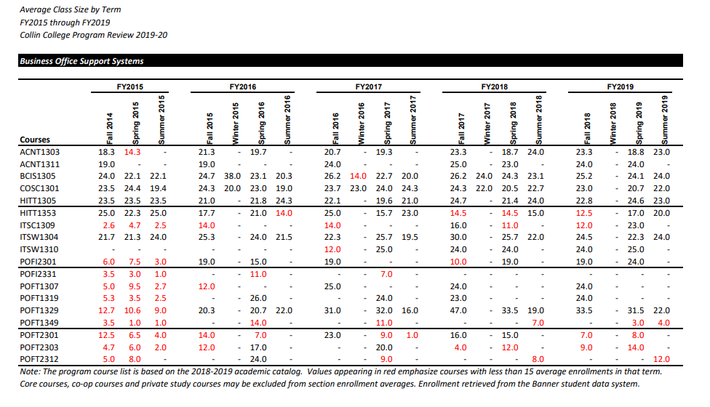
In the table above, courses that have low enrollment (indicated in red) are usually combined with another course to make the faculty load and to allow students to enroll in the course to get closer to completion of their certificate or degree. Our plans to grow these courses include: 1) faculty will continue to participate at Super Saturday events to recruit high schools students and/or their family members, 2) faculty will continue to attend quarterly meetings with local office administrative professionals (via International Association of Administrative Professionals or IAAP) to recruit working adults who want to add a certificate or degree to their credentials, and 3) our program plans to work with non-credit courses via Collin College’s continuing education to determine which of our credit courses can be merged to improve enrollment in our courses.

F. Make a case with evidence that the program is well-managed.

Suggested/possible points to consider: (Data elements can be found on CougarWeb under Workplace>Institutional Effectiveness>Program Review>Institutional Research Files for Program Review [in the right-hand column].)
- Average class size
- Unduplicated, actual, annual enrollment data
- Grade distributions
- Contact hours taught by full-time and part-time faculty
- Identify all courses that have a success rate below 75%. If any of these are core courses, visit with the discipline lead for the course(s) in question to determine whether or not the content of the course(s) is appropriate to the workforce program outcomes. Using assessment evidence and instructor observations, identify the student learning outcomes that are the greatest challenges for students in courses with low success rates. Explain what instructional and other intervention(s) might improve success rates for each identified course.
- How well are general education requirements integrated with the technical coursework?
- Student satisfaction: What evidence do you have that students are satisfied with the program? What kinds of complaints are made to the associate dean/director by program students?

Contact Hours Taught by Full-Time and Part-Time Faculty
Year | 2015 | 2016 | 2017 | 2018 | 2019
Full-time faculty | 100% | 100% | 100% | 100% | 51%
Part-time faculty | NA | NA | NA | NA | 49%
Source: Collin IRO/Program Review Data

Contact hours taught by full-time faculty for the years 2015 through 2018 were a 100% taught by the two full time faculty: Linda Thompson and Angela Payne. One full-time time faculty (Thompson) retired recently. For the year 2019, the full-time faculty (Payne) teaches 51% of contact hours and 49% of the contact hours are taught by part-time faculty.

Student Satisfaction and Complaints: Our students and community are pleased with our BOSS program based on student evaluations and the fact that Collin College has hired some of our BOSS graduates. In addition, our graduates work at local employers. Just a few are mentioned:
- JCPenny, 1st in Smiles, and Hope Center
- Plano Medical, Denton County, Hunters Glen Baptist Church
(source: collected student data sheets in our Canvas learning management system)
Complaints have been about students not having enough time in their lives to work and go to school, cost of books, and wanting a tutor for our computerized accounting course (QuickBooks). To resolve lack of tutors, instructors offer extra office hours each semester because it is challenging to find a QuickBooks tutor during the daytime when some students want the tutoring.
General Education Courses (skills used in our program courses) | Technical Course that Integrates General Education into the course
English (writing, typing business files, and preparing presentations) | Business Correspondence, Beginning Keyboarding, Intermediate Keyboarding, MS Office Courses, and Admin. Office Procedures
Math and Economics (calculating and critical thinking) | Introduction to Accounting and Computerized Accounting

General education requirements are integrated well with the technical coursework. English, economics, speech communication, and math is integrated into various courses as shown in the table above. For example, students are required to write using correct grammar in our business correspondence, keyboarding, and office procedures courses. In addition, students use math skills and critical thinking skills in our accounting courses and computerized accounting courses.
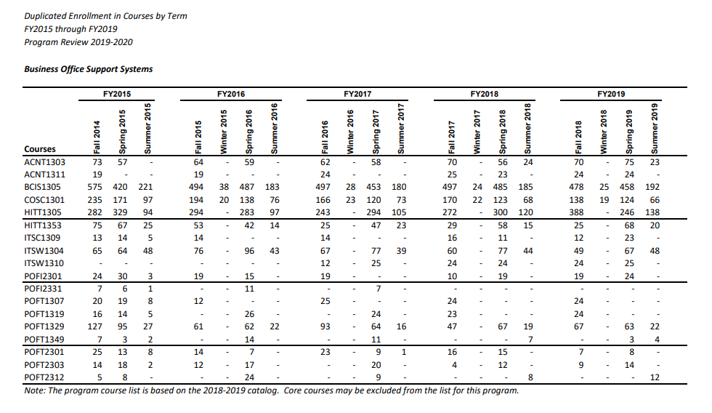
Explanation of Table above: There are duplicated course enrollments to try to meet the demand of BOSS students. Some students have to sit out a semester due to personal reasons. (based on the comments on our rosters when a student drops a course) Therefore, we offer numerous classes spring, fall, and summer. In addition, we have students who may need a course to graduate.

- Note: Classes that have low enrollment are usually combined with another class to make the faculty load and to allow students to enroll in the class to get closer to completion of their certificate or degree.

- Please see chart below for OTHER EXPLANATION of the numbers above

source: Enrollment numbers:

Enrollment is stable, with larger numbers in times of unemployment and resulting retraining and lower numbers when employment is readily available and the economy is better. In addition, our program participate in high school students’ recruitment via the college’s Super Saturday events that occur once per month at our various campuses. Also, the discipline lead attends events held by the International Association of Administrative Professionals (IAAP) to network and distribute information about our program and courses.

Enrollment does allow required courses to be offered within a 2-year cycle and usually more often. The department goal is for a student to be able to complete a certificate in one academic year. BOSS online advising is available to guide students concerning course sequence and combinations for completion and success. If enrollment patterns continue, the program should remain stable and very beneficial to the community.
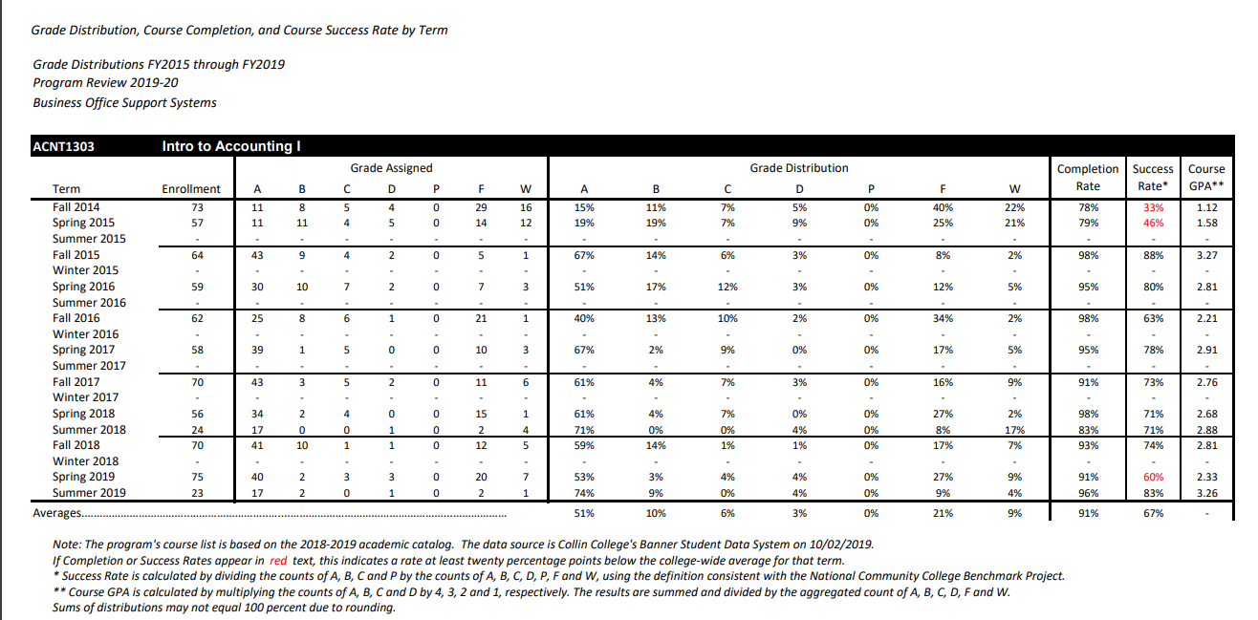

As shown in the Table above (“Grade Distribution”), the ACNT 1303 Introduction to Accounting course has had a few low success rates. Most of the low grades are due to student dropping a course or not completing course work due to personal reasons. Students have been offered many resources to help with the success rate: free tutoring, 3-day grace-period for turning in work, videos, powerpoints, and a few extra credit assignments. The program will look at reducing the work load in the upcoming semesters in terms of number of assignments per chapter without reducing the quality of the course. The program has already reduced the number of assignments in some chapters.

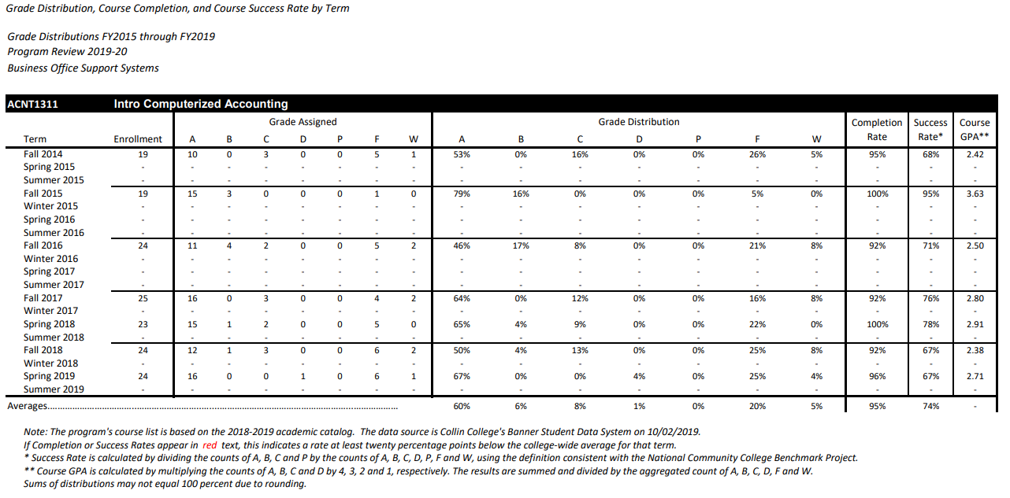
As shown in the Table above (“Grade Distribution”), the ACNT 1311 Introduction to Accounting course has had a few low success rates. Most of the low grades are due to student dropping a course or not completing course work due to personal reasons. The textbook was changed to a more user-friendly book. Students have access to resources to help with their success rate: 3-day grace-period for turning in work, videos, powerpoints, and a few extra credit assignments. In addition, the program has already reduced the number of assignments in some chapters due to students’ time constraints of managing college and personal responsibility.
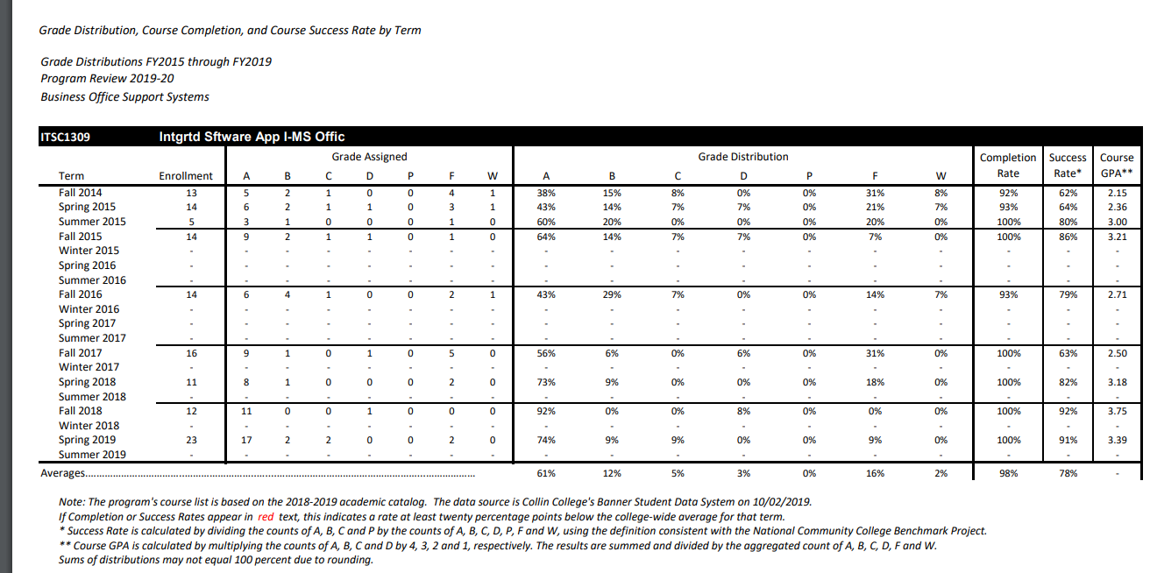

As shown in the Table above (“Grade Distribution”), the ITSC-1309 Integrated Software App – MS Office course has had a few low success rates. Most of the low grades are due to student dropping a course or not completing course work due to personal reasons. The textbook was changed to a more user-friendly learning tutorial with immediate grading for some projects. Students have more access to resources to help with their success rate: 3-day grace-period for turning in work, videos, and a few extra credit assignments. In addition, the program has already reduced the number of assignments in some chapters due to students’ time constraints of managing college and personal responsibility.

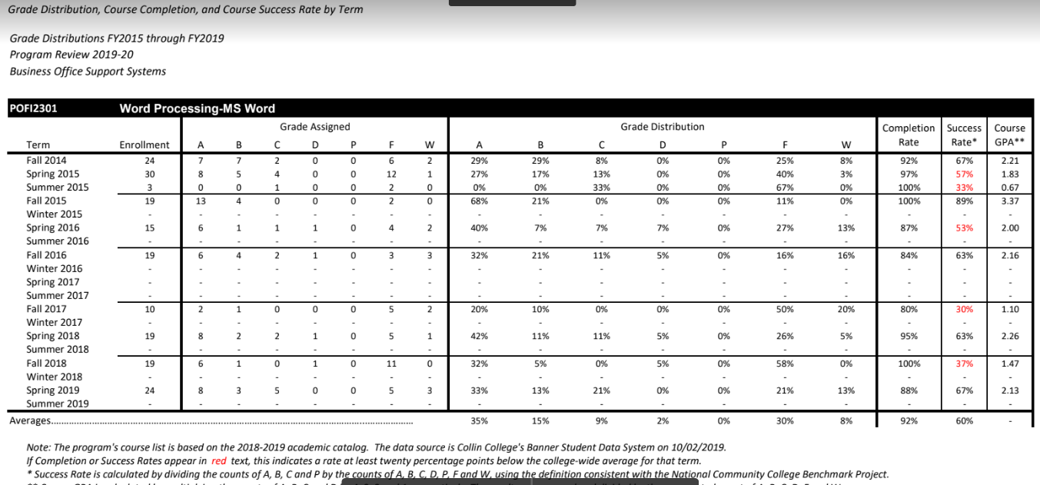

As shown in the Table above (“Grade Distribution”), the POFI-2301 – Word Processing – MS Word course has had several semesters of low success rates. Some of the low grades are due to students dropping a course or not completing course work due to personal reasons. The textbook was changed to a more user-friendly learning tutorial, web-based learning system with immediate grading for some assignments. Students have more access to resources to help with their success rate: a grace-period for turning in work and instructional videos. In addition, there is tutoring available through Collin College tutoring services.

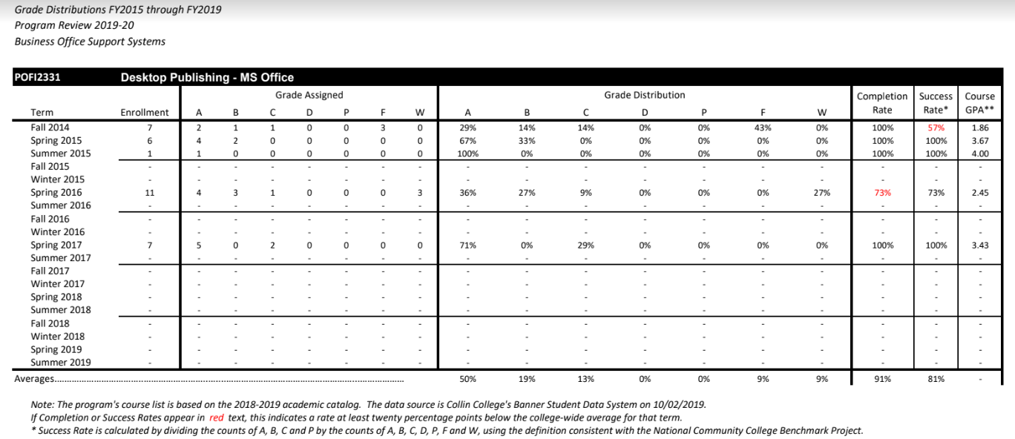

As shown in the Table above (“Grade Distribution”), the POFI-2331 – Desktop Publishing – MS Office course has had several semesters of low success rates. Some of the low grades are due to students dropping a course or not completing course work due to personal reasons. The textbook was changed to a more user-friendly learning tutorial, web-based learning system with immediate grading for some assignments. Students have more access to resources to help with their success rate: a grace-period for turning in work and instructional videos. In addition, instructors are available to help students during their office hours.

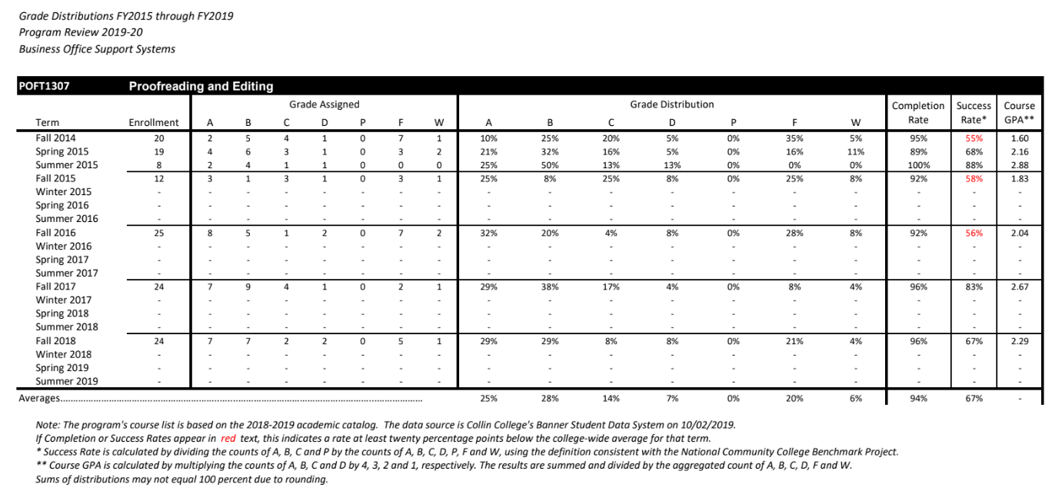
As shown in the Table above (“Grade Distribution”), the POFT – 1307 – Proofreading and Editing course has had several semesters of low success rates. Some of the low grades are due to students dropping a course or not completing course work due to personal reasons. The textbook was changed to a more user-friendly learning tutorial, web-based learning system with immediate grading for some assignments. Students have more access to resources to help with their success rate: a grace-period for turning in work and instructional videos. In addition, instructors are available to help students during their office hours.

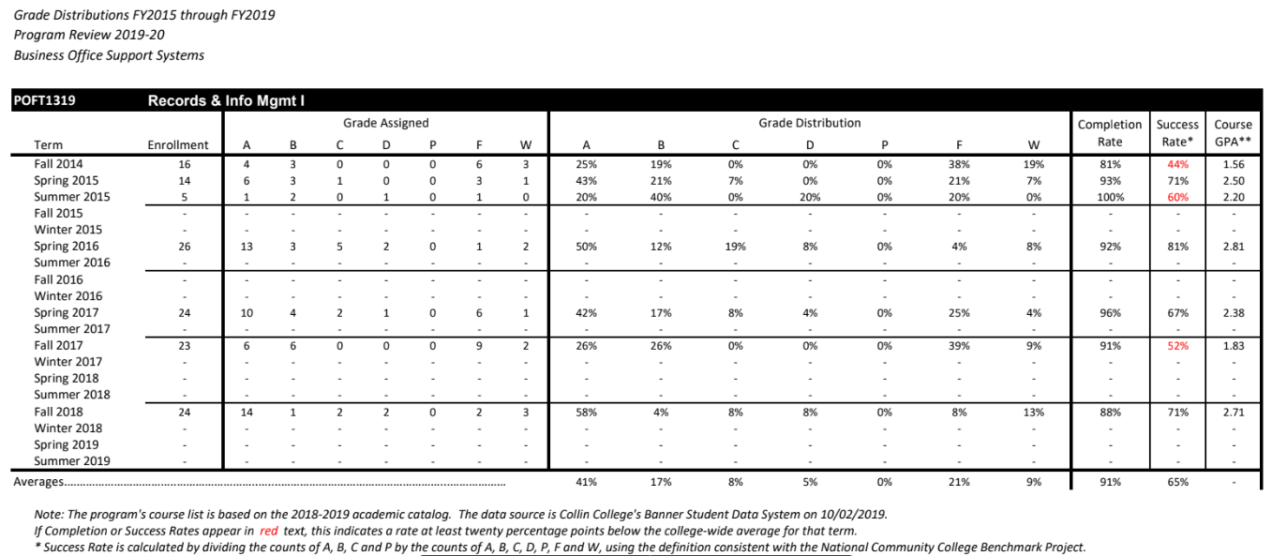

As shown in the Table above (“Grade Distribution”), the POFT 1319 – Records & Info Mgmt I course has had several semesters of low success rates. Some of the low grades are due to students dropping a course or not completing course work due to personal reasons. The textbook was changed to a more user-friendly learning tutorial, web-based learning system with immediate grading for some assignments. Students have more access to resources to help with their success rate: a grace-period for turning in work and instructional videos. In addition, instructors are available to help students during their office hours.

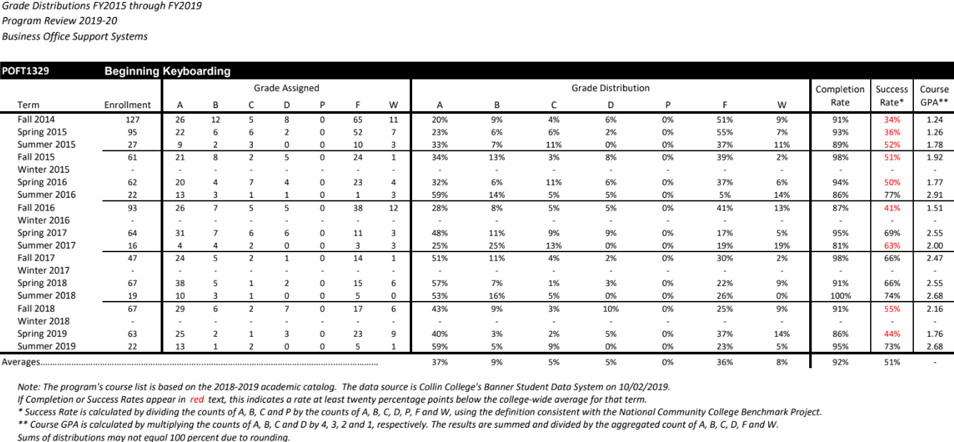
As shown in the Table above (“Grade Distribution”), the POFT 1329 – Beginning Keyboarding course has had several semesters of low success rates. Some of the low grades are due to students dropping a course or not completing course work due to personal reasons. The textbook was changed to a more user-friendly learning tutorial, web-based learning system with immediate grading for some assignments. Students have more access to resources to help with their success rate: a grace-period for turning in work and instructional videos. In addition, instructors are available to help students during their office hours.

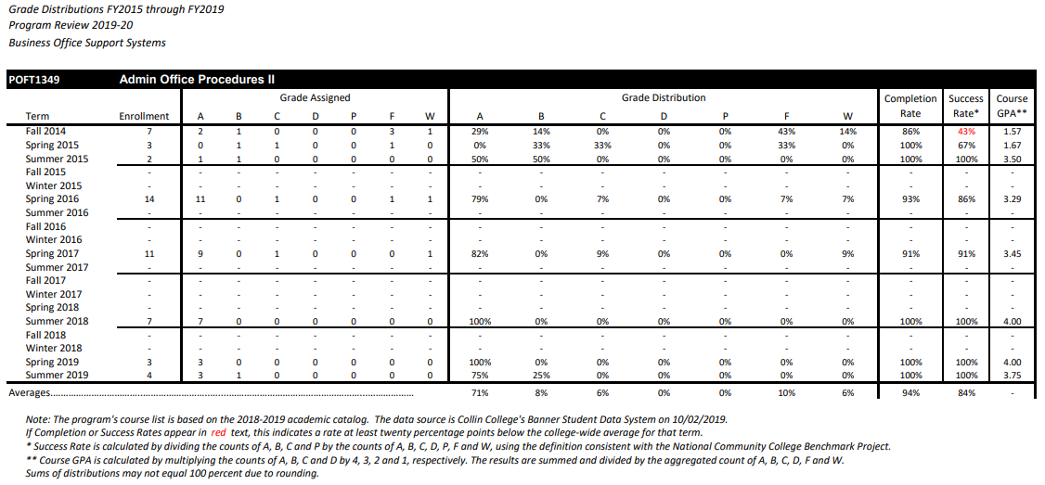
As shown in the Table above (“Grade Distribution”), the POFT 1349 – Administrative Office Procedures II course has had several semesters of low success rates. Some of the low grades are due to students dropping a course or not completing course work due to personal reasons. The textbook was changed to a more user-friendly learning tutorial, web-based learning system. Students have more access to resources to help with their success rate: a grace-period for turning in work, a few extra credit assignments, and instructional videos. In addition, instructors are available to help students during their office hours.

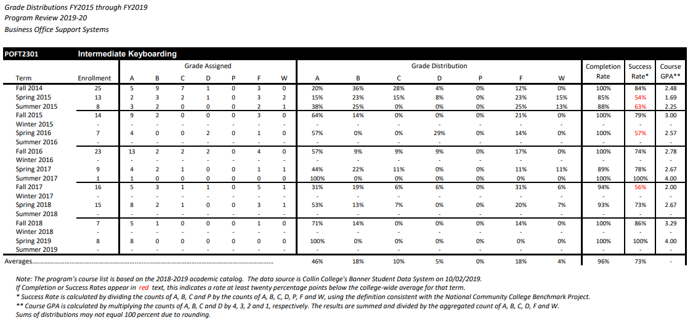
As shown in the Table above (“Grade Distribution”), the POFT 2301- Intermediate Keyboarding course has had several semesters of low success rates. Some of the low grades are due to students dropping a course or not completing course work due to personal reasons. The textbook version was updated to a more user-friendly learning tutorial, web-based learning system. Students have more access to resources to help with their success rate: a grace-period for turning in work and instructors are available to help students during their office hours.

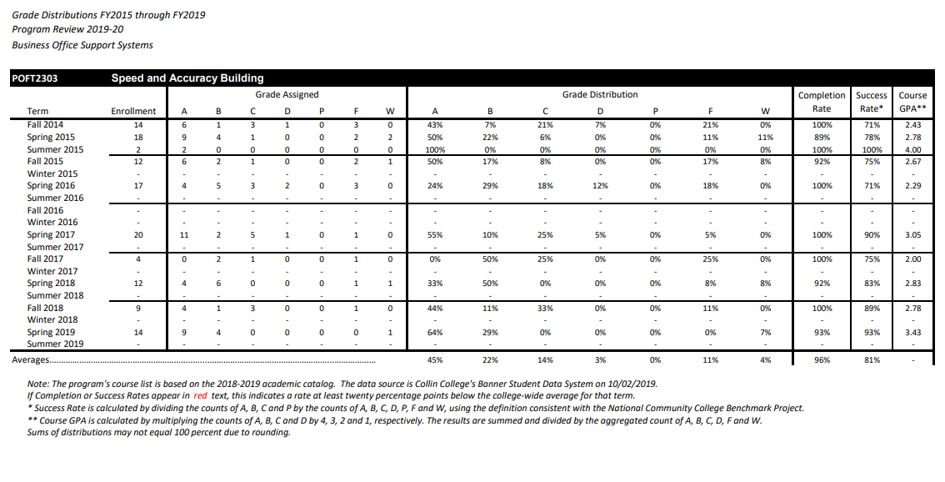
As shown in the Table above (“Grade Distribution”), the POFT 2303 – Speed and Accuracy Building course has had several semesters of low success rates. Some of the low grades are due to students dropping a course or not completing course work due to personal reasons. The textbook version was updated to a more user-friendly learning tutorial, web-based learning system. Students have more access to resources to help with their success rate: a grace-period for turning in work and instructors are available to help students during their office hours.

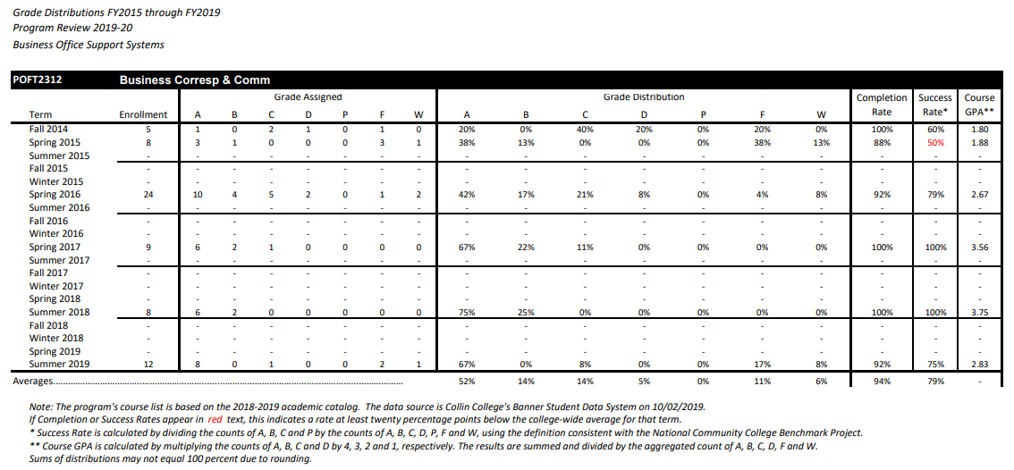
As shown in the Table above (“Grade Distribution”), the POFT 2312 – Business Correspondence & Communication course has had several semesters of low success rates. Some of the low grades are due to students dropping a course or not completing course work due to personal reasons. The textbook version was updated to a more user-friendly learning tutorial, web-based learning system. Students have more access to resources to help with their success rate: a grace-period for turning in work, instructional videos, and instructors are available to help students during their office hours.

6. How effectively do we communicate, and how do we know?

A. Make a case with evidence that the program literature and electronic sites are current, provide an accurate representation of the program, and support the program’s recruitment plan, retention plan and completion plan.
Suggested/possible points to consider:
- Demonstrate how the unit solicits student feedback regarding its website and literature and how it incorporates that feedback to make improvements.
- Designate who is responsible for monitoring and maintaining the unit’s website, and describe processes in place to ensure that information is current, accurate, relevant, and available.

B. In the following Program Literature Review Table, document that the elements of information listed on the website and in brochures (current academic calendars, grading policies, course syllabi, program handouts, program tuition, additional fees, description of articulation agreements, availability of courses and awards, and local job demand in related fields) were verified for currency, accuracy, relevance, and are readily available to students and the public.

Program Literature Review Table
Title | Type (i.e. URLs, brochures, handouts, etc.) | Date of Last Review/Update |  | Responsible Party
www.collin.edu/academics/programs/  BOSS_1Overview.html | Program URL | Fall 2019 | Current  Accurate  Relevant  Available | College WebMaster
www.Collin.edu/department/boss | BOSS URL | 11-23-2019 | Current  Accurate  Relevant  Available | Angela Payne
Business Office Support Systems | BOSS Flyer/ Info. Sheet | Fall 2019  (located at the BOSS website) | Current  Accurate  Relevant  Available | Angela Payne

7. How well are we leveraging partnership resources and building relationships, and how do we know?
Partnership Resources: On the table below, list any business, industry, government, college, university, community, and/or consultant partnerships, including internal Collin departments, to advance the service unit outcomes.

Partnership Resources Table
Partner | Description (See Points to Consider) | How is it Valuable to the Program
University of North Texas (UNT) | For example, BOSS has long had an agreement in place with the University of North Texas for BOSS associate degree graduates to continue bachelor’s degree course work such as the UNT degree: Information Science and Knowledge Organization degree. | Student with associate degrees have access to a bachelor’s degree.
Local High Schools and Universities | BOSS participates in agreements with area high schools and universities for high school to college and college to university pathways. History includes faculty participation in tech prep programs with area high schools. | High School students can earn college credit while in high school allowing them to complete their college courses earlier.

8. What professional developmental opportunities add value to your program? Provide a List of professional development activities employees have participated in since your last program review.

Employee Name | Role in Program | Professional Development Summary | How is it Valuable to Program
Linda Thompson | Professor (1990 – 2019) | See Table Below | Discipline Lead (2014 – 2019)
Angela Payne | Professor (2014 – Present) | See Table Below | Discipline Lead (2019 – Present)
Employee Resources Table
**For convenience, if providing a listing of professional development activities, this list may be included in this document as an appendix.

Professional Development (Angela Payne) (Professor 2015 – Present) (Discipline Lead – Fall 2019 – Present)
- Trained by college webmaster **I was able to developed and maintain the website for the office support systems program
- Developed the brochure for our program (researched content and layout)
- Trained and attended Faculty and Staff at Collin College’s Faculty Development Workshops (2015 - 2019)
- Trained as an Academic Coach **Improved my advising skills and resource knowledge to share with students
- Trained by ELC on Blackboard and Canvas **Create and maintain course websites via Blackboard and Canvas learning management systems (LMS); implemented Connect and SimNet Simulation Tutorials by McGraw Hill
- Research and test-out various publishers’ smart books and assessment tools; **Helped me to appropriately recommend for textbooks and smart books for various courses
- Participate on committees (Career Fair, Earth day, etc.) **Met potential students and recruited advisory committee members
- Texas Distance Learning Association (TXDLA) 2016 – 2019 (Learned numerous technology and implemented into the classroom)
- National Institute for Staff & Organizational Development (NISOD) – Presented “Getting Published Online”
May 2019
- NISOD – Webinar “CHEERS Teaching Strategy” – October 2018 (presentation)
- Assisted with the welcome table during the 1st week of classes for several semesters
- Earned Certification as a Microsoft Office Specialist (MOS) – Microsoft Word 2016
- Wrote E-book “Games & CHEERS Teaching Strategy and Presentation Tips” - July 2019 (via Amazon)
- Super Saturdays (setup tables & activities at several Collin campuses to help recruit high school students) 2015-2019
- Note: TXDLA is Texas Distance Learning Association; NISOD is National Institute for Staff & Organizational Development

Professional Development (Linda Thompson) (Professor 1990 – 2019) (Discipline Lead – 2014 - Spring 2019)
- Attended Faculty Development workshops
- Assisted with Developed of the brochure for the program
- Trained as an Academic Coach **Improved her advising skills and resource knowledge to share with students
- Trained by ELC on Blackboard and Canvas **Create and maintain course websites via Blackboard and Canvas learning management systems (LMS); implemented Connect and SimNet Simulation Tutorials
- Research and test-out various publishers’ smart books and assessment tools; **Helped to appropriately recommend for textbooks and smart books for various course
- Participated on committees (Hiring, Recruitment, etc.) **Met potential students and recruited advisory committee members
- TXDLA 2016 – 2019 (Learned numerous technology and implemented into the classroom)

9. Are facilities, equipment, and funding sufficient to support the program? If not, please explain.
[OPTIONAL—Only respond to prompt 9 if you are requesting improved resources for your program. If current facilities and budget are adequate, please proceed to prompt 10.]

Make a case with evidence that current deficiencies or potential deficiencies related to facilities, equipment, maintenance, replacement, plans, or budgets pose important barriers to the service unit or student success. As part of your response, complete the resource tables, below, to support your narrative.
Possible points to consider:
- The useful life of structure, technologies and equipment
- Special structural requirements
- Anticipated technology changes impacting equipment sooner than usual

Equipment/Technology Table
Significant Pieces of Equipment | Description  (i.e. Special Characteristics) | Meets Needs (Y or N):  Current For Next 5 Years |  | Analysis of Equipment Utilization
Not Applicable | Resources Available in Course Materials

Financial Resources Table
Source of Funds  (i.e. college budget, grant, etc.) | Meets Needs (Y or N):  Current For Next 5 Years |  | For any no in columns 2 or 3, explain why | For any no in columns 2 or 3, identify expected source of additional funds
Not Applicable
Resources Available in Course Materials
Section III. Continuous Improvement Plan (CIP)
10. How have past Continuous improvement plans contributed to success?
Program Review at Collin College takes place for each unit or program every five years. During the last (fifth) year, the program evaluates the data collected during the CIP process.
Please describe how you have used your continuous improvement plan (CIP) to make the following improvements to your program over the past 4 years (your last program review can be found on the Program Review Portal):
  - Student Learning Outcomes
  - Overall improvements to your program
SEE APPENDIX for CIP Table
*Please attach previous CIP Tables in the appendix

11. How Will we evaluate our success?
NOTE: Please contact the institutional effectiveness office if you need assistance filling out the CIP tables.
As part of the fifth year Program Review, the program should use the observations and data generated by this process along with data from other relevant assessment activities to develop the program’s CIP and an action plan for the next two years. At the conclusion of the first two years, data collected from the first year, plus any other relevant data that was collected in the interim, should be used to build on the accomplishments of those first two years by developing another two-year action plan for the CIP to help the program accomplish the expected outcomes established in its CIP or by implementing one of your other plans.

Based on the information, analysis, and discussion that have been presented up to this point, summarize the strengths and weaknesses of this program. There should be no surprise issues here! This response should be based on information from prior sections of this document. Describe specific actions the faculty intends to take to capitalize on the strengths, mitigate the weaknesses, and improve student success. Provide the rationale for the expected outcomes chosen for the CIP.

12. Complete the Continuous Improvement Plan (CIP) tables that follow.
Within the context of the information gleaned in this review process and any other relevant data, identify program priorities for the next two years, including at least one student learning outcome (or program competency), and focus on these priorities to formulate your CIP. You may also add short-term administrative, technological, assessment, resource or professional development outcomes as needed.

Table 1. CIP Outcomes, Measures & Targets Table (focus on at least one for the next two years)
A. Expected Outcome(s)  Results expected in this program  (e.g. Students will learn how to compare/contrast theories; Increase student retention in PSYC 2301) | B. Measure(s)  Instrument(s)/process(es) used to measure results  (e.g. surveys, end of term class results, test results, etc.) | C. Target(s)  Level of success expected  (e.g. 80% success rate, 25 graduates, etc.)
- Students will be able to list and/or recognize the marketable skills desired in the workplace for office administrative professionals | Survey or Quiz – Plan to share the list of marketable skills with the capstone course during the semester and give them a survey or quiz. | 80% Score
- Work productively with others to achieve group goals (program competency) | Survey or Quiz – Plan to have a class do at least one group project and students will be surveyed on their experience and how they will use the information for future workplace projects. | 80% Score

Continuous Improvement Plan
Outcomes might not change from year to year. For example, if you have not met previous targets, you may wish to retain the same outcomes. You must have at least one student learning outcome. You may also add short-term administrative, technological, assessment, resource or professional development goals, as needed. Choose 1 to 2 outcomes from Table 1 above to focus on over the next two years.

A. Outcome(s) - Results expected in this program (from column A on Table 1 above--e.g. Students will learn how to compare/contrast Conflict and Structural Functional theories; increase student retention in Nursing Program).
B. Measure(s) - Instrument(s)/process(es) used to measure results (e.g. results of essay assignment, test item questions 6 & 7 from final exam, end of term retention rates, etc.).
C. Target(s) - Degree of success expected (e.g. 80% success rate, 25 graduates per year, increase retention by 2% etc.).
D. Action Plan - Implementation of the action plan will begin during the next academic year. Based on analysis, identify actions to be taken to accomplish outcome. What will you do?
E. Results Summary - Summarize the information and data collected in year 1.
F. Findings - Explain how the information and data has impacted the expected outcome and program success.
G. Implementation of Findings – Describe how you have used or will use your findings and analysis of the data to make program improvements.
Table 2. CIP Outcomes 1 & 2
- Expected Outcome #1
Students will be able to list and/or recognize our BOSS program’s marketable skills for office administrative professionals.
- Measure (Outcome #1)  A survey or quiz will be given to students to measure the outcome of students being able to recognize their marketable skills from our courses. | - Target (Outcome #1)  The targeted score is 80% success rate for the survey or quiz.
- Action Plan (Outcome #1)
Students will be provided a list of marketable skills to review early in the semester. Students will be given a survey or quiz over the marketable skills later in the semester.
- Results Summary (Outcome #1) TO BE FILLED OUT IN YEAR 2

- Findings (Outcome #1) TO BE FILLED OUT IN YEAR 2

- Implementation of Findings (Outcome #1) TO BE FILLED OUT IN YEAR 2

Table 2. CIP Outcomes 1 & 2 (continued)
- Expected Outcome #2
Students will work in teams to complete a class project.
- Measure (Outcome #2)  A survey or quiz will be given to students to measure the outcome of their team experience and how it will help them in future team work. | - Target (Outcome #2)  The targeted score is 80% success rate for the survey or quiz.
- Action Plan (Outcome #2)
Students will be provided with a class project, assigned to teams, and graded on their weekly preparation (research, meetings, reports, etc.).
- Results Summary (Outcome #2) TO BE FILLED OUT IN YEAR 2

- Findings (Outcome #2) TO BE FILLED OUT IN YEAR 2

- Implementation of Findings (Outcome #2) TO BE FILLED OUT IN YEAR 2

What happens next? The Program Review Report Pathway

- Following approval by the Steering Committee,
- Program Review Reports will be evaluated by the Leadership Team;
- Reports will be posted on the intranet prior to fall semester;
- At any point prior to Intranet posting, reports may be sent back for additional development by the department.

- Program responses to the Program Review Steering Committee recommendations received by August 1st
- Leadership Team members will work with program supervisors to incorporate Program Review findings into planning and activity changes during the next five years.

APPENDIX (see next pages)

Continuous Improvement Plan

Outcomes might not change from year to year. For example, if you have not met previous targets, you may wish to retain the same outcomes. If this is an academic, workforce, or continuing education program, you must have at least one student learning outcome. You may also add short-term administrative, technological, assessment, resource or professional development goals, as needed.

Date: 2016-17 Name of Program/Unit: Office Systems Technology
Contact name: Linda Thompson Contact email: lthompson@collin.edu Contact phone: 903-456-0888
Table 1: CIP Outcomes, Measures & Targets Table (focus on at least one for the next two years)
A. Expected Outcome(s)  Results expected in this unit  (e.g. Authorization requests will be completed more quickly; Increase client satisfaction with our services) | B. Measure(s)  Instrument(s)/process(es) used to measure results  (e.g. survey results, exam questions, etc.) | C. Target(s)  Level of success expected  (e.g. 80% approval rating, 10 day faster request turn-around time, etc.)
Demonstrate proofreading and editing competency resulting in accurate and grammatically correct documents. | POFT 1307 Proofreading and Editing exams.  Compared with POFT 1349 capstone success. | Course completion with 80% or better success.
Demonstrate printed and electronic information management according to current ARMA (American Records Management Association) rules and privacy guidelines. | POFT 1319 Records and Information Management exam performance as compared to POFT 1349 capstone success. | Course completion with 80% or better success.

Description of Fields in the Following CIP Tables:
A. Outcome(s) - Results expected in this program (e.g. Students will learn how to compare/contrast conflict and structural functional theories; increase student retention in Nursing Program).
B. Measure(s) - Instrument(s)/process(es) used to measure results
(e.g. results of surveys, test item questions 6 & 7 from final exam, end of term retention rates, etc.)
C. Target(s) - Degree of success expected (e.g. 80% approval rating, 25 graduates per year, increase retention by 2% etc.).
D. Action Plan - Based on analysis, identify actions to be taken to accomplish outcome. What will you do?
E. Results Summary - Summarize the information and data collected in year 1.
F. Findings - Explain how the information and data has impacted the expected outcome and program success.
G. Implementation of Findings – Describe how you have used or will use your findings and analysis of the data to make improvements.
Table 2. CIP Outcomes 1 & 2 (FOCUS ON AT LEAST 1)

- Outcome #1
Demonstrate proofreading and editing competency resulting in accurate and grammatically correct documents.
- Measure (Outcome #1)  Hands-on application exam scores. | - Target (Outcome #1)  Overall improvement, especially for ESL students.
- Action Plan (Outcome #1)
Focus on and review basic skills that should have been learned in secondary school and retained at the college level.
- Results Summary (Outcome #1)
92% completion rate, 64% pass rate, 56% success rate (this is one of the BOSS detailed and difficult BOSS courses required).
- Findings (Outcome #1)
ESL students continue to find the course challenging. Some students simply do not spend enough study and practice time for success.
- Implementation of Findings
Simplifying the assignments to allow more study time for each basic course component. Slowing the pace to allow more tutoring for ESL and returning adult students.

- Outcome #2
Demonstrate printed and electronic information management according to current ARMA (American Records Management Association) rules and privacy guidelines.
- Measure (Outcome #2)  Hands-on application exam scores. | - Target (Outcome #2)  Overall improvement in students understanding detailed filing rules.
- Action Plan (Outcome #2)
Seek ways to better tutor students individually and to motivate them to continue the detailed processes required by this intense course.
- Results Summary (Outcome #2)
96% completion rate, 71% pass rate, 67 success rate
- Findings (Outcome #1)
Students unable to focus well on details experience greater challenges with this course content. Our large population of busy returning adults also simply need to stay on task and spend more time in study and practice of the filing rules for better understanding.
- Implementation of Findings
Add digital student support content for assignments, allowing students to receive immediate feedback on their answers, along with video helps for better understanding and opportunities to repeat learning experiences for improvement.

