PROGRAM NAME: New Student Orientation (NSO) | AUTHORING TEAM CONTACT: Kirk D. Lee
PHONE: 972.977.1793 | EMAIL:kdlee@collin.edu

GUIDELINES
Time Frames
- Scope:
The time frame of program review is five years, including the year of the review.
Data being reviewed for any item should go back the previous four years, unless not available.
- Deadline Dates:
January 15th – Program Review Document due to Department Dean for review (Deans may require submissions at their own, earlier due date)
February 1st – Program Review Document due to Program Review Steering Committee
- Years:
Years 1 & 3 – Implement Action Plan of (CIP) and collect data
Years 2 & 4 – Analyze data and findings, Update Action Plan
Year 5 – Write Program Review of past 5 years; Write Continuous Improvement Plan (CIP) and create new Action Plan

LENGTH OF RESPONSES: Information provided to each question may vary but should be generally kept in the range
of 1-2 pages or 500-1,000 words.

EVIDENCE GUIDELINES: In the following sections, you will be asked to provide evidence for assertions made.
- Sources: This evidence may come from various sources including professional accreditation reviews, THECB, Texas Workforce Commission’s CREWS, Institutional Research Office (IRO), National Student Clearinghouse, IPEDS, JobsEQ, EMSI Career Coach, and may be quantitative and/or qualitative. If you are unfamiliar with any of these information sources, contact the Institutional Research Office at: effectiveness@collin.edu. Use of additional reliable and valid data sources of which you are aware is encouraged.
- Examples of Evidence Statements:
- Poor example: Core values are integrated into coursework. (Not verifiable)
- Good example: Core values are integrated into coursework through written reflections. (Verifiable, but general)
- Better example: Core values are integrating into coursework through written reflections asking the student to describe how s/he will demonstrate each of the core values in his or her professional life and demonstrated through service learning opportunities. (Replicable, Verifiable)

FOR MORE INFORMATION: The Program Review Portal can be found at http://inside.collin.edu/institutionaleffect/Program_Review_Process.html. Any further questions regarding Program Review should be addressed to the Institutional Research Office (effectiveness@collin.edu, 972.599.3102).

Introduction/Preface
☐EXECUTIVE SUMMARY:
Briefly summarize the topics that are addressed in this self-study, including areas of strengths and areas of concern. (Information to address this Executive Summary may come from later sections of this document; therefore, this summary may be written after these sections have been completed.) Please do not include information in this section that is not already provided elsewhere in this submission. Using the questions in the template as headings in the Executive Summary can provide structure to the overview document.
Executive Summary
The division of Student and Enrollment Services (SES) orchestrates New Student Orientation (NSO) through the Office of Student Engagement with assistance from all other areas of the SES division. NSO supports Collin’s mission of developing student skills, strengthening their character, and challenging their intellect by introducing new students to the college and providing them with an overview of the collegiate experience and an introduction to resources that contribute heavily to their academic, personal, and professional success. District partners in academic affairs, physical plant, and auxiliary services contribute to the overall success and effectiveness of New Student Orientation through direct or indirect participation and providing feedback from their unique perspectives. Prior Continuous Improvement Plans were underutilized in the planning of NSOs following the last program review resulting in fewer changes being made to the program. A review of student NSO evaluations and other data points contribute to the program’s overall effectiveness. NSO data has been collected and reported as Summer, Fall, and Spring in contrast to how the college defines an academic year as Fall, Spring, and Summer. The mandatory requirement that all First Time in College Students (FTIC) must complete orientation prior to registration has increased the demand for the program and its continuous review and refinement.

Section I. Are We Doing the Right Things?

☐1. WHAT DOES OUR UNIT DO?
What is the service unit and its context?
This section is used to provide an overview description of the service unit, its relationship to the college and the community it serves. Keep in mind the reviewer may not be familiar with your area. Therefore, provide adequate explanation as needed to ensure understanding.
Suggested/possible points to consider:
- Unit’s purpose (Include the unit’s purpose/mission statement if one exists.)
- Services and products (i.e. event coordination, reports, promotional materials, handouts, etc.)
- Service across campus/departments/district/community
- Regulatory standards the unit must meet

Unit’s Purpose
Collin College New Student Orientation (NSO) (http://www.collin.edu/gettingstarted/explore/orientation_registration.html) is a sub-component of Student Success and is an initiative designed to increase student completion and persistence and is required for all first time in college students (FTIC). The purpose of NSO is to provide new students with valuable college information, and connect them to resources that will enable them to successfully navigate the college experience. Specifically, students are informed of advising and registration processes, campus safety policies and procedures, as well as academic and social resources outside of the classroom.

Program Overview
First Time in College (FTIC) students are required to either attend the NSO session on-campus or complete NSO online prior to registering for courses. There is no charge for students to attend NSO. Each NSO (on-campus) session lasts two hours. Students are required to attend the entire session to ensure completion. Students completing the Online Orientation are able to complete this on their own schedule, generally about an hour and a half. Still, they are required to complete the entire session to receive credit. Both online and in-person orientations include presentations of a Collin College overview, Academic Advising and Registration, CougarWeb tutorial, and the District Dean of Students Office.

NSO Contact Information
- Email: orientation@collin.edu
- Phone: 972.881.5788
- Website: https://www.collin.edu/orientation/
- Website: http://www.collin.edu/gettingstarted/explore/orientation_registration.html

Program Reporting Structure

Student Ambassadors (campus based)
↓↓↓↓↓↓↓↓↓
Assistant Director of Student Engagement (campus)
↓↓↓↓↓↓↓↓
Associate Deans of Student and Enrollment Services (campus)
↓↓↓↓↓↓↓
Dean of Student and Enrollment Services (campus)
↓↓↓↓↓
Associate Vice President of Student and Enrollment Services (district)
↓↓↓↓
Vice President of Student and Enrollment Services (district)
↓↓↓
Chief Student Success Officer (district)
↓↓
Executive Vice President (district)
↓
District President

Professional & Student Staffing
- Office of Student Engagement – Frisco Campus
  - Professional Staff consists of one full-time Assistant Director of Student Engagement, one full-time Student Engagement Specialist, and one part-time Student Engagement Specialist
  - Student Staff consists of an average of 4-6 Student Assistants and 4-6 Student Ambassadors
  - Supports Technical Campus and Celina Campus NSO events
- Office of Student Engagement – McKinney Campus
  - Staff consists of one full-time Assistant Director of Student Engagement
  - Student Staff consists of an average of 6-7 Student Assistants and 3-4 Student Ambassadors
  - Supports Farmersville NSO
- Office of Student Engagement – Plano Campus
  - Staff consists of one full-time Assistant Director of Student Engagement, one full-time Student Engagement Specialist, and one part-time Student Engagement Specialist
  - Student Staff consists of an average of 5-7 Student Assistants and 5-7 Student Ambassadors
- Office of Student Engagement – Wylie Campus
  - Staff consists of one full-time Assistant Director of Student Engagement, one full-time Student Engagement Specialist, and one part-time Student Engagement Specialist
  - Student Staff consists of an average of 2-3 Student Assistants and 3-4 Student Ambassadors

Services Across District
NSO is planned and facilitated by the Office of Student Engagement across the Collin College district in partnership with various Student and Enrollment Services departments as well as Academic Affairs. NSO is hosted on nearly every campus and led by the Office of Student Engagement (https://www.collin.edu/campuslife/studentlife/SL_contacts.html) professional staff and student staff known as Ambassadors. Student Ambassadors (https://www.collin.edu/gettingstarted/explore/studambassadors.html) are trained student staff who assist the professional staff with orientation by foremost connecting with the new students through presenting relevant material, providing campus tours, facilitating small group activities, and answering student questions (Ambassador Training Manual - https://collincollege620.sharepoint.com/:b:/s/StudentEngagement/EbvnQaRci3FGnN-lBjWfR84BBPWFTmbHNhv2BEp_GwhKaA?e=THe8Ka). The National Survey of Student Engagement (NSSE) characterizes a supportive campus environment as one that includes “high-quality student relationships with other students, faculty, and the institutional administrative personnel” (Kuh, Kinzie, Schuh, Whitt, and Associates, 2005, p 241). The primary benefit is that Orientation educates students on the advising and registration process, college expectations and opportunities.
- Campuses Hosting NSO
  - Frisco Campus
  - McKinney Campus
  - Plano Campus
  - Wylie Campus (opened Fall 2020, outside program review timeframe)
  - Technical Campus (opened Fall 2020, outside program review timeframe)
  - Farmersville Campus (opened Spring 2021, outside program review timeframe)
  - Celina Campus (opened Fall 2021, outside program review timeframe)

- NSO Campus Partners
  - Academic Advising – https://www.collin.edu/gettingstarted/advising/index.html - Provides an overview of the Admissions and Advising process, introduction to Cougarweb and registration process.
  - Admissions - https://www.collin.edu/gettingstarted/admissions/index.html - (see Advising)
  - Dean of Students Office - https://www.collin.edu/studentresources/deanofstudents/ - Provides an overview of Accommodations at Collin College for Equal Support Services (ACCESS), Counseling Services, Student Conduct, and Title IX.
  - Financial Aid - https://www.collin.edu/gettingstarted/financialaid/index.html - Provides an overview of the financial aid process.
  - Student Engagement - https://www.collin.edu/campuslife/studentlife/ - Provides students resources on how to get involved and engaged at Collin.
  - Academic Affairs - https://www.collin.edu/leadership/ProvostsAndDeans.html - Provide an overview of academic support services, classroom and scholarly expectations, and an opportunity for interactive dialogue with faculty.

Services and Products
From Fall 2015 through Spring 2020 NSO was available in two formats for students to attend, in-person and online. The NSO in-person orientation format is a campus-based orientation hosted on a physical Collin campus allowing participants to interact face to face with new student peers, students, staff, and faculty. The online orientation format is an interactive digital presentation with videos and no real-time involvement with peers, students, staff, or faculty. It is important to note that while agendas and sessions titles may vary, the informational content provided is consistent across platforms.

- Core Components of In-Person/Virtual Orientations (http://www.collin.edu/gettingstarted/explore/orientationfaq-agenda.html)
  - Welcome & Staff Introductions
  - Collin College Overview
  - Academic Advising & Registration Overview
  - Dean of Students – ACCESS Office, Student Conduct, Counseling, Title IX, Bystander Education
  - Faculty Round Tables
  - Optional Campus Tour (in-person, on-campus only)

See Addendum B: NSO Script-Frisco Spring 2020

Core Components of Online Orientation (https://launch.comevo.com/collin/2729/-/pub/Intake)
  - Welcome & Collin College Overview
  - Admissions Process
  - Advising & Course Registration
  - Paying for College
  - District Dean of Students Office – ACCESS Office, Student Conduct, Counseling, Title IX, Bystander Education
  - Get Involved and Engaged at Collin

See Addendum C: 2020 Online Orientation Screen Shots

NSO Websites and links
NSO Home - https://www.collin.edu/orientation/
NSO Registration - http://www.collin.edu/gettingstarted/explore/orientation_registration.html
Online Orientation - https://launch.comevo.com/collin/2729/-/pub/Intake
Online Parent & Family Orientation - https://launch.comevo.com/collin/1542
NSO Sessions Available November 2021 – January 2022 - https://www.eventbrite.com/o/collin-college-new-student-orientation-11380016370
NSO Sessions Available November 2021 – January 2022 - http://www.collin.edu/gettingstarted/explore/NSODATES-SPRING.pdf
NSO Frequently Asked Questions - http://www.collin.edu/gettingstarted/explore/orientationfaq-agenda.html
C.A.T. Camp (Cougars Achieve Together) - http://www.collin.edu/gettingstarted/explore/catcamp.html
First-Year Experience - https://www.collin.edu/firstyear/
NSO Campus Directions - https://www.collin.edu/gettingstarted/explore/untitled.html
Campus Tours - http://www.collin.edu/gettingstarted/explore/campus_tours.html

☐2. WHY DO WE DO THE THINGS WE DO? UNIT RELATIONSHIP TO THE COLLEGE MISSION & STRATEGIC PLAN.
- Provide unit-specific evidence of actions that the unit supports the mission statement: “Collin County Community College District is a student and community-centered institution committed to developing skills, strengthening character, and challenging the intellect.”
- Provide unit-specific evidence that supports how the unit supports the college strategic plan (2020-2025 Strategic Plan): http://www.collin.edu/aboutus/strategic_goals.html
Suggested/possible points to consider:
- What evidence is there to support assertions made regarding how the unit relates to the Mission and Strategic Plan?
- Analyze the evidence you provide. What does it show about the unit?

Provide program-specific evidence of actions that the program supports the college mission: “Collin County Community College District is a student and community-centered institution committed to developing skills, strengthening character, and challenging the intellect.”

New Student Orientation supports the mission of developing student skills, strengthening their character, and challenging their intellect.

- Developing Skills. NSO is the introduction to the college and provides students with an overview of the collegiate experience. NSO starts students on their journey of skill development at Collin by providing direct instruction in the use of tools essential to their success such as CougarWeb and Cougar Compass. Learning to navigate CougarWeb is crucial to First Time in College students. It is the critical source for connecting to the course offerings and registration portals, accessing course materials through Canvas, and accessing the various departmental services students learn about over the course of attending and/or participating in orientation.
  - See orientation topics and presentations - https://www.collin.edu/gettingstarted/explore/orientationfaq-agenda.html.
- Strengthening Character. NSO encourages the strengthening of character for students by introducing and reinforcing the concepts of self-discipline and accountability throughout the course of the NSO program. The Dean of Students Office further reinforces character building by laying out the college’s student conduct expectations that encourage students to embrace principles and values that positively impact them, the college, and their community.
  - Student Conduct - https://www.collin.edu/studentresources/deanofstudents/StudentConduct.html
- Challenging the intellect. NSO sets the foundation for students to be intellectually challenged. For those students who participate in in-person orientation, this happens through engaging in faculty roundtables. Students have the opportunity to engage with faculty and receive insight into what the classroom experience holds and receive guidance on ways to best prepare to meet the challenge. Students and parents ask questions that are answered by faculty. Faculty also take the opportunity to share their experiences, expectations, and academic best practices with students who may not know what to expect of this collegiate experience. Students also learn about the advising process, expectations of them as students, and what they can expect from the advising staff. Students learn that their advisors may challenge them to think deeper about the connections between course work, area of study, their personal and professional goals.

Provide unit-specific evidence that supports how the unit supports the college strategic plan (2020-2025 Strategic Plan):
3.a. Create and implement comprehensive integrated pathways to support student transitions. Total number of students who successfully complete key transitions into Collin College.
While this program review covers years 2015-2020, the reviewers did confirm with Institutional Research that the question was to be answered based on the 2020-2025 strategic plan. It also important to note a discrepancy in the way Orientation data has been collected and reported. The college defines an academic year as Fall, Spring, and Summer. Orientation data has been collected and reported as Summer, Fall, and Spring. For example, the 2015-2016 Academic year covers Summer 2015, Fall 2015, and Spring 2016. The primary reason for this is that orientation for the Fall 2015 year is offered beginning generally in late April or early May of the prior spring (Spring 2015) through just before the start of classes in fall (Fall 2015). Orientation for the Spring 2016 semester is offered beginning generally in late November through just before the start of classes in spring (Spring 2016).
The 2020-2025 Strategic Plan, in section 3b, calls for the creation of comprehensive integrated pathways to support student transitions into Collin College. New Student Orientation is a significant part of the transition into Collin College and is required for all first time, first year college students. NSO became mandatory in Spring 2017 for all FTIC students. Since implementing this change, NSO has seen a dramatic increase in NSO participation from a total of 2,180 participants in the 2015-2016 academic year to 10,133 participants in the 2019-2020 academic year. This demonstrates a 465% increase in NSO participants over a five-year period.

Academic Year | NSO In-Person | NSO Online | Total
2015-2016 | 1,956 | 224 | 2,180
2016-2017 | 1,596 | 6,736 | 8,332
2017-2018 | 1,580 | 8,092 | 9,672
2018-2019 | 1,420 | 9,186 | 10,606
2019-2020 | 987 | 9,146 | 10,133
% Increase/Decrease | 50% decrease | 4,083% increase | 465% increase
Data Source: SES departmental records

According to data from the 2014, 2017, and 2019 Student Satisfaction Surveys, the awareness of NSO stayed relatively the same with an average of 46.8% awareness by students completing the survey. Participation in orientation by students taking the surveys averaged 35.8%. Of note is the increase of 16% participation in NSO by survey respondents from 23.7% in 2014 to 43.5% in 2019. This can also be attributed to making orientation mandatory.

Student Satisfaction Survey Year | Awareness of NSO | Participation in NSO
2014 | 46% | 19.8%
2017 | 45.8% | 44.1%
2019 | 48.6% | 43.5%
Overall Average | 46.8 | 35.8
2014 Student Satisfaction Survey (p.97) - http://inside.collin.edu/institutionaleffect/surveypdf/StudentSurveyReportFall2014.pdf
2017 Student Satisfaction Survey (p.81) - http://inside.collin.edu/institutionaleffect/surveypdf/StudentSurveyReportSpring2017.pdf
2019 Student Satisfaction Survey (p.70) - http://inside.collin.edu/institutionaleffect/surveypdf/StudentServiceUnitSurveyReportSpring2019.pdf

☐3. WHY DO WE DO THE THINGS WE DO?
A. Make a case with evidence to show that the primary functions/services of the unit are necessary as they are, or they should be modified, or eliminated.

Suggested/possible points to consider:
- What is the purpose and reason for the service?
- How has the function evolved during the 5-year cycle? How have the reasons for the service changed over time?
- What would happen if the unit no longer provided these services and/or the services were outsourced?
- What unit services require the most resources including staff time? Which services add the biggest value to the college? Discuss any discrepancies between the services named in these two questions.
- Is there a clear line of communication with other units involved in or supporting each of these services?
- Does the unit or the college have alternate ways of providing any of these services?
- Are the services offered/conducted as efficiently as possible?
B. Benchmarking: Review two or three comparable colleges for the way they accomplish these services. Discuss what was learned and what new ideas for service improvement were gained.
A. Make a case with evidence to show that the primary functions/services of the unit are necessary as they are, or they should be modified, or eliminated.

After the process of admissions, New Student Orientation (NSO) is the first opportunity students have to learn about Collin College. Our NSO program has a history of growing and changing to meet the needs of our students. Over time, the NSO staff has worked to honor the purpose of orientation while at the same time adjusting to the institutional expectations and a changing student profile. This includes moving from an optional orientation to a mandatory orientation for new, first-time-in-college (FTIC) students as well as expanding offerings from the traditional on-site orientation to including asynchronous online options. More recently, as a result of the Covid-19 pandemic, a synchronous online option was created and offered to FTIC students. Institutionally, we benefit in that the time spent by a student (via either on-campus or online Orientation) at the front end will mean less class time will be used to cover institutional operational procedures and class time can be dedicated to the curriculum. The result is the continued growth of student participation with increased exposure to support services, policies and procedures, and other campus resources.

Purpose
NSO provides the first time at Collin College student with the knowledge needed to progress through the subsequent steps of starting at Collin College. NSO informs new students of the services and resources available to them as a student and member of the college community. NSO provides students with a foundation that frames the requirements of admission as well as the expectations for attendance, performance, and conduct. Most important, NSO connects students with resources that are designed to provide them with support through the completion of a credential, degree, or transfer to a four-year institution. Key offices and departments among these resources are Academic Advising, Counseling and ACCESS, the Anthony Peterson Centers for Academic Assistance, Collin College Libraries, Career Services, and Student Engagement (see Section 6 Partnership Resources Table for more detailed information on resources).

Evolution
NSO has evolved and changed over the past 5 years. The length of orientation has been adjusted from a 4-hour, on-site orientation to a 2-hour orientation program within the last 4 years. Online orientation was added in the 2015-16 academic year and made mandatory in Spring 2017 for all FTIC students. In Spring 2020, online synchronous orientation was introduced as a result of the pandemic for those students enrolling for Summer and Fall 2020.

Orientation numbers have grown exponentially after making orientation mandatory for all FTIC students, specifically in the online orientation. It should be noted that while online orientation has seen a drastic increase, an increase of over 4000%, there has been a pronounced decrease in the number of students attending in-person orientation.

Chart: NSO Growth Fall 2015 – Spring 2020
Academic Year | NSO In-Person | NSO Online | Total
2015-2016 | 1,956 | 224 | 2,180
2016-2017 | 1,596 | 6,736 | 8,332
2017-2018 | 1,580 | 8,092 | 9,672
2018-2019 | 1,420 | 9,186 | 10,606
2019-2020 | 987 | 9,146 | 10,133
% Increase/Decrease | 50% decrease | 4,083% increase | 465% increase
Data Source: SES departmental records

Discontinuation or Outsourcing
The absence of NSO would result in students lacking the initial understanding of the Advising and Registration process. Students would be deficient in the understanding of their role in the academic community. Without Orientation students would lack the direction needed to get started and be successful. Because of this lack in direction, Collin College staff and faculty would have to provide the information not available during Orientation. The planning, preparation, and presentation is labor intensive, but necessary. With each semester, based on experience and assessment feedback, Orientation continues to make needed changes in how it is offered and conducted. Staff ensure NSO is beneficial to students by increasing their knowledge of resources that contribute to students overall academic success.

Resources/Budget
NSO requires significant resources to operate. Substantial financial resources are necessary to cover operational costs of on-site orientations as well as the purchasing and licensing of the Comevo software used to administer online orientation. Most important are the personnel necessary to plan, research, recruit, and execute on-site orientation events as well as the online sessions.

NSO does not have its own budget but is funded through the New Student Programs operating account. Some costs like professional staffing, IT support, Zoom licensing, and facilities usage are absorbed by other departmental budgets.

Budget Item | Budget | Amount
Student Assistants/Ambassadors | New Student Programs | $27,500
Comevo (Orientation Software) | New Student Programs | $16,870
Student Ambassador Apparel | New Student Programs | $2,500
General Supplies | New Student Programs | $500

Communication/Interdependencies
Orientation now impacts every FTIC student at Collin College. All faculty are invited to participate in faculty panels hosted during on-campus orientation events. Student and Enrollment Services must collaborate with nearly all departments across the district for successful execution of the various orientation modalities. Given all the offices the Orientation staff interacts with, the staff has become very adept at communicating with these office as needed and in a timely manner. Orientation staff collaborate with stake holders for planning and needed changes. Some stake holders are directly included in discussion, while others are brought in as needed to support the creation of the Orientation program.

Efficiency
The orientation program is included in the functions of the Student Engagement department whereas many universities have a dedicated department and staff just for the orientation program. NSO at Collin is facilitated by the Assistant Directors of Student Engagement at the Frisco, McKinney, Plano and Wylie campus. Feedback from staff indicates more centralized leadership would allow the program to operate more efficiently.

Effectiveness/Impact
Results of the 2015-2020 NSO student surveys collected after students completed orientation along with the 2017 and 2019 Institutional Research student satisfaction survey suggest that student satisfaction with Orientation held steady over the reporting period speaking to effectiveness and impact of the program. The 2017 and 2019 Student Satisfaction Survey shows overall satisfaction with orientation at an average of 90% for both years. Corroborating this is the departmental orientation survey data over the 2015-2020 review period showing overall satisfaction has remained relatively steady with an overall satisfaction rate of 91%. Survey data further indicates that students who participated in online orientation felt they received enough information on programs and services related to student success which speaks to the impact of orientation. Overall, 95% of all students surveyed indicated they received enough information on student success. Online students indicated this at 96% while students participating in-person were at 89%. When looking at whether orientation enhanced student’s knowledge of Collin, survey results indicate 98% of online and 99% of in-person orientation attendees felt their knowledge was enhanced somewhat well, very well, or extremely well.

Table: Spring 2017 & Spring 2019 Student Satisfaction Survey Comparison
Category | 2017 | 2019
Overall Satisfaction | 4.46 (89%) | 4.54 (91%)
2017 Student Satisfaction Survey (p.81) - http://inside.collin.edu/institutionaleffect/surveypdf/StudentSurveyReportSpring2017.pdf
2019 Student Satisfaction Survey (p.70) - http://inside.collin.edu/institutionaleffect/surveypdf/StudentServiceUnitSurveyReportSpring2019.pdf

Table: 2015-2020 NSO Indicators of Effectiveness/Impact

Academic Year |  | Overall satisfaction with Orientation |  |  | Received enough information on programs and services for Student Success |  | New Student Orientation enhanced your knowledge of Collin College
 | Total Number of Evaluations | Satisfied & Very Satisfied | Neutral | Dissatisfied & Very Dissatisfied | Yes | No | Extremely Well & Very Well | Somewhat Well | Not So Well & Not at All Well
2015-2016 NSO in-person | 1390 | 1259  (91%) | 69  (5%) | 23  (2%) | 1294  (93%) | 15  (1%) | 1151  (83%)** | 250  (18%)** | 11  (1%)**
2016-2017 NSO in-person | 1242 | 1091  (88%) | 97  (8%) | 54  (4%) | 1195  (86%) | 48  (4%) | 923  (74%) | 297  (24%) | 21  (2%)
2016-2017 NSO Online * | 65 | 55  (85%) | 6  (9%) | 2  (3%) | 58  (89%) | 7  (11%) | 41  (63%) | 20  (31%) | 4  (6%)
2017-2018 NSO in-person | 1483 | 1369  (92%) | 79  (5%) | 34  (2%) | 1318 (89%) | 165  (11%) | 1165  (79%) | 294  (20%) | 20  (1%)
2017-2018 NSO Online | 4061 | 3750  (92%) | 238  (6%) | 72  (2%) | 3960 (98%) | 101  (2%) | 2949  (73%) | 1065  (26%) | 47  (1%)
2018-2019 NSO in-person | 1292 | 1196  (93%) | 69  (5%) | 27  (2%) | 1152  (89%) | 140  (11%) | 1014  (78%) | 266  (21%) | 12  (1%)
2018-2019 NSO Online | 5950 | 5424  (91%) | 436  (7%) | 56  (1%) | 5823  (98%) | 127  (2%) | 4479  (75%) | 1395  (23%) | 76  (1%)
2019-2020 NSO in-person | 970 | 919  (95%) | 33  (3%) | 18  (2%) | 845  (87%) | 125  (13%) | 825  (85%) | 128  (13%) | 17  (2%)
2019-2020 NSO Online | 5562 | 4982  (90%) | 467  (8%) | 113  (2%) | 5456  (98%) | 106  (2%) | 5432  (98%) | 50  (1%) | 80  (1%)
Overall,  2015-2016 – 2019-2020 | 22015 | 20045  (91%) | 1479  (7%) | 436  (2%) | 20831  (95%) | 834  (4%) | 17979  (82%) | 3765  (17%) | 288  (1%)
 |  |  |  |  |  |  | 16828  (82%)*** | 3515  (17%)*** | 277  (1%)***
* 2016-2017 NSO in-person excludes Spring 2017 information.
** Discrepancy in number of total number of responses, exceeds reported number of surveys.
*** Totals calculated excluding 2015-2016 due to reporting discrepancy. Based on an overall total of 20,625.
Data Source: SES departmental records

See Addendum E: 2019-2020 Orientation Survey
See Addendum F: 2019-2020 Online Orientation Survey

B. Benchmarking: Review two or three comparable colleges for the way they accomplish these services. Discuss what was learned and what new ideas for service improvement were gained.
Orientation Institution | Mandatory Orientation? | Cost | On-campus session length | Number of  on-campus sessions offered annually | Average number of attendees per event | Separate parent or family sessions offered annually | Employs Student Orientation Leaders | Orientation Leader pay per hour
Collin College | Yes, FTIC only | Free | 2 hours | 29 | 75 | Yes, online | Yes | $11.50
Lone Star College | Yes, FTIC only | Free | 3 hours | 600 | 23 | No | Yes | $11.00
San Jacinto College | Yes | Free | 3 hours | 40-50 | 35 | No | Yes | $11.00
Lone Star Community College: http://www.lonestar.edu/orientation.htm
San Jacinto: http://www.sanjac.edu/student-services/student-support/orientation-campus-tours

Observations:
- Collin College, like our peer institutions, require new students to attend some form of orientation.
- The length of Collin College on-campus orientation (2 hours) is 33% shorter than our peer institutions.
- Collin College NSO is comparable to peer institutions in terms of employing orientation leaders at comparable levels of pay.
- Collin College, in contrast to its peer institutions, provides interactive online orientation modules for parents and family.

Upon review, the benchmarking process clarifies how similar we are to our comparable schools while pointing out some differences. These similarities suggest we are providing a comparable experience to other schools based on the outlined items. However, we offer a slightly higher pay to our student orientation leaders (Ambassadors) as well as provide an online orientation for parents and families. Of particular note, Collin orientation is 33% shorter than our peers referenced. This is as a result of student feedback indicating a shorter orientation period would be preferable. To accommodate this and ensure students are not negatively affected by missing critical information, the campus tour was made optional for students at the end of the 2-hour orientation.

☐4. HOW DO WE IMPACT STUDENT OUTCOMES?
Make a case with evidence to show effects of the unit on student outcomes.

Suggested/possible points to consider:
- How does the unit influence the student experience?
- How does the unit influence the student environment and/or safety?
- In what way does the unit influence student enrollment, retention, persistence, and/or completion?
- What services are provided for a diverse student population?
- Analyze the evidence you provide. What does it show about the unit?

New Student Orientation lays the foundation for a new student’s experience at Collin. Based on a review of NSO surveys collected after each orientation from Fall 2015 through Spring 2020, 91% of students surveyed who attended an orientation in that timeframe indicated they were satisfied or very satisfied with their overall NSO experience. Of those same students surveyed during that timeframe, 82% who attended on-campus and/or online orientation indicated they felt it enhanced their knowledge of Collin College very well or extremely well. A large majority of students surveyed who attended on-campus and/or online orientation from Fall 2014 to Spring 2020 (95% or 20,831) indicated they felt they received enough information on programs and services related to their student success.

Academic Year |  | Overall satisfaction with Orientation |  |  | Received enough information on programs and services for Student Success |  | New Student Orientation enhanced your knowledge of Collin College
 | Total Number of Evaluations | Satisfied & Very Satisfied | Neutral | Dissatisfied & Very Dissatisfied | Yes | No | Extremely Well & Very Well | Somewhat Well | Not So Well & Not at All Well
Overall | 22015 | 20045  (91%) | 1479  (7%) | 436  (2%) | 20831  (95%) | 834  (4%) | 17979  (82%) | 3765  (17%) | 288  (1%)
 |  |  |  |  |  |  | 16828  (82%)* | 3515  (17%)* | 277  (1%)*
Note: 2016-2017 NSO in-person excludes Spring 2017 information.
There is a discrepancy in total number of responses, exceeds reported number of surveys reported in academic year 2015-2016
* Totals calculated excluding 2015-2016 due to reporting discrepancy. Based on an overall total of 20,574.
Data Source: SES departmental records

It must be noted that due to an issue with data collection, survey data for academic year 2015-2016 Online NSO and Spring 2017 in-person NSO were not included in the calculations.
Section II. Are We Doing Things Right?
☐5. How effectively do we communicate, and how do we know?
A. Make a case that the printed literature and electronic communication are current, provide an accurate representation, and support the college’s recruitment, retention and completion plans.
Suggested/possible points to consider:
- Demonstrate how the unit solicits student feedback regarding its website and literature and how it incorporates that feedback to make improvements.
- How does the program ensure that students are informed/aware of unit literature? Is unit literature made accessible to all students (i.e. can they obtain the information they need)?
- Designate who is responsible for monitoring and maintaining the unit’s website, and describe processes in place to ensure that information is current, accurate, relevant, and available.

B. Provide unit website URLs. If no website is available, describe plans for creation of website or explain the absence.

Make a case that the printed literature and electronic communication are current, provide an accurate representation, and support the college’s recruitment, retention and completion plans.

All materials pertaining to Orientation for distribution are designed with final review by of the district’s Public Relations office. Utilizing this office helps ensure quality control and design integrity. These documents are reviewed on an annual basis taking into consideration any district initiatives related to recruitment, retention and completion.

See Addendum D: PR Samples

The Community College Journal of Research and Practice (2004) made note of the fact that without the benefit of attending a new student orientation session, students can miss out on comprehensive information “about curricula, requirements, institutional policies, services, and resources”. In addition, there is “also a strong link between orientation, and student persistence, retention, and graduation, which are strategic goals for most community colleges”. When a student begins their journey at Collin College, they will either come by the Admissions office or they will log on to the college’s website to learn about the application process. Regardless of initial contact, they will be provided with a list of items that they will need to complete prior to registration. One of the items within this list is New Student Orientation. This is mandatory for entering freshmen or First Time in College (FTIC) students. Students are able to participate in New Student Orientation either by completing the session online or by attending an in-person session.

The Community College Journal of Research and Practice. (2004). An Orientation Course and Community College Retention. Retrieved from https://www.researchgate.net/publication/248937708_An_Orientation_Course_and_Community_College_Retention

B. Provide unit website URLs. If no website is available, describe plans for creation of website or explain the absence.

• Orientation overview with links to additional orientation information
http://www.collin.edu/orientation/

• Orientation registration (either online or in-person/virtual)
https://www.collin.edu/gettingstarted/explore/orientation_registration.html

• Orientation leader information and position application
https://www.collin.edu/gettingstarted/explore/studambassadors.html

C. In the Unit Literature Review Table, below, document that the elements of information listed on the website or other formats (services available, points of contact, current calendars, handouts, costs and additional fees, hours of availability) were verified for currency, accuracy, relevance, and are readily available to target audiences. Please fill out the table only for this prompt (C.), no analysis is necessary here.

Unit Literature Review Table
Title | Type (i.e. URL, brochure, handout, etc.) | Date of Last Review/Update |  |  | Responsible Party
Orientation overview with links to additional orientation information | URL:  http://www.collin.edu/orientation/ | 10/1/2021 |  | ☒Current  ☒Accurate  ☒Relevant  ☒Available | Stephen Rogers
Orientation registration (either online or in-person/virtual) | URL:  https://www.collin.edu/gettingstarted/explore/orientation_registration.html | 10/6/2021 |  | ☒Current  ☒Accurate  ☒Relevant  ☒Available | Stephen Rogers
Orientation leader information and position application | - URL:  - https://www.collin.edu/gettingstarted/explore/studambassadors.html | 10/23/2021 |  | ☒Current  ☒Accurate  ☒Relevant  ☒Available | Stephen Rogers
Collin College Catalog | URL (program content referenced on page 11):  https://www.collin.edu/academics/catalog.html | 6/1/2021 |  | ☒Current  ☒Accurate  ☒Relevant  ☒Available | Stephen Rogers
Collin College Student Handbook | URL (program content referenced on pages 24, 83 and 113):  https://www.collin.edu/studentresources/personal/studenthandbook.html | 9/1/2021 |  | ☒Current  ☒Accurate  ☒Relevant  ☒Available | Stephen Rogers

☐6. What partnerships and partner resources are established by the unit, and how are they valuable?
Partnership Resources: On the table below, list any business, industry, government, college, university, community, and/or consultant partnerships, including internal Collin departments, to advance the service unit outcomes. If a formal agreement is involved, indicate its duration.

Partnership Resources Table
Partner/Organization | Description | Formal Agreement Duration,  if any | Briefly explain the Partnership’s Value to Service Unit
Admissions | Application, residency, and new student holds. Meningitis vaccination proof is also submitted as part of the admissions process. | Internal college partnership | NSO is part of the admissions process along with the mandatory campus safety training for all first-time students.
Academic Advising | Provides course sequence and career planning guidance. | Internal college partnership | Provides explanation of the different types of advisors and demonstrates the registration process.
Financial Aid | Guides students through the process of obtaining financial resources to achieve their education goals. | Internal college partnership | Provide steps in financial aid process and scholarship information.
Barnes & Nobel Bookstore | Provides class materials (books, supplies, scantrons, etc.) and spirit items. | Auxiliary college partnership | Provides necessary instruction material.
Dean of Students (Accessibility Accommodations, Counseling Services, Student Conduct) | Promotes student success within an inclusive and respectful community, as well as training for students and faculty. | Internal college partnership | Provides information on essential services for students including accessibility accommodations; individual and group counseling and mental health resources, referrals and resolutions for student complaints. Provides support and resources for students affected by assault, dating violence, discrimination, domestic violence, harassment, hazing, retaliation, sexual assault, sexual harassment, and stalking.
Testing Center | Provides assessment testing for course placement, CLEP exams, and secure classroom testing. | Internal college partnership | Provides testing services for course placement and classroom testing support.
Workforce Programs | Provide programs to jump-start careers. Prepares students for employment quickly with stackable certificates. | Internal college partnership | Provides program information on alternatives to a traditional associate’s degree path of interest to students.
Intramural Sports | Various sports/activities to help promote a healthier lifestyle. Provides exercise and fun to our participants in a relaxed yet structured environment. | Internal college partnership | Enhances the student experience by promoting teamwork and personal accomplishment, collaboration, communication, leadership skills and self-discipline.
Center for Academic Assistance | Provides free  learning support to students and community members | Internal college partnership | Provides academic success support for students in-person and online, as well as various workshops.
Library | Supports teaching and learning by providing staff, resources, instruction, and information services. | Internal college partnership | Provides resources (research support, computer labs, and librarians) to assist students in their studies.
Veteran Resource Center | Support services for military and military connected individuals. | Internal college partnership | Provides specialized services, connections, study spaces, and community resources to ensure a smooth transition for our military connected students.
Student Housing | Campus apartments (Plano Campus) | Internal college partnership | Provides information for student residences and residential life programming.
Cougar Care/TimleyMD | No cost medical and  mental telehealth services available to credit students | Annual Contract | New, free, medical resource for students.
Academic Affairs | Academic Divisions | Internal college partnership | Faculty panels/roundtables for students to ask questions about classroom environments.
Comevo | Software utilized for personal and engaging orientation and trainings | Annual Contract | Provides online orientation platform and data reporting.

☐7. What professional development opportunities add value to our service unit?

The Office of Student Engagement staff are a part of Collin College’s Student and Enrollment Services (SES) division, and participate in numerous staff development events sponsored by the Association for Orientation, Transition, and Retention in Higher Education (NODA), College District, and SES. Additionally, the Office of Student Engagement staff participate in individual events to stay up to date with Collin College's goals and their own professional development.

Provide a List of professional development activities employees have participated in since your last program review.

Employee Resources**
Employee Name | Role in Unit | Professional Development Summary | How is it Valuable to the Unit?
Dr. Bill Horstman | Associate Dean, Student Enrollment Services | Attended:  2017 NASPA Conference  2017 FYE Conference  2018 FYE Conference  2018 Two Year – First Year Conference  2017 Two Year – First Year Conference | Provided information and resource material for improving Orientation for Collin College First Year In College students.
Stephen Rogers | Assistant Director, Student Engagement | Association for Orientation, Transition, and Retention in Higher Education (NODA) Region 4 Conference 2014, 2015, 2016, 2017, 2018, 2019, 2020, 2021  Association for Orientation, Transition, and Retention in Higher Education (NODA) Annual Conference  2019, 2020, 2021  Association for Orientation, Transition, and Retention in Higher Education (NODA) Retention  Symposium 2020  Association for Orientation, Transition, and Retention in Higher Education (NODA) Transition  Symposium 2021  Association for Orientation, Transition, and Retention in Higher Education (NODA) 2 Year Summit  2021  Disney Institute: Customer Service 2016  Caspio Training 2017-2018  2-year Schools Webinar 2017, 2018, 2019, 2020, 2021  Mental Health First Aid Training 2019  Campus Labs Connect Conference 2017  National Association for Campus Activities (NACA) Region Conference 2017, 2018 | These professional development opportunities are valuable to keep the staff member current on best practices and trends, core competencies, skills, leadership training, and standards at NODA-related conferences. He is involved in leadership opportunities in the association. NODA is the professional organization for orientation, transition, and retention in higher education.  Activities and professional development outside of NODA are focused on providing an excellent experience for students and providing support, customer services, program development, and execution.
Michael Gregorash | Assistant Director, Student Engagement | Association for Orientation, Transition, and Retention in Higher Education (NODA) Transition  Symposium 2021  OrgSync Webinar iModules 2014-2015  OrgSync Webinar Budget 2014-2015  OrgSync Webinar Polishing Up Your Event Request Process 2014-2015  OrgSync/Campus Labs Connect Conference 2015, 2016, 2017, 2018, 2019 | Further developing the core competencies, knowledge, skills, experiences, and abilities that are critical to functioning effectively as NODA orientation, transition, and retention professional with professional integrity and collegiality.  Continue to grow and expand knowledge on new developments in OrgSync (Cougar Connect), and how the system is utilized at other institutions to learn additional opportunities to help communicate our programs and events to our students
Andreshia Kelley  Started Jan. 2021 | Assistant Director, Student Engagement | APCA Regional Conference, 2021  Advisor Ed Sessions: Title IX-Campus Safety | Focusing on developing the core competencies, knowledge, skills, experiences, and abilities that are critical to functioning effectively as NODA orientation, transition, and retention professional with professional integrity and collegiality.
Donna Okaro  Retired Jan. 2021 | Assistant Director Student Engagement | OrgSync/Campus Labs Connect Conference 2015, 2017, 2018,  Association for the Promotion of Campus Activities (APCA) Conference 2016-2017  Holistic Approach to Student Support 2016-2017  Understanding Degrees, Majors, and Programs at Collin College 2017-2018  National Resume Writer Association Conference 2017-2018  Myers-Briggs Type Indicator (MBTI) Certification Training 2017-2018  Engage Training 2017-2018 | Implementation team for OrgSync (Cougar Connect), software used for online orientation.
Brooke Hughes  Left college May 2021 | Student Engagement Specialist | Mental Health First Aid Training, 2019 | Serve as a knowledge base for students to help them ensure that they are providing self care for themselves.
Jovanna Dollins  Left college July 2021 | Student Engagement Specialist | Association for the Promotion of Campus Activities (APCA) - Houston, TX, 2015, 2019  National Association Campus Activities Conference - Baltimore, MD, 2017  OrgSync Connect 2015, 2016,2017  Association for Orientation, Transition, and Retention in Higher Education (NODA) Region 4 Conference 2014, 2015, 2016, 2020  Association for Orientation, Transition, and Retention in Higher Education (NODA) Transition  Symposium 2021 | Learn more about additional programmatic opportunities to be able to bring to our students  Continue to grow and expand knowledge on new developments in OrgSync (Cougar Connect), and how the system is utilized at other institutions to learn more ways to help communicate our programs and events to our students  Further developing the core competencies, knowledge, skills, experiences, and abilities that are critical to functioning effectively as NODA orientation, transition, and retention professional with professional integrity and collegiality.
Andie (Schenk) Jackson  Left college July 2019 | Student Engagement Specialist | Association for Orientation, Transition, and Retention in Higher Education (NODA) Region 4 Conference 2018 & 2019 | These professional development opportunities are valuable to keep the staff member current on best practices and trends, core competencies, skills, leadership training, and standards at NODA-related conferences. She was involved in leadership opportunities in the association. NODA is the professional organization for orientation, transition, and retention in higher education.
Suzette Clement  Hired Nov. 2021 | Student Engagement Specialist | Collin College employee transferred from Admissions | OrgSync (Cougar Connect) training in progress.

☐8. Are facilities, equipment, and funding sufficient to support your service unit? If not, please explain.

The budget provided is sufficient to support the New Student Orientation Program and no additional funds nor facilities are requested.

Section III. Continuous Improvement Plan (CIP)
☐9. How have past Continuous Improvement Plans contributed to success?
Program Review at Collin College takes place for each unit or program every five years. During the last (fifth) year, the unit evaluates the data collected during the CIP process.
Please describe how you have used your Continuous Improvement Plan (CIP) to make the following improvements to your unit over the past 4 years (your last review can be found on the Program Review Portal):
- Student Outcomes
- Overall improvements to your unit

Program Reviews at Collin College take place for each unit or program every five years. During the last (fifth) year, the unit evaluates the data collected during the CIP process.

Please describe how you have used your Continuous Improvement Plan (CIP) to make the following improvements to your unit over the past 4 years (your last review can be found on the Program Review Portal):

- Student Outcomes: for a number of reasons the SOAR model and the Flight Plan did not come to fruition. Changes in staffing resulted in keeping the College’s historical model in place.

The table below reflects student post Orientation survey results from Fall 2015 through Spring 2020.

Table: 2015-2020 NSO Indicators of Effectiveness/Impact

Academic Year |  | Overall satisfaction with Orientation |  |  | Received enough information on programs and services for Student Success |  | New Student Orientation enhanced your knowledge of Collin College
 | Total Number of Evaluations | Satisfied & Very Satisfied | Neutral | Dissatisfied & Very Dissatisfied | Yes | No | Extremely Well & Very Well | Somewhat Well | Not So Well & Not at All Well
2015-2016 NSO in-person | 1390 | 1259  (91%) | 69  (5%) | 23  (2%) | 1294  (93%) | 15  (1%) | 1151  (83%)** | 250  (18%)** | 11  (1%)**
2016-2017 NSO in-person | 1242 | 1091  (88%) | 97  (8%) | 54  (4%) | 1195  (86%) | 48  (4%) | 923  (74%) | 297  (24%) | 21  (2%)
2016-2017 NSO Online * | 65 | 55  (85%) | 6  (9%) | 2  (3%) | 58  (89%) | 7  (11%) | 41  (63%) | 20  (31%) | 4  (6%)
2017-2018 NSO in-person | 1483 | 1369  (92%) | 79  (5%) | 34  (2%) | 1318 (89%) | 165  (11%) | 1165  (79%) | 294  (20%) | 20  (1%)
2017-2018 NSO Online | 4061 | 3750  (92%) | 238  (6%) | 72  (2%) | 3960 (98%) | 101  (2%) | 2949  (73%) | 1065  (26%) | 47  (1%)
2018-2019 NSO in-person | 1292 | 1196  (93%) | 69  (5%) | 27  (2%) | 1152  (89%) | 140  (11%) | 1014  (78%) | 266  (21%) | 12  (1%)
2018-2019 NSO Online | 5950 | 5424  (91%) | 436  (7%) | 56  (1%) | 5823  (98%) | 127  (2%) | 4479  (75%) | 1395  (23%) | 76  (1%)
2019-2020 NSO in-person | 970 | 919  (95%) | 33  (3%) | 18  (2%) | 845  (87%) | 125  (13%) | 825  (85%) | 128  (13%) | 17  (2%)
2019-2020 NSO Online | 5562 | 4982  (90%) | 467  (8%) | 113  (2%) | 5456  (98%) | 106  (2%) | 5432  (98%) | 50  (1%) | 80  (1%)
Overall,  2015-2016 – 2019-2020 | 22015 | 20045  (91%) | 1479  (7%) | 436  (2%) | 20831  (95%) | 834  (4%) | 17979  (82%) | 3765  (17%) | 288  (1%)
 |  |  |  |  |  |  | 16828  (82%)*** | 3515  (17%)*** | 277  (1%)***
* 2016-2017 NSO in-person excludes Spring 2017 information.
** Discrepancy in number of total number of responses, exceeds reported number of surveys.
*** Totals calculated excluding 2015-2016 due to reporting discrepancy. Based on an overall total of 20,625.

Table: Spring 2017 & Spring 2019 Student Satisfaction Survey Comparison
Category | 2017 | 2019
Convenient Hours | 4.43 (89%) | 4.56 (91%)
Timely Service | 4.53 (91%) | 4.66 (93%)
Courteous Staff | 4.72 (95%) | 4.72 (94%)
Knowledgeable Staff | 4.74 (94%) | 4.73 (95%)
Overall Satisfaction | 4.46 (89%) | 4.54 (91%)
2017 Student Satisfaction Survey (p.81) - http://inside.collin.edu/institutionaleffect/surveypdf/StudentSurveyReportSpring2017.pdf
2019 Student Satisfaction Survey (p.70) - http://inside.collin.edu/institutionaleffect/surveypdf/StudentServiceUnitSurveyReportSpring2019.pdf

Results of the 2015-2020 NSO student surveys along with those of the 2017 and 2019 student satisfaction survey suggest that while the College has stayed the course with its orientation model, student satisfaction with Orientation held steady. According to the 2017 and 2019 student satisfaction survey shows overall satisfaction with orientation at an average of 89% and 91% respectively. Similarly, orientation survey data over the 2015-2020 review period shows overall satisfaction has remained relatively steady with an overall satisfaction rate of 91%. Students participating in the in-person orientation rated their overall satisfaction with orientation at 92% while students participating in online orientation rated their overall satisfaction with orientation at 90%.

Survey data indicates that students who participated in online orientation felt they received enough information on programs and services related to student success. Overall, 95% of all students surveyed indicated they received enough information on student success. Online students indicated this at 96% while students participating in-person were at 89%. When looking at whether orientation enhanced student’s knowledge of Collin, survey results indicate 98% of online and 99% of in-person orientation attendees felt their knowledge was enhanced somewhat well, very well, or extremely well.

2. Overall improvements to your unit.

Updates to orientation content are made annually. Student Engagement staff reach out to campus departments requesting each area review and update the content that is presented on their behalf for NSO. In-person orientation was reduced from 4 hours to 2 hours in response to student feedback. Most notably, orientation was made mandatory which led to the development and implementation of online orientation.

*Previous CIP Tables are attached in the appendix

☐10. How will we evaluate our success?

NOTE: Please contact the institutional effectiveness office if you need assistance filling out the CIP tables.
As part of the fifth year of Program Review, the unit should use the observations and data generated by this process along with data from other relevant assessment activities to develop the unit’s CIP and an action plan for the next two years. At the conclusion of the first two years, data collected from the first year, plus any other relevant data that was collected in the interim, should be used to build on the accomplishments of those first two years by developing another two-year action plan for the CIP to help the unit accomplish the expected outcomes established in its CIP or by implementing one of your other plans.

Based on the information, analysis, and discussion that have been presented up to this point, summarize the strengths and weaknesses of this program. There should be no surprise issues here! This response should be based on information from prior sections of this document. Describe specific actions the personnel intend to take to capitalize on the strengths, mitigate the weaknesses, and improve student success. Provide the rationale for the expected outcomes chosen for the CIP.

New Student Orientation is a multifaceted program that requires the involvement of an array of departments and personnel to be executed successfully. The Assistant Directors of Student Engagement do a great job of planning and implementing the event and their biggest strength lies in the ability to coordinate the necessary departments and staff. They are organized and efficient in their work and make excellent use of the resources provided to execute the program. They are consistently noted as being courteous and knowledgeable as noted in both the Spring 2017 and 2019 Student Satisfaction Survey results.

Table: Spring 2017 & Spring 2019 Student Satisfaction Survey Comparison
Category | 2017 | 2019
Courteous Staff | 4.74 (95%) | 4.72 (94%)
Knowledgeable Staff | 4.72 (94%) | 4.73 (95%)
Overall Satisfaction | 4.53 (91%) | 4.54 (91%)
2017 Student Satisfaction Survey (p.81) - http://inside.collin.edu/institutionaleffect/surveypdf/StudentSurveyReportSpring2017.pdf
2019 Student Satisfaction Survey (p.70) - http://inside.collin.edu/institutionaleffect/surveypdf/StudentServiceUnitSurveyReportSpring2019.pdf

The consistent and thorough collection of attendance and survey data for orientation programs is a definite strength. However, while data collection practices are strong, the parsing of that data has not been done on a regular nor consistent basis over time. Data is rarely analyzed as a collective set of information but more often by a given year or a series of events occurring in close proximity.

Over the past five years the orientation program has been transitioned from being a part of the Office of New Student Programs, which no longer formally exists, to being run by the Student Engagement Office on the Plano, McKinney, Frisco, and Wylie campuses. The Assistant Directors of Student Engagement are responsible for planning and implementing orientation but the person responsible for oversight of the program has shifted several times. With these changes in responsible parties for oversight, the program has been condensed to two hours decreasing the amount of time available to focus on important and pivotal activities such as academic advising and registration.

In evaluating strengths and weaknesses over the last five years, two areas for the CIP emerged that would have a big impact on how we plan and implement orientation. First, the necessity of providing students with resources beyond the required online orientation necessitated that we examine how we could provide services like academic advising and registration to students who would benefit or be better served with an in-person experience. It also led to the exploration of the value of hosting a final transition event just prior to the beginning of the fall and spring semesters. Second, we recognized that we have done a good job of collecting data through surveys and tracking attendance. We also realized we could improve how we analyze the data as well as using new modalities to collect more diverse data. The use of multiple assessment modalities would provide a more well-rounded and accurate picture of orientations impact on student performance and success.

☐ 11. Complete the Continuous Improvement Plan (CIP) tables that follow.
Within the context of the information gleaned in this review process and any other relevant data, identify unit priorities for the next two years, and focus on these priorities to formulate your CIP. This may include short-term administrative, technological, assessment, resource or professional development outcomes as needed.

Over the course of this review process, many areas for improvement were identified. In-person orientation identified areas of improvement included post orientation student engagement with resources as well as having more engaging activity with students. Opportunities exist to increase overall satisfaction with the program and increase the amount new knowledge gained from orientation. Most notably, assessment was identified as an area for improvement and the following items were noted:
- aligning the programs assessment and reporting calendar with the college’s defined academic year.
- development and implementation of program learning outcomes.
- revise the current student survey to ensure alignment with learning outcomes and to ensure we are asking questions that produce data that is meaningful and useful.
- employing assessment methodology beyond surveys and better parsing of the ample data collected to better inform planning and practice.

Table 1. CIP Outcomes, Measures & Targets Table (focus on at least one for the next two years)
A. Expected Outcomes  Results expected in this unit  (e.g. Authorization requests will be completed more quickly; Increase client satisfaction with our services) | B. Measures  Instrument(s)/process(es) used to measure results  (e.g. sign-in sheets, surveys, focus groups, etc.) | C. Targets  Level of success expected  (e.g. 80% approval rating, 10 day faster request turn-around time, etc.)
1. Increase post online orientation opportunities to engage FTIC students with resources designed to increase student success through implementation of the following:  - Student testing, advising, registration, and transition event designed to fast track registration for FTIC students (reworking of in-person orientation)  - Student transition event (CAT Camp) hosted for registered FTIC students who completed orientation that focuses on easing the transition to college by acclimating students to college life at Collin. | - Year to Year registration rates for FTIC  - Orientation pre/post surveys (all 3 events)  - FTIC Retention rates by orientation type | - Increased registration rates for FTIC students.  - FTIC student survey results will indicate steady or increased satisfaction, knowledge base, and effectiveness with orientation and its components.  - FTIC students who complete online orientation and attend the student testing, advising, registration, and transition event will be retained at the same or higher rate than peers attending only online orientation.  - FTIC students who complete online orientation, the student testing, advising, registration, and transition event, and CAT Camp will be retained at the same or higher rate than peers attending one or both of the other orientation events.
Assessment: Utilize multiple assessment modalities to ascertain the impact of participation in orientation activities on student success and completion.  2.1. Assessment: Development and implementation of orientation program student learning outcomes.  2.2. Assessment: Realignment of orientation programming assessments with orientation program learning outcomes  2.3. Realign orientation program assessment and reporting calendar with the college’s defined academic year. | 2.1. Redesign orientation survey to include  Pre & Post Surveys  2.2. Sign in sheets  2.3. Focus Groups  2.4. Analysis of FTIC retention rates  2.5. Analysis of FTIC academic performance | 2.1. Students who participate in orientation will perform better academically than transfer students entering college at the same semester.  2.2. FTIC students participating in in-person orientation and CAT Camp will perform better academically than transfer students and FTIC peers who only participate in online orientation  3.3. Increase overall student satisfaction by 4% to total 95%.  3.4. Increase overall new gained knowledge by 8% to total 90%.

Continuous Improvement Plan
Outcomes might not change from year to year. For example, if you have not met previous targets, you may wish to retain the same outcomes. You may add short-term administrative, technological, assessment, resource or professional development goals, as needed. Choose up to 2 outcomes from Table 1 above to focus on over the next two years.

A. Outcome - Result expected in this unit (from column A on Table 1 above--e.g. Authorization requests will be completed more quickly; Increase client satisfaction with our services).
B. Measure - Instrument(s)/process(es) used to measure results (e.g. surveys, test results, focus groups, etc.).
C. Target - Degree of success expected (e.g. 80% approval rating, 10-day faster request turn-around time, etc.).
D. Action Plan - Implementation of the action plan will begin during the next academic year. Based on analysis, identify actions to be taken to accomplish outcome. What will you do?
E. Results Summary - Summarize the information and data collected in year 1.
F. Findings - Explain how the information and data has impacted the expected outcome and unit success.
G. Implementation of Findings – Describe how you have used or will use your findings and analysis of the data to make unit improvements.
Table 2. CIP Outcomes 1 & 2
Outcome #1 Click or tap here to enter text.
Increase post online orientation opportunities to engage FTIC students with resources designed to increase student success through implementation of the following:
- Student testing, advising, registration, and transition event designed to fast track registration for FTIC students (reworking of in-person orientation)
- Student transition event (CAT Camp) hosted for registered FTIC students who completed orientation that focuses on easing the transition to college by acclimating students to college life at Collin.

- Measure (Outcome #1)  1.1. Year to Year registration rates for FTIC  1.2. Orientation pre/post surveys (all 3 events)  - FTIC Retention rates by orientation type | - Target (Outcome #1)  - Increased registration rates for FTIC students.  - FTIC student survey results will indicate steady or increased satisfaction, knowledge base, and effectiveness with orientation and its components.  - FTIC students who complete online orientation and attend the student testing, advising, registration, and transition event will be retained at the same or higher rate than peers attending only online orientation.  - FTIC students who complete online orientation, the student testing, advising, registration, and transition event, and CAT Camp will be retained at the same or higher rate than peers attending one or both of the other orientation events.
- Action Plan (Outcome #1)
  - Establish desired outcomes of post online orientation program
  - Convene stakeholders and review current orientation plan
  - Research and design post online orientation plan
  - Determine appropriate assessments
  - Implement post online orientation program
- Results Summary (Outcome #1) TO BE FILLED OUT IN YEAR 2

- Findings (Outcome #1) TO BE FILLED OUT IN YEAR 2

- Implementation of Findings (Outcome #1) TO BE FILLED OUT IN YEAR 2

Table 2. CIP Outcomes 1 & 2 (continued)

- Outcome #2 Click or tap here to enter text.
2.1. Assessment: Utilize multiple assessment modalities to ascertain the impact of participation in orientation activities on student success and completion.

- Measure (Outcome #2)  2.1. Pre & Post Orientation Surveys (all 3 events)  2.2. Sign in sheets  2.3. Focus Groups  2.4. Analysis of FTIC retention rates  2.5. Analysis of FTIC academic performance | - Target (Outcome #2)  2.1. Students who participate in orientation will perform better academically than transfer students entering at the same semester.  2.2. FTIC students participating in in-person orientation and CAT Camp will perform better academically than transfer students and FTIC peers who only participate in online orientation.  3.3. Increase overall student satisfaction by 4% to total 95%.  3.4. Increase overall new gained knowledge by 8% to total 90%.
- Action Plan (Outcome #2)
1. Development and implementation of orientation program learning outcomes.
2. Realign orientation programming assessments with orientation program learning outcomes.
3. Realign orientation program assessment and reporting calendar from summer, fall, and spring with the college’s defined academic year of fall, spring, and summer.

- Results Summary (Outcome #2) TO BE FILLED OUT IN YEAR 2

- Findings (Outcome #2) TO BE FILLED OUT IN YEAR 2

- Implementation of Findings (Outcome #2) TO BE FILLED OUT IN YEAR 2

- Outcome #2 Click or tap here to enter text.

- Measure (Outcome #2)  Click or tap here to enter text. | - Target (Outcome #2)  Click or tap here to enter text.
- Action Plan (Outcome #2)
Click or tap here to enter text.
- Results Summary (Outcome #2) TO BE FILLED OUT IN YEAR 2

- Findings (Outcome #2) TO BE FILLED OUT IN YEAR 2

- Implementation of Findings (Outcome #2) TO BE FILLED OUT IN YEAR 2

What happens next? The Program Review Report Pathway
- Following approval by the Steering Committee,
- Program Review Reports will be evaluated by the Leadership Team;
- After Leadership Team review, the reports will be posted on the Intranet prior to fall semester;
- At any point prior to Intranet posting, reports may be sent back for additional development by the unit.

- Unit responses to the Program Review Steering Committee recommendations received before July 31st will be posted with the Program Review Report.

- Leadership Team members will work with program supervisors to incorporate Program Review findings into planning and activity changes during the next five years.

Appendix
Addendum A: CIP 2018-2019 Page 42
Addendum B: Online Orientation Screen Shots Page 46
Addendum C: NSO Script Spring 2020 Page 103
Addendum D: NSO Public Relations Examples Page 115
Addendum E: 2019-2020 Orientation Survey Page 118
Addendum F: 2019-2020 Online Orientation Survey Page 119
ADDENDUM A: CIP 2018-2019
Continuous Improvement Plan 2017-2019

Outcomes might not change from year to year. For example, if you have not met previous targets, you may wish to retain the same outcomes. If this is an academic, workforce, or continuing education program, you must have at least one student learning outcome. You may also add short-term administrative, technological, assessment, resource or professional development goals, as needed.

Date: 9/24/19 Name of Program/Unit: Academic Success – Programs for New Students (Orientation)
Contact name: Alicia Huppe Contact email: ahuppe@collin.edu Contact phone: 972.377.1749
Table 1: CIP Outcomes, Measures & Targets Table (focus on at least one for the next two years)
A. Expected Outcome(s)  Results expected in this unit  (e.g. Authorization requests will be completed more quickly; Increase client satisfaction with our services) | B. Measure(s)  Instrument(s)/process(es) used to measure results  (e.g. survey results, exam questions, etc.) | C. Target(s)  Level of success expected  (e.g. 80% approval rating, 10 day faster request turn-around time, etc.)
Increase student awareness using: SOAR (Student Orientation Advising Registration) – a common Orientation model which easily identifies to everyone involved the purpose and flow of orientation | • Orientation satisfaction survey  • A pre and post-test learning outcomes assessment | Baseline data to be gathered for 2016-2017
Development of Flight Plan – A personalized guiding tool to direct students from enrollment to individual completion. | • Students will compare Flight Plan developed during orientation to degree plan when meeting with advisors | Increase in student satisfactions responses for both orientation and advising student services

Table 2. CIP Outcomes 1 & 2 (FOCUS ON AT LEAST 1)

- Outcome #1
Increase student awareness using: SOAR (Student Orientation Advising Registration) – a common Orientation model which easily identifies to everyone involved the purpose and flow of orientation

- Measure (Outcome #1)  Orientation satisfaction survey | - Target (Outcome #1)  Baseline data to be gathered for 2016-2017
- Action Plan (Outcome #1)
Evaluations distributed at new student orientation sessions
- Results Summary (Outcome #1)
These are the results of the evaluations distributed at new student orientation
Survey item | Baseline 2016 (n = 1,242) |  | 2017 (n = 1,483)
How would you rate your overall satisfaction with orientation? | Somewhat satisfied:  Very satisfied: | 349 (28%)  742 (59%) | Somewhat satisfied:  Very satisfied: | 445 (29.9%)  925 (62.3%)
The Orientation Leaders (OL) were | Slightly Helpful: Helpful: | 150 (12%)  857 (69%) | Slightly Helpful:  Helpful: | 199 (13.4%)  1,122 (75.6%)
Do you feel that you received enough information on the various programs and services available for student success? | No:  Yes: | 48 (4%)  1195 (96%) | No:  Yes: | 168 (11.4%)  1315 (88.6%)
How much do you feel the New Student Orientation session has enhanced your knowledge of Collin College? | Not at all well:  Not so well: Somewhat well:  Very well:  Extremely well: | 12 (.009%)  9 (.007%)  297 (23.9%)  626 (50.4%)  297 (23.9%) | Not at all well:  Not so well:  Somewhat well:  Very well:  Extremely well: | 9 (.006%)  11 (.007%)  294 (19.9%)  824 (55.7%)  341 (23%)

These are the results of the student satisfaction inventory unit assessment:

Category | 2017 | 2019
Convenient Hours | 4.43 | 4.56
Timely Service | 4.53 | 4.66
Courteous Staff | 4.72 | 4.72
Knowledgeable Staff | 4.74 | 4.73
Overall Satisfaction | 4.46 | 4.54

Data Source:
http://inside.collin.edu/institutionaleffect/surveypdf/StudentSurveyReportSpring2017.pdf
http://inside.collin.edu/institutionaleffect/surveypdf/StudentServiceUnitSurveyReportSpring2019.pdf
- Findings (Outcome #1)
Compared to the baseline findings, the orientation program showed marked improvement in all self-identified evaluation items with the exception of: “Do you feel that you received enough information on the various programs and services available for student success?” This area experienced an 8% decrease in affirmative student responses.

From the student satisfaction inventory unit assessment, the only item that demonstrated a one-hundredth of a point decrease was “Knowledgeable Staff.” All other areas remained consistent or increased.
- Implementation of Findings

During the pilot of the SOAR model students were given opportunities to provide feedback on various campus initiatives, including intramural sports, music for fitness centers, etc. The orientation program was then moved to a different department and some of the interactive components were removed. The number of session offerings and months in which the programs were offered were increased. These actions would seem to correlate with the increase of satisfaction and convenience as well as the perceived decrease in program information.

- Outcome #2
Development of Flight Plan – A personalized guiding tool to direct students from enrollment to individual completion.
- Measure (Outcome #2)  Students will compare Flight Plan developed during orientation to degree plan when meeting with advisors | - Target (Outcome #2)  Increase in student satisfactions responses for both orientation and advising student services.
- Action Plan (Outcome #2)
For students that attended new student orientation, they were given a degree plan for their identified course of study as well as checklist identifying any missing documents or remaining holds. Students participating in the online orientation sessions were given instructions on how to run their degree audit. The students would then bring their documents for subsequent advising sessions prior to course registration.

- Results Summary (Outcome #2)
These are the results of the student satisfaction inventory unit assessment:

Category | 2017 - Orientation | 2019 - Orientation | 2017 – Advising | 2019 - Advising
Overall Satisfaction | 4.46 | 4.54 | 4.05 | 4.18

Data Source:
http://inside.collin.edu/institutionaleffect/surveypdf/StudentSurveyReportSpring2017.pdf
http://inside.collin.edu/institutionaleffect/surveypdf/StudentServiceUnitSurveyReportSpring2019.pdf

- Findings (Outcome #2)

Both areas of Orientation and Advising increased in overall satisfaction.

- Implementation of Findings

Some of the initiatives conducted during the enhanced orientation pilot were not sustainable when the program became mandatory for all first-time-in-college students. While registration was requested for on-campus orientation, many students showed up the day of the session. The orientation team was not given an opportunity to prepare degree audits and personalized checklists for those students. Additionally, this service could not be replicated for the online students. As a result, the flight plan concept has been temporarily grounded. In its place, all students who meet with an academic advisor are given a copy of their degree plan. Students are taught how to run their own degree audits during new student orientation. The number of total audits run from August 2018 to 2019 has almost doubled (9,969 in 2018 to 16,417 in 2019). The content of new student orientation is continually being reviewed and modified to reflect timely and relevant information for students new to Collin College.

Addendum B: 2020 Online Orientation Screen Shots

Online Orientation Slides

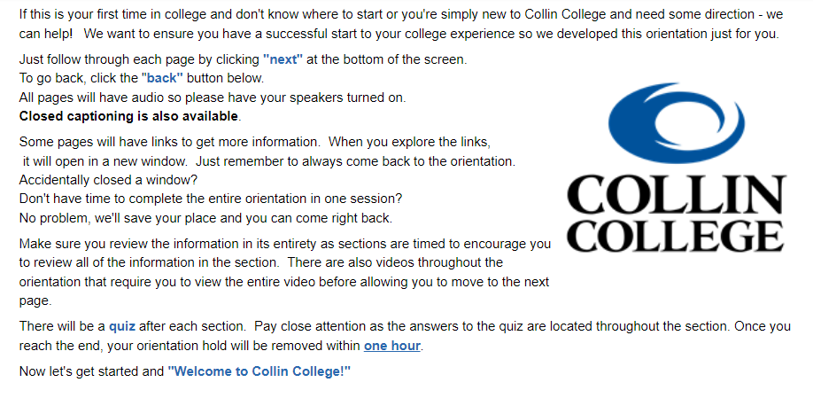
Slide 1 Welcome to Collin College

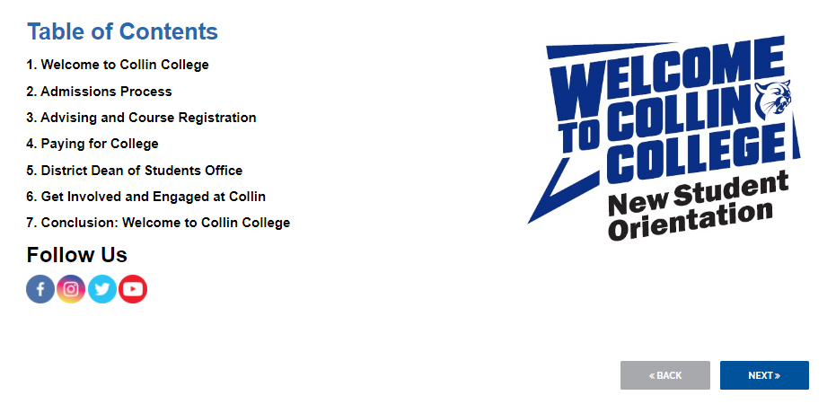
Slide 2 Table of Contents

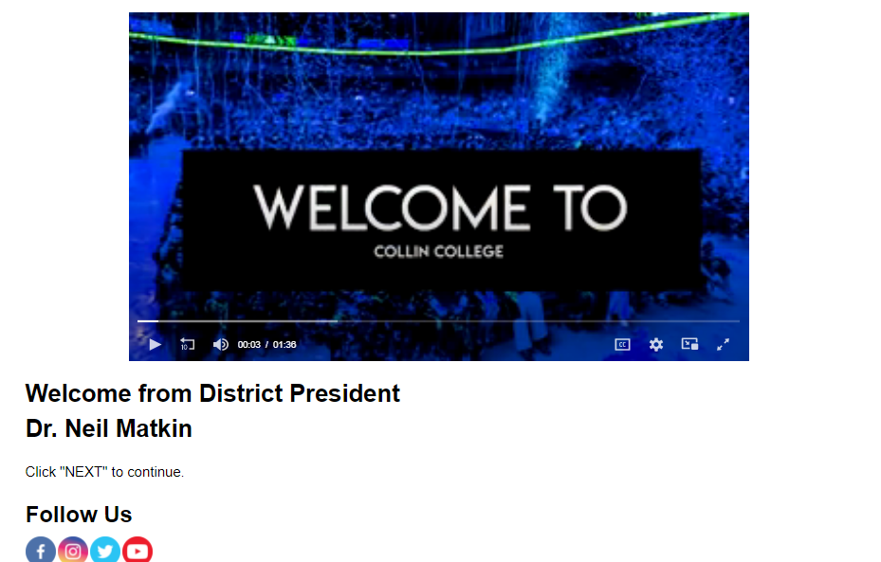
Slide 3 Welcome from Dr. Matkin

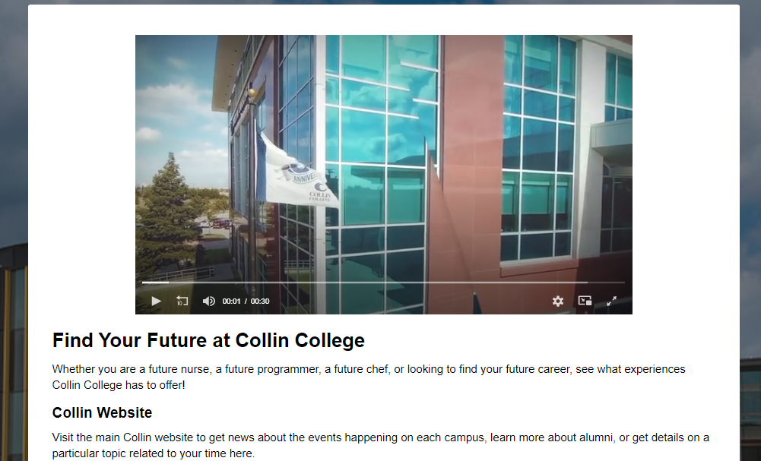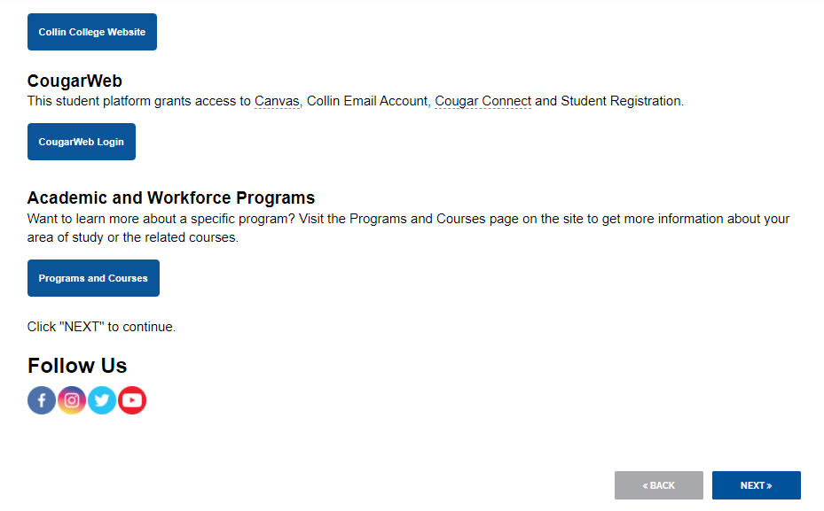
Slide 4 Find Your Future

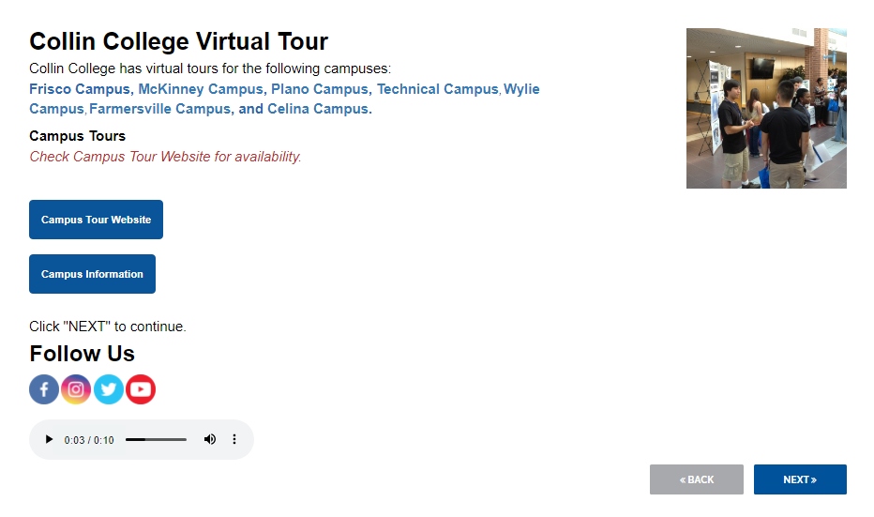
Slide 5 Virtual Tours

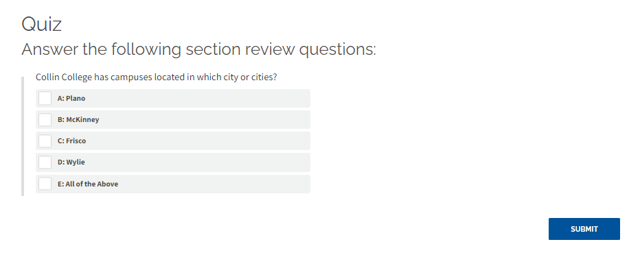
Slide 6 Quiz

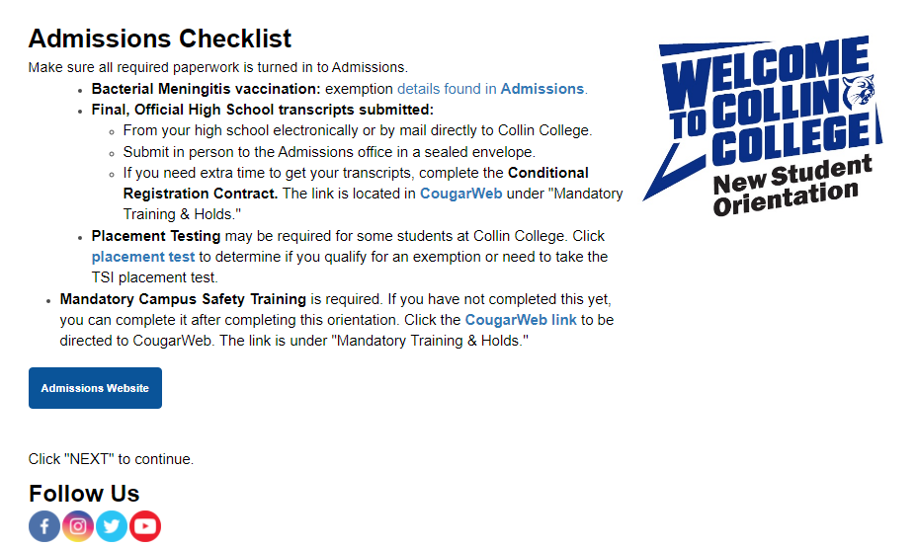
Slide 7 Admissions Checklist

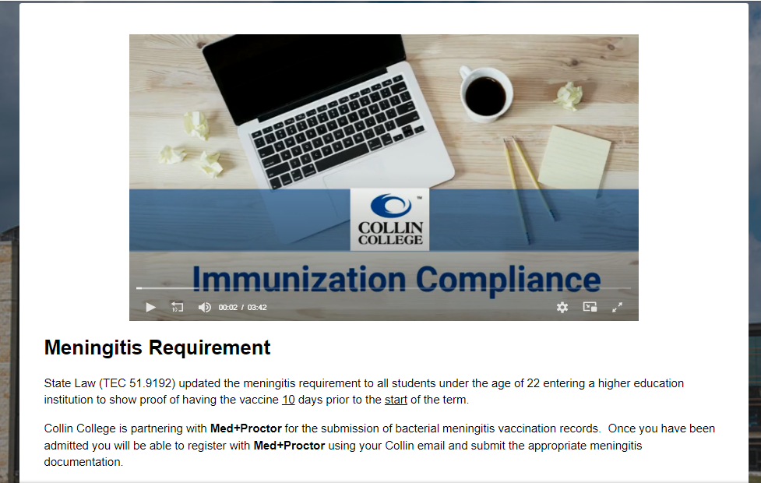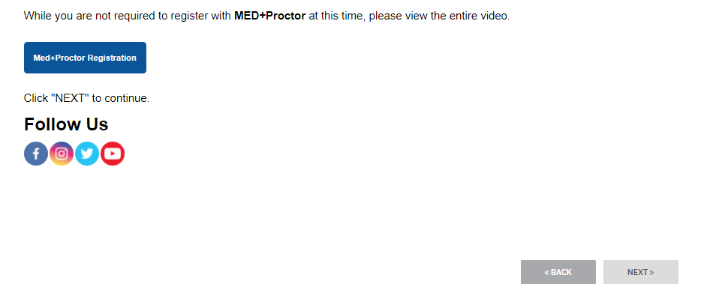
Slide 8 Meningitis Requirement

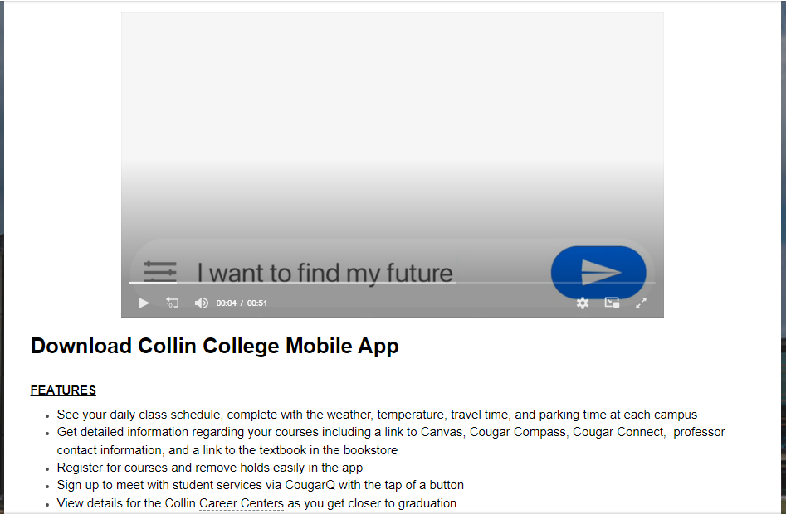
Slide 9 Mobile App

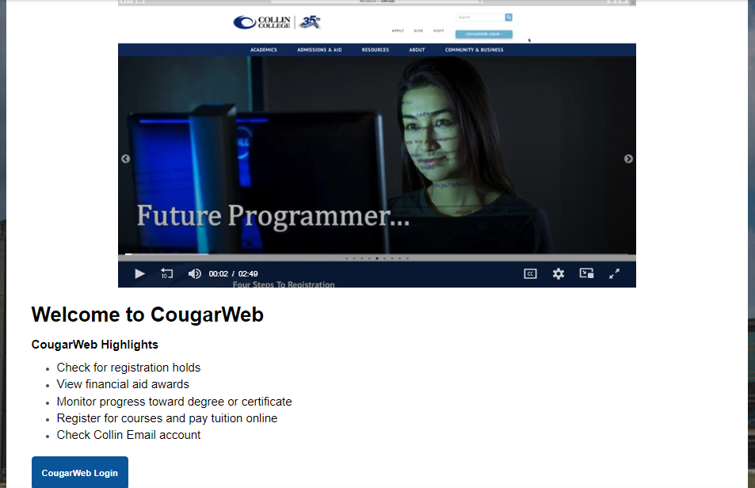
Slide 10 CougarWeb

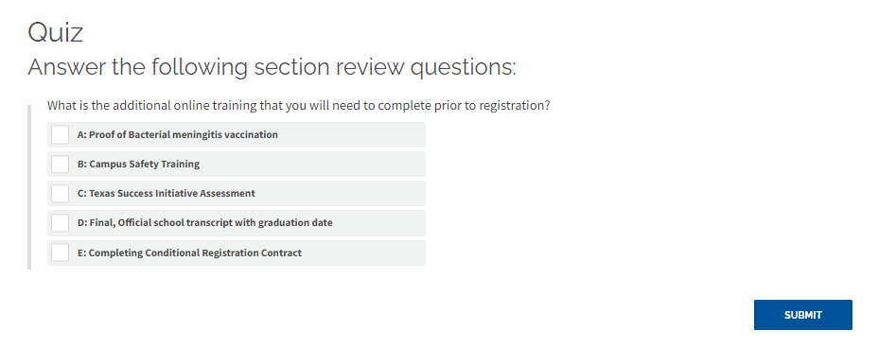
Slide 11 Quiz

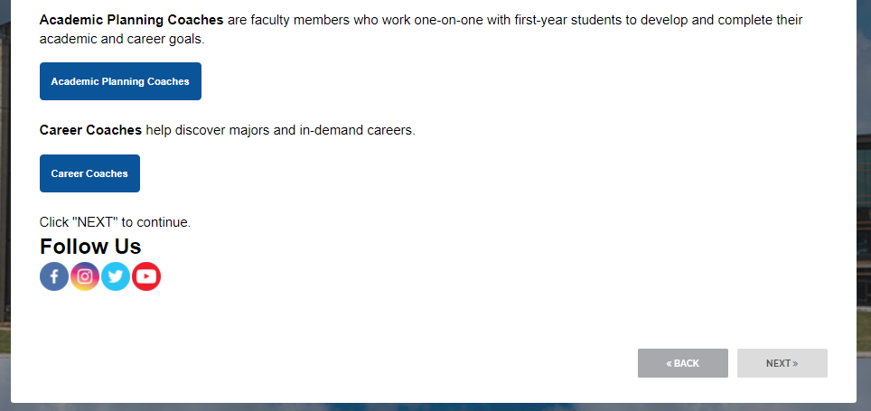
Slide 12 Academic Advising

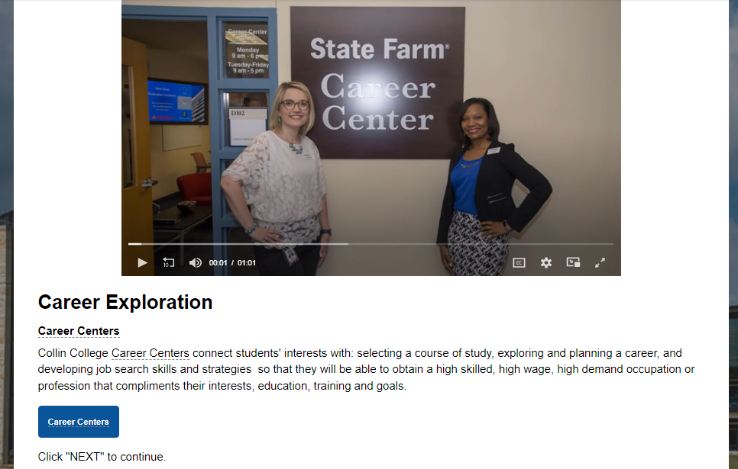
Slide 13 Career Center

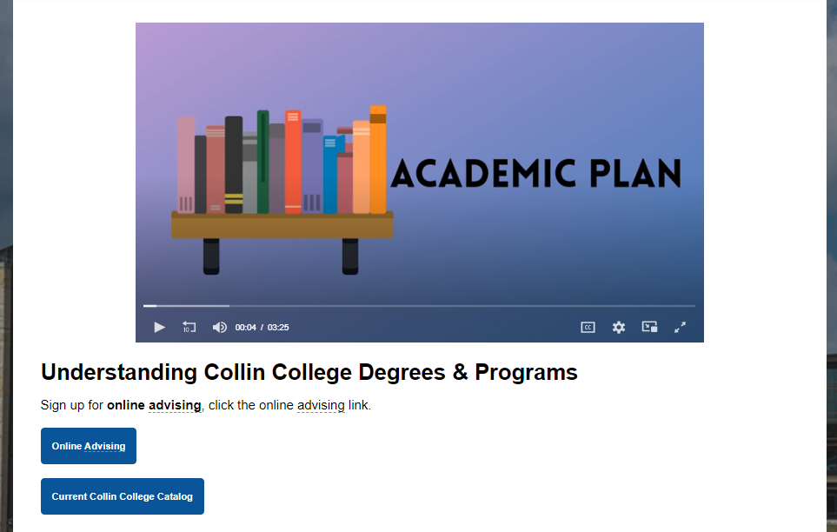
Slide 14 Collin College Degrees & Programs

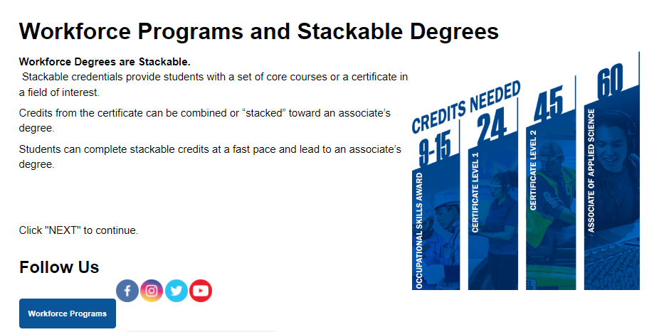
Slide 15 Workforce
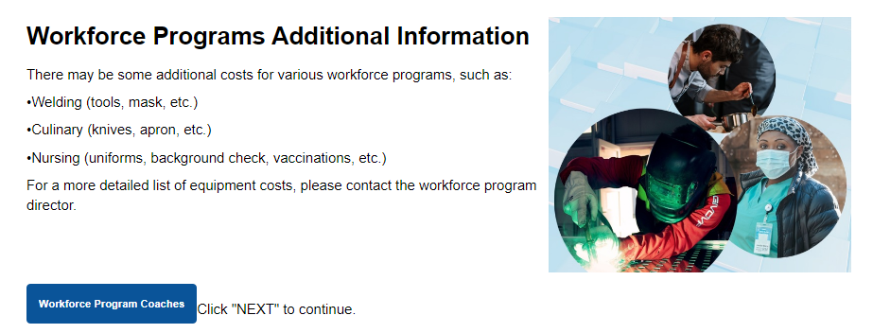
Slide 16 Workforce Programs Add. Information

Slide 17 Continuing Education

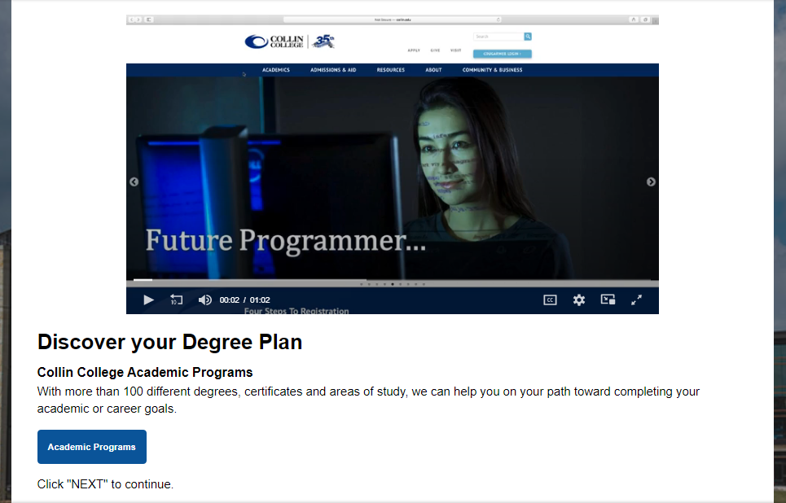
Slide 18 Academic Programs
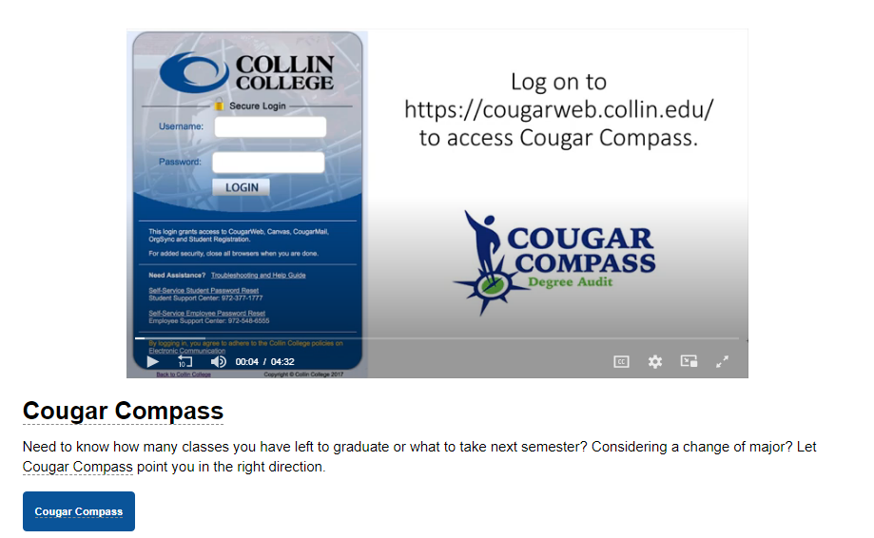
Slide 19 Cougar Compass
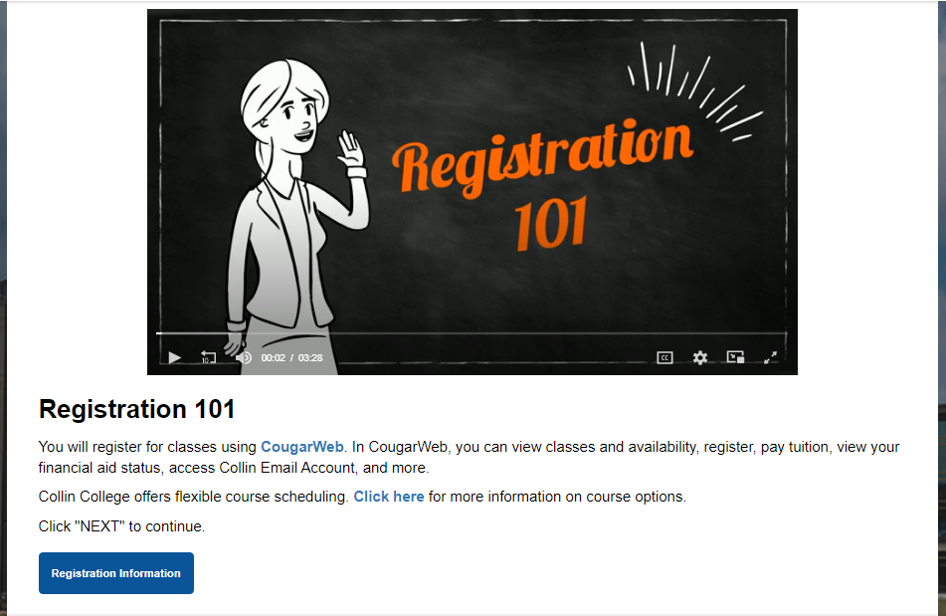
Slide 20 Registration

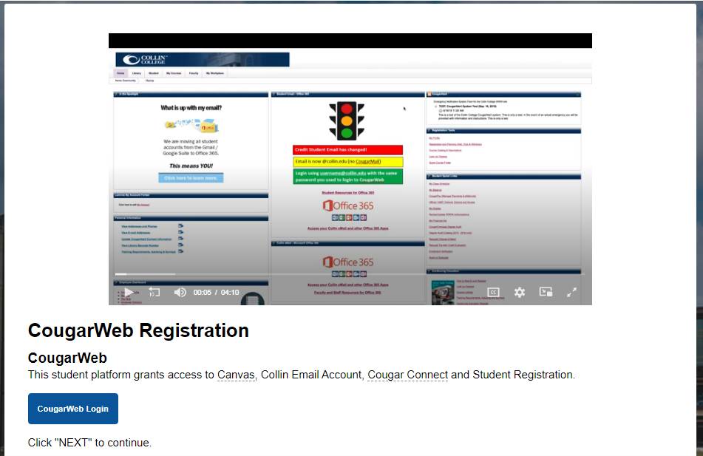
Slide 21 CougarWeb Registration

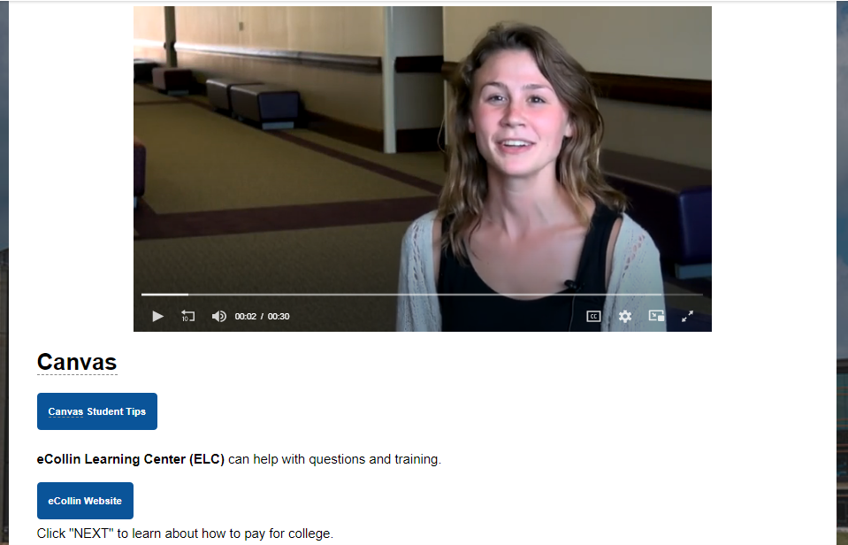
Slide 22 Canvas

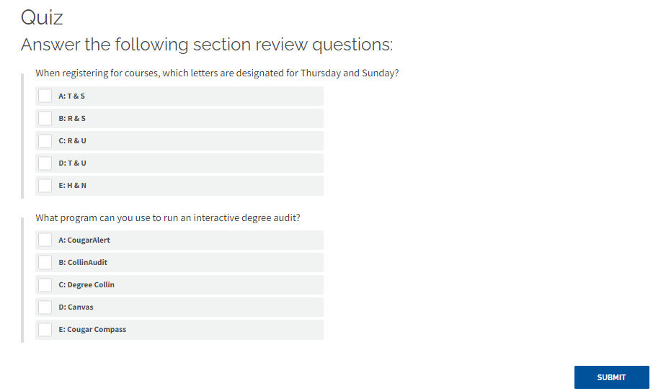
Slide 23 Quiz

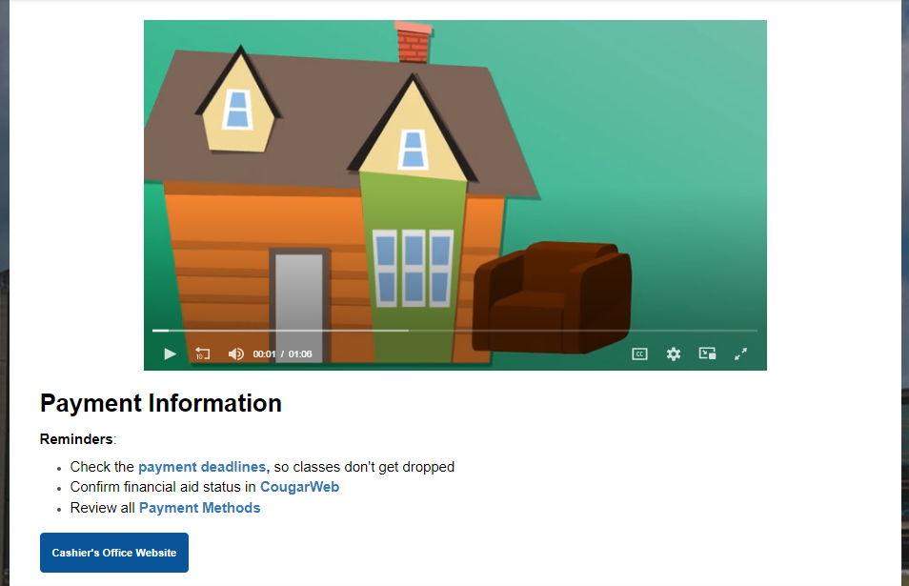
Slide 24 Payment

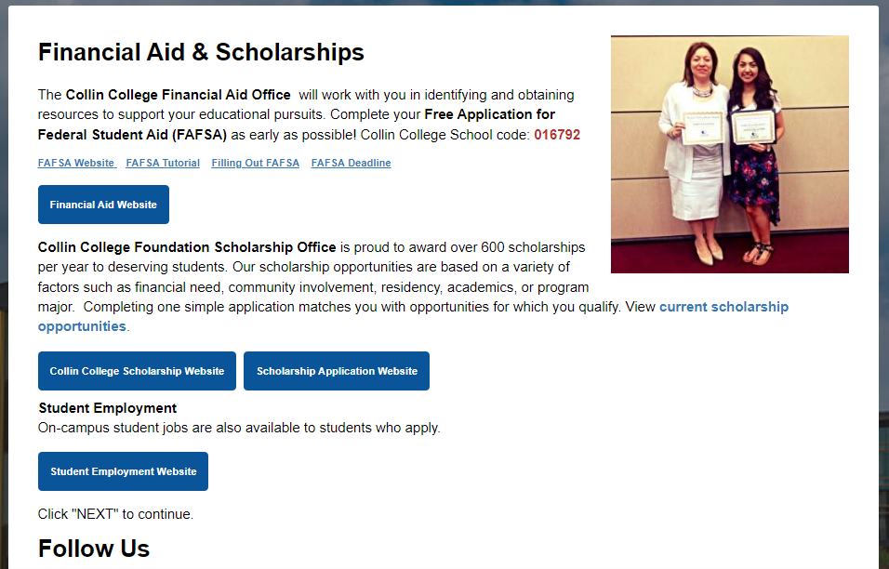
Slide 25 Financial Aid

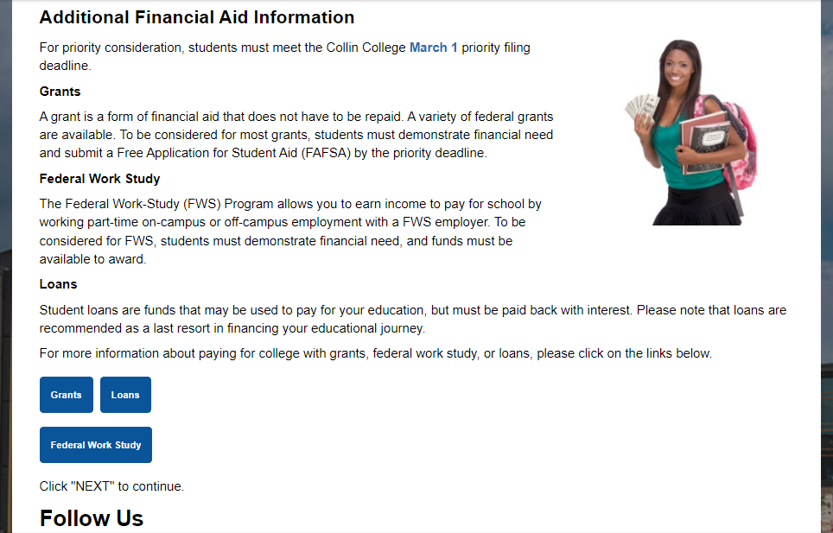
Slide 26 Add. Financial Aid

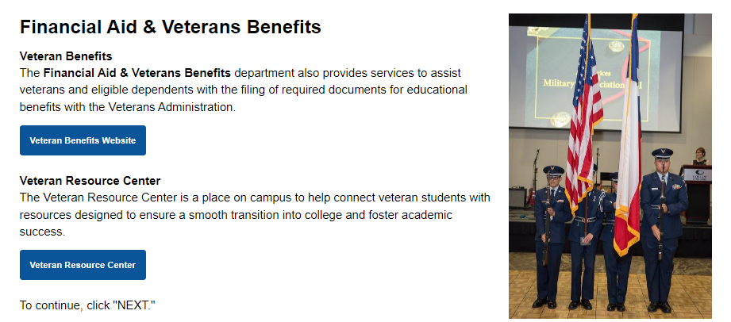
Slide 27 VA Benefits

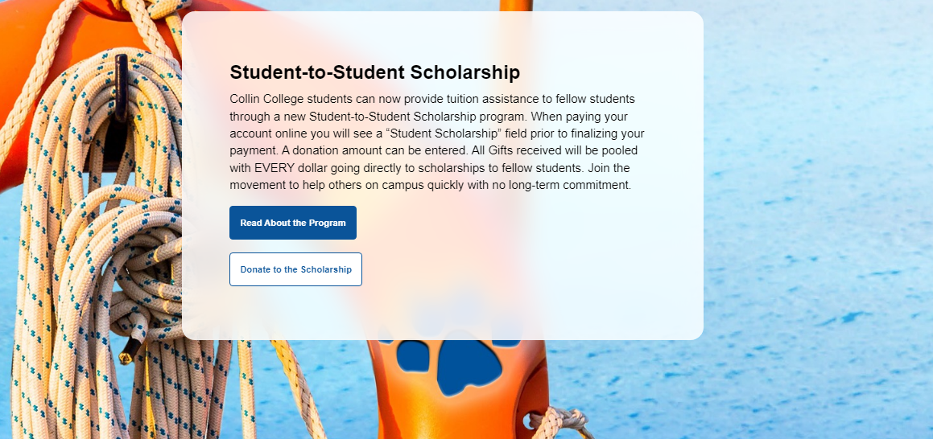
Slide 28 Student to Student Scholarships

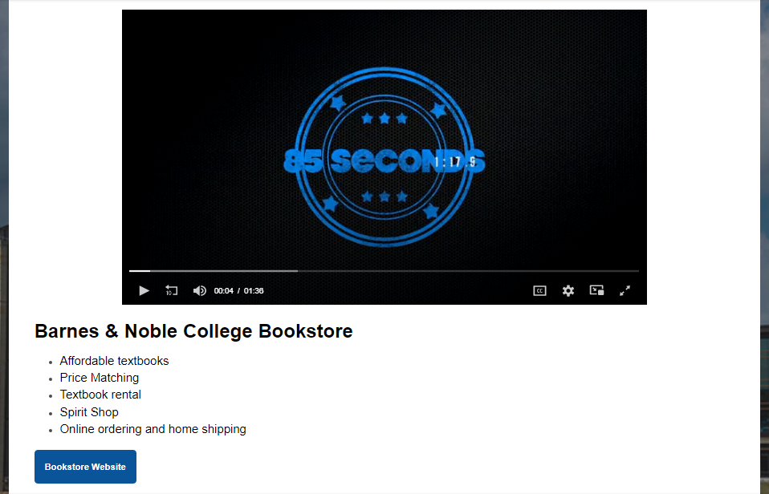
Slide 29 Bookstore

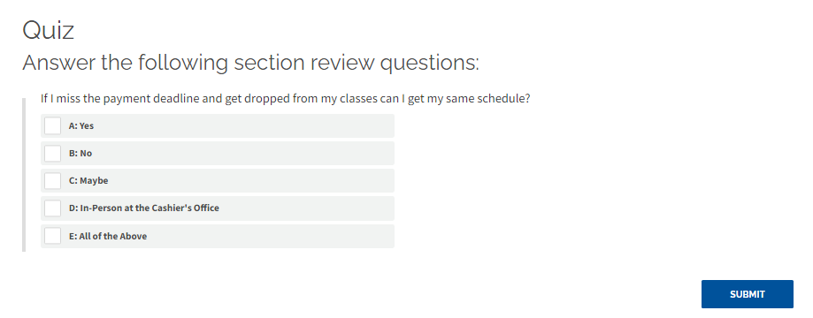
Slide 30 Quiz

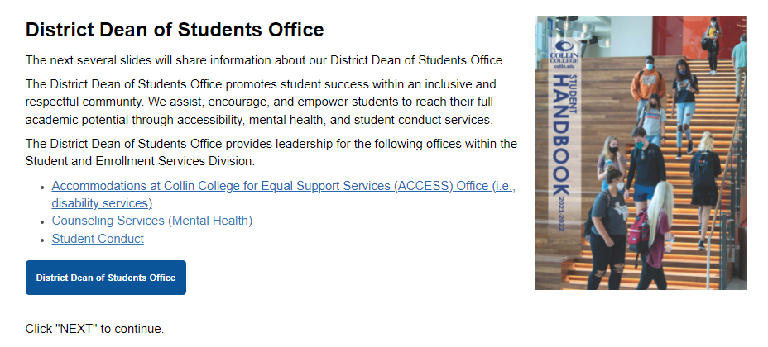
Slide 31 Dean of Students

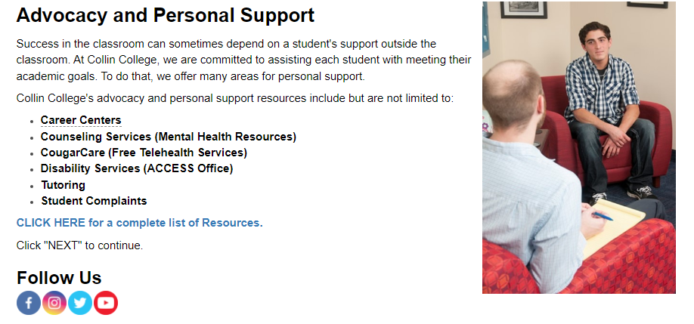
Slide 32 Personal Support

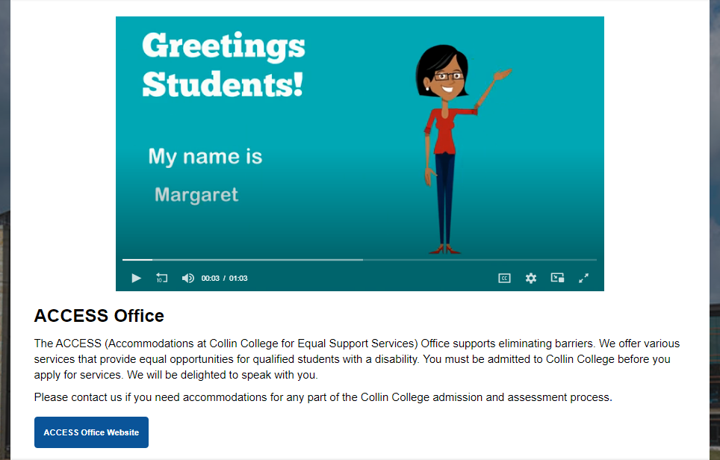
Slide 33 Access

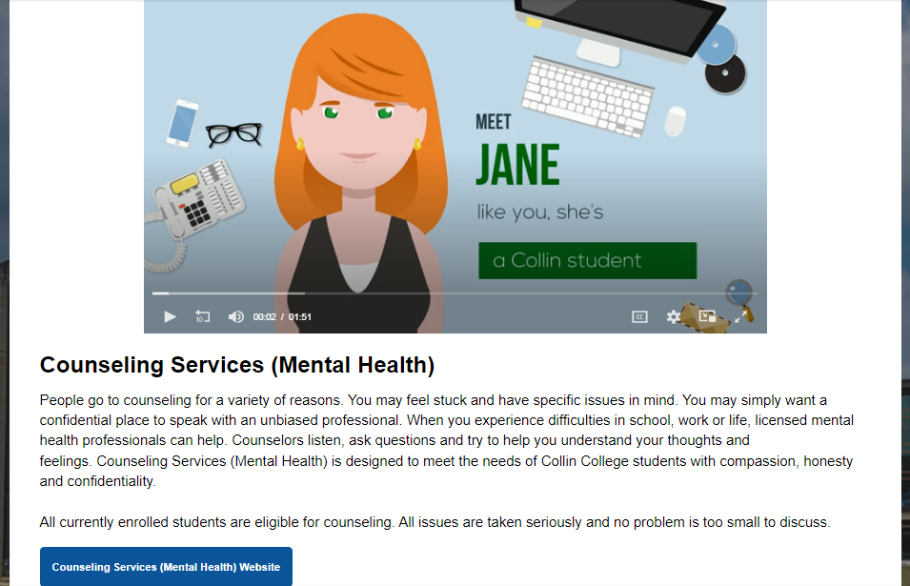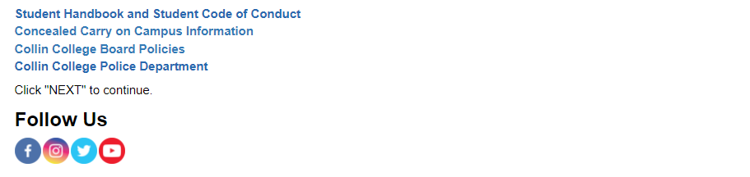
Slide 34 Mental Health

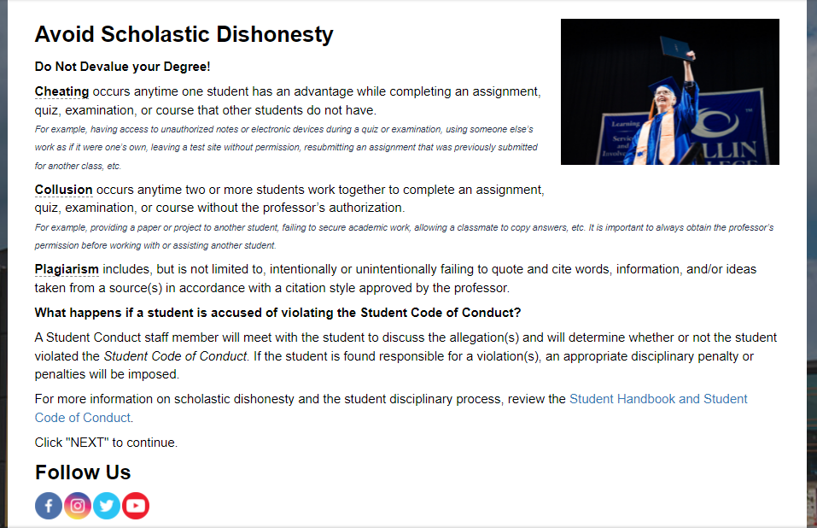
Slide 35 Scholastic Dishonesty

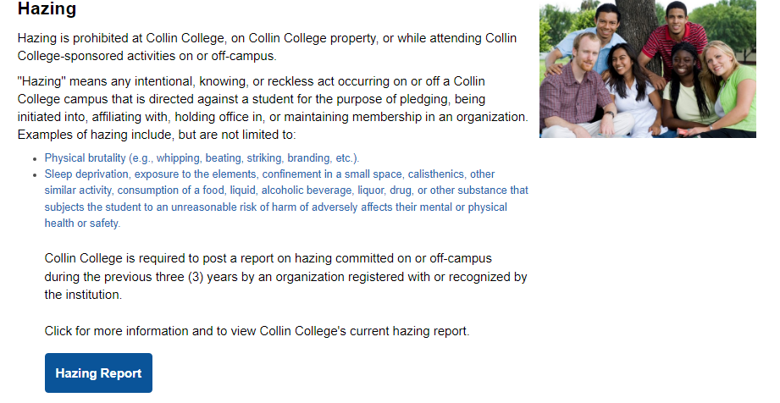
Slide 36 Hazing

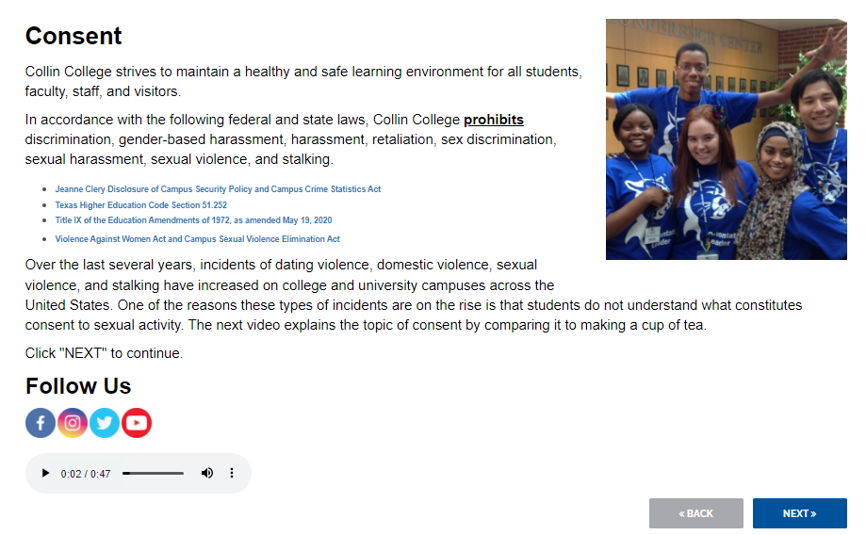
Slide 37 Consent

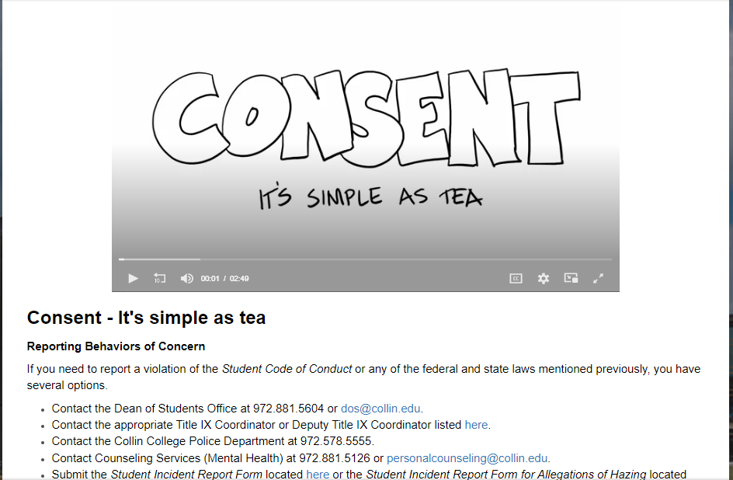
Slide 7b Consent

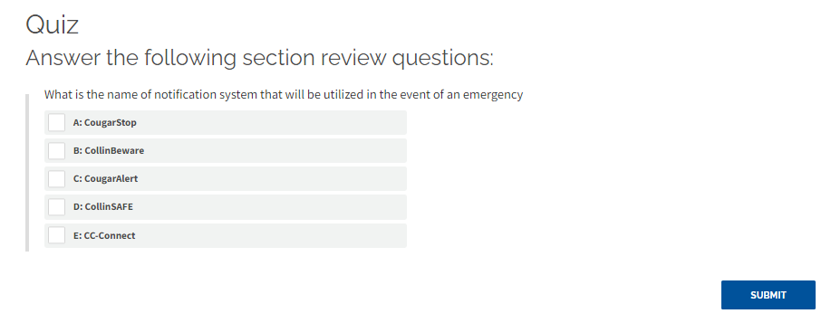
Slide 38 Quiz

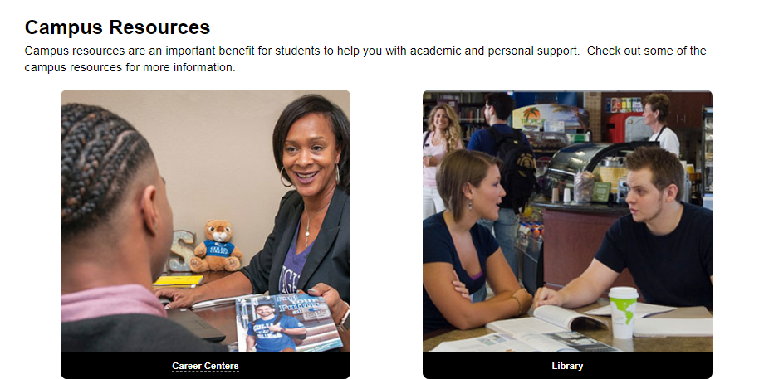
Slide 39 Campus Resources

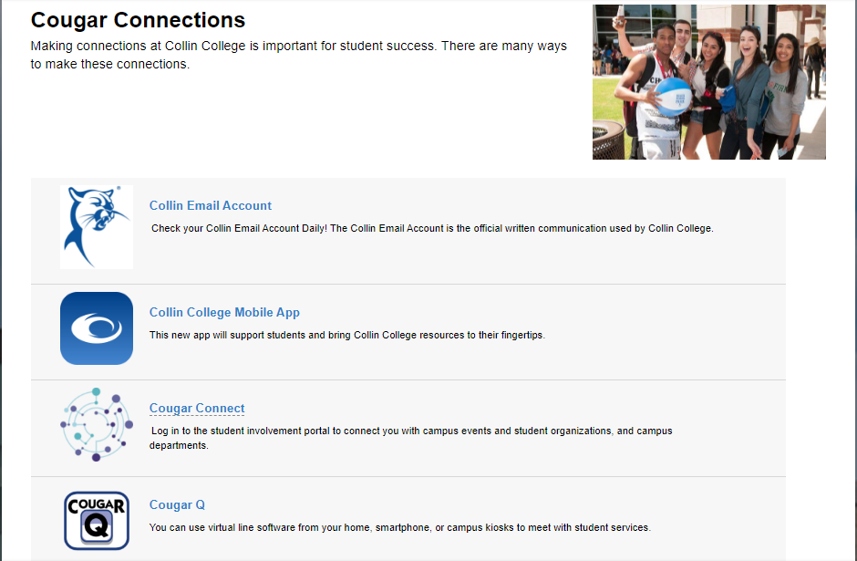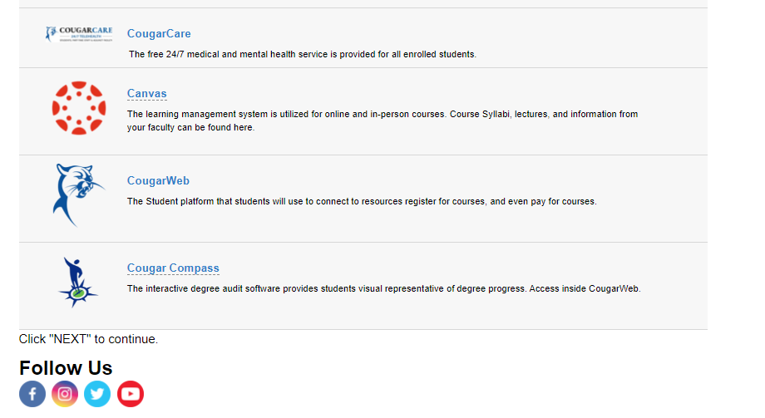
Slide 40 Campus Connections

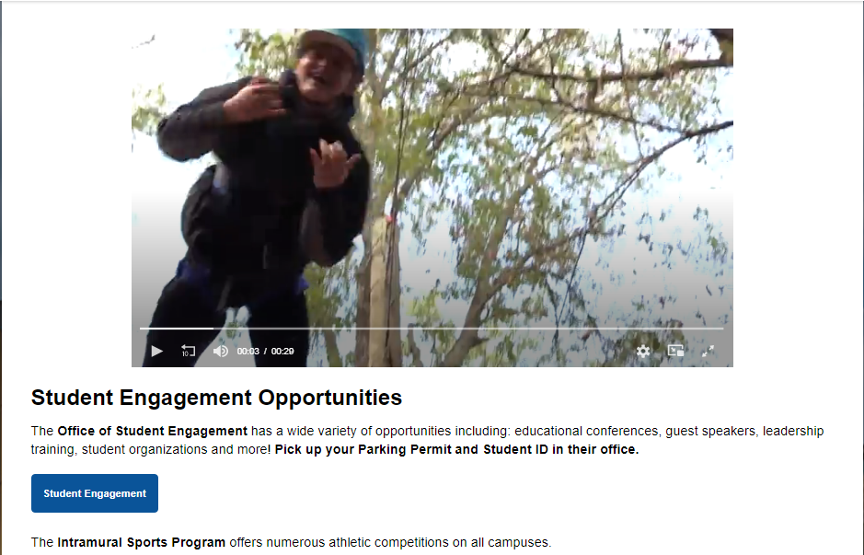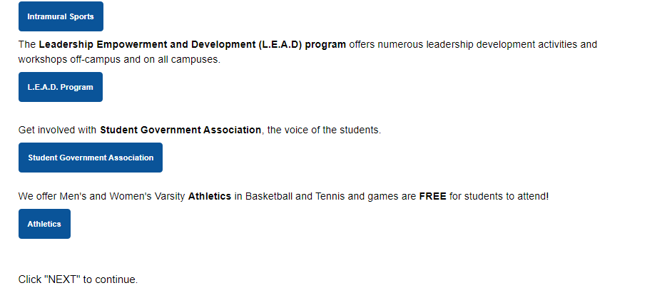
Slide 41 Student Engagement

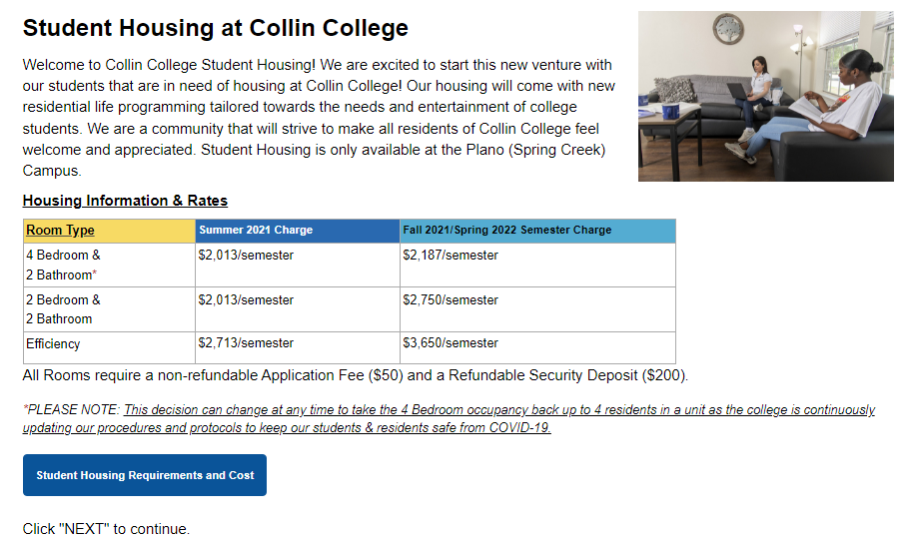
Slide 42 Student Housing

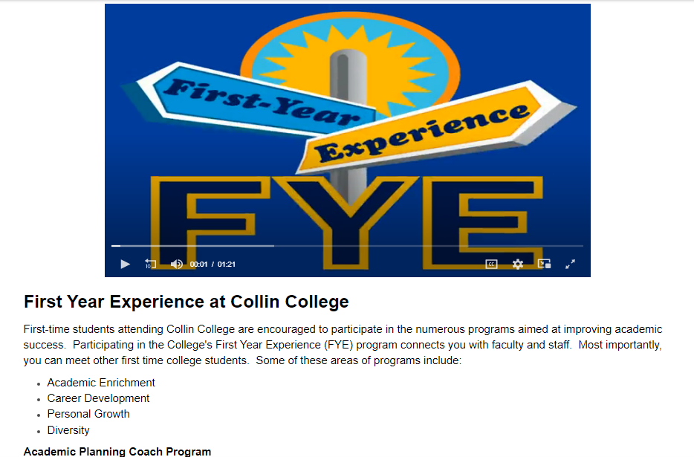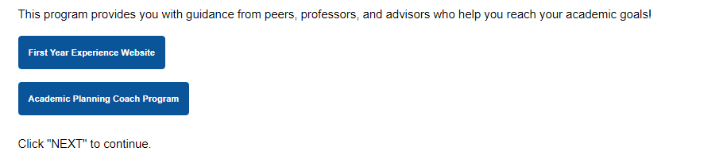
Slide 43 First Year Experience

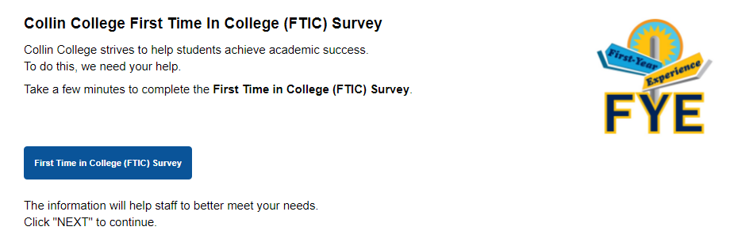
Slide 44 First Year Experience Survey
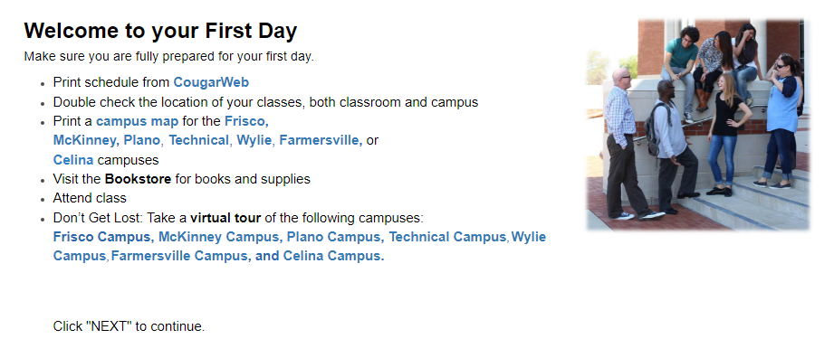
Slide 45 First Day

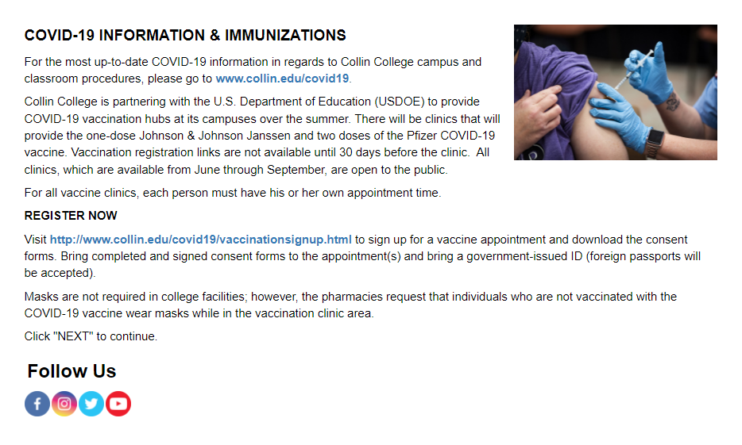
Slide 46 Covid-19

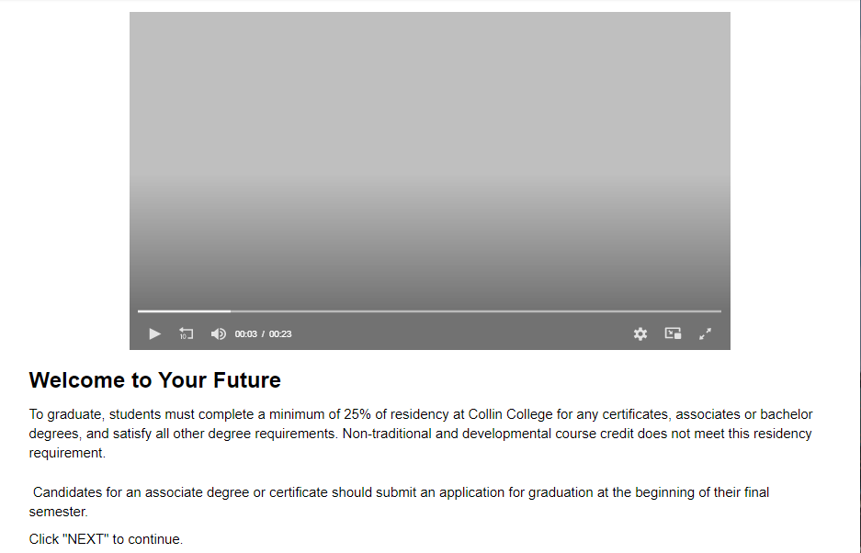
Slide 47 Welcome to Your Future

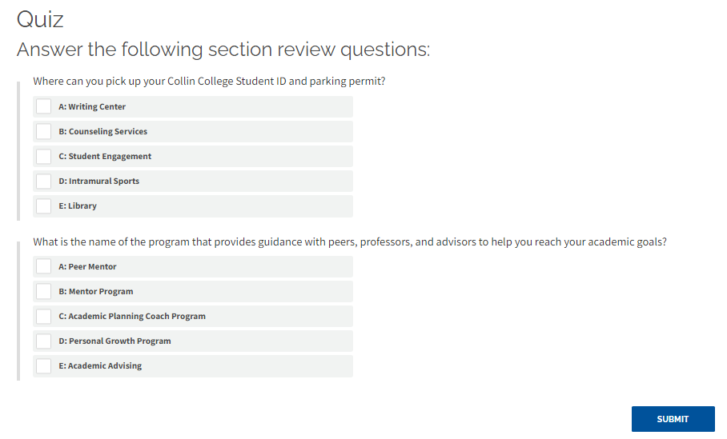
Slide 48 Quiz

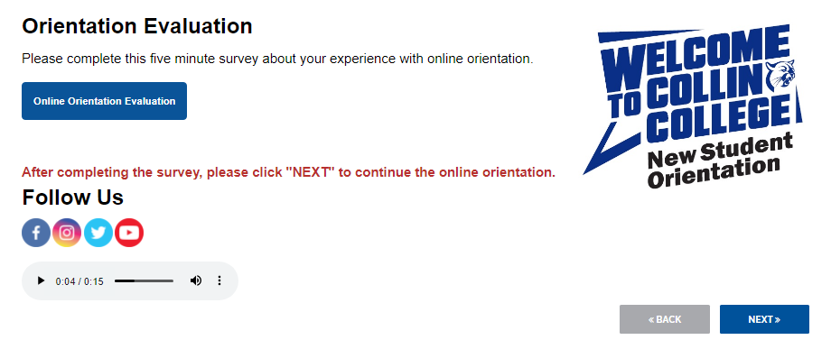
Slide 49 Orientation Evaluation

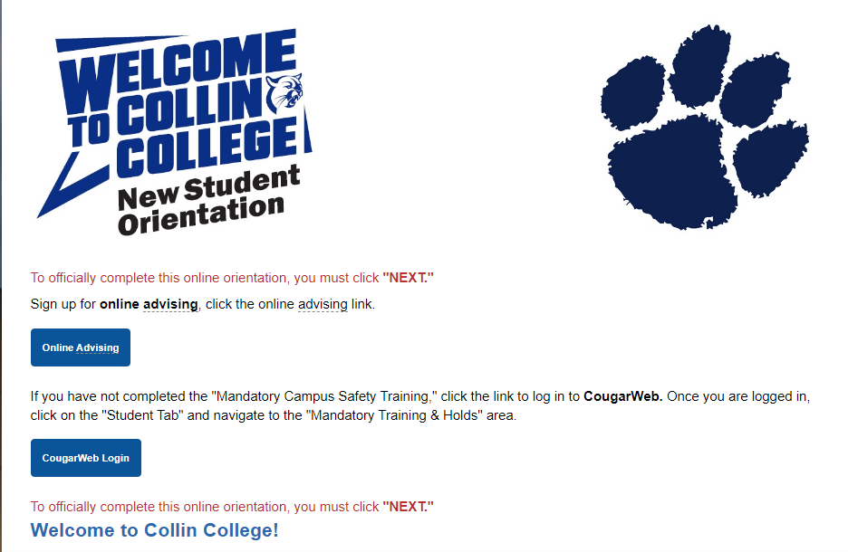
Slide 50 Closing of Orientation, Welcome to Collin College

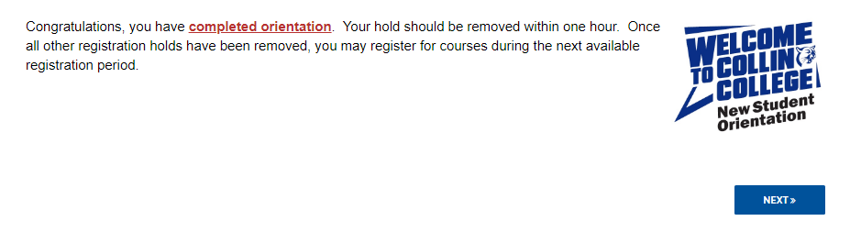
Slide 51 Orientation Complete

ADDENDUM C: NSO Script Spring 2020

Orientation Directions
- Traffic (1-2 OLs)
  - Greet students who look like they are here for orientation
(i.e. no backpack, looks confused, etc.)
  - Direct them to the Check-in table, where they will check-in.

- Check-in/Registration (2 people and Team Lead)
  - Greet students: “Hi! Welcome to orientation, did you signup online?”
  - If Yes -> “Do you have your ticket?”
If so, scan ticket using Eventbrite application on phone.
If not, look up their name on Eventbrite.
  - Grab a RAFFLE TICKET for PRIZES

- Greeter/Welcome (3-4 People)
  - Greet students at door: “Hi/Good Morning! Welcome to Orientation.
We have some excellent questions to see who is attending orientation.
- Hand them a notepad and pencil
Inside Conference Room
  - Direct students to seats up front.
“Hi! You can sit up here/We have seats at this table!””
  - Once you have guided them to their seats, have them come outside to meet with the Campus Resources.

ORIENTATION LEADERSHIP & ROLES
Mission:
Orientation leaders promote Cougar Pride and friendships through the encouragement we provide!
Purpose: To create a positive, welcoming, informative, fun experience for new students.
Tenets of Leadership:
- Every individual is hardwired with special gifts and talents.
- Each person has a unique personality.
- It is our job to help leaders discover their strengths.
- We believe that a positive, encouraging environment fosters personal growth.
- We are creating opportunities for our Orientation Leaders to stretch their leadership skills, practice interpersonal communication and become adept at public speaking.
- Having fun, playing together and experiential learning fosters team growth.
- It is ok if things aren't perfect the first time. We think practice with encouragement brings excellence.
- We contend for generosity within the group asking that everyone honors and respects each other.
- Feedback is an important tool. Feedback will be given one on one or within the group using a model of feedback and ground rules.
- Leadership is best received when asked in a courteous manner instead of demanding it with harshness.

Guidelines for Orientation Leaders:
- Your focus is on the new students. OLs stay with the new students throughout the session.
- The only reason to leave the main room is because you have an assignment that takes you out – group advising, faculty, bathroom etc.
- If you have to leave the room, you must inform the Team Lead. If you are leaving for a reason other than assignments, you must inform the Team Lead first and then the Professional lead.
- Your job is to look for ways to inform new students, make connections, encourage your teammates and stretch your leadership skills.
- The Pro Staff will be in the room or the hallway depending on what is needed.
- Talking in the back of the room must be at a minimum - very quick. If the conversation needs to be longer - take it out in the hallway. Minimize disruptions to the room - doors, etc.
- Segues must be tight. Do not wait until people are clapping or the person is ending to start moving toward the front. Be at the front so it is a quick hand off on the mic.
- Look for ways to improve the process. We invite new ideas and ways to make things better.
- If you are presenting, work with the Pro Staff and the team to get prepared. Read script before sessions.
- Encourage each other with what went well/what you liked.

Roles of Team Lead:
- Work with the OLs to make sure that the session transitions smoothly throughout the day and maintain the schedule.
- Serve as the point of contact for the OLs if they have questions, thoughts, or comments about the session.
- Encourage and support your fellow OLs throughout the session.
- Begin with the “Pride Award”. You past it off to someone you see doing a great job and encourage them when they see someone doing well to pass it on!
- Ask questions of the Pro Staff if you have questions (i.e. thoughts on if we are early or behind on schedule, # of faculty, etc.).
- Stay in the back of the room and lead throughout the session.

Roles of Media Person
- Make sure that all presentations are loaded on the laptop (Intro Slides, then OL slides, Spring2019 Presentation, and then have the Academic Advising Online Presentation logged in and loaded).
- Look at OL slides, and remove OLs that are not there (DO NOT SAVE CHANGES, since this would remove OLS for next Orientation).
- Sit at the front of the room and make sure that all speakers are aware of the presentation clicker, microphones, and that the presentation slides are on the correct slide.
- If you hear no sound, check to make sure the volume is up or if it is muted on the laptop.

Role of Presenters
- Read the script and practice the presentation before the day of the event.
- Arrive at the stage before the next person finishes their presentation.
- Utilize the laptop and the script if you need help, please refrain from turning your back or head to the audience to read the screen.
- Please do not talk and block the screen.

Role of Icebreaker person
- Check the Team Lead for time. For each question, already identify someone in the group who will represent option (i.e. OLA is representing Vanilla in ice cream question).
- Encourage groups to introduce themselves to two other people in the group and then come together as a group and cheer for their group when it is time.
- Try to finish before Dean of Students Office presentation. Adjust Icebreaker to fit time frame

WELCOME
Hello and Welcome to Collin College New Student Orientation.
I am (BLANK) and I am the (BLANK – position). We are so excited to have you join us today as you start your collegiate experience. Today you will hear from different campus resources, speak with faculty, and have time to meet with academic advisors all to help has a successful trip. We hope you leave with the connections to campus resources, faculty, staff, and fellow students that will be here at Collin College to help you succeed. You will be getting a lot of information presented to you, so please utilize the notebooks we have provided to you. You may not need them this summer, but you may need some of the information 2-3 weeks into the fall semester. We want to prepare you to have a BRIGHT FUTURE here at Collin College. Your success starts with orientation, so get ready for amazing start at Collin College.
Collin College services over 53,000 students and 7 different sites throughout Collin County, Rockwall County, and the Colony. Whether you are starting your collegiate career and plan to transfer to a 4-year university, are here for skill and workforce training, or taking classes for professional and personal enrichment, we are excited that you chose Collin College and we just once again want to say “Welcome to Collin College?”

DR. MATKIN VIDEO NEXT
DR. MATKIN VIDEO
Let’s play a welcome video of Dr. Neil Matkin, Collin College District President.
NEXT ORIENTATION LEADER introduction
We have some amazing student leaders that will be working with you today, let’s give them applause as they come to the stage
(use clicker and click the OL slide for each person)
WELCOME TO COLLIN COLLEGE
HIGH ENERGY FROM PRESENTER
SLIDE 2: Welcome to Collin College
Thank you for coming to orientation. We are so excited to welcome you to Collin College and make you aware of what the college has to offer.
We will hear from an Academic Advisor, the Dean of Students Office, and give you an opportunity to connect and ask questions to some of our Faculty!
Feel free to take notes in your Orientation notepad about the campus resources, campus activities and ways to get connected to Collin College.
You will learn about some of the online platforms you will be using like CougarWeb.
  - Teach you how to successfully navigate course registration and payment systems
  - We want you to be aware of policies and procedures pertaining to campus and personal safety as well as academic excellence and integrity
  - Become familiar with campus resources and ways to get involved with the campus community.
  - After the session you can choose to take a campus tour or participate in a group advising session.

SLIDE 3: Admissions Process
Before we start, let’s make sure that we have all our requirements in order
*Have you completed an application at Apply.Collin.edu?
*Have you turned in your meningitis paperwork already?
*Have you turned in your final, official high school transcript? If not, they can be sent electronically to Collin from your high school or turned into the admissions office in person as long as they are in a sealed envelope from your school! You can also complete the Conditional Registration Contract while we await your transcripts to arrive.
*All students must be evaluated to see if they are college ready. The TSI placement test will need to be completed unless you are eligible for an exemption.
*The campus safety training is required for all entering students.
If you haven’t completed this yet, you can do that after this orientation.

NEXT-TICKET TIME

SLIDE 4: Collin College Mobile App
Introducing the New Collin College Mobile App. The app provides student support such as hours of operation for student services, your daily class schedule, the weather, and even parking times. You can utilize the app to see the Cougar Q wait times for services on campus, remove registration holds and when available, register for courses. During the semester, you can check your GPA, navigate Cougar Compass for degree completion, and seek help from Career Centers. If you ever have a questions, reach out to CougarBot, the chat bot that can answer questions in real time. You can even deck CougarBot out in special themes and get a sticker pack for your device. So Download the Collin College Mobile App TODAY!

SLIDE 5: TICKET TIME
(click to make sure the tickets pop up)
It is now Ticket Time! Please pull out your tickets as we give out a cool COLLIN prize. After each number, CLAP if you have that number. (DRUMROLL please).
Please read each Number (CLAP!)

SLIDE 5: Introduce ACADEMIC ADVISOR
Now we will continue our training and hear from one of our academic advisors,

SLIDES 6-16: Academic Advising

SLIDE 17: TICKET TIME
(click to make sure the tickets pop up)
It is now Ticket Time! Please pull out your tickets as we give out a cool COLLIN prize. After each number, CLAP! if you have that number. (DRUMROLL please).
Please read each Number (CLAP!)

Let’s welcome one of our Orientation Leaders to the stage

SLIDE 18: COUGARWEB
CougarWeb can be used to investigate all things Collin College.
CougarWeb gets you prepared to become a successful Collin College Student.
If you haven’t logged in yet, your username and password can be found in your acceptance email. Cougar Web is a great resource for Collin College students.
Let’s watch a video to show you how to utilize Cougar Web.

SLIDE 19: VIDEO - CougarWeb Module

SLIDE 20: CANVAS
What is Canvas? Canvas is Collin College’s learning management system. What that means is that you will use it for online assignments, quizzes, discussions, view videos that your professor has uploaded, and much more! There’s even an online tutorial that walks you through how Canvas can help you – just search “canvas” on the Collin home page for the Canvas site.
SLIDE 21: COLLIN COLLEGE EMAIL
Did you know that all students receive a Collin College email account? Collin College email is the official form of communication for Collin College. Check for alerts in the Collin College email daily for unexpected campus closures, upcoming campus events, deadlines and announcements, and faculty and staff correspondence. Be sure to check it regularly! And remember when corresponding with anyone at Collin, to use your Collin College email and not your personal mail.
SLIDE 22: Financial Aid & Scholarships
Financial Aid is available for students who qualify. Students must complete the Free Application for Federal Student Aid or FAFSA to be eligible for LOANS, money you have to pay back), GRANTS, available money you do not have to pay back, and federal work study, ability to work on campus to help defer costs. Collin College’s school code is on the screen. Collin College also awards over 600 scholarships each year for deserving students in the fall and spring semester. All scholarships require an application, so make sure you do not miss those deadlines.
Let’s learn about the payment process at Collin College through this video.

SLIDE 23: PLAY PAYMENT VIDEO

SLIDE 24: Student-to-Student Scholarships
Collin College students can now provide tuition assistance to fellow students through a new Student-to-Student Scholarship program. When paying your account online you will see a “Student Scholarship” field prior to finalizing your payment.
A donation amount can be entered. All Gifts received will be pooled with EVERY dollar going directly to scholarships to fellow students. Join the movement to help others on campus quickly with no long-term commitment.

SLIDE 25: Get Involved and Engaged
Remember to take full advantage of all Campus resource assistance. Get involved with Student Engagement, and Show off your skills in our Intramural Sports program. To make you First Day at Collin College a total success we suggest that you follow this simple itinerary: print out your schedule, arrive early, make sure you are on the right campus, scope out the location of your classes, get your textbooks, and MEET new classmates!” Let’s talk about some of the resources.

SLIDE 26: Office of Student Engagement
Do not forget to get involved with Student Engagement. You can utilize COUGAR CONNECT, our student platform, to get more involved and join numerous student organizations like the Student Government Association, the voice of the students. You can also get your free parking permit and your Student ID Card from Student Engagement.

SLIDE 27: Cougar Connect & CORQ App
Cougar Connect is Collin College’s student involvement platform where you can interact with student organizations, check out Campus Events, and track your participation. You should also download the CORQ app - this will tie into the events calendar in Cougar Connect to make sure you do not miss any of the free prizes, free food, or great events on campus.

SLIDE 28: Intramural Sports
The Intramural Sports Program, offers team sport leagues like basketball and Soccer, individual events you can play sports like ping- pong or dodgeball, and special activities like bowling, escape rooms and much more. Events and activities are free for all students.

SLIDE 29: PLAY BOOKSTORE VIDEO

SLIDE 30: Center for Academic Assistance
The Writing Center and Math Lab are on each major campus to help you be successful. The Writing Center helps consultation on any writing assignments. They also offer an online writing lab and workshops to help improving your writing. The Math labs offer tutoring in any subject that utilizes math and provides study guides and calculators to use.

SLIDE 31: Library
The libraries at Collin College offer many resources beyond checking out books, laptops, and course materials. They have computers with internet access and free printing up to 300 pages, private and groups study rooms, and Makerspace at each major campus. Each library also hosts faculty offices and classrooms.

SLIDE 32: Athletics
Collin College has men’s and women’s basketball and tennis teams that compete at the Plano campus. Attendance at athletic events are free with your Student ID Card. Come cheer the Cougars on to victory!

SLIDE 33: Career Center
Our Career Center offers students the opportunity for career counseling, resume assistance, mock interviews, and job assistance. The Career Center also offers Career Fairs and career seminars to help make you the best candidate for future employment.

SLIDE 34: Veteran Resource Center
The center supports students who served in the military or military family members by providing a lounge, study area, and computer stations to help them succeed at Collin.
SLIDE 35: PLAY FYE Video

While video plays, come to stage to prepare for
the Group Photo and the Icebreaker

SLIDE 36: ICEBREAKER
– Group Photo / Four Corners
We are going to do an Icebreaker, but first, we’d like to take
a GROUP PHOTO that we will post on the New Student Orientation Facebook page
Get everyone to group together and take several pictures

Now, while you’re all up - We are going to ask everyone a question and list out some potential answers; when you hear your answer, you will go to one of the four corners of the room and then introduce yourself to everyone in the group.

FAVORITE PIZZA
(Pepperoni, Cheese, Hamburger, Meat Lovers)

FAVORITE ICE CREAM
(Vanilla, Chocolate, Strawberry, Cookies & Cream)

FAVORITE MUSIC
(Rock, Country, Rap, Pop)

FAVORITE PRO SPORT
(Football, Baseball, Basketball, Soccer)

SLIDES 37-43: DEAN of Students OFFICE
Let’s welcome
Associate Dean Cheri Jack
To tell us more about the
District Dean of Students Office.

SLIDE 38: ACCESS Video
SLIDE 39: Counseling Service VIDEO
SLIDE 43: TEA VIDEO

SLIDE 46: INTRODUCE FACULTY ROUNDTABLE

FOR FACULTY PANEL (use if not enough faculty: 1 per table)
It is an honor and a privilege to introduce you to our faculty panel. During this time, you will have a unique chance to ask questions you may have about taking classes at Collin. This is a great advantage to have some of Collin’s finest faculty with us.
If you would like to ask a question, please raise your hand or write the question down on a notecard and pass them to an Orientation Leader. Let’s start by going down the line and having the faculty introduce themselves, the classes they teach, and how long they have been at Collin College.
FACULTY ROUNDTABLE (use if enough for 1-2 faculty per table)
It is an honor and a privilege to introduce you to our wonderful faculty. During this time, you will have a unique chance to ask questions and talk with a professor about taking classes at Collin College and their tips for student success. Halfway through we will have professors switch tables.

WELCOME TO COLLIN COLLEGE!
We are so excited to Welcome YOU to Collin College and add you to our Cougar PRIDE! We hope you continue to prepare for the upcoming semester through completing the admissions process, TSI testing, completing the Campus safety training, and then registering for courses and paying by the payment deadline!
EVALUATIONS
We will now ask you to complete an evaluation on your experience today.
Please pull out your cell phones so that we can do a quick evaluation. Please look at the card and use the survey. Please show the Orientation Leaders your phones once you have completed the surveys.
If you cannot complete the form on your phone,
we can hand you a paper copy.
***We will use this evaluation to have your orientation hold removed**

OPTIONAL BREAKOUTS
Since we have a mix of International and Domestic students, We will now offer an opportunity you can take advantage of:
A Campus tour for domestic students. All international students will go on a campus tour, since their orientation does not end until 3pm.
If you would like to go on a Campus Tour, please go to RIGHT side of the room
All International students will remain in the room

If not, thank you so much for attending New Student Orientation!

Addendum D: NSO Public Relations Examples
2015-2016
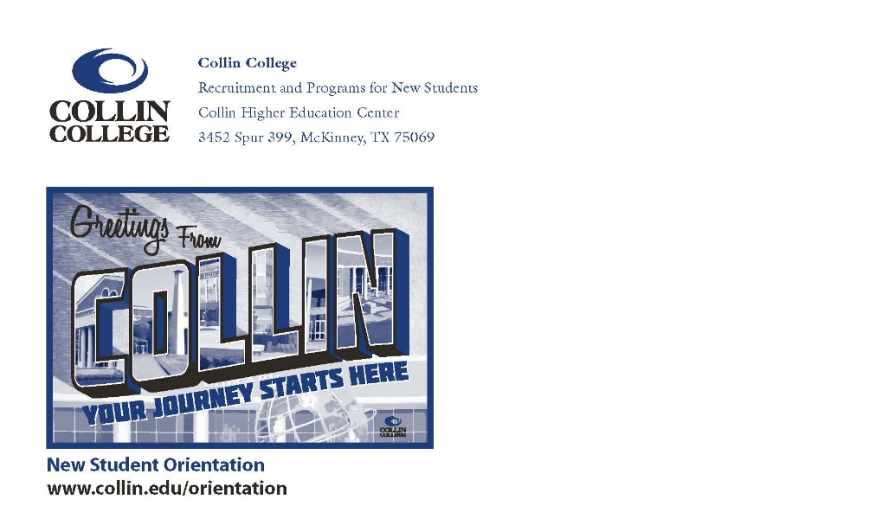
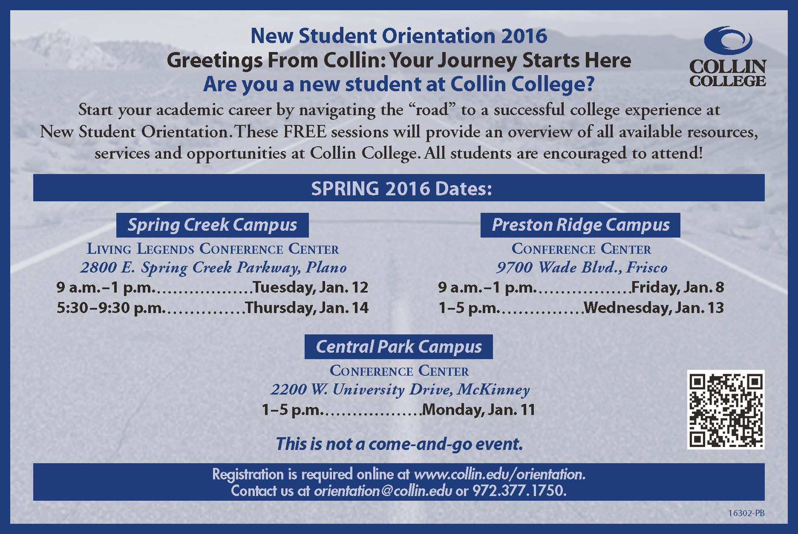

2016-2018
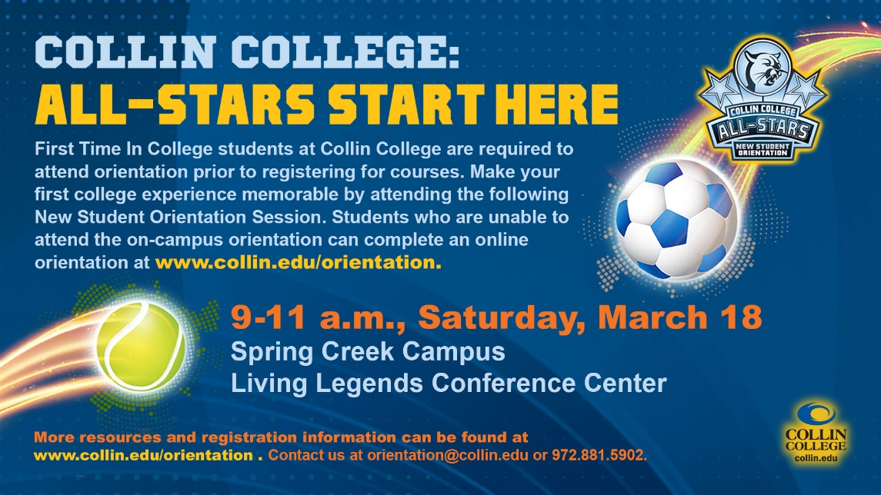

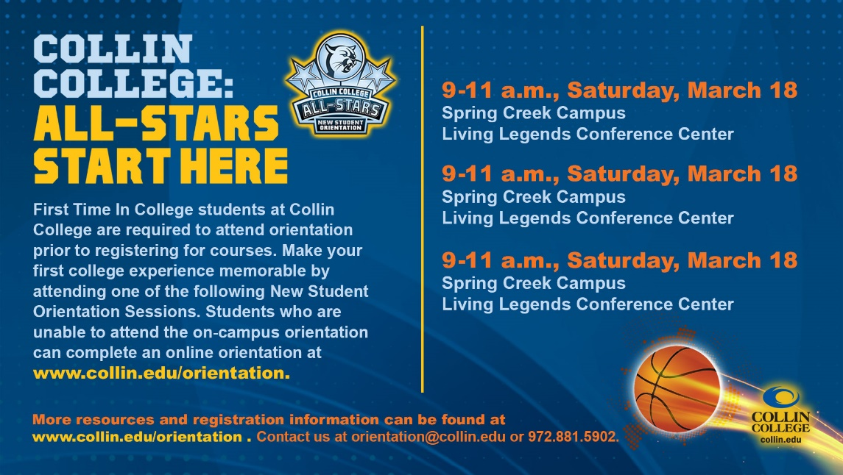

2018-2020
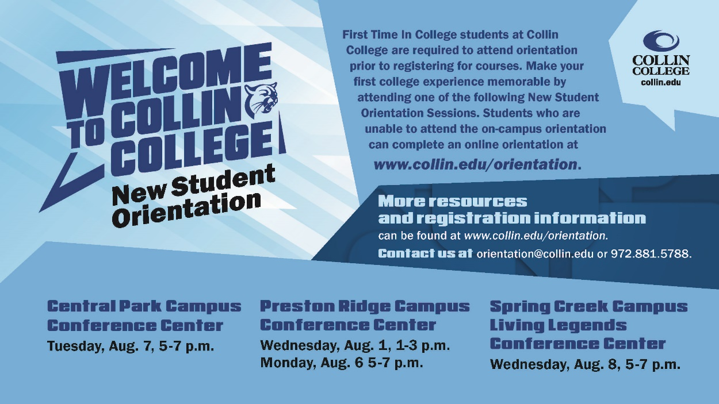

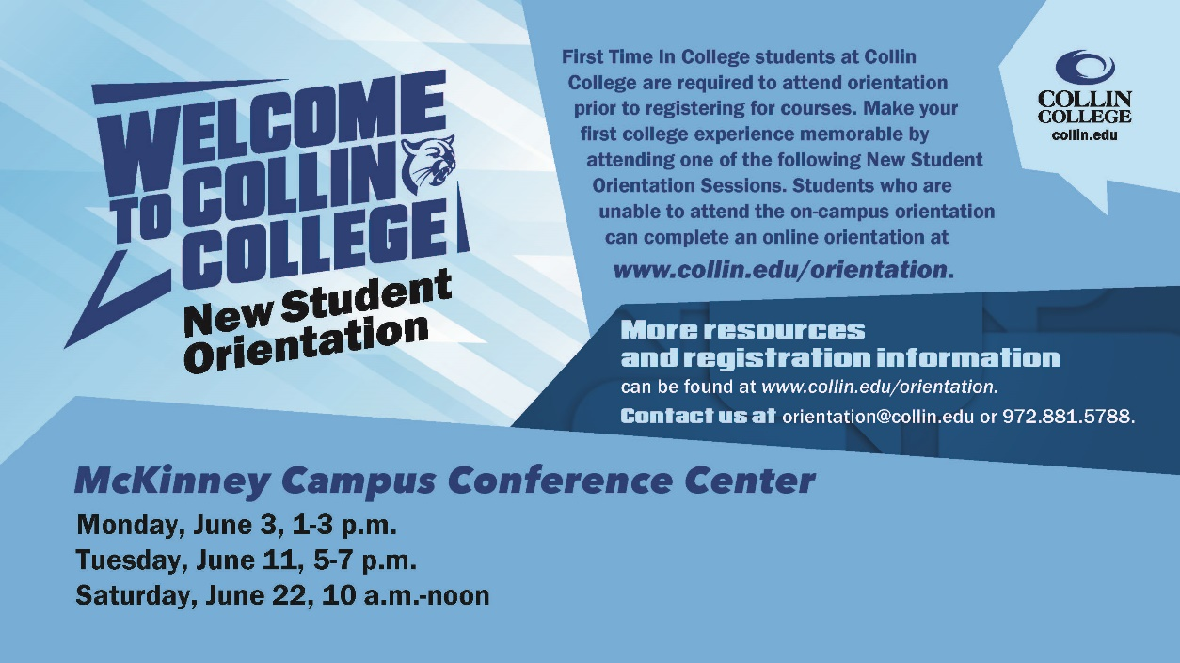
Addendum E: 2019-2020 Orientation Survey
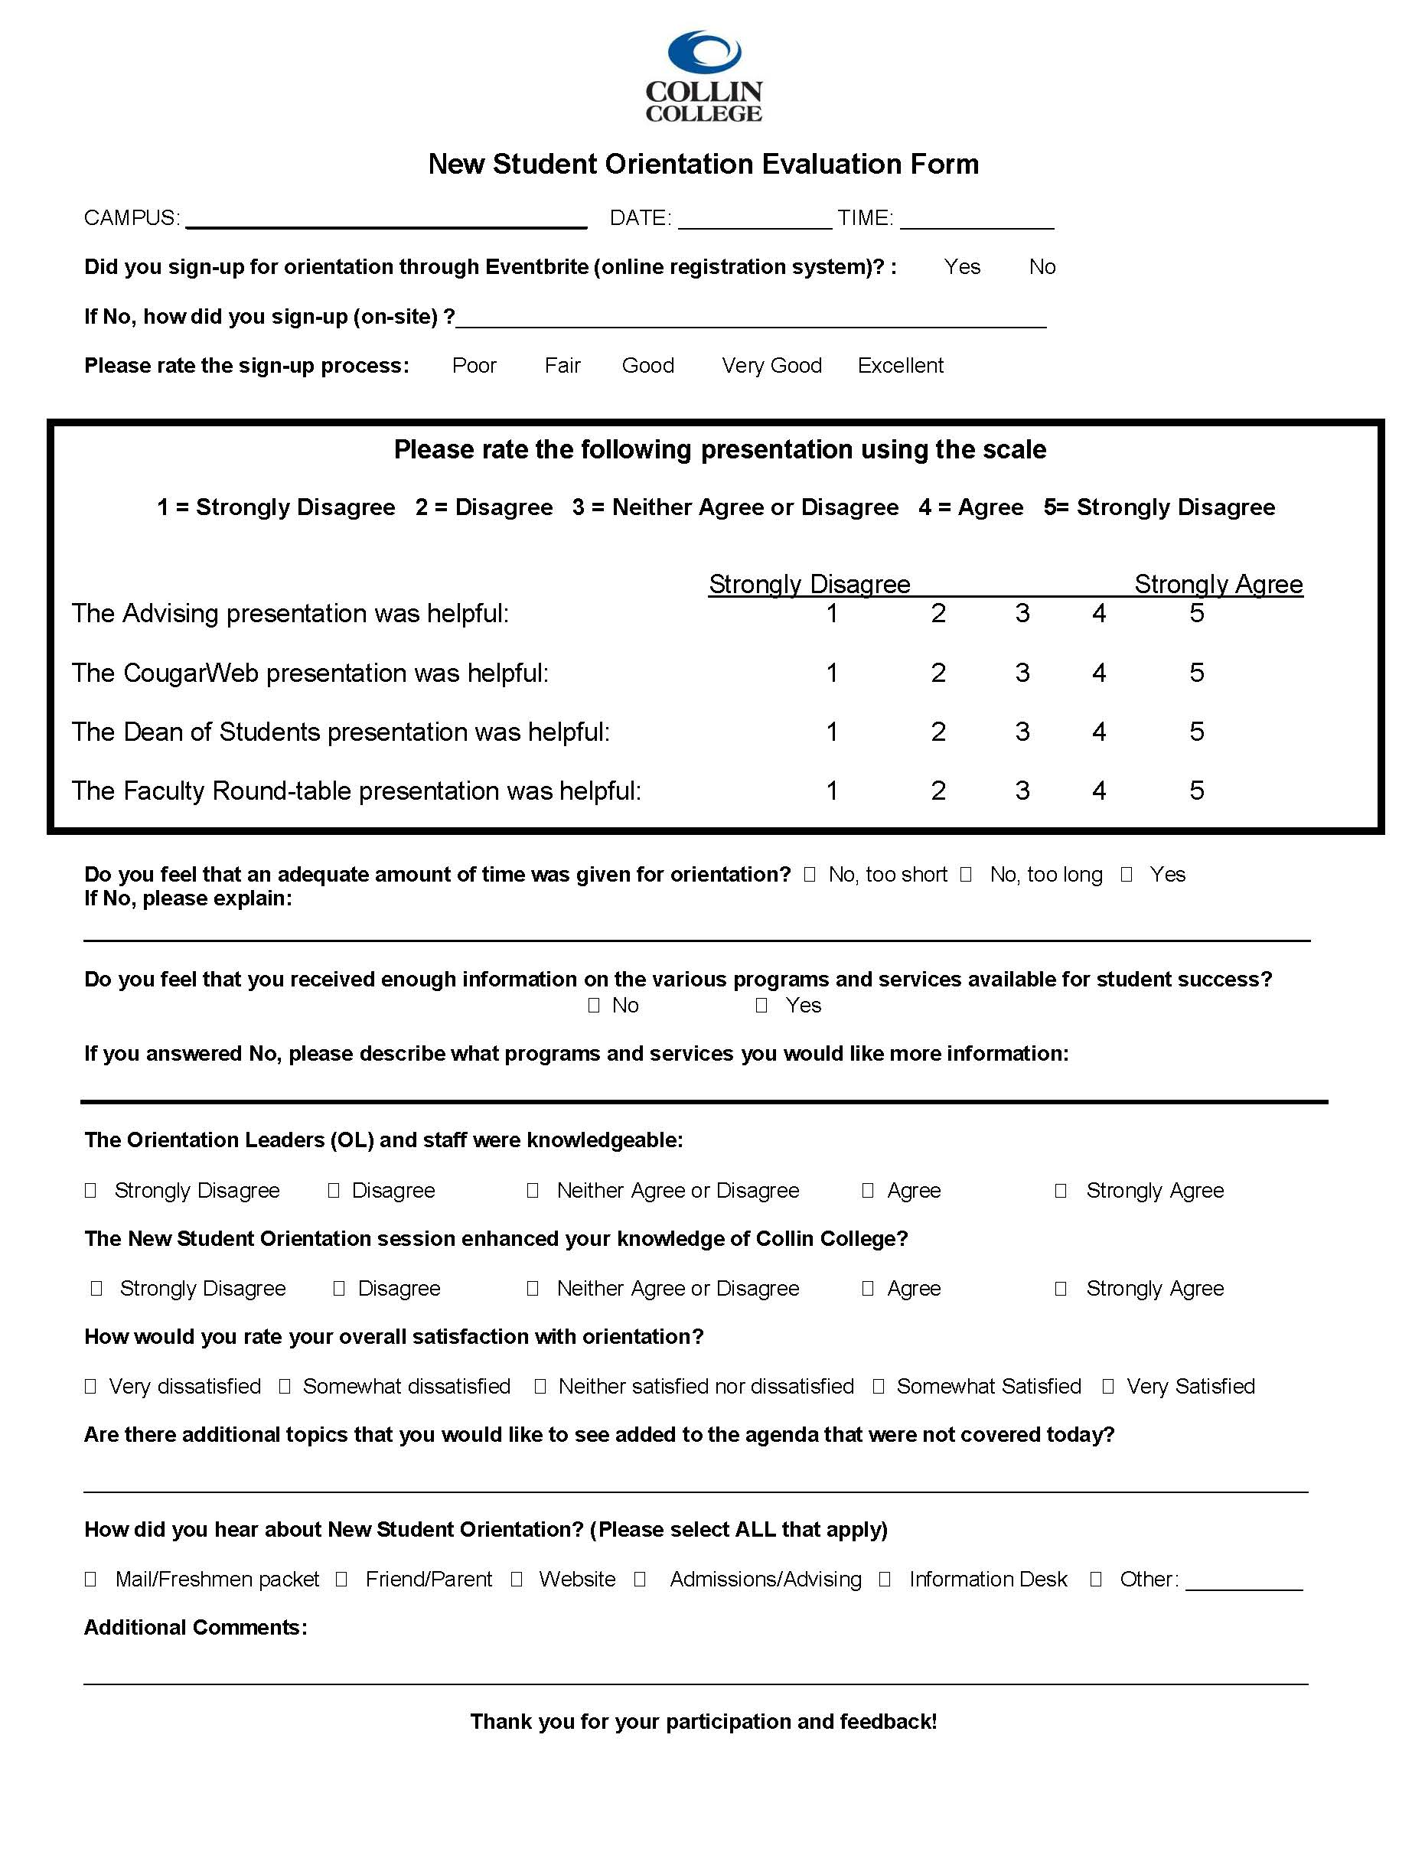

Addendum F: 2019-2020 Online Orientation Survey
ONLINE Orientation Evaluation

How would you rate your overall satisfaction with online orientation?
Very dissatisfied: x Somewhat dissatisfied: x Neither satisfied nor dissatisfied: x
Somewhat satisfied: x Very satisfied: x

Please rate the following:
The Advising portion was helpful:
Strongly Disagree: XX Disagree: XX Neither Agree or Disagree: XX
Agree: XX Strongly Agree: XX Not Rated:
Comments:

The Cougarweb portion was helpful:
Strongly Disagree: XX Disagree: XX Neither Agree or Disagree: XX
Agree: XX Strongly Agree: XX Not Rated:
Comments:

The Dean of Students portion was helpful:
Strongly Disagree: XX Disagree: XX Neither Agree or Disagree: XX
Agree: XX Strongly Agree: XX Not Rated:
Comments:

The videos throughout the orientation were helpful:
Strongly Disagree: XX Disagree: XX Neither Agree or Disagree: XX
Agree: XX Strongly Agree: XX Not Rated:

The voiceover for all content was helpful:
Strongly Disagree: XX Disagree: XX Neither Agree or Disagree: XX
Agree: XX Strongly Agree: XX Not Rated:

Do you feel an adequate amount of time was given for orientation?
No, too short: No, too long: Yes:

If No, please explain:
  - REASON

Do you feel that you received enough information on the various programs and services available for student success?
No: XX Yes: XX

If you answered No, please describe what programs and services for which you would like more information:
- REASON

Did the online orientation session enhance your knowledge of Collin College?
Strongly Disagree: XX Disagree: XX Neither Agree or Disagree: XX
Agree: XX Strongly Agree: XX Not Rated:
Comments:

Overall satisfaction with orientation?

Are there additional topics that you would like to see added to the agenda that were not covered today?
- REASON

Why did you choose to complete the online orientation, instead of on-campus orientation?
- reason

