PROGRAM NAME: Testing Division | AUTHORING TEAM CONTACT: Karen Stewart
PHONE: 972-548-6773 | EMAIL:kastewart@collin.edu

GUIDELINES
Time Frames
- Scope:
The time frame of program review is five years, including the year of the review.
Data being reviewed for any item should go back the previous four years, unless not available.
- Deadline Dates:
January 15th – Program Review Document due to Department Dean for review (Deans may require submissions at their own, earlier due date)
February 1st – Program Review Document due to Program Review Steering Committee
- Years:
Years 1 & 3 – Implement Action Plan of (CIP) and collect data
Years 2 & 4 – Analyze data and findings, Update Action Plan
Year 5 – Write Program Review of past 5 years; Write Continuous Improvement Plan (CIP) and create new Action Plan

LENGTH OF RESPONSES: Information provided to each question may vary but should be generally kept in the range
of 1-2 pages or 500-1,000 words.

EVIDENCE GUIDELINES: In the following sections, you will be asked to provide evidence for assertions made.
- Sources: This evidence may come from various sources including professional accreditation reviews, THECB, Texas Workforce Commission’s CREWS, Institutional Research Office (IRO), National Student Clearinghouse, IPEDS, JobsEQ, EMSI Career Coach, and may be quantitative and/or qualitative. If you are unfamiliar with any of these information sources, contact the Institutional Research Office at: effectiveness@collin.edu. Use of additional reliable and valid data sources of which you are aware is encouraged.
- Examples of Evidence Statements:
- Poor example: Core values are integrated into coursework. (Not verifiable)
- Good example: Core values are integrated into coursework through written reflections. (Verifiable, but general)
- Better example: Core values are integrating into coursework through written reflections asking the student to describe how s/he will demonstrate each of the core values in his or her professional life and demonstrated through service learning opportunities. (Replicable, Verifiable)

FOR MORE INFORMATION: The Program Review Portal can be found at http://inside.collin.edu/institutionaleffect/Program_Review_Process.html. Any further questions regarding Program Review should be addressed to the Institutional Research Office (effectiveness@collin.edu, 972.599.3102).

Introduction/Preface
☒EXECUTIVE SUMMARY:
Briefly summarize the topics that are addressed in this self-study, including areas of strengths and areas of concern. (Information to address this Executive Summary may come from later sections of this document; therefore, this summary may be written after these sections have been completed.) Please do not include information in this section that is not already provided elsewhere in this submission. Using the questions in the template as headings in the Executive Summary can provide structure to the overview document.
The Testing Division, which includes the District Testing Office and seven campus Testing Centers, strives to provide efficient customer service and a comfortable atmosphere conducive to a safe, secure and quality testing environment. The testing staff collaborate with faculty and administrators of Collin College, other colleges and universities, local Independent School Districts, testing companies, and state and national organizations to keep up to date with the changes in all aspects of testing services. We strive to provide outstanding customer service while adhering to the rigorous testing protocols and offer accurate information in an environment that treats everyone with dignity and respect.
The Testing Centers are located on the Celina, Farmersville, Frisco, McKinney, Plano, Technical, and Wylie Campuses. District Office staff, including the Director of Testing, Division Secretary and the Technical Coordinator are located on the McKinney campus. Testing Centers were included in the four newest campuses (Celina, Farmersville, Technical and Wylie) with the first opening fall of 2020. The Frisco Testing Center was remodeled in 2018. The McKinney Testing Center was moved to a temporary location in the fall of 2021 and will move to a new facility in the summer of 2022. Upgrades to the Plano Testing Center surveillance system started January 2022. Maintaining the testing and surveillance equipment is of the utmost importance and a continual challenge to ensure the integrity of all exams administered by the testing centers.
When Collin College was closed due the pandemic and reopened under limited capacity, the testing center pivoted services to online. As of fall 2021 the testing centers are back to full operational capacity but the usage has not fully rebounded. Additionally, the testing centers underwent an organizational redesign to centralize reporting to the Director of Testing under the office of the Associate Vice President of Student and Enrollment Services.
Since the previous program review, the testing division has changed reporting structures, added four new campus locations, modified service to online delivery during a pandemic, implemented an updated state standard exam, and significantly upgraded equipment.

Section I. Are We Doing the Right Things?

☐1. WHAT DOES OUR UNIT DO?
What is the service unit and its context?
This section is used to provide an overview description of the service unit, its relationship to the college and the community it serves. Keep in mind the reviewer may not be familiar with your area. Therefore, provide adequate explanation as needed to ensure understanding.
Suggested/possible points to consider:
- Unit’s purpose (Include the unit’s purpose/mission statement if one exists.)
- Services and products (i.e. event coordination, reports, promotional materials, handouts, etc.)
- Service across campus/departments/district/community
- Regulatory standards the unit must meet

The Division of Testing provides support to students and community members with facilities and services designed to help meet testing and assessment needs through partnerships with faculty, state and national testing vendors. The testing staff must complete training and annual testing to obtain and maintain the proctoring certifications required to administer tests for the vendors we partner with, including: Accuplacer (to administer the Texas Success Initiative with standards established by the Texas Higher Education Coordinating Board https://www.highered.texas.gov/) as set by Texas state law (https://www.highered.texas.gov/institutional-resources-programs/public-community-technical-state-colleges/texas-success-initiative-and-developmental-education/); the College Level Examination Program; Pearson VUE; and the Test of Essential Academic Skills assessment. Collin College Testing Centers are also members of the National College Testing Association https://www.ncta-testing.org/ and strive to adhere to their professional standards and guidelines.
To maintain our standing as certified testing centers for these programs we must follow many stringent guidelines. These include following identification requirements, ensuring no unauthorized materials are brought into or leave the testing center, and that test takers are continually monitored for suspicious behavior during testing. We monitor in person testing by conducting walk throughs in the physical testing rooms, as well as monitoring through glass windows and video surveillance. The advances in technology, specifically recording devices, has made testing security increasingly challenging. The Testing Centers need to continually be updated on the new devices in which a test taker can record the test content and receive information (i.e. smart rings, camera glasses, smart watches, etc.). The technology has become smaller and cheaper for the masses to purchase.
Many of our programs require we keep video records for up to 30 days in case questions arise about a possible testing violation and a review is requested. A few testing programs have software surveillance of the test taker that locks their computer if they try to click outside of the test window/browser.
Every exam that is administered has a unique set of guidelines that must be followed. An example of this would be scratch paper usage. Some programs allow for only one piece of scratch paper be used at a time. When that piece has been filled, the tester must raise their hand and the paper can be exchanged for a fresh piece of paper. Other programs will allow for a specific number of pieces of paper (i.e. a maximum of 3 pieces of paper). There can also be different requirements for disposing of scratch paper. This can range from total destruction through shredding to returning the paper collected with the test.
Depending on the program, we provide pencils, scratch paper (or dry erase boards and markers), calculators, ear plugs, headphones and other supplies as required. We must also maintain cleanliness of our testing stations and keep wipes, tissues, hand sanitizer, and other such supplies on hand. Silicone keyboard covers were installed to help maintain a cleaner environment when the testing centers were reopened after the start of the pandemic.
Testing can be extremely stressful and we strive to create an environment that attempts to reduce the stress and anxiety many students and testers feel when taking exams, while still following the guidelines that have been set by the various testing programs. The testing staff must occasionally deal with the adverse physiological side-effects of testing anxiety when students become ill or nervous. Our staff strive to handle these incidents in a way that maintains the dignity and privacy of the testers, as well as deal with the clean-up of such incidents as quickly and quietly as possible.
The Testing Division receives regular updates related to changes in the requirements of the assessments we deliver for various Collin College programs. We communicate these changes throughout the district. Our department’s effectiveness can be quantified through the volume of assessments we provide to incoming students, allowing them to register for classes, as well as services to the community such as CLEP and correspondence test proctoring.
The division provides services for the following areas:
- Provide the management, support and documentation of placement records for students entering Collin College in our Student Information System to establish college level readiness and course placement.
  - Pre-Assessment Activity (PAA)
  - Texas Success Initiative (TSI)
    - On-campus testing
    - Off-site testing at high schools within the Collin College service area.
    - Remote testing via 3rd party proctoring vendor (Examity), or at an approved college testing location.
  - College-Level math Assessment
  - English as a Second Language (ESL) Assessment
- Manage the TSI exemptions and waivers process for college to support student enrollment.
  - Conditional TSI Compliance Contract Process
  - Exemptions
    - ACT (American College Test)
    - SAT (Scholastic Aptitude Test)
    - STAAR (State of Texas Assessments of Academic Readiness)
    - GED (General Educational Development)/HiSET (High School Equivalency Test)
    - Military
    - Associates or Baccalaureate degree completion
    - Other college transcripts
      - In state – Public college
      - In state – Private college
      - Out of state
  - Waivers
    - Certificate Level 1 programs
    - Non-degree / non-certificate seeking programs
    - College Prep course completion
    - Military
  - Dual Credit Waivers
    - PSAT-NMSQT (Preliminary Scholastic Aptitude Test - National Merit Scholarship Qualifying Test)
    - ACT-Aspire (American College Test)
    - STAAR (State of Texas Assessments of Academic Readiness)
- Provide the management, support and documentation of the Prior Learning Assessment (PLA) for Collin College approved national credit by exam options for students to have credits added to their transcripts.
  - Advanced Placement (AP)
  - College Level Examination Program (CLEP)
  - International Bachelorette (IB)
- Provide support for the assessment of candidates for various academic programs
  - Test of Essential Academic Skills (TEAS) for Nursing program
  - Accuplacer assessments for Fire Science Program
  - Accuplacer assessments for Emergency Medical Services (EMS) programs
- Provide support for classroom assessment to students and faculty for make-up exams, and exams for some ACCESS students (depending on accommodation).
- Provide end of program certifications to students (State Fire Boards).
- Provide a service to community members requiring proctoring services for various certifications and licensures.

Division Location Information
Division Office
- 2200 W. University Dr.
McKinney, TX 75071
Room B209 - Technical Coordinator – (972) 548-6531
Room B210 - Director of Testing – (972) 548-6773
Room D118 - District Secretary – (972) 548-6794
Celina Testing Center
- 2505 Kinship Parkway
Celina, TX, 75009
Room: 125
Phone: (469) 905-3599
Email: Celinatesting@collin.edu
Farmersville Testing Center
- 501 S. Collin Parkway
Farmersville, TX 75442
Room: 107
Phone: (972) 549-6450
Email: Farmersvilletesting@collin.edu
Frisco Testing Center
- 9700 Wade Blvd.
Frisco, TX 75035
Room: F209
Phone: (972) 377-1522
Email: Friscotesting@collin.edu
McKinney Testing Center
- 2200 W. University Dr.
McKinney, TX 75071
Room: A206
Phone: (972) 548-6849
Email: TestingCPC@collin.edu
Plano Testing Center
- 2800 E. Spring Creek Pkwy.
Plano, TX 75074
Room: J232
Phone: (972) 881-5922
Email: Planotesting@collin.edu
Technical Campus Testing Center
- 2550 Bending Branch Way
Allen, TX 75013
Room: A001
Phone: (972) 553-1234
Email: Cctctesting@collin.edu
Wylie Testing Center
- 391 Country Club Road
Wylie, TX 75098
Room: Campus Commons 201
Phone: (972) 378-8849
Email: Wylietesting@collin.edu

☐2. WHY DO WE DO THE THINGS WE DO? UNIT RELATIONSHIP TO THE COLLEGE MISSION & STRATEGIC PLAN.
- Provide unit-specific evidence of actions that the unit supports the mission statement: “Collin County Community College District is a student and community-centered institution committed to developing skills, strengthening character, and challenging the intellect.”
- Provide unit-specific evidence that supports how the unit supports the college strategic plan (2020-2025 Strategic Plan): http://www.collin.edu/aboutus/strategic_goals.html
Suggested/possible points to consider:
- What evidence is there to support assertions made regarding how the unit relates to the Mission and Strategic Plan?
- Analyze the evidence you provide. What does it show about the unit?

Collin College Mission
The Testing Centers serve an important roll in student success at Collin College through administration of examinations and assessment of readiness for the next step in a student’s chosen academic path. We support the mission of being a student and community-centered institution by providing the physical location for our students and community members to test and assess for proper placement in their pursuit of developing skills and challenging the intellect. The total number of assessments and exams administered from 2016-2021 totaled 274,206.

Source: Testing Center Administrative Program (TCAP)
*Testing Centers were closed starting March 2020 and did not return to full capacity until Summer 2021

Collin College Values

Academic Excellence, Dignity and Respect
The Testing Centers serve as a vital part of a student’s academic excellence through examination and showing readiness for proper course placement. The Testing Centers strive to provide an environment that focuses on treating each test taker with dignity and respect, while maintaining the integrity of the assessments being administered.

Learning
As the division responsible for the administration of and record keeping for the assessments for Texas Success Initiative (TSI), English as a Second Language (ESL), Fire Science Academy, EMS/Paramedics, Nursing, and Allied Health programs, we help to provide students with a baseline to establish the skills needed to be successful in the college environment and their chosen program.

The Testing Division staff are required to maintain test proctoring credentials for many of the third-party vendors we work with (Accuplacer, CLEP, TEAS). Our staff must pass exams to maintain these credentials. In addition to the training provided by the testing vendors, staff also use LinkedIn Learning and attend Collin College sponsored professional development activities.

Service and Involvement
Students are also given the opportunity to advance their placement in higher level courses through AP (Advanced Placement), CLEP (College Level Examination Placement), IB (International Bachelorette), and the College Level Math Assessment. In 2020 the PLA (Prior Learning Assessment) program, of which the Credit by Exam program is a part, expanded the number of credits a student can apply toward an Associate’s Degree from 18 to 45 (30% - 75%). This change helps the student to be able to complete their degree more quickly, saving them both time and money.

We also support the Dual Credit program through the administration of off-site TSI Testing at local high schools and by accepting data files of TSI scores from high schools who have established their own TSI Testing programs on their campuses. In the 2021 academic year we served 4 high schools by proctoring at their location.

Innovation
The Testing Centers implemented new testing modalities during the pandemic to allow us to continue to service our students and to facilitate the registration process. By introducing online proctoring through Examity for TSI Assessments and Zoom proctoring for the College Level Math Assessments, we were able to provide testing services to 3,923 students in FY 20 and 4,958 students in FY 21 from their homes, which was previously not an option we were able to offer to our students.

Strategic Plan 2020-2025
(https://www.collin.edu/masterplan/#vision)

Goal 1 - Improve student outcomes to meet or exceed local, state, and regional accreditation thresholds and goals

The Testing division works closely with the Curriculum office and Academic Affairs to implement course placement based on student assessment levels from the TSI and College Level Math Assessment. The proper placement levels are necessary for students to be academically successful impacting retention, completion and graduation.

Students who were not exempt and took the TSI, placed at the following levels in 2020. This information is shared with Academic Affairs to aid in determining the number of developmental sections needed and to help anticipate student academic preparedness.

Strategic Plan – 2016-2020
(https://www.collin.edu/aboutus/pdfs/201610StrategicPlanVision2020.pdf)

Strategic Priority 2 - Increase outreach and create streamlined pathways from high school

The Division of Testing has contributed toward supporting this priority through its support of the Dual Credit program by offering TSI assessments at the high schools.
- We continue to travel to area high schools when requested to offer the TSI assessments to the students. In Spring of 2021 we provided this service to 4 area high schools (two in the Prosper ISD system; the Frisco Alternative School, and Melissa ISD).
- Many area high schools have now been set up with Accuplacer accounts to proctor the TSI exam at their location for their students. When the exams are complete, the ISD sends a data file to Collin College to be uploaded to the dual credit students account. While it is less resource intensive for the college (costs of exam units and proctors are paid by the ISD), this process occasionally results in some data matching issues. In spring of 2021, this caused additional issues when the state upgraded to TSIA2.0, causing the automatic links to upload scores to break and all scores had to be manually added. This issue was fixed and functional again by June 2021.
Strategic Priority 3 - Emphasize student achievement and streamline pathways to four-year colleges and universities.
The Division of Testing collaborated with the Prior Learning Assessment (PLA) committee to increase the number of Credit By Exam credits (AP, CLEP & IB) students can apply to their degree program to 75% of the program requirements.
- Previously students in an Associate’s Degree program were limited to applying a maximum of 18 credits to their program. This limit was increased to 45 credits (75% or a program’s credit) in the 2020 course catalog.
- Students in any Collin College program can petition to apply appropriate previous learning experiences to their transcripts through the Prior Learning Assessment (PLA) process.
- Credit By Exam is one possible avenue for PLA credit. Others, which are coordinated by individual departments can also be requested.
- Students must complete at least 25% of their degree program at Collin College.
Strategic Priority 6 - Create an increasingly welcoming environment for students, community members, faculty and staff.
The Division of Testing is continually working to improving the atmosphere of the Testing Centers in the following ways:
- Creating calm, welcoming spaces with friendly, customer focused employees to help reduce test anxiety.
  - Our professional staff focus on customer service and work hard to keep the atmosphere of the Testing Centers calm and comfortable without jeopardizing test security and confidentiality.
  - Four new testing centers have been opened at our new campuses since Fall 2020. Furniture selection was intentional - down to the chair legs that do not have wheels. Anxious test takers were found to roll at the desks, so standard chair legs were selected preventing students from rolling around.
  - The Frisco Testing Center was remodeled in 2019, expanding the number of computerized testing stations.
  - The McKinney Testing Center will have space in the new Welcome Center, scheduled to be completed in late spring of 2022.
- Keeping the website up-to-date and continually working to improve the content to be easily understood by the reader.
  - Three Testing Center staff members served on a Website review committee in FY 2021.
- Added online test proctoring during pandemic to continue to support student testing and assessment needs.
  - To continue to service students needing to take placement exams during the pandemic, online test proctoring options were added to our services.
  - TSI testing can be taken through a third-party vendor called Examity. Our staff create vouchers when requested by students and students then make an appointment with Examity to have their exams proctored. While the use of the online proctoring service for TSI has dropped significantly, we will continue to offer it as an alternative for students whose schedules will not allow them to get to campus to take the TSI Assessments.
  - The TEAS assessment for Nursing students was also moved to an online proctoring format through ATI’s approved vendor, ProctorU. TEAS testing is still being conducted online, although the Nursing Department has asked we return to in person testing when the McKinney Testing Center has moved to its new location.
  - Our Testing Center staff also began to proctor the higher-level math assessments via Zoom during the pandemic. This is a labor-intensive task as we proctor these exams on a one-on-one basis. Since re-opening at full capacity in August of 2021, we have encouraged students to come to a campus Testing Center to take these assessments, we will still proctor online at student request.

☐3. WHY DO WE DO THE THINGS WE DO?
A. Make a case with evidence to show that the primary functions/services of the unit are necessary as they are, or they should be modified, or eliminated.

Suggested/possible points to consider:
- What is the purpose and reason for the service?
- How has the function evolved during the 5-year cycle? How have the reasons for the service changed over time?
- What would happen if the unit no longer provided these services and/or the services were outsourced?
- What unit services require the most resources including staff time? Which services add the biggest value to the college? Discuss any discrepancies between the services named in these two questions.
- Is there a clear line of communication with other units involved in or supporting each of these services?
- Does the unit or the college have alternate ways of providing any of these services?
- Are the services offered/conducted as efficiently as possible?
B. Benchmarking: Review two or three comparable colleges for the way they accomplish these services. Discuss what was learned and what new ideas for service improvement were gained.
The primary responsibilities of the Testing Division are:
- To help students determine their placement levels so they can appropriately register for the courses they are academically on level for and can successfully complete.
- To keep accurate student records for student placement and the Credit By Exam program.
- To provide a safe, comfortable, secure location for students needing to take classroom make-up and other exams.
Over the past five years there have been many changes to the Testing Division, including the addition of four new campus Testing Centers and expanding remote proctoring. These changes are outlined below and charts have also been included.

Impacts on Students
Besides the testing we offer to help students reach their academic goals, we also strive to provide a location where students feel comfortable and welcome in order to help degrease test anxiety and stress, which can help improve test scores.

  - Gaines, K. S., & Curry, Z. D. (2011). The inclusive classroom: The effects of color on learning and behavior. Journal of Family and Consumer Sciences Education, 29(1), 46-57. Available at http://www.natefacs.org/JFCSE/v29no1/v29no1Gaines.pdf
  - Liu, D., Xu, B. Test anxiety: perceptions of American community college nursing students. Empirical Res Voc Ed Train 9, 4 (2017). https://doi.org/10.1186/s40461-017-0048-1
When the new Testing Centers were designed, they were located in areas that would be easily accessible by members of the community but not in high traffic areas of instructional classrooms. The individual testing stations were oversized in order to accommodate both a computer station as well as a desk for written exams.
Classroom Testing
In 2018, the Testing Centers stopped offering testing for entire classes, except for online/hybrid, weekend, and Developmental Education (DE) courses, which resulted in slight reduction of the number of test taker in the following two years. The pandemic that began in March of 2020 impacted our classroom related testing numbers in additional ways, as programs had to implement virtual proctoring methods. The continued use of these methods in online/hybrid and weekend courses since returning back to normal campus operations has dramatically lowered our classroom testing numbers. The testing centers are now only providing classroom exams as make-up tests for students who missed a regularly scheduled exam and for ACCESS students who have extended time or limited distraction environment accommodations if they do not want to test in the ACCESS office.

Program Assessments
Our most demanded testing functions following the pandemic are now the program and placement assessments of TSI, Nursing/Allied Health, Fire and EMS entry assessments.

All Other Exams
The pandemic also impacted the number of all other exams proctored in the Testing Centers. We were closed for all correspondence testing from March 2020 until May of 2021. From May-August of 2021 we were opened on a limited basis as time and space allowed while we were still operating with only half of our total capacity.

See chart showing the changes in testing numbers over the last five years on the next page.

Source: Testing Center Administrative Program (TCAP)
*Testing Centers were closed starting March 2020 and did not return to full capacity until Summer 2021

Resource Utilization
The purchase of TSI units from the College Board is the largest upfront cost to our operating budget in the amount of $165,000. These costs are reimbursed to the general fund through students’ TSI payments. In 2020, the State of Texas outsourced the online administration of the TSI to Examity. Starting May 2021, the Testing Center became responsible for paying the student proctoring fee of $25 each to Examity. While the college collects the funds, those are deposited in the general operating account and not the departmental budget. This is something that will need to be revisited as this new cost was not anticipated nor can the current budget support the additional expenses averaging $100,000 per year.

The demand for staff resources is the highest for program assessments. Currently, all of our Testing Centers are operating at staffing levels that are below the budgeted personnel headcount. With the demand for testing still being lower, we have been able to handle current volume (except at the McKinney Campus which is discussed in greater detail later in this section). We are monitoring the demand for off-site TSI testing at local high schools for the Dual Credit program, which could provide some staffing challenges this spring.

We are experiencing greater staffing challenges at the McKinney Campus Testing Center. Due to the construction projects, the Testing Center has a temporarily location in which the office and personnel are in a separate location from the testing room. The team has the challenge of staffing those two locations in addition to proctoring a third location when certain exams (TEAS-Nursing and state fire board) are being administered. There has been staff turn-over at that location as well. Team members from the Plano Campus and the District Secretary have been deployed to assist with the coverage.

The functions that add the largest value to Collin College are the TSI, program assessments, and classroom testing. Correspondence exams are a value-added service to community members; however, it is not a service that has any impact on our students. Correspondence exams must often be proctored by full-time staff, although a few can be proctored by part-time staff if they are not also students. The administration of these exams generates a small amount ($30 per exam) of revenue for the college. While students and community members are charged administrative fees for most exams, those fees often barely covered the actual expense of the exam. The chart below identifies the exams, the charges to the student, and institutional costs.
Resource Utilization

Exam Type/Name | Charge to Student | Cost to Collin | Other resources
TSI Assessment | $29 | Between $7.25 and $11.00  (Collin College purchases units)  The TSI Assessment will adapt to each student as they test. Up to 8 testing units may be required if routed into the diagnostic portion in both areas.  Personnel costs absorbed in standard departmental operations | Shared staff (only full/part time staff)  Shared facilities
TSI Off-Site | $29 | Between $7.25 and $11.00  (Collin College purchases units)  Personnel costs absorbed in standard departmental operations | Shared staff (Dual Credit, Advising, Testing, Recruitment) - 2 to 10 designated proctors  Local travel expense  Off-Site facilities and Collin designated labs
CLEP Exam | $15 | Personnel costs absorbed in standard departmental operations | Shared staff (only certified staff)  Shared facilities
Correspondence | $30 | Personnel costs absorbed in standard departmental operations | Shared staff (Only full-time staff or part-time staff who are not enrolled in any college program, depending on the requirements of the college for which we are proctoring.)  Shared facilities
College-Level Math Assessment | $11 | $1.75  Personnel costs absorbed in standard departmental operations | Shared staff (only full/part time staff)  Shared facilities
Departmental Exams (PLA) | $30 |  | Shared staff  Shared facilities
ESL Assessment | $0 | $9.63  Personnel costs absorbed in standard departmental operations | Shared staff  Shared facilities
Nursing TEAS Exam | $40 | $20  Personnel costs absorbed in standard departmental operations | For In-Person Proctoring  - 2 designated proctors  - Designated lab  For Online Proctoring  - 1 designated proctor
Fire Science Assessment | $0 | $7.00  Personnel costs absorbed in standard departmental operations | Shared staff (only full/part time staff)  Shared facilities
EMT Assessment | $0 | $7.00  Personnel costs absorbed in standard departmental operations | Shared staff (only full/part time staff)  Shared facilities
Classroom Test | $0 | Personnel costs absorbed in standard departmental operations | Shared staff  Shared facilities
Fire Science State Boards | $0 | Personnel costs absorbed in standard departmental operations | For In-Person Proctoring  - 1 designated proctor  Designated lab

Other Changes to The Division
In fall of 2020, the division was reorganized so that all campus Testing Centers would report to the Director of Testing instead of to the Student and Enrollment Services Dean at each campus. The previous Director, who retired in August of 2020, reported to the District Registrar. The current Director started in January of 2021 and now reports to the Associate Vice President of Student and Enrollment Services.

The division organizational chart is included on the next page.

At the start of the pandemic in March 2020, Testing Center staff quickly learned how to use online proctoring tools to enable the college to continue offering placement testing (through Examity or Zoom software). When campuses re-opened for in-person testing in late July 2020, seats available for testing was limited to half capacity at each campus to allow for social distancing. Appointments were also required for all testing, something that had not been previously required. The centers also initially limited testing to current Collin College or in-coming students only. In March 2021, services were expanded back for non-students taking CLEP and Correspondence tests as space allowed.

In August 2021 the testing centers returned to 100 percent seating capacity. Appointments are required to guarantee a seat; however, walk-ins are available as space and time permit.

Departmental Interdependencies and Communication
The Division of Testing works closely with all academic and workforce departments, all other units in Student Enrollment Services, Information Technology, the Bursar’s Office, Dual Credit and many other departments at Collin College. All academic and workforce departments use our services either as part of the initial placement exams for students or for classroom make-up exams when needed. Programs that require entrance exams (i.e., Fire/EMT, Nursing, and Allied Health) rely on the Testing Centers to administer, proctor, and in some instances, score these specialized exams.

We communicate daily with faculty, staff and administration on seven campuses in person, by phone, and/or through email. We work very closely with Admissions, Academic Advisors, the Transcripts Office, and P-12 Partners (Dual Credit and the College and Career Counselors).

The ACCESS Office (disability services) is able to proctor classroom, TSI, ESL and College Level Math assessments for students with documented accommodations. However, no other unit at Collin College is qualified to administer CLEP exams, Fire/EMT assessments, the State Fire Boards, or to provide testing services to the general student population.

The chart on the following page outlines the functions of the Division of Testing.

Testing Center Functions
Area | Test | Purpose/Reason | Has it evolved in 5 years? | What would happen if no longer provided/outsourced | Interdependencies | Efficient service?
Admission Process | Pre-Assessment Activity | To comply with regulation established by the THECB.  To provide students with information about the TSI Assessment, Resources and Sample Questions.  To improve student’s performance on the TSI so they will be more familiar with the exam and the significance of it. | Yes. First launched in August, 2013. It has undergone several revisions, the most recent in 2021 with the launch of TSIA2.0. | We would not be in compliance with the state-mandated directives from the THECB  *Refer to THECB - TSI | Prerequisite to take the TSI Assessment | Yes. It's offered online, the student can take it anytime and anywhere.
 | TSI Assessment | To comply with regulation established by the THECB  To determine the correct placement for a student. | Yes. First launched in August, 2013. Several updates have been made per Developmental Education/College Board directives, the latest in January 2021. | We would not be in compliance with the state-mandated directives from the THECB  *Refer to THECB - TSI | Prerequisite to register. Results impact most academic courses offered by institution | Appointments are required. Walk-ins are available as time/space allows.  An online proctoring option allows students to take the assessment remotely.
 | College-Level Math Assessment | It accurately measures a student’s knowledge to ensure proper placement for courses beyond College Algebra. | Yes. Switched from Compass platform to Accuplacer platform | All College-Ready (Math) students would have to start with College Algebra or equivalent, therefore extending time to graduate and increasing costs | All math courses at institution | Yes. Students can take the assessment twice per semester. Appointments are required.  An online proctored option is available.
 | ESL Assessment | To determine proficiency in the English language | Yes. Switched from Compass platform to Accuplacer platform | Would restrict student's placement options prior to TSI readiness | International student office and all ESL courses | Yes. It's available once per semester. Appointments are highly encouraged. There is no charge to the student.
 | TEAS Nursing | To establish readiness for the nursing program | Yes. Switched from paper and pencil to web-based administration – November 2016  Switched to 3rd party proctoring in April 2020. | Process for admissions to the Nursing program would need to be reevaluated. | Nursing department | Scheduled by the Nursing department, proctored by Testing.
 | Fire Science/EMT Assessment | To establish readiness for the Fire Science, or EMT program. | Yes. Switched from Compass platform to Accuplacer platform | Process for admissions to the Fire Science/EMT program would need to be reevaluated. | Fire Science, EMT and Police programs | Yes. It's available twice per semester on a walk-in basis. There is no charge to the student.
Area | Test | Purpose/Reason | Has it evolved in 5 years? | What would happen if no longer provided/outsourced | Interdependencies | Efficient service?
End of Program Exams | Texas State Fire Exam | The state written exam is one part of the overall state exam process. In addition to the written exam, students are required to complete a skills exam. We are approved by the Texas Commission on Fire Protection (TCFP) to conduct the entire exam process at our campus. All training providers must establish testing procedures as part of the required course approval process. |  | If Collin College did not provide facilities for conducting written and skills testing, we would not be approved to offer state certification training. | Fire Science program
Distance Learning | Correspondence | To support the community, we provide the adequate testing environment and the appropriate proctoring services for distance education students attending accredited institutions of higher education | N/A. Our procedures adapt to the other institutions' requests | Community members would have to find an alternate institution to meet their proctoring needs, having to travel further and increasing their cost | Serves institutional mission of being “community centered” | We administer a vast array of online and paper/pencil exams for online students for other colleges and universities, this entails scheduling, communication, logistical, and technical challenges; as each test is different.
Prior Learning Assessment  (Credit By Exam) | CLEP | To expedite the student's path to course completion | Yes. We make adjustments following the College Board directives- Last updated September 2021. | Community members and our students would have to find an alternate institution to meet their proctoring needs, having to travel further and increasing their cost | Depending on course, impacts numerous academic programs | Yes. We offer them at all the testing centers.
 | Departmental Exams | To expedite the student's path to course completion | Yes. Most departments now conduct their own testing, although we still proctor for some Fire Science PLA exams. | It would increase demand on faculty to administer | Depending on course, impacts numerous academic programs | Yes. We adapt to the needs of the academic departments.
 | Advanced Placement (AP) & International Baccalaureate (IB) Exams | To expedite the student's path to course completion | Yes. Additional classes have been added after discussions with the appropriate department. | Students would not be able to get credit for previous knowledge proven through exam, which could lengthen their time in college and increase the cost of their education. | Depending on course, impacts numerous academic programs | We do not offer the tests at our Testing Centers. The Testing Office works in conjunction with other departments to process student requests when their score reports are sent to us.
 | Test | Purpose/Reason | Has it evolved in 5 years? | What would happen if no longer provided/outsourced | Interdependencies | Efficient service?
Classroom/ Faculty | Make up exams  Special circumstances | To provide a secure and fair testing environment for make-up exams.  To meet the need of students with documented disabilities (that do not need to test in the ACCESS office)  To support faculty when emergencies arise | Yes. Many changes have occurred in our classroom testing for faculty as we now only test for make-up exams and limited special circumstances requiring Academic Dean and Director of Testing approvals. | Faculty would have to make other arrangements to give make-up exams to students. |  | Yes. We adapt to the needs of the academic departments.

Benchmarking
A survey was created and distributed through the National College Testing Association email list-serve. Twenty 2-year colleges in Texas replied to all or part of the survey. Results from comparable institutions who provided full data sets are shown below. The complete survey can be viewed here: https://collincc.co1.qualtrics.com/jfe/form/SV_e8urfAA8UXxjc3k

Source: https://collincc.co1.qualtrics.com/jfe/form/SV_e8urfAA8UXxjc3k

Source: Collin College data gathered from internal testing data capture program (TCAP). Other college data provided through survey response https://collincc.co1.qualtrics.com/jfe/form/SV_e8urfAA8UXxjc3k

Types of Exams Given

Out of the 23 exam types identified through the survey (see chart below), the Collin College Testing Centers currently offers 11 of them. We have just received approval on the agreement for Pearson VUE and GED testing and we will be moving forward with adding those tests to our inventory soon. We have also applied to become an ASE testing site, but have been turned down due to other testing centers proximity within a 50-mile radius of our sites. We were asked in December 2021 by the Allied Health Department to become a HESI Testing Site for their program entry assessment needs and we will be discussing that addition in early 2022. There are four other tests being offered at other colleges that we may want to explore adding to our offerings in the future.

Types of Tests Given at Texas Community Colleges | Collin College Administers | Additional Notes
Accuplacer (for other assessments) | Yes
ACT | Partial | Offered on two campuses but not administered by the Testing Centers.
ASE (Automotive Service Excellence) | No | Applied but were denied due to other centers within a 50-mile radius.
Classroom (accommodations testing) | Yes
Classroom (full class testing for in-person, or online/hybrid courses) | No | Only in emergency situations with Academic Dean & Director of Testing Approval.
Classroom (make-up testing) | Yes
CLEP (College Level Exam Program) | Yes
Correspondence Testing (distance learning) | Yes
DSST (DANTES Subject Standardized Tests ) | No | In the summer of 2021 it was decided not offer at this time.
ESL (English as a Second Language) | Yes
GED (General Education Development) | In progress | We have applied and have been accepted. We are waiting for final approval signatures on the agreement/contract.
HESI (Health Education Systems, Inc.) - Nursing | No | Will begin exploring this option in early 2022.
Kryterion | No | Would recommend exploring this as a possible addition to our offerings.
MPE (Math Placement Exams) | Yes
Pearson VUE | In progress | We have applied and have been accepted by Pearson VUE. We are waiting for final approval signatures on the agreement/contract.
Prometric | No | Not recommended at this time since the volume of testing needed is extremely high for compensation with little value to our students.
Scantron | No | Would recommend exploring this as a possible addition to our offerings.
TCEQ (Texas Commission on Environmental Quality) | No | Would recommend exploring this as a possible addition to our offerings.
TCFP (Texas Commission of Fire Protection) - State Fire Certification Boards | Yes
TCOLE (Texas Commission on Law Enforcement) | No | Would recommend exploring this as a possible addition to our offerings.
TEAS (Test of Essential Academic Skills) - Nursing | Yes
TSIA 2.0 (Texas Success Initiative Assessment) | Yes
Source: https://collincc.co1.qualtrics.com/jfe/form/SV_e8urfAA8UXxjc3k

Other Benchmark Survey Question Results
How have your testing services/operations changed since the pandemic? (12 colleges submitted comments)
What Other Colleges Reported | What We Do At Collin College
Seven colleges reported the number of students they are testing has dropped. | Our testing numbers dropped.
Eight colleges reported they are back to normal operating procedures. | We have returned to normal operating procedures.
Three colleges reported they are still limiting the number of testers allowed at one time. | We do not limit the number of testers.
Eleven colleges reported they added online testing options to their services. | We added online testing options to our services.
Seven colleges reported they will continue to offer online testing options as a part of their services. | We will continue to offer online testing as a part of our services.
Source: https://collincc.co1.qualtrics.com/jfe/form/SV_e8urfAA8UXxjc3k

What are the top 3-5 best practices you follow in your testing centers in the last 5 years? (10 colleges submitted comments)
- Number 1 priority is customer service.
- Offer a test environment that is as stress free as possible while still ensuring test security.
- Our best battle implementing test integrity is the use of NetSupport and Cameras to monitor testers.
- We offer remote and face to face TSI and TEAS testing for students who do not live in the vicinity.
- Customer service: helpful and responsive to the candidate's needs.
- Staff accountable for their actions- ensure fairness and test security.
- #1, most importantly, is KINDNESS. People are stressed when they come to test. Kindness puts their minds at ease and makes their testing experience remarkable.
- #2 is you can never have enough Clorox or Lysol wipes!! We wipe down keyboard, mouse, markers, eraser, chair (all surface areas) after each tester leaves our Testing Center.
- #3 is monthly reviews of testing manuals for Staff Development (we open late the second Tuesday of each month to give staff time to go over policies and procedures and update their skills).
- Flexibility. We know that things change, and we must be able to change as well.
- Creativity. The pandemic has shown us that we must be creative in finding ways to service our students and maintain academic integrity.
- Lastly, until business picks up, my staff also test students online on campus. This has helped us reach students who may be unable to make it to campus but still need our services.
- Always have an updated website.
- Always provide a clean facility for all customers.
- Always answer calls by the second ring.
- students must schedule 3 days in advance for all testing. This includes classroom accommodation testing.
- If they do not show up for the test they must repay and reschedule the test
- we use register blast for scheduling and bookings
- Require appointments for testing (via RegisterBlast).
- Prioritize testing schedule to meet student needs (occasionally limiting availability for professional testing services).
- Use NCTA standards for staff training.
- Open during lunch.
- Reply to emails immediately.
- Open 1 day of the week until 7pm.
- A friendly and helpful environment for students.
- Setting Testing Center Guidelines and being consistent across the board. This lessens the need to monitor and adhere to multiple sets of standards.
- Maintaining strict test security guidelines and procedures.

What are 2-3 innovations you have implemented in your testing centers in the last 5 years? (8 colleges submitted comments)
- Using Zoom for remote testing.
- Using RegisterBlast for payment and scheduling of tests.
- Veyon software statewide
- Video surveillance (work in progress)
- ADA test rooms
- We started sending appointment reminder emails each day. This email includes a map of campus, where to park, how to find us, any payment due, and the appropriate type/s of identification for each specific test. This has decreased our no-shows and the number of people we turn away for improper IDs.
- We additionally send a follow-up email to all testers with a link to our Customer Satisfaction Survey after they test with us. This has driven our survey return rate to around 16%.
- A repository in our imaging system to place TSI score reports for Admissions to add to student's record.
- Limited drop-in testing to help balance traffic in testing centers.
- Acquired computer cameras to facilitate 3rd. party proctoring for students who lack that resource.
- We changed our rosters to our share drive for all staff to use and add to or update.

What are the top 2-3 lessons you have learned over the last 5 years? (8 colleges submitted comments)
- There are ways to test without having students come in face to face.
- My staff have learned more about technology than they ever cared to learn.
- When in doubt, find out
- Emergency procedures
- You cannot control what happens outside of your office, but you can control the positivity and happiness of your office. Leave the negativity out!
- We have four appointment times each day, which allows for time to clean and set up each station prior to the testers arriving. This helps a great deal with our check-in process.
- Innovation. Education is a must, and we must meet students where they are, even if it is not on campus.
- Always keep technology up to date in the event of a pandemic!
- Be knowledgeable new ways of test delivery.
- There is an increased demand for private-room testing, which will inform building plans.
- Balancing the testing center traffic across days and time slots improves test securing and staff scheduling.
- We are being more efficient and effective, therefore, helping our students, staff and general community.
- We are making it easier for everyone to communicate with us and following up with accurate information and data.
- We not only proctor exams, we process AP/CLEP/ IB posting on transcript, Assessment for TSI compliance, update SZATXSI and state reporting for our college.
- We have adjusted our schedule to support peak times for TSIA2 and GED. We are open later when campus has late registration.

What software solutions do your use to coordinate test appointment registration? (10 colleges submitted comments)
- RegisterBlast (7)
- Outlook (3)
- Acuity scheduling
- Office Share Point
- Home Grown
- Customer Appointment Manager
- Google Calendar
- Touchnet Marketplace

How have past Continuous Improvement Plans contributed to success?
The previous CIP was initiated prior to the current staff was hired. The previous CIP is attached in the Appendix 1.

Outcome #1: Develop standardized evaluation for Testing Center equipment.
Computers and camera systems were updated at the Plano, Frisco and McKinney campuses during the time frame of this CIP. The four new campuses were not yet built or open. Discussions with staff and leadership have determined that equipment is usually upgraded frequently enough that such an inventory is no longer needed. Some discussion will need to be had about the new campuses and the fact that all computers for those campuses were new at the same time. This could lead to potential failure of machines in large groups in the future. A plan will need to be discussed and put in place to limit this possibility.

Outcome #2: Enhanced testing environment for student comfort.
Testing Center design is an important topic in the profession. Articles and conference presentations have been reviewed. The Collin College Testing Centers have attempted to follow good design principles and practices as much as possible, given various building constraints. The four new campus Testing Centers (Celina, Farmersville, Technical, and Wylie), and the Welcome Center at McKinney, were designed to allow for comfort as well as security. The testing stations were designed to be 5 feet apart from center monitor to center monitor. This spacing is required for administration of some exams. Additionally, each 5 foot station can accommodate both computerized and written exams.

Data Source
  - Gaines, K. S., & Curry, Z. D. (2011). The inclusive classroom: The effects of color on learning and behavior. Journal of Family and Consumer Sciences Education, 29(1), 46-57. http://www.natefacs.org/JFCSE/v29no1/v29no1Gaines.pdf
  - Liu, D., Xu, B. Test anxiety: perceptions of American community college nursing students. Empirical Res Voc Ed Train 9, 4 (2017). https://doi.org/10.1186/s40461-017-0048-1
The Target for success for Outcome #2 was an increase in the mean score for overall student satisfaction of the Testing Center from the Spring 2016 student survey results. The baseline score of 4.67 was listed in the CIP document. While no data for a student survey could be located for the 2016-year, survey results from the Student Services Unit Survey Report 2017 to 2019 show a slight increase on all measures. It was discovered that the Student Services Unit Survey for 2021 contained duplicated data from 2019. At the time this Program Review is being submitted, the updated report was unavailable.

Data Source
- 2017 data from: Page 95 of the Student Services Unit Survey Report Spring 2017 http://inside.collin.edu/institutionaleffect/surveypdf/StudentSurveyReportSpring2017.pdf
- 2019 data: Page 81 of the Student Services Unit Survey Report Spring 2019 - http://inside.collin.edu/institutionaleffect/surveypdf/StudentServiceUnitSurveyReportSpring2019.pdf

How will we evaluate our success?

We will continue to evaluate our success through student and faculty surveys. We will review benchmarking data and use it to implement new ideas and improve service.

☐4. HOW DO WE IMPACT STUDENT OUTCOMES?
Make a case with evidence to show effects of the unit on student outcomes.

Suggested/possible points to consider:
- How does the unit influence the student experience?
- How does the unit influence the student environment and/or safety?
- In what way does the unit influence student enrollment, retention, persistence, and/or completion?
- What services are provided for a diverse student population?
- Analyze the evidence you provide. What does it show about the unit?

The Testing Centers work to provide a safe, consistent and secure environment to provide students using our services with minimal distractions while taking the various tests needed to complete their program. We work to reduce test anxiety through friendly, compassionate, and knowledgeable staff. We work closely with the ACCESS Department to provide students who have been approved to receive extra testing time and reduced distraction accommodations with the facilities to take their exams. If the ACCESS office does not have room or personnel to provide these services, the testing centers are able to assist.

The Division of Testing provides the essential function of accurate student placement necessary for course enrollment. In order to demonstrate college readiness, students must have qualifying scores on standardized tests (ACT, SAT, etc.) or take the TSI Assessment.

Source: Testing Center Administrative Program (TCAP)

The Testing Centers also provide testing space to help students who have tested at college level through their initial TSI Assessment to try to test into higher level math classes. This service helps students who already know the math concepts to save time and money by bypassing courses they do not need.

Source: Testing Center Administrative Program (TCAP)

Other Program Assessments administered in the Testing Centers are provided below. Note: PSB (Psychological Services Bureau) testing ended when the pandemic began. The department has decided to use the Health Education Systems, Inc (HESI) testing assessments and the Testing Division will support this change.

Source: Testing Center Administrative Program (TCAP) Source: Testing Center Administrative Program (TCAP)

Source: Testing Center Administrative Program (TCAP)

While the numbers fell dramatically due to changes in testing and remote options during the pandemic, classroom exams remain the second highest usage of facilities, following the TSI Assessments. The change to online and hybrid courses using online proctoring systems to monitor tests has also contributed to lower numbers in this area. The Testing Centers currently only proctor classroom exams for students needing to make up an exam or to take an exam at a different time than the rest of the class.

Source: Testing Center Administrative Program (TCAP)
Section II. Are We Doing Things Right?
☐5. How effectively do we communicate, and how do we know?
A. Make a case that the printed literature and electronic communication are current, provide an accurate representation, and support the college’s recruitment, retention and completion plans.
Suggested/possible points to consider:
- Demonstrate how the unit solicits student feedback regarding its website and literature and how it incorporates that feedback to make improvements.
- How does the program ensure that students are informed/aware of unit literature? Is unit literature made accessible to all students (i.e. can they obtain the information they need)?
- Designate who is responsible for monitoring and maintaining the unit’s website, and describe processes in place to ensure that information is current, accurate, relevant, and available.

B. Provide unit website URLs. If no website is available, describe plans for creation of website or explain the absence.

Testing Center Websites

Each website is reviewed and updated on a continual basis. Much of the information is dependent upon external entities (i.e. THECB, Pearson VUE, etc.). Due to the numerous exams offered and complexity of administering the state TSI assessment, numerous websites have been built to provide necessary content.

Testing Center Home Page: http://www.collin.edu/studentresources/testing/index.html
- TSI (Texas Success Initiative): https://www.collin.edu/studentresources/testing/availabletesting/tsi.html
  - In-Person Testing Appointments: https://www.collin.edu/studentresources/testing/availabletesting/TSI_inperson.html
  - Online Testing Appointments: https://www.collin.edu/studentresources/testing/availabletesting/TSI_online.html
  - Mandatory Pre-Assessment Activity (PAA): https://www.collin.edu/studentresources/testing/availabletesting/paa.html
  - TSI Exemptions: https://www.collin.edu/studentresources/testing/availabletesting/tsi_full-exemptions.html
  - TSI Partial Exemptions: https://www.collin.edu/studentresources/testing/availabletesting/partial_exemptions.html
  - Conditional TSI Compliance Contract: https://www.collin.edu/studentresources/testing/availabletesting/Conditional%20TSI%20Compliance%20Contract%2004232020.pdf
  - Temporary Waivers: https://www.collin.edu/studentresources/testing/availabletesting/temporary_waivers.html
  - Temporary Waivers for Dual Credit Students: https://www.collin.edu/studentresources/testing/availabletesting/temporary_waivers_dc_students.html
  - Frequently Asked Questions: https://www.collin.edu/studentresources/testing/availabletesting/faqs.html
  - Collin and Community Resources: https://www.collin.edu/studentresources/testing/availabletesting/collin_community_resources.html
  - Texas Success Initiative Assessment Content: https://www.collin.edu/studentresources/testing/availabletesting/TSIA2-student-brochure.pdf
  - TSI Assessment Sample Questions and Essays: https://accuplacer.collegeboard.org/students/prepare-for-accuplacer/practice
- Credit By Exam: https://www.collin.edu/studentresources/testing/creditbyexam/index.html
  - The Advanced Placement Examination (AP) of the College Board: https://www.collin.edu/studentresources/testing/creditbyexam/ap.html
  - The College Level Examination Program (CLEP) of the College Board: https://www.collin.edu/studentresources/testing/creditbyexam/clep.html
  - Institutional Credit by Examination: https://www.collin.edu/studentresources/testing/creditbyexam/departmentalexaminations.html
  - International Baccalaureate Diploma (IB): https://www.collin.edu/studentresources/testing/creditbyexam/ib.html
- Classroom Testing: https://www.collin.edu/studentresources/testing/availabletesting/classroom_tests.html
  - Testing Center Guidelines: https://www.collin.edu/studentresources/testing/guidelines.html
- Additional Testing: https://www.collin.edu/studentresources/testing/availabletesting/
  - Anatomy & Physiology 1 (BIOL 2401) Assessment: https://www.collin.edu/studentresources/testing/availabletesting/AandP%20I%20assessment.html
  - Classroom Tests: https://www.collin.edu/studentresources/testing/availabletesting/classroom_tests.html
  - CLEP (College Level Examination Program): https://www.collin.edu/studentresources/testing/creditbyexam/clep.html
  - College-Level Math Assessment: https://www.collin.edu/studentresources/testing/availabletesting/placement.html
  - Correspondence Exams: https://www.collin.edu/studentresources/testing/availabletesting/correspondence.html
  - EMT/Fire Science/Paramedic Assessment: https://www.collin.edu/studentresources/testing/availabletesting/emt_fire.html
  - ESL Assessments: https://www.collin.edu/studentresources/testing/availabletesting/esl_assessments.html
  - TSI (Texas Success Initiative): https://www.collin.edu/studentresources/testing/availabletesting/tsi.html
- Campus Locations: https://www.collin.edu/studentresources/testing/directions.html
- Anatomy & Physiology 1 (BIOL 2401) Assessment: https://www.collin.edu/studentresources/testing/availabletesting/AandP%20I%20assessment.html
- College-Level Math Assessment: https://www.collin.edu/studentresources/testing/availabletesting/placement.html
- Correspondence Exams: https://www.collin.edu/studentresources/testing/availabletesting/correspondence.html
- EMT/Fire Science/Paramedic Assessment: https://www.collin.edu/studentresources/testing/availabletesting/emt_fire.html
- ESL Assessments: https://www.collin.edu/studentresources/testing/availabletesting/esl_assessments.html
- TSI Study Resources: https://www.collin.edu/studentresources/testing/TSI_ReviewMaterialsForWebsite.pdf
- State/National Testing: https://www.collin.edu/studentresources/testing/statenational/
  - ACT (American College Testing Program): https://www.collin.edu/studentresources/testing/statenational/act.html
  - CLEP (College Level Examination Program): https://www.collin.edu/studentresources/testing/creditbyexam/clep.html
- Helpful Links: https://www.collin.edu/studentresources/testing/links.html

C. In the Unit Literature Review Table, below, document that the elements of information listed on the website or other formats (services available, points of contact, current calendars, handouts, costs and additional fees, hours of availability) were verified for currency, accuracy, relevance, and are readily available to target audiences. Please fill out the table only for this prompt (C.), no analysis is necessary here.

Unit Literature Review Table
Title | Type (i.e. URL, brochure, handout, etc.) | Date of Last Review/Update |  | Responsible Party
Testing Center  Appendix 2 | Brochure | 9/1/2021 | ☒Current  ☒Accurate  ☒Relevant  ☒Available | Karen Stewart
TSI Study & Review Resources  Appendix 3 | Brochure | 11/1/2021 | ☒Current  ☒Accurate  ☒Relevant  ☒Available | Karen Stewart
Credit by Exam  Appendix 4 | Brochure | 11/1/2021 | ☒Current  ☒Accurate  ☒Relevant  ☒Available | Karen Stewart
How to Get Score Reports  Appendix 5 | Brochure | 11/1/2021 | ☒Current  ☒Accurate  ☒Relevant  ☒Available | Karen Stewart
TSIA 2.0 Frequently Asked Questions  Appendix 6 | Brochure | 11/1/2021 | ☒Current  ☒Accurate  ☒Relevant  ☒Available | Karen Stewart

☐6. What partnerships and partner resources are established by the unit, and how are they valuable?
Partnership Resources: On the table below, list any business, industry, government, college, university, community, and/or consultant partnerships, including internal Collin departments, to advance the service unit outcomes. If a formal agreement is involved, indicate its duration.

Partnership Resources Table
Partner/Organization | Description | Formal Agreement Duration,  if any | Briefly explain the Partnership’s Value to Service Unit
Admissions | Internal Department | N/A | Partner with department to ensure placement scores are loaded to student records.
Transcripts office | Internal Department | N/A | Partner to ensure proper placement scores are loaded to student records especially for initiatives such as the PLA.
Advising | Internal Department | N/A | Partner to help solve registration holds and answer questions related to placement issues. Test scores will determine student eligibility for course pre-requisites.
Dual Credit | Internal Department | N/A | Partner to help solve registration holds and answer questions related to placement issues. Test scores will determine student eligibility for course pre-requisites.  Also partner to conduct off-site TSI testing at local high schools as needed.
Information Technology/Technology Services | Internal Department | N/A | Work closely with IT and the Help Desk to solve computer issues in the testing rooms as quickly as possible to limit testing interruptions for students.  Also work with Technology Services to ensure test scores are loading properly to student records.
ACCESS Office | Internal Department | N/A | Partner to answer TSI related questions for ACCESS students and to support ACCESS staff in proctoring TSI exams.  Also work to support ACCESS students with extra time or minimized distraction accommodations who prefer to test in Testing Centers versus the ACCESS Office.
ESL Office | Internal Department | N/A | Partner with ESL staff to proctor ESL assessments at Testing Centers.
Institutional Reporting Office | Internal Department | N/A | Partner with IR staff to ensure student records are correct for various institutional and state reports.
Registrar’s Office | Internal Department | N/A | Partner with department to ensure placement scores and Credit By Exam records are loaded to student records.  Prior to 2019-2020, students were required to meet TSI requirements for graduation. The testing department provided confirmation to the registrar’s office.
College Board (Accuplacer & TSI) | Testing platform for TSI | Sole source contract (annual) | Provides the platform for the TSI, College-Level Math, ESL, Fire Science, and EMS Assessments.
College Board (CLEP & SAT) | National testing organization |  | Source of student score reports for proving TSI exemptions.
ACT | National testing organization |  | Source of student score reports for proving TSI exemptions.
ATI (TEAS) | National testing organization |  | Nursing program entry assessments.
Texas Higher Education Coordinating Board (THECB) | State of Texas organization |  | Provides all state regulations related to administration of the Texas Success Initiative Assessment
NCTA (National College Testing Association) | NCTA is dedicated to the promotion of professionalism and quality in the administration of testing services and programs, including issues relating to test administration, test development, test scoring and assessment. The objectives of the organization are to enhance professional testing practices, offer opportunities for professional development, encourage professional support activities, and advance collaborative efforts among testing professionals, testing companies, and other policy-making agencies. | Annual membership | Lists Collin College as a test site for administration of correspondence exams for distance education students from other institutions
TACTP (Texas Association of Collegiate Testing Personnel) | The Texas Association of Collegiate Testing Personnel is a non-profit organization comprised of testing professionals working in post-secondary institutions, in companies with test-related products and services, and in other professional testing venues.  Dedicated to the professional development of testing professionals, and providing quality in the administration of testing services and programs. | Annual membership | Communication and professional development are promoted through an active mailing list, quarterly newsletters, and projects advancing the mission of the organization. TACTP hosts an annual conference which draws members from across the state and provides opportunities for professional networking, valuable information on technical and operational developments related to testing, and chances to interface with representatives from all of the major testing companies.
Qualtrics | Survey and Research Engine | Sole source annual contract (IT). | Provides platform utilized for the Pre-Assessment Activity administration.
RegisterBlast | Test scheduling and reporting software for use in all seven Testing Centers | Annual Contract | Will provide a consistent scheduling and reporting system for all tests given in the Testing Centers. Implementation began December 2021.

☐7. What professional development opportunities add value to our service unit?

Testing Center staff participate in a variety of professional development opportunities throughout the year. From Collin College workshops and seminars, LinkedIn courses, to conferences and webinars, the information our staff members learn help us to provide better customer service, explore best practices, and expand our networks with other testing center personnel around the state and nation. This is in addition to the required certifications necessary to administer state and national exams.

Provide a List of professional development activities employees have participated in since your last program review.

Employee Resources**
Employee Name | Role in Unit | Professional Development Summary | How is it Valuable to the Unit?
See Appendix 7 | Click or tap here to enter text. | Click or tap here to enter text. | Click or tap here to enter text.
**If Employee Resource Table contains more than 18 rows it may be included at the end of this document as an appendix.

☐8. Are facilities, equipment, and funding sufficient to support your service unit? If not, please explain.
[Only respond to this prompt if you are requesting additional resources, otherwise proceed to prompt 9.]
Make a case with evidence that current deficiencies or potential deficiencies related to unit facilities, equipment, maintenance, replacement, plans, or budgets pose important barriers to the unit or student success. As part of your response, complete the resource tables, below, to support your narrative.
Suggested/possible points to consider:
- The useful life of structures and equipment,
- Special structural requirements, and
- Anticipated technology changes impacting equipment sooner than usual.
- If you plan to include new or renovated facilities or replacement of equipment in your unit improvement plan, be sure to justify the need in this section with qualitative and/or quantitative data evidence of the need.
The budget provided is sufficient to support the Testing Centers and no additional funds nor facilities are requested at this time. However, as previously mentioned, the addition of absorbing the costs for students using Examity without the fees being returned to the department may need to be evaluated.

Section III. Continuous Improvement Plan (CIP)
☐9. How have past Continuous Improvement Plans contributed to success?
Program Review at Collin College takes place for each unit or program every five years. During the last (fifth) year, the unit evaluates the data collected during the CIP process.
Please describe how you have used your Continuous Improvement Plan (CIP) to make the following improvements to your unit over the past 4 years (your last review can be found on the Program Review Portal):
- Student Outcomes
- Overall improvements to your unit

The previous Continuous Improvement Plan (CIP) focused on improvements to the equipment used in the Testing Centers to help enhance the testing environment for the students.

Outcome 1: Develop standardized evaluation for Testing Center equipment
In addition to the data reported in the attached CIP document for the Plano, Frisco and McKinney campuses, the following equipment upgrades have been made.
- Celina – new campus build (July 2021)
- Farmersville – new campus build (March 2021)
- Technical – new campus build (August 2020)
- Wylie – new campus build (August 2020)
- Fulltime staff at all campuses were provided new laptops with docking stations in August/September of 2021.
- Frisco – all testing room computers were replaced December 2020

Outcome 2: Enhanced testing environment for student comfort
The data reported in the initial CIP document showed an improvement in student satisfaction from 2017 to 2019 data. The data was duplicated from 2019 to 2021 and is currently unavailable.

Data Source
- 2017 data from: Page 95 of the Student Services Unit Survey Report Spring 2017 http://inside.collin.edu/institutionaleffect/surveypdf/StudentSurveyReportSpring2017.pdf
- 2019 data: Page 81 of the Student Services Unit Survey Report Spring 2019 - http://inside.collin.edu/institutionaleffect/surveypdf/StudentServiceUnitSurveyReportSpring2019.pdf

*Please attach previous CIP Tables in Appendix 1.

☐10. How will we evaluate our success?

NOTE: Please contact the institutional effectiveness office if you need assistance filling out the CIP tables.
As part of the fifth year of Program Review, the unit should use the observations and data generated by this process along with data from other relevant assessment activities to develop the unit’s CIP and an action plan for the next two years. At the conclusion of the first two years, data collected from the first year, plus any other relevant data that was collected in the interim, should be used to build on the accomplishments of those first two years by developing another two-year action plan for the CIP to help the unit accomplish the expected outcomes established in its CIP or by implementing one of your other plans.

Based on the information, analysis, and discussion that have been presented up to this point, summarize the strengths and weaknesses of this program. There should be no surprise issues here! This response should be based on information from prior sections of this document. Describe specific actions the personnel intend to take to capitalize on the strengths, mitigate the weaknesses, and improve student success. Provide the rationale for the expected outcomes chosen for the CIP.

The strengths and weaknesses of the Division of Testing are:

Strengths
- Serving multiple constituents throughout the district with quality service.
- Support for student placement and credit by exam records with quality service.
- Ability to offer both in-person and online services
- Agility to diversify types of exams offered due to center design and security protocols
Weaknesses
- Expanded testing services and centers with few staff per location.
- Part-time staff hourly salary is lower than many retail jobs in the area, causing difficulty filling positions when open.

Actions
- Developing appropriate training for all staff (Testing and Student and Enrollment Services as a whole) to keep up with changes in various rules and regulations related to test offerings.
- Improve communications through accurate printed and web-based materials.
- Upgrading technology (both equipment and software) to meet the needs of testing programs as appropriate.

☐ 11. Complete the Continuous Improvement Plan (CIP) tables that follow.
Within the context of the information gleaned in this review process and any other relevant data, identify unit priorities for the next two years, and focus on these priorities to formulate your CIP. This may include short-term administrative, technological, assessment, resource or professional development outcomes as needed.

In order to best serve our students and community members who use Testing Center services, the Division of Testing will continue to strive to offer superior customer service. We plan to implement a training program to not only assist new employees with the onboarding process, but to offer existing employees’ additional opportunities for continued development.

We will work with the Public Relations department to ensure our publications and Website meet college standards.

We will continue to work with other Collin College departments to expand testing services to fulfill the needs of our students and the community through seeking out new certification and licensure testing opportunities to support end of program assessment needs.

Table 1. CIP Outcomes, Measures & Targets Table (focus on at least one for the next two years)
A. Expected Outcomes  Results expected in this unit  (e.g. Authorization requests will be completed more quickly; Increase client satisfaction with our services) | B. Measures  Instrument(s)/process(es) used to measure results  (e.g. sign-in sheets, surveys, focus groups, etc.) | C. Targets  Level of success expected  (e.g. 80% approval rating, 10 day faster request turn-around time, etc.)
Develop a training program within Canvas for testing center staff and SES staff (as part of a larger SES training program) to help staff be better able to provide quick and accurate customer service to students related to testing topics. | Training program quizzes. Student Satisfaction Survey. | Staff will score 100% on quizzes. The overall satisfaction rating on the Student Satisfaction survey for the Testing Centers will increase from the 4.46 reported in the 2019 Spring Survey.
Review and update all division brochures and the division website. Have brochures re-designed as needed by the Collin PR department. Redesign the website for easier student use. | Brochures are reviewed and follow PR department standards.  All web pages meet Collin College standards. | Brochures are updated and approved for continued use by our department by the PR department.  All division Website pages can be reached within 3 clicks from the division home page.
Click or tap here to enter text. | Click or tap here to enter text. | Click or tap here to enter text.
Click or tap here to enter text. | Click or tap here to enter text. | Click or tap here to enter text.

Continuous Improvement Plan
Outcomes might not change from year to year. For example, if you have not met previous targets, you may wish to retain the same outcomes. You may add short-term administrative, technological, assessment, resource or professional development goals, as needed. Choose up to 2 outcomes from Table 1 above to focus on over the next two years.

A. Outcome - Result expected in this unit (from column A on Table 1 above--e.g. Authorization requests will be completed more quickly; Increase client satisfaction with our services).
B. Measure - Instrument(s)/process(es) used to measure results (e.g. surveys, test results, focus groups, etc.).
C. Target - Degree of success expected (e.g. 80% approval rating, 10-day faster request turn-around time, etc.).
D. Action Plan - Implementation of the action plan will begin during the next academic year. Based on analysis, identify actions to be taken to accomplish outcome. What will you do?
E. Results Summary - Summarize the information and data collected in year 1.
F. Findings - Explain how the information and data has impacted the expected outcome and unit success.
G. Implementation of Findings – Describe how you have used or will use your findings and analysis of the data to make unit improvements.
Table 2. CIP Outcomes 1 & 2
- Outcome #1 Develop a training program within Canvas for testing center staff and Student and Enrollment Services to aid in providing quick and accurate customer service to students related to testing topics.

- Measure (Outcome #1)  Training module quizzes. Student Satisfaction Survey. | - Target (Outcome #1)  Staff will score 100% on quizzes. The overall satisfaction rating on the Student Satisfaction survey for the Testing Centers will increase from the 4.46 reported in the 2019 Spring Survey (data from 2021 not available).
- Action Plan (Outcome #1)
Using Canvas, we will develop a training program for full, part-time and student Testing Center staff to use for onboarding as well as a continual reference for daily job duties.
- Results Summary (Outcome #1) TO BE FILLED OUT IN YEAR 2

- Findings (Outcome #1) TO BE FILLED OUT IN YEAR 2

- Implementation of Findings (Outcome #1) TO BE FILLED OUT IN YEAR 2

Table 2. CIP Outcomes 1 & 2 (continued)

Outcome #2 Review and update all division brochures and the division website. Have brochures re-designed as needed by the Collin PR department. Work with the Web Team to redesign the Website for easier student use.
- Measure (Outcome #2)  Brochures are reviewed and follow PR department standards.  All web pages meet Collin standards. | - Target (Outcome #2)  Brochures are updated and approved for continued use by our department by the PR department.  All division Website pages can be reached within 3 clicks from the division home page.
- Action Plan (Outcome #2)
All current brochures will be sent to the PR Department at Collin College for review and possible re-design to ensure quality, consistency and that Collin Standards for publications are being followed.

Website content will be streamlined and presented so that all information can be accessed in no more than 3 clicks from the division homepage.
- Results Summary (Outcome #2) TO BE FILLED OUT IN YEAR 2

- Findings (Outcome #2) TO BE FILLED OUT IN YEAR 2

- Implementation of Findings (Outcome #2) TO BE FILLED OUT IN YEAR 2

What happens next? The Program Review Report Pathway
- Following approval by the Steering Committee,
- Program Review Reports will be evaluated by the Leadership Team;
- After Leadership Team review, the reports will be posted on the Intranet prior to fall semester;
- At any point prior to Intranet posting, reports may be sent back for additional development by the unit.

- Unit responses to the Program Review Steering Committee recommendations received before July 31st will be posted with the Program Review Report.

- Leadership Team members will work with program supervisors to incorporate Program Review findings into planning and activity changes during the next five years.

Appendix 1: Continuous Improvement Plan

Outcomes might not change from year to year. For example, if you have not met previous targets, you may wish to retain the same outcomes. If this is an academic, workforce, or continuing education program, you must have at least one student learning outcome. You may also add short-term administrative, technological, assessment, resource or professional development goals, as needed.

Date: 9/11/19 Name of Program/Unit: Academic Success – Testing
Contact name: Susan Miller Contact email: smiller@collin.edu Contact phone: 972.548.6773
Table 1: CIP Outcomes, Measures & Targets Table (focus on at least one for the next two years)
A. Expected Outcome(s)  Results expected in this unit  (e.g. Authorization requests will be completed more quickly; Increase client satisfaction with our services) | B. Measure(s)  Instrument(s)/process(es) used to measure results  (e.g. survey results, exam questions, etc.) | C. Target(s)  Level of success expected  (e.g. 80% approval rating, 10 day faster request turn-around time, etc.)
Develop standardized evaluation for Testing Center equipment | Collaborate with Business Office and Information Technology for inventory assessment and acceptable shelf life of equipment. | Equipment upgrades will be on a rotation, preventing any loss of service due to machines being out of service.
Enhanced testing environment for student comfort | Conduct survey of Testing Center facilities, consulting best practices in facilities operations, management, and design. | Increase in Mean score for overall student satisfaction of Testing Center from Spring 2016 results [current 4.67]

Description of Fields from CIP Tables:

A. Outcome(s) - Results expected in this program (e.g. Students will learn how to compare/contrast conflict and structural functional theories; increase student retention in Nursing Program).
B. Measure(s) - Instrument(s)/process(es) used to measure results
(e.g. results of surveys, test item questions 6 & 7 from final exam, end of term retention rates, etc.)
C. Target(s) - Degree of success expected (e.g. 80% approval rating, 25 graduates per year, increase retention by 2% etc.).
D. Action Plan - Based on analysis, identify actions to be taken to accomplish outcome. What will you do?
E. Results Summary - Summarize the information and data collected in year 1.
F. Findings - Explain how the information and data has impacted the expected outcome and program success.
G. Implementation of Findings – Describe how you have used or will use your findings and analysis of the data to make improvements.

Table 2. CIP Outcomes 1 & 2 (FOCUS ON AT LEAST 1)

- Outcome #1
Develop standardized evaluation for Testing Center equipment
- Measure (Outcome #1)  Collaborate with Business Office and Information Technology for inventory assessment and acceptable shelf life of equipment. | - Target (Outcome #1)  Equipment upgrades will be on a rotation, preventing any loss of service due to machines being out of service.
- Action Plan (Outcome #1)
Testing Centers equipment needs will be operationalized to include retention cycle
- Results Summary (Outcome #1)
Plano Campus
- 43 New, updated testing computers in labs
- 8 New, updated computers for faster check in at reception area
- Purchased higher quality headphones for CLEP and ESL exams
- Upgraded security system that included 36 new HD cameras

Frisco Campus
- 23 New computer testing stations installed with taller security panels. Design of testing stations increased the number of available testing stations for students
- Upgraded security system that included 24 HD cameras

McKinney Campus
- Upgraded security system that included 16 new HD cameras in main testing room
- New testing room established that included 16 new HD security cameras – this lab is primarily used for the Nursing and Allied Health programs

- Findings (Outcome #1)
Upon evaluation of security system, it was decided that all campuses would be upgraded to include not only high definition security cameras but also high capacity video storage. Evaluation of testing computers is conducted annually and individual units are replaced as needed to prevent the labs from containing all same year models reducing loss of service.

- Implementation of Findings
In addition to the equipment replacement, the testing center furniture will also be evaluated for replacement. Due to the constant updates in testing platforms and implementation of new exams, the equipment will be evaluated on demand for new products and updates rather than on a standardized schedule. This will allow us to be responsive to the program needs.

- Outcome #2
Enhanced testing environment for student comfort
- Measure (Outcome #2)  Conduct survey of Testing Center facilities, consulting best practices in facilities operations, management, and design | - Target (Outcome #2)  Increase in Mean score for overall student satisfaction of Testing Center from Spring 2016 results [current 4.67]
- Action Plan (Outcome #2)
The physical space of the Testing Center will be enhanced to support student needs in the areas of technology, security, physical comfort, and timeliness of services
- Results Summary (Outcome #2)

Frisco Campus
New chairs were purchased for computer test stations

McKinney Campus
New testing lab was created to offer additional testing times

Off-site testing
Collin College in collaboration with our local high schools, helped them to offer TSI testing at their location. Through the end of 2018, there were 19 new TSI high school testing sites added. The location is significant convenience for the high school students.

All campuses offer customer service training opportunities for their full time, part time and student assistant staff.

- Findings (Outcome #1)
The original data source used for the Program Review could not be located to compare the mean overall 4.67. As such, new scoring rubrics have been pulled from the Institutional Effectiveness bi-annual Student Survey of Service Units. Comparison years are Spring 2017 and Spring 2019

Category | 2017 | 2019
Convenient Hours | 4.39 | 4.40
Timely Service | 4.54 | 4.62
Courteous Staff | 4.49 | 4.55
Knowledgeable Staff | 4.51 | 4.59
Overall Satisfaction | 4.43 | 4.46

Data Source:
http://inside.collin.edu/institutionaleffect/surveypdf/StudentSurveyReportSpring2017.pdf
http://inside.collin.edu/institutionaleffect/surveypdf/StudentServiceUnitSurveyReportSpring2019.pdf

- Implementation of Findings

Each category in the student satisfaction service unit inventory indicates improvement. Additionally, due to the increase in the number of off-site TSI testing centers, the college has developed a process to upload scores directly from the high school platforms into our student information system (Banner). The Testing Centers will continue to refine their test administration and evaluate new services to provide optimal testing conditions for students and the community.
Appendix 2: Publications - Testing Information Brochure

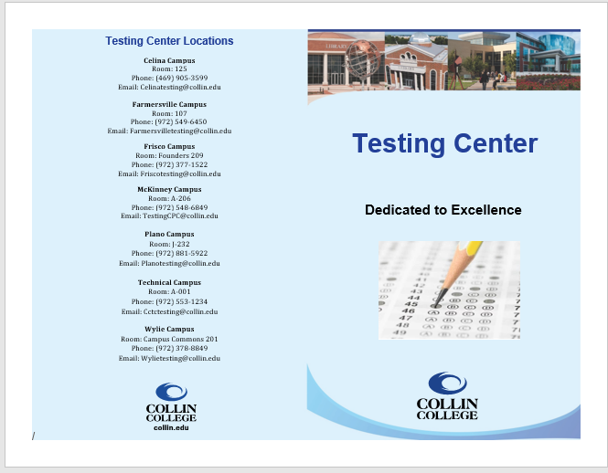
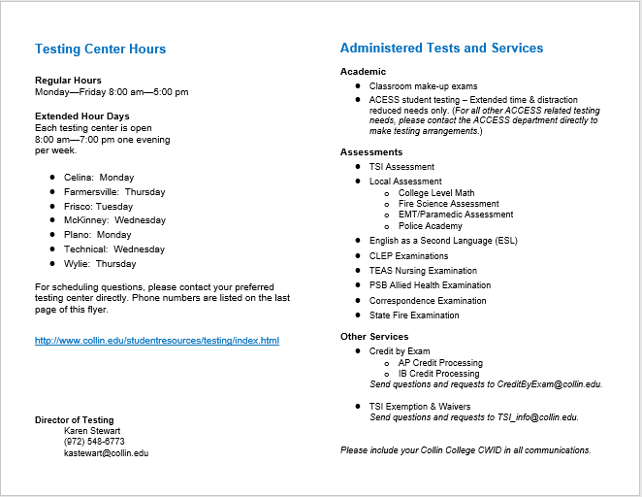

Appendix 3: Publications - TSI Study & Review Resources

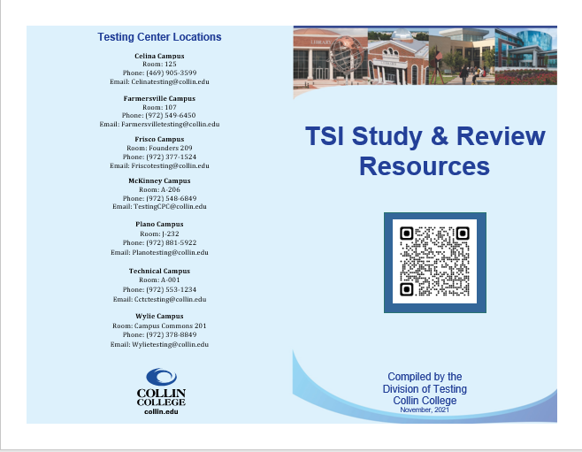

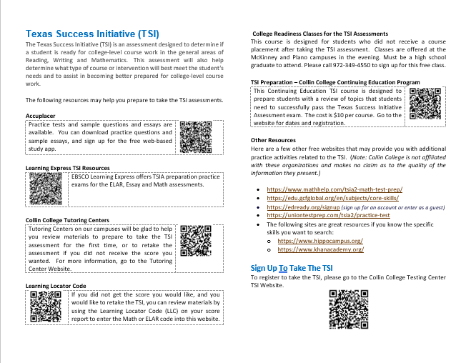

Appendix 4: Publications - Credit By Exam
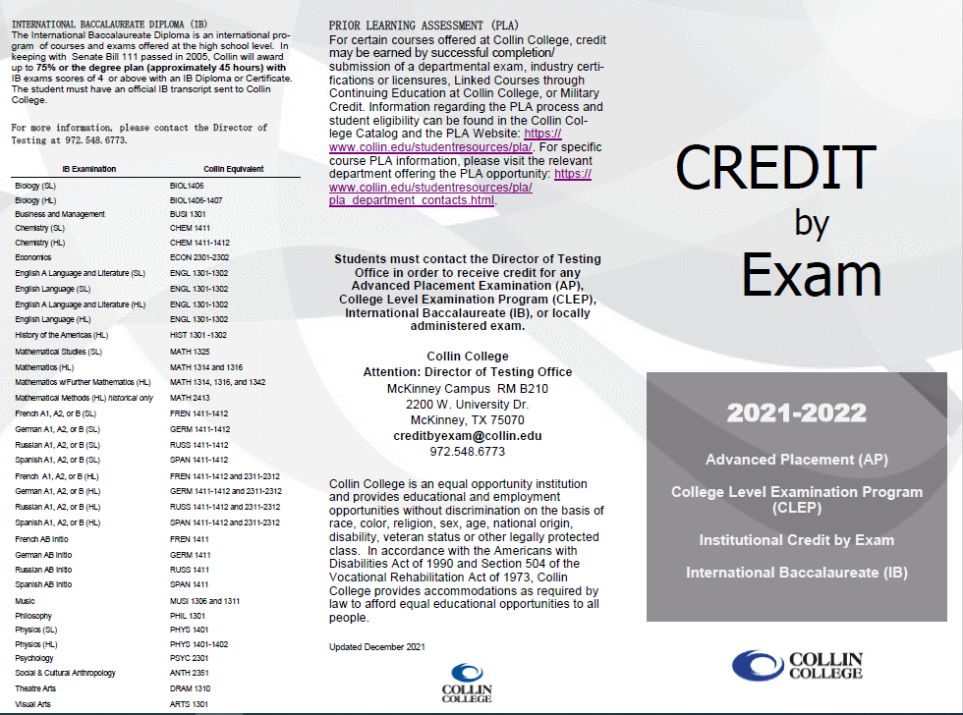

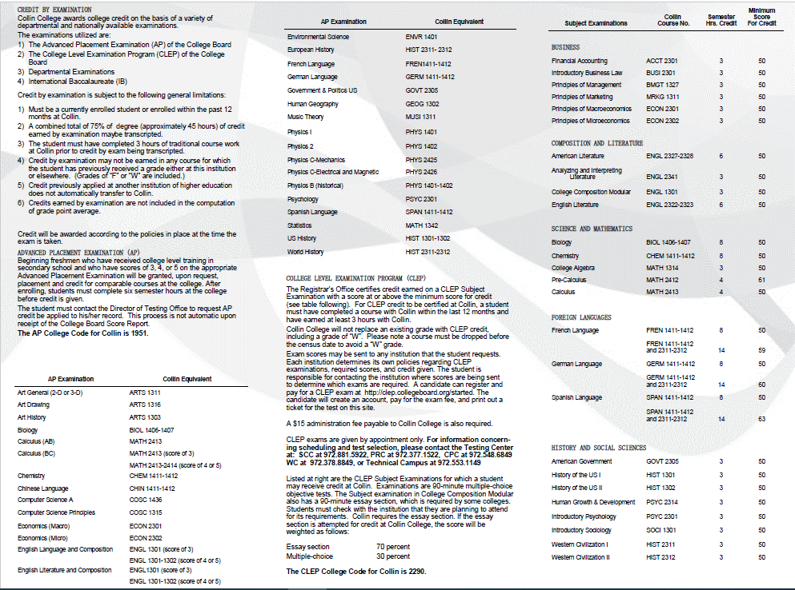
Appendix 5: Publications - How to Get Score Reports

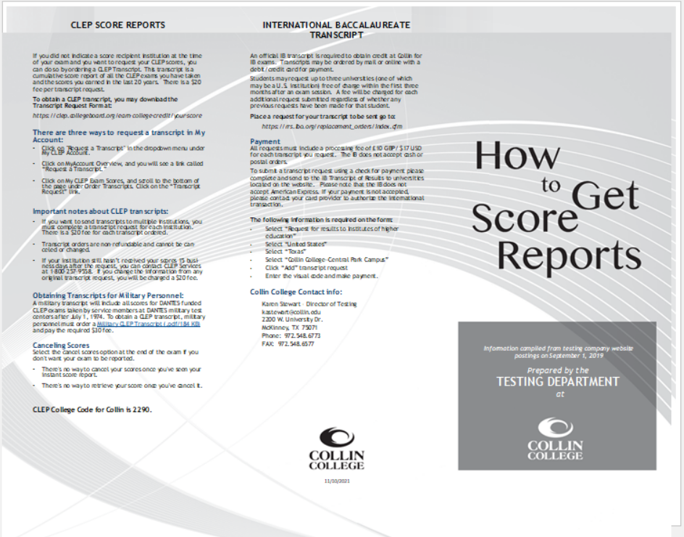

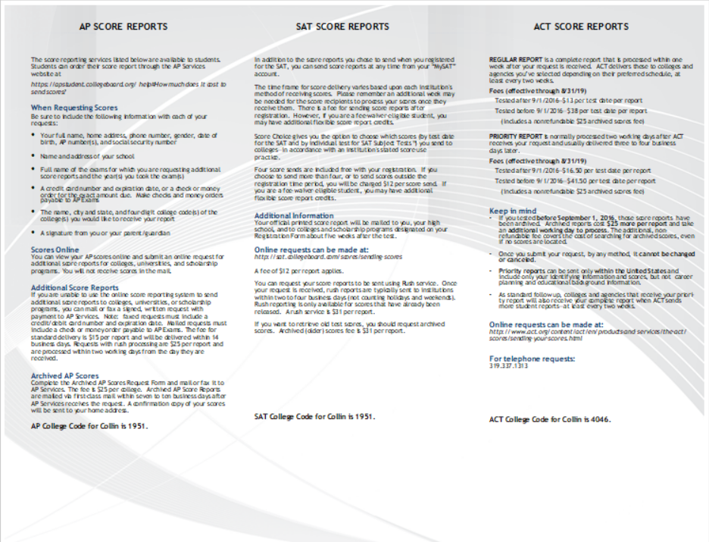

Appendix 6: Publications - TSIA 2.0 Frequently Asked Questions

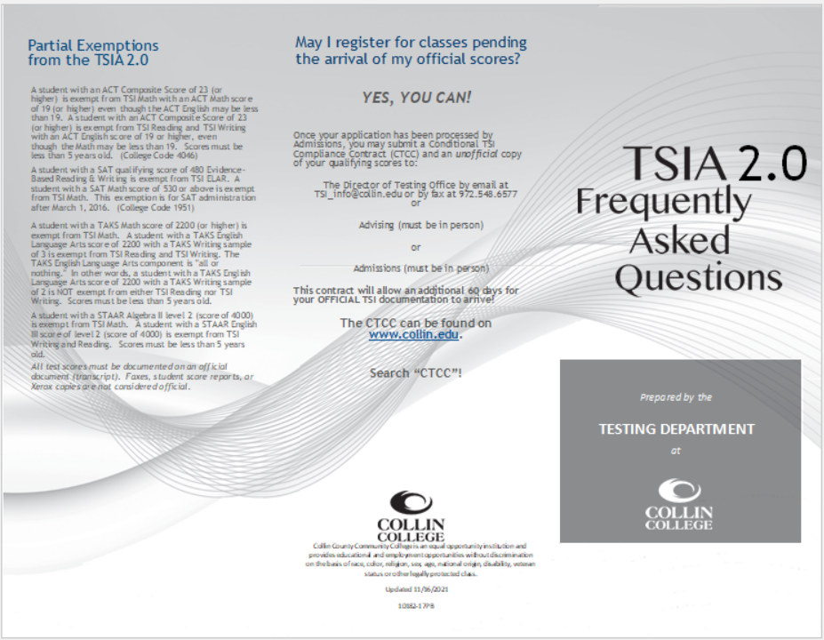

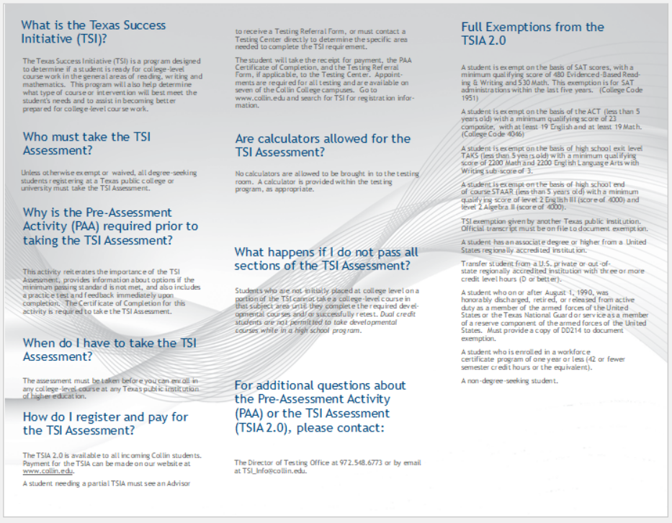

Appendix 7

professional development activities employees have participated in since your last program review.

Employee Name | Role in Unit | Professional Development Summary | How is it Valuable to the Unit?
Karen Stewart | Director of Testing | New Employee Orientation  FERPA Basics  FERPA review with Debbie Dunn  Preventing Harassment and Discrimination: Supervisors with Title IX/Clery Module  Clery Act Basics  Cyber security  The Ideal Testing Center (NCTA webinar)  Texas Assessment Conference/Texas Association of Collegiate Testing Personnel  Accuplacer Proctor Certification  CLEP Proctor Certification  Workday Training (supervisor, budgeting, purchasing, payroll, hiring, travel, etc.)  Collin College Green Zone Training  Walking in the Supervisor’s Shoes  Green Zone Training | Some training is mandatory in order for Collin College to administer certain exams and remain in compliance with the various testing agencies.  These courses and activities have helped me to get better acclimated to Collin College and my role here. They have also helped me to make contacts with colleagues outside of the College to enhance networking and benchmarking activities.
Kathleen Schlosser | District Secretary | Purchasing Training  FERPA Basics  Preventing Harassment  Accuplacer Proctor Certification  Testing Center Office (cross training)  Residency Training  Cyber Security | Some training is mandatory in order for Collin College to administer certain exams and remain in compliance with the various testing agencies.  Helped to understand Collin better and to take on new job responsibilities and help during a short staff time in the Testing Center.
Zane Ochoa | District Technical Coordinator | Argos Training  Training & Dev. Learning path – LinkedIn  Power Apps Training  Business Analyst Training – LinkedIn  TCC 2021 Virtual Conf.  PMI PMP Training  College compliance courses | Some training is mandatory in order for Collin College to administer certain exams and remain in compliance with the various testing agencies.  Helps me query data for reporting.  Helped me improve quality in testing center division by leading the creation of a uniform training program.  Helps me continue to automate operational processes.  Helps me write requirements and communicate effectively with technical teams.  Helped me understand TCC initiatives and changes coming up.  Helps me manage projects to improve operational processes.
Artorias Earley | Testing Center Supervisor (Celina) | Master’s Degree – Adult Education  Canvas training  Cyber Security  FERPA Harassment  Workday  Accuplacer Proctor Certification  CLEP Proctor Certification | Some training is mandatory in order for Collin College to administer certain exams and remain in compliance with the various testing agencies.  Help to understand the college better and to be able to do the work required for my position.
Stephen Hatton | Testing Center Supervisor (Farmersville) | Professional Development:  Member of Advisory Board which examined a new way to test incoming students on the A&P exam (2018)  Member of Accuplacer Community (previously Accuplacer Edge) (2020)  Workplace Training:  Cybersecurity (2020)  Preventing Harassment & Discrimination (2021)  FERPA Basics (2021)  Clery Act and Title IX Basics (2021)  Webinars:  Virtual ATI (2020)  Using ATI in Class/Clinical/SIM (2020)  TSIA2 Overview and New Features (2020)  TSIA2 Account Management and Test Administration (2020)  TSIA2 Test Security and Resources (2020)  NCTA Webinar: Accommodations at a Distance (2021)  College Courses:  Received Master of Science in Educational Tech in 2017 (4.0 GPA)  Selected coursework:  Technology Changes / Issues  Web 2.0 for Instruction  Applying Instructional Media & Tech  Online Learning Systems  Entered Ed.D. in Instructional Design in 2019 (75% complete – 4.0 GPA)  Selected Coursework:  Professional Development  Statistical Methods  Distance Learning  Leadership in Technology Administration  Continuing Education:  Principles of Management (2018) – management training class  e-Commerce Marketing (2019) – helps with our Marketplace look & design | Some training is mandatory in order for Collin College to administer certain exams and remain in compliance with the various testing agencies.  MS Degree  I feel this degree is important because it helps me assist the Testing Department in technical issues when they arise, and come up with solutions for computer-based testing, virtual proctoring, and online appointments.  Entered Ed.D. in Instructional Design in 2019 (75% complete – 4.0 GPA)  I feel this degree is an extension of the Ed Tech degree, in that it will help me assist student virtually, take leadership roles, enrich my employment with Collin, and give me the tools and knowhow to analyze data.
Natarsha Hall | Testing Center Supervisor (Frisco) | New Employee Orientation  FERPA  KnowBe4 Trainings – Cybersecurity, Harassment, Discrimination/Bias Trainings  Accuplacer trainings and webinars  CLEP training and webinars  Website Review Committee  CE Admission process training  Staff Appraisal Training  Workday Training  Workday Coaching and Discipline Training  Student Success Road Show  Adjunct Orientation and reception  College Resource Fair  Focus Group at Frisco  Leading for Excellence Academy: Walking in Supervisor’s Shoes | Some training is mandatory in order for Collin College to administer certain exams and remain in compliance with the various testing agencies.  Help to understand the college better and to be able to do the work required for my position.
Catherine Nicholls | Testing Center Supervisor (McKinney) | 2021-2022  FERPA Basics EVERFI Training  Preventing Harassment and Discrimination: Supervisors with Title IX/Clery Module EVERFI Training  Clery Act Basics EVERFI Training  KnowBe4 Cybersecurity Awareness for Texas Training  ACCUPLACER Test Administration Certification (proctor)  ACCUPLACER Test Administration Certification (site manager)  Introduction to Ransomware KnowBe4 Training  ETS Building a Bridge to Employment webinar  ACCUPLACER SPOTLIGHT: Best Practices for College/High School Partnerships webinar  2020-2021  EVERFI Building Supportive Communities: Clery Act and Title IX training  KnowBe4 Cybersecurity Awareness training  ATI Proctorio Faculty training  ATI TEAS Proctor Certification  ACCUPLACER Remote Testing with Examity training  ACCUPLACER Proctoring with Zoom training  ACCUPLACER Test Administration Certification (proctor)  Texas Higher Education Coordination Board (THECB) TSI training  LinkedIn Learning Online courses: Working with Upset Customers  LinkedIn Learning Online courses: Microsoft Teams Essential Training  LinkedIn Learning Online courses: Proven Success Strategies for Women at Work  ACCUPLACER SPOTLIGHT: Testing Centers Role in Retention  ACCUPLACER SPOTLIGHT: New Features and Dream Session webinar  ACCUPALCER: Proctortrack, An Additional Remote Proctoring Solution webinar  Collin ELC Microsoft Power Automate webinar  ACCUPLACER TSIA2 Training (part 1): Overview and New Features webinar  ACCUPLACER TSIA2 Training (part 2): Account Management and Test Administration  ACCUPLACER TSIA2 Training (part 3): Test Security and Resources  ACCUPLACER TSIA2 Training (part 4): Learning Resources  ACCUPALCER: Overview of Options for Remote Proctoring webinar  RegisterBlast Demo webinar  2019-2020  HiSET Unify computer-based testing eLearning Certification (TCA)  HiSET paper-based testing eLearning Certification (TCA)  ACCUPLACER Test Administration Certification (proctor)  ATI TEAS Proctor Certification  NHA Association Proctor Certification National Health career  CLEP Unify eLearning certified (TCA)  EVERFI Preventing Harassment and Discrimination: non-supervisors training  EVERFI FERPA Basics training  EVERFI Building Supportive Communities: Clery Act and Title IX training  KnowBe4 Cybersecurity Security Awareness Training  QEP professional development workshop: Facilitating Appreciated Inquiry  QEP professional development workshop: How to Encourage Academic Integrity  QEP professional development workshop: Demystifying Disability Accommodations  QEP professional development workshop: A Holistic Approach to Student Support  HiSET Program Professional Development: Exam at Home training  HiSET Program Professional Development: Best Practices in the Time of Coronavirus and Closures training  ATI Proctorio Faculty Demo Training  ACCUPLACER Remote Testing with Examity training  ACCUPLACER Proctoring with Zoom training  Texas Higher Education Coordination Board (THECB) TSI training  CougarTravel Pcard training  Collin College HR Professional Development presents Julie Burch – Change Management  Disney Institute Professional Development: Disney’s Approach to Quality Service training  Disney Institute Professional Development: Disney’s Approach to Leadership Excellence  2018-2019  QEP professional development workshop: Customer Service  QEP professional development workshop: Online Advising Resources  ATI TEAS Proctor Certification  NHA National Health career Association Proctor Certification  HiSET Unify computer-based testing eLearning Certification (TCA)  HiSET paper-based testing eLearning Certification (TCA)  ACCUPLACER Test Administration Certification (proctor)  Section 504 and Academic Accommodations Training Certification  Full-time Staff Student Service Training  Completed Bachelor’s Degree | Some training is mandatory in order for Collin College to administer certain exams and remain in compliance with the various testing agencies.  Utilizing professional development and trainings helps outline our strengths and opportunities for improvement as individuals as well as a team. They allow for cross-training and better awareness of our partnerships across individual departments and district wide.
Mibrak “Mimi” Teklay | Testing Center Supervisor (Plano) | Compliance trainings (2017)  - Respect and Inclusion Series – Learned valuable lessons about the power of respectful language and uncovering implicit bias.  - Section 504 & Academic Accommodations (2018) – Gave me understanding about legal requirements and policy and how to better serve our students with disability.  LinkedIn Learning (2018-2021) – I have completed these topics that are useful in gaining leadership and technical skills.  - Be the Manager People Won’t Leave  - Interpersonal Communication  - Avoiding New Manager Mistakes  - Improving Your Focus  - Customer Service Mastery  - Excel Essential Training  - Master Microsoft Excel (In progress)  - Computer Science Principles  - Data Science & Analytics  Customer Service Training (2019) – SES department training that helped me understand various issues related to customer service and how to better serve our students.  Adult Mental Health First Aid (2019) – Learned how to assess for risk of self-harm, listen, give reassurance and information and encourage professional help to anyone who is potentially suffering from mental illness.  Accuplacer Trainings (2020-2021) – Attended several topics and learned about the new TSIA2 assessment which launched in January 2021.  LEAD Leadership Symposium (2019-2021) – Attended several sessions with keynote speakers who shared their experiences that empowers and develops my leadership skills.  Green Zone Training (2021) – learned how to assist and address the needs of our student veterans.  Workday trainings (2021) – Attended several training sessions and learned valuable lessons for transitioning into the new system.  Compliance trainings (2021)  - Preventing Harassment & Discrimination  - FERPA Basics – Policy on student rights and protecting student privacy.  - Clery Act Basics – Policy regarding campus safety and security concerns.  - Cybersecurity Awareness – Learned how to detect, report, and be vigilant about information security risks to protect Collin College network. | Some training is mandatory in order for Collin College to administer certain exams and remain in compliance with the various testing agencies.  Help to understand the college better and to be able to do the work required for my position.
SoChoung “Christi” Cho | Testing Center Supervisor (Technical) | Texas Assessment Conference & Texas Association of Collegiate Testing Personnel Conference  CLEP and Completion Class  CLEP Validity Class  Modern State from TSIA Class  Next Gen Accuplacer Class  TSIA Write Placer Guide Class  NCTA Webinar: Accommodations at a Distance: Navigating and Integrating Disability Accommodations in a Post COVID World  Leading for Excellence Course: Taught by Collin College HR  • Communication Training  • Conflict and Difficult Conversation Training  • Creating an Effective Team Training  • Delegation and Motivation Training  • Finding and Onboarding Talent Training  • Fostering a Healthy Inclusive workplace Training  • Managing Performance Training  • Managing Employee Relations Challenges Training  • Nuts and Bolts Training  • Walking in Supervisor Shoe  Training Collin College Professional Development Courses:  • Disney Institute through Collin Corporate College Training  • Section 504 and Academic Accommodation Training  • Envision the Future, Change the Future, Be the Future Training  • The Power of Performance Appraisals Training LinkedIn  • Coaching Skills for Leaders and Managers The following courses and trainings have equipped me with the knowledge to proctor high stake assessments and utilize school equipment with proper practices.  Continuing Education Webinars:  • Navigating a Student’s Journey through GED  • All About Accommodations and the GED test Accuplacer:  • Test Administration Training & Certification  • Test Proctor Training & Certification  • Test Institution Score Reporter Training & Certification  ATI- Nursing Education: Proctor Training  CLEP: Testing Center Administrator Training & Certification  HiSET: Testing Center Administrator and Proctor Training & Certification  WorkDay Training  eLC RoadShow  Cyber Security:  • Internet Security and You  • Kevin Mitnick Security Awareness Training  • Captain Awareness: Detecting Suspicious Activity  • Micro-Module: Introduction to Ransomware  FERPA Basics Preventing Harassment & Discrimination: PHD Supervisors | Some training is mandatory in order for Collin College to administer certain exams and remain in compliance with the various testing agencies.  As the supervisor, the following conferences, trainings, and courses have enabled me to stay current with State and local testing policies. They have reinforced leadership skills to help me become an effective, innovative leader as a result creating a testing center which provides paramount services to students and faculties
Bijan Sameri | Testing Center Supervisor (Wylie) | Customer Service Training  SES Trainings  Collin College Green Zone Training  Workday  EVERFI – Compliance Training  KnowB4 Training  Accuplacer Proctor Certification  CLEP Proctor Certification  LinkedIn Training  Effective Listening  Coaching employees through difficult situations  Communicating with empathy  Becoming a manager your team loves | Some training is mandatory in order for Collin College to administer certain exams and remain in compliance with the various testing agencies.  Help to understand the college better and to be able to do the work required for my position.
Elizabeth Nix | Testing Center Assistant (PT – Celina) | EVERFI Compliance Training  Cyber Security  Accuplacer Proctor Certification  CLEP Proctor Certification  Workday | Some training is mandatory in order for Collin College to administer certain exams and remain in compliance with the various testing agencies.
Karen Strickland | Testing Center Assistant (PT – Farmersville) | All FERPA Trainings  Preventing Harassment and Discrimination Training  Title IX Basics  TSIA2 Overview and New Features  CLEP Training  Accuplacer Training  KnowBe4 (Cybersecurity Awareness Training)  Additional Cybersecurity Training (Ongoing)  Workday Training | Some training is mandatory in order for Collin College to administer certain exams and remain in compliance with the various testing agencies.  The training I received under the new hire umbrella was a good refresher. As a public-school district employee for many years, these trainings were required every year and very worthwhile.  The trainings I received specific to the testing center were extremely valuable for me to be successful in my job as a testing center assistant. Much of my training was from hands on learning.  The technology training is valuable for my job and personal use as well.
Marissa Hall | Testing Center Assistant (FT - Frisco) | Workday Training  CLEP webinar- CLEP on College/University Campuses  KnowBe4- Ransomware and Cybersecurity Awareness  LinkedIn Learning: InDesign 2021 Essential Training  LinkedIn Learning: Administrative Professional Tips | Some training is mandatory in order for Collin College to administer certain exams and remain in compliance with the various testing agencies.  CLEP trainings have helped me stay current about the exams we offer at Collin and how they benefit our students. The Administrative Professional Tips and Workday trainings help me be more knowledgeable about my current job position and how to protect my information as well as the college's. The InDesign training have helped me gain a better understanding of marketing and how to promote events using different types of media which could potentially be useful to my current position.
Michael Harris | Testing Center Assistant (FT - Frisco) | New Employee Orientation  “Preventing Harassment and Discrimination: Non-Supervisors with Title IX/Clery Module”  “FERPA Basics”  “KnowBe4 Cybersecurity Awareness Training for Texas  Micro-module – “Introduction to Ransomware”  CLEP training & TSI training | Some training is mandatory in order for Collin College to administer certain exams and remain in compliance with the various testing agencies.  I enjoyed the scenarios performed by the actors in this training session. They presented some interesting scenarios and topics. It is good to be aware of these harmful situations and how to avoid them.  I enjoyed learning about the different ways people will try to cyberattack people and businesses. It is always good to be reminded of what to look out for in our email and online environment.
Tea Johnson | Testing Center Assistant (PT - Frisco) | FERPA  Cybersecurity  CLEP training  Accuplacer training for TSI. | Some training is mandatory in order for Collin College to administer certain exams and remain in compliance with the various testing agencies.  The knowledge received from these courses helped me in being able to better assist our students by establishing great communication and providing them with necessary information for successful testing.
Jondalynn Buck | Testing Center Assistant (PT – McKinney) | KnowBe4 Cybersecurity Awareness Training for Texas  FERPA Basics  Preventing Harassment and Discrimination: non-supervisors with Title IX/Clery Module  ACCUPALCER Certificate of Test Administration | Some training is mandatory in order for Collin College to administer certain exams and remain in compliance with the various testing agencies.  Utilizing professional development and trainings helps outline our strengths and opportunities for improvement as individuals as well as a team. They allow for cross-training and better awareness of our partnerships across individual departments and district wide.
Sylvia Brooks | Testing Center Assistant (FT - Plano) | FERPA Basics - Helped with protecting students' privacy and rights.  Preventing Harassment & Discrimination - Helped build positive workplaces, recognizing discrimination, identifying harassment.  Mental Health First Aid - Helped identify depression, anxiety disorders.  Cybersecurity Awareness  LinkedIn Learning (In Progress) – Develop Your Customer Service Skills | Some training is mandatory in order for Collin College to administer certain exams and remain in compliance with the various testing agencies.  Help to understand the college better and to be able to do the work required for my position.
Gary Johnson | Testing Center Assistant (FT - Plano) | Completed the Federal Emergency Management Agency Independent Study (IS) courses "Introduction to Incident Command System IS-100 and IS-700  Gained useful knowledge and a strong foundation in consequence and crisis management. Drafted an Emergency Evacuation Plan and designed an escape route for the Testing Center and forwarded it to the Emergency Management Team Supervisor to incorporate in the Campus Plan  I have taken several courses over the past year that have been instrumental to me in my job offered on LinkedIn:  Critical Thinking is the ability to think reflectively and independently to make thoughtful decisions. It allows us as a team to work together and brainstorm ideals on how to make the work place better thought collaboration and teamwork  Humble Leadership: The Power of Relationships, Openness, and Trust  Working in organization, weather it cooperates America, schools, military, or whatever organization they all have their unique and different cultures, and this course enhanced my awareness even more through others lens how relationships and understanding those who work with or for you input counts.  Using Questions to Foster Critical Thinking and Curiosity:  Great course on learning how to ask critical questions without being afraid. Being curious on how something works allow you to leverage the power of questions to move yourself or other members of the group forward.  What Are Blind Spots?  Not recognizing blind spots can cause you to stifle your best employees instead of giving them the autonomy to do their finest and most engaged work. In addition, recognizing your blind spots helps transform your organization and unlock the potential of your employees, allowing them to showcase their talent.  Introduction of Ransomware, Cybersecurity  Understanding what cyber security risk are and how to avoid them. Prepared and prevent cyber security threats from hampering the workplace through malicious viruses by using best practices to reduce security risks.  FERPA:  Protecting student’s rights under the Family Educational Rights and Privacy Act  Preventing Harassment and Discrimination for Higher Education Employees  Treating each other fairly and having open dialogue | Some training is mandatory in order for Collin College to administer certain exams and remain in compliance with the various testing agencies.  Help to understand the college better and to be able to do the work required for my position.
Patrick Sheffield | Testing Center Assistant (FT - Plano) | FERPA (2020 & 2021)  CLERY Act (2020)  Ransomware (2021)  CLEP Certification (2021) – vendor required proficiency training.  TSI Certification (2020 & 2021) – vendor required proficiency training. | Some training is mandatory in order for Collin College to administer certain exams and remain in compliance with the various testing agencies.  These trainings have helped me build skills that promote integrity in our office. These trainings refresh important points about data privacy and communication standards to uphold.  Positive Workplace Environment (2020 & 2021) – helps me develop strategies for effective coworker communications.
Alexandra Alrawi | Testing Center Assistant (FT - Plano) | FERPA Basics  Cybersecurity Awareness for Texas  Introduction to Ransomware  Preventing Harassment & Discrimination  Accuplacer Certificate of Test Administration  CLEP Certificate of Test Administration | Some training is mandatory in order for Collin College to administer certain exams and remain in compliance with the various testing agencies.  Help to understand the college better and to be able to do the work required for my position.
Willie Booker | Testing Center Assistant (FT - Technical) | Access Training in Access Department  Accuplacer Certificate of Test Administration  CLEP Training  Cybersecurity Awareness Training - KnowBe4  De-Escalating Conversations for Customer Service - LinkedIn Learning  Detecting Suspicious Activity Training  Efficient Time Management Training  Examity/Voucher Proctoring Online  FERPA Basics  GED Webinars  HiSet at Courtyard Training  HiSet Certification  HiSet Training  How to Give Great Customer Service - LinkedIn  Learning to Teach Online - LinkedIn Learning  Listening to Customers Training - LinkedIn  Mental Health Training - Plano Campus  Micro-module Intro to Ransomware - KnowBe4  Preventing Harassment and Discrimination  Preventing Harassment Title IX Clery Module  Project Management Training at CHEC  Security Awareness Training  Sensitive Information Training  Successful Goal Setting LinkedIn Learning  WorkDay Training  Zoom Training | Some training is mandatory in order for Collin College to administer certain exams and remain in compliance with the various testing agencies.  Departmental Cross training  Testing Certification for TSI  Testing Training for Proctoring External Exams  Computer Security  Customer Service  Computer Security  SMART Goal Management  Testing Methodology  HR Policy training  Testing Training for Proctoring External Exams  Testing Certification Training  Testing Certification  Testing Certification Training  Enhancing Customer Service Skills  Online Testing Methodology  Enhancing Customer Service Skills  HR Policy training  Computer Security  HR Policy training  HR Policy training  SMART Goal Management  Computer Security  Computer Security  SMART Goal Management  HR Policy training  Proctoring via Examity
Allison Farris | Testing Center Assistant (FT - Technical) | New Employee Training: • Cougarweb • My Workplace Banner • TouchNet ﴾Marketplace﴿ • TCAP • TimeClock • OneNote (Test Schedule Collin College) • Cornerstone • OneLogin • Luma Surveillance • Excel Examity Registration Spreadsheet • Microsoft 365 Programs • Collin College Title IX Power Point I have completed certification for the following: • TSIA2 • CLEP • HiSET I have completed required professional development training for the following: • Cyber Security Awareness Training (Spring) • Cyber Security Awareness Training (Fall) Introduction to Ransomware • KnowBe4 Emergency Preparedness (Spring) • KnowBe4 Emergency Preparedness (Fall) • Staff Annual Performance Appraisal Training • FERPA Basics (Spring) • FERPA Basics (Fall) • Preventing Harassment and Discrimination: Non-Supervisors with Title IX/Clery Module Americans with Disabilities Act (Spring) • Preventing Harassment and Discrimination: Non-Supervisors with Title IX/Clery Module Americans with Disabilities Act (Fall) Page 1 LinkedIn Learning • Confronting Bias: Thriving Across Our Differences • Creating Positive Conversations with Challenging Customers • Customer Service Problem Solving and Trouble Shooting • Canvas: Tips, Tricks, and Techniques • Communicating with Diplomacy and Tact • Recharge Your Energy for Peak Performance • Preventing Harassment in the Workplace Workday GED Webinars For: • GED Back to Basics Ten Essentials • GED New Updates Plus Tips & Tricks for Learners and Educators to Successfully Navigate the OP Test Process (help@GED.com personal info is also available on this training) • GED All About Accommodations Zoom Professional Development: • ACCUPLACER: Multiple Reporting Options Confirmation • ACCUPLACER: Student Score Share & User Role Management • TSIA2: Accommodations Confirmation • ACCUPLACER: Examity A Remote Proctoring Option • Technical Campus Constitution Day Dr. Paula D. McClain • Collin College Green Zone Training 1 • Collin College Green Zone Training 2 • eLC Roadshow • TSI Zoom Proctor Training • SharePoint Zoom Register Blast Dem | Each of the following training sessions have a direct impact on my position as a Collin College employee and as a Testing Center employee. The following training sessions have allowed me to utilize required software programs, adhere to national, state and local laws, policies, and procedures, meet certification requirements, be prepared in an emergency, be aware and informed on various topics to assist our student populations, and to perform my duties to the best of my ability.
Connie Schneider | Testing Center Assistant (PT - Technical) | New Employee Training: • Cougarweb • Banner • TouchNet • TCAP • TimeClock • Luma Surveillance • Microsoft 365 Certifications: • Accuplacer Certification • CLEP Certification • HiSET Certification HR Trainings: • Cyber Security Awareness Training • FERPA Basics • Preventing Harassment and Discrimination • Workday | Some training is mandatory in order for Collin College to administer certain exams and remain in compliance with the various testing agencies.  Help to understand the college better and to be able to do the work required for my position.
Nichole Sindelar | Testing Center Assistant (FT - Wylie) | SES Trainings  Collin College Green Zone Training  EVERFI Compliance Training  Accuplacer Proctor Certification  CLEP Proctor Certification  LinkedIn Learning  Working with difficult people  Excel 2016 – Adv. Formatting  Communicating with Diplomacy & Tact  Communicating with Empathy | Some training is mandatory in order for Collin College to administer certain exams and remain in compliance with the various testing agencies.  Help to understand the college better and to be able to do the work required for my position.
Atefeh Bagheriraouf | Testing Center Assistant (PT - Wylie) | EVERFI – Compliance Training  KnowB4 Training  Accuplacer Proctor Certification | Some training is mandatory in order for Collin College to administer certain exams and remain in compliance with the various testing agencies.  Help to understand the college better and to be able to do the work required for my position.

