PROGRAM NAME: Commerical Photography | AUTHORING TEAM CONTACT: Elizabeth Mellott
PHONE: 972-881-5907 | EMAIL:emellott@collin.edu

GUIDELINES
Time Frames
- Scope:
The time frame of program review is five years, including the year of the review.
Data being reviewed for any item should go back the previous four years, unless not available.
- Deadline Dates:
January 15th – Program Review Document due to Department Dean for review (Deans may require submissions at their own, earlier due date)
February 1st – Program Review Document due to Program Review Steering Committee
- Years:
Years 1 & 3 – Implement Action Plan of (CIP) and collect data
Years 2 & 4 – Analyze data and findings, Update Action Plan
Year 5 – Write Program Review of past 5 years; Write Continuous Improvement Plan (CIP) and create new Action Plan

LENGTH OF RESPONSES: Information provided to each question may vary but should be generally kept in the range
of 1-2 pages or 500-1,000 words.

EVIDENCE GUIDELINES: In the following sections, you will be asked to provide evidence for assertions made.
- Sources: This evidence may come from various sources including professional accreditation reviews, THECB, Texas Workforce Commission’s CREWS, Institutional Research Office (IRO), National Student Clearinghouse, IPEDS, JobsEQ, EMSI Career Coach, and may be quantitative and/or qualitative. If you are unfamiliar with any of these information sources, contact the Institutional Research Office at: effectiveness@collin.edu. Use of additional reliable and valid data sources of which you are aware is encouraged.
- Examples of Evidence Statements:
- Poor example: Core values are integrated into coursework. (Not verifiable)
- Good example: Core values are integrated into coursework through written reflections. (Verifiable, but general)
- Better example: Core values are integrating into coursework through written reflections asking the student to describe how s/he will demonstrate each of the core values in his or her professional life and demonstrated through service learning opportunities. (Replicable, Verifiable)

FOR MORE INFORMATION: The Program Review Portal can be found at http://inside.collin.edu/institutionaleffect/Program_Review_Process.html. Any further questions regarding Program Review should be addressed to the Institutional Research Office (effectiveness@collin.edu, 972.599.3102).

Introduction/Preface
☒EXECUTIVE SUMMARY
Briefly summarize the topics that are addressed in this self-study, including areas of strengths and areas of concern. (Information to address this Executive Summary may come from later sections of this document; therefore, this summary may be written after these sections have been completed.) Please do not include information in this section that is not already provided elsewhere in this submission. Using the questions in the template as headings in the Executive Summary can provide structure to the overview document (see below for suggested format).
Executive Summary (suggested sections/format-not required format)
What does our program do?
Why do we do the things we do: Program relationship to the College Mission & Strategic Plan.
Why we do the things we do? Program relationship to student demand.
Why we do the things we do? Program relationship to market demand.
How effective is our curriculum and how do we know?
How effectively do we communicate, and how do we know?
How well are we leveraging partnership resources and building relationships, and how do we know?
How have past Continuous Improvement Plans contributed to success?
How will we evaluate our success?

Complete the Executive Summary below after you have completed your review.

What Does the Program Do?
Collin College Photography Department teaches and prepares students to pursue a professional career in photography. The program offers twenty photography-based courses and five award options. The variety of classes and awards allows students to select a path towards University Transfer or Workforce Commercial Photography Employment. The University Transfer Path has two-degree options - AA emphasis in photography or a 2+2 articulation agreement from Collin College to Texas A&M-Commerce. Students that desire to become professional commercial photographers have three award options, Level 1 Certificate, Level 2 Certificate, and an AAS Degree.

Program Relationship to the College Mission and Strategic Plan
Whether students are pursuing the university transfer route or working towards becoming commercial photographers, they will be emersed in a program that supports the college's mission and strategic goals. The Photography Department is rich in student and community-centered engagement such as field trips, guest speakers, and community projects. Additionally, the curriculum is designed to develop students’ skills, strengthen character, and challenge the intellect. The curriculum embraces advanced skills, teamwork, conceptualism, and professionalism to challenge student minds. Furthermore, the program supports the College’s strategic plan with attention to available certifications, striving to be a national exemplar program, creating smooth transitions for students from entry to the program to completion, and systematic engagement with external stakeholders.

Program Relationship to Student Demand
Over the last five years, enrollment has grown by 32%, and awards have exceeded the minimum of five graduates per year. Data collected from the Institutional Research Office shows that the program supports a diverse student population regarding race, ethnicity, and gender. The enrolment pattern is steady, with a few variations addressed in full later in this report. Looking at enrollment and attracting diverse populations, this report has revealed that there can be a more significant effort to build enrollment through outreach.

How effective is Curriculum
Another area to focus on improvement is to increase the variety/number of awards offered. Compared to peer colleges, data shows that a wider variety of awards would place Collin College as an exemplar program. The Department will address increasing awards and building enrollment in the upcoming Continuous Improvement Plan. However, the current curriculum is effective and relevant. The program offers photography degrees, with twenty photography-based courses. All twenty courses are current and intellectually challenging. After reviewing all classes, one skill set should be emphasized more: teaching social media skills. Appropriate courses will add new assignments, and the upcoming Continuous Improvement Plan will focus on social media skills as a goal.

How effectively do we Communicate?
Furthermore, in comparing peer colleges, Collin College Photography Department easily took the forefront in a program’s website design and social media communication. The website is attractive, informative, and easy to navigate. Social media platforms such as Instagram showcase student work, and the platform is used as a means of communication. Instagram posts send reminders, announcements, and updated information, quickly and efficiently reaching students. Student surveys are sent to advanced students and graduates for incoming communication and feedback.

Partnerships
Program partnerships, such as the Commercial Photography Advisory Board, Internship Partners, and Graduate Employers, provide feedback. The Commercial Photography Advisory Board has been vital in direction and advice as the program has grown. From the board’s recommendation, teaching professionalism skills, workplace etiquette, workplace expectations, and business management skills are embedded into numerous classes. Additionally, the number of Co-Op required hours was decreased, as advised by the board. Relationships have remained strong with the Advisory Board and with Internship Partners and Graduate Employers. Internship Partners and Graduate Employers are surveyed for feedback, and advice is welcomed.

Past CIP Contributions
Another platform that has assisted in positive growth is the previous Continuous Improvement Plan. The 2015-2020 Continuous Improvement Plan was to solidify the program's foundation by incorporating appropriate courses, detailing curriculum for stackable classes, purchasing industry-standard equipment, and incorporating current software applications into the curriculum. All the actions have been successfully implemented and showing positive results.

How to evaluate Success
Lastly, evaluating the program’s success can be determined by assessing the Commercial Photography student’s success. Students are graduating from the program very satisfied (as detailed with survey results later in this report). Student portfolios and websites showcase stellar work that demonstrates they have a successful knowledge of commercial photography (image capture, image creation, lighting, software applications, creativity, business, and marketing skills). Furthermore, students are obtaining jobs directly after graduation. Many students are hired from their internship position into a paying position, while others find employment in other avenues.

Program Strengths and Weaknesses
This Commercial Photography Program Review revealed that the program's strengths lie in a solid program structure, engaging in teaching and learning, and active partners. The Department will address weak areas in the next cycle of the Continuous Improvement Plan. These include outreach/enrollment, variety/number of awards, and student knowledge/demonstration of social media skills.

Areas of Strength:
Solid Program Structure
Over the last five years, the Photography Program has developed a solid foundation. The Department consists of three diverse professors that are active in their fields and the community. Each professor brings expert knowledge to their area. Additionally, the photography labs are current, and check-out options for equipment have increased to ensure that students learn on professional equipment. The Program offers twenty photography-based courses, blending Fine Art and Commercial Photography skills. Thus, students leave the program well versed in technical and creative skills. The Photography Program has become a solid foundation with advice from an active Advisory Board, Internship Partners, and Graduate Employers.

Engaging Teaching and Learning
Working on a solid foundation, faculty have had the room to focus on teaching and learning, making the program a strong educational and engaging experience. The well-rounded program aids students in developing a toolbox of considerable technical and soft skills paired with creativity. After students complete the AAS, they will have many skills and be well prepared to join the commercial photography workforce. Additionally, the curriculum includes technical and creative skills and pays attention to work ethics, business skills, and marketing skills. Furthermore, faculty go beyond the classroom to create an enriching education through field trips, guest speakers, student exhibitions, participation with Collin College’s Book-in-Common, collaborations within the department, collaborations with other disciplines, team-based assignments, community projects, Service-Learning Projects, and an active student organization – Obscura Photography Club. Students gain real-world experience and grow both educationally and personally.

Active Partners
The Commercial Photography Advisory Board and Internship Partners add a layer of exemplar quality to the program. The Advisory Board is a diverse board with members representing a range of ethnicity, gender, and specialization. Members also represent large firms to smaller individually owned businesses and equipment representatives to studio managers to photographers. The group includes Veterans and International photographers. The diverse board plays a vital role with advice on trends, direction, and technologies. Many of the advisory board members also serve as Internship Partners and thus can bring the topic of students’ work ethics to meeting discussions. Internship Partnerships are also an essential strength of the program. During the three years that the Co-Op (internship course) has been offered, partnerships have grown from zero to twelve businesses. Students can interview for an internship that fits their demeanor and interest. Partnerships vary from editing, architectural, editorial, assisting, food, sports, portraits, senior portraits, video, and product.
Additionally, they range from small one-person owned operations to large corporations. The faculty have fostered a strong relationship with the Internship Partners and have received helpful feedback. The advice received has led to the teaching of work ethics, career expectations, and business management skills. Furthermore, numerous internships have led to direct employment after the internship has ended. The support and guidance from the Commercial Photography Advisory Board and the Internship Partners have aided in positive growth for the program and confident, skilled students prepared to go directly from college to employment.

Areas to Grow:
Outreach/Enrollment
An area to be addressed is outreach to build enrollment. As discussed in the next Continuous Improvement Plan, faculty aim to target three areas of outreach, including High School Students, Collin Enrolled Students, and the Community, emphasizing returning adult students.

Variety/Number of Awards
A concern with non-completers has been made apparent from this review. One area to look at is degrees offered. The current degrees may be too specialized and not accessible to students focused on a different specialization in commercial photography. Reviewing course and program enrollment data showed that students were not completing degrees because they lacked only one specific class. Additionally, after reviewing programs at other colleges, it became apparent that a wider variety of degrees would benefit students. Reviewing and designing new awards is one of the main goals of the 2021-2026 Continuous Improvement Plan.

Student Knowledge/Demonstration of social media skills
The last item to be addressed in the 2021-2026 Continuous Improvement Plan is to add student knowledge and demonstration of social media skills. After reviewing other colleges and a thorough look at the curriculum, the need for detailed instruction on social media skills became apparent. Social Media is essential for a photographer, artist, and business owner. Advanced social media skills (storytelling skills) are opportunities for larger businesses. Many students know some social media skills; however, they should leave the program with skills that can set them apart and above the competition.

Section I. Are We Doing the Right Things?
☐1. WHAT DOES OUR PROGRAM DO?
What is the program and its context?
This section is used to provide an overview description of the program, its relationship to the college and the community it serves. Keep in mind the reviewer may not be familiar with your area. Therefore, provide adequate explanation as needed to ensure understanding.

Suggested points to consider:
- Program’s purpose (Include the program’s purpose/mission statement if one exists.)
- Program learning outcomes or marketable skills
- Brief explanation of the industry/industries the program serves
- Career paths and/or degree paths it prepares graduates to enter
- What regulatory standards must the program meet (THECB, Workforce, external accreditation)

PROGRAM PURPOSE

Collin College Photography Department teaches contemporary and historical photographic practices and offers training for students to pursue a career in photography. Introductory and advanced film and digital photography classes emphasize commercial and fine art approaches to composition, lighting, design, and style. Students have the option to earn one of two Certificates - Commercial Photography, an Associate of Arts (AA) - Emphasis in Photography, an Associate of Applied Science (AAS) - Commercial Photography Specialization or transfer their credits to a four-year university. The Photographic Arts Lab and Digital Photographic Arts Learning Center provide materials and facilities for students to experience equal opportunity and professional-level access to photographic equipment and processes. Paired with a tightly focused curriculum, students learn how photography impacts social history, become engaged in critical theory, are challenged to contribute original research, and are empowered to enter the industry with a competitive edge.

With three full-time faculty, multiple associate faculty, a full-time lab supervisor, a full-time lab assistant supervisor, and student assistants, the Photography Department hosts a series of events throughout the year, including speakers, workshops, field trips to museums and galleries, portfolio review observations with FotoFest Biennial, group exhibitions, and photo demonstrations with the local Girl Scouts. Outside of class, students can get involved with the Obscura Photo Club to organize various events centered on service learning and community involvement.

Workforce photography majors learn the most current software, camera, and lighting techniques to enter various jobs in the industry. The Program provides an incredible opportunity for students with special guests that have included - International Award-winning Nature photographer Jeremy Woodhouse, Pulitzer Prize Journalist Judy Walgren, Photojournalist and documentary film photographer Jan Sonnenmair, Prior Photo Editor of People Magazine and Time Magazine Andi Schreiber, Head Photographer at JC Penneys and Advisory Board Member Pat Jerina, Retired Dallas Morning News Photographer Randy Eli Grothe, Prior Editor of Dallas Morning News and Advocate Magazine Lisa Kresl, Emmy Nominated, Stylist, Prop Specialist and Wardrobe for both print and film Lynne Moon, Owner of David Beck Design – David Beck, Kendall Creative Owner Mark Platt, Blue Cross Blue Shield Graphic Designer – Debbie Allen, Award Winning Food Photographer Dick Patrick, and Commerical and Fashion Photographer Neil Whitlock.

Collin has a diverse advisory board consisting of sixteen members: two Collin alumni, one full-time university educator, in-house company studios, sole proprietor-owned studios, and one photography equipment supply corporation. The advisory board represents our community's diversity in demographics and areas within the photography field.

CO-OP includes opportunities for students to work with established photographers and studios to gain experience of on-the-job training within the photographic industry. Students may then have an additional chance of employment by their CO-OP upon graduation.

Collin’s Photography program currently has three full-time professors with a combined experience of over seventy years in the fields of both- commercial and fine art photography.

PROGRAM MISSION

The mission of the Collin College Photography Program is to foster a safe environment for experimentation and growth. It strives to deliver an exceptional photography education based on a solid foundation of basic photography skills. Those skills include camera operations, lighting equipment, software, and business practices. Assignments address the area of photography for each course, and critiques help educate the students on their execution of that assignment, allowing students to create a robust final product for their future clients. The Program encourages each student to find their creative voice through commercial and fine art endeavors. Through leadership, knowledge, and confidence, our students develop the tools for both professionalism and a life-long passion for learning and community engagement.

https://www.collin.edu/department/photography/

DEPARTMENT STRUCTURE

The Photography Program is based on the Plano Campus in Plano, TX, under the Fine Arts Division. Currently, the Photography department consists of 3 full-time professors and two full-time staff members (lab supervisor and assistant supervisor). Adjunct professors teach on the Plano, McKinney, Frisco, and Wylie campuses, along with three student workers that work in both equipment checkout and the wet and dry labs. The Photography department reports to the Associate Dean and Dean of the Fine Arts and Education Department.

PROGRAM STRUCTURE

The following diagram illustrates this parallel structure of the Photo Department. Including how the AAS program splits further into areas of specialization and certificate awards.

The following diagram illustrates this parallel structure of the Photo Department. Including how the AAS program splits further into areas of specialization and certificate awards.

Collin College Photography Department

↙ ↘

Transfer A.A. Workforce- A.A.S.
The emphasis in Photography Commercial Photography

↙ ↘ ↙ ↘
2+2 Articulation agreement AA Degree Level 1 Certificate- Level 2 Certificate-
Collin College to A&M University Studio Production Commercial Photography

Commercial Photography majors enroll in courses listed in the Workforce Education Course Manual (WECM), creating a unique opportunity for Collin College to serve the community and North Texas region by providing the training and skills necessary to support the Photography industry after two years.

Two Degrees

Transfer - A.A. Emphasis in Photography
Workforce- A.A.S. Commercial Photography

DEGREES AND CERTIFICATIONS
AAS- COMMERCIAL PHOTOGRAPHY
60 credit hours

FIRST-YEAR
First Semester
ARTS 1313 Foundations of Art (See Humanities/ Fine Arts options)
ARTS 2348 Digital Photography I
PHTC 1371 Book, Design and Presentation
ENGL 1301 Composition I
PHTC 2340 Photographic Studio Management

Second Semester
GEN ED Mathematics / Natural Science course
PHTC 1300 Digital Photography II
PHTC 1353 Portraiture I
PHTC 2331 Architectural Photography
CREATIVE COURSE¹

SECOND-YEAR
First Semester
PHTC 1341 Color Photography I
PHTC 2349 Digital Photography III
PHTC 2371 Video for Photographers
SPCH 1321 Business and Professional Communication (See Speech options)
TECHNICAL COURSE²

Second Semester
PHTC 1345 Illustrative Photography I
PHTC 2343 Portfolio Development (Capstone)
PHTC 2353 Portraiture II
PHTC 2380 Cooperative Education – Commercial Photography
SOCI 1301 Introduction to Sociology (See Social / Behavioral Sciences options)

1. Select one Creative course (3 Hours): ARTS 1311, ARTS 2356, or PHTC 1343
2. Select one Technical course (3 Hours): PHTC 1347, PHTC 135,1, or PHTC 2342

LEARNING OUTCOMES

The learning outcomes for the Photography Program are below and in the assessment plan for Photography Commercial.
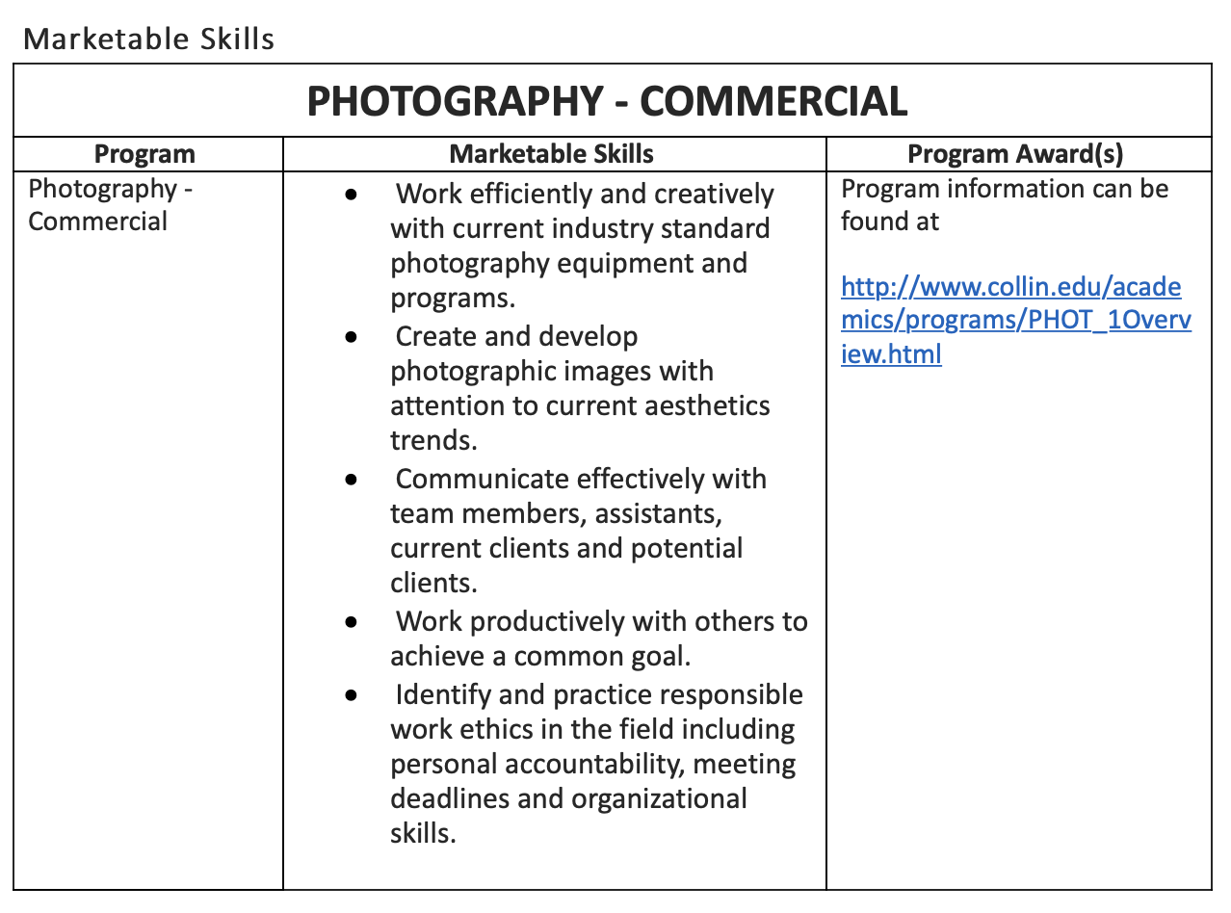
Source: Curriculum Office and Department Records

INDUSTRY INFORMATION AND CAREER PATHS

The first branch is the traditional Commercial Photography path that requires students to have a broad knowledge of camera and lighting operations, including location lighting and the most current software used in the field. The second branch is the consumer-based side of photography. Students could run their own business in a portrait studio for families, senior portraits, events, and weddings on the consumer side.

Graduates from the Commercial Photography Program find employment in various jobs, including photography assistant, stylist, props, digital tech, social media, studio manager, location scout, still photographer on movie/tv, and photographer. At the same time, some students may start their studio business. Students could begin working for other photographers as second photographers for weddings or events, and others may pursue a career in editorial photography with news outlets, including local publications.

AAS program graduates can apprentice with professionals making a living upon graduation in the commercial field. The photography profession is still one built strongly on apprenticeships.

By experiencing the many different fields of style with the techniques and tools needed in various areas, students are can employment within a multitude of jobs in the DFW market. The DFW market is ranked in advertising as one of the top ten cities in the country. There is a robust commercial photography community in the North Texas area. The photography community consists of nationally recognized professional groups in the DFW area, including ASMP (American Society of Media Photographers – www.asmp.org and PPA (Professional Photographers of America www.ppa.com).

With this diversity in the AAS photography program, students could explore many other jobs that may not be direct to only being the photographer but include many of the supportive roles within the industry. One of the most sought-after jobs for employment is in digital tech and image retoucher. The COVID-19 pandemic has impacted some areas within the photography industry due to the capacity or elimination of public gathers, such as Events, Location, and Wedding Photography.

www.onetonline.org - https://www.onetonline.org/find/result?s=photography&a=1

Local Wages For 27 -4021.00 -
Photographers Texas, 75074
https://www.onetonline.org/find/result?s=photography&a=1

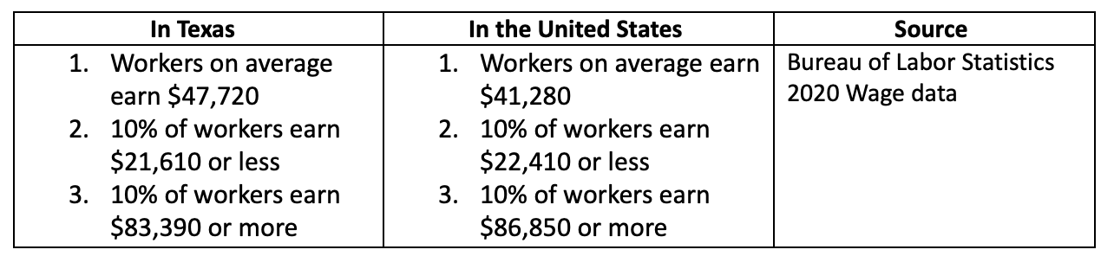

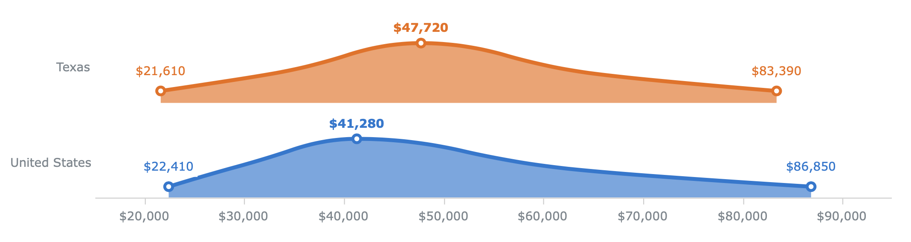

The average wage in Texas for Photographers is 47,720. The entry-level is 21,610.
Ontonline.org predicts that Photography is a bright outlook for the next five years and expects rapid growth. This growth is due to the demand for imagery on the web and social media. Technology is changing quickly, and with these changes, there will be a need for more images than ever before.

Data regarding the proportion of students employed within six months of completing coursework at Collin is not available other than students that have been in contact with Collin through email or posted on social media (i.e., Instagram). Salaries in photography vary depending on experience and skill level. Some students will start much higher than others if their skill level is higher. Most photographers work freelance in the field of Photography.

Page Break
DEGREES AND CERTIFICATIONS
AAS- COMMERCIAL PHOTOGRAPHY
60 credit hours

FIRST-YEAR
First Semester
ARTS 1313 Foundations of Art (See Humanities/ Fine Arts options)
ARTS 2348 Digital Photography I
PHTC 1371 Book, Design and Presentation
ENGL 1301 Composition I
PHTC 2340 Photographic Studio Management

Second Semester
GEN ED Mathematics / Natural Science course
PHTC 1300 Digital Photography II
PHTC 1353 Portraiture I
PHTC 2331 Architectural Photography
CREATIVE COURSE¹

SECOND-YEAR
First Semester
PHTC 1341 Color Photography I
PHTC 2349 Digital Photography III
PHTC 2371 Video for Photographers
SPCH 1321 Business and Professional Communication (See Speech options)
TECHNICAL COURSE²

Second Semester
PHTC 1345 Illustrative Photography I
PHTC 2343 Portfolio Development (Capstone)
PHTC 2353 Portraiture II
PHTC 2380 Cooperative Education – Commercial Photography
SOCI 1301 Introduction to Sociology (See Social / Behavioral Sciences options)

1. Select one Creative course (3 Hours): ARTS 1311, ARTS 2356, or PHTC 1343
2. Select one Technical course (3 Hours): PHTC 1347, PHTC 1351, or PHTC 2342

CERTIFICATE LEVEL 1 – STUDIO PRODUCTION
15 credit hours
FIRST-YEAR
First Semester
ARTS 1313 Foundations of Art
ARTS 2348 Digital Photography I

Second Semester
PHTC 1353 Portraiture I
PHTC 2371 Video for Photographers (Capstone)
CREATIVE COURSE¹

1. Select on Creative course (3 Hours): ARTS 2356 or PHTC 1300

CERTIFICATE LEVEL 2 – COMMERCIAL PHOTOGRAPHY SPECIALIST
36 credit hours
Before being admitted into this program, the student must have earned the Certificate – Studio Production or have permission from the Associate Dean.

Students must be TSI complete.

FIRST-YEAR
First Semester
PHTC 1300 Digital Photography II
PHTC 1371 Book, Design and Presentation
PHTC 2340 Photographic Studio Management
CREATIVE COURSE¹

Second Semester
PHTC 1341 Color Photography I (Theory and Management)
PHTC 2331 Architectural Photography
PHTC 2349 Digital Photography III
TECHNICAL COURSE²

SECOND-YEAR
First Semester
PHTC 1345 Illustrative Photography I
PHTC 2343 Portfolio Development (Capstone)
PHTC 2353 Portraiture II
PHTC 2380 Cooperative Education – Commercial Photography

1. Select one Creative Course (3 Hours): ARTS 1311, ARTS 2356, or PHTC. 1343
2. Select one Technical Course (3 Hours): PHTC 1347, PHTC 1351, or PHTC 2342

Page Break

ARTS 1313 Foundations of Arts
Introduction to the creative media designed to enhance artistic awareness and sensitivity through the creative and imaginative use of art materials and tools. Includes art history and culture through the exploration of a variety of artworks with an emphasis on aesthetic judgment and growth. Additionally, the examination of the change in art creation based on the advancement of tools and materials pushing art production from optic technology in Renaissance painting to mechanical art to technology-based art. 3 credit hours.

ARTS 2348 Digital Media
This is a foundational digital photography course. It is a studio art course that explores the potential of the computer hardware and software medium for visual, conceptual, and practical uses in the visual arts. It includes camera operation and professional image workflow, composition, supplemental lighting and exposure control. Lab required. 3 credit hours.

ARTS 2356 Photography I/Emphasis Fine Art
Introduction to photography: basic camera operations and darkroom techniques; emphasis on visual imagination and design. Lab required. 3 credit hours. Note: Students should expect additional supply costs, film, and photographic paper.

ARTS 2357 Photography II/Darkroom
Intermediate black-and-white course: emphasis on developing a visual language, problem solving, craftsmanship, and learning to edit personal work. Technical considerations include print and negative quality, use of studio lighting, and large-format cameras. Lab required. Prerequisite: ARTS 2356. 3 credit hours. Note: Students should expect additional supply costs.

PHTC 1300 Digital Photography II
An introduction to computers and software instruction for electronic imaging. Includes color, gray scale, image conversion, presentation, and ethics. Lab required. Prerequisite: ARTS 2348. 3 credit hours.

PHTC 1341 Color Photography I
Examination of color theory as it applies to photography. Emphasis on color concepts and the intricacies of seeing and photographing in color. Lab required. Prerequisite: PHTC 1300 or PHTC 2349.
3 credit hours.

PHTC 1343 Expressive Photography
A study of formal, professional, and individual uses of photography by applying photographic technology to personalized needs. Emphasis on creative visual thinking and problem solving and the exploration of personal vision. Lab required. 3 credit hours.

PHTC 1345 Illustrative Photography
Instruction in the technical aspects involved in commercial photography. Topics include lighting equipment, techniques of production photography, reproduction principles, illustrative techniques,
and advertising. Lab required. Prerequisite: PHTC 1353. 3 credit hours.

PHTC 1347 Landscape Photography
Skill development in the inspection of the landscape visually and photographically utilizing various camera formats. Topics include exploration of historic, geographical, and cultural locations, and review of landscape photographers. Lab required. Prerequisite: ARTS 2348 or ARTS 2356. 3 credit hours.

PHTC 1351 Photojournalism I
Presentation of photographic techniques used by photojournalists in newspapers, magazines, trade publications and digital media to include news, feature, sports, editorial portraits, and photo essays. Includes a study of layout design and the freelance market. Lab required. Prerequisite: ARTS 2348
or ARTS 2356. 3 credit hours.

PHTC 1353 Portraiture I
Skill development in the photographic principles of portrait lighting, posing, and subject rapport.
This is a foundation course in photographic portraiture. Assignments are designed to provide both aesthetic challenges as well as comprehensive studio technique. All students must participate in
class demos and stick close to prescribed procedures on assignments in order to maintain studio privileges. There will be a mixture of color and black and white materials used, with accent on studio time rather than darkroom or computer time. Lab required. Prerequisite: ARTS 2348 or ARTS 2356.
3 credit hours.

PHTC 1371 Book Design and Presentation
Elements of structure and principles of designing two- and three-dimensional concepts in the fiber forms of paper making and bookbinding. Lab required. 3 credit hours. Note: Students should expect additional supply costs.

PHTC 2331 Architectural Photography
Study of the equipment, processes, and procedures necessary for the photography of building exteriors and interiors, dusk/ night and night architectural landscapes, and construction progress. Lab required. Prerequisite: ARTS 2348 or ARTS 2356. 3 credit hours.

PHTC 2340 Photographic Studio Management
In-depth study of photography business management, pricing, market analysis, promotion, networking, job acquisition, and photographic equipment analysis. 3 credit hours.

PHTC 2342 Fashion Photography
Skill development in fashion photography in terms of trends and techniques included in studio and location work. Emphasizes model direction and lighting control. Lab required Prerequisite: PHTC 1353.
3 credit hours.

PHTC 2343 Portfolio Development
A culmination experience for the evaluation of the student’s photographic competencies. Includes association with a professional photographic organization, skills in resume creation, completion of portfolio, professional self-presentation, comprehensive exam, and seminars in areas of photographic interest. Lab required. Prerequisite: Consent of Professor. 3 credit hours.

PHTC 2349 Digital Photography III
Advanced concepts in the use of the computer and software for photographic manipulation and output. Lab required. Prerequisite: PHTC 1300. 3 credit hours.

PHTC 2353 Portraiture II
Advanced concepts in the study of principles of effective portraiture with specific emphasis on
unique presentation and environmental and location studies. Lab required. Prerequisite: PHTC 1353.
3 credit hours.

PHTC 2371 Video for Photographers
This is a foundation course in professional video production for photographers, including video
capture, editing, sound recording, color grading, and delivery. Lab required. Prerequisite: ARTS 2348.
3 credit hours.

PHTC 2380 Academic Cooperative Education
Career-related activities encountered in the student's area of specialization offered through an individualized agreement among the college, employer, and student. Under the supervision of the college and the employer, the student combines classroom learning with work experience. Includes a lecture component. Prerequisite: Consent of Associate Dean. 3 credit hours. (W)

STANDARDS
The regulatory standards that must be met for this program are under the Workforce Education Course Manual (WECM)
http://board.thecb.state.tx.us/apps/WorkforceEd/wecm/
The PHTC courses in the commercial photography department at Collin College are workforce courses.

☐2. WHY DO WE DO THE THINGS WE DO: PROGRAM RELATIONSHIP TO THE COLLEGE MISSION & STRATEGIC PLAN.
- Provide program-specific evidence of actions that document how the program supports the College’s mission statement: “Collin County Community College District is a student and community-centered institution committed to developing skills, strengthening character, and challenging the intellect.”
- Provide program-specific evidence that documents how the program supports the College’s strategic plan (2020-2025 Strategic Plan): https://www.collin.edu/aboutus/strategic_goals.html.

Suggested/possible points to consider:
- What evidence is there to support assertions made regarding how the program relates to the mission and strategic plan?
- Think broadly-increasing completion, articulation agreements, pathways from high schools, etc.
- Analyze the evidence you provide. What does it show about the program?

COLLIN COLLEGE’S MISSION STATEMENT
Collin County Community College District is a student and community-centered institution committed to developing skills, strengthening character, and challenging the intellect.

Student and Community-Centered Institution

Collin College’s Commercial Photography Program is a student and community-centered program that fosters a positive relationship between students and the community. Faculty create activities for students to learn from the community and opportunities for the community to be enriched by Collin students. Students have the opportunity to learn from field trips and invited speakers. In return, students can enrich the community through art exhibitions and Service-Learning Projects.

The photography faculty actively arrange numerous field trips each year. Trip examples include class shooting excursions such as photographing at Layla Farms (family farm in Collin County), Texas Theater (Lee Harvey Oswald capture location), and The Texas Discovery Gardens (largest native landscape park in Collin/Dallas area). Students not only learn technical photography skills, but they also learn about the community around them, the history, and the importance of photographic documentation.

Many commercial photography courses such as Photojournalism, Photography Portfolio, and Studio Management set aside time to invite guest speakers to meet with their classes. Guest speakers include Pulitzer Prize-winning journalists, highly successful commercial photographers, studio managers, make-up artists, and working commercial photographers. Meeting with working professional photographers gives students the chance to learn about real-world experiences and network with probable future employers.

Students also strive to enrich their community by arranging art exhibitions and sharing Service-Learning Projects. In the capstone course, Portfolio Development, photography students participate in an annual photography exhibition at the Plano Campus Art Gallery. Additionally, all students are encouraged to exhibit their work with the student organization Obscura Photography Club. Obscura Photography members have displayed their photographs in exhibitions off-campus, including locations in Dallas and Lubbock.
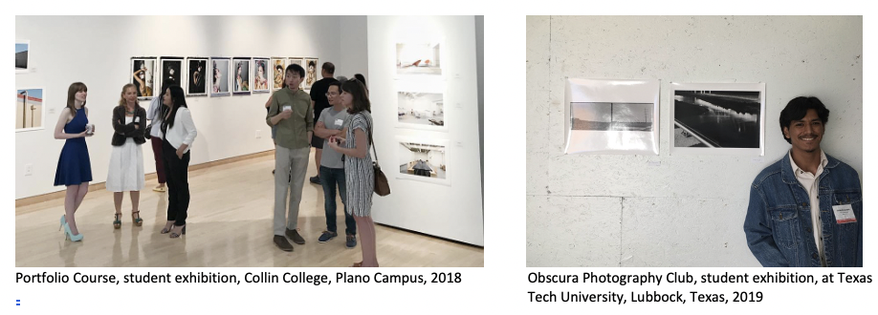

Furthermore, in 2020, photography classes began to incorporate Service-Learning Projects to understand community needs and how artists can work with their community to support those needs. For example, Book, Design, and Presentation classes created hand-made cards for populations affected by loneliness due to isolation during the pandemic (populations included seniors, elementary school children, and distant family members). Students learned how to use their technical skills and learn about their community. In return, the community around them became enriched by students' involvement.
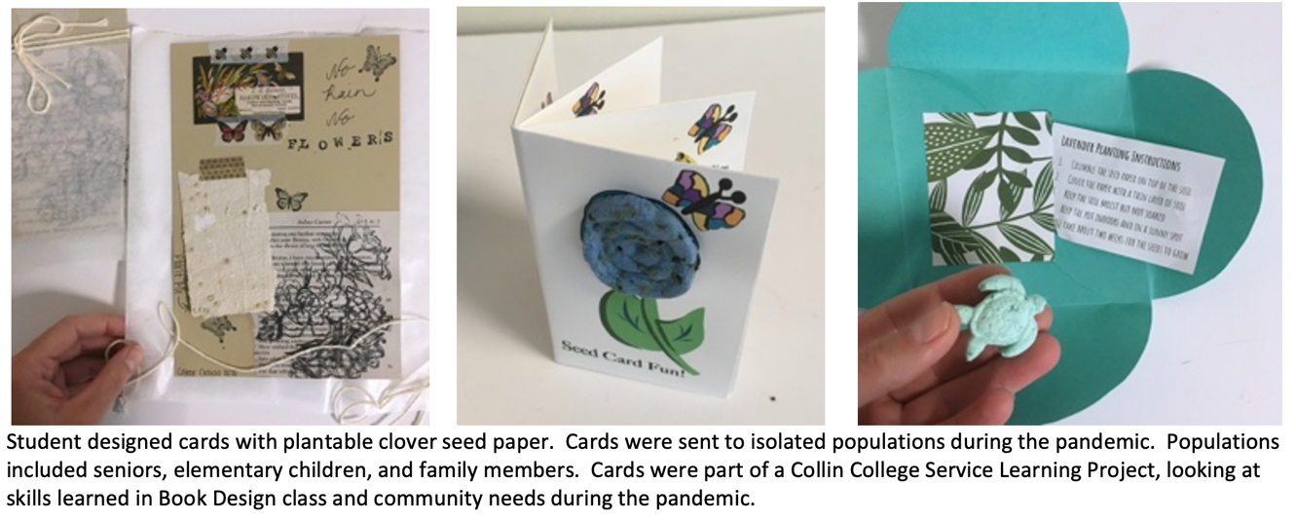

Developing Skills

The Commercial Photography Program assists in helping students to develop technical skills in photography, from camera operations (Digital Media and Photography I) to advanced photography software applications (Digital Imaging I and Digital Imaging II). Additionally, students master various photography studio lighting skills in Portrait 1, Portrait 2, Fashion, and Illustrative. Courses are also offered that teach students shooting styles outside the studio, such as Architecture Photography and Photojournalism.

Additionally, students learn studio management, business, and professionalism skills in Studio Management, Co-Op, and Portfolio. Lastly, students add individuality and creativity to their technical skills by enhancing creative skills in courses that push students outside of the technical safety zone and emphasize craft, creativity, and concept (Expressive, Landscape, Book, Design and Presentation, Digital Media, and Photography I).

The well-rounded program aims to aid students in developing a toolbox of considerable technical and soft skills paired with creativity. Once students complete the AAS, they will have many skills and be well prepared to join the commercial photography field.

"When I first joined the degree plan, I knew very little about cameras especially when it came to shooting. Now that I have been in the program for many semesters, I have learned a tremendous amount about cameras, lighting, and all the different equipment that I have never seen or even touched before coming into the program." - VJ

"I've learned a wide range of skills with this program that make it easier for me to find a wide variety of jobs. I don't just have skills for portraits, I have skills for architecture, commercial photography, ecommerce and more. I am very thankful for this program. Before I knew about it, I didn't think I would be able to make photography a full-time career. Since taking the leap into the program I've gotten nothing but confidence in knowing I'll be okay after graduating." - MM

Source – Student Quotes - Departmental Records

Strengthening Character

The Program strengthens character by creating projects beyond the Student Learning Outcomes. Projects are designed to teach in the “growing zone,” just outside of a student’s comfort zone; but, with attention, not moving into the fear zone. Besides focusing solely on the technical aspect, projects include teamwork, conceptualism, and professionalism.

Many of the studio assignments are designed as team-based learning. Students take on different tasks working as a team to complete production photographs. For example, Digital III students work in large groups, mimicking the work ethic of a production lighting studio. Working together, students create stunning portraits to work as a base for their final prints. Students can then personalize their photographs by adding digitally created backgrounds and effects.

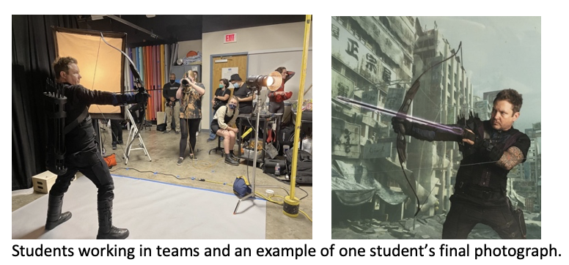

The Photography I classes attach a concept to every assignment ranging from self-reflective to community observation. These assignments teach students to look beyond the aesthetics and technical aspects of photography and use photography as a conversation and awareness. Furthermore, photography students have collaborated with students from other disciplines. For example, in Spring 2020, Photography I students collaborated with a theater and a music course to create art inspired by readings from the Book-in-Common book, The Leavers.

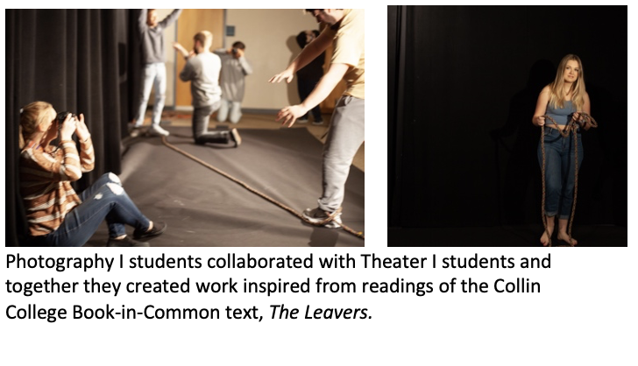
Courses such as Photojournalism and Portfolio arrange practice job interviews with professional photographers. Students receive feedback from the professor and invite portfolio reviewers to prepare and improve for future interviews. Teamwork, concept, and professionalism are vital traits for students to stand out in the Commercial Photography world and have the character to create their career.

Challenging the Intellect

Furthermore, the Commercial Photography Program challenges the intellect by incorporating thought-provoking assignments, advanced skills, and real-world applications. For example, faculty incorporate thought-provoking projects by collaborating with the Collin College Book-in-Common Program each semester, assigning students in the Photography I courses to create photographs inspired from readings in the book. The topics are discussed in class and presented visually through photographs.

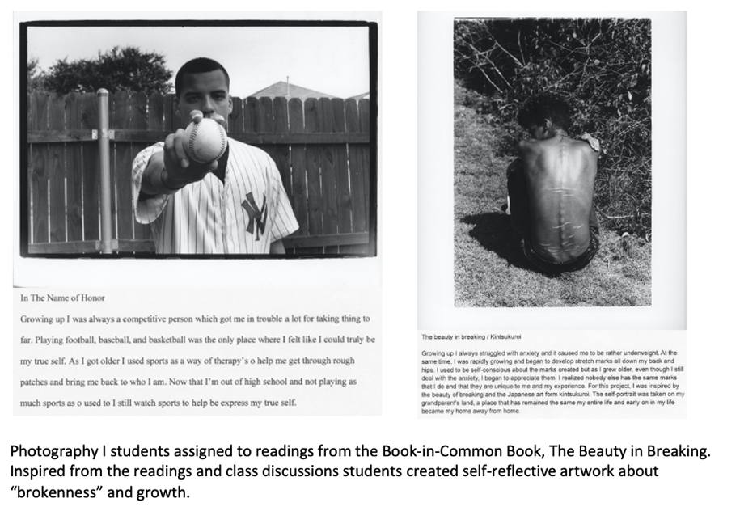

Upper-level courses prepare students with advanced skills and real-world applications. In Illustrative Photography, students learn to create lighting boxes at home. Thus, preparing students for working at home once they graduate from Collin College and no longer have access to the photography lighting studio. Assignments are created to mimic photography shooting jobs, whether in the studio, photojournalism, video, or the many other courses. Appropriate assignments add deadlines, budget proposals, bid proposals, and the real-world business of being a commercial photographer.

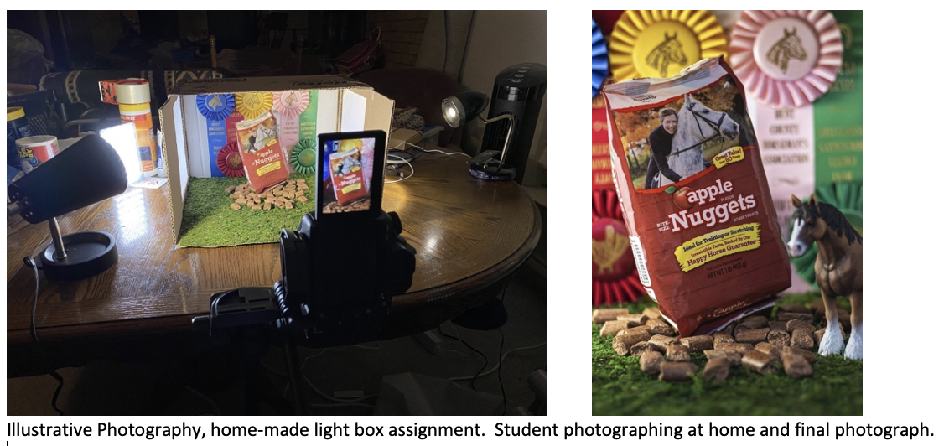

COLLIN COLLEGE’S STRATEGIC PLAN

The Commercial Photography Program has supported Collin College’s Strategic Plan throughout the last five years.
Link to strategic goals: http://www.collin.edu/aboutus/strategic_goals.html.

- Improve student outcomes to meet or exceed local, state, and regional accreditation thresholds and goals.
Even though there are no formal accreditations in commercial photography, the faculty have recognized available certifications and industry standards practiced by The Collin College Commercial Photography Advisory Board, American Society of Media Photographers, and Professional Photographers of America. To support outside certifications, such as Capture One Software Certification, the Photography Program redesigned PHTC 2349 Digital Imaging II to teach students Capture One. After completing PHTC 2349, if students desire to become certified, they will be prepared to take the certification exam. Besides software certification, faculty members work closely with the Commercial Photography Advisory Board, American Society of Media Photographers, and Professional Photographers of America to ensure that the program content meets the current industry standards of the Commercial Photography work field. Faculty members attend meetings, solicit advice, and maintain an updated curriculum.

- Develop and implement strategies to become a national exemplar in program and student outcomes.
Furthering the improvement of the Program, faculty members are active in developing it into a national exemplar program. The Program strives to create professional interactions for students at a national level in two main areas, off-campus field trips and on-campus guest speakers. Faculty members schedule field trips that allow students to visit nationally-recognized museums, attend conferences, and visit studios. Furthermore, faculty members arrange on-campus events, such as inviting nationally-recognized photographers to speak and meet with students. Guest speakers expose students to outside excellence.

Examples of off-campus engagements:
- Conferences attended by Obscura Photography Club: College Art Association National Conference, Society of Photographic Education National Conferences and Regional Conferences, FotoFest International Bi-annual
  - Conferences allow students to network outside of the classroom and the region. Students can show their portfolios to professionals to receive feedback and constructive criticism. Additionally, students attend lectures, observe demonstrations, and have the opportunity to view contemporary photography.
- Studio Tours attended by classes: Fossil Studios, TX Studios, Floc Creative Space,
  - Studio tours give students an insight into the reality of a running studio. They can observe the process, the energy, and the teamwork involved in successful commercial studios. They learn about the variety of positions involved in the commercial photography world and employment expectations. Additionally, they are networking and able to ask questions to potential employers.
- Museum and Gallery Tours attended by Obscura Photography Club: Museum Fine Arts Houston Private Tours of the Print Collection, Amon Carter Museum Private Tours, Harry Ransom Center, San Francisco Museum of Modern Art, Museum of Modern Art NY, Metropolitan Museum of Art, and more.
  - Museums and gallery tours allow students to view photographs in person versus on a screen. They can see the tactile quality of work. Furthermore, they learn why some work has become more successful than others. The opportunity to view work and speak with museum/gallery directors educates students in craft and content, leading to more robust work that excels beyond skill alone.

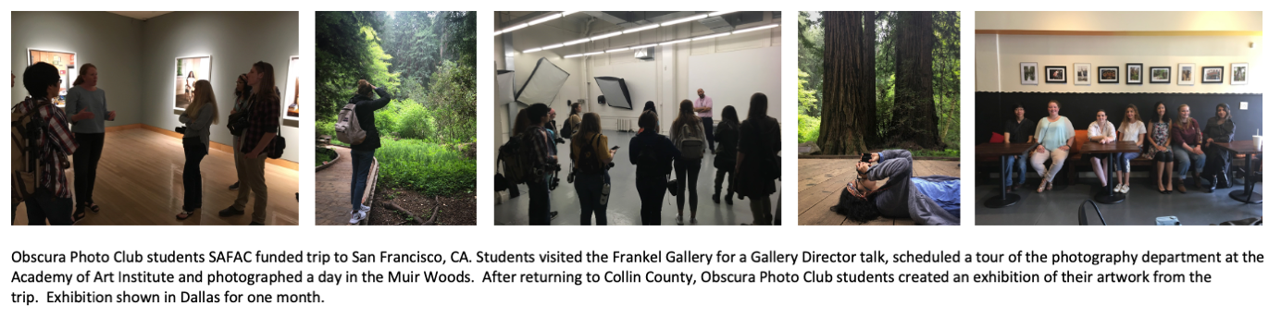

Examples of on-campus Guest Speakers:
- Neil Whitlock – Photographer
  - After retiring from a successful lifelong career as a commercial photographer, Neil Whitlock is a renowned Travel, Outdoor, Nature photographer. Whitlock met with students to review their portfolios and discuss his path to becoming a successful commercial photographer and his new passion for landscape photography.
- Henry Horenstein, Photographer
  - Mr. Horenstein is a fine art photographer, documentary photographer, commercial photographer, filmmaker, and book producer. He shared with students his long path from photojournalism to working with Polaroid, commercial photography, and the successful life he leads as a photographer.
- Judy Walgren - Pulitzer Prize-Winning Photojournalist
  - Judy Walgren is a former Staff Photographer for the Dallas Morning News and former Director of Photography at the San Francisco Chronicle. Currently, she is a Professor of Photojournalism and new media at Michigan State University. She reviewed student portfolios and discussed the business of photojournalism.

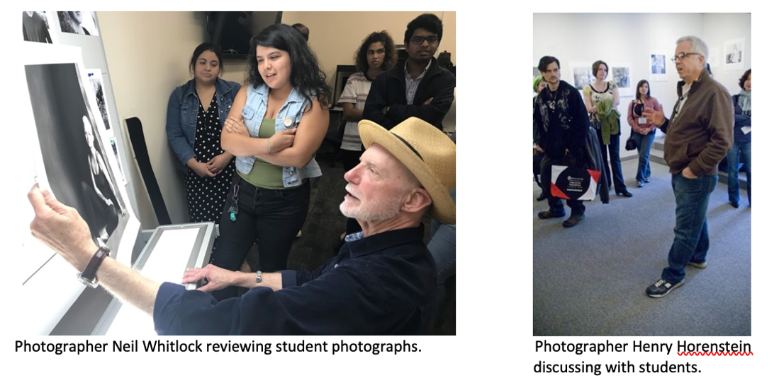

- Create and implement comprehensive, integrated pathways to support student transitions.
The photography program supports a smooth change for students in three areas of transition: High School to Collin, class to class, Collin to future endeavors (Commercial Photography employment or University transfer).

The photography department ensures a smooth transition from high school to college through high school outreach and advising. Faculty members reach out to high school students by attending resource fairs and orientations. For example, in the summer of 2020, two Zoom Orientations were arranged with Wylie High School (June and August 2020). Additionally, Faculty members are active with early advising to help guide students with understanding degree plans, course sequencing, and class expectations.

The Program has focused on course-to-course transitions. Detailed course skill sets help ensure that all prerequisite material is covered and that there is no unnecessary curriculum overlap. For example, three levels of digital photography courses (ARTS 2348, PHTC 1300, PHTC 2349) are planned out in detail and discussed with all professors who teach any of the three courses. This strict structure has proven successful for students and professors to ensure a smooth transition from course to course. Furthermore, a PLA (Prior Learning Assessment Exam) is currently being created to accommodate advanced students entering the program and allow a smooth transition.

Outside of the Commercial Photography Program, the Transfer Fine Arts side of the Photography Department has secured a 2+2 pathway with Texas A&M University, ensuring that transfer students have a smooth path from Collin College to a local University. To ensure that commercial photography students have a smooth route to enter the workforce, the AAS Degree and Level 2 Certificate require Co-Op Education (Commercial Photography Internship Course). Co-Op is a beneficial course that bridges the gap between college and employment. The course structure allows students to gain real-world experience while still having access to a professor for guidance. The course gives students the knowledge and confidence to move successfully from college to employment.

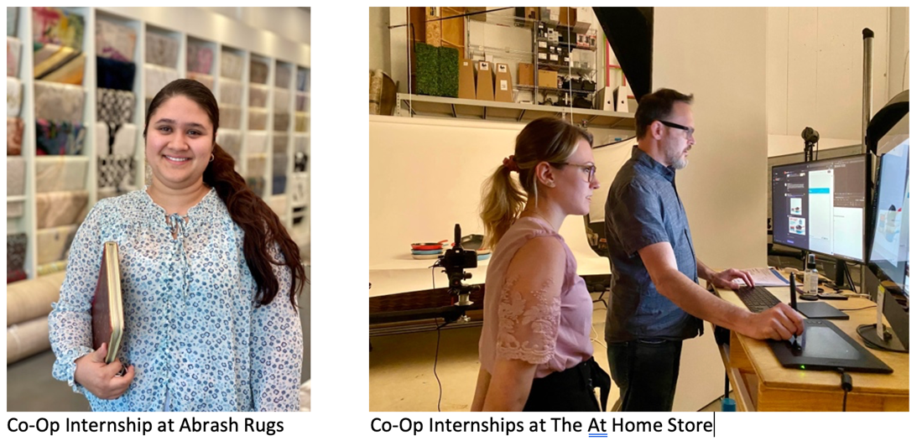

- Implement the third Baccalaureate degree by Fall 2022 and continue adding 2+2 programs with university partners.
Not Applicable

- Develop and implement a comprehensive staffing and succession model.
Not applicable

- Develop a coordinated and systematic approach to engage external stakeholders.
Regional employers serve as the primary stakeholders for the Commercial Photography Program. There are three avenues for coordinating a systematic approach for employment: Commercial Photography Co-Op Course/Internship, Faculty Recommendation, and the Commercial Photography Advisory Board. Co-Op/Internships have proven beneficial for students, not only as a means for students to gain real-world experience but also as many have received employment directly after serving their internship.

Co-Op to Employment examples:
  - Student (P.M.) interned at TX Studio after completion hired as Weekend Manager of TX Studio
  - Student (A.B.) interned at Wade Griffiths Photography, after completion hired as Digital Editor for Wade Griffiths Photography
  - Student (C.P.) interned at Brooke Drake Design, after completion hired as part-time Photography and Studio Assistant for Brooke Drake Design

Faculty Recommendation for employment examples:
- Student (J.M.) hired for a freelance position, event photography, recommendation by Professor
- Student (M.G.) employed as a digital tech for JC Penny’s, recommendation by Professor
- Student (C.M.) hired for lifestyle photography for Advocate Magazine, recommendation by Professor

Commercial Photography Advisory Board examples:
- Advisory Board Chair Phillip Bower of Fossil – hired one full-time, permanent assistant photographer, student (P.M.). Additionally, Mr. Bower of Fossil – hired two part-time, temporary photographers, students (J.B.) and (A.A.)
- Advisory Board Member Justin Clemons of Floc Creative Space – hired one full-time, permanent studio/office manager, student (K.M.)
- Advisory Board Member Chris Baylor – hired student (C.F.) as a freelance photography assistant

☐3. Why we do the things we do: Program relationship to student demand

Make a case with evidence to show that students want the certificate. Discuss whether or not there appears to be any disproportionate enrollment by gender, race, and ethnicity (compared to Collin College’s overall student demographic distributions http://inside.collin.edu/iro/programreview/prfilehostpage.html). If any differences exist, discuss possible reasons why the gap exists and plans to address these issues to close gaps in enrollment rates between groups of students (refer to the Program Review portal for Enrollment Reports and Average Section Size data files for your program http://inside.collin.edu/institutionaleffect/Program_Review_Process.html).
Suggested/possible points to consider:
- What is the enrollment pattern? Declining, flat, growing, not exhibiting a stable pattern, please explain. For required program courses where there is a pattern of low enrollment (fewer than 15 students), explain your plan to grow enrollment and/or revise the curriculum.
- What are the implications for the next 5 years if the enrollment pattern for the past 5 years continues?
- Describe any actions taken to identify and support students enrolled in program-required courses early in the degree plan. If no actions are taken at the present, please develop and describe a plan to do so.
- How does your program support (or plan) to support attraction of a diverse student population?
- Check with Institutional effectiveness for Data Reports -names of reports
- Analyze the evidence you provide. What does it show about the program?

STUDENT INTEREST

The Commercial Photography Program has experienced a 32% growth in unduplicated enrollment from Fall 2015 to Summer 2020.
After analyzing the data collected from the Institutional Research Office, one can see a steady increase in enrollment.
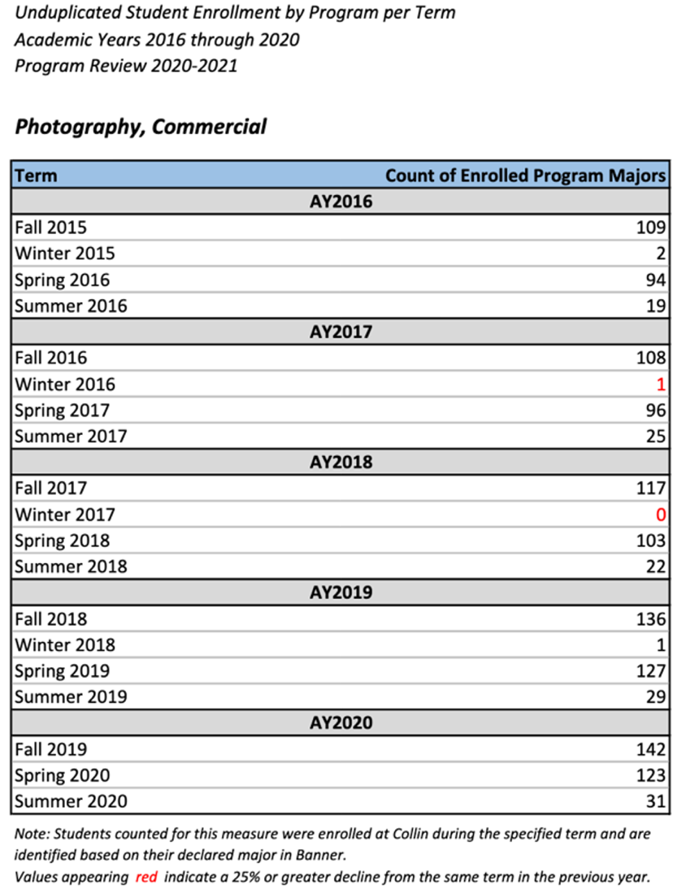
Date Collected from Collin College Institutional Research Office http://inside.collin.edu/iro/programreview/202021/AwardsByProgram_2016-2020.pdf

The following are comprehensive statistics for 2015-2020
 |  |  |  | Students Interest in Commercial Photography Program
 |  |  |  |  | 2015-16 | 2016-17 | 2017-18 | 2018-19 | 2019-20 |  | % Increase
 |  |  |  |  | 224 | 230 | 242 | 293 | 296 |  | 32% from  2015 to 2020
 |  |  |  |  | 12  Degree-3  Cert-2  OSA-7 | 18  Degree-4  Cert-6  OSA-8 | 14  Degree-5  Cert-9  OSA-0 | 28  Degree-8  Cert-19  OSA-1 | 17  Degree-4  Cert-13  OSA-0
Count of enrolled program majors

There is a steady increase in unduplicated student enrollment in the program. Overall, there is an increase in awards, with a decrease in 2019-2020. 2019-2020 was the year of the Covid-19 pandemic and showed a decrease in degrees, certificates, and OSA awards due to students not attending in-person classes.

ENROLLMENT BY RACE, ETHNICITY, AND GENDER

The Photography Program enrollment shows a diverse race, ethnicity, and gender representation. The photography enrollment is similar to the overall college’s enrollment in race, ethnicity, and gender. There is a slight difference in exact numbers; yet, close enough to not create a concern.

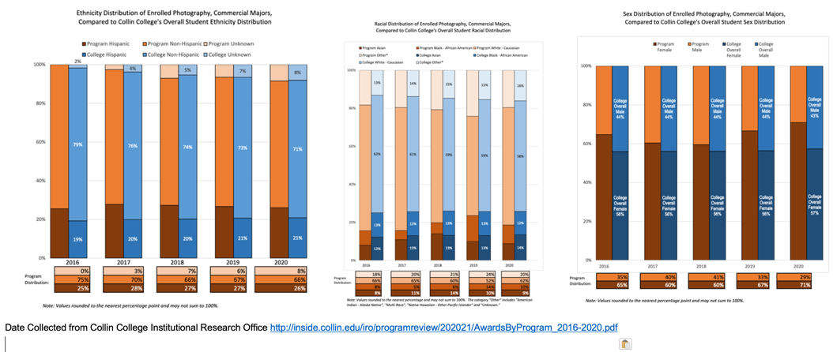

ENROLLMENT PATTERN / PROGRAM GROWTH

The enrollment pattern shows a steady increase in enrollment in all semesters except Wintermester. Due to the large number of contact hours required for Photography courses, the Wintermester session is not ideal, so classes are not offered. Summer enrollment has a trend for low enrollment. However, a few courses are offered every summer to allow summer students to continue their education. Additionally, when students enroll in summer courses, they are advised to complete their General Education Core requirements.
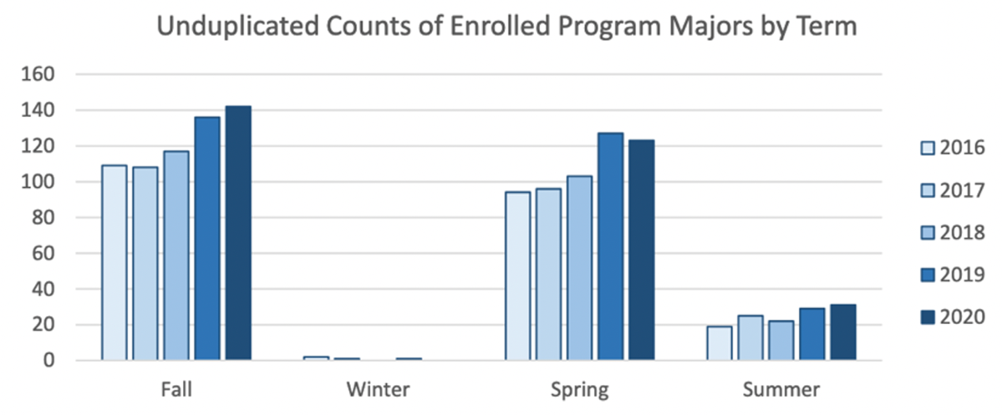
Date Collected from Collin College Institutional Research Office http://inside.collin.edu/iro/programreview/202021/AwardsByProgram_2016-2020.pdf

COURSES WITH LOW ENROLLMENT

All courses in the photography program show positive enrollment patterns. Most courses have a consistent average with slight variation in enrollment numbers. ARTS 1313 is an option for fulfilling the creative core requirement and shows an increase in enrollment. PHTC 1371 is only offered during the long semesters and has an enrollment cap of twelve. A few courses have a slight decrease, which is
mostly during 2020. Students were not attending in-person classes during spring 2020, and limited options were available during fall 2020. The decrease in enrollments is not significant enough to cause concern.
Course | 2015-16 | 2016-17 | 2017-18 | 2018-19 | 2019-20 | Notes
ARTS 1311, Design I (2-D) | 128 | 109 | 119 | 132 | 174 | Increase
ARTS 1313, Foundations of Art | 314 | 496 | 629 | 686 | 764 | Increase
ARTS 2348, Digital Media | 265 | 258 | 261 | 264 | 229 | Flat/Average  Decrease Covid Year
ARTS 2356, Photography I | 71 | 68 | 73 | 66 | 74 | Flat/Average
PHTC 1300, Digital Photography II | Not offered | 10 | 31 | 31 | 29 | Flat/Average  Not offered every semester
PHTC 1341, Color Photography I | 16 | 12 | Not offered | 18 | 18 | Increase  Not offered every semester
PHTC 1343, Expressive Photography | Not offered | 17 | 19 | 19 | 16 | Flat/Average
PHTC 1345, Illustrative Photography I | Not offered | 17 | Not offered | 17 | 19 | Flat/Average  Not offered every semester
PHTC 1347, Landscape Photography | Not offered | 10 | 4 | 11 | Not offered | Flat/Average  Not offered every semester
PHTC 1351, Photojournalism I | 15 | 13 | Not offered | Not offered | 15 | Flat/Average  Not offered every semester
PHTC 1353, Portraiture I | 25 | 39 | 44 | 32 | 33 | Flat/Average
PHTC 1371, Book, Design & Presentation | Not offered | Not offered | 11 | Not offered | 24 | Increase  Not offered every semester
PHTC 2331, Architectural Photography | 18 | Not offered | 18 | 18 | 13 | Flat/Average  Not offered every semester
PHTC 2340, Photographic Studio Management | 17 | 17 | Not offered | 19 | 16 | Flat/Average  Not offered every semester
PHTC 2342, Fashion Photography | 14 | Not offered | 14 | Not offered | 16 | Increase  Offered every other year
PHTC 2343, Portfolio Development | 15 | 12 | 13 | 16 | 9 | Flat/Average  Decrease Covid Year
PHTC 2349, Digital Photography III | Not offered | Not offered | 9 | 16 | 13 | Increase  Not offered until 2017-18
PHTC 2353, Portraiture II | 7 | 17 | 15 | 19 | 14 | Flat/Average
PHTC 2371, Video Production for Photographers | Not offered | Not offered | 18 | 16 | 9 | Decrease Covid Year  Not offered until 2017-18
Date Collected from Collin College Institutional Research Office http://inside.collin.edu/iro/programreview/202021/AwardsByProgram_2016-2020.pdf

IMPLICATIONS FOR NEXT 5 YEARS IF THE PATTERN CONTINUES AT 32% INCREASE

The 2015-2016 academic year had 224 unduplicated enrolled students, 2019-2020 academic year showed 296 unduplicated enrolled students, making a 32% increase from 2015 to 2020. With this significant increase, the program will need to be prepared to adjust if a 32% increase continues.
Areas to look at will be faculty, equipment, and lab space. After reviewing the Institutional Research Office data, full-time faculty to part-time faculty is currently at a good percentage. During Fall 2020, the full-time faculty percentage was 32%; however, an additional full-time faculty member was hired starting Fall 2021. If increased enrollment continues, an additional faculty member will need to be considered. Additionally, equipment supply will need to be increased if growth continues. The Collin College Photography Program supports and assists students with check-outed equipment, and many check-out items are aging. Lastly, if growth continues, the Program will outgrow the current lab space, and the need for additional digital lab space and studio space will need to be considered. All three areas should be watched closely as enrollment and program growth are analyzed.

ACTIONS TO IDENTIFY AND SUPPORT EARLY ENROLLED PROGRAM STUDENTS

Photography professors take two main actions to identify and support early enrolled program students. The first action is that professors arrange a time to discuss the program, degree options, and courses in every class. Many professors schedule class time just before early enrollment begins for the upcoming semester. This time is an excellent opportunity to explain courses and degree plans. The second action is to advise students at all program levels from freshman to graduating. Professors assist with course scheduling advice on course loads, degree plans, and internship opportunities. The photography department displays posters each semester to announce upcoming courses and schedules.
Furthermore, the department is active at maintaining department social media. Collin College Photography’s website is up-to-date, easy to navigate, and filled with information about degrees and courses. Collin College Photography’s Instagram feed posts registration reminders, payment deadlines, upcoming classes, and helpful guidance.
Photography Department Instagram: collincollege_photography
Photography department website: www.collin.edu/department/photography

ATTRACTING DIVERSE POPULATIONS

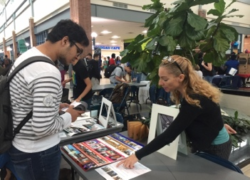
The photography program attracts diverse populations, including current Collin College students, High School Students, and the community. The photography program maintains an active presence on campus to attract Collin College students, including exhibitions of student photography throughout campus, an exhibition of student photography portfolio works each summer in the Art Gallery, and maintaining a table at Campus Resource Fairs.

Attracting high school students has been addressed with Zoom orientations, judging high school photography competitions, and attending high school resource fairs.
Examples of High School Outreach:
- 2019 Fall Semester - Judging ATPI Competition
- 2020 Summer - Zoom Photography Program Orientation, Wylie High School
- 2020 Spring Semester - Working with Plano West High School to arrange an orientation talk.
- 2020 Fall Semester Judging – State Competition for Prejudging, ATPI (Association of Texas Photography Instructors) State-wide organization for High School Students interested in photography
- 2020 Fall Semester – faculty joined as a member of ATPI (Association of Texas Photography Instructors)
- 2021 Fall Semester - ATPI (Association of Texas Photography Instructors) 2021 Fall State Contest – High School State Competition

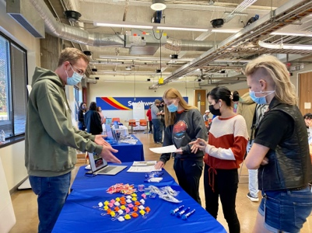
Photography faculty hosting a table for the Photography Department at Plano High School.

Lastly, to attract adult learners, second-career students, seniors, and other populations in the community, faculty maintain an active resume engaging with the public through community lectures, judging photography contests, and the like. Maintaining a professional public presence casts a larger net and introduces people to the program at Collin College.

Examples of Public Outreach:
- 2019 Digital Photography Class taught at North Haven Gardens (targeted to seniors)
- 2019 Fall Semester - Plano Photography Club, 2019 Judged –one photo competition
- 2020 Fall Semester - Speaker for Plano Photography Club (targeted to second career students)
- 2020 Plano Photography Club – Judged two photo competitions
- 2021 Fall Semester - Plano Photography Club, 2021 – Judged one photo competition
- 2021 Haggard Library Student Photography Exhibition

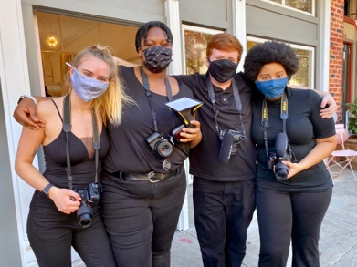
2020 Fall Semester - Public Fashion Shoot with photography students and models (outside and inside the store) at Hannah Marie’s Boutique on McKinney Square.

However, even though faculty have consistently tried to attract diverse populations, efforts can be increased. This is an area that will be addressed in the following review cycle’s Continuous Improvement Plan.

☐4. Why we do the things we do: Program relationship to market demand
Make a case with evidence to show that employers need and hire the program’s graduates. Some resources to utilize for information could be: JobsEQ http://inside.collin.edu/iro/programreview/202021/ProgramLaborMarketInfo_2020-21AY.pdf, Burning Glass, O-Net https://www.onetonline.org, Texas Labor Market Information https://www.twc.texas.gov/businesses/labor-market-information.
Suggested/possible points to consider:
- How many program-related jobs are available in the DFW Metroplex for program graduates? If the majority of related jobs in the DFW Metroplex require a baccalaureate degree, provide evidence that you have a current signed articulation agreement with one or more transfer institutions or that you plan to develop one.
- What proportion of the program’s graduates (seeking employment) found related employment within six months of graduation?
- What changes are anticipated in market demand in the next 5 years? Do program completers meet, exceed, or fall short of local employment demand? How will the program address under- or over-supply?
- Identify and discuss the program’s strengths and weaknesses related to market demand.

EMPLOYER DEMAND OF PROGRAM GRADS

Based on the data collected, JOB AVAILABILITY IN DFW - PHOTOGRAPHY HIRING PRACTICES
Most photography-related jobs are not posted on the typical jobs websites like Monster, Indeed, and LinkedIn. The survey below was taken in October 2021 – with professionals in the DFW area that hire photographers and other related positions in the field to confirm hiring practices. Over 75 people were contacted, and half of those completed the survey. The responses are from people working in-house corporate, individual studios, and large photography studios.

Source – Collin College Photography Department Survey – Oct 2021

"I am writing to you from New York City to thank you for providing me with the best possible training from the Collin College Photography Department. As a result, I am now actively pursuing my dreams and career path in one of the most competitive markets in the US and the world." - MZ

GRADUATION TO CAREER

Students are prepared to start their photographic career once they graduate from Collin College with a website, company logo, portfolio, as well as business practices. Interview skills are practiced in the Portfolio class, including presentations of their portfolio to working professionals in various areas throughout the Photographic industry. The mentioned professionals manage advertising, corporations, editorial venues, and public relations.

Co-Op's 2018-2021

This chart shows both the co-ops and hiring of co-ops for part-time and full-time jobs after co-op.

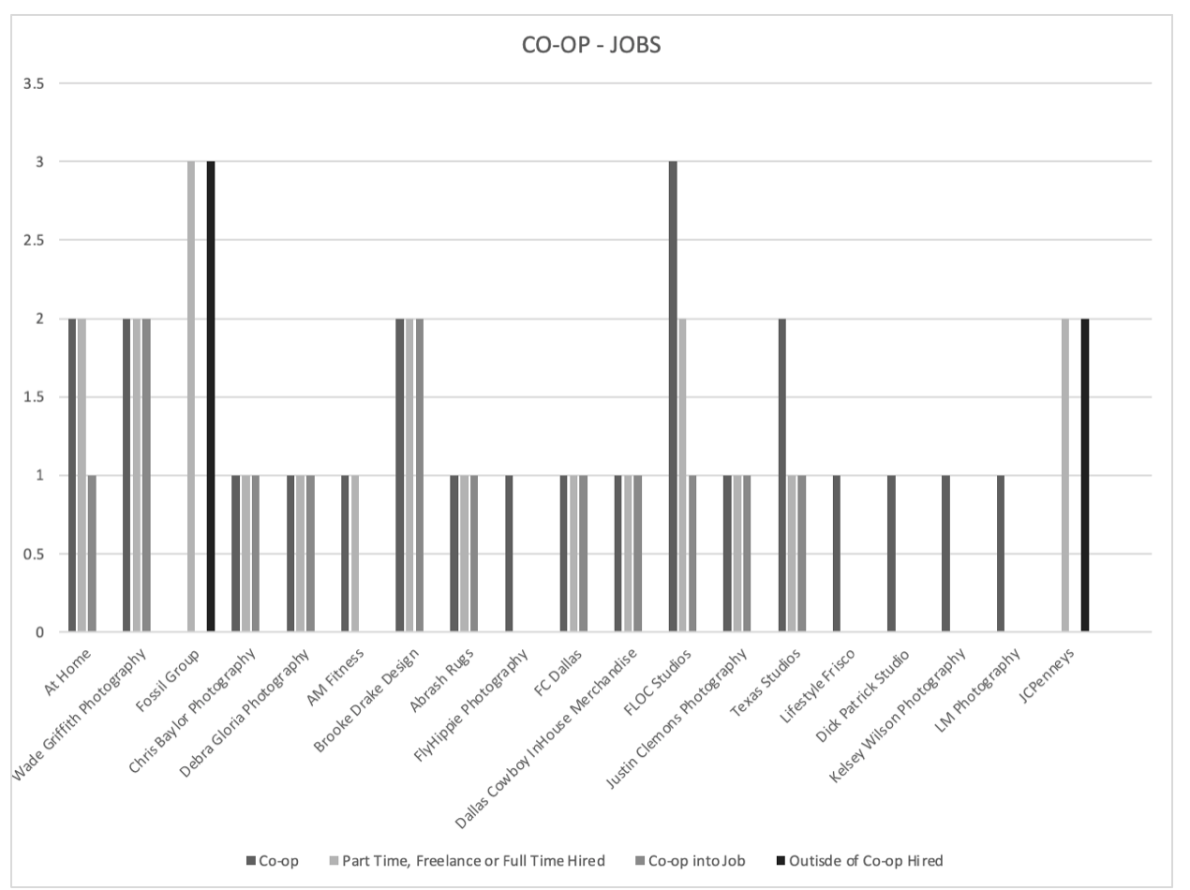

The most significant factor aiding students after graduation is the Co-Op program. Many students make connections with their Co-Op mentors, leading to introductions for other job opportunities. Students are being hired freelance, part-time, or full-time after graduation. In Co-Op, students can experience many aspects of the commercial side of Photography. Through Portfolio, students produce an art show to highlight their work to experience the fine art side of photography. Darkroom, Expressive, and Book Design classes also allow students to explore the fine art world of photography. These attributes can be grown in the Portfolio, Co-Op, and Studio Management classes.

There have been several of our Co-Op successes in the past three semesters.
At Home – in house Studio has hired their first full-time photo assistant after finishing Co-Op
Fossil – has two full-time photo assistants and one temporary assistant
Brooke Drake Designs – has hired two part-time photo assistants/photographers
Wade Griffiths – has hired two Co-ops as full-time digital retouchers.

"I took a Cooperative Work Experience course this past summer and was hired as a photo editor for an architectural photographer shortly after and I genuinely believe I could not have gone this far without the knowledge and guidance of my professors in the Collin College photography program.

I used to hear my professors and others that have been through the photography program say how the photo department of Collin College spring creek campus is the best in the state, and I now fully see how that could not be truer." - CDC

MARKET DEMAND NEXT 5 YEARS
Bright Outlook Occupation:
27 -4021.00 - Photographers
https://www.onetonline.org/help/bright/27-4021.00

Photographers are on the list for bright Outlook Occupation for the next several years. The outlook growth for the occupation of photographers is expected to grow rapidly.

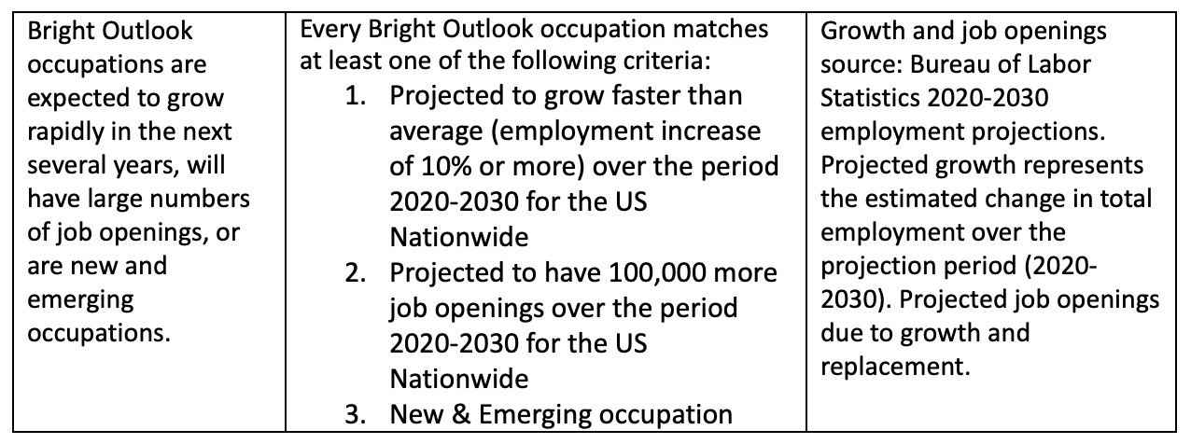

Texas Employment Trends For:
27 -4021.00 - Photographers

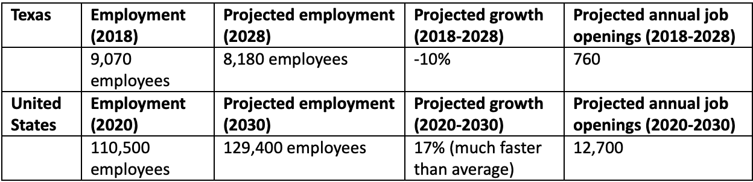

Even though the data from www.ontonline.org shows a decline for photographers in Texas, nationally, photographers will increase by
as much as 17%. According to the Photography Advisory Board, there will be an increase in supporting roles, especially for digital techs.
Digital Techs currently earn $275 a day and earn up to $600+ for highly experienced individuals. Also, with social media growing rapidly and e-commerce, the demand for photography is expected to continue to grow. Many photography jobs will not
be on an official website as many photographers are sole proprietors.

Source – Photography Advisory Board

Local Wages For 27 -4021.00 -
Photographers Texas, 75074
https://www.onetonline.org/link/localwages/27-4021.00?zip=75074&g=Go

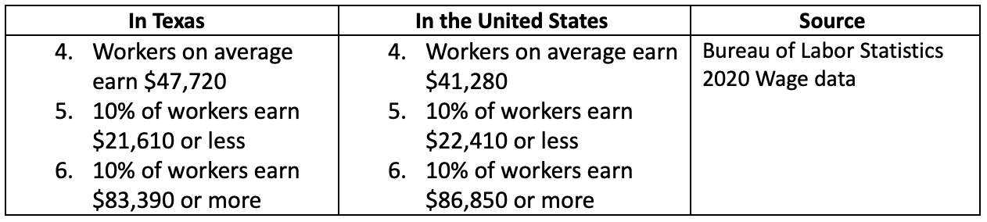

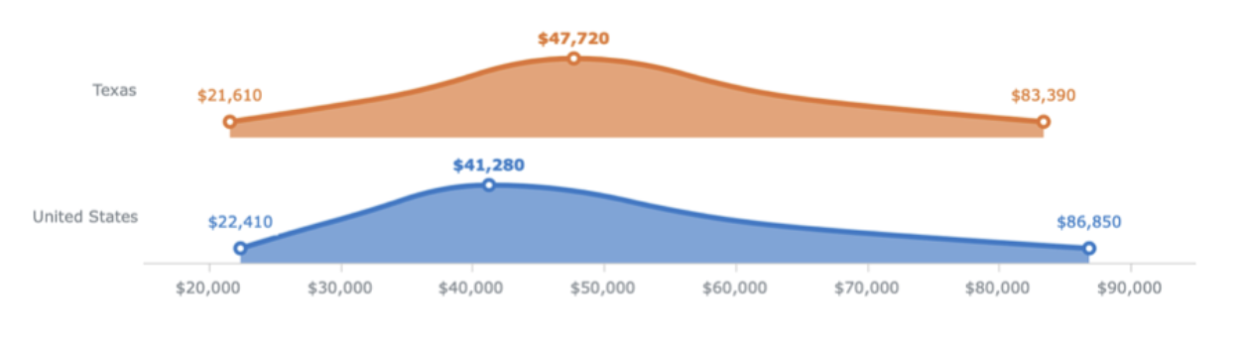

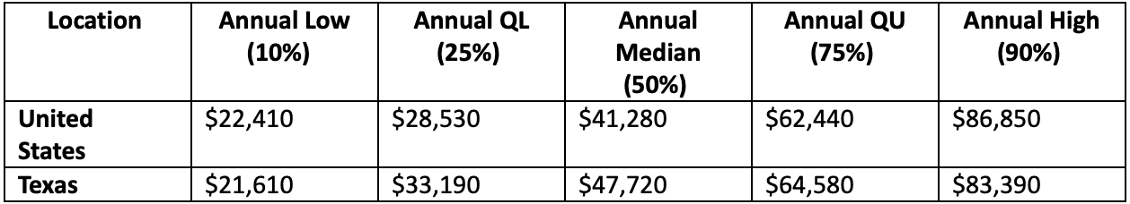

The source below shows the need for Photography Assistants in Dallas (ten positions are currently online in the DFW area). These are the jobs that are listed. According to the Photography Advisory Board, most assistant jobs are filled by word of mouth or referral. This was confirmed through a survey of professionals in the DFW area that hire photography assistants.

The survey was taken in October 2021 by individuals in the DFW photography community that hire photographers. These individuals work for Corporations, Photo studios, both large and small. The survey supports how those in the commercial field of photography hire photographers. The commercial photography industry does not typically use traditional job engines for hiring individuals.

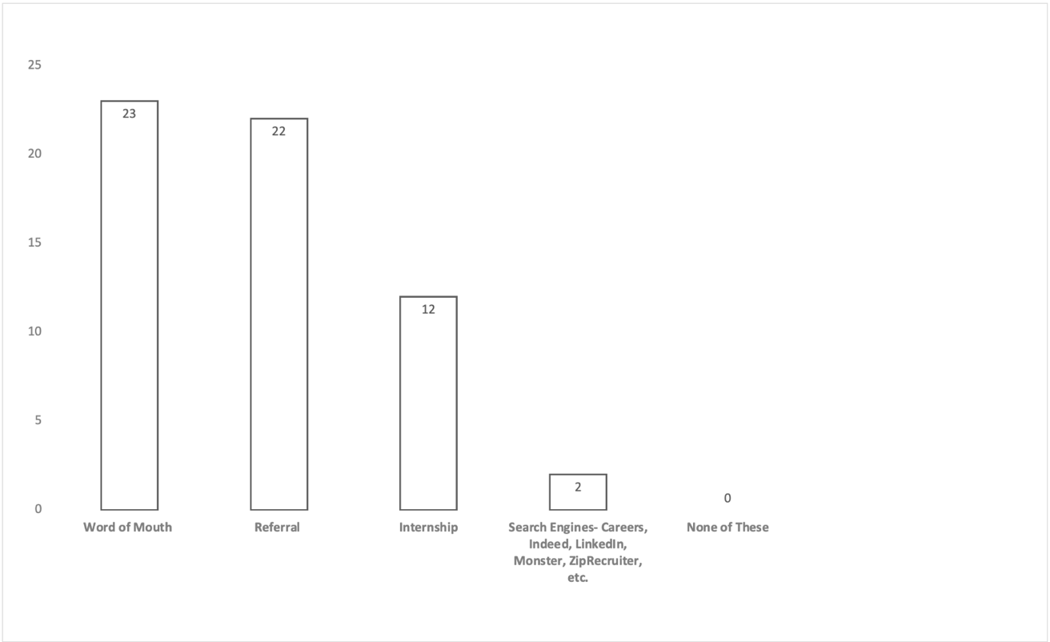

The income for photographers after graduation:
https://www.ziprecruiter.com/Salaries/Photographer-Assistant-Salary-in-Dallas,TX

What are the Top 5 Best Paying Related Photographer Assistant Jobs in Dallas?
We found at least five jobs related to the Photographer Assistant category that pay more per year than a typical Photographer Assistant salary in Dallas, TX. Top examples of these roles include Event Photographer, Architecture Photographer, and Corporate Photographer.
Importantly, all of these jobs are paid between $29,477 (72.7%) and $38,432 (94.8%) more than the average Photographer Assistant salary of $40,537. If you’re qualified, getting hired for one of these related Photographer Assistant jobs may help you make more money than the average Photographer Assistant position.
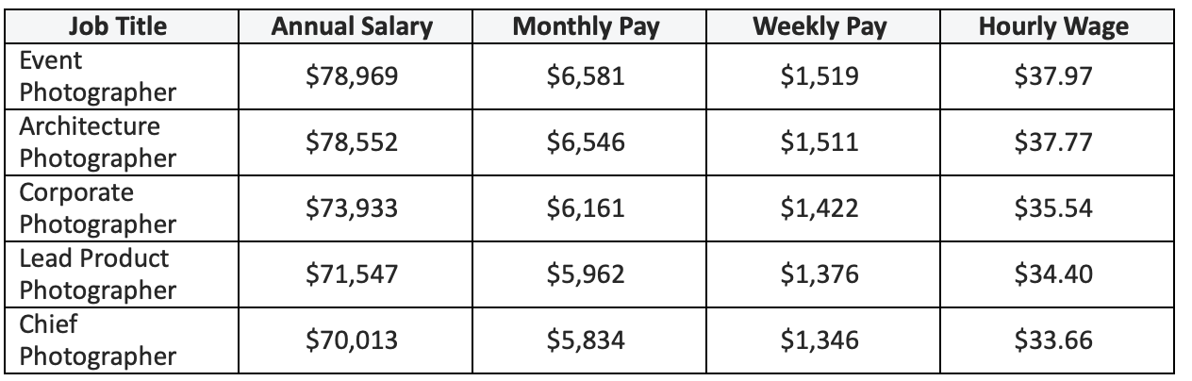

Wages and Employment Trends
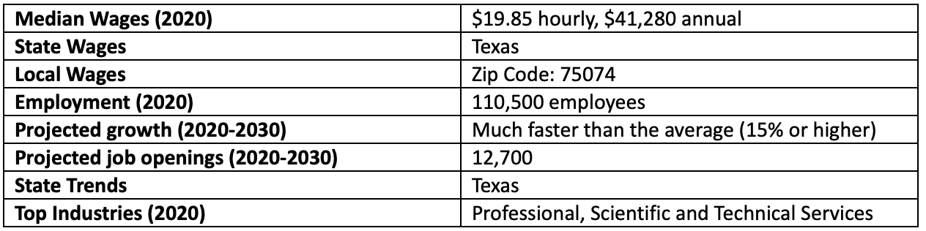
https://www.onetonline.org/link/localwages/27-4021.00?zip=75074&g=Go

Sources of Additional Information
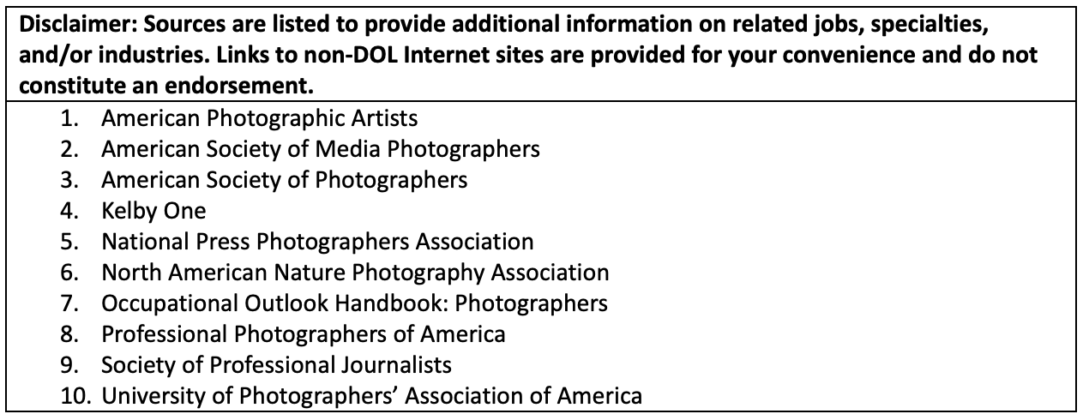

Local Wages for:
27-4032.00 - Film and Video Editors
Texas, 75074
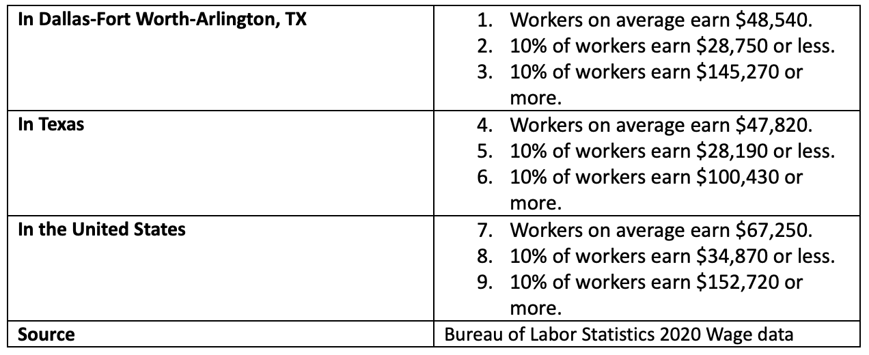
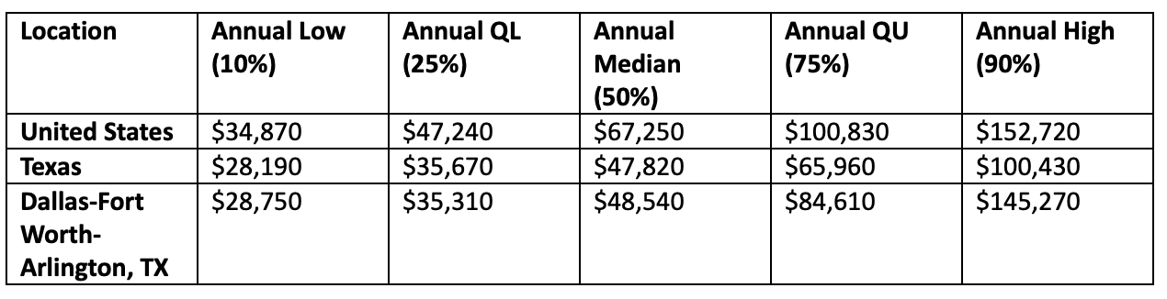
According to www.onetoline.org, the median income for photographers in Texas is $47,820. Since many photographers are freelance or sole-proprietor businesses, it is more challenging to track income in the field of Photography.

Job List Possibilities for Recent Graduates of the Workforce Photography program.
How many students in the last five years have gone into each section?
Source – departmental records, addendum

- Family and Senior Portraits
- Sports/Team Photography
- Wedding Photography*
- Event/Public Relations - Hot Job Market
- Editorial Photography
- Architecture / Real Estate
- Photography Assistant
- Digital Tech - Hot Job Market* *
- Videographer
- Video Editor Hot Job Market – DFW area
- Social Media Specialist – Contributor*
- Stylist – props
- Food Stylist
- Studio Manager
- Producer (Coordinator)
- Production Assistant (PA)
- Operations Manager for Photo Studio

* Source data from www.onetonline.org
* * Source Workforce Photography Advisory Committee
PROGRAMS STRENGTHS AND WEAKNESSES
IN RELATION TO MARKET DEMAND
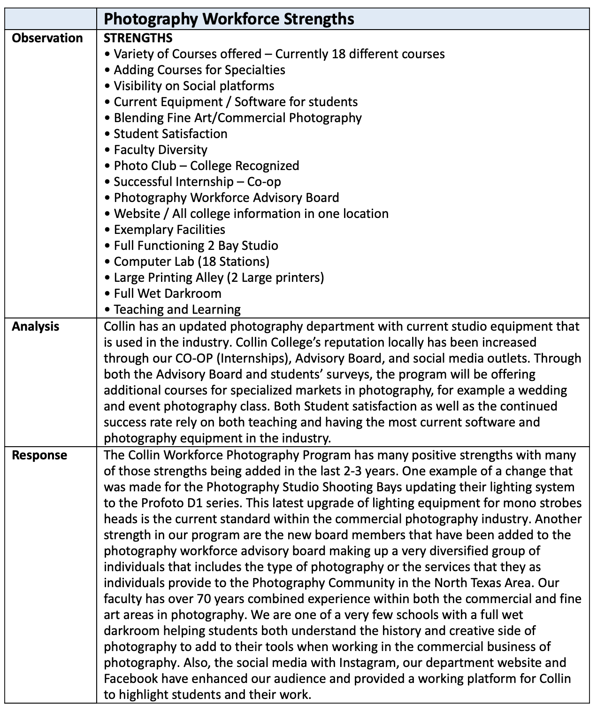
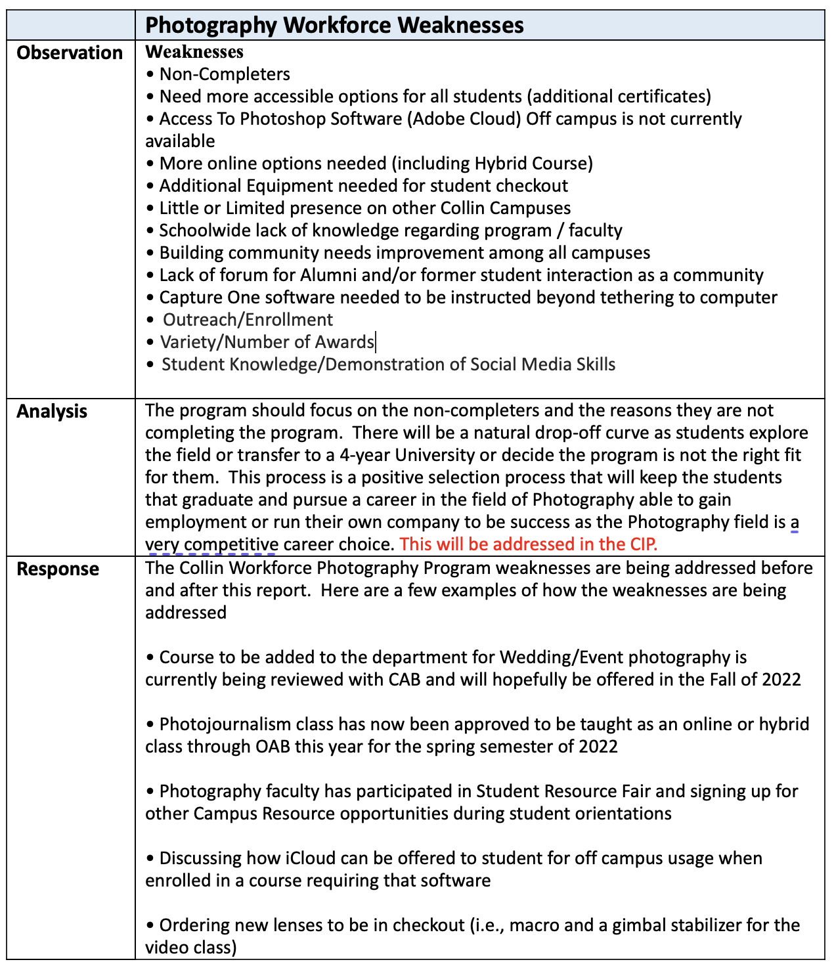
The job market for photographers tends to favor those who have and can demonstrate the expert knowledge in up-to-date technical skills, while demonstrating creativity through their work and through practical experience within the field. A photographer’s resume is indicated through their portfolio, social media, and website. Mastering photographic technology is critical with both photographic equipment and post-processing software tools necessary to blend the technical and creative skills. Having a full understanding of professional tools with both cameras and professional lighting equipment is critical to successfully compete for photography jobs. Overall employment trends favor self-employed or freelance photographers over traditional full-time employment. Many photographers will start individual companies after completing the program. There are several large companies in the DFW Metroplex: At Home, Fossil, The Container Store, Chewy, Amazon, Neiman Marcus, JC Penney, and Lifetouch, medium to smaller photography studios as well as individual photographers that will employ photographers, photography assistants, and digital techs and retouchers. These jobs usually require a portfolio of images that demonstrate the photographer’s skills. Major areas of demand for photographers include, but are not limited to the following fields in Commercial and Consumer Photography – Advertising, Aerial, Architectural, Catalog, , Fashion, Food, Editorial, Entertainment/Hospitality, Jewelry, Lifestyle, Medical, News, Portraits (Business, Seniors, Model Headshots), Product, Public Relations and Event, Publishing, Sports, Stock Photography, Social Media, Direct – Business to Business, Real Estate, Wedding, Digital Technicians, and Digital Retouching. Through the program, students will have a more specialized commercial photography degree plan to help students stand out among the average photographers. Teaching students how to use Adobe Products and Capture One software that are primarily used by professional commercial photographers will greatly increase their employability compared to their counterparts. Another part of Collin’s Commercial Photography program is how to teach students how create their own social media presence and website to market into a field where most jobs are not advertised in traditional markets such as Monsters.com, Indeed, ZipRecruiter, and LinkedIn. The main kickstart for students in the Collin College Program is the Co-Op opportunities that introduce the students into the workforce and assist them in creating relationships within the photography industry. Please view the chart provide to see how students are currently getting job experience as well as gaining employment through the Co-Op system. The Co-Op program has grown, as a wide range of opportunities for the individual are available to gain that all important on the job training within the field.

Workforce Photography Program
Co-Ops / Jobs - How We Measure Our Success

Company | Number of  Co-Ops | Number Hired | Full Time  Part Time  Freelance | Co-Op into Job  Opportunity | Hired Outside of Co-Op
At Home (Photo Studio for National chain) | 3 | 1 | 1st Full Time Employee – Photo Assistant | YES | 1 -Hired Full-Time  - Co-op working for family business  1 Moving out of state
Wade Griffith Photography | 2 | 2 | Both Co-Ops Hired Full Time | YES | Has hired both Co-Ops Full Time
Fossil Group | 1 | 4 | Hired Full Time | YES | 4 Students / 4 Hired either Full Time Temporary or Full Time
Chris Baylor Photography | 1 | 1 | Hires Freelance | YES | Yes, would hire freelancers
Debra Gloria Photography | 1 | 1 | Hires Co-Op Freelance | YES | Yes, would hire freelancers
AM Fitness | 1 | 1 | Worked only Photography prior to Co-Op now Photography and Video | YES | Student was promoted in photography role to include more video and editing
Brooke Drake Design | 2 | 2 | Hired  Part Time  Both Co-Op | YES | Yes, would hire freelancers
Abrash Rugs | 1 | 1 | Full Time Employment | YES | Full time
Company | Number of  Co-Ops | Number Hired | Full Time  Part Time  Freelance | Co-Op into Job  Opportunity | Hired Outside of Co-Op
Fly Hippie  Photography | 1 | 1 | Freelance | Only on freelance basis | Freelance Basis
FC Dallas | 1 | 1 | Freelance | YES | YES, working as a contractor as their top freelance photographer for multiple
Dallas Cowboys Merchandise | 1 | 1 | Full Time | YES | N/A
FLOC | 3 | 2 | Part Time | YES | Co-Ops have had several opportunities to be hired for additional work and
Texas Studios | 2 | 1 | Full Time | YES | Hired for Freelance jobs
Lifestyle Frisco | 1 | 1 | Freelance per assignment | N/A | Yes, has hired students as
Justin Clemons Photography | 1 | 1 | Freelance | YES | Worked part and full time
Dick Patrick Studio | 1 | 0 | N/A | NO | Photographed Retired
LM PHOTOGRAPHY | 1 | 0 | Freelance | YES | Hired on Freelance jobs
JC Penney’s | 0 | 2 | Freelance | N/A | Hired both photography assistants and digital teching
Kelsey Wilson Photography | 1 | 0 | N/A | N/A | N/A
Neiman Marcus | 0 | 2 | Full Time  Freelance/Digital Tech | Do not have a Co-op | Yes, both full time and freelance
Lombardi Restaurants | 0 | 1 | Freelance Contract Basis | N/A | On Contract Basis for all restaurants in chain including out of town

Section II. Are We Doing Things Right?
☐5. How effective is our curriculum, and how do we know?
A. Make a case with evidence that there are no curricular barriers to program completion. Review data related to course enrollments, course completion rates, course success rates, and the frequency with which courses are scheduled to identify barriers to program completion.
Suggested/possible points to consider:
- Number of students who completed the program awards in each of the last four years? If the number of graduates does not average 5 or more per year, describe your plan to increase completions and address this issue in the Continuous Improvement Plan (CIP).
- At what point(s) are substantive percentages of students dropping out of the program? Use data in the “Program-Based Course Performance” tool to examine enrollment flow through the program curriculum. Does the data suggest any curricular barriers to completion? Address problems in the CIP.
- Analyze the course success rates and the course completion rates of each course in your program. Address problems in the CIP.

The Commercial Photography Program curriculum is effective. Over the last five-year cycle, the program has exceeded five completers per year; Commercial Photography averages eighteen awards per year.

Furthermore, the minimum for a five-year cycle is twenty-five completers, and the commercial photography program awarded eighty-nine awards from 2015-2020. Looking at the data collected from the Office of Institutional Effectiveness, course enrollment, completion rate, success rate and frequency offered is of a good standard. A few courses show concern, and those concerns have already been addressed or are in the process of being addressed (awaiting the January Curriculum Advisory Board hearing, changes going into effect F2022). Looking deeper into the program, we reviewed overall enrollment patterns and program enrollment changes for barrier courses. After analyzing the data, courses that showed concerns for degree completion are PHTC 2371 Video for Photographers and PHTC 2380 CO-OP Education. Below is a detailed view of courses, looking at data and concerns. The information below pays close attention to observations, analysis, and suggested actions.

PROGRAM AWARDS
Year | Award | Completers | Year  Total Awards
2016 | Degree | 3
 | Certificate | 2
 | OSA | 7
 |  |  | 2016 total: 12
2017 | Degree | 4
 | Certificate | 6
 | OSA | 8
 |  |  | 2017 total: 18
2018 | Degree | 5
 | Certificate | 9
 | OSA | 0
 |  |  | 2018 total: 14
2019 | Degree | 8
 | Certificate | 19
 | OSA | 1
 |  |  | 2019 total: 28
2020 | Degree | 4
 | Certificate | 13
 | OSA | 0
 |  |  | 2020 total: 17
Photography, Commercial 5-year Total: 89 awards
*OSA , Occupational Skills Awards (Marketable Skills Awards) were not offered after 2019

Date Collected from Collin College Institutional Research Office http://inside.collin.edu/iro/programreview/202021/AwardsByProgram_2016-2020.pdf

COURSE ENROLLMENT, COMPLETION RATE, SUCCESS RATE, AND FREQUENCY OFFERED

First-level courses that do not require a prerequisite and are the introduction courses tend to have a success rate lower than 75%. ARTS 2348, Digital Media and ARTS 2356, Photography I are both foundation-level courses. During these courses students become aware of the seriousness and time involved in studying photography. These courses will naturally have a lower success rate than advanced courses, as students choose to opt-out to pursue a different field of interest. However, both courses have strong enrollment and completion rates.

Please note 2020 was the year the COVID-19 pandemic started, and attendance across all courses was affected.

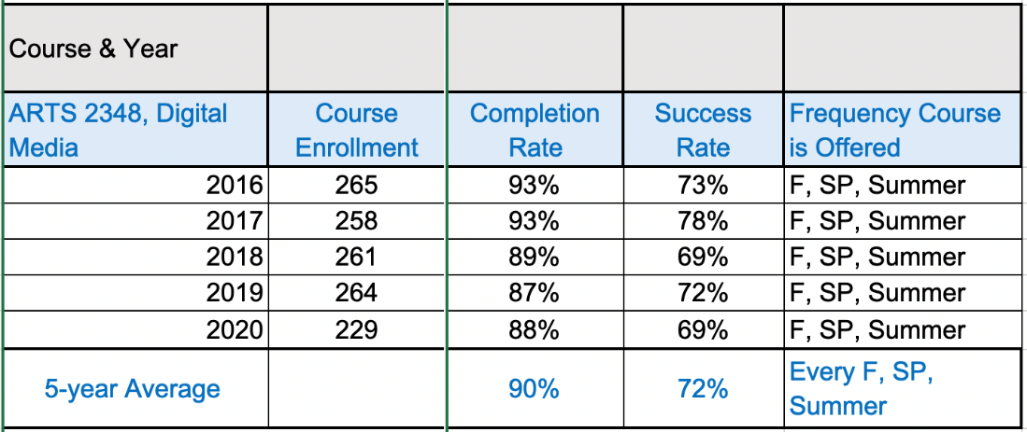
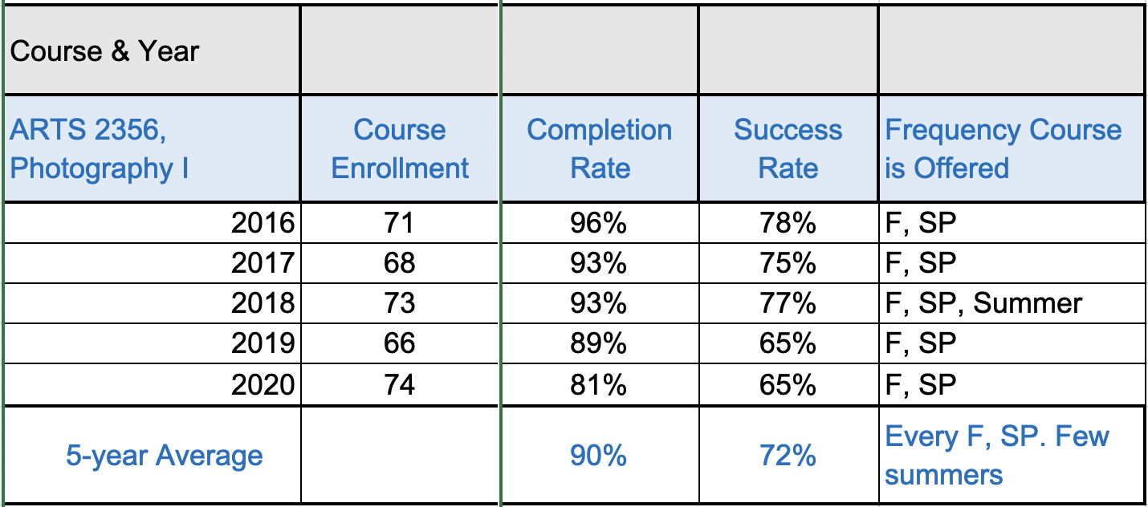
Date Collected from Collin College Institutional Research Office http://inside.collin.edu/iro/programreview/202021/AwardsByProgram_2016-2020.pdf

ARTS 1313, Foundations of Art is a Creative Arts Core Component option. Therefore, course enrollment comprises photography degree-seeking student and students working towards an associate degree in another discipline. During the 5-year review process in 2016, it became apparent that ARTS 1313 had a low success rate. Full-time faculty actively worked to increase the success rate. Review sheets were designed for each chapter and shared with the course instructors. Additionally, a designated sandbox Canvas shell was created as a space for sharing lecture PowerPoints, handouts, and other teaching aids for all instructors. Over the last five years, the data shows that this effort is working, and the success rate of ARTS 1313 has increased.
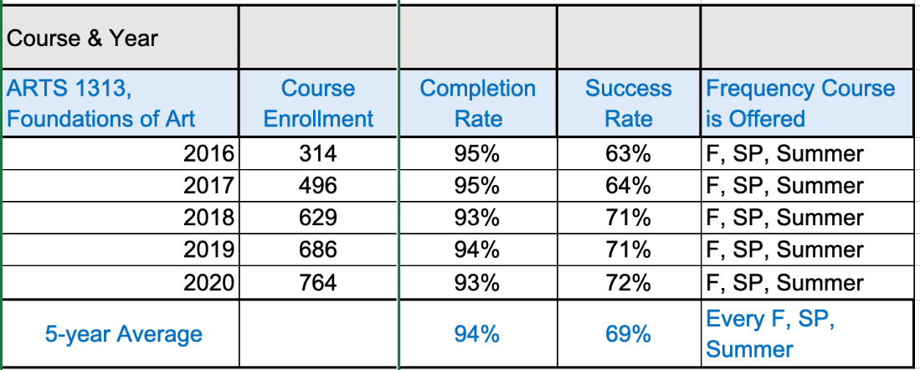
Date Collected from Collin College Institutional Research Office http://inside.collin.edu/iro/programreview/202021/AwardsByProgram_2016-2020.pdf

For the Studio Management course, the success rate was under 75% for two of the four semesters. Studio Management was listed as an introductory course without prerequisites. The low success rate demonstrated that the course is advanced-level rather than a first-semester course. Discussions with the Advisory Board and faculty members have led to adding prerequisites to the course, and moving Studio Management to the fourth semester. Curriculum change is planned and will be presented to the Curriculum Advisory Board in January 2022 with changes going into effect by Fall 2022.
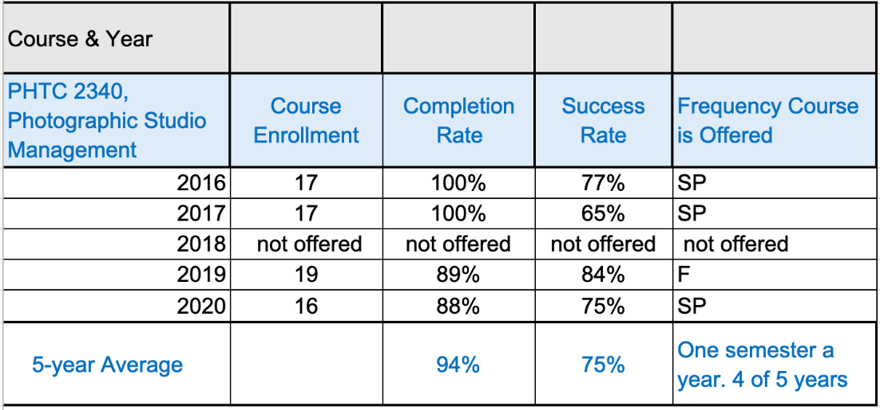
Date Collected from Collin College Institutional Research Office http://inside.collin.edu/iro/programreview/202021/AwardsByProgram_2016-2020.pdf

Expressive Photography is an elective course. Completion rate and success rate dropped during the first COVID year because the course did not move well to an online format.
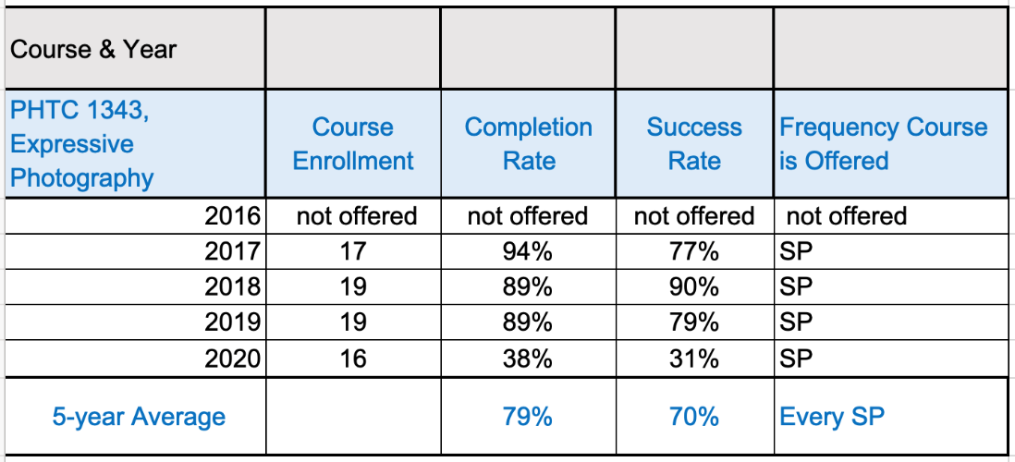
Date Collected from Collin College Institutional Research Office http://inside.collin.edu/iro/programreview/202021/AwardsByProgram_2016-2020.pdf

The remaining foundation courses in the program are ARTS 1311, Design I, and PHTC 1371 Book, Design & Presentation. Both courses have steady, or increasing enrollment with course completion and success rates above 75%.
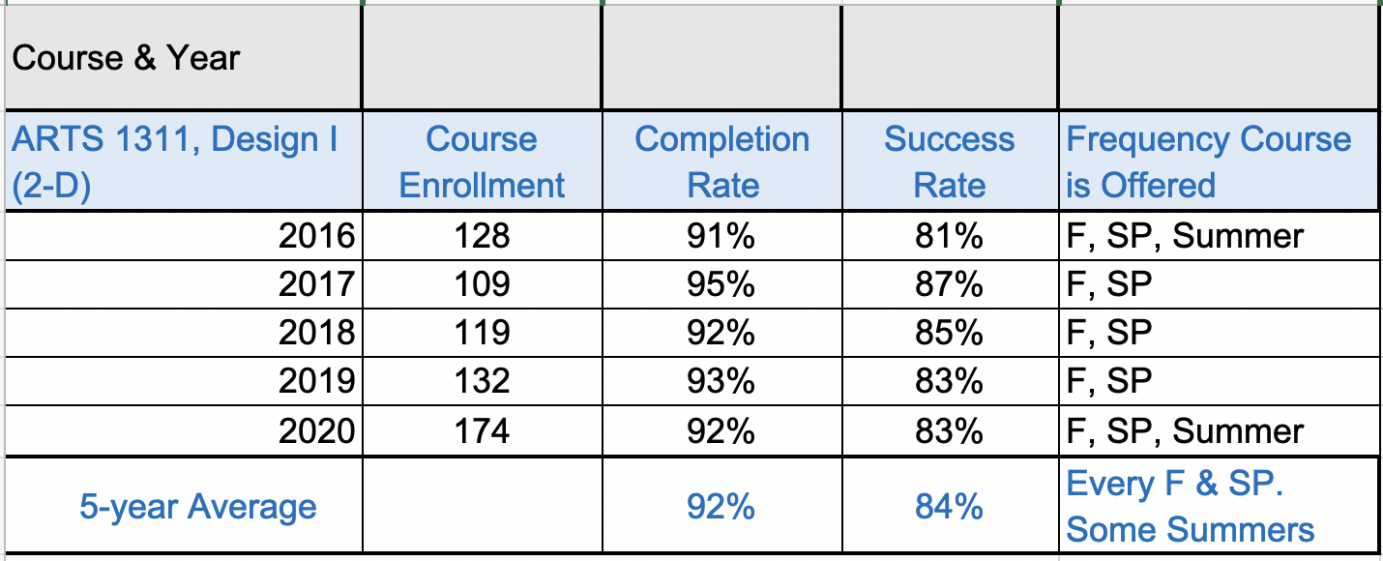

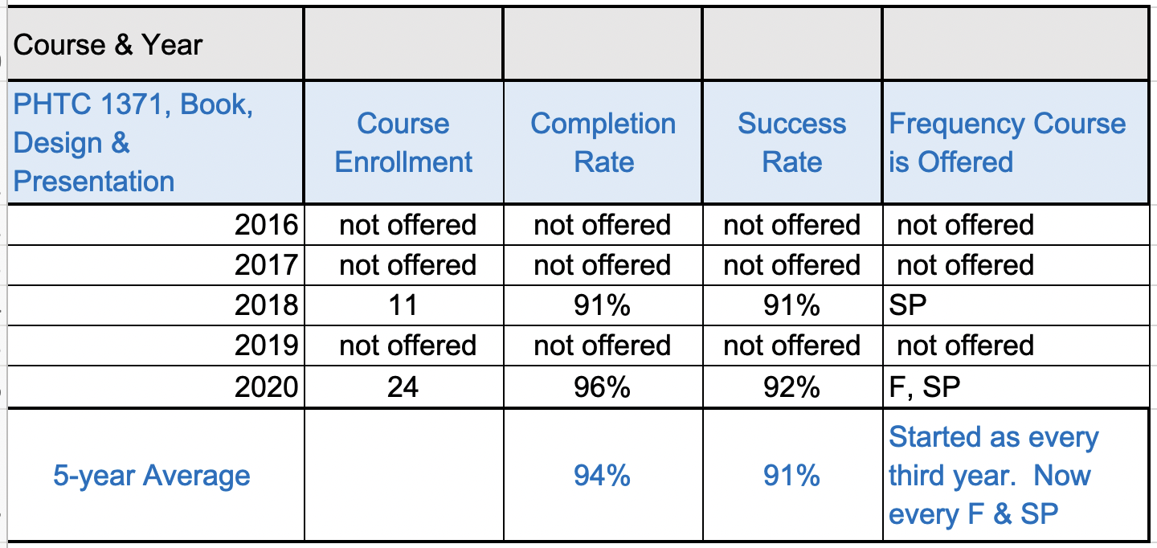
Date Collected from Collin College Institutional Research Office http://inside.collin.edu/iro/programreview/202021/AwardsByProgram_2016-2020.pdf

Second-level courses PHTC 1300, Digital Photography II, PHTC 1353 Portraiture I, PHTC 2331, and Architectural Photography have steady, or increasing, enrollment with course completion and success rates above 75%.
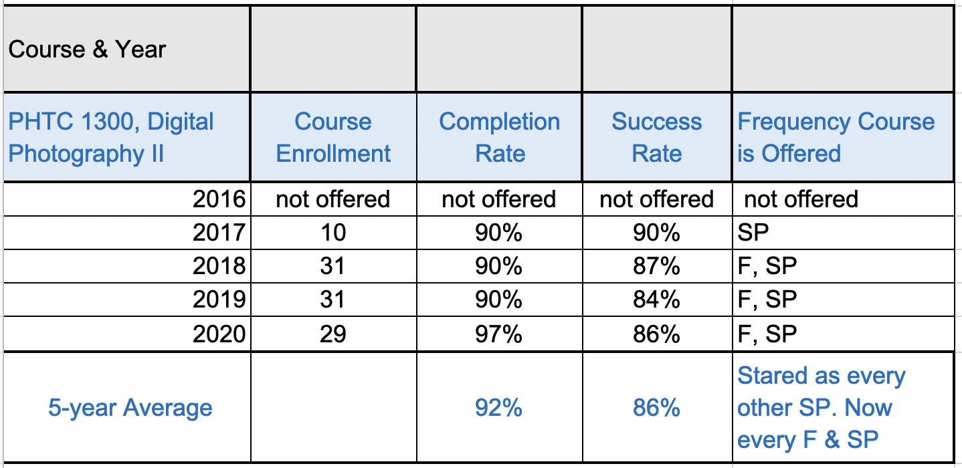

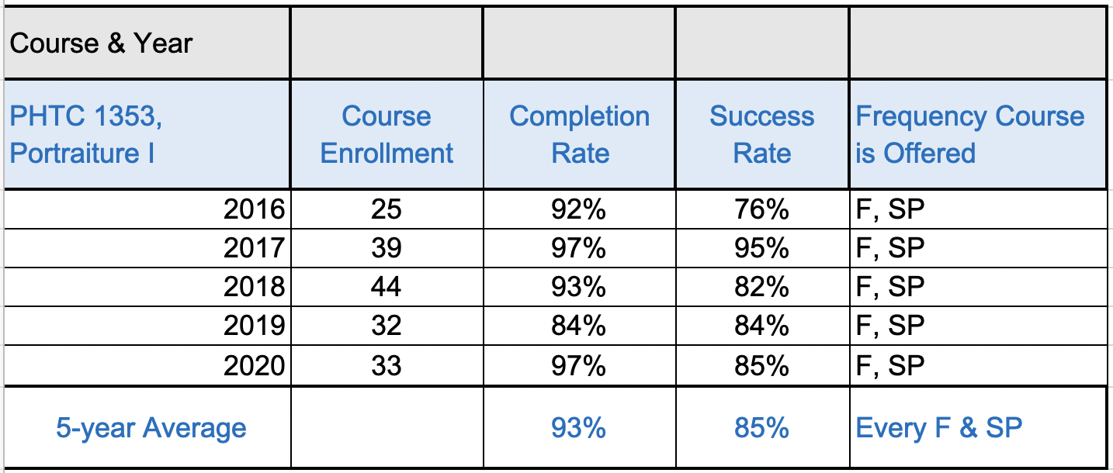

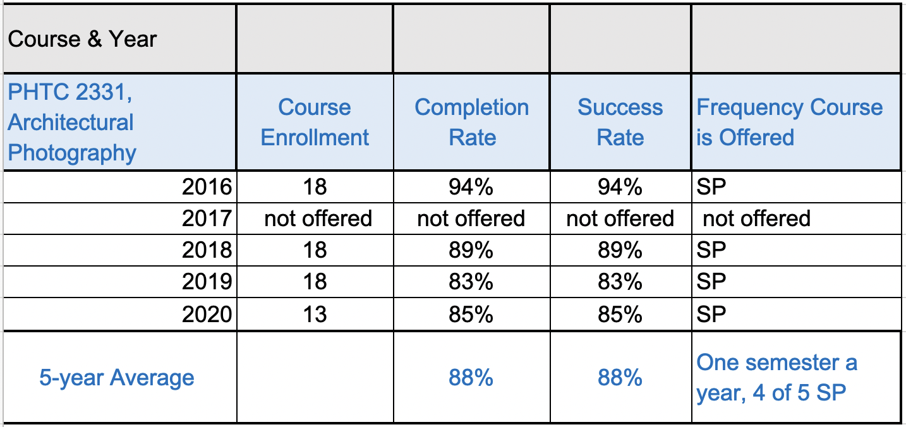
Date Collected from Collin College Institutional Research Office http://inside.collin.edu/iro/programreview/202021/AwardsByProgram_2016-2020.pdf

The third level required courses PHTC 1341 Color Photography, PHTC 2349 Digital Photography III, PHTC 2371 Video for Photographers and Technical course options PHTC 1347, PHTC ,1351 and PHTC 2342 have steady, or increasing enrollment with course completion and success rates above 75%. PHTC 2349 Digital Photography II had a drop in success rate during 2020, due to COVID.
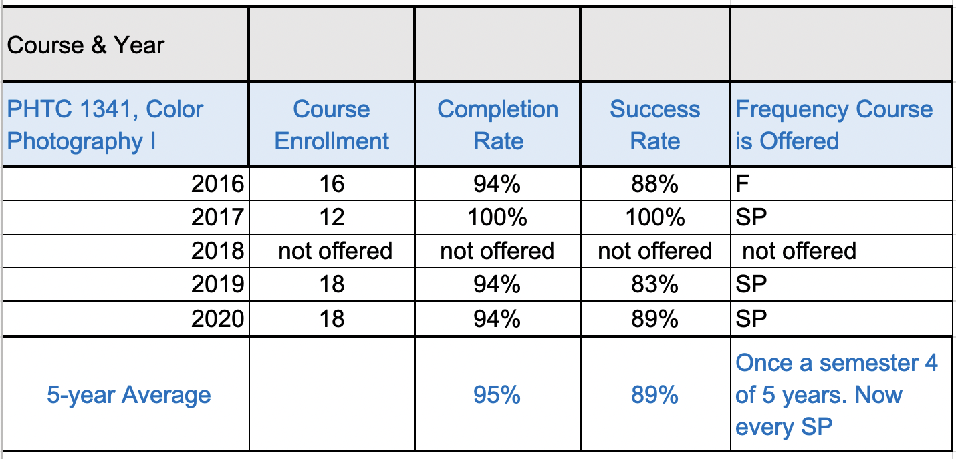

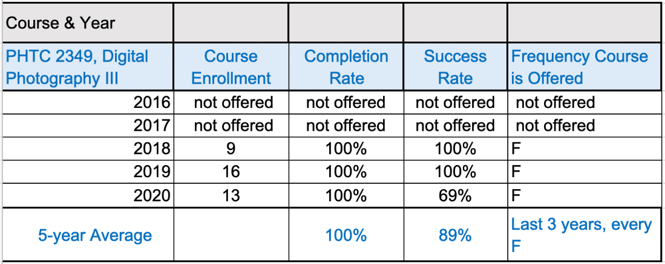
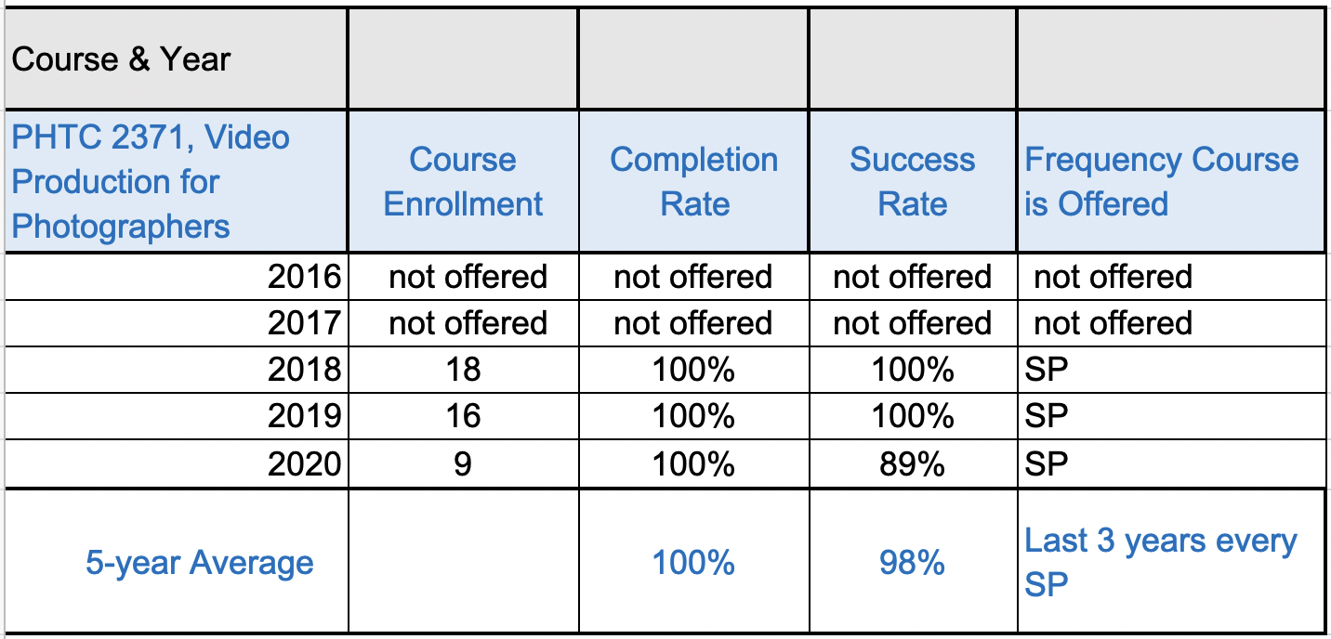
Date Collected from Collin College Institutional Research Office http://inside.collin.edu/iro/programreview/202021/AwardsByProgram_2016-2020.pdf

Technical courses at the third level are optional courses. They all have a high completion rate and success rate. However, they have low enrollment, because they are not required courses, and students can select one of the three courses. Additionally, the courses are not offered every semester.
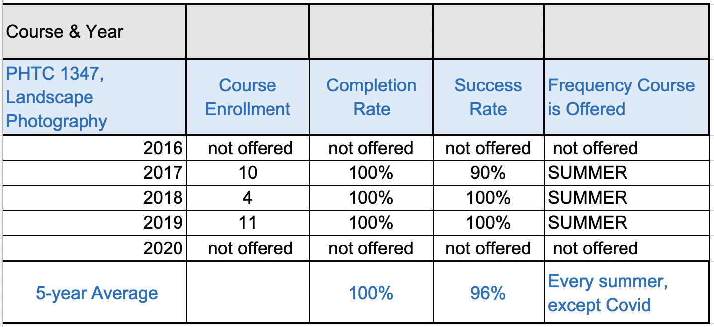

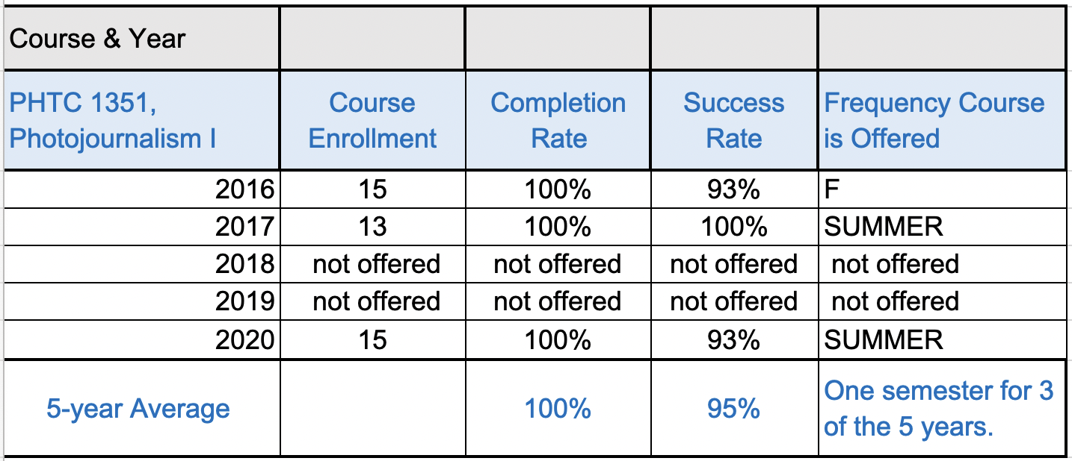
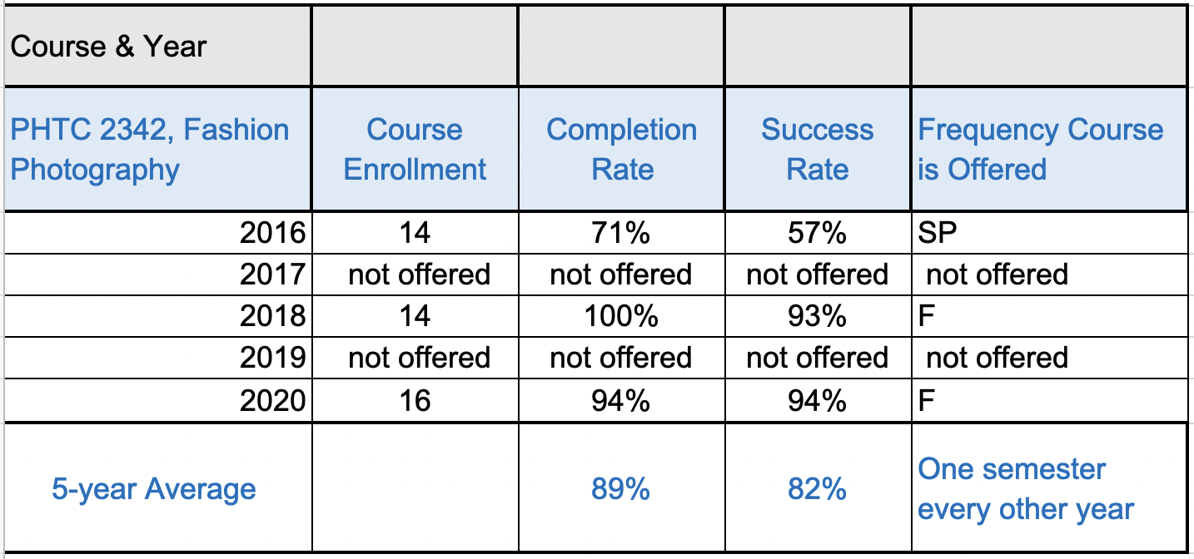
Date Collected from Collin College Institutional Research Office http://inside.collin.edu/iro/programreview/202021/AwardsByProgram_2016-2020.pdf

The fourth level required courses with a steady or increasing enrollment rate, completion rate, and success rate are PHTC 1345 Illustrative Photography, PHTC 2352 Portraiture II, and PHTC 2343 Portfolio Development.
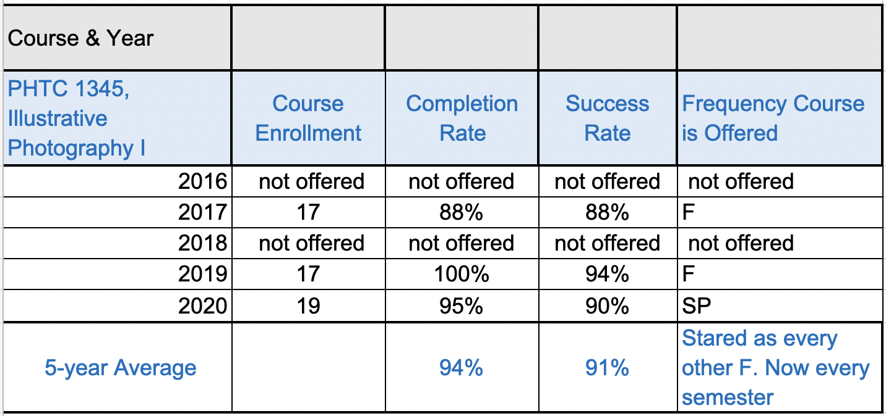
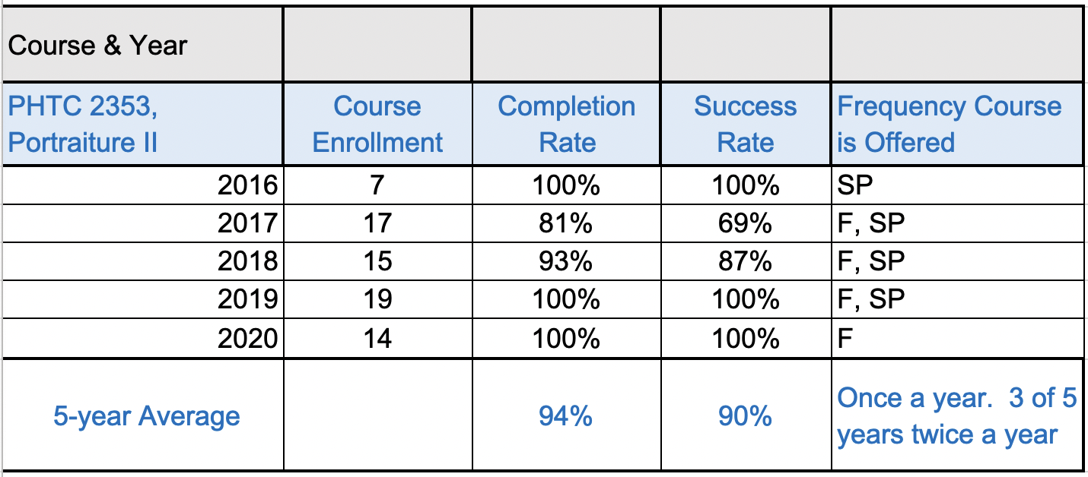
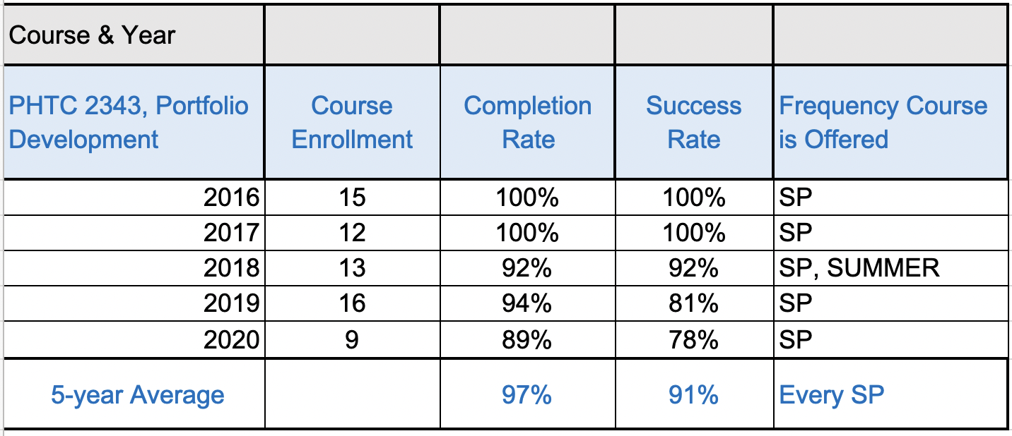
Date Collected from Collin College Institutional Research Office http://inside.collin.edu/iro/programreview/202021/AwardsByProgram_2016-2020.pdf

Fourth level course PHTC 2380 Cooperative Education completion and success rates have been high, except in 2020 during the pandemic. Many Co-Op partners had to dismiss students due to employment shutdowns. Eligible students were given an Incomplete; however, some did not complete the Co-Op after employment reopened.
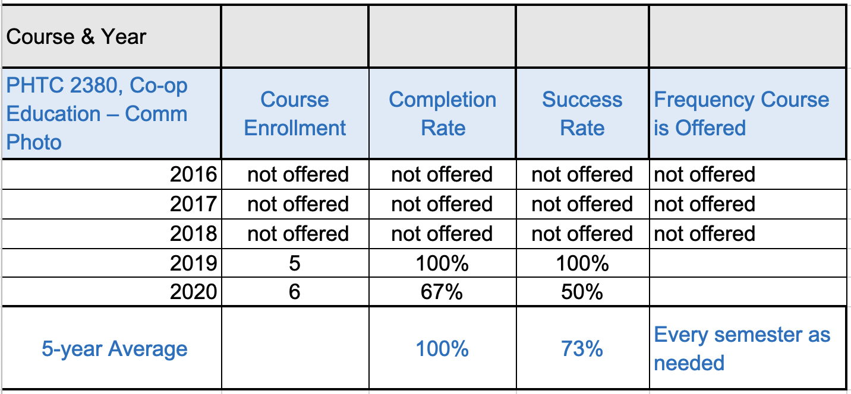
Date Collected from Collin College Institutional Research Office http://inside.collin.edu/iro/programreview/202021/AwardsByProgram_2016-2020.pdf

In observation from the data collected by the Institutional Research Office, nineteen of the twenty courses do not pose a barrier to completion. The curriculum is current and relevant, success rates, completion rates, and course frequencies are acceptable. One course that poses a barrier to completion is Studio Management. The placement of Studio Management in the degree plan has been addressed and will be moved in course sequencing to be an advanced class.

ENROLMENT PATTERN

*Note – The following chart looks at enrollment over the last two years. During the five-year review, new courses were added towards the last 2-3 years. Furthermore, many classes were offered once in two years. Therefore, two years is required to evaluate accurate enrollments for all courses. All courses listed are offered at the Plano campus, and marked if offered at additional campuses.

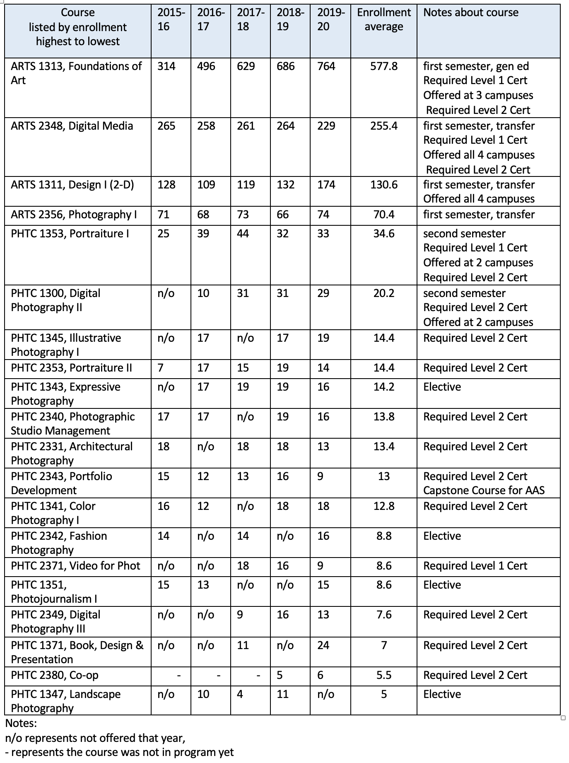
Date Collected from Collin College Institutional Research Office http://inside.collin.edu/iro/programreview/202021/AwardsByProgram_2016-2020.pdf

- Evaluating the collected enrollment pattern, there are four breaks in enrollment. The four courses with the highest enrollment (enrollment 764 - 70) serve transfer students and Commercial Photography students; therefore, enrollment is a selection of both branches of students- workforce and university transfer.

- This is a natural break to the next grouping of two courses that maintain an enrollment of 34 - 20 students. This group contains workforce-only courses. This selection of students working towards a commercial photography degree and not working towards transfer. Both courses are in the second semester. Both courses are the only Commercial Photography courses offered at an additional campus aside from the Plano Campus.

- The following change in enrollment is the group of ten courses that enroll 14-12 students. These courses are all advanced-level courses offered in the third and fourth-semester courses. The data demonstrates a concern with PHTC 2371 Video. PHTC 2371 Video is a required course for the Level 1 Certificate. The chart shows that all other Level 1 certificate courses have higher enrollment, and this course is a barrier to completion.
  - Action to take based on observation - The data shows that PHTC2371 Video may be a barrier for Level 1 Certificate completion. The photography department proposes redesigning the Level 1 Certificate to a degree plan that will move Video to an optional course, instead of required. The new Level 1 Certificate plan added more courses to the elective options. This change allows students working towards the Level 1 Certificate the opportunity to select the course that fits their specialty style. The proposed change will be presented to the Curriculum Advisory Board at their January meeting, with changes going into effect by Fall 2022.

- In the next grouping, we see a change in the pattern to half the enrollment (enrollment 8-5). Three of the four courses do not show concern because they are all electives. The only course that shows concern in this lower enrollment is PHTC 2380. PHTC 2380, Co-Op should match the enrollment of PHTC 2343 Portfolio Development, the capstone class for the AAS and Level 2 Certificate.
  - Action to take based observation - PHTC 2380, Co-op students state that the 20-hour week requirement is not achievable. Many students work full time. Additionally, some have families. The advisory board suggested decreasing the hours during the 2021 meetings. For Spring 2022, the required hours will be reduced to 14 hours per week. The Advisory Board and the Deans have approved this adjustment. An additional barrier to PHTC 2380, was that students have found it challenging to secure internships for the Co-Op course. Full-time professors have been activlye securing internship partners in the last two years. In the previous two years, internship partners have increased from 0 to 12 partners. Additionally, a variety of partners have been secured in order to accommodate the type of student career goals. With these two changes in place, enrollment is anticipated to increase to the appropriate level and thus secure more completers.

B. Show evidence that the institutional standards listed below have been met. For any standard not met, describe the plan for bringing the program into compliance.

- Completers Standard: Average 25 completers over the last five years or an average of at least five completers per year.
Number of completers: 89 in last five years.
If below the state standard, attach a plan for raising the number of completers by addressing barriers to completion and/or by increasing the number of students enrolled in the program. Definition of completer—Student has met the requirements for a degree or certificate (Level I or II)
- Licensure Standard: 93% of test takers pass licensure exams.
If applicable, include the licensure pass rate: No license or licensure exams required
For any pass rate below 93% (Collin College’s standard), describe a plan for raising the pass rate.

- Retention Standard: 78% of students enrolled in program courses on the census date should still be enrolled on the last class day (grades of A through F).
Include the retention rate: Retention Standard – chart of retention rate for each course, explanation for any below 78%
If the retention rate is below 78%, describe a plan for raising the course completion rate.

Retention Rate
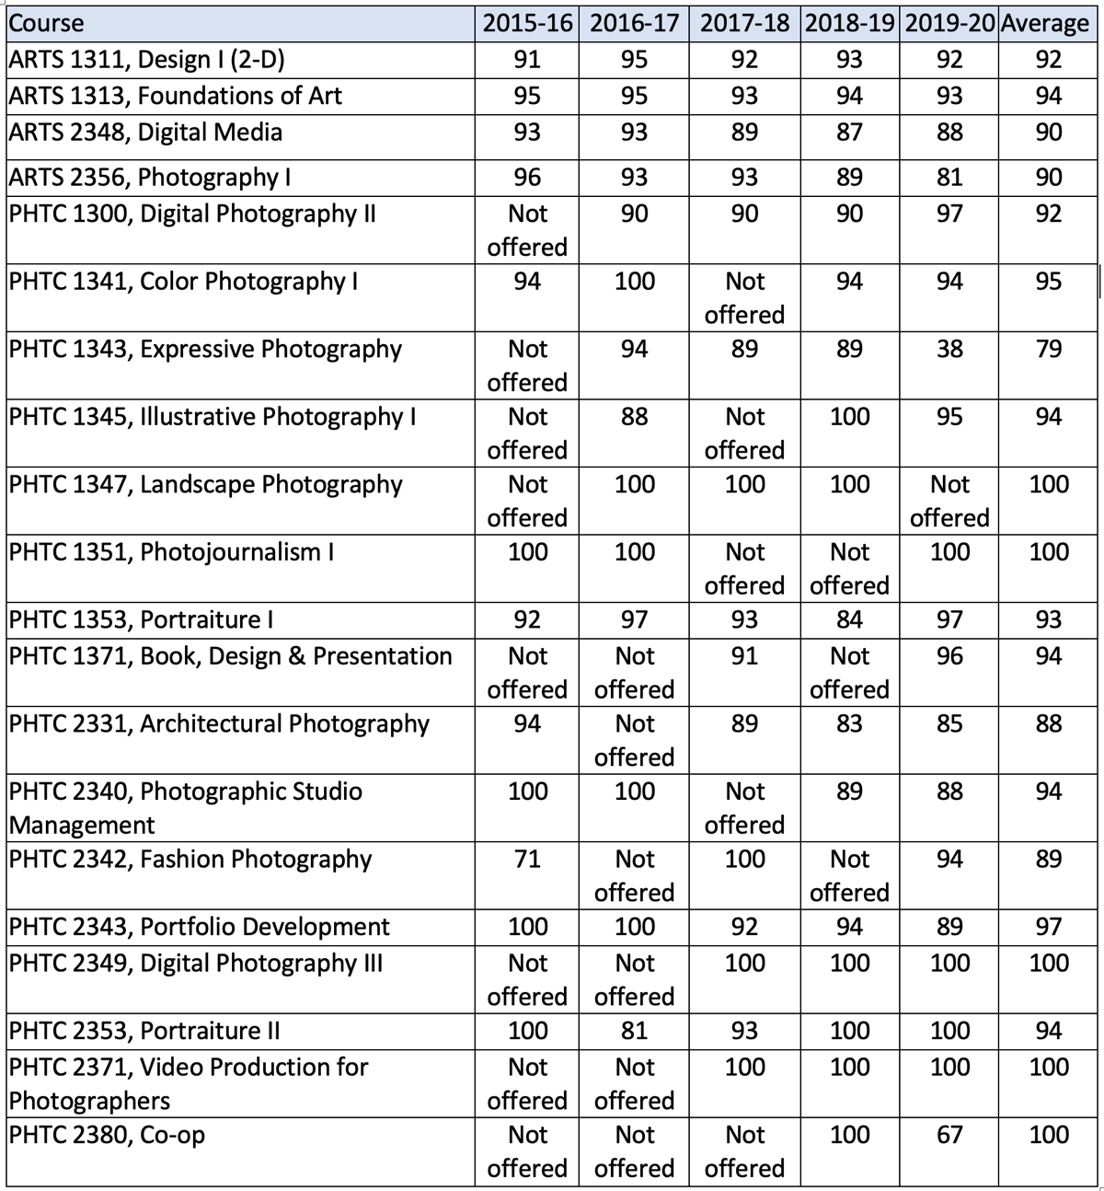
Date Collected from Collin College Institutional Research Office http://inside.collin.edu/iro/programreview/202021/AwardsByProgram_2016-2020.pdf

Three courses had one year that the retention rate fell below 78%. The courses are listed below.

PHTC 1343, Expressive Photography, the retention rate fell to 38% in 2020. However, 2020 was the first year of the pandemic. Many students withdrew due to changing to the online format. The class is hands-on and requires the darkroom.
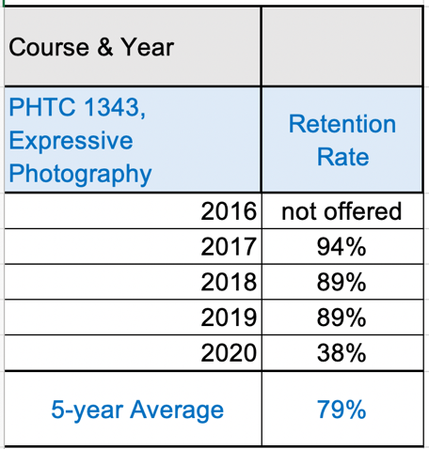
Date Collected from Collin College Institutional Research Office http://inside.collin.edu/iro/programreview/202021/AwardsByProgram_2016-2020.pdf

PHTC 2342, Fashion Photography the retention rate in 2016 was 71%. In 2016, the course was taught by an adjunct photographer that did not work well for the students. After evaluating student reviews, the adjunct was assigned to foundation courses, which was better suited for his teaching style. The following years more appropriate instructors were assigned to the course.
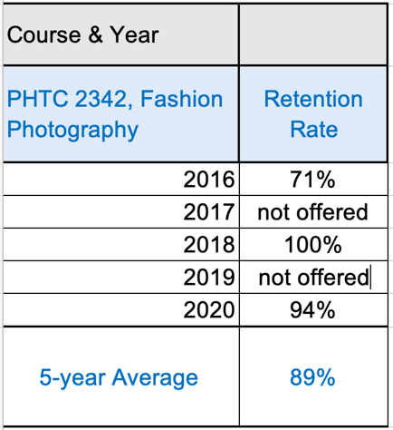
Date Collected from Collin College Institutional Research Office http://inside.collin.edu/iro/programreview/202021/AwardsByProgram_2016-2020.pdf

PHTC 2380, Co-op Education has been offered two years. In 2019 the retention was 100%, while in 2020 the retention rate dropped to 67% due to the challenges of the pandemic. Many co-op partnerships had to dismiss the student due to employment shutdowns. Eligible students were given an Incomplete; however, some did not complete the co-op after employment reopened.
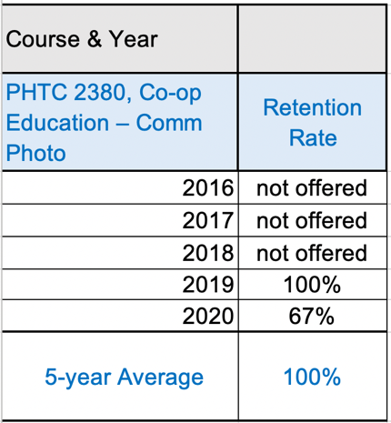
Date Collected from Collin College Institutional Research Office http://inside.collin.edu/iro/programreview/202021/AwardsByProgram_2016-2020.pdf

C. Make a case with evidence that the program curriculum is current.
Suggested/possible points to consider:
- How does the program curriculum compare to curricula at other schools? Review programs at two or more comparable colleges. Discuss what was learned and what new ideas for improvement were gained.
- How does the program curriculum align with any professional association standards or guidelines that may exist?
- Is the curriculum subject to external accreditation? If so, list the accrediting body and the most recent accreditation for your program.
If the program curriculum differs significantly from these benchmarks, explain how the Collin College curriculum benefits students and other college constituents.

PROGRAM CURRICULUM IS CURRENT – COMPARISON TO 5 COLLEGES

For this five-year review, five colleges were selected to compare: Dallas College, The Art Institute of Dallas, Austin Community College, Alamo College, and Amarillo College. Dallas Community College and The Art Institute of Dallas were chosen based on close location as an option for students living in the Collin/Dallas Region. Austin Community College, Alamo College, and Amarillo College were selected based on their reputation for offering a strong degree in photography. After analyzing the data, the curriculum at Collin College is current and relevant. All the courses offered at Collin College are offered at other colleges. Collin College’s Commercial Photography Degree has a strong emphasis on commercial photography courses. At the same time, some colleges such as Dallas College, Art Institute of Dallas, and Amarillo College offer a more rounded degree, adding studio art courses, graphic design courses, and more general education courses. Alamo College’s degree is rounded as well; however, it focuses on photojournalism instead of various commercial photography styles. Collin College and Austin Community College have the most substantial commercial photography degrees. Both Collin College and Austin Community College offer a large variety of commercial photography courses. A student completing one of these degrees can learn a wider variety of skills; thus, being more prepared to enter the workforce.
- Collin College
  - Twenty photography-related courses in degree.
  - Strong emphasis on photography-related courses.
- Dallas College
  - Nine photography-related courses in degree.
- The Art Institute of Dallas
  - Eleven photography-related courses in degree.
  - Rounded degree, strong emphasis on design and marketing. Twenty-one major courses, only eleven are photography
- Austin Community College
  - Twenty-two photography-related courses in degree.
- Alamo College
  - Five photography-related courses in degree.
  - All Photojournalism
- Amarillo College
- Ten photography-related courses in degree.

College Course Comparison Chart
Course
 | Collin College | Dallas College | Art Institute of Dallas | Austin Community College | Alamo College | Amarillo College
ARTS 1311, Design I (2-D) | yes | not offered | FNDA design Fundamentals | not offered | not offered | yes
ARTS 1313, Foundations of Art | yes | not offered | PHOA115  History of Photography I | PHTC 1313  History of Photography | not offered | PHTC 1313  History of Photography
ARTS 2348, Digital Media | yes | not offered | PHOA101  Principles of Photography | yes | COMM1318 Photography I | not offered
ARTS 2356, Photography I | yes | yes |  | yes | not offered | yes
PHTC 1300, Digital Photography II | yes | yes | PHOA102  Introduction of Photography applications | yes | COMM1319 Photography II | yes
PHTC 1341, Color Photography I | yes | not offered | FNDA Digital Color Theory | yes | not offered | yes
PHTC 1343, Expressive Photography | yes | not offered | not offered | yes | not offered | yes
PHTC 1345, Illustrative Photography I | yes | not offered | not offered | yes | not offered | yes
PHTC 1347, Landscape Photography | yes | not offered | not offered | yes | not offered | not offered
PHTC 1351, Photojournalism I | yes | not offered | PHOA105  Photojournalism | yes | COMM1316  News Photography I | not offered
PHTC 1353, Portraiture I | yes | not offered | PHOA113  Lighting | yes | not offered | yes
PHTC 1371, Book, Design & Presentation | yes | not offered | not offered | PHTC1371 Visual workflow design | not offered | not offered
PHTC 2331, Architectural Photography | yes | not offered | not offered | PHTC2431,  Architectural Photography | not offered | not offered
PHTC 2340, Photographic Studio Management | yes | not offered | not offered | yes | not offered | not offered
PHTC 2342, Fashion Photography | yes | not offered | not offered | yes | not offered | not offered
PHTC 2343, Portfolio Development | yes | not offered | MAAP309  Portfolio I | yes | not offered | yes
PHTC 2349, Digital Photography III | yes | yes | PHOA203  Photographic Post-Production | not offered | not offered | yes
PHTC 2353, Portraiture II | yes | not offered | PHOA232 Portraiture | yes | not offered | not offered
PHTC 2371, Video Production for Photographers | yes | not offered | DFVA103 Fundamentals of Video Production | FLMC1304 Film and Video Editing | not offered | COMM1337  Video Production II
PHTC 2380, Co-op Education | yes | not offered | not offered | not offered | not offered | not offered

Furthermore, besides analyzing the curriculum, the following categories were reviewed: website design and degrees/awards offered. In observation, Collin College’s Photography program exceeds or equals in comparison with the website and classes offered. One photography program area to review is how social media skills are taught in courses and degrees/awards offered.

Areas exceeding or equal in comparison
- Website: Collin College Photography Program has an engaging, informative, and easily navigated photography department website. All information is accessible in one location and does not require the viewer to search or open multiple pages. The website showcases stellar student artwork and visually explains course projects.
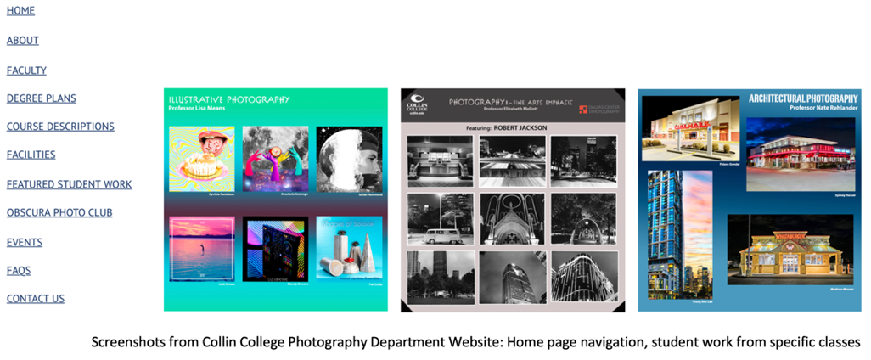
Photography Department Instagram: collincollege_photography
Photography department website: www.collin.edu/department/photography

Areas to review
- Social Media Skills: Looking thoroughly at other programs, it is apparent that many of the colleges embed social media skills in their program, either a whole class or emphasized in a class. Social media is essential for a photographer, artist, and business owner. Additionally, advanced social media skills (storytelling skills) are an employment opportunity at larger businesses. Many students know some social media skills; however, they should leave the program with skills that can set them apart and above the competition. Student Knowledge/Demonstration of social media Skills will be addressed in the 2021-2026 Continuous Improvement Plan.

- Degrees/awards offered: In the evaluation of other programs, the program at Collin College will investigate degrees and awards offered. In comparison to four of the five colleges, Collin College exceeds degree options. However, in comparison to Austin Community College, Collin College has fewer options. Austin Community College has a large variety of tracks that allow students to focus on specific photography styles. Additionally, they offer three enhanced skills certificates to give students the opportunity to learn beyond the AAS alone. The goal of increasing awards offered will be the main point for the upcoming cycle’s Continuous Improvement Plan.
  - Collin College – three workforce awards: level 1 certificate, level 2 certificate, AAS Degree
  - Dallas College – one workforce award: level 1 certificate
  - The Art Institute of Dallas - one workforce award: AAS Degree
  - Austin Community College- twelve workforce awards: two level 1 certificates, seven AAS Degrees, three Enhanced Skills Certificates
  - Alamo College - zero workforce awards
  - Amarillo College - two workforce awards: 1 certificate, 1 AAS Degree

STANDARDS

How does the program curriculum align with any professional association standards or guidelines that may exist?

N/A

EXTERNAL ACCREDITATION

Is the curriculum subject to external accreditation? If so, list the accrediting body and the most recent accreditation for the program.

N/A

D. Present evidence from advisory committee minutes, attendance, and composition that the advisory committee includes employers who are actively engaged on the committee and who are representative of area employers.
1. How many employers does your advisory committee have? Fifteen
2. How many employers attended the last two meetings? Nine members attended both meetings
3. How has the advisory committee impacted the program over the last five years (including latest trends, directions, and insights into latest technologies)?
COMMERCIAL PHOTOGRAPHY ADVISORY BOARD MEMBERS

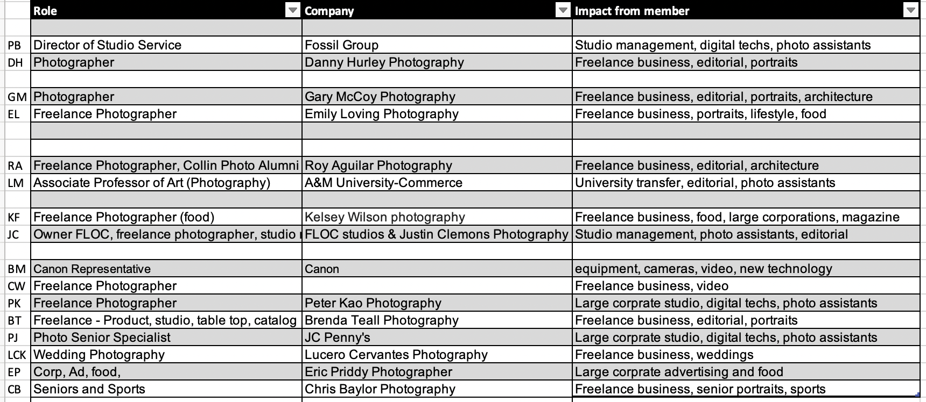Date Collected from Department records

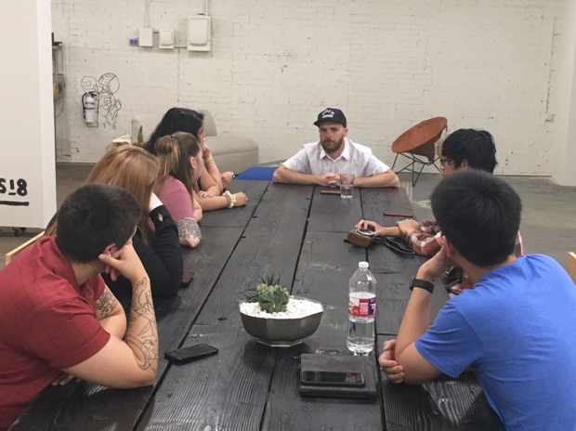
Advisory Board Member Justin Clemons of Floc Creative Space meets with students to discuss expectations for being a commercial photographer. The visit also included a tour, presentation, question/answer session.

ADVISORY BOARD IMPACTS

The Commercial Photography Advisory Board is composed of fifteen voting members representing the diversity of the commercial photography industry; areas include editorial, product, portraits, food, video, and sports. Areas of work environment include studio management, freelance, personal business, large corporations, and equipment representation. The advisory board meets twice a year, once each semester and additionally as needed. Over the last five years, the advisory board has been helpful in guidance with trends, equipment, and software applications. Specifically, the board has made recommendations about video courses, equipment, and software applications.

- Video
The board emphasized the importance of students learning more in-depth video skills than those that one course offered. Additionally, the importance of students learning how to create content for social media platforms, including short videos such as Tic-Tok, content for Instagram, and content for websites. From these recommendations, the program has made a few changes, including teaching time-based media (video) in the foundational Digital Media course and creating a new Video Enhanced Skills Certificate (planning to be presented to CAB 2022).

- Equipment – Profoto Lighting
The advisory board has clarified that Profoto Lights are the industry standard for studio lighting equipment. The members expressed that it would serve the students best to be familiar with ProFoto Lights. Profoto lighting equipment has been purchased, adding ten more Profoto lights, throughout the last five years, making the studio a Profoto Lighting studio.

- Software Applications
Capture One has been recommended as a necessary new software application for students to know. The majority of the board utilizes Capture One and expects all photography assistants they work with to know the software. Furthermore, students should leave the College knowing Capture One, Lightroom, and Photoshop. Capture One software has been purchased and installed on all Plano Campus photography lab computers. Full-time employees and one student have received Capture One training. The Photography Department hired a full-time faculty to design and teach a course in Capture One applications. Lastly, full-time faculty have worked with the advisory board and adjunct instructors to organize skills sets for digital courses to include stackable skills in Lightroom and Photoshop. Once a student completes the degree, they will be skilled in video, Capture One, Lightroom, and Photoshop.

4. Briefly summarize the curriculum recommendations made by the advisory committee over the last five years.
ADVISORY BOARD NEW CURRICULUM PROPOSALS AND RECOMMENDATIONS

The advisory board has given advice on curriculum including co-op hours, workplace etiquette, workplace expectations, and business management skills.

- Co-op Hours
In discussions with the advisory board, it was recommended to decrease the required service hours in the co-op course. The original hours were 20 hours per week, making it difficult for employers to fulfill those hours as well as students to serve them. On the recommendation of the advisory board, the hours have been reduced to 14 hours per week, and will go into effect in Spring 2022.

- Workplace etiquette, workplace expectations, and business management skills
The advisory board has suggested that workplace etiquette, workplace expectations, and business management skills be addressed more in the curriculum. Based on this recommendation, curriculum was added to Studio Management, Portraiture II, Illustrative, Photojournalism, and Portfolio.

Discussions with the advisory board have led to the following skills being included in the program curriculum.

Skills included in Studio Management
- Creating a business name (if different than their name)
- Registering a DBA
- Researching the differences between Sole Proprietor, LLP, LLC, and S-Corp and which one is right for their business
- Acquiring a domain name and website (if they do not have one)
- Building their website
- Creating a logo
- Creating a color theme for their brand
- Discovering the platforms where their communities (clients) live (Facebook, Instagram, LinkedIn, ThumbTack, Twitter, Reddit, Clubhouse, etc.)
- Creating a schedule for posting content to their community’s platform on a regular basis - this can be weekly, monthly, or quarterly, depending on the kind of content their brand produces
- Applying the Seven Principles of Community-Based Brand Building as outlined by Patrick Hanlon in Primal Branding to their own businesses

Skills included in Portrait II, Illustrative, Photojournalism
- Workplace Etiquette
- Expectations in the Workplace
- Ethics

Skills included in Portfolio
- Estimates
- Invoices
- State Sales Tax
- Copyright usage terms
- Insurance
- Marketing/Branding
- Ethics

E. Make a case with evidence that the program is well managed.

Suggested/possible points to consider (Data can be found at http://inside.collin.edu/institutionaleffect/Program_Review_Process.html):
- Average class size
- Grade distributions
- Contact hours taught by full-time and part-time faculty
- Identify all courses that have a success rate below 75%. If any of these are core courses, visit with the discipline lead for the course(s) in question to determine whether or not the content of the course(s) is appropriate to the workforce program learning outcomes. Using assessment evidence and instructor observations, identify the student learning outcomes that are the greatest challenges for students in courses with low success rates. Explain what instructional and other intervention(s) might improve success rates for each identified course.
- How well are general education requirements integrated with the technical coursework?
- Student satisfaction: What evidence do you have that students are satisfied with the program? What kinds of complaints are made to the associate dean/director by program students?
COMMERCIAL PHOTOGRAPHY PROGRAM IS WELL MANAGED

The Commercial Photography Program is well managed.

- Evaluating the data collected from the Institutional Research Office the average class size is 10-18 students with a few exceptions when the course was taught on a per/head basis.

- Grade distribution is even and brings no concerns. All courses have a pass rate of 81% or higher.

- Contact hours are taught mostly by full-time faculty.

- Most courses have a success rate above 75% with the exception of foundation-level courses and two higher-level courses, Expressive and Co-Op. Beginning-level courses, ARTS 1313, ARTS 2348, ARTS 2356 are beginning courses that introduce students to the expectations of a college-level photography course. Many students take the course with the false impression that photography is an easy “push-a-button” art course.

- General education requirements are evenly distributed throughout the four semesters with close attention to recommended general ed courses with a well-managed program.

AVERAGE CLASS SIZE
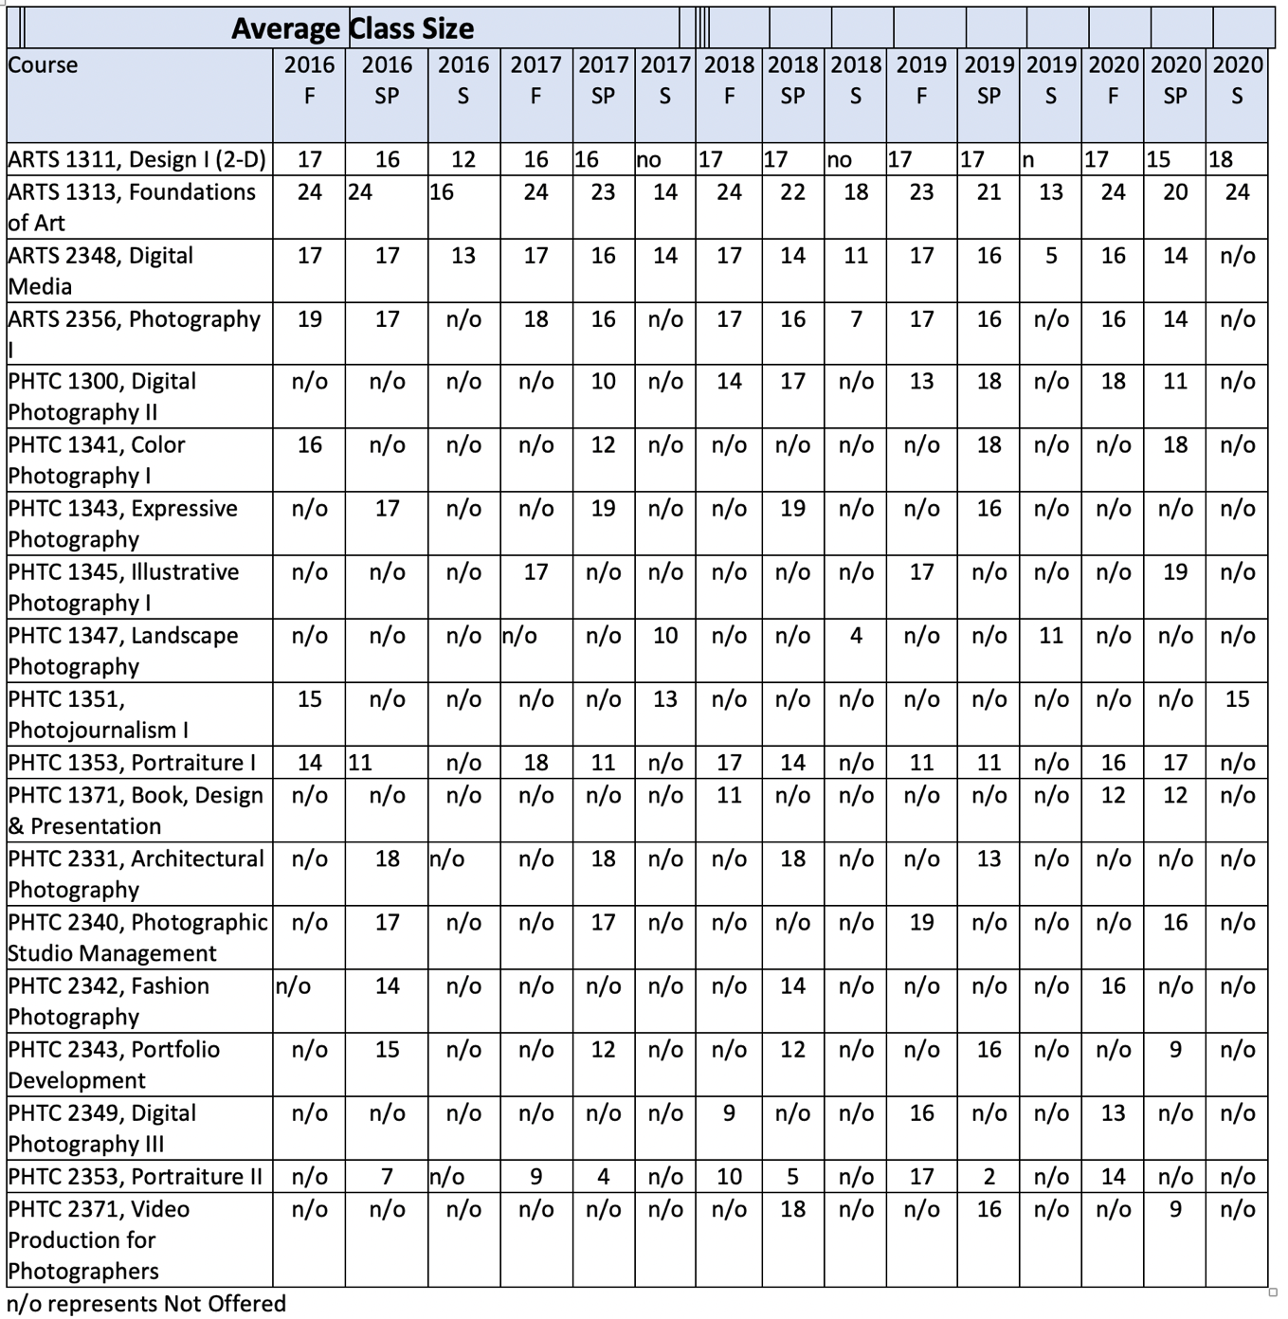
Date Collected from Collin College Institutional Research Office http://inside.collin.edu/iro/programreview/202021/AwardsByProgram_2016-2020.pdf

Courses with enrollment lower than ten students:
The following sections were taught with low enrollment during the summer term. The summer term tends to have a lower enrollment in the photography program. The courses below all demonstrate higher enrollment when offered during the fall or spring semester.

Digital Media: Summer 2019 – Five students enrolled
Photography I: Summer 2018 – Seven students enrolled
Landscape: Summer 2018- Four students enrolled
Portfolio: Summer 2018 – One student enrolled

PHTC 2349, Digital Imaging III, was first offered in Fall 2018, and nine students enrolled. Subsequent semesters had 16 and 13 students enrolled.
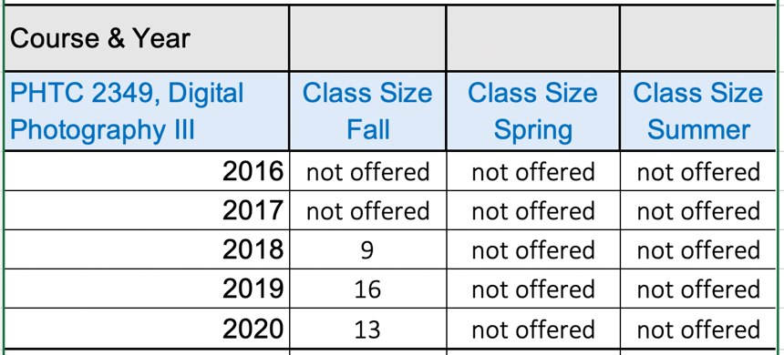
Date Collected from Collin College Institutional Research Office http://inside.collin.edu/iro/programreview/202021/AwardsByProgram_2016-2020.pdf

PHTC 2353, Portraiture II is a course that has higher enrollment in the fall semesters and lower enrollment during the spring semesters. The Frisco Campus offers Portraiture 1 and 2 as combined classes in the spring. This explains the low enrollment for the spring semester at the Plano Campus.
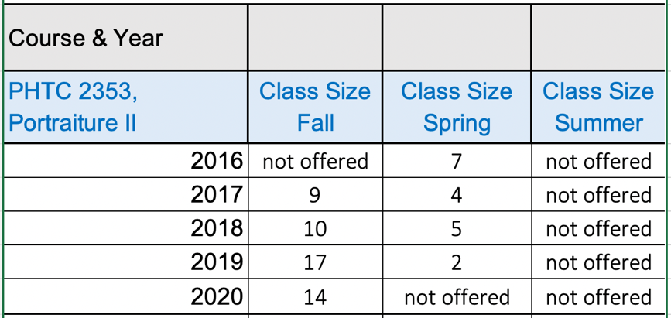
Date Collected from Collin College Institutional Research Office http://inside.collin.edu/iro/programreview/202021/AwardsByProgram_2016-2020.pdf

PHTC 2371, Video for Photographers had a low enrollment of nine students in fall 2020. The semesters prior show 18 and 16 students enrolled. Video is a hands-on interactive course. During the pandemic with hybrid courses and the A/B system, students were reluctant to register for the course.
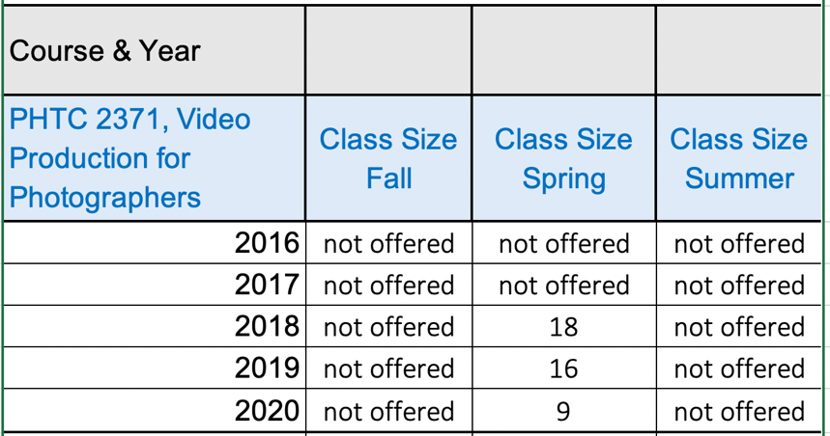
Date Collected from Collin College Institutional Research Office http://inside.collin.edu/iro/programreview/202021/AwardsByProgram_2016-2020.pdf

GRADE DISTRIBUTION

Grade distribution is even and brings no concerns. All courses have a pass rate of 79% or higher.
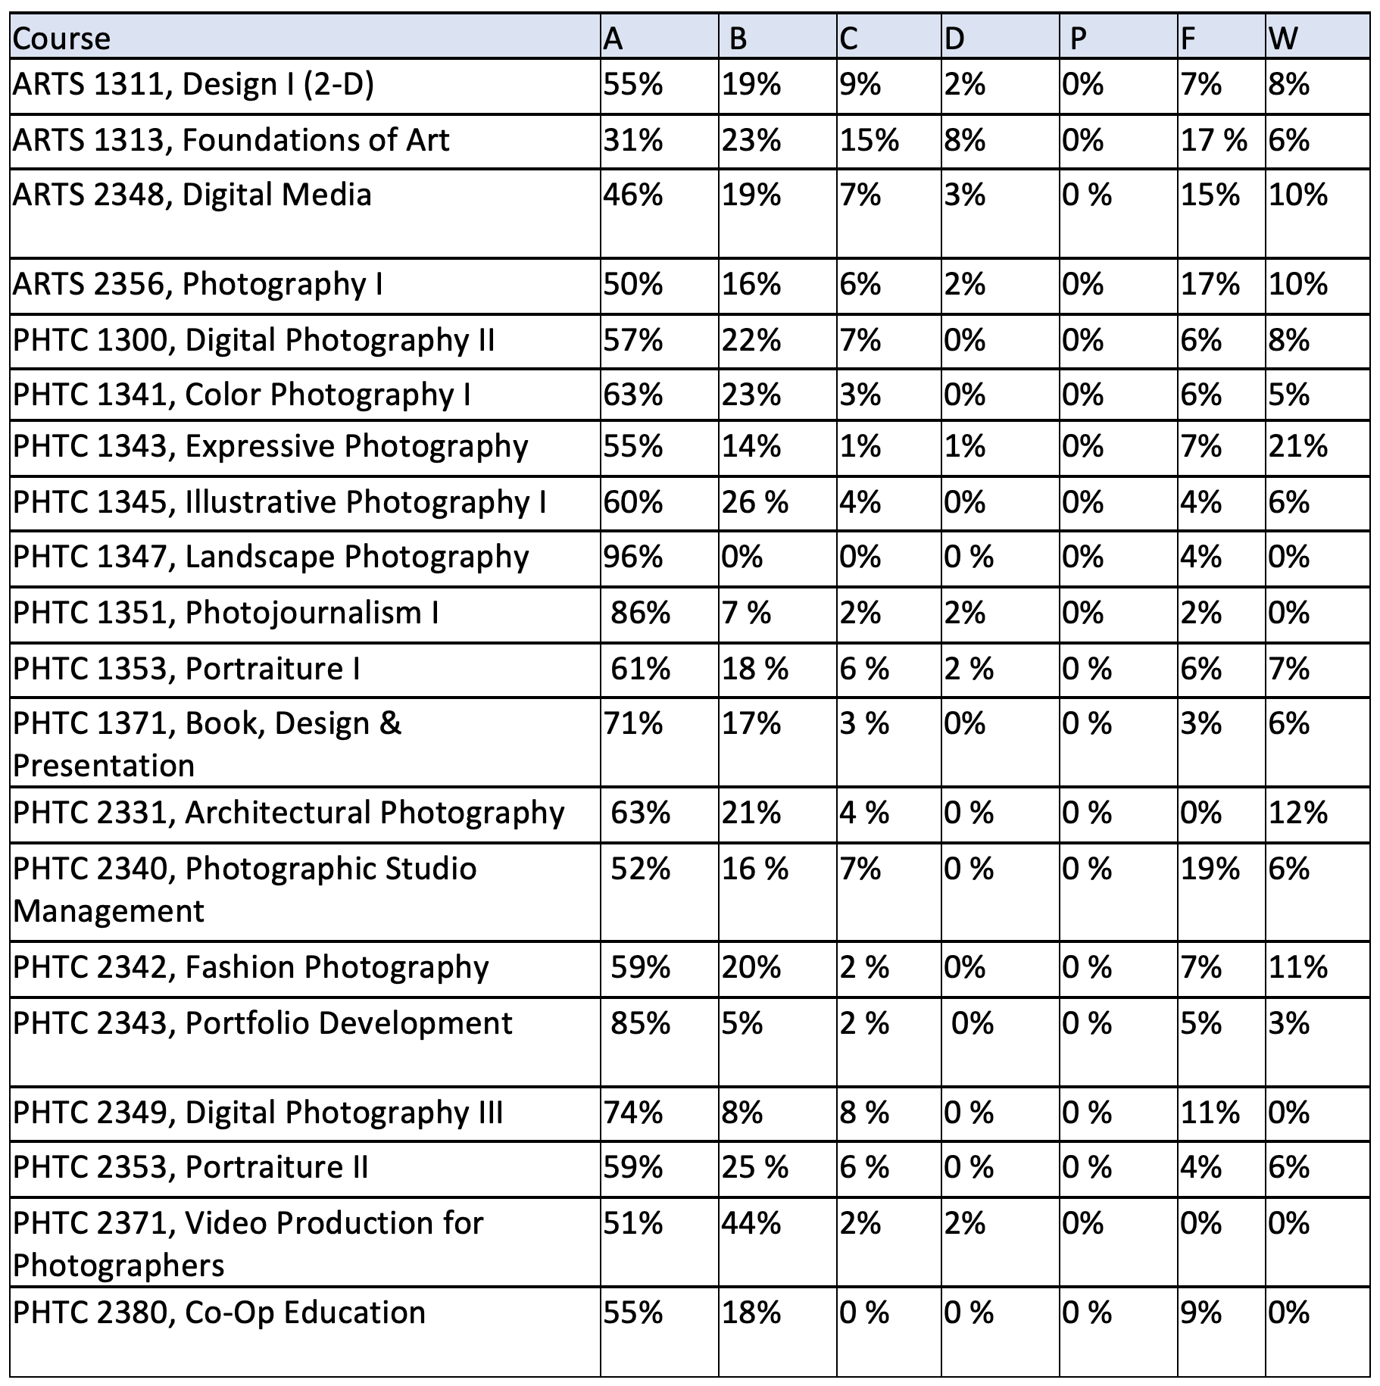Date Collected from Collin College Institutional Research Office http://inside.collin.edu/iro/programreview/202021/AwardsByProgram_2016-2020.pdf

CONTACT HOURS: FULL-TIME & PART-TIME

Full-time contact hours fell below 50% in 2018 and 2020. Both years had a search for a full-time faculty. By the following year, a new professor was in place, bringing the contact hours back to over 50%. During Fall 2021, a third full-time professor was hired, therefore the ratio is expected back to over 50%.
Year | FT Faculty # | % of classes taught by FT |  | PT Faculty # | % of classes taught by PT
2016, Fall | 20,544 | 87% |  | 2,976 | 13%
2017, Fall | 15,552 | 40% |  | 23,328 | 60%
2018, Fall | 10,080 | 24% |  | 31,344 | 76%
2019, Fall | 13,776 | 54% |  | 28,272 | 46%
2020, Fall | 11,040 | 32% |  | 23,136 | 68%
Date Collected from Collin College Institutional Research Office http://inside.collin.edu/iro/programreview/202021/AwardsByProgram_2016-2020.pdf

PATTERN OF SUCCESS RATE WITH ATTENTION TO COURSES LOWER THAN 75%

ARTS 2348, Digital Media and ARTS 2356, Photography I are both foundation-level courses. These courses are the first introduction to photography. During these courses, students become aware of the seriousness and time involved in studying photography. The course will have lower success rates than the advanced courses and is necessary to “weed out” students that have the misconception that photography is an “easy.” However, both courses have strong enrollment and completion rates.
Course | Success rate average | explanation
ARTS 2348, Digital Media | 72% | Year Success rate  2016 73%  2017 78%  2018 69%  2019 72%  2020 69%

Course | Success rate average | explanation
ARTS 2356, Photography I | 72% | Year Success rate  2016 78%  2017 75%  2018 77%  2019 65%  2020 65%
Date Collected from Collin College Institutional Research Office http://inside.collin.edu/iro/programreview/202021/AwardsByProgram_2016-2020.pdf

PHTC 1343 and PHTC 2380 both had lower success rates in 2020, the first year of the pandemic. Both courses have a history of higher success rates. The charts demonstrate that the change in success rate is due to the pandemic. PHTC 1343 did not move well to an online format; therefore, students did not complete the course. PHTC 2380 is Co-op education. During the pandemic, many co-op partnerships had to dismiss students due to employment shutdowns. Eligible students were given an Incomplete; however, some did not complete the co-op after employment reopened.

Course | Success rate average | explanation
PHTC 1343, Expressive Photography | 70% | Year Success rate  2016 Not offered  2017 77%  2018 90%  2019 79%  2020 31%

Course | Success rate average | explanation
PHTC 2380, Co-op Education – Comm Photo | 73% | year Success rate  2016 Not offered  2017 Not offered  2018 Not offered  2019 100%  2020 50%
Date Collected from Collin College Institutional Research Office http://inside.collin.edu/iro/programreview/202021/AwardsByProgram_2016-2020.pdf

GENERAL EDUCATION COURSES INTEGRATED WITH TECHNICAL COURSEWORK
 |  | General Education Courses Distribution throughout Degree Plan
Year  Semester | General Education Course |  |  |  |  | Technical Course | Notes if a suggested gen ed
Year 1, Semester 1
 | ENGL 1301, Composition 1
 | ARTS 1313, Foundations of Art  (see Humanities/Fine Arts options) |  |  |  |  |  | ARTS 1313 is the suggested General Ed Art Core Component course because the course address tools and materials including tools and materials in photography.
 |  |  |  |  |  | ARTS 2348, Digital Media
 |  |  |  |  |  | PHTC 1371, Book, Design, and Presentation
 |  |  |  |  |  | PHTC 2340, Photography Studio Management
Year 1, Semester 2
 | Mathematics/Natural Science Course
 |  |  |  |  |  | PHTC 1300, Digital Photography II
 |  |  |  |  |  | PHTC 1353, Portraiture I
 |  |  |  |  |  | PHTC 2331, Architectural Photography
 |  |  |  |  |  | Creative Course Option
Year 2, Semester 1
 | SPCH 1321, Business and Professional Communication (see speech options) |  |  |  |  |  | SPCH 1321, Business and Professional Communication is the suggested Speech option since students will need to be able to present themselves professionally in the workplace.
 |  |  |  |  |  | PHTC 1341, Color Photography I
 |  |  |  |  |  | PHTC 2349, Digital Photography II
 |  |  |  |  |  | PHTC 2371, Video for Photographers
 |  |  |  |  |  | Technical Course Option
Year 2, Semester 2
 | SOCI 1301, Introduction to Sociology  (See Social/Behavioral Sciences options) |  |  |  |  |  | SOCI 1301, Introduction to Sociology is the suggested Social/Behavioral Science due to the nature of photography as an observer/recorder of people and culture.
 |  |  |  |  |  | PHTC 1345, Illustrative Photography I
 |  |  |  |  |  | PHTC 2343, Portfolio Development (Capstone)
 |  |  |  |  |  | PHTC 2353, Portraiture II
 |  |  |  |  |  | PHTC 2380, Cooperative Education – Commercial Photography
https://www.collin.edu/department/photography/Degree%20Plans.html

STUDENT SATISFACTION

Overall, students are very satisfied with the program. Surveys have been collected from graduating and 4th-semester students. Responses from the surveys are shown below. Additionally, during this review cycle, only one complaint was brought forth to the Associate Dean. Students were dissatisfied with the course content for PHTC 2349, Digital Imaging II (formally ARTS 2349, Digital III). The faculty member received mentorship from the Associate Dean and was assigned to more relevant courses for their skill set. During the Fall 2021, a new full-time faculty was hired and one of his tasks was to redesign PHTC 2349, Digital Imaging III with current curriculum.

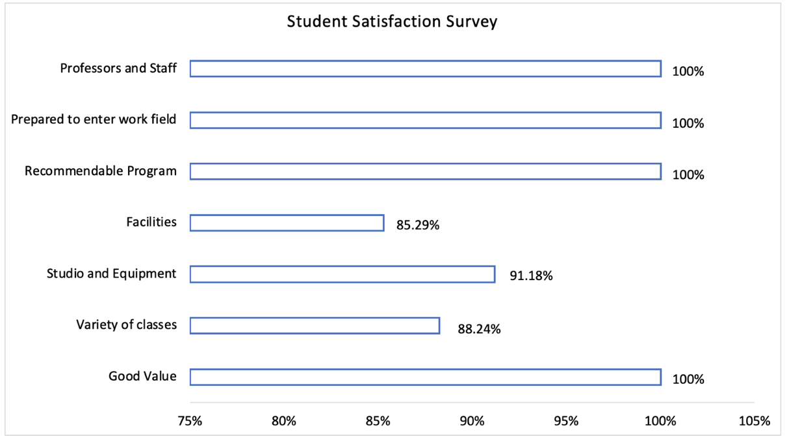
Source – Departmental Records from Student Survery in October 2021Outgoing Communications

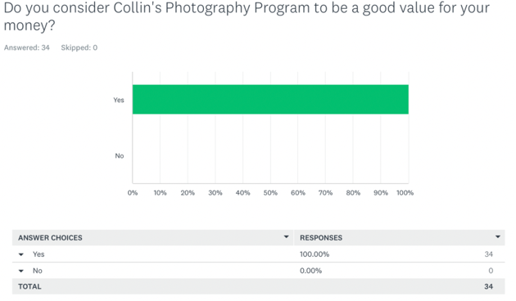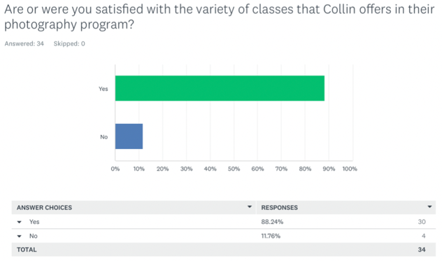
100% satisfaction 88.24% satisfaction
Good value variety of classes

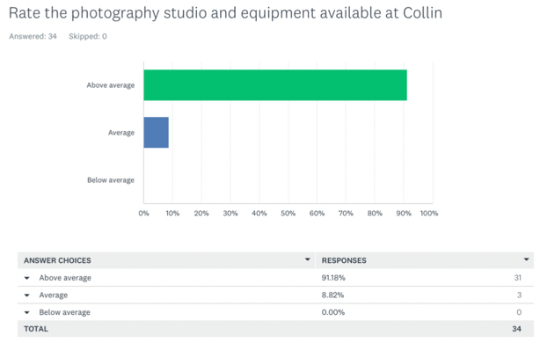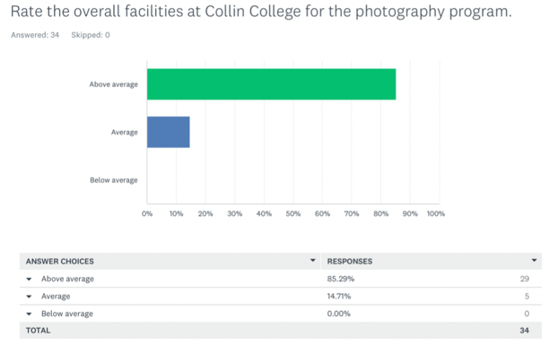
91.18% above average 85.29% above average
Studio and equipment facilities

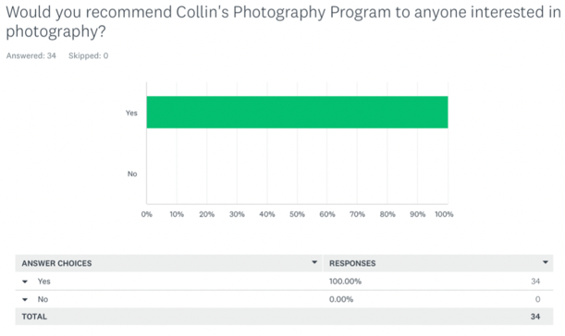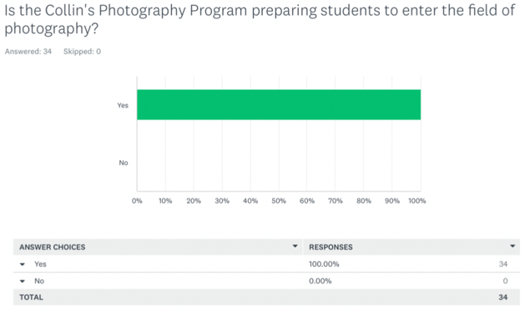
100% satisfaction 100% satisfaction
Recommendable program Prepared to enter work field

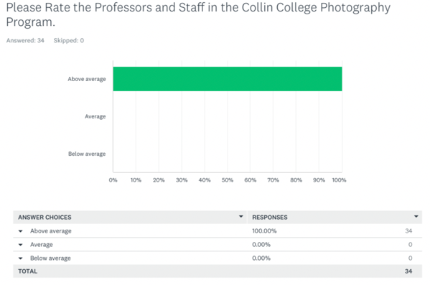
100% above average
Professors and staff

Data collected from department student survey sent Fall 2021

☐6. How effectively do we communicate, and how do we know?
A. Make a case with evidence that the program literature and electronic sites are current, provide an accurate representation of the program, and support the program’s recruitment plan, retention plan and completion plan.
Suggested/possible points to consider:
- Demonstrate how the unit solicits student feedback regarding its website and literature and how it incorporates that feedback to make improvements.
- How does the program ensure that students are informed/aware of program literature? Is program literature made accessible to all students (i.e. can they obtain the information they need)?
- Designate who is responsible for monitoring and maintaining the unit’s website, and describe processes in place to ensure that information is current, accurate, relevant, and available.

Outgoing Communications

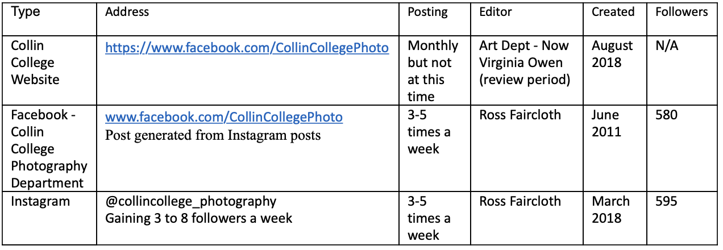
As Instagram is a strong tool in the photography industry, the Collin College Photography Department posts historical photography facts, master photographers, photographers in the news (i.e., Atlantic on Mondays for examples of current photojournalism) and keeps students informed of world events and what is happening outside their community. The main goal is to post student work throughout the semester to showcase their work and the type of work that is produced in a course. During holiday breaks, posting changes to more historical or master photographers along with their contemporary photographers. Many photography jobs are given through Instagram. Instagram is a calling card for photographers in business with little to no out-of-pocket expense. The department number of followers on Instagram is steadily increasing by 3 to 8 followers per week on average.

Using social media, in particular Instagram, we are able to regularly show our students' work to the world and potential students.
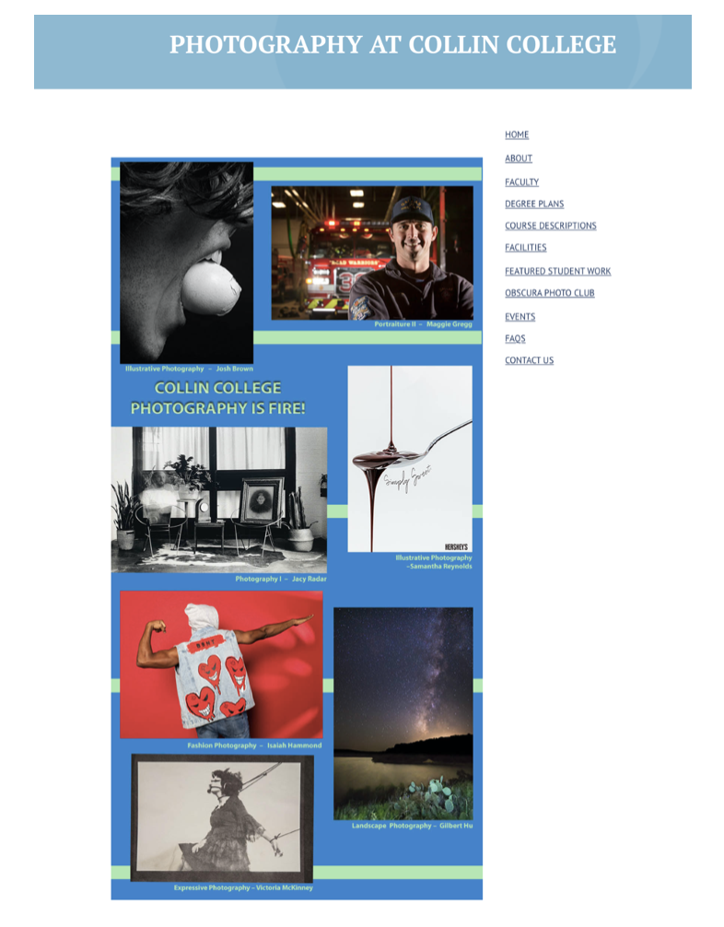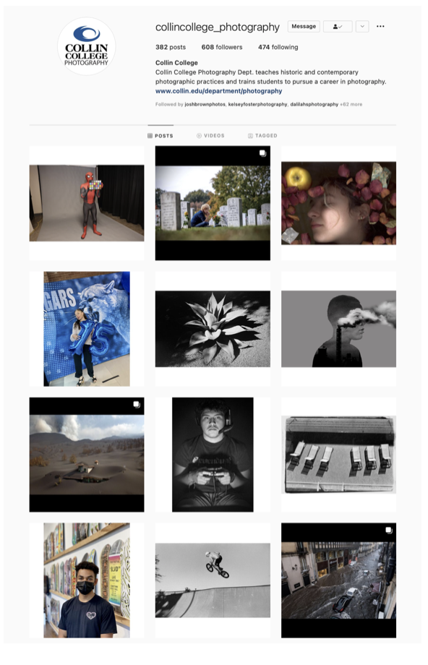
Department Website Instagram

INCOMING COMMUNICATION

Student Survey – October 2021
This is the survey that was sent through email through Survey Monkey to graduates and students with a semester left to graduate from the Collin College Photography Program.

The information below was collected for Collin’s Commercial Photography Program to be used as a departmental record.

Q1: Rate the overall facilities at Collin College for the Photography Program

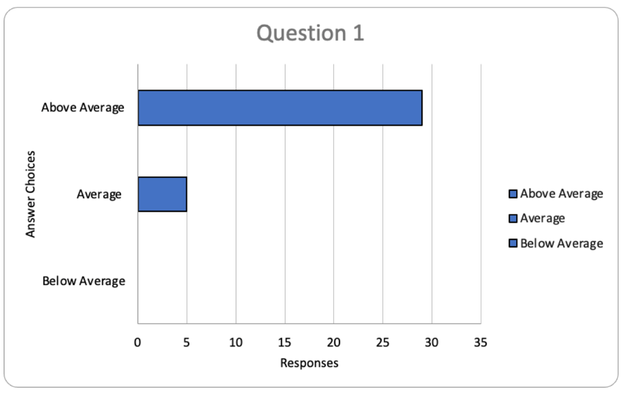

Q2: Rate the photography studio and equipment available at Collin
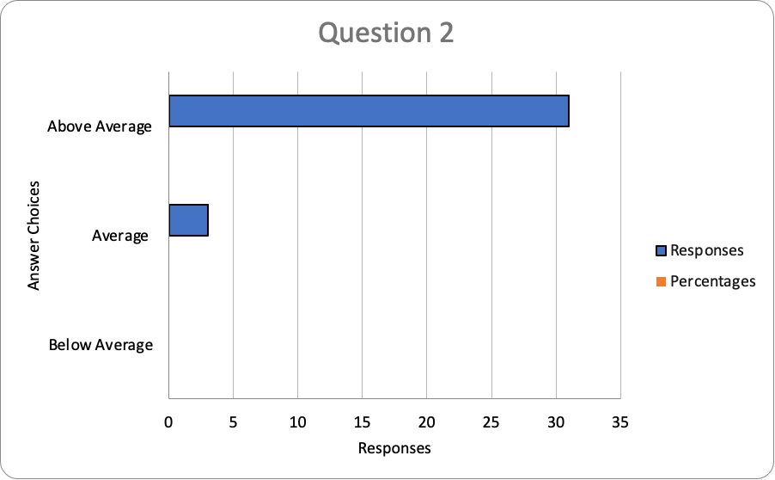

Q3: Please Rate the Professors and Staff in the Collin College Photography Program
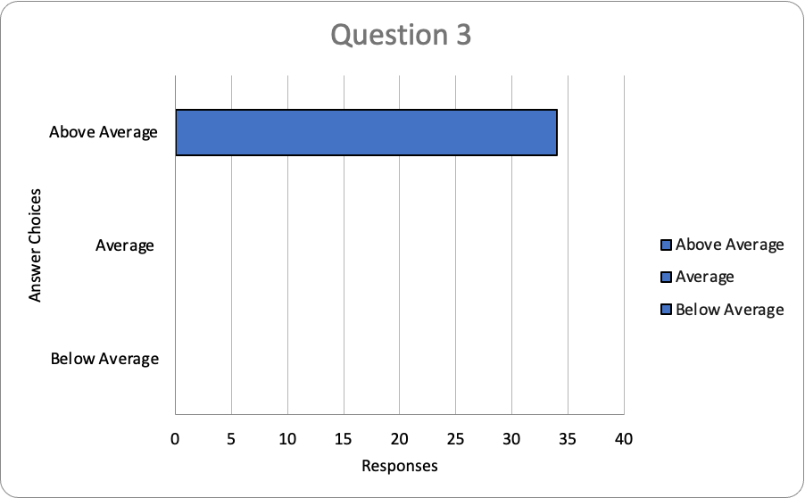
Q4: Are or were you satisfied with the variety of classes that Collin offers in their Photography Program?
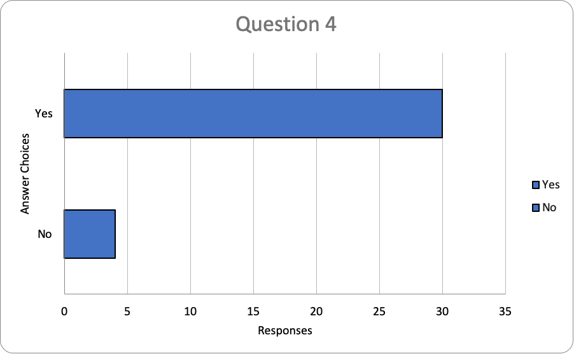

Q5: Do you consider Collin's Photography Program to be a good value for your money?
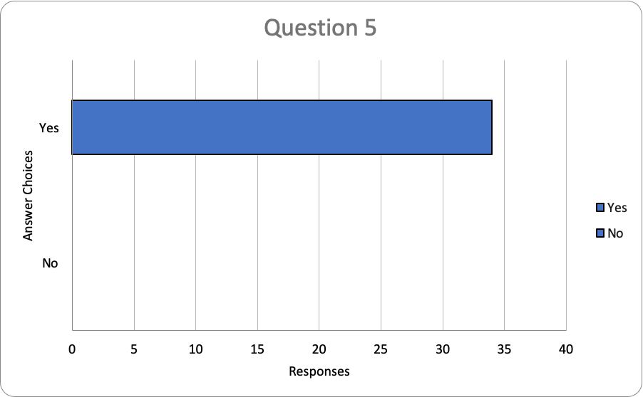

Q6: Would you recommend Collin's Photography Program to anyone interested in photography?
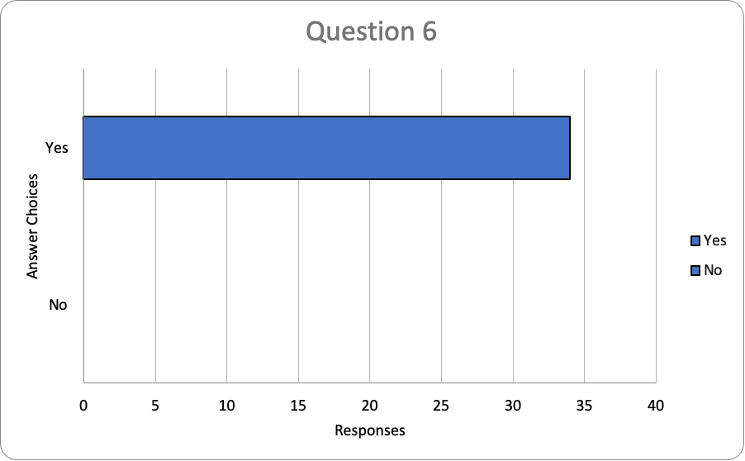

Q7: Is the Collin's Photography Program preparing students to enter the field of photography?
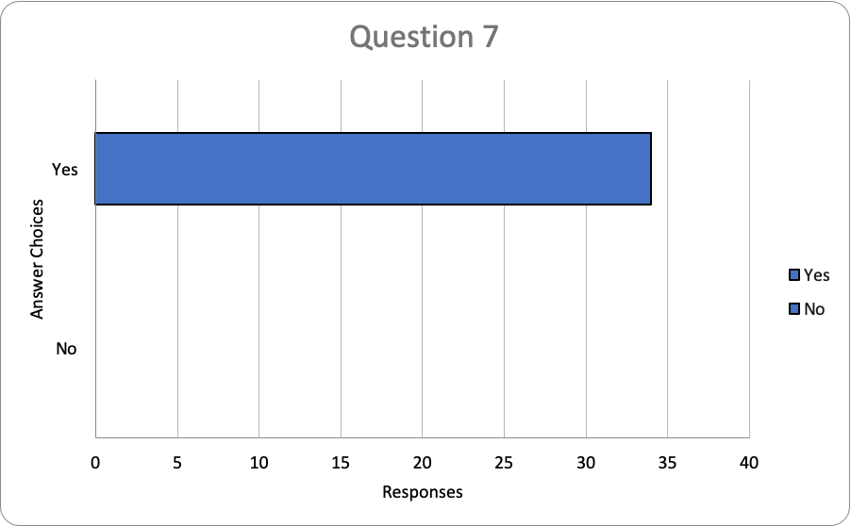

B. In the following Program Literature Review Table, document that the elements of information listed on the website and in brochures (current academic calendars, grading policies, course syllabi, program handouts, program tuition costs and additional fees, description of articulation agreements, availability of courses and awards, and local job demand in related fields) were verified for currency, accuracy, relevance, and are readily available to students and the public. Please fill out the table only for this prompt (B.), no analysis is necessary here.

Program Literature Review Table
Title | Type (i.e. URL, brochure, handout, etc.) | Date of Last Review/Update |  | Responsible Party
Photography Department Website | https://www.collin.edu/department/photography/ | 11/8/2021 | ☒Current  ☐Accurate  ☒Relevant  ☒Available | Box Office and Marketing Manager
Photography Program Brochure | Photography Department does not have a brochure  The Photography Department needs brochure | 11/8/2021 | ☐Current  ☐Accurate  ☒Relevant  ☐Available | Collin College
Current Academic Calendar | https://www.collin.edu/calendars/pdfs/2020-2021%20Academic%20Calendar.pdf | 11/8/2021 | ☒Current  ☒Accurate  ☒Relevant  ☒Available | Collin College
Grading Policies | Rubics on Canvas sites for each class | 11/8/2021 | ☒Current  ☒Accurate  ☒Relevant  ☒Available | Individual Professor
Program Handouts | Photography Department does not have program handouts  NEED HANDOUTS FOR PHOTOGRAPHY PROGRAM | 11/8/2021 | ☐Current  ☐Accurate  ☐Relevant  ☐Available | Collin College PR
Course Syllabi | Course Syllabi on Canvas for each class | 11/8/2021 | ☒Current  ☒Accurate  ☒Relevant  ☒Available | On each course in Canvas
Program Tuition Costs and Additional fees | On Collin College website  http://www.collin.edu/bursar/tuition.html | 11/8/2021 | ☒Current  ☒Accurate  ☒Relevant  ☒Available | Collin College
Description of Articulation Agreements | https://www.collin.edu/academics/programs/EMPH_PHOT_1Overview.html | 11/8/2021 | ☒Current  ☒Accurate  ☒Relevant  ☒Available | Box Office and Marketing Manager
Availablility of Courses and Awards | Courses  https://www.collin.edu/department/photography/Photography%20Courses.html  Awards  https://www.collin.edu/department/photography/AAS_TrackingSheet.pdf | 11/8/2021 | ☒Current  ☒Accurate  ☒Relevant  ☒Available | Box Office and Marketing Manager

☐7. How well are we leveraging partnership resources and building relationships, and how do we know?
Partnership Resources: On the table below, list any business, industry, government, college, university, community, and/or consultant partnerships, including internal Collin departments, to advance the program outcomes.
Partnership Resources are an important part of the Commercial Photography Program. With these partners, students are able to connect with the photography community before they graduate. By working together, Collin College can build a stronger community between the College and the photography community. The strongest evidence of this is through the Co-Op Program and the success rate students are experiencing with their mentors. Photography is still a trade built with a strong need for the practice of apprenticeship.

Partnership Resources Table**
Partner/Organization | Description | Formal Agreement Duration,  if any. | How is it Valuable to the Program?
Competitive Cameras | Local Professional Camera Store | No formal agreement only Verbal agreement | Helping students get photography gear at a reasonable cost and has agreed to give students a gift certificate upon graduating from the program being in the Fall of 2021.
Co-Op  “At Home” in house studio  Wade Griffith Photography  Fossil Group  Chris Baylor Photography  Debra Gloria Photography  AM Fitness  Brooke Drake Design  Abrash Rugs  FlyHippie Photography  FC Dallas  Floc Studios  Justin Clemons Photography  Texas Studio  Carmel Studios Photography  Incite Skateboarding | Current Co-Ops – that are working with the Workforce Photography Program | No formal agreement only Verbal agreement | Co-Ops play a very important role in giving students an opportunity to experience
Future Co-Ops The Container Store  Chewy.com  Neiman Marcus  Hertiage Antiques  Scott Harben Photography  AAFES – Army Air Force Exchange Service | Click or tap here to enter text. | Click or tap here to enter text. | Click or tap here to enter text.
Click or tap here to enter text. | Click or tap here to enter text. | Click or tap here to enter text. | Click or tap here to enter text.
Click or tap here to enter text. | Click or tap here to enter text. | Click or tap here to enter text. | Click or tap here to enter text.
Click or tap here to enter text. | Click or tap here to enter text. | Click or tap here to enter text. | Click or tap here to enter text.
Click or tap here to enter text. | Click or tap here to enter text. | Click or tap here to enter text. | Click or tap here to enter text.
Click or tap here to enter text. | Click or tap here to enter text. | Click or tap here to enter text. | Click or tap here to enter text.
Click or tap here to enter text. | Click or tap here to enter text. | Click or tap here to enter text. | Click or tap here to enter text.

☐8. What professional developmental opportunities add value to your program?
The Commercial Photography Faculty and Staff are very active in their professional development, which includes a variety of activities to stay current in the field. Below is a list of some of those activities.

• Attending Professional Conferences
• Attending Art and Photography Exhibitions
• Attending Photographic Workshops in person and online
• Published in Books and Magazines
• Attending online Software Classes for Capture One and Adobe Products
• Curatorial Work
• Judging Photography Competitions

Below is a listing of many of the activities the Commercial Photography Faculty and Staff have participated in since the last program review cycle.

A more extensive list will be in the appendix.

Provide a List of professional development activities employees have participated in since the last program review.
Employee Resources Table**
Employee Name | Role in Unit | Professional Development Summary | How is it Valuable to the Unit?
Elizabeth Mellott | Discipline Lead  Professor of Photography | Exhibition  Wild Life, traveling  Artist book exhibition  American Bookbinders Museum, San Francisco, CA  Robert C Williams  Museum of Papermaking, Atlanta, GA  North Bennet Street School, Boston, MA  Collins Memorial Library, University of Puget Sound, Tacoma, WA  Cushing Memorial Library, Texas A&M University, College Station, TX  Lloyd Library and Museum, Cincinnati, OH | Remaining current with art trends, exhibitions, and museum presentation.
Elizabeth Mellott | Discipline Lead  Professor of Photography | Workshop Conducted  World Cyanotype Day, Cyanotype Workshop, Elmwood Neighborhood, Dallas, Texas | Remaining current with workshop instruction and sharing the enjoyment of photography with the community.
Elizabeth Mellott | Discipline Lead  Professor of Photography | Professional Affiliations  Guild of Book Workers, Lone Star Chapter (Communications Director, 2020-current) | Remaining active in national art affiliations.
Elizabeth Mellott | Discipline Lead  Professor of Photography | Awards  Collin College Service-Learning Fellowship | Learned service-learning pedagogy and have incorporated numerous, successful service-learning projects with photography classes. Including partnering with Plano Library, Wylie Police Department, and The Birthday Party Project.
Elizabeth Mellott | Discipline Lead  Professor of Photography | Published Artwork  The Hand Magazine edition #29, magazine for reproduction-based art, magazine | Remaining current with art publication. Able to share insight to students, including direct photography students to be published as well
Elizabeth Mellott | Discipline Lead  Professor of Photography | Conference Attended  Society of Photographic Education 3-day conference, Houston, Texas | Research to remain current with art and photography practices. Additional to stay connected with local transfer universities
Elizabeth Mellott | Discipline Lead  Professor of Photography | Solo Exhibition  A Delicate Nature*, Heights Theater, FotoFest Participating Space, Houston, Texas | Remaining current with art trends, exhibition, proposing, and preparing artwork for exhibitions.
Elizabeth Mellott | Discipline Lead  Professor of Photography | Academic Training  Post Processing End-to-End, Lightroom and digital application, Los Angeles Center of Photography | Academic Learning to remain current in teaching practices and trends. Attended For Collin Leadership  Professional Development
Lisa Means | Professor of Photography | Published work  • Shooting for Direct Clients, Corporations, and Editorial Magazines  • Work published in D Magazine for Best Doctors and other issues  • Bookhouse Group – Book for National HealthCare – Nashville, TN  • CAPA International  •Folds of Honor Gala | Working in the industry helps keep current trends and equipment
Lisa Means | Professor of Photography | Judging APTI – High School National Competition | Keeping current and seeing what high school students are creating in photography
Lisa Means | Professor of Photography | International Spider Awards for Black and White Photography – Two HM awards in People and Americana Catalogs | International Competition with almost 7000 entrees - Keeping current and competing
Lisa Means | Professor of Photography | Attended the Adobe Education Summit - Conference – Virtually online  Joining the Adobe Education Group | Learning different skills and how to teach effectively using iCloud products – Photoshop, Lightroom, Portfolio - Professional Development
Lisa Means | Professor of Photography | Attended, Online Capture One Training | Essential skills for department  Professional Development
Anna Fritzel | Lab Supervisor | “DSLR Video Basics,” Alex Burnett, Maine Media Workshops | Attended to Learn Video Skills  Professional Development
Anna Fritzel | Lab Supervisor | Leading for Excellence Academy | Attended For Collin Leadership  Professional Leadership Development
Anna Fritzel | Lab Supervisor | “DSLR Video Basics,” Alex Burnett, Maine Media Workshops | Attended to Learn Video Skills  Professional Development
Anna Fritzel | Lab Supervisor | “How to Write an Artist Statement,” Liz Sales, Soho Photo Gallery | Attended Artist Lecture  Professional Development
Anna Fritzel | Lab Supervisor | “Creating Digital Negatives,” Brittonie Fletcher, Penumbra Foundation. | Updating knowledge  Professional Development
Anna Fritzel | Lab Supervisor | Attended, Online Capture One Training | Essential skills for department  Professional Development
Anna Fritzel | Lab Supervisor | Microsoft Teams 100 Training | Collin College Training  Professional Development
Ross Faircloth | Assistant Lab Supervisor | Presented work / gave artist talk at Hawn Gallery, SMU as part of “Illusion of Being” exhibition | Work presentation skills to pass on to students / advertise the program
Ross Faircloth | Assistant Lab Supervisor | Attended, Online Capture One Training | Essential skills for department  Professional Development
Ross Faircloth | Assistant Lab Supervisor | Presented, panel talk at Collin College in conjunction with “The Alternative Processes and Integrated Media Competition” Exhibition | Essential skills to pass on to students. Advertise the program
Ross Faircloth | Assistant Lab Supervisor | Presented Digital Negative Demo at SMU photo department in conjunction with “Illusion of Being” exhibition. | Essential skills for teaching / photography
**For convenience, if providing a listing of professional development activities, this list may be included in this document as an appendix.

☐9. Are facilities, equipment, and funding sufficient to support the program? If not, please explain.
[OPTIONAL—Only respond to prompt 9 if you are requesting improved resources for your program. If current facilities and budget are adequate, please proceed to prompt 10.]
Make a case with evidence that current deficiencies or potential deficiencies related to facilities, equipment, maintenance, replacement, plans, or budgets pose important barriers to the program or student success. As part of your response, complete the resource tables, below, to support your narrative.
Possible points to consider:
- The useful life of structure, technologies and equipment
- Special structural requirements
- Anticipated technology changes impacting equipment sooner than usual

With our continued growth, our facilities have become limited. The configuration of our digital classroom is not conducive to best practices. There is a large structural pole in the middle of the room, which obstructs the view of several students to the instructor, and the instructor to the students. Also, since the completion of the new AC unit, the room is loud, and students cannot hear the instructor over the AC. The problem has been addressed, but still not resolved. Another issue with the room is the peripheral and power cables that are out in the middle of the room, and the students are packed tightly into the space and the cables are easy to trip over and are constantly being unplugged. 508 students moved through the digital photography classroom in 2019, the classroom holds eighteen students, that is fourteen courses per long semester. The Foundations of Art courses five years ago had only 314 enrollments for the year. Now it has over 700. This course serves as a feeder course to our program. With Foundations of Art being in the core curriculum we expect the numbers to continue growing and consequently the photography program to continue growing as well.
*Need Larger Digital Classroom Space
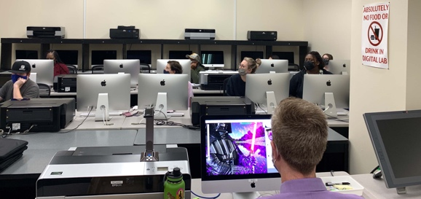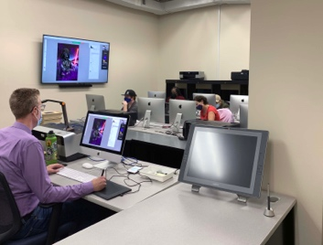

Our two-bay studio is no long larger enough to accommodate full classes of eighteen students plus one faculty member and possibly one to two guest demonstrators or speakers. Also, we have accumulated much-needed, updated equipment, including computers for tethering, so that an authentic studio production flow can be synthesized and understood. This extra equipment as well as a lot of other extra needed equipment makes the studio space limited for actual working and photographing. We could utilize another shooting space as well as have a space for storage of equipment.
Film Cameras
*We Need a larger studio space and/or studio storage space
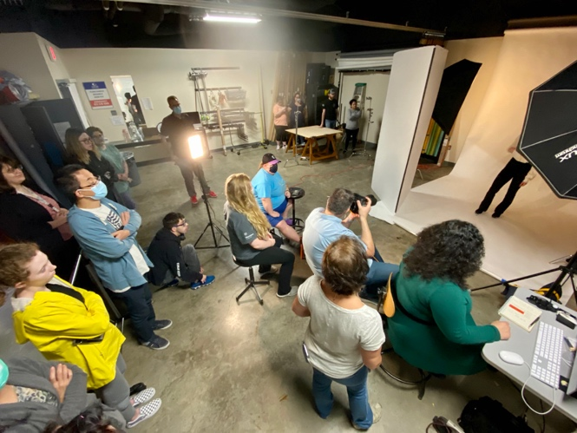

Facilities Resources Table**
Significant Pieces of Equipment | Description  (i.e. Special Characteristics) | Meets Needs (Y or N):  Current For Next 5 Years |  | Analysis of Equipment Utilization
Film Cameras | Student cameras for darkroom Classes | Yes | No | The majority of our film cameras have been donated. They are failing and we need reliable replacements.
Video Kits | We currently have 5 sets of microphones and recorders | Yes | No | We only have five sets for eighteen students to share during a semester. We need five more sets.
Off-campus lighting kits | Studio lights for locations advanced studio lighting courses | Yes | No | Location kits are old and may require some updates or replacements. Two to three more lighting kits would help our growing commercial program.
Click or tap here to enter text. | Click or tap here to enter text. | Choose an item. | Choose an item. | Click or tap here to enter text.
Click or tap here to enter text. | Click or tap here to enter text. | Choose an item. | Choose an item. | Click or tap here to enter text.
Click or tap here to enter text. | Click or tap here to enter text. | Choose an item. | Choose an item. | Click or tap here to enter text.
Click or tap here to enter text. | Click or tap here to enter text. | Choose an item. | Choose an item. | Click or tap here to enter text.
Click or tap here to enter text. | Click or tap here to enter text. | Choose an item. | Choose an item. | Click or tap here to enter text.
Click or tap here to enter text. | Click or tap here to enter text. | Choose an item. | Choose an item. | Click or tap here to enter text.

Equipment/Technology Table ($5,000 or more) **
Current Equipment Item or Budget Amount | Description | Meets Needs (Y or N):  Current For Next 5 Years |  | For any “N”, justify needed equipment or budget change
Click or tap here to enter text. | Click or tap here to enter text. | Choose an item. | Choose an item. | Click or tap here to enter text.
Click or tap here to enter text. | Click or tap here to enter text. | Choose an item. | Choose an item. | Click or tap here to enter text.
Click or tap here to enter text. | Click or tap here to enter text. | Choose an item. | Choose an item. | Click or tap here to enter text.
Click or tap here to enter text. | Click or tap here to enter text. | Choose an item. | Choose an item. | Click or tap here to enter text.
Click or tap here to enter text. | Click or tap here to enter text. | Choose an item. | Choose an item. | Click or tap here to enter text.
Click or tap here to enter text. | Click or tap here to enter text. | Choose an item. | Choose an item. | Click or tap here to enter text.
Click or tap here to enter text. | Click or tap here to enter text. | Choose an item. | Choose an item. | Click or tap here to enter text.
Click or tap here to enter text. | Click or tap here to enter text. | Choose an item. | Choose an item. | Click or tap here to enter text.
Click or tap here to enter text. | Click or tap here to enter text. | Choose an item. | Choose an item. | Click or tap here to enter text.
Click or tap here to enter text. | Click or tap here to enter text. | Choose an item. | Choose an item. | Click or tap here to enter text.

Financial Resources Table**
Source of Funds  (i.e. college budget, grant, etc.) | Meets Needs (Y or N):  Current For Next 5 Years |  | For any “N”, explain why | For any “N”, identify expected source of additional funds if needed
Click or tap here to enter text. | Choose an item. | Choose an item. | Click or tap here to enter text. | Click or tap here to enter text.
Click or tap here to enter text. | Choose an item. | Choose an item. | Click or tap here to enter text. | Click or tap here to enter text.
Click or tap here to enter text. | Choose an item. | Choose an item. | Click or tap here to enter text. | Click or tap here to enter text.
Click or tap here to enter text. | Choose an item. | Choose an item. | Click or tap here to enter text. | Click or tap here to enter text.
Click or tap here to enter text. | Choose an item. | Choose an item. | Click or tap here to enter text. | Click or tap here to enter text.
Click or tap here to enter text. | Choose an item. | Choose an item. | Click or tap here to enter text. | Click or tap here to enter text.
Click or tap here to enter text. | Choose an item. | Choose an item. | Click or tap here to enter text. | Click or tap here to enter text.
Click or tap here to enter text. | Choose an item. | Choose an item. | Click or tap here to enter text. | Click or tap here to enter text.
Click or tap here to enter text. | Choose an item. | Choose an item. | Click or tap here to enter text. | Click or tap here to enter text.
Click or tap here to enter text. | Choose an item. | Choose an item. | Click or tap here to enter text. | Click or tap here to enter text.

Section III. Continuous Improvement Plan (CIP)
☐10. How have past Continuous Improvement Plans contributed to success?
Program Review at Collin College takes place for each unit or program every five years. During the last (fifth) year, the program evaluates the data collected during the CIP process.
Please describe how you have used your Continuous Improvement Plan (CIP) to make the following improvements to your program over the past 4 years (your last program review can be found on the Program Review Portal):
  - Program Learning Outcomes/Program Competencies
  - Overall improvements to your program

CONTINOUS IMPROVEMENT PLANS CONTRIBUTION TO THE PROGRAM

The focus of the 2016-2020 review cycle was to solidify the foundation of the program by incorporating appropriate courses, detailing curriculum for stackable classes, purchasing industry-standard equipment, and incorporating current software applications into the curriculum. All the actions have been successfully implemented showing positive results.

Program Learning Outcome 3: Examine opportunities in the professional community.
(The student will develop an understanding of professional photographic practices relating to commercial photography work).
Addressing PLO 3, four courses were added that empathize current professional practices in commercial photography with technical skills in video and advanced digital. Photojournalism added curriculum in photographing lifestyle, editorial, and newspaper photography. Additionally, adding co-op education gave students the opportunity to serve an internship, gain real-world experience, and network before venturing out into the job market.

Four new courses added to program awards:

PHTC 2371 Video for Photographers
PHTC 2349 Digital Imaging II
PHTC 1351 Photojournalism
PHTC 2380 Co-op Education, Photography
- Not only was the new course Co-Op Education added, but Professor Lisa Means and Professor Elizabeth Mellott secured Co-Op partners. The program went from zero internship partners to twenty-two partners in the 5-year cycle. Securing internship partners assist the students in finding a Co-Op that suite their career goals and bridges the gap between being a student and entering the workforce.

PLO 3 was a successful change. The 4 new courses added all had high passing rates and students comments show that they were pleased with learning a variety of skills.
- PHTC 2371 Video for Photographers target passing rate – 75%, actual passing rate: 98%
- PHTC 2349 Digital Imaging II target passing rate – 75%, actual passing rate: 89%
- PHTC 1351 Photojournalism target passing rate – 75%, actual passing rate: 95%
- PHTC 2380 Co-op Education, Photography target passing rate – 75%, actual passing rate: 73% (2016-2018 not offered, 2019-100%, 2020-50% due to covid)

- "I've learned a wide range of skills with this program that make it easier for me to find a wide variety of jobs. I don't just have skills for portraits, I have skills for architecture, commercial photography, ecommerce and more. I am very thankful for this program. Before I knew about it, I didn't think I would be able to make photography a full-time career. Since taking the leap into the program I've gotten nothing but confidence in knowing I'll be okay after graduating." – MM, Source – Student Quotes - Departmental Records

Program Learning Outcome 1: The student will demonstrate an understanding of photographic techniques, including manual camera operation, exposure, and lighting.

Addressing PLO 1, with attention to photography techniques, digital skills that crossed between three digital courses, were detailed, setting up stackable skill sets from one course to the next. Creating a detailed distinction between skill levels reduced redundancy and allowed level 2 and level 3 digital courses to focus on more advanced digital skills.

PLO 1 was a successful change. Designing the digital courses to be stackable with specific skill sets created courses that students could focus on the content with more attention. The passing rates were high in the advanced classes and student comments show their satisfaction with the material learned. In each course students are evaluated by a final exam and additionally a final portfolio, ensuring that students are evaluated on both technical and creative skills.
- ARTS 2348 Digital Media target passing rate – 75%, actual passing rate: 72% (ARTS 2348 is an entry level course that serves in both work force and transfer. Many students enroll in the course as an elective for the AA degree. Therefore, the passing rate is lower than the dedicated workforce courses). This course has been removed from the workforce degree and a workforce specific course has been added in its place for the entry level digital course.
- PHTC 1300 Digital Photography target passing rate – 75%, actual passing rate: 86%
- PHTC 2349 Digital Imaging II target passing rate – 75%, actual passing rate: 89%

- Additionally, courses were reorganized by titles and descriptions. Current course titles were changed back to original WECM/ACGM titles to avoid confusion. PHTC 1311 Fundamentals of Photography was reinstated as a foundational digital/ camera operations course.

- "When I first joined the degree plan, I knew very little about cameras especially when it came to shooting. Now that I have been in the program for many semesters, I have learned a tremendous amount about cameras, lighting, and all the different equipment that I have never seen or even touched before coming into the program." – VJ, Source – Student Quotes - Departmental Records

Addressing PLO 1, with attention to lighting, ten Profoto studio lights have been purchased and added to the Plano Campus studio.
500 WS mono lights – Eight lights
1000 WS mono lights – Two lights

PLO 1 was a successful change with attention to lighting. The passing rates of the lighting courses, show that students are learning the equipment and lighting. Additionally, the department followed the advisory board’s recommendation for industry standard equipment and lighting. Following the board’s recommendations students are trained on equipment that they will be using in the work field and therefore have less of a learning curve when working with new employers.

- PHTC 1353 Portraiture I target passing rate – 75%, actual passing rate: 85%
- PHTC 2353 Portraiture II target passing rate – 75%, actual passing rate: 90%
- PHTC 1345 Illustrative target passing rate – 75%, actual passing rate: 91%

- The advisory board has clarified that ProFoto Lights are the industry standard for lighting equipment. The members expressed that it would serve the students best to be familiar with ProFoto lights. (from page 79, Advisory Board Impacts. Data collected from advisory board meeting minutes)

Continuation of evaluating PLO 1, Capture One software was incorporated into the program. Staying current with trends in the workforce, it became a necessity to add Capture One software skills to the curriculum. Capture One was first introduced in PHTC 2349 Digital Imaging II in 2019. Since then, the department has funded training on Capture One for all FT faculty, FT staff, and one student. Starting Fall 2021, the department took further steps to ensure Capture One software skills are included by hiring a new FT faculty member with extensive knowledge in Capture One. The new faculty member redesigned the curriculum for PHTC2349, to cover advanced skillsets for Capture One.

The improvements showed positive results. Students are graduating from the program with more advanced skills such as video and advanced photo editing. Additionally, students are trained with industry-standard lighting equipment and can move to a professional studio environment with ease and knowledge of working on professional equipment. Lastly, distinguishing skills sets in stackable courses have allowed level 2 and 3 courses to teach more advanced skills. There is less overlap of skills in the three levels of digital courses and a smoother transition from beginning digital courses to advanced digital courses.

Video of students working in the lighting studio, using Profoto lights and Capture One Software
https://drive.google.com/drive/folders/1uGpBUQbHKkBWoTwln5XXFv5z9zD9Ll9R?usp=sharing

*Please attach previous CIP Tables in the appendix

☐11. How will we evaluate our success?

NOTE: Please contact the institutional effectiveness office if you need assistance filling out the CIP tables.
As part of the fifth year Program Review, the program should use the observations and data generated by this process along with data from other relevant assessment activities to develop the program’s CIP and an action plan for the next two years. At the conclusion of the first two years, data collected from the first year, plus any other relevant data that was collected in the interim, should be used to build on the accomplishments of those first two years by developing another two-year action plan for the CIP to help the program accomplish the expected outcomes established in its CIP or by implementing one of your other plans.

Based on the information, analysis, and discussion that have been presented up to this point, summarize the strengths and weaknesses of this program. There should be no surprise issues here! This response should be based on information from prior sections of this document. Describe specific actions the faculty intends to take to capitalize on the strengths, mitigate the weaknesses, improve student success and program learning outcomes. Provide the rationale for the expected outcomes chosen for the CIP(s).

We are a workforce program, the easiest way to measure our success is to see how our students perform after they complete the program. Many of our co-op partners are hiring students. Jobs are a huge part of the Photography Program’s success.

Listed below are a few recent graduates' websites and their work – these sites were built while students were at Collin College and are helping these graduates to showcase their work for future employment. This could include both starting their own company or working within the photo industry for another corporation or individual photographer. Their work speaks for itself. Not only is the work of excellent quality but a very diverse type of work within the many different fields of photography. Our success is our students.

https://www.joshbrownphotos.com
Hired - June-2021 - present as a temporary employee for Fossil Inc.

https://www.carlymayphoto.com
Hired by Texas Tribune / signed contract for freelancing and Local Profile for Collin County Based Magazine

https://www.samanthamarie-photography.com
Student not graduated yet! almost there! Shooting for several restaurants and family portraits

https://jlm-media.com
Hired freelance for FC Dallas after Co-op and several other events
Sports and Photojournalism Photography

https://leianphotography.com
Transfer Student at North Texas University currently 2021

http://www.eyecapturephotos.com
Graduate shooting corporately, weddings, and events

https://www.annaeboling.com
Working for architectural photographer after Co-op

https://www.popcolorphotography.com
Working in Wisconsin. Making greeting cards

https://madisonkinleyphotography.co
Hired by At Home Studios as full-time photo assistant

STUDENT QUOTES
COLLECTED FALL OF 2021 – PART OF DEPARTMENT RECORDS – sent through school emails

TECHNICAL SKILLS
"The photoshop skills, technical skills, and connections that I have acquired throughout these courses are unbelievable and the Photo Department exceeded every expectation. They give you every opportunity for success and I would (and have) recommend the program to anyone looking to study photography." - AQ

TOP OF THE LINE EQUIPMENT
"I'm also really grateful for the equipment and studio provided for us. Amazingly, we have access to the top-of-the-line equipment that they use in the field." - AA

BUSINESS PRACTICES
The Collin college photography department has greatly impacted who I am as not just a photographer, but a business professional as well. Thanks to incredible instructors such as Professor Means, I am able to build a strong foundation of skill, creativity, and best business practices. The individual attention poured into myself, and my classmates fostered an environment where we phy business. I’ve already seen the fruits of that labor with increased clientele, higher job payouts, and unique opportunities. I will forever be grateful for this photography program! were all growing and spurring each other forward. All of these helped me prepare to run my own photography business. - SR

LEARNING STYLE
"The Collin College photography program was an amazing experience and I learned everything I know about photography from this program. These classes for me were more useful to my learning style than trying to decipher a YouTube video or article on how to use my camera, Photoshop, or film. Having a professor to provide feedback, critique, and help was necessary to my success in the field." - AB

WORLD CLASS
"I learned, as I entered the photography program, about the wide depth of resources that Collin college provided me with from the range of experience of all the instructors as well as industry professionals that we were exposed to from working Commercial Photographers to Fine Art Photographers. The facilities at Collin are world class and in my time there we were trained on the very latest technology and industry standard equipment to be found anywhere which ultimately prepared me to apply what I learned in real time on the same equipment that working professionals were using as a student." - CB

HOW TO START AND GROW
"This program is a smart choice to step into the world of photography for those who are new and experienced in the field; you will get to learn a lot about the ins and outs of photography and how to start and grow your photography business. I'm really happy with what I've learned and the connections I've made from my time at this program." - CR

FRIENDS FOR LIFE
"This degree has not only made me more knowledgeable, but it has also given me friends for life. The teachers are helpful and kind, while the students keep each other motivated!" - MG

ADVANCED EQUIPMENT
"They always have the most advanced equipment that we get to use whenever we like. The teachers are always there to help and make sure we understand what we are doing. They are always trying to help us learn everything we can for our future careers." - MB

OPPORTUNITIES
"As a graduating Collin college photography student, I would say I had some of my best photography moments and projects rooted from the classrooms. I learned so much and am grateful for the opportunities that the department provided. Collin prepared me to work in the professional world by emphasizing the importance of keeping up to date with the latest programming, staying thorough in each work of art, and having the experience to work with fine art and commercial art." - MG

☐ 12. Complete the Continuous Improvement Plan (CIP) tables that follow.
Within the context of the information gleaned in this review process and any other relevant data, identify program priorities for the next two years, including at least one program learning outcome (or program competency), and focus on these priorities to formulate your CIP. You may also add short-term administrative, technological, assessment, resource or professional development outcomes as needed.

After review of the 2015-2020 cycle, three areas for improvement were found. The awards offered, a student knowledge base with social media skills, and outreach/enrollment. For the upcoming five-year cycle, the Commercial Photography Program plans to focus on these three outcomes: increase awards, student skills with social media, and outreach/enrollment.

Table 1. CIP Outcomes, Measures & Targets Table (focus on at least one for the next two years)
A. Expected Outcomes  Results expected in this unit  (e.g. Authorization requests will be completed more quickly; Increase client satisfaction with our services) | B. Measures  Instrument(s)/process(es) used to measure results  (e.g. sign-in sheets, surveys, focus groups, etc.) | C. Targets  Level of success expected  (e.g. 80% approval rating, 10 day faster request turn-around time, etc.)
Additional award options, such as Enhanced Skills Certificates. | Awards offered | Enhanced Skills Certificates to increase from 0 to 3.
Students will increase skills on social media platforms. | Student work from appropriate classes | 80% of students will demonstrate knowledge and successful application of social media skills. Results will be demonstrated through class projects.
Increase outreach to grow enrollment. Outreach will include High School, Collin Enrolled Students, and Community members. | Faculty documentation submitted for annual reviews. | Faculty outreach efforts to average one per month.
Click or tap here to enter text. | Click or tap here to enter text. | Click or tap here to enter text.

Continuous Improvement Plan

Outcomes might not change from year to year. For example, if you have not met previous targets, you may wish to retain the same outcomes. You must have at least one program learning outcome. You may also add short-term administrative, technological, assessment, resource or professional development goals, as needed. Choose 1 to 2 outcomes from Table 1 above to focus on over the next two years.

A. Outcome(s) - Results expected in this program (from column A on Table 1 above--e.g. Students will learn how to compare/contrast Conflict and Structural Functional theories; increase student retention in Nursing Program).
B. Measure(s) – Instrument(s)s/process(es) used to measure results (e.g. results of essay assignment, test item questions 6 & 7 from final exam, end of term retention rates, etc.).
C. Target(s) - Degree of success expected (e.g. 80% success rate, 25 graduates per year, increase retention by 2% etc.).
D. Action Plan - Implementation of the action plan will begin during the next academic year. Based on analysis, identify actions to be taken to accomplish outcome. What will you do?
E. Results Summary - Summarize the information and data collected in year 1.
F. Findings - Explain how the information and data has impacted the expected outcome and program success.
G. Implementation of Findings – Describe how you have used or will use your findings and analysis of the data to make program improvements.
Table 2. CIP Outcomes 1 & 2
- Outcome #1 Design additional degree options, such as Enhanced Skills Certificates

- Measure (Outcome #1)  Awards offered | - Target (Outcome #1)  Enhanced Skills Certificates to increase from 0 to 3.
- Action Plan (Outcome #1)
Full-time faculty will work closely with the Commercial Photography Advisory Board and Deans in creating Enhanced Skills Certificates that address underrepresented specialization areas in the photography program.
- Results Summary (Outcome #1) TO BE FILLED OUT IN YEAR 2

- Findings (Outcome #1) TO BE FILLED OUT IN YEAR 2

- Implementation of Findings (Outcome #1) TO BE FILLED OUT IN YEAR 2

Table 2. CIP Outcomes 1 & 2 (continued)

- Outcome #2 Students will increase skills on social media platforms.

- Measure (Outcome #2)  Student work in appropriate classes | - Target (Outcome #2)  80% of students will demonstrate knowledge and successful application of social media skills. Results will be demonstrated through class projects.
- Action Plan (Outcome #2)
Assignments will be added in appropriate courses that teach students how to create social media content and utilize social media platforms.
- Results Summary (Outcome #2) TO BE FILLED OUT IN YEAR 2

- Findings (Outcome #2) TO BE FILLED OUT IN YEAR 2

- Implementation of Findings (Outcome #2) TO BE FILLED OUT IN YEAR 2

What happens next? The Program Review Report Pathway
- Following approval by the Steering Committee,
- Program Review Reports will be evaluated by the Leadership Team;
- After Leadership Team review, the reports will be posted on the Intranet prior to fall semester;
- At any point prior to Intranet posting, reports may be sent back for additional development by the unit.

- Unit responses to the Program Review Steering Committee recommendations received before July 31st will be posted with the Program Review Report.

- Leadership Team members will work with program supervisors to incorporate Program Review findings into planning and activity changes during the next five years.

Please make sure to go back and complete your Executive Summary at the start of the Review.

