**Introduction/Preface**

**Executive Summary:**

The Facilities and Grounds Service Unit exists to operate, maintain, and support quality facilities, grounds, and services to ensure a safe, effective, and comfortable educational and working environment for Collin College students, faculty and staff. The Facilities and Grounds department executes its mission district-wide on a daily basis. The department is responsible to provide emergency, routine, scheduled, and preventative maintenance on Facility and Building systems as well as District Grounds. Facility systems include, but are not limited to, Building Structures, Heating, Ventilation, Air Conditioning (HVAC), Electrical, Plumbing, Fire Alarms, Fire Suppression, Elevators, Interior and Exterior Lighting, Emergency Generators, Locks and Access Controls, Pavements, Drainage, Roofing, Windows, and the Building Envelope. The Grounds section is responsible for the maintenance and operation of all irrigation systems as well as maintenance and upkeep of all District grounds to include flower beds, trees, landscaped and un-landscaped areas. Additionally, the Facilities Department is responsible for Facility operations. Facility Operations includes, but is not limited to District Mail Operations, Shipping and Receiving, Asset Accountability, Vehicle Operations, Conference Services and Event support as well as contracted custodial services.

The department provides fully functional, comfortable, and effective classrooms, labs, student support areas, counseling, conference centers, and grounds to support the College’s mission. Without the Facilities and Grounds department, those same facilities and instruction spaces would not be inviting, functional, comfortable, or supportive of learning and growth. The Facility and Grounds Department must adhere to numerous applicable regulatory standards. These standards come from multiple governmental and regulatory agencies.

Over the previous 5 years, the Facilities and Grounds department has continued to improve its day to day operations as well as its management and oversight. As the College has grown, from 1.7 million square feet of facilities in 2017 to 3.04 million square feet of facilities in 2022, it has also needed to increase facilities and grounds staffing, funding, and improve processes. The department expends the most resources on providing maintenance services.

The Department leverages solid communications practices and partnerships to ensure successful completion of its responsibilities. Like any organization there is room for improvement. Areas for improvement include the tracking of work orders and equipment maintenance data, a further defining a department roles, responsibilities and expectations, and improved standardization across the department and Campuses.

**Section I. ARE WE DOING THE RIGHT THINGS?**

1. **What is the service unit and its context?**

The Facilities and Grounds Service Unit exists to operate, maintain, and support quality facilities, grounds, and services to ensure a safe, effective, and comfortable educational and working environment for Collin College students, faculty and staff. The Facilities and Grounds Department is a part of the larger Facilities and Construction Division. The Facilities and Construction Division is led by the Vice President of Facilities and Construction. Each supporting department is led by a Director. The Facilities and Construction Division also has a Planning, Design, and Construction Department as well as a Safety and Emergency Management Department. This program review will only focus on Facilities and Grounds in an effort to ensure a focused review.

Facilities and Grounds mission and vision are embedded in the larger Facilities and Construction Division mission to “Build, operate, maintain, and support quality facilities, grounds, and services for students, faculty, and staff” as well as the Division Vision to “Provide recognized facilities excellence, value, and leadership to deliver a brighter future for our students”.

The Facilities and Grounds department executes its mission district-wide on a daily basis. The department is responsible to provide emergency, routine, scheduled, and preventative maintenance on Facility and Building systems as well as District Grounds. Facility systems include, but are not limited to, Building Structures, Heating, Ventilation, Air Conditioning (HVAC), Electrical, Plumbing, Fire Alarms, Fire Suppression, Elevators, Interior and Exterior Lighting, Emergency Generators, Locks and Access Controls, Pavements, Drainage, Roofing, Windows, and the Building Envelope. The Grounds section is responsible for the maintenance and operation of all irrigation systems as well as maintenance and upkeep of all District grounds to include flower beds, trees, landscaped and un-landscaped areas.

Additionally, the Facilities Department is responsible for Facility operations. Facility Operations includes, but is not limited to District Mail Operations, Shipping and Receiving, Asset Accountability, Vehicle Operations, Conference Services and Event support as well as contracted custodial services. The Facility Department executes Facility Operations on a Daily Basis to support the students, staff, and visitors to Collin College.

The entirety of Facilities and Grounds Department services are executed at all Collin College owned facilities and property. This includes all Collin College Campuses, Public Safety Training Center, Collin Higher Education Center, and Courtyard Center, as well as unoccupied or unimproved Collin College owned property and land. The Facilities and Grounds Department does not support the Rockwall Center (not a Collin College owned facility) or any instruction location on private or Independent School District Property.

The Facility and Grounds Department must adhere to numerous applicable regulatory standards. These standards come from multiple governmental and regulatory agencies. While the complete list of regulatory standards is exhaustive, some of the most important standards that must be met include: City Fire Safety Standards, Elevator Safety Standards, Texas Department of Licensing and Regulation Accessibility Standards, City Planning and Zoning Standards, National Electric Code, National Fire Protection Code, City Pool Inspection Standards (Student Housing Pool), Backflow Prevention Inspection Requirements, and City and County Prescribed Facility Codes and Standards.

1. **Why do we do the things we do? Unit relationship to the College Mission & Strategic Plan**

The Facilities and Grounds Department directly and indirectly support the College Mission and Strategic Plan. The Collin College Mission to have District that “is a student and community-centered institution committed to developing skills, strengthening character, and challenging the intellect” and the Collin College Vision is “Delivering a brighter future for our students and communities”. The Facilities and Grounds department support the College’s mission and Vision by operating and maintaining facilities utilized by faculty and staff to provide students a wide variety of instruction, character, intellect, and skill development. Through the maintenance and operation of College Facilities and Grounds, the department provides fully functional, comfortable, and effective classrooms, labs, student support areas, counseling, conference centers, and grounds. Without the Facilities and Grounds department, those same facilities and instruction spaces would not be inviting, functional, comfortable, or conducive to learning and growth.

Specifically, the Facilities and Grounds Department performed 5,199 Work Orders to support Facility Maintenance, Repair, and Operations in the Month of June, 2022 and 5,749 Work Orders in May, 2022, the 2 most recent months data available. This data is collected in a Facilities and Construction Division Monthly Data report and shared with College Leadership via the Facilities and Construction Monthly report. Each work order represents a separate task in support of facilities operation and maintenance. These tasks can range from simple, minor maintenance like fixing a broken lock, to extremely complicated tasks such as reprogramming and scheduling of HVAC controls to ensure proper temperatures are maintained throughout a Campus. Additionally, a work order can also be to support Facility Operations, such as Mail Rounds or event set-up.

Excerpt from CC Facilities and Con Monthly Report June22:

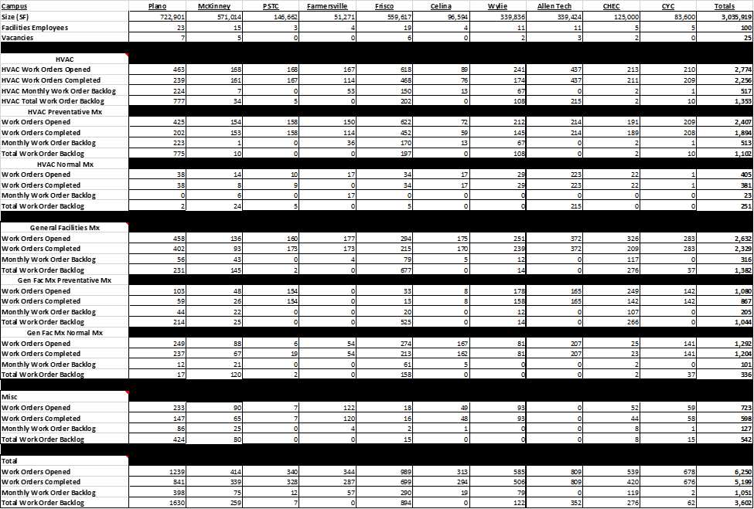

Each and every one of the work orders performed by the Facilities and Grounds department either directly or indirectly supports the mission and vision of the College. Examples of direct support include operating and maintaining the HVAC systems to ensure conditioned spaces for student and staff to have class and conduct business. indirect support would include work orders like Facilities Department Safety Training to ensure that staff are trained to adhere to the most current safety requirements, improving productivity and preventing lost time due to injury.

The Facilities and Grounds Department supports the Collin College 2020-2025 Strategic Plan in very similar fashion. The Operations and Maintenance of new and existing Campuses and Facilities is in direct support of the multiple strategic goals. Specifically, it supports Strategic Goal #1 “Improve student outcomes to meet or exceed local, state, and regional accreditation thresholds and goals.” By ensuring that College facilities meet all accreditation requirements as well ensuring that district facilities and grounds provide an environment conducive to learning to allow student outcomes to be improved. Without properly functioning and maintained facilities, it would be nearly impossible to accomplish this goal. Additionally, the day to day efforts of the Facilities and Grounds personnel directly support Strategic Goal #2 “Develop and implement strategies to become a national exemplar in program and student outcomes.” To become a national exemplar in program and student outcomes requires at minimum fully functional, safe, and comfortable facilities and campuses, which is not possible without the work performed by this department. Strategic goal #4 “Implement the third Baccalaureate degree by Fall 2022 and continue adding 2+2 programs with university partners.” is accomplished via the newest Baccalaureate program, Construction Management, which is in large part conducted at the Allen Technical Campus. This campus’s facilities, which opened in Aug 2020, is fully operated and maintained by Facilities and Grounds personnel.

1. **Why do we do the things we do?**

The primary functions of the Facilities and Grounds Department are to provide emergency, routine, scheduled, and preventative maintenance on Facility and Building systems as well as District Grounds. Additionally, the Facilities Department is responsible for Facility operations, to include contracted custodial services. The Facility Department executes Facility Operations on a Daily Basis to support the students, staff, and visitors to Collin College. The purpose of this effort is to ensure the facilities are conducive to learning and support a staff and student experience that allows for excellence and achievement.

Over the previous 5 years, the Facilities and Grounds department has continued to improve its day to day operations as well as its management and oversight. As the College has grown, from 1.7 million square feet of facilities in 2017 to 3.04 million square feet of facilities in 2022, it has also needed to increase facilities and grounds staffing, funding, and improve processes. Specifically, the staffing has increased by 35 personnel to address the additional square footage at the both the existing campuses and the 4 new campuses. Further, as the number of campuses increased, the need for common standards and procedures was identified. Starting in 2020, the Facilities and Grounds Department began issuing Standards Operating Procedures (SOPs). As of July, 2022, 22 separate SOPs have been created and enforced. Additional SOPs continue to be developed. Furthermore, to ensure standardization and adherence to standards, both legal/regulatory and SOPs, a standard Campus Facilities organization chart and responsibility delineation was established.

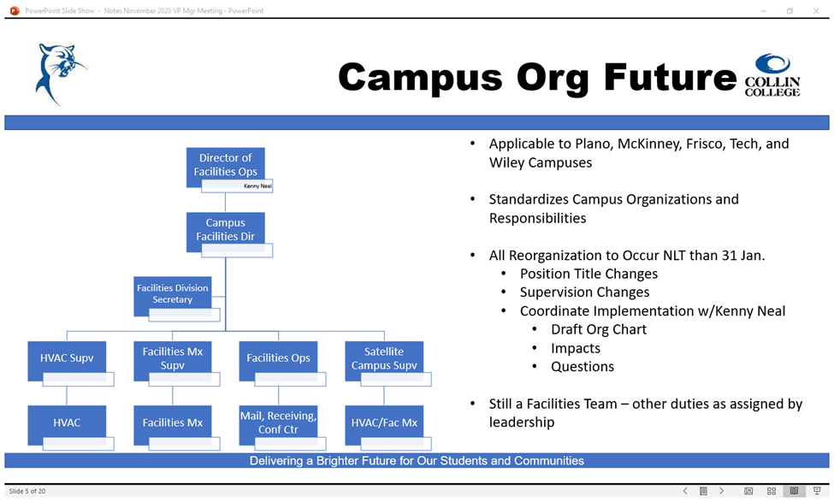

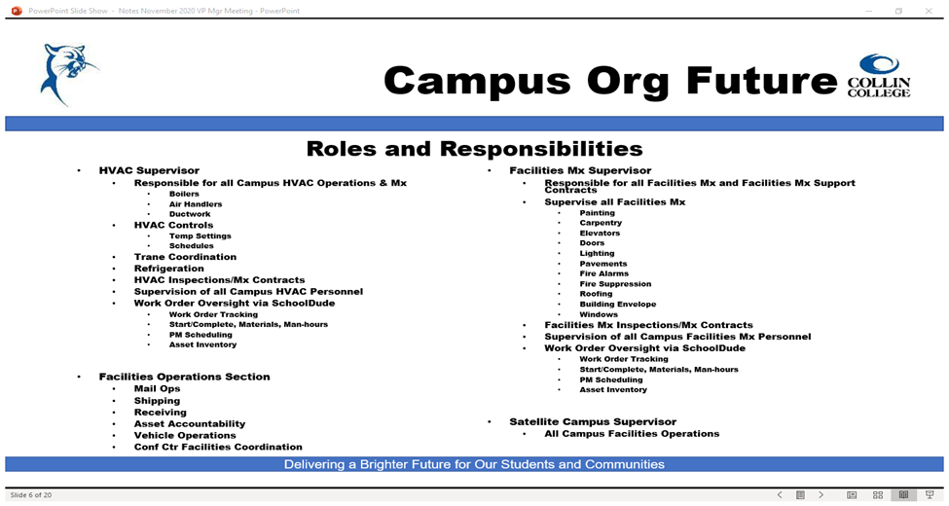

If Facilities and Grounds functions were no longer provided, the effect on the College would be catastrophic. Without these functions being accomplished on a daily basis, not only would the College facilities be uncomfortable, non-functional, and unpleasant aesthetically, the facilities and grounds would be unsafe and possibly illegal to occupy and utilize. If a facility does not meet specific safety and regulatory requirements, the facility may have its occupancy certificate revoked by the local municipality. This would make it impossible for the College to execute its mission. The College could outsource the Facilities and Grounds department functions; however, it would come at great risk. Specific risks include increase costs, lack of oversight, and poor asset management. The largest risk associated with differing goals between the College, which is here to excel in the education of students, whereas the contracted Facility Service Provider would prioritize profitability over students.

As can be seen on the monthly Facilities and Construction Division Monthly Data report, the Facilities and Grounds department expends the most resources on providing maintenance services. This is true both for funding and staffing resources. Resourcing maintenance efforts at this level is in alignment with the impact of this service on the College as maintenance efforts are clearly the most important thing that Facilities and Grounds accomplish. Without proper maintenance, the College would not be able to utilize its facilities in a safe and efficient manner, jeopardizing the existence of College. For example, per the Code of Ordinances City of Plano, <https://library.municode.com/tx/plano/codes/code_of_ordinances?nodeId=PTIICOOR_CH6BUBURE_ARTIINGE>;“All buildings, both existing and new, and all parts thereof, shall maintain minimum standards for continued use and occupancy in accordance with article III ‘property maintenance code’”. The maintenance performed by the Facilities and Grounds Department ensure that Collin College continues to maintain the standards required for continued occupancy and use as required by code.

To successfully execute critical tasks, the Facilities and Grounds coordinate with other Collin College organizations to ensure minimal disruption to the College Operations. Specifically, the Campus Facility Managers are mandated by the VP of Facilities and Construction and the Director of Facilities to have weekly meeting with the IT department to deconflict any work, projects, and to discuss needs. Additionally, the Campus Facility managers meet regularly with the Campus Provosts to ensure the Provost is aware of ongoing maintenance operations and issues, and to ensure the Facilities and Grounds are meeting the needs of the Campus leadership. Furthermore, the VP of Facilities and Construction has monthly meetings with Campus Provosts to synchronize efforts and ensure the Division, to include the Facilities and Grounds department, are meeting the Provost’s requirements. There are also established relationships and processes between the Facilities and Grounds Department and the Purchasing Department to ensure supplies, materials, and outside vendors are procured in a timely and efficient manner. Furthermore, as the VP of Facilities and Construction reports to the Chief Financial Officer, coordination for funding requirements of the department takes place on a near daily basis.

The Facilities and Construction Division has a significant portion of the College’s budget as can be seen in the charts below (from the Collin College Annual Budget for FY22; <https://www.collin.edu/financials/pdfs/FY22%20Budget%20Book%20Final%20Copy.pdf>). As a portion of the division, Facilities and Grounds need to operate as efficiently as possible in order to best serve the College and the Community. Like any organization, there are always opportunities to improve efficiency, however continuing to utilize the principal of prioritizing safety and legal requirements, emergencies, and preventative maintenance are the most efficient way of executing the department’s responsibilities. There are specific areas within the Facilities and Grounds Department that can be more efficient: the tracking of work orders, equipment maintenance data, a further defining a department roles, responsibilities and expectations, and improved standardization across the department and Campuses. These areas will be addressed in the CIP.

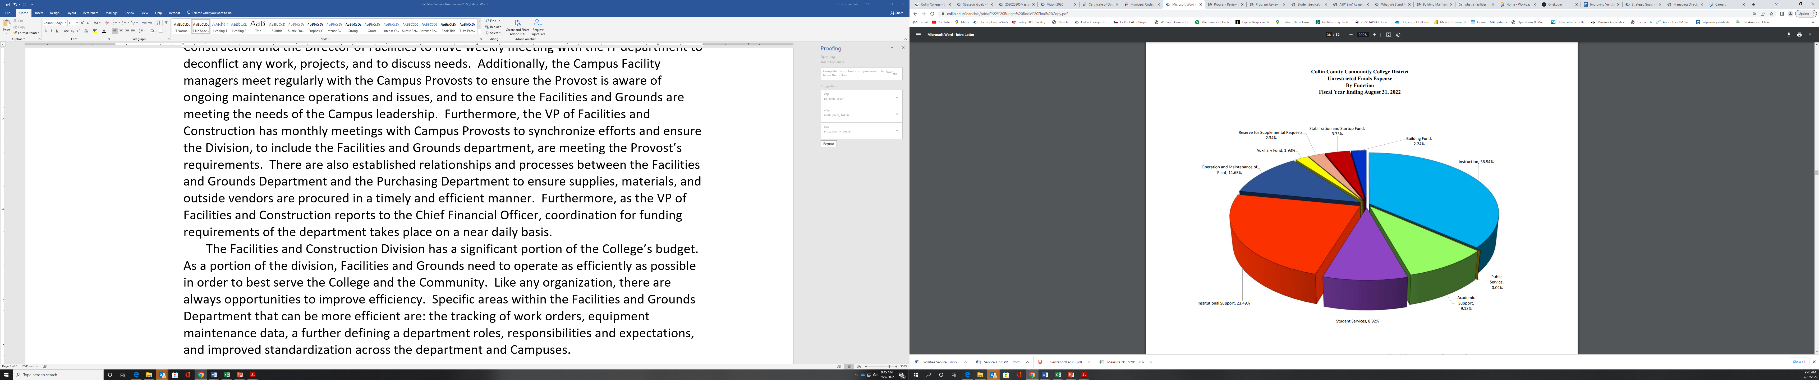

The Facilities and Construction Division is constantly benchmarking itself against other Higher Education institutions in order to find more efficient or effective ways of accomplishing its mission. The VP of Facilities and Construction established an email distribution list of Peer Texas institutions Facility and Construction Leadership personnel to further collaborate and assist each other. One Specific result was the ability to compare Collin College to Tarrant County Community College organizational data; the resulting chart is below. This chart shows similar levels of responsibility, though Tarrant College is approx. 33% physically larger than Collin College. However, the number of full-time facilities personnel is significantly different, and the Computerized Maintenance Management System (CMMS) is also different. After a review of its existing CMMS, Collin College is now actively pursuing a different system in order to address a number of School Dude shortfalls as well as increase efficiency in day to day operations.





Additionally, the Facilities and Grounds Department was tasked to compare additional comparable colleges and reviewed San Jacinto College and El Paso Community College Facilities departments and determined the following:

* San Jacinto College (Site Link): https://www.sanjac.edu/about-san-jac/facilities-services
* El Paso Community College (Site Link): https://www.epcc.edu/Administration/PhysicalPlant

Upon review, it was determined that Collin College Facilities and Grounds Department is much more in line with El Paso Community College Facilities Department as opposed to San Jacinto College. Unlike El Paso Community College, the Collin College outsources Energy Management. Collin maximizes in-house workforce usage; however, it supplements some highly technical maintenance and repairs due to the requires specialization or significant operational equipment requirements. Additionally, Collin it outsources, via contract, custodial and other facility service functions where services are predictable, measurable, and competitively priced to free up in-house labor for more technical or unpredictable requirements. This is done to maximize the budget effectiveness of Facilities, Construction, Emergency Management and Safety budgets. The San Jacinto College Facilities Department performs 50 to 75% service in-house. It's accomplished with their staff of full-time employees and contracted vendors.

This Department led review validated the types of services outsourced and further validated scopes and roles and responsibilities of the Collin College Facilities and Grounds Department.

1. **How do we impact student outcomes?**

The Facilities and Grounds Department have significant impact on student outcomes, though often indirectly. The Facilities and Grounds department most important impact on student outcomes is the proper operation and maintenance of facilities utilized by faculty and staff to provide students instruction. Through department provides fully functional, comfortable, and effective classrooms, labs, student support areas, counseling, conference centers, and grounds. Without the Facilities and Grounds department performing its duties, those same facilities and instruction spaces would not be inviting, functional, comfortable, or conducive to learning and growth.

There are multiple studies and reports that detail the impacts facilities can have on student success. From the Texas Association of School Boards, <https://www.tasb.org/members/enhance-district/school-facilities-student-achievement/#:~:text=Investing%20in%20facilities%20can%20add,include%20improved%20morale%20and%20instruction>, “Investing in facilities can add up to better student health, attendance, behavior, and achievement. For teachers, the benefits include improved morale and instruction.”, and “A 2007 study, The Relationship Between School Building Conditions and Student Achievement at the Middle School Level in the Commonwealth of Virginia, is one of many that has found that student achievement is connected to a building’s condition. Students perform better in newer or recently renovated buildings than they do in older buildings.”

Additionally, facility and grounds efforts affect enrollment and retention. From APPA (formerly the Association of Physical Plant Administrators) (<https://www1.appa.org/FacilitiesManager/article.cfm?ItemNumber=4184&parentid=2725>), “Failing buildings and infrastructure also threaten enrollment. Students are deeply influenced by their first impression of a campus; multiple surveys of college-bound students point to the campus visit as the most significant factor in choosing an institution. APPA’s own research reveals that roughly a quarter of prospective students will reject a college or university if they consider an important facility inadequate, and about 15 percent will reject an institution if an important facility is poorly maintained. (“Important facilities” are generally those related to a student’s major.)” As the above two examples show, the Facilities and Grounds Department perform critical services that affect student accomplishment, enrollment, and retention.

As can be seen in theFacilities and Grounds Results From the Service Unit Survey Report Faculty & Staff 2020 (<file:///J:/Facilities%20Construction/VP%20Facilities%20&%20Construction/program%20review/SurveyReportFacultyStaff2020.pdf>), Facilities and Grounds scores well on their performance and overall satisfaction.

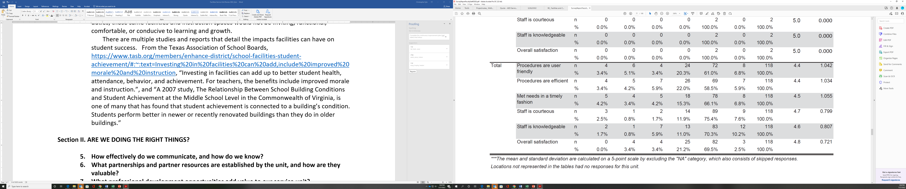

These scores show that the Faculty are generally satisfied with the department’s efforts. Unfortunately, there are no survey results available from the most recent Student Survey in 2021 or 2019, so it is difficult to assess direct impacts on Students from their perspective.

**Section II. ARE WE DOING THE RIGHT THINGS?**

1. **How effectively do we communicate, and how do we know?**

Unlike many other Service Units or Academic Units in the College, the Facilities and Grounds department do not publish literature or brochures on a regular basis. The Department does communicate outages and work status with the Provost, and as necessary with other impact organizations. Typically, those organizations will then coordinate with the Campus populace or Campus Leadership regarding any operational impact. In the event of a facility system outage or emergency, the department coordinates directly with the Campus leadership as well as the Facilities and Construction Division leadership.

For routine information, the Facilities and Grounds department utilizetheirwebsite found at <https://www.collin.edu/facilities/>. This webpage allows Faculty, Staff, and Students to gain initial access to the campus facilities department work order system allowing work requests to be submitted. Website monitoring and maintenance is the responsibility of the Assistant Director of Facilities Operations.

Facilities and Grounds Web Info:

|  |  |  |  |  |
| --- | --- | --- | --- | --- |
| Title | Type (i.e. URL, brochure, handout, etc.) | Date of Last Review/Update |  | Responsible Party |
| Facilities and Construction plus Emergency Management and Safety Department Home Page | https://www.collin.edu/facilities/ | 8/1/2021 | Current Accurate Relevant Available | Assistant Director of Facilities Operation |
| Forms | http://www.collin.edu/facilities/forms.html | 8/1/2021 | Current Accurate Relevant Available | Assistant Director of Facilities Operation |
| Key Request | http://inside.collin.edu/facilities/pdf/Key%20Request%20Form%202019.pdf | 8/1/2021 | Current Accurate Relevant Available | Assistant Director of Facilities Operation |
| Work Request Instructions | http://www.collin.edu/shared/shared_facilities/pdf/SchoolDude_Instructions.pdf | 8/1/2021 | Current Accurate Relevant Available | Assistant Director of Facilities Operation |

1. **What partnerships and partner resources are established by the unit, and how are they valuable?**

|  |  |  |  |
| --- | --- | --- | --- |
| Partner/Organization | Description | Formal Agreement Duration,  if any | Briefly explain the Partnership's Value to Service Unit |
| AECOM | 2017 Bond Program Manager | 5-year agreement with 1-year renewal option | Provide program management of the May 6, 2017, bond election of $600 million. |
| Trane Mechanical | Performance Agreement for Comfort from Trane (PACT) | 10-year agreement | Energy-saving performance contract to measure and identify energy savings across the five legacy campuses. |
| Gordian | Job Order Contract (JOC) Service Provider | 5-year agreement with 1-year renewal option | Helps Collin College prioritize investments, plan projects to maintain and operate facilities. |
| Multiple Local Service Contractors | Elevator, Fire Systems, Electrical, Plumbing, Roofing, Mechanical Systems | 5-year agreement with a 1-year renewal option | Procure inspection, maintenance, and repair services to ensure the District complies. |
| Information Technology (IT) and Campus Police | Campus Safety | Click or tap here to enter text. | The three departments work closely together to monitor and repair any Building Access issues. |

1. **What professional development opportunities add value to our service unit?**

**Professional development of Facilities and Grounds Department personnel is critical to ensure skills are maintained and upgraded in order to effectively and efficiently maintain and operate the College’s facilities and grounds. There are a wide variety of professional development opportunities and providers. The below table shows just some of the professional development options recently utilized. The attached Spreadsheet shows some of the Employee Professional Development Activity in the last 24 months.**



|  |  |  |  |
| --- | --- | --- | --- |
| Employee Name | Role in Unit | Professional Development Summary | How is it Valuable to the Unit? |
| See attachment (Exhibit A) Facilities Employee Training List | Staff, Supervisor, and Manager | • Trane Ensemble Basics  • Trane Ensemble Intermediate  • Trane Ensemble Advanced – To include Box Tuning/Calibration  • Chiller Operations Overview for SCC’s 770s  • Chiller System Internal PM’s – Cleaning Strainers, etc...  • VFD Basics  • VFD Intermediate  • Chemical Treatment and Understanding of Pitting, Fouling, Failure, Trending, etc.… | Training to improve asset longevity |
| See attachment for list of names | Individual Campus leads at each Campus | Microsoft PowerPoint Training through Linkedin Learning | Present Monthly job accomplishment to Vice President of Facilities and Construction |
| See attachment for list of names | Staff, Supervisor, Manager, and Director | HR Professional Development | Establish a more productive employee and well-run Facilities Operation |
| See attachment for list of names | Collin College District Facilities Administrators | APPA Basic Tools for Facilities Supervisors is tailored for educational facilities administrators, framing proven management principles within facilities operations. | Streamline supervisor productive, efficient staff and a well-run facilities operation. |
| All staff are provided opportunities for professional development, particularly if it will improve their understanding and effectiveness for their job.  Directors and managers in the past have utilized these Human Resource Leadership Academy Programs to increase knowledge and skills and pass the knowledge on to staff. Many Junior staff members were able to transition into supervisory roles after taking  advantage of these programs. The current success of these Human Resources training and evaluation programs has been beneficial. | | | |

**The below slide was distributed to Facilities and Grounds Department Leadership on 4 Jan, 2021. Leadership was encouraged to support professional development. Furthermore, Facilities and Grounds Budgets all include a $1000 per person professional development line item. Since then the department has had multiple personnel utilize the Tuition Reimbursement and Credential Reimbursement.**

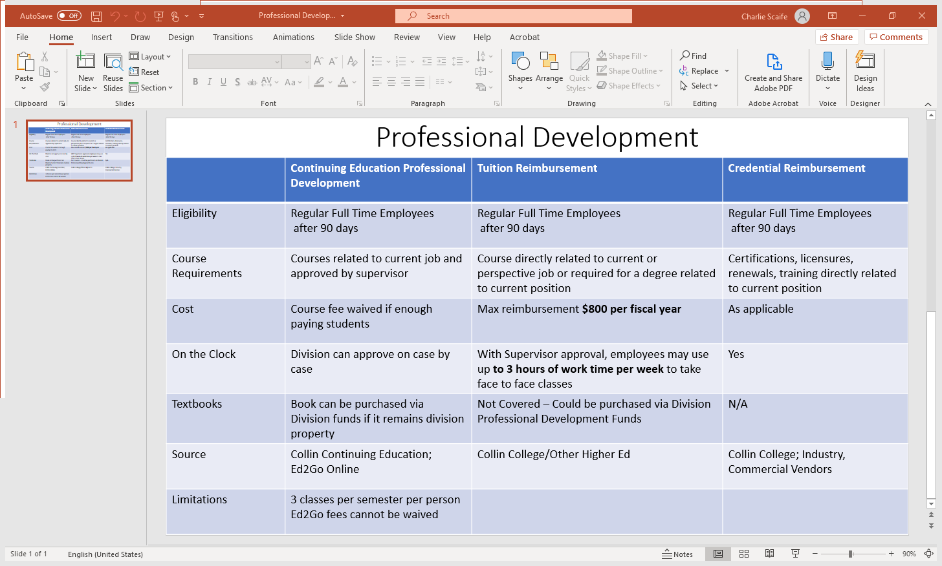

**Section III. CONTINUOUS IMPROVEMENT PLAN (CIP)**

1. **How have past continuous improvement plans contributed to success?**

The 2017-18 Facilities and Grounds CIP is embedded below.



The CIP above lists three Expected Outcomes: Faster Response Time to Work Orders, Better Customer Service, and Ability to manage a higher level of renewal replacement with less staff and more campuses by using training and technology. Due to significant personnel changes (retirements, separations, terminations), the current leadership of the Facilities and Construction Division and the Facilities and Grounds department were not aware of the existence of the above CIP until writing this program review. As would be expected in such a high-turnover environment, little to no effort was put into the utilizing the above CIP. There were no known metrics or tracking mechanisms put in place to determine baselines and improvements to the above expected outcomes.

1. **How will we evaluate our success?**

The Facilities and Grounds Department has a number of strengths and weaknesses that have been identified in this document. Strengths include a dedication to duty and accomplishment of mission, meeting all legal and regulatory requirements for facility operations, development and issuance of SOPs. To capitalize on these strengths the department will continue to prioritize safety and legal requirements, emergencies, and preventative maintenance as well as emphasizing customer service throughout the organization. Future Services Unit Surveys will be used to benchmark any significant changes is customer service and overall service success.

Weaknesses include the need for improved the tracking of work orders, equipment maintenance data, a further defining a department roles, responsibilities and expectations, and improved standardization across the department and Campuses. To mitigate the weakness, the Facilities and Grounds Department is pursuing upgrading its CMMS system, and hiring a CMMS manager to help with both the tracking and standardization of work order data as well as equipment maintenance data. The Facilities and Construction Division has drafted a Delineation of Responsibility document that details what each College organization’s responsibilities and expectations are, in an effort to improve coordination and expedite execution of requirements. This document needs to be coordinated with College stakeholders and approved by senior leadership. The intent of this document is to solidify which organization, department, etc, is responsible for funding, coordinating, and executing a wide variety of Facilities and Facilities related items, as well as equipment maintenance and operations and Operational requirements. Lastly, the Facilities and Grounds Department has identified and continues to identify needed SOPs. The Department will continue to develop and distribute new SOPs as well as refine existing SOPs in order to ensure requirements are met and productivity is maximized. A more productive and efficient Facilities and Grounds Department ensures resources are distributed wisely, the Campus are fully compliant, functional, well maintained, and supportive of an exemplary learning environment.

List of SOPs required as identified by the Facilities and Grounds Department:

1. **Complete the continuous improvement plan (cip) tables that follow.**

**Table 1. CIP Outcomes, Measures & Targets Table (focus on at least one for the next two years)**

|  |  |  |
| --- | --- | --- |
| **A. Expected Outcomes**  **Results expected in this unit**  **(Authorization requests will be completed more quickly; Increase client satisfaction with our services)** | **B. Measures**  **Instrument(s)/process(es) used to measure results**  **(sign-in sheets, surveys, focus groups, etc.)** | **C. Targets**  **Level of success expected**  **(80% approval rating, 10 day faster request turn-around time, etc.)** |
| **Purchase and implement new CMMS system to accurately track work orders and equipment maintenance data.** | **Status of CMMS purchase, implementation and utilization.** | **100 % completed CMMS purchase, implementation and utilization by all Facilities and Grounds Personnel; utilized for monthly reports and tracking purposes as validated and utilized by** **the VP of Facilities and Construction.** |
| **Develop and distribute new SOPs in order to ensure requirements are met and productivity is maximized.** | **Number of SOPs developed and distributed after Aug 1, 2022.** | **One new SOP developed and distributed per month after Aug 1, 2022, validated by the VP of Facilities and Construction.** |
| **Develop and implement Delineation of Responsibility document.** | **Develop and implement Delineation of Responsibility document.** | **A coordinated and approved Delineation of Responsibility document developed and implemented validated by the VP of Facilities and Construction..** |

**Continuous Improvement Plan**

**Outcomes might not change from year to year. For example, if you have not met previous targets, you may wish to retain the same outcomes. You may add short-term administrative, technological, assessment, resource or professional development goals, as needed. Choose up to 2 outcomes from Table 1 above to focus on over the next two years.**

**A. Outcome** -Result expected in this unit (from column A on Table 1 above--e.g. Authorization requests will be completed more quickly; Increase client satisfaction with our services).

**B. Measure** -Instrument(s)/process(es) used to measure results (e.g. surveys, test results, focus groups, etc.).

**C. Target** -Degree of success expected (e.g. 80% approval rating, 10-day faster request turn-around time, etc.).

**D. Action Plan** -Implementation of the action plan will begin during the next academic year. Based on analysis, identify actions to be taken to accomplish outcome. What will you do?

**E. Results Summary** - Summarize the information and data collected in year 1.

**F. Findings** - Explain how the information and data has impacted the expected outcome and unit success.

**G. Implementation of Findings** – Describe how you have used or will use your findings and analysis of the data to make unit improvements.

**Table 2. CIP Outcomes 1 & 2**

|  |  |
| --- | --- |
| 1. **Outcome #1** Click or tap here to enter text. | |
| 1. **Measure (Outcome #1)**   Click or tap here to enter text. | 1. **Target (Outcome #1)**   Click or tap here to enter text. |
| 1. **Action Plan (Outcome #1)**   Click or tap here to enter text. | |
| 1. **Results Summary (Outcome #1) TO BE FILLED OUT IN YEAR 2** | |
| 1. **Findings (Outcome #1) TO BE FILLED OUT IN YEAR 2** | |
| 1. **Implementation of Findings (Outcome #1) TO BE FILLED OUT IN YEAR 2** | |

**Table 2. CIP Outcomes 1 & 2 (continued)**

|  |  |
| --- | --- |
| 1. **Outcome #2** Click or tap here to enter text. | |
| 1. **Measure (Outcome #2)**   Click or tap here to enter text. | 1. **Target (Outcome #2)**   Click or tap here to enter text. |
| 1. **Action Plan (Outcome #2)**   Click or tap here to enter text. | |
| 1. **Results Summary (Outcome #2) TO BE FILLED OUT IN YEAR 2** | |
| 1. **Findings (Outcome #2) TO BE FILLED OUT IN YEAR 2** | |
| 1. **Implementation of Findings (Outcome #2) TO BE FILLED OUT IN YEAR 2** | |

**What happens next? The Program Review Report Pathway**

1. **Following approval by the Steering Committee,**

* Program Review Reports will be evaluated by the Leadership Team;
* After Leadership Team review, the reports will be posted on the Intranet prior to fall semester;
* At any point prior to Intranet posting, reports may be sent back for additional development by the unit.

1. **Unit responses to the Program Review Steering Committee recommendations received before July 31st will be posted with the Program Review Report.**
2. **Leadership Team members will work with program supervisors to incorporate Program Review findings into planning and activity changes during the next five years.**

**Please make sure to go back and complete your Executive Summary at the start of the Review.**