Section I. ARE WE DOING THE RIGHT THINGS?
- What is the service unit and its context?
Collin College Facilities and Construction Department's vision is to provide facilities excellence, value, and leadership to deliver a brighter future for our students through facilities operation, maintenance, and construction. The department stewardship offers the best teaching and learning environments for Collin College students, faculty, staff, and the surrounding communities. Facilities and construction use the latest training and industry standards to establish and maintain preventive and service maintenance programs, building and related equipment repairs, grounds maintenance, custodial, purchasing, inventory control, space planning, and renovation projects. Budget/financial planning, utility monitoring, energy management, and 24-hour safety monitoring for service optimization of district-wide facilities.
- Why do we do the things we do? Unit relationship to the College Mission & Strategic Plan
The Collin County voters' approval and belief in the Collin College District demonstrated by passing the $600 million bond referendum in 2017. They allowed the District to fund the Facilities Master Plan, which will accommodate the projected population growth in Collin County over the next two decades. Through the community approval and belief, the District has continued to invest in a service-oriented Facilities and Construction Department dedicated to the success and satisfaction of Collin College students, faculty, staff, and surrounding communities.
The following examples show capital improvements since 2016 to serve the growing student population:
• McKinney Campus: Cary Israel Health Science Center 125,000 sq. ft. Facility
• McKinney: PSTC 128,000 sq. ft. Fire Science and Law Enforcement Center
• Renovation of 176 bed Student Housing Complex
• Allen Technical Campus 340,000 sq. ft. Facility with a student capacity of 7,100
• Wylie Campus 340,000 sq. ft. Facility with a student capacity of 7,500
• Farmersville Campus 52,000 sq. ft. Facility opening Spring 2021
• Celina Campus 95,552 sq. ft. Facility opening Fall 2021
• Frisco IT Center 91,680 sq. ft. Facility opening Fall 2021

Under the vice president of Facilities and Construction, the department is charged with building, operating, maintaining, and supporting quality facilities, grounds, and services for students, faculty, and staff. The department use data and program research to develop plans that helped expand the physical footprint of Collin College to help meet emerging and programmatic needs.

- Why do we do the things we do?

- The Facilities and Construction Department's purpose is to provide day-to-day physical plant operation, maintenance, and campus grounds while being student-centered and seeking to achieve the college's missions, goals, and objectives.

- In the past five (5) years Facilities Management has evolved from having one level of leadership (Director of Facilities & Construction) who reported to the district CFO to having three leadership levels (Vice President of Facilities & Construction, Director of Facilities, Director of Construction) with the Vice President reporting directly to the President. This needed change is directly related to the College student, faculty, and staff increasing population as well as the physical footprint of additional campuses.

- Facilities Maintenance is the process of increasing the utility of campus buildings by regularly servicing capital assets and or areas around a building. Capital assets include machinery, equipment, offices, classrooms, hallways, parking lots and garages. Campus assets are always subject to constant wear and tear. When equipment fails occupant production or performance will be affected. If a building becomes a hazard to its occupants due to natural or man-made causes the college suffers.
Outsourcing may be more cost effective in the short term but there are restrictions to working with contractors. There is an obvious lack of control because of the inability to directly manage, set tasks and instruct the workforce. In-house maintenance has more years of service at a campus vs a contractor and therefore a higher understanding of the business and the College expectations. Bringing in outside contractors for maintenance can potentially create property and cyber security risks. Equipment downtime impacts employee productivity so having in-house staff available to deal with problems as soon as they occur has a significant advantage on response time.

- How do we impact student outcomes?

- COVID-19 has been the most considerable impact on the Facilities and Construction Department. Maintaining facilities' health and safety falls into this department's realm, and COVID-19 is a fluid situation that requires agility and proactive measures. The department's aggressive steps to help mitigate the spread of coronavirus (COVID-19) include making hand sanitizer available in all common areas, bathrooms, lobbies, and check-in areas—enhanced cleaning and sanitizing of all buildings, including all common areas and individual spaces. Increase the frequency and scope of cleaning of frequently touched surfaces throughout the workplace, including increasing the use of disinfectants on all high traffic areas, such as door handles, elevator call buttons, faucets. Fast-tracked an HVAC System Bipolar Ionization and Ultra-Violate Lamps project to improve interior building air quality. We post informative guides on proper hand-washing to ensure sanitization, maintaining continuous and accurate communication on additional measures implemented during this dynamic situation. Facilities and construction implemented not just the CDC recommended standards, but additional response measures to provide the best health and safety practices possible for the physical, emotional, and environmental well-being of Collin College students, faculty, and staff. The department has been committed to getting the job done regardless of the hour, human resources available, or obstacles.

- Our motto of “Build and Maintain Excellence” has continued through this pandemic. The Facilities and Contstruction Department has continued to be courteous, innovative, well trained, and observant problem solvers. A district-wide facilities operation that promote high-quality environment achieved by providing maintained landscaping (aesthetics) conditioned heat/air for better air quality, prompt and scheduled building maintenance (for building durability), and timely mail service.
- Research shows that poorly maintained facilities affect student enrollment. A letter published by The Office for Civil Rights at the U.S. Department of Education stated in a 2014 Dear Colleague letter: "Structurally sound and well-maintained schools can help students feel supported and valued. Students are generally better able to learn and remain engaged in instruction. Teachers can better do their jobs in well-maintained classrooms that are well-lit, clean, spacious, and heated, and air-conditioned as needed. In contrast, when classrooms are too hot, too cold, overcrowded, dust-filled, or poorly ventilated, students and teachers suffer. Decades of research confirm that school facilities' conditions and qualities affect students, teachers, and overall academic achievement. In their review of the peer-reviewed literature, researchers at the Harvard School of Public Health concluded that "the evidence is unambiguous — the school building environment influences student health, thinking, and performance" (Eitland et al., 2017). Uncomfortable faculty cannot challenge student intellects or strengthen their character, as stated in the College mission statement. Uncomfortable students will be unable to fully develop their skills, which is also a part of the College mission statement. Collin College Facilities and Construction Department provides students, faculty, staff, and visitors a comfortable and stimulating environment for learning, teaching, and working.

Section II. ARE WE DOING THE RIGHT THINGS?

- How effectively do we communicate, and how do we know?
The Facilities and Construction Department solicit student, faculty, and staff feedback regarding the website and literature through the Biennial Survey. There we request scoring on a 5-point scale to tell us whether the website procedures are user-friendly.
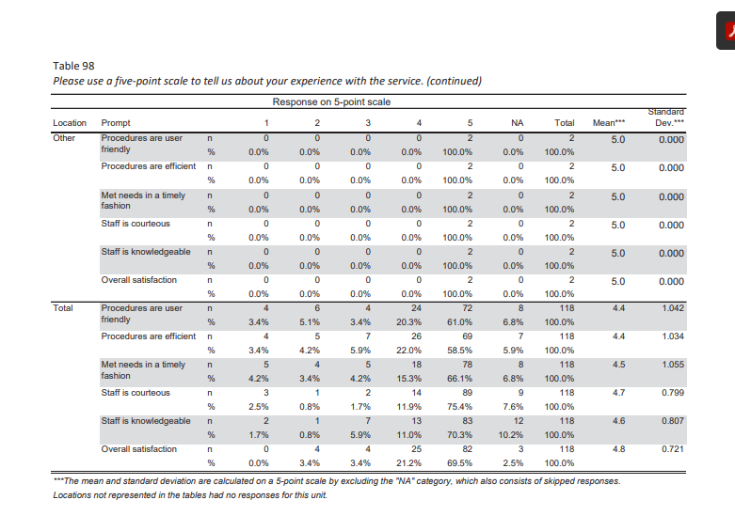
This feedback led the Facilities and Construction Department to correct outdated information on its site and use it to streamline improvements. For speed and consistency, one Point-of-Contact makes changes or updates to the site.

- " Facilities and Construction Department can benefit from using strategic alliances; it could be a method the department can use to bring about organizational change to take advantage of the changing external environment. This strategy would enable the Facilities and Construction Department to spread the risk of testing new technology and integrate the supply chain to gain a strategic alliance. One could argue the method would increase the chance of success during a strategic change program adapting to a changing market, one that is demanding increased energy management within FM." (Pitt, M., van Werven, M. & Price, S. The developing use of strategic alliances in facilities management. J Retail Leisure Property 9, 380–390 (2011). https://doi.org/10.1057/rlp.2011.2)
Campus Building Safety and Security - Value partnership exists between Campus Provosts, Facilities, Information Technology (IT), and the Collin Police Department with the Building Access Operational Guidelines' implementation. In this guidelines and Partnership, Collin College manages access to all buildings by limiting controlling the use and function of both access cards and keys issued to faculty, staff, students, and contractors. Limited access for each badge is based on the approved authorization of a faculty or staff member to enter locked academic and administrative buildings. Academic and administrative buildings on all Collin College campuses are open based on course schedules and planned activities within the semester. Campus hours are established by the campus Vice President/Provost and posted on the college's website. After-hours access to academic and administrative buildings is limited to faculty, staff, students, and contractors who have been adequately authorized in advance by their Authorized Signatory (as defined in Section 3.B. below) to enter a given building or set of buildings. For buildings used for public events after hours, the Facilities and Police personnel on site for the event are responsible for ensuring that the building is secured appropriately at the proper times. Information Services personnel (Office of the Chief Information Security Officer) manage the access card authorization at the system level. Currently, the Facilities Office personnel at each campus take photos and create the access badges for students, faculty, and staff, except for the Wylie and Technical Campuses, where Student Engagement personnel have that responsibility. During Fall 2020, the process for creating access badges will transition to Student Engagement at all campuses.
Additionally this Fall, the Collin Higher Education Center Facilities staff will transition the access badge process to the Human Resources office to become a part of the new employee's orientation. The Public Safety Training Center has their badging process for security purposes. (Collin College, Building Access Operational Guidelines, (2020))

- Collin College Facilities and Construction staff keep current and fulfill roles that advance the unit and the college through Professional Development programs offered by Collin College Human resources Department.
"
The Office of Human Resources and Organizational Development provides district-wide professional development programs, primarily for staff and administrators, and coordinates special events involving college staff and outside community organizations.
Contact this department if you need:
- Job-related training
- Training for your department
- If you have ideas for workshops that would be of interest for a large segment of the college district

Professional Development Guidelines for Regular Full-Time and Part-Time Faculty and Staff Guidelines Specific to Full-time Faculty and Staff:
- Eligible after a 90-day probationary period.
- Professional development courses must be related to the current job.
- Any class listed in the CE schedule is eligible if approved by your supervisor as to work-related.
- A maximum of three CE courses may be taken each semester. If more CE courses are needed, the employee's Vice President or Provost may approve by signing the registration form or emailing approval to Gen Northup.
- Books required for any course are to be paid for by the employee's department using the Textbook Charge Form.
Attending Continuing Education Classes:
If space becomes limited in a Continuing Education class, priority enrollments in the course are as follows:
- Paying community members are given the highest priority;
- Regular full-time college employees are placed next, followed by
- Regular part-time college employees.
If critical training is required for a regular part-time employee working less than 15 hours per week, the appropriate vice president or provost may approve the training.
If you are interested in any of the courses offered in the Continuing Education schedule of classes, please complete a Professional Development Continuing Education Registration Form and submit it to Gen Northup in Human Resources, Professional Development at the Collin Higher Education Center.
An employee is responsible for obtaining the instructor's signature and returning the signed Confirmation of Attendance to Human Resources within three days of the last class day. Confirmation of Attendance Form
Attending Ed2Go Classes:
If approved by the employee's supervisor, tuition for online Ed2Go classes will be paid from the department's budget. The employee will need to register for the course through Continuing Education and use a P-card for the purchase. A Professional Development CE Registration Form is not required.
Recently, the Vice President of Facilities and Construction sent out an email "one-slide Professional Development Opportunity slide. It asks managers to schedule with HR a visit by Genevieve Northup to go over Professional Development Opportunities with your teams." Genevieve (Gen) Northup is Collin College Professional Development Manager.
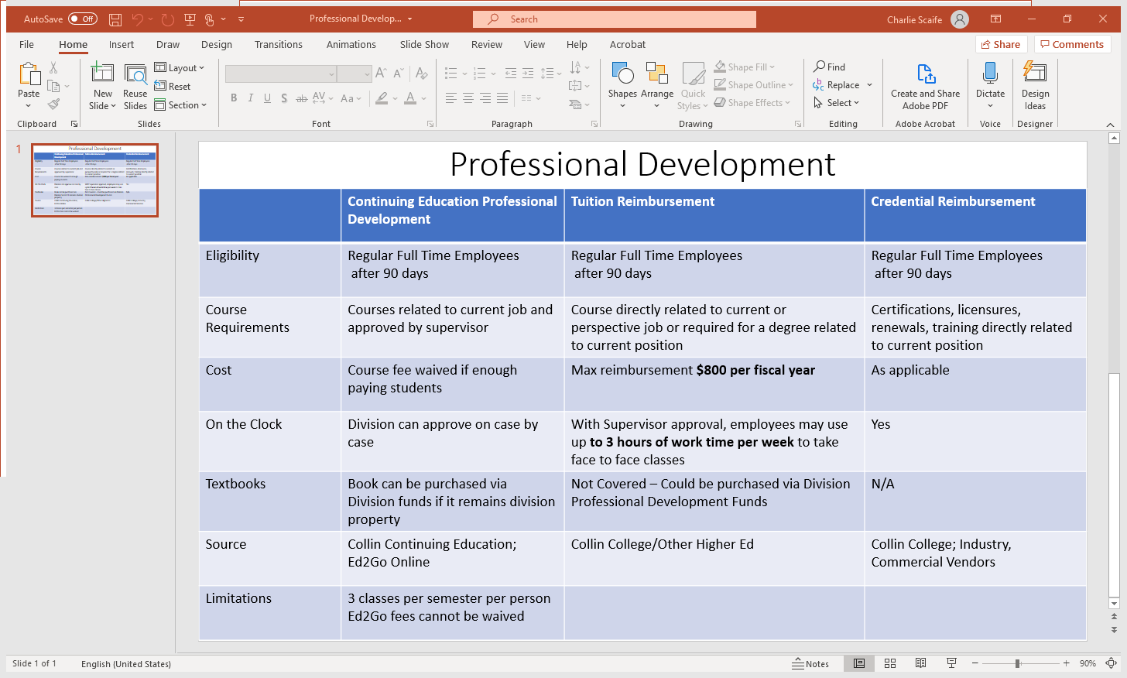
Directors and managers in the past have utilized these Human Resource Leadership Academy Programs to increase knowledge and skills and pass the knowledge on to staff. The Facilities and Construction Department will continue with the training provided to team members. A number of Junior staff members were able to tranisition into supervisory roles after taking advantage of these programs. The current success of these Human Resources training and evaluation programs has been beneficial.
- The voter's approval of a $600 million bond proposal has led to Facilities Departmental changes. In 2017, Collin College had seven locations (campus) throughout Collin County. Founded in 1985, Collin College has continued to grow each year and currently serves about 53,000 credit and continuing education students each year. The college now has seven locations throughout Collin County: Spring Creek Campus, Central Park Campus, Preston Ridge Campus, Allen Center, Courtyard Center, Collin Higher Education Center, and Rockwall Center. On May 6, 2017, voters approved a $600 million bond proposal to facilitate a long-range plan to accommodate the projected population growth in Collin County over the next two decades. The program consists of 4 new campuses, three new facilities (on existing sites), repurposing existing space projects, and wayfinding projects. The plan is to complete this program in 4 phases over seven years, with the Phase 1 projects concluding in the Fall of 2020 and Phase 2 projects ending Fall 2021.
Here are the Project Phases:
Phase | Location | Current Status
0 | Public Safety Training Center | Complete
1 | Wylie Campus | Closeout
1 | Technical Campus | Closeout
2 | Farmersville Campus | Construction
2 | Celina Campus | Construction
2 | Frisco Campus (IT Center) | Construction
3 | McKinney Campus (Welcome Center) | Design Development
3 | Frisco Campus (Additional Projects) | Programming

AECOM Contacted Services and Staffing includes Program Director, Wylie Campus Construction Manager, Celina, and Farmersville Campus Construction Manager. Program Controls, Design Management, Program Document Manager, Project Engineer(s) Scheduling, Cost/Estimating(PT) Programming Support (PT-Remote). As Program Manager, AECOM moved quickly to facilitate the college's long-range master plan, which provides programs and facilities to accommodate the projected population growth in Collin County over the next two decades. The bond issue carried the county, with more than 56 percent of voters in favor of the measure.
With the voter-approved $600 million bond referendum, the college has moved forward to construct several new facilities, including a public safety training center already under construction in McKinney. Other projects include a campus in Wylie, a technical center in Allen, educational centers in Celina and Farmersville, and an information technology center at the Preston Ridge Campus in Frisco.

"Retention of a management firm is a common practice for major building projects of this size and scope, to control costs, manage timelines, ensure quality and safety, and administer contracts," said Dr. Matkin. "AECOM has a stellar reputation, having worked for such clients as the One World Trade Center, the Kennedy Space Center, Los Angeles International Airport, The Lincoln Center for the Performing Arts, and educational institutions like the University of Texas System, Texas Tech University, El Paso Community College, the Dallas, Fort Worth and Houston ISDs, and many more. Collin College and the citizens of Collin County will benefit greatly from AECOM's experience and professional track record in project management."
Collin College District's growth sparked change in Facilities structure. This growth meant Facilities Administration and Campus Physical Plant would need to grow. The development includes adding personal at the newly formed campuses and realigning existing campuses. The administrator growth consists of the need for a Construction Department. Here is a look at the draft potential Facilities Department Organization.

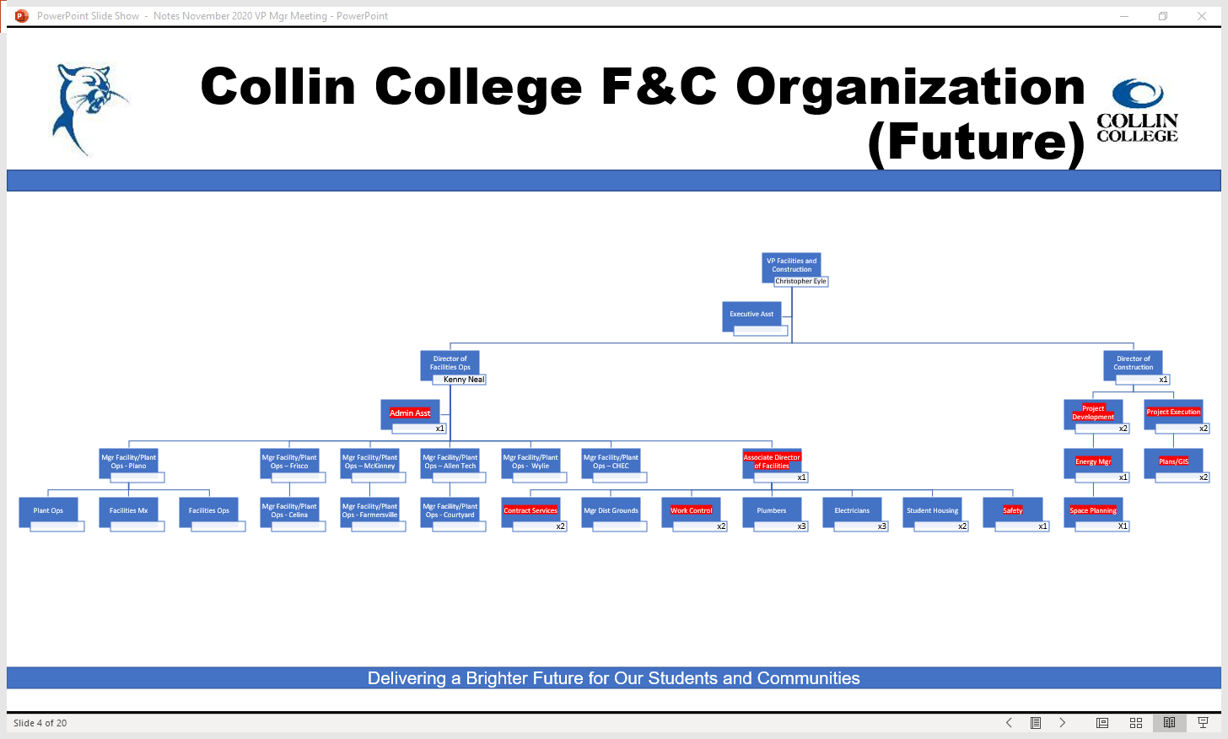

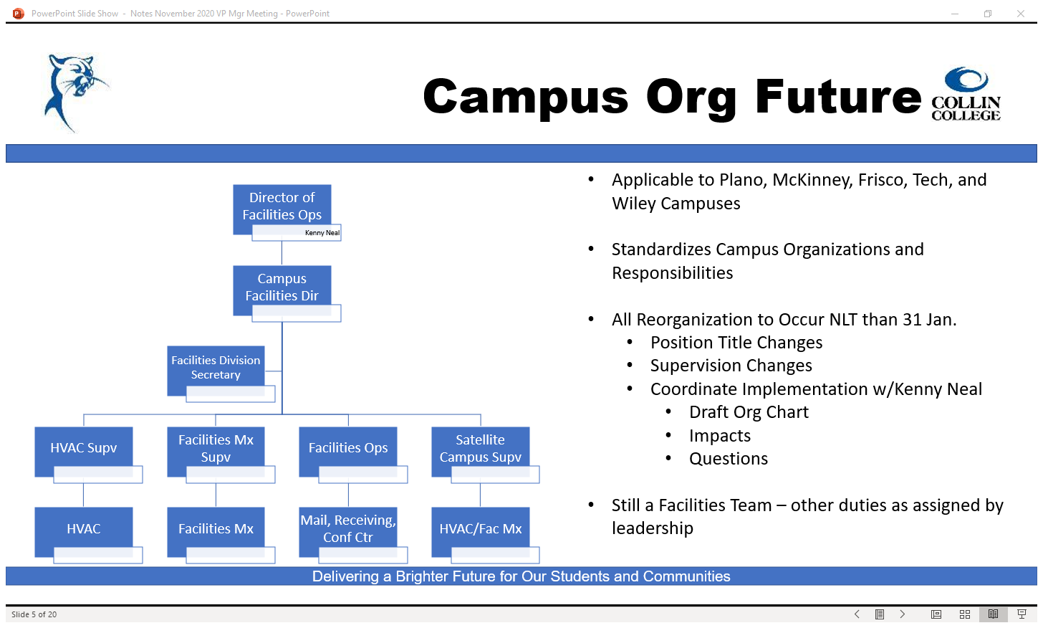
This proposed Campus Org Future is still in draft form and opens for discussion. The highlights are the title change of facilities manager to campus facilities director, with Human Resources approval. The proposed Future org chart attempts to standardize Facilities and Construction across all campuses and realign staff. There will always be "other duties as assigned" in each employee's job description, so they will continue to help in areas specified in their essential tasks. The Roles and Responsibilities aligning staff are in the chart below. The attachments are not all-encompassing. 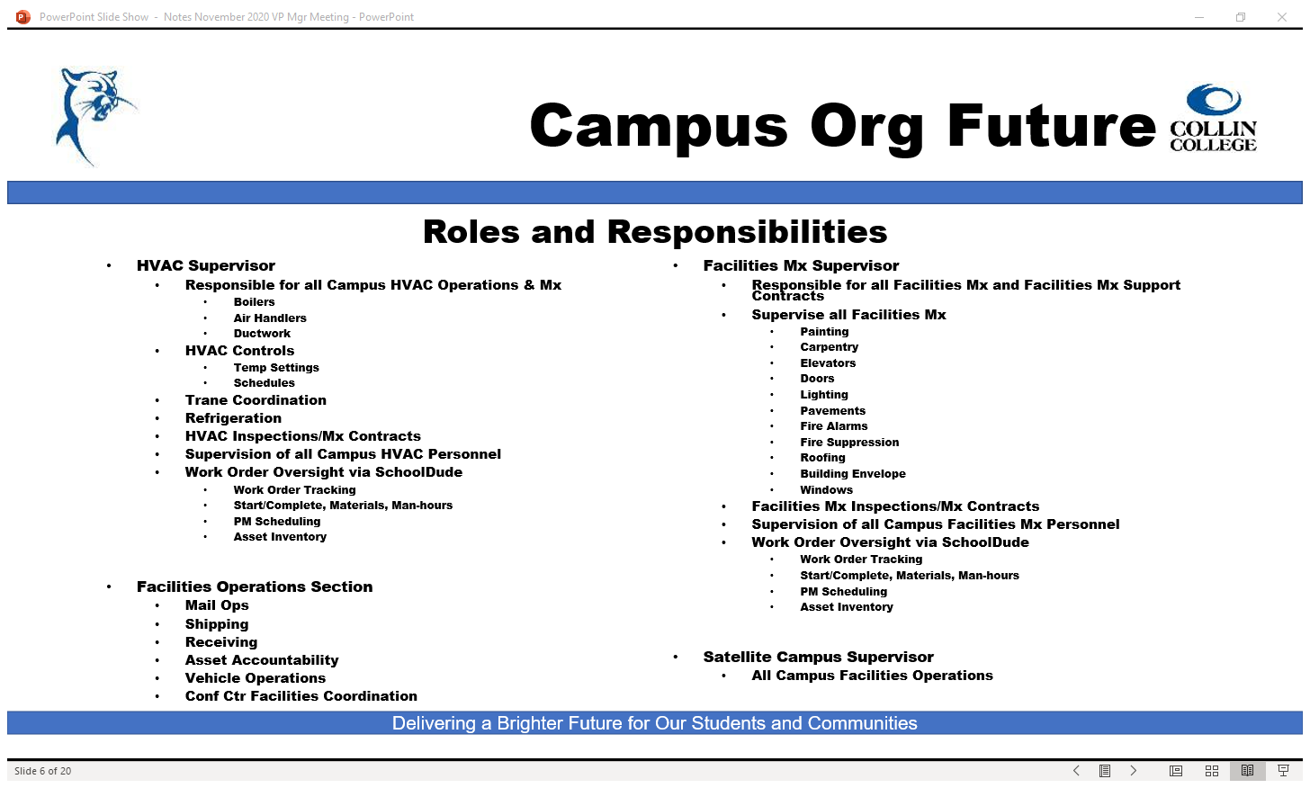

- Based on organizational change, the Facilities and Construction Department SACS Committee has chosen to discontinue utilizing the Schooldude Information previously provided on the previous Continuous Improvement Plan (CIP). We will use the Collin College Physical Plant and Grounds Services Unit Survey results going forward.

- The plan is to use the Collin College Physical Plan and Grounds Services Unit Survey Results to evaluate our success using the biennial survey Spring 2020.

