PROGRAM NAME: Electronics Engineering Technology | AUTHORING TEAM CONTACT: Yiping Wang
PHONE: 972 553 1181 | EMAIL:ywang@collin.edu

GUIDELINES
Time Frames
- Scope:
The time frame of program review is five years, including the year of the review.
Data being reviewed for any item should go back the previous four years, unless not available.
- Deadline Dates:
January 15th – Program Review Document due to Department Dean for review (Deans may require submissions at their own, earlier due date)
February 1st – Program Review Document due to Program Review Steering Committee
- Years:
Years 1 & 3 – Implement Action Plan of (CIP) and collect data
Years 2 & 4 – Analyze data and findings, Update Action Plan
Year 5 – Write Program Review of past 5 years; Write Continuous Improvement Plan (CIP) and create new Action Plan

LENGTH OF RESPONSES: Information provided to each question may vary but should be generally kept in the range
of 1-2 pages or 500-1,000 words.

EVIDENCE GUIDELINES: In the following sections, you will be asked to provide evidence for assertions made.
- Sources: This evidence may come from various sources including professional accreditation reviews, THECB, Texas Workforce Commission’s CREWS, Institutional Research Office (IRO), National Student Clearinghouse, IPEDS, JobsEQ, EMSI Career Coach, and may be quantitative and/or qualitative. If you are unfamiliar with any of these information sources, contact the Institutional Research Office at: effectiveness@collin.edu. Use of additional reliable and valid data sources of which you are aware is encouraged.
- Examples of Evidence Statements:
- Poor example: Core values are integrated into coursework. (Not verifiable)
- Good example: Core values are integrated into coursework through written reflections. (Verifiable, but general)
- Better example: Core values are integrating into coursework through written reflections asking the student to describe how s/he will demonstrate each of the core values in his or her professional life and demonstrated through service learning opportunities. (Replicable, Verifiable)

FOR MORE INFORMATION: The Program Review Portal can be found at http://inside.collin.edu/institutionaleffect/Program_Review_Process.html. Any further questions regarding Program Review should be addressed to the Institutional Research Office (effectiveness@collin.edu, 972.599.3102).

Introduction/Preface
☐EXECUTIVE SUMMARY
Briefly summarize the topics that are addressed in this self-study, including areas of strengths and areas of concern. (Information to address this Executive Summary may come from later sections of this document; therefore, this summary may be written after these sections have been completed.) Please do not include information in this section that is not already provided elsewhere in this submission. Using the questions in the template as headings in the Executive Summary can provide structure to the overview document (see below for suggested format).
Executive Summary (suggested sections/format-not required format)
What does our program do?
Why do we do the things we do: Program relationship to the College Mission & Strategic Plan.
Why we do the things we do? Program relationship to student demand.
Why we do the things we do? Program relationship to market demand.
How effective is our curriculum and how do we know?
How effectively do we communicate, and how do we know?
How well are we leveraging partnership resources and building relationships, and how do we know?
How have past Continuous Improvement Plans contributed to success?
How will we evaluate our success?

Complete the Executive Summary below after you have completed your review.
The AAS Electronics Engineering program is designed for students to obtain the associate degree in the field of electronics engineering in order to seek technician level jobs in the electronics manufacturing industry. The electives in robotics and electronics allow the graduates to select different pathways and seek employment as full time technicians in local semiconductor, electronics, and manufacturing sectors.

The electronics program offers hands-on projects to develop the required skill-set through application of concepts learned in the classroom. Team projects provide opportunity for peer learning and character building while challenging the students to think outside the box to solve the given problem within required parameters in order to learn the design, development, and testing cycle of the product.

The last five year enrollment pattern shows consistent enrollment and it is expected that this growth will continue as COVID situation improves. We have worked with our advisory board committee members to makeg curriculum adjustments as necessary to keep the program current. We have also met student needs in terms of class scheduling and better student/equipment ratios in the labs.

The demand for program completers is high in the DFW area and will continue to rise in coming years as more companies are moving in the area and the current technician population is aging. We are not able to meet this market demand currently and will probably stay short for more years.

The program was restructured to make the curriculum effective and current. It is comparable to Dallas College and Tarrant County College programs. The completion rate of our students is above 83%.

Many efforts have been in the last few years to communicate better with current students, potential students and the local employers about the program. College website, department website, and program brochures are updated on a regular basis. Changes in the catalogs are made anytime there is a change in the degree plan. Program brochures, flyers for tuition cost and BAAS pathways are displayed in the hallway boards where the program is housed. The brochures and information sheets are also accessible through department website to all current and potential students. Class presentations about the various options and pathways are made to educate the students. Portable stand-alone banners are used during the camps and open houses hosted by the department/campus to promote the electronics program and provide information about the low tuition rates and transfer opportunities to prospective families.

The program uses various methods to enlist local businesses to advance program success. Interactions with advisory board members, invitations to industry representatives for class presentations, industry tours by the students, campus open houses, career fair, exploration of internship/co-op opportunities, etc are some of the partnership activities that have occurred in the last four years.

The past CIP contributed significantly to our improvement. The equipment count matches with the class size now. It provides each student in the classroom with proper equipment to conduct classes and practice hands-on skills. The total number of awards in the program has increased these last four years. New classes in the restructured degree plan led to positive feedback from our students and the advisory committee members. Our students’ skill set matches with the current industry needs and therefore our completers are always in demand. Enrollment in the program has also steadily increased indicating steps in the right direction.

Section I. Are We Doing the Right Things?
☐1. WHAT DOES OUR PROGRAM DO?
What is the program and its context?
This section is used to provide an overview description of the program, its relationship to the college and the community it serves. Keep in mind the reviewer may not be familiar with your area. Therefore, provide adequate explanation as needed to ensure understanding.

Suggested points to consider:
- Program’s purpose (Include the program’s purpose/mission statement if one exists.)
- Program learning outcomes or marketable skills
- Brief explanation of the industry/industries the program serves
- Career paths and/or degree paths it prepares graduates to enter
- What regulatory standards must the program meet (THECB, Workforce, external accreditation)

The AAS Electronics Engineering program is designed for students to obtain the associate degree in the field of electronics engineering in order to seek technician level jobs in the electronics manufacturing industry. The electives in robotics and electronics allow the graduates to select different pathways and seek employment as full time technicians in local semiconductor, electronics, and manufacturing sectors.
The core of the curriculum focuses on basic electronics concepts in digital fundamentals and dc/ac circuits to prepare students to design and solve problems using microprocessors. The understanding of the analysis of digital signal processing is applied to teach students to develop and design solutions using linear integrated circuits. Industry standard software such as SolidWorks and Multisim further helps students to integrate electronic hardware with software to accomplish digital and electronic designs. In addition, the program curriculum integrates the concepts of math (algebra and trigonometry) and physics as applicable to practical electronic problem, and social and behavioral sciences to prepare students for workforce interactions.
Students can transfer their AAS degree in Electronic Engineering Technology to 4-year institutions like Midwestern State University, Tarleton State University and University of North Texas at Denton to earn a BAAS degree.
The program meets the requirements of THECB workforce program with 60 credit hours of coursework including a capstone course.

☐2. WHY DO WE DO THE THINGS WE DO: PROGRAM RELATIONSHIP TO THE COLLEGE MISSION & STRATEGIC PLAN.
- Provide program-specific evidence of actions that document how the program supports the College’s mission statement: “Collin County Community College District is a student and community-centered institution committed to developing skills, strengthening character, and challenging the intellect.”
- Provide program-specific evidence that documents how the program supports the College’s strategic plan (2020-2025 Strategic Plan): https://www.collin.edu/aboutus/strategic_goals.html.

Suggested/possible points to consider:
- What evidence is there to support assertions made regarding how the program relates to the mission and strategic plan?
- Think broadly-increasing completion, articulation agreements, pathways from high schools, etc.
- Analyze the evidence you provide. What does it show about the program?

The electronics program offers hands-on projects to develop the required skill-set through application of concepts learned in the classroom. Team projects provide opportunity for peer learning and character building while challenging the students to think outside the box to solve the given problem within required parameters in order to learn the design, development, and testing cycle of the product.

Strategic Goal 1: Improve student outcomes to meet or exceed local, state, and regional accreditation thresholds and goals – The program offers classes in the morning and evenings to assist working students in completing their curriculum. Program career coach guides and helps students to plan for classes based on their work/family situation to achieve program completion goals.

Strategic Goal 2: Develop and implement strategies to become a national exemplar in program and student outcomes – Frequent collaborations with advisory board members are done to identify skills in high demand from current job market. The advisory committee has played a big role in our department development. The committee members have provided us with the up to date industry trends and technology evolution. They have strongly recommended to include the wireless communication technology, and software package in MATLAB/SIMULINK. We have used the inputs to include the wireless communication technology as a capstone class, and a class on one of the most popular engineering software packages, MATLAB/SIMULINK in our curriculum during the past program review period. Our students take the capstone wireless communications class and learn first generation wireless communication systems in the history and up to the cutting-edge fifth generation technologies. Meanwhile, the students are provided opportunity to practice skills in MATLAB/SIMULINK to simulate the systems and facilitate the understanding of technologies. As a result, during the review period, at least, we have two graduates hired by the No. one telecommunication company in the world, Ericsson, and one graduate hired by the other major player in the industry, Qorvo. Therefore, the result of success is clearly demonstrated.

Strategic Goal 3: Create and implement comprehensive integrated pathways to support student transitions – Our EET program has implemented comprehensive integrated pathways to support our student transitions.
- Major selection: We arrange classroom presentations by the career coach every semester and keeps the students informed about degree requirements, degree audits, transfer opportunities, and industry related events. We also provide the students with multiple tours to different industry company sites who are potentially in need to hire our graduate. It has been found that the onsite touring is extremely effective. Some students have changed the major to the one which they like to do after the tours. To continue on the success, we have introduced a new one-credit class, ENTC-1171, Introduction to Engineering Technology, effective in Fall 2022. With this class, our students will have opportunity to tour multiple companies and hear presentations from the related industry. For now, all those companies have representation in our industry advisory committee.
- Transition to skillful work force: In addition to what we have done for the Strategic Goal 2, We also help our students looking for co-op/internship opportunities for students to get first hand industry experience before graduating. Industry partners are invited every semester to present and talk to students directly about various job opportunities. Classroom presentations by the career coach keeps the students informed about degree requirements, degree audits, transfer opportunities, and industry related events.

Strategic Goal 4: Implement the third Baccalaureate degree by Fall 2022 and continue adding 2+2 programs with university partners – Students can transfer their AAS degree in Electronic Engineering Technology program to 4-year institutions like Midwestern State University, Tarleton State University and University of North Texas at Denton to earn a BAAS degree.

Strategic Goal 5: Develop and implement a comprehensive staffing and succession model – Program maintains a pool of 4-5 adjunct faculty to teach various classes as needed. Professional development opportunities for both full time and part time faculty are available by Collin eLC. Full -time faculty are also encouraged to attend industry trainings, webinars, conferences, presentations, etc. to stay current with the technologies. Some example of profession development activities including:
- Attend four-days IEEE Consumer Communications & Networking Conference
- Complete Universal Robots Certification training, it makes Collin College eligible to issue UR training certificate to our student.
- Obtain a certificate on “Low-code AI: Making AI Accessible to Everyone”.
- Closely following the new development of 5G wireless communications from 3GPP by attending various webinars
- Continuously work with industry experts on new development on wireless network standards such that our curriculum is closely coupled with the current industry trend.

Strategic Goal 6: Develop a coordinated and systematic approach to engage external stakeholders – Program advisory committee has led in changing few courses in the program over the last 5 years to align it with the demand of regional skill set and current industry trends. Specifically, we have used the inputs to include the wireless communication technology as a capstone class, and a class on one of the most popular engineering software packages, MATLAB/SIMULINK in our curriculum during the past program review period.

☐3. Why we do the things we do: Program relationship to student demand

Make a case with evidence to show that students want the certificate. Discuss whether or not there appears to be any disproportionate enrollment by gender, race, and ethnicity (compared to Collin College’s overall student demographic distributions http://inside.collin.edu/iro/programreview/prfilehostpage.html). If any differences exist discuss possible reasons why the gap exists, and plans to address these issues to close gaps in enrollment rates between groups of students (refer to the Program Review portal for Enrollment Reports and Average Section Size data files for your program http://inside.collin.edu/institutionaleffect/Program_Review_Process.html).
Suggested/possible points to consider:
- What is the enrollment pattern? Declining, flat, growing, not exhibiting a stable pattern, please explain. For required program courses where there is a pattern of low enrollment (fewer than 15 students), explain your plan to grow enrollment and/or revise the curriculum.
- What are the implications for the next 5 years if the enrollment pattern for the past 5 years continues?
- Describe any actions taken to identify and support students enrolled in program-required courses early in the degree plan. If no actions are taken at the present, please develop and describe a plan to do so.
- How does your program support (or plan) to support attraction of a diverse student population?
- Check with Institutional effectiveness for Data Reports -names of reports
- Analyze the evidence you provide. What does it show about the program?

Looking at the Enrollment data on page 10, the enrollment for last five years is as follows,
- Year 2016-2017 505
- Year 2017-2018 520
- Year 2018-2019 538
- Year 2019-2020 353
- Year 2020-2021 296
As we can see that the enrollment before COVID was maintained at a consistent level of lower 500’s with a small amount of increase. COVID from 2020 to 2021 has caused some challenges on our enrollment. The enrollment dropped to 353 and 296 for 2020 and 2021 respectively. However, with improving COVID situation in the last several months, we have seen the enrollment picking up significantly. We are adding new sections to our classes. It is expected that the growth in enrollment will continue for the next five years. To meet this growth projection, we will need to upgrade one of our labs (B224) to duplicate lab (B220) so we can run multiple sections of the classes during the day and in the evenings.
The ratio of completers to the students enrolling into this program has been low over last five years. While a typical student in this program works full time and cannot take full load to complete certificate/degree in recommended time, it has been noted that very few students understand this industry sector and the job opportunities that this industry offers. A virtual speaker series – Meet Your Employer- was started in Fall 21 to help students understand local electronics industry sector, meet the employers and ask questions about job opportunities and career growth. Low student interest in this event raised the question of how to engage the students to help and support them in a way that is not optional. This led to the suggestion of starting a one credit hour course, ENTC 1171, in the degree which would focus on exposing students to industry via tours, professional presentations and other industry related exposure to motivate them to do paid co-op/internship to not only address their financial need while attending school but getting hands on experience in the industry to help successfully complete their degree plan. This course would also address awareness about various internal and external scholarship opportunities and other skills like job searching and using social media to better market themselves for better jobs.

The ethnicity and racial distribution of students in the program (refer to tables shown below - http://inside.collin.edu/iro/programreview/202122/UnduplicatedEnrollment-ElectronicEngineeringTechnology.pdf )
is observed as follows:
- For ethnicity distribution, the program has 18% to 25% Hispanic comparing to the College 20% to 21% during last five years.
- For racial distribution, the program has 11% to 20% Asian, 10% to 14% Black-African American, 50% to 61% White comparing to the College 13% to 14% Asian, 12% to 13% Black-African American, 58% to 61% White during last five years.
- For sex distribution, the program has 11% to 14% Female, 86% to 89% Male comparing to the College 56% to 57% Female, 43% to 44% Male during last five years.
As the data shown, the program is consistent with the overall ethnicity and racial distribution of students enrolled college-wide. However, the program has fewer female students than the college average. This is a common trend seen in technical programs and is not unique to the EET program at Collin.

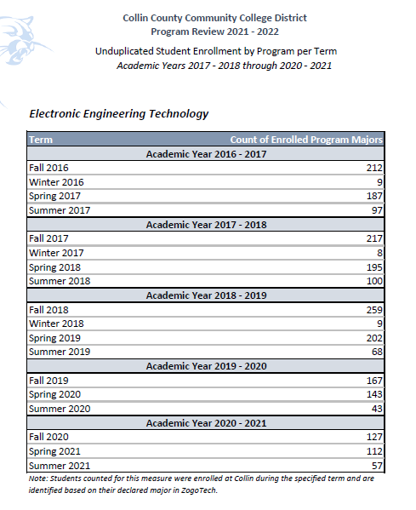

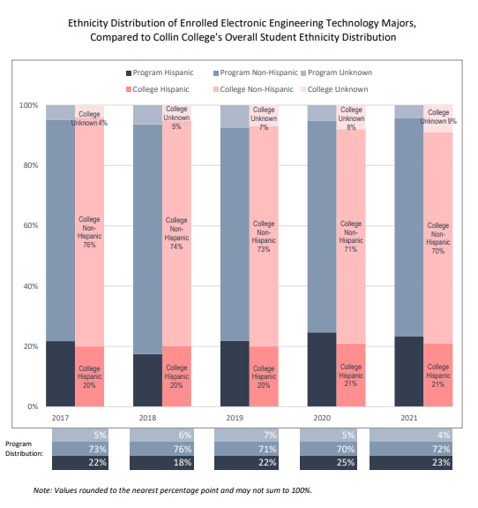

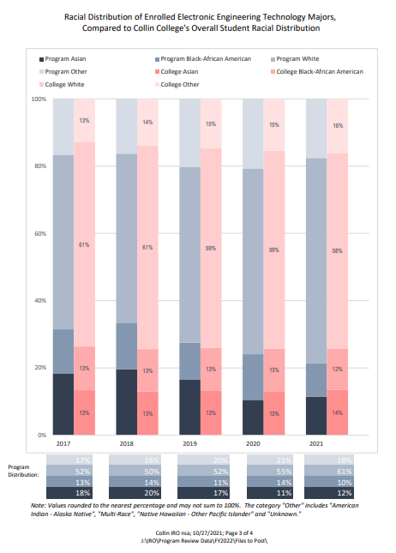
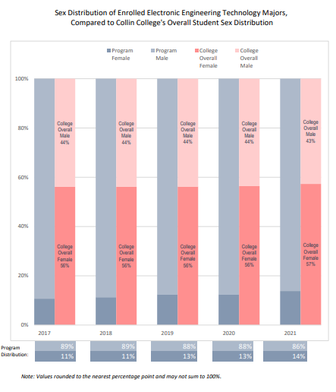

☐4. Why we do the things we do: Program relationship to market demand
Make a case with evidence to show that employers need and hire the program’s graduates. Some resources to utilize for information could be: JobsEQ http://inside.collin.edu/iro/programreview/202021/ProgramLaborMarketInfo_2020-21AY.pdf, Burning Glass, O-Net https://www.onetonline.org, Texas Labor Market Information https://www.twc.texas.gov/businesses/labor-market-information.
Suggested/possible points to consider:
- How many program-related jobs are available in the DFW Metroplex for program graduates? If the majority of related jobs in the DFW Metroplex require a baccalaureate degree, provide evidence that you have a current signed articulation agreement with one or more transfer institutions or that you plan to develop one.
- What proportion of the program’s graduates (seeking employment) found related employment within six months of graduation?
- What changes are anticipated in market demand in the next 5 years? Do program completers meet, exceed, or fall short of local employment demand? How will the program address under- or over-supply?
- Identify and discuss the program’s strengths and weaknesses related to market demand.

Review of three resources about the number of program-related jobs available in the DFW metroplex show the following data:

Collin Labor Market Information Report – 3827 (http://inside.collin.edu/iro/programreview/202021/ProgramLaborMarketInfo_2020-21AY.pdf )
O*Net – 750 (https://www.onetonline.org/ )
Texas Workforce Commission – 737 (https://www.twc.texas.gov/businesses/labor-market-information)

The total number of annual jobs available last year in the DFW area was well over 5000. Those jobs were all technician jobs and did not require a baccalaureate degree.

The data from “Texas Higher Education Coordinating Board Automated Student and Adult Learner Follow-Up System 2017-2018 Exit Cohort Reports COLLIN COUNTY COMMUNITY COLLEGE DISTRICT” shows that “the number of jobs demanded in associated occupations over one year” is 38. We think this data may not truly reflect the employment rate based on the number of employers contacting the department for hiring our graduates. We had about 20 employers contacting the department for hiring our graduates last semester, most of them with multiple number of technician job openings. For example, A local telecommunications company, Fortress Solutions, had hired one of our graduate and came to us again and directly spoke to our students in the Capstone class, Communication Circuits, for filling at least four more openings in wireless and wireline communication field.
According to https://communityimpact.com/dallas-fort-worth/na/data-reference/2022/03/29/collin-denton-tarrant-counties-see-population-increases-dfw-ranks-first-nationwide-in-population-growth/#:~:text=The%202020%20census%20reported%20a,from%20July%202020%2DJuly%202021.
“The 2020 census reported a DFW population of more than 7.6 million. In 2021, the census estimated the metro population had increased to more than 7.75 million. That growth of an estimated 97,290 residents moved DFW to the No. 1 metro spot in the nation for population growth from July 2020-July 2021.”
With the population and industry growth in DFW area, the job market demand will continue to be high. With the announcement of another factory by Texas Instruments and Raytheon in next two years, our program completers will fall short of local employment demand. To address this under supply of graduates, efforts like Open Houses and reaching out to high school students through presentations are planned for current academic year. Campus wide efforts and plans by the leadership team are under way to advertise the technical programs aggressively within local communities.

Program strengths related to job market:
  - Curriculum- several courses have been redesigned and new courses added based on inputs from advisory committee members to make the program current to industry needs.
  - Advisory Committee representation from 15 location companies.
  - Updated equipment to meet the teaching needs for relevant technologies
  - Faculty with many years industrial experience in the relevant technologies
  - Class schedules that fits student needs
  - Equipment/Student ratio – 1:2
Program weaknesses related to job market:
- Lack of advertising funds and PR support to raise awareness about the program in the local communities.
- Experiencing difficulty in class scheduling due to lack of lab space. As the student population grows to meet the job market, this issue will likely get aggregated.

Section II. Are We Doing Things Right?
☐5. How effective is our curriculum, and how do we know?
A. Make a case with evidence that there are no curricular barriers to program completion. Review data related to course enrollments, course completion rates, course success rates, and the frequency with which courses are scheduled to identify barriers to program completion.
Suggested/possible points to consider:
- Number of students who completed the program awards in each of the last 4 years? If the number of graduates does not average 5 or more per year, describe your plan to increase completions and address this issue in the Continuous Improvement Plan (CIP).
- At what point(s) are substantive percentages of students dropping out of the program? Use data in the “Program-Based Course Performance” tool to examine enrollment flow through the program curriculum. Does the data suggest any curricular barriers to completion? Address problems in the CIP.
- Analyze the course success rates and the course completion rates of each course in your program. Address problems in the CIP.

The number of students who completed the program awards over the last four years average 5 and more per year as shown in the table below. The data from the Program-based Course Performance Tool shows completion rate of above 83% for individual courses and lowest success rate of 47% in last four years. In addition, there were some classes that were cancelled because of low enrollment in academic years 2017 and 2018. This was result of limited lab space which resulted in limited classes that could be offered in the evenings and higher student: equipment ratios in the sole electronics lab. Most of these problems were addressed in the CIP and by restructuring the program degree to update and add new courses with feedback from advisory committee members in 2018. The restructuring took effect in Fall 2019. There was only 1 class cancelled in Spring 2020 because of low enrollment and two more in the following semester because of Covid pandemic. Opening of Technical campus in Fall 2020 elleviated the lab space problems and the student:equipment ratio issues. Since Spring of 2021, no classes in the program has been cancelled.

In Fall 2020, college also started dual credit partnerships for EET program and high school students were enrolled in the curriculum. This student population has not been highly successful in the program and has contributed to low success rate of the courses offered to them. The main reason is lack of the motivation to learn, and the maturity level. This is the feedback from all faculties who have taught the Dual Credit classes. The completion rate of the courses through all these changes has stayed above 83%. The dual credit student success rates have been notified to leadership and it has been recommended to have some sort of screening, if possible, at the high school level before enrolling students in the program to help them be succeeful in these courses. The possibility for screening process could include: a) Convey the purpose of the Dual Credit classes; b) Convey the difference between college and high school classes. College classes are much harder to make it up if fall behind. c) Make sure the students with proper self-discipline capability.

(http://inside.collin.edu/iro/programreview/202122/AwardsByProgram%202017-2021.10292021.pdf)

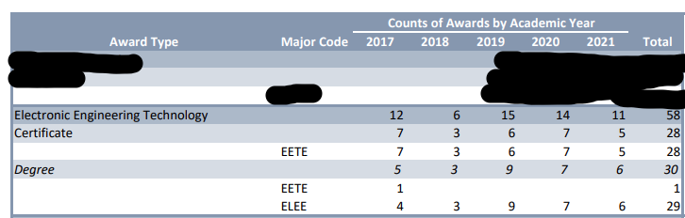

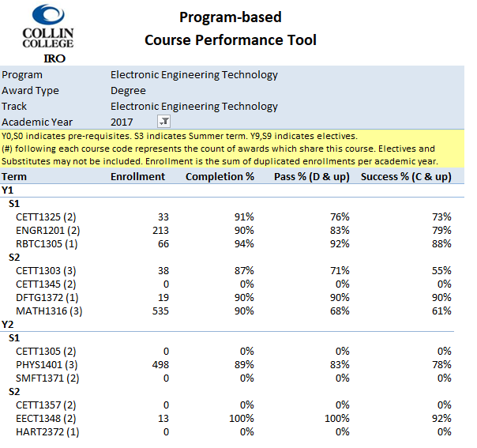
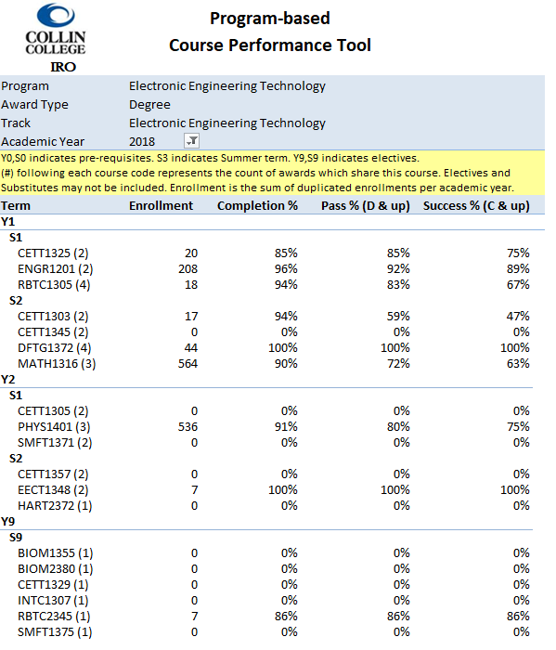
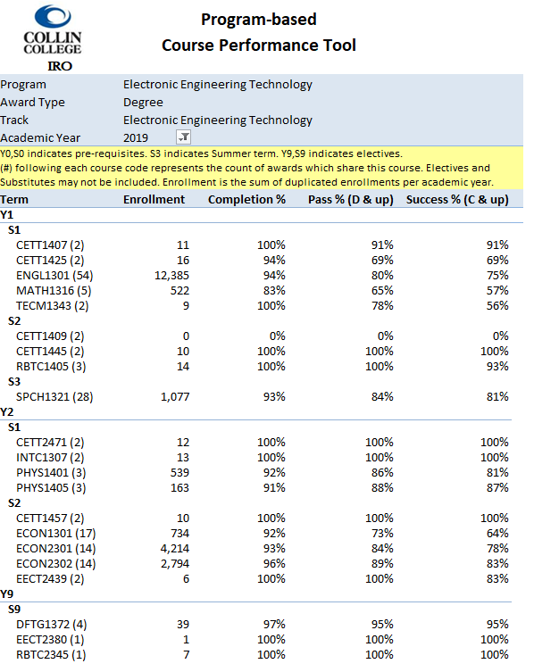
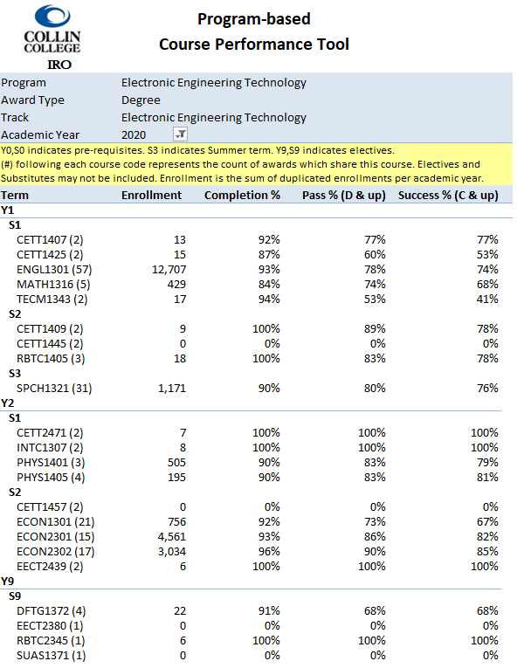

B. Show evidence that the institutional standards listed below have been met. For any standard not met, describe the plan for bringing the program into compliance.

- Completers Standard: Average 25 completers over the last five years or an average of at least five completers per year.
Number of completers: 58 in last five years.
If below the state standard, attach a plan for raising the number of completers by addressing barriers to completion and/or by increasing the number of students enrolled in the program. Definition of completer—Student has met the requirements for a degree or certificate (Level I or II)
- Licensure Standard: 93% of test takers pass licensure exams.
If applicable, include the licensure pass rate: Not applicable
For any pass rate below 93% (Collin College’s standard), describe a plan for raising the pass rate.

- Retention Standard: 78% of students enrolled in program courses on the census date should still be enrolled on the last class day (grades of A through F).
Include the retention rate: 94.75%
If the retention rate is below 78%, describe a plan for raising the course completion rate.

Refer to tables in section 5A for detailed information.

C. Make a case with evidence that the program curriculum is current.
Suggested/possible points to consider:
- How does the program curriculum compare to curricula at other schools? Review programs at two or more comparable colleges. Discuss what was learned and what new ideas for improvement were gained.
- How does the program curriculum align with any professional association standards or guidelines that may exist?
- Is the curriculum subject to external accreditation? If so, list the accrediting body and the most recent accreditation for your program.
If the program curriculum differs significantly from these benchmarks, explain how the Collin College curriculum benefits students and other college constituents.
Comparing with Dallas College, most classes are similar to the classes in our program. However, it appears that they have emphasis on the industrial automation with the classes like, Hydraulics and Pneumatics, AC/DC motor control, Industrial Automation, etc. However, we have all those classes offered in our Industrial Automation program.
The specific distinction between our program and Dallas College is,
- Dallas College tries to cover two technology fields, Electronics and Industrial Automation, with one Electronics Technology program. Since we have a separate Industrial Automation program, our program is dedicated to the Electronics Engineering Technology with more real-world applications such as Internet-of-thing (IOT).
- Our program covers Wireless Communication technology which is a key enabler in the industry revolution 4.0. It makes our graduates more attractive. We have two graduates hired by the No. one telecommunication company in the world, Ericsson last year.

Comparing with Tarrant County College, they have two programs under Electronics Technology, i.e. Electronics and Telecommunication, Robotics and Automation. Given the fact that we have our brother program in Industrial Automation, it makes sense to compare our program with their Electronics and Telecommunication. Our core classes are same as theirs. However, their upper level classes are heavily weighted on Communication side. They have three communication classes in the program, namely, Communications Circuits, Digital Data Communication, and Telecommunications. As communications gain huge momentum with emerging 5G, 6G systems and IOT, IIOT technologies, we may need to consider to add more classes in the subject matter of wireless communications. However, our program is still current for the following reasons.

- Our program has been periodically reviewed by advisory board members from local companies. They identify skills in high demand from current job market. The advisory committee has played a big role in our curriculum development. The committee members have provided us with the up to date industry trends and technology evolution. The feedback of the current curriculum from advisory board is very positive.
- Our graduates are in high demand. Overwhelming majority of our graduates are employed in the program field after completion. Many of them even got job offers well before the completion. Some companies ask to directly speak to the students after learning our curriculum.
- Our faculty members are highly qualified with rich industry experience in the field. They spend a lot of time to keep up the new development of the technology. Therefore, our Communications Circuits class is able to cover the necessary key important subjects from Communications Circuits, Digital Data Communication, and Telecommunications, three communication classes in the Tarrant County College program. One of students evaluation from the Communications Circuits says “… explains all concepts very well & tries to pass on as much knowledge as he can. He gave lots of labs which helps to relate to the course material. He is highly invested and enthusiastic about the course material that he teaches and conveys a sense of excitement in the classroom”.

Currently, there is not any professional association standards or guidelines for the program curriculum to align with. The curriculum is not subject to external accreditation either. We rely on the advisory committee to keep our program current and market relavant.

Dallas College https://www.dallascollege.edu/cd/gps/pages/gpsmap.aspx?gpsId=149
GUIDED PATHWAY: ELECTRONICS TECHNOLOGY A.A.S. – ELECTRICAL ENGINEERING TECHNOLOGY SPECIALIZATION
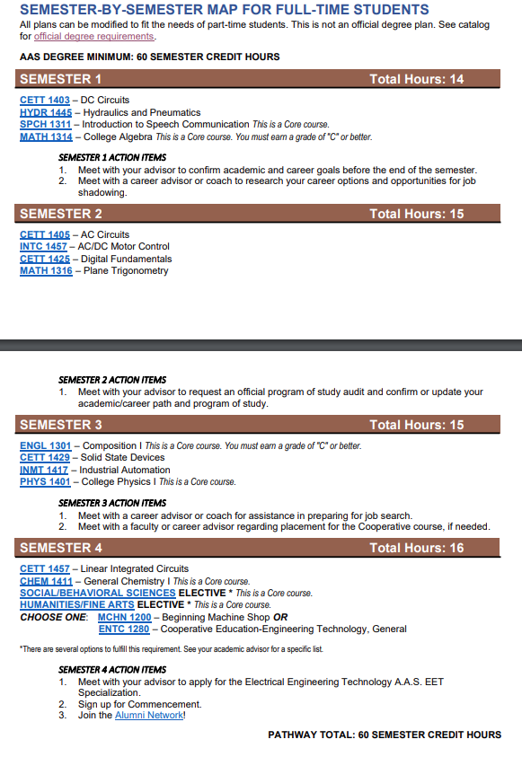
Tarrant County College
ELECTRONICS TECHNOLOGY: ELECTRONICS AND TELECOMMUNICATION, AAS
https://catalog.tccd.edu/preview_program.php?catoid=12&poid=3141
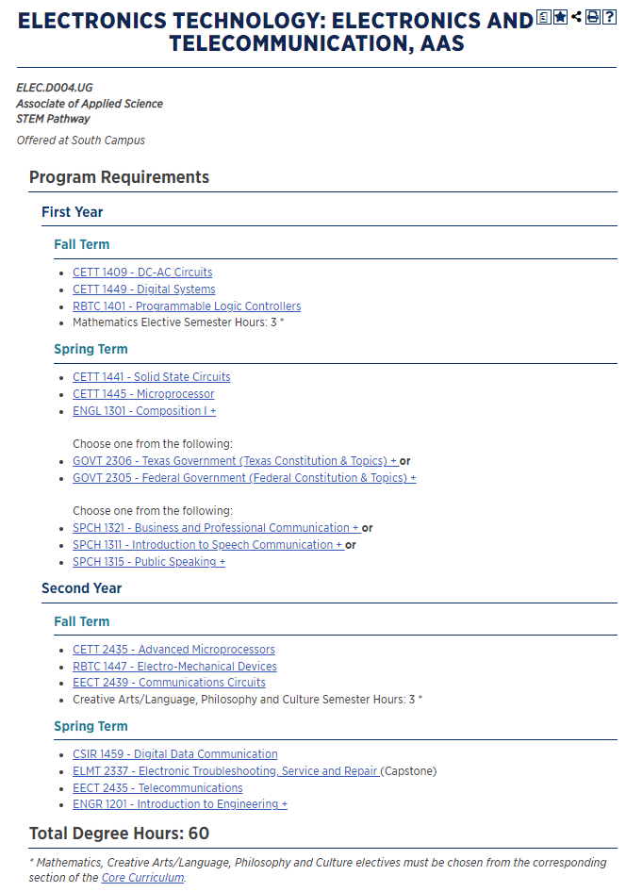
Tarrant County College
ELECTRONICS TECHNOLOGY: ROBOTICS AND AUTOMATION, AAS
https://catalog.tccd.edu/preview_program.php?catoid=12&poid=3143
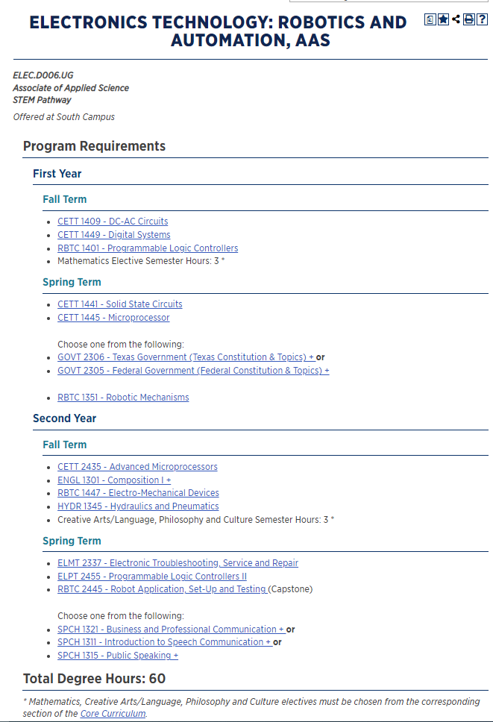

D. Present evidence from advisory committee minutes, attendance, and composition that the advisory committee includes employers who are actively engaged on the committee and who are representative of area employers.
1. How many employers does your advisory committee have? 15
2. How many employers attended the last two meetings? 12
3. How has the advisory committee impacted the program over the last five years (including latest trends, directions, and insights into latest technologies)?
The advisory committee has played a big role in our department development. The committee members have provided us with the up to date industry trends and technology evolution. They have strongly recommended to include the wireless communication technology, and software package in MATLAB/SIMULINK, and Multisim. We have used the inputs for the following curriculum changes. See question 4 below.

4. Briefly summarize the curriculum recommendations made by the advisory committee over the last five years.
Over the last four years, the committee members have made various recommendations for curriculum updates,
- Including wireless communication technology (year 2017)
- Including MATLAB/SIMULINK, and Multisim software package (year 2017)
- Adding a one credit hour class – ENTC 1171 (year 2021)

Based on above recommendations, we have added the following classes,
- EECT-2439 Communications Circuits as our Capstone class in Spring 2018. The result is very encouraging. There have been numerous graduates employed by various Telecommunications companies such as Ericsson and Fortress Solutions.
- CETT-2471 Emerging Topics Engineer Tech in Fall 2018. Teaching MATLAB/SIMULINK with engineering subjects.
- ENTC-1171 Introduction to Engineering Technology, effective in Fall 2022.

E. Make a case with evidence that the program is well managed.

Suggested/possible points to consider (Data can be found at http://inside.collin.edu/institutionaleffect/Program_Review_Process.html):
- Average class size
- Grade distributions
- Contact hours taught by full-time and part-time faculty
- Identify all courses that have a success rate below 75%. If any of these are core courses, visit with the discipline lead for the course(s) in question to determine whether or not the content of the course(s) is appropriate to the workforce program learning outcomes. Using assessment evidence and instructor observations, identify the student learning outcomes that are the greatest challenges for students in courses with low success rates. Explain what instructional and other intervention(s) might improve success rates for each identified course.
- How well are general education requirements integrated with the technical coursework?
- Student satisfaction: What evidence do you have that students are satisfied with the program? What kinds of complaints are made to the associate dean/director by program students?
The average class size is about 18 excluding some special cases. Refer to table below for details on class sizes and grade distributions.

http://inside.collin.edu/iro/programreview/202122/AvgSectionSize-ElectronicEngineeringTechnology.pdf

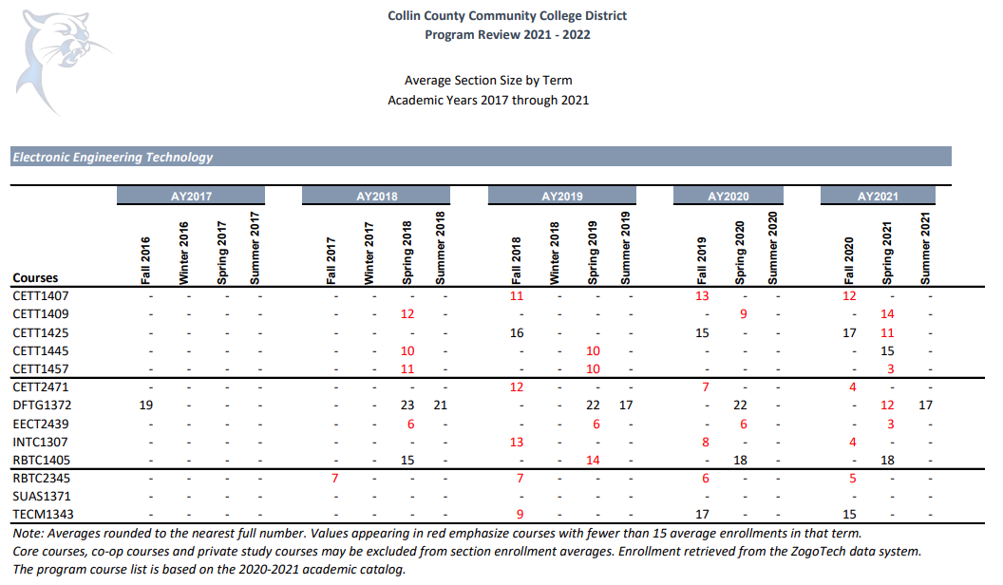

http://inside.collin.edu/iro/programreview/prfilehostpage.html

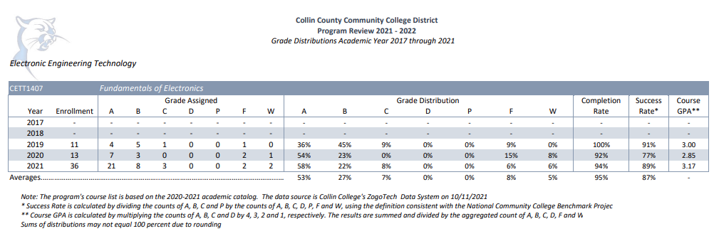

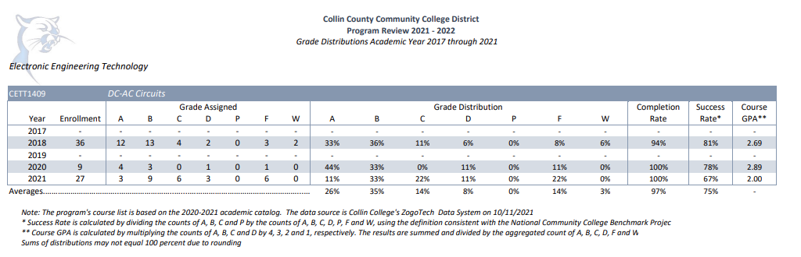

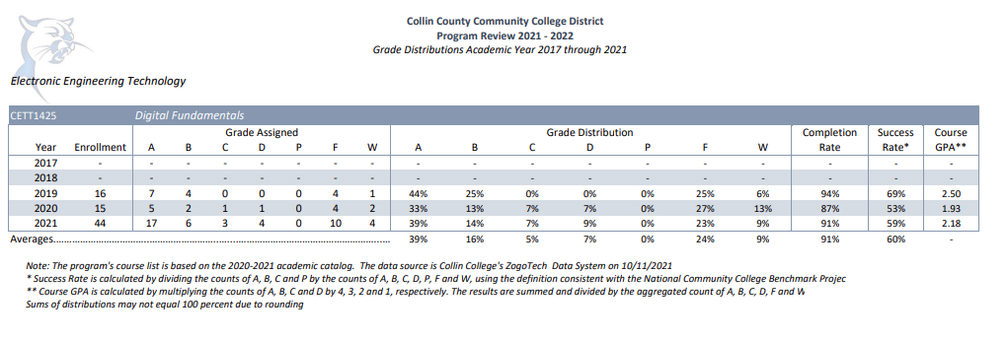
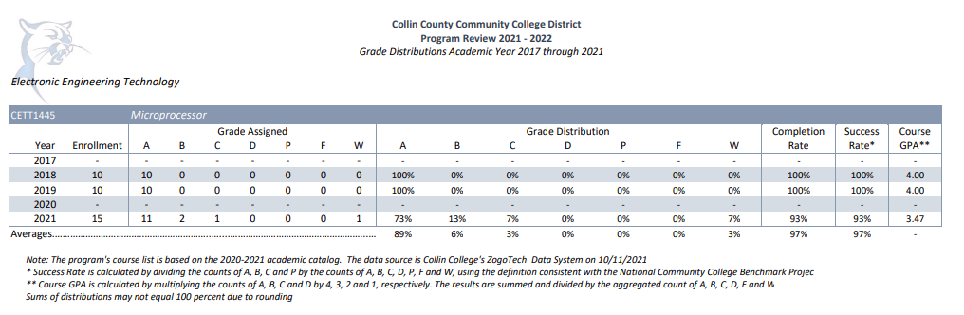

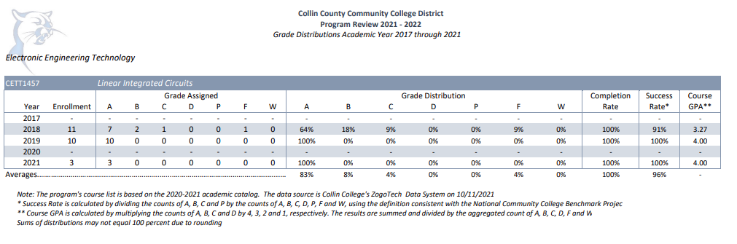
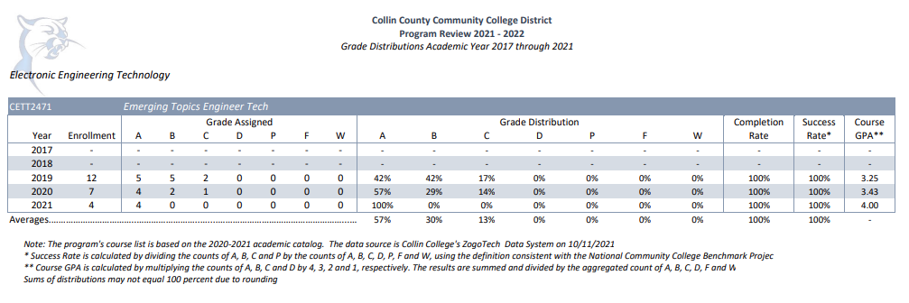

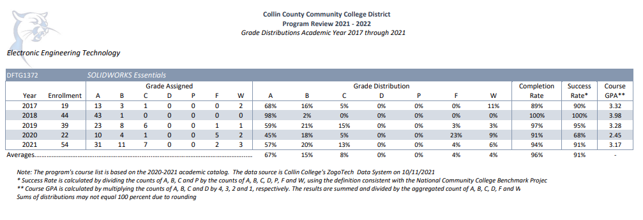

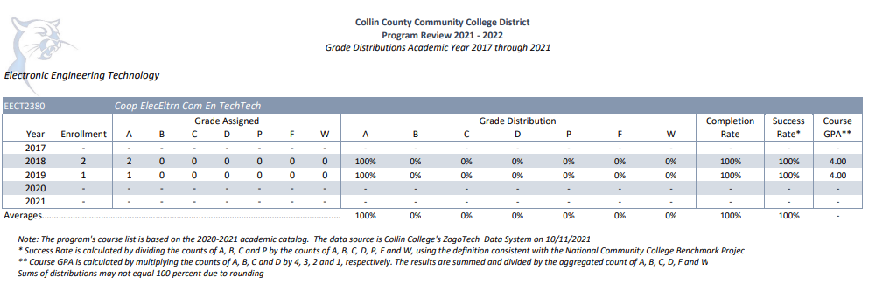

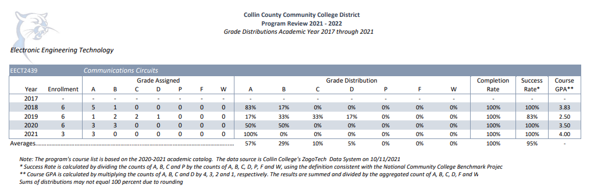

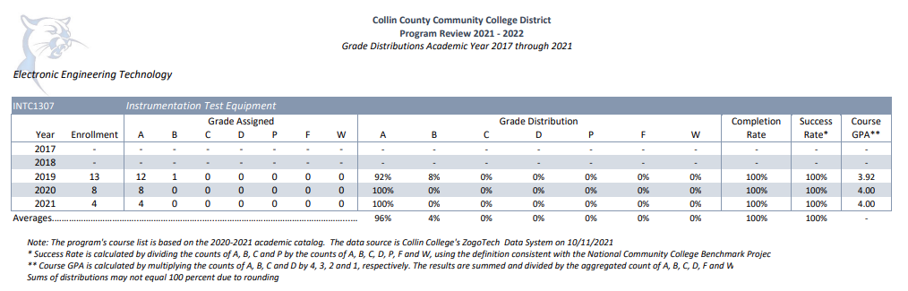

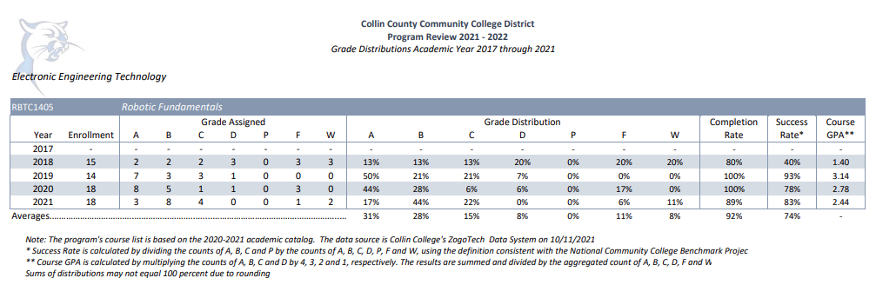
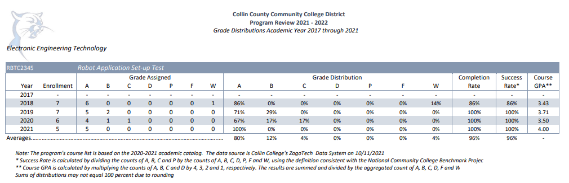

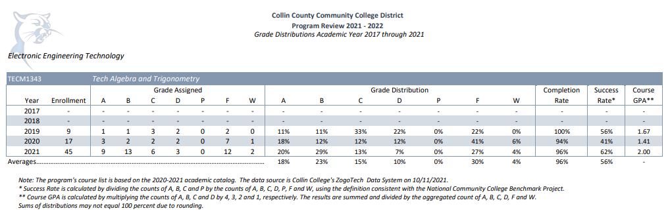

Contact hours taught by full-time and part-time faculty are presented in the table below, from top to bottom (2017 – 2021), i.e., in 2017, 77% full-time, 23% part-time, in 2018, 88% full-time, 12% part-time, etc. (http://inside.collin.edu/iro/programreview.html

Electronics | 5,168 | 88% |  | 720 | 12% | 5,888
Electronics | 4,368 | 76% |  | 1,360 | 24% | 5,728
Electronics | 8,432 | 100% |  | 0 | 0% | 8,432

We do not have any course that have a success rate below 75%.

We have 16 SCH of general requirements integrated with the technical coursework as required by SACSOC.

The general core classes are integrated in the program to help students learn written and communication skills so as to be able to document and present technical material to peers and supervisors. The physics and economics core classes provide fundamental knowledge of various technical and business skills desired in the electronics industry.

Students are encouraged by the faculty to contact them for any help that they need. They have access to director’s office/email for help and feedback. In addition, students get an opportunity every semester in every class to provide feedback about the faculty and the program in general. Few complaints about the limited number of equipment were received which have been addressed by the relocation of the program to the new Technical Campus. Some complaints about a faculty not using Canvas to keep students posted about the grades are being addressed at present. There have been some complaints about lack of response from career coach which is also under review by the dean’s office.

☐6. How effectively do we communicate, and how do we know?
A. Make a case with evidence that the program literature and electronic sites are current, provide an accurate representation of the program, and support the program’s recruitment plan, retention plan and completion plan.
Suggested/possible points to consider:
- Demonstrate how the unit solicits student feedback regarding its website and literature and how it incorporates that feedback to make improvements.
- How does the program ensure that students are informed/aware of program literature? Is program literature made accessible to all students (i.e. can they obtain the information they need)?
- Designate who is responsible for monitoring and maintaining the unit’s website, and describe processes in place to ensure that information is current, accurate, relevant, and available.

College website, department website, and program brochures are updated for students whenever there is a change on degree/certificate program. Changes in the catalogs are made anytime there is a change in the degree plan. Program brochures, flyers for tuition cost and BAAS pathways are displayed in the hallway boards where the program is housed. The brochures and information sheets are also accessible through department website to all the students. Class presentations about the various options and pathways are made to educate the students. Portable stand-alone banners are used during the camps and open houses hosted by the department/campus to promote the electronics program and provide information about the low tuition rates and transfer opportunities to prospective families.

The college website is maintained by PR department and the department website is maintained by the program director and the career coach. The brochures and flyers are updated by the dean/director’s office and reviewed/approved by PR department before distribution.

http://www.collin.edu/academics/info/electronicEngineerInfoSheet.pdf
https://www.collin.edu/department/engineering/electronic_engineering_technology.html

B. In the following Program Literature Review Table, document that the elements of information listed on the website and in brochures (current academic calendars, grading policies, course syllabi, program handouts, program tuition costs and additional fees, description of articulation agreements, availability of courses and awards, and local job demand in related fields) were verified for currency, accuracy, relevance, and are readily available to students and the public. Please fill out the table only for this prompt (B.), no analysis is necessary here.

Program Literature Review Table
Title | Type (i.e. URL, brochure, handout, etc.) | Date of Last Review/Update |  | Responsible Party
Electronic Engineering Technology | Information Sheets | 11/9/2021 | ☒Current  ☒Accurate  ☒Relevant  ☒Available | Dean and Program Director
Electronic Engineering Technology Department Website | Department Website | 9/13/2021 | ☒Current  ☒Accurate  ☒Relevant  ☒Available | Program Director and Career Coach
Click or tap here to enter text. | Click or tap here to enter text. | Click or tap to enter a date. | ☐Current  ☐Accurate  ☐Relevant  ☐Available | Click or tap here to enter text.
Click or tap here to enter text. | Click or tap here to enter text. | Click or tap to enter a date. | ☐Current  ☐Accurate  ☐Relevant  ☐Available | Click or tap here to enter text.
Click or tap here to enter text. | Click or tap here to enter text. | Click or tap to enter a date. | ☐Current  ☐Accurate  ☐Relevant  ☐Available | Click or tap here to enter text.
Click or tap here to enter text. | Click or tap here to enter text. | Click or tap to enter a date. | ☐Current  ☐Accurate  ☐Relevant  ☐Available | Click or tap here to enter text.
Click or tap here to enter text. | Click or tap here to enter text. | Click or tap to enter a date. | ☐Current  ☐Accurate  ☐Relevant  ☐Available | Click or tap here to enter text.
Click or tap here to enter text. | Click or tap here to enter text. | Click or tap to enter a date. | ☐Current  ☐Accurate  ☐Relevant  ☐Available | Click or tap here to enter text.
Click or tap here to enter text. | Click or tap here to enter text. | Click or tap to enter a date. | ☐Current  ☐Accurate  ☐Relevant  ☐Available | Click or tap here to enter text.

☐7. How well are we leveraging partnership resources and building relationships, and how do we know?
Partnership Resources: On the table below, list any business, industry, government, college, university, community, and/or consultant partnerships, including internal Collin departments, to advance the program outcomes.
The program uses various methods to enlist local businesses to advance program success. Hiring team from Texas Instruments was invited in the last years to give class presentations to the students about their technician job market. Raython provided opportunities for our students to tour their manufacturing site, also helped in resume workshop and mock interviews. Engineering director at Mathworks visited our campus and helped on the hardware compatibility issues, assigned an engineer to work on the resolution. Engineer from Federal Communications Commission presented the real-life RF emission landscape for our students to gain real-life experience.

Partnership Resources Table**
Partner/Organization | Description | Formal Agreement Duration,  if any. | How is it Valuable to the Program?
Texas Instruments | Technician job presentations  Mock Interview Program  Facility Tour  Career Fair | N/A | Job opportunities for graduates  Help students to better prepare for successful job interviews  Participate in career fair
Raytheon | Facility Tour  Mock Interviews  Resume workshop | N/A | Exposure to students about electronic manufacturing  Help improve student resumes with one on one interaction
Mathworks | Technical support | N/A | Technical support Matlab/Simulink software, compatibility issues with other hardwares.
Federal Communications Commission | Technical Talks and Demos | N/A | Class presentation about real life RF spectrum landscape. Show students how to use various spectrum analyzers and identify possible illegal emission.
Quest Medical Inc | Facility Tour | N/A | Provided facility tour to help students see other technicians at work  Participate in career fair
ONCOR | Class visits | N/A | Presentation to students about job opportunities
Qorvo  Wipro  Fortress Solutions  Communications & Power Industries  PSSTechnical | Career Fair | N/A | Participate in career fair
Student Career Services, Tech Campus | Resume Critique Event | N/A | Co-hosted this event for program students
Click or tap here to enter text. | Click or tap here to enter text. | Click or tap here to enter text. | Click or tap here to enter text.

☐8. What professional developmental opportunities add value to your program?
Workshops, conferences, professional presentations related to latest electronic technologies being used in the industry

Provide a List of professional development activities employees have participated in since the last program review.
Employee Resources Table**
Employee Name | Role in Unit | Professional Development Summary | How is it Valuable to the Unit?
Jeff Gibbons | Full Time Faculty | Attended, "Several Keysight University courses in 2020, including Oscilloscope courses used in Instrumentation classes," Fundamentals of Sensor Measurements, TX, Spring 2020  Attended, NSF Workshop on Automation, Dallas, TX, Spring 2020  Attended, "Profinet Workshop," Profinet Training, Houston, TX, Spring 2020  Attended, "BILT for National Convergence," Collin College, Frisco, TX, Fall 2020 | Helped to keep up with new technologies
Yiping Wang | Full Time Faculty | Certified FANUC Robot instructor (October 5, 2018)  Certified Universal Robot Instructor (January 4, 2022)  2017  Attended various IEEE DFW societies technical meetings, topics including IOT, smart city, intelligent highway and others.  Awarded the Certificate for successfully completed Keysight Test-Drive 2017  Faculty Development Conference.  Attended various technology webinars, one example is on signal generator. That includes continuous wave, analog and digital modulation signals. It also covers vector signal analysis aspect.  2018  Attended seminars on new development of wireless communications from 3GPP, the topics comprising, 5G eMMB, NB-IoT, Industry IoT, Massive MIMO, mmWave, etc.  Attended IEEE DFW societies technical meeting on “Crowdsourcing Wireless Channels with Phones and Drones”.  Faculty Development Conference.  Attended FANUC Robotics training and gained the qualification to issue industry recognized certification for our students.  Attended 2018 NISOD’s International Conference on Teaching and Leadership Excellence.  2019  Attended numerous in person and online seminars in 5G wireless communications.  Faculty Development Conference.  Attended Industrial Robot Workshop on Feb. 28 hosted by Festo  2020  Attended numerous online sessions to help moving classes online due to COVID  Attended numerous in person and online seminars in 5G wireless communications from 3GPP.  Webinar: What’s in the future of 5G millimeter wave?  Faculty Development Conference.  The Cobot Expo 2.0, Mon 11/16/2020, 9:00 AM to Tue 11/17/2020, 4:00 PM.  ATC UR EDU Community Meeting Tue 12/8/2020.  Attended Introduction to Simulink for System Modeling and Simulation  2021  Attend four-days IEEE Consumer Communications & Networking Conference  Complete Universal Robots Certification training, it makes Collin College eligible to issue UR training certificate to our student.  Obtain a certificate on “Low-code AI: Making AI Accessible to Everyone”.  Closely following the new development of 5G wireless communications from 3GPP by attending various webinars  Continuously work with industry experts on new development on wireless network standards such that our curriculum is closely coupled with the current industry trend.  Multi‐domain Physical Systems, Thu 1/21/2021.  Attended ATC roundup Workshop on Universal Robots in summer 2021.  MATLAB EXPO 2021, May 4–5, 2021.  MATLAB Webinars: Summer of Science Series: Data Analytics with MATLAB – [June 3 – July 15]. | Collin College able to issue Fanuc Robot training certificate to students.  Collin College able to issue Universal Robot training certificate to students  Helped to keep up with new technologies
Susan Stancy Abraham | Full Time Faculty | 2019:  Associate Faculty Conference (Collin College) – 02/23/2019  2020:  Spring 2020 Faculty Development Conference (Collin College) – 01/09/2020  Autodesk University (Online conference) – 11/17/2020 – 11/20/2020  Applying the Quality Matters Rubric (APPQMR) workshop (Collin College) – 12/15/2020 – 12/16/2020  2021:  Spring 2021 Faculty development conference (Collin College) – 01/07/2021 – 01/09/2021  Fall 2021 Faculty Development Conference (Aug 12, 2021)  WE 21 - National Conference of the Society of Women Engineers, virtual event (Oct. 21-23,2021)  2022:  Spring 2022 Faculty Development Conference (Jan 6, 2022)  Center for Teaching and Learning Session: “Easier Grading and meaningful evaluation through rubrics.” (Feb 2022) | Helped for teaching and student engagement.
Click or tap here to enter text. | Click or tap here to enter text. | Click or tap here to enter text. | Click or tap here to enter text.
Click or tap here to enter text. | Click or tap here to enter text. | Click or tap here to enter text. | Click or tap here to enter text.
Click or tap here to enter text. | Click or tap here to enter text. | Click or tap here to enter text. | Click or tap here to enter text.
Click or tap here to enter text. | Click or tap here to enter text. | Click or tap here to enter text. | Click or tap here to enter text.
Click or tap here to enter text. | Click or tap here to enter text. | Click or tap here to enter text. | Click or tap here to enter text.
Click or tap here to enter text. | Click or tap here to enter text. | Click or tap here to enter text. | Click or tap here to enter text.
Click or tap here to enter text. | Click or tap here to enter text. | Click or tap here to enter text. | Click or tap here to enter text.
Click or tap here to enter text. | Click or tap here to enter text. | Click or tap here to enter text. | Click or tap here to enter text.
Click or tap here to enter text. | Click or tap here to enter text. | Click or tap here to enter text. | Click or tap here to enter text.
Click or tap here to enter text. | Click or tap here to enter text. | Click or tap here to enter text. | Click or tap here to enter text.
Click or tap here to enter text. | Click or tap here to enter text. | Click or tap here to enter text. | Click or tap here to enter text.
Click or tap here to enter text. | Click or tap here to enter text. | Click or tap here to enter text. | Click or tap here to enter text.
Click or tap here to enter text. | Click or tap here to enter text. | Click or tap here to enter text. | Click or tap here to enter text.
Click or tap here to enter text. | Click or tap here to enter text. | Click or tap here to enter text. | Click or tap here to enter text.
Click or tap here to enter text. | Click or tap here to enter text. | Click or tap here to enter text. | Click or tap here to enter text.
Click or tap here to enter text. | Click or tap here to enter text. | Click or tap here to enter text. | Click or tap here to enter text.
Click or tap here to enter text. | Click or tap here to enter text. | Click or tap here to enter text. | Click or tap here to enter text.
Click or tap here to enter text. | Click or tap here to enter text. | Click or tap here to enter text. | Click or tap here to enter text.
Click or tap here to enter text. | Click or tap here to enter text. | Click or tap here to enter text. | Click or tap here to enter text.
Click or tap here to enter text. | Click or tap here to enter text. | Click or tap here to enter text. | Click or tap here to enter text.
Click or tap here to enter text. | Click or tap here to enter text. | Click or tap here to enter text. | Click or tap here to enter text.
**For convenience, if providing a listing of professional development activities, this list may be included in this document as an appendix.

☐9. Are facilities, equipment, and funding sufficient to support the program? If not, please explain.
[OPTIONAL—Only respond to prompt 9 if you are requesting improved resources for your program. If current facilities and budget are adequate, please proceed to prompt 10.]
Make a case with evidence that current deficiencies or potential deficiencies related to facilities, equipment, maintenance, replacement, plans, or budgets pose important barriers to the program or student success. As part of your response, complete the resource tables, below, to support your narrative.
Possible points to consider:
- The useful life of structure, technologies and equipment
- Special structural requirements
- Anticipated technology changes impacting equipment sooner than usual

We have equipment shortage in the labs:
  - Acquire a Fanuc robots CRX series: At present, we only have conventional Fanuc robots in our lab. CRX series is Fanuc newly added Collaborative Robot which we do not have. This addition will greatly enrich our RBTC-2345 Robot Application Set-up Test class.
  - Upgrade lab B224 to match lab B220 with 18 seats: Currently, B224 lab is a digital lab and analog circuits labs cannot be performed there. In addition, it has less seats compare to B220. By matching B224 lab with B220 lab, it will be fully equipped to run full sections of analog and digital classes.

Facilities Resources Table**
Significant Pieces of Equipment | Description  (i.e. Special Characteristics) | Meets Needs (Y or N):  Current For Next 5 Years |  | Analysis of Equipment Utilization
Fanuc LR MATE 200 iD : 2 units  Fanuc M-1iA : 1 inherited used | The proprietary operation system make it unique in terms of operation and commands. Used in our RBTC-2345 Robot Application Set-up Test class | Yes | No | The number of students is significantly larger than available equipment. For issuing certificate, we require enough hands-on time for each individual student.
Eletronics Lab classroom B220 and Digital Lab classroom B224 | Used for almost all classes in our programs including Analogy, Digital, Microprocessor, Instrumentation, and Linear Circuits, Emerging Topics, and Communications Circuits | Yes | No | As the student population significantly increases, there will be need to alleviate possible scheduling difficulties for all electronics classes. We need to expand the classroom capability.
Click or tap here to enter text. | Click or tap here to enter text. | Choose an item. | Choose an item. | Click or tap here to enter text.
Click or tap here to enter text. | Click or tap here to enter text. | Choose an item. | Choose an item. | Click or tap here to enter text.
Click or tap here to enter text. | Click or tap here to enter text. | Choose an item. | Choose an item. | Click or tap here to enter text.
Click or tap here to enter text. | Click or tap here to enter text. | Choose an item. | Choose an item. | Click or tap here to enter text.
Click or tap here to enter text. | Click or tap here to enter text. | Choose an item. | Choose an item. | Click or tap here to enter text.
Click or tap here to enter text. | Click or tap here to enter text. | Choose an item. | Choose an item. | Click or tap here to enter text.
Click or tap here to enter text. | Click or tap here to enter text. | Choose an item. | Choose an item. | Click or tap here to enter text.

Equipment/Technology Table ($5,000 or more) **
Current Equipment Item or Budget Amount | Description | Meets Needs (Y or N):  Current For Next 5 Years |  | For any “N”, justify needed equipment or budget change
Fanuc LR MATE 200 iD : 2 units  Fanuc M-1iA : 1 inherited used | The proprietary operation system makes it unique in terms of operation and commands. . Used in our RBTC-2345 Robot Application Set-up Test class | Yes | No | The number of students is significantly larger than available equipment. For issuing certificate, we require enough hands-on time for each individual standent. Moreover, as our Industrial Automation program is taking off, the demend is expected to increase further.  We currently do not have any Fanuc Cobot. To add one would be around $50,000
Eletronics Lab classroom B220 and Digital Lab classroom B224 | Used for almost all classes in our programs including Analogy, Digital, Microprocessor, Instrumentation, and Linear Circuits, Emerging Topics, and Communications Circuits | Yes | No | As the students population significantly increases, there will be a need to alleviate possible scheduling difficulties. We need to expand the classroom capability.
Click or tap here to enter text. | Click or tap here to enter text. | Choose an item. | Choose an item. | Click or tap here to enter text.
Click or tap here to enter text. | Click or tap here to enter text. | Choose an item. | Choose an item. | Click or tap here to enter text.
Click or tap here to enter text. | Click or tap here to enter text. | Choose an item. | Choose an item. | Click or tap here to enter text.
Click or tap here to enter text. | Click or tap here to enter text. | Choose an item. | Choose an item. | Click or tap here to enter text.
Click or tap here to enter text. | Click or tap here to enter text. | Choose an item. | Choose an item. | Click or tap here to enter text.
Click or tap here to enter text. | Click or tap here to enter text. | Choose an item. | Choose an item. | Click or tap here to enter text.
Click or tap here to enter text. | Click or tap here to enter text. | Choose an item. | Choose an item. | Click or tap here to enter text.
Click or tap here to enter text. | Click or tap here to enter text. | Choose an item. | Choose an item. | Click or tap here to enter text.

Financial Resources Table**
Source of Funds  (i.e. college budget, grant, etc.) | Meets Needs (Y or N):  Current For Next 5 Years |  | For any “N”, explain why | For any “N”, identify expected source of additional funds if needed
College budget | Yes | No | To purchase a Fanuc Cobot need additional $50,000.  Duplicate Lab B220 in Lab B224 need additional $50,000 | Supplement budget
Click or tap here to enter text. | Choose an item. | Choose an item. | Click or tap here to enter text. | Click or tap here to enter text.
Click or tap here to enter text. | Choose an item. | Choose an item. | Click or tap here to enter text. | Click or tap here to enter text.
Click or tap here to enter text. | Choose an item. | Choose an item. | Click or tap here to enter text. | Click or tap here to enter text.
Click or tap here to enter text. | Choose an item. | Choose an item. | Click or tap here to enter text. | Click or tap here to enter text.
Click or tap here to enter text. | Choose an item. | Choose an item. | Click or tap here to enter text. | Click or tap here to enter text.
Click or tap here to enter text. | Choose an item. | Choose an item. | Click or tap here to enter text. | Click or tap here to enter text.
Click or tap here to enter text. | Choose an item. | Choose an item. | Click or tap here to enter text. | Click or tap here to enter text.
Click or tap here to enter text. | Choose an item. | Choose an item. | Click or tap here to enter text. | Click or tap here to enter text.
Click or tap here to enter text. | Choose an item. | Choose an item. | Click or tap here to enter text. | Click or tap here to enter text.

Section III. Continuous Improvement Plan (CIP)
☐10. How have past Continuous Improvement Plans contributed to success?
Program Review at Collin College takes place for each unit or program every five years. During the last (fifth) year, the program evaluates the data collected during the CIP process.
Please describe how you have used your Continuous Improvement Plan (CIP) to make the following improvements to your program over the past 4 years (your last program review can be found on the Program Review Portal):
  - Program Learning Outcomes/Program Competencies
  - Overall improvements to your program

In the 2018-2019 CIP, we set two expected outcomes:
1. Make class size as 18 for classes held in H-150, PRC to justify equipment/student ratio of 18 work terminals/tables with 9 equipment stacks.
2. Develop six new classes to meet the market needs and streamline the student learning requirements,

We successfully achieved the first outcome by adding missing equipments in H-150 at Frisco Campus
We reached the second outcome by successfully developing/updating the listed six classes.

EECT 2439 Communications Circuits
CETT 1409 DC-AC Circuits
CETT 2471 Emerging Topics in Engineering Technology
CETT 1407 Introduction to Electronics
TECM 1343 Technical Algebra and Trigonometry
INTC 1307 Instrumentation Test Equipment

The equipment count matches with the class size. It provides each student in the classroom with proper equipment to conduct classes and practice hands-on skill in each class. The improvement of implementing findings has been demonstrated.

New classes in the consolidated degree plan lead to many positive feedbacks from our students and industrial advisory board. Our students’ skill set matches with the current industry needs. Enrollment has been almost doubled. There have been at least three our graduates employed by various local telecommunications companies, such as , Ericsson, Fortress Solutions, etc.

We have developed the CIPs to continue improving course work of these newly developed classes. See attach the CIPs [I have do not see where is the appendix in this document. I am just attaching here]
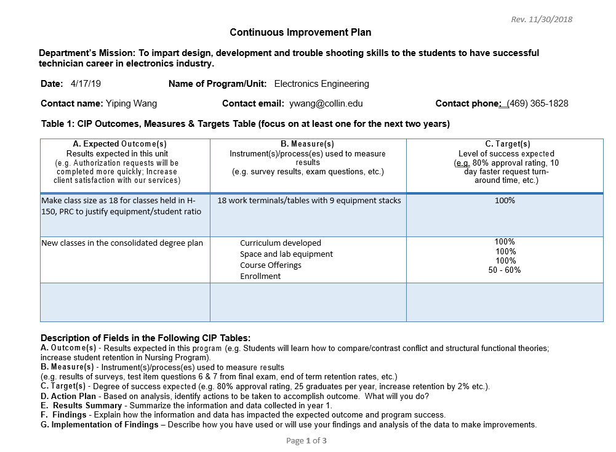
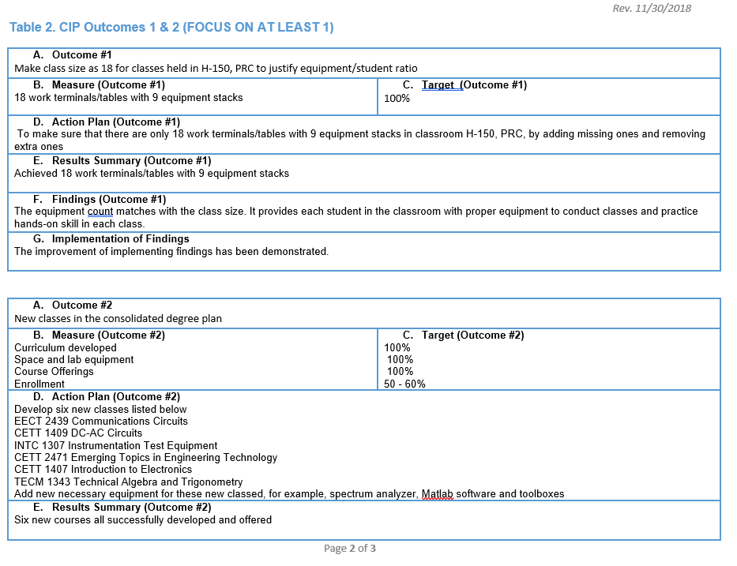

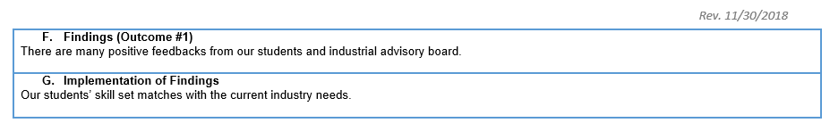

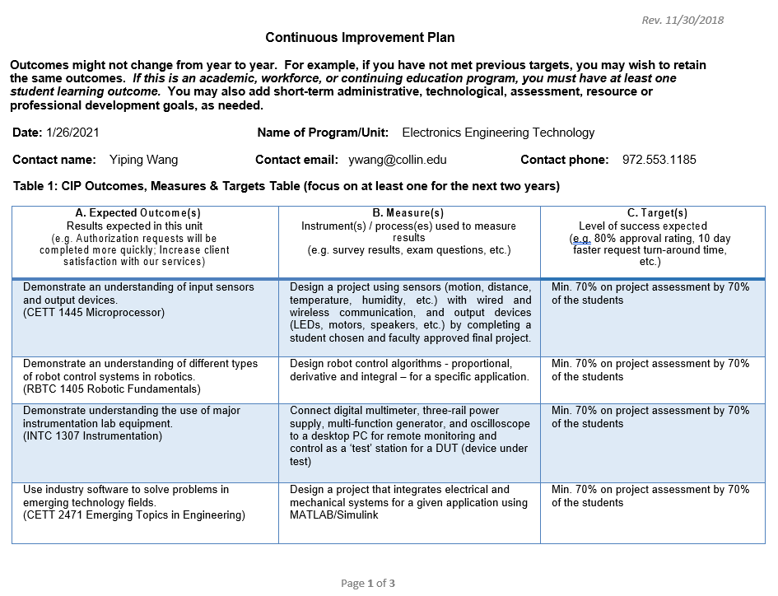
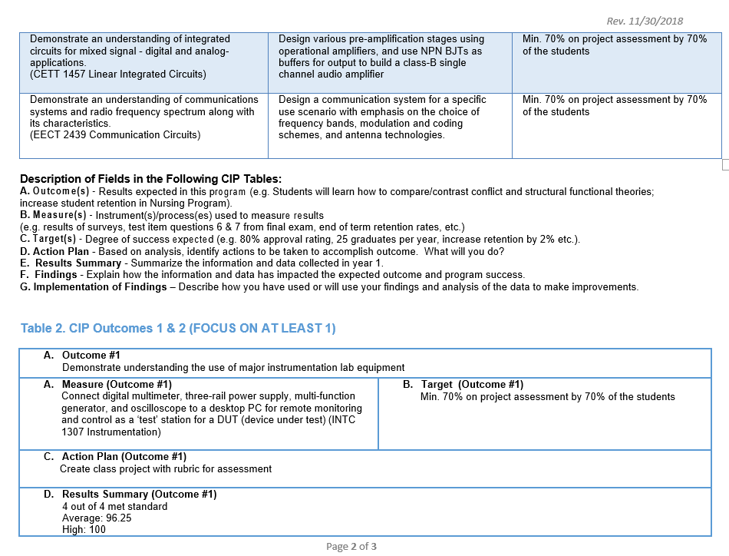
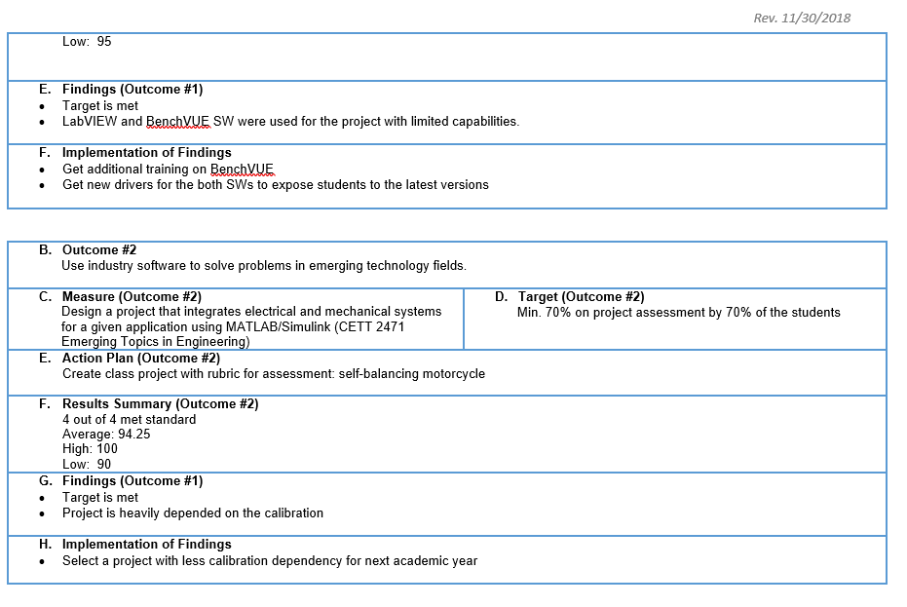

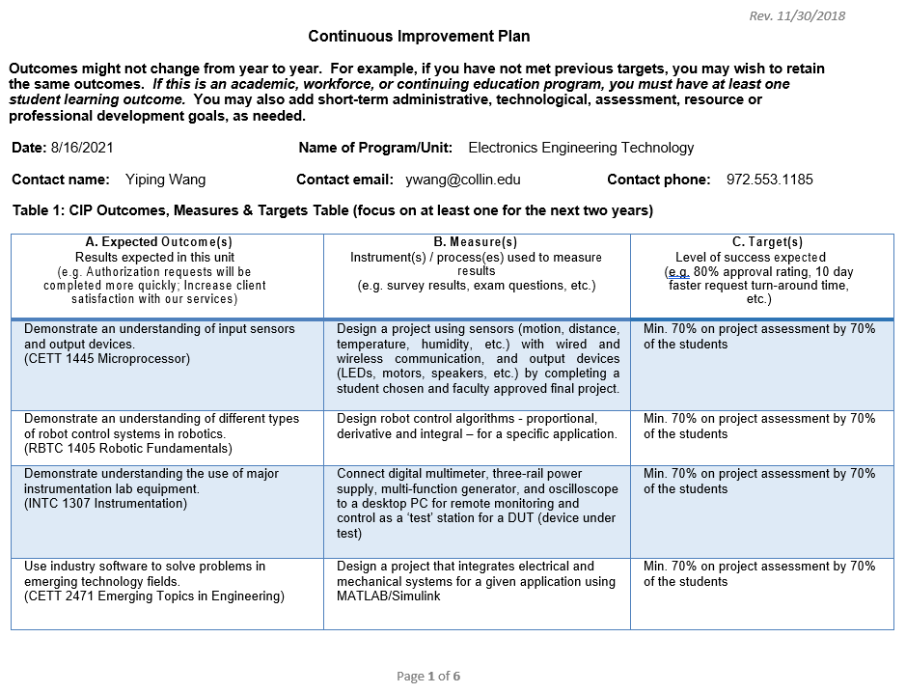

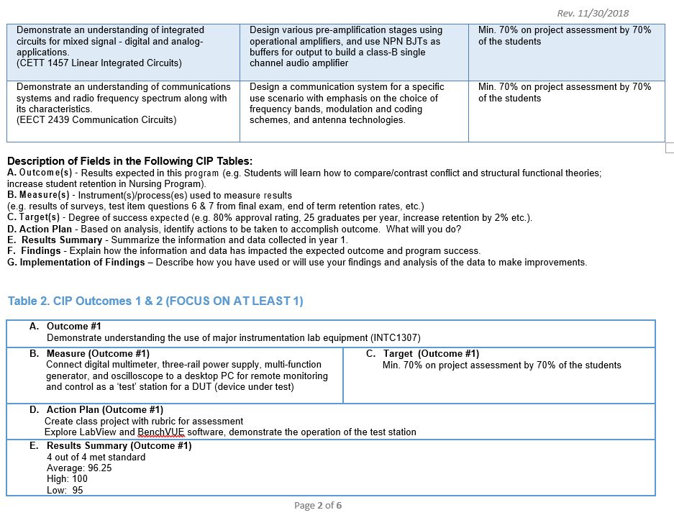
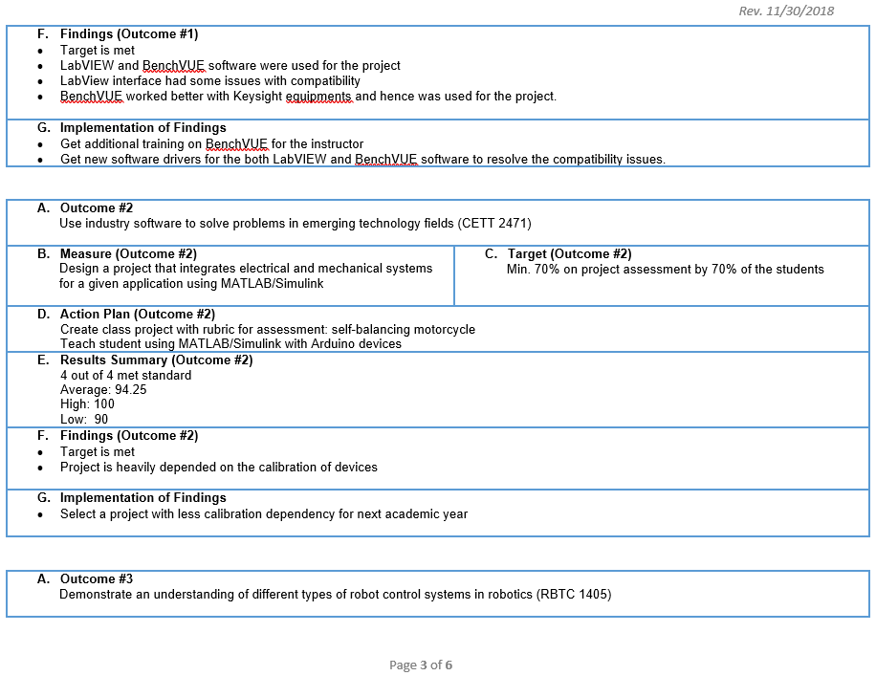
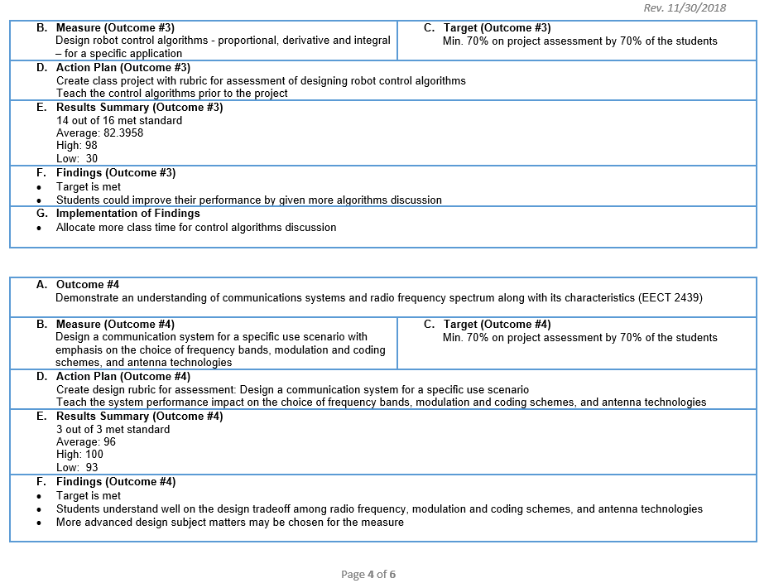
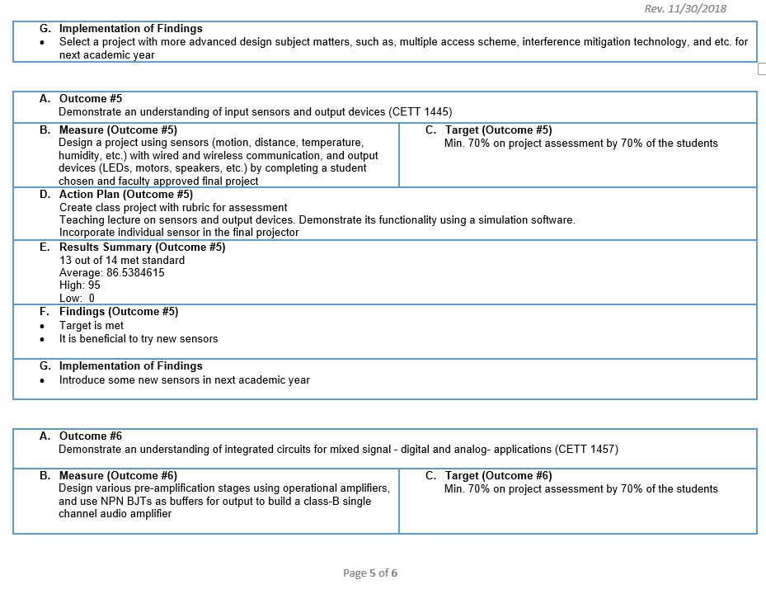
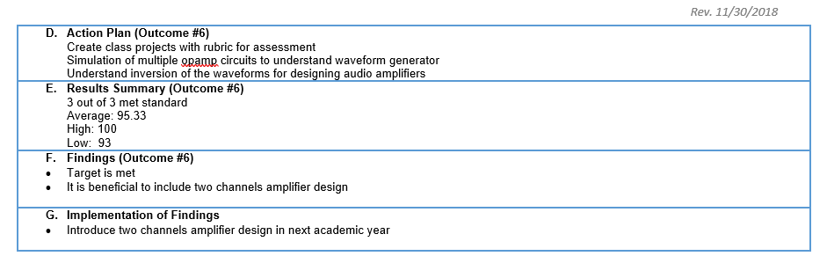
During year 2021, we took advisory board committee input to add an one credit hour class, ENTC-1171 Introduction to Engineering Technology, to have industrial professionals coming to the class and sharing first-hand work experience with their degree. For keep the degree plane hour at 60 SCHs, we have proposed one SCH deduction on CETT 1407 Introduction to Electronics. Our proposal has been approved, and the new class ENTC-1171 Introduction to Engineering Technology will become effective in Fall 2022.

*Please attach previous CIP Tables in the appendix

☐11. How will we evaluate our success?

NOTE: Please contact the institutional effectiveness office if you need assistance filling out the CIP tables.
As part of the fifth year Program Review, the program should use the observations and data generated by this process along with data from other relevant assessment activities to develop the program’s CIP and an action plan for the next two years. At the conclusion of the first two years, data collected from the first year, plus any other relevant data that was collected in the interim, should be used to build on the accomplishments of those first two years by developing another two-year action plan for the CIP to help the program accomplish the expected outcomes established in its CIP or by implementing one of your other plans.

Based on the information, analysis, and discussion that have been presented up to this point, summarize the strengths and weaknesses of this program. There should be no surprise issues here! This response should be based on information from prior sections of this document. Describe specific actions the faculty intends to take to capitalize on the strengths, mitigate the weaknesses, improve student success and program learning outcomes. Provide the rationale for the expected outcomes chosen for the CIP(s).

Refer to tables below for information on completers for the last 10 years.

http://inside.collin.edu/iro/programreview/202122/AwardsByProgram%202017-2021.10292021.pdf
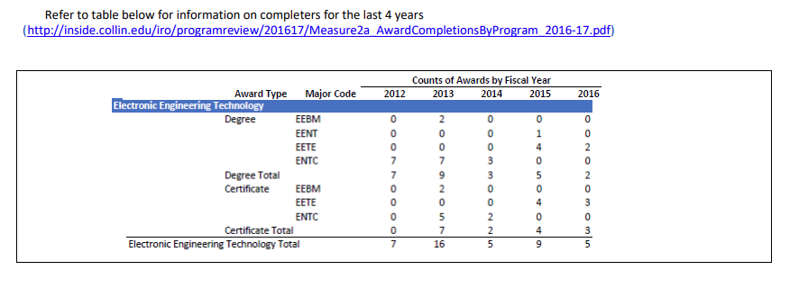
The above data shows that the counts of awards increased from 42 to 58 during the last five-year period. It indicates the success in implementing the CIP from the last program review cycle. We have made our class schedules fit student needs due to the adjustment of the Equipment/Student ratio. More cutting-edge technology topics by introducing/updating six classes led to high enrollment and more completion.
However, we still have a lot of room to improve. Especially, in the following areas,
- Lack of lab space, currently we are experiencing scheduling difficulty for some of classes in the evenings. As the student population grows to meet the job market, the issue will likely get aggregated.
- Lack of advertising funds and PR support.

Mitigation:
- Updating digital lab to work as analog lab also can alleviate this problem
- Proposal for advertising budget will be submitted to the leadership at the end of the current fiscal year to help advertise the program in the next fiscal year.

☐ 12. Complete the Continuous Improvement Plan (CIP) tables that follow.
Within the context of the information gleaned in this review process and any other relevant data, identify program priorities for the next two years, including at least one program learning outcome (or program competency), and focus on these priorities to formulate your CIP. You may also add short-term administrative, technological, assessment, resource or professional development outcomes as needed.

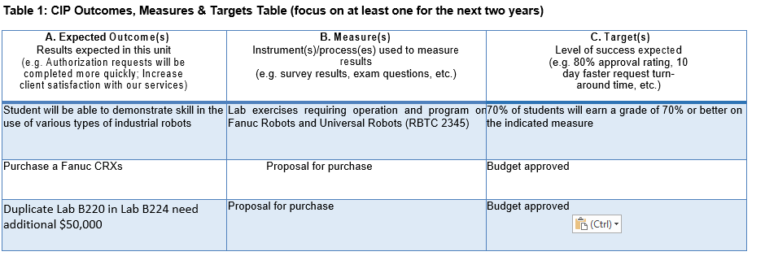

Table 1. CIP Outcomes, Measures & Targets Table (focus on at least one for the next two years)
A. Expected Outcomes  Results expected in this unit  (e.g. Authorization requests will be completed more quickly; Increase client satisfaction with our services) | B. Measures  Instrument(s)/process(es) used to measure results  (e.g. sign-in sheets, surveys, focus groups, etc.) | C. Targets  Level of success expected  (e.g. 80% approval rating, 10 day faster request turn-around time, etc.)
Students will be able to demonstrate skills in the use of instrumentation devices such as multi-meter, signal function generator, oscilloscope, and spectrum analyzer | Click or tap here to enter text. | 70% of students will earn a grade of 70% or better on indicated measure
Click or tap here to enter text. | Class project requiring assembly of an electronic system to accomplish a task. Perform subsequent testing and evaluation of its performance (CETT 1457) | 70% of students will earn a grade of 70% or better on indicated measure
Click or tap here to enter text. | Lab exercise to perform maintenance on a given system consisting of input devices, communication circuits, and output devices (CETT 1445) | 70% of students will earn a grade of 70% or better on indicated measure
Click or tap here to enter text. | Click or tap here to enter text. | 70% of students will earn a grade of 70% or better on indicated measure

Continuous Improvement Plan

Outcomes might not change from year to year. For example, if you have not met previous targets, you may wish to retain the same outcomes. You must have at least one program learning outcome. You may also add short-term administrative, technological, assessment, resource or professional development goals, as needed. Choose 1 to 2 outcomes from Table 1 above to focus on over the next two years.

A. Outcome(s) - Results expected in this program (from column A on Table 1 above--e.g. Students will learn how to compare/contrast Conflict and Structural Functional theories; increase student retention in Nursing Program).
B. Measure(s) – Instrument(s)s/process(es) used to measure results (e.g. results of essay assignment, test item questions 6 & 7 from final exam, end of term retention rates, etc.).
C. Target(s) - Degree of success expected (e.g. 80% success rate, 25 graduates per year, increase retention by 2% etc.).
D. Action Plan - Implementation of the action plan will begin during the next academic year. Based on analysis, identify actions to be taken to accomplish outcome. What will you do?
E. Results Summary - Summarize the information and data collected in year 1.
F. Findings - Explain how the information and data has impacted the expected outcome and program success.
G. Implementation of Findings – Describe how you have used or will use your findings and analysis of the data to make program improvements.
Table 2. CIP Outcomes 1 & 2
- Outcome #1 Student will be able to demonstrate skill in the use of various types of industrial robots

- Measure (Outcome #1)  Lab exercises requiring operation and program on Fanuc Robots and Universal Robots (RBTC 2345) | - Target (Outcome #1)  70% of students will earn a grade of 70% or better on indicated measure
- Action Plan (Outcome #1)
Create lab exercises on both Fanuc and Universal Robots with rubric for assessment.
- Results Summary (Outcome #1) TO BE FILLED OUT IN YEAR 2

- Findings (Outcome #1) TO BE FILLED OUT IN YEAR 2

- Implementation of Findings (Outcome #1) TO BE FILLED OUT IN YEAR 2

Table 2. CIP Outcomes 1 & 2 (continued)

- Outcome #2 Purchase a Fanuc CRXs

- Measure (Outcome #2)  Proposal on the purchase | - Target (Outcome #2)  Budget approved
- Action Plan (Outcome #2)
Make proposal
- Results Summary (Outcome #2) TO BE FILLED OUT IN YEAR 2

- Findings (Outcome #2) TO BE FILLED OUT IN YEAR 2

- Implementation of Findings (Outcome #2) TO BE FILLED OUT IN YEAR 2

What happens next? The Program Review Report Pathway
- Following approval by the Steering Committee,
- Program Review Reports will be evaluated by the Leadership Team;
- After Leadership Team review, the reports will be posted on the Intranet prior to fall semester;
- At any point prior to Intranet posting, reports may be sent back for additional development by the unit.

- Unit responses to the Program Review Steering Committee recommendations received before July 31st will be posted with the Program Review Report.

- Leadership Team members will work with program supervisors to incorporate Program Review findings into planning and activity changes during the next five years.

Please make sure to go back and complete your Executive Summary at the start of the Review.

