PROGRAM NAME: Associate of Arts in Teaching | AUTHORING TEAM CONTACT: Courtenay Jauregui
PHONE: 972-378-8507 | EMAIL: cjauregui@collin.edu

GUIDELINES
Time Frames
- Scope:
The time frame of program review is five years, including the year of the review.
Data being reviewed for any item should go back the previous four years, unless not available.
- Deadline Dates:
January 15th – Program Review Document due to Department Dean for review (Deans may require submissions at their own, earlier due date)
February 1st – Program Review Document due to Program Review Steering Committee
- Years:
Years 1 & 3 – Implement Action Plan of (CIP) and collect data
Years 2 & 4 – Analyze data and findings, Update Action Plan
Year 5 – Write Program Review of past 5 years; Write Continuous Improvement Plan (CIP) and create new Action Plan

LENGTH OF RESPONSES: Information provided to each question may vary but should be generally kept in the range
of 1-2 pages or 500-1,000 words.

EVIDENCE GUIDELINES: In the following sections, you will be asked to provide evidence for assertions made.
- Sources: This evidence may come from various sources including professional accreditation reviews, THECB, Texas Workforce Commission’s CREWS, Institutional Research Office (IRO), National Student Clearinghouse, IPEDS, JobsEQ, EMSI Career Coach, and may be quantitative and/or qualitative. If you are unfamiliar with any of these information sources, contact the Institutional Research Office at: effectiveness@collin.edu. Use of additional reliable and valid data sources of which you are aware is encouraged.
- Examples of Evidence Statements:
- Poor example: Core values are integrated into coursework. (Not verifiable)
- Good example: Core values are integrated into coursework through written reflections. (Verifiable, but general)
- Better example: Core values are integrating into coursework through written reflections asking the student to describe how s/he will demonstrate each of the core values in his or her professional life and demonstrated through service learning opportunities. (Replicable, Verifiable)

FOR MORE INFORMATION: The Program Review Portal can be found at http://inside.collin.edu/institutionaleffect/Program_Review_Process.html. Any further questions regarding Program Review should be addressed to the Institutional Research Office (effectiveness@collin.edu, 972.599.3102).

Introduction/Preface
☐EXECUTIVE SUMMARY
Briefly summarize the topics that are addressed in this self-study, including areas of strengths and areas of concern. (Information to address this Executive Summary may come from later sections of this document; therefore, this summary may be written after these sections have been completed.) Please do not include information in this section that is not already provided elsewhere in this submission. Using the questions in the template as headings in the Executive Summary can provide structure to the overview document (see below for suggested format).
Executive Summary (suggested sections/format-not required format)
What does our program do?
Why do we do the things we do: Program relationship to the College Mission & Strategic Plan.
Why we do the things we do? Program relationship to student demand.
Why we do the things we do? Program relationship to market demand.
How effective is our curriculum and how do we know?
How effectively do we communicate, and how do we know?
How well are we leveraging partnership resources and building relationships, and how do we know?
How have past Continuous Improvement Plans contributed to success?
How will we evaluate our success?

Complete the Executive Summary below after you have completed your review.
What does our program do?
The Associate of Arts in Teaching (AAT) at Collin College prepares students to enter educator preparation programs at baccalaureate institutions, leading to bachelor’s degrees and teaching certification in early childhood through grade six (EC-6), middle grades (4-8), secondary education (8-12) or specialized kindergarten through twelfth grade degrees (such as special education). The mission of the Collin College Department of Education is to equip life-long, reflective learners in critical thinking and communication techniques; and to prepare future teachers who utilize best teaching practices, create developmentally appropriate educational environments for diverse learners, and generate positive impacts on children, youth, families, and school communities.
Why do we do the things we do: Program relationship to the College Mission & Strategic Plan.
The AAT reinforces the College Mission and Strategic Plan in the following ways: student and community centered, developing skills, strengthening character, and challenging the intellect. The strategic goals include: improve student outcomes to meet or exceed local, state, and regional standards, create and implement comprehensive, integrated pathways to support student transitions, and develop a coordinated and systematic approach to engage external stakeholders. The department fosters the mission and strategic plan through targeted key assessments, classroom observations, and events focused on marketable and professional skills. The department hosts an annual event for potential and current teacher candidates to engage with transfer partners and local school employees. The department has strong partnerships with state-wide organizations and local school districts to enhance the student experience and implement best practices into the program. Stakeholders, including the department and transfer partners, created an alignment map to better scaffold the learning and challenge teacher candidates with professional skills and responsibilities prior to transfer.
Why we do the things we do? Program relationship to student demand.
There is demand for the Associate of Arts in Teaching. Over this program review period, student enrollment and student completion have increased, although we did see decreases in Year 5 that may be attributed to the on-going pandemic. Even with these decreases in Year 5, overall enrollment and completion are well above where they were at the beginning of our review period. Student completers grew from 82 to 133 within the review period, an increase of 61.7 percent. Student enrollment has also grown, from slightly over 1,000 unduplicated students in 2016 to a peak of about 1400 students in 2019. Classes are also offered in a variety of formats including online, hybrid, weekend, accelerated, day and evening classes to accommodate student need and schedules.
Why we do the things we do? Program relationship to market demand.
According to the Occupational Outlook Handbook produced by the U.S. Bureau of Labor Statistics, the teaching field projects a job growth rate of 7% between 2020-2030. While this is a national outlook, the job outlook in Texas is higher. Texas Career Check anticipates job growth of approximately 11% between 2018-2028. Teachers are needed and our students will be employable.
Upon completion of the AAT, students will have the following marketable skills:
- Create and implement objectives, instruction, and assessment in accordance with state standards and district guidelines.
- Develop an age-appropriate classroom management plan.
- Monitor and assess student performance and provide relevant and timely feedback.
- Adapt and modify teaching methods and instructional materials to meet students’ varying needs and interests.
- Identify characteristics of diverse learners that affect classroom learning and the culture of schooling.
- Communicate effectively and professionally with administrators, colleagues, staff, and families.
These skills directly correlate to the skills desired by future employers.
How effective is our curriculum and how do we know?
EDUC 1301 and EDUC 2301 IRO data report student success rates above 75% and student retention rates above 75%. The course key assessments and classroom observations with anecdotal records are designed to promote student learning outcomes, marketable skills, and the Texas Pedagogy and Professional Responsibility Standards. The department has worked to provide a consistent student experience across sections through the development of these key assessments, course vertical alignment, the development of course templates, and the training of adjunct faculty. We have intentionally addressed challenging student learning outcomes through our Continuous Improvement Plan, monitored through our key assessments and student survey. Further, grade distributions indicate student success above 75% in both EDUC 1301 and EDUC 2301. Students indicate strong satisfaction with faculty and the course through student evaluation data.
How effectively do we communicate, and how do we know?
One of our department’s biggest strengths is our departmental lab manual. This manual provides all EDUC 1301 and EDUC 2301 students with a step-by-step guide to the early field experience (observation) component of the course. Both EDUC 1301 and EDUC 2301 have OAB (Online Advisory Board) approved course templates that can be used in online, hybrid, and face-to-face courses by all faculty. These templates communicate the curriculum expectations, key assessment information, and lab information for all faculty. The department also has a department-based Canvas shell. The shell provides faculty members with course expectations, lab expectations, key assessment information (including rubrics and outcomes), and training videos. The inclusion of the department shell provides timely communication with any curriculum changes in the department.
Each semester, EDUC 1301 and EDUC 2301 faculty are trained on changes and updates to the lab manual, the course key assessments, and data collection. As a department, full-time faculty meet at least once per month to discuss any departmental business, course curriculum, and updates from local and state committees. Opportunities are also provided to share concerns and best practices that may have occurred in the semester.
To remain updated on current practices and policies, faculty regularly attend teacher education conferences and participate in state-wide teacher education committees. Faculty report relevant information, updates, and best practices through the monthly department meetings and the EDUC Faculty Outlook group email. Any relevant changes to programming and / or certification are communicated to students through the courses.
An approved promotional flyer highlights the Associate of Arts in Teaching. It is available to all faculty and can be distributed electronically or printed for use at our F.I.N.E. Education Fair, campus resource fairs, and other community events. The flyer has been shared with both career coaches and academic advising.
One area of opportunity / improvement is the department website. Faculty have been trained to edit the website; however, one designated division employee has the responsibility for updating the information. The discipline leads for education and early childhood met with the person responsible for the updates in the fall but updates have not yet been made. While most of the information is accurate, lab information and course offerings can change from semester to semester due to course sequencing and availability for classroom observations.
Another area of opportunity is student feedback. While faculty receive feedback from students via the student course survey and student course evaluations, there isn’t a formal collection system for student feedback across all courses. The student survey assesses the student’s comfort and knowledge for one of the student learning outcomes. Student evaluations assess the overall satisfaction. But, more specific questions on skills, professional responsibility, critical thinking, and communication could also be assessed at the end of the semesters.
How well are we leveraging partnership resources and building relationships, and how do we know?
In the Associate of Arts in Teaching, partnerships play a vital role in our student’s preparation and experiences. The state mandates that students complete 16 hours of observation in a public school classroom during a student’s enrollment in EDUC 1301 and EDUC 2301 courses. Local independent school districts welcome Collin students into their classrooms for these observations. The lab coordinator and full-time faculty maintain relationships with key personnel (including HR, administrators, and teachers) within these school districts to help foster these student observations. Additionally, full-time faculty serve on committees within the local school districts to further these partnerships. Faculty also take opportunities to present to students within these partner districts through avenues such as the TAFE ( Future Educators) Student Conference, our own annual FINE (Find, Investigate, Navigate, Education) event, and through presentations to AVID students on college success-type topics. We are fortunate to employ adjuncts who have or are currently working in local school districts as well.
The Collin faculty also regularly interact and communicate with transfer partner faculty. Transfer partners have been invited into classrooms, the FINE events, alignment meetings, and TSTA meetings. The Collin AAT program has bettered the transfer alignment through these conversations and interactions. The faculty created an alignment document stating theories and concepts that should be taught prior to transfer.
How have past Continuous Improvement Plans contributed to success?
Our past Continuous Improvement Plans encouraged us to reach out to our partner institutions to discuss alignment between our program and their expectations of students who transfer. We have also completed internal vertical alignment between EDUC 1301 and EDUC 2301 to ensure coverage and sequencing of topics. We continue to provide training to adjunct faculty to ensure consistency across sections of both courses. The focus on challenging student learning outcomes has encouraged faculty to regularly review and revise course key assessments and rubrics, as well as to regularly discuss areas of strengths and weaknesses as a department.
The key assessments with coordinating data have helped isolate challenging concepts within the courses. Scaffolding is provided with the key assessment to better ensure student comprehension and performance. Faculty regularly meet to discuss student performance with the key assessments and revisions are made each academic year to the key assessment instructions and rubrics as well as further discussion in best practices teaching the concepts.
How will we evaluate our success?
In reviewing the Program Review document, several strengths and opportunities for improvement were found. Strengths of the program include: faculty, teaching and learning, service and involvement, data collection, norms, alignment, consistency, and student success. Areas of opportunity include continued training in and emphasis on the importance of data collection by all faculty. Promotion of the AAT degree and the completion of the AAT degree must occur in our classes, with academic advising, and with our transfer partners. Looking forward, the department will focus on the goals in the new CIP including focusing on the new Program Level Outcomes.

Section I. Are We Doing the Right Things?
☐1. WHAT DOES OUR ACADEMIC PROGRAM DO?
What is the program and its context?
This section is used to provide an overview description of the program, its relationship to the college and the community it serves. Keep in mind the reviewer may not be familiar with your area. Therefore, provide adequate explanation as needed to ensure understanding.

Suggested points to consider:
- Program’s purpose (Include the program’s mission statement if one exists.)
- Program learning outcomes or marketable skills
- Brief explanation of who the program serves
- Degree paths it prepares graduates to enter
- What regulatory standards must the program meet (THECB, Workforce, external accreditation)

The Associate of Arts in Teaching at Collin College prepares students to transfer to educator preparation programs, leading to bachelor’s degrees and initial teacher certification in early childhood through grade six, middle grades (four through eight), secondary education (grades 8-12), or specialized K-12 degrees such as special education.

Program Purpose (including mission statement)
The mission of the Collin College Department of Education is to equip life-long, reflective learners in critical thinking and communication techniques; and to prepare future teachers who utilize best teaching practices, create developmentally appropriate educational environments for diverse learners, and generate positive impacts on children, youth, families, and school communities.

Program’s Learning Outcomes
- Program Learning Outcome 1: The students will design instruction that promotes student learning, makes use of effective communication techniques, and incorporates instructional strategies that actively engage a diverse student population in the learning process.
- Program Learning Outcome 2: The students will analyze grade-level curriculum and materials for various aspects of diversity, including ethnicity, gender, gifted and special education, bilingual / ESL, socioeconomic status, and family structure.
- Program Learning Outcome 3: The students will connect learning theories to educational practice.
- Program Learning Outcome 4: The students will incorporate effective technology tools and resources into the grade-level curriculum and course objectives.
- Program Learning Outcome 5: The student will analyze and evaluate ethical standards and other professional guidelines.

Program Marketable Skills
- Create and implement objectives, instruction, and assessment in accordance with state standards and district guidelines.
- Develop an age-appropriate classroom management plan
- Monitor and assess student performance and provide relevant and timely feedback
- Adapt and modify teaching methods and instructional materials to meet students’ varying needs and interests
- Identify characteristics of diverse learners that affect classroom learning and the culture of schooling
- Communicate effectively and professionally with administrators, colleagues, staff, and families.

Who the Program Serves
The Associate of Arts in Teaching serves students whose goal is to become educators in kindergarten through twelfth grade public school classrooms. The program and degree path prepare students to transfer to teacher preparation programs to complete their bachelor's degrees and obtain initial teacher certification in the state of Texas. Paths that currently exist upon transfer are certification in early childhood through grade 3, early childhood through grade 6, middle grades (4-8), secondary (8-12), and all level (e.g., special education and fine arts).

Standards the Program Must Meet
The Associate of Arts in Teaching is regulated by the Texas Higher Education Coordinating Board (THECB) and the Texas Education Agency (TEA). THECB regulates the curriculum and degree while TEA regulates teacher certification requirements, such as observation hours.

☐2. WHY DO WE DO THE THINGS WE DO: PROGRAM RELATIONSHIP TO THE COLLEGE MISSION & STRATEGIC PLAN.
- Provide program-specific evidence of actions that document how the program supports the College’s mission statement: “Collin County Community College District is a student and community-centered institution committed to developing skills, strengthening character, and challenging the intellect.”
- Provide program-specific evidence that documents how the program supports the College’s strategic plan (2020-2025 Strategic Plan): https://www.collin.edu/aboutus/strategic_goals.html.

Suggested/possible points to consider:
- What evidence is there to support assertions made regarding how the program relates to the mission and strategic plan?
- Think broadly-increasing completion, pathways to 4-yr and from high schools, etc.
- Analyze the evidence you provide. What does it show about the program?

The mission of the Collin College Department of Education is to equip life-long, reflective learners in critical thinking and communication techniques; and to prepare future teachers who utilize best teaching practices, create developmentally appropriate educational environments for diverse learners, and generate positive impacts on children, youth, families, and school communities. The following examples highlight the ways in which the Education faculty and AAT program support the mission of Collin College
Student and Community-centered
F.I.N.E. (Find, Investigate, Navigate, Educate) Education Fair: The Collin College F.I.N.E. Education Fair is an annual outreach event designed for prospective teachers. It is open to anyone in the community, including students at the high school, college, and post-graduate level. Attendees learn about the logistics of the education program, teacher certification options, short and long-term career planning, college transfer opportunities, academic planning and the merits of joining a national education student organization. In addition to Collin College Education faculty, the event involves university partners, prospective employers, student organization members, career services personnel, advising staff and other members of the Collin College team.
Student Observations: Public school teaching is not only a profession, but also service to the community. Students enrolled in the AAT program must proactively find placement to complete 32 observation hours within a public school classroom. This requirement provides an opportunity for AAT students to engage professionally with the community, giving them relevant hands-on experience in a K-12 classroom environment.
Pandemic Response: Many of our partner school districts discontinued in-person observations in response to the COVID-19 pandemic. Faculty worked tirelessly to create new options that would allow students to meet observation requirements in a virtual environment. A video library was curated for this purpose. Faculty worked one-on-one to evaluate student progress and issued incomplete contracts in eligible cases to ensure that the semester wasn’t derailed due to observation access. A resource was identified, The Teaching Channel, but this required a license which the college did not own. Numerous avenues were tenaciously pursued (library funds, division funds, innovation grant) before finally securing funding through the CARES Act in September 2021.
Student Organization: Education faculty supported the launch and development of the Texas State Teachers Association - Aspiring Educators student organization at Collin College in Fall 2019. Previously, education majors had the option to join Kappa Delta Pi International Honor Society in Education. However, the KDP eligibility requirement that 18 credits must be completed prior to joining put severe limits on the number of students who could participate. Pivoting to a new education-related student group provided greater opportunities for inclusion at all levels of degree completion. TSTA-AE has become a successful student organization, growing to over 70 members by Spring 2020. The group has continued to excel and received multiple awards at the state convention in 2020, including recognition of Suzanne Jones for Outstanding Lead Advisor. Several Collin College TSTA-AE officers advanced to serve in district and state-level leadership positions, including district president, district secretary, and state president. The group was awarded a “Voices Matter” grant through the National Education Association to build diverse libraries in Education classrooms.
Professional Conferences: Faculty regularly present at and participate in meetings, conferences, trainings and other activities that promote the teaching profession at the local, state, and national level.
Advisory Boards: Faculty serve on a variety of state-wide and community-based advisory boards. Courtenay Jauregui represented Collin College on the Texas Higher Education Coordinating Board Field of Study/Interdisciplinary Studies (AAT) Committee. Rebecca Burton serves on the Texas Education Agency Educator Preparation Advisory Committee and is a board member and secretary for the Texas Association of Community College Teacher Education Programs (2019-2021).
Developing Skills
Lesson Plan Project: The key assessment in EDUC 1301 is the Lesson Plan Project. Lesson planning is an essential part of successful teaching. Through the completion of this project, pre-service teachers experience the process of developing a complete lesson plan. Fundamental components of classroom instruction are included, such as alignment with the Texas Essential Knowledge and Skills (TEKS), identification of Bloom’s Taxonomy, creation of learning objectives, and the incorporation of effective classroom strategies, appropriate accommodations, and assessment activities.
Children’s Book Analysis: The key assessment in EDUC 2301 is the Children’s Book Analysis. Students must choose 10 children’s books that represent various dimensions of diversity including gender identity/gender expression, multiculturalism, academic ability, socioeconomics, and family structure. Students conduct a detailed analysis of each book to justify whether or not the books appropriately address the intended topics. This project provides the basis for building an inclusive classroom library upon entry to the teaching profession.
Anecdotal Records: Anecdotal Records provide students with the opportunity to critically reflect on the impact of classroom observation hours that are completed as part of their coursework.
Student Portfolios: As pre-service teachers, students are encouraged to develop portfolios which include a variety of materials such as lesson plans, teaching artifacts, and a personal philosophy of education statement. Portfolios provide an opportunity to reflect on and improve teaching practice as well as prepare for future job interviews.
Innovative Teaching Strategies: Faculty utilize creative and innovative ways to present difficult material and work together to ensure student success. Examples include community-based service learning through the Center for Scholarly and Civic Engagement and Team-Based Learning initiatives. Three campuses (Plano, Frisco, Wylie) have dedicated lab-style classrooms which offer opportunities for hand-on learning activities and collaborative work with additional resources like iPads, electronic die cut machines, and smart boards.
Vertical Alignment of Curriculum: Faculty have aligned curriculum so that EDUC 2301 builds on content and skills introduced in EDUC 1301. In addition, adjunct professors are included in training and communication is maintained to ensure that instructional standards and student performance measures are met.
Classroom Technology: Students are introduced to the International Society for Technology in Education standards and practices that leverage technology to improve student learning. Pre-service teachers build knowledge and skills through instruction on the use of technology commonly found in local independent school districts. Through targeted assignments, they learn to use current educational applications, Smart Boards, iPads, and other educational tools.
Strengthening Character
Professionalism: Early Field Experiences provide the opportunity for AAT students to learn standards of professionalism that are required in the teaching professions. Through the completion of observations and labs, students learn soft skills:
- Integrity: Students are required to maintain Pedagogy and Professional Responsibility Standards that clarify the attributes, knowledge, skills, and expectations, of successful educators. (Link to Pedagogy and Professional Responsibility Standards)
- Organization: Prior to observation placement, students must complete a variety of steps including orientation, criminal background check, confidentiality agreement, and placement applications.
- Communication: Students communicate verbally and in writing with Independent School District staff, teachers, and students. They reflect upon the experience in writing, and they are evaluated by the supervising teacher upon completion.
- Timeliness: Students must complete observation hours in a timely manner in order to receive course credit. Student punctuality is also noted on the Hour Log document and student evaluation.
- Diversity and Inclusion: Through coursework, students address contemporary issues in education, many of which are difficult and challenging. Potentially controversial topics such as race/ethnicity, gender identity, and sexual orientation, are discussed with civility and openness. Students learn to listen respectfully to viewpoints that may differ from their own.
Challenging the Intellect
Critical thinking is an essential component of teacher training. Teachers must continually analyze and evaluate what they are doing in the classroom, making corrections when needed. They must adapt to varying classroom environments and student needs. The key assessments used in the AAT program promote the development of critical thinking skills. For instance, in the Lesson Plan project students create two lessons based on selected TEKS (Texas Essential Knowledge and Skills) and written at the appropriate level of Bloom’s Taxonomy. Each lesson must align the student learning objective with the TEKS, apply the required instructional model, incorporate effective teaching strategies and assessment, and accommodate a particular learning need. In the Children’s Book Project, students analyze children’s and young adult books for various dimensions of diversity. The anecdotal records submitted in both courses require students to critically reflect on their observation experiences and apply what they are seeing to what they are learning in class. Detailed rubrics used in graded assignments allow students to identify the high-level cognitive processes that are expected. Faculty use these rubrics to standardize grading practices to ensure that a standard of excellence is met.
STRATEGIC GOALS 2020-2025
The following examples highlight the ways in which the Education faculty and AAT program support Collin College’s Strategic Goals.
Strategic Goal 1: Improve student outcomes to meet or exceed local, state, and regional accreditation thresholds and goals.
Advisory Boards: The Education Department faculty regularly engages local and state leaders in the field of education. This involvement, which is described in greater detail above, ensures that Collin College faculty is aware of current trends to ensure that student outcomes align with teaching standards and certification requirements.
Strategic Goal 3: Create and implement comprehensive integrated pathways to support student transitions.
F.I.N.E. (Find, Investigate, Navigate, Educate) Education Fair: This comprehensive program, which is described in greater detail above, combines academic advising, transfer information, and career planning to assist students with transitions to partner universities. It also provides an opportunity for local employers to engage with Collin College Education students.
University Partners: Education faculty maintains communication with key university partners who receive AAT graduates. Collin College currently has AAT transfer agreements in place with Texas Woman’s University, Texas A&M - Commerce, University of North Texas, and Texas Tech University to establish pathways for our students to obtain Baccalaureate degrees and Texas Teacher certification.
Strategic Goal 6:. Develop a coordinated and systematic approach to engage external stakeholders.
Outreach Activities: Education faculty routinely participate in outreach activities to showcase the degree program and provide information to potential students. The F.I.N.E. (Find, Investigate, Navigate, Educate) Education Fair, detailed above, targets Collin students, high school students, and community members who are interested in pursuing a career in education. Super Saturdays, held on each of the main campuses during the spring semester, targets local high school students, parents, and the community on each of the main campuses. Student Resource Fairs, aimed at current students, occur on each of the main campuses during fall and spring semesters.
Lab Coordinator: The Education department is fortunate to have a lab coordinator who is the designated liaison between local independent school districts and students who are seeking observation placements. The lab coordinator maintains a professional working relationship with key personnel to facilitate placements and troubleshoot any issues that may arise.
Student Observations: AAT students complete 32 observation hours within public school classrooms. This requirement provides an opportunity for AAT students to engage professionally with the community, giving them relevant hands-on experience in a K-12 classroom environment. Many students will go on to work for independent school districts throughout North Texas, so this requirement also provides greater understanding of potential future employers upon degree completion.

☐3. Why we do the things we do: Program relationship to student demand
Make a case with evidence to show that students want to enroll in the program. Discuss whether or not there appears to be any disproportionate enrollment by gender, race, or ethnicity (compared to Collin College’s overall student demographic distribution http://inside.collin.edu/iro/programreview/prfilehostpage.html). If any differences exist discuss possible reasons why the gap exists, and plans to address these issues to close gaps in enrollment rates between groups of students (refer to the Program Review portal for Enrollment Reports and Average Section Size data file http://inside.collin.edu/institutionaleffect/Program_Review_Process.html).
Suggested/possible points to consider:
- The number of students who completed the award in each of the last 5 years.
- What is the enrollment pattern? Declining, flat, growing, or not exhibiting a stable pattern; please explain.
- What are the implications for the next 5 years if the enrollment pattern for the past 5 years continues?
- Describe any actions taken to identify and support students enrolled in program-required courses early in the degree plan. Are there any specific supports for a diverse student population? If no actions are taken at the present, please develop and describe a plan to do so.
- Analyze the evidence you provide. What does it show about the program?

Number of students who completed the award in each of the last 5 years
Between 2017-2021, the number of completers has grown significantly, from 82 in 2017 to 133 in 2021. There was a slight decline (8 completers) from 2020 to 2021. Additional data will be needed to see if this trend continues. It could be related to the global Covid-19 pandemic in 2020-2021; however, it could also be a one-time decline. Clearly, the significant 5-year growth shows that there is demand for our program and that the overall demand has increased. Additional consideration of completers is provided later in this document.

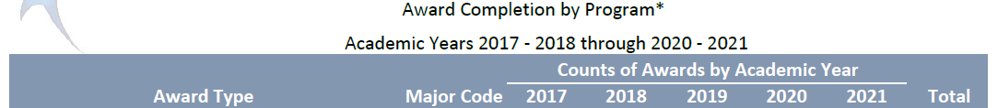
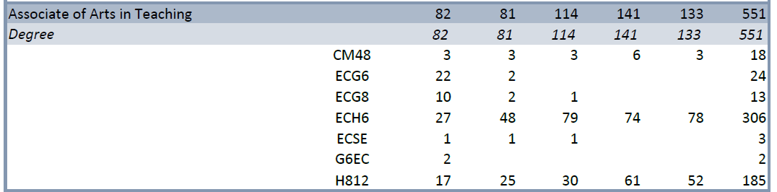
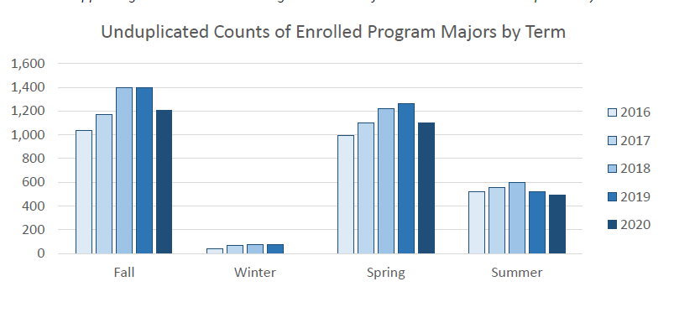
Enrollment Pattern in Unduplicated Enrollment Numbers
Evaluating Unduplicated Counts in the program, there is a steady growth pattern from Fall 2016 through Fall 2018, flat from 2018 to 2019, and a decrease from Fall 2019 to Fall 2020. Spring shows growth from Spring 2016 through Spring 2019 with a decline in Spring 2020. Winter and summer enrollments remain somewhat flat.

Possible reasons for steady growth in those academic years are expanding the number of offerings, establishing consistent and effective campus schedules, promoting the AAT within EDUC 1301 and EDUC 2301 classes and with Academic Advising. Some department members met with the advising staff on every campus to explain and to promote the benefits of the AAT major, especially in regards to transfer. In 2019, the department established the first Collin chapter of the Texas State Teachers Association - Aspiring Educators student organization. The AAT was promoted at every student organization meeting and event.

The enrollment decline seen in Spring 2020 and Fall 2020 may be a result of the global Covid-19 pandemic. The relatively flat enrollment in winter and summer may be because very few EDUC sections are offered in these parts of term due to the 16-hour observation requirement.

Duplicated Enrollment
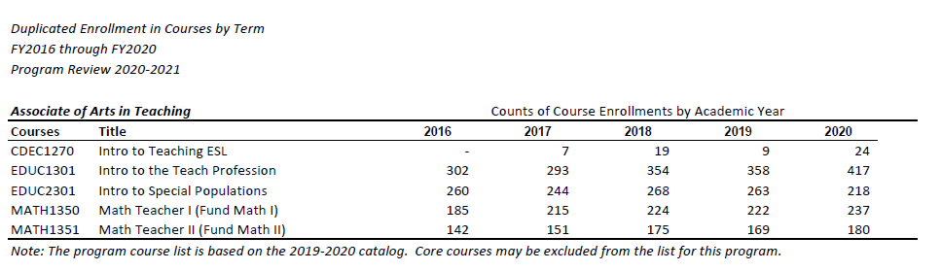
Enrollment Pattern in Duplicated Enrollment Numbers
During the program review period, CDEC 1270 was a recommended elective offered once a calendar year in Maymester. Because it is recommended and not required, enrollment seems to vary. Not every student needs the CDEC 1270 course to transfer. Many secondary education programs do not require a freshmen level ESL course. Many transfer programs embed ESL and Bilingual coursework at the upper levels once candidates are accepted into Educator Preparation Programs at the universities. Some students may have elected to take ESL and Bilingual coursework at the universities due to the express nature of Maymester. Similar to CDEC 1270, MATH 1350 and MATH 1351 are only required for students seeking an EC-6 certification. Secondary certifications do not require those classes. MATH 1350 and 1351 course offerings aren’t as prolific as the EDUC 1301 and 2301 courses. Historically, the math course offerings are limited to one-to-two face to face and one-to-two online sections per semester.

From 2016 to 2020, EDUC 1301 demonstrated growth in enrollment whereas EDUC 2301 experienced mostly flat enrollment. In 2019, EDUC 1301 became a prerequisite for EDUC 2301 which could explain the flat enrollment in 2301 and an increased enrollment in 1301. The increase in EDUC 1301 enrollment could be due to the reasons stated above with the unduplicated enrollment. For example, increased awareness, promotions of the AAT across departments, and increased conversations among the Collin education department faculty and transfer faculty. In addition, some students realize through taking EDUC 1301 that the teaching profession is not their career path, so not all students move on to take EDUC 2301.

Implications for the Next 5 Years
For EDUC 2301, if enrollment trends continue to remain mostly flat or trend to decline, then less EDUC 2301 course offerings will be needed. At the same time, EDUC 1301 continues to show upward trends in enrollment, more course offerings will be needed on each campus in different modalities, time, and parts of term.

CDEC 1270 continues to be a recommended elective. Beginning Spring 2022, the course will be offered in the full semester instead of the short-term semesters like Maymester. We anticipate flat to moderate growth due to the course being a recommended elective only. The course is not required for transfer and not required to complete the AAT.

Ethnicity Distribution for AAT Majors Compared to Collin College Overall Student Ethnicity Distribution
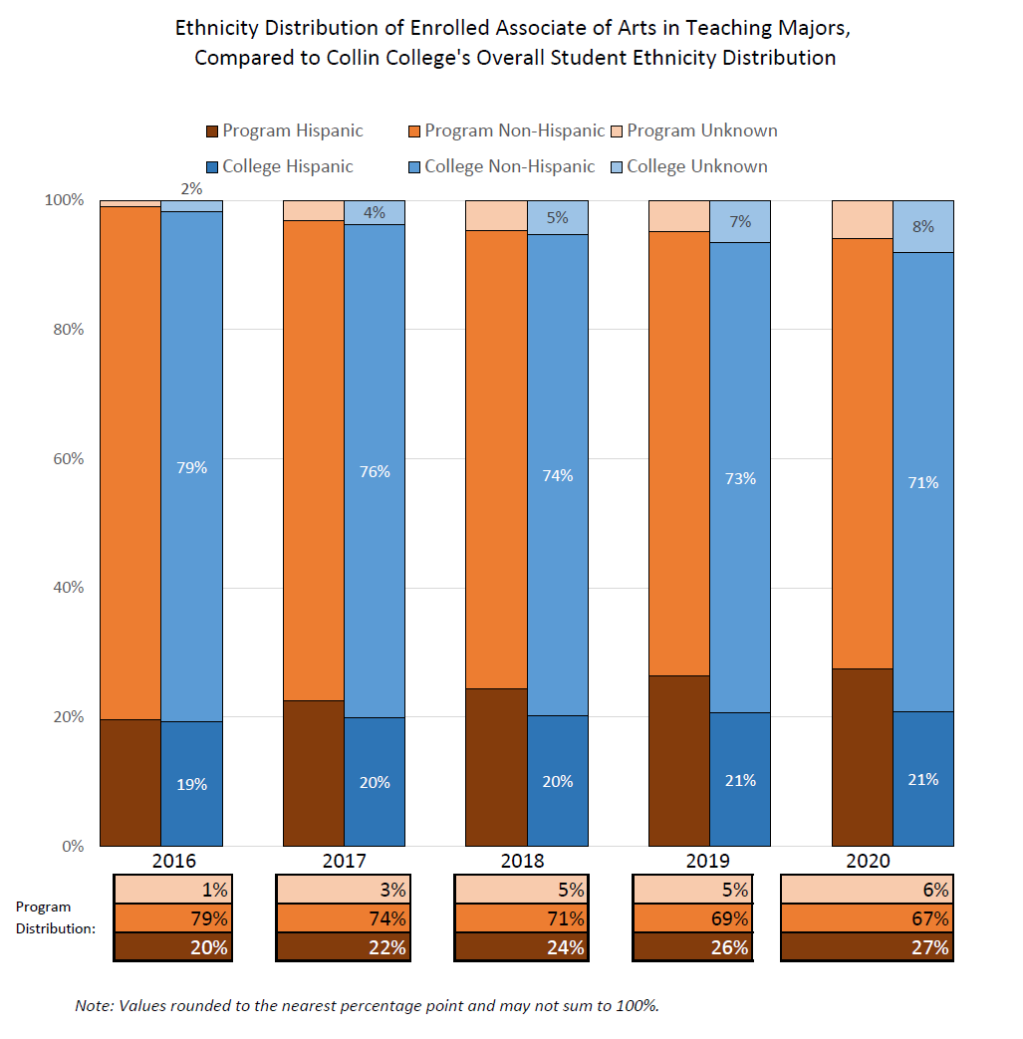

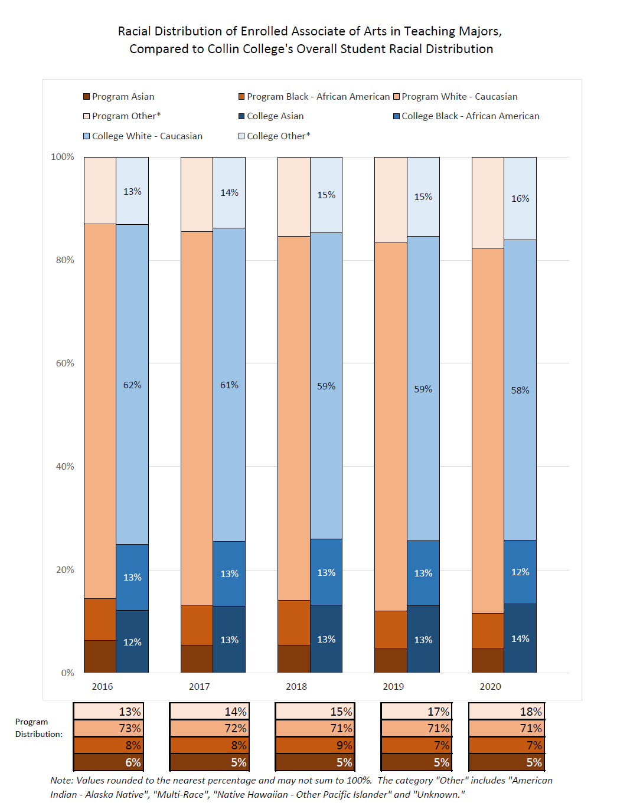

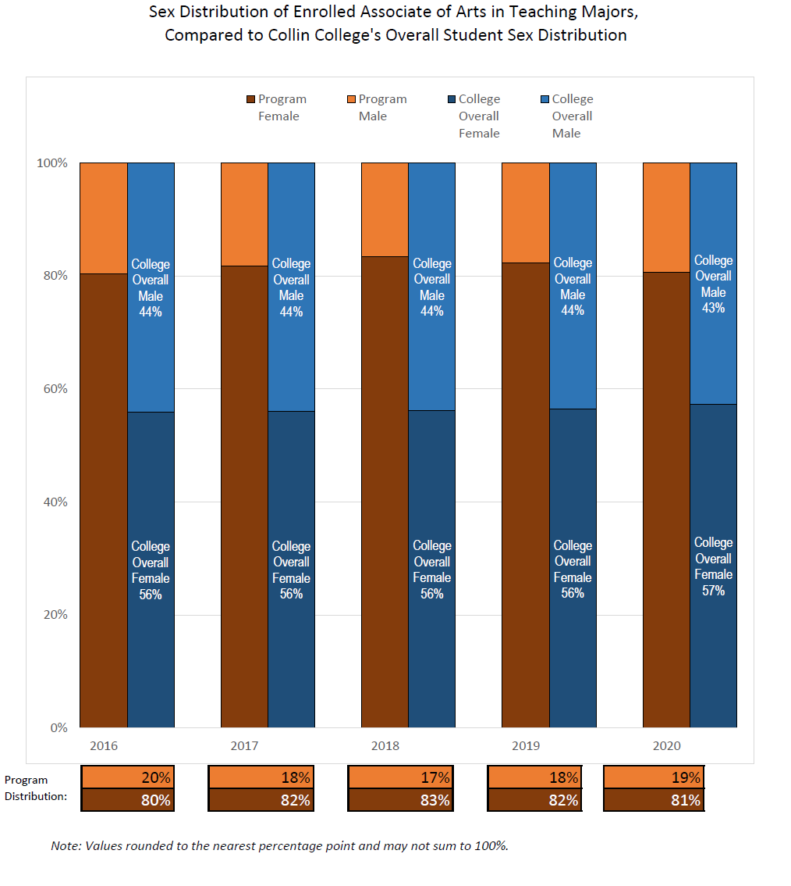
Demographic Enrollment Pattern Explanations
The program primarily consists of White, non-Hispanic, females.

The program ethnic demographic data closely mirrors the college’s ethnic demographic data. The program has slightly higher percentages of Hispanic students and slightly lower percentages of unknown ethnic demographics.

The program’s racial demographic data does not align as closely as the ethnic demographics. The program has a higher percentage of White and unknown racial demographics than the college’s distribution. The program has significantly lower percentages of Black and Asian students than the college’s distribution.

The program’s gender demographics are significantly different from the college’s gender distribution. The program has around 80% female students compared to the college’s 40%. Statistically, the education profession in Texas is primarily made of White, non-Hispanic, females, and the population of AAT students follows this pattern. Reporting by the Texas Education Agency (TEA) shows that in 2020-2021, 79.6% of all public school teachers were female, and 57% of regular classroom teachers were white. [https://tea.texas.gov/sites/default/files/employed-teacher-demographics-tgs210603.pdf]
Actions to Support Students in the AAT
In general, the first opportunity faculty have to identify an AAT student is when a student registers for EDUC 1301, the first education course in the AAT sequence. Students who elect to attend the F.I.N.E. Program (Find, Investigate, Navigation and Educate) prior to taking EDUC 1301, or students who enroll in an EDUC 1300 Learning Framework elective prior to taking EDUC 1301 may be identified sooner. In the last two years, the career coach for early childhood has taken an active role in identifying and reaching out to both early childhood and education students.

In EDUC 1301, Faculty explain the pathways from Collin’s AAT to transfer partners, give guidance on course sequencing and requirements, discuss education professional responsibilities and academic responsibilities in the EDUC 1301 course. Further, activities in EDUC 1301 provide students a glimpse of the teaching profession. For example, students learn lesson planning, classroom management, learning theory, and cultivating positive classroom climates. These activities support students by giving a solid foundation to transfer to teacher preparation programs and to be successful long term in the teaching field.

As a department, we host the FINE Event (Find, Investigate, Navigation and Educate) in the spring semester. The event is intended to equip students with transfer knowledge, AAT program knowledge, student organization awareness, and general career advice. The department also has a designated Career Coach who reaches out to all students who indicate interest in the AAT. The Career Coach also meets with students on a regular basis to provide information about the teaching profession and the AAT. The other designated staff member is a lab instructor who helps students navigate the required classroom observations.

☐4. Why WE DO THE THING WE DO: WHAT MARKETABLE SKILLS SHOULD STUDENTS HAVE AFTER COMPLETING OUR PROGRAM?
Make a case with evidence to show that the program teaches skills that are useful in the workplace.
Suggested/possible points to consider:
- What foundational skills and knowledge do employers say they want?
- Provide evidence from national, state, and/or local employer surveys, studies, editorials and other sources that identify current employer expectations for baccalaureate graduates in program-related fields.

All public schools in Texas require teachers to possess a bachelor's degree, complete an Educator Preparation Program, and obtain at least one Texas teacher certification by TEA (Texas Education Agency). Charter schools and private schools usually request teachers to have a bachelor’s degree or above, however not all charter and private schools require a teacher certification or the completion of an Educator Preparation Program.

According to the Occupational Outlook Handbook produced by the U.S. Bureau of Labor Statistics, elementary school teachers do the following:
- Create lesson plans to teach students subjects, such as reading, science, and math
- Teach students how to interact with others
- Observe students to evaluate their abilities, strengths, and weaknesses
- Instruct an entire class or smaller groups of students
- Grade students’ assignments
- Communicate with parents or guardian about their child’s progress
- Work with students individually to help them overcome specific learning challenges
- Prepare students for standardized tests required by the state
- Develop and enforce classroom rules to teach children proper behavior
- Supervise children outside of the classroom—for example, during lunchtime or recess

[https://www.bls.gov/ooh/education-training-and-library/kindergarten-and-elementary-school-teachers.htm#tab-2]

There are many different types of teacher certification, depending on grade levels, content areas, and supplemental certifications. However, the required skills for teachers remain similar to those skills noted in the Occupational Outlook Handbook, as evidenced by the job positions linked below. These job postings are from selected public independent school districts in Collin County and include elementary, middle school, special education, and high school positions.

Allen ISD Elementary Job Posting 2021
Anna ISD Elementary Job Posting 2021
Celina ISD Elementary Special Education Job Posting 2021
Community ISD Elementary Job Posting 2021
Frisco ISD Middle School Job Posting 2021
McKinney ISD Middle School Job Posting 2021
Plano ISD Elementary Job Posting 2021
Wylie ISD Elementary Job Posting 2021
Wylie ISD Secondary ELAR Job Posting 2021
Wylie ISD Secondary Math Job Posting 2021
Occupational Outlook Handbook Elementary Teacher Job Description 2021
Some school districts require elementary teachers to have supplemental ESL (English as a Second Language) certification. In the AAT (EC-6), students are encouraged to take CDEC 1270 (Introduction to Teaching ESL) as an elective to complete the degree. CDEC 1270 introduces students to concepts of teaching emergent bilingual students and helps prepare for ESL embedded content in their transfer programs and future ESL certification.

Districts and the Occupational Outlook Handbook emphasize that teachers must know how to write a lesson plan. Districts mention they want their teachers to assess students’ learning preferences and reflect differentiation within their lessons. Teachers must also make accommodations for students with different learning needs. In EDUC 1301 our students (future teachers) are required to complete a lesson plan project as the course key assessment. [Key Assessment for EDUC 1301: Lesson Plan] Each of the student-created lesson plans must be based on TEKS (Texas Essential Knowledge and Skills), standards set by the Texas Education Agency (TEA). The TEKS note the knowledge and skills for students at every grade and within every discipline or content area.

All job postings linked above state that teachers must be able to determine instructional goals, objectives, and methods. In the Lesson Plan Project, students are required to write a detailed, step-by-step lesson that could be picked up and taught by another teacher based on what is written. Students apply the Gradual Release of Responsibility instructional model to create a lesson that meets both the TEKS and the stated learning objective and incorporates specific discussion and cooperative learning strategies.

Districts also expect that teachers understand and assess students’ learning styles. Within the lesson plan process, students must account for different learning preferences and multiple intelligences. In addition, prior to final submission of the project, students incorporate appropriate classroom accommodations for a learning disability (such as ADHD or a specific learning disability). The listed job postings note that teachers must be able to conduct ongoing assessment of student achievement through formal and informal teaching. In the Lesson Plan Project, students must incorporate formative assessment at one or more points in the lesson.

In EDUC 2301, students conduct a Children's Book Analysis where they are required to demonstrate an understanding of the benefits and challenges of racial, ethnic, and other types of cultural diversity in the classroom. This project addresses Texas Pedagogy and Professional Responsibilities Standard II: The teacher creates a classroom environment of respect and rapport that fosters a positive climate for learning, equity, and excellence. Some of the linked job listings indicate that districts want teachers to assist in the selection of books, equipment, and other instructional materials. The Children’s Book Project allows students to select and analyze children’s and young adult books from various dimensions of diversity (gender expression/identity/stereotypes, multiculturalism, academic diversity, diverse family structure, and diverse socioeconomics). Students determine how well the books address diversity and justify whether or not they would include the book in a future classroom library.

All the job postings require teachers to demonstrate behavior that is professional, ethical, and responsible. They require teachers to exhibit professional judgment and responsibility at all times. In EDUC 1301, students complete a Code of Ethics assignment that requires students to review the Texas Educator Code of Ethics and apply them to various real world scenarios. Students identify the ethics violation in one of three general standards : (1) Professional Ethical Conduct, Practices, and Performance (2) Ethical Conduct Toward Professional Colleagues (3) Ethical Conduct Toward Students. However, professional standards are addressed beyond this assignment, throughout course discussions and activities as applicable, and especially in conjunction with student observations.
School districts want teachers that can manage and organize a classroom, including managing student behavior. In EDUC 1301, students create either a physical or digital classroom vision board that uses pictures and words to represent the classroom climate and culture, classroom style, and classroom management of their future classrooms. This assignment helps our students synthesize the discussions and activities that have been taking place all semester to visualize and begin to plan for their future classrooms.

The Occupational Outlook Handbook indicates that teacher duties include communicating with parents or guardians about their child’s progress. All included job listings include parent/guardian communication but further includes communication with students, colleagues, community members and administration. In both EDUC 1301 and 2301, students are required to conduct a minimum of 16 hours of state-mandated classroom observation. Students develop professional communication skills by setting up their observation site and corresponding with their mentor teacher. While the department lab instructor can guide the students, it is the student’s responsibility to contact the district and abide by their student observation policies (includes a background check). Students have to navigate requesting observation time without being rude or demanding. They have to communicate with the district, mentor teachers, and school administration and staff. While in the school, our students learn to communicate effectively with the students in the classroom.

In 2019, Dr. Suzanne Jones and Dr. Rebecca Burton founded TSTA-AE (Texas State Teachers Association - Aspiring Educators) at Collin College. This organization has been paramount to our students’ growth and development in the teaching profession. In chapter meetings, students hear from professionals in the field, such as principals, teachers, advocates, etc. This helps our students apply theory learned in the classroom to current events and issues in the field. It also helps stay abreast of current skills and strategies, and reinforces topics discussed in their EDUC 1301 and 2301 classes. TSTA-AE provides opportunities for students to network with future employers and colleagues. School districts want teachers that will grow in their profession, develop and further refine skills, and commit to ongoing professional development. TSTA-AE allows students to begin to do this from the start of their teaching journey.

Elementary and secondary job postings note that teachers should be familiar with IEPs (individualized education plans) and work with special education teachers to implement the IEP. In EDUC 1301, students are introduced to IEP and 504 plans and apply appropriate accommodations for students in their lesson plans. In EDUC 2301, students dive deeper into special education to learn more about the 13 categories of special education, laws and legal implication of special education, and application within general education classrooms.

Schools want teachers who are adept with technology and will use technology with students in the classroom. In both EDUC 1301 and 2301, students are required to understand and use current technologies used by local school districts, such as Google products, Padlet, NearPod, Pear Deck, educational applications, etc. The observation lab manual is digital and accessed online, and most assignments in EDUC 1301 and EDUC 2301 are submitted via Canvas, the course learning management system. Our program has iPads for our Frisco, Plano, and Wylie students to use during class. Furthermore, students in EDUC 1301 and 2301 are encouraged to “BYOD” (Bring Your Own Device) to analyze and review websites, apps, and other technologies that may be appropriate for use with future students. Students who cannot “BYOD” are encouraged to check out a laptop from the campus library.

The class instruction and assignments in EDUC 1301 and 2301 help our students obtain the skills and knowledge employers want. Students additionally benefit from the range of relevant experience our faculty bring to the classroom. All AAT faculty hold state teaching certifications, while some faculty additionally hold administrator certification. Every AAT faculty member has prior experience teaching in public school classrooms. Faculty regularly share “real-life experience” to address topics such as professional responsibilities, classroom management, collaboration, and communication. Students also have the opportunity to gain practical classroom experience through the observation requirements. Students are required to debrief with their mentor teachers and reflect on their observations through anecdotal records and reflective summaries.

Section II. Are We Doing Things Right?

☐5. HOW EFFECTIVE IS OUR CURRICULUM, AND HOW DO WE KNOW?
A. Make a case with evidence that there are no curricular barriers to completion. Review data related to course retention rates, course success rates, and the frequency with which courses are scheduled to identify barriers to program completion and transfer pathways.
Suggested/possible points to consider:
- FOS only: Given that FOS courses are defined by the state; what actionable barriers are seen?
- For Core only: Do all course options have sufficient enrollment to continue their inclusion in core?
- For Core and FOS certificates: What steps can be taken to improve course completion/success rates, course enrollment, and scheduling frequencies for specific courses?
- Program course retention and success rates: Attach the relevant information from the Program Review Data Set on the Institutional Research Office’s intranet page.
- Identify and discuss all courses that have a retention rate below 78% (Carl Perkins’ standard).
- Using assessment evidence and instructor observations, identify the student learning outcomes that are the greatest challenges for students. Identify any additional barriers to student success.

The Texas Higher Education Coordinating Board describes the AAT as “a Board approved specialized lower-division academic degree program designed to transfer in its entirety to a baccalaureate program that leads to initial Texas teacher certification.” [https://www.highered.texas.gov/institutional-resources-programs/public-universities-health-related-institutions/transfer-resources/associate-of-arts-in-teaching/] The AAT is similar to Field of Study curricula in that it is designed to transfer in its entirety to a baccalaureate program that leads to initial Texas teacher certification. In addition, the AAT curriculum is defined by a process in which the THECB coordinates the efforts of college faculty across the state.

Beginning Spring 2019, Professor Courtenay Jauregui was appointed to the committee that would develop the Multidisciplinary / Interdisciplinary Studies Field of Study that would fulfill the lower-division AAT requirements. The Field of Study was not completed and implemented due to the pandemic. It is unclear at this time when or if the committee work will continue.

The State Board of Educator Certification and the Texas Education Agency govern, oversee, and enforce certification requirements in preparation programs. Both EDUC 1301 and 2301 require additional hours outside of the required classroom contact hours. Students are required to complete 16 observation hours in a public school classroom or a school accredited through TEA in both EDUC 1301 and EDUC 2301. Due to the varied district processes, students must complete applications in their desired district. There is not a single formalized application process across the local districts. Additionally, the state requires that several forms are kept on record for seven years after completion of the AAT. For example, the lab instructor keeps records of the students’ verified classroom observation hours. Some districts may not place students until mid-way through the semester which can be challenging for students and creates a potential barrier to completion. This placement process creates a strain on students to both complete their hours and their classroom expectations in a reasonable time frame. Students cannot observe in the classrooms during Maymester or Wintermester due to state and district limitations. Summer semesters are also challenging as many districts do not allow student observers in summer school programs. During the start of the pandemic, the Collin education department had to quickly and efficiently convert all face to face student observers to a virtual classroom observation experience to maintain certification requirements dictated by the state. The education department faculty have continued to remain nimble through the pandemic to both serve the students and maintain government and certification mandates over the certification requirements and observations.

Grade Distributions
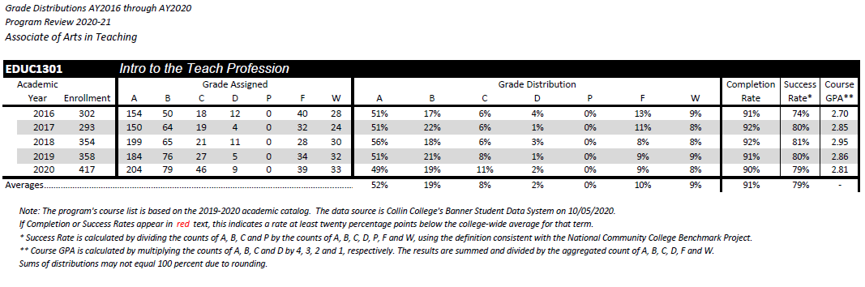
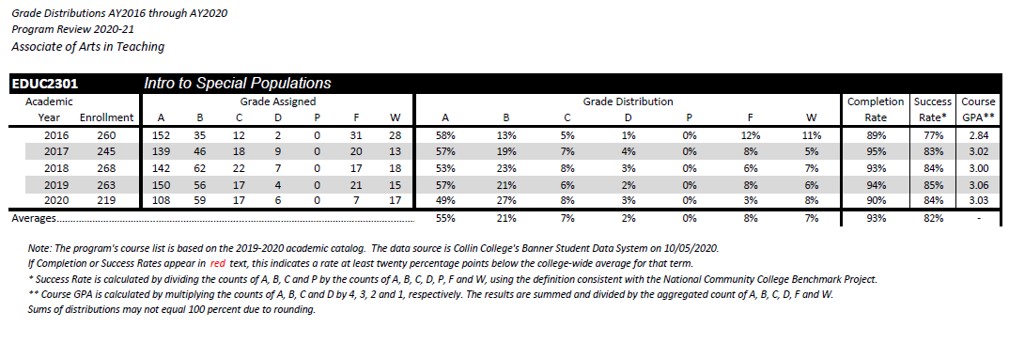
Course Retention and Success Rates
In EDUC 1301, course completion rates remain steady at around 91% during the 2016-2020 period. While success rates were below 78% in 2016 (74%), rates remain between 79 and 81% for all subsequent years. For EDUC 2301, course completion rates range between 89 and 95% during the 2016-2020 period. Success rates are higher than in EDUC 1301, ranging from 77% to 84%, averaging 82% over this period. One possibility for the greater success rates in this course is the implementation of the prerequisite requirement. After taking EDUC 1301, students are more familiar with the observation process and expectations for demonstrated marketable skills in the course activities.

EDUC 2301 average completion rate is 2 percent higher than EDUC 1301. EDUC 1301 course is the first in the AAT sequence. Some students use EDUC 1301 to determine their interest in the education field. In that process, some students decide that the teaching field is not a right fit and therefore do not complete the course or the required observation hours. Also, in EDUC 2301, students are more familiar with the observation process to receive placement, complete the observation hours, and write the anecdotal records. The observation hours, activities, and placement occurs outside of class time. While faculty members and the lab instructor assist with the process, it relies on the students to follow through with applications, setting up hours with districts and attending the observations.

Students are completing our EDUC 1301 and EDUC 2301 courses and completing them at an average above the Perkins requirement. There are several possible reasons for the higher success and completion rates. One, the department has created a lab manual for all EDUC 1301 and 2301 students to follow. This manual provides step-by-step instruction for all facets of the observation process from applying for placement to submission of all required forms and critical reflection. Prior to the lab manual creation, students articulated confusion with the process via student evaluations. Another possible reason for success is department-wide consistency through Canvas course templates, key assessments and rubrics, and course-designated focus hour topics for critical reflections on the observation requirement. Additionally, faculty have met to ensure inter-rater reliability when scoring key assessments. All faculty are updated in course and observation requirements through the departmental Canvas Course Shell. All faculty are also provided training in how to access course materials, training videos, and implementation of the key assessments. Faculty provide data on key assessments each semester which informs further revisions and training.

One possible reason that the student success is not higher may be the observation hours. According to the state requirements and ACGM (Academic Course Guide Manual) requirements, students must complete at least 16 hours of observation for each AAT course. If the student fails to complete all observation hours, then the state does not pass the course. Faculty teach students how to apply in the districts, review observation hour requirements, and introduce observation activities the first week of school. Districts set early deadlines for placement applications so that students have ample time to complete the observation hours. Students are also regularly reminded through announcements, class announcements, and emails about placement and observation hour deadlines.

The department has maintained a variety of course offerings through express, evening, weekend, online, hybrid, blended, face-to-face, and mini-mesters (where applicable). This ensures we have course offerings that best meet the needs of our students.
Challenging Student Learning Outcomes
The education department collects data on the lesson plan key assessment every long semester for EDUC 1301 and EDUC 2301. Both full-time and part-time faculty use the same lesson plan design, template, rubric, and outcomes in EDUC 1301. And, in EDUC 2301, faculty use the same children’s book analysis instructions, sample, rubric, and outcomes. At the completion of the key assessment, faculty rate students on SLO and PPR outcomes based on rubric scores in those areas. Not every course SLO is evaluated in the key assessment.

The SLOs in EDUC 1301 evaluated are SLO #2 Analyze the culture of schooling in classrooms from the perspectives of language, gender, socioeconomic, ethnic, and disability-based academic diversity and equity: SLO #3 provide examples from classroom observations and course activities that demonstrate understanding of educational pedagogy and professional responsibilities of teachers; SLO #5 Recognize the various multiple intelligences / learning styles in order to be able to implement instructional practices that meet the needs of all students. The PPR (Pedagogy and Professional Responsibility) Standards assessed in EDUC 1301 are: PPR #1 The teacher designs instruction appropriate for all students that reflects an understanding of relevant content and is based on continuous and appropriate assessment; PPR #3 The teacher promotes student learning by providing responsive instruction that makes use of effective communication techniques, instructional strategies that actively engage students in the learning process and timely high quality feedback. Using the key assessment outcome data, the SLO that students struggle with the most is SLO#2. Because students struggle with SLO #2, it has been included in our CIP data throughout this program review period.

Possible reasons for students struggling with SLO#2 are the accommodations section of the SLO. Students are required to demonstrate mastery of embedding accommodations for students with disabilities into their lesson plans. For many students, writing lesson plans and embedding accommodations is a new skill. Further, many of our students may not have personal or professional experience with students with disabilities and lack the perspective on effective accommodations. The department provided a foundation to accommodations, but with more professional and academic experience, this skill will be further developed, including their coursework in EDUC 2301.

Another potential issue is the design of EDUC 1301 SLOs. The SLOs are robust and include many complex facets of classroom teaching and learning. The nature of the SLOs allows students to learn about many topics in education but only at a foundation level, not at an advanced level of understanding.

The SLOs in EDUC 2301 evaluated are: SLO #2 Describe and analyze characteristics of diverse learners (e.g. language, gender, sexual orientation, race, ethnicity); SLO #4 Demonstrate an understanding of the benefits and challenges of racial, ethnic, and other types of cultural diversity in the classroom. The PPR Standard #2 is The teacher creates a classroom environment of respect and rapport that fosters a positive climate for learning, equity, and excellence. Using the key assessment outcome data, no patterns emerged. Semesters showed different SLOs and PPRs with lower scores.

Key assessment data sheets are below. Data was collected using outcomes in Canvas. The department started on a 2 point scale. 0 was given for those who did not complete the assessment or did not achieve the outcome. 1 point was given to students who met most expectations in the outcome, and 2 points were given to students who met all of the expectations in the outcome requirements. After reflection, in Fall 2019, the department moved to a 3 point scale to differentiate those students who did not complete the assessment and those students who did not achieve the expectations but did submit the assessment.
There are several factors that may have affected the data. The “0” point skewed the overall success average in the key assessment data so does not give an accurate reflection of those students who completed the assessment but may not have fully mastered it. Additionally, not all part-time or full-time faculty filled out the data sheets every semester, despite repeated reminders throughout the semester. Training was provided for faculty in how to embed the key assessment and the learning outcomes into Canvas. Training was also included in how to find the outcome data and transfer the data to the Google Sheet.
Fall 2018 Key Assessment Data (5 of 9 sections reported)
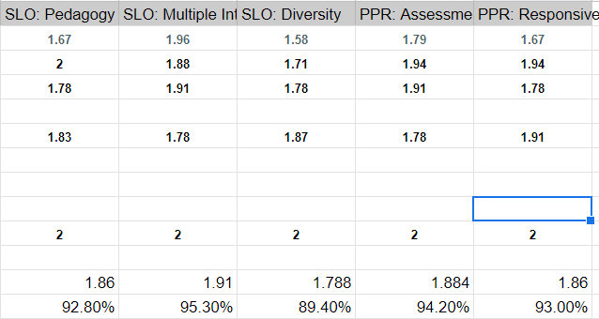

Spring 2019 Key Assessment Data (4 of 6 sections reported)
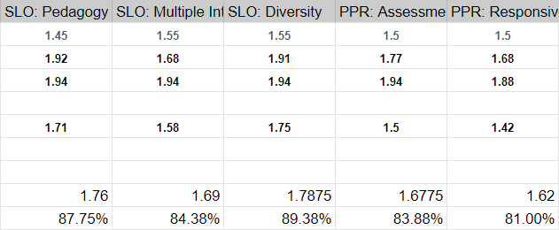

Fall 2019 Key Assessment Data (9 of 9 sections reported)
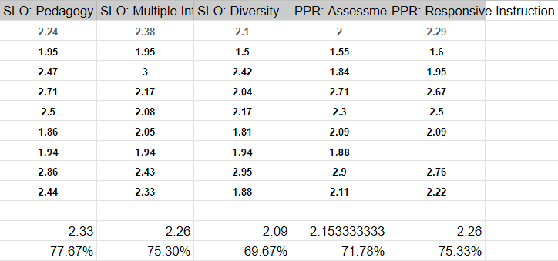

Spring 2020 Key Assessment Data (8 of 8 sections reported)
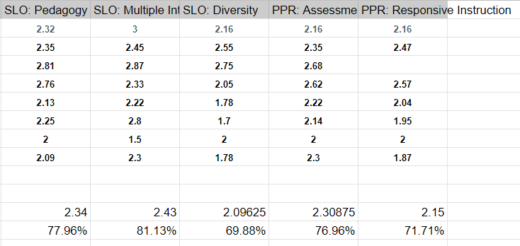

Fall 2020 Key Assessment Data (11 of 11 sections reported)
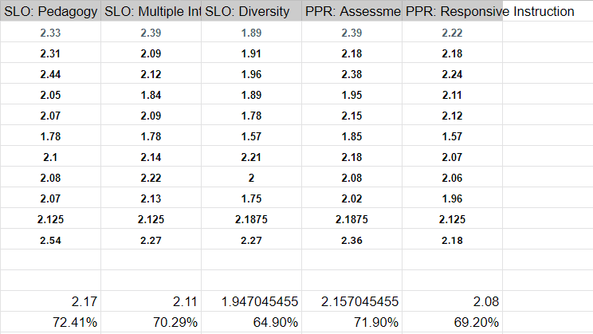

Spring 2021 Key Assessment Data (10 of 10 sections reported)
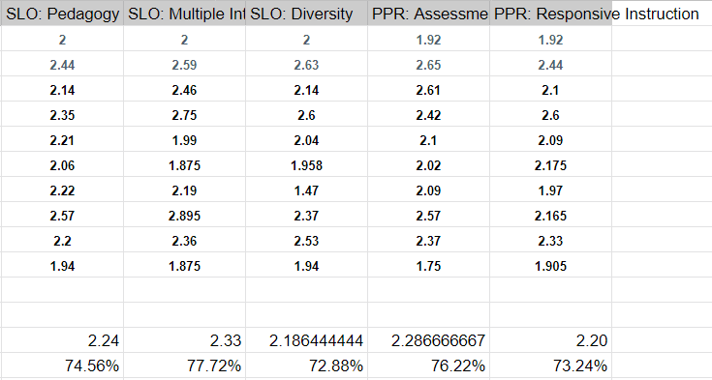

Fall 2018 Key Assessment Data (4 of 7 sections reported)
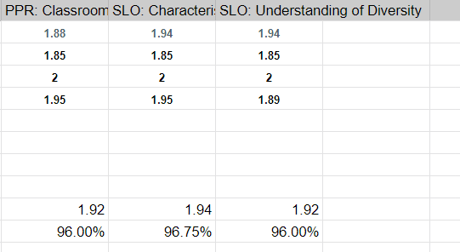

Spring 2019 Key Assessment Data (5 of 6 sections reported)
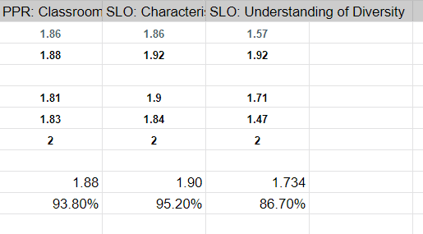

Fall 2019 Key Assessment Data (4 of 4 sections reported)
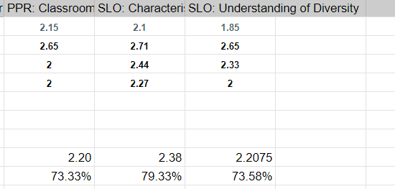

Spring 2020 Key Assessment Data (7 of 7 sections reported)
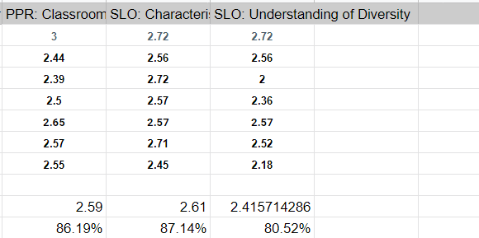

Fall 2020 Key Assessment Data (5 of 5 sections reported)
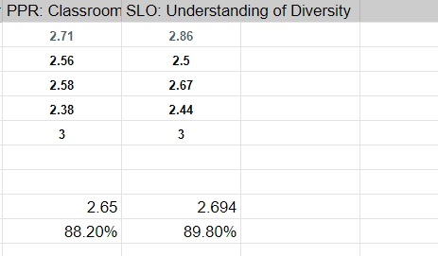

Spring 2021 Key Assessment Data (7 of 7 sections reported)

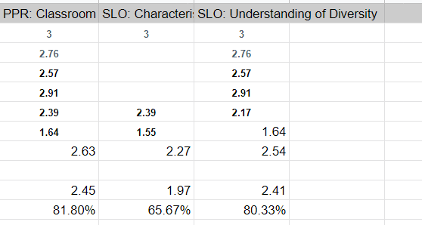

Student Self-Evaluation of EDUC 1301 SLO#2
Over the period of the program review, we began surveying EDUC 1301 students near the completion of the course and asked them to rate themselves in regard to this challenging SLO: Analyze the culture of schooling and classrooms from the perspectives of language, gender, socioeconomic, ethnic, and disability-based academic diversity and equity. The survey was conducted anonymously via a Google Form, and 629 survey responses were collected over this time. First, we asked students to rank their comfort level in analyzing the impact on classrooms and schooling for each dimension of diversity listed in the SLO. Students had to rank each area from “most comfortable” to least comfortable,” even if they felt comfortable with all areas. The area students felt least comfortable with was disabilities and academic diversity.

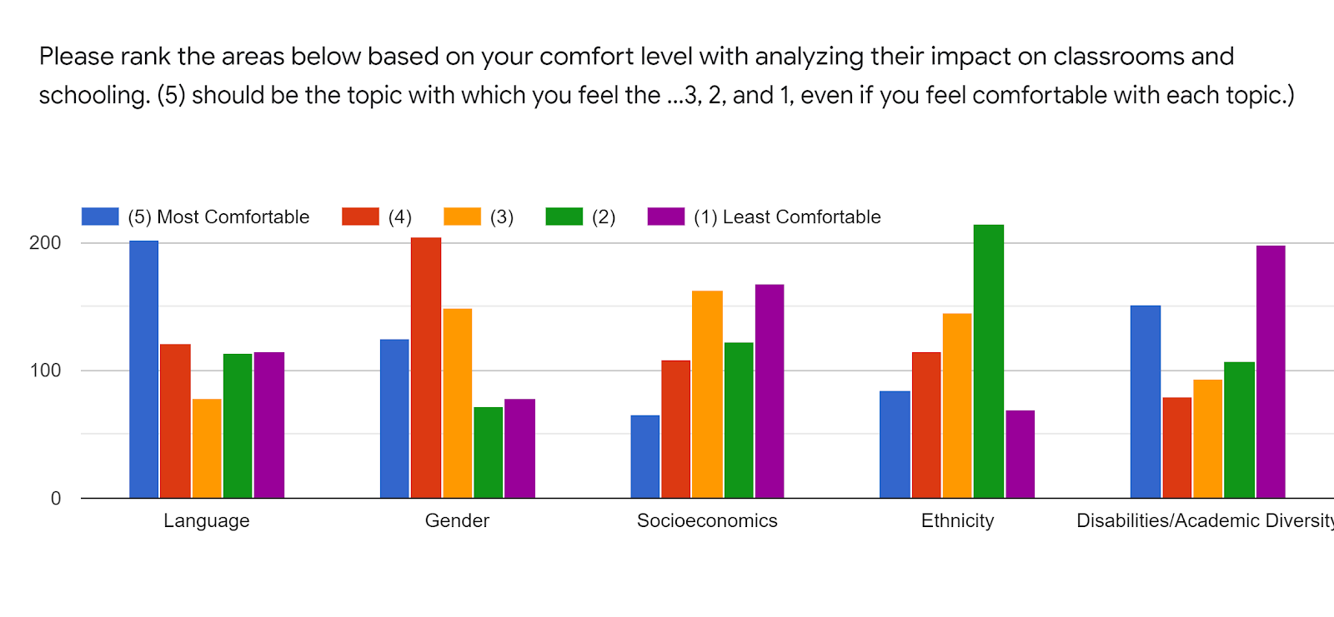
The data indicates that, in general, students are more comfortable in analyzing the impact of schooling on language and gender. Students are least comfortable in analyzing the impact of schooling on ethnicity and academic diversity / disability. However, these topics are covered in more detail during EDUC 2301. Even though academic diversity and ethnicity were areas they felt least comfortable with, the next question assessed their ability to analyze the culture of schooling and classrooms for various perspectives. The charts below indicate that students overwhelmingly rate themselves “average,” “above average,” and “exceptional.” Very few students rated themselves “below average” or “poor.”

Language
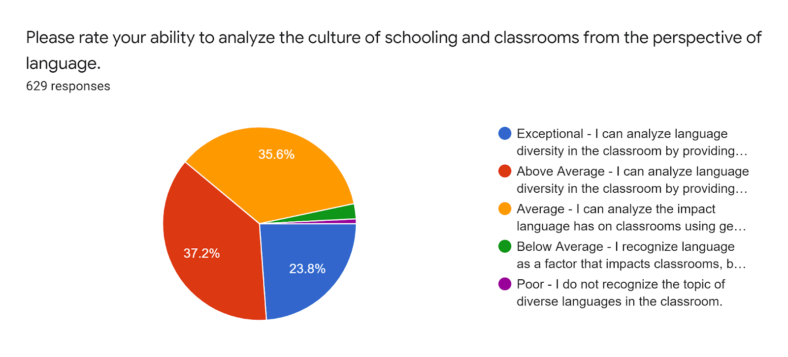
Gender
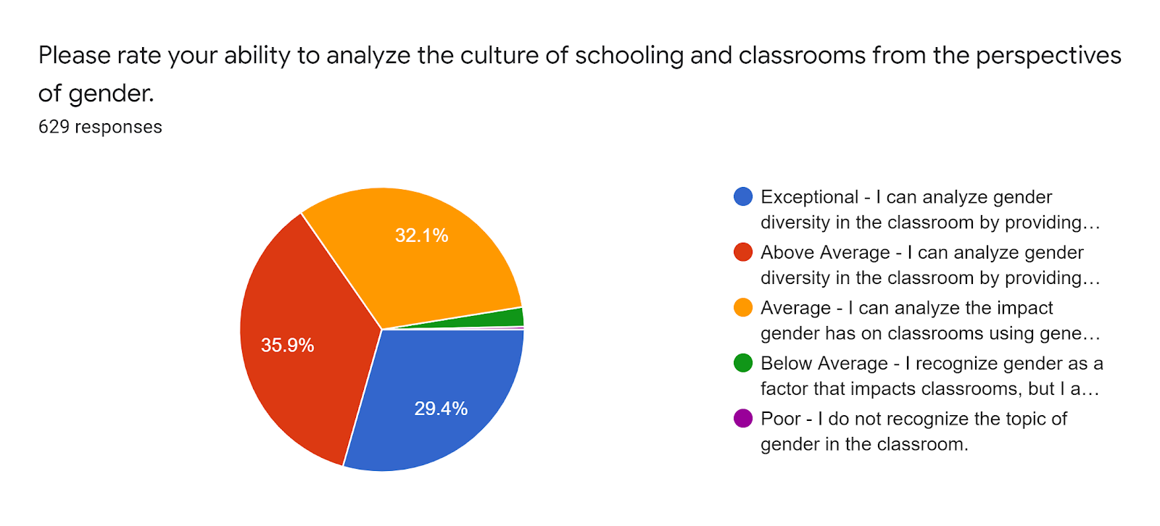

Socioeconomics

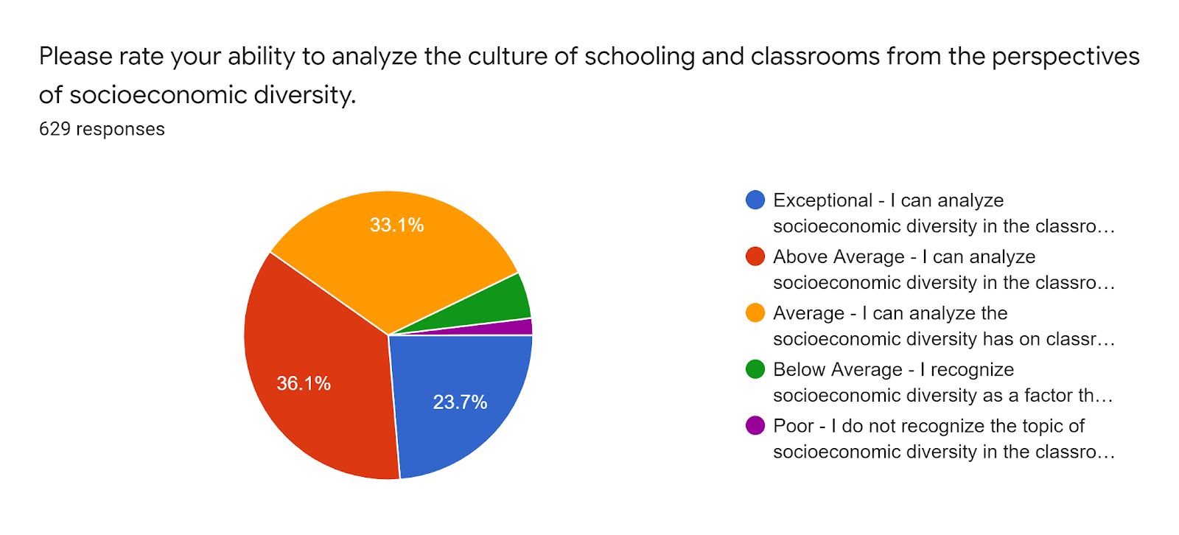

Ethnic Diversity

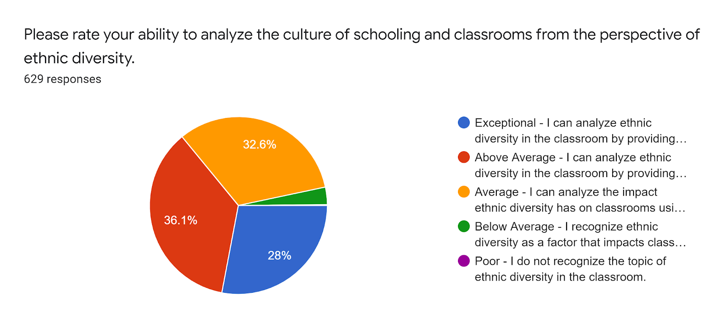
Academic Diversity

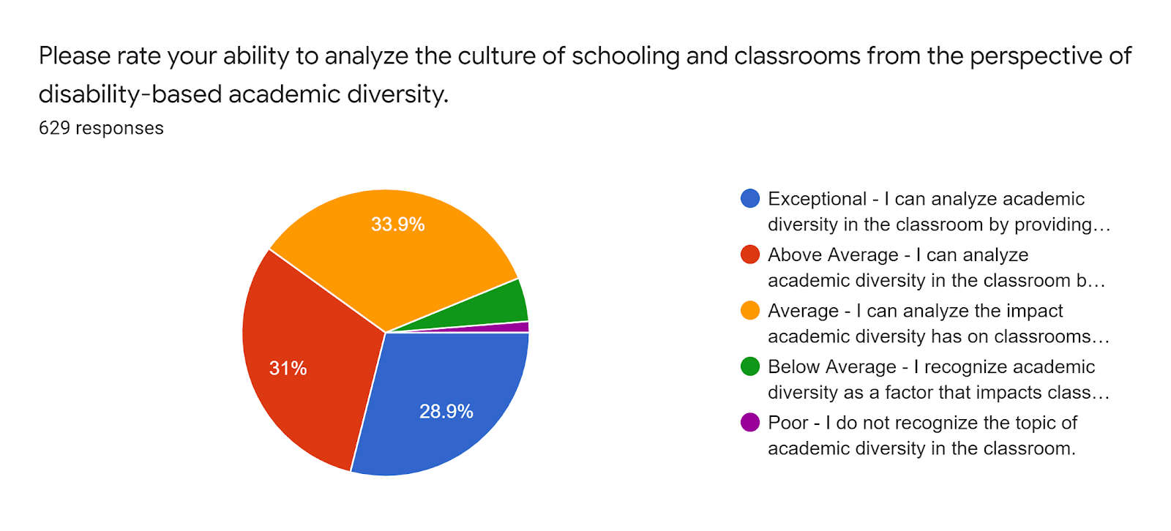

B. Show evidence that the state standard for award completion has been met.
Completers Standard: Average 25 completers over the last five years or an average of at least five completers per year.
Number of completers: 551 in last five years.
If below the state standard, attach a plan for raising the number of completers by addressing barriers to completion and/or by increasing the number of students enrolled in the program. Definition of completer—a student who has received an award.
As evidenced in the chart below, the AAT had 551 completers over the last 5 years. The number of completers per year was 82 in 2017 and 81 in 2018 before increasing to 114 (2019) and 141 (2020), then decreasing slightly to 133 (2021). We are well above the state standard of averaging 25 completers per year. In reviewing different major codes, some degree programs have fewer than 25 completers. The major codes are interpreted as: CM48 (AAT Middle Grades 4-8), ECG6 / ECH6 (AAT Early Childhood - Grade 6), ECG8 (AAT Grades 8-12 and EC -12 certifications other than special education), ECSE (AAT All level Special Education), G6EC (AAT Early Childhood - Grade 6 with recommended elective), H812 (AAT High School, Grades 8-12). However, the majors G6EC, G8SP, and ECG8 were canceled in 2018 but Collin is still awarding the degree to students who began the programs prior to the cancellation. Separate major codes have been used over the program review years to indicate different types of teaching certification routes and recommended specialities and electives. Even though some speciality areas have lower than 25 completers, the AAT overall has more than the state standard of degree completers. At this time, there is not a plan to address increasing enrollment in majors that have been canceled. But, as a department, we have made a significant effort to promote AAT completion prior to transfer. Efforts include discussing the AAT pathways in the EDUC 1301 and 2301 courses, individual faculty/student conferences, meetings with advising staff, and the F.I.N.E. (Find, Investigate, Navigate, Educate) community outreach event.

Despite the growth in completers over this period, education faculty uncovered an unexpected challenge to completion in Fall 2019. Some students across EDUC 1301 and EDUC 2301 sections mentioned that they were pursuing the Associate of Arts (AA) instead of the Associate of Arts in Teaching. Further investigation determined that although 3 sciences are required for the AAT [AAT Curriculum - THECB], Texas A&M Commerce, one of our biggest transfer partners, only requires 2 sciences. So, some students planning to transfer to A&M Commerce were opting to complete the AA, plus the required EDUC and MATH for Teachers courses, rather than the AAT, to avoid this 3rd science requirement. In Fall/Winter 2019 and early Spring 2020, full-time EDUC faculty attended advising meetings on the Plano, Frisco, and McKinney campuses to discuss the importance of promoting the AAT with students as well as helping students understand why and how the 3rd science is beneficial. In short, students who wish to be certified in EC-6 are tested in the content area of Science as part of their certification exams, with TEKS (Texas Essential Knowledge and Skills) drawn from the various science disciplines covered through sixth grade. A 3rd science helps students better prepare for this exam. In Fall 2020, the EDUC discipline lead, along with Associate Provost of Instruction Cameron Neal, Director of Academic Partnerships Jami Mills, and the Early Childhood Education discipline lead, met with representatives from A&M Commerce. While the representatives confirmed they do not and will not require a 3rd science, they did commit to promoting the completion of the AAT with our students prior to transfer [follow-up email from Juan Arauajo, Texas A&M-Commerce, dated 12/2/2020].

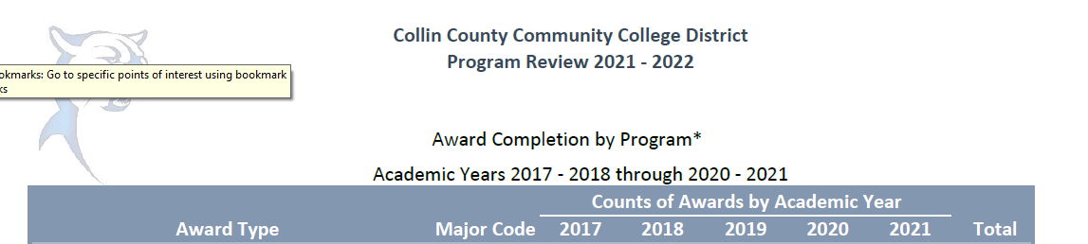
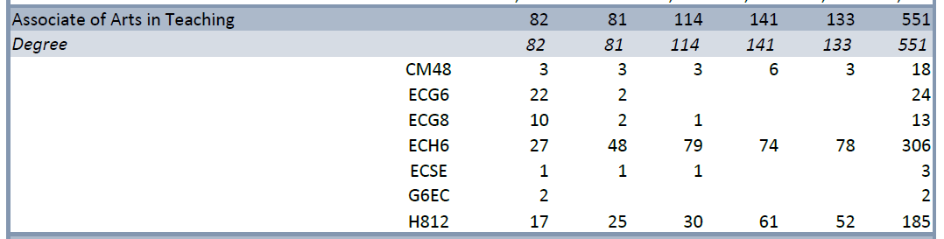

C. For any required program courses where there is a pattern of low enrollment (averaging fewer than 15 students), explain your plan to grow enrollment.

CDEC 1270 is the only course with fewer than 15 students during the period of this program review. This course is a recommended elective for students pursuing EC-6 certification and does not serve as a prerequisite for any required courses in the AAT. During this period, the course has been limited to one section offered per year, only during the Maymester session. Enrollment is challenging since it is not a required course, and not every interested student wants to take the course in a condensed, fast-paced format. Further, not every transfer partner accepts this course. Secondary students (those pursuing 7-12 certification) do not need this course for certification and degree completion. Efforts to increase enrollment include promoting the course in our EDUC 1301 and 2301 classes and with Academic Advising, discussing the benefit of the class as an elective, and working with the associate dean to offer the course during a long semester rather than Maymester.

D. Make a case with evidence that the program is well-managed.

Suggested/possible points to consider (Data can be found at http://inside.collin.edu/institutionaleffect/Program_Review_Process.html):
- Average class size
- Grade distributions
- Contact hours taught by full-time and part-time faculty
- Identify all courses that have a success rate below 75%. Using assessment evidence and instructor observations, identify the student learning outcomes that are the greatest challenges for students in courses with low success rates. Explain what instructional and other intervention(s) might improve success rates for each identified course.
- Student satisfaction: What evidence do you have that students are satisfied with the program? What kinds of complaints are made to the associate dean by program students?

Average class size
The average class size for EDUC 1301 from AY2016-AY2020 was 22.31 students. In AY2017-AY2019, the department’s average class size was slightly higher. In AY2020, the average class size for fall and spring semesters slightly declined. This decline could be due to the pandemic influence. The average class size for EDUC 2301 from AY2016-AY2020 was 19.82 students. In AY2019 and AY2020, the average class size declined from previous years. Two possible reasons for this decline are the pandemic and program requirements. Some transfer programs count EDUC 2301 as an education elective and some programs count EDUC 2301 towards the degree program requirements for all certification levels. While the Field of Study was meant to make the program requirements standardized, that initiative has been put on hold due to leadership changes at the THECB and the pandemic. Efforts are also being made to create seamless pathways with our transfer partners to include EDUC 2301 in their degree program requirements across all levels of certification. The other possible reason for a decline in EDUC 2301 numbers is that EDUC 1301 became a prerequisite for EDUC 1301. Some students transferred prior to taking EDUC 2301 and some students had to wait to take the course until meeting the prerequisite requirement.

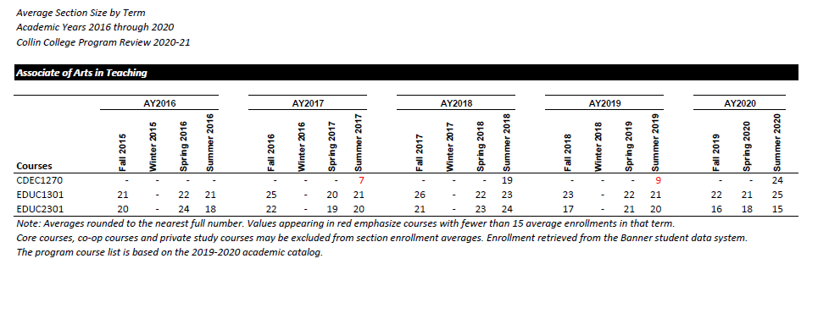

Grade Distribution
For EDUC 1301 from AY2016-2020, the average “A” grade distribution was 52%; the average “B” was 19%; the average “C” was 8%. The average passing rate (average of A, B, C, D grade) was 81% and the average success rate (average of A, B, C grade) was 79%. For EDUC 2301 from AY2016-2020, the average “A” grade distribution was 55%; the average “B” was 21%; the average “C” was 7%. The average passing rate was 85% and the average success rate was 83%. The graph indicates the overall success rate as 82%, which is different than calculating the raw scores. The department is unsure of why there is a difference. Overall, the education courses have a high average passing and success rates over the program review period. During the program review period, the number of “A” grades declined in both courses. The decline in “A” grades could be due to the shifting of face-to-face instruction to online instruction and external pandemic stressors.

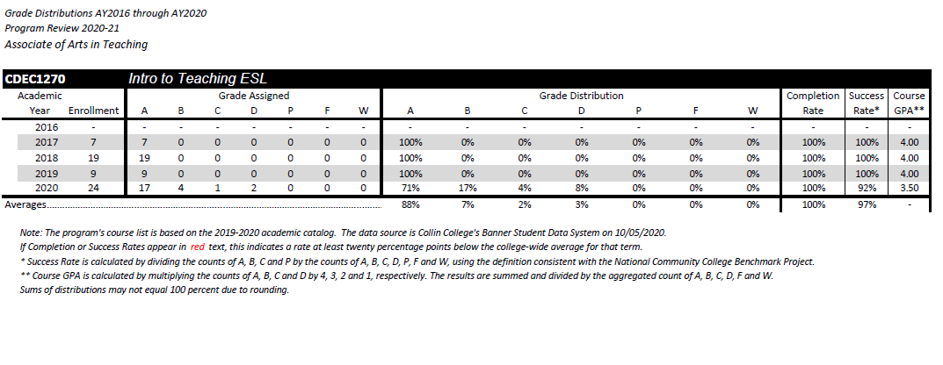
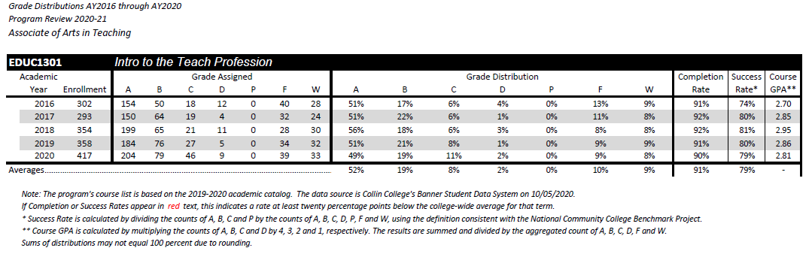

Courses with success rate below 75%
The only course that showed a success rate lower than 75% was EDUC 1301 in AY2016. During that academic year, there were several changes to the department, the course structure, key assessments, and observation requirements. The department evaluated the course content, key assessments, rubrics, and observation assignments for better alignment, consistency, and effectiveness. Those changes could be why the success rates increased the next academic year.

Contact Hours of Full-Time and Part-Time Faculty
In searching for contact hours of full-time and part-time faculty in the AAT, the data was conflicting. With the IRO reports, “Contact Hours by Department by Faculty Employment Status” and “Contact Hours Taught by Division, Associate Dean, and Department by Faculty Employment Status,” the Contact Hours by Department by Faculty Employment Status appropriately separated EDUC 1300, Learning Frameworks, from the AAT program; however, it combined the AAT courses with Child Development courses. Child Development courses are not part of the AAT program. With the Contact Hours Taught by Division, Associate Dean, and Department by Faculty Employment Status, some campuses separated EDUC 1300 from the AAT courses and other campuses combined those two areas. EDUC 1300 is not a required course in the AAT, though some students elect to take it as a CORE elective. So, none of the IRO data sheets provided a consistent look at the AAT program and did not separate out EDUC 1301 and EDUC 2301 from other courses. Therefore, we used contact hours available through Tableau. Tableau did not separate the hours into full-time and part-time faculty but did provide accurate information on the total contact hours for EDUC 1301 and EDUC 2301. The total number of contact hours decreased from fall to spring semesters (See charts below).

Because data was inconsistently reported, we cannot comment on the distribution of contact hours between full-time and part-time faculty. As a department, we encourage Associate Deans to assign full-time faculty members to the AAT courses first due to the state standards for certification and observation hours requirement.

Fall 2019-2021 Contact Hours
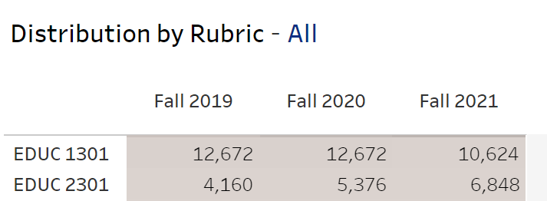

Spring 2020-2022
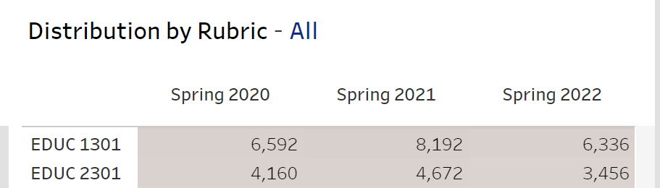

Student Satisfaction
The average student satisfaction score for the education department over 2019-2021 was 3.67 (see tables below). The scores were taken from the “Student Evaluation of Instruction by Department” through the IRO. The academic years presented were the only available tables from the IRO website.

Overall, based on student evaluations, students are most satisfied with #4 The instructor treated students with respect and #5 The instructor created an environment that facilitated learning. Comments from previous students supporting these measures are below.

“I just wanted to say thank you. Thank you for such an awesome semester! You helped me through a rough time of almost wanting to drop the second class, and I was able to pull through it with your support and thought-provoking questions.” - email communication sent to faculty on 5/13/2020.

“Thank you again for a wonderful semester!! You are an encouragement and an excellent example to me!! I appreciate the time that you put into each module. I am definitely able to tell that you love teaching others.” - email communication sent to faculty on 7/12/2019.

“I am grateful to have you as my professor for 1301 and 2301 EDUC. You are a huge inspiration and a influential role model! I can proudly say I will miss this class a bunch, besides my nervous crippling break down in the beginning of the semester I thoroughly enjoyed the content?! Not only were the books and podcasts super interesting I knew you were animated/passionate about what you do so it makes class more enjoyable.” - email communication sent to faculty on 5/13/2019.

“All of her projects are applicable to help us learn and prepare us for the next step of becoming a teacher. She also makes sure students know it is okay to change their mind as to whether teaching is right for them. [The professor] goes above and beyond her duties as a professor. In her projects that can be saved for our future portfolios she was willing to sit with students and help make corrections and fine tune the assignments so that they are the best representation of us. She never made a student feel stupid for asking questions and wanting clarification. Her goal is for us is to be prepared for the next phase and genuinely wants to see us succeed. One more thing is she welcomes ideas and constructive criticism. She wants to know what she does well but also areas of improvement because she believes being a good teacher is being able to improve. She also shared that she can't make improvements if she doesn't know where she needs to improve.” - email communication to faculty, 5/10/2018

“I just had to write you. Your classes were so full of important information and taught in such a memorable way! I am in 18 hours of Education classes at the CHEC for A&M Commerce and they are a breeze because of you! In week 3 I have already used about 5 things I did in your class and I just feel confident because of the knowledge I have from YOU. I have told you before and I will tell you time and again, you are a rock-star professor.” - email communication sent to faculty on 9/13/2018.

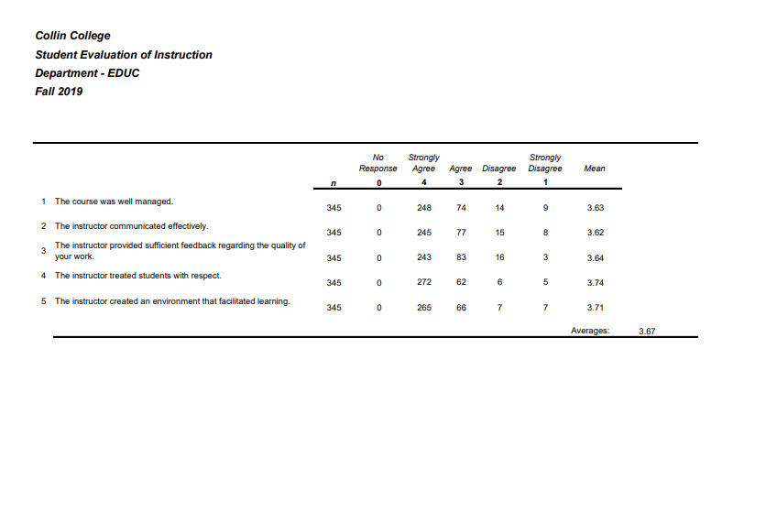
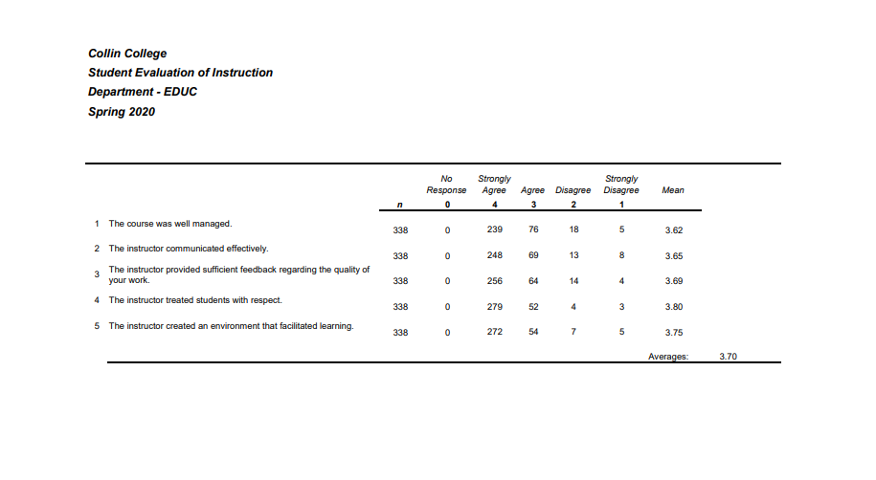
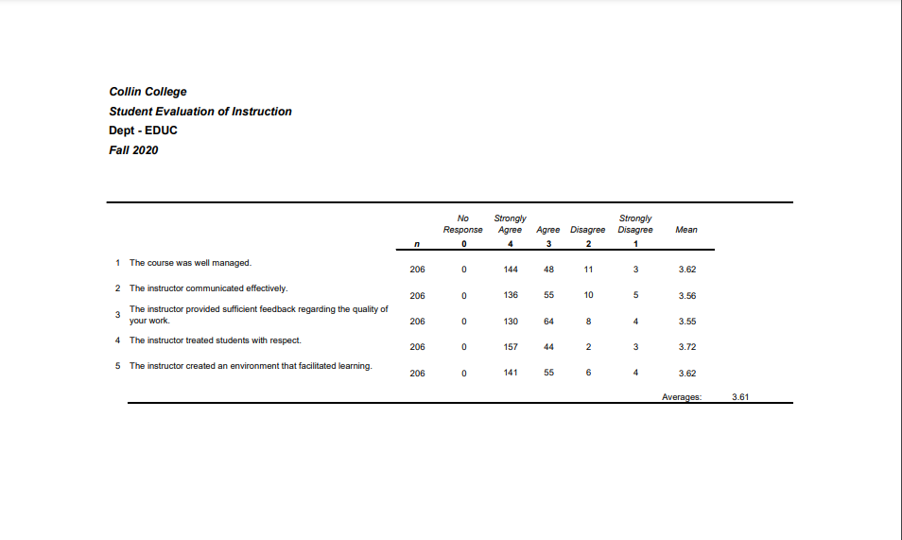

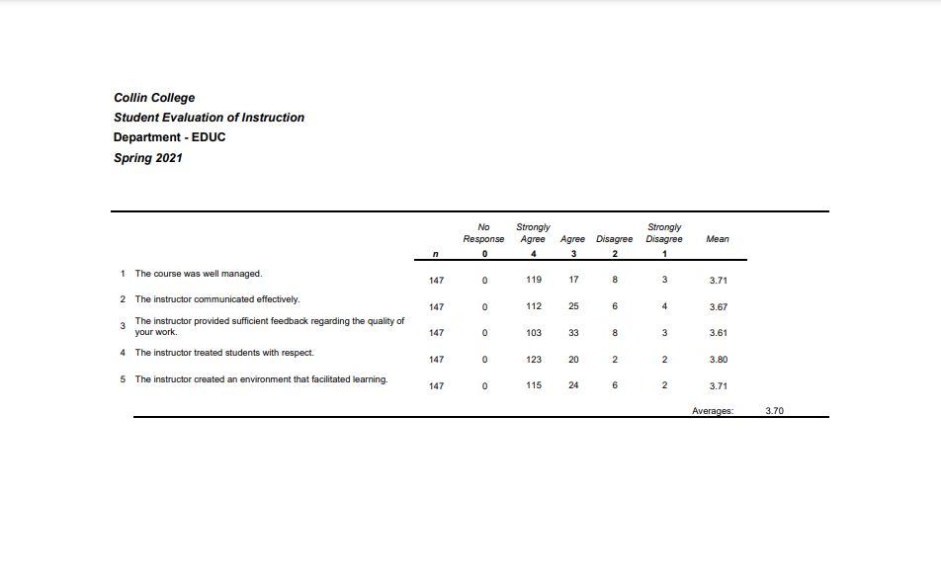
Student Evaluations
In reviewing available faculty student evaluations (2016-2020), the most common complaints are: the overload of information, the placement / observation process, the anecdotal record observation assignment, and the lesson plan key assessment. Content in the courses are abundant. The abundance of information is threefold: Student Learning Outcomes are broad containing many key skills in becoming an educator; the teaching profession is both an art and a science and therefore, requires both theory, practice, application, and differentiation; skills in education classes must build upon each other, and every education class is modeled in a similar fashion - many SLOs that are broad and require a lot of different types of content and instruction.

The placement for observations can be tedious based on the district’s application process and placement process. Some districts require job applications prior to placement. Some districts only require letters from the education department stating the request. Some districts require background checks through the district and other districts require them through the individual schools. Every district process is different and therefore, can be very confusing and time consuming for students. The state requires students to critically reflect on their observations. The department created anecdotal records with specific topics focused on the course SLOs. Some students struggle to critically analyze and evaluate what they are observing in regards to the topics in the anecdotal records. Students are encouraged to have conversations with their mentor teachers about topics that are troublesome. In regards to the lab process, the department created one lab manual for EDUC sections. The department also moved from district-wide face-to-face lab orientations to a virtual lab orientation through the lab manual in addition to reviewing the processes in classes. The department also makes revisions to the lab manual every semester to make the process more clearly outlined.

The lesson plan process is EDUC 1301 key assessment. The lesson plan process is divided into three parts. Each part builds on the previous part and requires students to implement meaningful feedback and apply new knowledge and skills. In a meeting with transfer partners in December 2020, TWU and UTD indicated that the skills learned in the lesson plan process are some of the most critical skills needed to build a solid foundation for transfer. Additionally, job postings for teachers in local area school districts (such as those linked in Section 4) note that lesson planning is a required and essential skill. That being said, the lesson plan process can be overwhelming for students who have never been exposed to writing learning objectives, creating assessments, implementing accommodations, selecting knowledge and skills, identifying learning preferences, and implementing effective teaching strategies.

☐6. How effectively do we communicate, and how do we know?
A. Make a case with evidence that the program literature and electronic sites are current, provide an accurate representation of the program, and support the program’s recruitment plan, retention plan and completion plan.
Suggested/possible points to consider:
- Demonstrate how the program solicits student feedback regarding its website and literature and how it incorporates that feedback to make improvements.
- How does the program ensure that students are informed/aware of program literature? Is program literature made accessible to all students (i.e. can they obtain the information they need)?
- Designate who is responsible for monitoring and maintaining the program’s website, and describe processes in place to ensure that information is current, accurate, relevant, and available.

Program Literature
Lab Manual: The Education department created a lab manual outlining the policies and procedures for completing observations. The lab manual is updated each semester with new information or to streamline the process. The lab manual was transferred from a paper format on the Child Development and Education website to an internal e-portfolio. Updates are automatic and available to all faculty immediately. The Texas Higher Education Coordinating Board (THECB) sets the standards for lab hours, and the lab manual assists students with meeting those standards. Dr. Rebecca Burton has updated and maintained the lab manual throughout the period of this program review, however the EDUC/ECE lab coordinator is responsible for the maintenance and upkeep of all lab materials. The manual is provided to faculty via Canvas Commons to embed in their individual courses. [EDUC Lab Manual; note: link will only work if you are logged into Canvas]

Promotional Flyer: The Education department worked with Public Relations to develop a promotional flyer for the AAT program. This colorful, informative flyer has been posted in strategic locations around the college to promote the AAT program. It is also used for outreach events with direct student contact such as Super Saturdays and Student Resource Fairs. [AAT Flyer]

Electronic Resources: The Education department maintains a departmental website to provide a convenient information source for students. Department specific information, such as faculty contacts and student organization information, is reviewed annually by the discipline lead. Updates and changes are forwarded to Glenn Trueman, Manager of Box Office and Marketing, who is responsible for maintaining the website. The website can be found at the following location: EDUC/ECE Departmental Website
Updates to Literature
To ensure that the literature related to the AAT degree program is current, the department utilizes links to official information that is
maintained and updated by the Curriculum Office. This includes links to the college catalog, AAT degree plan, course descriptions and marketable skills. All edits are coordinated and executed by the Curriculum office.
Collin Catalog entries are maintained by the Curriculum office and can be found at the following location: Collin College Catalog

The AAT degree plan information is maintained by the Curriculum Office with updates as approved by the Curriculum Advisory Board. The degree plan information can be found at the following location: AAT Degree Plan

AAT degree plan includes the completion of the General Core Curriculum. The 42 hours that make up the core are found at the following location: Collin Core Curriculum

The official course descriptions as mandated by the state are found at the following location: EDUC Course Descriptions

Marketable skills can be found at the following location: EDUC Marketable Skills
Beginning in Fall 2019, syllabi were integrated into Canvas courses using the Concourse system. This system pre-populates the course description and student learning outcomes, thus ensuring that the most accurate information is included. Prior to Fall 2019, faculty were individually responsible for utilizing the Syllabus Depot to obtain course descriptions and student learning outcomes. Both of these resources are found at the following location: Syllabus Depot (must be logged into Cougarweb) with direct access to Concourse syllabi provided at the following location: Collin - HB2504.

B. In the following Program Literature Review Table, document that the elements of information listed on the website and in brochures (current academic calendars, grading policies, course syllabi, program handouts, program tuition costs and additional fees, description of articulation agreements, availability of courses and awards, and local job demand in related fields) were verified for currency, accuracy, relevance, and are readily available to students and the public. Please fill out the table only for this prompt (B.), no analysis is necessary here.

Program Literature Review Table
Title | Type (i.e. URL, brochure, handout, etc.) | Date of Last Review/Update |  | Responsible Party
Lab Manual | http://collin.instructure.com/eportfolios/17893?verifier=af99Lsemmug9Ia42Y5hQ2BSB2EwZwP00kjVrnfbn  Note: must be logged into Canvas for link to work | Fall 2021 | ☒Current  ☒Accurate  ☒Relevant  ☒Available | EDUC/ECE Lab Coordinator (although not her responsibility, Dr. Rebecca Burton maintained and updated these materials throughout the program review period)
AAT Flyer | https://drive.google.com/file/d/1OJD4PMo9H42nwLbwyF6YvHYfL83uL8CC/view?usp=sharing | Fall 2021 | ☒Current  ☒Accurate  ☒Relevant  ☒Available | PR with input from faculty
Education and Early Childhood Education Website | https://www.collin.edu/department/childdevelopment/index.html | Fall 2021 | ☐Current  ☐Accurate  ☒Relevant  ☒Available | Division Marketing Manager
Collin College Catalog | http://www.collin.edu/academics/catalog.html | Fall 2021 | ☒Current  ☒Accurate  ☒Relevant  ☒Available | Curriculum Office
AAT Degree Plan | http://www.collin.edu/academics/programs/AAT_1Overview.html | Fall 2021 | ☒Current  ☒Accurate  ☒Relevant  ☒Available | Curriculum Office
Marketable Skills | http://www.collin.edu/academics/programs/MarketableSkills.html | Fall 2021 | ☒Current  ☒Accurate  ☒Relevant  ☒Available | Curriculum Office with input from department
Course Syllabi | http://inside.collin.edu/curriculum/Syllabus_Depot.html  http://www.collin.edu/hb2504/ | Fall 2021 | ☒Current  ☒Accurate  ☒Relevant  ☒Available | EDUC faculty and associate deans
Click or tap here to enter text. | Click or tap here to enter text. | Click or tap to enter a date. | ☐Current  ☐Accurate  ☐Relevant  ☐Available | Click or tap here to enter text.
Click or tap here to enter text. | Click or tap here to enter text. | Click or tap to enter a date. | ☐Current  ☐Accurate  ☐Relevant  ☐Available | Click or tap here to enter text.

☐7. How well are we leveraging partnership resources and building relationships, and how do we know?
Partnership Resources: On the table below, list any business, industry, government, college, university, community, and/or consultant partnerships, including internal Collin departments, to advance the program outcomes.
The AAT is fortunate to work with many local school districts. The school districts provide placement opportunities for classroom observations in EDUC 1301 and EDUC 2301. These placements provide students the opportunity to get hands-on classroom experience and the ability to network with campus administrators and teachers. The hands-on experience allows students to connect classroom SLOs to actual classroom experiences. The networking allows students potential opportunities for future teaching, assistant teaching, or substitute teaching in that district. It also teaches students how the school systems operate and what levels of professionalism are required.

Several faculty members serve on committees and organization boards. The committees keep faculty members current in the field of education, changes to the AAT, and changes to teacher certification and teacher certification pathways. Involvement also means that Collin College has representation in the decision making process. Involvement in organization boards also allows Collin College representation in the direction of best practices in teacher education. Organizational boards keep faculty abreast of best practices, current experts, and changes to teacher education preparation programs. It also allows faculty to network with local and state-wide transfer institutions.

With the student organization, TSTA-AE, guest speakers were invited to monthly meetings. Guest speakers consisted of current and retired education professionals, including classroom teachers, administrators, and professors. Local community members were also invited, including parents in the local districts. A variety of topics were covered, including special education, diversity, teacher leadership, and school experiences. These topics enhance the classroom learning in EDUC 1301 and EDUC 2301 with real-world experiences and perspectives.

Due to space limitations on the table below, the complete Partnership Resources Table can be found here: Partnership Resources Table

Partnership Resources Table
Partner/Organization | Description | Formal Agreement Duration,  if any. | How is it Valuable to the Program?
Allen Independent School District | Placement for EDUC 1301 and EDUC 2301 Observations | N/A | Students need observation hours to complete the requirements for the course. These observation hours not only help students to satisfy course requirements, but they also provide early networking for students in local districts.
Anna Independent School District | Placement for EDUC 1301 and EDUC 2301 Observations | N/A | Students need observation hours to complete the requirements for the course. These observation hours not only help students to satisfy course requirements, but they also provide early networking for students in local districts.
Carrollton-Farmers Branch Independent School District | Placement for EDUC 1301 and EDUC 2301 Observations | N/A | Students need observation hours to complete the requirements for the course. These observation hours not only help students to satisfy course requirements, but they also provide early networking for students in local districts.
Community Independent School District | Placement for EDUC 1301 and EDUC 2301 Observations | N/A | Students need observation hours to complete the requirements for the course. These observation hours not only help students to satisfy course requirements, but they also provide early networking for students in local districts.
Farmersville Independent School District | Placement for EDUC 1301 and EDUC 2301 Observations | N/A | Students need observation hours to complete the requirements for the course. These observation hours not only help students to satisfy course requirements, but they also provide early networking for students in local districts.
Frisco Independent School District | Placement for EDUC 1301 and EDUC 2301 Observations  Faculty member serves on Campus Improvement Team | N/A | Students need observation hours to complete the requirements for the course. These observation hours not only help students to satisfy course requirements, but they also provide early networking for students in local districts.  Involvement of faculty member on elementary Campus Improvement Team enhances the community partnership and relationship between Collin College and local district.
Garland Independent School District | Placement for EDUC 1301 and EDUC 2301 Observations | N/A | Students need observation hours to complete the requirements for the course. These observation hours not only help students to satisfy course requirements, but they also provide early networking for students in local districts.
Lewisville Independent School District | Placement for EDUC 1301 and EDUC 2301 Observations  Faculty member served on Building Leadership Team | N/A | Students need observation hours to complete the requirements for the course. These observation hours not only help students to satisfy course requirements, but they also provide early networking for students in local districts.  Involvement of faculty member on Building Leadership Team enhances the community partnership and relationship between Collin College and local districts.
Little Elm Independent School District | Placement for EDUC 1301 and EDUC 2301 Observations | N/A | Students need observation hours to complete the requirements for the course. These observation hours not only help students to satisfy course requirements, but they also provide early networking for students in local districts.
Lovejoy Independent School District | Placement for EDUC 1301 and EDUC 2301 Observations | N/A | Students need observation hours to complete the requirements for the course. These observation hours not only help students to satisfy course requirements, but they also provide early networking for students in local districts.
McKinney Independent School District | Placement for EDUC 1301 and EDUC 2301 Observations | N/A | Students need observation hours to complete the requirements for the course. These observation hours not only help students to satisfy course requirements, but they also provide early networking for students in local districts.
Plano Independent School District | Placement for EDUC 1301 and EDUC 2301 Observations | N/A | Students need observation hours to complete the requirements for the course. These observation hours not only help students to satisfy course requirements, but they also provide early networking for students in local districts.

☐8. What professional developmental opportunities add value to your program?
The faculty in the EDUC program embody the core principles of our department mission statement in that we are “lifelong, reflective learners dedicated to preparing future teachers and generating positive impacts on [our] students, schools and communities.” One hundred percent of current faculty engage in continuous learning by taking part in professional development opportunities. To best support students, faculty stay current in their field as evidenced by the professional development below. The value to the unit is supported by the mission statement, Student Learning Outcomes (SLO) and TExES Pedagogy and Professional Responsibility Standards (PPR).
A sampling of relevant professional development has been included in the chart below. A more complete listing of Professional Development can be found here: Link to AAT Faculty Professional Development

Provide a List of professional development activities employees have participated in since the last program review.
Employee Resources Table**
Employee Name | Role in Unit | Professional Development Summary | How is it Valuable to the Unit?
Amanda Ames, M.Ed. | Adjunct Faculty | Collin Adjunct Faculty Development Conference; 2015-2020  Leadership Seminars with Kyle Maynard, James Lawrence, Brendan Burchard, Mel Robbins; 2014-2019 | Aids in designing instruction appropriate for all students that reflects an understanding of relevant content and is based on continuous and appropriate assessment. (TExES PPR 1)  Provides understanding of educational pedagogy and professional responsibilities of teachers. (EDUC 1301 SLO 3)  Examines personal motivations, educational philosophies, and factors related to educational career decision making. (EDUC 1301 SLO 4)
LaJanna Barnett, M.Ed. | Former Adjunct Faculty | No information available | Click or tap here to enter text.
Rebecca Burton, Ed.D. | Full Time Faculty | Attended, Association of Teacher Educators Annual Conference, Orlando, Florida; Spring 2017  Attended, Faculty Development Conference, "Neuromyths: The Relationship between Brain Knowledge and Teaching Effectiveness;" Spring 2020  Attended, CSOTTE ﴾Consortium of State Organizations for Texas Teacher Education﴿ Conference, Virtual; Fall 2020. | Exposure to the characteristics of exceptional learners and how diversity impacts learning. (EDUC 2301 SLO 1 and 2)  Brings awareness to creating equitable classrooms. (EDUC 2301 SLO 3)  Understanding of diversity challenges in the classroom. (EDUC 2301 SLO 4)  Prepares future teachers to utilize best practices. (Mission Statement)  Aids in designing instruction appropriate for all students that reflects an understanding of relevant content and is based on continuous and appropriate assessment. (TExES PPR I)  Looks at school culture from the perspectives of language, gender, socioeconomic, ethnic, and disability based academic diversity and equity. (EDUC 1301 SLO 2)
Ann Butler, M.Ed. | Full Time Faculty | “Educational Equity in Pandemic Times” by Tyrone Howard; 2021  TCRWP: Social and Emotional Learning During a Pandemic: From Research to Practice by Marc Brackett; 2021 | Collaboration of ideas to assist in creating a classroom environment of respect and rapport that fosters a positive climate for learning, equity, and excellence. (TExES PPR II)  Promotes student learning by providing responsive instruction that makes use of effective communication techniques, instructional strategies that actively engage students in the learning process, and timely, high-quality feedback. (TExES PPR III)  Recognizes multiple intelligences and learning styles allowing for the creation and implementation of instructional practices to meet the needs of all students. (EDUC 1301 SLO 5)
Patricia Crawford, Ph.D. | Adjunct Faculty | Collin Adjunct Faculty Development Conference; 2016-2020 | Aids in designing instruction appropriate for all students that reflects an understanding of relevant content and is based on continuous and appropriate assessment. (TExES PPR I)  Provides understanding of educational pedagogy and professional responsibilities of teachers. (EDUC 1301 SLO 3)
Catherine Dutton, Ph.D. | Adjunct Faculty | Attended Conference, Educause; 2019  Attended 14th Annual Teaching and Learning Symposium; 2019 | Aids in designing instruction appropriate for all students that reflects an understanding of relevant content and is based on continuous and appropriate assessment. (TExES PPR I)  Provides understanding of educational pedagogy and professional responsibilities of teachers. (EDUC 1301 SLO 3)
Sharon Hirschy, M.Ed. | Professor Emeritus | Bruce Sperry: Working with Trauma in Children; 2021  National Association for the Education of Young Children- “Integrating Technology in YOUR Classroom: Digital tools and practical ways to apply the NAEYC/Fred Rogers Position Statement on Technology in the learning environment;” Los Angeles, California, 2016 | Aids in designing instruction appropriate for all students that reflects an understanding of relevant content and is based on continuous and appropriate assessment. (TExES PPR I)  Provides understanding of educational pedagogy and professional responsibilities of teachers. (EDUC 1301 SLO 3)  Generates developmentally appropriate education environments and positive impacts on children, families and school communities. (Mission Statement)
Judea Hodge, Ed.D. | Adjunct Faculty | Online Faculty Certification Course  Best Practices in Online Learning; March 2021  Quality Matters training- Applying the QM Rubric; Summer 2021 | Aids in designing instruction appropriate for all students that reflects an understanding of relevant content and is based on continuous and appropriate assessment. (TExES PPR 1)  Fulfills professional roles and responsibilities and adheres to legal and ethical requirements of the profession. (TExES PPR IV)
Adrienne Hunter, M.Ed. | Adjunct Faculty | Equity Outreach-The Pathway; 2017  Diversity Training; 2018  Pursuing doctoral studies in education. | Looks at school culture from the perspectives of language, gender, socioeconomic, ethnic, and disability based academic diversity and equity. (EDUC 1301 SLO 2)  Exposure to the characteristics of exceptional learners and how diversity impacts learning. (EDUC 2301 SLO 1 and 2)  Educates on the impact of socio-economic status on learning and creating equitable classrooms. (EDUC 2301 SLO 3)
Courtenay Jauregui, M.Ed. | Full Time Faculty | Workshop, “Why Boys Fail;” 2017  Conference, Consortium of State Organizations for Texas Teacher Education (CSOTTE); 2019, 2020  Attended, International Society for Technology in Education (ISTE) National Conference; Fall 2020 | Looks at school culture from the perspectives of language, gender, socioeconomic, ethnic, and disability based academic diversity and equity. (EDUC 1301 SLO 2)  Provides understanding of educational pedagogy and professional responsibilities of teachers. (EDUC 1301 SLO 3)  Aids in designing instruction appropriate for all students that reflects an understanding of relevant content and is based on continuous and appropriate assessment. (TExES PPR I)
Suzanne Jones, Ed.D. | Former Full Time Faculty | Attended Workshop, EdTPA; 2019  Conference, International Society for Technology in Education; 2019, 2020 | Aids in designing instruction appropriate for all students that reflects an understanding of relevant content and is based on continuous and appropriate assessment. (TExES PPR 1)  Provides understanding of educational pedagogy and professional responsibilities of teachers. (EDUC 1301 SLO 3)
Janet Kimbriel, M.Ed. | Former Adjunct Faculty | CSite Coordinator Training with US PREP; 2020  Pursuing doctoral studies in education. | Fulfills professional roles and responsibilities and adheres to legal and ethical requirements of the profession. (TExES PPR IV)  Provides understanding of educational pedagogy and professional responsibilities of teachers. (EDUC 1301 SLO 3)
Michael Minyard, Ph.D. | Adjunct Faculty | Multicultural Training; 2020  Professional Ethics; 2020 | Looks at school culture from the perspectives of language, gender, socioeconomic, ethnic, and disability based academic diversity and equity. (EDUC 1301 SLO 2)  Fulfills professional roles and responsibilities and adheres to legal and ethical requirements of the profession. (TExES PPR IV)  Provides understanding of educational pedagogy and professional responsibilities of teachers. (EDUC 1301 SLO 3)
Katelyn Riggins, M.Ed. | Adjunct Dual Credit Faculty | “Underrepresented GT Populations;” 2020  Bilingual and ESL Virtual Symposium; 2020 | Identifies current issues influencing the field of education. (EDUC 1301 SLO 1)  Understanding of diversity challenges in the classroom. (EDUC 2301 SLO 4)  Looks at school culture from the perspectives of language, gender, socioeconomic, ethnic, and disability based academic diversity and equity. (EDUC 1301 SLO 2)
Allison Tucker, M.Ed. | Former Adjunct Dual Credit Faculty | TTESS Evaluator Training; 2019  CTAT Administrator Conference; 2020, 2021 | Fulfills professional roles and responsibilities and adheres to legal and ethical requirements of the profession. (TExES PPR IV)  Provides understanding of educational pedagogy and professional responsibilities of teachers. (EDUC 1301 SLO 3)
Allison Venuto, Ed.D. | Former Full-Time Faculty | “Learning and the Brain Conference,” Washington, DC; 2017  Arizona State University’s Remote Virtual Conference; 2019 | Provides understanding of educational pedagogy and professional responsibilities of teachers. (EDUC 1301 SLO 3)  Identifies current issues influencing the field of education. (EDUC 1301 SLO 1)  Understanding of diversity challenges in the classroom. (EDUC 2301 SLO 4)
Elaine Zweig, Ph.D. | Full Time Faculty | Empowering Girls with Positive Role Models in Children's Books; 2020  Traumatic Experiences in the Lives of Children and Teachers: Creating Trauma-Sensitive Classrooms; 2019 | Provides examples of activities that demonstrate educational pedagogy. (EDUC 1301 SLO 3)  Identifies current issues influencing the field of education. (EDUC 1301 SLO 1)  Understanding of diversity challenges in the classroom. (EDUC 2301 SLO 4)
Click or tap here to enter text. | Click or tap here to enter text. | Click or tap here to enter text. | Click or tap here to enter text.
Click or tap here to enter text. | Click or tap here to enter text. | Click or tap here to enter text. | Click or tap here to enter text.
Click or tap here to enter text. | Click or tap here to enter text. | Click or tap here to enter text. | Click or tap here to enter text.
Click or tap here to enter text. | Click or tap here to enter text. | Click or tap here to enter text. | Click or tap here to enter text.
Click or tap here to enter text. | Click or tap here to enter text. | Click or tap here to enter text. | Click or tap here to enter text.
Click or tap here to enter text. | Click or tap here to enter text. | Click or tap here to enter text. | Click or tap here to enter text.
Click or tap here to enter text. | Click or tap here to enter text. | Click or tap here to enter text. | Click or tap here to enter text.
**For convenience, if providing a listing of professional development activities, this list may be included in this document as an appendix.

☐9. Are facilities, equipment, and funding sufficient to support the program? If not, please explain.
[OPTIONAL—Only respond to prompt 9 if you are requesting improved resources for your program. If current facilities and budget are adequate, please proceed to prompt 10.]
Make a case with evidence that current deficiencies or potential deficiencies related to facilities, equipment, maintenance, replacement, plans, or budgets pose important barriers to the program or student success. As part of your response, complete the resource tables, below, to support your narrative.
Possible points to consider:
- The useful life of structure, technologies and equipment
- Special structural requirements
- Anticipated technology changes impacting equipment sooner than usual
- If you plan to include new or renovated facilities or replacement of equipment in your Continuous Improvement Plan, be sure to provide qualitative and/or quantitative data evidence of the need in this section.

Our future teachers will need access to technologies to help them obtain and retain positions within local independent school districts. Job listings (please refer to section 4) require future teachers to integrate technology into their classrooms. Having students practice and become comfortable with different software and applications can be helpful to obtaining and retaining future teaching positions. The more comfortable students are with current tools, the better they will effectively implement technology in their own classrooms. A lack of updated educational technology could reflect poorly on our program and subsequently on our students. The interactive smart boards in Plano and Frisco need updating or replacing. The department is also requesting for professional development so professors can use these interactive smart boards at optimal levels. Wylie Campus needs an electronic die cut machine to simulate an aspect of real world teaching. Purchased with department money in 2019. However, with transition to workday, purchase amount information was lost.

Facilities Resources Table**
Significant Pieces of Equipment | Description  (i.e. Special Characteristics) | Meets Needs (Y or N):  Current For Next 5 Years |  | Analysis of Equipment Utilization
Click or tap here to enter text. | Click or tap here to enter text. | Choose an item. | Choose an item. | Click or tap here to enter text.
Click or tap here to enter text. | Click or tap here to enter text. | Choose an item. | Choose an item. | Click or tap here to enter text.
Click or tap here to enter text. | Click or tap here to enter text. | Choose an item. | Choose an item. | Click or tap here to enter text.
Click or tap here to enter text. | Click or tap here to enter text. | Choose an item. | Choose an item. | Click or tap here to enter text.
Click or tap here to enter text. | Click or tap here to enter text. | Choose an item. | Choose an item. | Click or tap here to enter text.
Click or tap here to enter text. | Click or tap here to enter text. | Choose an item. | Choose an item. | Click or tap here to enter text.
Click or tap here to enter text. | Click or tap here to enter text. | Choose an item. | Choose an item. | Click or tap here to enter text.
Click or tap here to enter text. | Click or tap here to enter text. | Choose an item. | Choose an item. | Click or tap here to enter text.
Click or tap here to enter text. | Click or tap here to enter text. | Choose an item. | Choose an item. | Click or tap here to enter text.

Equipment/Technology Table ($5,000 or more) **
Current Equipment Item or Budget Amount | Description | Meets Needs (Y or N):  Current For Next 5 Years |  | For any “N”, justify needed equipment or budget change
Purchased with department money in 2019. However, with transition to workday, purchase amount information was lost. | 12 iPads for Frisco  12 iPads for Plano  2 PowerSync trays | Yes | No | Technology will be outdated and need updating by 2024-2025.  If we want equitable distribution of resources across the district, then we would need to add iPad and PowerSync trays for other campuses.
iPads: $473/each  iPad cases: $34.95/each  Bretford Cart: $2,649.95. | 24 iPads for Wylie  1 lock box and charging station for Wylie | Yes | No | Technology will be outdated and need updating by 2024-2025.
$11,210 | Interactive Smart Board (Plano and Frisco) | No | No | These Smart Boards were purchased under a Perkins Grant in 2015-2016. Faculty are experiencing technical glitches and other issues requiring the help of media services. New Smart Boards and training to use the boards at an optimum level are needed.
$7396 plus shipping | Newline Smart Board (Wylie) | Yes | No | Technology will need updating as Smart Board ages.
$19,000 | Electronic Die Cut Machines (Plano and Frisco) | Yes | No | If we want equitable distribution of resources across the district, then we would need to add this technology on other campuses.
Click or tap here to enter text. | Click or tap here to enter text. | Choose an item. | Choose an item. | Click or tap here to enter text.
Click or tap here to enter text. | Click or tap here to enter text. | Choose an item. | Choose an item. | Click or tap here to enter text.
Click or tap here to enter text. | Click or tap here to enter text. | Choose an item. | Choose an item. | Click or tap here to enter text.
Click or tap here to enter text. | Click or tap here to enter text. | Choose an item. | Choose an item. | Click or tap here to enter text.
Click or tap here to enter text. | Click or tap here to enter text. | Choose an item. | Choose an item. | Click or tap here to enter text.

Financial Resources Table**
Source of Funds  (i.e. college budget, grant, etc.) | Meets Needs (Y or N):  Current For Next 5 Years |  | For any “N”, explain why | For any “N”, identify expected source of additional funds if needed
College budget | Yes | Yes | Click or tap here to enter text. | Click or tap here to enter text.
CARES Grant Funding | Yes | No | Grant covers 1-year college-wide license to The Teaching Channel. | College budget via discipline dean, Collin College library, and/or pursue other grant funding.
Click or tap here to enter text. | Choose an item. | Choose an item. | Click or tap here to enter text. | Click or tap here to enter text.
Click or tap here to enter text. | Choose an item. | Choose an item. | Click or tap here to enter text. | Click or tap here to enter text.
Click or tap here to enter text. | Choose an item. | Choose an item. | Click or tap here to enter text. | Click or tap here to enter text.
Click or tap here to enter text. | Choose an item. | Choose an item. | Click or tap here to enter text. | Click or tap here to enter text.
Click or tap here to enter text. | Choose an item. | Choose an item. | Click or tap here to enter text. | Click or tap here to enter text.
Click or tap here to enter text. | Choose an item. | Choose an item. | Click or tap here to enter text. | Click or tap here to enter text.
Click or tap here to enter text. | Choose an item. | Choose an item. | Click or tap here to enter text. | Click or tap here to enter text.
Click or tap here to enter text. | Choose an item. | Choose an item. | Click or tap here to enter text. | Click or tap here to enter text.

Section III. Continuous Improvement Plan (CIP)
☐10. How have past Continuous Improvement Plans contributed to success?
Program Review at Collin College takes place for each award-issuing program every five years. During the last (fifth) year, the program evaluates the data collected during the CIP process.
Please describe how you have used your Continuous Improvement Plan (CIP) to make the following improvements to your program over the past 4 years (your last program review can be found on the Program Review Portal):
  - Program Learning Outcomes/Program Competencies
  - Overall improvements to your program

Program Level Outcomes
The AAT did not have Program Level Outcomes during the initial period of this review. Program learning outcomes were created in summer 2021, the start of year 5 of the program review. These program level outcomes align with student learning outcomes, pedagogy and professional responsibility standards, and skills our transfer partners and local school districts expect our students to have. Although we cannot comment specifically about the improvements to the program level outcomes, we can comment on the Student Learning Outcomes and other measures in the CIP over the past five years.

Program Improvements
In summer 2020, Dr. Rebecca Burton and Dr. Suzanne Jones created departmental course templates for EDUC 1301 and EDUC 2301. The creation and adoption process was facilitated, reviewed, and approved by Collin’s Online Advisory Board (OAB). The course templates are aligned with course student learning outcomes (SLOs), PPR, and skills for transferring to a university partner. The course template resources and learning activities can be used in both online and face to face classes. The templates include OER and real world, relevant, and authentic activities to more effectively teach the SLOs.

Faculty discussed course and objective alignment both internally and externally. Internally, faculty had a norming session with the lesson plan rubric. Faculty scored several lesson plan projects with the coordinating rubric and discussed differences in the evaluation. Changes were made to the rubric to better assess the SLOs and PPR standards. Regular discussion continued via department meetings about the facilitation of the lesson plan project and the evaluation tool (rubric). Based on the lesson plan project data, challenging SLOs were identified. Faculty brainstormed teaching techniques and educational learning activities that may more effectively address the challenging SLOs.

The courses (EDUC 1301 and EDUC 2301) have overlapping topics and one overlapping SLO. As a result, faculty created an alignment document that articulates what topics and skills should be taught in EDUC 1301 and EDUC 2301. The alignment document was provided to full-time and part-time faculty for feedback throughout the following academic year. Changes were made based on faculty input and communicated to all AAT faculty.

Based on the internal discussions, faculty wanted to seek input from external stakeholders, specifically the transfer partners. AAT faculty met with TWU and UTD faculty members to discuss Collin to university alignment. UNT and TAMU-C were invited but did not attend the alignment conversation. AAT faculty sent TWU and UTD questions about content and activities in their introduction courses and the upper level courses. Faculty discussed the foundational skills, theories, theorists, activities, Pedagogy and Professional Responsibility (PPR) standards, and ITSE standards needed for transfer. TWU and UTD both indicated areas that Collin should focus on to be ready for upper level education courses when transferring. Collin AAT faculty created documents that indicated which ISTE (International Technology Society in Education) standards, theories, theorists, skills, and activities would be consistent among the department for more successful transfer. AAT faculty implemented those standards and skills in the semester immediately following the alignment meetings.

Based on student feedback, the lab / observation process is complicated. Observations are required by the state, so there are certain standards that must be followed. Districts have certain requirements to apply for placement and Collin also has requirements for paperwork. As a result, the lab process can be overwhelming and intimidating. A new lab manual was created to streamline the lab process and make the process more consistent across the district. All AAT faculty use the same lab manual and lab orientation, so students are going through the same process. The lab manual contains step by step information that satisfies state, local and college requirements. One of the state requirements is that students must reflect on their observation experience and connect those experiences to course SLOs. Transfer partners, in the alignment meetings, also indicated the need for students to be able to apply course concepts to practice. Students will be expected to make those connections for their certification assessments. To meet that expectation, new ‘focus hour topics’ were created to better align with course SLOs and to have students critically think to make those connections. The focus hour topics are called Anecdotal Records in the program and every student is required to complete them.

Before every semester, AAT full-time and part-time faculty are updated on revisions to the key assessments, lab manual, and the observation requirements. All AAT faculty have access to the department’s Canvas course where they can find updates to these items and training videos on how to embed these requirements into the course. AAT full-time faculty train and mentor part-time faculty in best practices in teaching the key assessment skills and facilitating the lab / observation process and activities. The Discipline Lead monitors and requests feedback from AAT faculty and communicates the feedback regularly within the department. Monthly faculty meetings are held to discuss any needed revisions, updates, or teaching techniques.

The program review period afforded opportunities to discuss transfer and articulation with some of our university partners. While the department did not expand the number of articulation agreements during this period, we were able to discuss issues with transfer and articulation with Texas A&M Commerce and University of North Texas. The discipline lead, in conjunction with the early childhood discipline lead, Jami Mills (Director of Academic Partnerships) and Cameron Neal (Associate Provost of Instruction) met with both University of North Texas and Texas A&M Commerce to discuss articulation and current transfer issues. Currently, our only articulation agreement with Texas A&M Commerce is for students pursuing EC-6 certification. An area of growth and future improvement that has been discussed with Jamie Mills is the creation of agreements with Texas A&M Commerce for both middle grades (4-8) and secondary (grades 8-12).

As noted earlier in this review, one challenge the department faced during this review period was the discrepancy between the requirements of the AAT (3 sciences) and what is required by Texas A&M Commerce (2 sciences). Students may be pursuing teacher certification without selecting the AAT as a major if transferring to Commerce to avoid taking the third science. During Fall 2019 and Winter 2020, faculty visited Academic Advising meetings on the Plano, Frisco, and McKinney campuses to promote the AAT, answer questions about the program, and discuss with advisors how taking a third science course benefits students in preparation for future certification exams. Additionally, this topic was discussed in the transfer and articulation meetings mentioned above.

In conjunction with the advising visits, the department renewed its emphasis of the AAT as a declared major with our students. The AAT is discussed in EDUC 1301 and 2301 classes. Some faculty also meet one on one with EDUC 1301 students to discuss the AAT degree program and answer questions about how the AAT benefits the students in transfer and in the profession. At departmental and adjunct faculty meetings, reminders of addressing this as a course topic were given. In addition, the annual FINE Program (Find, Investigate, Navigate, Education) provides a larger opportunity to both promote the AAT and address student and community questions.

The Covid-19 pandemic required AAT faculty to swiftly and adeptly move curriculum and observations online. Faculty curated over 32 hours of free videos that showed classroom lessons taught by certified teachers in public school settings. This work allowed our education students to fulfill the state-mandated observation requirements and allowed the department to move forward with classes during a period of great uncertainty. The faculty also worked to obtain funding for a site-based license to the Teaching Channel. The Teaching Channel provides over 1400 uncut videos of certified teachers in the classroom. It also provides professional development and teaching tools for any faculty member at Collin. The Teaching Channel is used by several transfer partners as part of their education program and observations. The Teaching Channel is considered an excellent, best practice tool for future educators. AAT faculty were turned down for Teaching Channel funding by the division, the library, and the innovation challenge grant program. Funding was secured through a CARES grant and a license was obtained in late Fall 2021. These videos allow students to begin their observation experience while waiting for classroom placement. The Teaching Channel also allows students to customize their observation experience to their intended grade level and subject level areas. Students can choose the videos that best meet their interests and needs.

In both the Years 1-2 and Years 3-4 CIP, AAT faculty focused on increasing student proficiency with the EDUC 1301 student learning outcome: Analyze the culture of schooling and classrooms from the perspectives of language, gender, socioeconomic, ethnic, and disability-based academic diversity and equity. In addition to collecting data via the Lesson Plan Project, EDUC 1301 students were surveyed towards the end of the course to gauge their own comfort-level with each of these dimensions of diversity. AAT faculty reviewed and discussed survey results to determine areas where students felt more or less comfortable and knowledgeable. The survey results also helped in the alignment process previously noted. Further, faculty realized the importance of explicitly explaining to students that these concepts are introduced in 1301 and are covered in more depth in EDUC 2301. These concepts were discussed with full-time faculty during the before-semester department meetings. Part-time faculty were informed and discussion was held at the before-semester Adjunct Faculty meetings.

The lesson plan project is complex and multi-faceted as it assesses several SLOs and PPR standards. In this key assessment students are applying many teaching skills and learning theories. To better facilitate the lesson plan project, it was divided into three parts. Students learned and applied different teaching skills in each part. Faculty reviewed and assessed each part, provided feedback, and allowed students to revise each part with subsequent submissions. This recursive process mimics the actual teaching process with planning, implementation, reflection, and revision. It also allowed students to continue to practice skills learned early in the semester and build on those skills with new parts. Course materials, resources, and activities were aligned to each lesson plan part (parts 1, 2, 3) to intentionally have students master skills in those parts. Activities included workshops to practice skills, peer review sessions, hands-on learning, critical reflections, and active application / simulation classroom strategies.

Scaffolding was also provided in EDUC 2301 with its key assessment, the Children’s Book Analysis. Rather than complete the entire key assessment at one time, the assessment was broken into three parts. The first part, students found 10 books that addressed a variety of diverse topics and diverse students. For example, students found books that addressed gender identity, academic diversity, and poverty. Faculty would check the books for appropriate alignment to the required topics. If students did not locate an appropriate book, then they could replace the book with one that met the criteria. The second part, students submitted one analysis to see if it provided the level of analysis required. This process allowed students to correct mistakes before completing the entire assessment and subsequently not performing as well. At the beginning of the semester, students are provided the directions, the rubric, and examples of the Children’s Book Analysis. Students are provided with course materials and course activities that help support their critical reflections in the key assessment. Classroom discussions and asynchronous dialogue are fostered in such a way to replicate the critical reflection process needed in the Children’s Book Analysis. Students practice making these connections through other course activities as well. Based on the new expectations for certification and the transfer partner expectation, students need to be able to connect course content to educational resources and materials.
CIP Years 1-2
CIP Years 3-4

*Please attach previous CIP Tables in the appendix

☐11. How will we evaluate our success?

NOTE: Please contact the institutional effectiveness office if you need assistance filling out the CIP tables.
As part of the fifth year Program Review, the program should use the observations and data generated by this process along with data from other relevant assessment activities to develop the program’s CIP and an action plan for the next two years. At the conclusion of the first two years, data collected from the first year, plus any other relevant data that was collected in the interim, should be used to build on the accomplishments of those first two years by developing another two-year action plan for the CIP to help the program accomplish the expected outcomes established in its CIP or by implementing one of your other plans.

Based on the information, analysis, and discussion that have been presented up to this point, summarize the strengths and weaknesses of this program. There should be no surprise issues here! This response should be based on information from prior sections of this document. Describe specific actions the faculty intends to take to capitalize on the strengths, mitigate the weaknesses, improve student success and program learning outcomes. Provide the rationale for the expected outcomes chosen for the CIP(s).

Program Strengths
Faculty
The AAT faculty work closely together to make decisions regarding the program. The AAT department is small, consisting of four full-time faculty at our peak. Currently, we have two full-time faculty teaching primarily EDUC 1301 and EDUC 2301. As a result of the small department size, the faculty regularly dialogue, share, review, and update improvements in the program. The AAT faculty are knowledgeable in their field and are actively involved in both college service and field-based service. Faculty sit on local, state, and national boards and committees to stay informed on current best practices and revisions to the AAT and certification process. Additionally, AAT faculty stay current in professional development. Faculty regularly attend local, state, and national conferences, including presenting at those conferences.
Teaching and Learning
The main focus of the AAT is promoting teaching and learning, not just within our classrooms but in the students’ future careers. Key assessments, lab / observation assignments, and course activities / assignments are designed to promote teaching and learning. The EDUC 1301 key assessment is a lesson plan with embedded learning objectives, effective teaching strategies, assessment, and critical thinking. The EDUC 2301 key assessment is an analysis that encourages inclusion of diverse learners and critical thinking and application of key course concepts to potential curriculum. The classroom observation anecdotal records combine course concepts with the practical experience. Students can witness first-hand the course concepts learned in the course in their observations. At the end of the semester, students write a reflection based on their classroom observation experience. Many students write about the benefit in seeing the course concepts ‘come to life’ in the observation experience.

Further, the faculty promote teaching and learning through regular professional development and presentations. Department faculty have presented at Collin through faculty development days, adjunct faculty development and other programming; they have presented at state and national conferences, including presentations to potential and current teacher candidates. Faculty are members of state-wide and national committees to stay abreast of new policies and practices in teacher education. Further, faculty regularly attend conferences at the local, state, and national level and bring the information back to the faculty through the EDUC Outlook email and monthly department meetings.

Service and Involvement
The department faculty are engaged in Collin and community service. Faculty are engaged in a number of district-wide committees including but not limited to: Faculty Council, Online Advisory Board (OAB), Core Objective Assessment Team (COAT), Disciplinary Appeals Committee (DAC), Academic Progress Appeals Committee (APAC), and Technology Committee. Faculty are also active in local, state and national committees including the THECB Field of Study, the TEA Education Preparation Advisory Committee, Kappa Delta Pi Public Policy Committee, the Campus Improvement Team (Frisco ISD), Long Range Planning Committee (Frisco ISD), the Building Leadership Team (Lewisville ISD), Plano Youth Leadership, Texas Community College Teachers Association Teacher Prep Chair, Texas Association of Community College Teacher Education Programs, and Collin’s Early Childhood Education Advisory Board. Faculty also regularly attend Student Information Fairs, Faculty Roundtables, and other student events to promote the AAT and to interact with students.

Response to the Pandemic
When the pandemic began, the AAT faculty had to transition from face-to-face to fully online, including the observation requirements. Due to the teamwork and camaraderie of the AAT faculty, the transition was relatively smooth. Courses were already offered fully online so AAT faculty could be supported in the transition from face-to-face to online. AAT full-time faculty worked quickly to secure and to curate 32 hours of free classroom teaching videos to satisfy the observation requirement. A new lab process had to be created to merge the face-to-face observations to fully online observations in Spring 2020. Then, a new process had to be created again when the observations transitioned to fully online in Fall 2020. New systems, new paperwork, new verification tools, and new technology tools had to be created to satisfy state requirements for observation.

Norms, Alignment and Consistency Across the District
One of the important departmental goals is to have consistency across the district. We hope that students have similar experiences regardless of the modality or the location (e.g. face-to-face, online, campus, faculty member). To that end, the department has conducted several norming sessions for key assessments, discussed alignment among education courses, met with transfer partners, trained and mentored part-time faculty, trained full-time faculty, and discussed best practices in teaching and learning. The AAT program has two primary agendas: successfully complete the AAT and successfully transfer to one of our partners. To help with the successful completion rate, the AAT faculty have created alignment documents articulating how concepts from EDUC 2301 build on concepts in EDUC 1301. The AAT faculty have also conducted norming sessions in evaluating the EDUC 1301 and 2301 key assessments. The key assessments, rubrics, and outcomes are re-evaluated every academic year for clarity, efficiency, effectiveness, reliability and validity. Once the AAT faculty implemented the alignment documents, they met with the transfer partners to ensure effective alignment between the AAT and the education bachelor degree programs. Based on those conversations, the AAT faculty created a document that includes theories, theorists, concepts, and technology standards that should be taught / implemented in the education courses.

Data Collection
After writing the program review five years ago, we realized that our efforts to collect data needed to increase. The AAT faculty created and / or revised two key assessments (one for each education course) with coordinating rubrics that include outcomes. The rubric was used to score the overall assessment aligned against SLOs and PPR standards. The outcomes were used to evaluate the overall performance for each SLO and PPR standard present in the key assessment. The data was used to analyze which portion(s) of the key assessment were the most challenging for students. Based on those challenges, AAT faculty discussed changes to classroom teaching, revisions to the rubrics to better assess SLOs and PPRs, revisions to instructions, norming sessions for faculty, and training for faculty in teaching the key assessments. Following the key assessment implementation, students were also given a short survey. The survey gathered self-reflection on areas of student diversity, which is based on one of the SLOs. Students were asked to rate their comfort level in knowledge and skills about student diversity and their ability to analyze schooling from those perspectives. The survey forced students into ranking them from most comfortable to least comfortable rather than a straight Likert scale.

Lab / Observation Process and Requirements
Over the program review, many changes and shifts have occurred in the state required lab / observation process. At the beginning of the program review, the lab manual was transitioned from a paper-based lab manual to an electronic lab manual. The lab manual moved to an electronic version to make the information more readily available to students and faculty, to make changes quickly and efficiently, and to provide more consistent information across the district. In transitioning from paper to electronic, the process was also streamlined into a step-by-step process. Each step was monitored by the lab instructor and AAT faculty to have more knowledge about where the student was in the observation process and the student’s understanding of the entire process. A lab orientation assessment was required at the beginning of the semester. If the student made an 80% or better on the assessment, then he / she could move on in the process. This addition helped with confusion and questions throughout the semester as they understood the process better before continuing with it. Forms were also transitioned from paper forms to electronic forms using Google products. The Google Form responses automatically went to the department’s Google Drive where AAT faculty and the lab instructor could access the information needed. The responses were kept in one place rather than in multiple locations (e.g. Canvas, paper, lab instructor). Documentation needs to be kept for a certain amount of time to meet state certification reporting standards. Additionally, short instructions were provided to apply in local districts. Prior to the electronic lab manual, students had to research the process on their own through the district HR website. The AAT faculty compiled a list of local districts and their observation application process and consolidated it on a document. Every semester, the forms, links, and district processes are updated with current information and / or required state changes. In the midst of the last five years, the AAT department has had to shift from full-time face-to-face observations to full-time virtual observations to partial virtual and partial face-to-face observations. With each iteration, the AAT department had to modify the observation process which meant modifying the forms, the assignments, and the observation tools.

Observation assignments were also updated. The state requires students to reflect on their observations and connect them to the course SLOs. The department was using a set of prompts for students to reflect. The prompts were critically analyzed and evaluated for connections among the course SLOs, course topics, and the prompt topics. A new set of prompts and instructions were created to better align the prompts to the SLOs and to provide more critical thought and reflection with the observations. All AAT faculty are required to use the prompts (i.e. Anecdotal Records) in the education courses. Prompts and instructions cannot be changed so that students, regardless of format or location, receive consistent expectations and opportunities for critical reflection.

Student Success
When analyzing the key assessment data in EDUC 1301, students met the intended target for the SLO about diversity. In three of the four semesters, students showed improvement from the previous semester. For the SLO regarding accommodations, students met the target in all four semesters; however, the success rate decreased in Fall 2020 and then increased in Spring 2021. One of the potential reasons is the result of the pandemic with more students transitioning to online in Fall 2020. Online instruction can be an adjustment for students when content is primarily delivered via text, materials, and videos. When analyzing the key assessment data in EDUC 2301, students met the targets in all four semesters. The numbers increased in Fall 2020 but decreased in Spring 2021. Since students build on skills from EDUC 1301 to EDUC 2301, a potential reason for this pattern is the decrease in EDUC 1301 students in Fall 2020 carried to their next semester of EDUC 2301 in Spring 2021. If the foundational skills were lacking in the fall, then it’s possible that the skills needed to build also lacked in the spring.

Weaknesses/Opportunities
Data collection is a continued area of opportunity. The department’s data collection for the CIP would be further improved if data had been collected from all faculty. Training and the stressed importance of data collection yielded improved collection results between the Years 1-2 and Years 3-4 plans. These efforts will need to continue going forward, as we collect data for both program review and our new program level outcomes.

During the Years 1-2 CIP, the number of articulation agreements increased by 1 (from 3 to 4). While this falls under the responsibility of academic partnerships, our department should continue to advocate for both the review of current agreements and the adoption of additional agreements if opportunities are available. In addition, the department must continue to update academic advising to ensure the promotion of AAT with students.

The department must continue to intentionally promote the AAT with our students who plan to transfer to Texas A&M-Commerce. The TAMU-C EC-6 pathway requires 2 sciences, while the AAT requires 3. Due to this additional science requirement, some students elect to pursue the AA rather than the AAT. Faculty must continue to promote the completion of the AAT, the AAT degree, and the benefit of the third science for preparation for certification exam content.

While faculty are not responsible for the scheduling of classes, it is important for faculty to work with the discipline dean and respective associate deans to ensure a balanced range of class offerings, both face-to-face and online. Offerings at various campuses, at various days/times, and in a variety of modalities will better ensure that students can take our classes and may help continue the pattern of growth in completion.

While the number of completers increased during the program review period, the number of completers did show a decline from 2019-2020. While this may be explained by the on-going pandemic or could be a one-time anomaly, completion rates are something the department will want to continue to monitor to determine appropriate action. For example, if students are struggling with a particular SLO, then measures need to be implemented to scaffold learning and performance.

Specific Actions
The AAT faculty will continue to work with advising at each campus. Advising should understand the requirements of the AAT, the benefits to completion of the AAT over an AA, and the different certification pathways. In addition, advising should be aware of classes outside the AAT that our transfer partners will accept as part of the bachelor’s degree.

The AAT faculty will continue training part-time faculty in data collection, key assessments, and lab information. The AAT faculty will also continue their training in best practices in each of these areas through further committee involvement and professional development.
The Discipline Lead will work with the Discipline Dean and appropriate associate deans to ensure a balanced offering of classes across locations and modalities. The discipline lead will follow-up with the discipline dean and division marketing manager to ensure requested website updates are implemented.
With the inclusion of new program level outcomes (PLO), assessments with coordinating rubrics will be revised to reflect the PLOs. These revisions will ensure that the PLO data is collected and disaggregated to inform practice.

There have been many improvements to the lab manual, assignments, and processes; the AAT faculty will continue to work with the new lab instructor on further improvements and ways to streamline the process and access to the lab materials and placement opportunities. Continued improvement with summer observations (where observation sites and dates are limited) will be brainstormed and implemented as needed.

Based on the specific actions, strengths and weaknesses, the faculty generated goals for the new CIP. Continued focus on challenging student learning outcomes and program level outcomes will be a main aspect in the CIP. Additionally, faculty will continue to connect course experiences and activities to the practical application via classroom observations. Student key assessment data and course success data will continue to be monitored and appropriate changes to teaching the curriculum and / or the classroom observation experience will be implemented.

☐ 12. Complete the Continuous Improvement Plan (CIP) tables that follow.
Within the context of the information gleaned in this review process and any other relevant data, identify program priorities for the next two years, including at least one program learning outcome (or program competency), and focus on these priorities to formulate your CIP. You may also add short-term administrative, technological, assessment, resource or professional development outcomes as needed.

For the next program review cycle and CIP, the department has elected to focus on two of our new Program Level Outcomes for our next CIP. The first PLO focuses on students connecting learning theories to educational practice. The second focuses on students incorporating effective technology tools into grade level curriculum and course objectives. We have selected these two PLOs, as these are skills we know employers want to see in teacher candidates. In addition, faculty work on EPAC (Educator Preparation Advisory Committee) and the AAT Field of Study committee have also reinforced the importance of these skills in teacher preparation programs. Our meetings and dialogue with transfer partners throughout the program review period reinforce the need for students to work on these skills in our AAT program prior to transfer. New certification exams, in particular the EdTPA, are being piloted state-wide. Focus on these selected PLOs also helps students better prepare for these changes.

Table 1. CIP Outcomes, Measures & Targets Table (focus on at least one for the next two years)
A. Expected Outcomes  Results expected in this unit  (e.g. Authorization requests will be completed more quickly; Increase client satisfaction with our services) | B. Measures  Instrument(s)/process(es) used to measure results  (e.g. sign-in sheets, surveys, focus groups, etc.) | C. Targets  Level of success expected  (e.g. 80% approval rating, 10 day faster request turn-around time, etc.)
The students will connect learning theories to educational practice. | Lesson Plan Project and rubric in EDUC 1301  Classroom Vision Board and rubric in EDUC 1301 | 80% of students score at or above 2.0 on the designated area of the rubric for the standard.  3.0 = meets expectations for the standard  2.0 = approaches expectations for the standard  1.0 = does not meet expectations for the standard  0 = did not submit assessment
The students will incorporate effective technology tools and resources into the grade-level curriculum and course objectives. | Lesson Plan Project and rubric in EDUC 1301 (Introduction to Teaching) | 80% of students score at or above 2.0 on the designated area of the rubric for the standard.  3.0 = meets expectations for the standard  2.0 = approaches expectations for the standard  1.0 = does not meet expectations for the standard 0 = did not submit assessment
Click or tap here to enter text. | Click or tap here to enter text. | Click or tap here to enter text.
Click or tap here to enter text. | Click or tap here to enter text. | Click or tap here to enter text.

Continuous Improvement Plan

Outcomes might not change from year to year. For example, if you have not met previous targets, you may wish to retain the same outcomes. You must have at least one program learning outcome. You may also add short-term administrative, technological, assessment, resource or professional development goals, as needed. Choose 1 to 2 outcomes from Table 1 above to focus on over the next two years.

A. Outcome(s) - Results expected in this program (from column A on Table 1 above--e.g. Students will learn how to compare/contrast Conflict and Structural Functional theories; increase student retention in Nursing Program).
B. Measure(s) – Instrument(s)s/process(es) used to measure results (e.g. results of essay assignment, test item questions 6 & 7 from final exam, end of term retention rates, etc.).
C. Target(s) - Degree of success expected (e.g. 80% success rate, 25 graduates per year, increase retention by 2% etc.).
D. Action Plan - Implementation of the action plan will begin during the next academic year. Based on analysis, identify actions to be taken to accomplish outcome. What will you do?
E. Results Summary - Summarize the information and data collected in year 1.
F. Findings - Explain how the information and data has impacted the expected outcome and program success.
G. Implementation of Findings – Describe how you have used or will use your findings and analysis of the data to make program improvements.
Table 2. CIP Outcomes 1 & 2
- Outcome #1 The students will connect learning theories to educational practice.

- Measure (Outcome #1)  Lesson Plan Project in EDUC 1301 (Introduction to Teaching) – Students will demonstrate application of educational theory through the development of two lesson plans.  Classroom Vision Board in EDUC 1301 (Introduction to Teaching) – Students will apply educational theory to classroom climate, culture, and set-up through the creation of a classroom vision board. | - Target (Outcome #1)  80% of students score at or above 2.0 on the designated area of the rubric for the standard. 3.0 = meets expectations for the standard 2.0 = approaches expectations for the standard 1.0 = does not meet expectations for the standard 0 = did not submit assessment
- Action Plan (Outcome #1)
Facilitate faculty input and discussion regarding course objectives with coordinating class activities / lessons and best practices to implement the program level outcome within the lesson plan and vision board; review and revise lesson plan project to ensure alignment with program level outcome; review and revise lesson plan rubric to capture appropriate data and to effectively assess program level outcome; review and revise vision board project to ensure alignment with program level outcome; r eview and revise vision board rubric to capture appropriate data and to effectively assess program level outcome; provide training to AAT faculty in best practices for teaching the program level outcome within the lesson plan and vision board.
- Results Summary (Outcome #1) TO BE FILLED OUT IN YEAR 2

- Findings (Outcome #1) TO BE FILLED OUT IN YEAR 2

- Implementation of Findings (Outcome #1) TO BE FILLED OUT IN YEAR 2

Table 2. CIP Outcomes 1 & 2 (continued)

- Outcome #2 The students will incorporate effective technology tools and resources into the grade-level curriculum and course objectives.

- Measure (Outcome #2)  Lesson Plan Project in EDUC 1301 (Introduction to Teaching) – Students will create two lesson plans that appropriately incorporate technology and resources that align with the lesson learning objectives. | - Target (Outcome #2)  80% of students score at or above 2.0 on the designated area of the rubric for the standard.  3.0 = meets expectations for the standard  2.0 = approaches expectations for the standard  1.0 = does not meet expectations for the standard  0 = did not submit assessment
- Action Plan (Outcome #2)
Review the ISTE (International Society of Technology in Education) standards with AAT faculty; facilitate faculty input and discussion regarding course objectives with coordinating class activities / lessons and best practices to implement technology standards; review and revise lesson plan project to ensure alignment with program level outcome; review and revise lesson plan rubric to capture appropriate data and to effectively assess program level outcome; provide training to AAT faculty in best practices for implementing the program level outcome within the lesson plan project
- Results Summary (Outcome #2) TO BE FILLED OUT IN YEAR 2

- Findings (Outcome #2) TO BE FILLED OUT IN YEAR 2

- Implementation of Findings (Outcome #2) TO BE FILLED OUT IN YEAR 2

What happens next? The Program Review Report Pathway
- Following approval by the Steering Committee,
- Program Review Reports will be evaluated by the Leadership Team;
- After Leadership Team review, the reports will be posted on the Intranet prior to fall semester;
- At any point prior to Intranet posting, reports may be sent back for additional development by the unit.

- Unit responses to the Program Review Steering Committee recommendations received before July 31st will be posted with the Program Review Report.

- Leadership Team members will work with program supervisors to incorporate Program Review findings into planning and activity changes during the next five years.

Please make sure to go back and complete your Executive Summary at the start of the Review.

