Continuous Improvement Plan

Outcomes might not change from year to year. For example, if you have not met previous targets, you may wish to retain the same outcomes. If this is an academic, workforce, or continuing education program, you must have at least one student learning outcome. You may also add short-term administrative, technological, assessment, resource or professional development goals, as needed.

Date: 1/15/2020 Name of Program/Unit: Computer Science FOS
Contact name: Tebring Daly Contact email: Tdaly@collin.edu Contact phone: 972-881-5838

OLD CIP Table 1: CIP Outcomes, Measures & Targets Table (focus on at least one for the next two years)
A. Expected Outcome(s)  Results expected in this program/department | B. Measure(s)  Instrument(s)/process(es) used to measure results | C. Target(s)  Level of success expected
Create a departmental website for Computer Science | Student survey feedback | Get a departmental website with contact information, tutoring hours, and course descriptions
Improve academic success rates in COSC Programming I,II, and III (COSC1436, COSC1437, COSC1337, COSC2336, COSC2436) | Semester success rate for COSC Programming I,II, and III (COSC1436, COSC1437, COSC1337, COSC2336, COSC2436) according the Institutional Research’s annually provided Program Review data | Increase success rates to average at least 70 percent.
Increase the number of students completing Computer Science degree by reevaluating the Computer Science curriculum and encouraging students to fill out degree plans. | Higher number of students completing the Computer Science degree plan according the Institutional Research’s annually provided Program Review data. | Higher number of students completing the Computer Science degree.
Track Computer Science students by adding a programming course for Engineering students (COSC1420) to differentiate Computer Science and Engineering majors. | Use the Institutional Research’s annually provided Program Review data by course to keep track of students in Engineering vs Computer Science. The Engineering students should start with COSC1420 and the Computer Science students should start with COSC1436. | Better ability to track Computer Science through the program

REVISED CIP Table 1: CIP Outcomes, Measures & Targets Table (focus on at least one for the next two years)
We decided to delete a few of our CIP outcomes and create new CIP outcomes based attending the Continuous Improvement Plan workshop.
A. Expected Outcome(s)  Results expected in this program/department | B. Measure(s)  Instrument(s)/process(es) used to measure results | C. Target(s)  Level of success expected
Address the following course learning outcome by moving the programming courses I, II, III into a computer classroom and adding in-class hands-on programming labs into the courses:  - Demonstrate appropriate design, coding, testing, and documenting of computer programs that implement project specifications and requirements. | Semester success rate for COSC Programming I,II, and III (COSC1436, COSC1437, COSC1337, COSC2336, COSC2436) according the Institutional Research’s annually provided Program Review data | Increase success rates to average at least 70 percent.
Create a departmental website for Computer Science | Student survey feedback | Get a departmental website with contact information, tutoring hours, and course descriptions
Add a comprehensive final exam to COSC1336 to ensure that students are meeting the following learning objectives:  - Demonstrate a fundamental understanding of the following:  - Data Types  - Control Structures  - Functions  - Arrays | Comprehensive Exam | 70% pass rate in academic year 2021  We are hoping to improve our measurement of assessing students across all of our sections of COSC1336 with the hopes that it will improve our COSC1437 success rates and ensure quality of our COSC1336 course. This exam will be given starting in the Fall 2020 semester. We will compare the previous success rates of COSC1437 with the Spring 2021 success rates to see if they improved. We will need to wait until the Spring 2021 since the COSC1336 Fall 2020 students need to take the exam and then move on to the COSC1437 course.  Having a comprehensive exam that all sections of COSC1336 students take will help us to add other measures and test whether the exam scores are impacted in the future.

Description of Fields in the Following CIP Tables:
A. Outcome(s) - Results expected in this program (e.g. Students will learn how to compare/contrast conflict and structural functional theories; increase student retention in Nursing Program).
B. Measure(s) - Instrument(s)/process(es) used to measure results
(e.g. results of surveys, test item questions 6 & 7 from final exam, end of term retention rates, etc.)
C. Target(s) - Degree of success expected (e.g. 80% approval rating, 25 graduates per year, increase retention by 2% etc.).
D. Action Plan - Based on analysis, identify actions to be taken to accomplish outcome. What will you do?
E. Results Summary - Summarize the information and data collected in year 1.
F. Findings - Explain how the information and data has impacted the expected outcome and program success.
G. Implementation of Findings – Describe how you have used or will use your findings and analysis of the data to make improvements.

Table 2. CIP Outcomes 1 & 2 (FOCUS ON AT LEAST 1)

- Outcome #1
Address the following course learning outcome by moving the programming courses I, II, III into a computer classroom and adding in-class hands-on programming labs into the courses:
Demonstrate appropriate design, coding, testing, and documenting of computer programs that implement project specifications and requirements.
- Measure (Outcome #1)  Semester success rate for COSC Programming I,II, and III (COSC1336, COSC1437, COSC2436) according the Institutional Research’s annually provided Program Review data | - Target (Outcome #1)  Increase success rates to average at least 70 percent in COSC Programming I,II, and III (COSC1336, COSC1437, COSC2436)
- Action Plan (Outcome #1)
Curriculum changes: COSC1436 was changed to COSC1336 in the Fall 2019, COSC1337 and COSC1437 merged into COSC1437 for the Spring 2020, COSC2336 and COSC2436 are being merged into COSC2436 in the Fall 2020.

Two sections of the COSC1436 classes were taught in a computer lab in the Fall 2017/Spring 2018. Half of the sections of COSC1436 and COSC1437 were moved into a computer lab for the Fall 2018. All of the COSC1436 and COSC1437 classes were moved into a computer lab for the Spring 2019. The COSC1337 course was not moved to a computer lab. The courses are being moved into a computer lab rather than a pure lecture lab to give students computer lab time to practice designing, coding, testing, and documenting computer programs. In-class programming labs have been added to the courses to give the students hands-on practice with this learning outcome.
- Results Summary (Outcome #2)
When we added the Fall 2017 and Fall 2018 the average increased for the following courses: COSC1436 (by 2 %), COSC1437 (by 6%), COSC2436 (by 5%), and COSC2325 (by 1%). The other 2 courses stayed the same. When we added the Spring 2018 and Spring 2019, the average increased for the following courses: COSC1436 (by 3%), COSC1437 (by 5%), COSC2436 (by 4%), and COSC2325 (by 4%). The following courses decreased: COSC2336 (by 2%) and COSC1337 (by 1%). See the charts below for more details.
- Findings (Outcome #1)
Our department reworked our curriculum so that all students will take COSC1437 and COSC2436. We previously had 2 options for programming II course and 2 options for programming III course, but due to ACGM changes, we condensed into 1 programming II course (COSC1437) and 1 programming III course (COSC2436). All students will take COSC1437 starting in the spring 2020 and all students will take COSC2436 starting in the fall 2020. All sections of the COSC1336 (previously COSC1436) were moved to a computer lab for instruction for the fall 2019.
It seems that COSC1337 course has the lowest success rate and did not improve.
- Implementation of Findings
The new COSC1437 (combined COSC1337 and previous COSC1437) course has been moved into a computer lab for the spring 2020 and it will be taught by various professors. Hands-on programming projects have been added to all of the courses to practice with the following learning outcome: Demonstrate appropriate design, coding, testing, and documenting of computer programs that implement project specifications and requirements.

We hope that this will help to improve success rates for this course for the next review.

- Outcome #2
Create a departmental website for Computer Science
- Measure (Outcome #2)  Student survey feedback | - Target (Outcome #2)  Get a departmental website with contact information, tutoring hours, and course descriptions
- Action Plan (Outcome #2)
Created departmental pages in OUCampus with faculty contact information and pictures, tutoring information, and resources.
- Results Summary (Outcome #2)
The sample size was small, but students seemed to find the new department page useful. They had a few suggestions for improvement. Suggestions are listed below.
- Findings (Outcome #1)
Most students found the website useful, but they had a few suggestions for improvement.
- Implementation of Findings
We will add more details to the department pages based on student feedback. We also need to sample a larger group of students/faculty to get more feedback on ways to improve the departmental website.

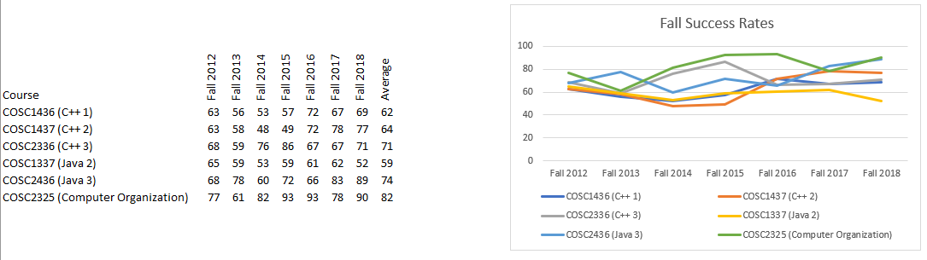

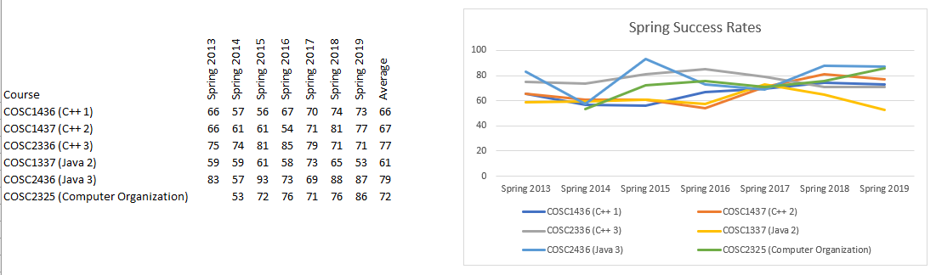

Fall 2019 Results of Usefulness of Computer Science Website:
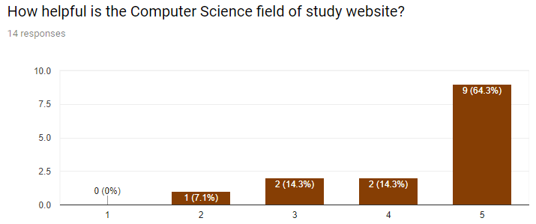
Comments:
- I think that the you have the right amount of information for someone to be able to get to what they need. Too much information can be overwhelming. This website is simple and to the point. I personally prefer it to sites that have a plethora of information and may cause confusion.
- I think it would be helpful to have a link where students can see which credits in the computer science program are transferable to universities in the DFW area. Also, a section talking more about the computer science field itself, and what types of careers are out there.
- I like it. The ETCS is especially nice. Wish I could help, but it all looks very organized, to me.
- Everything looks great! Maybe some more images and visual improvements, but information wise it's perfect enough.
- I think it would be nice if the site included some information on the different teachers styles.
- The courses required is very helpful. Perhaps instructions on how to sign up for said classes may be of use to new students.
- It could be more colorful. I has a lot of info but is not very visually exciting.
- Use a chatbot to ask people what they need and perhaps guide them to the correct obscure page.
- I would like to see more details about the courses and degrees offered.

