Continuous Improvement Plan

Outcomes might not change from year to year. For example, if you have not met previous targets, you may wish to retain the same outcomes. If this is an academic, workforce, or continuing education program, you must have at least one student learning outcome. You may also add short-term administrative, technological, assessment, resource or professional development goals, as needed.

Date: Name of Program/Unit:
Contact name: Contact email: Contact phone:
Table 1: CIP Outcomes, Measures & Targets Table (focus on at least one for the next two years)
A. Expected Outcome(s)  Results expected in this unit  (e.g. Authorization requests will be completed more quickly; Increase client satisfaction with our services) | B. Measure(s)  Instrument(s)/process(es) used to measure results  (e.g. survey results, exam questions, etc.) | C. Target(s)  Level of success expected  (e.g. 80% approval rating, 10 day faster request turn-around time, etc.)
Increase Dev Ed Success rates | Course success rates from Dev Education courses in AY 15, 16 and 17 | Year to year increase
Advising Plan Developing Block Schedules for M3 Developmental Education students. DE Pathways Pathway A: Certificate Pathway B: Workforce Pathway C: Core | Analyze data from focus groups, surveys and interviews with faculty & administrators. Conduct three CIP group action planning meetings to finalize block schedule pathways | 25% Of DE M3 students in DE pathways FALL 2020 50% Of DE M3 students in DE pathways FALL 2021 75% of DE M3 students in DE pathways FALL 2022
Providing academic support for DE students with low reading comprehension skills | Work with Deans/ Associate Deans to prepare for academic support and supplemental instruction district wide. DE Math/ INRW Faculty will present needs that will directly affect future professional development events as well as document formation and skill building exercises to use in the classroom. Compare success rates across different levels of reading readiness. | District wide Supplemental Instruction Fall 2020, 2 DE MATH / 2 INRW Tutors Faculty Resources for reading comprehension Available District wide Fall 2020 Professional Development FALL 2020 SPR 2021; FALL 2022
Increasing success rates in co-requisite courses in MATH 1342/ MATH 0342 | Conducting professional development sessions for faculty & staff. Offer professional development to address issues related to supplemental curriculum for reading comprehension. | Professional Development FALL 2020 SPR 2021 FALL 2022
Increasing ESL/ F1 program participants | Outreach to community programs and working with student & enrollment services. | Increase of 10% by 2022

Description of Fields in the Following CIP Tables:
A. Outcome(s) - Results expected in this program (e.g. Students will learn how to compare/contrast conflict and structural functional theories; increase student retention in Nursing Program).
B. Measure(s) - Instrument(s)/process(es) used to measure results
(e.g. results of surveys, test item questions 6 & 7 from final exam, end of term retention rates, etc.)
C. Target(s) - Degree of success expected (e.g. 80% approval rating, 25 graduates per year, increase retention by 2% etc.).
D. Action Plan - Based on analysis, identify actions to be taken to accomplish outcome. What will you do?
E. Results Summary - Summarize the information and data collected in year 1.
F. Findings - Explain how the information and data has impacted the expected outcome and program success.
G. Implementation of Findings – Describe how you have used or will use your findings and analysis of the data to make improvements.
Table 2. CIP Outcomes 1 & 2 (FOCUS ON AT LEAST 1)

- Outcome #1
Increase Developmental Ed Success Rates
- Measure (Outcome #1)  Course success rates from developmental education courses in AY 15, 16 and 17 | - Target (Outcome #1)  Year to year increase
- Action Plan (Outcome #1)

Developmental Math Action Plan
Beginning Fall 2018, the College offered co-requisite math courses as required by Texas House Bill 2333. Students took a 3-hour DE math support course concurrently with a 3-hour credit level math course. The Developmental Education support course was tailored to the course content in the credit level course. So, the material in the 1314 support course was different than the material in the 1342 support course. The goal was to provide just-in-time remediation through Developmental Education content that students needed to know in order to be successful on the content in the credit level course. For the AY2018 approximately 25% of DE students were enrolled in a co-requisite course, but that increased to approximately 50% in AY2019 and 75% in AY2020. This met the corequisite scaling requirements associated with Texas House Bill 2333

Integrated Reading and Writing Action Plan
Beginning Fall 2018, Collin College offered co-requisite INRW courses as required by Texas House Bill 2333. Students are enrolled in a 3-hour Developmental Education INRW 0315 support course concurrently that is paired with a 3-hour credit level course (ENGL 1301, HIST 1301, GOVT 2305, GOVT 2306, or SOCI 1301). The Developmental Education course curriculum scaffolds and supports the curriculum of the credit level course. Each Developmental Education course is unique and tailored to support the specific credit level course that it is paired with. This tailored instruction provides just-in-time support for students to be successful in the credit course. For the AY 2018, approximately 25% of DE students were enrolled in a co-requisite course. This increased to 50% for AY2019, and 75% in AY2020. This met the corequisite requirements outlined in Texas House Bill 2333.

ESL Action Plan
In Fall 2019, the ESL department restructured the program to make it an Intensive English Program, approved by SEVIS (Student Exchange and Visitor Programs) to admit F-1 Visa students in ESL (20 weekly required clock hours of ESL instruction). In addition to creating a program that could serve international populations seeking English study in the United States, the program change was geared toward making the program more academic and enhancing student success. The change was mainly in the number of classes offered and the contact hours of each course.
In the prior program, 3 levels (Intermediate 1, Intermediate 2 and Advanced) of 4 academic skills (Conversation, Grammar, Reading, and Writing) were offered, for a total of 12 contact hours at each level. Two 3-hour extra skills classes -- Idioms and Vocabulary and Test Taking Skills for Non-Native Speakers – were also offered. The maximum possible hours a student could carry in a given term was 15, but it would typically be lower.

In the new ESL program, all classes are four contact hours. Three levels (intermediate, advanced, and transitioning) of 4 academic skills (Conversation, Grammar, Reading, and Writing) are offered, for a total of 16 contact hours. Three extra skills classes – Pronunciation (new), Idioms and Vocabulary, and Test Taking Skills for Non-Native Speakers – are offered each for 4 contact hours. A maximum possible number of hours a student can carry in a semester is 20 contact hours per semester, but it is typically lower. As noted above, F1 Visa students studying ESL are required to carry 20 clock hours per week of ESL instruction.

The new program not only offers more classes but more hours, so students have more time to learn and practice the skills. For a language student, this intensive program provides stronger scaffolding for learning skills which improves the likelihood of being able to be successful and increases motivation among students promoting improved success rates. Please see the table below for class/skills organization details.

Comparison of ESL Class Arrangement
Old ESL Program  Academic Oriented Classes  Total Available Contact Hours = 12 | New Program  Academic Oriented Classes  Total Available Contact Hours = 16
ESL Listening and Speaking 0310 - Intermediate II | ESL Listening and Speaking 0305 – Intermediate
ESL Listening and Speaking - Advanced | ESL Listening and Speaking 0310 - Advanced
ESL 0325 - Pronunciation | ESL Listening and Speaking 0325 -Transitioning
ESL Grammar 0305 - Intermediate I | ESL Grammar 0305 - Intermediate
ESL Grammar 0310 - Intermediate II | ESL Grammar 0310 - Advanced
ESL Grammar 0325 - Advanced | ESL Grammar 0325 - Transitioning
ESL Reading 0305 - Intermediate I | ESL Reading 0305 - Intermediate
ESL Reading 0310 - Intermediate II | ESL Reading 0310 - Advanced
ESL Reading0325 - Advanced | ESL Reading 0325 - Transitioning
ESL Writing 0305 - Intermediate I | ESL Writing 0305 - Intermediate
ESL Writing 0310 - Intermediate II | ESL Writing 0310 - Advanced
ESL Writing 0325 - Advanced | ESL Writing 0325 - Transitioning
Extra Skills Courses
ESL Idioms and Vocabulary 310 - (Extra Skill) | ESLX0305 – Pronunciation (Intermediate) (Extra Skill)
ESL - Test Taking Skills for Non-Native Speakers (Extra Skill) | ESLX0310 – Vocabulary and idioms (Advanced) (Extra Skill)
 | ESLX0325 – Test Taking Skills for Non-Native Speakers (Extra Skill) (Transitioning Level)
Available Contact Hours = 6 | Available Contact Hours = 12

- Results Summary (Outcome #1)

Developmental Math Results Summary

Fall 2015:
Students enrolled in Math-0302, Math-0305, Math-0310, Math-0406: 2458
Students with grade A-C in those classes: 1189 for a success rate of 48%

Spring 2016:
Students enrolled in Math-0302, Math-0305, Math-0310, Math-0406: 2141
Students with grade A-C in those classes: 1072 for a success rate of 50%

Fall 2016:
Students enrolled in Math-0302, Math-0305, Math-0310, Math-0406: 2764
Students with grade A-C in those classes: 1392 for a success rate of 50%

Spring 2017:
Students enrolled in Math-0302, Math-0305, Math-0310, Math-0406: 2249
Students with grade A-C in those classes: 1138 for a success rate of 51%

Fall 2017:
Students enrolled in Math-0302, Math-0305, Math-0310, Math-0406: 2689
Students with grade A-C in those classes: 1394 for a success rate of 52%

Spring 2018:
Students enrolled in Math-0302, Math-0305, Math-0310, Math-0406: 2195
Students with grade A-C in those classes: 1105 for a success rate of 50%

Overall success rate for the AY 15, AY 16, and AY 17 is 50.3%

Math Co-Requisite Success Data
Fall 2018 (Goal 25% co-req)
Fall 2018  Co-Requisite Mathematics | Total Enrolled | Withdraw | Passed Credit Course with A-C | Passed Credit Course with A-D | Passed DE Course to become TSI Complete
Math 0314/1314 | 440 | n = 47  11% | n=219  50% | n=285  65% | n=297  68%
Math 0324/1324 | 39 | n = 2  5% | n=24  62% | n=31  79% | n=31  79%
Math 0342/1342 | 104 | n = 6  6% | n=38  37% | n=56  54% | n=69  66%
Math 0332/1332 | 53 | n = 4  8% | n=25  47% | n=36  68% | n=35  66%
Total | 636 | n = 59  9% | n=306  48% | n=408  64% | n=432  68%

Spring 2019
Spring 2019  Co-Requisite Mathematics | Total Enrolled | Withdraw | Passed Credit Course with A-C | Passed Credit Course with A-D | Passed DE Course to become TSI Complete
Math 0314/1314 | 374 | n = 18  5% | n=194  52% | n=254  68% | n=266  71%
Math 0324/1324 | 26 | n = 1  4% | n=16  62% | n=21  81% | n=21  81%
Math 0342/1342 | 103 | n = 9  9% | n=26  25% | n=55  53% | n=64  62%
Math 0332/1332 | 72 | n = 1  1% | n=36  50% | n=52  72% | n=52  72%
Total | 575 | n = 29  5% | n=272  47% | n=382  66% | n=403  70%

Fall 2019 (Goal 50% co-req)
Fall 2019  Co-Requisite Mathematics | Total Enrolled | Withdraw | Passed Credit Course with A-C | Passed Credit Course with A-D | Passed DE Course to become TSI Complete
Math 0314/1314 | 664 | n = 73  11% | n=304  46% | n=381  57% | n=412  62%
Math 0324/1324 | 74 | n = 14  19% | n=27  36% | n=37  50% | n=38  51%
Math 0342/1342 | 304 | n = 30  10% | n=153  50% | n=199  65% | n=210  69%
Math 0332/1332 | 139 | n = 6  4% | n=77  55% | n=92  66% | n=93  67%
Total | 1181 | n = 123  10% | n=561  48% | n=709  60% | n=753  64%

Spring 2020 (Covid hit in March)
Spring 2020  Co-Requisite Mathematics | Total Enrolled | Withdraw | Passed Credit Course with A-C | Passed Credit Course with A-D | Passed DE Course to become TSI Complete
Math 0314/1314 | 606 | n = 120  20% | n=280  46% | n=349  58% | n=384  63%
Math 0324/1324 | 94 | n = 19  20% | n=50  53% | n=52  55% | n=58  62%
Math 0342/1342 | 232 | n = 37  16% | n=123  53% | n=147  63% | n=155  67%
Math 0332/1332 | 99 | n = 16  16% | n=49  49% | n=58  59% | n=61  62%
Total | 1031 | n = 192  19% | n=502  49% | n=606  59% | n=658  64%

Fall 2020 (Goal 75% co-req) (mostly online or blended with social distancing)
Fall 2020  Co-Requisite Mathematics | Total Enrolled | Withdraw | Passed Credit Course with A-C | Passed Credit Course with A-D | Passed DE Course to become TSI Complete
Math 0314/1314 | 707 | n = 69  10% | n=319  45% | n=421  60% | n=486  69%
Math 0324/1324 | 167 | n = 17  10% | n=76  46% | n=95  57% | n=106  63%
Math 0342/1342 | 178 | n = 17  10% | n=93  52% | n=113  63% | n=118  66%
Math 0332/1332 | 57 | n = 4  7% | n=27  47% | n=35  61% | n=36  63%
Total | 1109 | n = 107  10% | n=515  46% | n=664  60% | n=746  67%

Spring 2021 (mostly online or blended with social distancing)
Spring 2021  Co-Requisite Mathematics | Total Enrolled | Withdraw | Passed Credit Course with A-C | Passed Credit Course with A-D | Passed DE Course to become TSI Complete
Math 0314/1314 | 566 | n = 46  8% | n=254  45% | n=330  58% | n=383  68%
Math 0324/1324 | 128 | n = 22  17% | n=49  38% | n=56  44% | n=67  52%
Math 0342/1342 | 189 | n = 14  7% | n=101  53% | n=121  64% | n=129  68%
Math 0332/1332 | 109 | n = 4  4% | n=81  74% | n=92  84% | n=95  87%
Total | 992 | n = 86  9% | n=485  49% | n=599  60% | n=674  68%

Integrated Reading and Writing Results Summary

Fall 2015:
Students enrolled in INRW 0405 and INRW 0315: 762.
Students with grade A-C in those classes: 516 for a success rate of 68%.

Spring 2016:
Students enrolled in INRW 0405 and INRW 0315: 747
Students with grade A-C in those classes: 502 for a success rate of 67%

Fall 2016: (note: first time INRW 0300 was offered again)
Students enrolled in INRW 0300, INRW 0405, and INRW 0315: 1079
Students with grade A-C in those classes: 750 for a success rate of 70%

Spring 2017:
Students enrolled in INRW 0300, INRW 0405, and INRW 0315: 1076
Students with grade A-C in those classes: 767 for a success rate of 71%

Fall 2017:
Students enrolled in INRW 0300, INRW 0405, and INRW 0315: 1423
Students with grade A-C in those classes: 890 for a success rate of 63%

Spring 2018:
Students enrolled in INRW 0300, INRW 0405, and INRW 0315: 972
Students with grade A-C in those classes: 619 for a success rate of 64%

Overall success rate for INRW for the AY 15, AY 16, and AY 17 is 67%

INRW Co-Requisite Success Data
Fall 2018 (Goal 25% co-req)
Fall 2018  Co-Requisite INRW | Total Enrolled | Withdraw | Passed Credit Course with A-C | Passed Credit Course with A-D | Passed DE Course to become TSI Complete
INRW 0315/  ENGL 1301 | 394 | 26  6.59% | 267  67.76% | 301  76.39% | 304  77%
INRW 0315/  HIST 1301 | 46 | 4  8.69% | 13  28.26% | 19  41.30% | 26  57%
INRW/GOVT 2305 | 44 | 4  9.09% | 21  47.72% | 31  70.45% | 29  66%
TOTAL ENROLLMENT | 484 | 34  7.02% | 301  62.19% | 351  72.52% | 359  74%

Spring 2019
Spring 2019  Co-Requisite INRW | Total Enrolled | Withdraw | Passed Credit Course with A-C | Passed Credit Course with A-D | Passed DE Course to become TSI Complete
INRW 0315/  ENGL 1301 | 364 | 29  8% | 230  63.18% | 262  71.97% | 247  68%
INRW 0315/HIST 1301 | 11 | 2  1.8% | 7  63.63% | 8  72.72% | 8  73%
INRW 0315/ GOVT 2305 | 21 | 0  0% | 19  90.47% | 19  90.47% | 18  86%
TOTAL ENROLLMENT | 396 | 31  7.82% | 256  64.64% | 289  72.97% | 273  69%

Fall 2019 (Goal 50% co-req)
Fall 2019  Co-Requisite INRW | Total Enrolled | Withdraw | Passed Credit Course with A-C | Passed Credit Course with A-D | Passed DE Course to become TSI Complete
INRW 0315/  ENGL 1301 | 625 | 36  6% | 425  68% | 468  75% | 434  69%
INRW 0315/HIST 1301 | 22 | 1  5% | 14  64% | 17  77% | 11  50%
INRW 0315/ GOVT 2305 | 21 | 0  0% | 20  95% | 21  100% | 20  95%
Total | 689 | 37  5% | 459  67% | 506  73% | 465  67%

Spring 2020 (Covid hit in March)
Spring 2020  Co-Requisite INRW | Total Enrolled | Withdraw | Passed Credit Course with A-C | Passed Credit Course with A-D | Passed DE Course to become TSI Complete
INRW 0315/  ENGL 1301 | 440 | 51  12% | 272  62% | 297  68% | 287  65%
INRW 0315/HIST 1301 | 0 | 0 | 0 | 0 | 0
INRW 0315/ GOVT 2306 | 20 | 2  10% | 15  75% | 15  75% | 15  75%
Total | 460 | 53  12% | 287  62% | 312  68% | 302  66%

Fall 2020 (Goal 75% co-req) (mostly online or blended with social distancing)
Fall 2020  Co-Requisite INRW | Total Enrolled | Withdraw | Passed Credit Course with A-C | Passed Credit Course with A-D | Passed DE Course to become TSI Complete
INRW 0315/  ENGL 1301 | 672 | 35  5% | 429  64% | 473  70% | 453  67%
INRW 0315/HIST 1301 | 0 | 0 | 0 | 0 | 0
INRW 0315/ GOVT 2305 | 27 | 1  4% | 22  81% | 22  81% | 20  74%
INRW 0315/SOCI 1301 | 25 | 5  20% | 8  32% | 9  36% | 9  36%
Total | 724 | 41  57% | 459  63% | 504  70% | 482  67%

Spring 2021 (mostly online or blended with social distancing)
Spring 2021  Co-Requisite INRW | Total Enrolled | Withdraw | Passed Credit Course with A-C | Passed Credit Course with A-D | Passed DE Course to become TSI Complete
INRW 0315/  ENGL 1301 | 470 | 21  4% | 291  62% | 315  67% | 320  68%
INRW 0315/HIST 1302 | 20 | 2  10% | 8  40% | 12  60% | 8  40%
INRW 0315/ GOVT 2306 | 24 | 1  4% | 18  75% | 18  75% | 20  83%
INRW 0315/SOCI 1301 | 24 | 0  0% | 12  50% | 16  67% | 12  50%
Total | 538 | 24  4% | 329  61% | 361  67% | 360  67%

English as a Second Language Findings

AY 2016-2017 Total Average Success Rate – 75%
Total students enrolled in ESLC 0305, ELSC 0310, and ESLC 0320: 371.
Students with grade A-C in those classes: 312 for a success rate of 83%.
Total students enrolled in ESLG 0305, ELSG 0310: 304.
Students with grade A-C in those classes: 220 for a success rate of 75%.
Total students enrolled in ESLR 0305, ELSR 0310: 279.
Students with grade A-C in those classes: 198 for a success rate of 71%.
Total students enrolled in ESLW 0305, ELSW 0310: 279.
Students with grade A-C in those classes: 196 for a success rate of 69%.

AY 2017-2018 Total Average Success Rate – 77%
Total students enrolled in ESLC 0305, ELSC 0310, and ESLC 0320: 321.
Students with grade A-C in those classes: 280 for a success rate of 87%.
Total students enrolled in ESLG 0305, ELSG 0310: 287.
Students with grade A-C in those classes: 218 for a success rate of 78%.
Total students enrolled in ESLR 0305, ELSR 0310: 276.
Students with grade A-C in those classes: 197 for a success rate of 71%.
Total students enrolled in ESLW 0305, ELSW 0310: 276.
Students with grade A-C in those classes: 200 for a success rate of 73%.

AY 2018-2019 Total Average Success Rate – 79%
Total students enrolled in ESLC 0305, ELSC 0310, and ESLC 0320: 85.
Students with grade A-C in those classes: 78 for a success rate of 93%.
Total students enrolled in ESLG 0305, ELSG 0310: 75.
Students with grade A-C in those classes: 53 for a success rate of 72%.
Total students enrolled in ESLR 0305, ELSR 0310: 87.
Students with grade A-C in those classes: 66 for a success rate of 76%.
Total students enrolled in ESLW 0305, ELSW 0310: 87.
Students with grade A-C in those classes: 67 for a success rate of 77%
The overall ESL success rate for years prior to the program review (AY 16, AY 17 and AY 18) averaged to be 78.3%, while the overall success rates in the years post program review were 72.9% for AY19 and 10% for AY 20.

2016-2020 Total Completion and Success Rates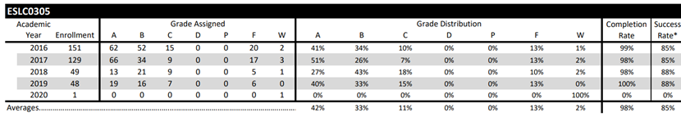
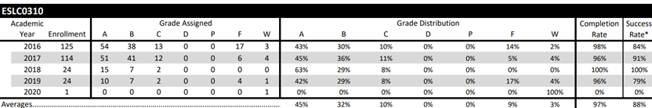
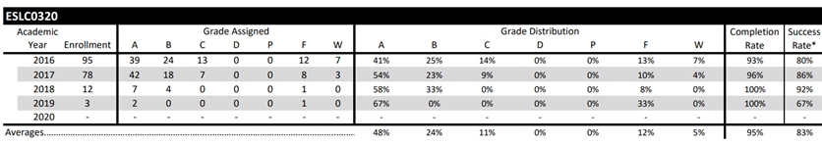
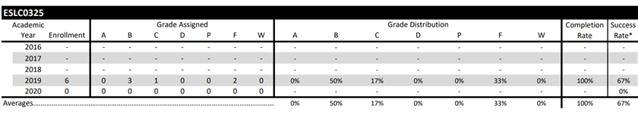
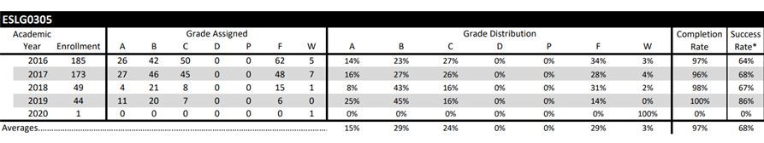
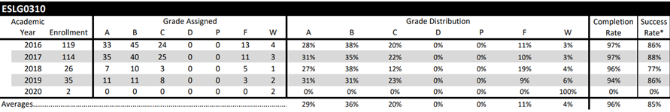
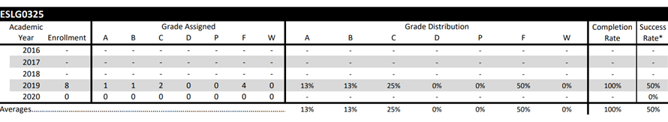
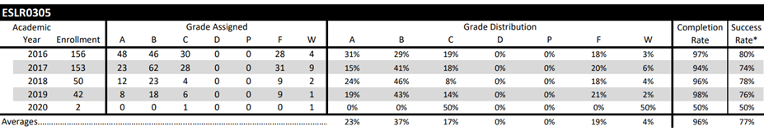
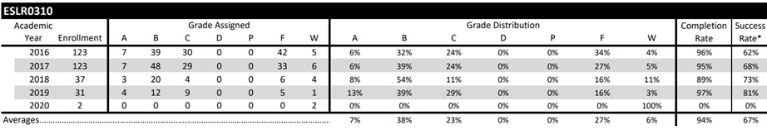

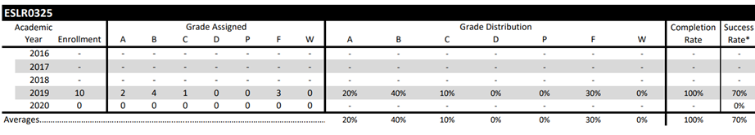
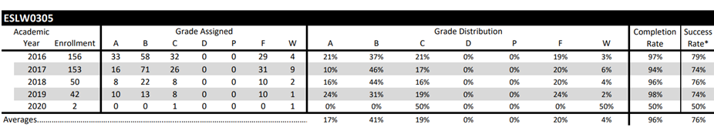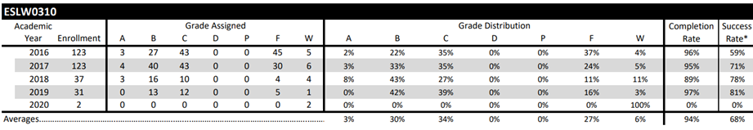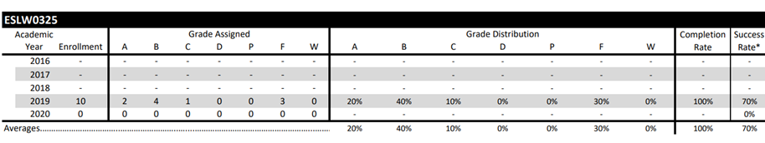
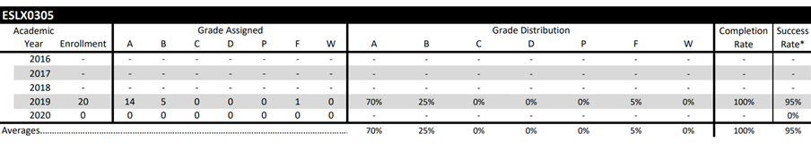
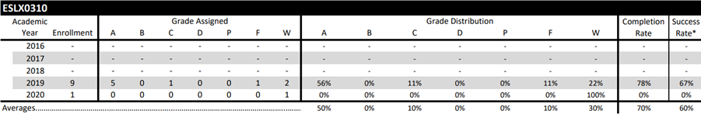
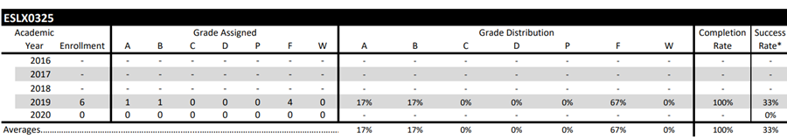

- Findings (Outcome #1)

Developmental Math Findings

For the AY15, AY16, and AY17, the success rate in stand-alone DE math courses was about 50%. That is, 50% of enrolled students passed the course and were able to move forward to their next math class. Note that some students still needed to take another DE math course before moving on to a credit level math course. Since the implementation of co-requisite courses, the success rate in the DE course has been between 64 and 70% each semester. That means 64%-70% of the DE math students were TSI complete at the end of that one semester and needed no more DE math courses. Many of these students were able to pass a credit level math course the same semester, though the percentages varied from course to course and semester to semester.

Integrated Reading and Writing Findings

For the AY15, AY16, and AY17, the success rate in stand-alone INRW courses was about 67%. That is, 67% of enrolled students passed the course and were able to move forward to their next INRW class. Note that some students still needed to take another DE math course before being TSI complete. Since the implementation of co-requisite courses, the success rate in the DE course has been between 66% and 74% each semester. That means 66%-74% of the INRW students were TSI complete at the end of that one semester and needed no more INRW courses. Many of these students were able to pass a credit level paired course (ENGL 1301, GOVT 2305/2306, HIST 1301/1302, SOCI 1301) the same semester, though the percentages varied from course to course and semester to semester.

English as a Second Language Findings

In discussing the findings, it is important to note the following factors:

-The ESL program is unique in admitting both credit and non-credit students. All data listed here is only for credit students; therefore, we are not really getting a full picture of success or completers.
-The data for the 2020 AY consists of a very low sample size and may not be acceptable to use for analysis and projection of future success.
-The success rate is not available for ESLX0305 and ESLX0325 for the 2016-2018 academic years as there were newly created courses.

Comparing 2019, the year the new program was introduced and the year that has the most complete data post program creation to the years prior, the completion rates and success rates are comparable. There was a decrease of roughly 5%. which could partially be attributed to COVID-19 influencing factors. In addition, the changes to the program structure resulted in a much more rigorous program which required more hours to complete. This may have contributed to increased numbers of students not being able to complete the program compared to the years prior; however, the program review needed to be made more rigorous in order to comply with federal student visa regulations.

In ESL, we have 3 levels (Intermediate-305, Advanced -310, and transitioning -325) and of 5 skills (Conversation (C), Grammar (G), Reading (R), Writing (W), and Extra Skills (X)). For the Academic years 2016, 2017, and 2018, the success rate was about 75% for all classes, which means 75% of enrolled students passed and moved on to the next level. Some students in ESLR0325 and ESLW0325 might have completed TSI and moved on to college. Please see the charts previously provided for completion and success rate data.

- Implementation of Findings

Developmental Math Implementation of Findings
The co-requisite model has increased student success rate in DE courses by 28%-40% by semester. It would be great to see the success rates in the DE course stay approximately 70% per semester.
The success rates in the credit level math course vary from semester to semester and course to course. The overall success rates in credit level courses for DE students in co-requisite classes hovers around 48% for grades A-C and around 60% for grades A-D. These levels are fairly consistent despite the increase in the percent of students enrolled in co-requisite courses (25% to 50% to 75%) and despite limited time in face-to-face classes with an instructor because of the Covid-19 pandemic. It would be nice to see the credit level success rates continue to improve both overall and per course.

Integrated Reading and Writing Implementation of Findings
The co-requisite model has kept student success rate in INRW corequisite courses consistent by semester at 67-68%. It would be great to see the success rates in the INRW course increase to approximately 70% per semester.
The success rates in the credit level corequisite course vary from semester to semester and course to course. The overall success rates in credit level courses for DE INRW students in co-requisite classes hovers around 63% for grades A-C and around 71% for grades A-D. These levels are fairly consistent despite the increase in the percent of students enrolled in co-requisite courses (25% to 50% to 75%) and despite limited time in face-to-face classes with an instructor because of the Covid-19 pandemic. It is a goal to see the credit level success rates continue to improve both overall and per course.

English as a Second Language Implementation of Findings
Overall, the success rate increased in the new program. The pandemic situation may be a cause for the low enrollment in Fall 2020 (167); however, it went up dramatically in Spring 2021 (264). Students certainly needed to make a great adjustment to the blended/online class set up. We hope that more students enroll for credit. As a result, a higher number can be recorded for completion and success rates. Implementing the following ideas may be helpful to improve completion/success rate:
- Adjusting in-between class time to give enough time for students to have a good break.
- Revising the departmental final exams to make sure that we have 2 sets of exams for all classes at all levels
- Reviewing the text book selections to make sure they have updated materials and are challenging for students.

- Outcome #2
Advising plan developing block schedules for M3 developmental education students. DE Pathways
- Measure (Outcome #2)  Analyze data from focus groups, surveys and interviews with faculty & administrators.  Conduct three CIP group action planning meetings  to finalize block schedule pathways | - Target (Outcome #2)  25% Of DE M3 students in DE pathways  FALL 2020  50% Of DE M3 students in DE pathways  FALL 2021  75% of DE M3 students in DE pathways  FALL 202
- Action Plan (Outcome #2)
Conduct three CIP group action planning meetings
to finalize block schedule pathways

- Results Summary (Outcome #2)
No report. Progress not made on this outcome.
- Findings (Outcome #1)
No report. Progress not made on this outcome.
- Implementation of Findings
No report. Progress not made on this outcome.

  - Outcome #3
Providing academic support for DE students with low reading comprehension skills
- Measure (Outcome #3)  Work with Deans/ Associate Deans to prepare for academic support and supplemental instruction district wide.  DE Math/ INRW Faculty will present needs that will directly affect future professional development events as well as document formation and skill building exercises to use in the classroom. Compare success rates across different levels of reading readiness. | - Target (Outcome #3)  District wide Supplemental Instruction  Fall 2020, 2 DE MATH / 2 INRW Tutors  Faculty Resources for reading comprehension  Available District wide Fall 2020  Professional Development FALL 2020  SPR 2021; FALL 2022
  - Action Plan (Outcome #3)

A DE Mathematics and INRW faculty member will pair up to write a series of lessons or activities to be shared with faculty to help students improve reading skills in mathematics courses.
A Supplemental Instruction and Tutoring Program will be implemented to provide extra assistance to co-requisite math students.
Professional Development sessions will be held to help DE math faculty learn and improve pedagogy.
  - Results Summary (Outcome #3)

Professional Development

A PD was held in January 2019 where a faculty member (Sharon Jackson) from Dallas County Community College presented on techniques to help co-requisite math students. Another PD was held in April of 2019 specifically for co-requisite statistics. Pearson representatives demonstrated StatCrunch software, general MyMathLab offerings, and Leah Beck hosted a brainstorming session on strategies to help co-requisite statistics students. Leah Beck (DE math) and Tawnya Smith (INRW) collaborated in Fall of 2019. They wrote a series of lessons or activities to share with faculty. Lessons were intended to help math faculty work with students on reading skills in math co-requisite courses, particularly the Elementary Statistics co-requisite course. Activities includes samples of scaffolding, helping students pre-read challenging problems, and helping students move from “outsider” language to “insider” language in math problems. The activities created were shared at PD sessions for Collin faculty in January of 2020. Those activities are still posted on the Synergy website that all math faculty (both full-time and adjunct) can access.

Supplemental Instruction Update

Spring 2019 to Spring 2021

Spring 2019
College Algebra Supplemental Instruction (pilot – Frisco Campus)
- Frisco Campus - 7 sessions per week
- Online – 1 session every other week
- 350 verified sign ins
- 80 unique co-requisite college algebra students
- Students who attended at least ONE SI/T session
- 88.8% passed Math 0314 (TSI complete in Math)
- 87.5% passed Math 1314 with D or higher
- 71.3% passed Math 1314 with C or higher (success is first college level math class)
- Students who attended 3 or more SI/T sessions
- 96.7% passed Math 0314 (TSI complete in Math)
- 95% passed Math 1314 with D or higher
- 80.3% passed Math 1314 with C or higher (success in first college level math class)
THECB Reported success rates for All Math Co-requisite classes
- 43% of students met TSI standards (TSI complete)
- 43% of students success in first College level math class (C or higher)

Fall 2019
College Algebra Supplemental Instruction
- Frisco Campus - 8 sessions per week
- McKinney Campus – 6 sessions per week
- Plano Campus – 8 sessions per week
- Online – 4 sessions per week (including 1 weekend session)
College Algebra SI Outcomes
- 865 verified sign ins
- 201 Unique co-requisite College Algebra students
- 30% of Co-requisite college algebra students attended at least one SIT session
- Students who attended at least ONE SI/T session
- 80.6% passed Math 0314 (TSI Complete in Math)
- 79.1% passed Math 1314 with D or Higher
- 65.2% passed Math 1314 with C or higher (Success in first college level math class)
- Students who attended 3 or more SI/T sessions
- 87% passed Math 0314 (TSI complete in Math)
- 84.5% passed Math 1314 with D or higher
- 71.8% passed Math 1314 with C or higher (Success in first college level math class)
Elementary Statistics Supplemental Instruction (pilot – McKinney Campus)
- McKinney Campus – 3 sessions per week
- 60 verified sign ins
- 19 Unique co-requisite Elementary Statistics Students
- Did not track success rates due to small sample size

Spring 2020
Changes –
- Making worksheets/lessons available to students online using OneDrive
- Expanding Elementary Statistics SI to all three campuses and online
- Offering training to AIM center staff in Elementary Statistics by embedding AIM staff into co-requisite classrooms to increase tutor availability in Statistics
- Increasing placement of tutors in classrooms to encourage student SI/T attendance, decrease student/teacher ratio, and increase tutor familiarity of material
- Increasing number of weekend and evening SI/T opportunities
Covid arrived in March. All classes moved completely online. We converted most SIT sessions to online. It was not possible to fully track attendance and success rates due to the sudden change in formats and campuses closing.

Fall 2020
Most classes were online or blended format where students were socially distanced in the classrooms. This means not all students were able to attend each class meeting (in most cases). This meant we could not have embedded tutors to help recruit to SIT or to allow for more tutor access during the class period. Most instructors did not require/grade SIT attendance due to Covid restrictions.
New – Dev Math piloted SIT for Math for Business and Social Sciences. There were no lessons created, but we offered sessions in a Q & A format.
1314/0314 College Algebra:
- 4 face-to-face sessions weekly at Frisco
- 10 face-to-face sessions weekly at Plano
- 18 weekly online sessions
- 133 total visits by 37 different students
- 5% of co-requisite college algebra students attended SIT at least once. The drop in attendance is likely due to most sessions being online. Also, many instructors did not require/grade SIT attendance due to Covid.
- Students who attended AT LEAST one session:
- 89.19% passed 0314 and are TSI complete
- 67.57% passed 1314 with a D or higher
- 48.65% passed 1314 with a C or higher
- Students who attended AT LEAST 3 sessions (23 students)
- 96.65% passed 0314 and are TSI complete (1 withdrew)
- 96.65% passed 1314 with a D or higher (1 withdrew)
- 47.83% passed 1314 with a C or higher
1342/0342 Elementary Statistics:
- 2 face-to-face sessions weekly at Frisco
- 14 weekly online sessions
- 71 total visits by 20 total students
- 11% of co-requisite elementary statistics students attended SIT at least once
- Students who attended AT LEAST one session:
- 90% passed 0342 and are TSI complete
- 90% passed 1342 with a D or higher
- 80% passed 1342 with a C or higher
- Students who attended AT LEAST 3 sessions:
- 92.86% passed 0342 and are TSI complete
- 92.86% passed 1342 with a D or higher
- 78.57% passed 1342 with a C or higher
1324/0324 Math for Business and Social Sciences
- 6 weekly online sessions
- 39 sessions attended by 12 students
- 7% of co-req business math students attended at least once
- Students who attended AT LEAST one session:
- 66.66% passed 0324 and are TSI complete
- 66.66% passed 1324 with a grade of C or higher (no D’s)
- Students who attended AT LEAST three sessions:
- 66.66% passed 0324 and are TSI complete
- 66.66% passed 1324 with a grade of C or higher (no D’s)
Spring 2021
Most classes are still online or blended format, meaning not all students are able to attend class each meeting. Still no embedded tutors. Most instructors still not requiring/grading attendance.

1314/0314 College Algebra:
- 2 face-to-face sessions weekly at Frisco
- 7 face-to-face sessions weekly at Plano
- 10 face-to-face sessions weekly at McKinney
- 21 weekly online sessions
- 80 total visits by 16 different students
- 3% of co-requisite college algebra students attended SIT at least once. The drop in attendance is likely due to most sessions being online. Also, many instructors did not require/grade SIT attendance due to Covid.
- Students who attended AT LEAST one session:
- 93.75% passed 0314 and are TSI complete
- 81.25% passed 1314 with a D or higher
- 43.75% passed 1314 with a C or higher
- Students who attended AT LEAST 3 sessions:
- 90% passed 0314 and are TSI complete
- 80% passed 1314 with a D or higher
- 40% passed 1314 with a C or higher
1342/0342 Elementary Statistics:
- 2 face-to-face sessions weekly at Frisco
- 12 weekly online sessions
- 65 total visits by 15 total students
- 8% of co-requisite elementary statistics students attended SIT at least once
- Students who attended AT LEAST one session:
- 93.33% passed 0342 and are TSI complete
- 93.33% passed 1342 with a D or higher
- 80% passed 1342 with a C or higher
- Students who attended AT LEAST 3 sessions:
- 100% passed 0342 and are TSI complete
- 100% passed 1342 with a D or higher
- 84.61% passed 1342 with a C or higher
1324/0324 Math for Business and Social Sciences
- 5 weekly online sessions
- 4 sessions attended by 4 students
- 3% of co-req business math students attended at least once
- 1 student scored A in 0324 and B in 1324
- 1 student scored B in 0324 and C in 1324
- 1 student withdrew
- 1 student must have used a nickname because unable to find grades

  - Findings (Outcome #3)
There has not been PD geared specifically for improving reading in math co-requisite classes since Spring 2020. Covid has made it difficult to do this, but it is also challenging to find relevant, helpful PD for how to improve reading skills in math classes. The sessions in January 2020 did start good discussions, and as faculty have gained experience teaching the statistics co-requisite course, success rates have improved. The suggested lessons/activities are still posted for faculty in Synergy.
The SIT program is highly effective and helpful for students who attend. Attendance has dramatically dropped in the last year due to Covid limitations and faculty not emphasizing it as much due to Covid. Hopefully attendance will increase starting in Fall 2021. There are lessons provided for SIT tutors to use, however they are not necessarily focused on helping students improve their reading skills in math. That may be a nice result, but the focus is on math and helping students improve their math skills.

  - Implementation of Findings
It would be nice to promote the SIT program more (faculty encouraging student attendance) and see if success rates also increase. However, this does not tie closely to the goal of improving reading comprehension skills.
While increased PD would help faculty, it is difficult to find PD that will specifically help with reading comprehension for students.

  - Outcome #4
Increasing success rates in co-requisite courses in MATH 1342/ MATH 0342

- Measure (Outcome #4)  Conducting professional development sessions for faculty & staff. Offer professional development to address issues related to supplemental curriculum for reading comprehension. | - Target (Outcome #4)  Professional Development  FALL 2020  SPR 2021  FALL 2022
  - Action Plan (Outcome #4)
Conduct professional development sessions for faculty teaching co-requisite statistics. Expand the Supplemental Instruction and Tutoring program to include co-requisite statistics so those students can get assistance outside of class.
  - Results Summary (Outcome #4)

A PD was held in January 2019 where a faculty member (Sharon Jackson) from Dallas County Community College presented on techniques to help co-requisite math students. Another PD was held in April of 2019 specifically for co-requisite statistics. Pearson representatives demonstrated StatCrunch software, general MyMathLab offerings, and Leah Beck hosted a brainstorming session on strategies to help co-requisite statistics students. Leah Beck (DE math) and Tawnya Smith (INRW) collaborated in Fall of 2019. They wrote a series of lessons or activities to share with faculty. Lessons were intended to help math faculty work with students on reading skills in math co-requisite courses, particularly the Elementary Statistics co-requisite course. Activities includes samples of scaffolding, helping students pre-read challenging problems, and helping students move from “outsider” language to “insider” language in math problems. The activities created were shared at PD sessions for Collin faculty in January of 2020. Those activities are still posted on the Synergy website that all math faculty (both full-time and adjunct) can access.

No professional development sessions were held specifically for Stats co-req in Fall 2020 or Spring 2021.

The Supplemental Instruction and Tutoring program (SI/T) was expanded to include co-requisite statistics. In Fall of 2019, pilot sessions were held at the McKinney campus. Three sessions were held each week, and there were 60 verified sign-ins by 19 unique students. More sessions were offered district wide in Spring 2020, but Covid hit and made it difficult to track overall attendance and success rates for the Spring.

SI/T data from Fall 2020:
- 2 face-to-face sessions weekly at Frisco
- 14 weekly online sessions
- 71 total visits by 20 total students
- 11% of co-requisite elementary statistics students attended SIT at least once
- Students who attended AT LEAST one session:
- 90% passed 0342 and are TSI complete
- 90% passed 1342 with a D or higher
- 80% passed 1342 with a C or higher
- Students who attended AT LEAST 3 sessions:
- 92.86% passed 0342 and are TSI complete
- 92.86% passed 1342 with a D or higher
- 78.57% passed 1342 with a C or higher

SI/T data from Spring 2021:
- 2 face-to-face sessions weekly at Frisco
- 12 weekly online sessions
- 65 total visits by 15 total students
- 8% of co-requisite elementary statistics students attended SIT at least once
- Students who attended AT LEAST one session:
- 93.33% passed 0342 and are TSI complete
- 93.33% passed 1342 with a D or higher
- 80% passed 1342 with a C or higher
- Students who attended AT LEAST 3 sessions:
- 100% passed 0342 and are TSI complete
- 100% passed 1342 with a D or higher
- 84.61% passed 1342 with a C or higher

Co-Requisite Statistics (Math 0342/1342)
Historical Success Data
Semester | Total Enrolled | Withdraw | Passed Credit Course with A-C | Passed Credit Course with A-D | Passed DE Course to become TSI Complete
Fall 2018 | 104 | n = 6  6% | n=38  37% | n=56  54% | n=69  66%
Spring 2019 | 103 | n = 9  9% | n=26  25% | n=55  53% | n=64  62%
Fall 2019 | 304 | n = 30  10% | n=153  50% | n=199  65% | n=210  69%
Spring 2020 | 232 | n = 37  16% | n=123  53% | n=147  63% | n=155  67%
Fall 2020 | 178 | n = 17  10% | n=93  52% | n=113  63% | n=118  66%
Spring 2021 | 189 | n = 14  7% | n=101  53% | n=121  64% | n=129  68%

  - Findings (Outcome #4)
The first year of stats co-req (AY2018) the success rate for 1342 was low. We made a conscious effort to have PD sessions during the 2019-2020 school year. We added SI/T sessions as a pilot in Fall 2019 at the McKinney campus and expanded district wide in Spring 2020. It was difficult to track success data that year for students who attended due to limited sample size in the fall and Covid protocols in the Spring. There was in increase in 1342 success rates for co-requisite students for AY2019. Despite Covid protocols and no additional PD for AY2020, success rates remained about the same for 1342/0342 in AY2020..

  - Implementation of Findings
Now that Covid protocols will be more limited, hopefully SIT attendance will increase and success rates will continue to rise. Due to TSIA2, all students who test below college ready take the diagnostic test and will be routed to co-req stats. There will no longer be an option of “bubble” students taking stand alone 1342 with NCBM 0042 with minimal oversight/support. It is likely that success in the co-req part of 1342 will increase again, though we will not know for sure until we see data from Fall 2021. It would be nice to have more PD for co-req instructors, but perhaps it should not be isolated for stats alone. Perhaps the sessions could be for all co-req math courses or even offer session unique to each course.

A. Outcome #5
Increasing ESL/F1 program participants
- Measure (Outcome #5)  Outreach to community programs and working with SES | - Target (Outcome #5)  Increase of 10% by 2022
  - Action Plan (Outcome #5)
- During the 2020-2021 academic year, the ESL department planned to make revisions of the ESL Website in order to make it more informative and user-friendly.
- During the 2020-2021 academic year, the department planned to monitoring ESL database profiles, create new profiles where possible and correspond with prospective students.
- During Fall of 2020, the ESL Department had planned on participating in the Plano International Festival to promote the ESL Program setting up booth and making use of Collin College resources such as the Collin College truck and distributing flyers

  - Results Summary (Outcome #5)
- During the 2020-2021 academic year, several revisions were made to the ESL website in terms of making the tuition and registration more easily understood and providing updates to COVID-19 concerns. 4 out of 10 responses given for the Celebration of Achievement Event survey indicated that students learned about our ESL Program through the website, and, according to Heather Webb-Losh, Web Services, the website received 29, 401 Page Views and 19, 662 Unique Page Views for the 2019-2020 academic year and 63, 965 Page Views and 43, 541 Unique Page Views for the 2020-2021 academic year. As you can see, the views were more than doubled.
- 7 students reached out during 2020-2021 academic year through Internationalstudent.com each from a different country. Students were provided registration information and directed to the Associate Dean and ESL website for more information. Although searches were conducted to determine if additional profiles could be established on new ESL databases, no potential sites were found.
- Due to Covid-19, the Plano International Festival was canceled. As such, it was not possible to create a booth to promote the program
Due to COVID-19 and related factors such as a travel ban prohibiting new students coming to the US, the ESL department was not able to reach its goal of increased enrollment during the 2020-2021 academic year. At the beginning of Spring 2020, total enrollments across classes numbered 458. For Fall 2020, the total number of enrollments were 167, and for Spring the total number of enrollments were 264. Although there was a sharp decline during the Fall of 2020, enrollment did significantly increase during the subsequent semester.

  - Findings (Outcome #5)
The three strategies still hold merit. However, Due to the pandemic situation, it was hard to implement any marketing strategy and invite more new students to the program. However, the enrollment went up significantly from Fall 2020 (167) to Spring 2021 (264).
  - Implementation of Findings
- We will continue to enhance the website to provide more information because the EL Website has been a great source of resource for existing and new students.
- The department will monitor the database profiles and create new profiles to expand communication/interaction with our students.
- We will continue to seek opportunities to take part in the future Plano International Festivals and other such international celebrations to promote the program.
Although the results do not reflect the effectiveness of our plan, we are planning to continue to implement the above-mentioned strategies to find out their efficacy as the pandemic situation has improved now. This will also enable us to be more innovative.

