**Continuous Improvement Plan**

**Outcomes might not change from year to year. For example, if you have not met previous targets, you may wish to retain the same outcomes. *If this is an academic, workforce, or continuing education program, you must have at least one student learning outcome.* You may also add short-term administrative, technological, assessment, resource or professional development goals, as needed.**

**Date:** January 27, 2022 **Name of Program/Unit:** Communication Design

**Contact name:** Richard LeBlanc **Contact email:** [**rleblanc@collin.edu**](mailto:rleblanc@collin.edu) **Contact phone:**  972-881-5114

**Table 1: CIP Outcomes, Measures & Targets Table (focus on at least one for the next two years)**

|  |  |  |
| --- | --- | --- |
| **A. Expected Outcome(s)** Results expected in this program (e.g. Students will learn how to compare/contrast theories; Increase student retention in PSYC 2301) | **B. Measure(s)**  Instrument(s)/process(es) used to measure results (e.g. surveys, end of term class results, test results, etc.) | **C. Target(s)** Level of success expected (e.g. 80% success rate, 25 graduates, etc.) |
| 1. Improve students’ technical foundation skills in *ARTC 1325 Introduction to Computer Graphics*. | Compare *ARTC 1325 Introduction to Computer Graphics* student end of course assessment for from Spring 2020 to Fall 2020. | 25% overall improvement in demonstrated student technical knowledge and execution.  Improved grade distribution in sequential courses. |
| 2. Improve student understanding and application of style in *ARTC 1317 Design Communication I*. | Compare *ARTC 1317 Design Communication I* students project 2 submitted work from spring 2020 to fall 2020 using rubric gauging students’ understanding of style and its application in course work. | 25% overall improvement in demonstrated student understanding and application of style. |
| 3. Improve implementation of industry-standard technology and instructional support technology. | Develop a communication channel with Campus Technology. Develop a technology maintenance strategy. | Establish communication path. Outlined technology maintenance schedule. |
| 4. Improve retention in the Graphic Design program | Retention of students transitioning from first year second semester ARTC 1327 Typography through second year/second semester ARTC 2335 Portfolio Development for Graphic Design. FY2020 over FY2022. | 25% Improvement |

**Description of Fields in the Following CIP Tables:**

**A. Outcome(s)** -Results expected in this program (e.g. Students will learn how to compare/contrast conflict and structural functional theories; increase student retention in Nursing Program).

**B. Measure(s)** -Instrument(s)/process(es) used to measure results

(e.g. results of surveys, test item questions 6 & 7 from final exam, end of term retention rates, etc.)

**C. Target(s)** -Degree of success expected (e.g. 80% approval rating, 25 graduates per year, increase retention by 2% etc.).

**D. Action Plan** -Based on analysis, identify actions to be taken to accomplish outcome. What will you do?

**E. Results Summary** - Summarize the information and data collected in year 1.

**F. Findings** - Explain how the information and data has impacted the expected outcome and program success.

**G. Implementation of Findings** – Describe how you have used or will use your findings and analysis of the data to make improvements.

**Table 2.1 CIP Outcomes 1**

|  |  |  |
| --- | --- | --- |
| 1. **Expected Outcome #1**   Improved technical foundation skillsets will permit students to produce better quality work as they progress through the program.   1. They will have a better understanding of the technical skills needed to execute desired outcomes. 2. By providing this foundation skillset, students can more skillfully and artfully execute their concepts, a more visually superior product. | | |
| 1. **Measure (Outcome #1)**   Compare *ARTC 1325 Introduction to Computer Graphics* student end of course assessment from Spring 2020 to Fall 2020. | 1. **Target (Outcome #1)**   25% overall improvement in demonstrated student technical knowledge and execution.  Improved grade distribution in sequential courses. | |
| 1. **Action Plan (Outcome #1)**   *ARTC 1325 Introduction to Computer Graphics* course curriculum and implementation recommendations are being revised Spring and Summer 2020. These revisions will be rolled out as curriculum guidelines for all ARTC 1325 sections starting Fall 2020. | | |
| 1. **Results Summary (Outcome #1) TO BE FILLED OUT IN YEAR 2**  * New course curriculum and implementation recommendations began in Spring 2020 and released to the instructor pool in Fall for ARTC 1325 Intro to Computer Graphics (see ***Appendix 2.1.a — Overview of ARTC 1325 Intro to Computer Graphics Content — Fall 2019 vs. Spring 2020 vs. Fall 2020***). * Implementation of the new course curriculum and recommendations coincided with the emergence of COVID and a move to fully-online learning in late Spring 2020 and through Summer 2020, before moving into Hybrid (“split lab time”) mode through Fall 2020 and Spring 2021. * Quantitative assessment from semester-to-semester as outlined above may not the best indicator for the success of this Outcome. Instead, the qualitative assessment of additional/expanded skills being taught and assessed in the course indicate the expected outcome has been met. | | |
| 1. **Findings (Outcome #1) TO BE FILLED OUT IN YEAR 2**  * Average Grade Distribution (Final Average) for Spring 2020 vs. Summer trended downward rather than upward, but overall success trended upward, though only marginally. (See ***Appendix 2.1.a — Final Grade Distribution for ARTC 1325 Intro to Computer Graphics —Spring 2020 vs. Fall 2020***). * Regardless of grades, the revised course curriculum introduced instruction and assessment on additional skills over those taking the course prior to implementation), vastly increasing the amount of knowledge gained and skills learned for those passing the course after implementation. | |
| 1. **Implementation of Findings (Outcome #1) TO BE FILLED OUT IN YEAR 2**  * The revised/updated content became the foundation for a District Template for *ARTC 1325 Intro to Computer Graphics*, and has been implemented in all sections of the course (Face-to-face, Hybrid, Web). | |

**Table 2.2 CIP Outcomes 2**

|  |  |
| --- | --- |
| 1. **Expected Outcome #2**   Improved understanding of style and application will translate into student work with an additional skill layer above concept and execution. Currently, a fraction of our students are successfully applying style to all levels of work. | |
| 1. **Measure (Outcome #2)**   Compare *ARTC 1317 Design Communication I* students project 2 submitted work from spring 2020 to fall 2020 using rubric gauging students’ understanding of style and its application in course work. | 1. **Target (Outcome #2)**   25% overall improvement in demonstrated student understanding and application of style. |
| 1. **Action Plan (Outcome #2)**   In ARTC 1317, develop additional lecture and resources on style and application. Add exercises covering the application of style. Add the integration of style as project level assessment. | |
| 1. **Results Summary (Outcome #2) TO BE FILLED OUT IN YEAR 2**  * The assignment (see ***Appendix 2.2.a — Assignment Overview — “Prj 2 | Phase 1: Research for Promotion & Styles”***) was implemented in Spring 2020 with immediate success. It was continued in Fall 2020 with marked improvement, with all students achieving a perfect score on the assignment. | |
| 1. **Findings (Outcome #2) TO BE FILLED OUT IN YEAR 2**  * 100% of students scored 40/40 on the Rubric for the assignment in Fall 2020,  with the average score improving from Spring 2020 by 3 points (7.5%) over Spring 2020.   (See ***Appendix 2.2.a — Grading Rubric & Scores — “Prj 2 | Phase 1: Research for Promotion & Styles”.***) | |
| 1. **Implementation of Findings (Outcome #2) TO BE FILLED OUT IN YEAR 2**  * The assignment will continue as a required component in the development of Branding Project 1 for all sections of *ARTC 1317 Design Communication I.* | |

**Table 2.3 CIP Outcomes 3**

|  |  |
| --- | --- |
| 1. **Expected Outcome #3**   Students obtain current industry standard technical skillsets by using equipment and software parallel to the level they would be expected to use in the workforce. Instructors should effectively communicate course content and demonstrate technical skills as well as require students to produce industry standard work. | |
| 1. **Measure (Outcome #3)**   Develop a communication channel with Campus Technology. Develop a technology maintenance strategy. | 1. **Target (Outcome #3)**   Establish communication path. Outlined technology maintenance schedule. |
| 1. **Action Plan (Outcome #3)**   Work with Campus Technology and leadership to develop a communication pathway, action plans, and maintenance strategies. | |
| 1. **Results Summary (Outcome #3) TO BE FILLED OUT IN YEAR 2**  * On the whole, the program has been successful in keeping software up-to-date with some minor exceptions (see ***“F. Findings”*** below). * The divergent nature of technology maintenance (with each campus having separate IT management and focus) has made assurance of the technological needs difficult away from the program’s main (Plano) campus, on the supporting campuses (Frisco, McKinney) during the plan’s ramp-up, but those issues have been resolved. * Program growth and budget constraints are challenging the department in keeping hardware up to date, especially as the industry software becomes more-and-more demanding on the processors of the computers. | |
| 1. **Findings (Outcome #3) TO BE FILLED OUT IN YEAR 2**  * A plan was established so all labs used by Communication Design courses on its main campus (Plano) and supporting campuses (Frisco, McKinney) to make sure all relevant software (including the desktop operating systems) are updated before Fall, Spring, and Summer sessions begin. * A minor issue does arise when the software publishers (particularly Adobe), push a new version of the software. This typically happens in mid-October, after the computers have been updated on the various campuses. Most students are set to update their personal versions of the software automatically. If they take a file created/updated with their own/newer version of the software and try to work with on the campus computers running an older version of the software, it won’t let them. | |
| 1. **Implementation of Findings (Outcome #3) TO BE FILLED OUT IN YEAR 2**  * Knowing Adobe typically releases a mid-October update of their software, the department needs to consider an additional program-wide update on the computers to coincide with this (therefore making sure updates are done just before Fall start, and again to coincide with Adobe October release schedule). | |

**Table 2.4 CIP Outcomes 4**

|  |  |
| --- | --- |
| 1. **Expected Outcome #4**   Improve student retention, completion, and satisfaction with the program. | |
| 1. **Measure (Outcome #4)**   Retention of students transitioning from first year second semester *ARTC 1327 Typography* through second year, second semester *ARTC 2335 Portfolio Development for Graphic Design*. FY2020 over FY2022. | 1. **Target (Outcome #4)**   25% Improvement |
| 1. **Action Plan (Outcome #4)**   Work with Career Coaches to accurately capture program enrolled students and survey students on key questions that impact their level of engagement in the program (i.e. full or part-time, working full or part-time, veteran status).  Pair students with faculty member mentors.  Work with leadership to develop course offering strategies that reduce completion barriers. | |
| 1. **Results Summary (Outcome #4) TO BE FILLED OUT IN YEAR 2**  * Tracking per the established metric for the CIP is difficult (see ***“F. Findings”*** below) and may not be reliable. * The emergence of COVID and the unexpected transitioning of Discipline Lead duties (at the end of Summer 2020) delayed progress toward creating an effective action plan on this CIP. * Classroom space limitations (*see* ***Graphic Design Program Review 20-01-30-e081320****, p.4, “Areas of Concern for the Program”)* continued through the 2020-2021 Academic Year, delaying the development of adequate course offering strategies until a Fall 2021 implementation. * Classroom space limitations and instructor availability affected course availability for the newly introduced introduced ***AAS — Communication Design – User Experience Option***. * Development began on materials to aid Advising and Career Coaches with student guidance. In this process, it was determined that the course order for ***AAS — Communication Design – User Experience Option*** students was not ideal; it hindered completion, so curriculum changes were undertaken. (See ***“Implementation of Findings”*** below). * Overall enrollment has been on a steady increase from Fall 2018 to the present (see ***F. Findings*** below***, and Appendix 2.4.b — Communication Design Program – Enrollment by Course F2018 to S2022***)   . | |
| 1. **Findings (Outcome #4) TO BE FILLED OUT IN YEAR 2**  * Trying to accurately track retention for this Program/Discipline at the course level for the term outlined is nearly impossible, with any results being potentially flawed, for the following reasons:   + The personal schedules of many students within the program do not allow them to follow the 2-year course order outlined in the catalog (e.g., many attend only part-time, or course availability based on time of day may conflict with other obligations like work or family), with some students taking as few as 2 courses per semester and taking as long as a decade to complete.   + The suggested course order for the AAS changed in the Fall of 2020, so many students following the course order for the AAS – Graphic Design with Print or Web options (catalog years 2017-2018, 2018-2019, 2019-2020) are enrolled in classes with students following the course order for the AAS – Communication Design (catalog years 2020-2021, 2021-20222).   + Course availability for the User Experience courses was hindered by classroom space limitations and instructor availability, forcing them into a “2-1/2 year plan” (as opposed to the 2-year plan outlined for the program). * The “Cohort” date represented in ***Appendix 2.4.a — Communication Design Program – Enrollment by Cohort***, which attempts to track student retention over a 1-year span from *ARTC 1327 Typography* through *ARTC 2335 Portfolio Development for Graphic Design (Capstone)*, suggests retention is up.  |  |  | | --- | --- | | **1st Year/2nd Semester to 2nd Year/2nd Semester** | **ARTC 2335 over  ARTC 1327** | | Spring 2020 to Spring 2021 | 34.4% | | Fall 2020 to Fall 2021 | 51.4% | | Spring 2021 to Spring 2022 | 94.5% |      * Regardless of retention, total enrollment has been on a steady increase as demonstrated below.  (For complete data, see ***Appendix 2.4.b — Communication Design Program – Enrollment by Course F2018 to S2022***).  |  |  |  | | --- | --- | --- | | **Academic Year** | **Unduplicated Headcount** | **Duplicated Headcount\*** | | 2018-2019 | 126 | 315 | | 2019-2020 | 144 | 371 | | 2020-2021 | 158 | 388 | | 2021-2022 | 185 | 436 |   *\* Includes only courses specific to Communication Design program (ARTC 1313, 1317, 1327, 1349, 1359, 2311, 2335, 2347, 2371;  IMED 1316 UXUI 1370, 1371) and does not include courses shared with other programs (Video Production, Animation & Game Art).* | |
| **Implementation of Findings (Outcome #4) TO BE FILLED OUT IN YEAR 2**   * Initiated by the need to provide clear and helpful communications, a number of changes were approved by the Curriculum Advisory Board, including:   + The creation of separate ***AAS — Communication Design*** “tracks,” one for ***Graphic Design*** and one ***for User Experience Design***.   + Changes in pre-requisites to support course order and aid students in developing the necessary skills for other classes. * During Spring 2022, the Communication Design program is undertaking the development of a “Course Packet” to assist Communication Design students. The packet will include the following:   + Program Overview and information about Marketable Skills   + Portfolio Information   + Alumni Success Stories & Student Work   + Course Track Outlines & Course Track Flowcharts (see Appendix 2.4.c.1 and 2.4.c.2)   + Course Descriptions   + Contact information (including Faculty Mentoring, Career Coaches, Advising, etc.) * The packet will be distributed through:   + The department Web site   + Through Advising/Career Coaches   + Outreach/recruitment (high schools and local design organizations)   + Incoming students (via *ARTC 2311 History of Communication Graphics* and *ARTC 2371 User Experience I*) * Beginning Fall 2022, the program’s Career Coaches, assisted by Communication Design Faculty teaching *ARTC 2311 History of Communication Graphics* and *ARTC 2371 User Experience I*, will work to make sure first semester Communication Design students have accurately declared their major with the college, and provide a pathway for individual advising (supported by the materials noted above). | |

**Appendix 2.1.a — Overview of ARTC 1325 Intro to Computer Graphics Content — Fall 2019 vs. Spring 2020 vs. Fall 2020**

|  |  |  |
| --- | --- | --- |
| **FALL 2019** | **SPRING 2020** | **SUMMER 2020** |
| **General**   * Exercises 1: File Creation & File Management * Exercise 2: Email | **General**   * Exercise 1a: File Naming & Packaging | **General**   * Quiz: Computer Basics * Exercise 1a: File Naming & Packaging * Quiz: Software Applications * Quiz: Workspace Concepts, File Destinations & Types |
| **Adobe Illustrator**   * Exercise 5: Scanning * Exercise 6: Pen Tool * Project 2: Adobe Illustrator | **Adobe Illustrator**   * Exercise 2a: Document Setup; Working with Lines, Shapes, Color; The Pathfinder Tool * Exercise 2b: Working with Placed Images; The Pen Tool; Masking * Exercise 2c: Saving and Exporting Documents from Illustrator * Exercise 2d: Typography * Exercise 2e: Monogram * PROJECT 1: Pizza Graphic * QUIZ: Typography | **Adobe Illustrator**   * Exercise 2a: Document Setup; Working with Lines, Shapes, Color * Exercise 2b: Working with Placed Images; The Pen Tool; Masking * Exercise 2c: Saving and Exporting Documents from Illustrator * Exercise 2d: Mandala Design * Quiz: Typography * Exercise 2e: Typography * Exercise 2f: Monogram * Project 1: Pizza Graphic |
| **Adobe Photoshop**   * Exercise 3: Layer Masks * Exercise 4: Adjustment Layers * Project 1: Photoshop Collage | **Adobe Photoshop**   * Exercise 3a: Working in Photoshop * PROJECT 2: Photocollage/Photomontage * QUIZ: Copyright Basics | **Adobe Photoshop**   * Exercise 3a: Image Size, Resolution, Formatting * Exercise 3b: Basic Photo Editing * Exercise 3c: Basic Photo Collage * Project 2: Photocollage/Photomontage * QUIZ: Copyright Basics |
|  | **Adobe XD**   * Exercise 4a: Adobe XD | **Adobe XD**   * Exercise 4a: Adobe XD |
| **Adobe InDesign**   * Exercise 7: Adobe InDesign * Project 3: Adobe InDesign | **Adobe InDesign**   * Exercise 5a: Adobe InDesign | **Adobe InDesign**   * Exercise 5a: Adobe InDesign |
| **Adobe Premiere Pro/Adobe After Effecs**   * Exercise 10: Adobe Premiere Pro movie/After Effects * Project 4: Premiere Pro/After Effects | **Adobe Premiere Pro**   * Project 3: Video Sequence | **Adobe Premiere Pro**   * Project 3: Video Sequence |
| **Adobe After Effects**   * Project 4: After Effects Animation | **Adobe After Effects**   * Project 4: After Effects Animation |

**Appendix 2.1.a — Final Grade Distribution for ARTC 1325 Intro to Computer Graphics —Spring 2020 vs. Fall 2020**

* **Grade Distribution –** Spring 2020: A = 8; B = 1; C = 2; D = 0; F = 3; W = 3  
  *Delivery method moved from in-person to online (due to emergence of COVID).*
  + 11 of 17 starting passing = 65% passing
  + 11 of 14 graded passing = 79% passing
* **Grade Distribution –** Summer 2020: A = 8; B = 2; C = 2; D = 0; F = 3; W = 3  
  *Delivery method was fully-online for the summer (due to COVID).*
  + 12 of 18 starting passing = 65% passing = 67% passing
  + 12 of 15 graded passing = 79% passing = 80% passing

**Appendix 2.2.a — Assignment Overview – “Prj 2 | Phase 1: Research for Promotion & Styles”**

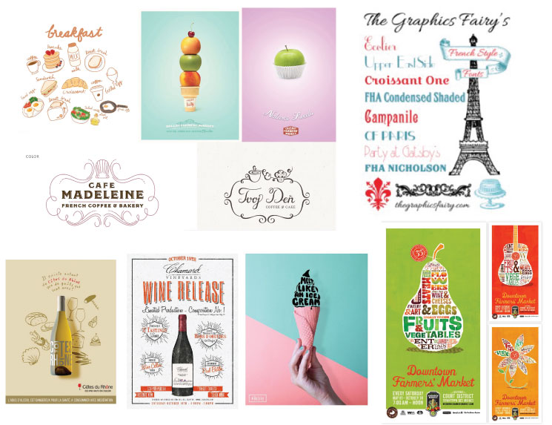

Based in part on the lecture Graphic Styles, research is crucial for the success of any design solution. Look and feel. Instead of just pulling an idea from the air, a direction is crucial to achieving success and a great style of the art and concept.

Please upload all items you have researched to help develop this promotion.  
This includes the direction for the style of art you will be using to support the graphic execution.

**What to Turn In**

* All Research to support the direction of your Promotion Concept
* How it will feel, Art direction ideas, Art styles, etc THESE Must Be Included
* JPEGs or Multi Page PDFS of your sketches are just fine.
* Website links of anything thing you researched
* Pintrest etc

**Appendix 2.2.b — Grading Rubric and Scores – “Prj 2 | Phase 1: Research for Promotion & Styles”**

**Criteria:** Research grade is based on the level of an idea’s development, its quality,   
its reinforcement and/or compliment to the project’s objective and uniqueness of the solution.   
All assessments are based on the expected level of aptitude upon entering the course.   
Failure to do the research and idea stage will result in a poor promotion solution, as well as a loss of 40 points.

|  |  |  |  |  |  |  |  |
| --- | --- | --- | --- | --- | --- | --- | --- |
| **CRITERA** | **RATINGS** | | | | | | |
| **Reinforces/ Complements Objective** | **40 pts**  **Excellent:**  *Exceeds Expectations*  Student has exceeded expectations in both the amount and relevance of the stylistic research presented, and development of application to the project. | **35 pts**  **Above Average**: *Meets Expectations*  Student met expectations in both the amount and relevance of the stylistic research presented, and development of application to the project.. | **30 pts**  **Average:** *Needs Some Improvement*  The work presented and its relevance are in line with expectations, but fall short in terms depth of exploration. | **25 pts**  **Below Average:** *Needs Significant Improvement*  The work presented and its relevance fall short in terms depth of exploration. | **20 pts**  **Significantly Below Average**  *Needs significant improvement but still meets basic project requirements*  The work presented and its relevance underthought and underdeveloped. | **10 pts**  **Marginally Meets Basic Criteria**  Only minimal research was done, with very little exploration of how it will be applied to the project. | **0 pts**  **Does Not Meet Basic Criteria**  Either little-to-no style research was presented, or there is no exploration of how the style will be incorporated into the project, or no work was submitted. |
| **Spring 2020**  **Ratings** | **× 15** | **—** | **—** | **× 1** | **—** | **—** | **× 1** |
| **Fall 2020  Ratings** | **× 17** | **—** | **—** | **—** | **—** | **—** | **—** |

* **SPRING 2020**
* Average score = 37/40
* 88% of students scored 40/40
* **SPRING 2020**
* Average score = 40/40
* 100% of students scored 40/40
* Average score improved by 3 points (7.5%) over Spring 2020

**Appendix 2.4.a — Communication Design Program – Enrollment by Cohort**

**“Cohort” Beginning Fall 2019**

|  |  |  |
| --- | --- | --- |
| **Term** | **AAS – Graphic Design – Print+Web** | **Enrollment** |
| Fall 2019 | ARTC 2311 History of Comm Graphics | 52 |
| Spring 2020 | ARTC 1327 Typography 1 | 32 |
| ARTC 1317 Design Communication I | 35 |
| Fall 2020 | ARTC 2347 Design Communication II | 16 |
| Spring 2021 | ARTC 2335 Portfolio Development for Graphic Design (Capstone) | 11 |

**“Cohort” Beginning Spring 2020**

|  |  |  |
| --- | --- | --- |
| **Term** | **AAS – Graphic Design – Print+Web** | **Enrollment** |
| Spring 2020 | ARTC 2311 History of Comm Graphics | 13 |
| Fall 2020 | ARTC 1327 Typography 1 | 35 |
| ARTC 1317 Design Communication I | 17 |
| Spring 2021 | ARTC 2347 Design Communication II | 18 |
| Fall 2021 | ARTC 2335 Portfolio Development for Graphic Design (Capstone) | 18 |

**“Cohort” Beginning Fall 2020**

*NOTES*

* *Beginning in the Fall of 2020, the* ***AAS – Graphic Design*** *(with specialties in* ***Print*** *or* ***Web****)   
  was replaced by the* ***AAS – Communication Design*** *(with options in* ***Graphic Design*** *or* ***User Experience****).*
* *Based on severe classroom space limitations on the Spring Creek Campus through the Spring of 2021  
  (at which point the Animation & Game Art and Video Production programs moved from the Spring Creek Campus   
  to the Preston Ridge Campus, User Experience course options were severely limited, and therefore   
  did not originally allow User Experience students to follow the course order prescribed by the Fall 2020 catalog.*
* *The UX cohort that began Summer/Fall 2020 (the first semesters the course   
  ARTC 2371 User Experience I was offered) have been limited by course availability and will not be able   
  to enroll in ARTC 2335 Portfolio Development for Graphic Design (Capstone) until Fall of 2022.*

|  |  |  |  |  |
| --- | --- | --- | --- | --- |
| **Term** | **AAS – Communication Design  Print Option** | **Enrollment** | **AAS – Communication Design  User Experience Option** | **Enrollment** |
| Fall 2020 | ARTC 2311 History of Comm Graphics | 48 | (same as Print Option) | — |
| Spring 2021 | ARTC 1327 Typography 1 | 36 | (same as Print Option) | — |
| ARTC 1317 Design Communication I | 29 | UXUI 1370 Human Factors & Design Psychology | 7 |
| Fall 2021 | ARTC 2347 Design Communication II | 22 | ARTC 1359 Visual Design for New Media | 8 |
| UXUI 1370 Human Factors & Design Psychology | 5 |
| Spring 2022 | ARTC 2335 Portfolio Development for Graphic Design (Capstone) | 19 | ARTC 1359 Visual Design for New Media | 8 |
| UXUI 1371 Prototyping & Usability Testing | 15 |

* + Spring 2021 *ARTC 2335 Portfolio Development for Graphic Design (Capstone)*   
    over Spring 2020 *ARTC 1327 Typography 1* = 11/32 = 34.4%
  + Fall 2021 ARTC 2335 Portfolio Development for Graphic Design (Capstone)   
    over Fall 2020 *ARTC 1327 Typography 1* = 18/35 = 51.4%
  + Spring 2022 *ARTC 2335 Portfolio Development for Graphic Design (Capstone)*   
    over Spring 2021 ARTC *1327 Typography 1* cannot be measured accurately as the User Experience students   
    have been delayed from enrolling in *ARTC 2335 Portfolio Development for Graphic Design (Capstone).*However, total numbers between Spring 2022 Print Option students in *ARTC 2335 Portfolio* plus User Experience students   
    in *UXUI 1371 Prototyping & Usability Testing* suggests retention is up — (19+15)/36 = 94.5%

**Appendix 2.4.b — Communication Design Program – Enrollment by Course F2018 to S2022**

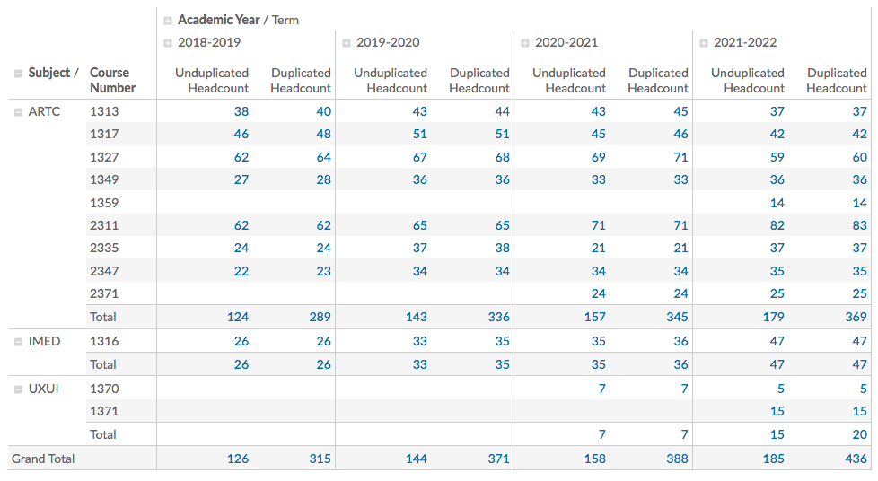

**Appendix 2.4.c — Course Outline Flowchart for AAS Communication Design – Graphic Design Track**

**Macintosh HD:Users:richardleblanc:Desktop:School:CourseOutlineGraphic:CourseOutline-AASCommDesign-GraphicDesignTrack.pdf**

**Appendix 2.4.c — Course Outline Flowchart for AAS Communication Design – User Experience Design Track**

Macintosh HD:Users:richardleblanc:Desktop:School:CourseOutlineGraphic:CourseOutline-AASCommDesign-UXDesignTrack.pdf