PROGRAM NAME: Business Management | AUTHORING TEAM CONTACT: Jeffery Johnson
PHONE: (972) 378-8560 | EMAIL:JWJohnson@collin.edu

GUIDELINES
Time Frames
- Scope:
The time frame of program review is five years, including the year of the review.
Data being reviewed for any item should go back the previous four years, unless not available.
- Deadline Dates:
January 15th – Program Review Document due to Department Dean for review (Deans may require submissions at their own, earlier due date)
February 1st – Program Review Document due to Program Review Steering Committee
- Years:
Years 1 & 3 – Implement Action Plan of (CIP) and collect data
Years 2 & 4 – Analyze data and findings, Update Action Plan
Year 5 – Write Program Review of past 5 years; Write Continuous Improvement Plan (CIP) and create new Action Plan

LENGTH OF RESPONSES: Information provided to each question may vary but should be generally kept in the range
of 1-2 pages or 500-1,000 words.

EVIDENCE GUIDELINES: In the following sections, you will be asked to provide evidence for assertions made.
- Sources: This evidence may come from various sources including professional accreditation reviews, THECB, Texas Workforce Commission’s CREWS, Institutional Research Office (IRO), National Student Clearinghouse, IPEDS, JobsEQ, EMSI Career Coach, and may be quantitative and/or qualitative. If you are unfamiliar with any of these information sources, contact the Institutional Research Office at: effectiveness@collin.edu. Use of additional reliable and valid data sources of which you are aware is encouraged.
- Examples of Evidence Statements:
- Poor example: Core values are integrated into coursework. (Not verifiable)
- Good example: Core values are integrated into coursework through written reflections. (Verifiable, but general)
- Better example: Core values are integrating into coursework through written reflections asking the student to describe how s/he will demonstrate each of the core values in his or her professional life and demonstrated through service learning opportunities. (Replicable, Verifiable)

FOR MORE INFORMATION: The Program Review Portal can be found at http://inside.collin.edu/institutionaleffect/Program_Review_Process.html. Any further questions regarding Program Review should be addressed to the Institutional Research Office (effectiveness@collin.edu, 972.599.3102).

Introduction/Preface
☒EXECUTIVE SUMMARY
Briefly summarize the topics that are addressed in this self-study, including areas of strengths and areas of concern. (Information to address this Executive Summary may come from later sections of this document; therefore, this summary may be written after these sections have been completed.) Please do not include information in this section that is not already provided elsewhere in this submission. Using the questions in the template as headings in the Executive Summary can provide structure to the overview document (see below for suggested format).
Executive Summary (suggested sections/format-not required format)
What does our program do?
Why do we do the things we do: Program relationship to the College Mission & Strategic Plan.
Why we do the things we do? Program relationship to student demand.
Why we do the things we do? Program relationship to market demand.
How effective is our curriculum and how do we know?
How effectively do we communicate, and how do we know?
How well are we leveraging partnership resources and building relationships, and how do we know?
How have past Continuous Improvement Plans contributed to success?
How will we evaluate our success?

Complete the Executive Summary below after you have completed your review.
Collin College’s Business Management (BMAN) Program Review assesses the 5-year performance for academic years 2016-17 through 2020-21, providing evidence of past actions taken to support the college mission, core values, and strategic plan. Based on analyses of past performance, this review will also highlight areas for improvement and recommendations for actions to be taken to ensure that the next 5 years will be successful ones.
The BMAN program remains committed to providing its diverse student population with the education needed to prepare them for careers in the business community, equipping them with the skills sought by employers or those of an entrepreneur and/or in achieving a successful transfer to pursue a degree beyond their associate degree.

Despite formidable challenges during the past 5 years, particularly those related to COVID, student enrollment in the BMAN program experienced a significant increase from 13,177 students in 2016-17 to 17,301 students in 2020-21. Indeed, year over year increases between 8.1% to 14.8% were realized for the first 4 consecutive years, with a modest decline of 2.7% for 2020-21 from prior year. Moving forward, a linear regression analysis projects BMAN student enrollment to increase by 23% over the next 5 years.

The program went through two noteworthy changes: adding an Entrepreneurship AAS and Certificate component and the separation of Human Resources Management (HRM) as an independent program no longer falling under BMAN. Not surprisingly, this change accounts for the aforementioned decrease in the 2020-21 enrollment totals.
The BMAN program offers students a high degree of flexibility in earning Associate of Applied Science (AAS) degrees and Level 1 Certificates in Business Management and/or Entrepreneurship. Courses are offered:
- face-to-face, hybrid and online
- during different part of terms -regular 16 weeks, 1st 8 weeks & 2nd 8 weeks
- on multiple campuses – McKinney, Frisco, Plano, Wylie, Celina & Farmersville
- every semester – fall, spring & summer
- during the day, evenings & weekends

The success of this flexibility is confirmed by class enrollment consistently reaching 25 students or more, and relatively low withdrawal rates. Three courses with withdrawal rates in excess of 10% have been noted, all of which require proficiency in quantitative skills. (Accounting and Small Business Management). Additionally, GPAs by class showed improvement in most instances over the past 5 academic years.
BMAN student evaluations for Fall 2020 through Spring 2022 showed steady improvement for both the five individual evaluation criteria as well as the averages of those five evaluations: in Fall 2020 the average was 3.62 (out of a possible 5 rating); 3.64 for Spring 2021; 3.69 for Fall 2021; and 3.70 for Spring 2022.

Although the BMAN program is one of the largest and healthiest workforce programs in all of Collin College, the commitment to its stakeholders is unwavering. Rooted in the results of this program review, the BMAN program has identified several areas of opportunity. The program has prioritized areas of opportunity to focus on over the next two years in the Continuous Improvement Plan (CIP) (see #12, Table 1). Specific outcomes include:
- Developing the Entrepreneurship capstone course – BUSG 1371 Business Plan for Funding
- Improving the Success Rate of course BUSG 1304 Financial Literacy
- Improve students’ ability to determine the financial needs of a business (Program Learning Outcome (PLO) #6

The BMAN program plans to go above and beyond by enhancing a few additional identified areas:
- Entrepreneurship as a degree and certificate is still developing.
- The program website could benefit from revisions and improvements and development of a program social media presence would be more effective in reaching our target audiences (students, employers, partners and the business community).
- The BMAN program should seek to further strengthen and expand partnerships with entities that benefit any and every aspect of program.

The future looks bright for the BMAN program considering the full scope of the program review.

Section I. Are We Doing the Right Things?
☒1. WHAT DOES OUR PROGRAM DO?
What is the program and its context?
This section is used to provide an overview description of the program, its relationship to the college and the community it serves. Keep in mind the reviewer may not be familiar with your area. Therefore, provide adequate explanation as needed to ensure understanding.

Suggested points to consider:
- Program’s purpose (Include the program’s purpose/mission statement if one exists.)
- Program learning outcomes or marketable skills
- Brief explanation of the industry/industries the program serves
- Career paths and/or degree paths it prepares graduates to enter
- What regulatory standards must the program meet (THECB, Workforce, external accreditation)

Program's Purpose
The Business Management Program (BMAN) program at Collin College is a workforce program meaning it prepares students for employment and business ownership in the diverse business community of Collin County. Although BMAN is a workforce program, students can also transfer to numerous universities in Texas and through the United States through formal “Pathways”.
The BMAN program’s mission statement is: “To foster an innovative, engaged, scholarly community dedicated to academic excellence, providing practical skills and knowledge that prepares students for successful careers in management.” Furthermore, the program’s purpose is to meet the local workforce demands for well-trained, knowledgeable and diverse entry-level managers by offering students the highest quality courses and degree plans based on practical, theoretical, and technical knowledge needed to be successful in the business management profession and the entrepreneurial sphere. BMAN provides students with the skills and knowledge necessary: 1) to enhance individual management abilities and to help them to seek employment in a business and management positions or as an entrepreneur; 2) to transfer and support success at a baccalaureate degree granting institution and 3) to increase professional job enhancement.

Program Changes
The BMAN program has experienced significant changes over the last few years. Based on the continued growth of Collin College, the BMAN program in collaboration with their advisory committee identified an area of opportunity. Many Collin College students were already operating their own business and other students were contemplating starting a business as well. As a result, the BMAN program established the Entrepreneurship focus option in the Fall of 2019 for the AAS degree plan. A Level 1 Certificate in Entrepreneurship was also added.
Another major change that occurred pertains to the Human Resource Management (HRM) AAS and Level 1 Certificate, both of which have historically been components of the BMAN program. The program collaborated with their advisory committee to analyze the growth in BMAN and HRM and decided to separate them and make each their own independent program, effective Fall of 2020. These changes will be reflected throughout the program review.

Degree Plans
Within the Associate of Applied Science (AAS) degree in the Business Management program, students can select from two different areas of concentration (tracks): Business Management and/or Entrepreneurship. Both tracks require 60 credit hours (20 classes) and the degree plans are very similar with only 3 courses separating the two tracks. Many students take the additional 3 courses to earn both AAS degrees (Business Management and Entrepreneurship). Students can also earn a Level 1 Certificate in Business Management and/or Entrepreneurship. Each certificate requires 18 credit hours (6 classes) which are unique to each certificate.

BMAN certificate and degree programs are intended to prepare students for careers in numerous industries such as retail, government, real estate, operations, and restaurants, to name a few; in a varied number of managerial positions from team/shift lead to initial/lower level manager/supervisor or entrepreneurs.

AAS – Business Management (Business Management and/or Entrepreneurship tracks)
Certificate Level 1 - Business Management
Certificate Level 1 - Entrepreneurship

Program-Level Learning Outcomes
The BMAN program curriculum is designed to teach students to:
- Identify key industry and/or corporate strategic issues.
- Describe the perspectives of key corporate stakeholders.
- Formulate actions that address issues central to the business environment.
- Communicate business concepts in writing using clear, effective, and concise language appropriate to the audience.
- Work as an effective team member.
- Determine the financial needs of a business.
- Perform an analysis of a business market.
These outcomes are assessed at specific points in the program to determine student achievement. The BMAN Program Assessment Plan document also describes the measures and targets used to determine student success at the program level. The complete document is found in the Appendix.

Marketable Skills
The BMAN program has defined its marketable skills, which are communicated and reiterated throughout the curriculum, making students well-rounded and more marketable after program completion. The marketable skills are listed below:
- View and plan for future needs, set priorities, adjust as needed, and organize work flow and outputs.
- Apply basic understanding of the income statement, balance sheet, sources and uses of funds statement, and cash flow statement.
- Work productively with others to achieve group goals.
- Communicate effectively and professionally with peers, managers, customers, and other stakeholders.
- Take time to understand the point being made and ask appropriate questions.
- Analyze data critically to reach sound conclusion.
- Identify key drivers to make decisions and align to a clear path and direction.
- Apply fact-based and fair-minded solutions when resolving conflict.

Regulatory Standards
The BMAN program is regulated by the Federal Government (Title IV, etc.) and Texas Higher Education Coordinating Board’s (THECB) Guidelines for Instructional Programs in Workforce Education (GIPWE) in accordance with the Principles of Accreditation adopted by the Southern Association of Colleges and Schools Commission on Colleges (SACSCOC). The following are the requirements and evidence that workforce regulations are met:
Federal Regulations. The following federal regulations for Collin College are applicable to the BMAN program and it is the responsibility of the college to ensure these regulations are met (as a program of Collin College):
- US Department of Education (Higher Education Act)
o An institution that offers distance or correspondence education documents each of the following: demonstrates that the student who registers in a distance or correspondence education course or program is the same student who participates in and completes the course or program and receives the credit by verifying the identity of a student who participates in class or coursework by using, at the option of the institution, methods such as a secure login and passcode, (b) proctored examinations, or (c) new or other technologies and practices that are effective in verifying student identification; has a written procedure for protecting the privacy of students enrolled in distance and correspondence education courses or programs; and has a written procedure distributed at the time of registration or enrollment that notifies students of any projected additional student charges associated with verification of student identity. The Business Management program enforces these regulations by ensuring all students use the Canvas Learning platform, the textbooks selected for on-line course offerings clearly address the program outcomes and seeks to integrate new technologies adopted by the institution. The Business Management and Human Resources Management degrees are offered 100% on-line which allows students to complete the degree without traveling to a brick and mortar campus.
o The institution has policies and procedures for determining the credit hours awarded for courses and programs that conform to commonly accepted practices in higher education and to Commission policy. https://www.uc.edu/content/dam/uc/registrar/docs/higher_education_opportunity_act_of_2008.pdf

Title IV of the Higher Education Act

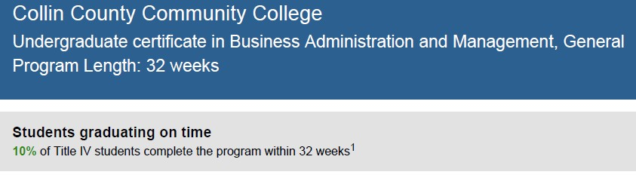
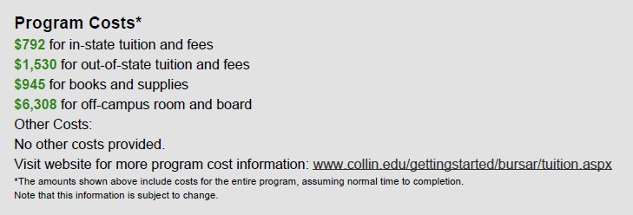

THECB Standard
Measure: General Education Requirements
Standard: 100 percent of all associate degrees have at least 15 SCH of general education. General education must include at least one course in each of the following three areas: Humanities/Fine Arts, Social/Behavioral Sciences, and Natural Sciences/Mathematics. Business Management core requirements for general education courses are listed below:
Humanities/Fine Arts
__x_Humanities

Social/Behavioral Science
_x__Psychology
_x__Sociology
_x__Communication

Natural Science/Math
__x_College-level Math (must be academic)

☒2. WHY DO WE DO THE THINGS WE DO: PROGRAM RELATIONSHIP TO THE COLLEGE MISSION & STRATEGIC PLAN.
- Provide program-specific evidence of actions that document how the program supports the College’s mission statement: “Collin County Community College District is a student and community-centered institution committed to developing skills, strengthening character, and challenging the intellect.”
- Provide program-specific evidence that documents how the program supports the College’s strategic plan (2020-2025 Strategic Plan): https://www.collin.edu/aboutus/strategic_goals.html.

Suggested/possible points to consider:
- What evidence is there to support assertions made regarding how the program relates to the mission and strategic plan?
- Think broadly-increasing completion, articulation agreements, pathways from high schools, etc.
- Analyze the evidence you provide. What does it show about the program?

Supporting the College’s Mission Statement
- Developing Skills: The BMAN program utilizes faculty with relevant, current workforce skills and academic credentials to offer innovative curriculum to meet the needs of our local business community. The curriculum provides both theoretical and practical application to develop student’s critical thinking and problem-solving skills to ensure success in the competitive workplace. The program is ideal for students new to both supervisory or managerial roles, as well as tenured professionals looking to improve their skills. The BMAN program offers students the practical skills and development they need to be proficient in the business community. The curriculum is comprehensive and up-to-date. It is based on identified competencies, has capstone courses, strives to be socially responsible, and addresses employer and entrepreneurial needs.

- Strengthening Character: Service learning is encouraged in many courses including BMGT 2309 (Leadership) and the capstone courses. The BMAN advisory committee is comprised of diverse business representatives partnered with College resources creating career pathways for our students.

- Challenging the Intellect: A solid foundation in business management is essential at every organizational level, no matter how long individuals have been in the workforce. The curriculum is comprehensive and up-to-date. It is based on identified competencies, has a capstone course, strives to be socially responsible, and addresses employer and entrepreneurial needs.

Supporting the College’s Strategic Plan
- Improve student outcomes to meet or exceed local, state, and regional accreditation thresholds and goals: The BMAN program’s curriculum is comprehensive and up-to-date. It is based on identified competencies, has a capstone course, strives to be socially responsible, and addresses employer and entrepreneurial needs. Service learning is encouraged in many courses including BMGT 2309 (Leadership) and the capstone courses. The flexible course scheduling (online, weekend, 8-week semesters, etc.), the ability to respond to community workforce needs, superior faculty and innovative, community-service based curriculum provides students with the foundation for a successful career in management, business and in life.
- Create and implement comprehensive integrated pathways to support student transitions: The Business Management department has dedicated resources to partner with colleges and universities to create formal “Pathways” for students by collaborating with colleges and universities to accept workforce courses toward their College of Business requirements. As a result, the BMAN program has a general Guided Pathway for transfer to any institution. http://www.collin.edu/transferu/2022pathways/21-22%20Business%20Management.collin.pdf

Additionally, the BMAN has formal Pathways with the following institutions with the goal of adding more:
Midwestern State University
http://www.collin.edu/transferu/2020Pthwys/MSU%20AAS%20to%20BAAS%2020-21%20Business%20Managment%20-%20Business%20Management%20Track.pdf

Tarleton State University
http://www.collin.edu/transferu/2020Pthwys/TSU/20-21%20Bus.%20Mgmt.%20-%20Entrepreneurship%20to%20Applied%20Science%20-%20Bus.%20Admin.%20-%20Revised..pdf

University of North Texas
http://www.collin.edu/transferu/2020Pthwys/UNT/20-21%20Business%20Management%20-%20Business%20Management%20Track_BM%20Focus%20-%20Rev.pdf

Western Governors University
http://www.collin.edu/transferu/2020Pthwys/WGU/20-21%20AAS%20Business%20Mgmt.%20Track%20to%20BS%20Business%20Administration%20Management%20-%20Option%20A.pdf

- Develop a coordinated and systematic approach to engage external stakeholders: The BMAN program utilizes and heavily weighs the input of an advisory committee comprised of diverse business representatives that partner with the program and other Collin College resources to create career pathways for our students.

☒3. Why we do the things we do: Program relationship to student demand

Make a case with evidence to show that students want the certificate. Discuss whether or not there appears to be any disproportionate enrollment by gender, race, and ethnicity (compared to Collin College’s overall student demographic distributions http://inside.collin.edu/iro/programreview/prfilehostpage.html). If any differences exist discuss possible reasons why the gap exists, and plans to address these issues to close gaps in enrollment rates between groups of students (refer to the Program Review portal for Enrollment Reports and Average Section Size data files for your program http://inside.collin.edu/institutionaleffect/Program_Review_Process.html).
Suggested/possible points to consider:
- What is the enrollment pattern? Declining, flat, growing, not exhibiting a stable pattern, please explain. For required program courses where there is a pattern of low enrollment (fewer than 15 students), explain your plan to grow enrollment and/or revise the curriculum.
- What are the implications for the next 5 years if the enrollment pattern for the past 5 years continues?
- Describe any actions taken to identify and support students enrolled in program-required courses early in the degree plan. If no actions are taken at the present, please develop and describe a plan to do so.
- How does your program support (or plan) to support attraction of a diverse student population?
- Check with Institutional effectiveness for Data Reports -names of reports
- Analyze the evidence you provide. What does it show about the program?

Enrollment Patterns
The following figure illustrates student demand by displaying the duplicated enrollment data for BMAN courses between the 2017 and 2021 academic years.
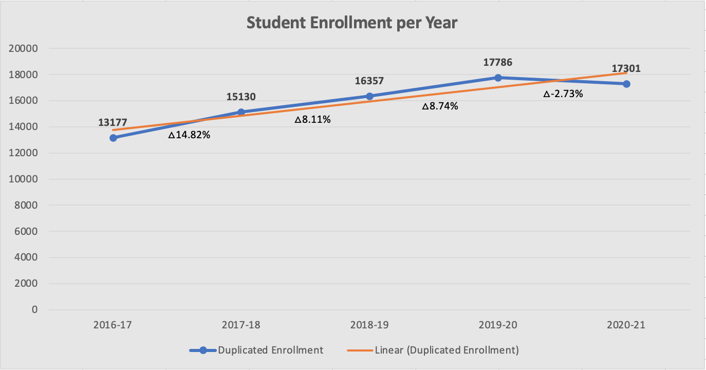
Duplicated Student Enrollment for BMAN Courses
Source: Collin College Institutional Research Office

- The BMAN program’s enrollment pattern is growing due to the concerted efforts of the program’s faculty, discipline lead, program career coaches, associate dean and dean to promote the program district-wide.
- Linear regression analysis predicts the enrollment trend to continue with 23% growth over the next 5 years.
- The program reorganized the AAS degree plan to more evenly distribute program versus core courses throughout each of the four semesters of the program. Previously the degree plan suggested students take four program courses in their first semester of year one and zero program courses in their first semester of year two. This created an imbalance and the potential for students to be overloaded initially and disengaged later in the program.
- Despite the overall growth, from 2019-20 to 2020-21 student enrollment slightly declined by 485 (2.7%). The leading factor contributing to this decline was HRM had become a separate program, thus all of those students were no longer included in the BMAN program’s enrollment.
- The program anticipates student enrollment to continue its positive trend and no adjustments are necessary.

Enrollment Pattern by Semester
The following tables display student enrollment in each course required in the BMAN program by semester.
Note that any courses with enrollment fewer than 15 has been highlighted; however, no pattern of low enrollment has been identified.
 | ACCT 2301 | ACNT 1303 | ACNT 1311 | BMGT 1305 | BMGT 1307 | BMGT 1327 | BMGT 1341 | BMGT 1344 | BMGT 2303 | BMGT 2309 | BMGT 2311 | BMGT 2341
Fall 2016 | 28 | 21 | 24 | 26 | 30 | 22 | 26 | 22 | 26 | 29 | 23 | 12
Spring 2017 | 28 | 19 | - | 29 | 22 | 24 | 21 | 27 | 24 | 24 | - | 14
Summer 2017 | 27 | - | - | 25 | - | 24 | 17 | 24 | - | - | - | -
Fall 2017 | 28 | 23 | 25 | 29 | 25 | 24 | 24 | 24 | 23 | 26 | 20 | 22
Spring 2018 | 28 | 19 | 23 | 30 | 25 | 21 | 22 | 22 | 22 | 22 | 24 | 13
Summer 2018 | 25 | 24 | - | 23 | 24 | 22 | 15 | 24 | 14 | - | - | 16
Fall 2018 | 27 | 23 | 24 | 25 | 28 | 26 | 26 | 25 | 25 | 22 | 20 | 21
Spring 2019 | 27 | 19 | 24 | 28 | 26 | 26 | 21 | 20 | 21 | 24 | 22 | 18
Summer 2019 | 27 | 23 | - | 25 | 25 | 48 | 17 | 21 | - | - | - | 8
Fall 2019 | 26 | 21 | 24 | 25 | 24 | 27 | 22 | 27 | 28 | 25 | 20 | 24
Spring 2020 | 25 | 22 | 24 | 27 | 28 | 25 | 25 | 23 | 19 | 24 | 20 | 25
Summer 2020 | 24 | 25 | - | 25 | 48 | 48 | 24 | 24 | - | - | - | 14
Fall 2020 | 25 | 23 | 25 | 30 | 23 | 24 | 20 | 26 | 26 | 23 | 27 | 24
Spring 2021 | 23 | 49 | 24 | 35 | 25 | 22 | 33 | 22 | 17 | 24 | 26 | 25
Summer 2021 | 26 | 52 | - | 72 | 68 | 63 | 50 | 53 | 9 | 12 | - | 14
Total | 394 | 363 | 217 | 454 | 421 | 446 | 363 | 384 | 254 | 255 | 202 | 250

 | BUSG 1304 | BUSG 1371 | BUSG 2309 | HRPO 2301 | HRPO 2303 | HRPO 2304 | HRPO 2306 | HRPO 2307 | IBUS 2341 | MRKG 1311 | Total
Fall 2016 | - | - | 27 | 20 | - | - | - | 17 | 18 | 25 | 396
Spring 2017 | - | - | 26 | 18 | - | - | - | 18 | 20 | 20 | 334
Summer 2017 | - | - | 23 | 25 | - | - | - | - | - | 24 | 189
Fall 2017 | - | - | 25 | 24 | 25 | 24 | - | 24 | 20 | 26 | 461
Spring 2018 | - | - | 22 | 22 | 25 | - | 25 | 20 | 24 | 20 | 429
Summer 2018 | - | - | 24 | 24 | - | - | - | - | - | 21 | 256
Fall 2018 | - | - | 20 | 16 | 24 | 24 | - | 22 | 24 | 24 | 446
Spring 2019 | - | - | 20 | 14 | 21 | - | 22 | 21 | 21 | 21 | 416
Summer 2019 | - | - | 23 | 49 | - | - | - | - | - | 23 | 289
Fall 2019 | - | - | 24 | 20 | 25 | 24 | - | 20 | 18 | 27 | 451
Spring 2020 | - | - | 24 | 22 | 24 | - | 24 | 20 | 27 | 24 | 452
Summer 2020 | - | - | 22 | 49 | - | - | - | 23 | - | 23 | 349
Fall 2020 | - | - | 21 | 24 | 29 | 31 | - | 26 | 20 | 29 | 476
Spring 2021 | 29 | - | 32 | 21 | 24 | - | 25 | 25 | 24 | 21 | 526
Summer 2021 | - | - | 42 | 50 | - | - | - | - | - | 48 | 559
Total | 29 | 0 | 375 | 398 | 197 | 103 | 96 | 236 | 216 | 376 | 6029
Unduplicated Student Enrollment for BMAN Courses by Semester
Source: Collin College Institutional Research Office

Demographics within the BMAN Program
The following figures display the BMAN program's demographic information in comparison to Collin College’s overall student demographic distribution.
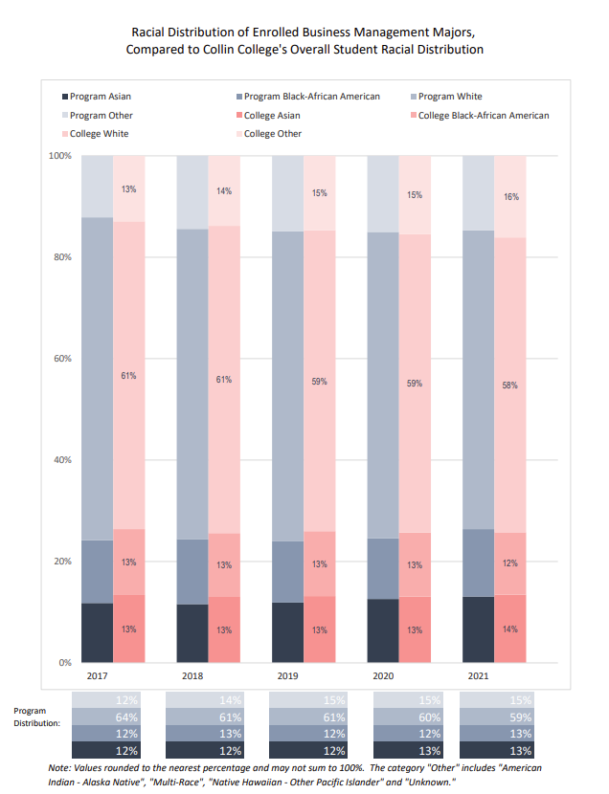
Source: Collin College Institutional Research Office

The racial distribution of enrolled Business Management majors aligns to that of Collin College’s overall student racial distribution. No program adjustments are necessary.
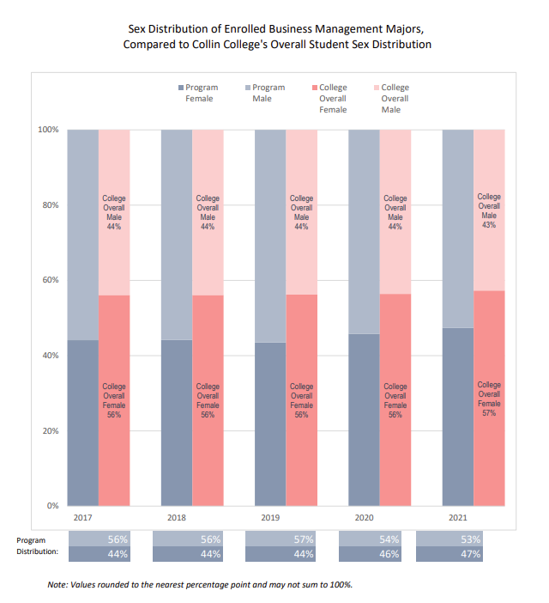
Source: Collin College Institutional Research Office

The sex distribution of enrolled Business Management majors aligns to that of Collin College’s overall student sex distribution. No program adjustments are necessary.

☒4. Why we do the things we do: Program relationship to market demand
Make a case with evidence to show that employers need and hire the program’s graduates. Some resources to utilize for information could be: JobsEQ http://inside.collin.edu/iro/programreview/202021/ProgramLaborMarketInfo_2020-21AY.pdf, Burning Glass, O-Net https://www.onetonline.org, Texas Labor Market Information https://www.twc.texas.gov/businesses/labor-market-information.
Suggested/possible points to consider:
- How many program-related jobs are available in the DFW Metroplex for program graduates? If the majority of related jobs in the DFW Metroplex require a baccalaureate degree, provide evidence that you have a current signed articulation agreement with one or more transfer institutions or that you plan to develop one.
- What proportion of the program’s graduates (seeking employment) found related employment within six months of graduation?
- What changes are anticipated in market demand in the next 5 years? Do program completers meet, exceed, or fall short of local employment demand? How will the program address under- or over-supply?
- Identify and discuss the program’s strengths and weaknesses related to market demand.

Market Description
The U.S. Bureau of Labor Statistics describes the general manager positions as the following: Plan, direct, or coordinate the operations of public or private sector organizations, overseeing multiple departments or locations. Duties and responsibilities include formulating policies, managing daily operations, and planning the use of materials and human resources, but are too diverse and general in nature to be classified in any one functional area of management or administration, such as personnel, purchasing, or administrative services. Usually manage through subordinate supervisors. Excludes First-Line Supervisors. Management Occupations is the general occupation title along with an occupation code of 11-0000 which consists of 35 sub-occupations.

Market Demand
According to the U.S. Bureau of Labor Statistics (May 2021), with an employment of 256,120, the Dallas-Fort Worth-Arlington area ranked 6th in metropolitan areas with the highest employment level in Management Occupations.
Footnotes directly from the source:
(1) Estimates for detailed occupations do not sum to the totals because the totals include occupations not shown separately. Estimates do not include self-employed workers.
(9) The location quotient is the ratio of the area concentration of occupational employment to the national average concentration. A location quotient greater than a one indicates the occupation has a higher share of employment than average, and a location quotient less than one indicates the occupation is less prevalent in the area than average.
(2) Annual wages have been calculated by multiplying the hourly mean wage by a “year-round, full time” hours figure of 2,080 hours; for those occupations where there is not an hourly wage published, the annual wage has been directly calculated from the report survey data.
Metropolitan area | Employment (1) | Employment per thousand jobs | Location quotient (9) | Hourly mean wage | Annual mean wage (2)
New York-Newark-Jersey City, NY-NJ-PA | 559,890 | 64.52 | 1.02 | $ 80.30 | $ 167,020
Los Angeles-Long Beach-Anaheim, CA | 410,750 | 71.81 | 1.14 | $ 65.31 | $ 135,840
Chicago-Naperville-Elgin, IL-IN-WI | 338,330 | 79.93 | 1.26 | $ 62.00 | $ 128,970
Washington-Arlington-Alexandria, DC-VA-MD-WV | 266,870 | 91.00 | 1.44 | $ 73.39 | $ 152,640
Boston-Cambridge-Nashua, MA-NH | 264,180 | 102.19 | 1.62 | $ 72.24 | $ 150,250
Dallas-Fort Worth-Arlington, TX | 256,120 | 71.36 | 1.13 | $ 59.38 | $ 123,510
San Francisco-Oakland-Hayward, CA | 218,400 | 97.41 | 1.54 | $ 80.19 | $ 166,780
Houston-The Woodlands-Sugar Land, TX | 195,950 | 67.64 | 1.07 | $ 59.32 | $ 123,380
Atlanta-Sandy Springs-Roswell, GA | 194,170 | 75.03 | 1.19 | $ 60.03 | $ 124,850
Philadelphia-Camden-Wilmington, PA-NJ-DE-MD | 159,940 | 60.25 | 0.95 | $ 65.59 | $ 136,420
https://www.bls.gov/oes/current/oes110000.htm#st

Per LinkedIn, there are currently 1,923,000 manager open positions in the U.S. with approximately 74,000 openings in Collin County. Sample positions listed on SimplyHired in the DFW area are as follows:

General Manager  Jake's GAMEDAY - Dallas, TX  $40,000 - $70,000 a year | General Manager (GM)  Centennial - Plano, TX  $90,000 - $105,000 a year
Automotive General Manager  Caliber Auto Care - Plano, TX  $70,000 - $100,000 a year | General Manager  Restore Hyper Wellness - Plano, TX  Estimated: $65,000 - $83,000 a year
General Manager, Golf Retail  2nd Swing Golf - The Colony, TX  Estimated: $58,000 - $81,000 a year | General Manager  Ninja Nation - Frisco, TX  $60,000 - $80,000 a year
Restaurant General Manager  Snappy Salads - Dallas, TX  $55,000 - $62,000 a year | Assistant General Manager  Fairfield Plano - Plano, TX  Estimated: $58,000 - $78,000 a year
Restaurant General Manager  Goat & Vine - Plano, TX  $70,000 - $80,000 a year | General Manager, Golf Retail  2nd Swing Golf - The Colony, TX 4.2  Estimated: $58,000 - $81,000
Automotive General Manager  Alternative Automotive - Frisco, TX  $70,000 - $100,000 a year | Assistant General Manager - North Dallas  Restore Hyper Wellness - McKinney, TX  Estimated: $44,000 - $57,000
https://www.simplyhired.com/search?q=General+Manager&l=Plano%2C+TX&job=kw7iNKYvL6yrKz7QV7G4MVemMPZEVR5y_4ecMPDCzOCFt8fhqUyFsQ

Market Baccalaureate Requirements
Educational requirements are not available for the overall occupational title of Management Occupations. As a result, the largest four sub-occupations were used in the following chart.

Occupation Title | Employment | Masters Required | Post-Bach Certification | Baccalaureate | Some College or High School
General & Operations Management | 336,380 | 0% | 0% | 29%  97,550 | 34%  114,369
Financial Manager | 48,790 | 0% | 21%  10,246 | 56%  27,322 | 14%  6,831
Computer & Info Systems Manager | 40,270 | 0% | 0% | 48%  19,330 | 40%  16,108
Management Analyst | 39,900 | 24%  9,576 | 0% | 57%  22,743 | 10%  3,990
Totals | 465,340 | 9,576 | 10,246 | 166,945 | 141,298
 |  |  |  | Baccalaureate or higher
 |  |  |  | 186,767 | 141,298
https://www.onetonline.org/

The majority of jobs nationally require a Baccalaureate, post-Baccalaureate certification or master degree compared to some college or high school diploma. The BMAN program has a current signed articulation agreement with multiple transfer institutions. See Guided Pathways in #1 above.

Market Projections
Employment projections are not available for the overall occupational title of Management Occupations. As a result, the largest five sub-occupations were used in the following chart.

Occupation Title | O-Net National Projected Growth (2020-2030) | US Depart of Labor via careeronestop.org State Projected Growth (2020-2030)
General & Operations Management | Average 5 – 10% | +23%
Project Management Specialist | Average 5-10% | +17%
Financial Manager | Higher 15% or more | +33%
Computer & Info Systems Manager | Faster 10 – 15% | +26%
Management Analyst | Faster 10 – 15% | +25%
https://www.onetonline.org/ https://www.careeronestop.org/
Utilizing the five largest sub-occupations local growth is projected to be 24.8% which is greater than national projections. A strength of the BMAN program is the growth of both enrollment and completers. to contributing to a robust ob market. A weakness of the program is the lack of employment data available on program graduates. In 2021, the college, division and BMAN program has entered into a partnership with Handshake which is job placement platform designed to connect students, employers and college career centers. It is anticipated that post-graduation data will be captured from surveys and job placement information.

Section II. Are We Doing Things Right?
☒5. How effective is our curriculum, and how do we know?
A. Make a case with evidence that there are no curricular barriers to program completion. Review data related to course enrollments, course completion rates, course success rates, and the frequency with which courses are scheduled to identify barriers to program completion.
Suggested/possible points to consider:
- Number of students who completed the program awards in each of the last 4 years? If the number of graduates does not average 5 or more per year, describe your plan to increase completions and address this issue in the Continuous Improvement Plan (CIP).
- At what point(s) are substantive percentages of students dropping out of the program? Use data in the “Program-Based Course Performance” tool to examine enrollment flow through the program curriculum. Does the data suggest any curricular barriers to completion? Address problems in the CIP.
- Analyze the course success rates and the course completion rates of each course in your program. Address problems in the CIP.

The BMAN program at Collin College offers four awards: an Associate of Applied Science (AAS - 60 credit hours) in Business Management and/or Entrepreneurship and a Level 1 Certificates (18 credit hours each) in Business Management and/or Entrepreneurship.
- The AAS degree is designed for students pursuing a career in business management. This program is also for those students who wish to major in another field but need business and management skills and thus, prepares students to work in the business sector in a variety of industries including preparing them to start their own businesses. The degree plan is shown below.
- The Level 1 Certificate – Business Management provides introductory knowledge and skills to work in the workplace as a leader including team building, business ethics, problem solving, and decision making. The certificate is for career changers or students seeking to gain skills that may be applied in their current jobs. The degree plan is shown below.
- The Level 1 Certificate – Entrepreneurship provides introductory knowledge and skills to start their own businesses including principles of marketing, financial literacy, computerized accounting, small business management, and business plan for funding. The certificate is for career changers or students seeking to gain skills that can assist them to become entrepreneurs. The degree plan is shown below.
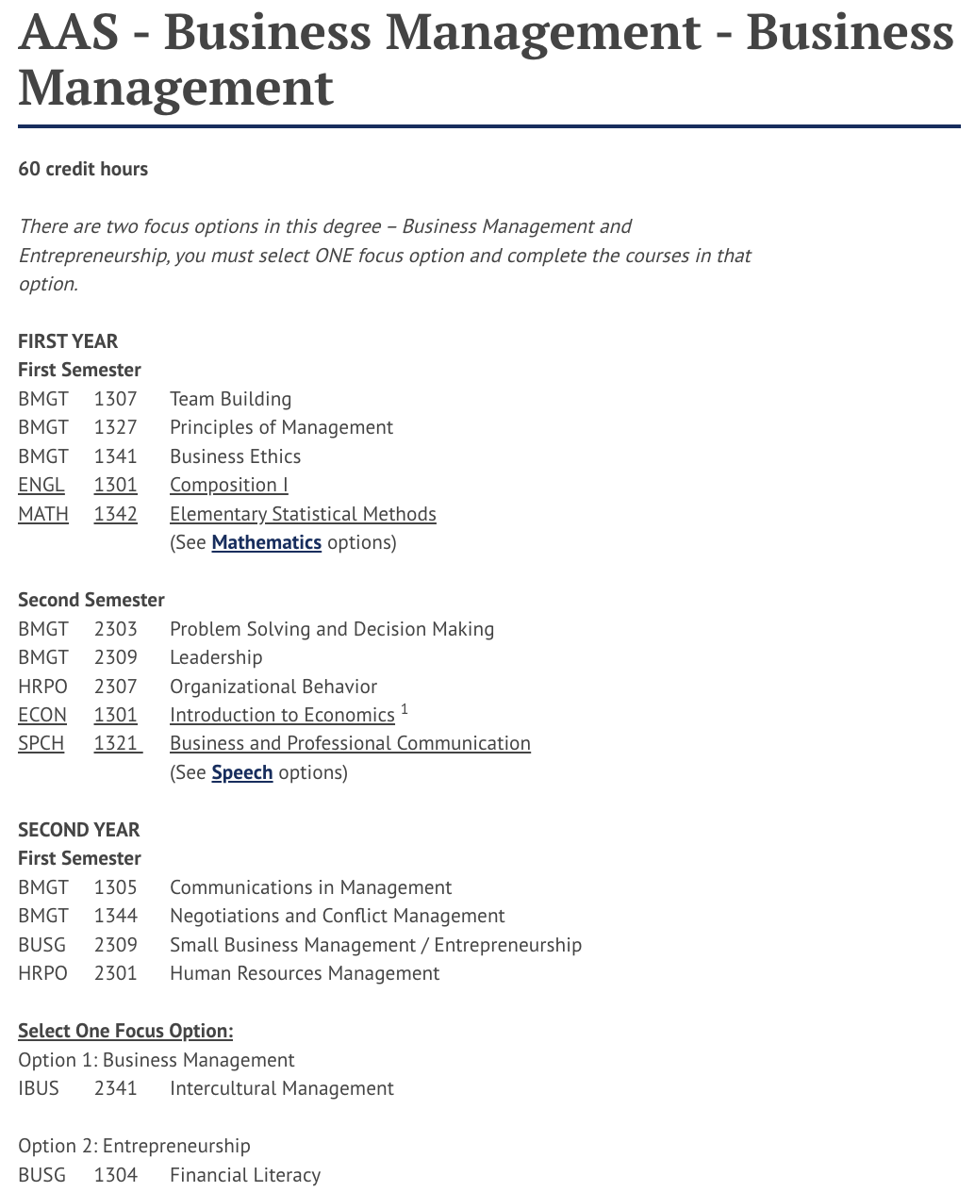
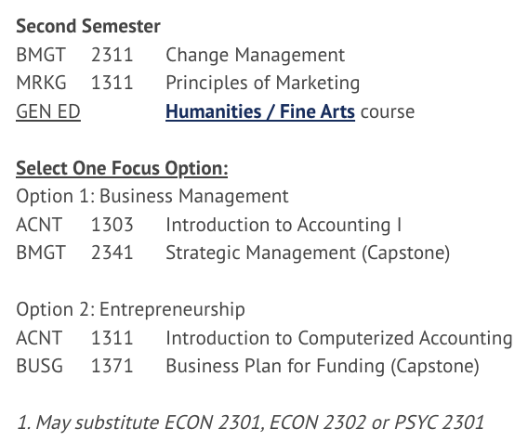

AAS Degree Plan
SOURCE: https://www.collin.edu/academics/programs/BUSM_BusMgmt_AAS.html

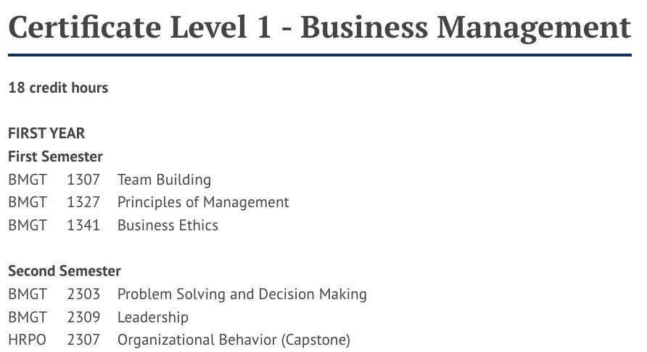

Certificate Level 1 – Business Management Degree Plan
Source: https://www.collin.edu/academics/programs/BUSM_BusMgmt_Cert1.html

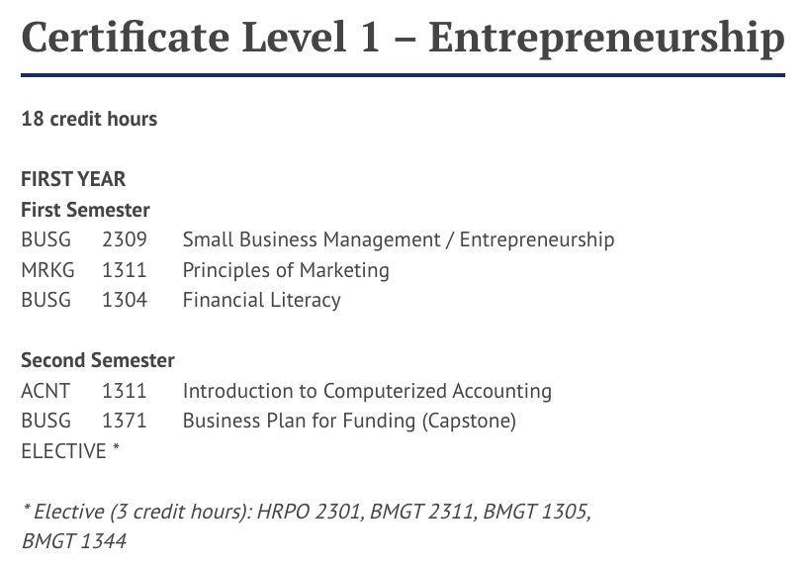
Certificate Level 1 – Entrepreneurship Degree Plan
Source: https://www.collin.edu/academics/programs/MRKG_Cert1_Entrepreneur.html

Course Performance
The following tables are a breakdown of courses, their enrollments, frequencies, retention rates, success rates and the concluding observations.
Course: | ACCT 2301 – Principles of Financial Accounting*
 | Year | Enrollment | Retention | Success Rate | GPA
 | 2016-17 | 1737 | 84% | 58% | 1.83
 | 2017-18 | 1801 | 87% | 63% | 1.99
 | 2018-19 | 1870 | 88% | 63% | 2.04
 | 2019-20 | 1908 | 88% | 72% | 2.43
 | 2020-21 | 1691 | 91% | 74% | 2.54
Average |  | 1801 | 87% | 66% | 2.17
Barriers to Program Completion | None - course is no longer part of curriculum
ACCT 2301 Performance
Source: Collin College Institutional Research Office
Course: | ACNT 1303 – Intro to Accounting I*
 | Year | Enrollment | Retention | Success Rate | GPA
 | 2016-17 | 120 | 97% | 70% | 2.55
 | 2017-18 | 150 | 93% | 72% | 2.75
 | 2018-19 | 168 | 92% | 69% | 2.66
 | 2019-20 | 153 | 95% | 73% | 2.84
 | 2020-21 | 169 | 96% | 78% | 2.99
Average |  | 152 | 94% | 73% | 2.76
Barriers to Program Completion | Yes – course is governed by Field of Study - Accounting. The BMAN program will partner with them on ways to improve student success rate.
ACNT 1303 Intro to Accounting I
Source: Collin College Institutional Research Office
Course: | ACNT 1311 – Introduction to Computerized Accounting*
 | Year | Enrollment | Retention | Success Rate | GPA
 | 2016-17 | 24 | 92% | 71% | 2.50
 | 2017-18 | 48 | 96% | 77% | 2.85
 | 2018-19 | 48 | 94% | 67% | 2.54
 | 2019-20 | 48 | 75% | 60% | 2.17
 | 2020-21 | 49 | 90% | 71% | 2.67
Average |  | 43 | 89% | 69% | 2.55
Barriers to Program Completion | Yes – course is governed by Workforce Program – Business Office Support Systems. The BMAN program will partner with them on ways to improve student success rate.
ACNT 1311 Introduction to Computerized Accounting
Source: Collin College Institutional Research Office
Course: | BMGT 1305 – Communications in Management
 | Year | Enrollment | Retention | Success Rate | GPA
 | 2016-17 | 131 | 93% | 75% | 2.48
 | 2017-18 | 139 | 96% | 83% | 2.91
 | 2018-19 | 209 | 96% | 80% | 2.81
 | 2019-20 | 210 | 94% | 80% | 2.95
 | 2020-21 | 266 | 95% | 82% | 2.95
Average |  | 191 | 95% | 80% | 2.82
Barriers to Program Completion | None
BMGT 1305 Communications in Management
Source: Collin College Institutional Research Office
Course: | BMGT 1307 – Team Building
 | Year | Enrollment | Retention | Success Rate | GPA
 | 2016-17 | 167 | 95% | 86% | 3.02
 | 2017-18 | 225 | 92% | 77% | 2.74
 | 2018-19 | 242 | 98% | 90% | 3.08
 | 2019-20 | 274 | 96% | 81% | 2.79
 | 2020-21 | 306 | 97% | 83% | 2.91
Average |  | 242.8 | 96% | 83% | 2.91
Barriers to Program Completion | None
BMGT 1307 Team Building
Source: Collin College Institutional Research Office
Course: | BMGT 1327 – Principles of Management
 | Year | Enrollment | Retention | Success Rate | GPA
 | 2016-17 | 368 | 96% | 77% | 2.62
 | 2017-18 | 361 | 95% | 77% | 2.63
 | 2018-19 | 360 | 95% | 81% | 2.71
 | 2019-20 | 384 | 95% | 79% | 2.68
 | 2020-21 | 357 | 96% | 83% | 2.87
Average |  | 366 | 96% | 79% | 2.7
Barriers to Program Completion | None
BMGT 1327 Principles of Management
Source: Collin College Institutional Research Office
Course: | BMGT 1341 – Business Ethics
 | Year | Enrollment | Retention | Success Rate | GPA
 | 2016-17 | 172 | 94% | 78% | 2.72
 | 2017-18 | 198 | 91% | 73% | 2.41
 | 2018-19 | 292 | 92% | 78% | 2.64
 | 2019-20 | 277 | 94% | 79% | 2.76
 | 2020-21 | 303 | 97% | 84% | 2.97
Average |  | 248.4 | 94% | 79% | 2.7
Barriers to Program Completion | None
BMGT 1341 Business Ethics
Source: Collin College Institutional Research Office
Course: | BMGT 1344 – Negotiations and Conflict Management
 | Year | Enrollment | Retention | Success Rate | GPA
 | 2016-17 | 148 | 93% | 78% | 2.63
 | 2017-18 | 162 | 95% | 82% | 2.91
 | 2018-19 | 218 | 97% | 79% | 2.83
 | 2019-20 | 200 | 92% | 83% | 2.97
 | 2020-21 | 276 | 95% | 86% | 3.04
Average |  | 200.8 | 95% | 82% | 2.88
Barriers to Program Completion | None
BMGT 1344 Negotiations and Conflict Management
Source: Collin College Institutional Research Office
Course: | BMGT 2303 – Problem Solving and Decision Making
 | Year | Enrollment | Retention | Success Rate | GPA
 | 2016-17 | 198 | 96% | 74% | 2.57
 | 2017-18 | 194 | 94% | 81% | 2.86
 | 2018-19 | 181 | 95% | 83% | 2.83
 | 2019-20 | 224 | 93% | 76% | 2.68
 | 2020-21 | 248 | 93% | 84% | 2.99
Average |  | 209 | 94% | 80% | 2.79
Barriers to Program Completion | None
BMGT 2303 Problem Solving and Decision Making
Source: Collin College Institutional Research Office
Course: | BMGT 2309 - Leadership
 | Year | Enrollment | Retention | Success Rate | GPA
 | 2016-17 | 152 | 91% | 82% | 2.90
 | 2017-18 | 168 | 96% | 77% | 2.63
 | 2018-19 | 159 | 98% | 83% | 2.83
 | 2019-20 | 193 | 96% | 81% | 2.89
 | 2020-21 | 199 | 97% | 81% | 2.91
Average |  | 174.2 | 96% | 81% | 2.83
Barriers to Program Completion | None
BMGT 2309 Leadership
Source: Collin College Institutional Research Office
Course: | BMGT 2311 – Change Management
 | Year | Enrollment | Retention | Success Rate | GPA
 | 2016-17 | 68 | 96% | 78% | 2.68
 | 2017-18 | 88 | 97% | 74% | 2.30
 | 2018-19 | 82 | 95% | 84% | 2.88
 | 2019-20 | 79 | 97% | 86% | 3.06
 | 2020-21 | 106 | 96% | 86% | 3.18
Average |  | 84.6 | 96% | 82% | 2.82
Barriers to Program Completion | None
BMGT 2311 Change Management
Source: Collin College Institutional Research Office
Course: | BMGT 2341 - Strategic Management
 | Year | Enrollment | Retention | Success Rate | GPA
 | 2016-17 | 38 | 95% | 74% | 2.66
 | 2017-18 | 63 | 90% | 81% | 2.84
 | 2018-19 | 47 | 98% | 83% | 3.13
 | 2019-20 | 63 | 94% | 86% | 3.14
 | 2020-21 | 63 | 100% | 78% | 3.00
Average |  | 54.8 | 95% | 81% | 2.95
Barriers to Program Completion | None
BMGT 2341 Strategic Management
Source: Collin College Institutional Research Office
Course: | BMGT 2382 - Co-op Ed-Bus Admin-Mgmt Gen
 | Year | Enrollment | Retention | Success Rate | GPA
 | 2016-17 | 2 | 100% | 50% | 2.00
 | 2017-18 | 2 | 100% | 100% | 4.00
 | 2018-19 | - | - | - | -
 | 2019-20 | - | - | - | -
 | 2020-21 | - | - | - | -
Average |  | 2 | 100% | 75% | 3.0
Barriers to Program Completion | None – no longer a part of the curriculum
BMGT 2382 Co-op Ed-Bus Admin-Mgmt Gen
Source: Collin College Institutional Research Office
Course: | BUSG 1304 – Financial Literacy
 | Year | Enrollment | Retention | Success Rate | GPA
 | 2016-17 | - | - | - | -
 | 2017-18 | - | - | - | -
 | 2018-19 | - | - | - | -
 | 2019-20 | - | - | - | -
 | 2020-21 | 88 | 86% | 66% | 2.10
Average |  |  | 86% | 66% | -
Barriers to Program Completion | Yes – new course required in Entrepreneurship AAS & Level 1 Certificate. Course governed by new Workforce Program, Banking & Finance. The BMAN program will collaborate with the Banking & Finance program to discover the causation of low success rate and implement solutions.
BUSG 1304 Financial Literacy
Source: Collin College Institutional Research Office
Course: | BUSG 1371 – Business Plan for Funding
 | Year | Enrollment | Retention | Success Rate | GPA
 | 2016-17 | - | - | - | -
 | 2017-18 | - | - | - | -
 | 2018-19 | - | - | - | -
 | 2019-20 | - | - | - | -
 | 2020-21 | - | - | - | -
Average |  | - | - | - | -
Barriers to Program Completion | Yes - several factors have delayed the development of this course. This course is in the process of being scheduled for development. BUSI 1301 has been approved for substitution until the course is offered.
BUSG 1371 Business Plan for Funding
Source: Collin College Institutional Research Office
Course: | BUSG 2309 - Sm Bus Mgmt-Entreprnrshp
 | Year | Enrollment | Retention | Success Rate | GPA
 | 2016-17 | 154 | 88% | 62% | 1.95
 | 2017-18 | 191 | 90% | 69% | 2.46
 | 2018-19 | 224 | 91% | 69% | 2.32
 | 2019-20 | 263 | 92% | 66% | 2.30
 | 2020-21 | 262 | 95% | 77% | 2.72
Average |  | 218.8 | 92% | 69% | 2.35
Barriers to Program Completion | Yes – the BMAN program in collaboration with their advisory committee rearranged courses in the degree plan, specifically ENGL & Math so students can build necessary foundational skills earlier in the program for increased success.
BUSG 2309 Sm Bus Mgmt-Entreprnrshp
Source: Collin College Institutional Research Office
Course: | HRPO 2301 – Human Resources Management
 | Year | Enrollment | Retention | Success Rate | GPA
 | 2016-17 | 82 | 98% | 92% | 3.33
 | 2017-18 | 114 | 96% | 91% | 3.33
 | 2018-19 | 110 | 94% | 76% | 2.72
 | 2019-20 | 131 | 96% | 80% | 2.80
 | 2020-21 | 165 | 95% | 86% | 3.02
Average |  | 120.4 | 96% | 85% | 3.04
Barriers to Program Completion | None
HRPO 2301Human Resources
Source: Collin College Institutional Research Office
Course: | HRPO 2303 – Employment Practices
 | Year | Enrollment | Retention | Success Rate | GPA
 | 2016-17 | - | - | - | -
 | 2017-18 | 50 | 94% | 68% | 2.68
 | 2018-19 | 45 | 91% | 78% | 2.36
 | 2019-20 | 49 | 98% | 80% | 2.45
 | 2020-21 | 53 | 94% | 87% | 2.77
Average |  | 49.25 | 94% | 78% | 2.57
Barriers to Program Completion | None – no longer a part of the curriculum
HRPO 2303 Employment Practices
Source: Collin College Institutional Research Office
Course: | HRPO 2304 – Employee Relations
 | Year | Enrollment | Retention | Success Rate | GPA
 | 2016-17 | - | - | - | -
 | 2017-18 | 24 | 100% | 79% | 2.71
 | 2018-19 | 24 | 92% | 88% | 2.92
 | 2019-20 | 24 | 100% | 96% | 3.08
 | 2020-21 | 31 | 94% | 90% | 3.39
Average |  | 25.75 | 96% | 88% | 3.03
Barriers to Program Completion | None – no longer a part of the curriculum
HRPO 2304 Employee Relations
Source: Collin College Institutional Research Office
Course: | HRPO 2306 – Benefits and Compensation
 | Year | Enrollment | Retention | Success Rate | GPA
 | 2016-17 | - | - | - | -
 | 2017-18 | 25 | 96% | 92% | 3.00
 | 2018-19 | 22 | 95% | 82% | 3.00
 | 2019-20 | 24 | 100% | 83% | 3.13
 | 2020-21 | 25 | 88% | 84% | 3.04
Average |  | 24 | 95% | 85% | 3.04
Barriers to Program Completion | None – no longer a part of the curriculum
HRPO 2306 Benefits and Compensation
Source: Collin College Institutional Research Office
Course: | HRPO 2307 – Organizational Behavior
 | Year | Enrollment | Retention | Success Rate | GPA
 | 2016-17 | 70 | 97% | 83% | 3.13
 | 2017-18 | 87 | 99% | 79% | 2.99
 | 2018-19 | 85 | 100% | 87% | 3.26
 | 2019-20 | 102 | 96% | 87% | 3.12
 | 2020-21 | 100 | 98% | 90% | 3.37
Average |  | 88.8 | 98% | 86% | 3.17
Barriers to Program Completion | None
HRPO 2307 Organizational Behavior
Source: Collin College Institutional Research Office
Course: | IBUS 2341 – Intercultural Management
 | Year | Enrollment | Retention | Success Rate | GPA
 | 2016-17 | 74 | 92% | 78% | 2.76
 | 2017-18 | 64 | 91% | 73% | 2.63
 | 2018-19 | 66 | 92% | 82% | 2.88
 | 2019-20 | 89 | 89% | 79% | 2.69
 | 2020-21 | 88 | 92% | 82% | 2.93
Average |  | 76.2 | 91% | 79% | 2.78
Barriers to Program Completion | None
IBUS 2341 Intercultural Management
Source: Collin College Institutional Research Office
Course: | MRKG 1311 – Principles of Marketing
 | Year | Enrollment | Retention | Success Rate | GPA
 | 2016-17 | 288 | 92% | 81% | 2.72
 | 2017-18 | 292 | 91% | 74% | 2.62
 | 2018-19 | 243 | 92% | 76% | 2.53
 | 2019-20 | 223 | 91% | 75% | 2.39
 | 2020-21 | 241 | 96% | 83% | 2.86
Average |  | 257.4 | 92% | 78% | 2.62
Barriers to Program Completion | None
MRKG 1311 Principles of Marketing
Source: Collin College Institutional Research Office

In summary, the courses that do not meet the 75% success rate are:
- ACNT 1303 - Introduction to Accounting I
- ACNT 1311 - Introduction to Computerized Accounting
- BUSG 1304 – Financial Literacy
- BUSG 1371 – Business Plan for Funding (BMAN)
- BUSG 2309 - Small Business Management/Entrepreneurship (BMAN)

B. Show evidence that the institutional standards listed below have been met. For any standard not met, describe the plan for bringing the program into compliance.

- Completers Standard: Average 25 completers over the last five years or an average of at least five completers per year.
Number of completers: 401 in last five years.
If below the state standard, attach a plan for raising the number of completers by addressing barriers to completion and/or by increasing the number of students enrolled in the program. Definition of completer—Student has met the requirements for a degree or certificate (Level I or II)
- Licensure Standard: 93% of test takers pass licensure exams.
If applicable, include the licensure pass rate: N/A
For any pass rate below 93% (Collin College’s standard), describe a plan for raising the pass rate.

- Retention Standard: 78% of students enrolled in program courses on the census date should still be enrolled on the last class day (grades of A through F).
Include the retention rate: 93.95%
If the retention rate is below 78%, describe a plan for raising the course completion rate.

Award Completers
The following table displays the number of awards each year for the Level 1 certificates (BMGT, BMHR, Entrepreneurship) and AAS degrees (BMGT, BMHR, BUSM). Historically, the effort has been to promote the certificate to students. Additional course sections and certificates have been added due to increased enrollment. This is discussed more in Section II.

Award Type | 2017 | 2018 | 2019 | 2020 | 2021 | Total | Average
BMGT Certificate | 24 | 33  +38% | 55  +67% | 45  -18% | 67  +49%  +179% | 228 | 46
BMHR Certificate |  | 2 | 6 | 10 |  | 18 | 4
Entrepreneur Cert.
Certificate Total | 28 | 35 | 61 | 55 | 67 | 246 | 49
AAS BMGT | 6 |  |  |  |  | 6 | 1
AAS BMHR |  |  | 4 | 4 |  | 8 | 2
AAS BUSM | 18  [24] | 22  -8% | 30  +36% | 33  +10% | 38  +15%  +50% | 141 | 28
AAS Total | 24 | 22 | 34 | 37 | 38 | 155 | 78
Total | 52 | 57  [55] +5% | 95  [85] +55% | 92  [78] -8% | 105  +35% | 401 | 80
Award Completion for BMAN Program
Source: Collin College Institutional Research Office
Important to Note – 2017 BMAN combined with MRKT, 2018-2020 BMAN combined with HRM, 2020 ENTR established & added to BMAN, 2021 BMAN & HRM separated

- AAS and Certificate awards are on a healthy and positive trend due to the concerted efforts of faculty, the discipline lead, program career coach, associate dean and dean to promote the program district-wide along with regular degree audits to enhance student degree planning.
- Business Management Level 1 Certificate – the first two years awards increased significantly at 38% and 67%, respectively. The 18% decrease in 2020 can be attributed to the COVID-19 pandemic which began in Spring 2020. In 2021 awards not only recovered and increased by 49% but also surpassed the pre-pandemic numbers by 12.
- Entrepreneurship Level 1 Certificate – recently established in the Fall of 2019; therefore, no awards in review period. However, the program is anticipating awards beginning in 2022 based on student degree audits.

AAS – BMGT & BUSM awards are combined in 2017 to reflect the prior and current designations. In 2018 awards slightly decreased by 8%. Excluding HRM/BMHR, in 2019 awards significantly increased by 36%, again due to efforts to promote the program district-wide. In 2020 and 2021 awards continued to increase at a lower rate of 10% and 15%, respectively.

The above table illustrates the BMAN program is far exceeding institutional standards.
- 80 average completers exceed the 25 average institutional standard by 320%
- Licensure standard is not applicable to BMAN program
- 93.95% retention is significantly higher than 78% standard

C. Make a case with evidence that the program curriculum is current.
Suggested/possible points to consider:
- How does the program curriculum compare to curricula at other schools? Review programs at two or more comparable colleges. Discuss what was learned and what new ideas for improvement were gained.
- How does the program curriculum align with any professional association standards or guidelines that may exist?
- Is the curriculum subject to external accreditation? If so, list the accrediting body and the most recent accreditation for your program.
If the program curriculum differs significantly from these benchmarks, explain how the Collin College curriculum benefits students and other college constituents.
Curriculum Comparison
According to the Texas Higher Education Coordinating Board (THECB), sixty-five community colleges in Texas offer an Associate of Applied Science (AAS) degree and/or Certificate in Business Management (also known as Business administration and Management, CIP Code 52.0201.00). Also according to the THECB, only one community college offers an AAS degree in Entrepreneurship (Austin College) and zero colleges offer a Certificate in Entrepreneurship (CIP Code 52.0701.00).
https://www.highered.texas.gov/apps/programinventory/?view=ProgSearchForm

The following table presents a comparison of the award options of the three colleges in neighboring counties to Collin College:
 | AAS  BMGT | Certificate I  BMGT | Certificate II  BMGT | Certificate I  Retail Mgt | AAS and/or Certificate  Entrepreneurship
Collin College | Y | Y | N | N | Y
Dallas College | Y | Y | N | Y | N
Tarrant College | Y | Y | Y | Y | N
Grayson College | Y | Y | Y | N | N
Collin College https://www.collin.edu/academics/programs/BUSM_1Overview.html
Dallas College https://www1.dcccd.edu/catalog/programs/dp_toc.cfm?loc=econ
Tarrant College https://www.tccd.edu/academics/courses-and-programs/programs-a-z/credit/management/#degrees
Garyson Collegehttps://catalog.grayson.edu/2022-2023/programs/Business/index.php

All three colleges offer an AAS and Level I Certificate in Business Management. Dallas College and Grayson College offer a Level II Certificate in Business Management. Dallas College and Tarrant College offer a Level I Certificate in Retail Management. This information was shared at the Fall 2022 BMAN Advisory Committee meeting for further analysis and is pending a recommendation on:
- adding a Level II Certificate in Business Management
- adding a Level I Certificate in Retail Management
- continuing to offer the Level I Certificate in Entrepreneurship and the AAS focus option in Entrepreneurship
Next, the following table represents a breakdown of all courses of a technical nature in each colleges' curriculum.

Course | Collin | Dallas | Tarrant | Grayson
BMGT 1301 – Supervision |  | AAS/Cert | AAS/ Cert
BMGT 1305 – Communications in Management | AAS/ Cert |  | AAS/ Cert | AAS/ Cert
BMGT 1307 – Team Building | AAS/ Cert
BMGT 1327 – Principles of Management | AAS/ Cert | AAS/Cert | AAS/ Cert | AAS/ Cert
BMGT 1341 – Business Ethics | AAS/ Cert |  | AAS/ Cert | AAS
BMGT 1344 – Negotiations & Conflict Management | AAS/ Cert
BMGT 1382, 1383, 2382 & 2383 - Cooperative Education-Business Administration & Management |  | AAS/Cert
BMGT 2303 – Problem Solving & Decision Making | AAS/ Cert | AAS/Cert
BMGT 2309 – Leadership | AAS/ Cert |  | AAS/ Cert | AAS/ Cert
BMGT 2311 – Change Management | AAS/ Cert
BMGT 2341 Strategic Management | AAS
BUSG 1304 – Financial Literacy | AAS/ Cert |  |  | AAS/ Cert
BUSG 1371 – Business Plan for Funding | AAS/Cert
BUSG 2300 - Business Leadership Application |  | AAS
BUSG 2305 - Business Law/Contracts |  |  |  | AAS/ Cert
BUSG 2309 – Small Business Management/Entrepreneurship | AAS/ Cert |  |  | AAS/Cert
ACNT 1303 – Introduction to Accounting I | AAS | Cert |  | AAS/Cert
ACNT 1304 – Introduction to Accounting II |  |  |  | AAS/ Cert
ACNT 1311 – Introduction to Computerized Accounting | AAS/ Cert
ACNT 2302 –Principles of Managerial Accounting |  |  |  | AAS/ Cert
HRPO 1311 - Human Relations |  | AAS | Cert
HRPO 2301 – Human Resources Management | AAS/ Cert | AAS/Cert | AAS/ Cert | AAS/ Cert
HRPO 2307 – Organizational Behavior | AAS/ Cert | AAS/Cert | AAS/ Cert
MRKG 1302 - Principles of Retailing |  | Cert | Cert | AAS/ Cert
MRKG 1311 - Principles of Marketing | AAS/ Cert | Cert | Cert | AAS/ Cert
MRKG 2333 - Principles of Selling |  |  |  | AAS/ Cert
ACCT 2301 - Principles of Financial Accounting |  | AAS/Cert | AAS/ Cert
ACCT 2302 - Principles of Managerial Accounting |  | AAS |  | AAS
IBUS 2341 – Intercultural Management | AAS
BUSI 1301 – Business Principles |  | AAS | AAS/ Cert | AAS/ Cert
BCSI 1305 - Business Computer Applications |  | AAS | Cert
ITSC 1309 - Integrated Software Applications |  |  |  | AAS/ Cert
COSC 1301 - Introduction to Computing |  | Cert
POFI 1301 – Computer Applications I |  | Cert
Collin College AAS https://www.collin.edu/academics/programs/BUSM_BusMgmt_AAS.html
Collin College Cert I Bus Mgt https://www.collin.edu/academics/programs/BUSM_BusMgmt_Cert1.html
Collin College Cert I Entrepreneurship https://www.collin.edu/academics/programs/MRKG_Cert1_Entrepreneur.html
Dallas AAS https://www1.dcccd.edu/catalog/programs/degree.cfm?degree=aas_management&loc=econ
Dallas Cert I Bus Mgt https://www1.dcccd.edu/catalog/programs/degree.cfm?degree=cert_mgmt_management&loc=econ
Dallas Cert I Retail Mgt https://www1.dcccd.edu/catalog/programs/degree.cfm?degree=cert_retail_management&loc=econ
Tarrant AAS https://catalog.tccd.edu/preview_program.php?catoid=14&poid=3684
Tarrant Cert II Bus Mgt https://catalog.tccd.edu/preview_program.php?catoid=14&poid=3696
Tarrant Cert I Bus Mgt https://catalog.tccd.edu/preview_program.php?catoid=14&poid=3695
Tarrant Cert I Retail Mgt https://catalog.tccd.edu/preview_program.php?catoid=14&poid=3697
Grayson AAS & Cert I Bus Mgt https://catalog.grayson.edu/2022-2023/programs/Business/index.php

Observations from this comparison data:
- Group 1: courses required by the Collin College BMAN program that are required by none of the other three colleges: BMGT 1305, BMGT 1344, BMGT 2311, BMGT2341, BUSG 1371, ACNT 1311 and IBUS 1341

- Group 2: courses required by all three of the other colleges but not by Collin College BMAN: BUSI 1301 and MRKG 1302

- Group 3: courses required by two of the three other colleges but not by Collin College BMAN: BMGT 1301, HRPO 1311, ACCT 2301 and ACCT 2302

This information was shared at the Fall 2022 BMAN Advisory Committee meeting for further analysis and is pending a recommendation on the justification to continuing requiring group 1 courses with replacements prioritized from group 2 then group 3. The BMAN program is not subject to any professional association standards or guidelines nor external accreditation.

D. Present evidence from advisory committee minutes, attendance, and composition that the advisory committee includes employers who are actively engaged on the committee and who are representative of area employers.
1. How many employers does your advisory committee have? 8
2. How many employers attended the last two meetings? 5
3. How has the advisory committee impacted the program over the last five years (including latest trends, directions, and insights into latest technologies)?
The BMAN Advisory Committee meets twice a year, in Fall and Spring semesters, and has assisted the program with advising in several different areas:
- changes in curriculum to keep students empowered with the latest knowledge, skills, and abilities,
- awareness of technology changes in the industry,
- review and approval of marketable skills for the students,
- insight on current hiring trends and skills,
- career development ideas to assist students in finding jobs.

All meetings of the BMAN Advisory Committee are recorded in official minutes. The minutes include: identification of committee members (name, title, and affiliation); an indication of the committee members' presence or absence from the meeting; the names and titles of others present at the meeting; the signature of the recorder; and evidence that industry partners have taken an active role in making decisions that affect the program.

The BMAN advisory committee has expressed interest in and provided input on the local business environment and education, such as:
- Initial impact of shifting employees and students to virtual due to COVID-19 along with the adjustments as both groups return to the workplace and classroom. How technology has played role and the necessary skills the program can emphasize to prepare student for the post COVID-19 workplace.
- Employers are continuing to notice a need for improved soft skills in students entering the workforce, particularly management.
- Collaborated with the BMAN program and approved several curriculum recommendations, see #4 below.

The BMAN advisory committee is comprised of professionals from government, education, and business organizations in the Dallas/Ft. Worth area as follows.
USAA | Capital One | Andrews Distributing Co.
Atmos Energy | University of North Texas | Howorth International
VisionPoint Advisory Group | IBM | SmallByte Workshops

4. Briefly summarize the curriculum recommendations made by the advisory committee over the last five years.
- Adoption of an AAS focus option in Business Management – Entrepreneurship and a Level I Certificate in Entrepreneurship to take advantage of the increased community demand for structured education in starting and managing a business. Both degree options were introduced in the 2020-2021 academic year.

- Establishing Human Resources Management (HRM) as a sole and separate program due to the growth of both track the Business Management and HRM tracks along with the introduction of the Entrepreneurship AAS and Level I Certificate. The HRM program began in the 2021-2022 academic year.

- Reorganization of AAS degree plan to more evenly distribute program versus core courses throughout each of the four semesters of the program. Previously the degree plan suggested students take four program courses in their first semester of year one and zero program courses in their first semester of year two. This created an imbalance and the potential for student being overloaded initially and disengaged later in the program.
E. Make a case with evidence that the program is well managed.

Suggested/possible points to consider (Data can be found at http://inside.collin.edu/institutionaleffect/Program_Review_Process.html):
- Average class size
- Grade distributions
- Contact hours taught by full-time and part-time faculty
- Identify all courses that have a success rate below 75%. If any of these are core courses, visit with the discipline lead for the course(s) in question to determine whether or not the content of the course(s) is appropriate to the workforce program learning outcomes. Using assessment evidence and instructor observations, identify the student learning outcomes that are the greatest challenges for students in courses with low success rates. Explain what instructional and other intervention(s) might improve success rates for each identified course.
- How well are general education requirements integrated with the technical coursework?
- Student satisfaction: What evidence do you have that students are satisfied with the program? What kinds of complaints are made to the associate dean/director by program students?
Average Class Size
The following table displays the average class size in all technical courses which are part of the BMAN program.

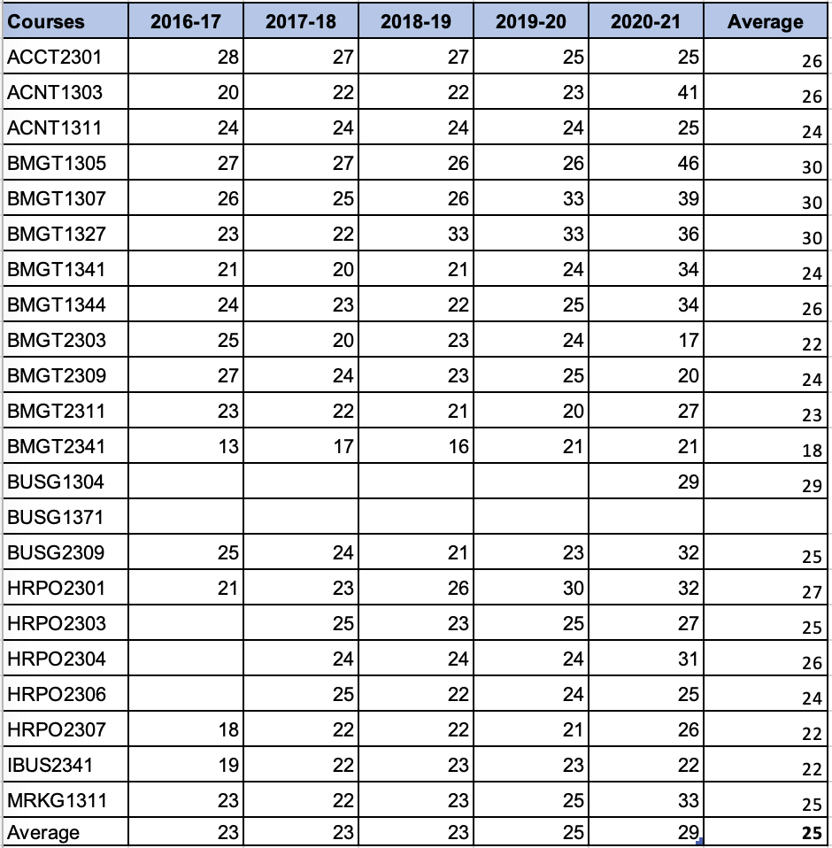
Average Class Sizes Source: Collin College Institutional Research Office
The average class size over the past five years is 25 students in relation to the low enrollment standard of 15 (see section #3) is evidence of high enrollment and proper management.

Grade Distributions
The following table displays the average grade distributions from the past five years across the degree's technical courses.

Courses | A | B | C | D | F | P | W
ACCT2301 | 28% | 22% | 16% | 6% | 0% | 15% | 13%
ACNT1303 | 61% | 7% | 4% | 3% | 0% | 19% | 6%
ACNT1311 | 56% | 5% | 8% | 0% | 0% | 19% | 11%
BMGT1305 | 50% | 21% | 9% | 3% | 0% | 12% | 5%
BMGT1307 | 48% | 25% | 11% | 4% | 0% | 9% | 4%
BMGT1327 | 40% | 27% | 12% | 4% | 0% | 12% | 4%
BMGT1341 | 43% | 24% | 12% | 3% | 0% | 11% | 6%
BMGT1344 | 51% | 23% | 9% | 2% | 0% | 10% | 5%
BMGT2303 | 47% | 24% | 9% | 3% | 0% | 12% | 6%
BMGT2309 | 47% | 25% | 9% | 3% | 0% | 12% | 4%
BMGT2311 | 48% | 21% | 13% | 3% | 0% | 12% | 4%
BMGT2341 | 56% | 18% | 6% | 5% | 0% | 9% | 5%
BMGT2382 | 75% | 0% | 0% | 0% | 0% | 25% | 0%
BUSG1304 | 25% | 19% | 22% | 9% | 0% | 11% | 14%
BUSG1371 | - | - | - | - | - | - | -
BUSG2309 | 36% | 23% | 11% | 5% | 0% | 17% | 8%
HRPO2301 | 55% | 20% | 10% | 3% | 0% | 8% | 4%
HRPO2303 | 36% | 25% | 17% | 4% | 0% | 13% | 6%
HRPO2304 | 48% | 30% | 11% | 3% | 0% | 5% | 4%
HRPO2306 | 52% | 25% | 8% | 4% | 0% | 5% | 5%
HRPO2307 | 64% | 16% | 5% | 3% | 0% | 10% | 2%
IBUS2341 | 49% | 20% | 10% | 2% | 0% | 10% | 9%
MRKG1311 | 38% | 29% | 11% | 4% | 0% | 11% | 8%
Grade Distribution
Source: http://inside.collin.edu/iro/programreview/202122/GradeDistribution-BusinessManagement.pdf

There are no established failure or withdrawal standards. However, please note the following courses with withdrawal rates that are higher than 10 %:
- ACCT 2301 - 13% withdrawal rate - is no longer part of the curriculum
- ACNT 1311 - 11% withdrawal rate - course is governed by Field of Study - Accounting. The BMAN program will partner with them on ways to improve student success rate
- BUSG 1304 - 14% withdrawal rate - new course required in Entrepreneurship AAS & Level 1 Certificate. Course governed by new Workforce Program, Banking & Finance. The BMAN program anticipates improved student success as faculty experience grows.

Faculty Contact Hours
The following table displays the number of faculty contact hours for BMAN courses, meeting the guidelines of having at least one full-time faculty member whose primary teaching assignment is within the program.

Faculty Employment Status/Student Contact Hours
Academic Year | 2016-2017 |  | 2017-2018 |  | 2018-2019 |  | 2019-2020 |  | 2020-2021
Full Time | 15,360 | 45% | 17,376 | 41% | 15,648 | 36% | 19,392 | 40% | 31,056 | 61%
Part Time | 19,056 | 55% | 24,816 | 59% | 28,416 | 64% | 29,136 | 60% | 19,536 | 39%
Total | 34,416 |  | 42,192 |  | 44,064 |  | 48,528 |  | 50,592
Faculty BMAN Contact Hours
Source: Collin College Institutional Research Office

The normal target is for full time faculty to teach 60% of student contact hours and part time faculty to teach the remaining 40%. The growth of the BMAN program impacted the number and composition of faculty members. Multiple adjunct faculty members were added to staff the increase in enrollment and adjuncts taught more sections of courses as evidenced by the increase in adjunct contact hours from 2016-17 to 2020-21. Justification to hire the third full time faculty member in the program was reached when the adjunct contact percentage significantly surpassed the full time contact hours in both 2018-19 and 2019-20. The resulting new full time faculty began in fall 2020, reducing the full time to part time ratio down to 61%/39%, close to the target range.
However, the BMAN program has continued to grow and the full time versus part time percentage is trending back towards the need for a potential fourth full time faculty member.

Course Success Rates
The following courses do not meet the 75% success rate and are not core courses:
- ACNT 1303 - Introduction to Accounting I
- ACNT 1311 - Introduction to Computerized Accounting
- BUSG 1304 – Financial Literacy
- BUSG 1371 – Business Plan for Funding (BMAN)
- BUSG 2309 - Small Business Management/Entrepreneurship (BMAN)
Student Satisfaction
The following table displays the BMAN student evaluations for Fall 2020 through Spring 2022.

 | Fall 2020 | Spring 2021 | Fall 2021 | Spring 2022
The course was well managed. | 3.61 | 3.66 | 3.72 | 3.71
The instructor communicated effectively. | 3.61 | 3.62 | 3.65 | 3.69
The instructor provided sufficient feedback regarding the quality of your work. | 3.53 | 3.55 | 3.61 | 3.64
The instructor treated students with respect. | 3.72 | 3.73 | 3.77 | 3.77
The instructor created an environment that facilitated learning. | 3.62 | 3.62 | 3.67 | 3.69
Average | 3.62 | 3.64 | 3.69 | 3.70
BMAN Student Evaluation Averages
Sources: http://inside.collin.edu/iro/sei_reports/fall_2020/dept/Dept%20A-B.pdf, http://inside.collin.edu/iro/sei_reports/spring_2021/departments/Dept%20A-B.pdf, http://inside.collin.edu/iro/sei_reports/fall_2021/dept/BIOL-BUSI.pdf, http://inside.collin.edu/iro/sei_reports/spring_2022/courses/BCIS-BUSI.pdf

These averages indicate that most students "Strongly Agree" or "Agree" with survey criteria for these terms, concluding that students are satisfied with the courses in the program.

☒6. How effectively do we communicate, and how do we know?
A. Make a case with evidence that the program literature and electronic sites are current, provide an accurate representation of the program, and support the program’s recruitment plan, retention plan and completion plan.
Suggested/possible points to consider:
- Demonstrate how the unit solicits student feedback regarding its website and literature and how it incorporates that feedback to make improvements.
- How does the program ensure that students are informed/aware of program literature? Is program literature made accessible to all students (i.e. can they obtain the information they need)?
- Designate who is responsible for monitoring and maintaining the unit’s website, and describe processes in place to ensure that information is current, accurate, relevant, and available.

The BMAN program has been developing a strategy to communicate with prospective, current, and former students. The primary source of information comes from the department's website, which is maintained by the discipline lead. The website provides information on the program's mission, available awards and degrees, program updates, course descriptions, academic advice, and marketable skills.

- The Collin College BMAN website is located at:
https://www.collin.edu/academics/programs/BUSM_1Overview.html
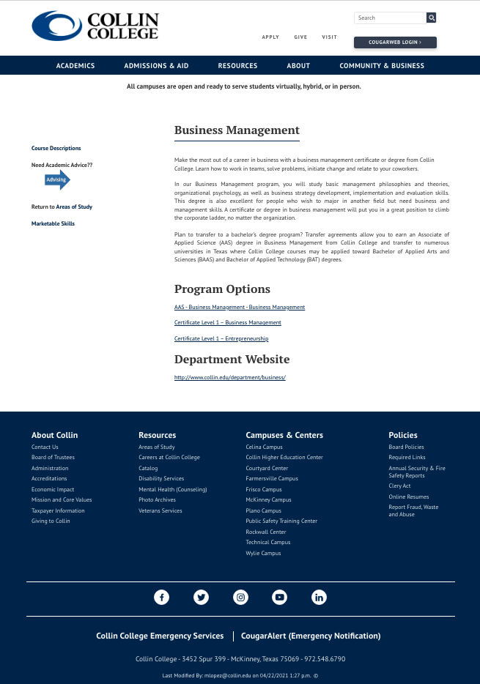
Figures 1– Program page
Source: https://www.collin.edu/academics/programs/BUSM_1Overview.html

B. In the following Program Literature Review Table, document that the elements of information listed on the website and in brochures (current academic calendars, grading policies, course syllabi, program handouts, program tuition costs and additional fees, description of articulation agreements, availability of courses and awards, and local job demand in related fields) were verified for currency, accuracy, relevance, and are readily available to students and the public. Please fill out the table only for this prompt (B.), no analysis is necessary here.

Program Literature Review Table
Title | Type (i.e. URL, brochure, handout, etc.) | Date of Last Review/Update |  | Responsible Party
BMAN Program Information Sheet | Print and  Web flyer (click here) | 3/17/2022 | ☒Current  ☒Accurate  ☒Relevant  ☒Available | Nicole Luna, Marketing & Communications Coordinator, Collin College
BMAN Program Website | URL (click here) | 4/21/2021 | ☒Current  ☒Accurate  ☒Relevant  ☒Available | Mari Lopez, Curriculum Specialist, Curriculum Office, Collin College
BMAN Department Website | URL (click here) | 8/16/2021 | ☒Current  ☒Accurate  ☒Relevant  ☒Available | Jeffery Johnson, Discipline Lead BMAN Program, Collin College
BMAN Marketable Skills | URL (click here) | 8/22/2020 | ☒Current  ☒Accurate  ☒Relevant  ☒Available | Mari Lopez, Curriculum Specialist, Curriculum Office, Collin College
Degree Plan: AAS Business Management – Business Management & Entrepreneurship focus options | URL (click here) | 4/23/2021 | ☒Current  ☒Accurate  ☒Relevant  ☒Available | Mari Lopez, Curriculum Specialist, Curriculum Office, Collin College
Degree Plan: Certificate Level I – Business Management | URL (click here) | 8/21/2020 | ☒Current  ☒Accurate  ☒Relevant  ☒Available | Anne Reid, Executive Assistant, SVP Operations, Collin College
Degree Plan: Certificate Level I – Entrepreneurship | URL (click here) | 1/14/2021 | ☒Current  ☒Accurate  ☒Relevant  ☒Available | Mari Lopez, Curriculum Specialist, Curriculum Office, Collin College
Click or tap here to enter text. | Click or tap here to enter text. | Click or tap to enter a date. | ☐Current  ☐Accurate  ☐Relevant  ☐Available | Click or tap here to enter text.
Click or tap here to enter text. | Click or tap here to enter text. | Click or tap to enter a date. | ☐Current  ☐Accurate  ☐Relevant  ☐Available | Click or tap here to enter text.

☒7. How well are we leveraging partnership resources and building relationships, and how do we know?
Partnership Resources: On the table below, list any business, industry, government, college, university, community, and/or consultant partnerships, including internal Collin departments, to advance the program outcomes.
The BMAN program has engaged a diverse group of external and internal partners to not only advance program outcomes but also the program’s mission as stated in #1 above. The program’s major sources of partnerships are through the advisory committee, university partners and internal Collin College departments as outlined in the table that follows.

The most recent program partnership was with Dell Technologies. Three students were hired in various sites throughout Texas. The program continues to search for partners that add value to the program, college and community. Another recent partnership introduced and promoted by the BMAN program’s dean is Handshake. According the Collin College Career Center, “Handshake is the number one network for college students seeking job opportunities.”

Partnership Resources Table**
Partner/Organization | Description | Formal Agreement Duration,  if any. | How is it Valuable to the Program?
Dell Technologies | Job Recruitment & Hiring  Internships | Informal agreement with no end date | Support workforce program goal of employment and opportunities to learn and advance through interships
Handshake via Collin College Career Center | Job Recruitment & Hiring  Internships | Formal Agreement Duration governed by Career Center | Support workforce program goal of employment and opportunities to learn and advance through interships
University Partners: Midwestern State, Tarleton State, Univ. of North Texas & Western Governers Univ. | Transfer opportunities for program students  Input on current business and educational trends | Formal Agreement Duration governed by University Partnerships, Advising Office, Collin College | Provides formal pathway for program students to continue their education and provides information to guide program improvement
Click or tap here to enter text. | Click or tap here to enter text. | Click or tap here to enter text. | Click or tap here to enter text.
Click or tap here to enter text. | Click or tap here to enter text. | Click or tap here to enter text. | Click or tap here to enter text.
Click or tap here to enter text. | Click or tap here to enter text. | Click or tap here to enter text. | Click or tap here to enter text.
Click or tap here to enter text. | Click or tap here to enter text. | Click or tap here to enter text. | Click or tap here to enter text.
Click or tap here to enter text. | Click or tap here to enter text. | Click or tap here to enter text. | Click or tap here to enter text.
Click or tap here to enter text. | Click or tap here to enter text. | Click or tap here to enter text. | Click or tap here to enter text.

☒8. What professional developmental opportunities add value to your program?
The growth in the BMAN program and the subsequent increase in faculty has brought a diverse range of skills, expertise and professional development. The following table displays the recent trainings, conferences, workshops and any activity both full time and adjunct faculty members have completed to further develop and contribute to the program.

Provide a List of professional development activities employees have participated in since the last program review.
Employee Resources Table**
Employee Name | Role in Unit | Professional Development Summary | How is it Valuable to the Unit?
Jeffery Johnson | Discipline Lead & Full Time Faculty | 1. Prior Learning Assessment (PLA) Training – Fall 2022  2. Program Review Data Collection Workshop – Fall 2022  3. Fall 2022 Faculty Development Day - Developing and OER Course & Connecting with Workforce Students - Fall 2022  4. United States Distance Learning Association Annual Conference - Summer 2022  5. 75th Annual Texas Community College Teachers Association Conference – Spring 2022  6. KnowBe4 Cybersecurity Training for Texas – Spring 2022  7. Program Review Steering Committee Senior Reviewer Training - Spring 2022  8. Spring 2022 Faculty Development Day  9. New Faculty Academy - Spring 2022 & Fall 2021  10. KnowBe4: Introduction to Ransonware – Fall 2021  11. Preventing Harassment and Discrimination for Higher Education – Fall 2021  12. Discipline Lead Training – Fall 2021  13. New Faculty Orientation – Fall 2021  14. Fall 2021 Faculty Development Day – Fall 2021 | 1. Training for faculty and staff on PLA committee to evaluate proposals for course PLA acceptance  2. Training for discipline leads to assist in data retrieval for program review  3. Conference keeps faculty informed on current educational trends  4. Conference keeps faculty informed on current educational trends in distance learning  5. Conference keeps faculty informed on current educational trends  6. Training keeps faculty and staff aware of cybersecurity issues and prevention  7. Training with Senior Reviewer for new committee members to enhance program review evaluation process  8. Conference keeps faculty informed on current educational trends  9. Series of training to help new faculty members with roles and responsibilities  10. Training for faculty to be attentive to hackers trying to penetrate personal emails  11. Training for faculty awareness of the importance of privacy for students & understanding the channels for following up in the event of harassment  12. Training to help faculty members with roles and responsibilities of discipline lead  13. Training for new faculty members to help with roles and responsibilities  14. Conference keeps faculty informed on current educational trends
Dr. Christine DeLaTorre | Full Time Faculty | 1. Received Society of Human Resource Management (SHRM) CERTIFIED PROFESSIONAL ﴾SHRM‐CP﴿ credential (Summer 2022)  2. Attended Western Governor's University (WGU) Colorado Community College Summit -Colorado Springs, CO (Fall 2021)  3. Attended 59th Annual Conference on Intellectual Property Law - Dallas, TX (Fall 2021)  4. Attended Bring Small Business Back Conference - Tampa, FL (Fall 2021)  5. Attended International Conference in Management, Leadership and Business Intelligence- Houston, TX (Spring 2019) | 1. Provides a industry credential to increase credibility of faculty knowledge of Human Resource Management. Contributes to meet SACS-COC requirements to teach required HRPO courses.  2. Conference provided information on competency-based teaching techniques and provided insight regarding best practices to foster partnership between WGU and Collin College.  3. Conference focused on "ethics in negotiations." This information provides insight and "real-world" examples to enhance curriculum (BMGT 1344: Negotiations and Conflict Management).  4. Conference addressed relevant issues face by small businesses post COVID 19 which can assist student entrepreneurs, as well as community partners.  5. Conference addressed e‐commerce security, trust and privacy in the digital economy; challenges for knowledge management; strategic and entrepreneurial leadership capabilities; data mining and analytics; and the use of AI in business. This information helps to increase the relevancy of the BMGT curriculum.
James Gilbert | Full Time Faculty | 1. Faculty Development Day - Developing and OER Course - & Connecting With Workforce Students - Fall 2022  2. USDLA Annual Conference - Spring 2022  3. TRUST zoom presentation by Amy Rossellini - Spring 2022  4. Pearson's Digital Leadership Forum - Spring 2022  5. Cybersecurity Awareness Training - Spring 2022  6. Annual TCCTA 75th Annual Conference - Spring 2022 & Fall 2020  7. Against Memorization: Teaching Concepts and Skills - Spring 2022  8. North Texas Community College Consortium - The Power of Collaboration Comprehensive Collaborative Care Model - Lessons Learned from Implementing Leadership Programs – Spring 2022  Social Engineering Red Flags - Fall 2021  9. Webinar - Think Big: Fostering Critical Thinking in Students - Fall 2021  10. FERPA Basics Certificate of Completion - Fall 2021 & Fall 2020  11. Micro-Module Introduction to Ransomware - Fall 2021  12. Faculty Development Day - Working with Students in Distress - Fall 2021  13. Workforce/Field of Study Discipline Leads Meeting presented by John Hardesty - Fall 2021  14. Spring Faculty Development Conference - Multiple Topics - Spring 2021  15. Preventing Harassment & Discrimination - Fall 2020  16. Building Supportive Communities: Clery Act and Title IX Training - Fall 2020  17. Zogotech Training - Fall 2020  18. CIP Workshop – Fall 2020 | 1. Conference keeps faculty informed on current educational trends  2. Conference with multiple topics to keep faculty and staff aware of current educational trends  3. Presentation for faculty to develop trust with students  4. Conference to help Pearson develop courses that better meet the digital student needs  5. Training keeps faculty and staff aware of cybersecurity issues and prevention  6. Conference keeps faculty informed on current educational trends  7. Training to ensure we teach students to prepare by properly studying the material and not relying on our short-term memory for success  8. Conference keeps faculty informed on current educational trends  9. Training for faculty to be attentive to hackers trying to penetrate our personal emails  10. Training to remind faculty to challenge students to utilize critical thinking skills  11. Keeps faculty aware of the importance of privacy for students & understanding the channels for following up in the event of harassment  12. Training keeps faculty and staff aware of cybersecurity issues and prevention  13. Conference keeps faculty informed on current educational trends  14. Presentation for faculty to better understanding our roll to ensure we are meeting the SLOs  15. Conference keeps faculty informed on current educational trends  16. Keeps faculty aware of the importance of privacy for students & understanding the channels for following up in the event of harassment  17. Keeps faculty aware of the importance of privacy for students & understanding the channels for following up in the event of harassment  18. Another tool presented to assist in gaining insight into Collin's online data
Abraham Akech | Adjunct Faculty | 1. KnowBe4 Cybersecurity Training, Summer 2022 | 1. Training keeps faculty and staff aware of cybersecurity issues and prevention
Antonya Brown | Adjunct Faculty | 1. Preventing Harassment & Discrimination - Fall 2022  2. FERPA Basics Certificate of Completion - Fall 2022  3. KnowBe4 Cybersecurity Training, Summer 2022 | 1. Keeps faculty aware of the importance of privacy for students & understanding the channels for following up in the event of harassment  2. Keeps faculty aware of the importance of privacy for students & understanding the channels for following up in the event of harassment  3. Training keeps faculty and staff aware of cybersecurity issues and prevention
Carter Bryant | Adjunct Faculty | New Adjunct Fall 2022 | Click or tap here to enter text.
Barry Driks | Adjunct Faculty | 1. Frisco & Plano Campuses Fall Adjunct Meetings – Fall 2022  2. KnowBe4 Cybersecurity Training, Spring 2022 | 1. Conference keeps adjunct faculty informed on education and department trends.  2. Training keeps faculty and staff aware of cybersecurity issues and prevention
Erika Funderburk | Adjunct Faculty | 1. Completed KnowBe4 Cybersecurity Training – Spring 2022  2. Agile Project Management training – Spring 2022  3. Shopify and BigCommerce platform training – Fall 2021  4. Business Requirements Writing training – Fall 2021 | 1. Training keeps faculty and staff aware of cybersecurity issues and prevention.  2. Training keeps me up to date and adds useful information to share in the classroom.  3. Training and knowledge of ecommerce platforms keeps me relevant and provides information to share with students.  4. Industry training keeps me up to date on industry trends and able to educate students with new information.
Chantelle James | Adjunct Faculty | 1. Completed KnowBe4 Cybersecurity Training – Spring 2022  2. Completed Preventing Harassment & Discrimination – Spring 2022 | 1. Training keeps faculty and staff aware of cybersecurity issue and prevention.  2. This training helps create a safe workplace for everyone.
Dewanna Jefferson | Adjunct Faculty | 1. Online Webinar: Being A Better Teacher Online – Spring 2022  2. Online Webinar: Fostering Student Engagement in an Online Course – Sprin 2022  3. Online Webinar: Think Big Foster Critical Thinking in Our Students – Spring 2022 | As an Adjunct Professor teaching an online course for the first time, this course was valuable in having a better understanding of how to keep online students engaged with participation, interacting with students to ensure there is a level of understanding of the course material, remaining organized, and being intentionally available for students.  2. This course provided valuable insight and best practices in developing relationships with students through a virtual environment, providing consistent routines to keep students engaged with learning, and being able to access various learning styles of students to work better together while improving the learning process.  3. This course provided key points to breaking down subjects and engaging students to clearly defining the situation, obstacles and impacts, and what 's to be accomplished. Empowering students to think critically allows students to demonstrate their understanding and putting their knowledge of the subject into practice.
Stacy Kuenn | Adjunct Faculty | 1. Completed Teaching with Canvas Course – Fall 2022  2. Viewed recording of “On the Record: Cultivating Good Notetaking Skills in our Students” – Fall 2022  3. Viewed recording of “Engaging and Connecting with Students using Canvas” – Fall 2022  4. FERPA Basics – Spring 2022  5. Preventing Harassment and Discrimination: Non-Supervisors with Title IX/Clery Module  6. Completed KnowBe4 Cybersecurity Training – Spring 2022  7. Completed KnowBe4 Cybersecurity Training – Fall 2021  8. Completed Workday Training – Spring 2021  9. Completed KnowBe4 Cybersecurity Training – Spring 2021  10. Viewed “Good Teaching, Less Cheating: Facilitating Academic Integrity in Online Classes – Spring 2021  11. Quality Matters Workshop, APPQMR – Fall 2020  12. Accessibility Webinar – Fall 2020 | 1. Training to ensure consistency, compliance and quality with Canvas courses  2. Training to help faculty to encourage notetaking habits  3. Professional Development to provide faculty tips to engage students in Canvas  4. Training keeps faculty informed of FERPA regulations  5. Training ensures faculty have knowledge of how to prevent harassment and discrimination  6. Training keeps faculty and staff aware of cybersecurity issue and prevention.  7. Training keeps faculty and staff aware of cybersecurity issue and prevention.  8. Training informed faculty how to utilize and operate Workday  9. Training keeps faculty and staff aware of cybersecurity issue and prevention.  10. Professional Development providing faculty tips on maintaining integrity  11. Training to provide faculty tools to provide accessible and quality online instruction  12. To teach faculty how to ensure course shells are accessible
Fred Kuglin | Adjunct Faculty | 1. Preventing Harassment and Discrimination: Non-Supervisors with Title IX/Clery Module – Spring 2022  2. FERPA Basics – Spring 2022  3. Quality Matters (QM) Digital Certification – Summer 2021 | 1. Very valuable. A safe environment for all just doesn't happen - it takes everyone working together to make it happen.  2. Very Valuable. FERPA affords parents the right to have access to their children’s education records, the right to seek to have the records amended, and the right to have some control over the disclosure of personally identifiable information from the education records. Many to most of our students are over 18 years old, so the rights under FERPA transfer from the parents to our students.  3. Very, Very Valuable. As a result, I was asked and then created the master Canvas Course Shell for Negotiations & Conflict Management for all Professors in Business Management at Collin College to use. It was a rigorous process, but the net beneficiaries are the current and future Collin College students who take this course.
Alyna Nathoo | Adjunct Faculty | 1. Doctorate in Leadership and Innovation – Fall 2022  2. Lean Six Sigma Green Belt Certification – Fall 2022  3. Lean Six Sigma White Belt Certification – Summer 2022  4. Certified Project Management Essentials – Summer 2022  5. Certified Content Marketing – Summer 2022  6. Certified Digital Marketing – Summer 2022  7. Certified SEO – Summer 2022  8. KnowBe4 Cybersecurity Training – Spring 2022  9. Quality Matters – Applying the QM Rubric – Fall 2021  10. Quality Matters – Improving Your Online Course – Fall 2021  11. Adjunct Faculty Meeting/Collaboration – Fall 2021 and Fall 2022 | 1. Advancement in professional capacities to formulate innovative solutions to become a results-focused leader in my industry. Also assists in building a solidifies my foundation for teaching in higher education.  2. Enhances the ability to confidently discuss rather complex subjects, effectively solve problems, and provide useful recommendations.  3. Provides opportunity to assist with change management within an organization and participate with problem solving teams that support projects.  4. Provides information regarding project management essential concepts and tools to assist in improving project management techniques and processes through risk, cost, and time organization.  5. Provides information for content marketing best practices such as crafting your social media messaging to bring visitors to a website and understanding the importance of keywords on a homepage.  6. Provides information for digital marketing best practices such as optimizing websites for search engines, creating strategies to build and grow a following, as well as creating ads to increase business towards targeted audiences.  7. Provides information for search engine optimization best practices such as increasing visibility on popular search engines and search performance as well as website optimization, link building, and keyword research.  8. Training keeps faculty and staff aware of cybersecurity issues and prevention.  9. Building engaging online courses, making sure that they reach students.  10. Training on building the framework of online courses.  11. Meeting with other adjunct professors as well as communicating about best practices and improving student experiences.
Ryan Savage | Adjunct Faculty | 1. Everfi software training – Fall 2022  2. Adjunct faculty meeting/collaboration – Fall 2022  3. Completed KnowBe4 Cybersecurity Training - Spring 2022  4. Quality Matters Rubric Training Fall 2021  5. Quality Matters Improving your online course – Fall 2021  6. Online Faculty orientation – Spring 2021  7. Faculty development conference - Spring 2021  8. Dual Credit Professional Development workshop – Fall 2020 | 1. Introduction to supplemental material resource  2. Meeting with other adjunct professors, communicating about best practices and improving student experiences  3. Training keeps faculty and staff aware of cybersecurity issue and prevention.  4. Building engaging online courses, making sure that they reach students  5. Training on building the framework of your online course.  6. Training to become familiar with college online best practices.  7. Attended different sessions to help enrich my classroom  8. Workshops on challenges dual credit students provide and how to meet them.
Cameron Shaw | Adjunct Faculty | 1. Attended National Black MBA Association Conference, Executive Training Track – Fall 2022  2. Attended National Black MBA Association Conference, Leadership Development Training Track – Fall 2022 | 1. Executive training track focused on sharpening the skillset of middle to senior management executive in business. The insight that I obtained is used to teach my course.  2. Leadership development track reaffirmed what I know about leadership and provided me with additional training and development that will be used to teach my course.
Michael Watson | Adjunct Faculty | 1. Attended Collin College Fall Faculty Development Conference – Fall 2022  2. Completed KnowBe4 Cybersecurity Training – Summer 2022 | 1. Conference keeps faculty informed on current educational trends.  2. Training keeps faculty and staff aware of cybersecurity issue and prevention.
Click or tap here to enter text. | Click or tap here to enter text. | Click or tap here to enter text. | Click or tap here to enter text.
Click or tap here to enter text. | Click or tap here to enter text. | Click or tap here to enter text. | Click or tap here to enter text.
Click or tap here to enter text. | Click or tap here to enter text. | Click or tap here to enter text. | Click or tap here to enter text.
Click or tap here to enter text. | Click or tap here to enter text. | Click or tap here to enter text. | Click or tap here to enter text.
Click or tap here to enter text. | Click or tap here to enter text. | Click or tap here to enter text. | Click or tap here to enter text.
Click or tap here to enter text. | Click or tap here to enter text. | Click or tap here to enter text. | Click or tap here to enter text.
Click or tap here to enter text. | Click or tap here to enter text. | Click or tap here to enter text. | Click or tap here to enter text.
Click or tap here to enter text. | Click or tap here to enter text. | Click or tap here to enter text. | Click or tap here to enter text.
**For convenience, if providing a listing of professional development activities, this list may be included in this document as an appendix.

☒9. Are facilities, equipment, and funding sufficient to support the program? If not, please explain.
[OPTIONAL—Only respond to prompt 9 if you are requesting improved resources for your program. If current facilities and budget are adequate, please proceed to prompt 10.]
Make a case with evidence that current deficiencies or potential deficiencies related to facilities, equipment, maintenance, replacement, plans, or budgets pose important barriers to the program or student success. As part of your response, complete the resource tables, below, to support your narrative.
Possible points to consider:
- The useful life of structure, technologies and equipment
- Special structural requirements
- Anticipated technology changes impacting equipment sooner than usual

N/A

Facilities Resources Table**
Significant Pieces of Equipment | Description  (i.e. Special Characteristics) | Meets Needs (Y or N):  Current For Next 5 Years |  | Analysis of Equipment Utilization
N/A | Click or tap here to enter text. | Choose an item. | Choose an item. | Click or tap here to enter text.
Click or tap here to enter text. | Click or tap here to enter text. | Choose an item. | Choose an item. | Click or tap here to enter text.
Click or tap here to enter text. | Click or tap here to enter text. | Choose an item. | Choose an item. | Click or tap here to enter text.
Click or tap here to enter text. | Click or tap here to enter text. | Choose an item. | Choose an item. | Click or tap here to enter text.
Click or tap here to enter text. | Click or tap here to enter text. | Choose an item. | Choose an item. | Click or tap here to enter text.
Click or tap here to enter text. | Click or tap here to enter text. | Choose an item. | Choose an item. | Click or tap here to enter text.
Click or tap here to enter text. | Click or tap here to enter text. | Choose an item. | Choose an item. | Click or tap here to enter text.
Click or tap here to enter text. | Click or tap here to enter text. | Choose an item. | Choose an item. | Click or tap here to enter text.
Click or tap here to enter text. | Click or tap here to enter text. | Choose an item. | Choose an item. | Click or tap here to enter text.

Equipment/Technology Table ($5,000 or more) **
Current Equipment Item or Budget Amount | Description | Meets Needs (Y or N):  Current For Next 5 Years |  | For any “N”, justify needed equipment or budget change
N/A | Click or tap here to enter text. | Choose an item. | Choose an item. | Click or tap here to enter text.
Click or tap here to enter text. | Click or tap here to enter text. | Choose an item. | Choose an item. | Click or tap here to enter text.
Click or tap here to enter text. | Click or tap here to enter text. | Choose an item. | Choose an item. | Click or tap here to enter text.
Click or tap here to enter text. | Click or tap here to enter text. | Choose an item. | Choose an item. | Click or tap here to enter text.
Click or tap here to enter text. | Click or tap here to enter text. | Choose an item. | Choose an item. | Click or tap here to enter text.
Click or tap here to enter text. | Click or tap here to enter text. | Choose an item. | Choose an item. | Click or tap here to enter text.
Click or tap here to enter text. | Click or tap here to enter text. | Choose an item. | Choose an item. | Click or tap here to enter text.
Click or tap here to enter text. | Click or tap here to enter text. | Choose an item. | Choose an item. | Click or tap here to enter text.
Click or tap here to enter text. | Click or tap here to enter text. | Choose an item. | Choose an item. | Click or tap here to enter text.
Click or tap here to enter text. | Click or tap here to enter text. | Choose an item. | Choose an item. | Click or tap here to enter text.

Financial Resources Table**
Source of Funds  (i.e. college budget, grant, etc.) | Meets Needs (Y or N):  Current For Next 5 Years |  | For any “N”, explain why | For any “N”, identify expected source of additional funds if needed
N/A | Choose an item. | Choose an item. | Click or tap here to enter text. | Click or tap here to enter text.
Click or tap here to enter text. | Choose an item. | Choose an item. | Click or tap here to enter text. | Click or tap here to enter text.
Click or tap here to enter text. | Choose an item. | Choose an item. | Click or tap here to enter text. | Click or tap here to enter text.
Click or tap here to enter text. | Choose an item. | Choose an item. | Click or tap here to enter text. | Click or tap here to enter text.
Click or tap here to enter text. | Choose an item. | Choose an item. | Click or tap here to enter text. | Click or tap here to enter text.
Click or tap here to enter text. | Choose an item. | Choose an item. | Click or tap here to enter text. | Click or tap here to enter text.
Click or tap here to enter text. | Choose an item. | Choose an item. | Click or tap here to enter text. | Click or tap here to enter text.
Click or tap here to enter text. | Choose an item. | Choose an item. | Click or tap here to enter text. | Click or tap here to enter text.
Click or tap here to enter text. | Choose an item. | Choose an item. | Click or tap here to enter text. | Click or tap here to enter text.
Click or tap here to enter text. | Choose an item. | Choose an item. | Click or tap here to enter text. | Click or tap here to enter text.

Section III. Continuous Improvement Plan (CIP)
☒10. How have past Continuous Improvement Plans contributed to success?
Program Review at Collin College takes place for each unit or program every five years. During the last (fifth) year, the program evaluates the data collected during the CIP process.
Please describe how you have used your Continuous Improvement Plan (CIP) to make the following improvements to your program over the past 4 years (your last program review can be found on the Program Review Portal):
  - Program Learning Outcomes/Program Competencies
  - Overall improvements to your program

The BMAN program utlizies the Continuous Improvement Plan (CIP) to identify areas in which the program can improve administratively, student performance/success and student learning outcomes. The most recent BMAN CIP was submitted on June 29, 2020 (see appendix). That CIP provided insight and information that allowed the program to improve since submitted.

Based on previous CIPs and program analysis, the 2020 CIP identified four areas to improve along with how they will be measured and targeted level of improvement, as copied in the following table:

Expected Outcome | Measure | Target
1. Increase the number of students in BMGT courses and programs | Unduplicated Student Enrollment Analysis | By 25% (consistent with overall programs success rate)
2. Review Prior Learning Assessment Models | PLA is a new program being developed for BMGT 1327 – Principles of Management | Projected implementation – Fall 2020
3. Improve success rate of ACNT 1303 | Grade Distribution analysis | Consistent with overall program success rate – 50% (Not required for the Certificate)
4. Students will demonstrate application of key financial concepts in formulating strategy development. | Primary Course Completion Rates – HRPO 2307 for BMGT certificate. BMGT 2341 for AAS degree  Secondary: Score of 70% or higher on HRPO 2307 BMGT and BMGT 1341 Case Study (Capstone Project) Assignment | Primary: 80% course completion rate

According to the 2020 CIP, the following are the results:
1. Enrollment increased by 37% from Fall 2018 to Fall 2019 - Goal exceeded, increased over goal by 12%.
2. Target goal not yet determined since not fully developed - Goal not achieved, action plan implemented (see 2020 CIP in appendix). Since submission, the BMAN program successfully developed a PLA for BMGT 1327.
3. No results reported – Goal exceeded, from academic year 2017 to 2021 the ACNT 1301 success rate was 70%, 72%, 69%, 73% & 78%. (see #5 above)
4. Course completion rate for HRPO 2307 was 82% and BMGT 2341 was 70% - Goal not achieved, action plan implemented (see 2020 CIP in appendix). According to the most recent data the goal was achieved. From academic year 2017 to 2021 the HRPO 2307 completion rate was 97%, 99%, 100%, 96% & 98%. From academic year 2017 to 2021 the BMGT 2341 completion rate was 95%, 90%, 98%, 94% & 100%. (see #5 above)

*Please attach previous CIP Tables in the appendix

☒11. How will we evaluate our success?

NOTE: Please contact the institutional effectiveness office if you need assistance filling out the CIP tables.
As part of the fifth year Program Review, the program should use the observations and data generated by this process along with data from other relevant assessment activities to develop the program’s CIP and an action plan for the next two years. At the conclusion of the first two years, data collected from the first year, plus any other relevant data that was collected in the interim, should be used to build on the accomplishments of those first two years by developing another two-year action plan for the CIP to help the program accomplish the expected outcomes established in its CIP or by implementing one of your other plans.

Based on the information, analysis, and discussion that have been presented up to this point, summarize the strengths and weaknesses of this program. There should be no surprise issues here! This response should be based on information from prior sections of this document. Describe specific actions the faculty intends to take to capitalize on the strengths, mitigate the weaknesses, improve student success and program learning outcomes. Provide the rationale for the expected outcomes chosen for the CIP(s).

Throughout this program review, numerous strengths and weaknesses of the BMAN program have been identified.
Strengths
  - Increase in BMAN enrollment numbers in spite of COVID emphasizing the necessity and essential need for this program.
  - Student evaluations indicate student satisfaction of BMAN programs has continued to increase over the last 4 semesters between Fall 2020 and Spring 2022.
  - In addition to this, withdrawal rates for courses in the BMAN program remains low at less than 15% for all classes.
  - Number of completers continues to increase academic year over academic year and has doubled from academic year 2017 (52 certificate and AAS completers) to academic year 2021 (105 certificate and AAS completers) despite environmental setbacks.
  - Full-time and part-time faculty contact hours are appropriately allocated by a 60-40 division.
  - The program prepares students for entry-level BMAN jobs in a variety of industries. Upon program completion, graduates have career opportunities in diverse business, management, and entrepreneurship areas.
  - The program has defined marketable business, management, and entrepreneurial skills that employers value. These are taught and reiterated throughout the curriculum, so students can effectively market their skills after program completion.
  - There is a local demand for entry-level positions and entrepreneurial opportunities in the BMAN discipline. Additionally, the job market is projected to continue to grow over the next ten years.
  - The program benefits by receiving input and guidance from an advisory committee comprised of business professionals representing numerous industries in the Dallas/Ft. Worth region.
  - Every BMAN course required for both focus options of the Business Management AAS or both the Business Management or Entrepreneurship Certificates are offered in multiple modalities (face to face, hybrid & online), providing flexibility for students seeking any program award.
  - The program is offered at various Collin College campuses, providing access for students and allowing them to utilize state-of-the-art resources at the each campus.
Weaknesses
  - The Entrepreneurship component of the program is still a work in progress as it is a newer program that has recently become offered by the program.
  - The BUSG 1371 capstone course requires development to reduce barriers to completion.
  - All required courses are not meeting the 75% success rate.
  - Website and social media presence must be increased to enhance reach to potential, current, and former students as well as local businesses and companies.
  - Continued need to build partnerships with local businesses and companies to present real-world opportunities and experience for program students.
  - Lack of feedback from program graduates diminishes data available for program analysis and improvement.
  - Lack of official pathway with every area university limits options for program students.
New CIPs have been determined to address the highest priority weaknesses with anticipated positive impact for program students. These CIPs will be the focus over the next two years to create positive program course changes that will improve the level of student success.
Projected business job growth in North Texas presents an opportunity for increased demand in the BMAN program at Collin College. The program will continue efforts and communication with students to increase enrollment and completion rates. Additionally, the program will continue working with the program career coaches to encourage employers and students to use Handshake for internship, employment and cooperative education opportunities.

☐ 12. Complete the Continuous Improvement Plan (CIP) tables that follow.
Within the context of the information gleaned in this review process and any other relevant data, identify program priorities for the next two years, including at least one program learning outcome (or program competency), and focus on these priorities to formulate your CIP. You may also add short-term administrative, technological, assessment, resource or professional development outcomes as needed.

Table 1. CIP Outcomes, Measures & Targets Table (focus on at least one for the next two years)
A. Expected Outcomes  Results expected in this unit  (e.g. Authorization requests will be completed more quickly; Increase client satisfaction with our services) | B. Measures  Instrument(s)/process(es) used to measure results  (e.g. sign-in sheets, surveys, focus groups, etc.) | C. Targets  Level of success expected  (e.g. 80% approval rating, 10 day faster request turn-around time, etc.)
Develop Entreprenuership capstone course BUSG 1371 – Business Plan for Funding | Online Advisory Board (OAB) Application Process | Submit to OAB spring 2023 for approval, offer course beginning fall 2023
Increase Successs Rate of BUSG 1304 – Financial Literacy | Grade Distribution Analysis | Success Rate of 75% or greater
Students will be able to determine the financial needs of a business (Program Learning Outcome (PLO) #6 | Financial Section of Business Plan Project in BUSG 1371 – Business Plan for Funding | 80% of students score 80% or better
Click or tap here to enter text. | Click or tap here to enter text. | Click or tap here to enter text.

Continuous Improvement Plan

Outcomes might not change from year to year. For example, if you have not met previous targets, you may wish to retain the same outcomes. You must have at least one program learning outcome. You may also add short-term administrative, technological, assessment, resource or professional development goals, as needed. Choose 1 to 2 outcomes from Table 1 above to focus on over the next two years.

A. Outcome(s) - Results expected in this program (from column A on Table 1 above--e.g. Students will learn how to compare/contrast Conflict and Structural Functional theories; increase student retention in Nursing Program).
B. Measure(s) – Instrument(s)s/process(es) used to measure results (e.g. results of essay assignment, test item questions 6 & 7 from final exam, end of term retention rates, etc.).
C. Target(s) - Degree of success expected (e.g. 80% success rate, 25 graduates per year, increase retention by 2% etc.).
D. Action Plan - Implementation of the action plan will begin during the next academic year. Based on analysis, identify actions to be taken to accomplish outcome. What will you do?
E. Results Summary - Summarize the information and data collected in year 1.
F. Findings - Explain how the information and data has impacted the expected outcome and program success.
G. Implementation of Findings – Describe how you have used or will use your findings and analysis of the data to make program improvements.
Table 2. CIP Outcomes 1 & 2
- Outcome #1 Develop Entrepreneurship capstone course BUSG 1371 – Business Plan for Funding

- Measure (Outcome #1)  Online Advisory Board (OAB) | - Target (Outcome #1)  Submit to OAB spring 2023 for approval, offer course beginning fall 2023
- Action Plan (Outcome #1)
Associate dean & dean approves a service contract for a professor to develop the course & submit to OAB
- Results Summary (Outcome #1) TO BE FILLED OUT IN YEAR 2

- Findings (Outcome #1) TO BE FILLED OUT IN YEAR 2

- Implementation of Findings (Outcome #1) TO BE FILLED OUT IN YEAR 2

Table 2. CIP Outcomes 1 & 2 (continued)

- Outcome #2 Improve Success Rate of BUSG 1304 – Financial Literacy

- Measure (Outcome #2)  Grade Distribution Analysis | - Target (Outcome #2)  Success Rate of 75% or greater
- Action Plan (Outcome #2)
Course governed by new Workforce Program, Banking & Finance. The BMAN program will collaborate with the Banking & Finance program to discover the causation of low success rate and implement solutions.
- Results Summary (Outcome #2) TO BE FILLED OUT IN YEAR 2

- Findings (Outcome #2) TO BE FILLED OUT IN YEAR 2

- Implementation of Findings (Outcome #2) TO BE FILLED OUT IN YEAR 2

What happens next? The Program Review Report Pathway
- Following approval by the Steering Committee,
- Program Review Reports will be evaluated by the Leadership Team;
- After Leadership Team review, the reports will be posted on the Intranet prior to fall semester;
- At any point prior to Intranet posting, reports may be sent back for additional development by the unit.

- Unit responses to the Program Review Steering Committee recommendations received before July 31st will be posted with the Program Review Report.

- Leadership Team members will work with program supervisors to incorporate Program Review findings into planning and activity changes during the next five years.

Please make sure to go back and complete your Executive Summary at the start of the Review.

