Assessment Data collected from Spring 2023 semester
    - IMED-1341 – 100% of students that completed the project scored above a 70.0 grade
      - 5 out of 21 total students skipped it – inactive students or didn’t complete the project
    - INEW-2334 – out of students who were active in course (7) 5 got 70% or above. 2 of them were under 70. 1 student was inactive all semester.
    - ITSE-2374 – 100% above 70% - only 4 students – 3Bs + 1A – Average grade around an 87

Assessment Data collected over multiple semesters for ITSE-2302 for CIP
21SP – Prof Pannell
Quiz 1
- Avg Score: 92
- High Score: 100
- Low Score: 70
- Std Dev: 7.86
- Avg Time to complete: 14:51
Quiz 2
- Avg Score: 93
- High Score: 100
- Low Score: 70
- Std Dev: 9.6
- Avg Time to complete: 6:49

21FA – Prof Pannell
Quiz 1
- Avg Score: 95
- High Score: 100
- Low Score: 80
- Std Dev: 5.89
- Avg Time to complete: 12:51
Quiz 2
- Avg Score: 95
- High Score: 100
- Low Score: 80
- Std Dev: 6.56
- Avg Time to complete: 8:26

22FA – Prof Pannell
Quiz 1
- Avg Score: 86
- High Score: 100
- Low Score: 70
- Std Dev: 10.11
- Avg Time to complete: 19:04
Quiz 2
- Avg Score: 95
- High Score: 100
- Low Score: 70
- Std Dev: 8.19
- Avg Time to complete: 9:19

23SP – Prof Shoaib
Quiz 1
- Avg Score: 86
- High Score: 100
- Low Score: 60
- Std Dev: 10.65
- Avg Time to complete: 19:02
Quiz 2
- Avg Score: 95
- High Score: 100
- Low Score: 70
- Std Dev: 8.06
- Avg Time to complete: 7:56

The same ITSE-2032 data presented graphically (Screenshots from Canvas)
21SP-Pannell
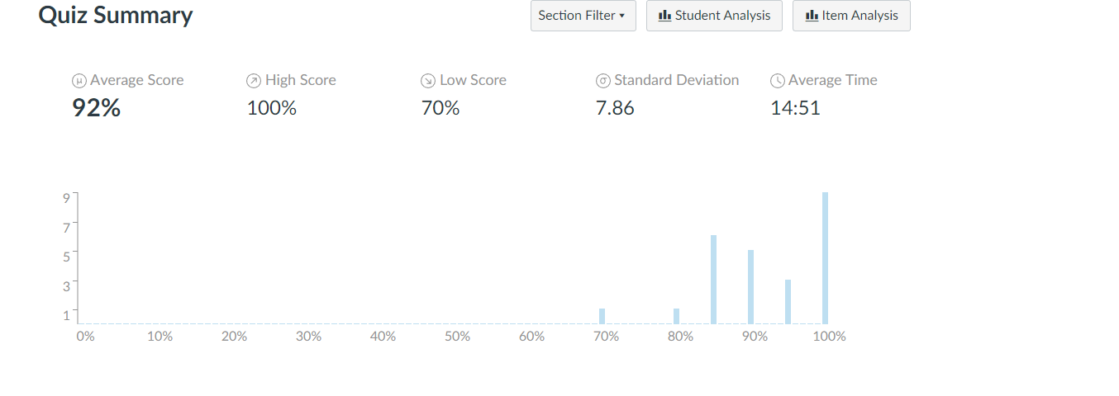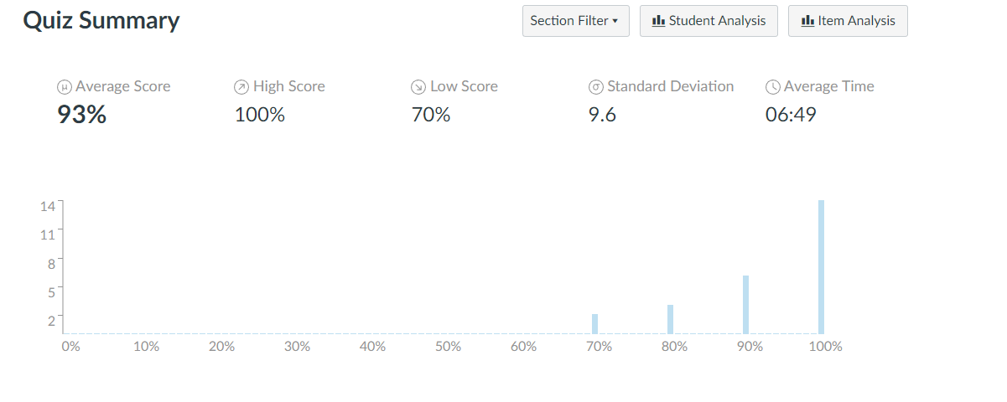

21FA-Pannell
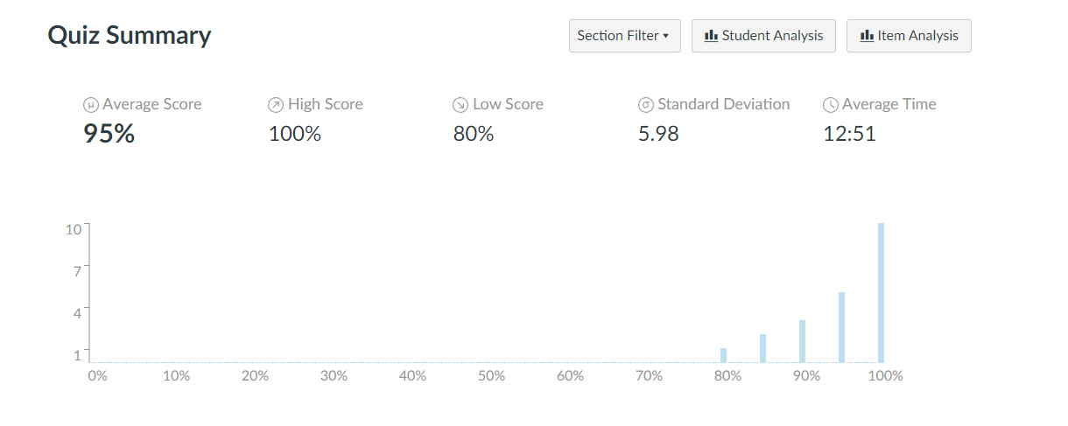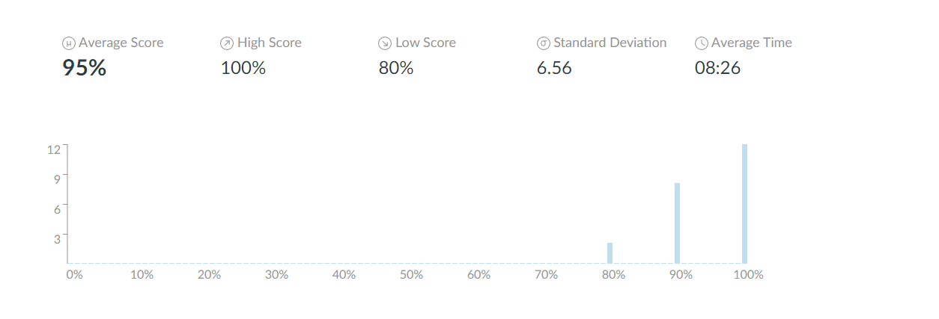

22FA-Pannell
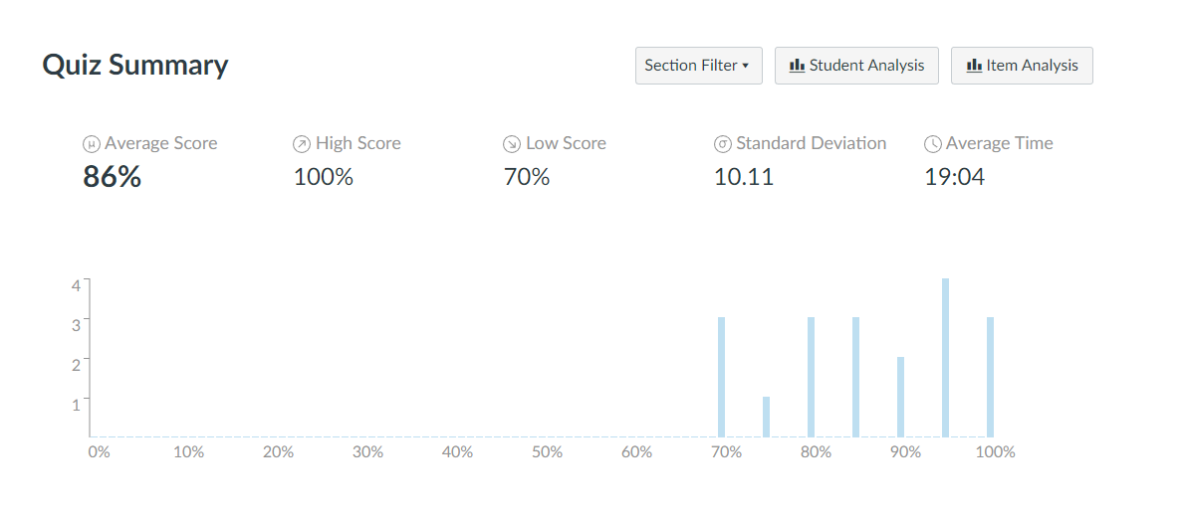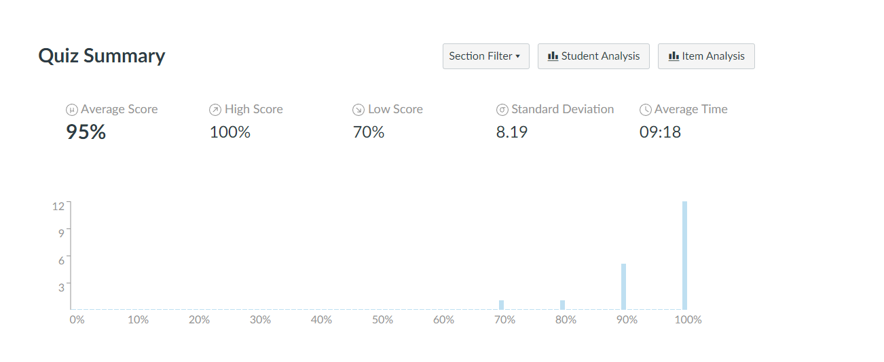

23SP-Shoaib
