APPENDIX
Advisory Committee Minutes
- March 14, 2017 (Spring)
- October 19, 2017 (Fall)
- March 26, 2018 (Spring)
- October 30, 2018 (Fall)
- April 18,2019 (Fall)
- October 30, 2019 (Fall)
- June 16, 2020 (Spring)
- April 19, 2021 (Spring)
- November 11, 2021 (Fall)
Workforce Continuous Improvement Plans
- April 22, 2020 (2020)
- April 1, 2022 (2022)

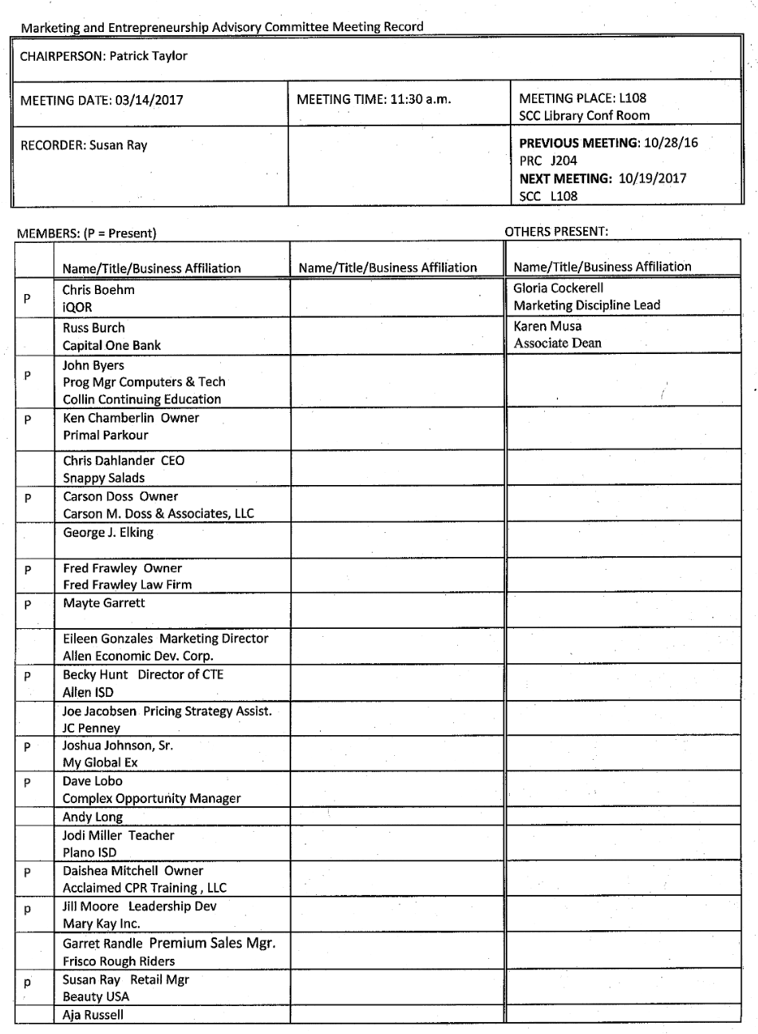
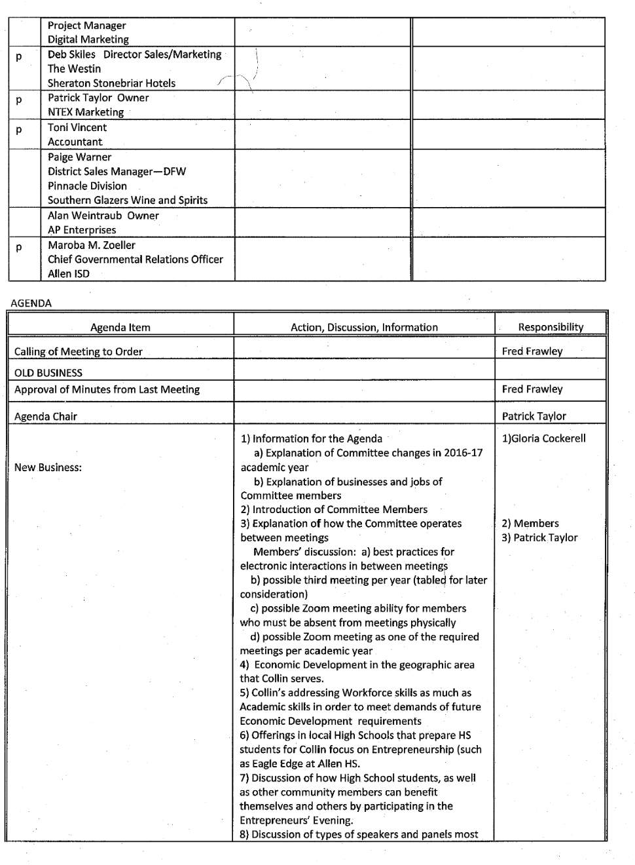
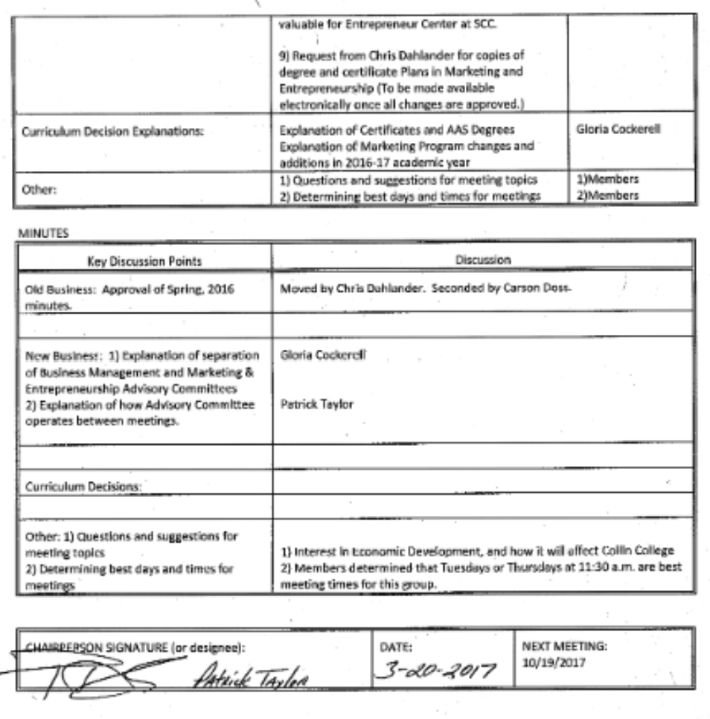

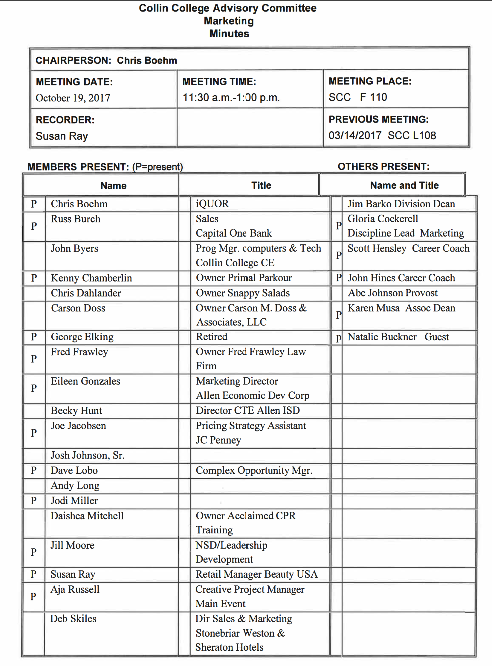
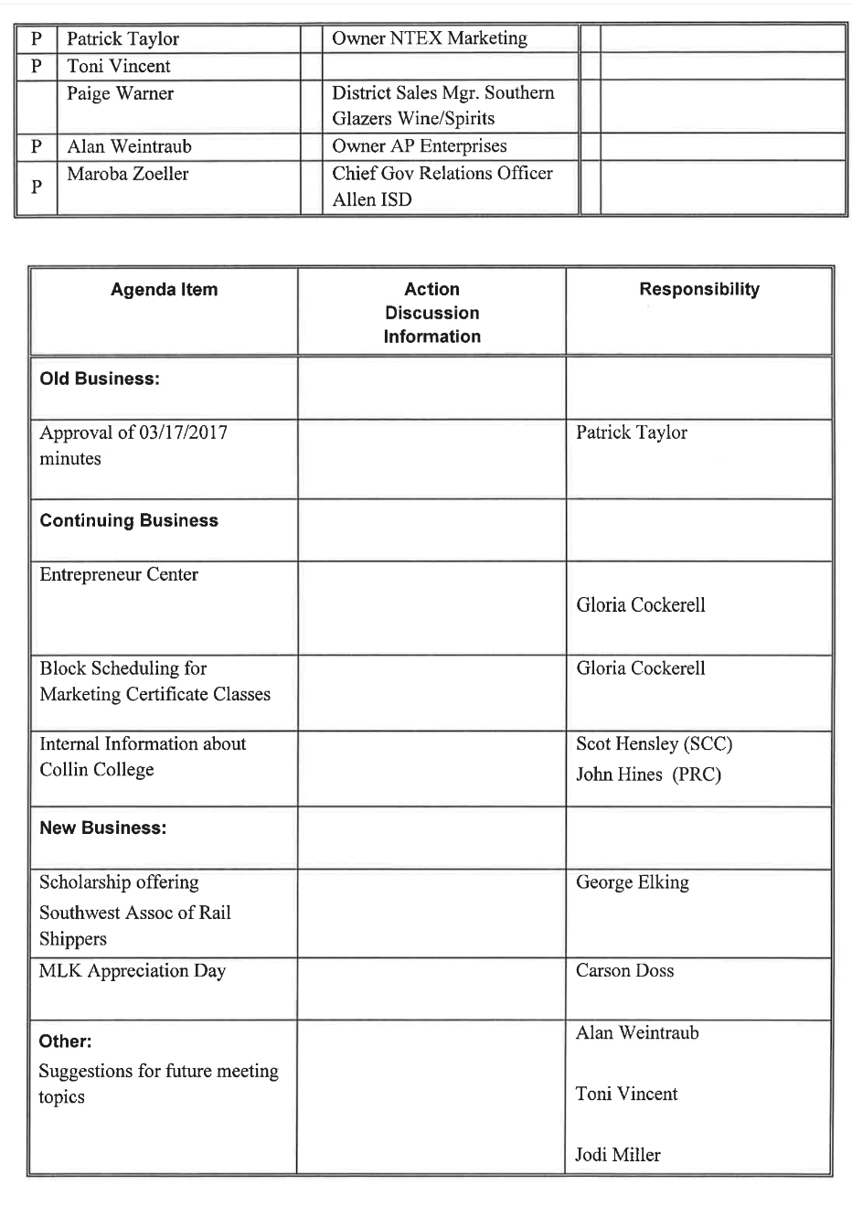

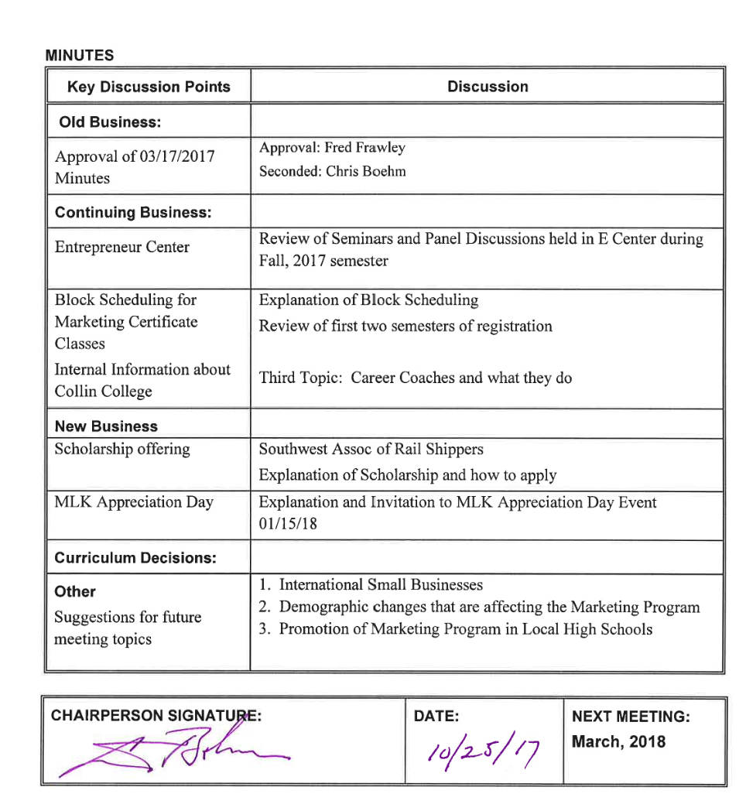

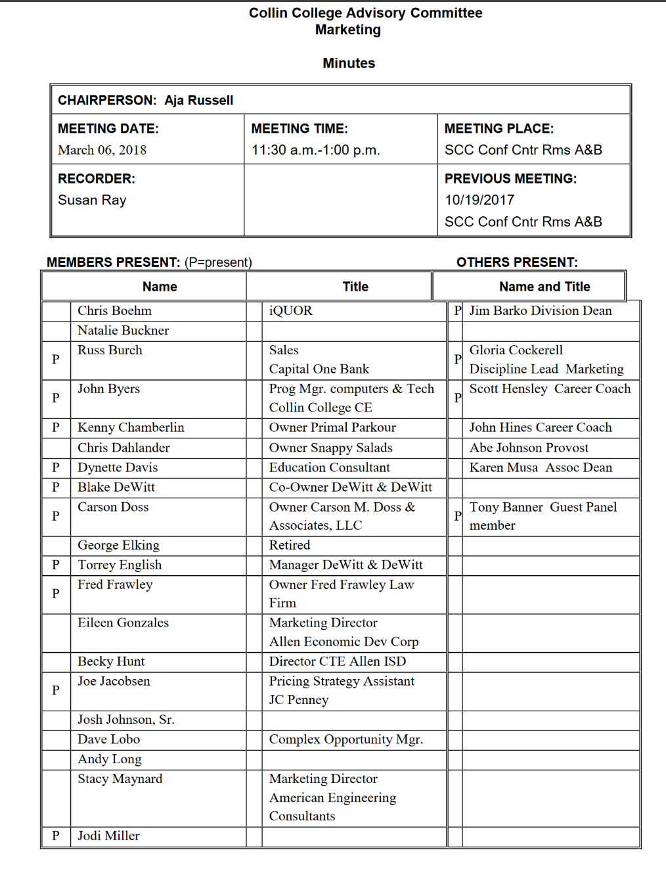
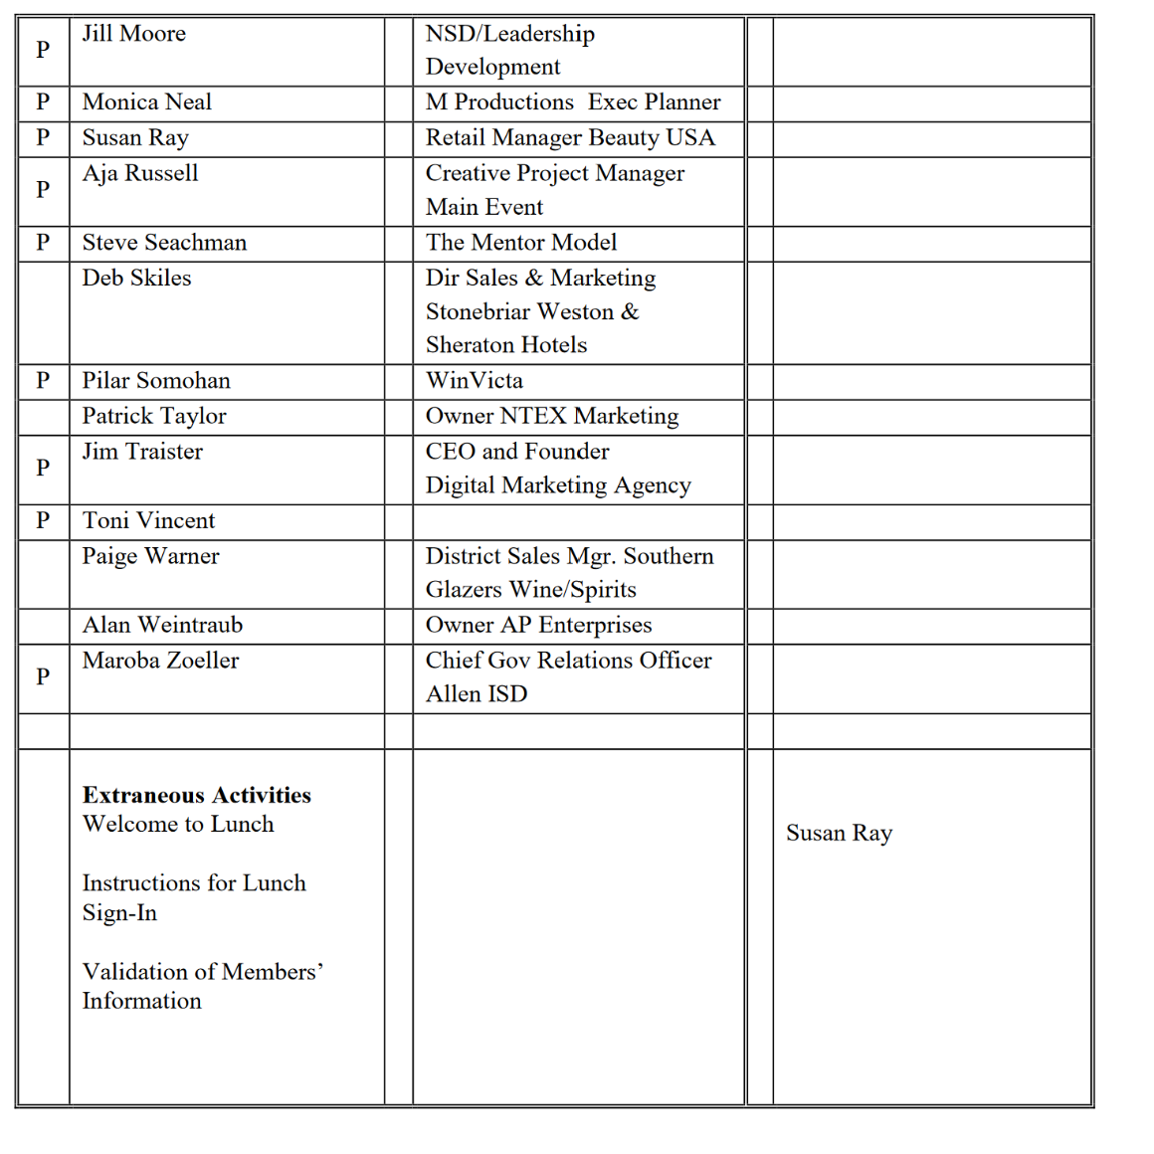
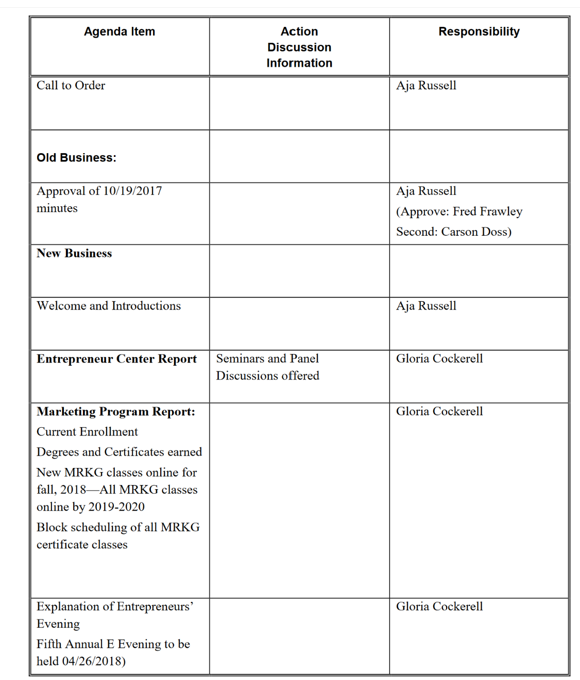

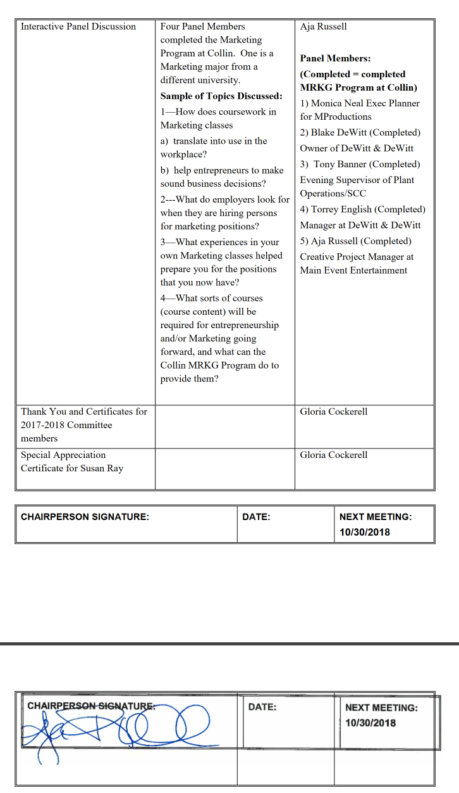
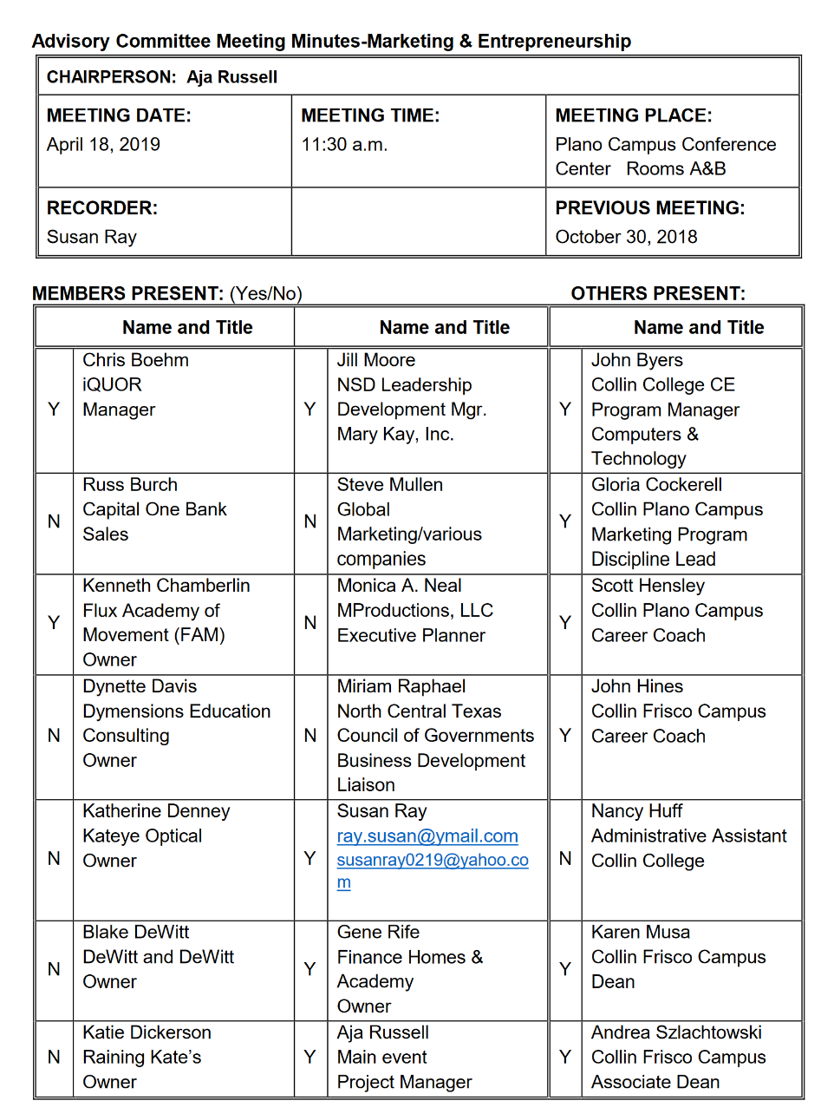

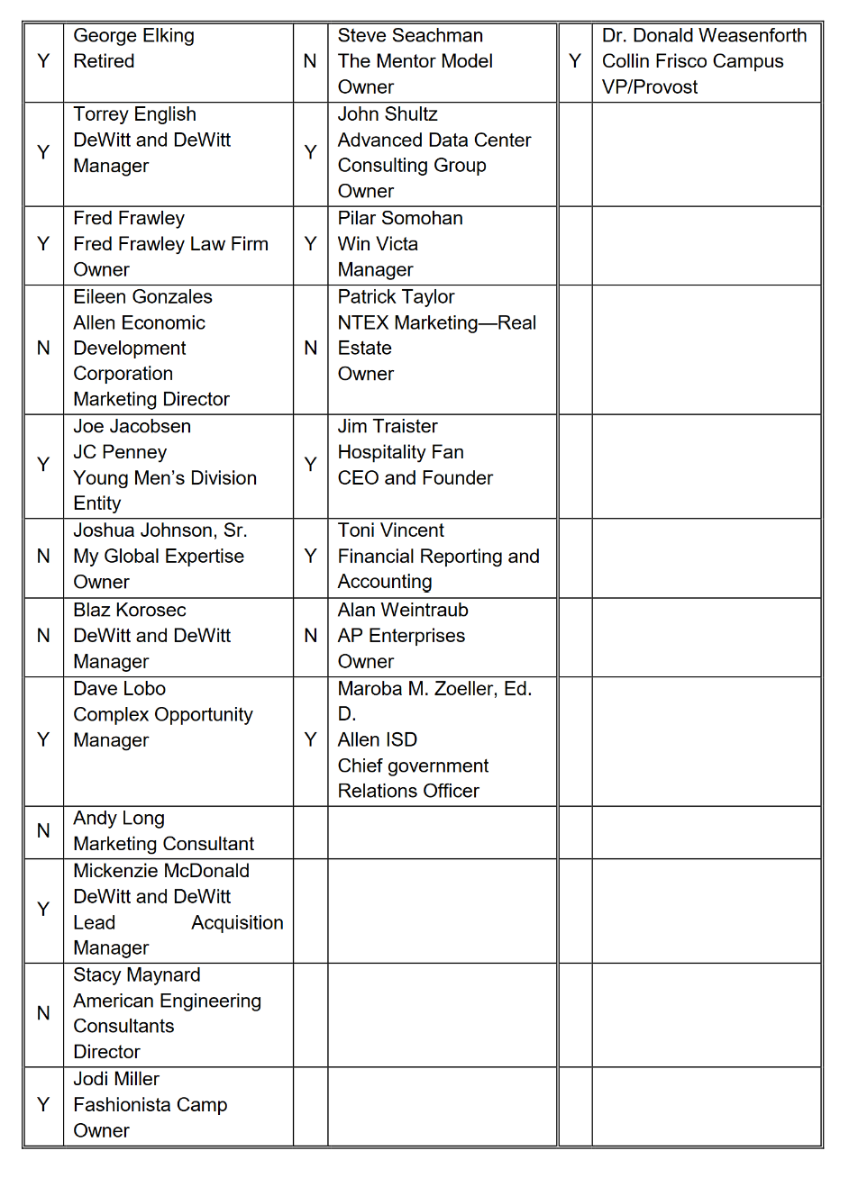

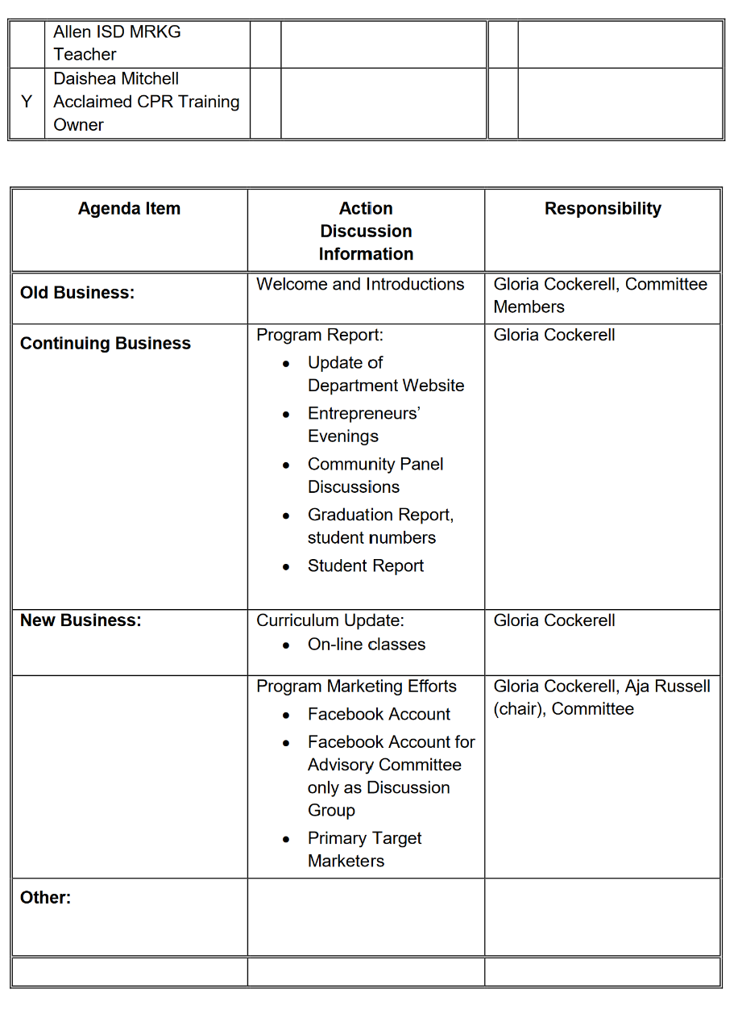
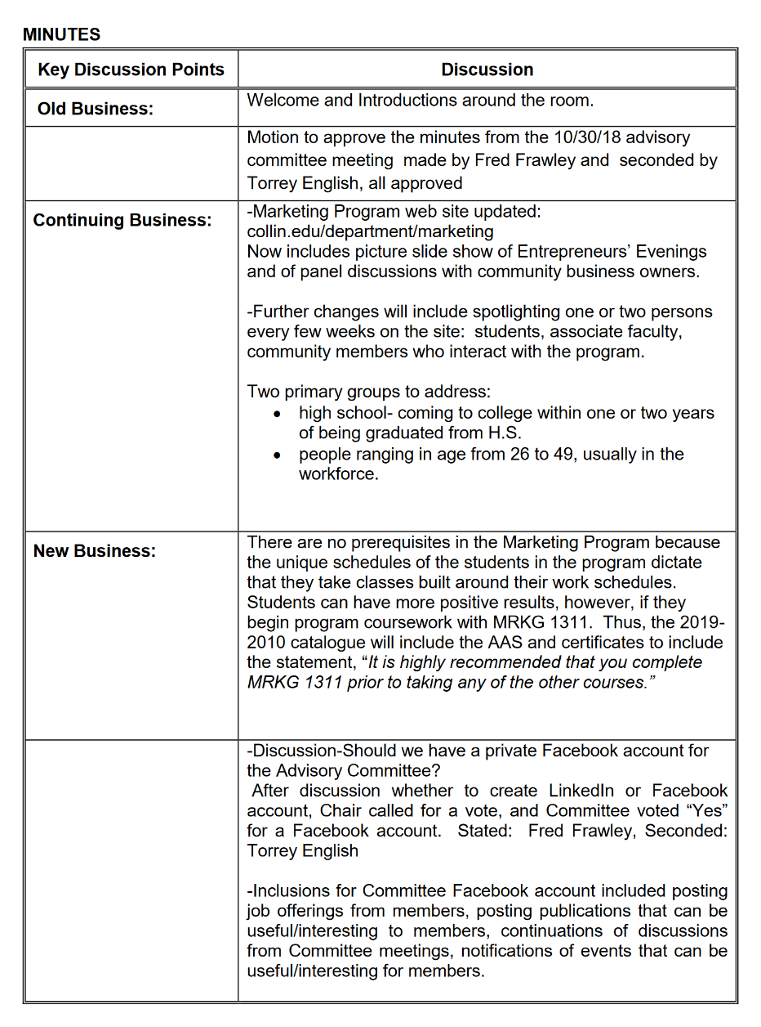

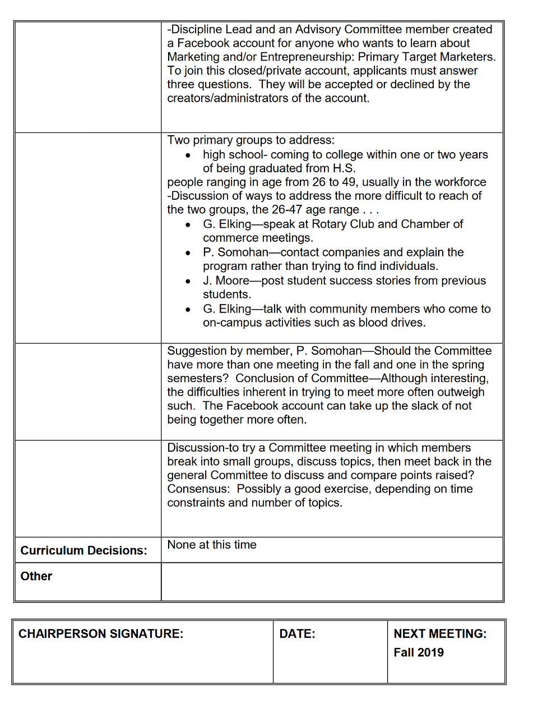

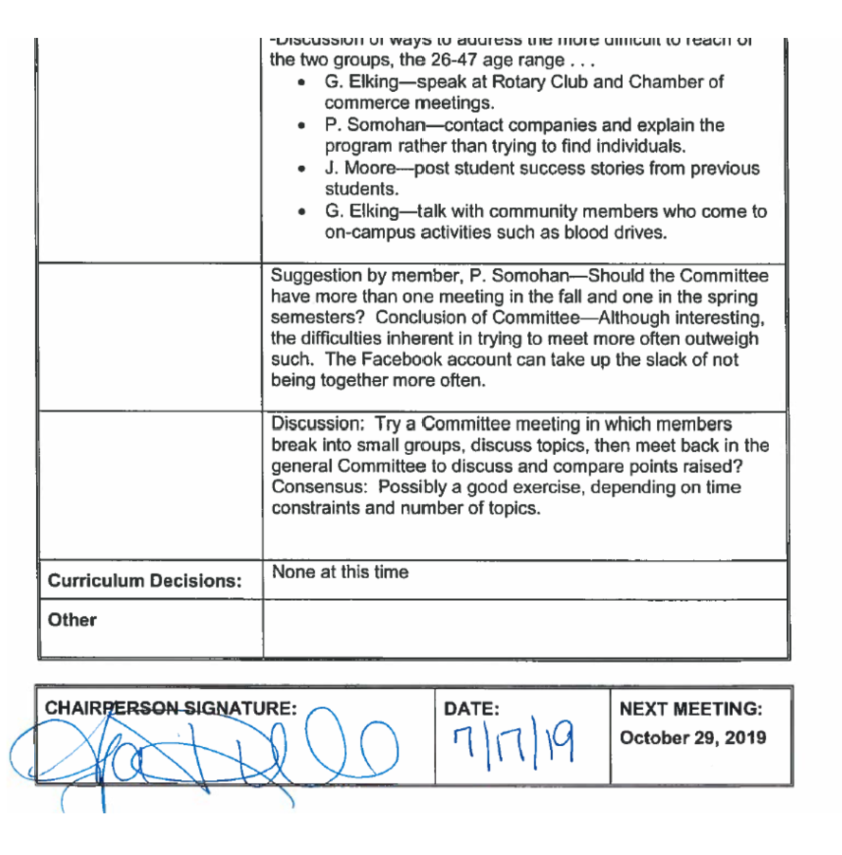

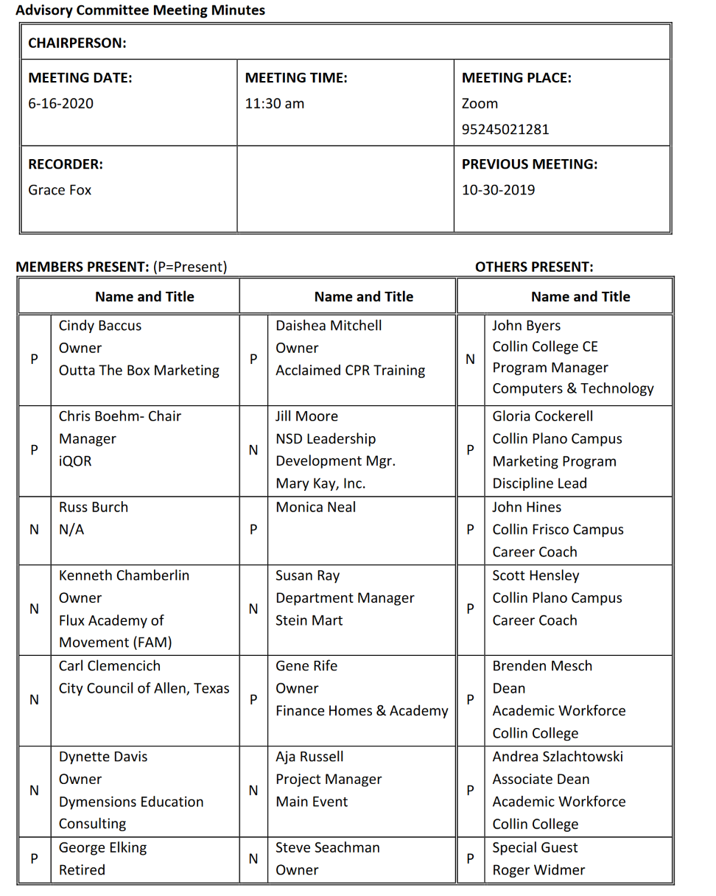

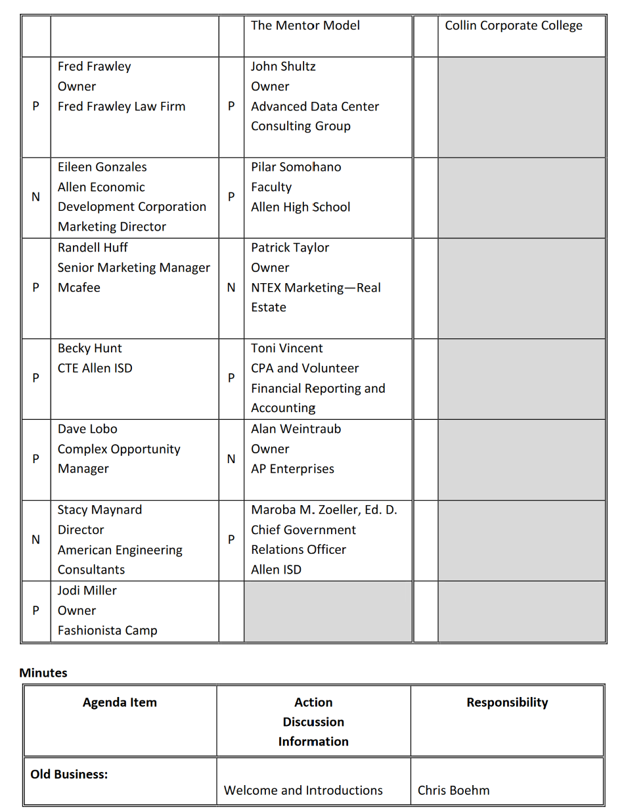
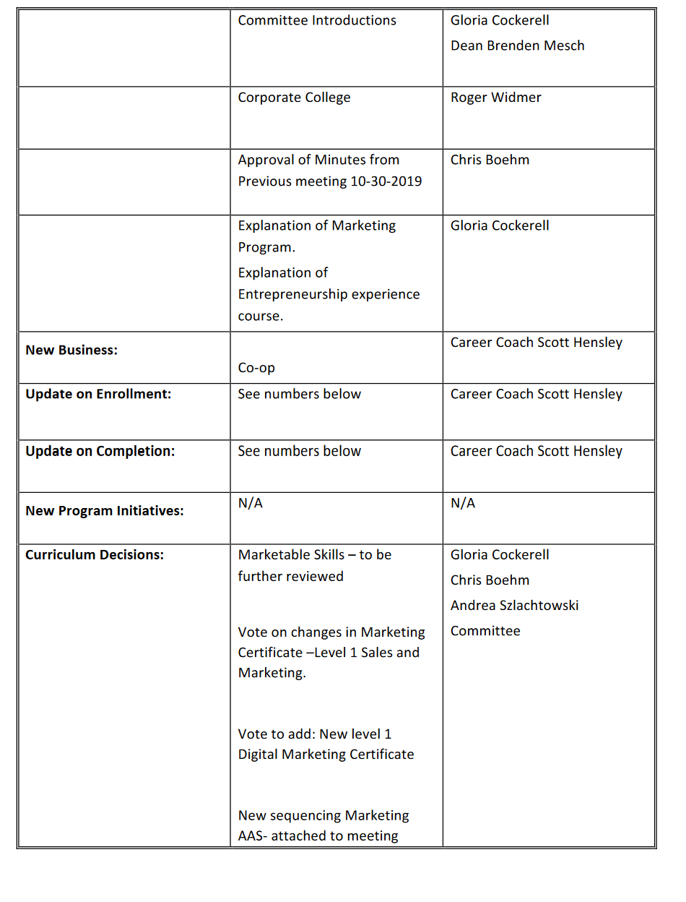
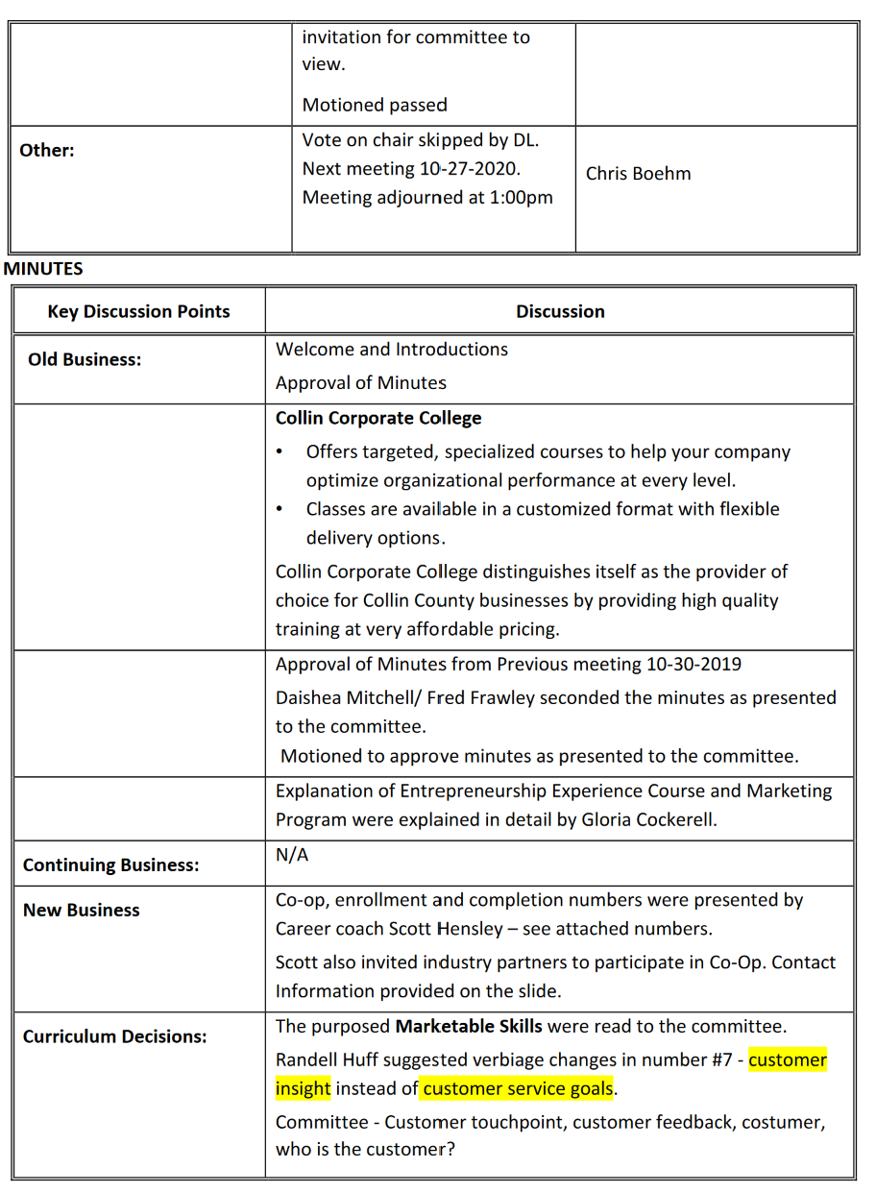
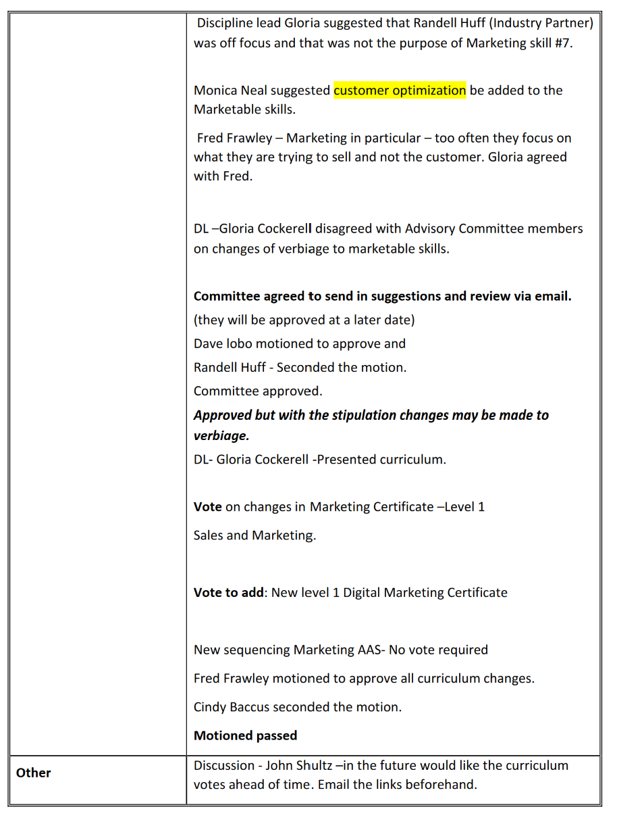
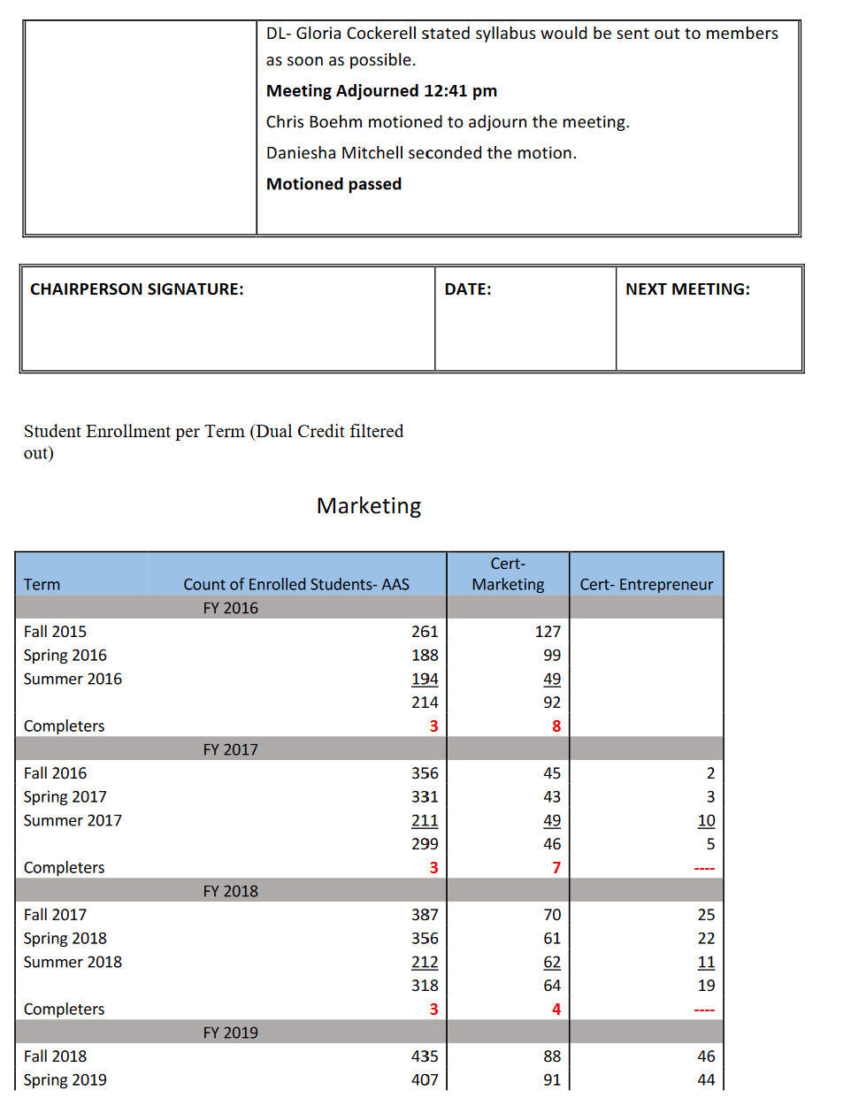
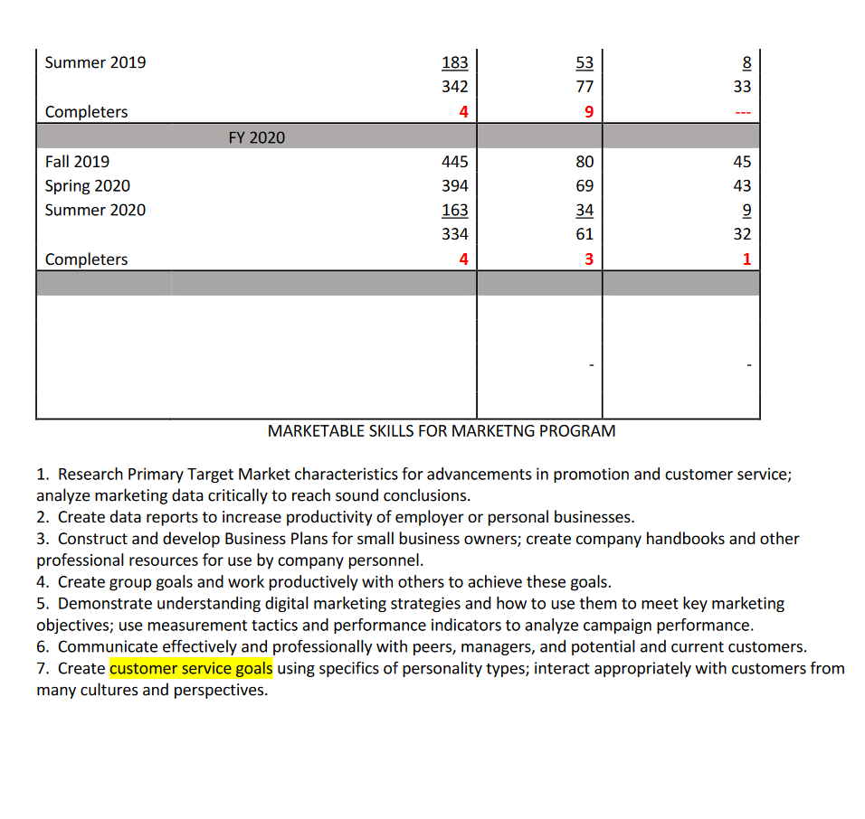
Advisory Committee Meeting Fall 2021 Minutes -- Marketing
CHAIRPERSON: Chris Boehm, Chair; Vice Chair: Fred Frawley
MEETING DATE:  November 11, 2021 | MEETING TIME:  11:30am - 12:30pm | MEETING PLACE:  Collin College, Plano Campus
RECORDER:  Scott Hensley |  | PREVIOUS MEETING:  April 22, 2021

MEMBERS PRESENT: (Yes/No) Collin College PRESENT:
Name and Title |  | Name and Title |  | Name and Title
N | 1. Baccus, Cindy, Owner, Outta the Box Marketing | Y | 14. Mitchell, Daishea, Owner, Acclaimed CPR  Training | Y | Dr. Dean Meredith Wang, Acad Affairs/Workforce
Y | 2. Boehm, Chris Manager, iQOR | N | 15. Moore, Jill, NSD Leadership Development, Mgr.,  Mary Kay, Inc | Y | Associate Dean Mark Fischer, Acad.  Affairs/Workforce
N | 3. Burch, Russ, | N | 16. Neal, Monica,  ?? ? | Y | Dr. Carl Rossini, Discipline Lead,  Marketing
N | 4. Chamberlin, Kenneth, Owner, Flux Academy of  Movement (FAM) | N | 17. Ray, Susan, Dept. Mgr., Stein Mart | Y | Gloria Cockerell, Faculty
N | 5. Clemencich, City Council,  Allen, TX | N | 18. Rife, Gene, Owner, Finance  Homes & Academy | Y | Karen Power, Faculty
N | 6. Davis, Dynette, Owner, Dymensions Education  Consulting | N | 19. Russell, Aja, Project Mgr, Main Event | Y | Scott Hensley, Workforce Programs Coach
N | 7. Elking, George,  Retired | N | 20. Schultz, John,  Owner, Advanced

Advisory Committee Meeting Minutes
Marketing
CHAIRPERSON: Chris Boehm
MEETING DATE  4-22-2021 | MEETING TIME:  11:30 am | MEETING PLACE:  Zoom  95245021281
RECORDER:  Grace Fox |  | PREVIOUS MEETING:  6-16-2020

MEMBERS PRESENT: (P=Present) OTHERS PRESENT:
Name and Title |  | Name and Title |  | Name and Title
P | Cindy Baccus  Owner  Outta The Box Marketing  Adjunct Collin College | N | Jill Moore  NSD Leadership Development Mgr.  Mary Kay, Inc. | N | John Byers  Collin College CE  Program Manager Computers & Technology
P | Chris Boehm- Chair  Manager  iQOR | P | Monica Neal  Senior Event Planner  MProductions | P | Gloria Cockerell  Collin Plano Campus  Marketing Program Discipline Lead
P | Kenneth Chamberlin  Owner  Flux Academy of Movement (FAM) | N | Susan Ray  Department Manager  Stein Mart | P | Grace Fox  Admin/ Meeting and Event Coordinator  Frisco Campus
N | Carl Clemencich  City Council of Allen | N | Gene Rife  Owner  Finance Homes & Academy | P | John Hines  Program Coach  Frisco Campus
P | Dynette Davis  Owner  Dymensions Education Consulting | N | Aja Russell  Project Manager  Main Event | P | Scott Hensley  Program Coach  Plano Campus
P | George Elking  Retired | N | Steve Seachman  Owner  The Mentor Model | P | Dr. Brenden Mesch  Dean  Academic Workforce  Collin College
P | Fred Frawley  Owner  Fred Frawley Law Firm | P | John Shultz  Owner  Advanced Data Center Consulting Group |  | Andrea Szlachtowski  Associate Dean  Academic Workforce  Collin College
P | Randell Huff  Senior Marketing Manager  Mcafee | P | John Shultz  Owner  Advanced Data Center Consulting Group
N | Becky Hunt  CTE Allen ISD | N | Patrick Taylor  Owner  NTEX Marketing—Real Estate
P | Dave Lobo  Complex Opportunity Manager | P | Toni Vincent  CPA and Volunteer  Financial Reporting and Accounting
P | Stacy Maynard  Director  American Engineering Consultants | N | Alan Weintraub  Owner  AP Enterprises
P | Jodi Miller  Owner  Fashionista Camp
P | Daishea Mitchell  Owner  Acclaimed CPR Training

Minutes
Agenda Item | Action  Discussion  Information | Responsibility
Old Business: | Welcome and Introductions  Committee Introductions | Chris Boehm  Gloria Cockerell  Dean Brenden Mesch
 | Approval of Minutes from Previous meeting 6-16-2020 | Chris Boehm
New Business: |  | Program Coach Scott Hensley  Program Coach John Hines
Update on Enrollment: | See numbers below | Program Coach Scott Hensley
Update on Completion: | See numbers below | Program Coach Scott Hensley
New Program Initiatives: | N/A | N/A
Curriculum Decisions: |  | Gloria Cockerell
Other: | Campus Construction update | Dr. Brenden Mesch
MINUTES
Key Discussion Points | Discussion
Old Business: | Welcome and Introductions were led by Chair-Chris Boehm.
Approval of Minutes from Previous meeting 6-16-2020
Chris Boehm called for a vote to approve the minutes from the previous meeting on 6-16-2020.
Fred Frawley motioned to approve the minutes as presented.
Stacy Maynard seconded the motion.
The motion carried, Minutes approved.
Continuing Business: | N/A  Chris Boehm mentioned that there is no old business to discuss.  Chris introduced Program Coach Scott Hensley .
New Business | Program Coach Scott Hensley went over Enrollment and Completion numbers with the committee.  Committee- Do you guys know what was the driver for the spike in enrollment?  The increase in marketing certificates between people participated in that program from 2018 to 2019, it was a jump it went from 15 enrollees to 121 and do you know what drove that increase in people enrolling in the Program?  John Hines – What the College did is we actually performed an audit of past students who had completed the classes, but not yet been given, and so this was actually catch up of that report. And something we did for this team, so they would be awarded their degrees.  Committee – John, I have a quick question so if you look at the national averages for graduations at a Community College on a two-year program, which is about 13% graduation rates. If it's normalized other factors can be up to 40% we're seeing here if I look at this data anywhere from around a 1% to 4% graduation rate and we know why we're. Less than a third of a normal graduation rate or, in some cases, Like 2% of a normal graduation rate?  Dr. Brenden Mesch  I’m going to answer that. Okay, I think one of the challenges is that our way of tracking who's a marketing student is limited so there's a lot of students that are taking marketing classes, they believe they're in the marketing associates or certificate. But they don't actually select that when they apply or when they update their degree plan so it's an interpretation of who we believe is in that marketing pathway. If we want to look at who is actually selected that pathway, here’s the crazy thing. Is that you could take classes outside of the marketing pathway, you could take nursing classes, if you wanted to and be a marketing student there's nothing in column that stops you. Our challenge is that we're trying to represent the most likely students, that are within a marketing pathway based upon their actual enrollment in classes. That may not represent the students also truly going for that associate or certificate. Some students take Marketing classes specifically to round out their other classes they're taking in a business field of study. We have other programs, where they have electives and they have options to take marketing as a way of furthering their skill set and we have students that because of the cost of college classes just decide hey I’m going to take it, It’s not anything that I have as a requirement for degree, but for $160 and the price of the book, it makes sense for me to take this additional class.  Committee -got you, so there's really no concept of a declared major that you can track against so when someone enters the middle to these are marketing and these were people that were declared marketing?  - Gloria Cockerell - There is now but we're having to make sure that students understand it, they just think.  - They signed up, they don't have a major and they start taking classes and I think gosh, this is biology and I love it I didn't know I’d love it and they keep taking it.  - Thinking now I’m a biology major that unless they do go down and do that, so one of the things that our program coaches Scott and John and others are doing now is making sure that they understand that and more and more of our professors are actually saying it. In fact, I just sent a message out about three weeks ago to everybody.  - If you have taken all these marketing courses by the time this semester is over, you have a marketing certificate go and apply for it here, and you know so we've got more of that in place now.  Scott Hensley - yeah and also kind of following up on what john Hines we had a major audit not too long ago it's I can't remember the date. But we found that there were a number of students that had never applied for the awards. Regardless of the major so it was kind of across the board, and so we did a lot of phone calls we started doing. A lot of surveys in class whenever we were in the coaches whenever we were invited into a class, we could do a survey and then through those surveys we'd get the student information.  Committee- I guess the big question I’ve got is, do you guys feel like moving forward you'll have a clearly declared marketing major then and you've kind of got most of the noise out of the system?  Gloria Cockerell – I feel so.  - Dr. Brenden Mesch,  - Let me jump in, I think we're in better shape, but I think one of the beauties and curses of our system of enrollment is that students can change  - Their major every day of the week, if they want to.  - It's a moving target, so what we do is we communicate to students about.  - This is what we think you are in, are you in this program you should be in this program and nine times out of 10 we get a response it's that other 10% where it's out there and we don't know if they've made that move we can't make the move for them.  - We can only give advice, so I think we're going to be better, and I think you know the other time here is 16 by 30 and that's kind of like the, the purpose of this audit.  - Is that we want to improve our student success rates with certificates and associate degrees and bachelor degrees now as well?  - Like paying closer attention to that and also providing kind of a roadmap for all of our programs so students understand that I’m in this associate, but there's this this embedded certificate.  - That halfway through my progress, I also get that degree so it's that messaging. I think it is working, but it's going to take some time.  - So, I don't think that you will know John when you come back next fall and you see the data, for you know spring 21 and fall 21.  - It's going to be miraculously perfect, I think it's going to improve the validity, the veracity of the information will improve over time, so you know we also we also have new data analysis systems that we didn't have back then.  - They are coming online so things should be looking better, but just don't want to paint a picture of it's going to be perfect, the next time we all get together  Scott Hensley – explained CO-OP to the Industry partners and invited them to participate. 320 hours are required  Questions?  Committee- How do we participate?  Reach out to COOP email address.  Question on Contract? Non –binding? Can a family member employ the student?  Scott Hensley – Non- binding, no on the family member.
Gloria Cockerell – Entrepreneurship Course
- I am going to go through it kind of quickly because I want to get to the stuff I’m excited about for today.
- But I am about this co-op, I have thought and kept co-op is the capstone for the marketing the entire time we used to have a whole department of co-op and it was it's been wonderful.
- But more and more and more over time, a higher and higher percentage of our students had their own businesses and also.
- Not as high percentage by any means that somewhat we have international students whose visas, do not allow them to work in the United States.
- And in either of those instances those students cannot take part in co-op so that was a real difficult kind of thing, so I had devised a course called entrepreneurship experience.
- And, quite frankly, with my little company Community Mark I go out into companies, and I can charge them a whole bunch of money for this, it is one on one consulting with the students.
- And they come in, first of all, and me course now we're doing it by zoom but.
- They devise packets of information that they're going to complete as the employee or owner employer of this business, then they switch places.
- You'll be surprised to know not everybody's wealthy and starts a business and puts it over for other people to do most of the vacuuming and watering the plants and making sure there's toilet tissue and all of this stuff.
- And so, they're working to and over the course of the Semester they complete this work and meet about every two weeks with the Faculty liaison and which right now happens to be me.
- We go through what they're doing and how it's going to add to what else is happening they're working on actual things that that you have to do when you own a business.
- And so they're putting together an employee handbook they're dealing with promotion aspects, all the things that we have to do if we have a business and then toward the end of the Semester.
- As they're working, they are evaluating what's going on.
- From the perspective of an employee and if they have actual employees, a lot of them don't.
- But if they have if you're opening a food place or daycare or eldercare or something you do have employees.
- So they're having those employees evaluate what they're doing, and then, as we get toward the end they have the final sessions to give a final overview evaluation of everything they did, and what changes they would make and how well it would work and it's 100% setup for their particular business, and this is also available.
- If somebody does work somewhere and could be in in co-op these, you can take either one of these classes.
- And if they do have a job, but they want to start a business or they're going into that once this semester is over, something they can do the entrepreneurship experience but that's what it is really a good learning tool and it's an overview of everything they've covered in all the classes they're dealing with, but also the APP today, this is what we do every day in a business.
Gloria went over all certificates and the AAS degree in great detail.
Slides 9- 14
The changes that were made and voted on at previous meetings.
Committee - so why would business ethics be optional that they can substitute, what made you decide?
Gloria Cockerell -
Every one of the other five classes is critical to a digital marketing certificate and although we would like to have people take business ethics. It is in the degree but it can be substituted.
Committee
- Gloria, this is Randall can jump in really quick?
- Sure, just because you've just missed it, I find that statement at the top around taking marketing 1311to be confusing because there's two other marketing classes in the first semester, so it would lead me to as a customer to kind of go why can’t I take those two at the same time, if it tells me I need to take its recommended take 1311 first. So, it's kind of your opinion, I take three marketing classes, but you're saying at the top is recommend you take this one first before you take the others?
Gloria Cockerell – I agree with you. This is how the curriculum office wanted it.
Committee
Just trying to represent the student and how they might be confused.
Committee
committee gave positive feedback.

Curriculum Decisions: | No Vote required – Gloria just wanted to fill the committee in with slides 9-14 on the changes voted at the previous meeting.
Committee Comments and Concerns
What are we doing to track the success of this program starting day one, so we don’t run into the same issues?
Gloria Cockerell - okay I’m going to ask Dean Mesch to go down and get on his broom and fly back and tell them - you better …. Some of the things he was talking about before are in place. Our program Coaches have better tracking information. The system itself is catching up.
Committee- Are the classes online or in person?
Both
Hybrid
Committee
Can we pop in on a session and see how it’s going?
Gloria Cockerell
Sometimes it can be intrusive, but I think they will welcome that.
Committee
Different measures of success?
What is your KPI for the digital Marketing?
Gloria Cockerell
Assessments that show how a particular class is being evaluated. They have to practice everything they learn in class.
Committee
Here’s the other part, not sure it’s measurable. I can take your class, and I can digest the material and I can do good on the test but I may leave the class thinking it was worth it or it was not worth my time, I am going to pass it.
Gloria Cockerell
Randall, you would be wrong.
Well, Randall. Randall, they don't just read something to take a test, there are so many different ways to assess their abilities to learn it.
- They have audio visual presentations that they have to create and present they critique those of others, they take quizzes and exams, of course. Strategic the strategies that social media marketing, they have to create an advertising campaign based on what they're learning so they have to show that they know how to do it, this is.

- Committee
- I was asking if they found it a value? I can succeed is if the ended, I find it a value that I would recommend it to somebody else, so you get the word of mouth out. I was asking if they found it a value?
- Gloria Cockerell
That's OK, we have student evaluations, at the end of each class in fact I did on 18th of this month and students go in and vet and evaluate different things, like what they learned and what they learn best. What could the teacher have done better that kind of thing.
- Another thing is that a lot of us asked students to write reflection papers, at the end I’ve got that in my classes to write a reflection paper.
Committee
So that's great, I guess. I guess what I would say, is to write it down and you say success for this new course is that we receive a score of four or greater from our evaluations, at the end of the course.
- And you have documented and you measure against it, so you can see that what.
- The new ones were but that's it.
Gloria Cockerell Why?
Committee
I don't want to bog you down I.
Gloria Cockerell
Know absolutely the questions are really good and we need to have them noted. If we didn't think about it and Brenden, did you want to address that?
Committee -You took us off mute Brenden.
Dr. Brenden Mesch
Alright, so yeah, I was going to say the student evaluations that's a really good thing. The lens into the class, but then you know back to Randall’s question about 1311 needs to be taken, initially.
And in the catalog it lists it after 1301, how do we communicate that so Gloria didn't mention that we have another way of conveying that information, so we have a curriculum map that we share.
- Students where it shows them like all right take these classes first number one because they're going to you're not going to define a pre REC laws.
- But then also we want you to take these classes, first because you're going to walk away with a certificate, if you take them in this sequence, and it goes into detail about you know which ones might be.
- Eight week versus 16 weeks and which ones also are offered during certain terms, so t's a lot more visibility than we are able to provide, in the course catalog and it's you know greatly enhancing our student’s ability to understand what are they need to do.
Chris Boehm - Chair
Brendan we're short on time, but if you don't mind going over the update on the new campuses and then, if we have some extra time we can go back to the subject and talk about it, some more if that's okay.
Dr. Brenden Mesch
That sounds good, so no other questions for Gloria on curriculum?
Committee- I wanted to follow up on something Randall said because he suggested an evaluation afterwards, but what about one before. Like if they determine before, when I heard about this course, this is what I was feeling I would get out of it at the beginning and then at the end a follow up to see if it met their expectation?
Gloria Cockerell
I do that in my classes and some of my faculty do, and certainly you know, we can ask faculty to do that a lot of us just do that anyway, but I don't think it’s a not a college policy that we did.
Dr. Brenden Mesch
I think it's I think it's a good idea.
Gloria Cockerell
Good idea, I think.
Dr. Brenden Mesch
You know you might get some students they're like hey I really like Facebook and Twitter and I’m doing all kinds of crazy stuff on there, and I want to take this class, for that reason.
- And their perception of digital marketing is not really where it should be so you know kind of right sizing that but also, I think that that might be useful to the Faculty to understand who's the audience and you know.
- If they have already used, you know, a social media management system, then all right, do we need it up the level of the game for this particular cohort and provide more.
- Detailed instruction so it's a good thing to add in because it's all new I mean, so we want to do it the right way, the first time, but we know we're going to probably get some things back from students that will help us improve and for the second, third and fourth time.
Gloria Cockerell
I do this in my introductions at the beginning of this of the any class. I asked them to send me in writing exactly what you're talking about Tony and then, as I, and I can use that.
- Maybe I’m doing all those things that I need to as Brendan saying retrofit it to go with the people that I see in the primary target of that class?
- So, it may not be exactly the same way for each class but yeah absolutely, that was excellent ideas. I like those we can actually add that is something we need to put in each syllabus if we wanted to.
Dr. Brenden Mesch
Well, I think that's great folks, let me try to go and three to four minutes and let's have some time at the end to discuss anything.
- It's a really exciting time for Collin College we're opening campuses left and right, we have the Wylie campus and the Allen technical campus they opened in the fall and doing really well, we also have there's
- We also have.
- Celina that's opening up in fall 2021 and that's just up the road from Frisco we're going to have some workforce classes there we're going to have dual credit there we're also going to have.
- Traditional transfer programs like you know business field of study Farmersville, it says 2021 and it technically opened up in the spring, so they have students that are now taking courses.
- There's going to be a high emphasis on workforce courses, as well as dual credit at that campus, at least for the first couple years.
- And I think that a really exciting thing .On the Frisco campus where I’m based is , we have a 92,000 square foot building that is.
- 500 computing devices.
Other | Meeting Adjourned  Chair –Chris Boehm called for a motion to adjourn the meeting.  Antoinette Vincent made the motion  Stacy Maynard seconded the motion  Motion carried, meeting adjourned  12:42 pm

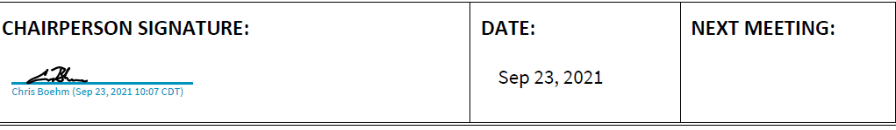

Term | Count of Enrolled Students- AAS (MKTT) | Cert- Marketing (MARK) | Cert- Entrepreneur (ENTR)
FY 2017
Fall 2016 | 225 | 28 | 1
Spring 2017 | 213 | 19 | 2
Summer 2017 | 191 | 9 | 9
 | 629 | 56 | 12
Completers | 3 | 7 | ----
FY 2018
Fall 2017 | 267 | 7 | 9
Spring 2018 | 257 | 5 | 8
Summer 2018 | 200 | 3 | 10
 | 724 | 15 | 27
Completers | 3 | 4 | ----
FY 2019
Fall 2018 | 328 | 29 | 46
Spring 2019 | 296 | 37 | 44
Summer 2019 | 181 | 55 | 8
 | 805 | 121 | 98
Completers | 4 | 6 | ---
FY 2020
Fall 2019 | 437 | 80 | 45
Spring 2020 (Covid) | 388 | 68 | 43
Summer 2020 | 174 | 38 | 9
 | 999 | 186 | 97
Completers | 8 | 8 | 1
FY 2021
Fall 2020 | 383 | 48 | 19
Spring 2021 | 338 | 41 | 18
Summer 2021 | 45 | 4 | 3
 | 766 | 93 | 40
Completers | 1

Advisory Committee Meeting Fall 2021 Minutes -- Marketing
CHAIRPERSON: Chris Boehm, Chair; Vice Chair: Fred Frawley
MEETING DATE:  November 11, 2021 | MEETING TIME:  11:30am - 12:30pm | MEETING PLACE:  Collin College, Plano Campus
RECORDER:  Scott Hensley |  | PREVIOUS MEETING:  April 22, 2021

MEMBERS PRESENT: (Yes/No) Collin College PRESENT:
Name and Title |  |  | Name and Title |  | Name and Title
N | 1. Baccus, Cindy, Owner, Outta the Box Marketing |  | Y | 14. Mitchell, Daishea, Owner, Acclaimed CPR  Training | Y | Dr. Dean Meredith Wang, Acad Affairs/Workforce
Y | 2. Boehm, Chris Manager, iQOR |  | N | 15. Moore, Jill, NSD Leadership Development, Mgr.,  Mary Kay, Inc | Y | Associate Dean Mark Fischer, Acad.  Affairs/Workforce
N | 3. Burch, Russ, |  | N | 16. Neal, Monica,  ?? ? | Y | Dr. Carl Rossini, Discipline Lead,  Marketing
N | 4. Chamberlin, Kenneth, Owner, Flux Academy of  Movement (FAM) |  | N | 17. Ray, Susan, Dept. Mgr., Stein Mart | Y | Gloria Cockerell, Faculty
N | 5. Clemencich, City Council,  Allen, TX |  | N | 18. Rife, Gene, Owner, Finance  Homes & Academy | Y | Karen Power, Faculty
N | 6. Davis, Dynette, Owner, Dymensions Education  Consulting |  | N | 19. Russell, Aja, Project Mgr, Main Event | Y | Scott Hensley, Workforce Programs Coach
N | 7. Elking, George,  Retired |  | N | 20. Schultz, John,  Owner, Advanced
 |  | There was some discussion re: the option of sending out Minutes by email and having the Committee approve the Minutes by email.  Mr. Boehm moved the discussion to the current Academic state of the AAS Marketing Program.  Dr. Rossini suggested the Program has “no scaffolding,” which allows students to enroll into classes as they like, without any specific/visible degree plan.  This approach has advantages, according to Professor Cockerell, in that many of the Marketing students are getting the courses |  |  |  |  | Dr. Carl Rossini, Discipline Lead
New Business/ Discussio n |  | and training needed without having to follow a specific degree path.  AD Mark Fischer pointed out there is still some need for this type of flexibility, but |  |  |  |  | Chair Boehm Dr. Rossini
 |  | reminded the Committee the goal, along with retention, is completion/graduation. Dr. Rossini mentioned that MRKG 1311-  Principles of Marketing is an unofficial |  |  |  |  | Chair Boehm Dr. Rossini
 |  | prerequisite for some of the higher level MRKG courses. Prof. Cockerell added that there are pre and co-requisites in place, (MRKG 2371 and 2372) for some of the higher-level courses and this helps to provide some strength to the “flexible” degree plan scaffolding. |  |  |  |  | Chair Boehm Dr. Rossini
 |  | Professor Karen Power stated MRKG 1311- Principles of Marketing should be an “official” prerequisite, while Prof.  Cockerell stated having MRKG 1311 as a prerequisite would “restrict potential students from enrolling.”  Fred Frawley agreed MRKG 1311 should become a prerequisite. |  |  |  |  | Chair | Boehm
 |  | Associate Dean Fischer asked the Committee: Completion numbers are very few—"are students just taking a few classes then leaving?” |  |  |  |  | Chair | Boehm
New Business/ Discussio n |  | Randall Huff asked about the Collin College/Marketing Program: “What is the mission/goal?” Is it completion or is it the number of students enrolled? Is the Program data-driven? We must know the consequences of the data. Who is the “Target Audience?” Is the Program accomplishing the goals it has set for itself: completion/retention? Mr. Huff emphasized: If the goal is completion, the students need to stick to the degree plan. |  |  |  |  | Chair | Boehm
 |  | AD Fischer mentioned the possibility of working with the Continuing Education (CE) department, which would focus more on skills, while allowing the for-credit students to stick to the degree plan.  Dean Wang added that separating CE and Dual Credit students, from the AAS Degree seekers could be a viable option. |  |  |  |  | Chair Boehm Dr. Rossini
New Business/ Discussio n |  | Prof. Power mentioned it is possible for students going the CE route would lose sight of the “Big Picture.” |  |  |  |  | Chair | Boehm
 |  | Professor Karen Power stated MRKG 1311- Principles of Marketing should be an “official” prerequisite, while Prof.  Cockerell stated having MRKG 1311 as a prerequisite would “restrict potential students from enrolling.”  Fred Frawley agreed MRKG 1311 should become a prerequisite. |  |  |  |  | Chair | Boehm
 |  | Associate Dean Fischer asked the Committee: Completion numbers are very few—"are students just taking a few classes then leaving?” |  |  |  |  | Chair | Boehm
New Business/ Discussio n |  | Randall Huff asked about the Collin College/Marketing Program: “What is the mission/goal?” Is it completion or is it the number of students enrolled? Is the Program data-driven? We must know the consequences of the data. Who is the “Target Audience?” Is the Program accomplishing the goals it has set for itself: completion/retention? Mr. Huff emphasized: If the goal is completion, the students need to stick to the degree plan. |  |  |  |  | Chair | Boehm
 |  | AD Fischer mentioned the possibility of working with the Continuing Education (CE) department, which would focus more on skills, while allowing the for-credit students to stick to the degree plan.  Dean Wang added that separating CE and Dual Credit students, from the AAS Degree seekers could be a viable option. |  |  |  |  | Chair Boehm Dr. Rossini
New Business/ Discussio n |  | Prof. Power mentioned it is possible for students going the CE route would lose sight of the “Big Picture.” |  |  |  |  | Chair | Boehm
Mr. Huff suggested there is a need to reinforce Soft and other skills across the various classes.
Chair Boehm discussed next meeting time and AD Fischer mentioned the importance of Advisory Committee membership.
Motion made by Mr. Frawley to adjourn meeting. Mr. Huff seconded the Motion. Meeting was adjourned without dissension.

CHAIRPERSON SIGNATURE: | DATE:  4/28/2022 | NEXT MEETING:
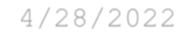

Continuous Improvement Plan

Outcomes might not change from year to year. For example, if you have not met previous targets, you may wish to retain the same outcomes. If this is an academic, workforce, or continuing education program, you must have at least one student learning outcome. You may also add short-term administrative, technological, assessment, resource or professional development goals, as needed.

Date: 4/22/2020 Name of Program/Unit: Marketing
Contact name: Gloria Cockrell
Contact email: Contact phone:
Table 1: CIP Outcomes, Measures & Targets Table (focus on at least one for the next two years)
A. Expected Outcome(s)  Results expected in this unit  (e.g. Authorization requests will be completed more quickly; Increase client satisfaction with our services) | B. Measure(s)  Instrument(s)/process(es) used to measure results  (e.g. survey results, exam questions, etc.) | C. Target(s)  Level of success expected  (e.g. 80% approval rating, 10 day faster request turn-around time, etc.)
The Program will demonstrate increasing numbers of completers. | Use of IRO enrollment figures for semesters after the Program puts new recruitment processes into place | Five Completers
Students will demonstrate the ability to perform job-description duties in actual workforce settings. | On-site managers’ evaluations of work performance using evaluation rubric from co-op department OR the evaluation rubric for the Entrepreneurship Experience course. | Grade of B

Description of Fields in the Following CIP Tables:
A. Outcome(s) - Results expected in this program (e.g. Students will learn how to compare/contrast conflict and structural functional theories; increase student retention in Nursing Program).
B. Measure(s) - Instrument(s)/process(es) used to measure results
(e.g. results of surveys, test item questions 6 & 7 from final exam, end of term retention rates, etc.)
C. Target(s) - Degree of success expected (e.g. 80% approval rating, 25 graduates per year, increase retention by 2% etc.).
D. Action Plan - Based on analysis, identify actions to be taken to accomplish outcome. What will you do?
E. Results Summary - Summarize the information and data collected in year 1.
F. Findings - Explain how the information and data has impacted the expected outcome and program success.
G. Implementation of Findings – Describe how you have used or will use your findings and analysis of the data to make improvements.
Table 2. CIP Outcomes 1 & 2 (FOCUS ON AT LEAST 1)

- Outcome #1
*The Program will demonstrate increasing numbers of completers.

- Measure (Outcome #1)  Use of IRO enrollment figures for semesters after the Program puts new recruitment processes into place | - Target (Outcome #1)  Five Completers
- Action Plan (Outcome #1)
The Program will implement social media accounts for former, current, and potential Marketing students, create a Program promotion piece, and organize visits to high schools by current and former Marketing students. In addition, the discipline lead will suggest to all Program faculty that they include in their Canvas classes the information for petitioning for degrees and certificates.
- Results Summary (Outcome #1)
With one exception (academic year 2017-2018), enrollment has stayed strong, with an addition of students completing in summer terms ((2016-2017 and 2017-2018). Unduplicated: 2015-2016 = 11 2016-2017 = 10 2017-2018 = 7 (a bit lower, but with three completers in summer terms
- 1
- Findings (Outcome #1)
Promotion pieces published in the Marketing Program’s Facebook account, as well as in that of Collin College resulted in inquiries by potential students. In addition, postings on the Marketing Program’s web site generated such inquiries that came directly to the discipline lead of the Marketing Program.
- Implementation of Findings
The Marketing Program launched all parts of the Action Plan with one exception: there is a prohibition against programs’ visiting high schools, so, even though scheduled, such visits never took place. Although faculty have not followed through on sharing information about petitioning for degrees and certificates, the Program Discipline Lead worked with Career Coaches to set up such information sharing with students; such has since become part of the responsibilities of Career Coaches. As a result of this better communication between Collin College and students, more students and potential students stay in regular contact with both the discipline lead and Career Coaches.

- Outcome #2
Students will demonstrate the ability to perform job-description duties in actual workforce settings.

- Measure (Outcome #2)  On-site managers’ evaluations of work performance using evaluation rubric from co-op department OR the evaluation rubric for the Entrepreneurship Experience course. | - Target (Outcome #2)  Grade of B or higher
- Action Plan (Outcome #2)
Students who earn the AAS in Marketing have as their capstone class, co-op, for which they are evaluated by their managers in the workforce, using an evaluative instrument provided by the co-op department. Students may substitute for the co-op class, the Entrepreneurship Experience course, which has its own evaluation instrument.
- Results Summary (Outcome #2)
Some students are not able to take the co-op course: those whose visas will not allow their working in the united states, those who own their own businesses and therefor have no managers above them. The Entrepreneurship Experience course, a Local Need course, allows them to complete their degrees.
- Findings (Outcome #1)
Students who are not able to take the co-op course now do not, as in the past, simply discontinue their work toward the Marketing AAS, but take instead the Entrepreneurship Experience course, allowing them not only to be completers, but also to learn about operating their businesses what would take them years in the workplace. Students who take the Entrepreneurship experience course have consistently earned excellent grades in the class, with two exceptions, one failure caused by personal problems, and one B simply because of quality of work. The Entrepreneurship Experience is an individual, independent study class, not a regular class with a minimum of 15 students, and there are two-to-five students each term. The numbers are steady throughout the academic year, with summer terms averaging two students and long terms boasting four or five. Out of 9 students enrolled in BUSG 2371 in 2019, 6 received a grade of B or higher.
- Implementation of Findings
The actions of Career Coaches is especially valuable in informing students about the Entrepreneurship Experience course and letting them know that they have the option of choosing either that or the co-op course. The Discipline Lead works closely with Career Coaches to interview and approve student participation in either course. The Marketing Program is richer for having available both the co-op course which allows students to work in businesses that they most likely would not have been able to do, under the guidance of managers and faculty members, and the Entrepreneurship Experience course which allows students who operate their own businesses to act as both manager and employee and then evaluate how well or poorly managerial decisions contributed to the success of the business. The experience of students who take this Entrepreneurship class is highly useful for them, and without exception they note how much better they understand how to operate their businesses after completing the various projects of the class. Perhaps most useful is the fact that they take first the role of the owner/entrepreneur as they devise best practices for their businesses, then the role of the employee as they actually use the strategies put into place by the employer role. Finally, they return to the role of owner and evaluate how well the strategies that they devised are contributing to their businesses.

Continuous Improvement Plan

Outcomes might not change from year to year. For example, if you have not met previous targets, you may wish to retain the same outcomes. If this is an academic, workforce, or continuing education program, you must have at least one student learning outcome. You may also add short-term administrative, technological, assessment, resource or professional development goals, as needed.

Date: 2/1/2022 Name of Program/Unit: Marketing
Lead Instructor: Dr. Carl Rossini, Jr.
Contact: cdrossini@collin.edu, 214.205.8912

Table 1: CIP Outcomes, Measures & Targets Table (focus on at least one for the next two years)
- Expected Outcome(s)  Results expected in this unit  (e.g. Authorization requests will be completed more quickly; Increase client satisfaction with our services) | B. Measures  Instrument(s)/process(es) used to measure results  (e.g. survey results, exam questions, etc.) | C. Target(s)  Level of success expected  (e.g. 80% approval rating, 10 day faster request turn-around time, etc.)
- The Program will demonstrate increasing numbers of completers. | Use of IRO enrollment figures for semesters after the Program puts new recruitment processes into place | Five Completers
- Students will demonstrate the ability to perform job-description duties in actual workforce settings. | On-site managers’ evaluations of work performance using evaluation rubric from co-op department OR the evaluation rubric for the Entrepreneurship Experience course. | Grade of B
Description of Fields in the Following CIP Tables:
A. Outcome(s) - Results expected in this program (e.g. Students will learn how to compare/contrast conflict and structural functional theories; increase student retention in Nursing Program).
B. Measure(s) - Instrument(s)/process(es) used to measure results
(e.g. results of surveys, test item questions 6 & 7 from final exam, end of term retention rates, etc.)
C. Target(s) - Degree of success expected (e.g. 80% approval rating, 25 graduates per year, increase retention by 2% etc.).
D. Action Plan - Based on analysis, identify actions to be taken to accomplish outcome. What will you do?
E. Results Summary - Summarize the information and data collected in year 1.
F. Findings - Explain how the information and data has impacted the expected outcome and program success.
G. Implementation of Findings – Describe how you have used or will use your findings and analysis of the data to make improvements.

- Outcome #1
*The Program will demonstrate increasing numbers of completers.
Please see attached chart after this table.

- Measure (Outcome #1)  Use of IRO enrollment figures for semesters after the Program puts new recruitment processes into place | - Target (Outcome #1)  Five Completers  Actual:  Fall, 2019 – four (4) completers  Spring, 2020 – eight (8) completers  Summer, 2020 – five (5) completers  Fall, 2020 – two (2) completers (COVID)  Spring, 2021 – five (5) completers  Summer, 2021 in progress
- Action Plan (Outcome #1)
The Program will implement social media accounts for former, current, and potential Marketing students, and create a Program promotion piece. In addition, the discipline lead will suggest to all Program faculty that they include in their Canvas classes the information for petitioning for degrees and certificates.
Assessment Goals - 2022:
- A survey to collect and evaluate student goals for their education in Marketing department is underway; those student goals will be evaluated to define “success” in terms of student goals.
- Marketing department information in the Collin Web site will be updated, so that it is current and accurate.

- Results Summary (Outcome #1)
With one exception (academic year 2017-2018), enrollment has stayed strong, with an addition of students completing in summer terms ((2016-2017 and 2017-2018). Unduplicated: 2015-2016 = 11 2016-2017 = 10 2017-2018 = 7 (a bit lower, but with three completers in summer terms.

The measurement of “completers” captures students who have met their educational goals of an associates degree and a certificate. The survey of student goals underway will also comprehend and allow the reporting of the percent of students responding students who have other educational goals (see below). The results may show that the current measure of “completers” is too narrow to fully measure the success of the department in meeting its mission.
- Are taking classes to increase job opportunities
- Seeking promotion in current job
- Increase knowledge base while seeking employment
- Seeking or maintaining licensure
- Seeking Bachelor’s degree
- Lifelong learning
- Findings (Outcome #1)
Updates to the Program Website are scheduled for 2023, and skills training has been started; the planned updates will match those already noted in the Collin College Academic Programs website.

- Implementation of Findings
The Marketing Program launched all parts of the original Action Plan with one exception: Collin College policy includes a prohibition against visiting high schools, so, even though scheduled, such visits never took place. Although faculty have not followed through on sharing information about petitioning for degrees and certificates, the Program Discipline Lead worked with Career Coaches to set up such information sharing with students; such has since become part of the responsibilities of Career Coaches. As a result of this better communication between Collin College and students, more students and potential students stay in regular contact with both the discipline lead and Career Coaches.

Program Coaches are sending program and certificate registering information that will enable progress to an award and petitioning information each term to all students who qualify for the AAS or a certificate.

- Outcome #2
Students will demonstrate the ability to perform job-description duties in actual workforce settings. This outcome will remain the same for students who take the Co-Op course, but students who participate in the alternative—the independent study course—Entrepreneurship Experience, will demonstrate the ability to demonstrate job-description duties that they develop.

- Measure (Outcome #2)  On-site managers’ evaluations of work performance using evaluation rubric from co-op department OR the evaluation rubric for the Entrepreneurship Experience course.  Students who register for the Co-Op class will be evaluated by their faculty liaisons, but also through on-site managers’ evaluations of work performance, using the evaluation rubric from the Co-Op Department.  Students who register for the Entrepreneurship Experience class will be evaluated by their faculty liaison, using the evaluation rubric for this independent study course. | - Target (Outcome #2)  Grade of B or higher
- Action Plan (Outcome #2)
  - Students who earn the AAS in Marketing are encouraged to complete the capstone class, co-op, for which they are evaluated by their managers in the workforce, using an evaluative instrument provided by the co-op department. Students that may substitute for the co-op class, the Entrepreneurship Experience course, which has its own evaluation instrument.
  - Faculty and the Advisory Committee are exploring the development, measurement, and use of data for high-value specific marketing skill outcomes for future CIPs.
- Results Summary (Outcome #2)
Some students are not able to take the co-op course. The Entrepreneurship Experience course (BUSG 2371), a Local Need course, allows them to complete their degrees. In the time frame of Fall, 2019, through Spring, 2021, ten (10) students earned As in this course, two (2) earned Bs, and two earned Cs, totaling 14 students who completed this course at target outcome level, and 2 that did not (earned Cs).
- Findings (Outcome #2)

- Students who are not able to take the co-op course now but take instead the Entrepreneurship Experience course.
- Because if both published research and faculty experience with employers, it is judged that a co-op experience in the field is better both for job readiness and because employers value that experience and the ability of the student to communicate what they learned from it.
- If the co-op course cannot be experienced, the alternative Entrepreneurial experience does offer a substitute that teaches business and project planning skills.
- During 2020-2022 the COVID pandemic precautions prevented almost all co-op claes in the field, that class will be offered as soon as it can be done so within government guidelines.

DATA TABLE – FA 2021
TERM | ENROLLMENT | AAS COMPLETERS | CERTIFICATE COMPLETERS
Fall 2018 | 568 |  | MRKG 1
Spring, 2019 | 542 | 4 | MRKG 6
Summer, 2019 | 244 |  | MRKG 2
Total 2018/2019 | 1354 | 4 | MRKG 6
Fall, 2019 | 570 | 2 | MRKG 2
Spring, 2020 (COVID) | 504 | 5 | MRKG 2 ENTR 1
Summer, 2020 | 221 | 1 | MRKG 4
Total 2019/2020 | 1295 | 8 | MRKG 8 ENTR 1
Fall, 2020 | 460 | 1 | MRKG 1
Spring, 2021 | 406 | 2 | MRKG 3
Summer, 2021 | 147
Total 2020/2021 | 613
Fall, 2021 (on 6/17/21) | 179
Information provided by Scott Hensley, Program Coach, on June 17, 2021.

Enrollment in MRKG Fall, 2019-Fall, 2021 = 2294 (unduplicated)
Enrollment in BUSG 2371—Entrepreneurship Experience Fall, 2019 to Fall, 2021 = 14
Enrollment in MRKG 2381—Cooperative Work Experience Fall, 2019 to Fall, 2021 = 2

