Continuous Improvement Plan

Date: 02/16/2023 Name of Program/Unit: Law Enforcement Academy
Contact name: Scott Donaldson Contact email: sdonaldson@collin.edu Contact phone: 972-549-6325
Table 1: CIP Outcomes, Measures & Targets Table (focus on at least one for the next two years)
A. Expected Outcome(s)  Results expected in this unit  (e.g. Authorization requests will be completed more quickly; Increasing client satisfaction with our services) | B. Measure(s)  Instrument(s)/process(es) used to measure results  (e.g. survey results, exam questions, etc.)  Include Course Information and the Semester in which the assessment will occur | C. Target(s)  Level of success expected  (e.g. 80% approval rating, 10-day faster request turn-around time, etc.)
Staff will develop a stackable course for the BPOC in order to meet training industry standards. | Implementation of a stackable course to follow the completion of the 775 Basic Peace Officer Course prior to the start of the 113th BPOC in May 2022. | 100%
Maintain a 90% or higher first-time pass rate on the Basic Peace Officer and Basic Correctional Officer State licensing exam. | State licensing test results | 90% or higher first-time pass rate on both State licensing exams.

Description of Fields in the Following CIP Tables:
A. Outcome(s) - Results expected in this program (e.g. Students will learn how to compare/contrast conflict and structural-functional theories; increase student retention in Nursing Program).
B. Measure(s) - Instrument(s)/process(es) used to measure results
(e.g. results of surveys, test item questions 6 & 7 from final exam, end of term retention rates, etc.)
C. Target(s) - Degree of success expected (e.g. 80% approval rating, 25 graduates per year, increase retention by 2% etc.).
D. Action Plan - Based on analysis, identify actions to be taken to accomplish outcome. What will you do?
E. Results Summary - Summarize the information and data collected in year 1.
F. Findings - Explain how the information and data has impacted the expected outcome and program success.
G. Implementation of Findings – Describe how you have used or will use your findings and analysis of the data to make improvements.

Table 2. CIP Outcomes 1 & 2 (FOCUS ON AT LEAST 1)

- Outcome #1
Staff will develop a stackable course for the BPOC in order to meet training industry standards.
- Measure (Outcome #1)  Implementation of a stackable course to follow the completion of the 775 Basic Peace Officer Course prior to the start of the 113th BPOC in May 2022 | - Target (Outcome #1)  100%
- Action Plan (Outcome #1)
Law Enforcement Academy staff will work with the curriculum office to develop an 80-hour stackable course for the Basic Peace Officer Course. The curriculum will be based on legislatively mandated training, industry standards, best practices, and recommendation for our advisory board.
- Results Summary (Outcome #1)
The 80 hours course was developed and has been delivered.
- Findings (Outcome #1)
Implementation has increased academic rigor and training standards.
- Implementation of Findings
The advanced course has allowed us to meet our training needs. It also allows us room to add/alter the curriculum for each class based on new legislative mandates and best practices. AN unintentional result was also creating flexibility in scheduling/makeups for COVID and weather-related class closing.

- Outcome #2
Maintain a 90% or higher first-time pass rate in the Basic Peace Officer and Basic Correctional Officer State licensing exam.
- Measure (Outcome #2)  Maintain a 90% or higher first-time pass rate in the Basic Peace Officer and Basic Correctional Officer State licensing exam. | - Target (Outcome #2)  90% or higher first-time pass rate on both State licensing exams.
- Action Plan (Outcome #2)
The Law Enforcement Academy Director, Program Coordinator, and assigned Basic Correctional Officer Course Coordinator will work together to monitor the status. Ongoing monitoring will identify areas of instruction that may need more reinforcement and or restructuring.
- Results Summary (Outcome #2)
The Law Enforcement Academy achieved a 91.667% pass rate on the Basic Correctional Officer Course (Jailer License) exam and a 100% first time pass rate on the Basic Peace Officer Course (Peace Officer License) for FY 2022.
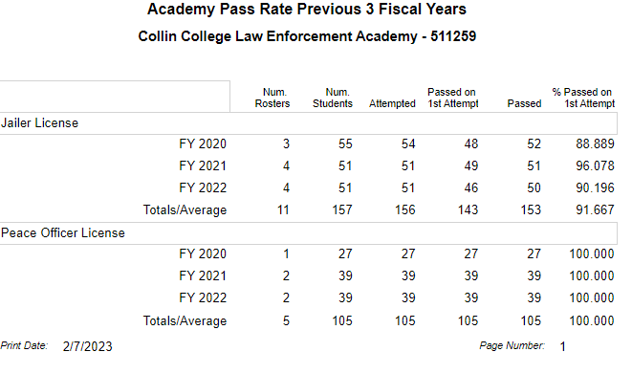
- Findings (Outcome #1)
We continue to have success on the state licensing exams. We have maintained an average well above the 80% required per our TCOLE contract.
- Implementation of Findings
We constantly evaluate each level of instruction for both licensing courses. We utilized data from homework, practice quizzes, internal exams, and the state licensing exam to recognize where we are strong as well as weak. We then increase lectures, course time/assignments, and assessments to reinforce these identified objectives.

