PROGRAM NAME: Construction Management | AUTHORING TEAM CONTACT: Cheri Weinhagen
PHONE: Click or tap here to enter text. | EMAIL: cweinhagen@collin.edu

GUIDELINES
Time Frames
- Scope:
The time frame of program review is five years, including the year of the review.
Data being reviewed for any item should go back the previous four years, unless not available.
- Deadline Dates:
January 15th – Program Review Document due to Department Dean for review (Deans may require submissions at their own, earlier due date)
February 1st – Program Review Document due to Program Review Steering Committee
- Years:
Years 1 & 3 – Implement Action Plan of (CIP) and collect data
Years 2 & 4 – Analyze data and findings, Update Action Plan
Year 5 – Write Program Review of past 5 years; Write Continuous Improvement Plan (CIP) and create new Action Plan

LENGTH OF RESPONSES: Information provided to each question may vary but should be generally kept in the range
of 1-2 pages or 500-1,000 words.

EVIDENCE GUIDELINES: In the following sections, you will be asked to provide evidence for assertions made.
- Sources: This evidence may come from various sources including professional accreditation reviews, THECB, Texas Workforce Commission’s CREWS, Institutional Research Office (IRO), National Student Clearinghouse, IPEDS, JobsEQ, EMSI Career Coach, and may be quantitative and/or qualitative. If you are unfamiliar with any of these information sources, contact the Institutional Research Office at: effectiveness@collin.edu. Use of additional reliable and valid data sources of which you are aware is encouraged.
- Examples of Evidence Statements:
- Poor example: Core values are integrated into coursework. (Not verifiable)
- Good example: Core values are integrated into coursework through written reflections. (Verifiable, but general)
- Better example: Core values are integrating into coursework through written reflections asking the student to describe how s/he will demonstrate each of the core values in his or her professional life and demonstrated through service learning opportunities. (Replicable, Verifiable)

FOR MORE INFORMATION: The Program Review Portal can be found at http://inside.collin.edu/institutionaleffect/Program_Review_Process.html. Any further questions regarding Program Review should be addressed to the Institutional Research Office (effectiveness@collin.edu, 972.599.3102).

Introduction/Preface
☐EXECUTIVE SUMMARY
Briefly summarize the topics that are addressed in this self-study, including areas of strengths and areas of concern. (Information to address this Executive Summary may come from later sections of this document; therefore, this summary may be written after these sections have been completed.) Please do not include information in this section that is not already provided elsewhere in this submission. Using the questions in the template as headings in the Executive Summary can provide structure to the overview document (see below for suggested format).
Executive Summary (suggested sections/format-not required format)
What does our program do?
Collin College Construction Management Program is a student and community-centered program committed to developing skills strengthening character, and challenging the intellect to better serve those that will design, build and maintain our built environment.
The Construction Management program equips students with the knowledge, skills, and experience needed to obtain entry level employment in the Construction industry.

Why do we do the things we do: Program relationship to the College Mission & Strategic Plan.
The Construction Management Program strives to align with the Collin College Mission & Strategic Plan by utilizing our relationships with industry partners to identify skills desired by the construction industry, and to incorporate these desired skills into our curriculum and our classrooms. The Program works to align with current industry standard practices and software programs, as well as develop the “soft skills” necessary for success in the industry. These soft skills include communication, organization, critical thinking, etc. We strengthen character by emphasizing team relationships between faculty and students, building trust and engaging in open and honest communication. We are challenging the intellect of our students by providing opportunities to solve complex real-world construction problems and build the skills required for competitiveness in the construction industry.
Why we do the things we do? Program relationship to student demand and market demand.

The demand for construction management professionals continues to grow in both the DFW metroplex and in the nation as a whole. The construction management program aspires to continue our growth pattern to meet the growing demand. We will continue to provide extra support to our students who need help to maintain the high success rate we have achieved to date.
How effective is our curriculum and how do we know?
The Construction Management Program has seen an average course success rate of 92% and a course completion rate of 98%, according to our grade distribution reports (Figures 9 & 10). As the program grows, it will be critical that we continue to provide the level of personal interaction between faculty and students, and the efforts of our support staff and career coach to maintain this rate of success. Our new accreditation (2023) by the American Council for Construction Education (ACCE) adds another level of quality assurance to our learning outcomes as well as ensuring we stay current in terms of comparability with other similar construction management programs.
How effectively do we communicate, and how do we know?
Communication has been identified as an area of opportunity for improvement. We recently updated and redesigned our program website to be more user friendly and to incorporate more information and data for prospective students. The website contains contact information for several key department members who can help current and prospective students set goals and enroll in the classes they need to meet those goals. Further improvement can be realized by incorporating a student survey to gather data about student needs, feedback, and after graduation status. The survey is in development now, and is anticipated to be complete in the Fall of 2024.
How well are we leveraging partnership resources and building relationships, and how do we know?
The Construction Management Advisory Committee has been instrumental in providing a link between what the industry demands and what we teach in the classroom. We have a wide variety of industry partners representing different pathways and sectors within the construction industry. We have successfully leveraged our industry partners in participating in our career fairs, serving as guest speakers in our classrooms, providing workshops outside of class, providing internship opportunities for our students, and providing cooperative work experience as part of the degree program. We have identified an opportunity for improvement in that we have a large number of industry partners, but not a high percentage of them who actively participate in advisory board meetings.

How have past Continuous Improvement Plans contributed to success?
We do not have this data from the Institutional Effectiveness website. This has been an area of improvement identified for the upcoming year.
How will we evaluate our success?
We have raised our expectations with regard to success and completion rates, the number of AAS graduates from the construction management program, and the number of students who we retain after AAS graduation who will continue on to the construction management bachelor’s degree program at Collin College. Continual data gathering and analysis of our success and completion rates, coupled with our new efforts to survey our existing and graduating students will be a critical part of our evaluation plan moving forward.

Section I. Are We Doing the Right Things?
☐1. WHAT DOES OUR PROGRAM DO?
What is the program and its context?
This section is used to provide an overview description of the program, its relationship to the college and the community it serves. Keep in mind the reviewer may not be familiar with your area. Therefore, provide adequate explanation as needed to ensure understanding.

Suggested points to consider:
- Program’s purpose (Include the program’s purpose/mission statement if one exists.)
- Program learning outcomes or marketable skills
- Brief explanation of the industry/industries the program serves
- Career paths and/or degree paths it prepares graduates to enter
- What regulatory standards must the program meet (THECB, Workforce, external accreditation)

Program’s Purpose
Collin College Construction Management Program is a student and community-centered program committed to developing skills strengthening character, and challenging the intellect to better serve those that will design, build and maintain our built environment.
The Construction Management program equips students with the knowledge, skills, and experience needed to obtain entry level employment in the Construction industry. The program provides training in standard methods and materials used in residential and commercial construction, and hands-on experience using tools and building materials. As the students work their way through the program, they learn construction print reading practices, estimating, scheduling, construction safety and learn to apply these practices using industry standard software and tools. Additionally, the program is committed to collaborating with industry professionals and providing students with opportunities to learn from industry professionals and gain cooperative work experience. Opportunities include in-class speakers by industry experts, job site tours / field trips, local industry events, and cooperative work experience with industry partners.

Program Learning Outcomes
The Construction Management program learning outcomes include:
- Program Learning Outcome 1: Construction Safety. Students will be able to identify safety hazards on a construction site and implement standard prevention measures to reduce risk.
- Program Learning Outcome 2: Effective Communication and Teamwork. Students will be able to apply, assess, and demonstrate management and communications skills required to complete a construction project.

- Program Learning Outcome 3: Construction Project Management. Students will be able to demonstrate entry level competence in planning, analyzing, decision-making and problem-solving in construction to appropriately estimate costs and to successfully apply conventional scheduling skills to a construction project.
- Program Learning Outcome 4: Construction Fundamentals. Students will be able to identify construction materials, describe the uses of those materials, and demonstrate the appropriate manner of assembly.

Marketable Skills
The Construction Management program has defined marketable skills as valued by local employers. These skills were created in Spring 2020 with the help of the Construction Management Advisory Committee. The marketable skills will be communicated and reiterated throughout the curriculum, so students can effectively market their skills after program completion. The marketable skills are reflected in the Program Learning Outcomes above. They are:
• Demonstrate understanding of safe work practices to prevent injury and accidents on a construction job site
• Demonstrate problem solving and decision-making skills related to the construction process.
• Interpret construction plans and documents.
• Apply construction estimating skills and scheduling process and procedures.
• Communicate effectively and professionally with peers, managers and other stakeholders.

Industries and Career Paths
The Construction industry consists of two main sectors: residential construction and commercial construction. Students are exposed to both sectors as they progress through the program, and their cooperative work experience will be in one of these two sectors, based on personal interest.

The program prepares students for a variety of entry-level positions in the construction industry directly after program completion, and/or during the program. All students in the program either work full time during the program, or at very least work part time for part of the program. Career opportunities for graduates include:
- Residential or Commercial Project Assistant Superintendent
- Residential or Commercial Assistant Project Manager
- Residential or Commercial Project Engineer
- Residential or Commercial Construction Estimator
- Construction Project Planner
- Construction Project Finance Manager
- Construction Project Insurance Representative
- Engineered Materials Representatives

Degree Plans
The Construction Management department offers multiple stacked certificates and awards: an AAS in Construction Management (60 credit hours), an OSA in Construction Management (12 credit hours), a Certificate Level 1 in Construction Management (18 credit hours), and a Certificate Level 2 in Construction Management (45 credit hours).
- The AAS degree is designed for students that are serious about pursuing a career in construction. This program prepares students to work as an construction management assistant with a prominent firm or any other business involving residential or corporate construction.
- The Certificate Level 2 includes all CNBT courses in the AAS degree. Thus, students pursuing this degree gain the same construction knowledge as the AAS degree without taking general education courses. Some examples of job opportunities with this degree include: assistant superintendent, project engineer and assistant project manager.
- The Certificate Level 1 provides basic knowledge and information for a career in the construction profession. This degree is designed for students whose objective is to obtain the following (or similar) positions after completion: construction project coordinator, foreman, project safety coordinator.
- The OSA award is designed for professionals that want to gain technical skills for construction. Students learn how to read construction plans, use standard tools, and work with materials, which are skills that are highly valued in industry.

Regulatory standards (THECB, Workforce, external accreditation)
The Construction Management program meets the requirements of THECB for workforce programs. These requirements include:
- Program Demand - There is national, state, and local demand for entry-level positions in the Construction industry. Please see question 4 for more information.
- Effective Use of Advisory Committees - The program holds an advisory committee with strong local industry employers. The committee meets with faculty twice a year and significantly influences program decisions and curriculum. See question 5.
- Identification of Program Competencies - The academic and workforce skills integrated in the curriculum are identified by the advisory committee (program experts) as stated above.
- Selection of Program Courses - All courses in the curriculum are selected from WECM approved courses.
- Recruitment, Retention, and Program Completion by students - All CNBT courses use Canvas, a learning management system that allows students to see all course material, assignment feedback, and grades throughout the semester. Faculty also provide resources for counseling, career coaches, and other tools for student success on course Canvas sites.
- Establishment of Program Linkages - The program has implemented initiatives to promote the program to local high school students (secondary school) and to provide continuity for students into the Collin College BAS Construction Management Degree program.
- Verification of Workforce Competencies - Students completing AAS in Construction Management are required to complete a capstone course (Construction Management II) verifying entry-level workplace competencies.

In the spring of 2023, the Construction Management Program successfully completed the accreditation process as required for the American Council for Construction Education (ACCE). The mission of ACCE is to be a leading global advocate of quality construction education; and to promote, support and accredit quality construction education programs. To achieve accreditation, among many other submittals, the Construction Management program was required to submit documentation and supporting evidence of the ability to meet the 13 Student Learning Outcomes as prescribed by ACCE:
SLO #1: Apply effective communication, both orally and in writing.
SLO #2: Apply quantity takeoff skills for bidding or budgeting purposes on a construction project.
SLO #3: Apply the aptitude to schedule a basic construction project.
SLO #4: Apply current technology related to the construction industry.
SLO #5: Apply the interpretation of construction documents (contracts, specifications, and drawings) used in managing a construction project.
SLO #6: Apply basic principles of construction accounting.
SLO #7: Apply basic surveying techniques used in building layout.
SLO #8: Understand basic principles of ethics in the construction industry.
SLO #9: Understand the fundamentals of contracts, codes, and regulations that govern a construction project.
SLO #10: Understand basic construction methods and materials.
SLO #11: Understand basic safety hazards on a construction site and standard prevention measures.
SLO #12: Understand the basic principles of structural design.
SLO #13: Understand the basic principles of mechanical, electrical and plumbing systems.

Additionally, instructors participate in ACCE staff development consortiums twice per year, as well as participating in the accreditation process as visiting team members for other higher education institutions. The ACCE reaccreditation process is repeated in 5 year cycles.

☐2. WHY DO WE DO THE THINGS WE DO: PROGRAM RELATIONSHIP TO THE COLLEGE MISSION & STRATEGIC PLAN.
- Provide program-specific evidence of actions that document how the program supports the College’s mission statement: “Collin County Community College District is a student and community-centered institution committed to developing skills, strengthening character, and challenging the intellect.”
- Provide program-specific evidence that documents how the program supports the College’s strategic plan (2020-2025 Strategic Plan): https://www.collin.edu/aboutus/strategic_goals.html.

Suggested/possible points to consider:
- What evidence is there to support assertions made regarding how the program relates to the mission and strategic plan?
- Think broadly-increasing completion, articulation agreements, pathways from high schools, etc.
- Analyze the evidence you provide. What does it show about the program?

Provide program-specific evidence of actions that document how the program supports the College’s mission statement: “Collin County Community College District is a student and community-centered institution committed to developing skills, strengthening character, and challenging the intellect.”

Developing Skills
Throughout the Construction Management program, students develop a variety of different skills to learn and understand the fundamental concepts of construction. Below are examples of different skills students learn throughout the program.

- Effectively utilizing Microsoft Project software to create construction project schedules is a critical and a highly desired skill construction firms look for. The software is introduced and utilized in CNBT1359 Project Scheduling, and reinforced and expanded upon in CNBT2344 Construction Management II, as part of students’ capstone project.

- Additionally, due to industry demand and the input from our advisory committee, the program has added two other industry desired software programs to CNBT2310 Commercial Blueprint Reading, and CNBT2344 Construction Management II (Capstone). Bluebeam and Procore are both software packages used to interact with blueprints, schedules, budgets and other critical construction management documents. Students are introduced to this software in CNBT2310, and continue to utilize it with the Capstone project in CNBT2344.

- As professionals, construction managers need to develop skills that are needed to work effectively with architects, engineers, clients, vendors and subcontractors. Like any other profession, construction has its own language that professionals must learn to effectively communicate. The ability to communicate effectively with all parties on a project using the language of construction is taught and reinforced throughout the program. Beginning in the first semester with CNBT2342 Construction Management I, students keep a vocabulary and concepts journal where they list new vocabulary, definitions and sketches of methods and materials to reinforce language acquisition. Learning this professional language is expanded in application courses (such as Estimating, Mechanical, Electrical & Plumbing Systems, Scheduling, Surveying, etc.) and culminates with the capstone course CNBT2344, Construction Management II. Students are required to keep their vocabulary journal current and utilize it throughout the program to continue to build upon language skills.

- Skills associated with industry standard methods and materials are taught in CNBT1311 (Methods and Materials I), and these skills are reinforced during the remainder of the program in conjunction with CNBT2304 (Methods and Materials II). The concepts learned in the Methods and Materials classes are built upon in subsequent courses as students learn how to sequence, schedule and estimate the costs and manpower required to construct environments utilizing these concepts.

Strengthening Character

- Cultivating character is a key component of the Construction Management program. The construction process requires trust, collaboration and respect between contractors, clients, engineers, architects, and many other team members. These skills are embedded in our courses throughout the program in team based projects, class research project presentations, and mock project teams. Additionally, in order to maintain trust throughout a project, students learn the importance of a budget and schedule; communicating budget and scheduling changes with the professors and identifying possible conflicts, so students gain experience operating with integrity and open, honest communication.

- Additionally, the Construction Management department is in the process of creating a student chapter with the Construction Management Association of America (CMAA). This student organization will provide students with opportunities to volunteer and engage with the construction industry outside of the classroom. After the Collin chapter is created, faculty will promote and encourage volunteer opportunities with positive reinforcement such as extra credit. These efforts are intended to contribute to the community by meeting community needs, developing servant leaders, and connecting students’ career interests with civic responsibility.

Challenging Intellect

- Critical thinking skills and analytical processes are vital in the construction industry. Construction Managers are required to frequently solve complex jobsite problems, and use logic and reasoning to formulate alternative solutions. Jobsite issues can include such items as the discovery of design errors in the construction drawings. Construction Managers must have the ability to analyze the problem, communicate it to the architect or engineer, and participate in the solution process, all while striving to keep the project on schedule and within the prescribed budget.

- Our students gain skills in these areas by solving complex problems such as identifying a critical path within a construction schedule to determine where there may be some “float” or flexibility in the timeline (CNBT1359 Project Scheduling), or determining required labor and equipment resources to meet project objectives (CNBT1346 Estimating).

- In CNBT2310 Commercial Print Reading, students are given construction documents that are incomplete and contain errors. Students must use critical thinking skills to identify and evaluate the issues, formulate possible solutions, and craft communication documentation to involve architects, engineers, clients, subcontractors, and any other parties whose work may be affected by the errors.

- The presentation of real world problems in the classroom gives students an opportunity to develop and practice skills that will be required in the workplace, in a safe and mutually respectful environment which encourages exploration.

Provide program-specific evidence that documents how the program supports the College’s strategic plan (2020-2025 Strategic Plan): https://www.collin.edu/aboutus/strategic_goals.html.

Develop a coordinated and systematic approach to engage external stakeholders.
The construction management program engages stakeholders in several ways. 1. Our industry partners are invited to participate in our annual career fair where they can interact with our students, share career advice and coordinate interviews. Our industry partners also participate extensively as guest lecturers and speakers both in the classrooms and at special events.

Improve student outcomes to meet or exceed local, state, and regional accreditation thresholds and goals.
In addition to our 4 Program Learning Outcomes, we have an additional 13 Student Learning Outcomes in the AAS program as part of our American Council on Construction Education (ACCE) accreditation. The student learning outcomes are distributed throughout the program’s curricular offerings to reinforce and ensure students mastery of basic construction management concepts and skills. The

outcomes are attached to specific assessment tools, and are tracked each semester. Concepts and skills are generally introduced in the lower-level courses and reinforced through practice in the upper-level courses. In some courses where concepts are practiced, students are assessed for both achievements of course objectives and proficiency in selected student learning outcomes. The student learning outcomes include:
- Apply effective communications, both orally and in writing.
- Apply quantity takeoff skills for bidding or budgeting purposes on a construction project.
- Apply the aptitude to schedule a basic construction project.
- Apply current technology related to the construction industry.
- Apply the interpretation of construction documents (contracts, specifications, and drawings) used in managing a construction project.
- Apply basic principles of construction accounting.
- Apply basic surveying techniques used in building layout
- Understand basic principles of ethics in the construction industry.
- Understand the fundamentals of contracts, codes, and regulations that govern a construction project.
- Understand basic construction methods and materials.
- Understand basic safety hazards on a construction site and standard prevention measures.
- Understand the basic principles of structural design.
- Understand the basic principles of mechanical, electrical and plumbing systems.

☐3. Why we do the things we do: Program relationship to student demand
Make a case with evidence to show that students want the certificate. Discuss whether or not there appears to be any disproportionate enrollment by gender, race, and ethnicity (compared to Collin College’s overall student demographic distributions http://inside.collin.edu/iro/programreview/prfilehostpage.html). If any differences exist discuss possible reasons why the gap exists, and plans to address these issues to close gaps in enrollment rates between groups of students (refer to the Program Review portal for Enrollment Reports and Average Section Size data files for your program http://inside.collin.edu/institutionaleffect/Program_Review_Process.html).
Suggested/possible points to consider:
- What is the enrollment pattern? Declining, flat, growing, not exhibiting a stable pattern, please explain. For required program courses where there is a pattern of low enrollment (fewer than 15 students), explain your plan to grow enrollment and/or revise the curriculum.
- What are the implications for the next 5 years if the enrollment pattern for the past 5 years continues?
- Describe any actions taken to identify and support students enrolled in program-required courses early in the degree plan. If no actions are taken at the present, please develop and describe a plan to do so.
- How does your program support (or plan) to support attraction of a diverse student population?
- Check with Institutional effectiveness for Data Reports -names of reports
- Analyze the evidence you provide. What does it show about the program?

As illustrated below, Figure 1 lists the unduplicated enrollment data for the Construction Management program for 2018 through 2022-2023.
Outside of the program courses, the table reflects the enrollment in BMGT1305 and ENVR1401, which are required for the degree, but not part of our program, and OSHT1305 which is both required for the degree and certificates, and is part of the Construction Management program.

The program has experienced rapid growth since its inception in 2018, and this year’s enrollment data continues that trend.
Figure 2 expresses the award completions for the Construction Management Program.
The published data from IRO included up to the school year 2021-2022. From our own departmental records, the totals for 2022-2023 are reflected in the table.

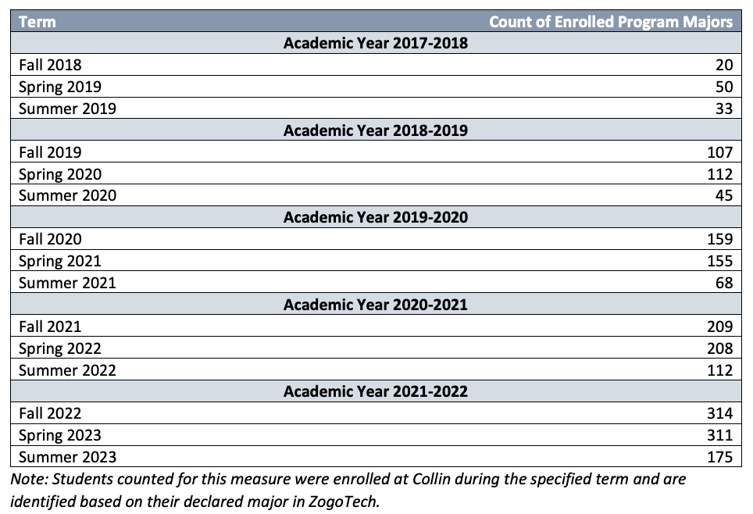
Figure 1: Unduplicated Student Enrollment for CNBT Courses
Source: https://inside.collin.edu/institutionaleffect/2023-24%20Construction%20Management%20-%20Unduplicated%20Enrollment.pdf

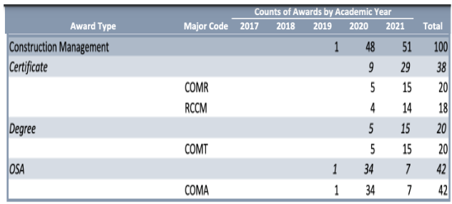
Figure 2: Construction Management Program Awards 2017-2022
Source: https://inside.collin.edu/iro/programreview/202122/AwardsByProgram%202017-2021.10292021.pdf

5 Year Implications:
If the current enrollment pattern continues, the implications will include
- More instructors will be needed
- More classroom and office space will be required. Will create a space issue at Technical Campus as space is currently maximized.
- Higher numbers of students will be continuing into the Construction Management BAS program.
- Department will need to ensure adequate numbers of co-op and internship opportunities exist with our industry partners.
- Increased student support will be required

Actions Taken to Identify and Support Students

Identifying and supporting students early in the Construction Management program is an additional way to increase enrollment and completion. Some different methods the program uses to identify and support students include:
- The faculty promote advising to first year students during class, and provide contact information for our career coach on Canvas courses.
- Our career coach meets with all incoming students to help them identify courses they will need for their specific educational goals, and to set up an educational plan for coursework.
- Our career coach visits classrooms at the beginning of each semester to remind students about deadlines, degree plans, next steps, etc.

- Our career coach works closely with faculty and program management, where information and updates are shared both ways to ensure all are supporting students in the same manner. The career coach also checks in frequently with instructors to obtain information about students who may
need extra help, either academically or financially, and the coach works directly with instructors to make sure students who need it are supported similarly in all their classes in the program. Our career coach additionally does an audit for all second year students to ensure all graduation requirements have been identified and addressed, and students know what steps they need to take to graduate.
- Our faculty are approachable, and all maintain an open door policy, so students can feel comfortable communicating issues before they escalate. Most professors arrive early and stay late before and after class to give individual help to students.
- Faculty promote collaboration in coursework so students can connect with each other and become useful resources.

Program Demographics

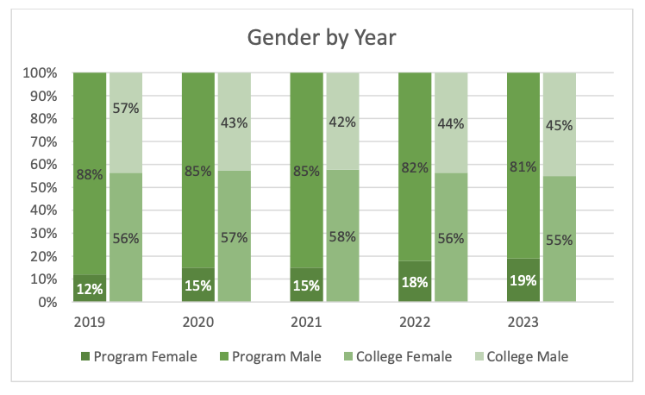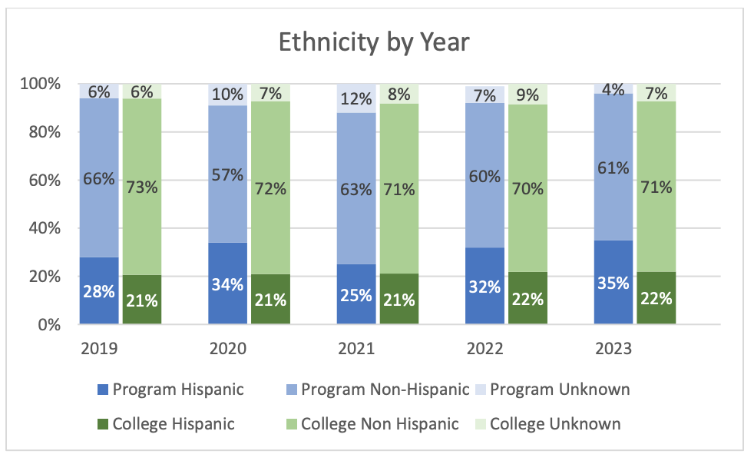
Figure 3: Student Enrollment by Gender 2019-2023
Figure 4: Student Enrollment by Ethnicity 2019-2023
Source: https://inside.collin.edu/institutionaleffect/2023-24%20Construction%20Management%20-%20Unduplicated%20Enrollment.pdf

There is a large disparity when comparing gender distributions between the Construction Management Program and the Collin College population. Construction is historically a male-dominated field, and our enrollment by gender distribution reflects that. According to Zippia, in 2023 only 8% of construction management professionals are female, and only 6.2% of construction workers as a whole are female. (Zippia, 2023).

Our ratios are certainly higher for females than the national averages, and have been increasing year by year. However the Construction Management program continues to strive to increase female enrollment and completion. In 2023, in conjunction with Women In Construction Week, the program hosted a Women In Construction event with guest speakers, industry panel discussions, presentations, lunch and scholarship giveaways. This year the program intends to increase the size and scope of the event, to both support our existing female students and encourage prospective females to join the program.

Source: https://www.zippia.com/construction-manager-jobs/demographics/

As illustrated in Figure 5, the Construction Management program’s Hispanic population ratio is slightly higher than that of the overall College. These numbers accurately reflect the higher number of Hispanic workers employed in the construction industry. According to the Texas Demographic Center, 61% of the construction workforce in Texas is comprised of Hispanic workers. As our Ethnicity ratio is far below that number, it represents an area of opportunity for the Construction Management department to recruit and support Hispanic students to increase our ratio.

Source: https://demographics.texas.gov/Resources/Presentations/OSD/2023/20230829_TexasAdvisoryCouncilCultural.pdf?v=2023082912

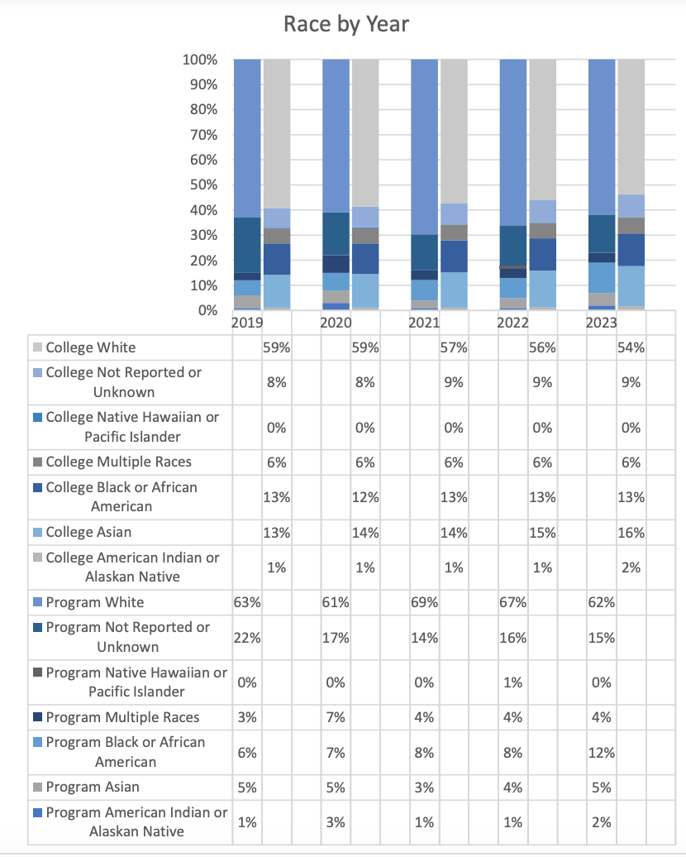
Figure 5: Student Enrollment by Race 2019-2023
Source: https://inside.collin.edu/institutionaleffect/2023-24%20Construction%20Management%20-%20Unduplicated%20Enrollment.pdf
According to Figure 5, the Race distribution for the Construction Management program is similar to that of the overall College.

☐4. Why we do the things we do: Program relationship to market demand
Make a case with evidence to show that employers need and hire the program’s graduates. Some resources to utilize for information could be: JobsEQ http://inside.collin.edu/iro/programreview/202021/ProgramLaborMarketInfo_2020-21AY.pdf, Burning Glass, O-Net https://www.onetonline.org, Texas Labor Market Information https://www.twc.texas.gov/businesses/labor-market-information.
Suggested/possible points to consider:
- How many program-related jobs are available in the DFW Metroplex for program graduates? If the majority of related jobs in the DFW Metroplex require a baccalaureate degree, provide evidence that you have a current signed articulation agreement with one or more transfer institutions or that you plan to develop one.
- What proportion of the program’s graduates (seeking employment) found related employment within six months of graduation?
- What changes are anticipated in market demand in the next 5 years? Do program completers meet, exceed, or fall short of local employment demand? How will the program address under- or over-supply?
- Identify and discuss the program’s strengths and weaknesses related to market demand.

Program-related Jobs in DFW Area:
According to the Texas Workforce Commission, the demand for Construction Managers in the state is projected to increase by 24% by 2030, while the national demand will increase by 8% by 2028 (Zippia). As of January 2024, Zippia.com has 531 Construction Manager jobs listed as open in the DFW area. Additionally, according to the Bureau of Labor Statistics, Texas has the second highest employment for construction managers in the nation (Figure 6).

While it is possible to obtain employment in the construction management field with an AAS degree, it is preferable for applicants to possess a bachelor’s degree. The Construction Management program has anticipated this need, and has launched the BAS in Construction Management program in Fall of 2022, with our class of BAS graduates commencing in December of 2023. The BAS program is a 2+2 degree program, with students completing the 2 year AAS program then have the option to continue on with two more years to complete the BAS program.

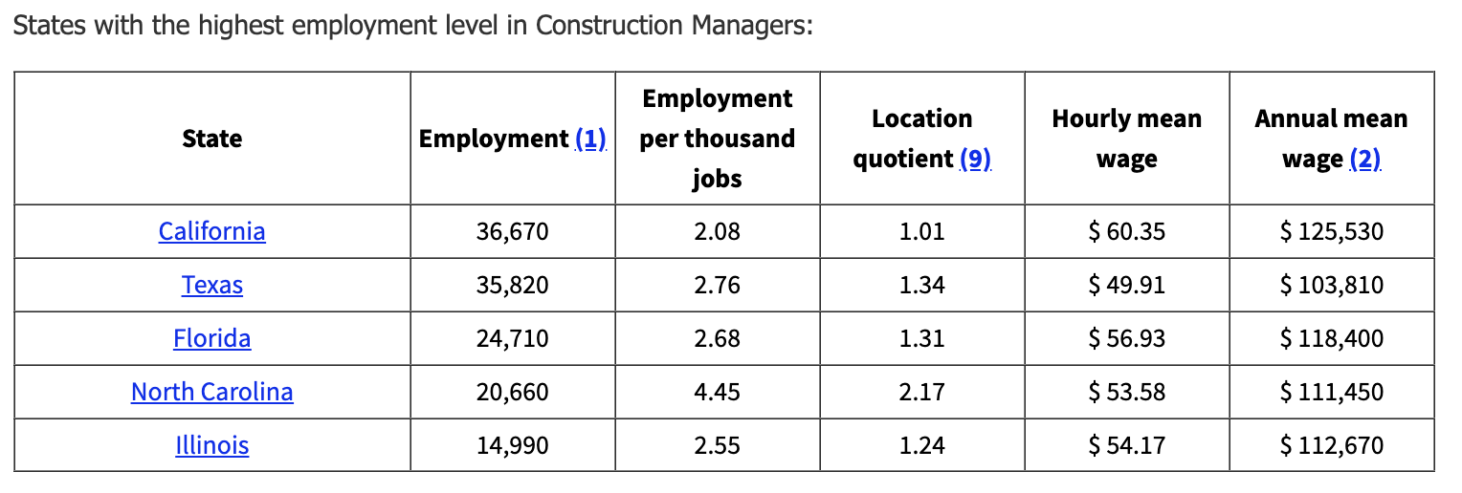
Figure 6: Status with the highest employment level in Construction Managers
Source: https://www.bls.gov/oes/current/oes119021.htm

Additional Sources:
Source: https://texascareercheck.com/OccupationInfo/OccupationSummary/11-9021.00/
Source: https://www.zippia.com/construction-manager-jobs/trends/

Construction Management Students Employment Data:
At this time the Construction Management Department does not have a reliable method of surveying students and employers and gathering data on employment rates. We have identified this as a program weakness, and are taking steps to address it. We are in the process of creating a survey system for data collection and analysis so we can effectively track this information in the future. We anticipate the system will be ready to launch for the Fall 2024 semester.

Employment Demand vs. Growth Rate of Program:
As we currently do not have concrete data and analysis of our graduate employment rates, we can only use anecdotal data and feedback from our industry partners and our students. As many of our students receive multiple job offers resulting from our career fair, we can safely assume that demand is outpacing our growth rate at the moment. Additionally, based on the data in Figure 6 (state figures for construction management employment), and the 24% growth rate estimated by Zippia (noted above), we can compare those statistics with our growth rate as indicated in Figure 7 and surmise that our growth rate must continue to grow exponentially to meet the anticipated demand for construction managers.

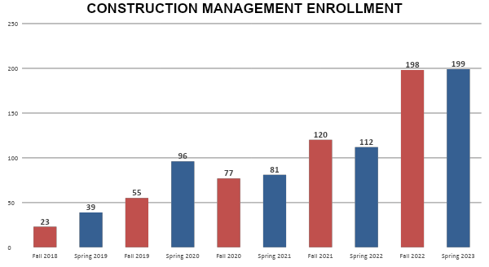
Figure 7: Construction Management Enrollment
Source: Construction Management Department Study / Industry Advisory Board Spring 2023

Program Strengths and Weaknesses Related to Market Demand:

One of our greatest strengths with regard to market demand is our industry partnerships and the participation rate in our career fairs and internship / cooperative education programs. With each year our career fair has grown with the number of participating employers, and as our enrollment grows we will continue to cultivate more industry partners to ensure greater participation and more opportunities for our students.

Our greatest weakness with regard to market demand is our lack of data regarding employment status of graduates. As previously stated, we have identified our need to collect and analyze this data, and are working on a solution to be rolled out by Fall 2024.

Section II. Are We Doing Things Right?
☐5. How effective is our curriculum, and how do we know?
A. Make a case with evidence that there are no curricular barriers to program completion. Review data related to course enrollments, course completion rates, course success rates, and the frequency with which courses are scheduled to identify barriers to program completion.
Suggested/possible points to consider:
- Number of students who completed the program awards in each of the last 4 years? If the number of graduates does not average 5 or more per year, describe your plan to increase completions and address this issue in the Continuous Improvement Plan (CIP).
- At what point(s) are substantive percentages of students dropping out of the program? Use data in the “Program-Based Course Performance” tool to examine enrollment flow through the program curriculum. Does the data suggest any curricular barriers to completion? Address problems in the CIP.
- Analyze the course success rates and the course completion rates of each course in your program. Address problems in the CIP.

Figure 8 represents the number of completion awards by academic year. The award data for 2022 and 2023 were not available on the Institutional Effectiveness website.

Program Completion Data:

Figure 8: Count of Awards by Academic Year, Construction Management Program
Source: https://inside.collin.edu/iro/programreview/202122/AwardsByProgram%202017-2021.10292021.pdf

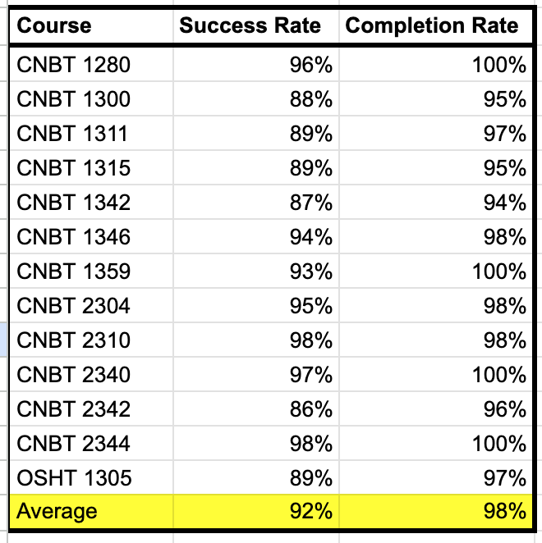
Figure 9: Compiled Success and Completion Rates from Grade Distribution in Courses by Year (below)
Source: https://inside.collin.edu/institutionaleffect/2023-24%20Construction%20Management%20-%20Grade%20Distribution.pdf

Dropout, “Program-Based Course Performance” Data: (barriers to completion)
Figure 9 lists Success and Completion Rates aggregated for all Construction Management Courses for 2019 through 2023. Our average success rate is 92%, and the average completion rate is 98%. The lowest completion rate numbers are in CNBT1300 Print Reading (95%), CNBT 1315 Field Engineering (95%), CNBT 1342 Building Codes & Inspections (94%), and CNBT2342 Construction Management I (96%).

Course Success Rates and Completion Rates For Each Course:

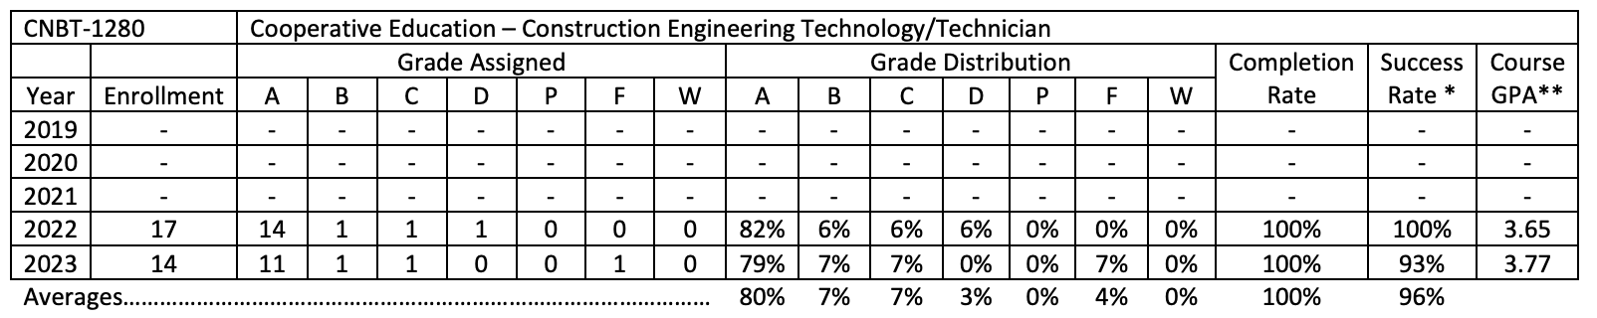

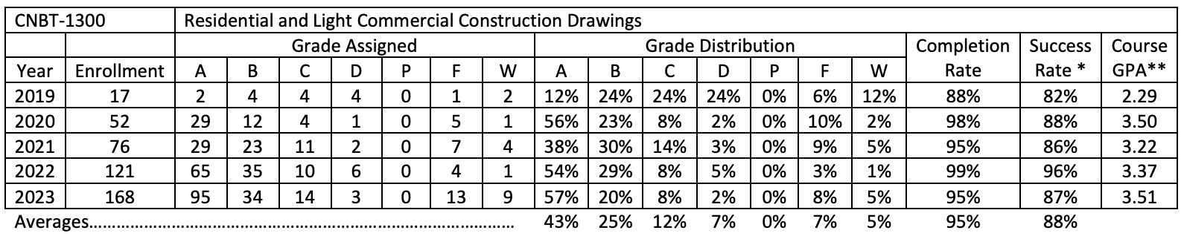

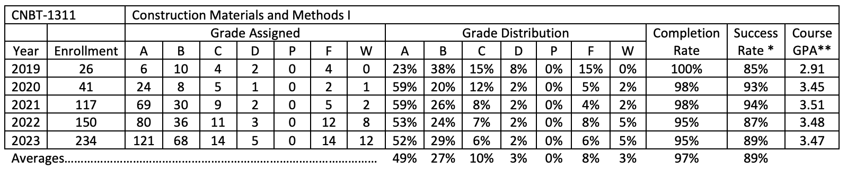

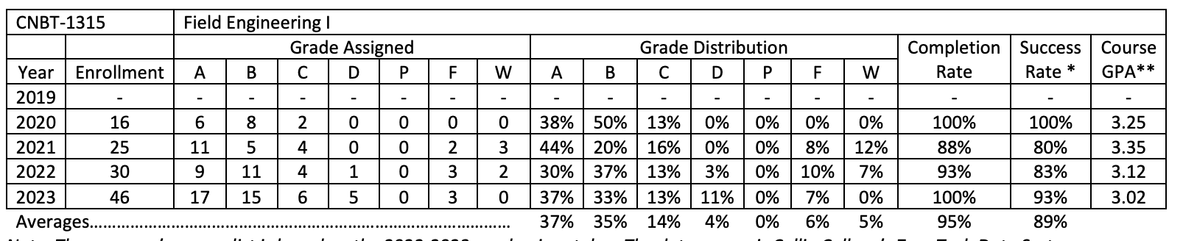

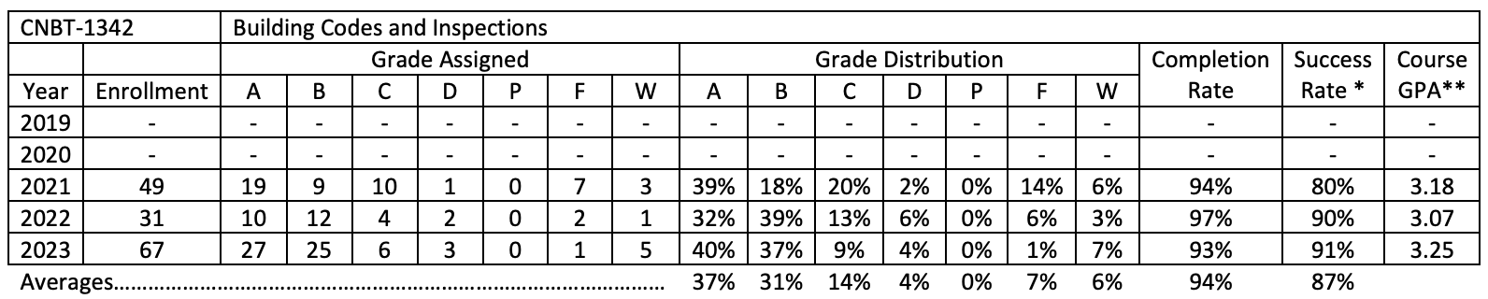

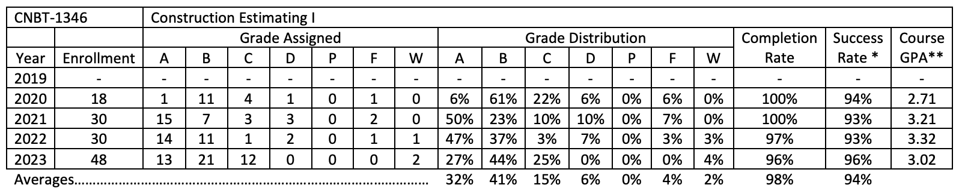

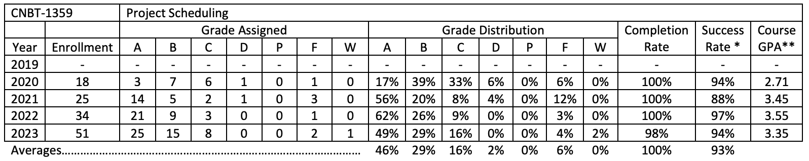

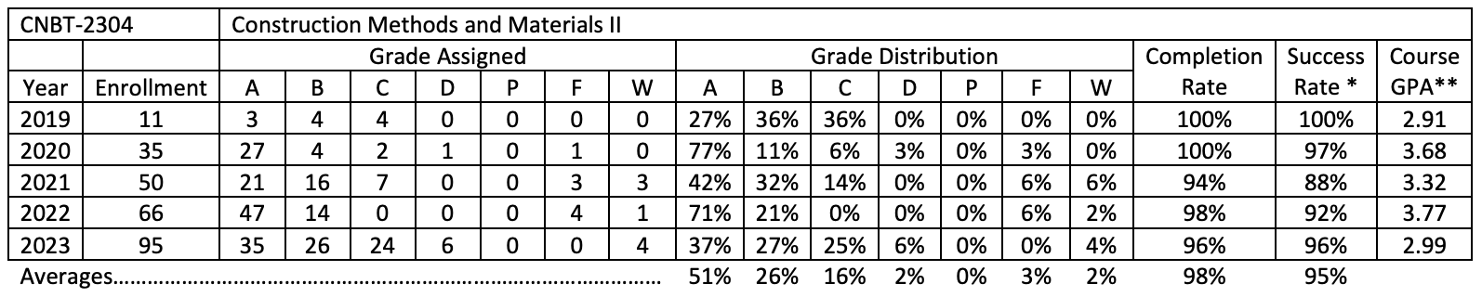

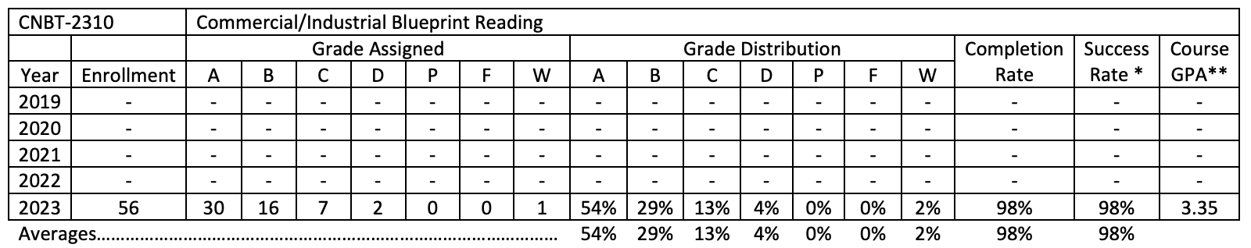

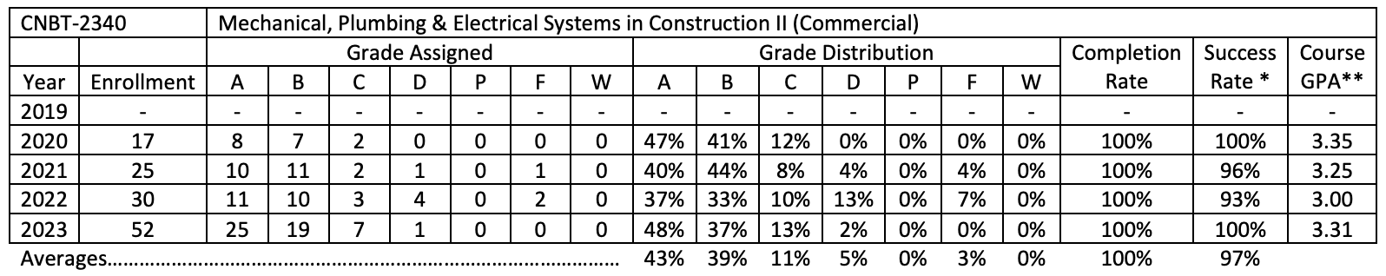

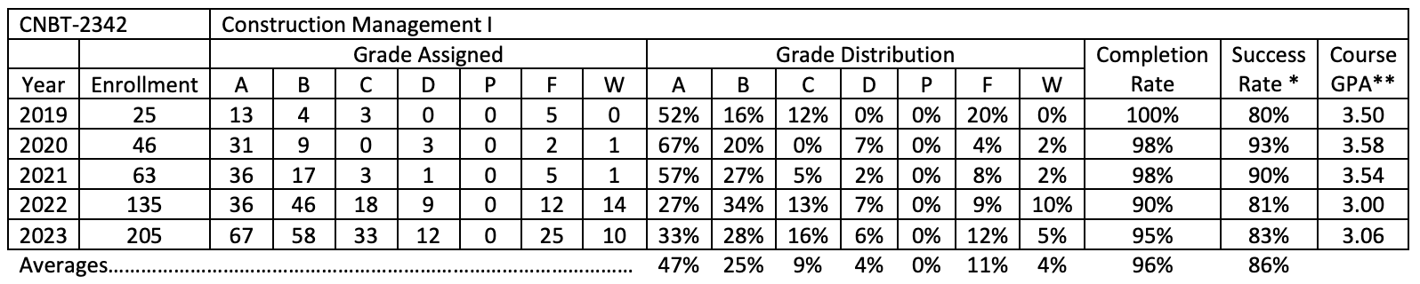

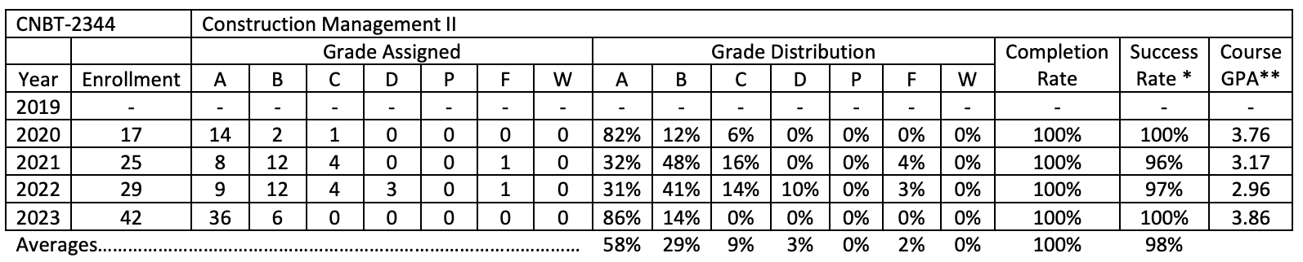

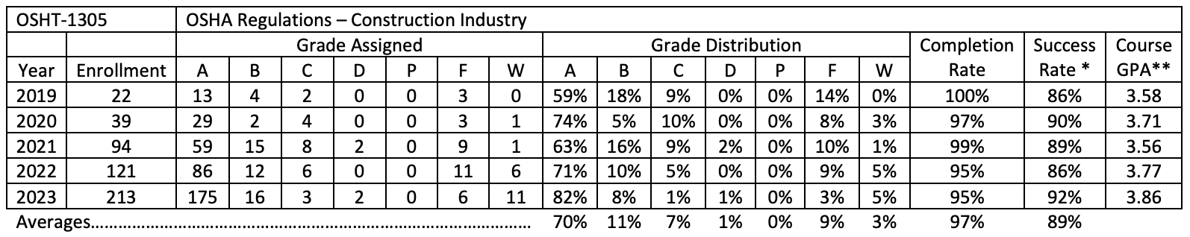
Figure 10: Grade Distribution in Courses by Year
Source: https://inside.collin.edu/institutionaleffect/2023-24%20Construction%20Management%20-%20Grade%20Distribution.pdf

B. Show evidence that the institutional standards listed below have been met. For any standard not met, describe the plan for bringing the program into compliance.

- Completers Standard: Average 25 completers over the last five years or an average of at least five completers per year.
Number of completers: 100 + (2022 & 2023 completers we do not have data for) completion in the last five years.
If below the state standard, attach a plan for raising the number of completers by addressing barriers to completion and/or by increasing the number of students enrolled in the program. Definition of completer—Student has met the requirements for a degree or certificate (Level I or II)
- Licensure Standard: 93% of test takers pass licensure exams.
If applicable, include the licensure pass rate: N/A not required in construction management
For any pass rate below 93% (Collin College’s standard), describe a plan for raising the pass rate.

- Retention Standard: 78% of students enrolled in program courses on the census date should still be enrolled on the last class day (grades of A through F).
Include the retention rate: average of 92% across program courses
If the retention rate is below 78%, describe a plan for raising the course completion rate.

Retention Rates Per Course:
Figure 11: Compiled Success and Completion Rates
Source: Aggregated data from https://inside.collin.edu/institutionaleffect/2023-24%20Construction%20Management%20-%20Grade%20Distribution.pdf

C. Make a case with evidence that the program curriculum is current.
Suggested/possible points to consider:
- How does the program curriculum compare to curricula at other schools? Review programs at two or more comparable colleges. Discuss what was learned and what new ideas for improvement were gained.
- How does the program curriculum align with any professional association standards or guidelines that may exist?
- Is the curriculum subject to external accreditation? If so, list the accrediting body and the most recent accreditation for your program.
If the program curriculum differs significantly from these benchmarks, explain how the Collin College curriculum benefits students and other college constituents.
According to the Texas Higher Education Coordinating Board (THECB), there are currently four other colleges in Texas that offer an associate degree in Construction Management. These colleges include: Dallas College (32 miles away), Tarrant County College in Fort Worth (40 miles away), Alamo College Live Oak (290 miles away) and Austin Community College (270 miles away). All programs have the same overall goal, which is to provide program completers with the skills needed to gain entry level employment in the construction industry.

The two that are closest to Collin College are Dallas College and Tarrant County College. Both award AAS degrees with 60 credit hour programs, and have stacked certificate programs similar to Collin College. Both Dallas College and Tarrant County College are accredited by the American Council on Construction Education (ACCE), as is Collin. Because ACCE has specific coursework requirements, it is expected that the required coursework will be very similar in these programs.

Program at Dallas College, 2 year AAS:

Dallas College similarly required courses include: Construction Management 1, Accident Prevention Inspection and Investigation, Introduction to Surveying, Project Scheduling, Construction Estimating, Mechanical Electrical Plumbing, Methods and Materials, Commercial Print Reading, Codes and Inspections and Construction Management II.

The largest difference is that Dallas College separates the electives for an emphasis on either residential or commercial construction. The classes in the Construction Management program at Collin College deliver content in both residential and commercial construction under the same degree program.

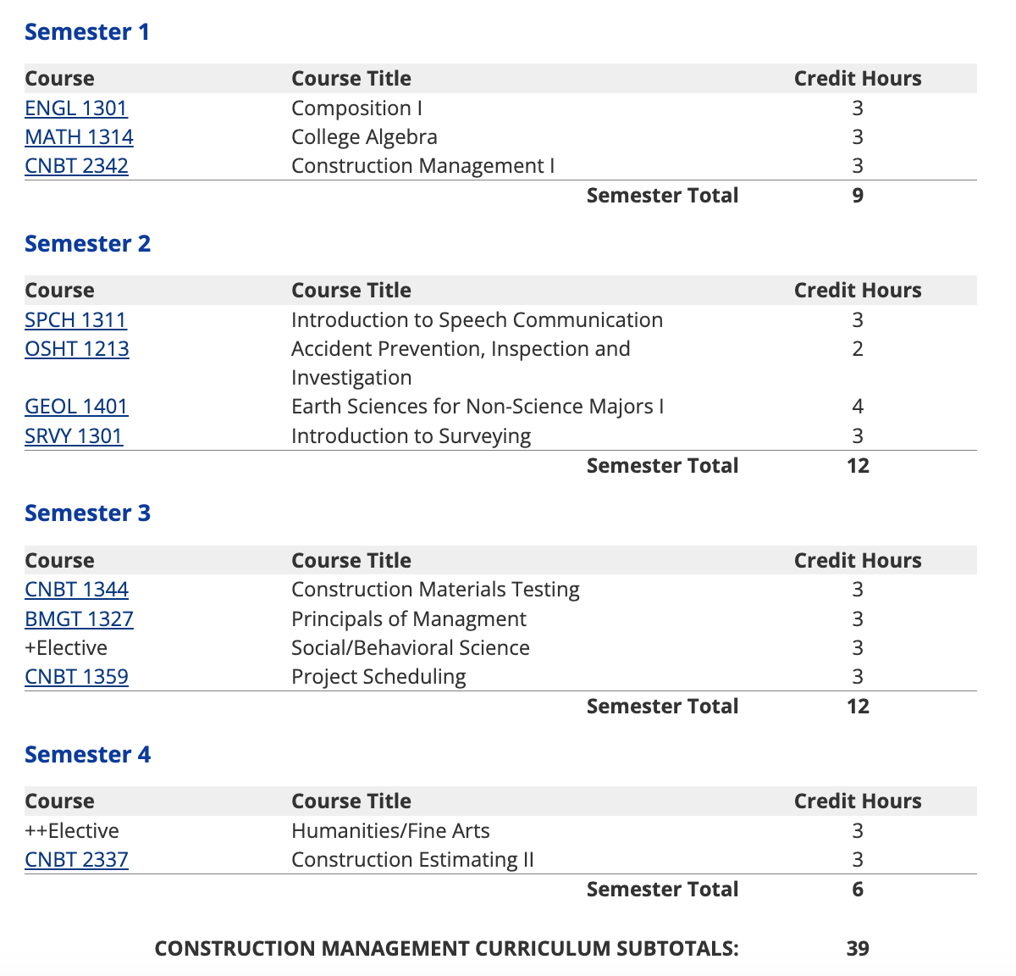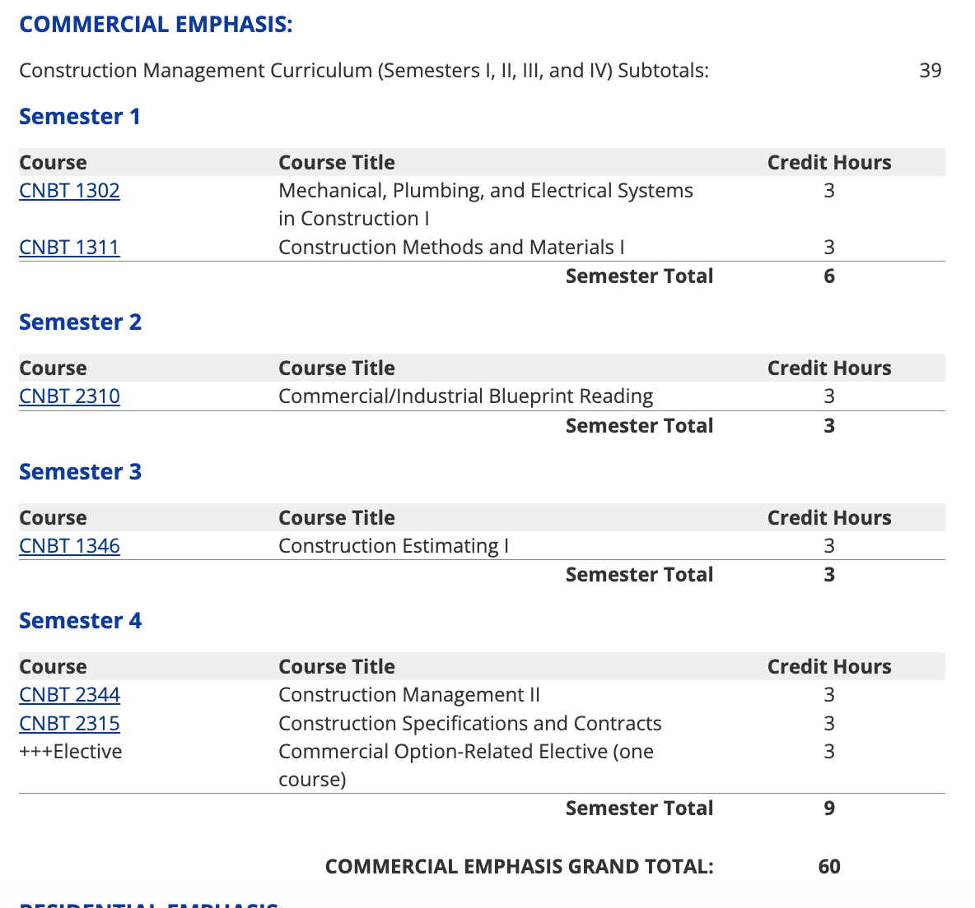

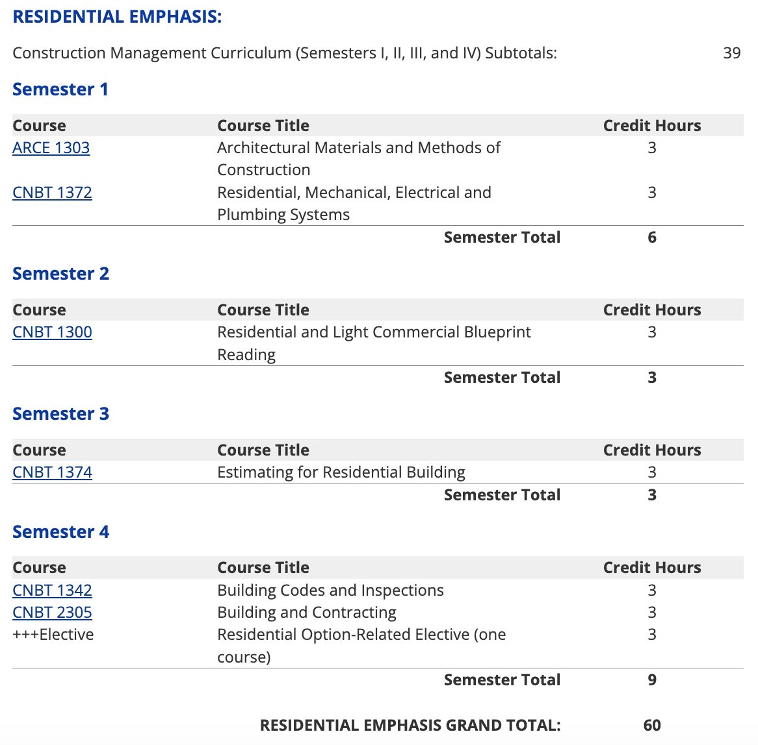

Figure 12: Construction Management Program, Dallas College
Source: https://www1.dcccd.edu/catalog/programs/degree.cfm?degree=const_mgmt_tech_aas

Program at Tarrant County College, 2 year AAS:

Tarrant County College have similar courses: Basic Construction Safety, Residential and Light Commercial Construction Drawings, Methods and Materials I, Mechanical Electrical Plumbing Systems, Construction Estimating, Building Codes and Inspections, Intro to Surveying, Construction Management I, Construction Estimating, Construction Scheduling, and a Capstone course similar to our Construction Management II course.

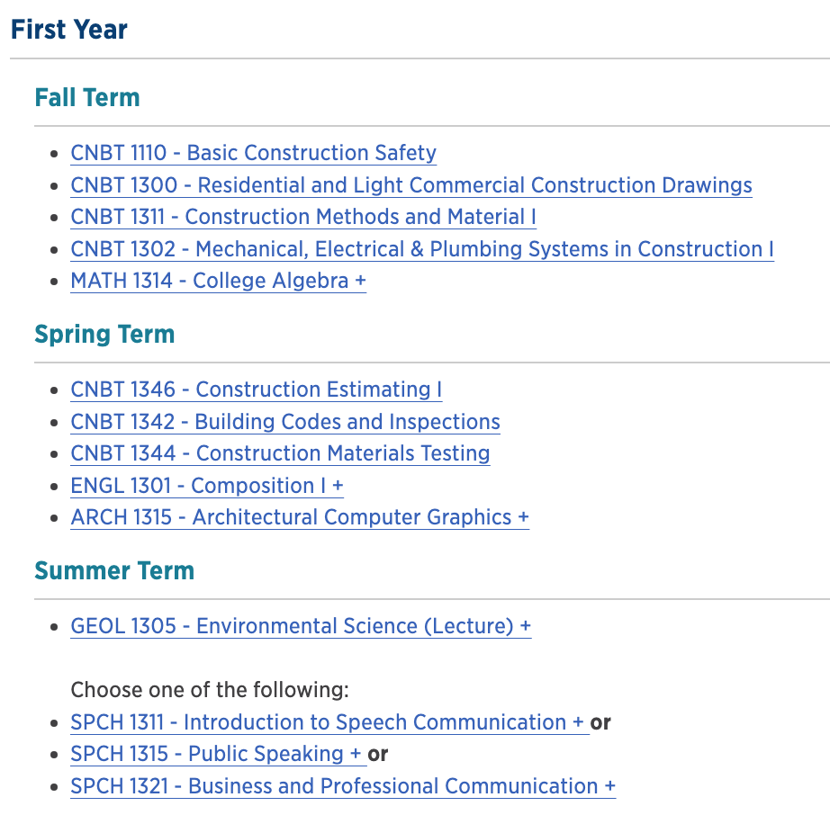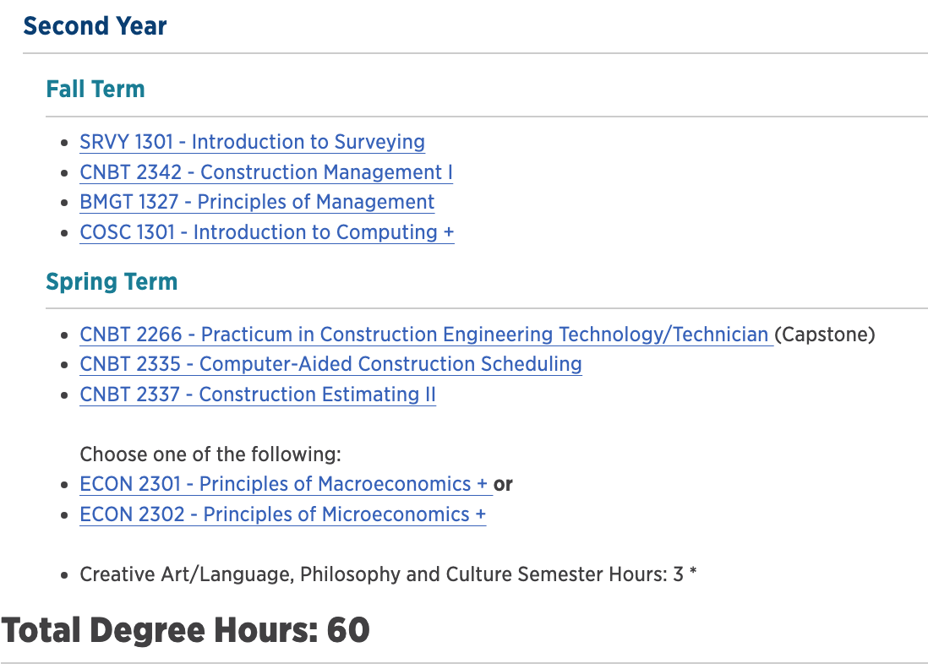

Figure 13: Tarrant County College Construction Technology
Source: https://catalog.tccd.edu/preview_program.php?catoid=14&poid=3640

In the spring of 2023, the Collin College Construction Management Program successfully completed the accreditation process as required for the American Council for Construction Education (ACCE). The mission of ACCE is to be a leading global advocate of quality construction education; and to promote, support and accredit quality construction education programs. To achieve accreditation, among many other submittals, the Construction Management program was required to submit documentation and supporting evidence of the ability to meet the 13 Student Learning Outcomes as prescribed by ACCE:

SLO #1: Apply effective communication, both orally and in writing.
SLO #2: Apply quantity takeoff skills for bidding or budgeting purposes on a construction project.
SLO #3: Apply the aptitude to schedule a basic construction project.
SLO #4: Apply current technology related to the construction industry.

SLO #5: Apply the interpretation of construction documents (contracts, specifications, and drawings) used in managing a construction project.
SLO #6: Apply basic principles of construction accounting.
SLO #7: Apply basic surveying techniques used in building layout.
SLO #8: Understand basic principles of ethics in the construction industry.
SLO #9: Understand the fundamentals of contracts, codes, and regulations that govern a construction project.
SLO #10: Understand basic construction methods and materials.
SLO #11: Understand basic safety hazards on a construction site and standard prevention measures.
SLO #12: Understand the basic principles of structural design.
SLO #13: Understand the basic principles of mechanical, electrical and plumbing systems.

Additionally, instructors participate in ACCE staff development consortiums twice per year, as well as participating in the accreditation process as visiting team members for other higher education institutions. The ACCE reaccreditation process is repeated in 5 year cycles.

D. Present evidence from advisory committee minutes, attendance, and composition that the advisory committee includes employers who are actively engaged on the committee and who are representative of area employers.
1. How many employers does your advisory committee have? 38 members.
2. How many employers attended the last two meetings? 22 members at each of the last two meetings
3. How has the advisory committee impacted the program over the last five years (including latest trends, directions, and insights into latest technologies)?
For the majority of this program review period, the advisory committee meetings have been smaller than they should be, some members didn’t attend meetings, and some of the members were not representing employers that hire program completers. The committee is comprised of representatives from the following specialties:
∙ Commercial Concrete Contractor
∙ Commercial General Contractor
∙ Residential Home Remodeling
∙ Residential General Contractor, Production Homes
∙ Commercial Mechanical Engineering / Contracting
∙ Dallas Builders Association
∙ Heavy Civil Construction Contractor
∙ Construction Management Consultant
∙ Custom Home Builder
∙ Engineered Wood Supplier
∙ Electrical Contractor
∙ Structural Components Supplier

4. Briefly summarize the curriculum recommendations made by the advisory committee over the last five years.
The advisory committee recommended incorporating industry standard software in the Construction Management program curriculum for construction estimating, construction scheduling, blueprint reading, construction project management, CAD (Computer Aided Design) and BIM (Building Information Management). As a result, the program incorporated the use of Bluebeam and Procore Construction Management software, Microsoft Project scheduling software, and Revit BIM software.

The Construction Management program and the advisory committee agreed that as industry software technology frequently changes, we review current applications with our advisory committee at least once a year. Our advisory committee reviewed a list of desirable employee attributes obtained from O*NET Online Occupational Database. The committee prioritized specific attributes of knowledge, skill and abilities they would like to see in our completers. The resultant list is below. We review this list together with the advisory committee once a year as well, to ensure that our completers reflect current industry standard skills and knowledge.

Advisory Committee Knowledge Attributes:
Building and Construction — Knowledge of materials, methods, and the tools involved in the construction or repair of houses, buildings, or other structures such as highways and roads.
Administration and Management — Knowledge of business and management principles involved in strategic planning, resource allocation, human resources modeling, leadership technique, production methods, and coordination of people and resources.
Engineering and Technology — Knowledge of the practical application of engineering science and technology. This includes applying principles, techniques, procedures, and equipment to the practice of construction management.
English Language — Knowledge of the structure and content of the English language including the meaning and spelling of words, rules of composition, and grammar. Knowledge of specific vocabulary as related to the construction industry.
Customer and Personal Service — Knowledge of principles and processes for providing customer and personal services. This includes customer needs assessment, meeting quality standards for services, and evaluation of customer satisfaction.
Design — Knowledge of design techniques, tools, and principles involved in production of precision technical plans, blueprints, drawings, and models. The ability to read plans and specifications related to commercial and residential construction.
Mathematics — Knowledge of arithmetic, algebra, geometry, calculus, statistics, and their applications.
Public Safety and Security — Knowledge of relevant equipment, policies, procedures, and strategies to promote effective local, state, or national security operations for the protection of people, data, property, and institutions. Knowledge of Occupational Safety and Health (OSHA) standards and practices as related to the construction industry.
Mechanical — Knowledge of machines and tools, including their designs, uses, repair, and maintenance.
Economics and Accounting — Knowledge of basic estimating skills and the accounting process as related to the construction industry.
Computers and Electronics — Knowledge of current industry standard software used for estimating, scheduling, plan reading and design.
Advisory Committee Skills Attributes:
Coordination — Adjusting actions in relation to others' actions.
Management of Personnel Resources — Motivating, developing, and directing people as they work, identifying the best people for the job.
Active Listening — Giving full attention to what other people are saying, taking time to understand the points being made, asking questions as appropriate, and not interrupting at inappropriate times.
Monitoring — Monitoring/Assessing performance of yourself, other individuals, or organizations to make improvements or take corrective action.
Speaking — Talking to others to convey information effectively.
Time Management — Managing one's own time and the time of others.
Complex Problem Solving — Identifying complex problems and reviewing related information to develop and evaluate options and implement solutions.
Critical Thinking — Using logic and reasoning to identify the strengths and weaknesses of alternative solutions, conclusions, or approaches to problems.
Judgment and Decision Making — Considering the relative costs and benefits of potential actions to choose the most appropriate one.
Reading Comprehension — Understanding written sentences and paragraphs in work-related documents.
Active Learning — Understanding the implications of new information for both current and future problem-solving and decision-making.
Negotiation — Bringing others together and trying to reconcile differences.
Social Perceptiveness — Being aware of others' reactions and understanding why they react as they do.
Management of Financial Resources — Determining how money will be spent to get the work done, and accounting for these expenditures.
Mathematics — Using mathematics to solve problems.
Writing — Communicating effectively in writing as appropriate for the needs of the audience.
Management of Material Resources — Obtaining and seeing to the appropriate use of equipment, facilities, and materials needed to do certain work.
Service Orientation — Actively looking for ways to help people.
Advisory Committee Abilities Attributes:
Problem Sensitivity — The ability to tell when something is wrong or is likely to go wrong. It does not involve solving the problem, only recognizing that there is a problem.
Deductive Reasoning — The ability to apply general rules to specific problems to produce answers that make sense.
Inductive Reasoning — The ability to combine pieces of information to form general rules or conclusions (includes finding a relationship among seemingly unrelated events).
Oral Comprehension — The ability to listen to and understand information and ideas presented through spoken words and sentences.
Oral Expression — The ability to communicate information and ideas in speaking so others will understand.
Visualization — The ability to imagine how something will look after it is moved around or when its parts are moved or rearranged.
Written Comprehension — The ability to read and understand information and ideas presented in writing.
Written Expression — The ability to communicate information and ideas in writing so others will understand.
Speech Clarity — The ability to speak clearly so others can understand you.
Mathematical Reasoning — The ability to choose the right mathematical methods or formulas to solve a problem.
Number Facility — The ability to add, subtract, multiply, or divide quickly and correctly.
Selective Attention — The ability to concentrate on a task over a period of time without being distracted.
Originality — The ability to come up with unusual or clever ideas about a given topic or situation, or to develop creative ways to solve a problem.
Source: https://www.onetonline.org/link/summary/11-9021.00 (adapted, prioritized and revised by Collin College Construction Management Advisory Committee

E. Make a case with evidence that the program is well managed.
Suggested/possible points to consider (Data can be found at http://inside.collin.edu/institutionaleffect/Program_Review_Process.html):
- Average class size
- Grade distributions
- Contact hours taught by full-time and part-time faculty
- Identify all courses that have a success rate below 75%. If any of these are core courses, visit with the discipline lead for the course(s) in question to determine whether or not the content of the course(s) is appropriate to the workforce program learning outcomes. Using assessment evidence and instructor observations, identify the student learning outcomes that are the greatest challenges for students in courses with low success rates. Explain what instructional and other intervention(s) might improve success rates for each identified course.
- How well are general education requirements integrated with the technical coursework?
- Student satisfaction: What evidence do you have that students are satisfied with the program? What kinds of complaints are made to the associate dean/director by program students?
As referenced in Figure 14, for the total of 69 classes, the average class size for the Construction Management program is 19.17students per class section. Some of the courses have capped enrollment numbers for safety purposes (supervision of power tool use, etc.).

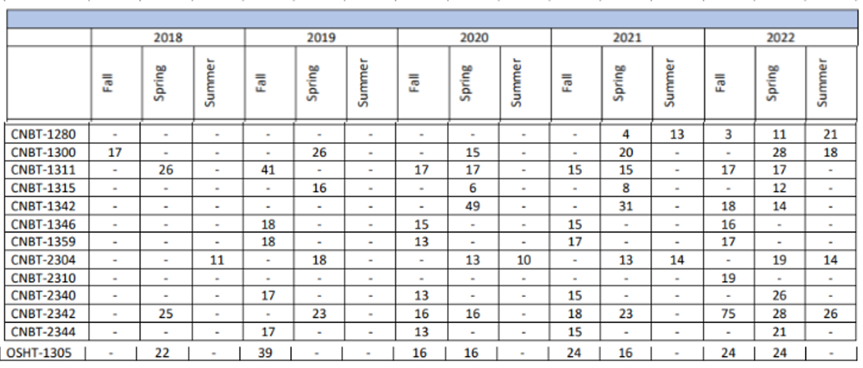

Figure 14: Average Section Size
Source: https://inside.collin.edu/institutionaleffect/averagesectionsize.html
Grade Distribution:
Per the grade distribution information presented in Figure 10, there are no Construction Management courses that have a success rate below 75%. Per Figure 10, Compiled Success and Completion Rates, the average success rate for Construction Management courses is 92% and the average completion rate is 98%. This success is partly credited to the full time faculty and adjunct instructors dedication
to our students. Since the majority of our professors and instructors hold employment either full or part time in the construction industry, they are able to successfully coach and mentor the construction management students with real-world problem examples and class exercises. Additionally, as our faculty members have extensive knowledge and experience in all aspects of construction management, they are able to coach and mentor students in subjects other than what they may be teaching in any given semester. This ensures that students are always able to ask any faculty member for help in another course, and the opportunities for individual coaching are plentiful.
Faculty Contact Hours:
Per the information gathered in Figure 15, the Construction Management program as of Fall 2022 provided only 32% of our contact hours with full-time faculty, and 68% with adjunct faculty. We have identified this discrepancy as a weakness in the past, and have requested funding for additional full-time faculty, particularly with the anticipated growth we expect. This school year (2023-24) we have added four new full-time faculty members to mitigate the discrepancy, however we anticipate we will need to continue recruiting full-time faculty to keep up with growing enrollment.
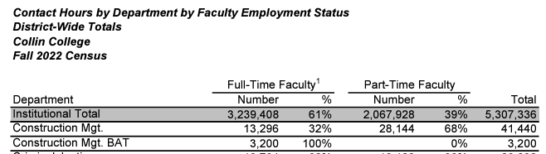
Figure 15: Faculty Contact Hours
Source: https://inside.collin.edu/institutionaleffect/202310%20Census%20Contact%20HoursActual.pdf

How well are general education requirements integrated with the technical coursework?
Our AAS degree plan coursework is integrated with the technical coursework throughout the program. Our career coach meets with students when they enroll to help them lay out an achievement plan. The coursework is sequential, and is listed on our Construction Management Program website. As a department, we have identified that this integration could be an area of improvement for the department as the general education classes are primarily offered at other campuses. This semester, the PHIL 2306 Introduction to Ethics (second year, first semester) class is being offered at the technical campus for our construction management students. The construction management leadership team met with the PHIL 2306 instructor prior to the beginning of the semester to identify areas within the construction management curriculum and lessons that can be integrated into the PHIL class to make it more specific and relevant to the construction industry.
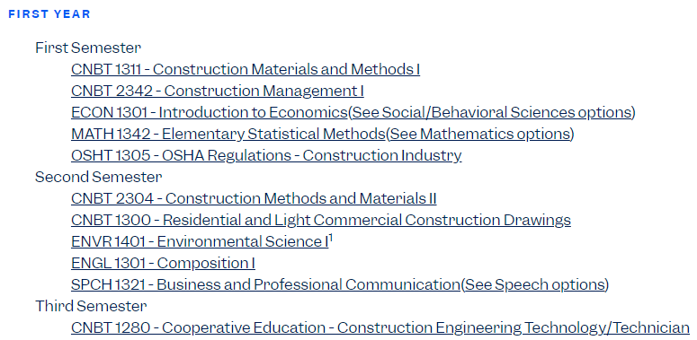
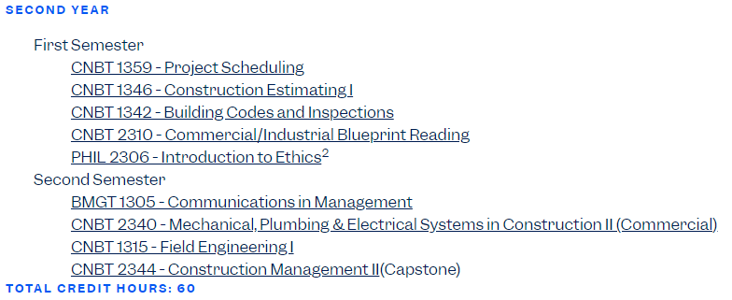
Figure 16: Construction Management AAS Degree Course Requirements
Source: Collin College Construction Management Program website https://www.collin.edu/academics/programs/CNST_AAS.html

☐6. How effectively do we communicate, and how do we know?
A. Make a case with evidence that the program literature and electronic sites are current, provide an accurate representation of the program, and support the program’s recruitment plan, retention plan and completion plan.
Suggested/possible points to consider:
- Demonstrate how the unit solicits student feedback regarding its website and literature and how it incorporates that feedback to make improvements.
- How does the program ensure that students are informed/aware of program literature? Is program literature made accessible to all students (i.e. can they obtain the information they need)?
- Designate who is responsible for monitoring and maintaining the unit’s website, and describe processes in place to ensure that information is current, accurate, relevant, and available.

The CM program catalog can be found at https://www.collin.edu/academics/programs/CNST_AAS.html. The catalog expresses the goals of the program, the different award types the program offers, the degree plan for each award type, and course descriptions with prerequisite requirements. The catalog is maintained by Collin’s Curriculum Office, allowing the degree plans to update whenever changes are made to the curriculum. The goals of the program are revised by the Director, Craig Johnson and Discipline Lead, Cheri Weinhagen. The Curriculum Office also maintains Collin course descriptions and the associated student learning outcomes. This information is formally established at the statewide level or (in the case of local needs courses) must be submitted to the Texas Higher Education Coordinating Board to be approved.
The biggest strength of the catalog is that potential students are aware that a Construction Management program at Collin College exists and has the goal of fulfilling constant demand by the industry for an educated and well prepared workforce. The catalog also expresses that students planning on transferring should consult an academic advisor before registering to ensure transferability of courses. This ensures that students registering for the program are aware of the program’s transfer constraints (i.e. CNBT courses won’t transfer to a bachelor’s degree at a 4-year university, but will count toward the bachelor’s degree program at Collin College). The biggest weakness is that the catalog has no information on industry information or career opportunities. This has been identified as a need, and addressed with the information on the Construction Management Department website https://collin.oudeve.com/department/constructionmanagement/.
Program literature is posted on the Construction Management program website (linked below). Additionally, we have department bulletin boards in the hallways outside our classrooms with job postings, program information, scholarship opportunities, etc. The bulletin boards and website are managed by our career coach, Kate Smith. Kate’s contact information is also posted on all the bulletin boards and on the website. Kate works with every individual student in the department, and follows up with classroom visits each semester to ensure that the students have all current information regarding the program.

https://www.collin.edu/department/constructionmanagement/constructionmanagement.html
The construction management career coach is currently creating a student survey system to gather information on employment, internships, students experiences, etc. This information will be used to keep our website current and relevant, as well as to integrate feedback into program improvement.

B. In the following Program Literature Review Table, document that the elements of information listed on the website and in brochures (current academic calendars, grading policies, course syllabi, program handouts, program tuition costs and additional fees, description of articulation agreements, availability of courses and awards, and local job demand in related fields) were verified for currency, accuracy, relevance, and are readily available to students and the public. Please fill out the table only for this prompt (B.), no analysis is necessary here.
Program Literature Review Table
Title | Type (i.e. URL, brochure, handout, etc.) | Date of Last Review/Update |  | Responsible Party
Online Catalog | https://www.collin.edu/academics/programs/CNST_AAS.html text. | 2024 review and update (in progress) | x☐Current  x☐Accurate  x☐Relevant  x☐Available | Director, Craig Johnson and Discipline Lead, Cheri Weinhagen
Department Website | https://collin.oudeve.com/department/constructionmanagement/ | 2023 review and update | x☐Current  x☐Accurate  x☐Relevant  x☐Available | Director, Craig Johnson and Career Coach, Kate Smith
Click or tap here to enter text. | Click or tap here to enter text. | Click or tap to enter a date. | ☐Current  ☐Accurate  ☐Relevant  ☐Available | Click or tap here to enter text.
Click or tap here to enter text. | Click or tap here to enter text. | Click or tap to enter a date. | ☐Current  ☐Accurate  ☐Relevant  ☐Available | Click or tap here to enter text.
Click or tap here to enter text. | Click or tap here to enter text. | Click or tap to enter a date. | ☐Current  ☐Accurate  ☐Relevant  ☐Available | Click or tap here to enter text.
Click or tap here to enter text. | Click or tap here to enter text. | Click or tap to enter a date. | ☐Current  ☐Accurate  ☐Relevant  ☐Available | Click or tap here to enter text.
Click or tap here to enter text. | Click or tap here to enter text. | Click or tap to enter a date. | ☐Current  ☐Accurate  ☐Relevant  ☐Available | Click or tap here to enter text.
Click or tap here to enter text. | Click or tap here to enter text. | Click or tap to enter a date. | ☐Current  ☐Accurate  ☐Relevant  ☐Available | Click or tap here to enter text.
Click or tap here to enter text. | Click or tap here to enter text. | Click or tap to enter a date. | ☐Current  ☐Accurate  ☐Relevant  ☐Available | Click or tap here to enter text.

☐7. How well are we leveraging partnership resources and building relationships, and how do we know?
Partnership Resources: On the table below, list any business, industry, government, college, university, community, and/or consultant partnerships, including internal Collin departments, to advance the program outcomes.
The Construction Management program works diligently to recruit industry partners to advance program outcomes. These partners can serve on the program’s advisory committee, serve as guest speakers during classes and special events, provide course projects, and participate in career and job fair events. The program is constantly looking for opportunities that shorten the gap between students and the industry.

Partnership Resources Table**
Partner/Organization | Description | Formal Agreement Duration,  if any. | How is it Valuable to the Program?
Mario Sinacola & Sons | Serves on Advisory Committee | Click or tap here to enter text. | Provides industry trends on construction costs and labor markets for site work and concrete construction. Provides connections with students at career fair.
Polk Mechanical, Inc. | Serves on Advisory Committee | Click or tap here to enter text. | Provides industry trends, workforce demands for mechanical construction.
Highland Homes | Serves on Advisory Committee | Click or tap here to enter text. | Provides industry trends on residential construction.
Dallas Builders Association | Serves on Advisory Committee | Click or tap here to enter text. | Provides guidance for the advisory committee and program leadership. Information on residential construction trends and needs.
Moss Construction | Serves on Advisory Committee | Click or tap here to enter text. | Provides industry trends in commercial construction.
Whiting Turner Construction | Serves on Advisory Committee  Classroom and special event guest speakers and career fair participation. | Click or tap here to enter text. | Provides industry trends in commercial construction and connections to students in class and at the career event.
McCarthy Building Companies | Serves on Advisory Committee  Classroom and special event guest speakers and career fair participation. | Click or tap here to enter text. | Provides industry trends in commercial construction and connections to students in class and at the career event.
Simpson Strong-Tie Co. | Serves on Advisory Committee | Click or tap here to enter text. | Provides industry trends in building materials.
Crossland Construction | Participates in classroom and event presentations and career fair. Provides internships. | Click or tap here to enter text. | Provides connections with our students to industry professionals and provides internship and career opportunities and advice.

☐8. What professional developmental opportunities add value to your program?
The Construction Management program has experienced rapid growth in the past 5 years since its inception. Currently, we have only two full-time professors who have been with the program for longer than 12 months. These two professors and their respective professional development opportunities are listed below.
Within the six months, four new full time professors have been added and their professional development opportunities will be added in the next review period.

Provide a List of professional development activities employees have participated in since the last program review.
Employee Resources Table**
Employee Name | Role in Unit | Professional Development Summary | How is it Valuable to the Unit?
Mike Zolton | Professor | - Connex Webinars  - IFMA Webinars  - Collin College Green Zone Training  - SPECS virtual conference on lighting and HVAC issues  - Collin College Professional Development Programs | These professional development opportunities have kept Mike abreast of recent industry developments in both residential and commercial construction as well as facilities construction and management. Additionally, the Collin College Professional Development seminars have contributed to the continued improvement of teaching methods.
Cheri Weinhagen | Professor | - American Council on Construction Education (ACCE) Industry Seminars and Training  - ACCE Visiting Team Participation  - Completed Masters Degree in Construction Law at Arizona State University in 2023.  - Home Builder’s International Conference  - Collin College Professional Development Programs | These professional development opportunities have kept Cheri abreast of recent industry developments and trends in residential and commercial construction. The ACCE  participation has provided an opportunity to review other college and university construction management programs and learn from their experiences and best practices, in addition to making industry connections. The masters degree has provided an advancement in the field of construction law that will be used in the updating of curriculum, and the Collin College Development seminars have contributed to continued teaching craft improvement.
**For convenience, if providing a listing of professional development activities, this list may be included in this document as an appendix.

☐9. Are facilities, equipment, and funding sufficient to support the program? If not, please explain.
[OPTIONAL—Only respond to prompt 9 if you are requesting improved resources for your program. If current facilities and budget are adequate, please proceed to prompt 10.]
Make a case with evidence that current deficiencies or potential deficiencies related to facilities, equipment, maintenance, replacement, plans, or budgets pose important barriers to the program or student success. As part of your response, complete the resource tables, below, to support your narrative.
Possible points to consider:
- The useful life of structure, technologies and equipment
- Special structural requirements
- Anticipated technology changes impacting equipment sooner than usual

N/A.

Facilities Resources Table**
Significant Pieces of Equipment | Description  (i.e. Special Characteristics) | Meets Needs (Y or N):  Current For Next 5 Years |  | Analysis of Equipment Utilization
Click or tap here to enter text. | Click or tap here to enter text. | Choose an item. | Choose an item. | Click or tap here to enter text.
Click or tap here to enter text. | Click or tap here to enter text. | Choose an item. | Choose an item. | Click or tap here to enter text.
Click or tap here to enter text. | Click or tap here to enter text. | Choose an item. | Choose an item. | Click or tap here to enter text.
Click or tap here to enter text. | Click or tap here to enter text. | Choose an item. | Choose an item. | Click or tap here to enter text.
Click or tap here to enter text. | Click or tap here to enter text. | Choose an item. | Choose an item. | Click or tap here to enter text.
Click or tap here to enter text. | Click or tap here to enter text. | Choose an item. | Choose an item. | Click or tap here to enter text.
Click or tap here to enter text. | Click or tap here to enter text. | Choose an item. | Choose an item. | Click or tap here to enter text.
Click or tap here to enter text. | Click or tap here to enter text. | Choose an item. | Choose an item. | Click or tap here to enter text.
Click or tap here to enter text. | Click or tap here to enter text. | Choose an item. | Choose an item. | Click or tap here to enter text.

Equipment/Technology Table ($5,000 or more) **
Current Equipment Item or Budget Amount | Description | Meets Needs (Y or N):  Current For Next 5 Years |  | For any “N”, justify needed equipment or budget change
Click or tap here to enter text. | Click or tap here to enter text. | Choose an item. | Choose an item. | Click or tap here to enter text.
Click or tap here to enter text. | Click or tap here to enter text. | Choose an item. | Choose an item. | Click or tap here to enter text.
Click or tap here to enter text. | Click or tap here to enter text. | Choose an item. | Choose an item. | Click or tap here to enter text.
Click or tap here to enter text. | Click or tap here to enter text. | Choose an item. | Choose an item. | Click or tap here to enter text.
Click or tap here to enter text. | Click or tap here to enter text. | Choose an item. | Choose an item. | Click or tap here to enter text.
Click or tap here to enter text. | Click or tap here to enter text. | Choose an item. | Choose an item. | Click or tap here to enter text.
Click or tap here to enter text. | Click or tap here to enter text. | Choose an item. | Choose an item. | Click or tap here to enter text.
Click or tap here to enter text. | Click or tap here to enter text. | Choose an item. | Choose an item. | Click or tap here to enter text.
Click or tap here to enter text. | Click or tap here to enter text. | Choose an item. | Choose an item. | Click or tap here to enter text.
Click or tap here to enter text. | Click or tap here to enter text. | Choose an item. | Choose an item. | Click or tap here to enter text.

Financial Resources Table**
Source of Funds  (i.e. college budget, grant, etc.) | Meets Needs (Y or N):  Current For Next 5 Years |  | For any “N”, explain why | For any “N”, identify expected source of additional funds if needed
Click or tap here to enter text. | Choose an item. | Choose an item. | Click or tap here to enter text. | Click or tap here to enter text.
Click or tap here to enter text. | Choose an item. | Choose an item. | Click or tap here to enter text. | Click or tap here to enter text.
Click or tap here to enter text. | Choose an item. | Choose an item. | Click or tap here to enter text. | Click or tap here to enter text.
Click or tap here to enter text. | Choose an item. | Choose an item. | Click or tap here to enter text. | Click or tap here to enter text.
Click or tap here to enter text. | Choose an item. | Choose an item. | Click or tap here to enter text. | Click or tap here to enter text.
Click or tap here to enter text. | Choose an item. | Choose an item. | Click or tap here to enter text. | Click or tap here to enter text.
Click or tap here to enter text. | Choose an item. | Choose an item. | Click or tap here to enter text. | Click or tap here to enter text.
Click or tap here to enter text. | Choose an item. | Choose an item. | Click or tap here to enter text. | Click or tap here to enter text.
Click or tap here to enter text. | Choose an item. | Choose an item. | Click or tap here to enter text. | Click or tap here to enter text.
Click or tap here to enter text. | Choose an item. | Choose an item. | Click or tap here to enter text. | Click or tap here to enter text.

Section III. Continuous Improvement Plan (CIP)
☐10. How have past Continuous Improvement Plans contributed to success?
Program Review at Collin College takes place for each unit or program every five years. During the last (fifth) year, the program evaluates the data collected during the CIP process.
Please describe how you have used your Continuous Improvement Plan (CIP) to make the following improvements to your program over the past 4 years (your last program review can be found on the Program Review Portal):
  - Program Learning Outcomes/Program Competencies
  - Overall improvements to your program

The program utilizes the Continuous Improvement Plan (CIP) as a methodology to identify important learning outcomes in the curriculum and ensure students are mastering these respective topics. Our learning outcomes are as follows:

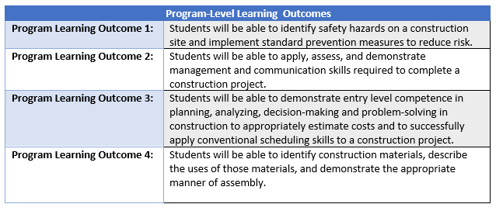
Figure 16: Program Level Learning Outcomes Construction Management AAS
Source: Collin College Construction Management Program Program Level Learning Outcomes 2022

PLO #1 is assessed in OSHT1305 OSHA Regulations - Construction Industry with the goal of 80% of the students passing written exams and the National Center for Construction Education & Research (NCCER) Core Curriculum modules on Basic Safety, Introduction to Basic Rigging, and Introduction to Materials Handling. Additionally 80% of the students will earn OSHA 30-hour Construction Safety Certification.

PLO#2 is assessed with the comprehensive final exam in CNBT2342 - Construction Management 1 with the goal of 80% of students will achieve a score of 70% or higher.

PLO#3 is assessed with the final budgeting project in CNBT1359 - Project Scheduling with the goal of 80% of students achieving a score of 70% or higher.

PLO#4 is assessed with the final exam in CNBT2304 - Materials and Methods II with 80% of the students scoring 70% or higher.

** No CIP Tables were available on the Institutional Effectiveness Data Website

*Please attach previous CIP Tables in the appendix

☐11. How will we evaluate our success?

NOTE: Please contact the institutional effectiveness office if you need assistance filling out the CIP tables.
As part of the fifth year Program Review, the program should use the observations and data generated by this process along with data from other relevant assessment activities to develop the program’s CIP and an action plan for the next two years. At the conclusion of the first two years, data collected from the first year, plus any other relevant data that was collected in the interim, should be used to build on the accomplishments of those first two years by developing another two-year action plan for the CIP to help the program accomplish the expected outcomes established in its CIP or by implementing one of your other plans.

Based on the information, analysis, and discussion that have been presented up to this point, summarize the strengths and weaknesses of this program. There should be no surprise issues here! This response should be based on information from prior sections of this document. Describe specific actions the faculty intends to take to capitalize on the strengths, mitigate the weaknesses, improve student success and program learning outcomes. Provide the rationale for the expected outcomes chosen for the CIP(s).

Throughout this program review, strengths and weaknesses of the Collin College Construction Management Program have been presented. The strengths include:
- The program prepares students for a variety of jobs in the construction management industry. Upon program completion, graduates have career opportunities in residential or commercial construction in a variety of capacities. Additionally, by the time most students finish the AAS program, they are already employed.
- Our career fairs provide our students with an array of opportunities for employment both while they are still students in the program and after graduation. We have an impressive participation rate from both students and industry partners in the career fairs.
- Our industry partners play a significant and active role in the development and maintenance of our program. This participation includes the industry advisory committee, special events, classroom guest speakers, workshop speakers, internships and cooperative education, and our career fairs.
- The local demand for entry-level positions in the construction industry in our region continues to grow. The Dallas area outpaces the national average in demand for construction workforce and the trend continues to grow.
- Our students are well equipped to participate in the workforce partially due to the exposure to industry professionals who bring their experience to the classroom.
- Student demand for construction management courses has grown exponentially in the past 5 years and continues to grow.

- Our advisory board represents a variety of sectors within the construction industry including residential construction, commercial construction, subcontractors, materials suppliers and design services. This gives a diversity of perspective when reviewing current trends and industry demand that we incorporate into our program.

- All construction management courses are meeting the standard for completion rates and success rates.

The Construction Management Program also has opportunities for improvement. These opportunities include:

- Construction Management courses taught within the program are not transferable to Construction Management programs at 4-year colleges and universities. Therefore, students in the program will not receive credit towards a bachelor’s degree in construction management at another institution. However, they may apply their first two years of coursework in construction management to a bachelor’s degree in construction management at Collin College.
- The Construction Management program does not have solid data about employment after graduation for program completers. We have kept in touch with former students, but do not have an organized means of collecting data from graduates. However, a method to collect and organize this data is being prepared currently.
- The Construction Management program has had some issues in the past 5 years with students taking classes within the program that they are not prepared for (i.e. prerequisite courses). This is due to the fact that many of the prerequisite courses are not currently listed in the program catalog so there is no method for controlling the sequence in which the students are required to take classes. The program is currently in process of updating the prerequisites for all program courses, with the goal of having those in place in the catalog before Fall 2024 registration begins.
- The program’s industry advisory committee meetings are at approximately 40-50% attendance. It would be beneficial to review the current membership of the advisory committee to identify inactive members and seek some replacement members that would be more likely to participate. There is an additional opportunity to seek more industry partners during this process who would be willing to commit to serving as guest speakers, career fair participants and internship providers.

☐ 12. Complete the Continuous Improvement Plan (CIP) tables that follow.
Within the context of the information gleaned in this review process and any other relevant data, identify program priorities for the next two years, including at least one program learning outcome (or program competency), and focus on these priorities to formulate your CIP. You may also add short-term administrative, technological, assessment, resource or professional development outcomes as needed.

Table 1. CIP Outcomes, Measures & Targets Table (focus on at least one for the next two years)
A. Expected Outcomes  Results expected in this unit  (e.g. Authorization requests will be completed more quickly; Increase client satisfaction with our services) | B. Measures  Instrument(s)/process(es) used to measure results  (e.g. sign-in sheets, surveys, focus groups, etc.) | C. Targets  Level of success expected  (e.g. 80% approval rating, 10 day faster request turn-around time, etc.)
Increase the pass-rate level for PLO#1. Students will be able to identify safety hazards on a construction site and implement standard prevention measures to reduce risk. | 3 written exams in OSHT1305 - OSHA Regulations - Construction Industry aligned to National Center for Construction Education & Research (NCCER) Core Curriculum modules on: basic safety, basic rigging and introduction to materials handling.  Performance Profiles (i.e. practical assessments) in OSHT 1305 - OSHA Regulations - Construction Industry and NCCER core curriculum for: basic safety, basic rigging and introduction to materials handling.  Complete OSHA 30-hour Construction Safety Certification | 90 % of students will pass written exams and performance profiles for NCCER Core Curriculum modules on: basic safety, basic rigging and introduction to materials handling.  90% of students will earn OSHA 30-hour Construction Safety Certification upon completion of OSHT1305.
Increase number of graduates who complete AAS degree. | Total AAS graduates per year. | 40 graduates
Increase number of students continuing in Collin College BAS in Construction Management degree upon completion of AAS. | Total program third year entry students. | 30 students
Click or tap here to enter text. | Click or tap here to enter text. | Click or tap here to enter text.

Continuous Improvement Plan

Outcomes might not change from year to year. For example, if you have not met previous targets, you may wish to retain the same outcomes. You must have at least one program learning outcome. You may also add short-term administrative, technological, assessment, resource or professional development goals, as needed. Choose 1 to 2 outcomes from Table 1 above to focus on over the next two years.

A. Outcome(s) - Results expected in this program (from column A on Table 1 above--e.g. Students will learn how to compare/contrast Conflict and Structural Functional theories; increase student retention in Nursing Program).
B. Measure(s) – Instrument(s)s/process(es) used to measure results (e.g. results of essay assignment, test item questions 6 & 7 from final exam, end of term retention rates, etc.).
C. Target(s) - Degree of success expected (e.g. 80% success rate, 25 graduates per year, increase retention by 2% etc.).
D. Action Plan - Implementation of the action plan will begin during the next academic year. Based on analysis, identify actions to be taken to accomplish outcome. What will you do?
E. Results Summary - Summarize the information and data collected in year 1.
F. Findings - Explain how the information and data has impacted the expected outcome and program success.
G. Implementation of Findings – Describe how you have used or will use your findings and analysis of the data to make program improvements.
Table 2. CIP Outcomes 1 & 2
- Outcome #1 PLO #1: Students will be able to identify safety hazards on a construction site and implement standard prevention measures to reduce risk.

- Measure (Outcome #1)  3 written exams in OSHT 1305 – OSHA Regulations – Construction Industry aligned to National Center for Construction Education & Research (NCCER) Core Curriculum modules on: a) Basic Safety b) Introduction to Basic Rigging, and c) Introduction to Materials Handling. Complete OSHA 30-hour Construction Safety Certification. | - Target (Outcome #1)  90% of students will pass written exams for NCCER Core curriculum modules on: Basic Safety, Intro. To Basic Rigging, and Intro. To Materials Handling. 90% of students will earn OSHA 30-hour Construction Safety Certification.
- Action Plan (Outcome #1)
Teach students NCCER modules on basic safety, basic rigging and materials handling. Teach OSHA safety modules.
- Results Summary (Outcome #1) TO BE FILLED OUT IN YEAR 2

- Findings (Outcome #1) TO BE FILLED OUT IN YEAR 2

- Implementation of Findings (Outcome #1) TO BE FILLED OUT IN YEAR 2

Table 2. CIP Outcomes 1 & 2 (continued)

- Outcome #2 Increase number of graduates in AAS Program.

- Measure (Outcome #2)  Total number of AAS graduates | - Target (Outcome #2)  40 graduates
- Action Plan (Outcome #2)
Monitor student progress, audit student graduation plans, coach students who need help completing graduation plans.
- Results Summary (Outcome #2) TO BE FILLED OUT IN YEAR 2

- Findings (Outcome #2) TO BE FILLED OUT IN YEAR 2

- Implementation of Findings (Outcome #2) TO BE FILLED OUT IN YEAR 2

What happens next? The Program Review Report Pathway
- Following approval by the Steering Committee,
- Program Review Reports will be evaluated by the Leadership Team;
- After Leadership Team review, the reports will be posted on the Intranet prior to fall semester;
- At any point prior to Intranet posting, reports may be sent back for additional development by the unit.

- Unit responses to the Program Review Steering Committee recommendations received before July 31st will be posted with the Program Review Report.

- Leadership Team members will work with program supervisors to incorporate Program Review findings into planning and activity changes during the next five years.

Please make sure to go back and complete your Executive Summary at the start of the Review.

