PROGRAM NAME: Computer Science | AUTHORING TEAM CONTACT: Tebring Daly
PHONE: 972-378-8439 | EMAIL:tdaly@collin.edu

GUIDELINES
Time Frames
- Scope:
The time frame of program review is five years, including the year of the review.
Data being reviewed for any item should go back the previous four years, unless not available.
- Deadline Dates:
January 15th – Program Review Document due to Department Dean for review (Deans may require submissions at their own, earlier due date)
February 1st – Program Review Document due to Program Review Steering Committee
- Years:
Years 1 & 3 – Implement Action Plan of (CIP) and collect data
Years 2 & 4 – Analyze data and findings, Update Action Plan
Year 5 – Write Program Review of past 5 years; Write Continuous Improvement Plan (CIP) and create new Action Plan

LENGTH OF RESPONSES: Information provided to each question may vary but should be generally kept in the range
of 1-2 pages or 500-1,000 words.

EVIDENCE GUIDELINES: In the following sections, you will be asked to provide evidence for assertions made.
- Sources: This evidence may come from various sources including professional accreditation reviews, THECB, Texas Workforce Commission’s CREWS, Institutional Research Office (IRO), National Student Clearinghouse, IPEDS, JobsEQ, EMSI Career Coach, and may be quantitative and/or qualitative. If you are unfamiliar with any of these information sources, contact the Institutional Research Office at: effectiveness@collin.edu. Use of additional reliable and valid data sources of which you are aware is encouraged.
- Examples of Evidence Statements:
- Poor example: Core values are integrated into coursework. (Not verifiable)
- Good example: Core values are integrated into coursework through written reflections. (Verifiable, but general)
- Better example: Core values are integrating into coursework through written reflections asking the student to describe how s/he will demonstrate each of the core values in his or her professional life and demonstrated through service learning opportunities. (Replicable, Verifiable)

FOR MORE INFORMATION: The Program Review Portal can be found at http://inside.collin.edu/institutionaleffect/Program_Review_Process.html. Any further questions regarding Program Review should be addressed to the Institutional Research Office (effectiveness@collin.edu, 972.599.3102).

Introduction/Preface
☐EXECUTIVE SUMMARY
Briefly summarize the topics that are addressed in this self-study, including areas of strengths and areas of concern. (Information to address this Executive Summary may come from later sections of this document; therefore, this summary may be written after these sections have been completed.) Please do not include information in this section that is not already provided elsewhere in this submission. Using the questions in the template as headings in the Executive Summary can provide structure to the overview document (see below for suggested format).
Executive Summary (suggested sections/format-not required format)
What does our program do?
Why do we do the things we do: Program relationship to the College Mission & Strategic Plan.
Why we do the things we do? Program relationship to student demand.
Why we do the things we do? Program relationship to market demand.
How effective is our curriculum and how do we know?
How effectively do we communicate, and how do we know?
How well are we leveraging partnership resources and building relationships, and how do we know?
How have past Continuous Improvement Plans contributed to success?
How will we evaluate our success?

Complete the Executive Summary below after you have completed your review.
The Computer Science Field of Study helps to prepare students for transferring to a college or university. We equip students with the skills needed to be successful at their four-year institution by following the institutional effectiveness process to remain in compliance with SACSCOC. Our curriculum is continually being assessed using the Quality Matters standards to ensure that our courses are accessible, and our outcomes are linked to our course assessments. We keep in contact with our local universities to ensure that students are able to easily transition from our college to theirs by creating pathways for students. We are currently reviewing our courses and trying to reestablish our AS degree in Computer Science so that students can earn their degree at Collin and then transfer to a four-year school.

The growth in our Computer Science classes has been steadily increasing over the past few years. We are setting the foundation for students to become software engineers as well as building strong soft skills such as communication, interpersonal skills, and basic reasoning. Students will learn how to design, code, and document programming projects and they will need to problem-solve along the way. We are retaining students and most of our courses are exceeding the 70% benchmark for success. Our average class size is 24 students. When students were solicited for feedback on our current department website, 96% of them found the website to be valuable. Because our Computer Science courses have been successful at building a strong programming foundation, the Web Development department at Collin College is using 3 of our Computer Science courses in their program.

Our Society of Women Engineers (SWE) group is very active at Collin. Our SWE group works in collaboration with the Dallas SWE group to offer events such as “Design your World” to encourage middle school/high school girls to explore STEM careers. We also work with Raytheon, Emerson Automation Solutions, Texas Instruments, and Siemens Software to offer company tours, resume-building events, and mock interviews.

In our past Continuous Improvement Plan, we set a goal to create a department website based on student feedback and we met this goal. We set a goal to increase success rates in our Computer Science courses by moving our classes into computer labs and adding hands-on coding projects so that students learn how to properly design, code, and document their projects. Our success rates increased from our last program review. We are currently working on increasing our success rates from our comprehensive exams in our first two programming courses so that we can show that students to able to be successful with the following programming concepts: data types, control structures, functions, and arrays. We hope that students will show a 70% mastery of each of these concepts in their first programming course and an increased 80% mastery of each of the concepts in their second programming course. We need to ensure that students are building the foundation that they need to be successful when transferring and these concepts are the building blocks for this foundation.

Section I. Are We Doing the Right Things?
☐1. WHAT DOES OUR ACADEMIC PROGRAM DO?
What is the program and its context?
This section is used to provide an overview description of the program, its relationship to the college and the community it serves. Keep in mind the reviewer may not be familiar with your area. Therefore, provide adequate explanation as needed to ensure understanding.

Suggested points to consider:
- Program’s purpose (Include the program’s mission statement if one exists.)
- Program learning outcomes or marketable skills
- Brief explanation of who the program serves
- Degree paths it prepares graduates to enter
- What regulatory standards must the program meet (THECB, Workforce, external accreditation)

The purpose and goal of the Computer Science Field of Study coursework is to prepare students for transfer to a college or university where they can specialize in such disciplines as computer science and software engineering. Texas Higher Education Coordinating Board (THECB) (http://www.thecb.state.tx.us/) approves fields of study in accordance with the Texas Education Code, Section 61.823 with the assistance of an advisory committee of content experts. The Computer Science Field of Study (FOS) curriculum is a set of courses that will satisfy the lower division requirements for a bachelor’s degree in a specific academic area at a baccalaureate institution. If a student successfully completes the Field of Study curriculum, that block of courses may be transferred to a baccalaureate institution (http://www.sacscoc.org/). The FOS must be substituted for that institution’s lower division requirements within the degree program for the Field of Study into which the student transfers. Within the Computer Science FOS, there are courses listed that will satisfy requirements for both the AS General Education Core and the FOS.

All of our computer science courses are listed in the Lower Division Academic Course Guide Manual (http://www.thecb.state.tx.us/AAR/UndergraduateEd/WorkforceEd/acgm.htm). Through completing the field of study program, the students learn how to design, code, and document programming projects in C++ and Java. They learn how to break their programs in methods/functions, pass data between their methods/functions, use precedence and associativity operators, code logical control structures (sequence, selection, and iteration), use input and output, manipulate one-dimensional and multidimensional arrays, code data structures (linked list, stack, queue, binary tree, and sorting algorithms), use error-handling mechanisms, use object-oriented methodology (inheritance, polymorphism, and encapsulation), and read and write to sequential data files.

Our Computer Science department has set the following program-level learning outcomes:

- Program Learning Outcome 1: Students will demonstrate an understanding of the fundamental concepts of structured programming: data types, control structures, functions/methods, and arrays.
- Program Learning Outcomes 2: Students will use object-oriented programming techniques to develop executable programs.
- Program Learning Outcome 3: Students will design and develop programs that implement basic data structures.
- Program Learning Outcome 4: Students will be able to describe how data are represented, manipulated, and stored in a computer.

Besides the occupational skills, students will also attain the following marketable skills from the general education courses: communication, interpersonal, and basic reasoning skills.

☐2. WHY DO WE DO THE THINGS WE DO: PROGRAM RELATIONSHIP TO THE COLLEGE MISSION & STRATEGIC PLAN.
- Provide program-specific evidence of actions that document how the program supports the College’s mission statement: “Collin County Community College District is a student and community-centered institution committed to developing skills, strengthening character, and challenging the intellect.”
- Provide program-specific evidence that documents how the program supports the College’s strategic plan (2020-2025 Strategic Plan): https://www.collin.edu/aboutus/strategic_goals.html.

Suggested/possible points to consider:
- What evidence is there to support assertions made regarding how the program relates to the mission and strategic plan?
- Think broadly-increasing completion, pathways to 4-yr and from high schools, etc.
- Analyze the evidence you provide. What does it show about the program?

Supporting Collin’s Strategic Plan:
- Improve student outcomes to meet or exceed local, state, and regional accreditation thresholds and goals.
The Computer Science Field of prepares students with the skills needed to successfully transfer to four-year institutions and complete an undergraduate degree in Computer Science.

The Computer Science program follows the institutional effectiveness processes to remain in compliance with the Southern Association of Colleges and Schools Commission on Colleges (SACSCOC).

Our Computer Science department has set the following program-level learning outcomes:

- Program Learning Outcome 1: Students will demonstrate an understanding of the fundamental concepts of structured programming: data types, control structures, functions/methods, and arrays.
- Program Learning Outcomes 2: Students will use object-oriented programming techniques to develop executable programs.
- Program Learning Outcome 3: Students will design and develop programs that implement basic data structures.
- Program Learning Outcome 4: Students will be able to describe how data are represented, manipulated, and stored in a computer.

We have created an assessment plan to measure each of above learning outcomes and our continuous improvement plan will address some of shortcomings as result of our data analysis.

- Develop and implement strategies to become a national exemplar in program and student outcomes.
This goal is addressed through continual program reviews, curriculum revisions, and growth strategies discussed throughout this document.
Updated program-level learning outcomes were developed in 2021 and mapped at the course level to ensure that students are taught skills aligned with the outcomes. Assessment measures and targets for success will provide data that will be used to support the program's continuous improvement processes. The detailed assessment plan is a separate document submitted with this review. Our Computer Science department has cross-referenced our student learning outcomes with our assessment in our courses to ensure that we are meeting the course objectives.

One of our faculty members serves on the Online Advisory Board (OAB) that evaluates online courses to ensure that they are meeting Quality Matters standards. This faculty member has attended various Quality Matters workshops to earn the Peer Reviewer Course and Independent Applying the QM Rubric certifications. As a subject-matter expert and as a team lead on reviewing courses, this faculty member checks the courses for accessibility, and organization, and to ensure that the course is meeting the student learning outcomes. Another faculty member has 3 years of reading and leadership for the Advanced Placement Computer Science A exam (APCS A). This experience of working with the assessment for Advanced Placement helps this faculty member to gain a better understanding of what is expected of the students to pass this exam and to help Collin College to build better measurements of assessing students.

- Create and implement comprehensive, integrated pathways to support student transitions.
The Computer Science Field of Study certificate courses is comprised of a list from the Lower-Division Academic Course Guide Manual (ACGM). These courses are all transfer courses: COSC1436, COSC1437, COSC2436, COSC2325, MATH2413, MATH2414, MATH2305, PHYS2425, and PHYS2426. Collin College has articulation agreements with the University of Texas at Dallas and the University of North Texas. These articulation agreements guarantee that students at Collin College will get credit for the course in the agreement at the time of transfer. The courses identified in the ACGM guide should transfer to all Texas college and Universities, but working closely with surrounding colleges/universities and creating agreements ensures that our students have a smooth transfer from Collin College to their transfer college/university.
- Implement the third Baccalaureate degree by Fall 2022 and continue adding 2+2 programs with university partners.
We have applied to get a Bachelor’s degree in Applied Computer Science, but this was not accepted. In the Fall 2020, the Computer Science Field of Study Associate of Applied Science was removed as an option at Collin College because of credit hour changes determined by the Texas Higher Education Coordinating Board (THECB). We are in the process of reviewing our curriculum to create the Computer Science Field of Study Associate of Applied Science degree option again. As of right now, we only have the Computer Science Field of Study Certificate.

Collin College is only authorized to have five baccalaureate degrees. The work is underway to examine a baccalauraeate degree that utilizes computer science skills at Collin College.

- Develop and implement a comprehensive staffing and succession model.
Each semester when classes are being built for the next semester, we evaluate the need for hiring more full-time professors, adjunct professors, and program tutors.

The computer science department ensures that new faculty are acclimated to the program and courses. The veteran faculty support the new adjuncts and full-time faculty with supportive resources and well developed courses.

- Develop a coordinated and systematic approach to engage external stakeholders.
For the Computer Science program, the primary external stakeholders are the four-year transfer institutions where students will complete their Bachelor’s degree. Collin College continues to communicate with four-year transfer institutions in the area (University of Texas at Dallas and University of North Texas).

Collin College also offers students a tool named Handshake to help to identify internship possibilities. Students can start searching and applying for internships after nearing the end of the completion of the Computer Science Field of Study certificate.

☐3. Why we do the things we do: Program relationship to student demand
Make a case with evidence to show that students want to enroll in the program. Discuss whether or not there appears to be any disproportionate enrollment by gender, race, or ethnicity (compared to Collin College’s overall student demographic distribution http://inside.collin.edu/iro/programreview/prfilehostpage.html). If any differences exist discuss possible reasons why the gap exists, and plans to address these issues to close gaps in enrollment rates between groups of students (refer to the Program Review portal for Enrollment Reports and Average Section Size data file http://inside.collin.edu/institutionaleffect/Program_Review_Process.html).
Suggested/possible points to consider:
- The number of students who completed the award in each of the last 5 years.
- What is the enrollment pattern? Declining, flat, growing, or not exhibiting a stable pattern; please explain.
- What are the implications for the next 5 years if the enrollment pattern for the past 5 years continues?
- Describe any actions taken to identify and support students enrolled in program-required courses early in the degree plan. Are there any specific supports for a diverse student population? If no actions are taken at the present, please develop and describe a plan to do so.
- Analyze the evidence you provide. What does it show about the program?

Student Demand
The number of students completing the Computer Science certificate and degree has been increasing every year since 2017. We started with only 35 students completing the certificate/degree in 2017 and ended with 88 in 2021, which is a 151% increase. In 2021, the number of students that was previously listed on the “Certificate” award type on the following chart was moved to the “Field of Study” award type.

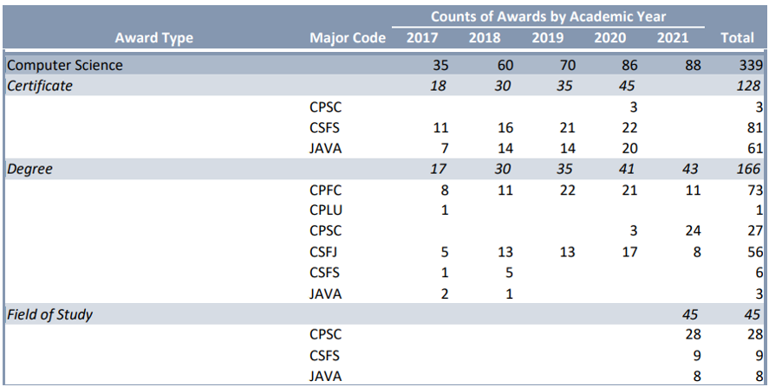

Enrollment Pattern
As demonstrated by the data below enrollment increased from 2017 to 2019 and then took a drop in the fall of 2020. The Computer Science Field of Study AAS degree was removed as an option in the fall of 2020. Students were able to get a Computer Science Field of Study Certificate but were no longer able to get the AAS FOS degree. This is significantly impacting the number of enrolled program majors. Since students are unable to enroll in the Computer Science FOS degree, we believe that we will see low enrollment in the program in the next few years. We hope to revise our curriculum to get the FOS degree option back for students.

Students that were enrolled before 2020 were able to finish the degree. We will see the impact of removing this degree option in the next program review.

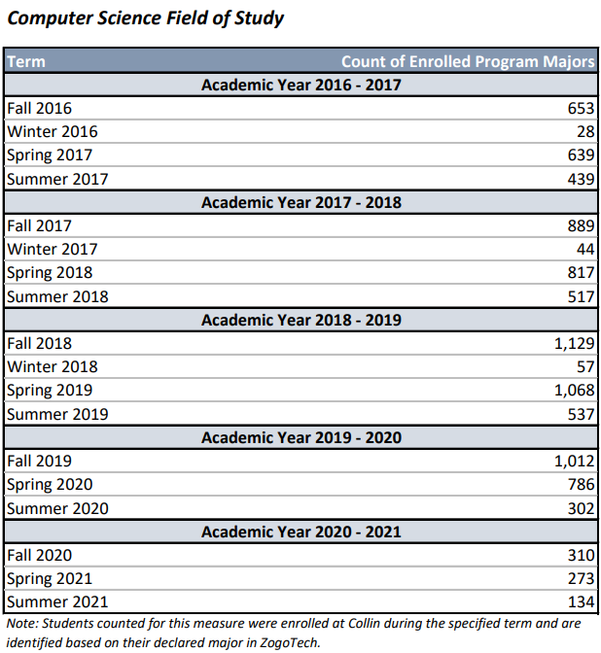
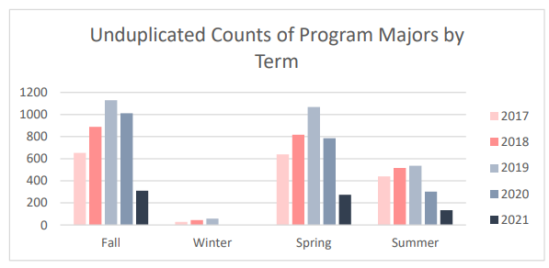

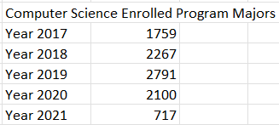

The Computer Science FOS had 2 tracks (C++ and Java) until 2021. In the Fall of 2021, the C++ track was removed and all Computer Science FOS students took COSC1436 as the first course, COSC1437 as the second course, and COSC2436 as the third course.

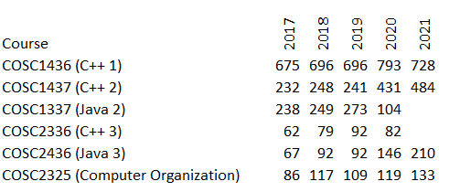

When the COSC1437/COSC1337 and COSC2336/COSC2436 are combined into Programming 2 and Programming 3 in the following chart, you can see the growth of the different levels of courses.

The following chart shows the enrollment in our computer science courses from 2017-2021. All of our courses show steady growth each year. Year 2020 had the highest number of students our programming 1, 2, and 3 courses. This could have been a result of COVID and more reverse-transfer students.
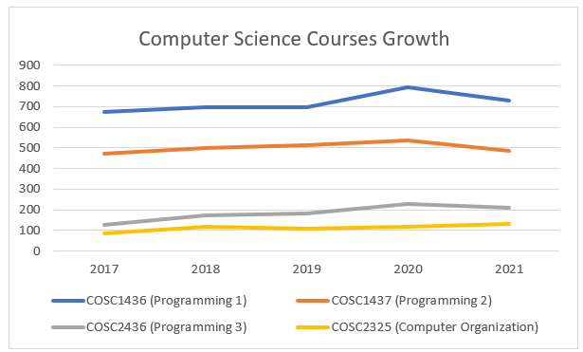

Future Demand
All of the computer science FOS courses showed growth from year 2017 to year 2021. The programming 3 and computer organization had the most growth at 63% and 55% respectively. We are showing growth in our computer science courses and we believe that this growth will continue in the future as long as we have enough faculty to meet this demand. We currently cannot offer more classes because we do not have the faculty to support this.

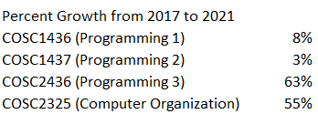

We currently do not have enough faculty to meet the enrollment demand. There are more students than we can support at this moment. There is so much more that we could be doing with our computer science department, but we need more faculty to do it. We have the ability to grow our enrollment, but only if we have the faculty to teach the classes. Hiring adjunct faculty to meet the demand is not a viable solution because often times adjunct faculty are not available in the mornings/afternoons when our students need classes. Most adjunct faculty are working during the day and only available to teach in the evening and weekend. Hiring more full-time faculty gives us the potential to grow our program at various locations: Allen Technical Center, Plano Campus, McKinney Campus, Collin Higher Education Center to support the University of North Texas Bachelor’s Degree in Computer Science, and to offer dual credit at surrounding area high schools.

Diversity
The following graph shows the racial distribution of enrolled computer science FOS students compared with Collin College’s overall student racial distribution and it looks as if we are in line with the college’s overall distribution. We have a higher population of Asian students enrolled compared with the college’s overall number.
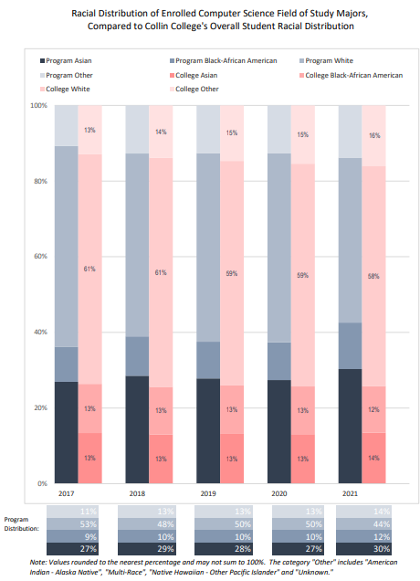

When comparing gender distribution, the computer science program has less than 20% female while the college has an overall of around 56% female.
Two of our female computer science faculty members have been working to encourage females to explore engineering opportunities by offering summer coding camps for middle school girls and by promoting students to get involved with Collin’s chapter of the Society of Women Engineers (SWE), a national organization that supports females interested in engineering. One of our faculty members has been an advisor for the Collin chapter of SWE for the past few years. This student organization offers resume building workshops, mock interviews, company tours, and hosts various speakers every year. The student officers of SWE have promoted this organization at our various campuses during various events, have attended the SWE national conference (the world’s largest conference for women in engineering and technology), and have volunteered to help with engineering events such as Design your World, aimed at promoting and engaging middle school/high school girls in STEM areas.

Collin College is also collaborating with Texas A&M University at Commerce on an NSF S-STEM grant that provides financial support and mentoring to eligible non-traditional computer science students. This grant could help to attract more females into the computer science field.
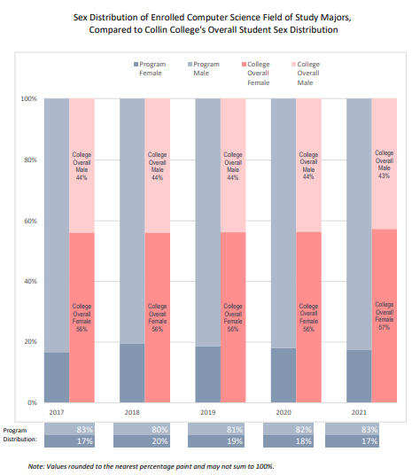

Final Analysis
Our enrollment in the upper-level computer science courses has doubled over the past few years. We are offering classes at the Frisco, Plano, Wylie, and iCollin campuses. There is potential for more growth, but we would need to have more instructors to support this growth. Our programming 1 and 2 courses have shown growth as well, but not as much as the upper-level courses. We already had high enrollment in these courses and so it is harder to grow. If we had more instructors, we could offer more courses and expand this growth to the Allen Technical campus and to high schools to offer dual credit.

We have a low enrollment of female students and we have been encouraging more females to consider majoring in computer science/engineering disciplines by promoting engineering to females at the middle school, high school, and college level with the Society of Women Engineers and by offering summer coding camps to local middle school girls.

Although our enrollment is growing, the number of students completing the computer science program will be declining over the next few years since the Computer Science Field of Study Associate of Science degree was removed as an option for new students in the fall of 2020. Students are still finishing this degree, but new students can no longer enroll in this degree option. Students can still get a Computer Science Field of Study Certificate, but only having this option will most likely impact us in the years to come.

☐4. Why WE DO THE THING WE DO: WHAT MARKETABLE SKILLS SHOULD STUDENTS HAVE AFTER COMPLETING OUR PROGRAM?
Make a case with evidence to show that the program teaches skills that are useful in the workplace.
Suggested/possible points to consider:
- What foundational skills and knowledge do employers say they want?
- Provide evidence from national, state, and/or local employer surveys, studies, editorials and other sources that identify current employer expectations for baccalaureate graduates in program-related fields.

Soft Skills (Marketable Skills)
Students attain the following skills from the general education courses: communication, interpersonal, and basic reasoning skills.

Occupational Skills (Foundational)
The computer science program is not a workforce program and as a FOS program, it does not have a business and industry advisory committee. Therefore, feedback from employers on foundational skills from the region surrounding the college is not available.

We teach the foundational skills to prepare students to be successful when they transfer to a college/university specializing in such disciplines as computer science and computer software engineering. The Computer Science Field of Study (FOS) curriculum is a set of courses that will satisfy the lower division requirements for a bachelor’s degree in a specific academic area at a baccalaureate institution. If a student successfully completes the Field of Study certificate curriculum, that block of courses may be transferred to a baccalaureate institution. The FOS must be substituted for that institution’s lower division requirements within the degree program for the Field of Study into which the student transfers. Within the Computer Science FOS, there are courses listed that will satisfy requirements for both the AS General Education Core and the FOS.

The purpose of this program is to set the pathway with the foundational skills needed to transfer to a college or university and specialize in computer science and computer software engineering. All of our computer science courses are listed in the Lower Division Academic Course Guide Manual. Our computer science program is a field of study program that transfers to colleges and/or universities in the state of Texas. The students will learn how to design, code, and document programming projects in C++ and/or Java. They will learn how to break their programs in methods/functions, pass data between their methods/functions, use precedence and associativity operators, code logical control structures (sequence, selection, and iteration), use input and output, manipulate oone-dimensional and multidimensional arrays, code data structures (linked list, stack, queue, binary tree, and sorting algorithms), use error-handling mechanisms, use object-oriented methodology (inheritance, polymorphism, and encapsulation), and read and write to sequential data files.

Along with these technical skills, professional communication in oral and written media are commonly sought. Various assignments and project-based assignments allows the instructors to assess student attainment of these skills.

Strengths and Weaknesses related to Marketable Skills:
The US Bureau of Labor Statistics projects that the job outlook for Software developers, Quality Assurance Analysts, and Testers for 2021-31 is 25%, much faster than average. The median pay in 2021 is reported to be $109,020 per year or $52.41 per hour. The degree requirement for these jobs is typically a bachelor’s degree in computer and information technology or a related field. https://www.bls.gov/ooh/computer-and-information-technology/software-developers.htm.

We offer Java and C++ programming fundamentals courses. Both languages provide a solid base for building the foundations of computer programming and consistently rank very high in the list of most in-demand programming languages in the industry. Along with programming language proficiency, analytical and problem-solving abilities are at the top of required technical skills for a successful computer programming career. Developments of these skills are one of our program’s top priorities. This also aligns with program requirements of the transfer schools that we are partnered with and facilitates a seamless transfer of our students into their programs.

In addition to required technical skills hiring managers look for soft skills, most vital of which are:
- Collaboration. Software developers typically collaborate as a team rather than work in isolation. Being a good team player able to coordinate with other programmers and testers, brainstorm ideas, effectively resolve disagreements, etc., is essential for a successful IT professional career.
- Communication skills. Teamwork is impossible without effective communication. Working closely with technical and non-technical colleagues requires the ability to clearly describe ideas, explain complex abstractions in simple terms, and articulate merits of different strategies.
- Initiative and independence. Software developers are often required to complete their work with little or no supervision. Initiative and self-motivation without over-reliance on external guidance is viewed as more and more essential, especially in the context of the recent trend of working remotely.

Section II. Are We Doing Things Right?

☐5. HOW EFFECTIVE IS OUR CURRICULUM, AND HOW DO WE KNOW?
A. Make a case with evidence that there are no curricular barriers to completion. Review data related to course retention rates, course success rates, and the frequency with which courses are scheduled to identify barriers to program completion and transfer pathways.
Suggested/possible points to consider:
- FOS only: Given that FOS courses are defined by the state; what actionable barriers are seen?
- For Core only: Do all course options have sufficient enrollment to continue their inclusion in core?
- For Core and FOS certificates: What steps can be taken to improve course completion/success rates, course enrollment, and scheduling frequencies for specific courses?
- Program course retention and success rates: Attach the relevant information from the Program Review Data Set on the Institutional Research Office’s intranet page.
- Identify and discuss all courses that have a retention rate below 78% (Carl Perkins’ standard).
- Using assessment evidence and instructor observations, identify the student learning outcomes that are the greatest challenges for students. Identify any additional barriers to student success.

Actionable Barriers
Being a FOS puts certain limitations as to the number of discipline-specific courses that can be offered after meeting the general education core requirements. Many of the technical skills identified by the industry can only be offered at the junior and senior levels of a four-year institution.

Course Completion/Retention Rates
We do not have any courses with retention rates below the 78% Carl Perkins’ standard. The following chart shows a list of our computer science courses separated by track. We had a C++ and a Java track option for the programming 2 and 3 courses.

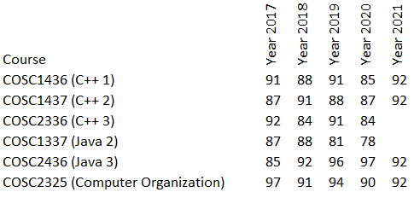

The following chart shows the average completion rates when the programming 2 and 3 courses were combined.

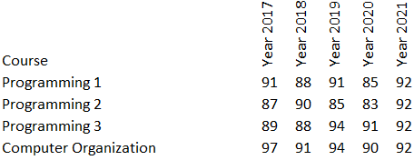

The graph shows a visual representation of the data with the programming 2 and 3 courses combined.

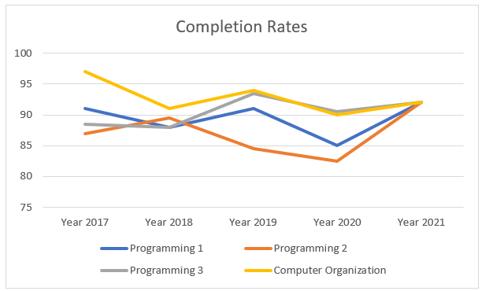

Success Rates
We have a few courses that had below a 70% success rate. The following chart shows a list of our computer science courses separated by track. We had a C++ and a Java track option for the programming 2 and 3 courses. The COSC2436 has improved since and is now averaging in the upper 80th percentile. The COSC2336 dropped in 2020, but this most likely was impacted by COVID. The COSC2336 course was taught entirely in the classroom and was never offered online; when forced to go online during COVID, it was difficult to get this course transferred to a fully online environment. The COSC1337 course has had significantly low success rates. In 2021, the programming tracks were removed and there was only one programing 2 option for students. The COSC1437 course was the only option in 2021 and there was an increase in student success in this course at 71%. Now that we only have one programming track for students, we have been focusing on improving the delivery of our courses. We have added an interactive digital textbook to our programming 1 and programming 2 courses. We have also added standardized testing and hands-on coding projects to these courses.
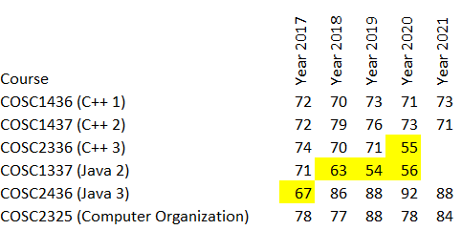

The following chart shows the average success rates when the programming 2 and 3 courses were combined. When the programming 2 and 3 were combined, the success rate averages were satisfactory except for year 2019 and 2020.
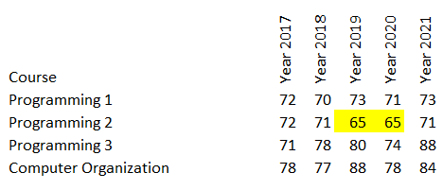

The graph shows a visual representation of the data with the programming 2 and 3 courses combined.

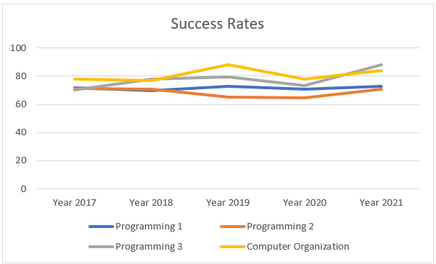

Course Enrollment/Scheduling
We simplified our Computer Science Field of Study by removing one of our programming tracks and having students all take the same track. This helped remove confusion for students by allowing them to easily move from one class to the next without trying to decide which track they should take or accidentally registering for the wrong course in the wrong track. This makes it easier to analyze the data for our courses and for us to improve upon our courses since we have less overhead from having two programming tracks. It makes it easier for us to find instructors to teach the courses since we aren’t using different curriculum, textbooks, tests, etc. for each of the programming tracks.

We are working on growing our program at the Frisco, Wylie, and iCollin campuses. All of our courses are currently offered at the Plano campus.

Barriers to Student Success
COSC1436
As a department, we decided to measure the following program outcome in COSC1436:
Students will demonstrate an understanding of the fundamental concepts of structured programming: data types, control structures, functions/methods, and arrays. The students in COSC1436 were given a comprehensive standardized exam at the end of the course to measure their understanding of the above programming concepts. Based on analysis of this data, students struggled the most with data types and control structures. We discussed this as a department and decided that we wanted to break down the “Data Types” programming concept into “Data Types” and “Arithmetic Problems”. We started this in the spring 2022 and we found that “Data Types” had an average of 68.39% and “Arithmetic Problems” had an average of 62.67%. It seems that both of these areas need improvement, but we will continue to analyze them separately to see what exactly needs to be improved. We also broke the “Control Structures” down into “Loops” and “Conditionals” which are 2 different types of control structures. We had these in separate question banks from the start of the testing so it is easier to analyze. It seems that “Loops” average percentages are significantly lower than those for the “Conditionals”. One of our faculty members is creating a practice test bank for students to use to test their skills. More questions will be added for data types, arithmetic problems, conditionals, and loops. Another faculty member is working on a practice exam that students will take before the final exam so that they know exactly which areas they need more help with before taking the final exam. Students seem to need more practice with these programming concepts and we are working on getting them the practice that they need and hoping that this will increase their ability to answer coding questions that include these concepts. We also discussed that the final exam included a mix of easy, medium, and hard questions in a question bank, but that some students could unfairly be pulling all the hard questions for their exam. We split the questions for the fall 2022 semester into easy, medium, and hard questions within the categories. We are hoping that this will help with the fairness of the exam and possibly even improve the exam scores.

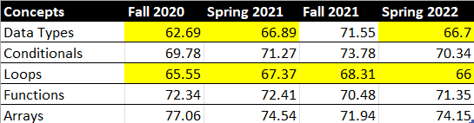

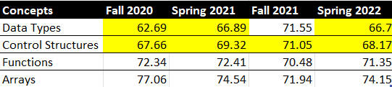

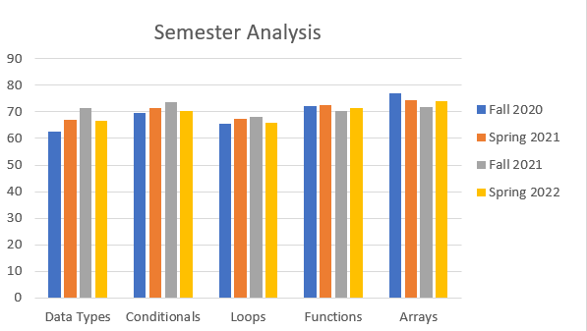

COSC2325
One of our faculty members noticed that students were struggling in COSC2325 with the flow of the program. They couldn’t visualize how it was working internally. In order to solve this problem, he started executing the program in class in debugger mode and working through the code line by line. This helped the students to visualize the code in action.

COSC2436
Another faculty member commented that the students are struggling the most with staying current on the class material/assignments. The course content is comprehensive and always builds on itself. If the students fall behind they can never recover. This professor is working to remind students of due dates and has weekly question-and-answer Zoom sessions that are recorded to help students that are struggling with the concepts.

B. Show evidence that the state standard for award completion has been met.
Completers Standard: Average 25 completers over the last five years or an average of at least five completers per year.
Number of completers: Click or tap here to enter the number of completers in last five years.
If below the state standard, attach a plan for raising the number of completers by addressing barriers to completion and/or by increasing the number of students enrolled in the program. Definition of completer—a student who has received an award.
We had 35 completers in Computer Science in 2017 and 88 in 2021. We met the completers standard set by the state.

C. For any required program courses where there is a pattern of low enrollment (averaging fewer than 15 students), explain your plan to grow enrollment.

We don’t have any Computer Science classes that are averaging less than 15 students.
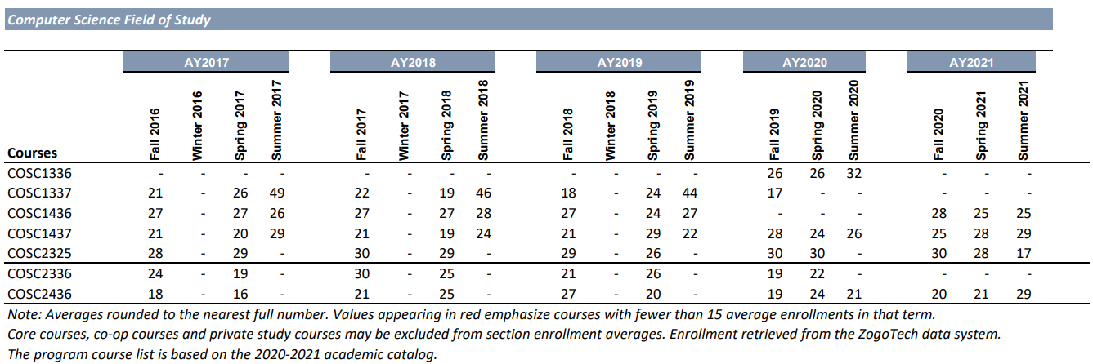

D. Make a case with evidence that the program is well-managed.

Suggested/possible points to consider (Data can be found at http://inside.collin.edu/institutionaleffect/Program_Review_Process.html):
- Average class size
- Grade distributions
- Contact hours taught by full-time and part-time faculty
- Identify all courses that have a success rate below 75%. Using assessment evidence and instructor observations, identify the student learning outcomes that are the greatest challenges for students in courses with low success rates. Explain what instructional and other intervention(s) might improve success rates for each identified course.
- Student satisfaction: What evidence do you have that students are satisfied with the program? What kinds of complaints are made to the associate dean by program students?

Average class size
The average class size in Computer Science is about 24 students. The average across all the class sections was 25.5 students, but a few outliers were found in the chart. Three of the class sections were actually two class sections merged into one course. Sometimes online classes were merged into one course in the summer. Because the summer outliers were skewing the results, they were removed from the chart.

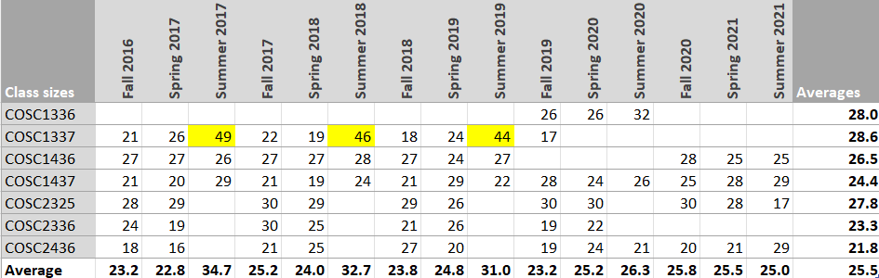

When summer was removed from the chart, the number of students per class averaged 24.2. Our department strives to meet the minimum enrollment of at least 15 students in a class and very rarely do we go below that number.

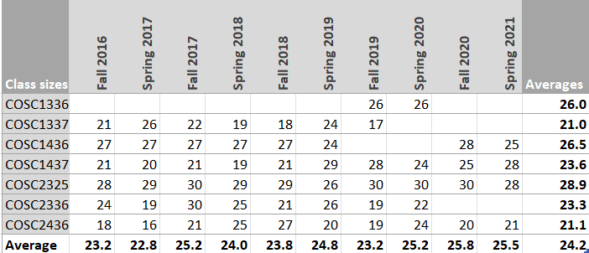

Grade distributions
The following chart shows the average grade distributions from the past five years (2017-2021). Failure and withdrawal rates equal to or greater than 15% are highlighted. The COSC1337 and COSC2336 had a higher failure and withdraw rate than the other courses. COSC1337 and COSC1437 were merged into one course and the COSC2336 and COSC2436 were merged into one course in the Fall 2021. We used to offer 2 programming tracks (Java and C++), now we are only offering 1 programming track with a combination of the programming languages. With only having 1 track, we have been able to focus and help to improve these courses together. We have switched to interactive books, we have been teaching all the in-person classes in a computer lab environment, and we have added standardized tests and projects to ensure consistency of how we are measuring success across our course sections.

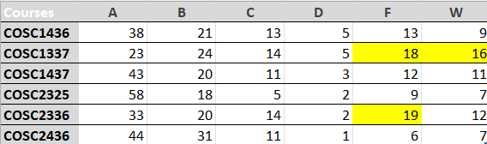

Contact Hours Taught by Full-Time and Part-Time Faculty
There is a higher number of full-time faculty teaching COSC courses than part-time faculty. We have been working to hire more part-time instructors.

 | Full-Time Faculty |  | Part-Time Faculty
COSC | 31,936 | 59% | 22,000 | 41%

Course Success Rates
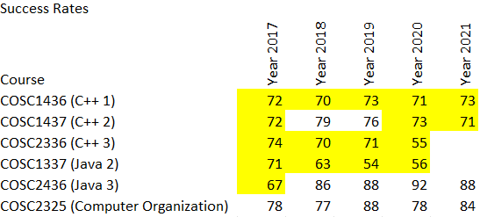

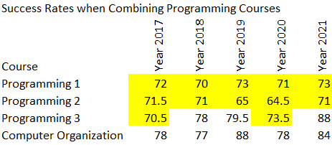

Student satisfaction
The class evaluations can be used to measure student satisfaction with the program. The students rate various categories using a Likert scale from 1 to 4 (1-strongly disagree, 2-disagree, 3-agree, 4-strongly agree).

When examining the class evaluation summary of data for the Spring 2022, the students rated all of the various categories above 3 except for COSC2436 “The instructor communicated effectively”, but this was averaged at 2.92 which is really close. The averages for each of the courses were above 3.

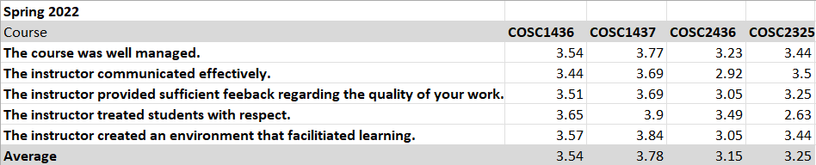

The Fall 2021 class evaluation summary of data shows ratings above 3 except for “The instructor provided sufficient feedback regarding the quality of your work” for COSC2436. This was rated at 2.95 which is extremely close to 3. The department is continuing to monitor this course and others offered to ensure that student evaluation improves over time.

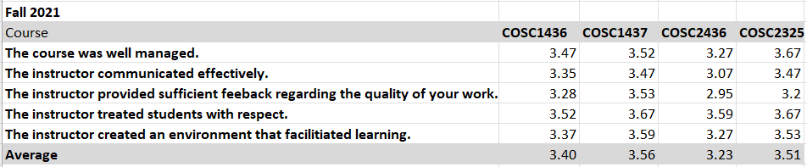

The averages over Spring 2022, Fall 2021, Spring 2021, and Fall 2020 semesters were all above 3. Since the rating of 3 equates with “agree” on the Likert scale, students seem to be satisfied with the computer sciences courses.
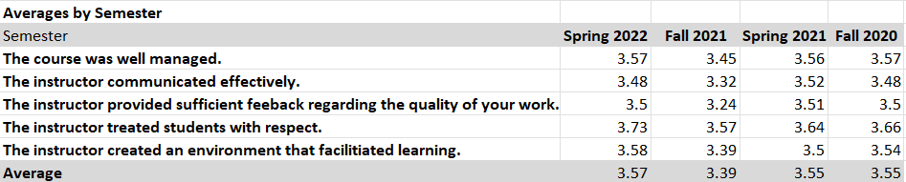

☐6. How effectively do we communicate, and how do we know?
A. Make a case with evidence that the program literature and electronic sites are current, provide an accurate representation of the program, and support the program’s recruitment plan, retention plan and completion plan.
Suggested/possible points to consider:
- Demonstrate how the program solicits student feedback regarding its website and literature and how it incorporates that feedback to make improvements.
- How does the program ensure that students are informed/aware of program literature? Is program literature made accessible to all students (i.e. can they obtain the information they need)?
- Designate who is responsible for monitoring and maintaining the program’s website, and describe processes in place to ensure that information is current, accurate, relevant, and available.

Academic Website
Our FOS certificate information is provided at the following website: Computer Science - Collin College

Department Website
Our department website is located at the following website: Computer Science - Collin College This website includes faculty information, tutoring hours, and resources. The discipline lead is responsible for monitoring and maintaining the program’s website. We did not have a department website other than the degree plan five years ago. We solicited students in the FOS courses to collect student feedback during the last program review and we created a department website based on this student feedback. The departmental website for Computer Science is linked to the Academic Website so that students can easily access it. The departmental website includes contact information for faculty and the dean, club and organizations related to computer science, and tutoring information. We solicited feedback from students in the Computer Science courses about the website and 96% of the students the responded found the website helpful and they also provided valuable feedback that can be used to improve the website.
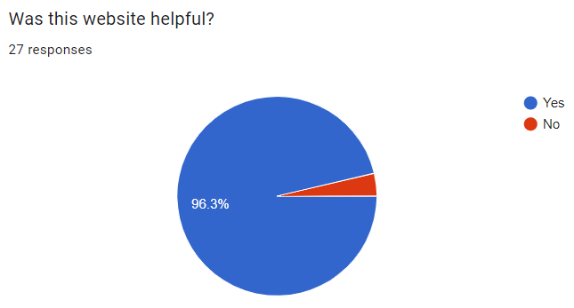
Some student comments:
- “Maybe a visual way to appeal to students as well. Not just words but images too.”
- “Probably add an option for potential transfer programs”
- “I'd say, some statistics about the amount of computer science related jobs would be informative.”
- “A link to the description page of different Computer Science courses would be useful”
- “Links to recommended free software students can download on their own devices such as IDEs, text Editors, or whatever other software may be needed for a course”

Program Information Sheet
Our department is currently in the process of creating a program information sheet for computer science. This information sheet will list possible jobs, salary information, transfer opportunities, etc., and will help to advertise our program.

Facebook
A Facebook page is maintained by the discipline lead to advertise seminars, workshops, speakers, and internships to computer science students. Collin College Computer Science/Systems and Web Development | Facebook

B. In the following Program Literature Review Table, document that the elements of information listed on the website and in brochures (current academic calendars, grading policies, course syllabi, program handouts, program tuition costs and additional fees, description of articulation agreements, availability of courses and awards, and local job demand in related fields) were verified for currency, accuracy, relevance, and are readily available to students and the public. Please fill out the table only for this prompt (B.), no analysis is necessary here.

Program Literature Review Table
Title | Type (i.e. URL, brochure, handout, etc.) | Date of Last Review/Update |  | Responsible Party
Academic Website | Computer Science - Collin College | Occurs after any curriculum update for the next catalog. | ☒Current  ☒Accurate  ☐Relevant  ☐Available | Associate Dean
Program brochures and promotional materials | Brochures | In process | ☐Current  ☐Accurate  ☐Relevant  ☐Available | Discipline Lead/Associate Dean
Department Website | Computer Science - Collin College | 11/1/2022 | ☒Current  ☒Accurate  ☐Relevant  ☐Available | Discipline Lead
Department Facebook Page | Collin College Computer Science/Systems and Web Development | Facebook | 11/1/2022 | ☒Current  ☒Accurate  ☐Relevant  ☐Available | Click or tap here to enter text.
Click or tap here to enter text. | Click or tap here to enter text. | Click or tap to enter a date. | ☐Current  ☐Accurate  ☐Relevant  ☐Available | Click or tap here to enter text.
Click or tap here to enter text. | Click or tap here to enter text. | Click or tap to enter a date. | ☐Current  ☐Accurate  ☐Relevant  ☐Available | Click or tap here to enter text.
Click or tap here to enter text. | Click or tap here to enter text. | Click or tap to enter a date. | ☐Current  ☐Accurate  ☐Relevant  ☐Available | Click or tap here to enter text.
Click or tap here to enter text. | Click or tap here to enter text. | Click or tap to enter a date. | ☐Current  ☐Accurate  ☐Relevant  ☐Available | Click or tap here to enter text.
Click or tap here to enter text. | Click or tap here to enter text. | Click or tap to enter a date. | ☐Current  ☐Accurate  ☐Relevant  ☐Available | Click or tap here to enter text.

☐7. How well are we leveraging partnership resources and building relationships, and how do we know?
Partnership Resources: On the table below, list any business, industry, government, college, university, community, and/or consultant partnerships, including internal Collin departments, to advance the program outcomes.
We have been in communication with the University of Texas at Dallas and the University of North Texas and we have pathways set up to allow our FOS courses to transfer into their courses. We use ACGM courses so that our courses will transfer to colleges/universities in Texas. We keep in close contact with the University of Texas at Dallas; we met with their Associate Dean for Undergraduate Education in the Spring 2020 to discuss changes to their curriculum and our course content. We also met with the University of North Texas in the Fall 2017. While our strongest connections are University of North Texas and the University of Texas at Dallas, we would like to have closer relationships with other universities in the future.

Our department strives to stay connected with industry professionals from various companies to provide our students with networking and development opportunities that can help them build their portfolio and possibly help them to gain an internship. We do not have an advisory board for Computer Science since it is a transfer program, but we still communicate with the local companies. The Director of Engineering, Tripat Baweja, has helped our department tremendously by providing contacts of industry professionals that have volunteered to help.

Partnership Resources Table
Partner/Organization | Description | Formal Agreement Duration,  if any. | How is it Valuable to the Program?
Society of Women Engineers (SWE) | Collin College SWE Collegiate Section | Students must join the national organization to be recognized as a member of the organization. | SWE promotes and empowers women to succeed in engineering fields by offering training and development programs, networking opportunities, scholarships, outreach and advocacy activities.
Dallas Society of Women Engineers (SWE) | Attend and promote Dallas SWE events at Collin College SWE Collegiate Section and work in collaboration with Dallas SWE to offer events such as “Design your World” | Click or tap here to enter text. | Collaborating with Dallas SWE helps our students to gain more opportunities to attend workshops and training and gain more volunteer experience. For example, Dallas SWE has a “Design your World” event every year that gets middle school/high school students involved with hands-on STEM activities.
Computer Science and Engineering Club at Collin | This is a new club that meets to discuss technology related projects. SWE officers are working with this club to collaborate on events. | Click or tap here to enter text. | This is a great place for students to work together to create events that they feel are beneficial. There is no national organization fee that is associated with this club.
Raytheon | Has helped SWE with resume workshops, mock interviews, and company tours. Provides internships for transferring students. | Click or tap here to enter text. | Students have benefited from resume critiques, mock interview feedback, and networking opportunities during company tours. Provides students with internships that give them valuable experience in the field.
Emerson Automation Solutions | Has helped SWE with resume workshops, mock interviews, and company tours. | Click or tap here to enter text. | Students have benefited from resume critiques, mock interview feedback, and networking opportunities during company tours.
Texas Instruments | Has helped SWE with mock interviews. Provides internships for transferring students. | Click or tap here to enter text. | Students have benefited from mock interview feedback. Provides students with internships that give them valuable experience in the field.
Siemens Software | Has helped SWE with mock interviews. | Click or tap here to enter text. | Students have benefited from mock interview feedback.
Motorola Solutions | Has provided Collin College eligible non-traditional students majoring in Information Technology with an Associate of Applied Science degree or workforce certificate scholarship funding. | Fall 2021-Spring 2023 | Students in Information Technology receive funding for classes or reimbursement for Certification
Texas A&M University at Commerce | Partners on a National Science Foundation S-STEM grant that will provide financial support and mentoring to eligible non-traditional computer science students with high academic potential. | Fall 2022-Spring 2027 | Eligible students receive funding and mentoring for majoring in computer science at Collin College and additional funding if they decide to transfer to Texas A&M University at Commerce.
Click or tap here to enter text. | Click or tap here to enter text. | Click or tap here to enter text. | Click or tap here to enter text.
Click or tap here to enter text. | Click or tap here to enter text. | Click or tap here to enter text. | Click or tap here to enter text.
Click or tap here to enter text. | Click or tap here to enter text. | Click or tap here to enter text. | Click or tap here to enter text.

☐8. What professional developmental opportunities add value to your program?
In order for our faculty to stay current in the field of Computer Science Education, conference attendance is immensely valuable. Local and national conferences such as ones held by TCCTA (Texas Community College Teachers Association) and ACM (Association for Computing Machinery) provide valuable insights into current trends in education, optimal teaching strategies for both in person and online delivery, and future research being conducted. They also provide networking opportunities which may lead to collaborative efforts between institutions.

Another useful activity is the pursuit of certifications or continuing education in the languages being taught. This ensures that faculty are up-to-date with the latest features of the languages they are teaching and also allows for insight into the process which can be disseminated to the students hoping to attain certifications themselves.

Additionally, any opportunity for making contacts in the commercial arena such as Meetups or office tours provides exceptional opportunities to see firsthand what companies are looking for in their graduates as well as the latest technologies being used corporately that may need to be introduced into the curriculum.

Provide a List of professional development activities employees have participated in since the last program review.
Employee Resources Table**
Employee Name | Role in Unit | Professional Development Summary | How is it Valuable to the Unit?
Misti Clark | Full time Faculty, Teaches COSC 1436, COSC 1437 | - Java Fundamentals Certification  - 4 years of work on Advanced Placement Computer Science A Exam Reading  - Microsoft Innovative Educator  - Team Based Learning Fundamentals Certification | Language Knowledge, Rubric development expertise, New tool integration to classroom, Expertise in classroom collaboration
Edward Pershwitz | Full time Faculty, Teaches COSC 1436, COSC 2436 | - TMForum Conferences in Portugal and France (2019). Received Outstanding Contributor Award  - ETSI Conference in France (2019) | Conferences related to automated software testing, which is an area we are interested in incorporating in our upper level courses.
Tebring Daly | Full time Faculty, Teaches COSC 1315, COSC 1436, COSC 1437 | - “Oracle Java Foundations Associate” certification  - “Peer Review Course” certification for Quality Matters  - Presented at “2020 Design Your World Coding Edition” on “Scratch Coding”  - Presented “Video Tools” for the “Faculty Development Conference”  - Co-authored a textbook for COSC1315; it is now on the 4th edition (Learning Java through Alice 3) | Language knowledge, Online course development and deployment, outreach to middle and high school girls about the computer science field, improvement of videos for online courses, Course material development for both Collin and colleges nation-wide.
Muhammad Shoaib | Full time Faculty, Teaches COSC 1436, COSC 1420, COSC 2325 | None to report, new faculty as of 2022 | Click or tap here to enter text.
Jason Moore | Adjunct Faculty, Teaches COSC 1436, COSC 1437 | Xilinx Security Conference 2022 | Security Training
Zoltan Szabo | Adjunct Faculty, Teaches COSC 1436 | - Accessibility Training  - Project Management Foundations training  2022 Leadership Skill for a Diversity Conscious Leader Session | Awareness of accessibility requirements for disabled students, Awareness of diversity issues within the classroom setting
Basudeb Dash | Adjunct Faculty, Teaches COSC 1436, COSC 2436 | AWS Solutions Architect certification | Knowing AWS is a valuable skill that could be incorporated into the classroom.
Koshy Joseph | Adjunct Faculty, Teaches COSC 2436 | None to report | Click or tap here to enter text.
Charles Braun | Adjunct Faculty, Teaches COSC 1420, COSC 1436 | None to report | Click or tap here to enter text.
Click or tap here to enter text. | Click or tap here to enter text. | Click or tap here to enter text. | Click or tap here to enter text.
Click or tap here to enter text. | Click or tap here to enter text. | Click or tap here to enter text. | Click or tap here to enter text.
Click or tap here to enter text. | Click or tap here to enter text. | Click or tap here to enter text. | Click or tap here to enter text.
Click or tap here to enter text. | Click or tap here to enter text. | Click or tap here to enter text. | Click or tap here to enter text.
Click or tap here to enter text. | Click or tap here to enter text. | Click or tap here to enter text. | Click or tap here to enter text.
Click or tap here to enter text. | Click or tap here to enter text. | Click or tap here to enter text. | Click or tap here to enter text.
Click or tap here to enter text. | Click or tap here to enter text. | Click or tap here to enter text. | Click or tap here to enter text.
Click or tap here to enter text. | Click or tap here to enter text. | Click or tap here to enter text. | Click or tap here to enter text.
Click or tap here to enter text. | Click or tap here to enter text. | Click or tap here to enter text. | Click or tap here to enter text.
Click or tap here to enter text. | Click or tap here to enter text. | Click or tap here to enter text. | Click or tap here to enter text.
Click or tap here to enter text. | Click or tap here to enter text. | Click or tap here to enter text. | Click or tap here to enter text.
Click or tap here to enter text. | Click or tap here to enter text. | Click or tap here to enter text. | Click or tap here to enter text.
Click or tap here to enter text. | Click or tap here to enter text. | Click or tap here to enter text. | Click or tap here to enter text.
Click or tap here to enter text. | Click or tap here to enter text. | Click or tap here to enter text. | Click or tap here to enter text.
Click or tap here to enter text. | Click or tap here to enter text. | Click or tap here to enter text. | Click or tap here to enter text.
**For convenience, if providing a listing of professional development activities, this list may be included in this document as an appendix.

☐9. Are facilities, equipment, and funding sufficient to support the program? If not, please explain.
[OPTIONAL—Only respond to prompt 9 if you are requesting improved resources for your program. If current facilities and budget are adequate, please proceed to prompt 10.]
Make a case with evidence that current deficiencies or potential deficiencies related to facilities, equipment, maintenance, replacement, plans, or budgets pose important barriers to the program or student success. As part of your response, complete the resource tables, below, to support your narrative.
Possible points to consider:
- The useful life of structure, technologies and equipment
- Special structural requirements
- Anticipated technology changes impacting equipment sooner than usual
- If you plan to include new or renovated facilities or replacement of equipment in your Continuous Improvement Plan, be sure to provide qualitative and/or quantitative data evidence of the need in this section.

Click or tap here to enter text. Lorem ipsum dolor sit amet, consectetur adipiscing elit, sed do eiusmod tempor incididunt ut labore et dolore magna aliqua. Ut enim ad minim veniam, quis nostrud exercitation ullamco laboris nisi ut aliquip ex ea commodo consequat. Duis aute irure dolor in reprehenderit in voluptate velit esse cillum dolore eu fugiat nulla pariatur. Excepteur sint occaecat cupidatat non proident, sunt in culpa qui officia deserunt mollit anim id est laborum.

Lorem ipsum dolor sit amet, consectetur adipiscing elit, sed do eiusmod tempor incididunt ut labore et dolore magna aliqua. Ut enim ad minim veniam, quis nostrud exercitation ullamco laboris nisi ut aliquip ex ea commodo consequat. Duis aute irure dolor in reprehenderit in voluptate velit esse cillum dolore eu fugiat nulla pariatur. Excepteur sint occaecat cupidatat non proident, sunt in culpa qui officia deserunt mollit anim id est laborum.

Lorem ipsum dolor sit amet, consectetur adipiscing elit, sed do eiusmod tempor incididunt ut labore et dolore magna aliqua. Ut enim ad minim veniam, quis nostrud exercitation ullamco laboris nisi ut aliquip ex ea commodo consequat. Duis aute irure dolor in reprehenderit in voluptate velit esse cillum dolore eu fugiat nulla pariatur. Excepteur sint occaecat cupidatat non proident, sunt in culpa qui officia deserunt mollit anim id est laborum.

Lorem ipsum dolor sit amet, consectetur adipiscing elit, sed do eiusmod tempor incididunt ut labore et dolore magna aliqua. Ut enim ad minim veniam, quis nostrud exercitation ullamco laboris nisi ut aliquip ex ea commodo consequat. Duis aute irure dolor in reprehenderit in voluptate velit esse cillum dolore eu fugiat nulla pariatur. Excepteur sint occaecat cupidatat non proident, sunt in culpa qui officia deserunt mollit anim id est laborum.

Facilities Resources Table**
Significant Pieces of Equipment | Description  (i.e. Special Characteristics) | Meets Needs (Y or N):  Current For Next 5 Years |  | Analysis of Equipment Utilization
Click or tap here to enter text. | Click or tap here to enter text. | Choose an item. | Choose an item. | Click or tap here to enter text.
Click or tap here to enter text. | Click or tap here to enter text. | Choose an item. | Choose an item. | Click or tap here to enter text.
Click or tap here to enter text. | Click or tap here to enter text. | Choose an item. | Choose an item. | Click or tap here to enter text.
Click or tap here to enter text. | Click or tap here to enter text. | Choose an item. | Choose an item. | Click or tap here to enter text.
Click or tap here to enter text. | Click or tap here to enter text. | Choose an item. | Choose an item. | Click or tap here to enter text.
Click or tap here to enter text. | Click or tap here to enter text. | Choose an item. | Choose an item. | Click or tap here to enter text.
Click or tap here to enter text. | Click or tap here to enter text. | Choose an item. | Choose an item. | Click or tap here to enter text.
Click or tap here to enter text. | Click or tap here to enter text. | Choose an item. | Choose an item. | Click or tap here to enter text.
Click or tap here to enter text. | Click or tap here to enter text. | Choose an item. | Choose an item. | Click or tap here to enter text.

Equipment/Technology Table ($5,000 or more) **
Current Equipment Item or Budget Amount | Description | Meets Needs (Y or N):  Current For Next 5 Years |  | For any “N”, justify needed equipment or budget change
Click or tap here to enter text. | Click or tap here to enter text. | Choose an item. | Choose an item. | Click or tap here to enter text.
Click or tap here to enter text. | Click or tap here to enter text. | Choose an item. | Choose an item. | Click or tap here to enter text.
Click or tap here to enter text. | Click or tap here to enter text. | Choose an item. | Choose an item. | Click or tap here to enter text.
Click or tap here to enter text. | Click or tap here to enter text. | Choose an item. | Choose an item. | Click or tap here to enter text.
Click or tap here to enter text. | Click or tap here to enter text. | Choose an item. | Choose an item. | Click or tap here to enter text.
Click or tap here to enter text. | Click or tap here to enter text. | Choose an item. | Choose an item. | Click or tap here to enter text.
Click or tap here to enter text. | Click or tap here to enter text. | Choose an item. | Choose an item. | Click or tap here to enter text.
Click or tap here to enter text. | Click or tap here to enter text. | Choose an item. | Choose an item. | Click or tap here to enter text.
Click or tap here to enter text. | Click or tap here to enter text. | Choose an item. | Choose an item. | Click or tap here to enter text.
Click or tap here to enter text. | Click or tap here to enter text. | Choose an item. | Choose an item. | Click or tap here to enter text.

Financial Resources Table**
Source of Funds  (i.e. college budget, grant, etc.) | Meets Needs (Y or N):  Current For Next 5 Years |  | For any “N”, explain why | For any “N”, identify expected source of additional funds if needed
Click or tap here to enter text. | Choose an item. | Choose an item. | Click or tap here to enter text. | Click or tap here to enter text.
Click or tap here to enter text. | Choose an item. | Choose an item. | Click or tap here to enter text. | Click or tap here to enter text.
Click or tap here to enter text. | Choose an item. | Choose an item. | Click or tap here to enter text. | Click or tap here to enter text.
Click or tap here to enter text. | Choose an item. | Choose an item. | Click or tap here to enter text. | Click or tap here to enter text.
Click or tap here to enter text. | Choose an item. | Choose an item. | Click or tap here to enter text. | Click or tap here to enter text.
Click or tap here to enter text. | Choose an item. | Choose an item. | Click or tap here to enter text. | Click or tap here to enter text.
Click or tap here to enter text. | Choose an item. | Choose an item. | Click or tap here to enter text. | Click or tap here to enter text.
Click or tap here to enter text. | Choose an item. | Choose an item. | Click or tap here to enter text. | Click or tap here to enter text.
Click or tap here to enter text. | Choose an item. | Choose an item. | Click or tap here to enter text. | Click or tap here to enter text.
Click or tap here to enter text. | Choose an item. | Choose an item. | Click or tap here to enter text. | Click or tap here to enter text.

Section III. Continuous Improvement Plan (CIP)
☐10. How have past Continuous Improvement Plans contributed to success?
Program Review at Collin College takes place for each award-issuing program every five years. During the last (fifth) year, the program evaluates the data collected during the CIP process.
Please describe how you have used your Continuous Improvement Plan (CIP) to make the following improvements to your program over the past 4 years (your last program review can be found on the Program Review Portal):
  - Program Learning Outcomes/Program Competencies
  - Overall improvements to your program

Goals of Last Continuous Improvement Plan
Goal 1: Improve academic success rates in Computer Science Courses
We are working to improve our success rates in our Computer Science courses. All Computer Science courses are now taught in labs with computers so students can practice their coding skills during and after class. All instructors are using the same textbooks to keep consistency across courses. COSC1436 and COSC1437 are using an interactive textbook to help students to better comprehend the programming concepts with added videos, coding practice, and checkpoint questions to check for understanding of concepts.

Goal 2: Create a departmental website for Computer Science
We created a departmental website for Computer Science and linked this to the Academic Website so that students can easily access it. The departmental website includes contact information for faculty and the dean, club and organizations related to computer science, and tutoring information. We solicited feedback from students in the Computer Science courses about the website and 96% of the students the responded found the website helpful and they also provided valuable feedback that can be used to improve the website.

Goal 3: Increase successful completion rates in Computer Science degree
Unfortunately, we lost our Computer Science degree in 2020 and this is going to hurt our completion rates as students to not have as much incentive to complete the Field of Study certificate. We did add a COSC1420 class for Engineering students so that we can track the Computer Science students more efficiently. The curriculum was redesigned to eliminating the Java and C++ tracks and it was condensed into 1 track that includes both Java and C++. This eliminates confusion and makes it easier to students to follow and finish the certificate.

Modification of Continuous Improvement Plan
Since we didn’t have any learning objectives that we were focusing on from our last continuous improvement plan, we modified and added goals.
Goal 1: Students will demonstrate appropriate design, coding, testing, and documenting of computer programs that implement project specifications and requirements. Students will have a minimum of 70% success rates in COSC1436 and COSC1337/COSC1437.

Goal 2: Students will demonstrate a fundamental understanding of data types, control structures, functions/methods, and arrays in Programming I. Students will receive a minimum of 70% on comprehensive exam on the data types, control structures, functions/methods, and arrays.

The “data type” and “control structure” exam areas fell short of the 70% threshold during the Fall 2020, Spring 2021, and Spring 2022 semesters, but met this goal for the Fall 2021 semester. The “function” and “array” areas on the exam met the 70% threshold for all of the semesters.
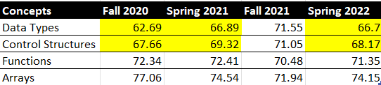
We need to improve the “data types” and “control structures” categories.

When the “control structures” sections was broken down into “conditionals” and “loops”, it seems that students were falling below the 70% mark in the “loops” category and not the “conditionals”.
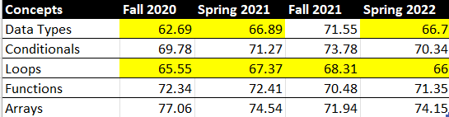
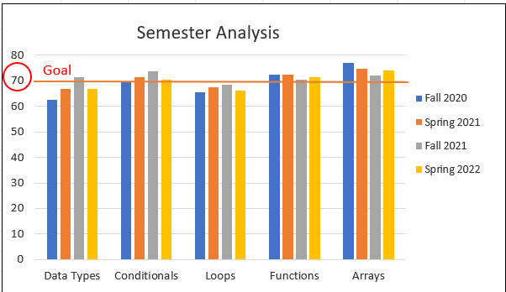

An exam study guide and practice review questions were created to help students to study for the comprehensive exam. The review questions were focused on the areas that needed improvement. Practice exam review questions were sent to each instructor for the Fall 2021 to help to prepare students for the comprehensive exam. The Fall 2021 semester results met the target threshold of 70% for all of the exam areas, except for “loops”, but then the Spring 2022 fell short again for both “loops” and “data types”. We need to reexamine these areas to see how we can make them successful and keep them successful. A practice final exam was given in a few classes in the Fall 2022 to see if it helps to improve success on the final exam. If scores are better on the final exam in those few classes in the Fall 2022, then the practice final exam will be distributed to all the class sections for the Spring 2023.

Goal 3: Students will demonstrate a fundamental understanding of data types, control structures, functions/methods, and arrays in Programming II. Students will receive a minimum of 80% on comprehensive exam on the data types, control structures, functions/methods, and arrays. Since this is the second course practicing these concepts, we set a higher success rate goal.
Unfortunately, all areas fell short of this 80% benchmark.
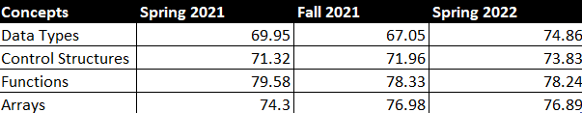

When the “control structures” category was split into “conditionals” and “loops”, you can see that students are still struggling more with “loops”. This is what they have been struggling with in the first programming class as well. The “data types” and “loops” category still remain the lowest categories in the second programming class. The “data types” category include arithmetic statements which tend to be more difficult for students.
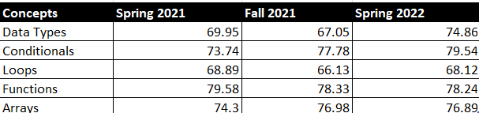

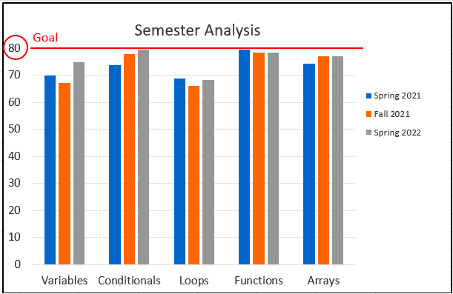

In the Fall 2022, a practice exam was given before the actual exam in a few sections. The purpose of this practice exam was to help students to practice their skills and seek help if needed before taking the actual exam. This practice exam is scored so that they know which concepts they need to practice, but this grade does not count towards their final grade. If the scores on the actual exam are higher for the Fall 2022, then this practice exam will be distributed to all sections of this course.

When compared to the first programming course in C++, it seems that the second programming course in Java does have higher scores, but is not yet where we need the scores to be.
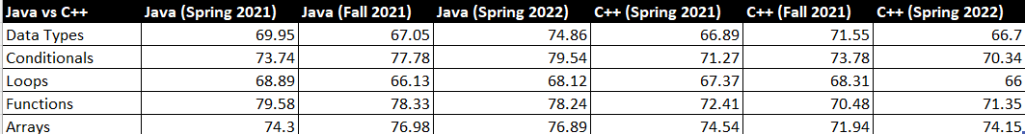
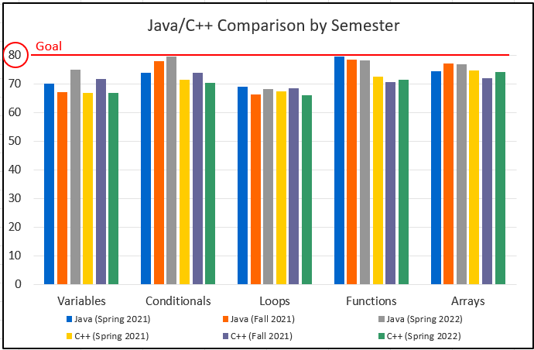

Goal 4: Students will use object-oriented programming techniques to develop executable programs. Students should obtain a minimum of 70% on the object-oriented project. Data was collected in the Spring 2022 and the average for all sections was 75%. We will continue to collect and analyze this data every semester, even though we did meet our goal.

*Please attach previous CIP Tables in the appendix

☐11. How will we evaluate our success?

NOTE: Please contact the institutional effectiveness office if you need assistance filling out the CIP tables.
As part of the fifth year Program Review, the program should use the observations and data generated by this process along with data from other relevant assessment activities to develop the program’s CIP and an action plan for the next two years. At the conclusion of the first two years, data collected from the first year, plus any other relevant data that was collected in the interim, should be used to build on the accomplishments of those first two years by developing another two-year action plan for the CIP to help the program accomplish the expected outcomes established in its CIP or by implementing one of your other plans.

Based on the information, analysis, and discussion that have been presented up to this point, summarize the strengths and weaknesses of this program. There should be no surprise issues here! This response should be based on information from prior sections of this document. Describe specific actions the faculty intends to take to capitalize on the strengths, mitigate the weaknesses, improve student success and program learning outcomes. Provide the rationale for the expected outcomes chosen for the CIP(s).

Strengths:
  - Steady enrollment growth in the program.
  - Students find the department website informative and helpful.
  - The students in COSC1437 are completing their object-oriented project at the end of the course with an average of 75% which is above our 70% benchmark.
  - We are meeting the benchmark for COSC1436 comprehensive final exam in the following categories: “functions”, “arrays”, and “conditionals”.
  - The students in COSC1437 are scoring higher on the comprehensive exam than the students in COSC1436.

Weaknesses:
- Lack of faculty to meet the growth.
- We need to improve our comprehensive final exam scores for COSC1436 in the following categories: “data types” and “loops”
- We need to improve our comprehensive midterm exam scores for COSC1437 in all areas.
- Although we have pathways to surrounding colleges for transfer, it would be nice to have updated articulation agreements with those colleges as well.
- Although students can complete a Field of Study Certificate in Computer Science, it would be helpful to have the AS degree in Computer Science.
- We are lacking in the number of females majoring in Computer Science.

Because we are growing, we need to be recruiting more adjunct faculty and full-time faculty members. We need to find faculty that are willing to teaching in the mornings/afternoons, to match the needs of our student population. Currently we are offering classes at Plano, Frisco, Wylie, and online. We need to be offering classes in McKinney, Allen, CHEC, and at local high schools.

We need to improve the student success rates on the comprehensive exam in COSC1436 and COSC1437. We are currently working to add a practice exam that students will take before taking the comprehensive exam. This will help the instructors to scaffold students based on their practice exam scores. The instructor will be able to analyze the practice exam data to be able to help students in the areas that they are struggling and teach the students how to break down these problems before they are asked to do this on their own. This will also help the students to know which areas they need to focus on when they are studying for their exam. They will be able to keep retaking the practice exam and look up questions that they missed. We are also analyzing the classes that are meeting the thresholds for the exam to see what they are doing in their class that might be making a difference.

We need to work with the University of Texas at Dallas and the University of North Texas to create articulation agreements so that students feel comfortable that their credits will transfer.

We need to work on reestablishing our AS degree in Computer Science since it will help with getting more students to complete the degree.

The Society of Women Engineers (SWE) at Collin needs to keep working to advise and entice more females to consider majoring in Computer Science and Engineering. We need to have more presence at recruiting events.

☐ 12. Complete the Continuous Improvement Plan (CIP) tables that follow.
Within the context of the information gleaned in this review process and any other relevant data, identify program priorities for the next two years, including at least one program learning outcome (or program competency), and focus on these priorities to formulate your CIP. You may also add short-term administrative, technological, assessment, resource or professional development outcomes as needed.

For the next 2 years, our department is going to focus on improving the comprehensive exam scores for COSC1436 and COSC1437. We hope to improve the exam scores to meet the 70% benchmark in COSC1436 and 80% benchmark in COSC1437 in all of the following categories: data types, control structures (conditionals and loops), functions/methods, and arrays. We really need to focus on data types and control structures for both classes since these were the lowest categories overall. Although COSC1437 students scored higher than COSC1436 on the exam, we still did not meet our goal and need improvement for all areas.

Table 1. CIP Outcomes, Measures & Targets Table (focus on at least one for the next two years)
A. Expected Outcomes  Results expected in this unit  (e.g. Authorization requests will be completed more quickly; Increase client satisfaction with our services) | B. Measures  Instrument(s)/process(es) used to measure results  (e.g. sign-in sheets, surveys, focus groups, etc.) | C. Targets  Level of success expected  (e.g. 80% approval rating, 10 day faster request turn-around time, etc.)
Students will demonstrate a fundamental understanding of data types, control structures, functions/methods, and arrays in Programming I. | Comprehensive exam in COSC1436 (first programming course). | Minimum of 70% on comprehensive exam on the data types, control structures, functions/methods, and arrays.
Students will demonstrate a fundamental understanding of data types, control structures, functions/methods, and arrays in Programming II. | Comprehensive exam in COSC1437 (second programming course). | Minimum of 80% on comprehensive exam on the data types, control structures, functions/methods, and arrays.
Students will use object-oriented programming techniques to develop executable programs. | Object-oriented project in COSC1437 (second programming course). | Minimum of 70% on the object-oriented project.
Students will design and develop programs that implement basic data structures. | Data Structures project in COSC2436 (third programming course). | Minimum of 70% on the data structures project.

Continuous Improvement Plan

Outcomes might not change from year to year. For example, if you have not met previous targets, you may wish to retain the same outcomes. You must have at least one program learning outcome. You may also add short-term administrative, technological, assessment, resource or professional development goals, as needed. Choose 1 to 2 outcomes from Table 1 above to focus on over the next two years.

A. Outcome(s) - Results expected in this program (from column A on Table 1 above--e.g. Students will learn how to compare/contrast Conflict and Structural Functional theories; increase student retention in Nursing Program).
B. Measure(s) – Instrument(s)s/process(es) used to measure results (e.g. results of essay assignment, test item questions 6 & 7 from final exam, end of term retention rates, etc.).
C. Target(s) - Degree of success expected (e.g. 80% success rate, 25 graduates per year, increase retention by 2% etc.).
D. Action Plan - Implementation of the action plan will begin during the next academic year. Based on analysis, identify actions to be taken to accomplish outcome. What will you do?
E. Results Summary - Summarize the information and data collected in year 1.
F. Findings - Explain how the information and data has impacted the expected outcome and program success.
G. Implementation of Findings – Describe how you have used or will use your findings and analysis of the data to make program improvements.
Table 2. CIP Outcomes 1 & 2
- Outcome #1 Students will demonstrate a fundamental understanding of data types, control structures, functions/methods, and arrays in Programming I.

- Measure (Outcome #1)  Comprehensive exam in COSC1436 (first programming course). | - Target (Outcome #1)  Minimum of 70% on comprehensive exam on the data types, control structures, functions/methods, and arrays.
- Action Plan (Outcome #1)
In order to increase exam scores on the comprehensive exam, we will add a practice exam that all students will take before they are given access to the final exam. After receiving results from this practice exam, the instructors will work with the students on the concepts that they are struggling with to help them to better prepare for the final exam. We will also analyze classes that are meeting the threshold goal to see if there is something that we could be adding to the classes that are not meeting the goal.
- Results Summary (Outcome #1) TO BE FILLED OUT IN YEAR 2

- Findings (Outcome #1) TO BE FILLED OUT IN YEAR 2

- Implementation of Findings (Outcome #1) TO BE FILLED OUT IN YEAR 2

Table 2. CIP Outcomes 1 & 2 (continued)

- Outcome #2 Students will demonstrate a fundamental understanding of data types, control structures, functions/methods, and arrays in Programming II.

- Measure (Outcome #2)  Comprehensive exam in COSC1437 (second programming course). | - Target (Outcome #2)  Minimum of 80% on comprehensive exam on the data types, control structures, functions/methods, and arrays.
- Action Plan (Outcome #2)
In order to increase exam scores on the comprehensive exam, we will add a practice exam that all students will take before they are given access to the midterm exam. After receiving results from this practice exam, the instructors will work with the students on the concepts that they are struggling with to help them to better prepare for the midterm exam. We will also analyze classes that are meeting the threshold goal to see if there is something that we could be adding to the classes that are not meeting the goal.
- Results Summary (Outcome #2) TO BE FILLED OUT IN YEAR 2

- Findings (Outcome #2) TO BE FILLED OUT IN YEAR 2

- Implementation of Findings (Outcome #2) TO BE FILLED OUT IN YEAR 2

What happens next? The Program Review Report Pathway
- Following approval by the Steering Committee,
- Program Review Reports will be evaluated by the Leadership Team;
- After Leadership Team review, the reports will be posted on the Intranet prior to fall semester;
- At any point prior to Intranet posting, reports may be sent back for additional development by the unit.

- Unit responses to the Program Review Steering Committee recommendations received before July 31st will be posted with the Program Review Report.

- Leadership Team members will work with program supervisors to incorporate Program Review findings into planning and activity changes during the next five years.

Please make sure to go back and complete your Executive Summary at the start of the Review.

