Continuous Improvement Plan Report to be Completed in Years 2/4 of Program Review Cycle

Date: 2/28/2024 Name of Program:______Commercial Music
Contact Name: Christopher Morgan Contact Email: cmorgan@collin.edu
Contact Phone: 972.516.5010

Table 1: CIP Student/Program Level Learning Outcomes Targeted for Improvement, Description of Assessment Measure(s) and Targets Levels of Success Table (focus on at least one student/program level outcome for the next two years)
Description of Fields in CIP Table 1:
A. Student Learning Outcome(s) - Results expected in this program (e.g., students will be able to compare/contrast conflict and structural functional theories). Outcomes must be quantifiable and measurable.
B. Assessment Measure(s) – Assessment instrument(s)/process(es) used to measure results (e.g., embedded test questions 6 & 7 from final exam)
C. Targeted Level(s) of Success - Level of success expected (e.g., X% of students will score at least Y on the indicated assessment)

 | - Student/Program Level Learning Outcome(s)  Targeted for Improvement  (e.g., “Students will be able to…”) | B. Description of Assessment Measure(s)  (Assessment instrument(s)/process(es) used to measure results - Include course in which assessment will be given) |  | C. Targeted Level(s) of Success  (e.g., X% of students will score at least Y on the indicated assessment.)
Students will learn to adjust final mix loudness levels that conform to online streaming content providers, using dynamic processing tools such as compression, limiting and EQ. |  | Students will use a Loudness Unit Full Scale (LUFS) meter to rate their standards conformity by how much gain reduction is applied to their file. | 80% success. Success = less than 0-6db attenuation imposed by the content provider.
Students will develop standardized portfolio templates for use by other students. |  | Adoption by Audio IV, Live Sound III and Commercial Music Project students. | 75% adoption by students.
Add additional rows if necessary.

Table 2. CIP Student Learning Outcomes 1–3 (focus on at least one for the next two years)

Description of Fields in CIP Table 2:
A. Student/Program Level Learning Outcome(s) Targeted for Improvement - Results expected in this program (e.g., Students will be able to compare/contrast conflict and structural functional theories). Outcomes must be quantifiable and measurable.
B. Assessment Measure(s) – Assessment Instrument(s)/process(es) used to measure results (e.g., embedded test questions 6 & 7 from final exam)
C. Targeted Level(s) of Success - Level of success expected (e.g., X% of students will earn a score of Y or greater on the embedded test questions)
D. Description of Action Plan to Improve Learning - Describe action(s) to be taken to improve student attainment of the indicated student/program level outcome. What will you do?
E. Summary of Results/Data - Summarize the information and data collected in year 1/3 when action plan was implemented.
F. Findings - Explain how the information and data has impacted the expected student learning outcome.
G. Implementation of Findings – Describe how you have used or will use your findings and analysis of the data to make improvements.

Student/Program Level Learning Outcome Targeted for Improvement #1
- Student/Program Level Learning Outcome Targeted for Improvement #1:
Students will learn to adjust final mix loudness levels that conform to online streaming content providers using dynamic processing tools such as compression, limiting and EQ.

- Assessment Measure(s):  Results from a Loudness Unit Full Scale (LUFS) meter. | - Targeted Level(s) of Success:  < 0-6dB gain reduction imposed by steaming service.  Note: Since the year-two CIP report, this target has been adjusted to focus on “gain boosting” instead of attenuation as the reduction has less impact on the resulting audio quality compared to the gain boosting listed above.
- Description of Action Plan to Improve Learning:

For one mixing assignment, students will adjust output levels to conform with one streaming service (YouTube, Spotify, TIDAL, etc.)

- Summary of Results/Data:

Students were able to achieve 100% success with this student learning.
- Findings:
Students were able to achieve 100% success with this student learning outcome due to two factors. Students have historically strived to create mix output levels as “hot” as possible due to the industry’s history of “level wars” dating back to the late 1990’s. The knowledge gained from continued research into the continuously-evolving standards and guidelines shows that a LUFS level that is too high, is easily attenuated by the streaming service with no loss of quality. This information is provided by streaming services as well as the available online resources for evaluating a mix’s LUFS and comparing that to the streaming services, cultural/music-industry. So as long as a student uses a level “limiter” on the final master bus, the mix will not clip and the students can continue to make their mix as loud as they wish, as long as it is above -14 dB LUFS.
Finally, in addition to the available online tools, Protools, the DAW students are trained on, now includes a LUFS meter available to the master output bus. Therefore, students don’t’ need to export their mix and upload it to a website for evaluation.
- Implementation of Findings:

For at least one assignment in Audio Engineering IV, the rubric will include a requirement that students report the LUFS evaluation level of their mixes when they upload and turn in their mixes. This will ensure that students are aware of how loud their music will be perceived as well as alerting them to any possible gain applied by the streaming service.
Finally, as a result of the success rate of this Student Learning Outcome, this CIP item will not be included in future CIPs unless there are significant changes in file LUFS requirement (for example, new expectations such as future support for AI-based audio mastering models.)

Student/Program Level Learning Outcome Targeted for Improvement #2
- Student/Program Level Learning Outcome Targeted for Improvement #2:

Students will develop standardized portfolio templates for use by other students.

- Assessment Measure(s):  Adoption by Audio IV, Live Sound III and Commercial Music Project students | - Targeted Level(s) of Success:  75% adoption by students.
- Description of Action Plan to Improve Learning:
Commercial Music Project Students will develop templates for several AAS graduate specializations: Mixing Engineer, Live Sound Engineer, Songwriter, etc. These are modeled on the CSS-based templates provided by some web hosting sites (e.g. WordPress).
- Summary of Results/Data:

The adoption rate for the templates by Commercial Music Project students :
Spring 23 through Fall 2024: 90% (up 10% from two-year CIP report.

The adoption rate for the templates by Audio Engineering IV. Class only offered Spring Semesters.
Spring 23 : Class did not make and therefore no data collected.
Spring 2024 Data collected and assessed but adoption was not required by students so: 0%.
Note however, the completion of of both an online portfolio was still at 90%

The adoption rate for the templates by Live Sound III students was not statistically relevant for the purposes of the CIP as the enrollment was typically less than 4 students for the cross-listed sections Live Sound II/III. In addition, requiring the students create an online portfolio was also put an additional strain on instruction and ultimately was less relevant for future hiring of live sound engineers and techs.

- Findings:

The faculty and employers are in agreement and continue to stress the importance of the online portfolio for career development and job placement with the slight exception for live sound engineers. However, the faculty have discovered that the original CIP expected outcome and measures ended up being off-target given the fact that most students outside of the Commercial Music Project class where the templates are developed, do not choose to use a template. In spite of the fact that the portfolio templates were specifically designed for musicians and audio engineers, the Audio Engineering IV students preferred not using them and instead relied on the AI tools now provided as a free benefit of the various hosting services. The Commercial Music Project templates still served as a checklist for deciding which content the students should include in the AI-generative web hosting site. As an example, in several current hosting services, students can type a general description of their skills and experience and the AI engine in the hosting service will generate multiple polished versions including variations in tone. As a result, students can use a much more flexible approach to designing their portfolio website and focus more attention on collecting content such as photos of their course work at Collin College and polishing and uploading their media such as their “mix reel”, etc. In addition, faculty discovered that more students are entering the Audio Engineering IV class with a commercial website already in place. For example, one student’s band already maintained a website for concert dates, selling merchandise, etc. Therefore it was a simple task to adapt a similar format for their own portfolio website by adding on to the larger band website.
- Implementation of Findings:

These findings indicate that development of the templates will and should continue and students will continue to be given the option of which tools they find suit them best. Therefore, the main implementation of these finding was in terms of the execution of the assessment itself. For instance, to more easily assess the adoption and value of the templates, the future portfolio assignments will be decoupled from the business plans which was historically combined into one assignment. The primary challenge facing faculty is the need for continuous messaging to the students about the importance of having their online portfolios. Once the students reach this level of awareness, the templates are helpful as a guide for structure, but then students can rely on AI tools provided by the web hosting services as needed.

Commercial Music – Year Two Report – February 2023
Prepared by Christopher Morgan, Discipline Lead, Commercial Music
The following contains the portion of the Commercial Music program review document submitted in January 2021, pages 96-98.
From the original 2021 program review document, Table 1 summarizes the expected outcomes.
Table 2 parts A, B, C and D are the original Expected Outcomes, Measure, Target and Action Plan respectively. Section, E, F and G are now completed as part of the two-year update.
12. Complete the Continuous Improvement Plan (CIP) tables that follow.
Table 1. CIP Outcomes, Measures & Targets Table (focus on at least one for the next two years)
A. Expected Outcomes | B. Measures | C. Targets
Students will learn to adjust final mix loudness levels that conform to online streaming content providers, using dynamic processing tools such as compression, limiting and EQ. | Students will use a Loudness Unit Full Scale (LUFS) meter to rate their standards conformity by how much gain reduction is applied to their file. | 80% success. Success = less than 0-6db attenuation imposed by the content provider.
Students will develop standardized portfolio templates for use by other students. | Adoption by Audio IV, Live Sound III and Commercial Music Project students. | 75% adoption by students.
Students will produce and engineer a livestream musical performance. | Students will learn Online Broadcast System (OBS) software and livestream one concert as either the engineer or engineer/performer. | 80% students in Audio IV or Commercial Music Project live stream one event.

Continuous Improvement Plan
Outcomes might not change from year to year. For example, if you have not met previous targets, you may wish to retain the same outcomes. You must have at least one program learning outcome. You may also add short-term administrative, technological, assessment, resource or professional development goals, as needed. Choose 1 to 2 outcomes from Table 1 above to focus on over the next two years.

A. Outcome(s) - Results expected in this program (from column A on Table 1 above--e.g. Students will learn how to compare/contrast Conflict and Structural Functional theories; increase student retention in Nursing Program).
B. Measure(s) – Instrument(s)s/process(es) used to measure results (e.g. results of essay assignment, test item questions 6 & 7 from final exam, end of term retention rates, etc.).
C. Target(s) - Degree of success expected (e.g. 80% success rate, 25 graduates per year, increase retention by 2% etc.).
D. Action Plan - Implementation of the action plan will begin during the next academic year. Based on analysis, identify actions to be taken to accomplish outcome. What will you do?
E. Results Summary - Summarize the information and data collected in year 1.
F. Findings - Explain how the information and data has impacted the expected outcome and program success.
G. Implementation of Findings – Describe how you have used or will use your findings and analysis of the data to make program improvements.
Table 2. CIP Outcomes 1 & 2
- Expected Outcome #1

Students will learn to adjust final mix loudness levels that conform to online streaming content providers using dynamic processing tools such as compression, limiting and EQ.

- Measure (Outcome #1)  Results from a Loudness Unit Full Scale (LUFS) meter. | - Target (Outcome #1)  < 0-6dB gain reduction imposed by steaming service.
- Action Plan (Outcome #1)
For one mixing assignment, students will adjust output levels to conform with one streaming service (YouTube, Spotify, TIDAL, etc.)
- Results Summary (Outcome #1)

Examples of student work:

https://www.youtube.com/watch?v=UD_ZtkbcJ5w

Faculty research showed that most students preferred presenting audio on YouTube, therefore this streaming service was the focus of faculty efforts. Additional research confirmed that best practices are very similar to traditional mixing levels such as the example below:
Dialogue: -6db to -15db(Nb. Most YouTubers tend to stick at -12db max)
Overall mix Level: -12db to -20db
Music: -18db to -20db
Sound Effects: -14db to -20db.
(Source: https://filmstro.com/blog/how-to-set-the-right-audio-levels-for-youtube)

It should be noted that this chart of recommended values is aimed at videos that contain voiceover dialog, i.e. dialog that is intended to be heard above the music. As a result, these recommended music loudness levels (-18db to -20db) are too low and not recommended for a music-only video. The recommended level for music-only videos is -14 LUFS (Loudness Unit Full Scale: the maximum loudness a system can handle and which varies from system to system). Therefore, students mixing their audio in classes such as MUSC 2448 Audio Engineering IV and MUSC 2350 Commercial Music Project for the purposes of using these as source material for their “demo reels” aka portfolios, will likely exceed this in some cases. As a result, YouTube’s audio algorithm may attenuate their audio level. Conversely, YouTube’s compression algorithms will not only attenuate audio that exceeds -12 LUFS but will actually increase audio levels that are too low. For example, audio levels that are below the recommended range of -13 to -15 LUFS will be boosted.

- Findings (Outcome #1)

For the purposes of this CIP, faculty learned that obtaining the gain/attenuation factors applied to uploaded audio is not possible. However, considering the similarity with traditional levels, best practices dictate that students err on the side of caution and mix their audio slightly softer, at the target range of -14 LUFS and to apply compression/limiting to prevent any transient peaks from exceeding this level (which would result in YouTube’s own compression algorithm being applied. At the end of the process, faculty and students have learned that it is better to have YouTube apply gain rather than have YouTube attenuate.

Based on these findings, as well as feedback from students who are uploading music content to YouTube, the faculty are including these concepts earlier in the curriculum. Historically, emphasis on mixing for streaming services has been the focus in Audio Engineering IV because it is the last course in the Audio Engineering sequence. However, students seeking the AAS Commercial Music Degree are only required to complete up to Audio Engineering II and as a result, they may not obtain the specialized emphasis on mixing levels for streaming services since their focus may be on Live Sound or Music Business.

- Implementation of Findings (Outcome #1)

For the purposes of monitoring their target mix levels, students have access to the built-in level meters on their Digital Audio Workstations (DAWs) such as Avid’s Protools and Apple’s Logic. In addition, students are able to specify these target level limits inside the DAW as well as in third-party plugins. Therefore, the ideal class for this new focus on introducing streaming service mixing levels is the MUSC 2427 Audio Engineering II. For applying these concepts as well as developing mastery, additional focus will be included in the Commercial Music program’s newly created MUSC 2741 Audio Plugins course which is also required for all Commercial Music students and has Audio Engineering II as a prerequisite. In the Audio Plugins course there are a variety of plugins referred to as “mastering plugins” which are specifically developed for specifying target output levels.
As mentioned above, while finding out specific gain/reduction data from a streaming service are not readily available, faculty will continue to investigate services which may provide this data. In addition, faculty will investigate the possibility of reverse engineering the gain/reduction of audio after it has been downloaded and compared to the original uploaded material. Finally, faculty will also collect data from student experiences regarding any obstacles and/or improvements to student outcomes.

Table 2. CIP Outcomes 1 & 2 (continued)
- Expected Outcome #2

Students will develop standardized portfolio templates for use by other students.
- Measure (Outcome #2)  Adoption by Audio IV, Live Sound III and Commercial Music Project students. | - Target (Outcome #2)  75% adoption by students.
- Action Plan (Outcome #2)

Commercial Music Project Students will develop templates for several AAS graduate specializations: Mixing Engineer, Live Sound Engineer, Songwriter, etc. These are modeled on the CSS-based templates provided by some web hosting sites (e.g. WordPress)

- Results Summary (Outcome #2)

As can be seen below, the objective of creating and adopting standardized portfolio templates catered to audio industry students was achieved:

Spring 22
Online Profile 80% Completed Portfolios 90% Adopted In-House Created Portfolio Templates 80%

Fall 22
Online Profile 90% Completed Portfolios 90% Adopted In-House Created Portfolio Templates 90%

While the target adoption by a minimum of 75% of students was achieved in the CIP’s intended sense, continued research has yielded new information. For instance, as mentioned in the Action Plan above, general, high-quality portfolio templates have been available for several years by web hosting services such as WordPress and these templates continue to greatly improved in quality. While it is the goal of this CIP for students to use the templates created in the MUSC 2350 Commercial Music Project course, it may potentially become unnecessary when considering the quality and availability of these often free templates. In addition, while the intention was to develop templates that were more specific to audio industry professionals, the reality is that, at a granular level, there will never be a “one size fits all” template. Therefore, in the process of researching templates, new resources have become available. Specifically, companies have made templates tailored to portfolios in specific sub-disciplines within the audio industry. For example, the following screenshots are from Slidesgo.com: https://slidesgo.com/theme/audio-engineer-portfolio and these slides templates can be readily converted to web pages for hosting on a student’s domain or with his hosting service.

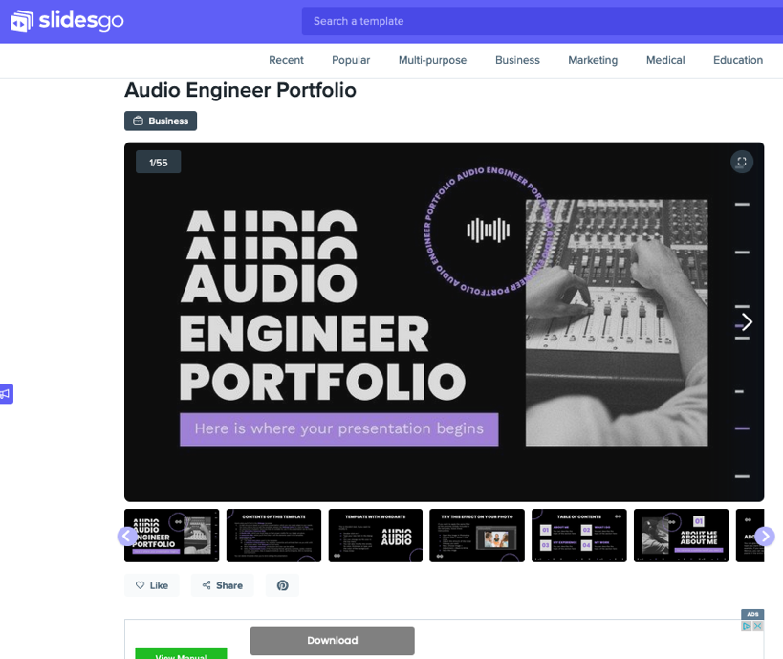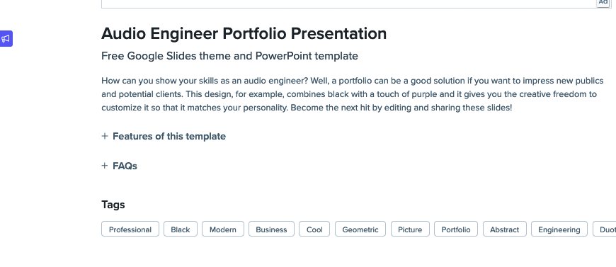

- Findings (Outcome #2)

These template resources may lessen the need for students to develop their own specialized templates for areas such as audio engineering, songwriting, etc. However, it should be noted that the free-online resources are not as detailed. The examples listed above are 5-10 slides each while the the Songwriter Template developed by students and faculty at Collin is 42 slides prompted much more detail. Therefore, while some students may continue to want to develop their own templates, our findings are that most students do not have the necessary design skills to do a superior template compared to what is now available and the templates function as a helpful “checklist” of prompts for information they should include. Regardless, the most important takeaway for both students and faculty is to continue researching these resources along with research into current trends in portfolio best practices.
- Implementation of Findings (Outcome #2)

Students will continue focusing their efforts on creating professional-quality portfolios that include both print and online materials. The most important item in the portfolio is the student’s “demo reel”. Based on our continued research, issues discussed in faculty meetings have resulted in changes that are implemented in the classroom. For example, in Fall 2022 the Commercial Music Project professor expressed the need for shorter example clips which could be pieced together to form a 2-3 minute demo reel showcasing a variety of the student’s work in different genres of music. The problem at that point was that students were needing to spend too much time going back through their course work to create the needed short sample clips. As a result of this discussion, the Audio Engineering instructors began requiring that all student mixing assignments be submitted with both a 15-20 second excerpted example as well as the full-length version. These short clips were of immediate value and used in the Commercial Music Project class for the portfolio demo reel as part of the online portfolio in this CIP. These demo reels are the most important part of the student portfolio and therefore need to be the primary emphasis. In conclusion, the packaging template is less important and therefore can be sourced from readily available resources such as those shown above as well as templates created by students.
Faculty will continue to collect data on this CIP from both students and the online resources as they become available.

Notes on CIP 3.
As stated in the instructions for the CIP, only one outcome needed to be the focus.
Table 1. CIP Outcomes, Measures & Targets Table (focus on at least one for the next two years)
Commercial Music chose to focus on the first two of the three listed in the table and those findings are presented in this document. While CIP 3 was a not the focus for the past two-year cycle, it will become a focus in the next two years leading up to the Program Review in year 5. The sudden increase in need for live streaming skills in both software and hardware brought on by the COVID-19 pandemic has declined along with the decline in the pandemic itself. And while there were many positive takeaways from the new skills both students and faculty in music and audio technology suddenly needed to learn, the pressing need for these skills is no longer as urgent. In addition, opportunities for student v vs to run live-stream concerts have diminished as well due to increased constraints imposed by the college. For example, initially faculty were free to stream from a variety of services including Twitch, Discord, YouTube, etc. However, as of now, the college only permits livestreaming through the college’s Facebook account and students do not have access to the streaming key. Regardless, at this point, new research will begin to assess the current need for these livestreaming audio skills and those findings will be implemented in the commercial music curriculum.

Program Assessment Data Report
Program:__Commercial Music _ Terms Data Collected: __Spring 2023 to Fall 2024_____
Program-Level Learning Outcome- (From Assessment Plan) | Assessment Measure(s) and Where Implemented in Curriculum – (From Assessment Plan) | Target Outcome(s)- Level of Success Expected – (From Assessment Plan) | Assessment Results – (Provide data in a form related to targeted levels of success to left. Indicate if targeted level of success was met, partially met, or not met.)
Create a small business plan proposal for either a recording studio, a live sound company or a music marketing business. | Small Business Plan Assignment in MUSB 2350 Commercial Music Project (Capstone) in which students are required to:  - describe/assess the market to be served,  - define the marketing efforts to be carried out (and associated costs) to make customers aware of the business,  - develop a staffing plan, and  - define the financial investment necessary to carry out the plan.”  These last elements can be taken from the required grading rubric so that it is clear students are being assessed on the business plan they have developed.) | 80% of students will score a 75% or better on the rubric for their small business plan. | For each of the four semesters 90% of MUSB 2350 students scored a 75% or better for their small business plan.
Compose a professional response on a technical topic related to either audio engineering, live sound or music business marketing. | Assignment in MUSC 2427 Audio Engineering II in which students are required to create a professionally written email demonstrating the student’s level of knowledge (or identifying the relevant specialist) for a particular technical issue (troubleshooting, equipment purchases, etc.) | 80% of students will score a 75% or better on the rubric for their professional email. | For each of the three semesters the class was offered, data collected and assessed, 95% of MUSC 2427 scored a 75% or better for their professional response emails.
Provide possible troubleshooting solutions based on a verbal or visual description of a signal flow problem with either a Live Sound Reinforcement or Recording Setup. | Single Topic Objective exam (multiple-choice and/or true/false) in MUSC 1405 Live Sound I with 20 questions about a technical diagram or written description of a live sound signal flow problem that requires students to provide possible/appropriate troubleshooting solutions for a live sound setup. | 80% of students will score a 75% or better on the objective quiz. | For each of the four semesters data was collected and assessed, 85% of students scored a 75% or better on both objective exams as well as visual/verbal scenarios. Data collection was expanded to include Audio Engineering I and Audio Electronics..
Create a web-based portfolio. | Project to create a website in MUSB 2350 Commercial Music Project (Capstone) on any hosting platform containing professional quality examples of student’s work, work experience and education to date to market the student’s skills and abilities to potential customers or employers. | 80% of students will score a 75% or better on the rubric for their web-based portfolio. | For each of the four semesters 90% of MUSB 2350 students scored a 75% or better for creating their online portfolio. Additional assessment was collected from Audio Engineering IV students in Spring 2024 with the same results.

