Continuous Improvement Plan
Outcomes might not change from year to year. For example, if you have not met previous targets, you may wish to retain the same outcomes. You may add short-term administrative, technological, assessment, resource, or professional development goals, as needed. Choose up to 2 outcomes from Table 1 above to focus on over the next two years.

A. Outcome - Result expected in this unit (from column A on Table 1 above--e.g. Authorization requests will be completed more quickly; Increase client satisfaction with our services).
B. Measure - Instrument(s)/process(es) used to measure results (e.g. surveys, test results, focus groups, etc.).
C. Target - Degree of success expected (e.g. 80% approval rating, 10-day faster request turn-around time, etc.).
D. Action Plan - Implementation of the action plan will begin during the next academic year. Based on analysis, identify actions to be taken to accomplish outcome. What will you do?
E. Results Summary - Summarize the information and data collected in year 1.
F. Findings - Explain how the information and data has impacted the expected outcome and unit success.
G. Implementation of Findings – Describe how you have used or will use your findings and analysis of the data to make unit improvements.
Table 2. CIP Outcomes 1 & 2
- Outcome #1 Increase the library patron interactions both online and in-person.

- Measure (Outcome #1)  It is measured via surveys and reference, chat, book-a-librarian, and circulation statistics.  Collin College IR surveys during Fall and Spring. Book a Librarian statistics using data from - https://www.collin.edu/library/bookalibrarian.html  Ask a Librarian statistics on usage of the service - https://www.collin.edu/library/aska.html  Chat Statistics usage data from - https://libraryh3lp.com/dashboard/  Circulation data from Polaris Reports of check-outs during the year | - Target (Outcome #1)  Increase the rate of interactions by 5%.
- Action Plan (Outcome #1)
Use library website, LibGuides, social media and f2f interactions to market the library services. Popularize the services to faculty and students through programs and events.
- Results Summary (Outcome #1)
Increase the rate of interactions by 5%.

Interaction Method | 2021 baseline | 2023 | % Increase
Book a Librarian | 135 | 400 | 196%
Ask a Librarian | 2037 | 2363 | 16 %
LibraryH3lp Chat | 1009 | 1154 | 5%
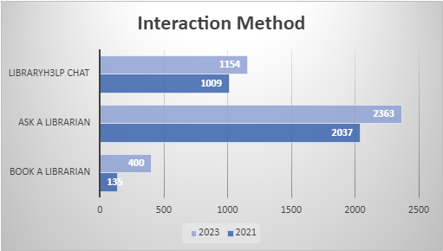

Circulation | 2021 baseline | 2023 | % Increase
Checkouts | 55521 | 66479 | 19.75

- Findings (Outcome #1)
The data supports that the reference interactions with the librarian via chat, ask a librarian, and book a librarian increased more than the predicted 5%. The data shows/supports that students responded positively to the interaction via chat and email. The one-on-one Book a Librarian service increased by 196%, showing that the individual research consultations utilized the librarian's expertise to do in-depth research on their topic.
- Implementation of Findings (Outcome #1)
Based on the findings, the library will continue to meet the information needs of all users through online and in-person interactions. The marketing of the available resources, and developing services tailored to diverse user groups by continuously adapting to user demands and emerging technology, should be pursued.

Table 2. CIP Outcomes 1 & 2 (continued)

Outcome #2 Increase the participation of students using online tutorials

- Measure (Outcome #2)  The Canvas tutorials, Research Ready, have short quizzes to measure if the students understood the information presented, as well as the ability to track the number of modules completed over time | - Target (Outcome #2)  ​​Increase tutorial participation by 2%.​
- Action Plan (Outcome #2)
​Market the tutorials to the faculty via the Distance Learning Services Libguide, the Collin College Faculty Libguide, library instruction sessions, and email/newsletter communications with faculty.
- Results Summary (Outcome #2)
The Research Ready Canvas Tutorials have been an online option for faculty since the Fall 2021 semester. From inception to 2023, we have had an overall participation increase of 138%
Research Modules (all library Canvas module)
Year | Completions
2021 | 758
2022 | 1078
2023 | 1808

- Findings (Outcome #2) Due to the success of the Canvas tutorials over the last two years, the instruction librarians have added more tutorials on other research topics that have been requested by faculty. The instruction committee is currently working on modules addressing more in-depth research questions such as citations, fake news, and bias.
- Implementation of Findings (Outcome #2)
The instruction team has met to determine which new tutorials are to be created. Since the instruction team membership changed, layout and planning were delayed, but the tutorials are now in production. Once data is available on the new tutorials, the direction of tutorials will be reevaluated for consistency of approach. New topics will be considered based on feedback from librarians and faculty. Based upon faculty satisfaction with the current Canvas tutorials, a Health Sciences related/focused page is under construction and once launched the numbers will be included in future plans.

