Continuous Improvement Plan

Date: Name of Program/Unit:
Contact name: Contact email: Contact phone:
Table 1: CIP Outcomes, Measures & Targets Table (focus on at least one for the next two years)
A. Expected Outcome(s)  Results expected in this unit  (e.g. Authorization requests will be completed more quickly; Increase client satisfaction with our services) | B. Measure(s)  Instrument(s)/process(es) used to measure results  (e.g. survey results, exam questions, etc.)  Include Course Information and Semester in which assessment will occur | C. Target(s)  Level of success expected  (e.g. 80% approval rating, 10 day faster request turn-around time, etc.)
PLO #1 Commercial​ Workforce Photography Students at Collin College to participate in photographic skills competitions outside of Collin for the 1st time. Our goal is to create an award-winning program in the workforce photography program.​ This outcome requires teaching basic camera, lighting and software skills. | The competition needs to be outside of Collin College and judged by professional photographers as we are a workforce program. Judging on the student's photographic knowledge of skills that will include camera functions, lighting, retouching and digital skills and the use of digital software. | Competing against other community colleges across Texas in photography. Our target is to be successful at the state level and make our photography program an award-winning program. By winning a place in a competition we will have a strong presence in the photographic community
PLO #2 Students will learn how to use social media as an effective marketing tool. Increasing overall skills in posting and tagging their images. | ​​Students will be measured on the effectiveness of their tags on their posts. The students will be learning when to post which can be measured as the Instagram algorithms suggest times for the largest audience on their platform. These marketing skills will help the students grow their audience and therefore their own photography business. Questions on both discussions and tests will be given for social posting in studio management and portfolio. Social media will be introduced in lower classes too to monitor and assist students on how and what to post image-wise for the best results to represent their business. On social media Students in advanced classes will post their work bi-weekly. The main platform will be Instagram.​ | 80% of students will demonstrate knowledge and successful application of social media skills. Results will be demonstrated through actual posts on Instagram. This will be reflected in their participation grade in portfolio.​
​​PLO #3 Improve outreach to increase enrollment and build knowledge about the Photography program and what certificates and degrees are offered.  ​Outreach will include High School, Collin Enrolled Students, and Community members. ​ | Increased enrollment will be one way to achieve this goal for our department. Both Enrollment and completers need to increase overall to build a stronger program. Some of the drop was due to Covid but Collin needs to make the high school programs aware of our workforce program.​ | ​​Outreach could include working with organizations outside of Collin that are a part of Collin County area​. Others could be the high schools throughout Collin. Also, working with non-profits to benefit the community in art shows and photographing events. Faculty outreach efforts to average one per month during the academic year.

Description of Fields in the Following CIP Tables:
A. Outcome(s) - Results expected in this program (e.g. Students will learn how to compare/contrast conflict and structural functional theories; increase student retention in Nursing Program).
B. Measure(s) - Instrument(s)/process(es) used to measure results
(e.g. results of surveys, test item questions 6 & 7 from final exam, end of term retention rates, etc.)
C. Target(s) - Degree of success expected (e.g. 80% approval rating, 25 graduates per year, increase retention by 2% etc.).
D. Action Plan - Based on analysis, identify actions to be taken to accomplish outcome. What will you do?
E. Results Summary - Summarize the information and data collected in year 1.
F. Findings - Explain how the information and data has impacted the expected outcome and program success.
G. Implementation of Findings – Describe how you have used or will use your findings and analysis of the data to make improvements.

Table 2. CIP Outcomes 1 & 2 (FOCUS ON AT LEAST 1)

- Outcome #1

Collin competed in its first time ever competition in SkillsUSA. This goal was to promote our program on the state level by competing against other community colleges in the state. Not only did Collin send six students to the competition, but Collin College also won 1st, 2nd, and 3rd place at the state level for SkillsUSA. SkillsUSA is a strong organization that supports students in the workforce. Our 1st place winner at state qualified for the nationals SkillsUSA competition and won 1st place at the national competition.
- Measure (Outcome #1)  Our action plan consisted of making sure the students in our class could compete at this level with these skills. These photographic skills were needed to compete in a competition and will be used to prepare our students for the workforce. Those students competing in the competition would also meet weekly to ensure their knowledge and promote self-esteem in that knowledge. | - Target (Outcome #1)  Our target was to prepare our students to win a place in a competition outside of Collin College. Then the opportunity came to Collin to compete in SkillsUSA. This competition is what our program has been looking for to compete against other community college photography programs in Texas.
- Action Plan (Outcome #1)
Our action plan consisted of making sure the students in our class could compete at this level with these skills. These photographic skills were needed to compete in a competition and will be used to prepare our students for the workforce. Those students competing in the competition would also meet weekly to ensure their knowledge and promote self-esteem in that knowledge.

- Results Summary (Outcome #1)
Winning state at SkillsUSA has increased our programs' visibility throughout the area and even in the professional areas of DFW. This is in part to potential employers knowing that our students are earning a great foundation in skills for their photography career. This has allowed us to even partner with a Dallas modeling agency to provide models for our fashion and portrait classes as well as a CoOp. Our own students are more confident in believing in our program and how we approach what we teach in the field. Since winning we have been receiving more requests for information and tours of our facilities.

- Findings (Outcome #1)
The students that competed gained confidence and communication skills both with each other and their own creative selves. This energy was met by the entire body of students understanding that what is taught in our classes is both relevant and accurate in our field of study. The work produced since this experience by the entire department has grown exponentially. Our students know that they are prepared to compete outside of Collin in competition including the workforce. We will continue to educate with the most up-to-date tools in both camera and lighting skills but also just as important with computer and software skills. AI (Artificial Intelligence) will need to be studied at great length and the legal implications for copyright and usage for the future.

- Implementation of Findings
We are current with the equipment and software that we are teaching and in some cases by teaching additional skills with software (Capture One) ensuring that our students will be ready in the current workforce for the commercial field. We need to be ready for the next big challenge in our field that will impact both the usage and field in photography with AI.

- Outcome #2
Student skills using social media to market their photography on Instagram
- Measure (Outcome #2)  Students required in Portfolio, Student Management, Digital II and  Fashion to post regularly (twice a month) on Instagram. | - Target (Outcome #2)  Students are required in Portfolio, Student Management, Digital II  and Fashion to post regularly on Instagram for a target that is at  least 20+ or more followers for the semester.
- Action Plan (Outcome #2)
Making sure students know how to post and tag their images. Learning how to tag images is a critical part of social media. Making sure students tag their images correctly can gain more viewers.
- Results Summary (Outcome #2)
Students find that being consistent with posting while learning the best times and days to post for the most viewership. Social media is a strong part of marketing in the photography field and cannot be overlooked or ignored. Instagram is now necessary for those trying to gain an audience for their own business.

Below are some examples of students present and graduated posting on Instagram to promote their photographic skills. These student examples show many different genres of photography. Many types of photography are represented on this platform including food, beverage, portraits, wedding, landscapes, and products to name a few. According to ASMP (American Society of Media Photographers) and PPA (Professional Photographers of America). Even companies now use Instagram in their marketing campaigns. Learning to navigate and social media is critical for a photographer in this industry.

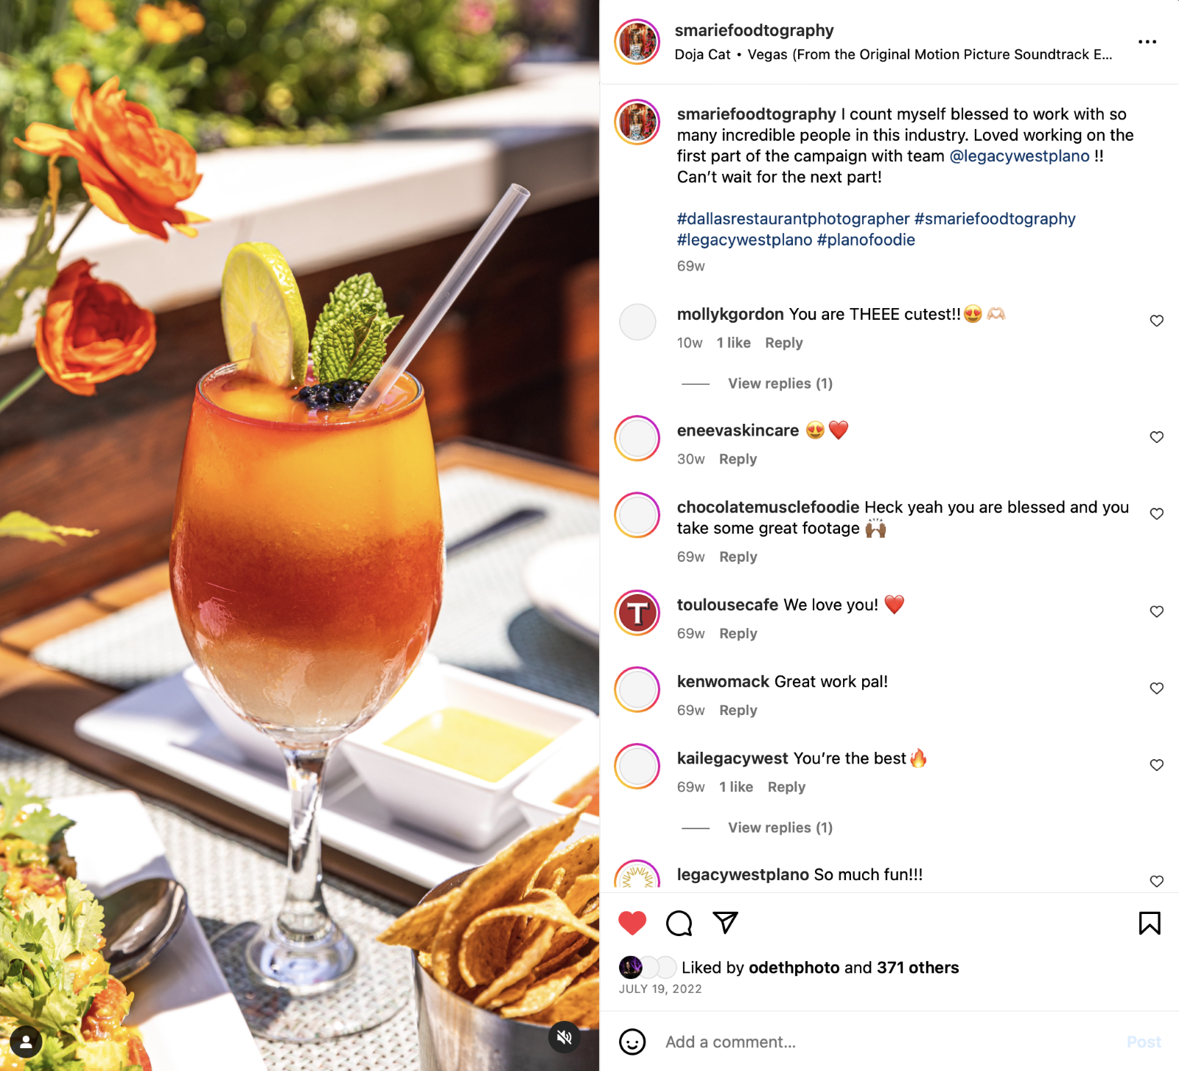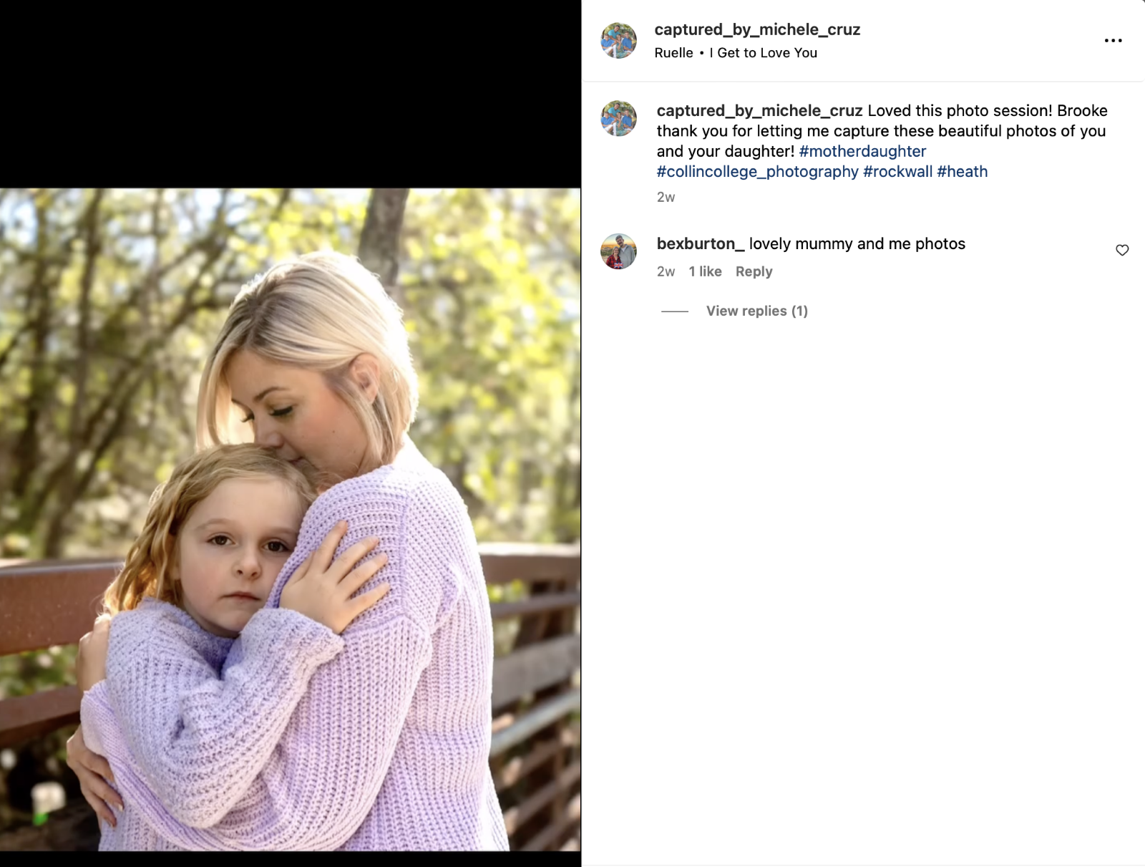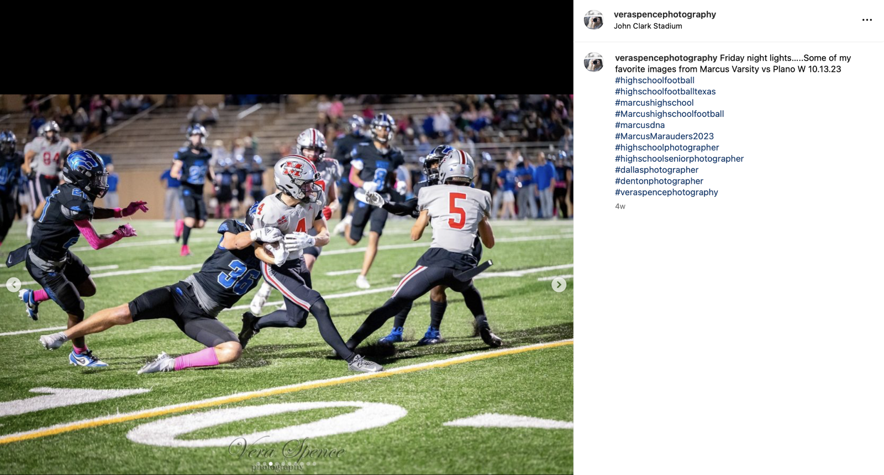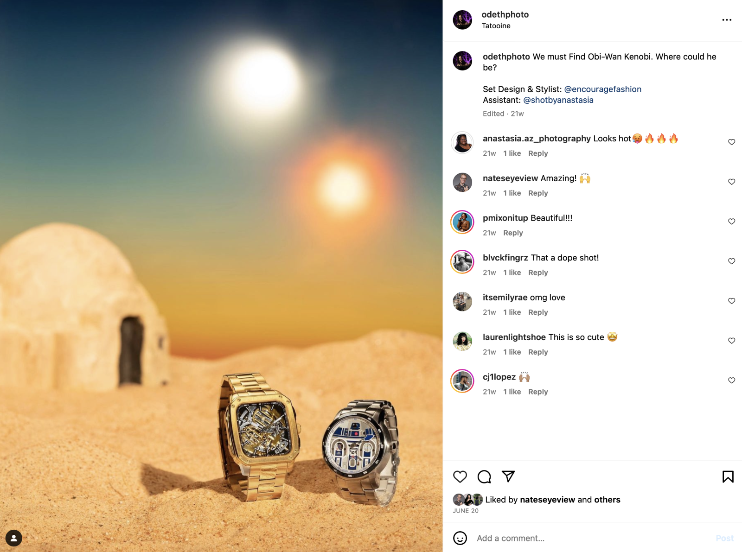

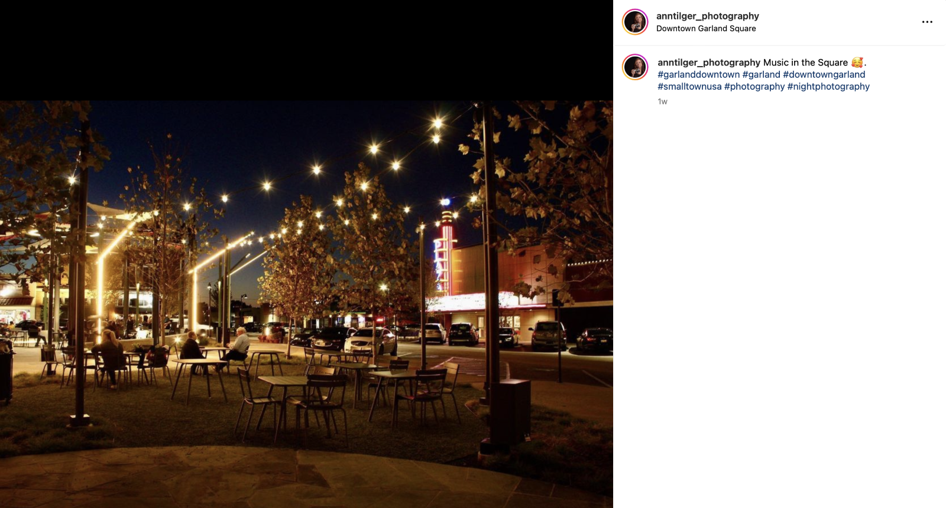

- Findings (Outcome #1)
Students see their viewership go up with the tags and regular posting. Also, if the viewership does not increase using the algorithms that are taught will help them make the changes necessary. Making unique hashtags and posting at the right time of day is a big part of the algorithms that are used to wider audiences. By posting on Instagram the students can drive the viewers to their website to see their portfolios and gain jobs through those viewings.

- Implementation of Findings
One of the main teachings in social media is how to tag and what time is best with the algorithms of Instagram. Which days are best? Which time is best for the largest audience to find the student’s post?

- Results Summary (Outcome #2)

Students find that being consistent with posting while learning the best times and days to post for the most viewership. Social media is a strong part of marketing in the photography field and cannot be overlooked or ignored. Instagram is now necessary for those trying to gain an audience for their own business.

Below are some examples of students present and graduated posting on Instagram to promote their photographic skills. These student examples show many different genres of photography. Many types of photography are represented on this platform including food, beverage, portraits, wedding, landscapes, and products to name a few. According to ASMP (American Society of Media Photographers) and PPA (Professional Photographers of America). Even companies now use Instagram in their marketing campaigns. Learning to navigate and social media is critical for a photographer in this industry.

- Findings (Outcome #1)

Students see their viewership go up with the tags and regular posting. Also, if the viewership does not increase using the algorithms that are taught will help them make the changes necessary. Making unique hashtags and posting at the right time of day is a big part of the algorithms that are used to wider audiences. By posting on Instagram the students can drive the viewers to their website to see their portfolios and gain jobs through those viewings.

- Implementation of Findings
One of the main teachings in social media is how to tag and what time is best with the algorithms of Instagram. Which days are best? Which
time is best for the largest audience to find the student’s post.

A. Outcome #3
Increase outreach to grow enrollment. Outreach will include High School, Collin Enrolled Students, and Community members. One big priority for CIP in the Workforce Photography Department is boosting visibility and enrollment in Collin’s Workforce Photography. Also, making the visibility noticeable in the commercial photography field in the DFW Area.
B. Measure (Outcome #3)  Here are some ways in which we are increasing our outreach  and growing out program. Our program was shrinking and  needed to see growth back from Covid.  • Events through Collin Workforce  • High School Visits  • Judging High School Competitions  • Community service with the Haggard Library and Darkroom students every semester.  • CoOps are growing more every semester reaching deeper into the Commercial Photography Community to provide students with more internships and job opportunities upon graduation. We have used over 23 different CoOps in the past few years.  • Participate in SkillsUSA and win both state and nationals. | C. Target (Outcome #3)  Every month of the academic year (fall, spring) at least one outreach to the High Schools, Collin Students, or our community members. Most months our department had multiple outreaches.  Creating new CoOps will help ensure that Collin and the Photography community in the DFW area will work together and gain more contacts for our students to achieve their goals in the
D. Action Plan (Outcome #3)
Continue the following:
• Attend High School College Events
• Collin Workforce and Job Fairs
• Working with students and SkillsUSA to enhance high schoolers participating in SkillsUSA
• Giving tours of our facilities. Making each prospective student

E. Results Summary (Outcome #3)
• Enrollment is up! The visibility of the program is up. See chart below.
• Great feedback from both high school students and teachers

Academic Year | Enrollment | Percent of Change
2021-2022 | 255
2022-2023 | 320 | +25.49

Partial List of Outreaches

F. Findings (Outcome #3)
• Informing high schools both teachers and students of our workforce photography program at Collin.
• Collin has been invited not just to College Days, but as guest speakers to present our program to the art and photography students in the classes.
• The high schools did not know of our extensive workforce photography program and our recent successes for past students. Now knowing about the Workforce Photography program teachers are informing their students and asking Collin to come to their classrooms and College Days.
G. Implementation of Findings
• Our program is gaining traction from the high schools and community outreach.
Continuing with Community Groups
• Haggard Library
• Plano Parks, and Recreation
We need to continue this outreach to maintain and grow the Workforce Photography Program. We will continue and try to reach more high schools in the Collin County ISDs.

We were surprised at how many high schools in our own district did not know you could get certificates and an AAS degree.

Many corporate photography studios have done CoOps with Collin now and are hiring our students. Fossil Inc, At Home, FLOCC Studios,

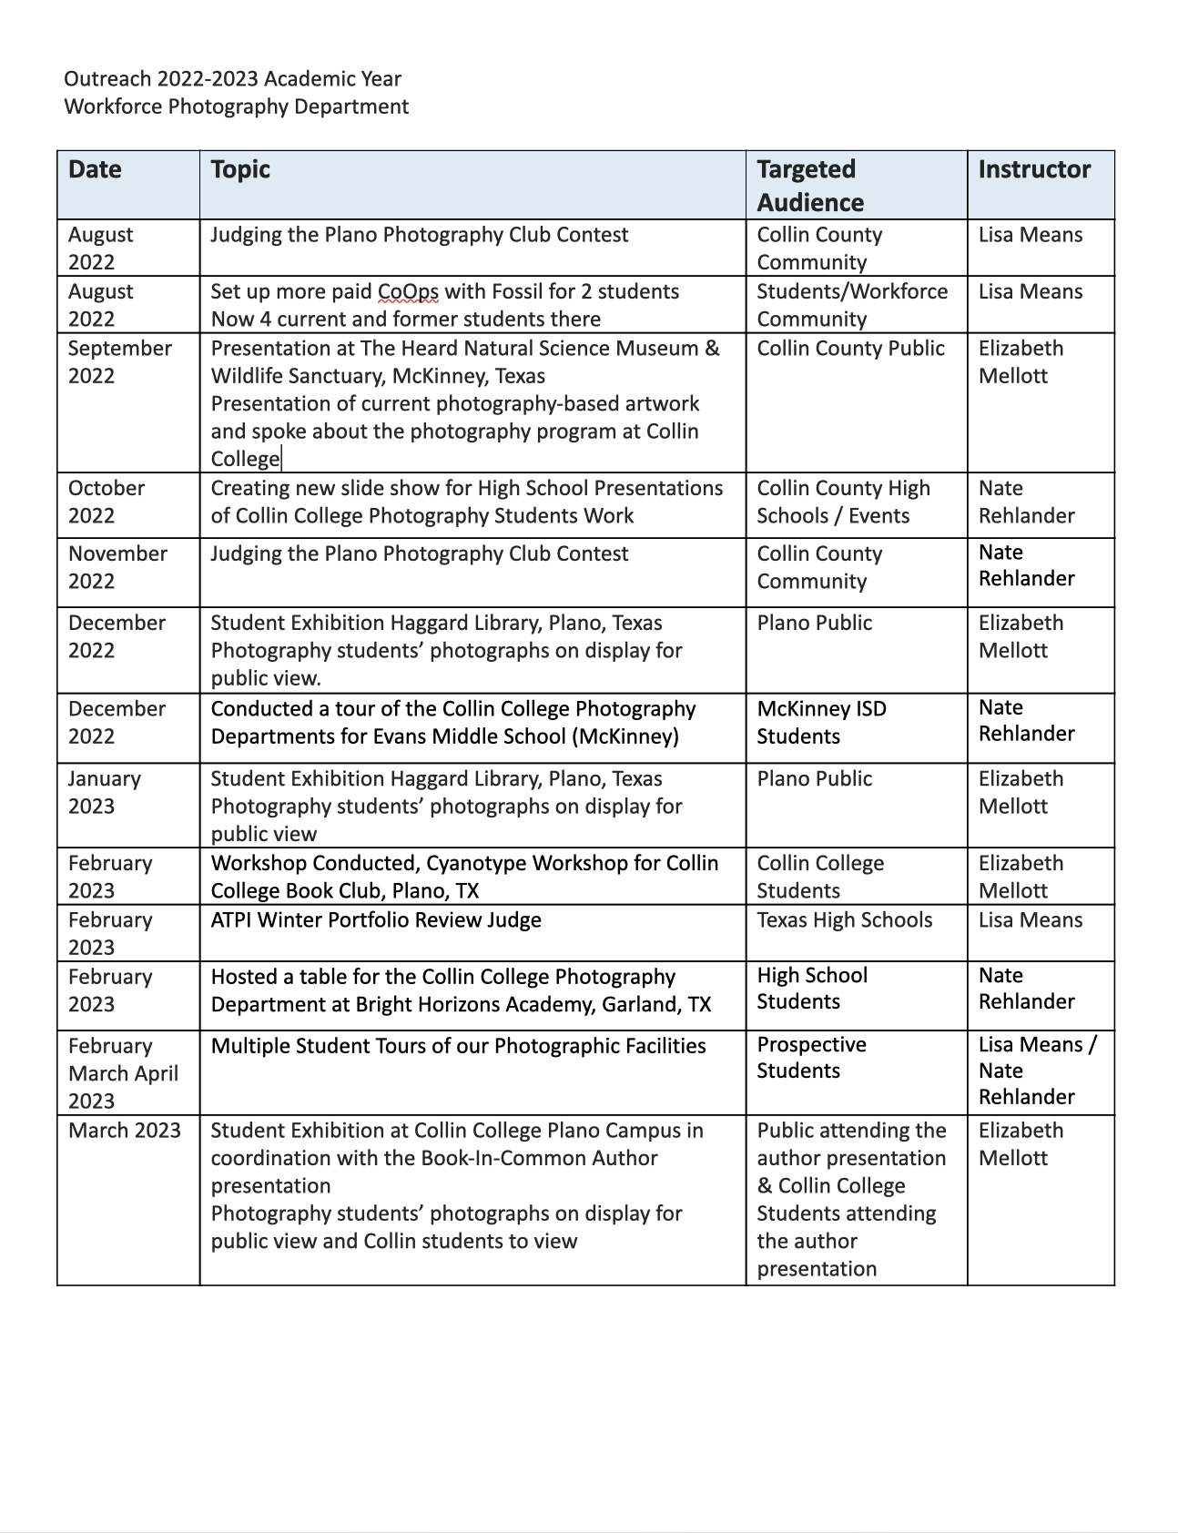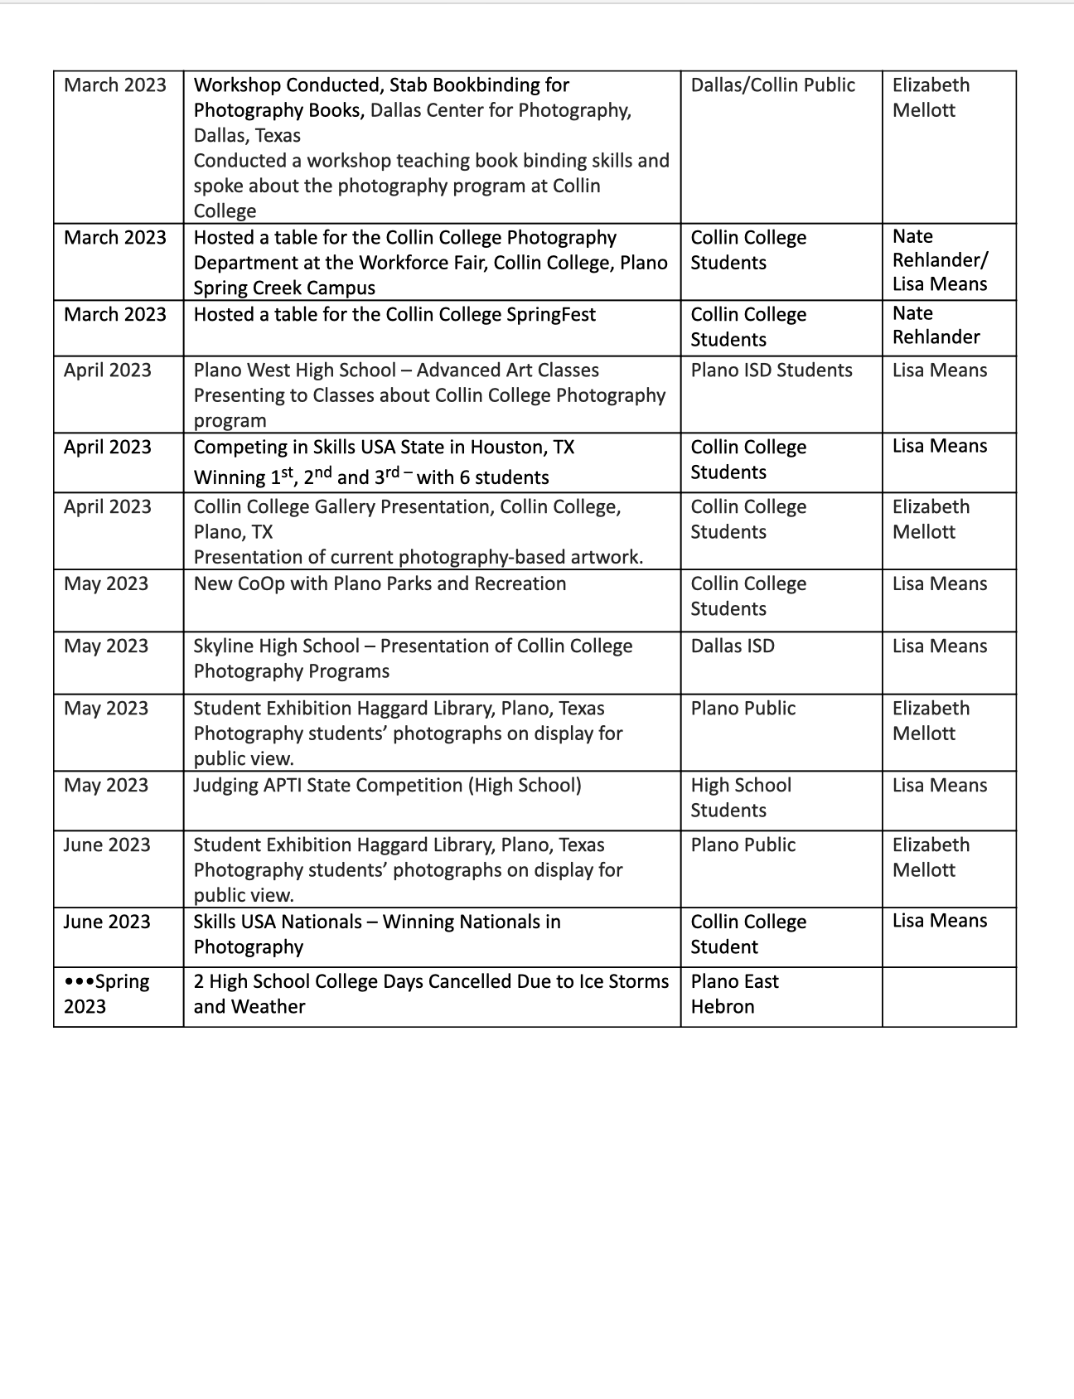
Program Assessment Data Report
Program: Commercial Photography Terms Data Collected: Fall 2021-Fall 2022
Program-Level Learning Outcome- (From Assessment Plan) | Assessment Measure(s) and Where Implemented in Curriculum – (From Assessment Plan) | Targets- Level of Success Expected-(From Assessment Plan) | Assessment Results – (Provide Data in a form related to targeted levels of success to left. Indicate if Targeted level of success was met, partially met, or not met.)
PPL #1  Demonstrate photographic techniques equal to the industry standards and trends, including camera operation, software application, studio management skills, printing, lighting and social media techniques. | PHTC 1311 – Foundations of Photography - Basic Camera Functions (Manual, Aperture, Shutter Speed) Making images in RAW format and using Lightroom to process images into JPEG’s.  PHTC 1300 – Digital I - Software – Photoshop is introduced and basic retouching skills.  PHTC 1353 – Portrait I – Learning the studio lighting equipment and how to use the light meter and studying lighting patterns and lighting ratios.  PHTC 1345 – Illustrative - Learning how to light tabletop. Including lighting food, jewelry, beverage, and glassware.  PHTC 2343 Portfolio – Creating a website and interviewing with professionals in the industry. The website and social media are graded assignments. The final exam is an interview on zoom with professionals presenting their work. | Targeting 75% of students learning these skills in the classes listed. | Classes listed more than 80 % of the class successful learned these skills.  See Data Below
Class for Software – Photoshop – Retouching
Assignments that are measurable for retouching skills are – restoration of an old photography, retouching a portrait (removing blemishes, red eye, and smoothing skin).
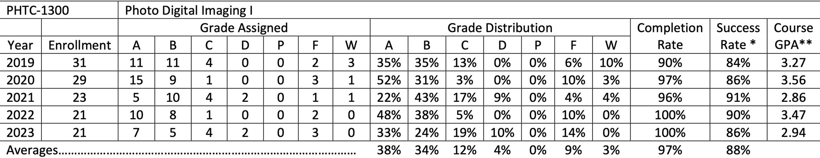

Class for Basic Camera Operations and Lightroom Software
Assignments that are measurable are Shutter Speed - Motion, Aperture – Depth of Field. Using Lightroom and learning how to make a catalog.
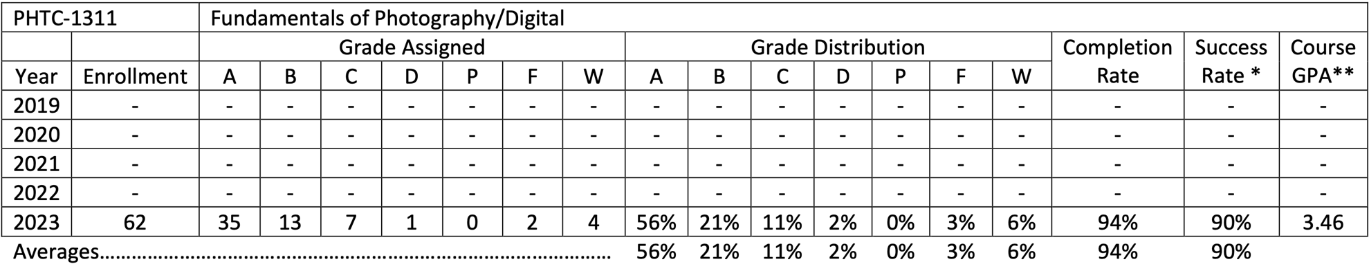

Class for showing how to light and use lighting ratios with product and tabletop photography.
Assignments that are measurable are Food, Jewelry, Beverage, Texture (showing lighting ratios).
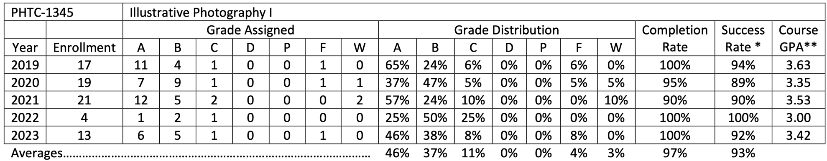

This class has lessons with lighting ratios and how to set up portrait studio. Learning the different lighting patterns for portraits.
Assignments that are measurable are Split, Butterfly, Rembrandt, and Rim Lighting patterns. Also, making all 4 lighting patterns in one assignment with one subject.
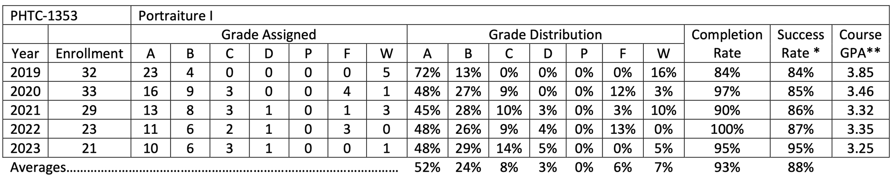

This class has a final exam with professionals in the photography industry on zoom showing their website with their portfolio. This will increase student’s abilities to interview for jobs in the industry. Another assignment in this class will be posting correctly on social media. Assignments that are measurable are the portfolio showing to professionals for a final exam, social media posting, and building a website.
