The Program Review Steering Committee has completed its review of your submission. Attached you will find the full composite review for your program. After reading this document, if you would like to make any changes or updates to the program review document that you had originally submitted to the committee, please do so and forward the edited submission to effectiveness@collin.edu by December 15, 2023. Your program review submission has been published on the college website. For clarification of findings, please contact the senior reviewer Alicia Huppe.

Program Review Steering Committee Contact Information
Name and email of the committee member you can contact
Alicia Huppe ahuppe@collin.edu
Status of Review
Overall current status of your program review
☐ Acceptable without recommendations
☒ Acceptable with recommendations
☐ Revisit and revise
Summary
Description of findings from your program review
Significant improvement from the previous submission. Opportunities to expand content in areas of: program relationship to college mission, strategic plan, and institutional partnerships. Would like to have seen references to student learning outcomes, feedback from advisory board, and possible demonstrated knowledge, skills, abilities for student preparedness for workforce.

Data provided was excellent, especially in the areas of student and market demand.

Highlights
Most important reviewer comments
New CIP looks identical to the previous years with the addition of faculty recruiting. CIP focuses on one capstone course which could be subject to professor grading. The previous goal appears to have been met with no rationale as to why it is being repeated.

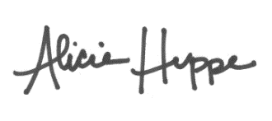
As the senior reviewer in the review process, I acknowledge the notification of findings to the author and supervisor.
_______________________________________________ 12.4.2023
Senior Reviewer Name Date

